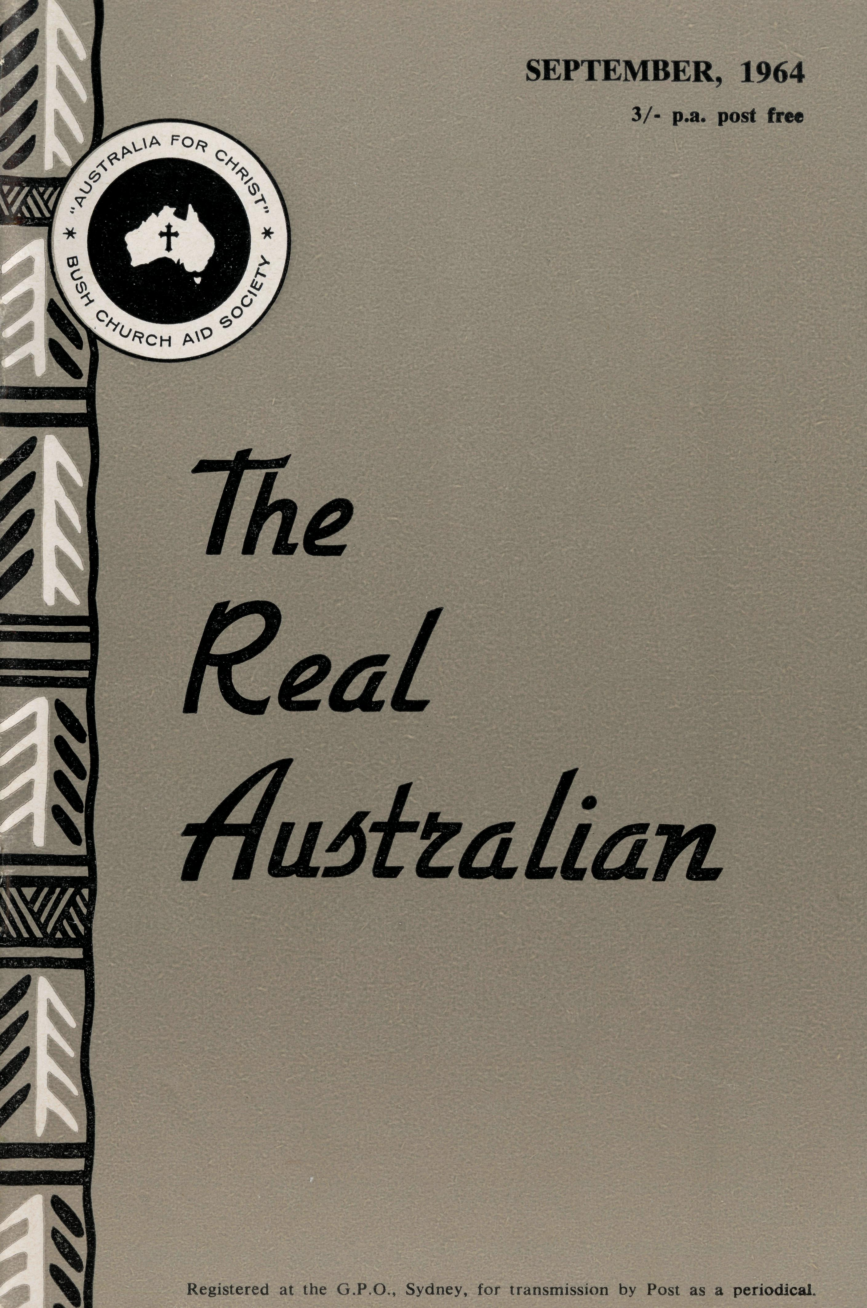
PHARMACIST
Mr. J. ARGALL.
FLYING MEDICAL SERVICE STAFF
Executive Officer: Medical Officers:
Mr. S. HUMMERSTON
Dr. M. MUELLER Dr. R. ROBINSON
Matron: Sister M. HOPE
HOSPITAL CENTRES
Sisters M. BELL, M. CUTHBERT, E. DEARDON, V. GAMEAU, J. GRIFFEN, and Miss D. DUVER.
Matron: Sister J. ZILLMAN.
Sisters N. WILKINS, J. GEE, D.
WHYBURN, Misses M. SMEE and
M. CHADWICK.
Sisters B. FOX, M. ROSS.
CEDUNA, S.A.
The Murat Bay District Hospital—
WUDINNA, S.A.
The Central Eyre Peninsula Hospital-
COOK, S.A.
The Bishop Kirkby Memorial
Hospital—
TARCOOLA, S.A.
Sisters V. COCHRANE, B. SMITH.
Sister V. HOLLE, and Miss M. WALLACE.
The Tarcoola Hospital—
PENONG, S.A.
The Penong Memorial Hospital—-
Sister E. THOMAS.
RAWLINNA, W.A. The Nursing Hostel—
PILOTS
Mr. A. E. CHADWICK Mr. J. LINDRIDGE Mr. W. BEDFORD
AIRCRAFT
Cessna 210 — VH-AEC
Cessna 210 —VH-FMS
Beagle Airedale — VH-UEP
RADIO CONTROL STATION
Control Officer — Mr. K. ELLIS Assistant — Mr. D. McDOUGALL
HOSTELS FOR SCHOOL CHILDREN
PORT LINCOLN, S.A.
Mr. and Mrs. H. RICH. Miss M. ATTWOOD.
BROKEN HILL, N.S.W.
Mr. and Mrs. W. KERR. Miss B. HYETT.
MOREE, N.S.W.
Mr. and Mrs. S. BENNETTS.
EDGAR BRAGG & SONS PTY. LTD.

The Bush Church Aid Society
from the
FEDERAL SECRETARY
for Australia and Tasmania
PRESIDENT
The Most Reverend, The Archbishop of Sydney.
VICE-PRESIDENT
The Most Reverend, The Archbishop of Melbourne.
CHAIRMAN OF COUNCIL HONORARY TREASURER
Rev. Canon E. Cameron. Mr. R. T. Stokes.
COUNCILLORS
Ven. G. R. Delbridge, Rev. Canon R. M. Hudson, Revs. C. A. Baker, L. H.
Broadley, E. V. Constable, O. W. C. Cooper, W. I. Fleming, A. C. Miles,
S. S. Viney, Messrs. H. M. Bragg, E. Stockton.
FEDERAL SECRETARY
Rev. C. W. Rich, Th.L.
ASSISTANT FEDERAL SECRETARY
Rev. A. E. Williams, Th.L.
NEW SOUTH WALES SECRETARY
Rev. L. J. Wiggins, Th.L.
VICTORIAN SECRETARY
Rev. J. Stockdale, Th.L
HONORARY SOLICITOR
Messrs. Maxwell and Boyd, 141 Elizabeth Street, Sydney.
SOUTH AUSTRALIAN REPRESENTATIVES
HONORARY AUDITOR
F. W. A. Eagar and Co., 8 Belgrave Street, Manly, N.S.W.
Rev. T. J. Hayman, Th.L., St. Matthew's Rectory, Marryatville, S.A. Telephone: FA 1022. Mr. A. Kirkby, 7 Ruthven Avenue, Glandore, S.A. Telephone: LF 3268.
B.C.A. HOUSE
135 Bathurst Street, Sydney.
Phones: 26 3164, 26 3780.
Telegraphic Address: "Chaplaincy", Sydney.
VICTORIAN OFFICE
Morton House,
262 Flinders Lane, Melbourne.
Phone: 63 8962.
"AUSTRALIA FOR CHRIST"
There are two matters of importance of which I want to write.
You will notice that this article no longer carries the title "From the O.M.". A glance to your left will see that we are now using "Federal Secretary" to describe my function. As well, the Rev. A. E. Williams and the Rev. L. J. Wiggins have also been given a change in title along with Canon E. Cameron. In my last letter to you I hinted that changes in structure and function were necessary. Council has been considering this break from tradition for a long time, I find, and at the Council Meeting in July they approved the structure which is printed on the next page of this issue.
Whilst many of us feel that there is a sentimental sense of attachment to traditional things we must also face the present and future activities of the Society with a sense of realism.
I anticipate that I will be able to give more personal attention to policy and staff relationships.
Mr. Williams, it is hoped, will be able to give more time to local and, where necessary, field administration. Mr. Stockdale and Mr. Wiggins will, it is expected, be able to concentrate on publicity, deputation work and general contact with our supporters. We trust that this more obvious division of responsibility in administration will enable each of us to function in a more effective way and so be of greater value within and outside the Society, thus serving God and His Church in a better degree.
Elsewhere in this issue you will read of the B.C.A. Fellowship. Here is an exciting new aspect of Society endeavour which we hope will appeal to you. It is only by informed prayerful concern that folk will play their full part in the Society task. We trust that the creating of this "core" of supporters will strengthen our combined ministry beyond measure. A badge, now available, will readily identify other interested members. We do not want to overload

THE REAL AUSTRALIAN, SEPTEMBER, 1964
THE REAL AUSTRALIAN, SEPTEMBER, 1964

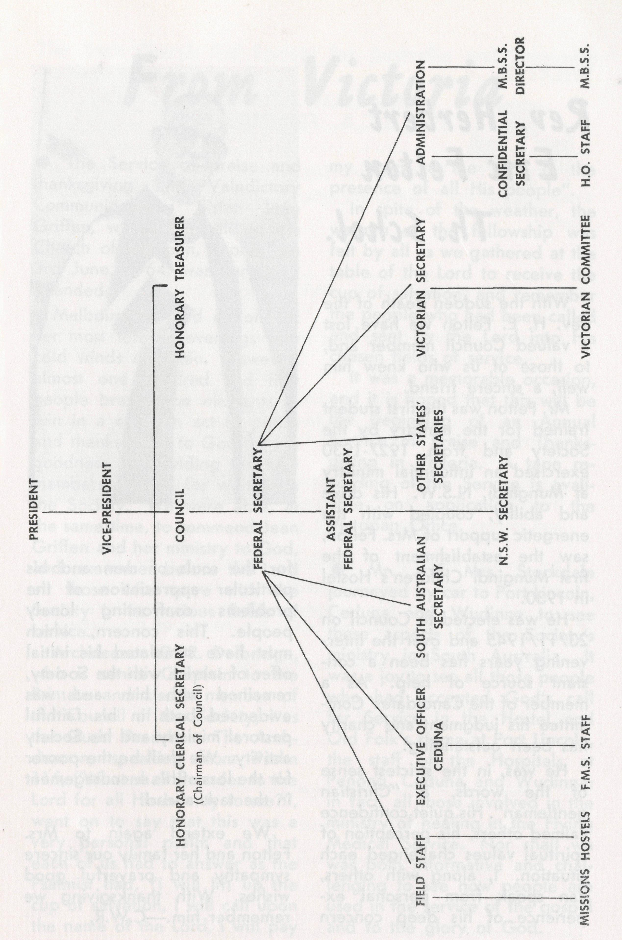
challenge of service and who will, in turn, interest others in our task.
Both these aspects denote a sense of growth and development within the Society. We pray that God will bless our endeavours and so continue to use us all to His Glory.
our already crowded existence with another organisation, as such, but as you will see from the publicity material our primary purpose is to weld the combined efforts of interested people into a constructive, informed and so effective unit.
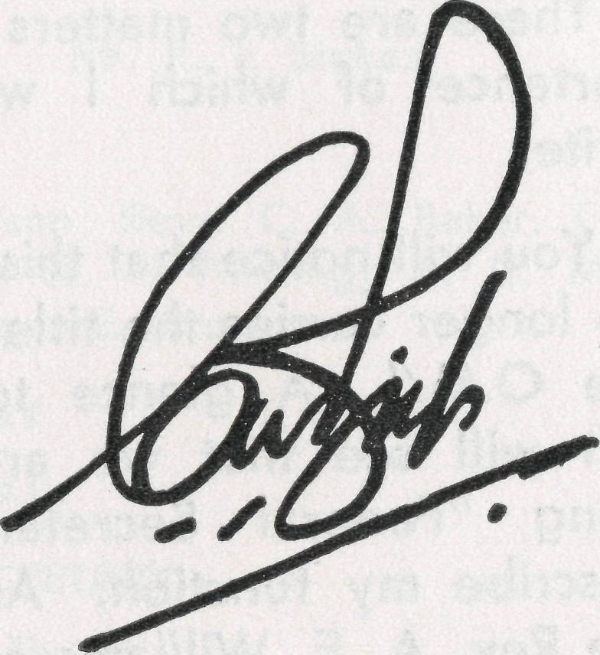
The constant sense of practical support which comes in answer ro our appeals for financial help has given us to think that this practical demonstration proves the existence of just such a "core" as we envisage will join our Fellowship. We are hopeful that with the growth of the Fellowship we might be assured of a reserve of interested people before whom we can put the
OF THE SOCIETY
—From the first issue of "The Real Australian", September, 1920.
"The need was of a Home Mission Society, bound by no fetters other than that of a loyalty to the Gospel and a sturdy Churchmanship, which could operate in all the States, organise the resources of the Capital cities and concentrate energy and service upon the neglected Bush areas, which so long had been a problem and a reproach to the Church of England. So the Society born of prayer and vision came into being. Its programme justified its birth and its achievements up to the present have justified its existence and its right to further and fuller support.³'
—Rev. S. J. Kirkby.

THE REAL AUSTRALIAN, SEPTEMBER, 1964
THE REAL AUSTRALIAN, SEPTEMBER, 1964

From Victoria
Rev. Herbert Eric Felton
Th. Schol.
With the sudden death of the Rev. H. E. Felton we have lost a valued Council member and, to those of us who knew him well, a sincere friend.
Mr. Felton was the first student trained for the ministry by the Society and from 1927-1930 exercised an influential ministry at Mungindi, N.S.W. His drive and ability, coupled with the energetic support of Mrs. Felton, saw the establishment of the first Mungindi Children's Hostel in 1930.
He was elected to Council on 23/11/1945 and over the intervening years has been a constant source of help. As a member of the Candidates' Committee his judgment and charity has been outstanding.
He was, in the strictest sense of the words, a "Christian gentleman". His quiet confidence calmed others, his perception of spiritual values challenged each situation. I, along with others, can speak from personal experience of his deep concern
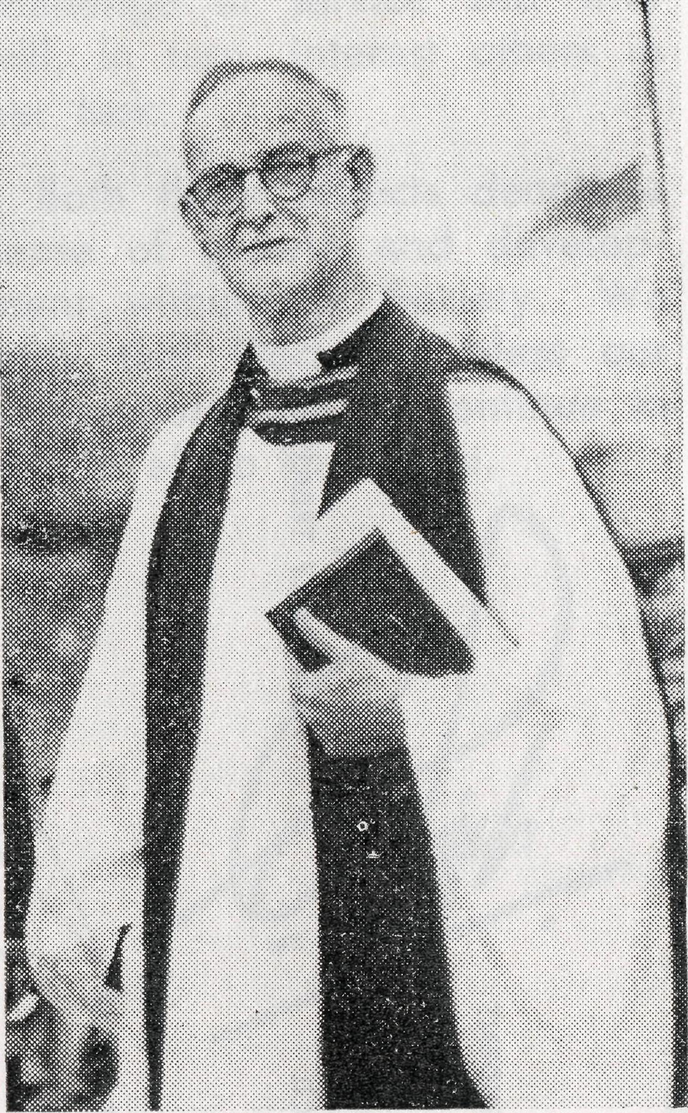
for the souls of men and his particular appreciation of the problems confronting lonely people. This concern, which must have stimulated his initial offer of service with the Society, remained with him and was evidenced both in his faithful pastoral ministry and his Society activity. We shall be the poorer for the loss of his encouragement in the task ahead.
We extend again to Mrs. Felton and her family our sincere sympathy and prayerful good wishes. With thanksgiving we remember him.—C.W.R.
• The Service of praise and thanksgiving and Valedictory Communion for Sister Jean Griffen, which was held at the Church of St. John, Toorak, on 3rd June, 1964, was very well attended.
Melbourne turned on one of her most terrible evenings with cold winds and rain. However, almost one hundred and fifty people braved the elements to join in a common act of praise and thanksgiving to God for His goodness in providing ten new members of Staff for work with the Society. We were able, at the same time, to commend Jean Griffen and her ministry to God, and remember before the Lord all those who serve with the Society in its various fields of service.
Archdeacon G. R. Delbridge, who is senior Chaplain to the Primate and also a member of the Council of the Society, was the Guest Preacher. The Archdeacon, speaking from Psalm 116, "What shall I render to the Lord for all His bounty to me?", went on to say that this was a very persona! psalm and that each of us had to answer as the Psalmist had, "I will lift up the cup of salvation, I will call upon the name of the Lord, I will pay
my vows to the Lord in the presence of all His people".
In spite of the weather, the warmth of the fellowship was felt by all as we gathered at the table of the Lord to receive the cup of salvation, and remember the people who had been called and sent by the Lord into His chosen fields of service.
It was a memorable occasion, and it is hoped that this will be the beginning of an Annual Service of Praise and Thanksgiving in Victoria. A tape recording of the Service is available on application to the Victorian Office.
© Mr. and Mrs. Stockdale journeyed by car to Port Lincoln, Ceduna and Wudinna to see these aspects of the Society's ministry in South Australia. It was a joy to see all those people who had accepted God's call for Service in the Hostel and Old Folk's Home at Port Lincoln, the staff of the Hospitals at Penong, Ceduna and Wudinna; in fact, all those involved in the ministry of healing in the Flying Medical Service. Nor shall we was both informative and challenging to see how people are used in the service of the gospel and to the glory of God.

THE REAL AUSTRALIAN, SEPTEMBER, 1964
THE REAL AUSTRALIAN, SEPTEMBER, 1964

WHAT IS
THE B.C.A. FELLOWSHIP?
The aim of the Fellowship is to bring together all workers and supporters of the Society into one Fellowship of prayer and active interest.
The Bush Church Aid Society for Australia and Tasmania
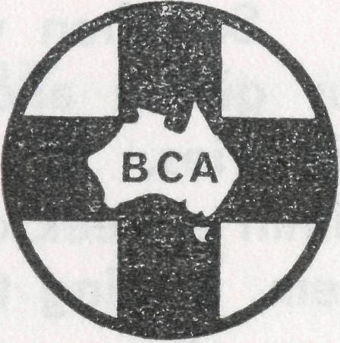
THE B.C.A. FELLOWSHIP
Application Form
(Please print in BLOCK letters)

NAME..

WHAT WILL MEMBERSHIP INVOLVE?
- Members will promise to pray regularly for the work and witness of the Society.
- Members will undertake to share in the financial responsibilities of the Society by giving regularly through B.C.A. boxes or other means.
- Members will receive information about the Society's activities through the Real Australian (quarterly) and through information and prayer bulletins, sent out regularly.
- An annual meeting of Fellowship members is to be held in addition to the B.C.A. Annual Rally.
- Members may purchase and wear the badge of the Society.
- There is no joining or membership fee.
(State whether Revel., Mr., Mrs. or Miss)
Address
I wish to become a member of the B.C.A. Fellowship, and undertake with God's help to:
Pray regularly for the work of B.C.A. and its members;
Learn all I can of the spiritual needs of Australia, and of the efforts of B.C.A. to meet them;
Support the work of B.C.A. financially, and to use every opportunity to make the purpose and work of B.C.A. more widely known.

I wish to receive the Badge of the Society. (Cost 5/-. Please include.)

HOW TO JOIN
Fill in the form on the next page and send to:
The N.S.W. Secretary, B.C.A. House, 135 Bathurst Street, Sydney, N.S.W.
Or for further information — phone 26 3164.
6 THE REAL AUSTRALIAN, SEPTEMBER, 1964
If not already a Boxholder/Subscriber— I wish to receive a B.C.A. box. I wish to subscribe to the Real Australian.
Date Signed
THE REAL AUSTRALIAN, SEPTEMBER, 1964

APPRECIATION
So often we labour and see so little return for our prayers, our giving and doing in support of the Society and its various ministries. The two letters, printed below, have been received within a week of each other. We have taken the liberty of printing them, trusting that they will serve as a measure of encouragement to us all.
Wirrulla, S.A. 17/7/64.
I have been asked by the Central Council of the Minnipa Mission to pass on to your Society the grateful thanks and appreciation of the Parishioners of this Mission District for the work and money that you have seen fit to put into our district; I feel that only now that we have to "run our own show", is it that we fully realise how much we are indebted to your Society.
Thanking you for all your past efforts and wishing you every success in your present and future undertakings.
For and on behalf of
The Parishioners of Minnipa Mission District. Don Woods (Secretary).
The Place of Prayer
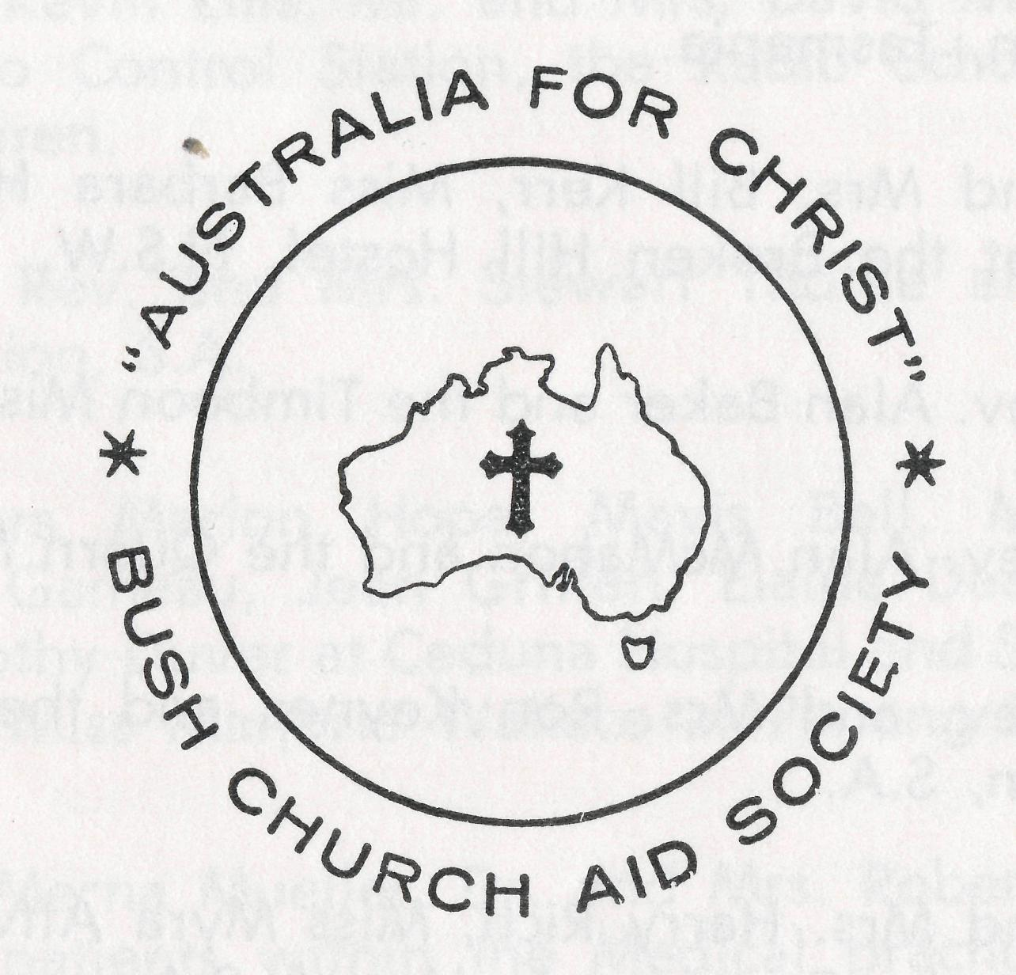

Rock Valley, N.S.W. 22/7/64.
This is a "thank you" from a grateful mother living on a dairy farm in Rock Valley. I wish to thank the B.C.A. for enabling my son, Philip, to have Sunday School lessons for 11 years since the age of four—fie is now fifteen—through the Mail Bag Sunday School. I would like to express my deepest thanks to Miss Rose Campbell, the Director, with whom I had correspondence during that time.
Miss Campbell is a silent worker for that wonderful Society who, with untiring promptness, has seen each month to the despatching of the Lessons, the correcting and returning of same. The B.C.A. and its Director have given Philip a knowledge of the Bible, the Prayer Book and most of all the knowledge that the Lord Jesus is his Friend. The outback or those who cannot attend Churches bless this branch of the Society.
Yours sincerely,
Mrs. Josephine McLean.
The following pages represent a daily prayer calendar which will be revised with each issue. We earnestly seek your prayers for the individual members of our staff. We suggest you remove these centre pages from the magazine and keep them for your regular devotional use.
"Let us ask God that they may receive from Him all wisdom and spiritual understanding for full insight into His will, so that their manner of life may be worthy of the Lord and entirely pleasing to Him. Pray that they may bear fruit in active goodness of every kind and grow in the knowledge of God. May He strengthen them, in His glorious might, with ample power to meet whatever comes with fortitude, patience and joy; and to give thanks to the Father who has made them fit to share the heritage of God's people in the realm of light."
(Adapted from Colossians 1 N.E.B.)

THE REAL AUSTRALIAN, SEPTEMBER, 1964
THE REAL AUSTRALIAN, SEPTEMBER, 1964

1st The Rev. and Mrs. Ray Neve and the Wilcannia Mission, N.S.W.
2nd The Rev. and Mrs. Brian Viney and the Menindee Mission, N.S.W.
3rd The Rev. and Mrs. Brian O'Grady and the Tarraleah Mission, Tasmania.
4th Mr. and Mrs. Bill Kerr, Miss Barbara Hyett and the boys at the Broken Hill Hostel, N.S.W.
5th The Rev. Alan Baker and the Timboon Mission, Victoria.
6th The Rev. Alan McMahon and the Quorn Mission, S.A.
7th The Rev. and Mrs. Ron Keynes and the Leigh Creek Mission, S.A.
8th Mr. and Mrs. Harry Rich, Miss Myra Attwood and the girls at the Port Lincoln Hostel, S.A.
9th Miss Rose Campbell, Miss Dianne Sidebottom and all the helpers and scholars in the Mail Bag Sunday School.
10th Mr. and Mrs. Allan Chadwick, Mr. and Mrs. John Lindridge and the flying within the Medical Service.
11th Mr. and Mrs. Stan Hummerston and the administrative work within the Flying Medical Service.
12th The Rev. and Mrs. John Wyndham and the North-West Line Mission, Tarcoola, S.A.
13th The Rev. and Mrs. Noel Hart and the Derby Mission, W.A.
14th Mr. and Mrs. John Argall and the work at the Ceduna Pharmacy, S.A.
15th The Rev. Theo Hayman, Mr. Alban Kirkby and the South Australian Representation.
16fh Mr. and Mrs. Sid Bennetts and the boys at Urallie Hostel, Moree, N.S.W.
17th hAr. Kevin Ellis, Mr. and Mrs. David McDougall at the Radio Control Station, the Radio School teacher and children.
18th The Rev. and Mrs. Stewart Thorne and the Orroroo Mission, S.A.
19th Sisters Marion Hope, Mavis Bell, Meryl Cuthbert, Val Gameau, Jean Griffen, Elaine Deardon and Miss Dorothy Duver at Ceduna Hospital and Sister Vera Holle and Miss Marjorie Wallace at Penong Hospital, S.A.
20fh Dr. Merna Mueller, Dr. and Mrs. Robert Robinson and the patients within the Medical practice.
21st Sisters Barbara Fox and Maude Ross at Cook Hospital and Sisters Vaisey Cochrane and Beverly Smith at Tarcoola Hospital, S.A.
22nd Sister Edna Thomas at the Rawlinna Nursing Home, W.A.
23rd Sisters Julia Zillman, Nancy Wilkins, Joan Gee, Dorothy Whyburn, Misses Margaret Smee, Margaret Chadwick at Wudinna Hospital, S.A., Mr. Bill Bedford and the patients carried by air.
24th The Rev. and Mrs. Bernard Buckland and the Murchi-son Mission, W.A.
25fh The Rev. and Mrs. Barry Huggett and the Port Hedland Mission, W.A.

THE REAL AUSTRALIAN, SEPTEMBER, 1964
THE REAL AUSTRALIAN, SEPTEMBER, 1964

TARCOOLA HOLIDAY
Miss Isobel Gilfiilan
Miss I. Gilfiilan is a parishioner of Holy Trinity, Williamstown (Victoria), and a personal friend of Sister Cochrane. We are grateful to her for her permission to reprint these impressions of her visit to Tarcoola.
26th The Rev. and Mrs. Harry Goodhew and the Ceduna Mission, S.A.
27th Mr. and Mrs. Roy Avery, Misses Marjorie Farr and Brenda Moore, Staff and Residents at the Old Folk's Home, Port Lincoln, S.A.
28th All students in training for outback ministries, a continued supply of replacement personnel, our Box Secretaries, the evergrowing number of supporters and their ready response.
29th The Rev. and Mrs. John Stockdale, Mrs. W. Hughes, the Victorian Committee and Office Staff.
30th The Rev. and Mrs. Bill Rich, the Rev. and Mrs. Arthur Williams, the Rev. Les Wiggins, Messrs. Laurie Calder, Frank Burner, Mrs. Joy O'Neill, Misses Ruth Close, Deirdre Briggs, Suzanne Thorley at Headquarters and the Council of the Society.
O Lord God of our nation, Who hast commanded men to subdue and replenish the earth: Look in Thy love upon all who in distant parts of our land are striving against many difficulties, and are deprived the access of the means of grace. Strengthen and guide the Bush Church Aid Society and all members of the staff. Cheer and comfort them in discouragement and loneliness, bless their ministrations to the good of those they serve, and grant that the message of redeeming love may thus be rooted and grounded in our national life, to the glory of Thy Great Name through Jesus Christ our Lord. Amen.
O God, we remember before Thee those whom Thou hast called to Thy service. Bless them this day, we beseech Thee, as we
pray for Call forth others
to stand with them in their task. Grant to them, as to us, the joy of service, the ability to achieve and the serenity of Thy peace, for Jesus' sake.
Amen.
Very early on Easter morning
- climbed out of the Trans-Continental Express at Tarcoola. Sister Cochrane was waiting impatiently at the station and we ploughed through deep red earth to greet each other. About
- a.m. we retired to our beds to catch up on some much-needed sleep but we were up again at 7 o'clock to be ready for Church.
The people at Tarcoola have been blessed with the arrival of a resident ministry and that means that we were able to meet for a celebration of Holy Communion. Twelve adults were present for this service of thanksgiving and we sang the Easter Hymns with great joy. It was a wonderful experience to share with these people, two of whom had travelled 80 miles over country roads to be present.
After breakfast at the hospital we returned to Church for the Family Service. At this service 35 adults and children were present, which gave me food for thought. Tarcoola consists of
approximately twenty houses, the hospital and an hotel and yet 35 people met for that service. Parishioners from outlying properties helped to make up the number. The heat in the Church was fairly intense but I was told the weather was reasonably mild. I believe we had century heat for the two days I was in Tarcoola.
In the evening we returned to Church for Evening Prayer. The two men who had driven in for Holy Communion returned for the evening service, which proves distance means nothing if your faith is real. Mr. Wynd-ham showed a film instead of a sermon, which made for variety. After Church everyone returned to the hospital for supper and an hour of fellowship. The young people made the tea, served supper and washed up while the older people talked and relaxed.
I will remember Easter Day, 1964, with joy. I feel I was privileged to be able to stay at the hospital on my holidays.

12
THE REAL AUSTRALIAN, SEPTEMBER, 1964
THE REAL AUSTRALIAN, SEPTEMBER, 1964
13

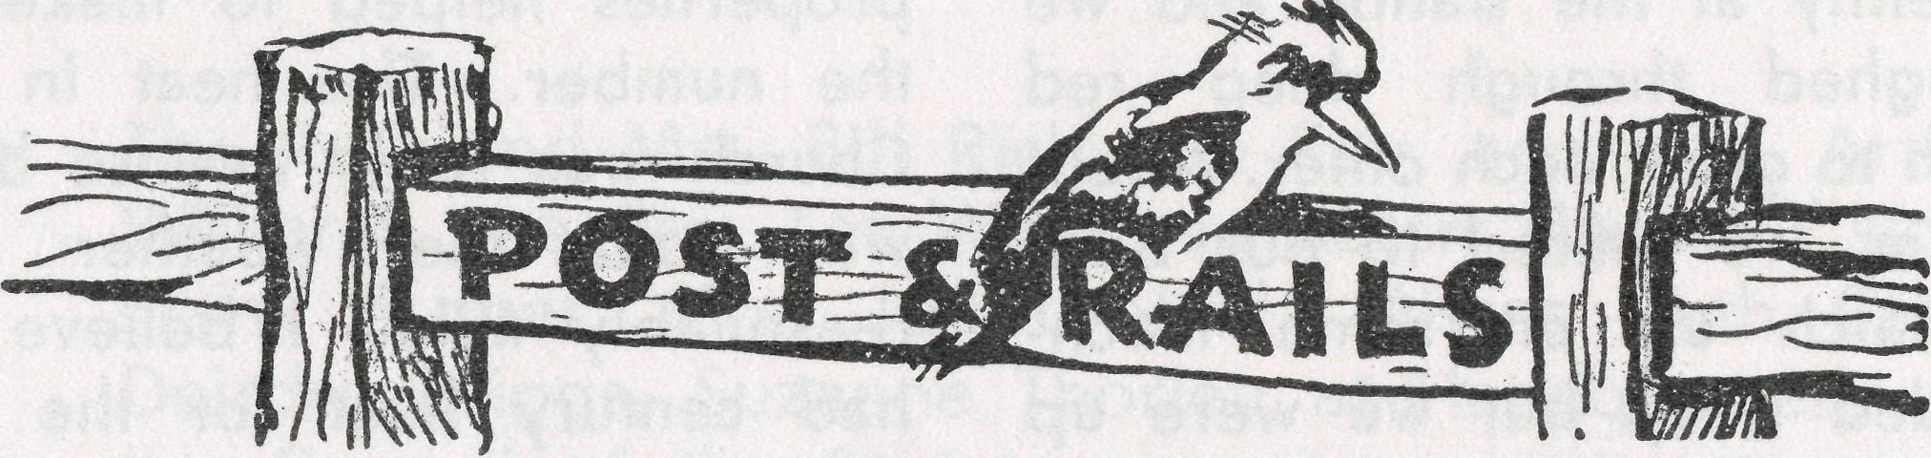
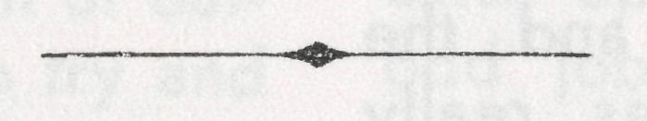
© Did you make a note in your Diary when we wrote to you about the Rally? It will encourage us and deepen your concern if you can come.
SYDNEY: St. Andrew's Cathedral Chapter House Friday, 11th September, at 7.45 p.m.
MELBOURNE: St. Paul's Cathedral Chapter House
Tuesday, 15th September, at 7.45 p.m.
SOUTH COAST: St. Michael's (Wollongong) Parish HaU Friday, 25th September, at 7.45 p.m.
• Mr. and Mrs. Harry Rich have taken responsibility for the Girls' Hostel at Port Lincoln following the resignation of Mr. and Mrs. Wiggins. Mr. and Mrs. Rich have been associated with the work of "Teen Ranch" for some time and we commend them to your prayers in this venture. We would also express our gratitude to Miss Farr of the Old Folk's Home Staff for her ready assistance in acting as Matron during the changeover.
• Mr. and Mrs. Roy Avery have intimated their intention to resign from the staff of the Old Folk's Home at Port Lincoln, S.A., at the end of this year. After 6 years' faithful ministry these two have endeared themselves to many and they will be greatly missed by all. As a trained nurse, Mrs. Avery has made a practical contribution to the welfare of the Home, and it is essential that she be replaced by someone with similar training, is there someone reading this who would pray about this opportunity of service? If so, we would like to meet you.
14
• The Women's Auxiliary (Sydney) is rejoicing and recovering from their recent Annual Fair. Unfortunately Mrs. Bury was ill and unable to open the Fair as advertised. We are most grateful ro our President, the Primate, for his acting in her stead at such short notice. At time of writing the financial return is a little over £700. The project to which the Auxiliary has worked this year is to supply portable air coolers to the inland Rectories.
© Broken Hill Boys' Hostel is the scene of more chaos than usual. Added to all that 22 boys can do, builders have now descended upon the kitchen to carry out much-needed alterations and renovations. Slight additions are being made to the staff quarters and it is hoped that the results will provide far more effective domestic arrangements. The building alterations are to cost £3,500 and refurnishing, including stove and refrigeration, is estimated at £1,000. Perhaps some of our supporters who have followed the work of the Hostel over its many years would like to share in this.
THE REAL AUSTRALIAN, SEPTEMBER, 1964
©The Wollongong Rally will be held at St. Michael's Hall, Wollongong, on Friday, 25th September, at 7.45 p.m. Our N.S.W. Secretary, the Rev. L. J. Wiggins, and the Federal Secretary, Rev. C. W. Rich, will be the principal speakers. We look forward to this time of fellowship with our supporters from the South Coast.
• The members of the Clovelly Women's Auxiliary have joined with the other Auxiliaries in working towards the supply of air coolers to field staff residences. The Clovelly folk have provided the unit for the Rectory at Quorn and we are most grateful to them.
© Sister Val Gameau has joined the staff of the F.M.S. network, coming to us from Two Wells, South Australia. We welcome her into the work and pray that God will sustain her and use her to His Glory.
© Recently B.C.A. history was made in the Diocese of North West Australia. For the induction of the Rev. Barry Huggett, Noel Hart made a 500-mile trip each way from Derby and from Murchison, Bernard Buckland drove 700 each way. We thought you would appreciate a woman's view of this occasion, so elsewhere in this issue you will find extracts from a personal letter from Mrs. Hart describing the days as she saw them.

THE REAL AUSTRALIAN, SEPTEMBER, 1964
15

As I am writing this we are sitting in the dim light of a kerosene lamp — yes, even though we now have the A.C. power. Things were going to be marvellous when we got the A.C. power on every day and night except for 20 minutes daily. It sounded good but hasn't worked out that way as the old engine kept breaking down, but then we were all told to wait until the new engine is installed then everything will be O.K. Result—one engine installed last week, without power the 3 days it took to install it but we had it at night even though we were told we may not. One week later—a sudden blackout about 7 p.m. and so far without power for 2 days and nights—an oil seal had burst!! At least we can rely on a dim light if we keep our lamps filled with kerosene and the wicks trimmed. It was really
As for our life in this little railway camp at Tarcoola, our duties are many and varied. Besides our nursing duties we, of course, have our household chores such as washing, ironing, cooking (a Porta gas stove), simplified bookkeeping, coping with coke boilers, fuel coppers, gardening, etc. Then, of course, we do a bit of butchering when our meat is delivered in one large lump and we have to decide how to dissect it and
Tarcoola
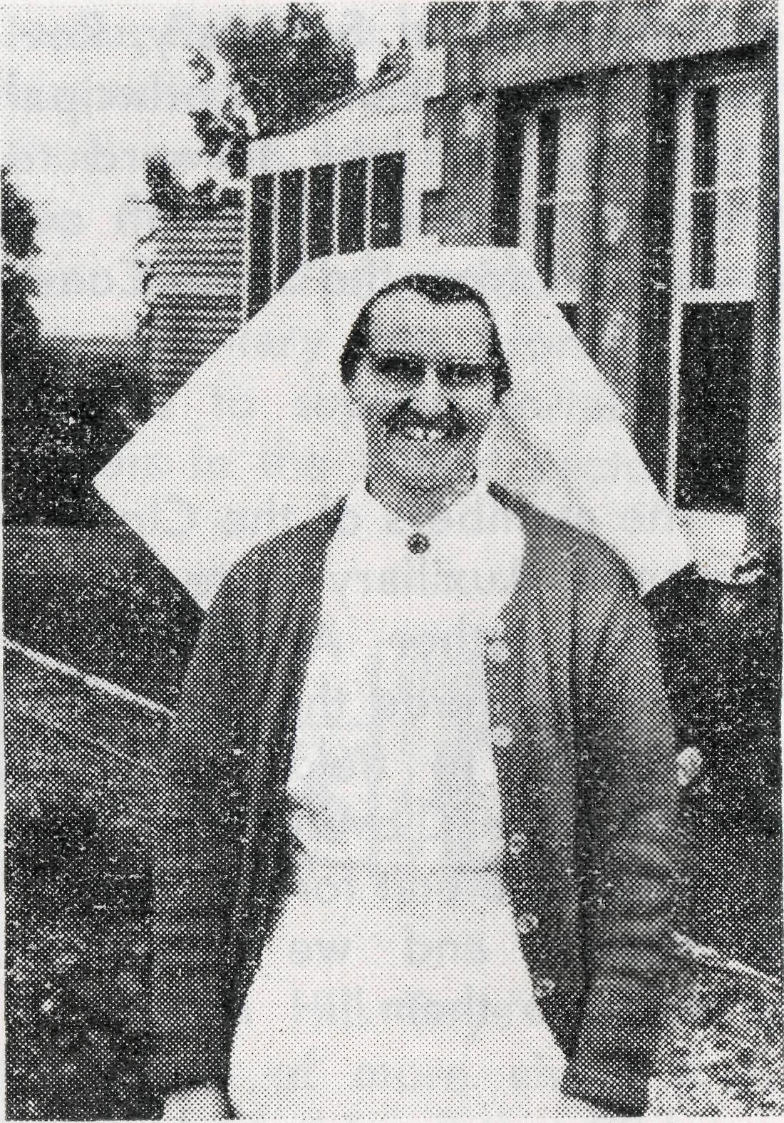
Sister V. Cochrane
then set to work. There is also the small matter of haircutting as the nearest hairdresser is over 250 miles away, so really we are jacks of all trades. We have been relieved of some of our duties since Rev. J. Wyndham came to live in Tarcoola as he helps with the Sunday School, the Children's Fellowship and also takes the religious instruction when in the camp. We praise God for the freedom that we do have with the children in this camp and pray that we may
at least sow a seed in their hearts which will, in time, bring forth fruit.
We have quite a number of emergency cases here which necessitates Doctor coming to see us once or twice most weeks —we haven't seen him this week so far!! W© generally do things properly, such as admitting an ante-partum haemorrhage at 1 a.m. which meant Doctor had to come up. This, of course, meant waking the policeman, who in turn woke all the car owners so that they could use the headlights to light the airstrip for the plane to land. The people certainly rally together in a time of emergency and are willing to stand by as donors if needed. Of course, all our emergencies are not as serious as this one was. Besides our inpatients we have a continuous stream of outpatients and we have to try and diagnose their complaints and treat them — different to our training days when we were taught that a nurse never diagnoses a patient's complaint but just carries out Doctor's orders. If we are worried we naturally ask Doctor's advice over the transceiver.
Other incidents happen here also to break the monotony. The hospital was rewired a few months ago, 3 men doing the job, and it did not matter which
room we wanted to go into, one of the men always beat us to it. One poor patient changed from her normal complexion to the colour of a Red Indian when one of the men put his foot through the ceiling just over her head and she was showered with plenty of red dust and cane-ite. The next incident was when the same man came through the passage ceiling outside the theatre door and landed on the floor—what a mess there was to clean up. We became experts jumping over obstacles and getting around them as the men had a habit of leaving step-ladders and their stools, etc., in the doorways.
Of course, we do have our few quiet spells when we try to catch up on all those numerous odd jobs such as turning out cupboards, writing letters, doing our mending, etc., not to mention catching up on a bit of sleep. We also have our Sunday School picnic besides taking the children for one during the term holidays.
This is just a brief outline of our life at Tarcoola, if you want to know more come and see for yourself. We do ask you to remember our work in your prayers.

THE REAL AUSTRALIAN, SEPTEMBER, 1964
THE REAL AUSTRALIAN, SEPTEMBER, 1964
17

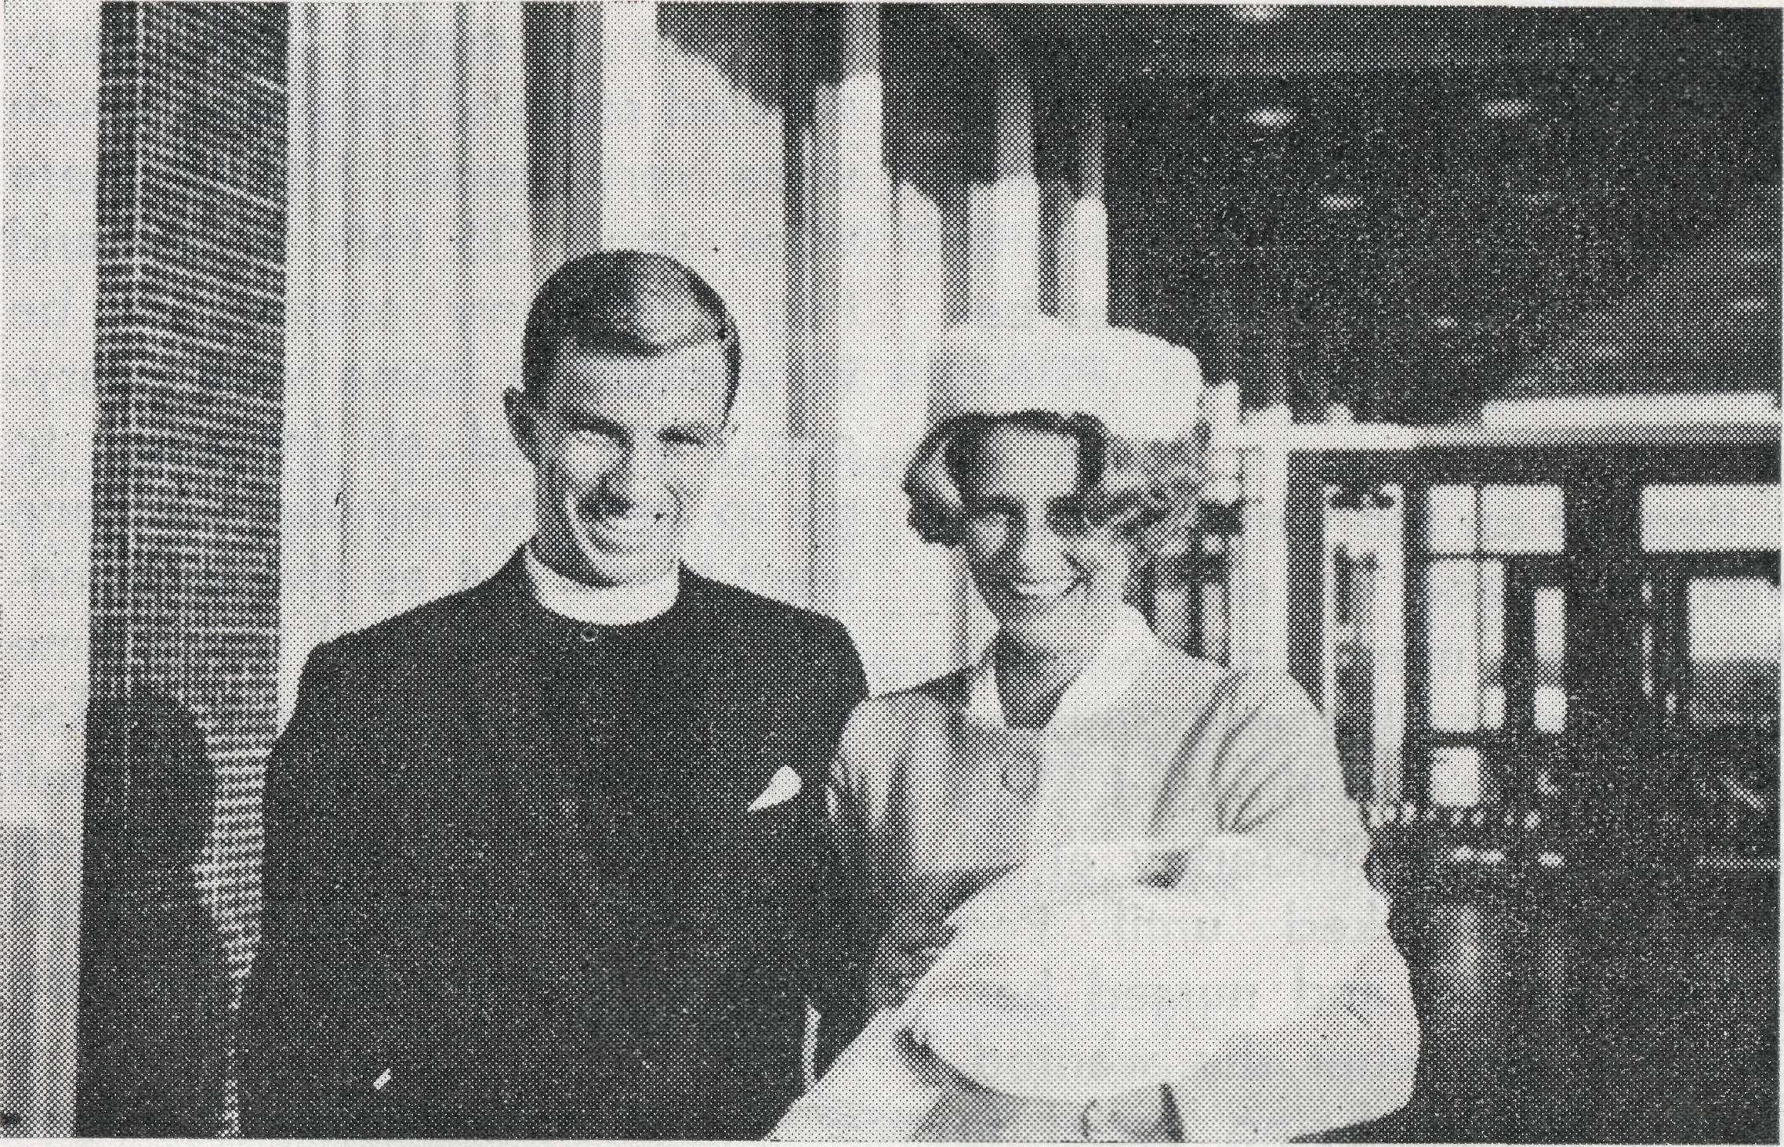
day alright and after about IV2 hours' sleep hit the road for Hedland at 3.30 a.m. Wednesday morning, arriving that evening at 5.30 The Induction was at 7.30 so I think we did pretty well, don't you? The children were very good, but Stephen would insist on going berserk every time he was "let out" when we stopped along the road. He rolled in the dust, be it red or white, and was just filthy by the time we arrived. Baby was very good as well.
We were met at the door by Barry, Bernie Buckland and Harry Dormer of all people! Did you know him at all? He is a colporteur for the B. & F.B. Society and travels all over the outback. We had met him at Kingswood and were most impressed with his slides, etc. We hadn't realised he'd be there and, of course, Bishop was there as well, but he elected to stay with other parishioners. Poor Peg! She coped very well, I'm afraid if it had been me I'd have been standing on my head.
When we first arrived they didn't think they'd have tea as the stove was giving trouble and then there was no hot water in the shower. It's some sort of kerosene system that threatens to blow up any tick of the clock, but between them the men managed to get it working. On top of this her baby wasn't having its bottle and falling to sleep in the middle of it. I had said to Noel that as our children were so tired and me, too, I'd stay home and take over Peg's baby as well, and she could go to the service in peace, as Caroline had been playing up. Only then was I asked had I
Port Hedland Induction
A Women's View
Mrs. Robin Hart
You've probably heard by now of our trip down to Hedland for the Huggetts' Induction. We had a lovely time, and had good fellowship with them. What a beaut couple they are! We found out from the Bishop when the Induction was to be, and decided to have a break from Derby for a day or two. We were to leave here late Tuesday evening after Men's Club and parish meeting, and arrive in time, we hoped, for the service. We had had a busy Sunday with the youth meeting, etc., and on Monday Noel decided to do the Parish Paper. Some friends of ours from the ship came to visit us so were roped in as well, but it certainly had the paper finished in record time. I complicated things by trying to defrost the fridge and make a cup of tea for Noel, and ended up scalding my right hand in the effort. Hysterics ensued for a while until the pain stopped—I'd hate to be badly burnt. They are quite well now, but still peeling a little. We managed to get through the next
Rev. and Mrs. Barry Huggett and Caroline.
picked the hymns, at which I looked very blank until it dawned on Barry that I didn't know what he was talking about. Bishop had said that I'd play for them as their organist was away for a day or two! The best laid plans of mice and men . . . etc. Peggy organised us all somehow and the men eventually got away to go down to the church to plan things. We began then to organise the babes. They have a very large black dog that, unfortunately, wasn't very keen on Stephen, so every time he ran past, the dog let out this tremendous bark, which frightened the wits out of Kim-

18
THE REAL AUSTRALIAN, SEPTEMBER, 1964
THE REAL AUSTRALIAN, SEPTEMBER, 1964
19

berley, and she proceeded to have hysterics. After about 4 or 5 goes of this we were all nearly mental and just fell into the car with relief, to arrive at the church about 5 minutes before starting time.
Peg sat on the very front seat with her babe on one side in the basket, mine on the other side in her basket and Stephen in his pyjamas on the end. This just didn't suit Kimberley at all and she shrieked until Peg picked her up and nursed her. This was just what she wanted, so she started being social to everyone in general, waving and cooing and giving Stephen the giggles in the effort. She was reasonably quiet until Bishop began his address, and the more he talked the louder she gurgled and waved. It was dreadful, and neither of us could take her out as Peg's baby was fretful. In the end Kimberley spied Caroline's bottle and that was the end, so she laid down the law until she got it. We should have thought of it in the first place, but one never does. Bishop said later that he never noticed her, and I honestly don't think he did, but never again! After the
service we returned to the Rectory for a cuppa and Harry showed some of his slides, which were very good. I think there were about 36 folk in all, and Peg and Barry seemed to be very much at home with everyone. We had all intended to go to bed the minute everyone went home, but as always someone got talking and in no time we were drinking more coffee and exchanging notes until well after midnight. It was well worth it, we felt, as not many opportunities of this sort arise, do they?
Peg and I gossiped all next day, while Noel and Barry talked or showed Bishop around. We went for a drive in the afternoon to "Pretty Pool", about 6 miles from Hedland. Unfortunately, the tide was out, but even so it was a lovely spot. It is nice to see the sea when you've been away from it for a while. We left Hedland the next morning about 9 and arrived that same evening here about 11.30. We were tired, Noel especially, but it was well worth the effort. We hope it won't be too long before we see them again.
The Bush Church Aid Society
for Australia and Tasmania
FIELD STAFF:
TTIOCESE OF ADELAIDE, S.A.
Ceduna-Penong, S.A.—Rev. R. H. Goodhew, Th.L. Tarcoola, S.A.—Rev. J. Wyndham, Th.L.
DIOCESE OF WILLOCHRA, S.A.
Leigh Creek, S.A.—Rev. R. Keynes, Orroroo, S.A.—Rev. G. S. Thorne,
Th.L. B.E.
Quorn, S.A.—Rev. A. McMahon, Th.L. Gladstone, S.A. (Grant in Aid).
DIOCESE OF BALLARAT, VIC. Heytesbury Mission, Vic.—Rev. A. Baker, Th.L.
DIOCESE OF RIVERINA, N.S.W.
Wilcannia, N.S.W.—Rev. R. Neve, Menindee.—Rev. B. Viney, Th.L. Th.L.
DIOCESE OF GIPPSLAND, VIC. Croajingalong, Vic.— (Grant).
DIOCESE OF TASMANIA
Tarraleah, Tas.—Rev. B. J. O'Grady, Th.L.
DIOCESE OF NORTH-WEST AUSTRALIA
Derby Mission.—Rev. N. E. Hart, Th.L., Derby, W.A.
Port Hedland Mission.—Rev. B. Huggett, Th.L., Port Hedland, W.A.
MAIL BAG SUNDAY SCHOOL
Director: Miss R. Campbell.
Murchison Mission.—Rev. B. R. Buckland, Th.L., Mount Magnet, W.A.

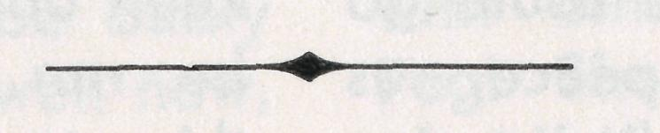
OLD FOLK'S HOME (Port Lincoln, S.A.)
Mr. and Mrs. R. Avery.
Miss M. Farr.
Miss B. Moore.

THE REAL AUSTRALIAN, SEPTEMBER, 1964
THE REAL AUSTRALIAN, SEPTEMBER, 1964

