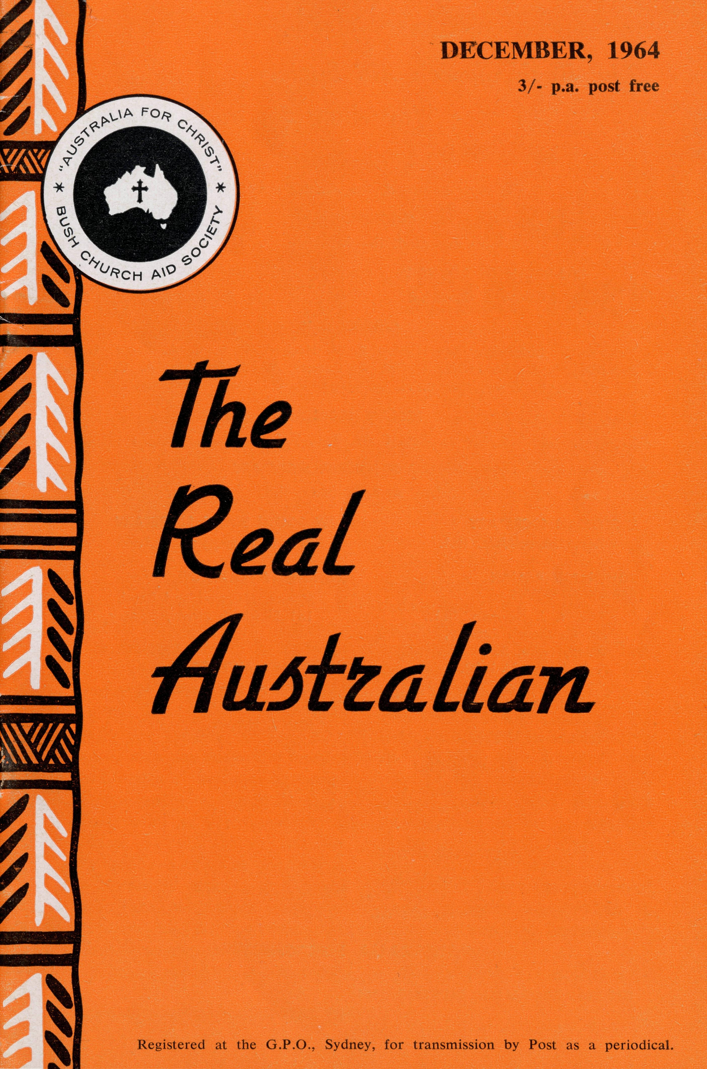
PHARMACIST
Mr. J. ARGALL.
FLYING MEDICAL SERVICE STAFF
Executive Officer: Mr. S. HUMMERSTON
Medical Officers:
Dr. M. MUELLER Dr. R. ROBINSON
Matron: Sister M. HOPE
HOSPITAL CENTRES
Sisters M. BELL, M. CUTHBERT, V. GAMEAU, V. HOLLE, Misses D. DUVER and L. WHITE.
Matron: Sister J. ZILLMAN.
Sisters N. WILKINS, J. GEE, D.
WHYBURN, Misses M. SMEE and
M. CHADWICK.
Sisters B. FOX, M. ROSS.
CEDUNA, S.A.
The Murat Bay District Hospital—
WUDINNA, S.A.
The Central Eyre Peninsula Hospital-
COOK, S.A.
The Bishop Kirkby Memorial
Hospital—
TARCOOLA, S.A.
Sisters V. COCHRANE, J. GRIFFEN.
The Tarcoola Hospital—
PENONG, S.A.
Sister B. SMITH.
The Penong Memorial Hospital—
Sister E. THOMAS.
RAWLINNA, W.A. The Nursing Hostel—
AIRCRAFT
PILOTS
Cessna 210 —VH-AEC Mr. A. E. CHADWICK Cessna 210 —VH-FMS Mr. J. LINDRIDGE Beagle Airedale — VH-UEP Mr. W. BEDFORD
RADIO CONTROL STATION
Control Officer — Mr. K. ELLIS Assistant — Mr. D. McDOUGALL
HOSTELS FOR SCHOOL CHILDREN
PORT LINCOLN, S.A.
Mr. and Mrs. H. RICH. Miss M. ATTWOOD.
BROKEN HILL, N.S.W.
Mr. and Mrs. W. KERR. MOREE, N.S.W.
Mr. and Mrs. S. BENNETTS.
EDGAR BRAGG & SONS PTY. LTD.

The Bush Church Aid Society
for Australia and Tasmania
PRESIDENT
The Most Reverend, The Archbishop of Sydney.
VICE-PRESIDENT
The Most Reverend, The Archbishop of Melbourne.
CHAIRMAN OF COUNCIL HONORARY TREASURER
Rev. Canon E. Cameron. Mr. R. T. Stokes.
COUNCILLORS
Ven. G. R. Delbridge, Rev. Canon R. M. Hudson, Revs. C. A. Baker, L. H.
Broadley, E. V. Constable, O. W. C. Cooper, W. I. Fleming, A. C. Miles,
S. S. Viney, Messrs. H. M. Bragg, K. C. Lyne, E. Stockton.
FEDERAL SECRETARY
Rev. C. W. Rich, Th.L. ASSISTANT FEDERAL SECRETARY
Rev. A. E. Williams, Th.L.

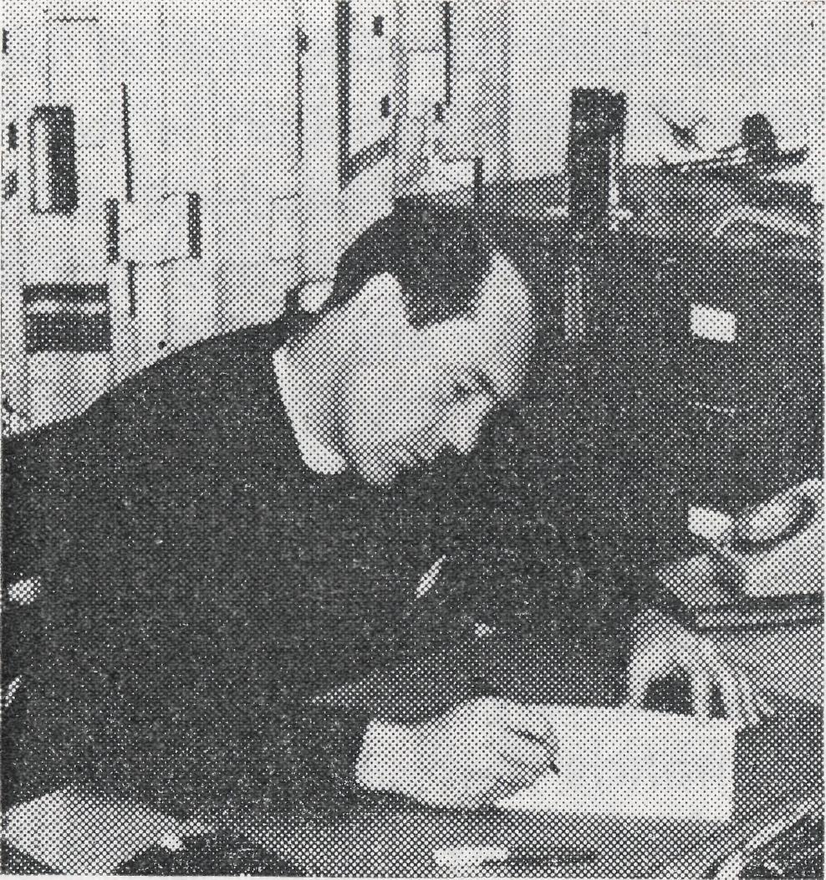
from the
FEDERAL
SECRETARY
As my letter to you for this issue I would repeat the concluding portion of the address I gave at the Sydney and Melbourne Rallies. These words were spoken in Melbourne and come from a tape recording made there.

135 Bathurst Street, Sydney.
Phones: 26 3164, 26 3780.
Telegraphic Address: "Chaplaincy", Sydney.
VICTORIAN OFFICE
Morton House,
262 Flinders Lane, Melbourne.
Phone: 63 8962.
"AUSTRALIA FOR CHRIST"
VICTORIAN SECRETARY
Rev. J. Stockdale, Th.L.
SOUTH AUSTRALIAN REPRESENTATIVES
Rev. T. J. Hayman, Th.L., St. Matthew's Rectory, Marryatville, S.A. Telephone: FA 1022. Mr. A. Kirkby, 7 Ruthven Avenue, Glandore, S.A. Telephone: LF 3268.
B.C.A. HOUSE
NEW SOUTH WALES SECRETARY
Rev. L. J. Wiggins, Th.L.
HONORARY SOLICITOR
Messrs. Maxwell and Boyd, 141 Elizabeth Street, Sydney.
HONORARY AUDITOR
F. W. A. Eagar and Co., 8 Belgrave Street, Manly, N.S.W.
I want to conclude with a thought about this sense of mutual responsibility that has been brought to us by our Church Leaders from Toronto. This concept which is at large in the world today, a sense, a challenge, which has been given us to look beyond our own particular locality, to lift, as it were, our eyes above the hedges and fences of our own particular circumstance; a vision and an expression of that vision in action, as well as in concern. As we have read in documents, in books, in reports, and heard from those who have come and spoken to us, words like "frontiers mission", words like "giving, receiving churches",
words like "older and younger churches" have all become pari and parcel of the expression o) the mission of the Church today So much so, that it would be impertinent for me to try and enlarge or develop what hai been already said. But this I want to make quite clear, in my own mind, that this Bush Church Aid Society, as a Society, that you as the supporters of this Society, have been practising this doctrine of mutual responsibility since 1920. This is no new thing as far as we are concerned. Your very sense of being mutually responsible to your brethren has brought you here tonight.
This is what it was that took

THE REAL AUSTRALIAN, DECEMBER, 1964
THE REAL AUSTRALIAN, DECEMBER, 1964

some of the men that I see sitting in the congregation now, into unknown parts of this great continent of ours, or has taken some of our women from the hospitals of the cities, where they were trained, where they had every circumstance of opportunity, and put them into a little bush hospital, in the middle of nowhere. This is what took a man like Stan Hummerston out of a practising, thriving business and put him in a hostel to look after someone else's children.
This is mutual responsibility; the people who have responded to our appeals, the people who have prayed constantly for the ministry of God in parts of Australia that they will never see, that they will never know; the people to whom these ministries have been made possible . . . this is a real expression of our mutual concern; the Society experience, the staff and its supporters all demonstrate this fact.
Now, having said that, we have no excuse to glory in achievement for achievement's sake. We must be prepared to lift our vision higher—we must not allow ourselves a sense of spiritual pride. We have an even bigger part to play, I believe, today than ever before in the story of the Society. We
must look inwards first of all, to see that our function is fulfilled; we must be conscious that in every avenue of the Society's service we are following the precepts of Jesus; that we must be fulfilling our reason for being a Bush Church Aid Society; that we must have the structure in the Society to cope with the demands that can come upon us in these days of challenge, in these days of development, of new thought, of new responsibilities.
I have spoken about the sense of structure that we have tried to create, and our delegation of authority, and this is essential if we are to go forward to play our part at the national level, the federal scene, which is still before us. We must look outward, to the needs of remote Australia; where we can meet a need we must have the courage to commit ourselves to meet that need. Whether we have the people or the funds at the time may be another thing, but we must be constantly prepared to give ourselves.
I believe we are yet on the fringe of the Society's opportunity. True, in the medical realm there is expansion to Coober Pedy. I doubt very much whether there is a great deal
THE REAL AUSTRALIAN, DECEMBER, 1964
more expansion possible in the work of the Flying Medical Service. But I believe that in the realm of the ordained Ministry, in the work of our Mail Bag Sunday School and, as Mr. Hummerston has reminded you, and begged of the Society, in the work of the hostels, there is an opportunity to go further and further forward in this sense of mutual concern. It will require vision. It will require courage. It will require determination.
Yet we have a heritage of just these things: the vision, the courage, and the determination that has given us the Society today stands before us. As we thank God from the bottom of our hearts for those who have lived their lives in service, we take the same spirit that called them, the same sense of challenge that motivated them, and you and I, no matter what our function in the Society's story, should be prepared to so match that sense of sacrificial service.
THE REAL AUSTRALIAN, DECEMBER, 1964
This is a task to which we are completely inadequate, and
completely useless, if we rely on ourselves, and yet He has given us of His Spirit.
He has called some to be apostles, some prophets, some evangelists, some pastors and teachers, to equip God's people for work in His Service, to the building up of the Body of Christ, and so as you and I commit ourselves afresh at this time of gathering together, as we look to the ways in which with courage we can face the future, as we look to the opportunity stretching before us, we take hold of the unlimited Spirit of God, and so we ask God that we may receive from Him more wisdom, understanding and spiritual insight into His Will, so that our manner of life might be worthy of the Lord and entirely pleasing to Him.
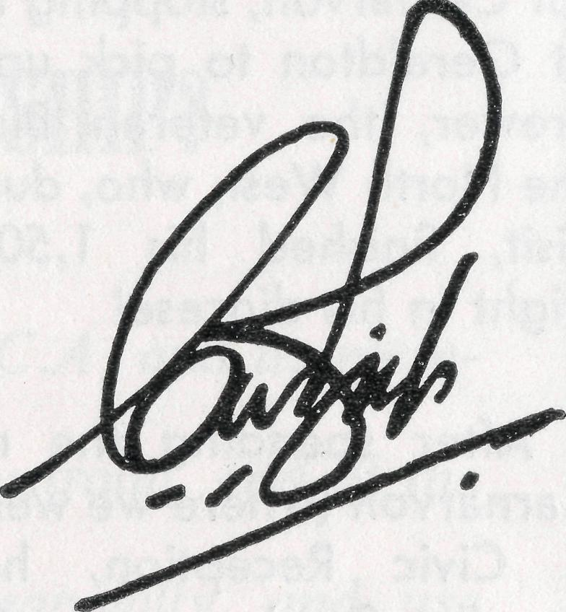

MUTUAL
RESPONSIBILITY
HAVE YOU JOINED
THE B.C.A. FELLOWSHIP?
Fellowship members undertake to:
- Pray regularly for the work of B.C.A. and its members.
- Learn of the spiritual needs of Australia, and of the efforts of B.C.A. to meet them.
- Support the work of B.C.A. financially, and use every opportunity to make the purpose and work of B.C.A. more widely known.
A badge is available at the cost of 5/-.
Apply now to the N.S.W. or Victorian Secretary.
I thought you might be interested to hear a little of the visit which I paid last month to North-West Australia. The tour was arranged by the Hon. C. W. Court, Minister in the Government of Western Australia for Industrial Development. After arriving in Perth from Sydney on the Monday evening I joined the Archbishop of Perth and Archdeacon Hodgins of the Diocese of London and we left at dawn the next morning by air for Carnarvon, stopping en route at Geraldton to pick up Bishop Frewer, the veteran Bishop of the North West, who, during our visit, finished his 1,500th air flight in his diocese!
After spending the night at Carnarvon (where we were given a Civic Reception, held an Evening Service and a Celebration of Holy Communion next morning) we flew on to Derby. On the way we made brief stops at Barrow Island, a normally uninhabited island but where a strike of oil has just
We would express our thanks to the Most Reverend, The Archbishop of Sydney, who has kindly allowed us to reprint these extracts from his letter in the November issue of The Southern Cross.
been made, and at Broome and at Port Hedland where we were met by the Rev. Barry Huggett and his wife, recently come there from our Diocese. We arrived at Derby to be met by local authorities and by the Rev. Noel Hart, also from Sydney (unfortunately Mrs. Hart was ill in hospital in Perth). We spent two nights in Derby but most of the intervening day was taken up by flying over to Koolan and Cockatoo Islands, about 80 miles distant, where rich iron ore deposits are being worked. On both islands attractive residential quarters have been built for the families of the men working at the ore, and delightful schools for the children and canteen facilities provided. The work is hot, hard and exhausting but rewarding and there seemed to be a good spirit amongst them all. Mr. Hart goes over from
Derby frequently to hold services and to meet the people, and is doing excellent work. Back at Derby we had another Civic Reception and Evening Service and then left very early next morning for Kunnunurra, the township being built in the centre of the Ord River Development Area.
As a result of this visit, I greatly hope we shall be able to do much more for the people of those distant parts. The Church must keep step with the growth of the community. The Bishops of Australia, at their annual conference this month, will be discussing this problem
and I hope we shall be guided into new ventures. Meanwhile, I am glad to pay warm tribute to the work of the Bush Church Aid Society in that part of Australia. But for this help the Diocese of the North West could hardly have carried on. During the last seven years the Society has provided eight men and £40,000 for this work. All of the eight men and much of the money has come from our own Diocese of Sydney. This has been the kind of "Mutual Responsibility" which we are discussing in connection with the call that came to us last year from the Anglican Congress in Canada.

THE REAL AUSTRALIAN, DECEMBER, 1964
THE REAL AUSTRALIAN, DECEMBER, 1964

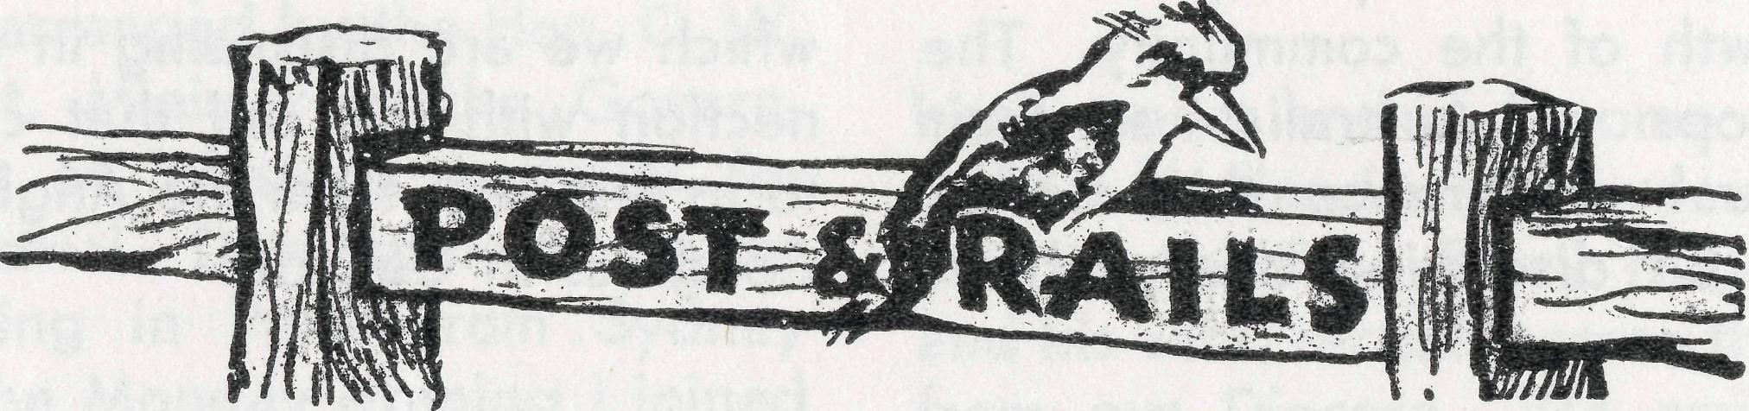
May the Joy of Christmas
Bring Blessing for the New Year
"Glory to God in highest heaven.
And on earth His peace for men on
whom His favour rests/'
—Luke 2:14.
THE REAL AUSTRALIAN, DECEMBER, 1964
• The many friends of Mr. Allan Chadwick will be concerned to know that he has been on sick leave following a severe illness. He expects to be "airborne" again before the New Year. We record our appreciation of the additional flying Mr. John Lindridge has been called upon to do and the postponement of his holidays.
• Sickness has also been the lot of two of the North West Rectories. As Mrs. Buckland was slowly recovering from hepatitis her youngest son, Graham, needed hospitalization first in Mt. Magnet then in Perth. Mrs. Robin Hart spent some time away from Derby also in hospital in Perth. Both families now report being well and have expressed appreciation of the prayerful concern shown by so many.
® Recently we were privileged to have several episcopal visitors as the Bishops met in Sydney during October. One notable absentee was Bishop T. E. Jones, former Organising Missioner. Unfortunately he too was in hospital at the time and is still restricted in his movements although he has resumed Diocesan activities.
® B.C.A. babies continue to make their arrival—this time a prospective missioner to Jan and John Wyndham of Tarcoola. We welcome Michael John to our family and offer our sincere congratulations to his parents.
# Mr. K. C. Lyne of Belfield has been elected to Council following the death of the Reverend Eric Felton. We welcome Mr. Lyne as he comes to us with experience from the field of Insurance and as Parish Secretary at St. Paul's, Belfield.
THE REAL AUSTRALIAN, DECEMBER, 1964
® Broken Hill Hostel has presented a fascinating problem for the past few weeks—a family of 22 and no kitchen! However, patience and hard work (not to mention ingenuity) have won the day and it is anticipated that all will be well before the end of term. Almost £5,000 has been spent on alterations to the kitchen, dining room, dormitories and staff quarters.
• Regular visitors to B.C.A. House have noticed some difference. Our Gift Shop has changed in character and now concentrates on Aboriginal Arts and Crafts as well as Society Souvenirs. The adjoining shop is now vacant and awaiting the arrival of the builders to enable all our administrative staff to be located on the ground floor. The new shop front is being used to display the work of the Society and draws considerable attention.
® Forty-four parishes in the Dioceses of Armidale, Canberra-Goulburn, Gippsland and Tasmania have been visited for deputation work since June this year. Mr. Wiggins has been able to establish many new supporters and create much general interest in the work of the Society. This, added to the engagements in the City, together with the organisation and maintaining of the B.C.A. Fellowship, has given us all great encouragement.
• Our sincere congratulations and prayerful good wishes are extended to Sister Elaine Dear-don and Mr. John Penberthy on the announcement of their engagement. Sister Deardon's four months on our relieving staff met a need which is not covered by our constitution but well established by precedent! We wish them well as Mr. Penberthy continues his work at the Radio School.

What's the Use ?
Rev. Ron Keynes, Leigh Creek
What's the use of giving money to send a Missioner into such a vast area, when contact with folk can only be made two or three times a year? Does the expense of the travelling justify the results, if any?
A pertinent question, if you are running a business and have to consider sending your representative out. In fact, it was a question put to me, before coming out to work in a parish that covers fifty-five percent of South Australia. But I have found the answer!
If we are honest, any expenditure is justified, even if it only brings one to the knowledge of Christ, or several committed folk into contact with their Church.
Listen to some stories, all true, and see what you think.
At a home in Coober Pedy, not so long ago, there was a spontaneous conversation, lasting three hours, that brought one person to see very clearly what the implications of Christian discipleship are. Though then unwilling to take the step—
The Place of Prayer
because as he said, "Every Christian must be an evangelist, musn't he!"—he went away with a Modern Translation of the Bible under his arm. That alone, to me, made that 1,500-mile trip worthwhile.
At another homestead on that renowned "Birdsville Track" another conversation, nearly as long, brought another four people more closely into touch with the Christian Gospel.
Small but keen congregations in Coober Pedy and Oodnadatta gather at the quarterly services. Marree, much closer, make sure that their Services are no longer than three weeks apart, for they, too, value the refreshment that this affords.
And when the Church here, at Leigh Creek, sees its calling as the Church as being expressed by a concern that the rest of the parish does not suffer and that the home Church here should make a definite evangelical impact in the town, over and above that which is being done already at the personal level by dedicated Christians, then to my mind it IS worthwhile. And we praise God for all that He has done.
Rest assured, too, that the local congregation is immensely thankful for all that the B.C.A. supporters provide, to make this work possible.
THE REAL AUSTRALIAN, DECEMBER, 1964
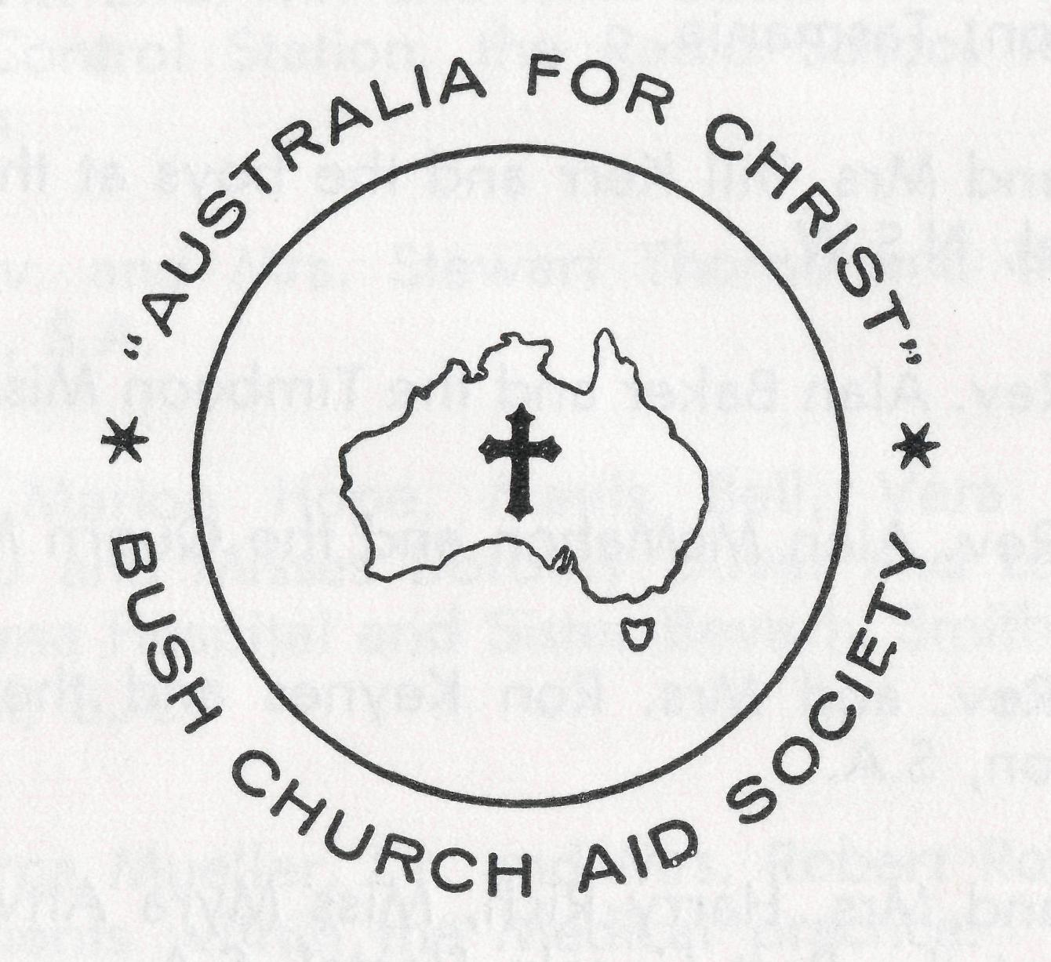
The following pages represent a daily prayer calendar which will be revised with each issue. We earnestly seek your prayers for the individual members of our staff. We suggest you remove these centre pages from the magazine and keep them for your regular devotional use.
"Let us ask God that they may receive from Him all wisdom and spiritual understanding for full insight into His will, so that their manner of life may be worthy of the Lord and entirely pleasing to Him. Pray that they may bear fruit in active goodness of every kind and grow in the knowledge of God. May He strengthen them, in His glorious might, with ample power to meet whatever comes with fortitude, patience and joy; and to give thanks to the Father who has made them fit to share the heritage of God's people in the realm of light."
(Adapted from Colossians 1 N.E.B.)
THE REAL AUSTRALIAN, DECEMBER, 1964 9

1st The Rev. and Mrs. Ray Neve and the Wilcannia Mission, N.S.W.
2nd The Rev. and Mrs. Brian Viney and the Menindee Mission, N.S.W.
3rd The Rev. and Mrs. Brian O'Grady and the Tarraleah Mission, Tasmania.
4th Mr. and Mrs. Bill Kerr and the boys at the Broken Hill Hostel, N.S.W.
5th The Rev. Alan Baker and the Timboon Mission, Victoria.
6th The Rev. Alan McMahon and the Quorn Mission, S.A.
7th The Rev. and Mrs. Ron Keynes and the Leigh Creek Mission, S.A.
8th Mr. and Mrs. Harry Rich, Miss Myra Attwood and the girls at the Port Lincoln Hostel, S.A.
9th Miss Rose Campbell, Miss Dianne Sidebottom and all the helpers and scholars in the Mail Bag Sunday School.
10th Mr. and Mrs. Allan Chadwick, Mr. and Mrs. John Lindridge and the flying within the Medical Service.
11th Mr. and Mrs. Stan Hummerston and the administrative work within the Flying Medical Service.
12th The Rev. and Mrs. John Wyndham and the North-West Line Mission, Tarcoola, S.A.
13th The Rev. and Mrs. Noel Hart and the Derby Mission, W.A.
14th Mr. and Mrs. John Argall and the work at the Ceduna Pharmacy, S.A.
15th The Rev. Theo Hayman, Mr. Alban Kirkby and the South Australian Representation.
16th Mr. and Mrs. Sid Bennetts and the boys at Urallie Hostel, Moree, N.S.W.
17th Mr. Kevin Ellis, Mr. and Mrs. David McDougall at the Radio Control Station, the Radio School teacher and children.
18th The Rev. and Mrs. Stewart Thorne and the Orroroo Mission, S.A.
19th Sisters Marion Hope, Mavis Bell, Vera Holle, Val Gameau and Misses Dorothy Duver and Lesley White at Ceduna Hospital and Sister Beverly Smith at Penong Hospital, S.A.
20fh Dr. Merna Mueller, Dr. and Mrs. Robert Robinson and the patients within the Medical practice.
21st Sisters Barbara Fox and Maude Ross at Cook Hospital and Sisters Vaisey Cochrane and Jean Griffen at Tarcoola Hospital, S.A.
22nd Sister Edna Thomas at the Rawlinna Nursing Home, W.A.
23rd Sisters Julia Zillman, Nancy Wilkins, Joan Gee, Dorothy Whyburn, Misses Margaret Smee, Margaret Chadwick at Wudinna Hospital, S.A., Mr. Bill Bedford and the patients carried by air.
24th The Rev. and Mrs. Bernard Buckland and the Murchi-son Mission, W.A.
25th The Rev. and Mrs. Barry Huggett and the Port Hedland Mission, W.A.

10
THE Rl'AL AUSTRALIAN, DECEMBER, 1964
THE REAL AUSTRALIAN, DECEMBER, 1964

WILCANNIA CENTENARY Some Impressions
The Reverend L. T. Lambert
26th The Rev. and Mrs. Harry Goodhew and the Ceduna Mission, S.A.
27th Mr. and Mrs. Roy Avery, Misses Marjorie Farr and Brenda Moore, Staff and Residents at the Old Folk's Home, Port Lincoln, S.A.
28th All students in training for outback ministries, a continued supply of replacement personnel, our Box Secretaries, the evergrowing number of supporters and their ready response.
29th The Rev. and Mrs. John Stockdale, Mrs. W. Hughes, the Victorian Committee and Office Staff.
30th The Rev. and Mrs. Bill Rich, the Rev. and Mrs. Arthur Williams, the Rev. Les Wiggins, Messrs. Laurie Calder, Frank Burner, Mrs. Joy O'Neill, Misses Ruth Close, Deirdre Briggs, Suzanne Thorley at Headquarters and the Council of the Society.
O Lord God of our nation, Who hast commanded men to subdue and replenish the earth: Look in Thy love upon all who in distant parts of our land are striving against many difficulties, and are deprived the access of the means of grace. Strengthen and guide the Bush Church Aid Society and all members of the staff. Cheer and comfort them in discouragement and loneliness, bless their ministrations to the good of those they serve, and grant that the message of redeeming love may thus be rooted and grounded in our national life, to the glory of Thy Great Name through Jesus Christ our Lord. Amen.
O God, we remember before Thee those whom Thou hast called to Thy service. Bless them this day, we beseech Thee, as we
pray for Call forth others
to stand with them in their task. Grant to them, as to us, the joy of service, the ability to achieve and the serenity of Thy peace, for Jesus' sake.
Amen.
The town of Wilcannia, in the far west of New South Wales, celebrated the centenary of its foundation at the beginning of October. The Rector, the Reverend Ray Neve, had sent invitations to many people, including past Rectors, to be present at the special services to mark the occasion. In company with the Federal Secretary, the Reverend C. W. Rich, I boarded the Fokker Friendship at Mascot on Friday morning, 2nd October, en route to Broken Hill.
After a somewhat bumpy journey into a strong head wind, we arrived at Broken Hill to be met by Bill Kerr of the Hostel. He and his charming wife made us most welcome and served a much-appreciated late lunch to the hungry travellers.
As it was a holiday weekend, arrangements had been made for the boys to go home and thus allow the Hostel staff to go to Wilcannia to join in the celebrations. When we arrived the kitchen tables were groaning under the weight of luggage of all kinds which had to be trans-
ported. It appeared that five adults and four children, with the mountains of bedding, food, and general luggage aforesaid, were all somehow to fit into the Morris van.
The packing capacities of Bill Kerr were taxed to the utmost, but at last the van was packed and passengers loaded, the extra cartons were fitted in somewhere and the journey started about 8.30 a.m. on the Saturday.
On arrival at the Rectory at 1 p.m. we found there the Reverend Hugh Linton and his wife; the Reverend Brian Viney, Minister in charge of Menindee, and his wife and children; Mrs. Home, Mr. Linton's daughter; Mr. and Mrs. Cook and their three sons from Broken Hill; the Rector and Mrs. Neve and their two children. The Rectory seemed full! However, by some amazing ingenuity on the part of Mary Neve, ably seconded by assistance from all the party, we all fitted in and some 19 people sat down for lunch— and an ample lunch it was!

12
THE REAL AUSTRALIAN, DECEMBER, 1964
THE REAL AUSTRALIAN, DECEMBER, 1964
13

Linton was asked to cut a cake specially made and iced for the occasion.
Wilcannia will always have a special place in the thoughts and prayers of B.C.A. supporters as it was there that the work of the Society started. St. James' Church is a stately building of sandstone but badly in need of repair and a Renovation Fund has been opened. The Rector would be most happy to receive any contributions.
It is exceedingly fortunate that the Wilcanniai Rectory has elastic sides, for fifteen people somehow managed to sleep there on the Saturday night. The "Boys' Dormitory" was the lounge room with four hefty bodies occupying various beds and couches. Rumour hath it that one gentleman, who shall be nameless, found the bed much too short for his length, but all managed to get a fair night's sleep in spite of such trifles as that. One should mention that about 5 p.m. on Saturday two further guests had arrived in the persons of the Reverend L. Daniels and the Reverend Les Nixon. They had come in Mr. Nixon's light plane after a rough journey into a head wind. They also slept at the Rectory!
The first Service on Sunday morning was 8 a.m. Holy Communion, at which the Rector celebrated, the Reverend Hugh Linton assisted, the writer preached, and the Reverend L. Daniels was the organist. It was a fine service of worship with the Church reasonably full. Also present was another former Rector of Wilcannia in the person of the Reverend John Stockdale.
At 10.30 a.m. there was a Family Service combined with Harvest Thanksgiving and two Baptisms. The offerings of
produce were appropriately displayed on fleece of wool and the abundance of flowers made the Church look very beautiful. There was an overflowing congregation and it was truly an inspiring occasion as we gave thanks to God for His goodness over the years. The children's address was given by Mr. Daniels and he recalled many incidents of his time spent in the parish and at the Hostel. The Reverend C. W. Rich preached and took as his text "Jesus Christ, the same yesterday, today and forever" reminding us that in a changing world we could rely on the unchanging Christ. The Rector took the service and the Reverend Hugh Linton gave the Benediction. Four former Rectors of Wilcannia were at the service: Reverend H. Linton, 1911-1919; Reverend L. Daniels, 1923-1932; Reverend L. T. Lambert, 1934-1937; Reverend J. Stockdale, 1953-1961. In addition Deaconess Clark (now married and living at Ivanhoe) was also present.
Following the service, the congregations adjourned to the hall where the Ladies' Guild had provided a sumptuous repast. During the luncheon there was a tremendous amount of excited chatter as friends greeted each other and the former Rectors renewed old acquaintances. Mrs.
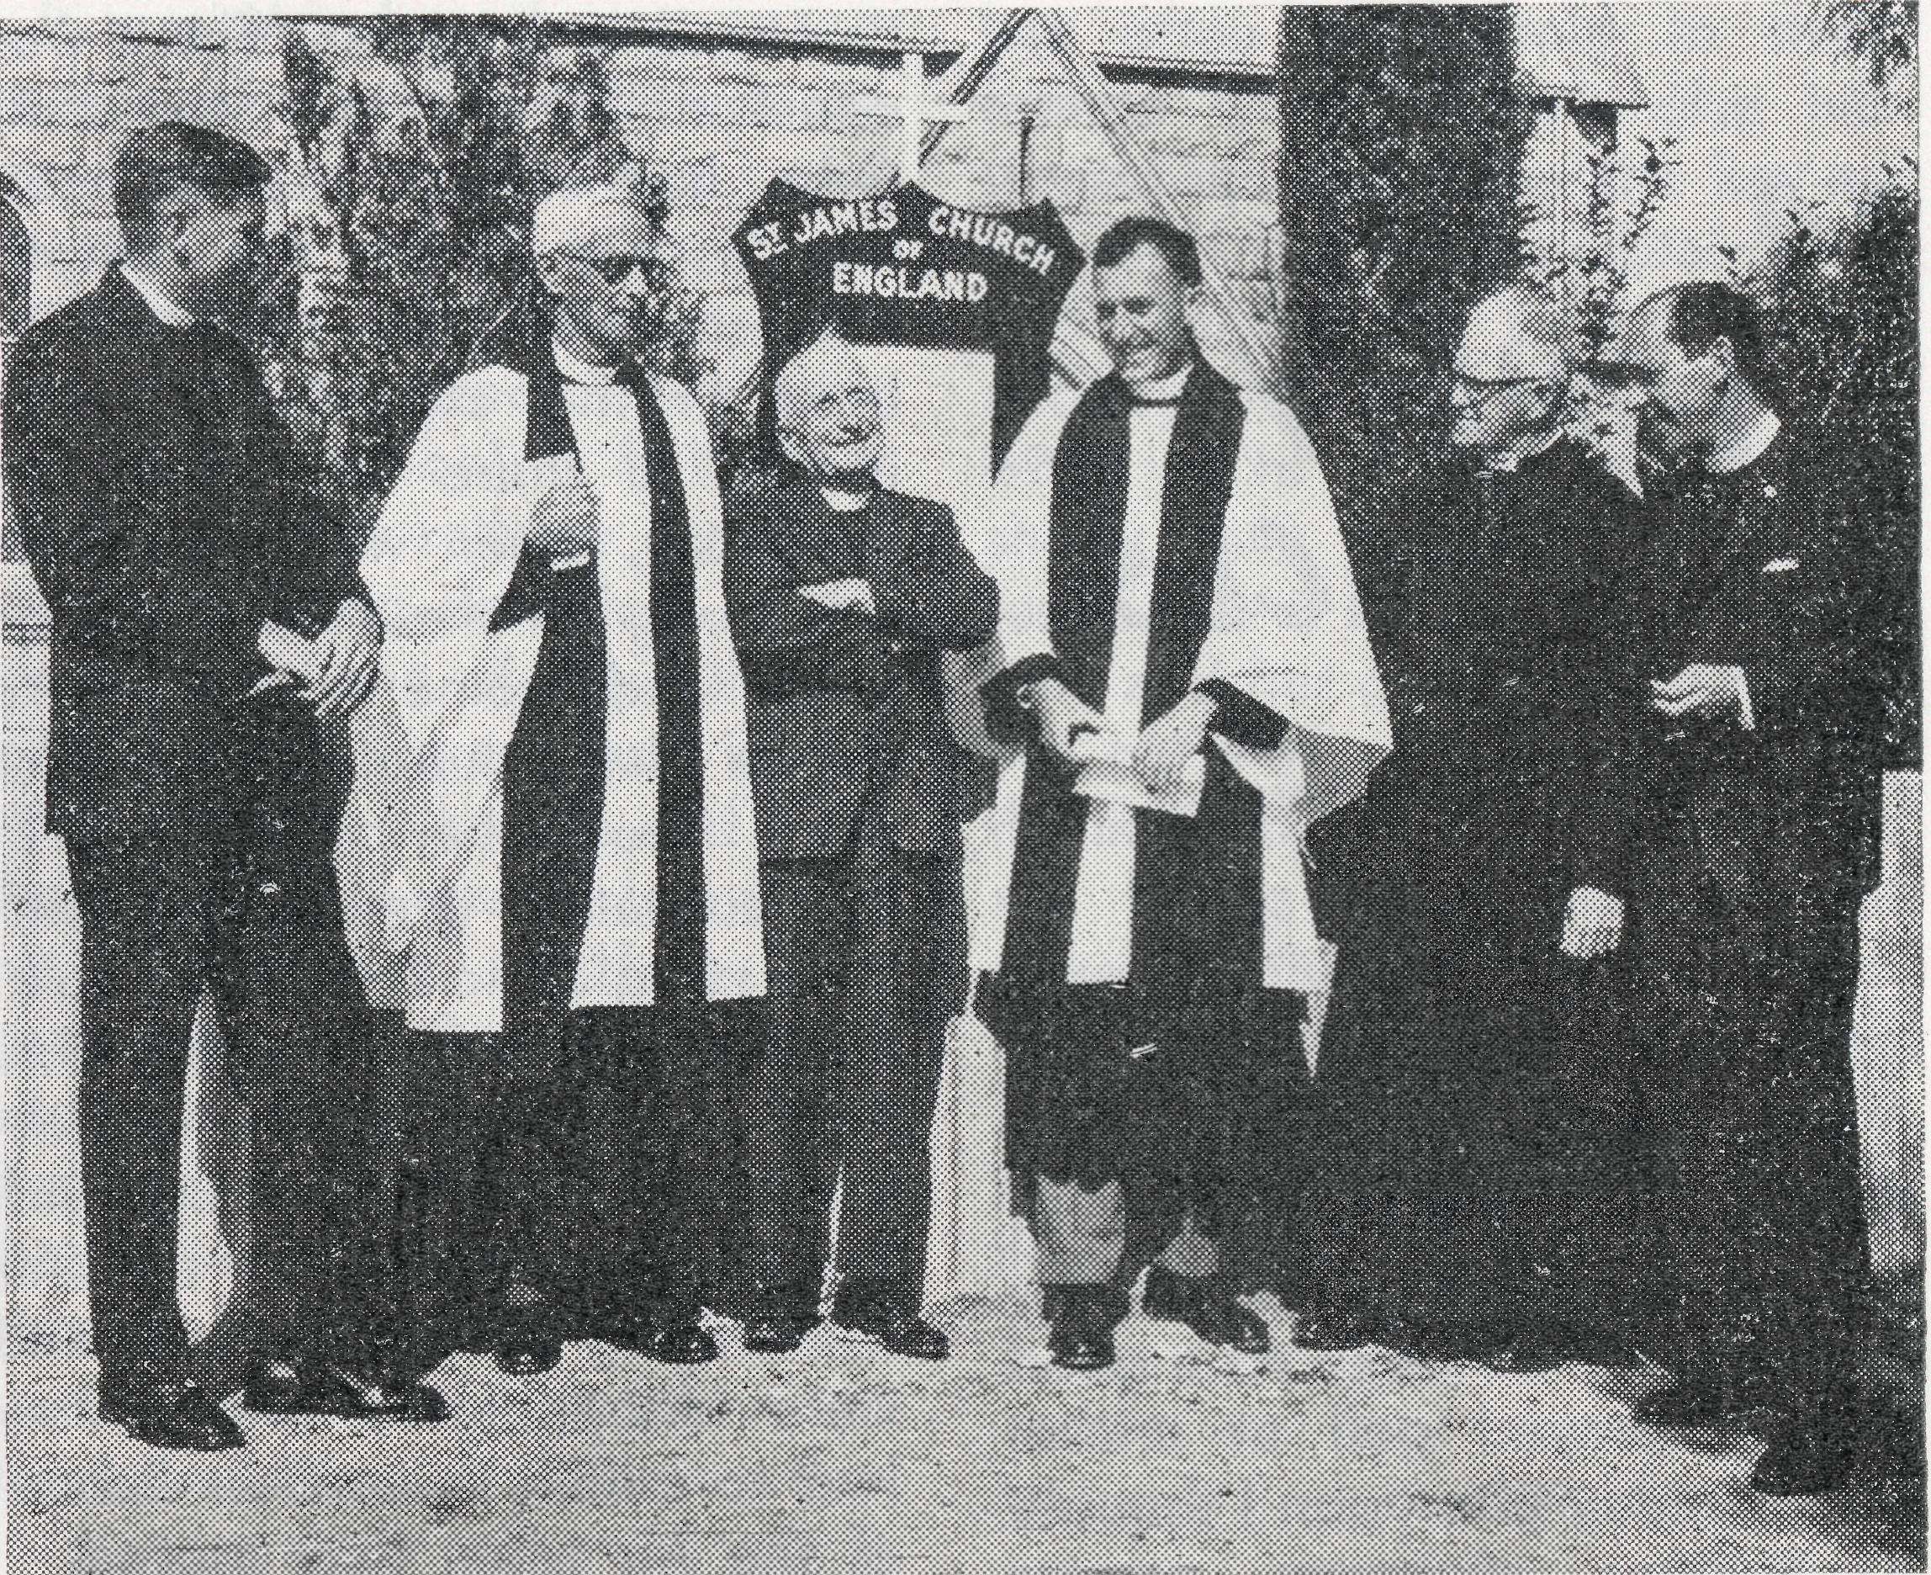
Left to right: The Reverends J. Stockdale, H. Linton, L. Daniels, R. Neve, L. Lambert and C. W. Rich.
The coming together for the celebrations of hundreds of people from all over the district —some coming 200 miles and more—was a reminder that the work of the Church in ministering to those in the outback is still just as vital as ever. Radio and other contact have broken down a little the isolation of former days, but the ministrations and Sacraments of the Church are still as necessary as ever and we in the B.C.A. are proud to have a part in this far-flung ministry.

14
THE REAL AUSTRALIAN, DECEMBER, 1964
THE REAL AUSTRALIAN, DECEMBER, 1964
15

TAX DEDUCTIONS
When sending your gift to the Society please remember that only donations to the Flying Medical Service are allowable tax deductions. Should you wish to use the receipt for this purpose, be sure to mark your donation "Flying Medical Service". Gifts not marked are directed into our General Fund and are not tax deductions.
TO
LONELY PLACES
Rev. Stewart Thorne
I had been taking Evening Services at Mannahill for over two years, either on a Sunday or through the week. As a good number played golf or cricket on a Sunday afternoon I thought a Sunday afternoon service would be out of the question. However, for the sake of the children who weren't coming at night I tried an afternoon service and it was fairly successful. It allowed me to visit some out of the way homesteads.
On the first occasion I travelled south after the service. The first homestead was devoid of people so I continued another ten miles and as the sun was setting I drove up to an out-station wondering whether there would be anyone home. However, as I was turning the corner of the house there came into view a group of people with a
barbecue in progress. There was one family there from Mannahill (who had missed the service), the couple from the empty homestead and the people who lived in the outstation. I was invited to share with them the barbecue, after which a sheet was hung on the rotary clothes hoist and some slides were shown plus a Jungle Doctor film strip. The father who lived in this outstation greeted me with "Always glad to see B.C.A. folk. They are doing a mighty fine job." He went on to explain that they had linked up with the Ceduna School of the Air when living over in the west and were disappointed when they had to switch to another School of the Air when they moved.
Some station people stay in the same place for years while others are continually on the move and the Bush Padre has to change his route so as to minister to them all. By doing this I called in at another station. The people had only been living there three months and the first question was "How is Mr. Greenwood? I knew him when he was at Minnipa." They had also met George Fuhrmeister of Quorn and Ray Neve at Wilcannia. It is certainly encouraging to meet people who have knowledge of the Lord Jesus Christ through the Bush Padres.
It was Monday, the Ministers' traditional day off. After packing lunch for Kathryn and Douglas we set off with David for Nackara. At Nackara (50 miles from Orroroo) there is a one-teacher school, a hall, Post Office and f\ve railway cottages, only two being occupied at the moment. In one of these lives a widower and his son and in the other a married couple and their daughter. This couple lost a son in a drowning accident four years ago. My first visit to their house in 1962 revealed a very depressing situation. However, they have been most constant in coming to worship. A service
has often been held in their lounge when no one else has turned up and when the key to rhe local hall was unobtainable. This Monday we arrived about midday and took the lady out with us to a dry creek with shady gum trees for a picnic lunch. We had a very happy time and her gratitude for taking her out was very touching. We thank God for the changes we see taking place gradually in some of the people we meet. We pray that they may find Jesus Christ can satisfy their every need and surrender their lives to Him.

16
THE REAL AUSTRALIAN, DECEMBER, 1964
THE REAL AUSTRALIAN, DECEMBER, 1964
17

STAFF MOVEMENTS
We are indeed grateful to two Victorian nurses whose offers of service for a limited period came at a critical time for the Flying Medical Service. Sister Joan Gee joined the staff in January, 1963, for six months and will have been with us for just over two years when she leaves in February next. In this time she has served at Ceduna, Cook and Wudinna. Miss Mar-jorie Wallace has helped immensely with relieving work. Miss Wallace stayed for her promised month at Wudinna but then returned to extend her service at Penong and Tarcoola until the end of the year.
The Reverend S. Tfiorne, who commenced work in February, 1961, and who has been in charge of the work at Orroroo, S.A., has resigned. He and his family will move early next year to the parish of Melrose, S.A.
Miss Lesley White of Wal-leroo, S.A., has joined the staff and will assist the trained staff at Ceduna Hospital. Her offer of service came after seeing the Flying Medical Service in action while working with a Christian youth group at Coober Pedy.
18
Miss Margaret Smee, who has served as an assistant for the past three years at the Wudinna Hospital, will resign at the end of this month. Margaret has been of immense help to the trained staff and as well has been a mainstay as a teacher at the local Sunday School.
Mr. and Mrs. Roy Avery of the Old Folk's Home at Port Lincoln will resign at the commencement of next year after five years with the Society. Much has been achieved by them at the Home in this time, and they will be very difficult to replace. We wish them and their family God's richest blessing.
Following advice from a skin specialist, Miss Barbara Hyett reluctantly feels she must resign from work at the Boys' Hostel at Broken Hill. Barbara has been involved in B.C.A. service for some time now, having been assistant in the Mail Bag Sunday School office and for the past year assistant at the Hostel.
THE REAL AUSTRALIAN, DECEMBER, 1964
Dr. M. Mueller has been able to snatch a short holiday because of the offer once again this year of Dr. Stan Anderson of Sydney Hospital. We are most grateful to Dr. Anderson for this valued assistance with the medical work.
At the beginning of this year mention was made of the twelve months' offer of service of Dr. Robert Robinson. Doctor will leave Ceduna at the beginning of next year and we indeed thank him and his wife (Mrs. Robinson, being a nurse, has helped at the Ceduna Hospital) for their year with us. We extend to them both our prayerful good wishes.
Once again we thank God that there is a replacement for Dr. Robinson in the person of Dr. Don Tindal, who is not new to the work at Ceduna. Dr. and Mrs. Tindal will commence with the F.M.S. early next year. We will remember them in prayer, particularly as Mrs. Tindal is interrupting her medical studies for twelve months to be with her husband at Ceduna.
THE REAL AUSTRALIAN, DECEMBER, 1964
From the Ceduna Pharmacy has come the news that fv\r. John Argall has resigned as from early next year. Mr. Argall has served with B.C.A. for the past five years and has been extremely active in the parish work at Ceduna. He is indeed going to be sadly missed in the work. We wish him and his family God's richest blessing in his future work.
We are pleased to know that because of the offer for a time of Miss Roweena McLachlan of Hurlstone Park, N.S.W., the work at the Ceduna Pharmacy will continue. This will give us time to find another permanent Chemist for the Flying Medical Service.
HAVE YOU MOVED TOO?
If so — please let us know your old address as well as your new one so we shall not have your name recorded at both addresses.
19

RALLY REFLECTIONS
The Reverend C. W. Rich
Much of our activity of the past months has revolved around three Rallies—Melbourne, Sydney and Wollongong.
The obvious reaction is one of thankfulness and gratitude to Almighty God for the genuine interest and concern expressed by those who were present. The strength of any Society rests with the zeal of its supporters and we have again been encouraged by the practical response of so many.
Our principal speakers each did their part well and were able to enthuse us all. The film in Sydney, the audio visual in Melbourne and the slides at Wollongong were each in their own way a graphic portrayal of the Society at work.
Young people, particularly in Sydney and Wollongong, were very much in evidence and it is to be hoped that this pleasing aspect of our gatherings will see a greater increase at subsequent Rallies.
Clergy, apart from Council Members and one or two notable exceptions, were conspicuous by their absence. Though well aware of the exacting demands of parochial responsibility we find ourselves
20
wishing that more could be present with the groups from their parishes.
Former staff members, families of existing staff as well as future staff joined with supporters in many instances to demonstrate, once again, the "family" bond which was most evident on all these occasions.
Many feel that future Rallies would have a deeper significance if they were preceded by a Service of Praise and Thanksgiving, a printed summary of the year's activities made available and the date brought nearer to the anniversary of the Society's foundation. This we will attempt next year, where possible, as it is felt that such suggestions are most worthwhile. Another practical outcome would be the separation of our two major appeals by a space of several months rather than the present situation where Rally and Christmas Appeals follow so close together.
Make it a date now! The Sydney Rally date will be May 28th. The others are yet to be arranged but we shall look forward to seeing you there.
THE REAL AUSTRALIAN, DECEMBER, 1964
The Bush Church Aid Society
for Australia and Tasmania
FIELD STAFF:
DIOCESE OF ADELAIDE, S.A.
Ceduna-Penong, S.A.—Rev. R. H. Goodhew, Th.L Tarcoola, S.A.—Rev. J. Wyndham, Th.L.
DIOCESE OF WILLOCHRA, S.A.
Leigh Creek, S.A.—Rev. R. Keynes, Orroroo, S.A.—Rev. G. S. Thorne,
Th.L. B.E.
Quorn, S.A.—Rev. A. McMahon, Th.L.
DIOCESE OF BALLARAT, VIC. Heytesbury Mission, Vic.—Rev. A. Baker, Th.L.
DIOCESE OF RIVERINA, N.S.W.
Wilcannia, N.S.W.—Rev. R. Neve, Menindee.—Rev. B. Viney, Th.L. Th.L.
DIOCESE OF GIPPSLAND, VIC. Croajingalong, Vic.— (Grant).
DIOCESE OF TASMANIA
Tarraleah, Tas.—Rev. B. J. O'Grady, Th.L.
DIOCESE OF NORTH-WEST AUSTRALIA Derby Mission.—Rev. N. E. Hart, Th.L., Derby, W.A. Port Hedland Mission.—Rev. B. Huggett, Th.L., Port Hedland, W.A. Murchison Mission.—Rev. B. R. Buckland, Th.L., Mount Magnet, W.A.
MAIL BAG SUNDAY SCHOOL
Director: Miss R. Campbell.
OLD FOLK'S HOME (Port Lincoln, S.A.)
Mr. and Mrs. R. Avery. Miss M. Farr. Miss B. Moore.
THE REAL AUSTRALIAN, DECEMBER, 1964

