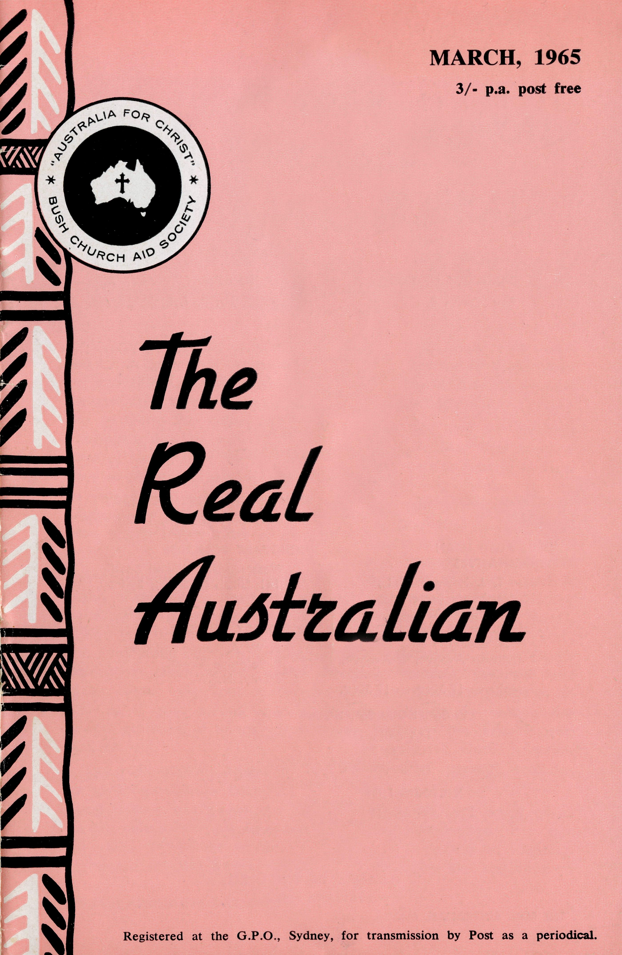
FLYING MEDICAL SERVICE STAFF
Executive Officer: Mr. S. HUMMERSTON
Medical Officers: Dr. M. MUELLER, O.B.E. Dr. D. TINDAL
Matron: Sister M. HOPE
HOSPITAL CENTRES
Sisters M. BELL, V. HOLLE, M. CUTH-BERT, V. GAMEAU, Misses D. DUVER and L. WHITE.
Matron: Sister J. ZILLMAN.
Sisters N. WILKINS, D. WHYBURN, M. MACKENZIE, Miss M. CHAD-WICK.
CEDUNA, S.A.
The Murat Bay District Hospital—
WUDINNA, S.A.
The Central Eyre Peninsula Hospital—
COOK, S.A.
The Bishop Kirkby Memorial
Sisters B. FOX, M. ROSS.
Hospital—
TARCOOLA, S.A.
Sisters AA. TARR, J. GRIFFEN.
The Tarcoola Hospital—
PENONG, S.A.
Sister B. SMITH.
The Penong Memorial Hospital—
COOBER PEDY, S.A.
Sisters V. COCHRANE, H. HEAVER.
The Coober Pedy Medical Centre—
Sister E. THOMAS.
RAWLINNA, W.A. The Nursing Hostel—
PHARMACIST
Miss R. McLACHLAN.
PILOTS
AIRCRAFT
Cessna 210 —VH-AEC Mr. A. E. CHADWICK Cessna 210 —VH-FMS Mr. J. LINDRIDGE Beagle Airedale — VH-UEP Mr. W. BEDFORD
RADIO CONTROL STATION
Control Officer — Mr. K. ELLIS Assistant — Mr. D. McDOUGALL
EDGAR BRAGG & SONS PTY. LTD.

The Bush Church Aid Society
for Australia and Tasmania
PRESIDENT
The Most Reverend, The Archbishop of Sydney.
VICE-PRESIDENT
The Most Reverend, The Archbishop of Melbourne.
CHAIRMAN OF COUNCIL HONORARY TREASURER
Rev. Canon E. Cameron. Mr. R. T. Stokes.
COUNCILLORS
Ven. G. R. Delbridge, Rev. Canon R. M. Hudson, Revs. C. A. Baker, L. H.
Broadley, E. V. Constable, O. W. C Cooper, W. I. Fleming, A. C. Miles,
S. S. Viney, Messrs. H. M. Bragg, K. C. Lyne, E. Stockton.
FEDERAL SECRETARY
Rev. C. W. Rich, Th.L.
ASSISTANT FEDERAL SECRETARY
Rev. A. E. Williams, Th.L.
NEW SOUTH WALES SECRETARY
Rev. L. J. Wiggins, Th.L.
HONORARY SOLICITOR
Messrs. Maxwell and Boyd, 141 Elizabeth Street, Sydney.
VICTORIAN SECRETARY
Rev. J. Stockdale, Th.L.
SOUTH AUSTRALIAN REPRESENTATIVES
HONORARY AUDITOR
F. W. A. Eagar and Co., 8 Belgrave Street, Manly, N.S.W.
Rev. T. J. Hayman, Th.L., St. Matthew's Rectory, Marryatville, S.A. Telephone: FA 1022. Mr. A. Kirkby, 7 Ruthven Avenue, Glandore, S.A. Telephone: LF 3268.
B.C.A. HOUSE
135 Bathurst Street, Sydney.
Phones: 26 3164, 26 3780.
Telegraphic Address: "Chaplaincy", Sydney.
VICTORIAN OFFICE
Morton House,
262 Flinders Lane, Melbourne.
Phone: 63 8962.
"AUSTRALIA FOR CHRIST"
THE REAL AUSTRALIAN, MARCH, 1965
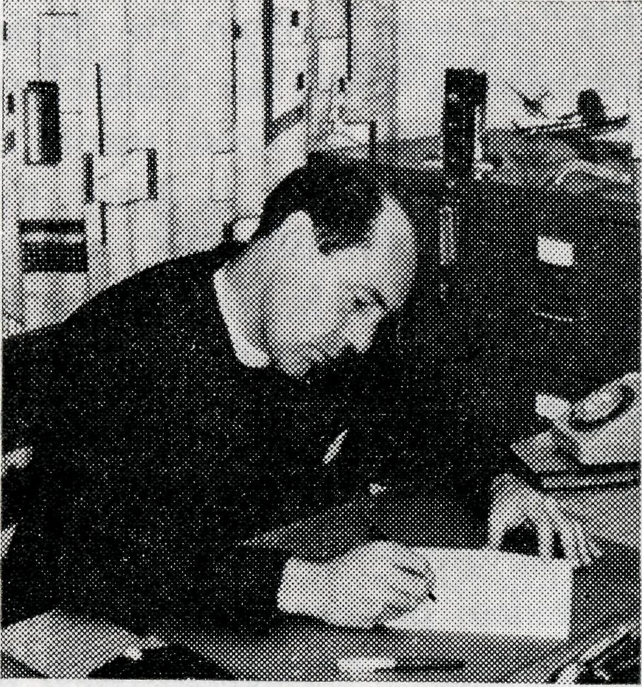
"It's a new kind"—she said —"and because it's new it's better!" She was a nine-year-old extolling the virtues of the Harbour's new hydrofoil. Her brother, who must have been four at the most, was very impressed with her worldly wisdom—as he should be, for here spoke the wisdom of our age.
Indoctrination in this philosophy shrieks at us from every hand. How often are we told things are better because they are new? Soap suds are soapier, detergents clean better, petrol gives more miles per gallon, and so it goes on till one is almost ashamed of things which may be old.
The inclination to experiment, to taste, to venture because a thing is new has been part of human nature from creation. By the time of the prophets I wonder if it was such a philo-
THE REAL AUSTRALIAN, MARCH, 1965
from the
FEDERAL
SECRETARY
sophy which called forth from The Preacher—"there is no new thing under the sun"?
Today we live in exciting times. It is true that only a remnant remains faithful to God in a virtually pagan society. This we must recognise with honesty and positive determination. The conflict between the old and the new is well attested in the pages of history and in our own experience. We may be offended by the "Jazz Mass", bewildered by "Honest to God" and exhausted by "God's Frozen People", yet we must recognise such new things as an honest attempt to bridge the gap between the Church and the people of God's creation lost in their present environment.
During this Lent many of us will be challenged by our clergy to a re-birth of Christian conscience by the emphasis of

DATES TO REMEMBER
ANNUAL RALLIES
MELBOURNE: 21st May, 1965. SYDNEY: 28th May, 1965.
Please note that both Rallies have been brought forward to May this year. B.C.A. was founded at a meeting on the 26th May, 1919.
the M.R.I. Programme. Some will say "Another new thing" with contempt, and ignore the prompting of the Spirit of God. Some will want to abandon all else for the sake of a new way of thought. Between these two extremes, in the Providence of God, I believe, lies the answer. As a Society and as individual Christian people, we must have the courage to boldly face the future. We will have confidence in Him Who is able but we must be prepared to be moulded, without regard to self, by Him.
This age of new things, new methods, new expressions still stands in need of "the old, old story". Our methods of evangelism, of social conduct, of joint activity must be shaped to meet the needs of the age in which we live. Our message of God's redemptive love in Christ must never change. It is only by a fearless presentation of
this "old way" within the Society framework that we can expect the blessing of God upon our present tasks. It is only then that new avenues of service, new ventures in faith can become realities and be of vital significance to those we would serve.
Changing circumstance we must be prepared to meet in every aspect of our witness, but change can soon become chaos if we lose the emphasis of Him Who said, "Behold I make all things new".
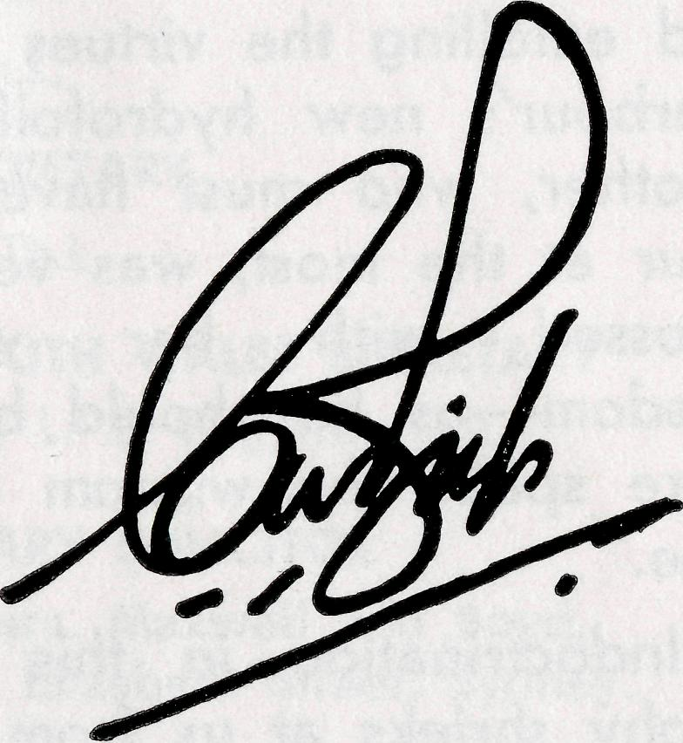
For Service
to the Community
Miss Merna Alma Mueller,
of Ceduna, South Australia, for services to the community.
Commonwealth Relations List of Honours, "S.M.H.", 1/1/65.
This is all that appeared in the New Year Honours List published in January, 1965,
But behind this brief announcement is the story of 14 years of work with the Society's Flying Medical Service.
In 1951 Dr. Mueller joined Dr. Freda Gibson, O.B.E., in the medical work at Ceduna.
Doctor's father had been superintendent of the Koonibba Lutheran Mission Station so that when she took up residence in Ceduna, Doctor was not new to either Ceduna or the Far West Coast. Today a great deal of her work is among the aboriginal people of this huge area of South Australia.
Recently the Lutheran congregation at Ceduna honoured Dr. Mueller by naming the new wing of their Church hall "The Dr. Merna Mueller Wing".
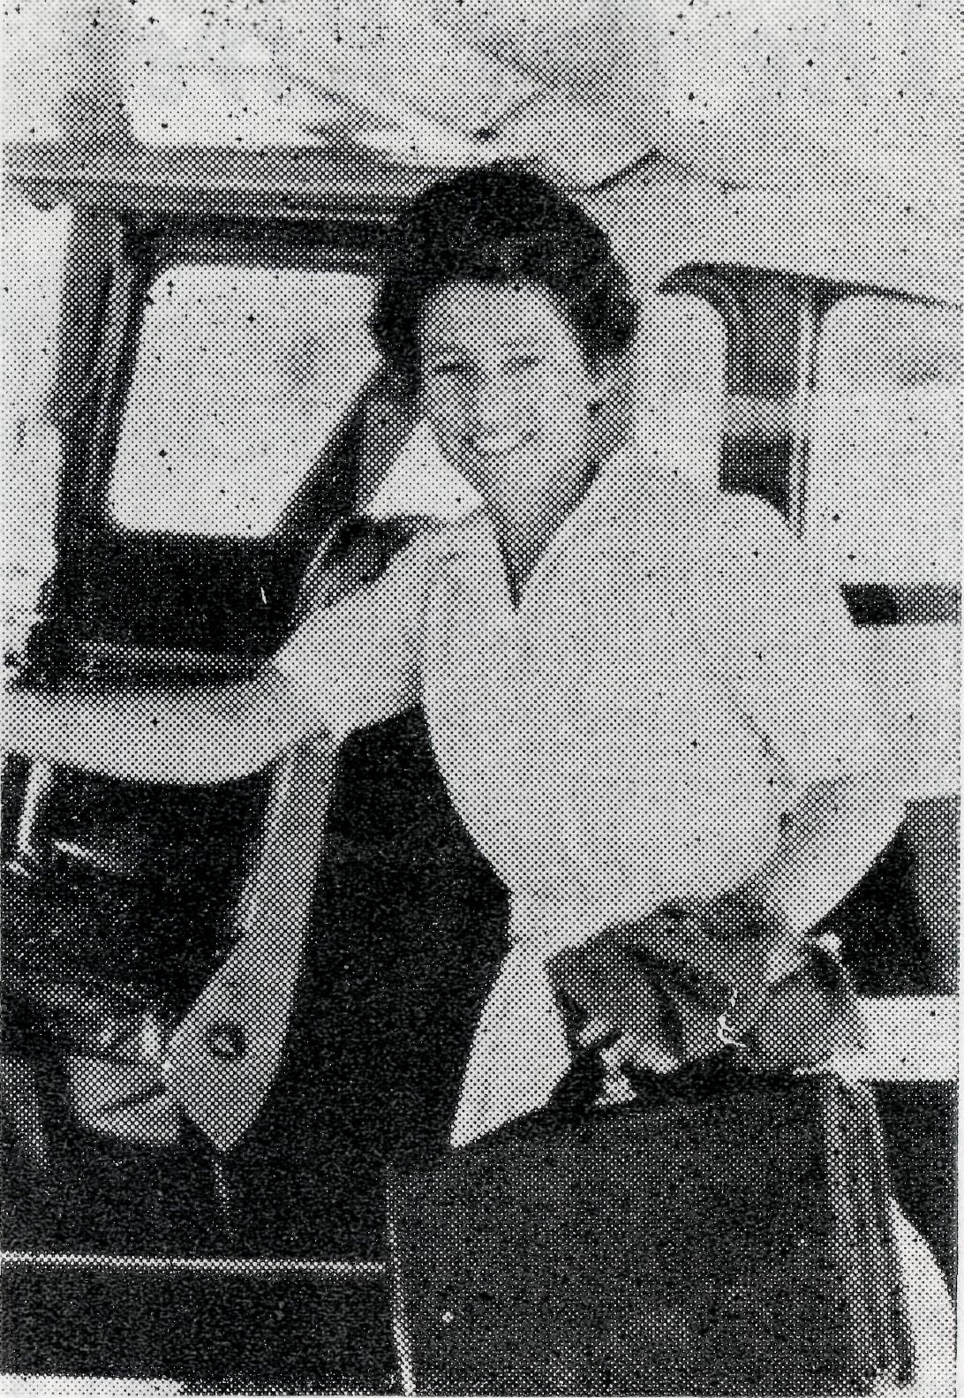
Dr. Merna Mueller, O.B.E.
For a great deal of the time that Doctor has spent at Ceduna she has been the backbone of the Medical Service. For long stretches she has been the only doctor in a network covering thousands of square miles of outback Australia. It would be almost impossible to count the number of flights she has made to all parts of the network, and certainly it would be difficult to estimate the tens of thousands of patients that she has seen.
One only has to speak to a few of the folk in that part of Australia to know of the great admiration and esteem with which Doctor is regarded by all members of the community.

THE REAL AUSTRALIAN, MARCH, 1965
THE REAL AUSTRALIAN, MARCH, 1965

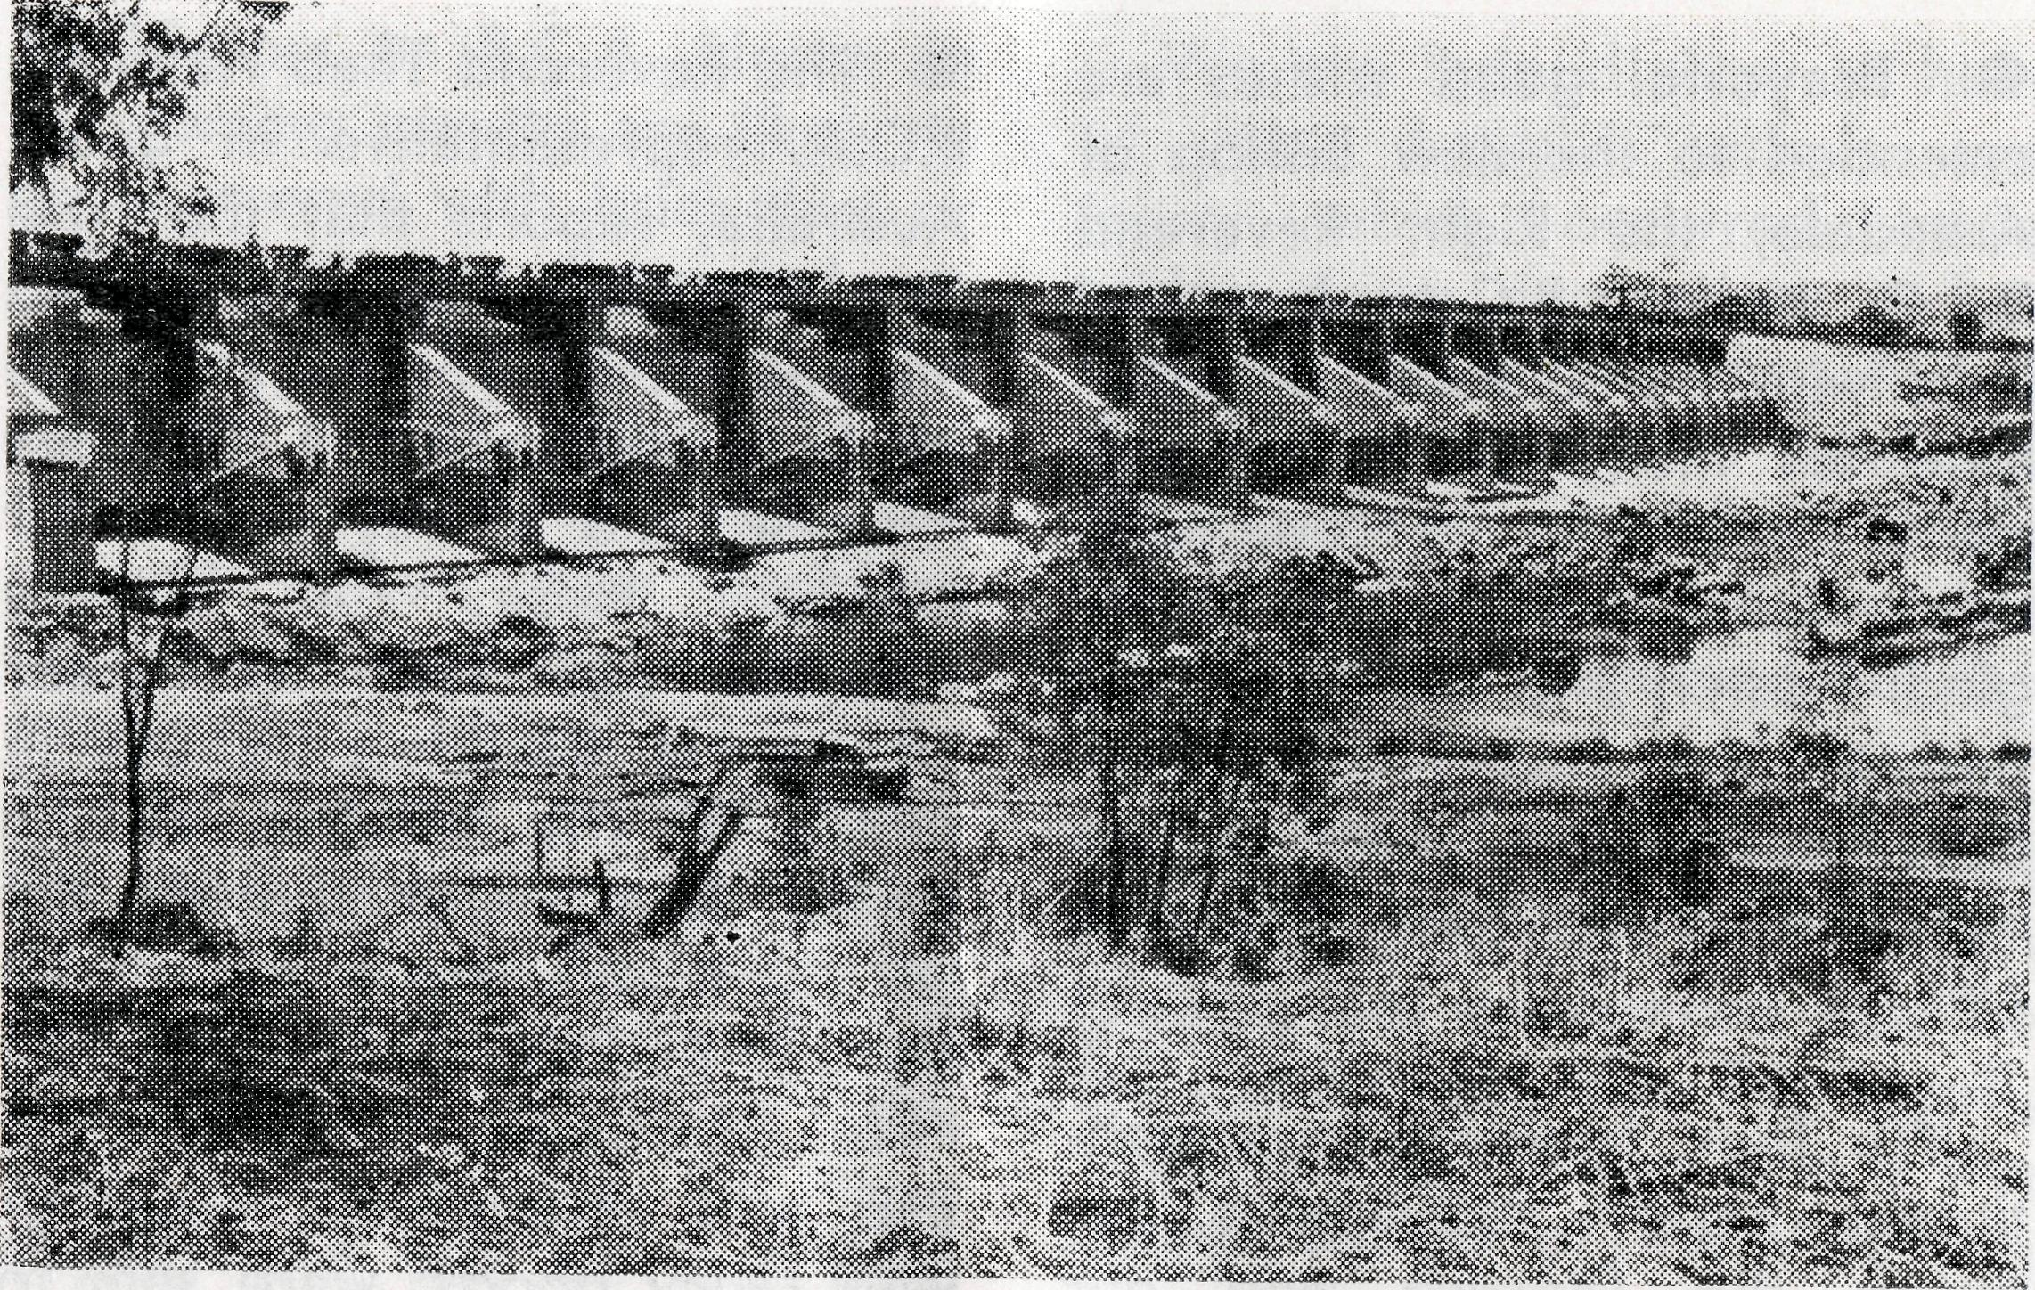
and Goulburn. They will go first to Wyndham, until a Rectory and other buildings are erected at Kununurra, which is expected to be the home base for their ministry. No doubt they will have to face and overcome many problems, especially in the early months, as they live and work alongside this new generation of true pioneers. And as they seek to present Jesus Christ to these families through the ministry of the Word and Sacraments, we must see to it that they are continually supported by our prayers and active interest in this new work committed to our trust.
The Ord River Project
- A New Challenge
With the appointment of the Reverend Barry Green to Kunu-nurra, the key town of the Ord River project in the far northwest of Australia, B.C.A. has accepted a further challenge in its ministry to the remote areas of our land.
Recently, His Grace the Archbishop of Sydney, after a visit to the north-west, expressed a hope that the Church would soon undertake an active ministry to the families concerned in this project. The need is urgent, and B.C.A. has responded to the invitation of the Bishop of North-West Australia.
The Ord River irrigation project is a scheme of national importance, aimed at promoting closer settlement of the East Kimberleys, and at making use of natural resources. Occupation of the Ord Valley began late in the 19th century, following surveyors' reports of the suitability of the fertile plains for pastoral and tropical agriculture, but until recently progress was very slow. In 1945, a Rural Commission recommended research into the possibility of
intensive irrigation, and from this the development scheme began.
The first stage, commenced in 1961, is now well advanced, comprising a diversion dam, and the preparation of 30,000 acres for irrigation. The Ord River and its tributaries drain a catchment area of 18,000 square miles. In the monsoonal season, the river flow often reaches peak levels, then subsides in the dry season to a long string of pools. The diversion dam has created a large and permanent supply of water, and later developmental work will greatly increase this capacity.
The present irrigation area has been divided into 600 acre farms, and the population is increasing rapidly as new farms are being occupied. The main crop in the immediate future is expected to be cotton, together with safflower and rice.
Because the area was completely undeveloped before this, a new township, Kununurra, had to be established near the diversion dam, about 60 miles from Wyndham, the main outlet port. Kununurra will even-
THE REAL AUSTRALIAN, MARCH, 1965
The Diversion Dam, Kununurra.
tually have a population of about 6,000 and no doubt Wyndham will also expand because of increased shipping and other trade.
Just as the Ord River project represents an exciting new venture into tropical agriculture, so too the project offers a very real opportunity and challenge to the Church.
The Reverend Barry Green comes originally from Wollon-gong, and Mrs. Green from Kurrajong. They have two young children, Elizabeth and Philip. Before his appointment with B.C.A., Mr. Green served as Assistant Curate in the parish of Cooma, Diocese of Canberra
THE REAL AUSTRALIAN, MARCH, 1965

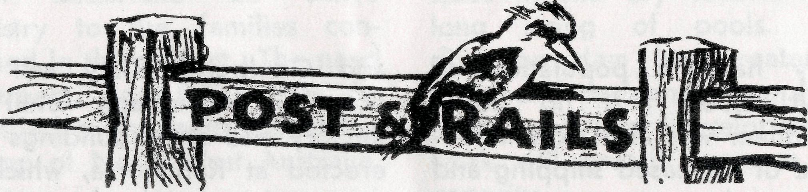
• Prayerful good wishes are extended to the new Bishop of Armidale, the Right Reverend R. C. Kerle. B.C.A. has had links with the Diocese of Armidale for many years, through parish assistance in the early days, then through the Mun-gindi Hostel, and more recently through the Hostel at Moree. Mail Bag Sunday School lessons are used throughout this area also.
We look forward to a continued happy association between the Diocese and our Society in the coming years.
9 Mr. Harry Rich, Warden of the Girls' Hostel at Port Lincoln, reports on the Break-up Evening held in December. Parents and friends of the girls were present, and a very enjoyable evening was spent by all. Incidentally, we congratulate all those young people at our three hostels who were successful in their examinations. Several reports of very good passes have reached our office.
• The Reverend Theo Hayman, B.C.A. representative in South Australia, reports that the Firle (S.A.) Auxiliary last year raised enough money for the purchase of a humidi-crib for Tarcoola Hospital and a tray-mobile for Coober Pedy. A sewing machine was sent for Sister Thomas at Rawlinna to use in tuition of the children at the school there. Also, through the St. Matthew's Marryatville, St. Mary's Beulah Park, and the Firle Auxiliaries a number of cup and saucer sets, together with fancy goods, were sent to Coober Pedy.
9 Once again this year the Family Day was held at the Botanical Gardens, and there was a good roll-up of 62 people—36 adults and 26 children. Over a picnic lunch, members of the field staff on holidays were able to "get together" with some of the "home base" staff and former members and .enjoy a happy time of fellowship.
THE REAL AUSTRALIAN, MARCH, 1965
9 Visitors to B.C.A. House in the coming months are likely to be showered with brick-dust or paint, as the much-needed extensions get under way. The premises at 133 Bathurst Street will be integrated with the present offices, thus doubling the space available. The administrative offices will be located on the ground floor, the Mail Bag Sunday School office and Board Room on the first floor, and storage and work space on the top floor. This work is estimated to cost £9,500 and will be met from the proceeds of a legacy.
9 Our thanks are due to many folk who have kindly given used' Bibles and Prayer Books. These are useful for homes where neither book has been available, and means that children are now able to make full use of our Mail Bag Sunday School lessons. Books in good condition and large print are most helpful.
9 Calling all stamp savers! Your efforts on our behalf are appreciated. Keep up the good work, won't you! For those who would like to join in —we need any quantity of any used postage stamps. It adds to the value of the stamps if Va inch of the envelope is left around the edge. The sale of these stamps makes a valuable contribution to our funds.
THE REAL AUSTRALIAN, MARCH, 1965
We are indeed sorry to hear of Mrs. Argall's serious eye injury which occurred while taking down decorations in her Ceduna home. Mrs. Argall was flown immediately to Adelaide for specialist treatment. We assure her of our prayers that sight will be regained in the injured eye..
9 The Bishop of North-West Australia, the Rt. Rev. John Frewer, has announced that he will retire on the 9th April, 1965. Bishop Frewer, who is the Senior Bishop of the Anglican Communion, will have completed 36 years as the Bishop of the largest land-based diocese in the world. Clergy supported by the Society have worked under the Bishop in the three largest parishes (in area) in the diocese for the past eight years. The Bishop has seen the population of many of the big towns in North-West Australia drop as goldmining and the pearling industry declined. However, in recent years, tremendous developments have taken place in other industries and soon a fourth area is to be staffed by the Society as the huge Ord River Project develops further.
We extend to Bishop Frewer our best wishes for his retirement and we thank him for his cheerful friendship during the years that we have worked with him.

THE B.C.A. FELLOWSHIP

Since its inception only a few months ago, the Fellowship has proved its worth by providing a valuable link between the praying, concerned supporters of the Society, and staff members throughout Australia. Membership is growing steadily, and should reach 200 before long.
Prayer and information Setters are sent out at intervals, and are intended to be used in conjunction with the prayer pages in the "Real Australian". In this way, members are able to pray for specific needs, and also continue to remember all
the staff and those they serve. Several staff members have written to say how much they appreciate this fellowship of prayer.
Membership of the Fellowship is invited from all who are concerned in our work. There is no joining or membership fee, though the Fellowship badge (pin or brooch) may be purchased for 5/- if so desired.
Send your name and address to the N.S.W. Secretary or the Victorian Secretary, and the prayer letter will be forwarded to you.
The Place of Prayer
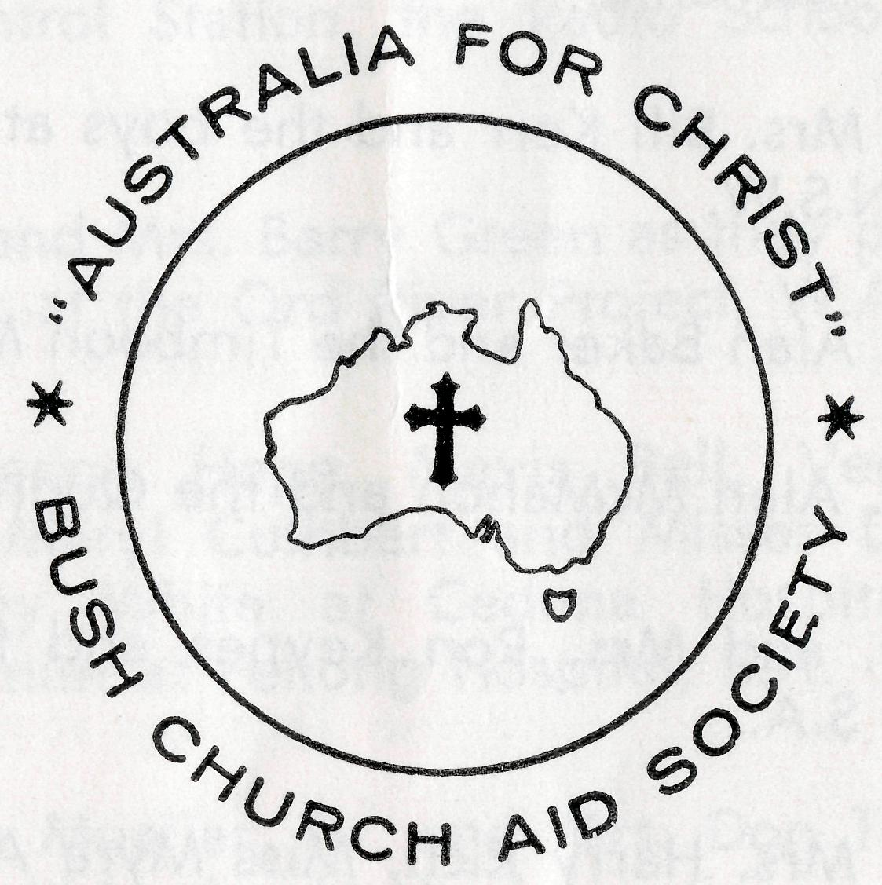

STAFF MOVEMENTS
The following pages represent a daily prayer calendar which will be revised with each issue. We earnestly seek your prayers for the individual members of our staff. We suggest you remove these centre pages from the magazine and keep them for your regular devotional use.

We welcome back to our nursing staff Sister Marjorie Tarr who is, of course, not new to the Flying Medical Service after a previous term of nine years with the Society.
Also returning for a further period of service with the Society is Miss Win Ikin—this time as assistant at the Urallie Hostel, Moree.
From St. Clement's, Mosman, we welcome Sister Margaret Mackenzie to the nursing work
of the Medical Service.
A third nurse to join the staff is Sister Heather Heaver, who has been training at Deaconess House, Sydney, for the past two years. Miss Heaver was able to give valuable assistance to our staff as she did relieving work during her summer vacations.
To each of these new staff members we extend a warm welcome and assure them all of our constant prayer support.
THE REAL AUSTRALIAN, MARCH, 1965
"Let us ask God that they may receive from Him all wisdom and spiritual understanding for full insight into His will, so that their manner of life may be worthy of the Lord and entirely pleasing to Him. Pray that they may bear fruit in active goodness of every kind and grow in the knowledge of God. May He strengthen them, in His glorious might, with ample power to meet whatever comes with fortitude, patience and joy; and to give thanks to the Father who has made them fit to share the heritage of God's people in the realm of light."
(Adapted from Colossians 1 N.E.B.)
THE REAL AUSTRALIAN, MARCH, 1965 9

1st The Rev. and Mrs. Ray Neve and the Wilcannia Mission, N.S.W.
2nd The Rev. and Mrs. Brian Viney and the Menindee Mission, N.S.W.
3rd The Rev. and Mrs. Brian O'Grady and the Tarraleah Mission, Tasmania.
4th Mr. and Mrs. Bill Kerr and the boys at the Broken Hill Hostel, N.S.W,
5th The Rev. Alan Baker and the Timboon Mission, Victoria.
6th The Rev. Alan McMahon and the Quorn Mission, S.A.
7th The Rev. and Mrs. Ron Keynes and the Leigh Creek Mission, S.A,
8th Mr. and Mrs. Harry Rich, Miss Myra Attwood and the girls at the Port Lincoln Hostel, S.A.
9th Miss Rose Campbell, Miss Dianne Sidebottom and all the helpers and scholars in the Mail Bag Sunday School.
10th Mr. and Mrs. Allan Chadwick, Mr. and Mrs. John Lindridge and the flying within the Medical Service.
11th Mr. and Mrs. Stan Hummerston and the administrative work within the Flying Medical Service.
12th The Rev. and Mrs. John Wyndham and the North-West Line Mission, Tarcoola, S.A.
13th The Rev. and Mrs. Noel Hart and the Derby Mission, W.A.
14th Miss Rowena McLachlan and the work at the Ceduna Pharmacy, S.A.
15fh The Rev. Theo Hayman, Mr. Alban Kirkby and the South Australian Representation.
16th Mr. and Mrs. Sid Bennetts, Miss Win Ikin and the boys at Urallie Hostel, Moree, N.S.W.
17th Mr. Kevin Ellis, Mr. and Mrs. David McDougall at the Radio Control Station, the Radio School teacher and children.
18th The Rev. and Mrs. Barry Green as they prepare for the new work at the Ord River Project, W.A.
19th Sisters Marion Hope, Mavis Bell, Vera Holle, Val Gameau, Meryl Cuthbert and Misses Dorothy Duver and Lesley White at Ceduna Hospital and Sister Beverly Smith at Penong Hospital, S.A.
20th Dr. Merna Mueller, Dr. and Mrs. Don Tindal, and the patients within the Medical practice.
21st Sisters Barbara Fox and Maude Ross at Cook Hospital, and Sisters Marjorie Tarr and Jean Griffen at Tarcoola Hospital, S.A,
22nd Sisters Vaisey Cochrane and Heather Heaver at the Coober Pedy Medical Centre, S.A., and Sister Edna Thomas at the Rawlinna Nursing Home, W.A.
23rd Sisters Julia Zillman, Nancy Wilkins, Dorothy Whyburn, Margaret Mackenzie and Miss Margaret Chadwick at Wudinna Hospital, S.A,, Mr, Bill Bedford and the patients carried by air.
24th The Rev. and Mrs. Bernard Buckland and the Murchi-son Mission, W.A.
25th The Rev. and Mrs. Barry Huggett and the Port Hedland Mission, W.A,

10
THE REAL AUSTRALIAN, MARCH, 1965
THE REAL AUSTRALIAN, MARCH, 1965

26th The Rev. and Mrs. Harry Goodhew and the Ceduna Mission, S.A.
27th Miss Marjorie Farr, the Staff and Residents at the Old Folk's Home, Port Lincoln, S.A.
28th All students in training for outback ministries, a continued supply of replacement personnel, our Box Secretaries, the evergrowing number of supporters and their ready response.
29th The Rev. and Mrs. John Stockdale, Mrs. W. Hughes, the Victorian Committee and Office Staff.
30th The Rev. and Mrs. Bill Rich, the Rev. and Mrs. Arthur Williams, the Rev. Les Wiggins, Messrs. Laurie Calder, Frank Burner, Mrs. Joy O'Neill, Misses Ruth Close, Deirdre Briggs, Suzanne Thorley at Headquarters and the Council of the Society.
O Lord God of our nation, Who hast commanded men to subdue and replenish the earth: Look in Thy love upon all who in distant parts of our land are striving against many difficulties, and are deprived the access of the means of grace. Strengthen and guide the Bush Church Aid Society and all members of the staff. Cheer and comfort them in discouragement and loneliness, bless their ministrations to the good of those they serve, and grant that the message of redeeming love may thus be rooted and grounded in our national life, to the glory of Thy Great Name through Jesus Christ our Lord. Amen.
O God, we remember before Thee those whom Thou hast called to Thy service. Bless them this day, we beseech Thee, as we
pray for Call forth others
to stand with them in their task. Grant to them, as to us, the joy of service, the ability to achieve and the serenity of Thy peace, for Jesus' sake.
Amen.
'NEW LOOK' at Broken Hill
Wednesday, 9th December, 1964, became another important day in the B.C.A. calendar when the additions and renovations at the Broken Hill Hostel were opened and dedicated.
The Hostel, which cares for 20 boys from remote areas as far apart as Tibooburra, N.S.W., and Woomera, S.A., has long been in need of extension to give adequate accommodation for both staff and boys. And so, at a cost of more than £5,000, additions were made to the kitchen and dining room area, doubling the size and providing more modern cooking and storage facilities. Dividing partitions were added to the main dormitory, and the formerly cramped staff quarters were enlarged by the addition of a lounge and bedroom.
On the opening day, the Federal Secretary, the Reverend C. W. Rich, travelled from Sydney to conduct the Service of Dedication. Amongst the fifty guests present were a number of parents, some of whom had travelled up to 80 miles for this
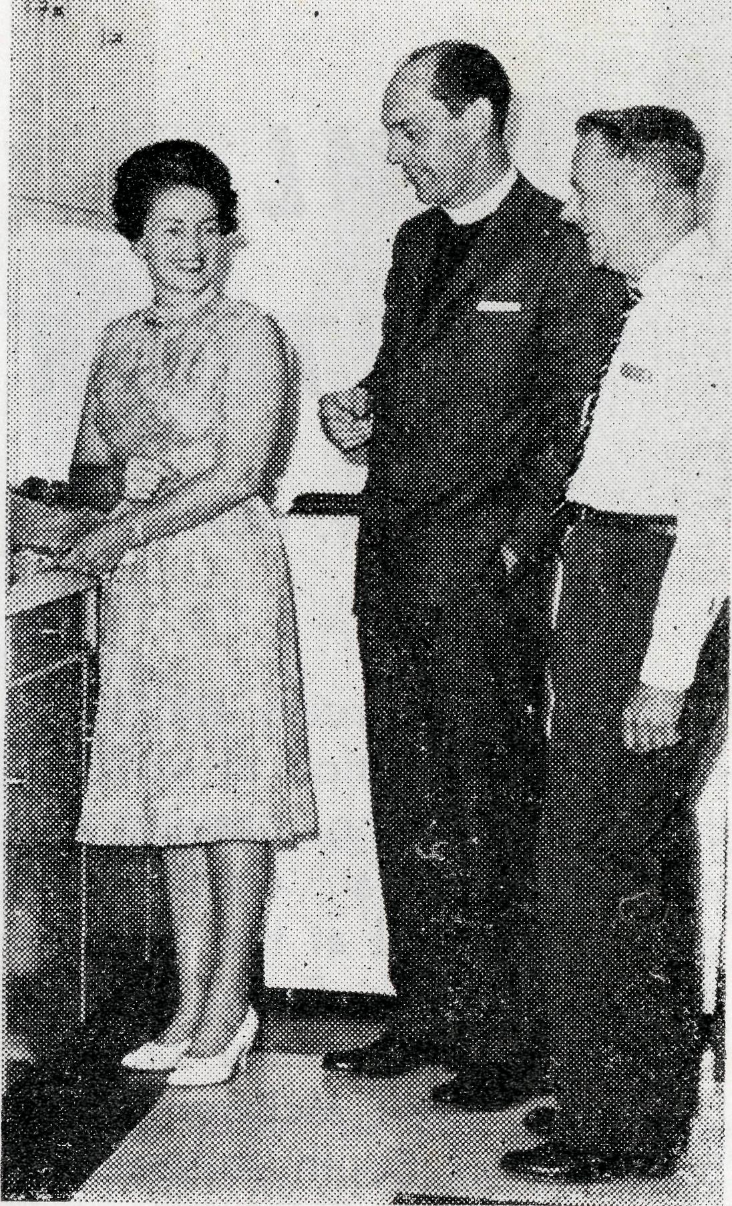
Mr. and Mrs. W. Kerr and the Rev. C. W. Rich.
day. The Warden and his wife (Mr. and Mrs. W. Kerr), and of course the boys, acted as hosts and ail joined together in giving thanks to God for His many blessings on this aspect of the Society's endeavour.
The Hostel not only provides accommodation to enable lads from distant places to attend the large schools at Broken Hill, but also gives valuable opportunities for Christian witness, as staff and boys live together in a happy family atmosphere.

12
THE REAL AUSTRALIAN, MARCH, 1965
THE REAL AUSTRALIAN, MARCH, 1965
13

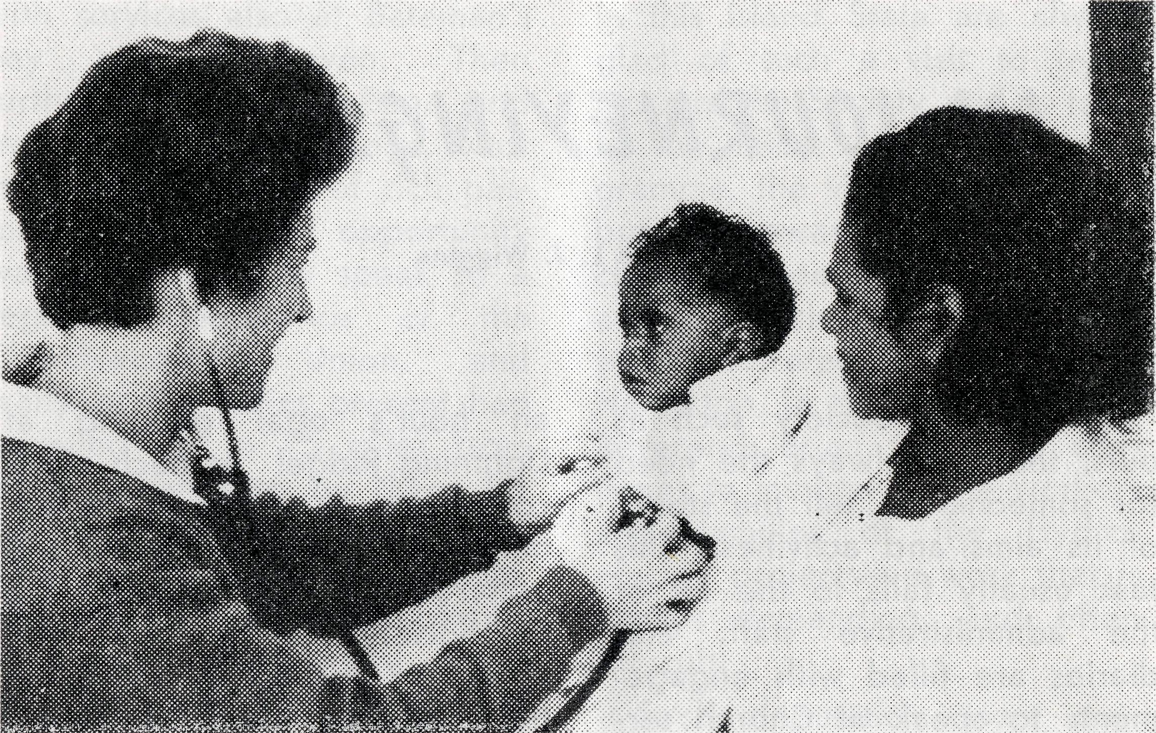
The particular ministry of Dr. Mueller.
MEDICAL OUTPOST
Rev, C. W. RICH
Thursday, February 4th, 1965, saw the culmination of years of thinking, planning, praying and working as a considerable crowd gathered at the entrance to^jhe Coober Pedy Medical Centre for its official opening by Sir A. Lyell McEwen, Chief Secretary of South Australia.
The building has recently been erected by the Housing Trust of S.A. with finance supplied by the Coober Pedy Progress Association and a subsidy from the South Australian Government. Our Society has played a constructive part in being one of the four members of the Medical Centre Committee and by undertaking to staff and control the completed Centre. Together with the Mines Department, the Aborigines Department and the Progress Association, the Society played its part in the many involved problems surounding the establishing of such a centre in such a remote situation. As
the project neared completion, the task of furnishing for the staff and supplying the medical equipment necessary to maintain the work was also undertaken. Here, as in so many other ways, the contribution of Mr. Hum-merston and Sister Hope was invaluable.
Of the day itself, so much could be said—but perhaps a few impressions will give a picture of this new work.
One important topic of conversation was the weather. Many—those of us who were confined to suits in particular-were apprehensive. Others were obviously disappointed when the temperature (shade) only ran to 99 degrees.
To those who had seen the project grow, the outstanding thing was the volume of last-minute work that was undertaken to have all in order, and full tribute was given to those folk—particularly from the Coober Pedy Progress Association—who rose to the occasion.
An Official Luncheon was given for the visitors, which included not only the Chief Secretary's party but also visiting officials of the other Boards and Trusts involved.
A brief ceremony marked the official opening, and due expressions of gratitude and appreciation were offered to ail concerned. Particular emphasis
was given to the part played by the F.M.S. Staff in general, and to the particular ministry over many years by Doctor Mueller and Sister Dowling.
A public inspection of the building followed. The Centre consists of two wards, surgery, office, kitchen and bathroom facilities and accommodation for the two members of staff. The overall impression is one of an attractive, functional and modern Medical Centre.
As the tumult subsided the ten members of the Society Staff present gathered for a few moments to express gratitude to God for His provision, to seek His continued blessing and guidance upon the venture
and to pray for the sustaining sense of His nearness to those whose work and witness had begun.
My most outstanding impression of the whole day was the sense of joyful service coupled with the sense of responsibility and challenge demonstrated by Sisters Vaisey Cochrane and Heather Heaver as we left them to carry on the task. One felt a sense of very real privilege in sharing this ministry with them. We commend them and their work to the prayers of all our supporters in the fervent hope that God will use this undertaking to His glory and the extension of His Kingdom.

THE REAL AUSTRALIAN, MARCH, 1965
THE REAL AUSTRALIAN, MARCH, 1965
15

IN JOURNEYINGS OFT
Reverend L. J. Wiggins
STAFF URGENTLY NEEDED
- Double Certificate Nurses.
- Domestic workers capable of cooking and helping generally
in outback Hospitals.
Requirements include a virile Christian faith and willingness to serve for at least two years.
THE REAL AUSTRALIAN, MARCH, 1965 17
Within any Society such as ours, there is always the need for someone to "tell the story" of its aims and activities. This task usually falls to the lot of the administrative staff, and diaries are filled with engagements to speak at Church services, fellowship teas, week-day meetings and missionary rallies.
The deputationist must inform his hearers, telling of the work that is being done in the Name of Christ and His Church. He asks Christian people to pray, to give, perhaps to serve, as they are led of God.
Most deputations, of course, take place within the large city dioceses of Sydney and Melbourne, but at other times the Society's representative must be prepared to travel far beyond the city limits.
Last year, for instance, the N.S.W. Secretary travelled to the north-west of the Diocese of Armidale, leaving behind the rich pastoral areas of Gunnedah and Narrabri, across the black soil country to Wee Waa and Walgett, with time allowed for
16
an hour's opal gouging at Lightning Ridge! At each place congregations, though sometimes small, were interested and generous in their support for the Society. On this same trip, a visit to the B.C.A. Hostel in the northern town of Moree found that a number of the staff and boys were suffering from the 'flu virus that was sweeping the northern areas of the State at this time. Soon after this, Church people at places such as Walcha, in the Highlands, heard about the Society's activities, while the temperatures outside were at near freezing!
Then on to the national capital, and a deputation to the unusual and striking "railway Church" of All Saints' Ainslie, followed by a visit to the towns on the south-western slopes.
Another journey of contrasting scenes was provided by the visit to the southern areas of Canberra-Goulburn Diocese. Travelling from Sydney down the beautiful South Coast, a weekend was spent at Moruya,
THE REAL AUSTRALIAN, MARCH, 1965
with services also at Bateman's Bay and Batehaven. Then further south through Bega, and over the mountain range, west to Bombala, centre of rich pastoral areas. The opportunity was given here to speak to a regional conference of the Churchwomen's Union, and many of the ladies present had travelled up to 75 miles from many parishes to be there for the day's activities. From Born-bala, the route led to Berridale, and amongst the many centres of worship of this vast parish are included the chalets of Mt. Kosciusko and the work camps of the Snowy Mountains Authority. A trip to Island Bend ended with a hurried retreat because of a heavy snowstorm —quite a contrast to the heat-baked plains of the Nullarbor, where the Reverend John Wyndham ministers to the folk on the Line!
Each year Tasmania receives a representative of the Society,
and the many friends of B.C.A.
in this island State are always glad of such a visit to learn more of the Society and its task. In the midst of a busy programme, the visitor cannot help but be aware of the ever-changing beauty of the island, and the quiet but warm hospitality offered in each town. Here, too, in the highlands, the Reverend Brian O'Grady continues to minister to the workers and families of the Hydroelectric projects—a work that is always demanding, and often difficult.
Such deputation tours provide a cross-section, not only of the diverse landscapes of our great land, but also of the Church, at work and at worship. Whether in mountain hamlets or in sun-drenched northern towns, there are always faithful and humble Christian people, who never cease to pray, and who share their blessings to bring the Gospel to their counterparts in the far-off places of Australia.

MAIL BAG
SUNDAY SCHOOL
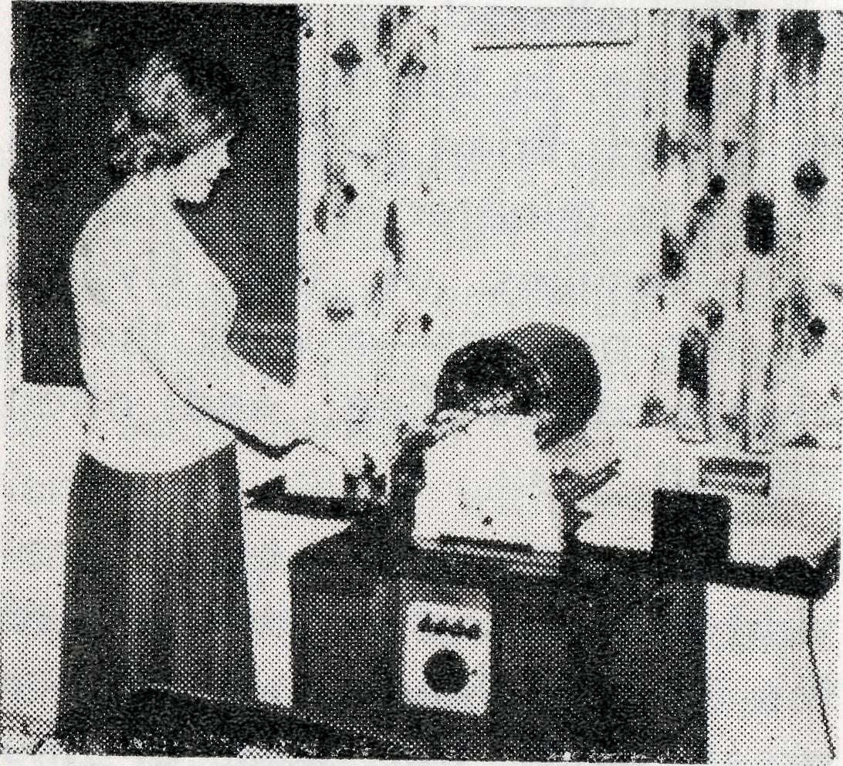
It starts in the office! "Colouring in" is always popular with young children and the duplicator helps us to fulfil this need. It also enables us to have many illustrations in the lessons for the younger children.
Voluntary workers help to assemble the lessons and do many other valuable tasks.
Teachers in the Mai! Bag Sunday School need to be Sunday School teachers—plus! It's at one and the same time a painstaking yet rewarding task. Memory work from Bible or Catechism has to be checked, as well as Answers to Questions and Handwork.
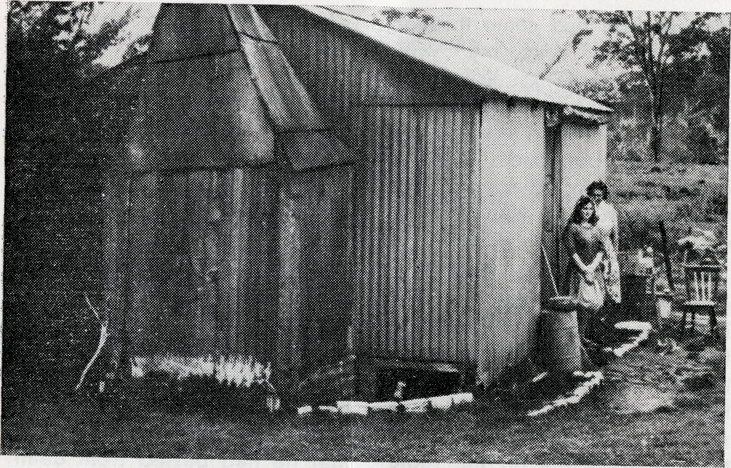
Types of homes vary as much as localities to which we send lessons.
For lessons to be effective much depends upon the mother in the home. Her role is important for she creates the atmosphere, and her concern for the spiritual development of her children Is vital to the success of our lessons.

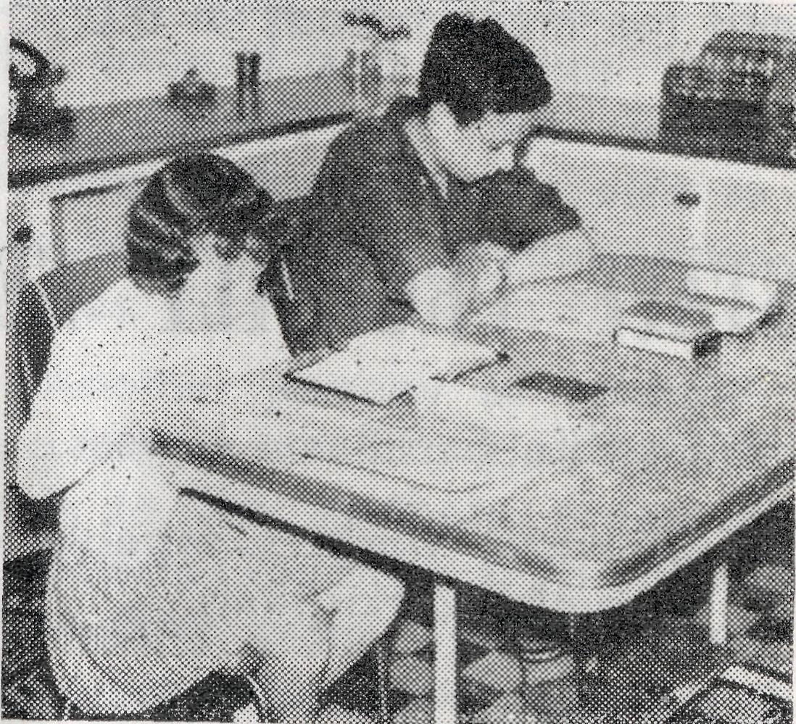
ALL ARE PRECIOUS
Children all over the Commonwealth as well as the Pacific Islands use B.C.A. lessons. Some start when quite small and rarely, if ever, miss a Sunday right through, year by year, until the course of eleven grades is completed.
Thousands of children receive their secular and Christian education in their homes. They return their work to a teacher at the end of each month.
18
THE REAL AUSTRALIAN, MARCH, 1965
I was some 110 miles out from Wilcannia on the first day of a two weeks' patrol in the Tibooburra area. While at Kay-runner Station the radio telephone was constantly ringing, but while Mrs. Clark could hear the girl on the switch, she in turn could not be heard. Leav-
THE REAL AUSTRALIAN, MARCH, 1965
Rev. Ray Neve
ing there on my next call, More-don, some 16 miles away, I arrived there just as a light aircraft was landing on the strip alongside the homestead. Much to my surprise out stepped Mr. Clark and his son Brian whom ! had only left half an hour before. Just after I had left
19

the message had come through for me to ring my wife, urgently, back in Wilcannia. They had in turn tried to contact the Moredon people by transceiver but had failed to get on to them, so decided that the quickest way would be to come after me by 'plane.
As it was just on dusk they gave me the message and left immediately and I had just time to say hello and goodbye to the people at Moredon before making my way to a station some ten miles distant to ring Wilcannia on the radio telephone. After some delay I was able to speak to my wife and found that an aboriginal had died and the relatives had requested that they would like me to take the burial if possible. I decided to return at once to Wilcannia. En route I called on the Clark family and told them what had happened and they invited me to have some tea before going on any further. I could easily have been further out as I had spent about two hours helping to dig out a car bogged in a dry creek bed that afternoon.
Some people would say it was not worth returning just for an old aborigine, and this is just how many people treat and look upon him. The Scripture reminds us that in God's sight all people are equal, that Christ died for the sins of the
whole world, and the things that divide us here will mean nothing in eternity. The only thing that will matter will be our personal relationship to Jesus Christ.
Only a week earlier, when this aboriginal had been in hospital, I felt led by the Holy Spirit to explain fully and simply the way of salvation through faith in Christ. He appeared to understand the Way and accepted it. I had no further opportunity to see him before he died, but I believe that he had passed from death to life eternal. It made me realise afresh that we need to be sensitive to the leading of the Holy Spirit and buy up the opportunity while there is time. In the Service that followed his death there was real freedom for the preaching of the Gospel.
Some aboriginals have come to the ordinary Church Services, quite a number of the children come to Sunday School, and we have a large weekly Fellowship of school-age children.
The Church Army Mobile Mission to Aborigines, under the direction of Captain Roser, assisted by Captains Allan and Norman Polgen, will be visiting Wilcannia from April 22nd to May 13th to conduct a Mission among the aboriginal people in the area. Will you pray for this Mission?
The Bush Church Aid Society
for Australia and Tasmania
FIELD STAFF:
DIOCESE OF ADELAIDE, S.A.
Ceduna-Penong, S.A.—Rev. R. H. Goodhew, Th.L Tarcoola, S.A.—Rev. J. Wyndham, Th.L.
DIOCESE OF WILLOCHRA, S.A.
Leigh Creek, S.A.—Rev. R. Keynes, Quorn, S.A.—Rev. A. McMahon, Th L Th.L.
DIOCESE OF BALLARAT, VIC. Heytesbury Mission, Vic.—Rev. A. Baker, Th.L.
DIOCESE OF RIVERINA, N.S.W.
Wilcannia, N.S.W.—Rev. R. Neve, Menindee.—Rev. B. Viney Th L Th.L.
DIOCESE OF TASMANIA
Tarraleah, Tas.—Rev. B. J. O'Grady, Th.L.
DIOCESE OF NORTH-WEST AUSTRALIA Derby Mission.—Rev. N. E. Hart, Th.L., Derby, W.A. Port Hedland Mission.—Rev. B. Huggett, Th.L., Port Hedland, W.A. Murchison Mission.—Rev. B. R. Buckland, Th.L., Mount Magnet, W.A.
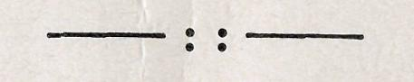
MAIL BAG SUNDAY SCHOOL
Director: Miss R. Campbell.
HOSTELS FOR SCHOOL CHILDREN
PORT LINCOLN, S.A.
Mr. and Mrs. H. RICH. Miss M. ATTWOOD.
BROKEN HILL, N.S.W.
Mr. and Mrs. W. KERR. MOREE, N.S.W.
Mr. and Mrs. S. BENNETTS. Miss W. IKIN.

20
THE REAL AUSTRALIAN, MARCH, 1965
THE REAL AUSTRALIAN, MARCH, 1965

