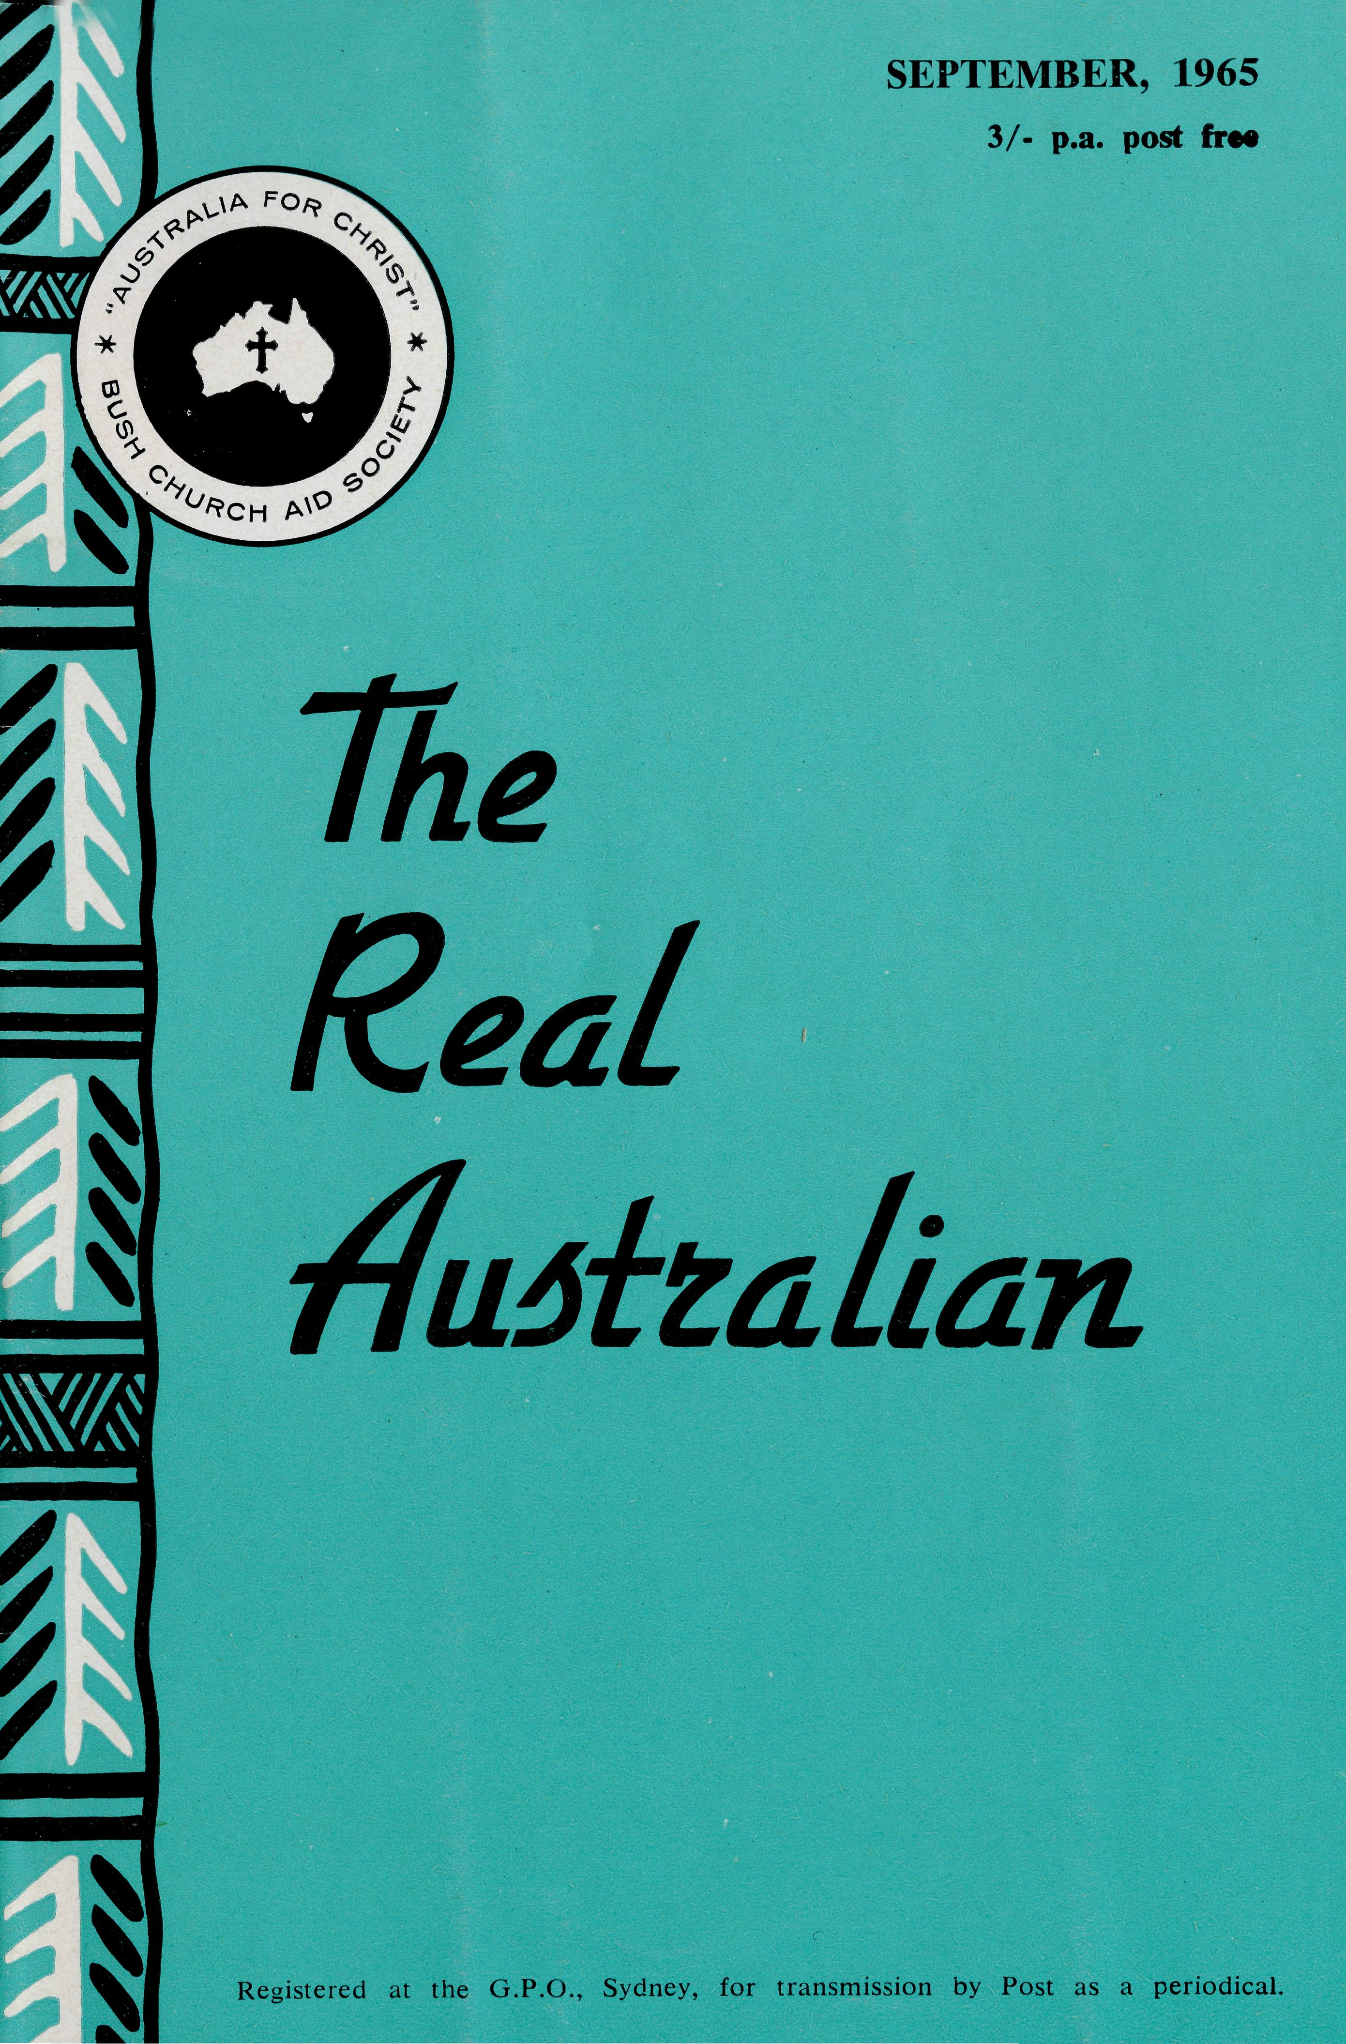
FLYING MEDICAL SERVICE STAFF
Executive Officer: Mr. S. HUMMERSTON
Medical Officers: Dr. M. MUELLER, O.B.E. Dr. D. TINDAL
Matron: Sister M. HOPE
HOSPITAL CENTRES
CEDUNA, S.A.
The Murat Bay District Hospital—
Sisters V. HOLLE, M. BELL, V. GAMEAU, J. GRIFFEN, L. HIGGS, Misses D. DUVER and L. WHITE.
WUDINNA SA Matron: Sister J. ZILLMAN.
The Central Eyre Peninsula Hospital- ^{Sisters} ^{N}' WILKINS, D. WHYBURN,
M. MACKENZIE, Miss M. CHAD-
WICK.
COOK, S.A.
The Bishop Kirkby Memorial
Sisters M. TARR, M. ROSS.
Hospital—
TARCOOLA, S.A.
Sisters B. FOX, B. SMITH.
The Tarcoola Hospital—
PENONG, S.A.
Vacant.
The Penong Memorial Hospital—
COOBER PEDY, S.A.
Sisters V. COCHRANE, H. HEAVER.
The Coober Pedy Medical Centre-
Sister E. THOMAS.
RAWLINNA, W.A. The Nursing Hostel—
PILOTS
AIRCRAFT
Mr. J. LINDRIDGE Mr. A. E. CHADWICK Mr. W. BEDFORD
SINGLE STAFF HOUSEKEEPER
Miss M. FARR.
Cessna 210 —VH-AEC
Cessna 210 —VH-FMS
Beagle Airedale — VH-UEP
PHARMACIST
Miss N. PATTON.
RADIO CONTROL STATION
Control Officer — Mr. K. ELLIS
Mr. A. E. CHADWICK
EDGAR BRAGG & SONS PTY. LTD.

The Bush Church Aid Society
for Australia and Tasmania
PRESIDENT
The Most Reverend, The Archbishop of Sydney.
VICE-PRESIDENT
The Most Reverend, The Archbishop of Melbourne.
CHAIRMAN OF COUNCIL HONORARY TREASURER
Rev. Canon E. Cameron. Mr. R. T. Stokes.
COUNCILLORS
Ven. G. R. Delbridge, Rev. Canon R. M. Hudson, Revs. C. A. Baker, L. H.
Broadley, E. V. Constable, O. W. C. Cooper, W. I. Fleming, A. C.' Miles]
S. S. Viney, Messrs. H. M. Bragg, K. C. Lyne, E. Stockton,
FEDERAL SECRETARY
Rev. C. W. Rich, Th.L. ASSISTANT FEDERAL SECRETARY
Rev. A. E. Williams, Th.L.
VICTORIAN SECRETARY
Rev. J. Stockdale, Th.L.
NEW SOUTH WALES SECRETARY
Rev. L. J. Wiggins, Th.L.
SOUTH AUSTRALIAN REPRESENTATIVES
Rev. T. J. Hayman, Th.L., St. Matthew's Rectory, Marryatville, S.A. Telephone: FA 1022. Mr. A. Kirkby, 7 Ruthven Avenue, Glandore, S.A. Telephone: LF 3268.
B.C.A. HOUSE
SOLICITOR
Messrs. Maxwell and Boyd, 141 Elizabeth Street, Sydney.
HONORARY AUDITOR
F. W. A. Eagar and Co., 8 Belgrave Street, Manly, N.S.W.
135 Bathurst Street, Sydney.
Phones: 26 3164, 26 3780.
Telegraphic Address: "Chaplaincy", Sydney.
VICTORIAN OFFICE
Morton House,
262 Flinders Lane, Melbourne.
Phone: 63 8962.
"AUSTRALIA FOR CHRIST"
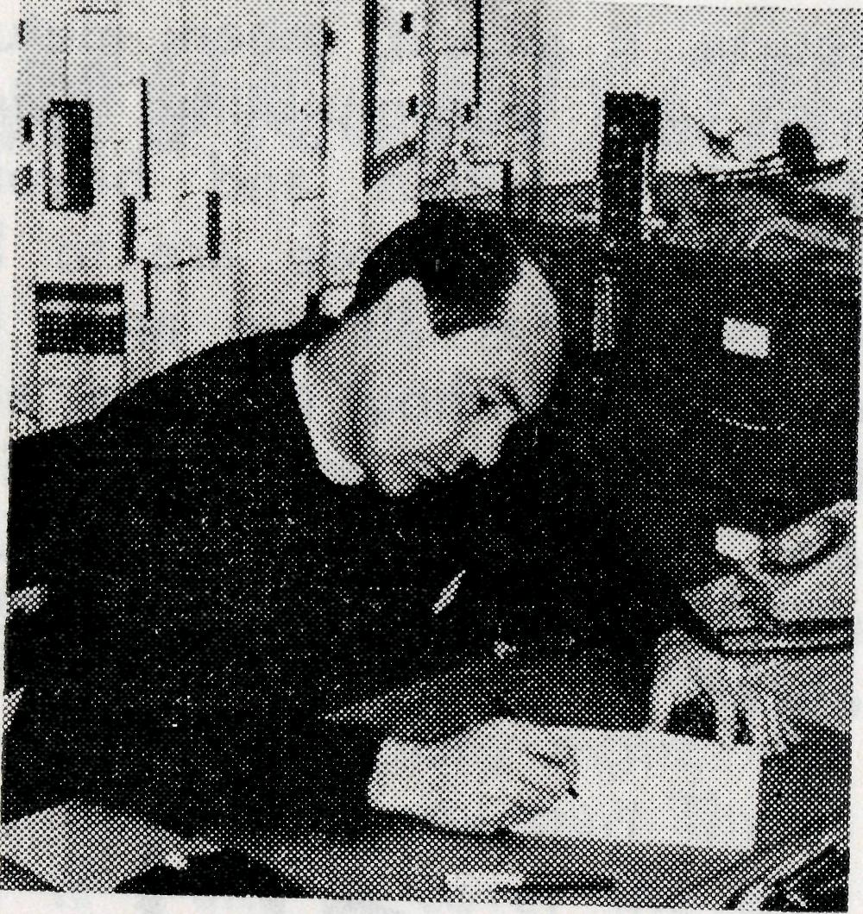
Serious attempts have been made in recent months to direct the thinking of the Australian Church to a deeper awareness of the spiritual and material problems which confront the Church and her ministry to those living in the bush.
From the informality of "Letters to the Editor" to the solemnity of Synod charges, many problems have been raised. An acute shortage of manpower, restricted diocesan financial resources, immense cost factors for establishment, development and maintenance all contribute to the enormity of the task ahead when thought is given to finding a solution. Some have spoken in very critical terms, and with good reason, of the lack of concern shown by some of those who have, for those who have not. By the same token I doubt if enough has been said of what could and should be done by some within
from the
FEDERAL
SECRETARY
the problem areas themselves. Time and again in the past years I have been humbled by the self-sacrificing spirit demonstrated by some who give of their substance, time, and energy, to assist those who, if they so chose, could give and do so much themselves.
However, the basic fact remains—the spiritual needs of so many are not being met adequately in spite of the noble efforts of a comparative few. Our Society is attempting to provide a spiritual ministry to one third of the continent. In many instances, be it the clergy or the laity involved, they are so few and the areas of concern so great that any achievement must of needs be limited. Achievement often only serves to highlight the frustration of not being able to do more.
As a solution to the national problem one hears of such terms as "M.R.I.", as though it

THE REAL AUSTRALIAN, SEPTEMBER, 1965
THE REAL AUSTRALIAN, SEPTEMBER, 1965

course it would mean mutual trust and responsibility being exercised within and beyond the Society. If we are to be concerned at all we must be concerned without measure, and invested with a sense of vision and faith which in stature matches the enormity of the task ahead.
MURCHISON
MEANDER
Reverend B. Buckland
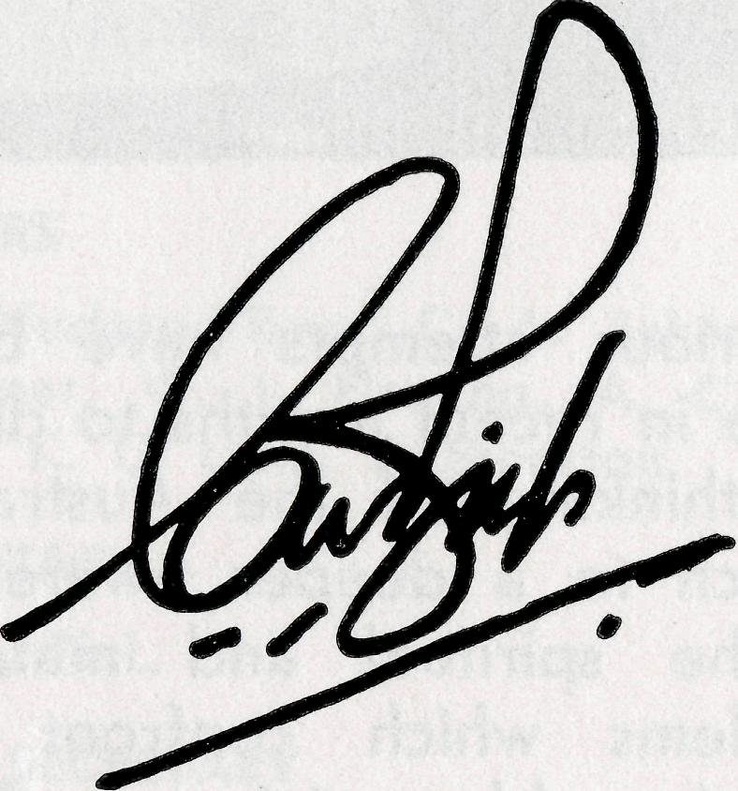
were a magic password, or "National Responsibility" — a vague, undefined term which has, at present, no foundation in reality. Although I may be expected to say to the contrary, I do not consider for a moment that Bush Church Aid Society in itself is the answer. We can only ever be an instrument of those involved in the problem. However, if the sense of values which has created the Society, and the faith and vision which have sustained it, count for anything, then we could and should be of greater consequence in the overall task. I believe we stand unique by virtue of our constitution and structure as the only body competent at present to play a national role. Of
STAFF URGENTLY NEEDED
- Double Certificate Nurses.
- Domestic workers capable of cooking and helping generally in outback Hospitals.
Requirements include a virile Christian faith and willingness to serve for at least two years.
2 THE REAL AUSTRALIAN, SEPTEMBER, 1965
With no assistant Scoutmaster a\ Mt. Magnet, I must remain in rown on Wednesday night, and that means an early start Thursday if I am to cover the 240 miles to Wiluna before tea. I actually had my hat in my hand —it's a good hat despite the rubbishing I get because of the large brim and the hole in it— when the phone rang. It was the relieving policeman to tell me that a man who had disappeared into the bush ten months ago had been found—dead ten months. I went to see the family again and made arrangements for the funeral. Then picked up Sandstone mail (three large bags), Windsor mail and papers, four loaves of bread for my hostess, and left almost three hours late.
The day seemed rather warm and I was glad to stop just past the 22nd mile for a go at the water bag, and was very glad when further on at Windsor Station, about 50 miles out, I was offered a cup of tea. Some of the bread was handed over there for it was six days since the last delivery, also the mail and papers.
THE REAL AUSTRALIAN, SEPTEMBER, 1965
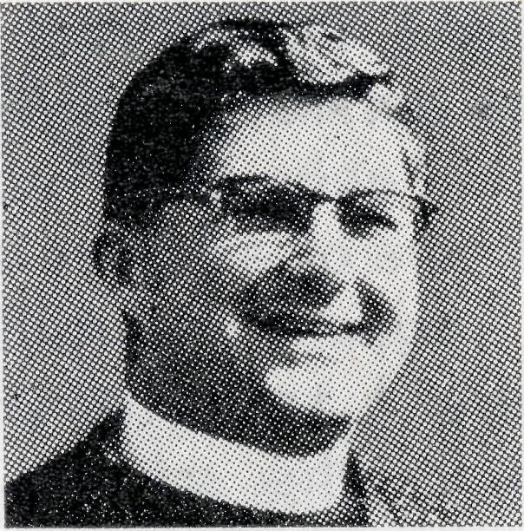
At the Lake Mason turnoff I stopped to test the radio. The aerial is a bit difficult to handle (35 feet when fully erected), but I got straight through to Jim at VKJ Meekatharra and Charlie at VJQ Kalgoorlie. It's nice to know 8WVG is working, since it was shaken up and defunct when it arrived.
No more stops except for a few mouthfuls from the water bag each 25 miles or half an hour. It was fairly warm—unpleasant, but not unbearable— although it turned out to be 113° in the shade—the white roof keeps the car cool. Surprisingly I wasn't drowsy, but two large lemon squashes disappeared quickly once I reached Barney's Hotel. There was then just time for a shower, tea, then off to ring the bell at 7 p.m. The school teacher came over and helped me clean the church, and at 7.30 p.m. there were seven at the service.
The next morning I took religious instruction at the school; there are 23 on the roll this year; then a quick visit to the hospital.
There were no stores for the

From Victoria
stations, so with mail and papers I set out for Lakeway Station. I could only stay about three-quarters of an hour before I was off again to Albion Downs where I took religious instruction at the school. There are sixteen kiddies at the school now.
There are a couple of new families at Albion Downs, one of whom I had met at Coonana on the Trans Line. The day was cooler, 103°, and we had 22 in the new hall for the evening Service.
I had to get back to Magnet by 2.30 p.m. for the funeral, and as it's almost 200 miles from Albion Downs I set off early the next morning. They have put a few ramps in between Albion Downs and Yeelirrie Stations, but there are still plenty of gates on the Yeelirrie-Altona stretch. A cup of tea at Yeelirrie and on again past Altona, which is still vacant, then suddenly a mob of kangaroos—about 20 —hopped out onto the road and into the fence. I have yet to see one jump clean over, but one went clean under the car, out the back, through the fence and away, as if it hadn't been touched. On through Lake Mason, where I met the travelling Polio Clinic on the way and had a chat about the road. Through Sandstone and to Magnet by 1.30 p.m. so I could have lunch before the funeral.
It was fairly warm in the sun, and a bit difficult because of the circumstances, but all things were done decently and in order, and after a shower I took off back to Sandstone. That made 300 miles that day. We had ten for service, and afterwards I gave one of my adult confirmees her final confirmation lesson.
Next morning there were five communicants at the Communion Service, then breakfast, a visit to a new family in town, and then off to Meekatharra— which is 125 miles from Sandstone.
At the Evening Service there were about 15, including five men.
Monday we had nine communicants—better than some Sundays. I called in at Tucker-narra and on the way picked up a chap from the railway who had just walked eight miles after a breakdown. He drank two gallons of water on the way in, but you wouldn't have guessed it to see him at the bar. He thought my lime and water strange, but was glad of a lift to Cue. No school there, but I had a call to make and then on home.
I took seven services, including the funeral, taught in two schools, visited two hospitals and twenty-seven homes and travelled nearly 900 miles from Thursday to Monday. I'm glad this is only a monthly trip!
THE REAL AUSTRALIAN, SEPTEMBER, 1965
A recent visitor to the Office was Sister Jean Griffen. Jean hails from St. John's Toorak, and was able to give the Parish and the Women's Centra! Auxiliary an illustrated talk on her work with the Flying Medical Service.
* * *
The Reverend and Mrs. Brian Viney, together with Philip and Rosemary, were safely seen off by the Victorian Secretary. They were given a one-way ticket to Derby, and the latest news is that they are basking in sunshine at 88° temperature. We wish these staff members God speed and every blessing in their new sphere of ministry.
• * *
A reminder that the Service of Praise and Thanksgiving will be held at St. Andrew's, Ros-anna, on Friday, 3rd December, at 7.45 p.m. All Victorian friends are invited to this service.
• * *
There has been a wonderful response by the members of the G.F.S. in the Diocese of Melbourne for the provision of a projector and screen for the Medical Centre at Coober Pedy.
* * *
The Reverend and Mrs. Brian
THE REAL AUSTRALIAN, SEPTEMBER, 1965
O'Grady, with their three children, passed through Melbourne on their way to take up their new sphere of work at Wil-cannia.
We extend a note of appreciation to Mr. Harold Bragg for his gracious leadership at the Rally, and we thank God that some were challenged to think and pray about service with the Society.
The Victorian Secretary reports that under God there has been a quickening of interest among members of the Australian Nurses' Christian Movement.
The Central Women's ?
Auxiliary are looking for *
saleable items for their |
Fair, to be held in the I
Lower Melbourne Town Hall i
on September 30th. They i
will also be grateful for
any assistance that can be f
given to staff the various I
stalls. \

NORTH-EAST
FO QUORN

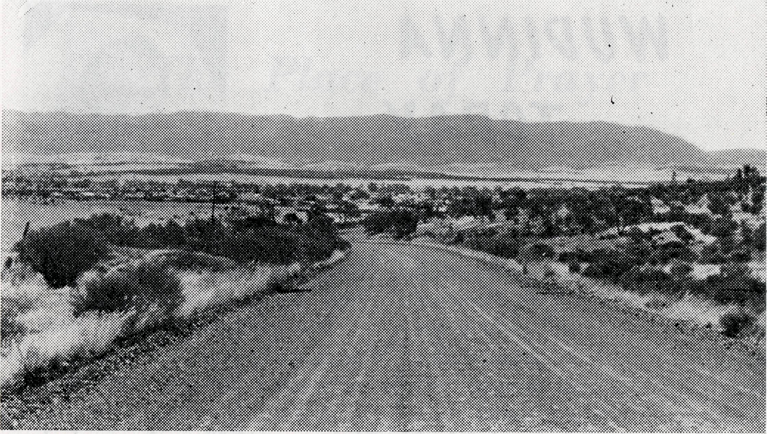
Reverend Alan MoMahon
there just on tea time to be welcomed by "bring your gear in while I tell the cook to hold tea until you have had time to shower and change." The manager of this station travels 60 miles to church each month and is most disappointed if I don't stay with them when I'm visiting the area north east of Quorn. As they were engaged in shearing at the time I had the further opportunity of meeting most of the team.
Next day as I set out for home I detoured to Wilpena Chalet, the holiday resort in the Flinders Ranges, to make final arrangements for a service to be held a few weeks later.
A couple of Wednesdays ago I set out for my regular weekly Religious Instruction lessons at Hawker, a small town just 42 miles north of Quorn. This trip was, however, to be a little different, for I had planned to travel further north after the lessons were completed.
So then, after lessons had finished at the Hawker State School, I travelled northwards along the plain road which runs along the foot of the beautiful Flinders Ranges, a sight which always fills one with inspiration and admiration at the mighty handwork of God.
I arrived at Parachilna Railway Siding just on lunchtime and as the Hotel is the only public building, I stayed there for lunch. A few minutes after I arrived, the grandson of the publican came looking for me to see if I would go to the school for an extra scripture lesson, in fact he wouldn't leave until I said I would. I only have one Religious Instruction lesson here each month, but their keenness is tremendous. Lessons I've given in previous
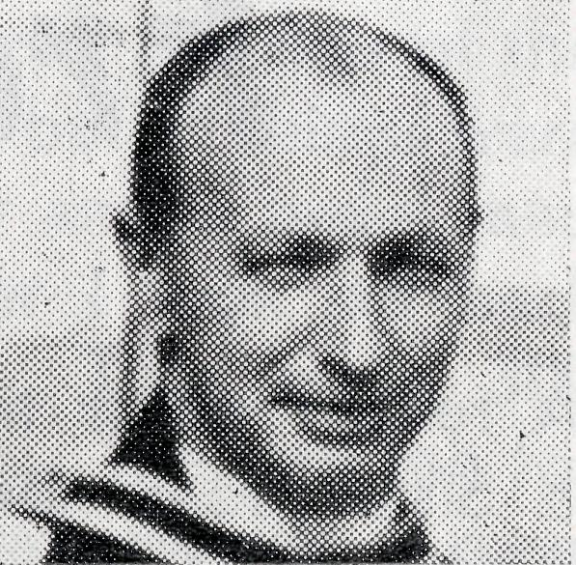
years are still remembered, such is their thirst for the things of God. It was suggested to me that we hold a service as they only have three church services each year and these are conducted by the Lutheran pastor. So I arranged to return the following week especially to take a church service.
Incidentally, when I arrived just one week later only one person, the schoolteacher who is a Christian lad, came even though he had personally visited every home and had invited every family in the district.
After the lesson at the School, I travelled another 20 miles north east to Blinman, a township of approximately forty people. Here again I was able to take a Religious Instruction lesson at the school and then set out in an easterly direction to visit some of the stations in the area.
I arrived at the first in time for afternoon tea and although I normally stay here overnight I had decided to visit another station which is about one hour's drive further south. I arrived
The road to Quorn.
This time, however, some 61 people were present. So different from my previous experience at Parachilna.
Folk may sometimes wonder if a bush ministry such as mine is worth all the effort and the cost to maintain. To this my reply would be, "Yes, it is worth it." First of all God has called me to this work in the outback and if it were not His will He would never have called. Then secondly, if you could see the hunger which the children have for the things of God, if you could experience the warm welcome extended to me on every visit, then you too would agree that it is worth it.

THE REAL AUSTRALIAN, SEPTEMBER, 1965
THJC REAL AUSTRALIAN, SEPTEMBER, 1965

The Place of Prayer
Wudinna is one of the major towns on Central Eyre Peninsula but even so it is still only a very small town with a population of approximately 250 people living in the town while a similar number of people live on the farms which surround the centre.
Just recently the local council were able to encourage a Chemist to set up a pharmacy in the town and the St. John Ambulance Association have introduced an Ambulance Service.
The Central Eyre Peninsula District Hospital is, of course, staffed and run by the B.C.A. and our work as members of the staff consists mainly in nursing the variety of cases which would be found in any city hospital. We have a midwifery section, general section and an outpatients department. Being a country hospital, one would suppose that it would be much quieter than its city counterpart but I must say that I have not noticed the quietness as we seem to be as busy as any city hospital. At the moment we are giving lectures in the local St. John First Aid Course. The average attendance so far has
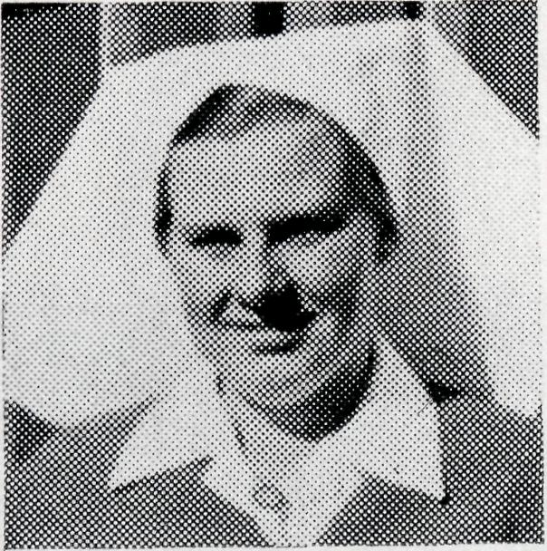
WUDINNA TODAY
Sister J. Zillman
been approximately 28 with just half the course completed.
The purpose of the first aid lectures is that we will be able to roster drivers and first aid assistants for the new ambulance. Unlike city ambulance services we are not able to have a permanent staff but must rely upon local folk as volunteer drivers and attendants.
So far the new ambulance has already saved one life in providing oxygen for a patient during a journey to our hospital, so it has been well worth while. Then, should an accident occur it is much better to have trained first aiders to assist in handling injured folk and to have a proper vehicle to transport them to hospital rather than making do with trucks or station waggons.
So you see, although Wudinna may only be a small town, nevertheless there is always a great deal to do and I am often reminded of St. Paul's words in 1 Corinthians 15:58, "Therefore, my beloved brethren, be steadfast, immovable, always abounding in the work of the Lord, knowing that in the Lord your labour is not in vain."
THE REAL AUSTRALIAN, SEPTEMBER, 1965
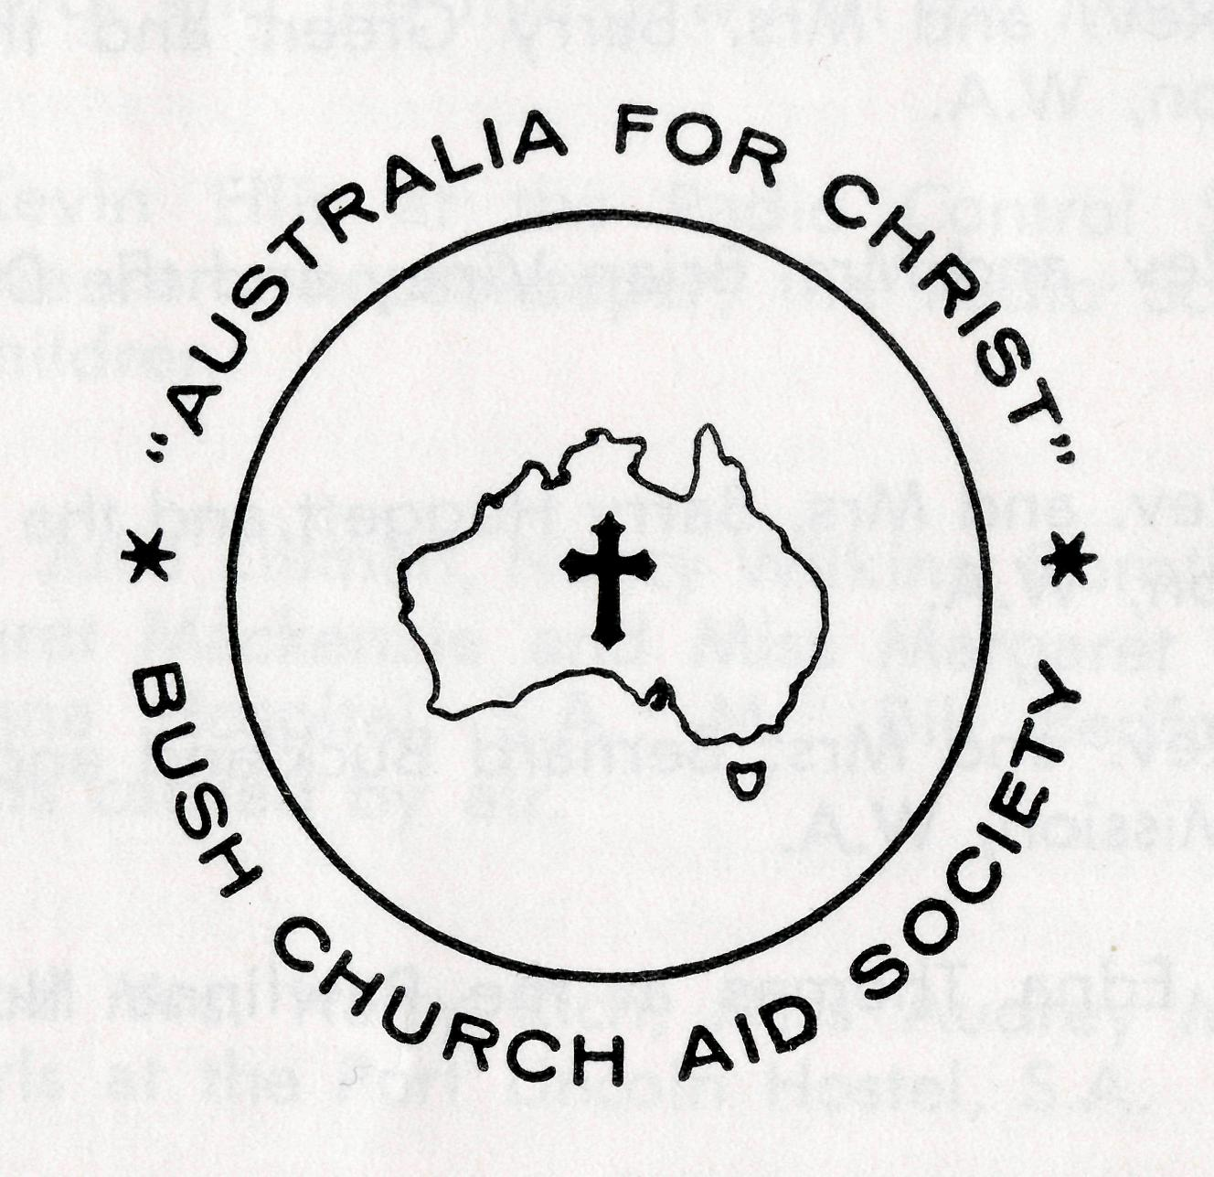
The following pages represent a daily prayer calendar which will be revised with each issue. We earnestly seek your prayers for the individual members of our staff. We suggest you remove these centre pages from the magazine and keep them for your regular devotional use.
"Let us ask God that they may receive from Him all wisdom and spiritual understanding for full insight into His will, so that their manner of life may be worthy of the Lord and entirely pleasing to Him. Pray that they may bear fruit in active goodness of every kind and grow in the knowledge of God. May He strengthen them, in His glorious might, with ample power to meet whatever comes with fortitude, patience and joy; and to give thanks to the Father who has made them fit to share the heritage of God's people in the realm of light."
(Adapted from Colossians 1 N.E.B.)
THE REAL AUSTRALIAN, SEPTEMBER, 1965 9

1st Miss Rose Campbell, Miss Dianne Sidebottom and all the helpers and scholars in the Mail Bag Sunday School.
2nd Mr. and Mrs. Sid Bennetts, Miss Win I kin and the boys at Urallie Hostel, Moree, N.S.W.
3rd The Rev. and Mrs. Barry Green and the Ord River Mission, W.A.
4th The Rev. and Mrs. Brian Viney and the Derby Mission, W.A.
5th The Rev. and Mrs. Barry Huggett and the Port Hedland Mission, W.A.
6th The Rev. and Mrs. Bernard Buckland and the Murchi-son Mission, W.A.
7th Sister Edna Thomas at the Rawlinna Nursing Home, W.A.
8th Sisters Marjorie Tarr and Maude Ross at Cook Hospital, S.A.
9th Sisters Barbara Fox and Beverley Smith at Tarcoola Hospital, S.A.
10th The Rev. and Mrs. John Wyndham and the North-West Line Mission, Tarcoola, S.A.
11th Mr. and Mrs. Stan Hummerston and the administrative work within the Flying Medical Service.
12th Dr. Merna Mueller, Dr. and Mrs. Don Tindal, and the patients within the Medical practice.
13th Miss Nicole Patton and the work at the Ceduna Pharmacy, S.A.
14th The Rev. and Mrs. Harry Goodhew and the Ceduna Mission, S.A.
15th Sisters Marion Hope, Vera Holie, Mavis Bell, Val Gameau, Jean Griflfen, Lola Higgs and Misses Dorothy Duver and Leslie White at the Ceduna Hospital, S.A.
16th Mr. and Mrs. John Lindridge, Mr. and Mrs. Allan Chadwick and the flying within the Medical Service.
17th Mr. Kevin Ellis at the Radio Control Station, Miss Marjorie Farr, housekeeper, the Radio School Teacher and children.
18th Sisters Julia Zillman, Nancy Wilkins, Dorothy Whyburn, Margaret Mackenzie and Miss Margaret Chadwick at Wudinna Hospital, S.A., Mr. Bill Bedford and the patients carried by air.
!9fh N\r. and Mrs. Harry Rich, Miss Audrey Morrison and the girls at the Port Lincoln Hostel, S.A.
20th Sisters Vaisey Cochrane and Heather Heaver at the Coober Pedy Medical Centre, S.A., and Sister Edna Thomas at the Rawlinna Nursing Home, W.A.
21st The Rev. and Mrs. Ron Keynes and the Leigh Creek Mission, S.A.
22nd The Rev. Alan McMahon and the Quorn Mission, S.A.
23rd The Rev. and Mrs. Brian O'Grady and the Wilcannia Mission, N.S.W.
24th Mr. and Mrs. Bill Kerr, Miss Myra Attwood and the boys at the Broken Hill Hostel, N.S.W.
25th The Rev. and Mrs. Ray Neve and the Menindee Mission, N.S.W.

THE REAL AUSTRALIAN, SEPTEMBER, 1965
THE REAL AUSTRALIAN, SEPTEMBER, 1965

OVER-ORD
The Reverend Barry Green
26th The Rev. Theo Hayman, Mr. Alban Kirkby and the South Australian Representation.
27th The Rev. Alan Baker and the Timboon Mission, Victoria.
28th All students in training for outback ministries, a continued supply of replacement personnel, our Box Secretaries, the evergrowing number of supporters and their ready response.
29th The Rev. John Stockdale, Mrs. W. Hughes, the Victorian Committee and Office Staff.
30th The Rev. Bill Rich, the Rev. Arthur Williams, the Rev. Les Wiggins, Messrs. Laurie Calder, Frank Burner, Mrs. Joy O'Neill, Misses Ruth Close, Deirdre Briggs, Suzanne Thorley at Headquarters and the Council of the Society.
31st Give thanks to God always—for personal blessing, for opportunities to serve Him, for the growth of the Society work since its formation.
O Lord God of our nation, Who hast commanded men to subdue and replenish the earth: Look in Thy love upon all who in distant parts of our land are striving against many difficulties, and are deprived the access of the means of grace. Strengthen and guide the Bush Church Aid Society and all members of the staff. Cheer and comfort them in discouragement and loneliness, bless their ministrations to the good of those they serve, and grant that the message of redeeming love may thus be rooted and grounded in our national life, to the glory of Thy Great Name through Jesus Christ our Lord. Amen.
O God, we remember before Thee those whom Thou hast called to Thy service. Bless them this day, we beseech Thee, as we
pray for Call forth others
to stand with them in their task. Grant to them, as to us, the joy of service, the ability to achieve and the serenity of Thy peace, for Jesus' sake.
Amen.
Driving the 2,500 miles from Perth to Wyndham convinced us of one thing: Australia is a huge, old, waterless expanse. Nearly all of the river beds we crossed were dry, even though the "wet" had just finished. Nevertheless, the beauty of the land is breathtaking. Seeing how few people live in the few North West towns is a sobering observation, and causes one to rethink his approach in ministering to the needs of people in this area, especially after coming from larger "established" centres of Anglican folk. It is amazing how one takes for granted that each town has an Anglican Church building, with people to worship there and a priest to minister to them.
Along the route we encountered locked-up or disused Church buildings. From Broome to Wyndham there are only two garage-like Anglican Church buildings: St. Paul's, Derby, and St. Boniface's Wyndham. It would take pages to describe the trip and so all I will say here is, that it was an educational introduction to the North West. It was good to meet fel-
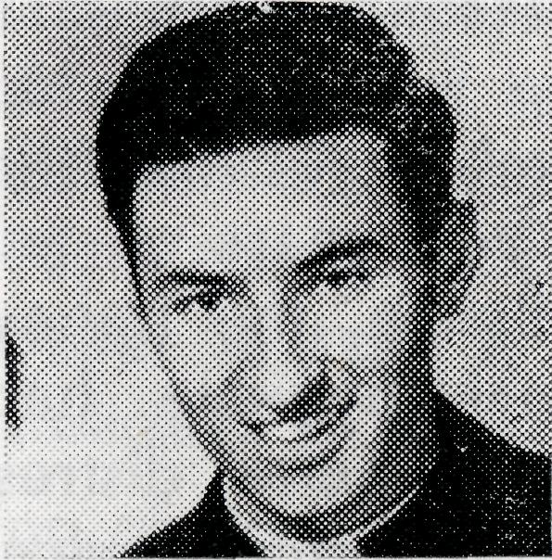
low B.C.A. priests and share in Christian fellowship and also good in that now we can put faces to some of the names on the B.C.A. prayer list.
The house at Kununurra cannot be built until the end of the year at the very earliest, and Jan and I have found accommodation in Wyndham which is very temporary to say the least. However, for the time being, we have a roof over our heads and why worry about what could happen?
Half an hour after arriving in Wyndham I conducted my first service—a funeral. Nearly all the town turned out for it and although many local customs were quite foreign to me, I did at least have the opportunity to give a message to perhaps the biggest congregation I'll ever have in Wyndham. As it stands at present, weekly services are held at both Wyndham and Kununurra, with monthly "safaris" to cattle stations, taking in a service at Halls Creek. At Wyndham nearly all members of the congregation are aborigines, with very few whites, some of whom only come up here for

12
THE REAL AUSTRALIAN, SEPTEMBER, 1965
THE REAL AUSTRALIAN, SEPTEMBER, 1965
13

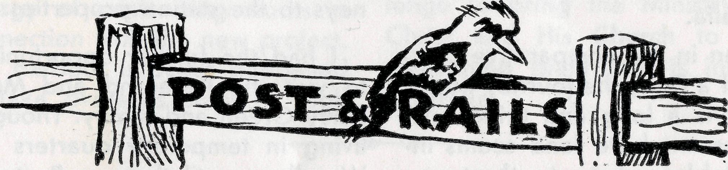
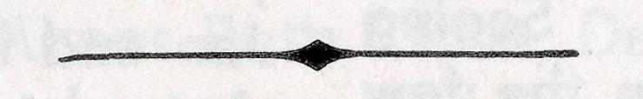
STAFF MOVEMENTS
the seasonal work at the meat-works, from May to August/ September. Even though we spent two years on an Aboriginal Mission, the behaviour and personal hygiene habits here leave us quite distressed and the noise during services at times is rather distracting. The Roman Catholic brethren also have this problem.
Services at Kununurra are held at the school in one of the classrooms. The attendance is not great but then, all things
# The vacancy in the Derby Mission, W.A., has resulted in a number of moves by members of our staff. The Reverend Brian Viney and family have moved from Menindee, N.S.W., to Derby, W.A. The Reverend Ray Neve and family have moved from Wilcannia to Menindee, N.S.W., while the Reverend Brian O'Grady and family have moved from Tarraleah, Tas., to Wilcannia, N.S.W. To each of these men we extend our prayerful good wishes as they take up work in these mission districts. @ From Binna Burra (via Lis-more), N.S.W., we welcome to our staff Miss Audrey Morrison. Miss Morrison, who was a regu-
14
must have a beginning. Although being the first priest into an area has its difficulties re housing, travelling, searching out, etc., the joy of trying to build is rewarding. So much is different here, so much presents a challenge but the need for presenting the Gospel is great.
Jan and I need your support in prayer, to help us in this vital task, and we also wish to thank the many supporters of B.C.A. who have made it possible for us to serve God in this part of His vineyard.
lar listener to our "Bush Padre" sessions, has been appointed Assistant at the Port Lincoln Girls' Hostel.
• It is always good to welcome new staff members, particularly when it concerns the Flying Medical Service. From Lithgow, N.S.W., we welcome Sister Lola Higgs to the staff at the Ceduna Hospital. From the parish of St. Barnabas', Broadway, Sydney, we welcome Miss Nicole Patton. Miss Patton as a pharmacist, will take charge of the Pharmacy at Ceduna. May we assure each of these new members of staff of our prayers for them as they settle into the work.
THE REAL AUSTRALIAN, SEPTEMBER, 1965

® Our best wishes and congratulations are extended to Sisters Marjorie Tarr and Val Gameau, both of whom have recently announced their engagements.
• Congratulations are also due to Dr. and Mrs. Don Tindal on the arrival of their son, Robert Stuart. We also congratulate our former Medical Officer, Dr. Robert Robinson, and Mrs. Robinson, on the arrival of their son, David Robert.
• There were many favourable comments following the Annual Rallies, both in Sydney and Melbourne. Financially the results were Sydney £2,377 and Melbourne £1,100. The move to bring both Rallies forward to May to coincide with the approximate date of the beginning of B.C.A. proved very successful. In Sydney the Service of Thanksgiving which preceded the Rally was an inspiration to all. It was good to have as occasional preacher the Rt. Reverend Tom Jones. ® A contract has been signed for a £9,500 house to be built at Kununurra. Work is expected to start soon and the house finished before the end of the year.
THE REAL AUSTRALIAN, SEPTEMBER, 1965
# Once again we express our thanks and appreciation to Dr. Geoff. Middleton of Sydney for his month at Ceduna, enabling Dr. M. Mueller to take a well-deserved holiday.
@ Speaking of Doctor's holiday, it was good to see Dr. Mueller while she was in Sydney. An informal gathering of former members of the Flying Medical Service was held in the home of Sister L. Loane.
• Following discussions with the Bishop of Tasmania and the clergy of the Derwent Valley, our responsibilities at Tarraleah have ceased from the end of August. Although we regret the loss of contact with Tasmania in this way, our sense of stewardship of Society resources and and the readiness of the Diocese to assume local responsibility prevail. We thank God that ten years of faithful ministry by Society staff, coupled with prayerful and practical concern from our supporters, have resulted in yet another achievement. ® The Sydney Women's Auxiliary had a very pleasant day for their Annual Fair in July and are pleased to report that the sum of £750 was raised.
15

Iron Ore opens up North-West Australia
NOKTH
WEST JOURNEY
Reverend L. J. Wiggins
A 'locum tenancy" for several months at Derby provided an opportunity for me to see and experience the ministry of B.C.A. in the far north west of Australia.
Even in the comparative comfort of a DC3, the journey northwards is a long and tiring one. The brown bare land seems inhospitable and empty, the towns impossibly far apart, but this is the "real" Australia, and there is a work and a witness to be brought to these people who have made their lives in such barren places.
The "parish" of Derby consists of the town itself, the iron-ore islands in Yampi Sound, the cattle stations around and the families living on the Camballin rice project. I was fortunate to be there in the warm, dry winter rather than in the humid "wet" season, when all the normal burdens of outback living are made all the more uncomfortable and difficult.
Derby is a small town, with several modern civic buildings but little else that is attractive to
the visitor. On the flat peninsula of land leading to a wharf in King Sound, it is almost surrounded by mud flats that are covered by the sea only several times a year. The Rectory, built with B.C.A. assistance, is airy and comfortable and the little Church next door, though plain, represents the faithfulness of the small congregation. The pastoral ministry in Derby follows the usual pattern but much time is taken up by the trips to the islands and occasional journeys to the station properties.
I had the further opportunity to visit the Reverend and Mrs. Barry Green and family. Though living in temporary quarters at Wyndham until the new Rectory is completed at Kununurra, they were cheerfully tackling the complexities of this new work. The day was hot when we drove in the Land Rover to Kununurra to meet some of the people and to see the progress of the cotton growing on the Ord River project. Part of Mr. Green's "parish" extends more than 200 miles south to Hall's Creek with many station properties in between.
Back at Derby it was time to prepare for the coming of the Revd. Brian Viney and family, preceded by a visit from the Administrator of the Diocese, who instituted and inducted Mr. Viney on Sunday, 16th July. I started my return journey by
travelling to Port Hedland by car with the Revd. Barry Hug-gett who had come to Derby for the Induction Service. Five hundred miles of heat, dust and incredibly bad roads (part of "National Route No. 1"!). We made a side trip to visit the new iron ore project at Mt. Golds-worthy, where the whole mountain, all of iron ore, is to be transported to Japan. Then on to Port Hedland, where the typical sleepy town atmosphere has been replaced by the bustling energy of contracting works in connection with the new project. The harbour is being deepened to take overseas ships, a high
The following is from a report published recently in Western Australia which highlights some of the development at present going on in that State.
The discovery of iron ore in incredible quantities that cannot be calculated accurately in our time is precipitating Western Australia's second big economic leap. Discovery of gold at Cool-gardie precipitated the first leap and now iron ore promises to project Western Australia into the position of major provider of some of the world's mineral raw materials.
school is being built, housing and accommodation are desperately short with the influx of new workers.
Finally, another trip by car to Wittenoom Gorge, where Mr. Huggett was to hold services on the Sunday. Blue asbestos is mined here and the township, though very isolated, is situated in the magnificent scenery of the Gorge. I left Mr. Huggett here to continue his ministry, part of an ever-widening challenge to bring the Ministry of Christ and His Church to the awakening giant that is inland Australia.
So far, three companies have completed contracts to supply Japan with iron ore—a fourth company has signed letters of intent and will shortly negotiate a contract.
The total value of iron ore committed for export to Japan by these four concerns comes to £900,000,000.
Thus one of the exciting mineral stories of the world is now unfolding in Western Australia—it is the story of the discovery and development of the third biggest reserve of high grade iron ore in the free world.

16
THE REAL AUSTRALIAN, SEPTEMBER, 1965
THE REAL AUSTRALIAN, SEPTEMBER, 1965
17

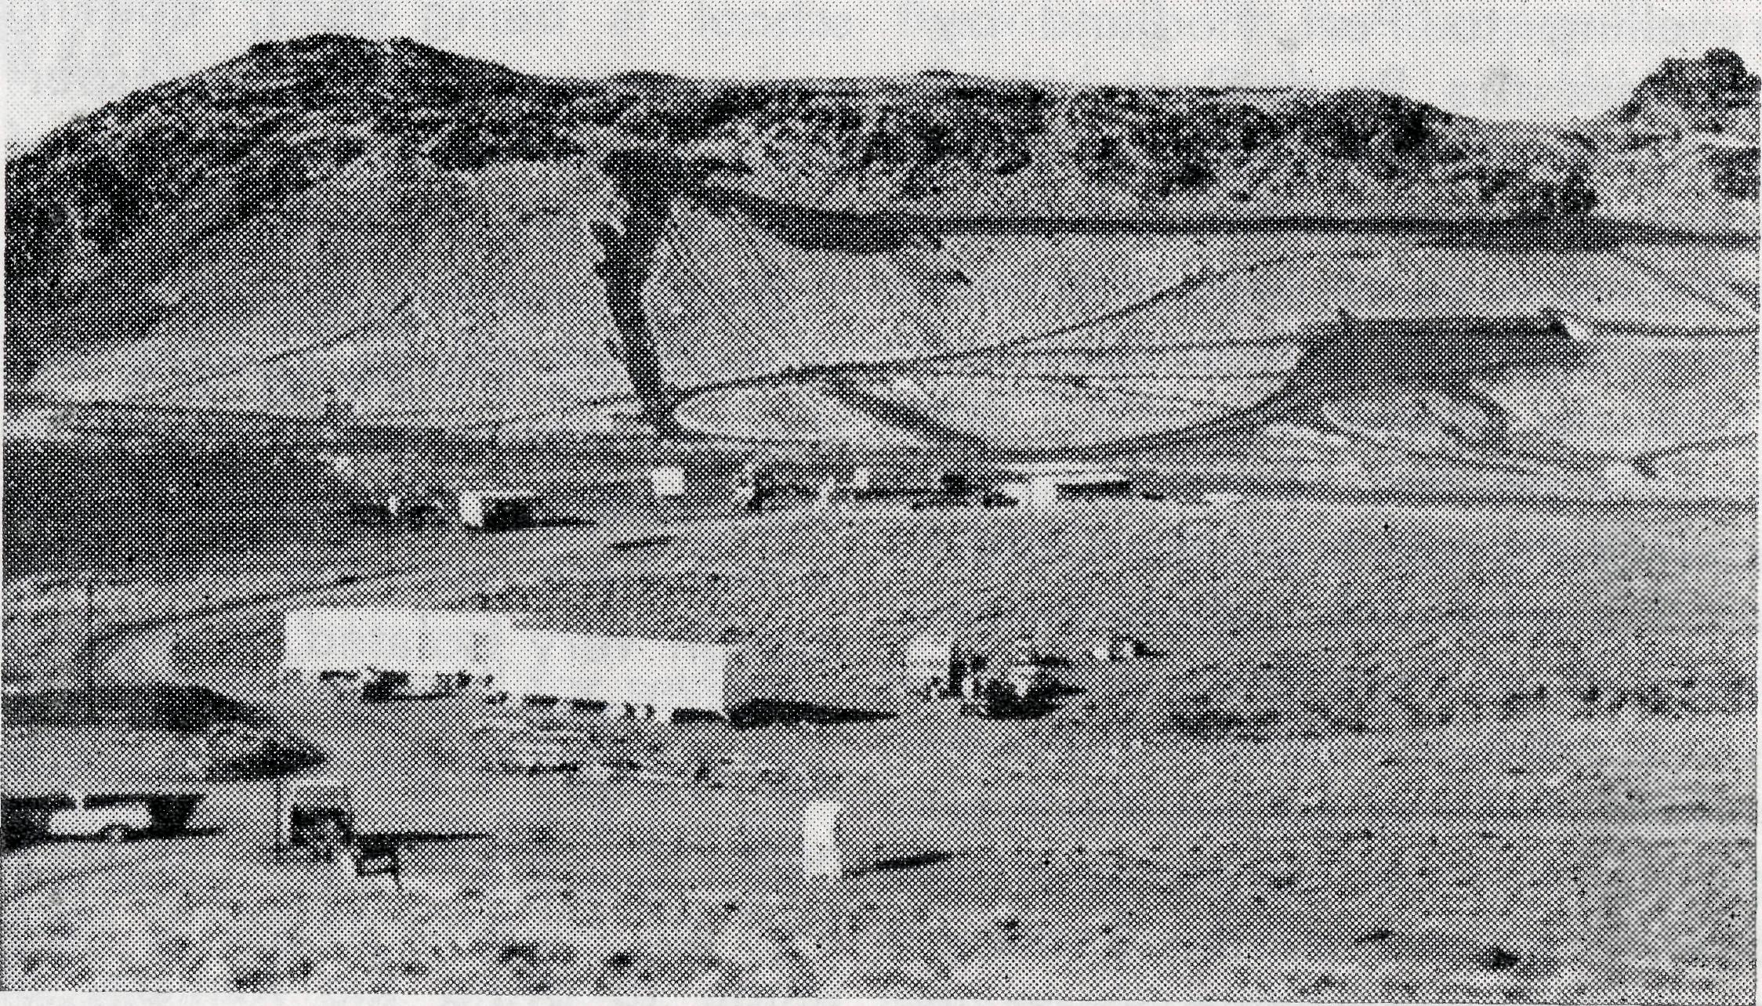
Mf. Goldsworthy
The Premier of Western Australia said recently, "It is difficult to believe that the major discoveries have all occurred in the first half of this decade. It is difficult to believe that two thirds of the investment programme may be completed in the second half of the decade. In the North West alone present plans indicate that Port Hedland could be trebled in size, six new towns created, together with four or five deep sea ports and 600 miles of standard gauge railway."
Every day now sees dramatic changes taking place in Port Hedland, new buildings in concrete and other permanent building materials—indeed during the past four years the number of houses in the town has doubled. As well as new standard gauge railway lines, with trucks, engines, and terminals,
iron ore project.
Port Hedland will have a new port big enough to cope with 30,000-ton ore carriers.
New air conditioned towns are being built with modern amenities for shopping and recreation. Towns like Mt. Goldsworthy with an expected population of 500-600, Mt. Tom Price—107 houses planned here (population 500), Mt. Newman —300 houses, population 1,500, are at present under way at the ore sites while at King Bay, 28 miles west of Roebourne, a new port site is roaring ahead on a round-the-clock basis.
B.C.A. has already been asked by the Diocese of North West Australia to find and finance a fifth clergyman for a new district between Onslow and the Hammersleys.
More than ever before the Society needs men of "grace, grit and gumption".
Never a Dull
Moment
Reverend J. Wyndham
"Am I on the road to Cook, mate?" was how he opened the conversation. I'd passed his Land Rover on the track about an hour before, and it had really sounded sick then. In the vehicle were his wife and two kiddies.
\ was a bit taken aback, as this was the "track" beside the railway line and there was still the sand hill country to go through—certainly no place to travel in a mechanically unsound vehicle with a family.
This was at Wynbring, and despite all advice to the contrary, he was determined to get through. I suggested that he wait until the morning before setting off as it was now dusk, and to go on before me for security. This he did, and the family left about three hours ahead of me.
As I travelled along the track the next morning, I lost the tracks of the other Land Rover about 40 miles out and became concerned for its occupants. About 4.30 p.m. I reached
Immarna to find that nobody had sighted the Land Rover since the point at which the tracks disappeared.
Through the Commonwealth Railways Control Officer I contacted the policeman at Tar-coola. Imagine my surprise when he said to me on the Control phone, "Did this feller have any firearms on him?", and to be told that the man was wanted for armed robbery in two states.
As if all this wasn't enough excitement, I then discovered that a stud had been torn out of the gearbox casing and that oil was pouring out. This would be bad enough in the city, but at this point in Australia, with 18 miles of the worst sand dunes to cross, it was disastrous and a matter for much prayer.
The answer to this prayer is proof that we serve a God who is sufficient for all our needs.
I returned to the control phone at 6.15 p.m. and said to the Controller, "There's no chance of getting a flat-top out on to-night's goods, is there, Vic?" His answer was what I might have expected. "Fair go, mate, she's made up to leave in about two hours. What's the trouble?" I related the problem and he said that he'd see what he could do. At 8.00 p.m. there

18
THE REAL AUSTRALIAN, SEPTEMBER, 1965
THE REAL AUSTRALIAN, SEPTEMBER, 1965
19

was no flat-top but there was room for one on the train. After a service at Immarna I went to bed, having committed the problem to the Lord once more.
The next morning, the new controller was able to tell me there was a flat-top wagon on the train for me. This was a miracle for normally even in an emergency Port Augusta would require two days' notice. However, our God knows of our needs before they occur. Even more miraculous was the fact that the goods train had left Port Augusta without the empty wagon.
As this train was heading north-west at 40-50 m.p.h., another train was at Pimba, 112 miles from Port. The driver had been given an order to proceed towards Port Augusta and wait at Woocalla crossing loop until the FAST goods went through. He had orders to leave immediately or else wait for three hours where he was. Just as he was pulling out, a porter informed him that he should have picked up two flat-tops for Port Augusta—some-one had failed to pass this message on. A hurried call to the controller resulted in being told to get going and leave the flat-tops where they were—one was wanted!
20
So, I had my flat-top. But there was another problem! The Land Rover had to be put on this wagon and then taken to Watson where repair facilities were available. This would take time and there was no loading ramp. What to do! At this point the fettlers came to help. Before work and in their own time they built a huge platform of sleepers and a ramp of sleepers on to it, beside the line.
Even then, could the train wait long enough—twenty minutes—for the operation to be carried out. You see, it was a goods express and had to cross another at Ooldea, twenty miles away. Another call was made to the Train Controller, who contacted a senior officer to gain permission. This was granted, but only because the train I wanted was half an hour early, and the other half an hour late. This gave time for the loading to be done. Had the trains been on time, I would have had to wait at least twenty-four hours before being able to move.
As it was the repairs were effected the next day, and I was on my way with no loss of time.
As Paul wrote to the Philip-pians, "My God shall supply all your need . . ." Praise Him!
THE REAfl, AUSTRALIAN, SEPTEMBER, 1965
The Bush Church Aid Society
for Australia and Tasmania
FIELD STAFF:
DIOCESE OF ADELAIDE, S.A. Ceduna-Penong, S.A.—Rev. R. H. Goodhew, Th.L Tarcoola, S.A.—Rev. J. Wyndham, Th.L.
DIOCESE OF WILLOCHRA, S.A.
Leigh Creek, S.A.—Rev. R. Keynes, Quorn, S.A.—Rev. A. McMahon, Th.L Th.L
DIOCESE OF BALLARAT, VIC. Heytesbury Mission, Vic.—Rev. A. Baker, Th.L.
DIOCESE OF RIVERINA, N.S.W.
Wilcannia, N.S.W.—Rev. B. O'Grady, Menindee, N.S.W.—Rev. R. Neve Th.L. Th.L.,
DIOCESE OF NORTH-WEST AUSTRALIA Derby Mission.—Rev. B. Viney, Th.L., Derby, W.A.
Murchison Mission.—Rev. B. R. Buckland, Th.L., Mount Magnet, W.A. Ord River Mission.—Rev. B. W. Green, Wyndham, W.A. Port Hedland Mission.—Rev. B. Huggett, Th.L., Port Hedland, W.A.
MAIL BAG SUNDAY SCHOOL
Director: Miss R. Campbell.
HOSTELS FOR SCHOOL CHILDREN
PORT LINCOLN, S.A.
Mr. and Mrs. H. RICH. Miss A. MORRISON.
BROKEN HILL, N.S.W.
Mr. and Mrs. W. KERR. Miss M. ATTWOOD.
MOREE, N.S.W.
Mr. and Mrs. S. BENNETTS. Miss W. IKIN.
THE REAL AUSTRALIAN, SEPTEMBER, 1965

