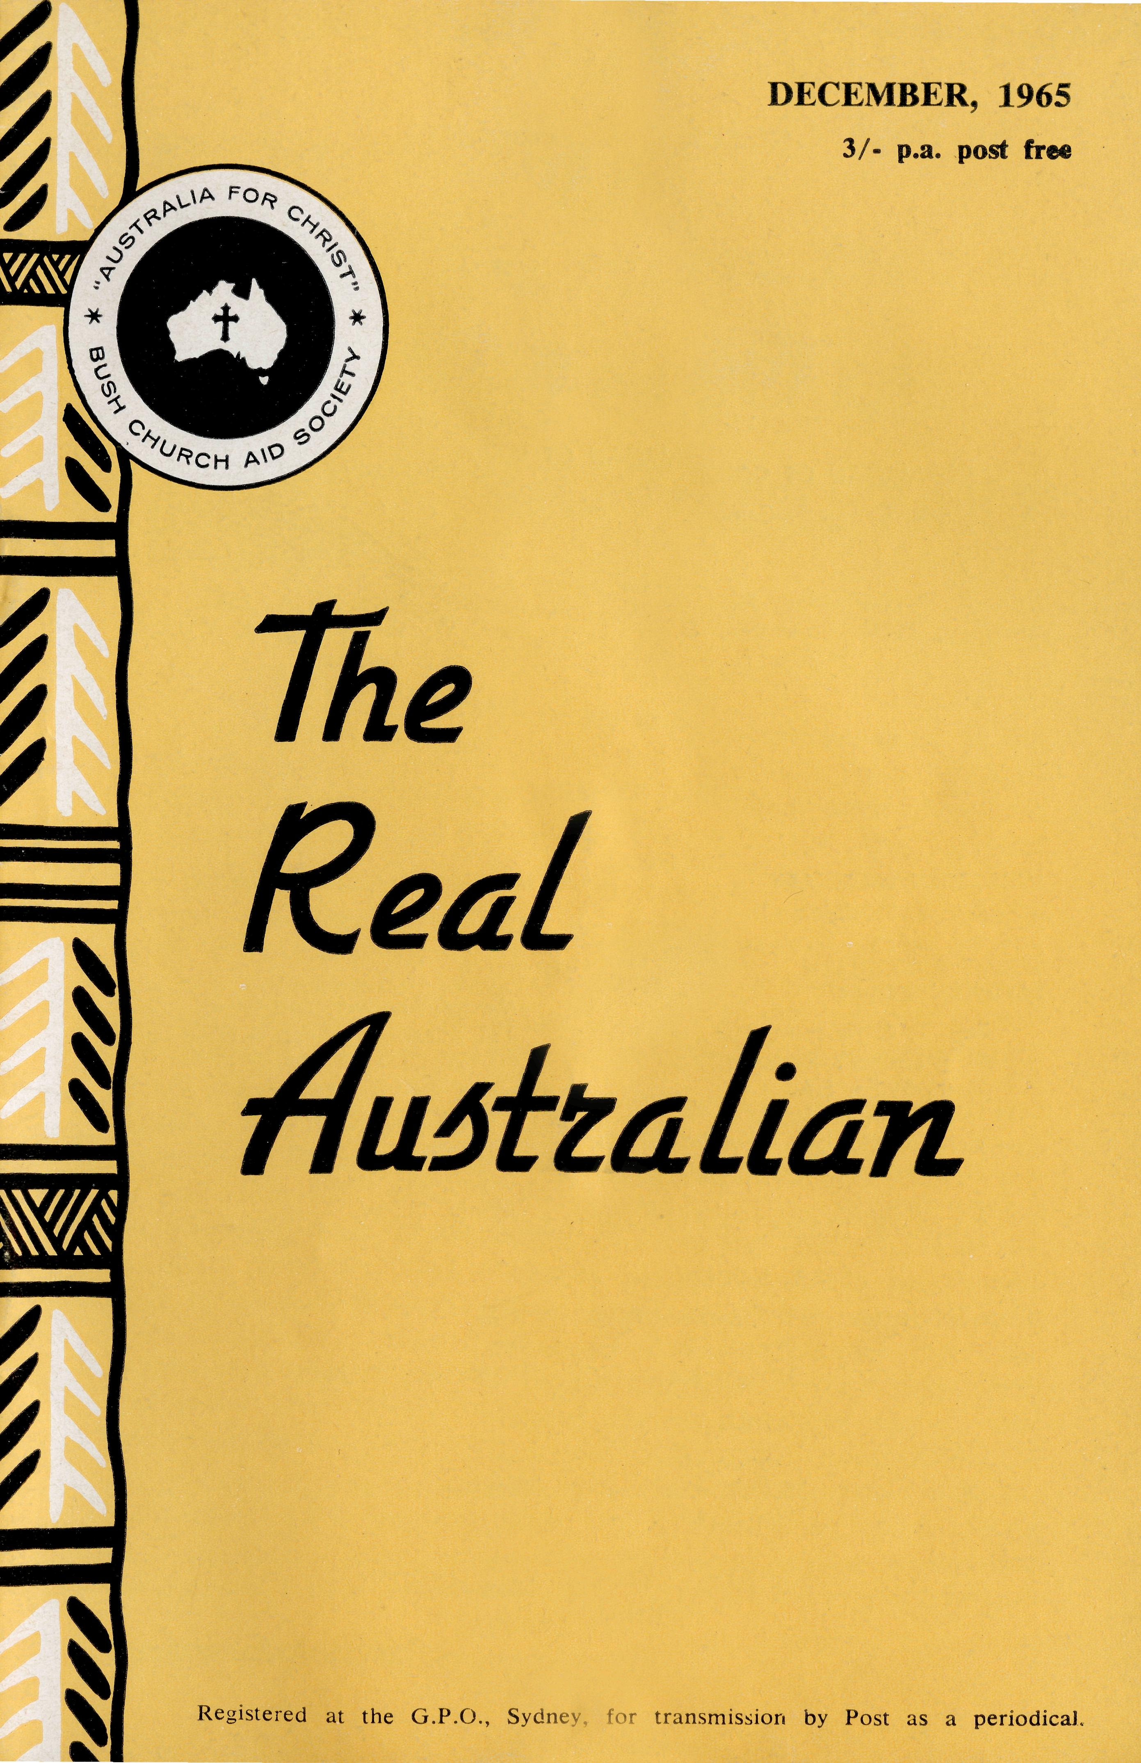
FLYING MEDICAL SERVICE STAFF
Executive Officer: Mr. S. HUMMERSTON Medical Officers: Dr. M. MUELLER, O.B.E.
Matron: Sister M. HOPE
HOSPITAL CENTRES
Sisters V. HOLLE, V. GAMEAU, B. SMITH, Misses D. DUVER and L. WHITE.
Matron: Sister f. ZILLMAN.
Sisters N. WILKINS, D. WHYBURN, M. MACKENZIE, Miss M. CHAD-WICK.
CEDUNA, S.A.
The Murat Bay District Hospital—
WUDINNA, S.A.
The Central Eyre Peninsula Hospital—
COOK, S.A.
The Bishop Kirkby Memorial
Sisters L. HIGGS, M. ROSS.
Hospital—
TARCOOIA, S.A.
Sisters B. FOX, M. TARR.
The Tarcoola Hospital—
PENONG, S.A.
Vacant.
The Penong Memorial Hospital—
COOBER PEDY, S.A.
Sisters V. COCHRANE, H. HEAVER.
The Coober Pedy Medical Centre—-
Sister J. GRIFFEN.
PILOTS
Mr. J. LINDRIDGE Mr. A. E. CHADWICK Mr. W. BEDFORD
SINGLE STAFF HOUSEKEEPER
Miss M. FARR.
RAWLINNA, W.A. The Nursing Hostel—
AIRCRAFT
Cessna 210 —VH-AEC
Cessna 210 —VH-FMS
Beagle Airedale — VH-UEP
PHARMACIST
Miss N. PATTON.
RADIO CONTROL STATION
Control Officer — Mr. K. ELLIS
Mr. A. E. CHADWICK
EDGAR BRAGG & SONS PTY. LTD.

The Bush Church Aid Society
for Australia and Tasmania
PRESIDENT
The Most Reverend, The Archbishop of Sydney.
VICE-PRESIDENT
The Most Reverend, The Archbishop of Melbourne.
CHAIRMAN OF COUNCIL HONORARY TREASURER
Rev. Canon E. Cameron. Mr. R. T. Stokes.
COUNCILLORS
Ven. G. R. Delbridge, Rev. Canon R. M. Hudson, Revs. C. A. Baker, L. H
Broadley, E. V. Constable, O. W. C. Cooper, W. I. Fleming, A. C. Miles
Messrs. H. M. Bragg, K. C. Lyne, E. Stockton.
FEDERAL SECRETARY
Rev. C. W. Rich, Th.L.
ASSISTANT FEDERAL SECRETARY
Rev. A. E. Williams, Th.L.
VICTORIAN SECRETARY
Rev. J. Stockdale, Th.L.
SOUTH AUSTRALIAN REPRESENTATIVES
Rev. T. J. Hayman, Th.L., St. Matthew's Rectory, Marryatville, S.A. Telephone: FA 1022. Mr. A. Kirkby, 7 Ruthven Avenue, Glandore, S.A. Telephone: LF 3268.
B.C.A. HOUSE
NEW SOUTH WALES SECRETARY
Rev. L. J. Wiggins, Th.L.
SOLICITOR
Messrs. Maxwell and Boyd, 141 Elizabeth Street, Sydney
HONORARY AUDITOR
F. W. A. Eagar and Co., 8 Belgrave Street, Manly, N.S.W.
135 Bathurst Street, Sydney.
Phones: 26 3164, 26 3780.
Telegraphic Address: "Chaplaincy", Sydney.
VICTORIAN OFFICE
Morton House,
262 Flinders Lane, Melbourne.
Phone: 63 8962.
"AUSTRALIA FOR CHRIST"
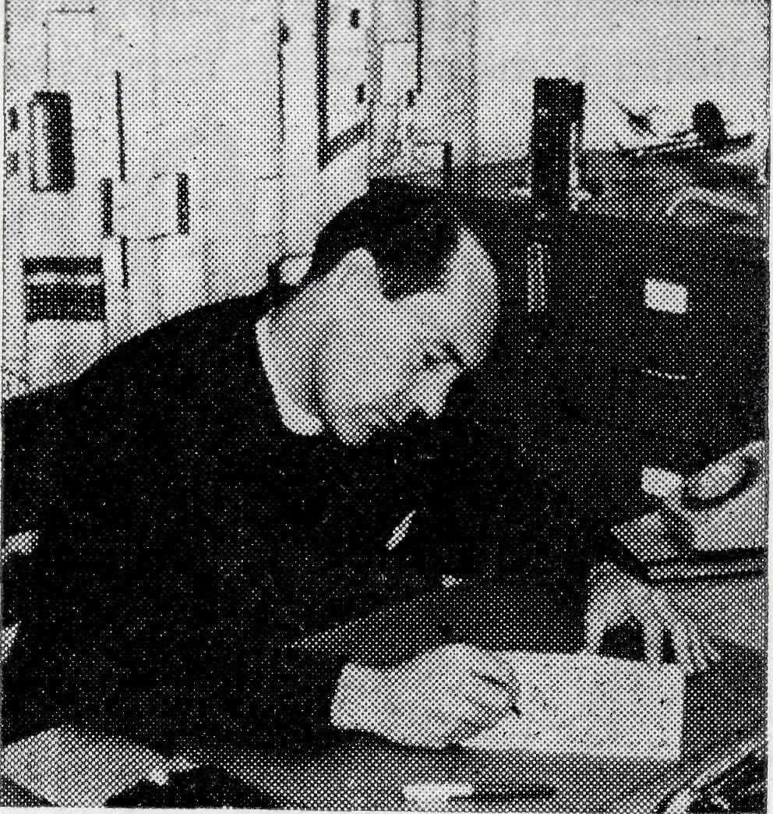
For some time past I have spoken and written freely of the changing character of parts of remote Australia.
In no small way this was impressed upon my mind as recently I travelled through the iron ore development areas of Western Australia. Industrial and commercial enterprises have taken charge there in a most dramatic way. Towns are being created, distances appear to be shrinking and public facilities are being taxed to the limit. By direct contrast, other areas seem to be slowing down to "a point past Stop!" Lethargy and apathy to current affairs prevail and many take refuge in the glories of former days.
It is into this atmosphere that our Society staff is projected and as I constantly move amongst our people I hear and appre-
from the
FEDERAL
SECRETARY
ciate the worthwhileness of the Christian witness these folk present. In most cases there are but a dedicated few to stand with our clergy or our medical staff in their efforts. Here I know the staff are conscious of the volume of sympathetic, prayerful concern of our supporters—and how keenly this is appreciated.
As prevails at present, and as I believe will prevail even more keenly in the future, the resources of the Society will be taxed to the utmost to meet the demands of those we would serve. Of all our resources none is more inadequate than the availability of people to go forth into this changing scene. Our nursing staff is desperately in need of trained nurses and domestic assistants, our clergy ranks need to be replenished —where are the young men and

THE REAL AUSTRALIAN, DECEMBER, 1965.
THE REAL AUSTRALIAN, DECEMBER, 1965.

of opportunity to glorify Him amongst men.
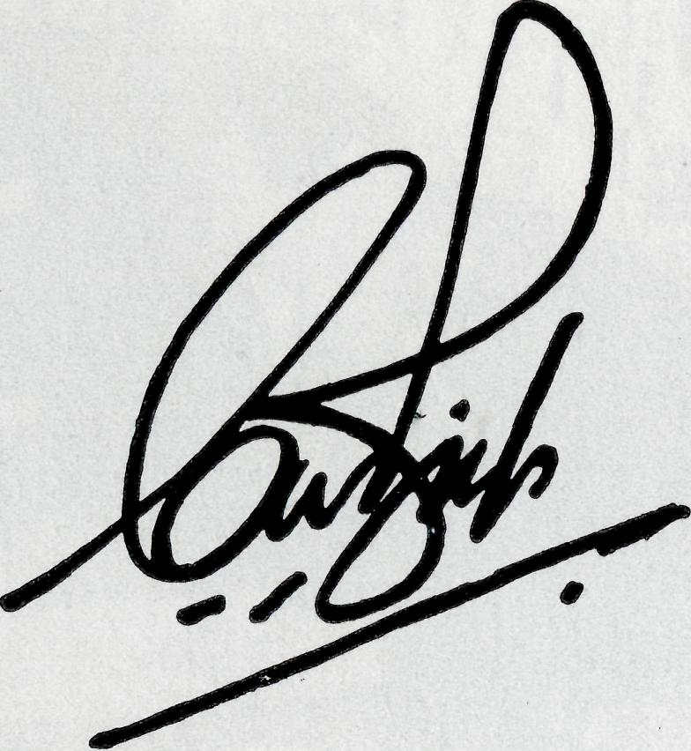
women needed for the task? Can we each make this a priority in our prayerful concern?
As we at this time thank God for His unspeakable gift of His Son to redeem mankind let us, in faith believing that He will provide, go on into a New Year

STAFF URGENTLY NEEDED
- Clergy in Priest's Orders.
- A Doctor.
- Double Certificated Nurses.
- Domestic workers capable of cooking in small outback hospitals.
May the Joy of Christmas
Bring Blessing for the New Year
"for behold, I bring you good news of great joy which will come to all the people; for to you is born this day in the city of David a Saviour, who is Christ the Lord."
—Luke 2:10.
INASMUCH
Sister Marion Hope
Inasmuch! This is a word which opens before us a vision of glorious service. It portrays Christian stewardship through the lips of our Saviour. It displays a canvas of Christian truth which cannot be ignored. It brings Christ down to the common way of ordinary men.
"Inasmuch as ye have done it unto one of the least of these my brethren, ye have done it unto me." Who were His brethren? None but the hungry, the thirsty, the naked, the sick and the prisoners—the lower strata of humanity symbolizing the helpless, friendless and forgotten peoples of the world.
So often in our daily walk of life we come face to face with these folk—people who are in physical and material needs— and people without a saving knowledge of Christ.
Nursing within the Bush Church Aid Society doesn't offer very much of a difference in nursing. We have the ordinary daily hospital routine and come
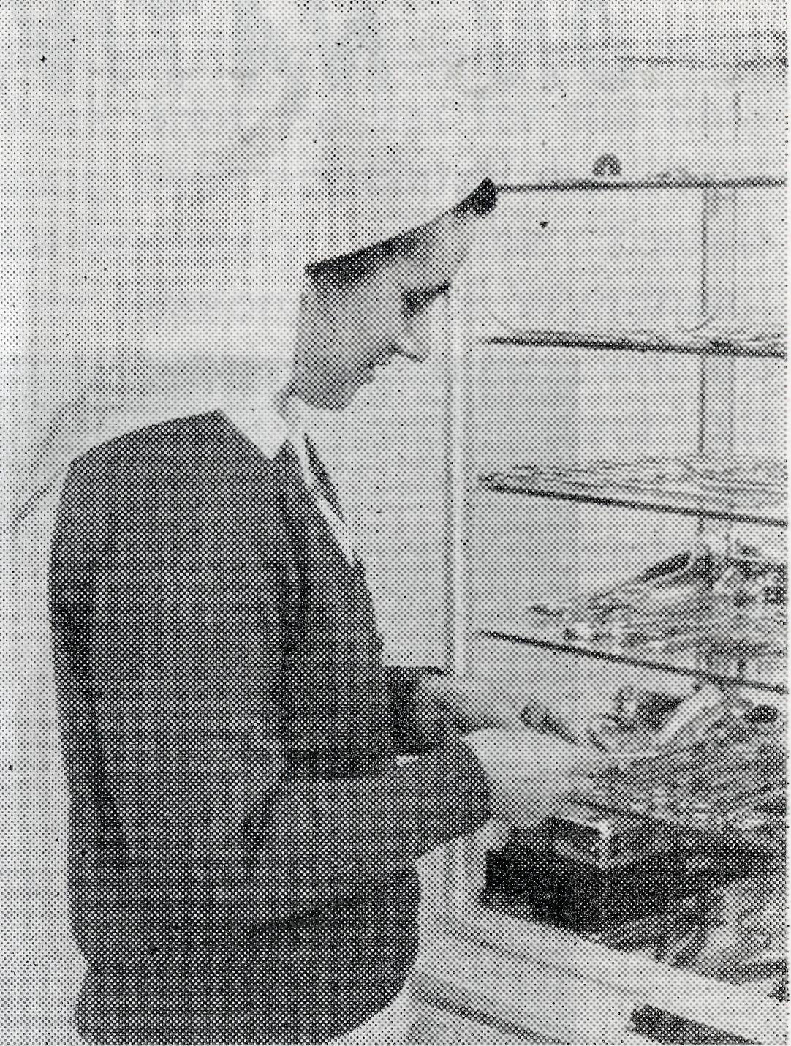
into contact with the ordinary everyday people, BUT we are here with a purpose, and that purpose is summed up in the word Inasmuch'.
Our work cannot continue without the necessary staff to maintain the five hospitals within the network. The need is great —but then you say so is the need great overseas and at home in the cities. This is true but if the Lord's work is to continue, He will call forth labourers into His harvest. Maybe He will call you!
Not only trained nurses are required, but dedicated women prepared to do domestic work or nursing aides can be used to help maintain the staff position in our hospitals.
Remember—"Inasmuch . . . ye have done it unto me."

THE REAL AUSTRALIAN, DECEMBER, 1965
THE REAL AUSTRALIAN, DECEMBER, 1965

to enable the parish to support a curate whose specific responsibility will be to work at Cherbourg. The Reverend David McDougall, formerly at the Radio Base, Ceduna, is at present engaged in this task.
The Reverend Barry Green has been resident in Wyndham for the past five months awaiting the erection of the Rectory in Kununurra. Although his ministry will ultimately be extended over
ON NATIVE AFFAIRS
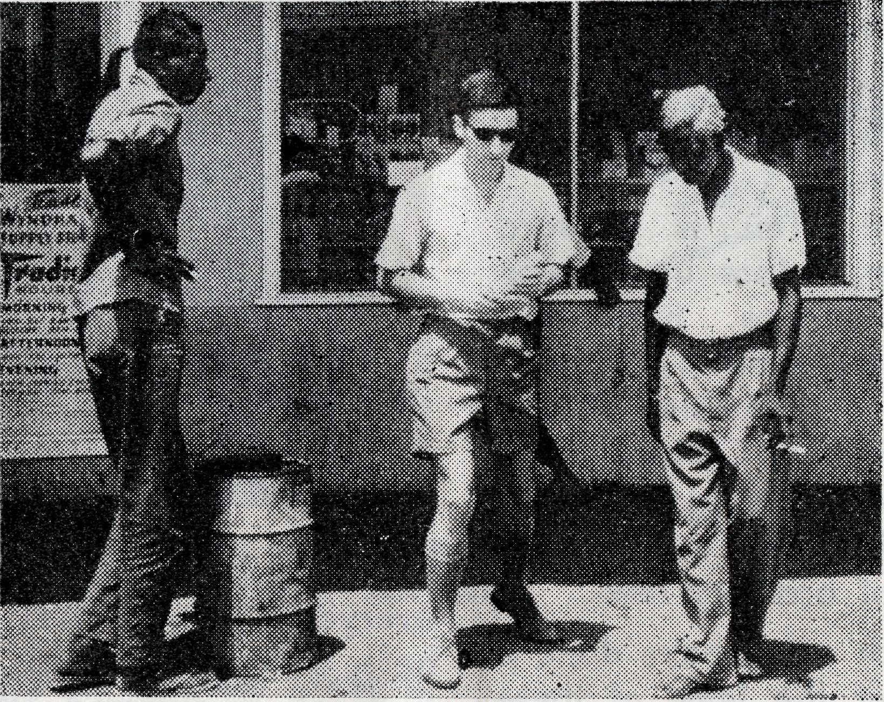
The Rev'd Barry Green speaks with one of the Wyndham vestrymen.
the Ord River Project and Halls Creek area, he has for the time being been appointed the Chaplain-Secretary of the Forrest River Mission, east of Wyndham. It is expected that this will be a temporary appointment till other arrangements can be made by the F.R.M. Committee. We would commend to your prayers these two particular ministries in which the Society has been able to be of assistance.
B.C.A.S.Q.

Miss M. Farr

Many times we are asked whether the Society undertakes Native Mission work amongst our Australian Aborigines. The answer is, of course, that the Society has not, nor has it had, any specific responsibility in this regard. This does not mean that we do not extend a ministry to natives. Far from it, in fact. Our Flying Medical Service Staff spend a considerable portion of their time assisting the natives from Government or Church Mission Stations and our Clergy, in most instances, minis-
ter to the many fringe-dwelling natives within their parishes.
However two specific ministries have recently come within the orbit of Society endeavour.
The parish of Kilkivan, Mur-gon, Queensland, has within its boundaries the Cherbourg Mission, which is under the control of the State Native Welfare Board. The present Rector, the Reverend A. J, Geriach—a former B.C.A. missioner, approached the Society through the diocese for assistance. We have been able to make a grant
A new series of initials are to be seen around Ceduna "B.C.A.S.Q." The last two stand for Single Quarters, which have been established at the Radio Base Home. At present we have our Chemist and our Radio Operator and are looking forward to a Dentist coming in January. We have had an occasional visitor and have entertained many of our friends. We have large rooms where we can store the equipment for our varied interest and also a nice lounge for combined doings.
We take our part in B.C.A. doings as a family, but each has his or her own outside interests. Life at the Radio Base is sometimes exciting. When an emergency arises we ail, including amateurs, have to do a little bit to help. The ambulance is also kept at the Base and sometimes as our tea is on the table, away goes the ambulance and a tea goes into the oven. As in all families, there are some times of strain and we ask your prayers that we may be able to show a really Christian witness in our living together.

THE REAL AUSTRALIAN, DECEMBER, 1965
THE REAL AUSTRALIAN, DECEMBER, 1965

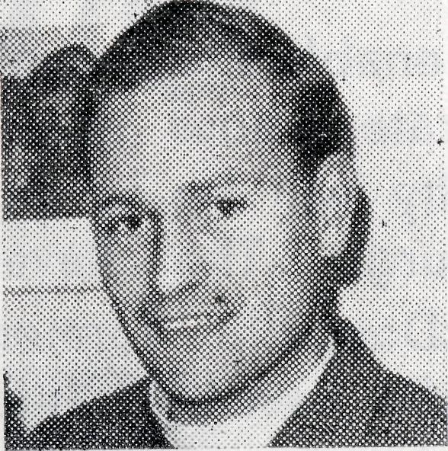
THE OUTBACK PARSON
The Reverend Brian O'Grady
and without the modern vehicles, and so we are sharing in a pioneering work in a land full of local colour and tradition which is also the backbone of the primary producing areas of this country.
Christian ministers are needed everywhere. We are not to lower our thinking and our vision of the mission of our Church, but to support and become involved anywhere that we as Christians might witness, by our lives and prayers.

CEDUNA-TUESDAY NIGHT!
Miss Nicole Patton
The day was hot and muggy. The kind of humid weather typical to mid-summer in Melbourne. We were sitting out in the sun-room hoping to catch some breeze, when a friend turned to me and said, "How do you manage to put up with the hot climate of the outback? Wouldn't it be better for you and your family to settle down and not to run all around the countryside? Why don't you stay in the city and work in a normal parish?" Thoughts such as these are often expressed by friends and well-meaning folk, but I feel that their vision of Christian service is limited and their attitude to the ministry rests too much upon physical and outward circumstances.
There are many places similar to the Wilcannia Mission, isolated from the hub of suburban life and extending over huge areas of flat land dotted with small scrub, sheep, and station buildings. The outback does present problems. There are the lonely nights for the wives and the families who must often stay at home whilst the missioner travels for many days visiting
his vast area. Medical and schooling facilities are not as good as in the city, and food is rarely at super-market prices, also the heat, flies and dust can leave one a little uncomfortable; but while one could list many disadvantages of this kind of work, I believe that the outback parsons are engaged in a ministry which challenges not only the spiritual life of the missioner and his family but also our capacity to adapt without compromising the Christian life.
There is a greater opportunity in scattered areas to really get to know your people. There are many people who think that the Christian life is impracticable and for this reason often become lax in their observance of public worship. Here in the distant parts of the Australian outback we have the privilege of spending many evenings and sharing meals, giving us opportunities that seldom present themselves in the atmosphere of the formal Christian service.
We are conscious that we are treading in the paths of those who have laboured before us, often in more trying conditions
Ceduna could never be said to be a dull place. Though it seems quiet to the casual observer, the young newcomer has only himself to blame if he sits at home every night and does not become acquainted with some folk of the town. There are many clubs to which one can belong. In fact there often comes an evening when one could choose between three or four meetings. To name but a few of these clubs, there is the Sailing Club, Swimming Club, Speed Boat Club, Basketball Club, Tennis Club, Football Club, Cricket Club, Camera Club, Drama Group and the most recent one established, the Combined Christian Churches' Youth Club.
Just after my arrival at the end of July, the first meeting of C.C.C.Y.C. was held in the Methodist Hall with an attend-
ance of nearly thirty. Since then the attendance has soared to more than forty on several occasions. The obvious enthusiasm of those who attend confirms the wisdom of establishing this club meeting, the first three-quarters to one hour of which is spent in Bible Study or discussion groups, stimulating and thought-provoking topics being chosen and presented by one or other of the three Ministers concerned.
It behoves the Committee to dream up entertainment for the group following this devotional period and, so far, their ideas have proved successful. The table tennis competition was a huge success and was a good way of introduction to a few people for those who were new to the town. There was a background of music on record for the music enthusiast. The pur-

THE REAL AUSTRALIAN, DECEMBER, 1965
THH REAL AUSTRALIAN, DECEMBER, 1965

chase by the Basketball Club of lights to enable them to play at night made possible a C.C.C.Y.C. Evening at Basketball. The rules varied with the Umpire (Men's B-ball, Women's B-ball, combinations of each, etc.) and much laughter was heard that night. Even Sergeant Arney, our Police Sergeant, joined in and proved to be one of the best goalies.
Another recent event was the Car Rally, which was really a scavenger hunt on four wheels.
This group has enabled me to make many friends and also
given me the opportunity to play the guitar (about the only practice I have these days!). Your prayerful concen for our Club will be ^appreciated. Apathy to the Gospel is very great here, some I have heard think that the Youth Club's programme is too religious, but one is encouraged by the interest shown by the majority, that many who were not seriously interested in the Christian message before now have begun to think more deeply as shown by their contribution to our meetings.

From Victoria
The Place of Prayer
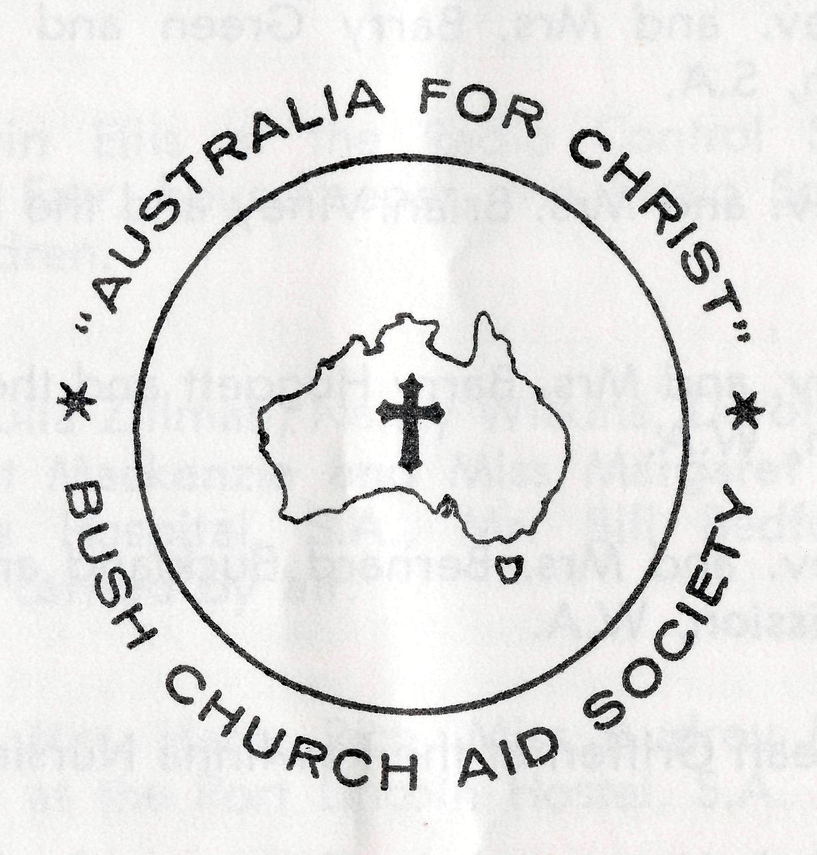

There has been a wonderful response by the members of the Girls' Friendly Society in the Diocese of Melbourne this year with regard to interest in B.C.A. Over 40 branches have been visited by the Victorian Secretary. Their mission project for the next two years is B.C.A., and more specifically the provision of a projector and screen for the Medical Centre at Coober Pedy. The Society is most appreciative of this interest and practical assistance.
A recent visitor to the office was Sister Vaisey Cochrane who has been home on leave.
Deep appreciation is expressed to all who gave gifts or donations towards the Annual Fair, and to all helpers who worked so hard on the various stalls to ensure the success of this year's Fair.
* * *
Council has received the resignation of the Reverend S. S. Viney from the Council of the Society. Mr. Viney has served faithfully as a missioner and Council member for many years. We thank him for his service and extend to him our sincere good wishes.
THE REAL AUSTRALIAN, DECEMBER, 1965
The following pages represent a daily prayer calendar which will be revised with each issue. We earnestly seek your prayers for the individual members of our staff. We suggest you remove these centre pages from the magazine and keep them for your regular devotional use.
Further prayer items and information letters are sent at regular intervals, to all members of the B.C.A. Fellowship of Prayer.
Membership in the Fellowship is invited from all who are concerned in the prayer support of our work. There is no joining or membership fee, although a badge (pin or brooch) may be purchased for 5/- if so desired.
Send your name and address to the N.S.W. or Victorian Secretary and the prayer letter will be forwarded to you.
THE REAL AUSTRALIAN, DECEMBER, 1965 9

1st Miss Rose Campbell, Miss Dianne Sidebottom and all the helpers and scholars in the Mail Bag Sunday School.
2nd Mr. and Mrs. Sid Bennetts, Miss Win I kin and the boys at Urallie Hostel, Moree, N.S.W.
3rd The Rev. and Mrs. Barry Green and the Ord River Mission, S.A.
4th The Rev. and Mrs. Brian Viney and the Derby Mission, W.A.
5th The Rev. and Mrs. Barry Huggett and the Port Hedland Mission, W.A.
6th The Rev. and Mrs. Bernard Buckland and the Murchi-son Mission, W.A.
7th Sister Jean Griffen at the Rawlinna Nursing Home, W.A. 8th Sisters Lola Higgs and Maude Ross at Cook Hospital, S.A.
9th Sisters Barbara Fox and Marjorie Tarr at the Tarcoola Hospital, S.A.
10th The Rev. and Mrs. John Wyndham and the North-West Line Mission, Tarcoola, S.A.
11th Mr. and Mrs. Stan Hummerston and the administrative work within the Flying Medical Service.
12th Dr. Merna Mueller and the patients within the medical practice.
13th Miss Nicole Patton and the work at the Ceduna Pharmacy, S.A.
14th The Rev. and Mrs. Harry Goodhew and the Ceduna Mission, S.A.
15th Sisters Marion Hope, Vera Holle, Beverley Smith, Misses Dorothy Duver and Lesley White at the Ceduna Hospital, S.A.
16th Mr. and Mrs. John Lindridge, Mr. and Mrs. Allan Chadwick and the flying within the Medical Service.
17th Mr. Kevin Ellis at the Radio Control Station, Miss Marjorie Farr, housekeeper, the Radio School Teacher and children.
18th Sisters Julia Zillman, Nancy Wilkins, Dorothy Whyburn, Margaret Mackenzie and Miss Margaret Chadwick at Wudinna Hospital, S.A., Mr. Bill Bedford and the patients carried by air.
19th Mr. and Mrs. Harry Rich, Miss Audrey Morrison and the girls at the Port Lincoln Hostel, S.A.
20th Sisters Vaisey Cochrane and Heather Heaver at the Coober Pedy Medical Centre, S.A.
21st The Rev. and Mrs. Ron Keynes and the Leigh Creek Mission, S.A.
22nd (he Rev. Alan McMahon and the Quorn Mission, S.A.
23rd The Rev. and Mrs. Brian O'Grady and the Wilcannia Mission, N.S.W.
24th Mr. and Mrs. Bill Kerr, Miss Myra Attwood and the boys at the Broken Hill Hostel, N.S.W.
25th The Rev. and Mrs. Ray Neve and the Menindee Mission, N.S.W.

10
THE REAL AUSTRALIAN, DECEMBER, 196f
THE REAL AUSTRALIAN, DECEMBER, 1965

FIRST AIDERS
26th The Rev. Theo Hayman, Mr. Alban Kirkby and the South Australian Representation.
27th The Rev. Alan Baker and the Timboon Mission, Victoria.
28th All students in training for outback ministries, a continued supply of replacement personnel, our Box Secretaries, the evergrowing number of supporters and their ready response.
W. Hughes, the Victorian
29th The Rev. John Stockdale, Mrs, Committee and Office Staff.
30th The Rev. Bill Rich, the Rev. Arthur Williams, the Rev. Les Wiggins, Messrs. Laurie Calder, Frank Burner, Mrs. Joy O'Neill, Misses Ruth Close, Deirdre Briggs, Suzanne Thorley at Headquarters and the Council of the Society.
31st Give thanks to God always—for personal blessing, for opportunities to serve Him, for the growth of the Society work since its formation.
O Lord our God, Who hast given unto us a fair land and abundant blessings, Make us ever mindful of those who live in lonely places. Bless, we beseech Thee, all members of the Bush Church Aid Society, and those whom they seek to serve. Grant that, through the ministry of the Word and Sacraments, through healing, through caring and instruction of the young, the message of Thy redeeming love may be proclaimed, and Thy Church strengthened in this our land, Through Jesus Christ our Lord. Amen.
O God, we remember before Thee those whom Thou hast called to Thy service. Bless them this day, we beseech Thee, as we
pray for Call forth others
to stand with them in their task. Grant to them, as to us, the joy of service, the ability to achieve and the serenity of Thy peace, for Jesus' sake.
Amen.
Miss Margaret Chadwick.
Early his year, after a public meeting at Wudinna decided to purchase an ambulance, it was found necessary for a group of people to train as 'first aiders', so as to assist not only with the driving of the ambulance but with any casualties as well.
Late in June, many people duly turned up at the school to see what the Hospital Sisters and Dr. Douglass could teach us.
Coming into the class room one saw the old familiar desks and chairs, but on turning to the blackboard we were confronted with the horrible sight of two skeletons (on paper) pinned to the wall. By the time a month of lectures had been and gone, I began to wonder what on earth I'd let myself in for, and would have pulled out if it hadn't been for the thought that one day I might help save a life if I came across anyone involved in an accident and as well I could be more assistance in our work here at the hospital.
As time progressed and we became more familiar with what was expected of us, the classes
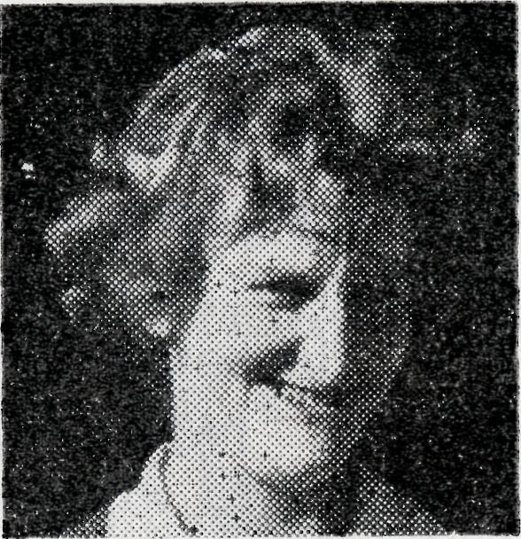
were quite welcome and much amusement was enjoyed by all. Our evenings always started off on a serious note when we were each handed a Test Paper on our previous lecture, then followed the lecture for the night. The next hour or so of practical work was spent putting as many bandages and splints on our partners as we could, apart from when the 'casualty' had a specific complaint or injury.
The most interesting lecture as far as I was concerned was on the unconscious patient; mainly because that is when my assistance is required. I enjoy my work here in Theatre and in Outpatients if I can be of assistance, as well as amongst the patients as a whole.
The first aid classes just finished have taught me quite a bit that I didn't know before, and now I am quite looking forward to the Drivers' Nursing Course which Sister Wiikins is giving. The reward for nights of lost sleep and hours of study is obvious when we see a person walk out of the front door of the Wudinna Hospital well enough to go home.

12
THE REAL AUSTRALIAN, DECEMBER, 1065
THE REAL AUSTRALIAN, DECEMBER, 1965
13

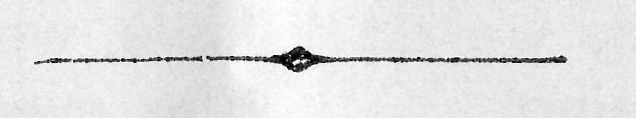
® During the year deputation visits have been made to 106 Sydney parishes, while a further 34 parishes have been visited in the dioceses of Canberra-Goulburn, Newcastle, Grafton and Armidale. The response in the country dioceses is certainly growing and we should like to record our appreciation to the Bishops of all these dioceses and to their clergy for their helpful co-operation in not only making the deputation possible but also in providing over-night accommodation for our deputation staff.
# As we come to the end of yet another year, may we express our sincere thanks to all of our supporters. While we write to acknowledge donations sent direct to us, we find that some forget to include a name and address. To you, may we say "Thank you!". Also may we add a "Thank you" to our many box holders, although we ask our local Box Secretaries to do this for us each time a box is opened. We should like you all to know that we greatly appeciate your practical and prayerful concern.
# After months of banging hammers and clouds of dust, the extensions to B.C.A. House are now complete. Improved office facilities have made the administration work much more convenient, while the extra storage space on the third floor has meant that the Sunday School and deputation stores at Bondi and North Sydney are now not needed.
• From the 14th February, 1966, all receipts issued by the Society will be made out in dollars and cents. However, like the banks, we will continue to receive donations in either currency. Plans are under way to assist our Box Secretaries to convert all box moneys to the new currency at the regular parish box opening times.

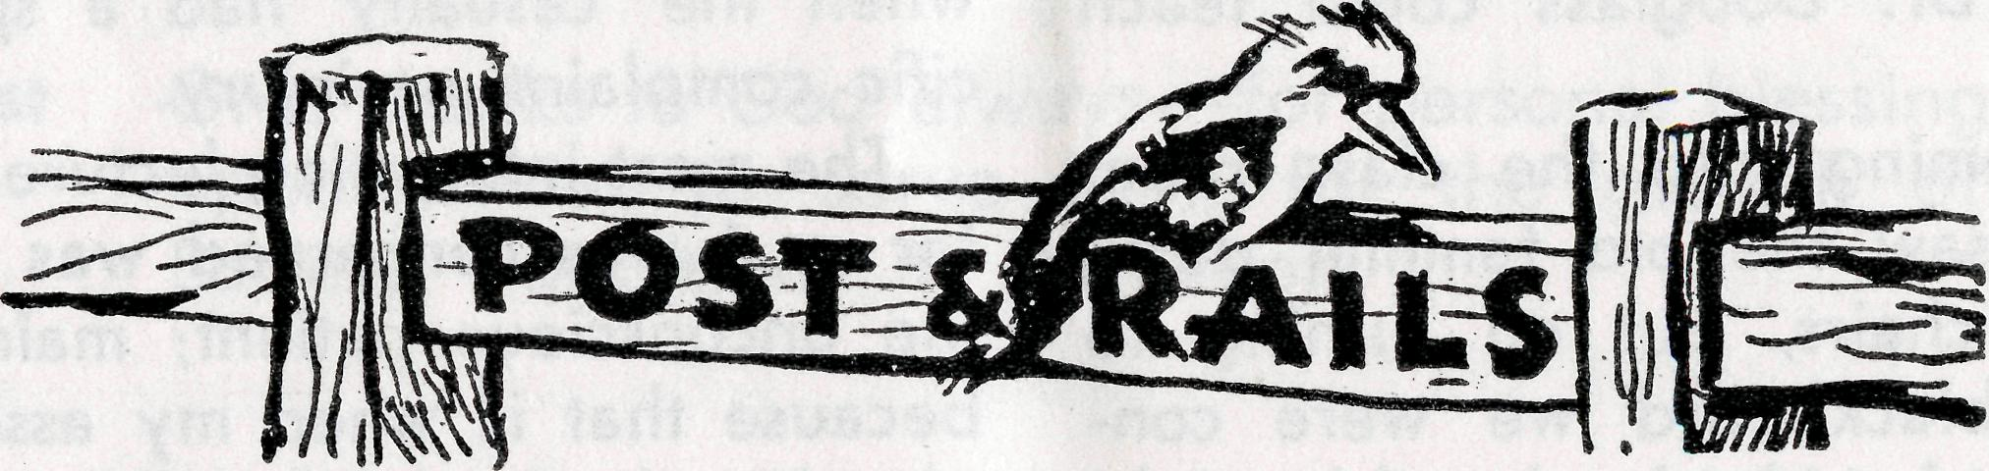
STAFF MOVEMENTS
# Prayerful good wishes are
extended to the new Bishop of
North West Australia, the Rt.
Reverend Howell Witt, and to
his family as they settle in to
the Bishop's House at Gerald-
ton, W.A. The new Bishop was
consecrated and enthroned in
the Cathedral of the Holy Cross,
Geraldton, on St. Andrew's Day.
• Our prayerful good wishes
are extended to Sister Mavis
Bell, who has recently an
nounced her engagement, and
to Sister Marjorie Tarr, whose wedding will take place at St. Stephen's Church, Willoughby, on the 8th January. # We record, with regret, the passing of Mrs. Vera Richards on the 4th October, 1965. Mrs. Richards was a member of our Sydney Women's Auxiliary and had been a faithful Box Secretary and supporter of the Society for many years. Her love for the work resulted in many gifts during her lifetime.
© All Society supporters will rejoice with us that our prayerful search for a Dentist has ended. Mr. John Crocker, from the parish of St. Aidan, Longue-ville, will take up this work within the Flying Medical Service from February, 1966. Since the tragic death of Mr. Lyn Jauncey this work has been idle for the past three years. We would commend Mr. Crocker to your prayers as he prepares for this task, and as he proceeds to meet this need.
© A number of resignations from the nursing staff of the Flying Medical Service take effect at the end of this year:
To Sisters Mavis Bell, Marjorie Tarr and Val Gameau, we extend our best wishes for the future and assure them of our appreciation of their years of service in the F.M.S.
$ We are grateful to Dr. Don Tindal for his twelve months' service with the Society at Ceduna. Unfortunately, at the end of October, Doctor had to be flown as a patient to Adelaide for an urgent operation. We trust that he has fully recovered since his return to Sydney, and we extend to him and Mrs. Tindal our prayerful good wishes.

14
THE REAL AUSTRALIAN, DECEMBER, 1965
THE REAL AUSTRALIAN, DECEMBER, 1965
15

Is hostel work really worth doing?
This is a question I have often asked myself since beginning work in hostels, yet surely I must answer, everything we do for the Lord is worth doing.
Life in a hostel such as this is both very busy and very interesting. May I tell you something about the routine of hostel life?
The care of 20 boys between the ages of 7 and 17 years is the responsibility of Mr. and Mrs. Kerr, the Warden and Matron of the hostel here at Broken Hill. My task as Assistant Matron is mainly directed in helping Mr. and Mrs. Kerr in the general supervision of the boys, preparation of meals, and some of the housework, plus the many little jobs which crop up from time to time. I can assure you that this is indeed a full-time job and at times gets rather frustrating, so much so that I often wonder if it is worth ail the effort.
It is at moments like this that I remember that the Lord has called me to His work and that
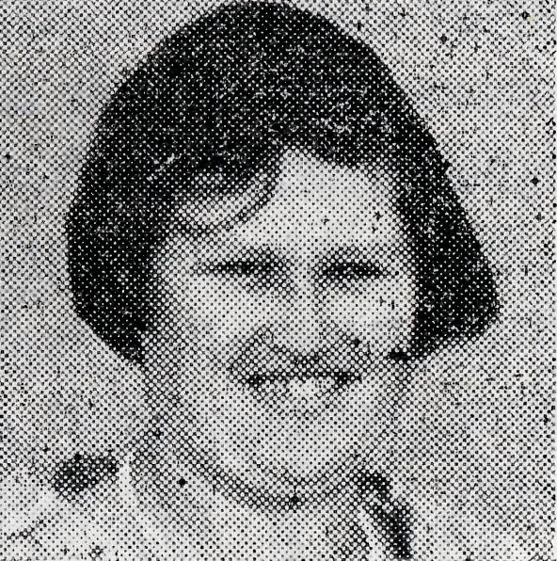
THE BKOKEN HILL HOSTEL
Miss Myra Attwood
He will enable us to do work, no matter how hard it may be. After all Jesus died on the cross that we might have eternal life, so then what a privilege have we to show our love for Him even in the mundane tasks of life.
Each morning we have devotions before the boys go to school and each Sunday they attend either Church or Sunday School, and, of course, there is the religious instruction given at school.
Each month we have a party for the boys who have had a birthday during the month and of course there is no need to mention just how much this is enjoyed. Then there is an end of term party when the boys have an opportunity to ask their friends along to the hostel. These parties sometimes include films and supper.
Yes we may sometimes wonder about the worth of all this. Is it worth giving up a part of one's life to look after children from the outback, in order that they might have the opportunity of a normal education? Is it
tmk bu=_{al} AUSTRALIAN. DECEMBER, 1965
worth it to provide a Christian that when you think about it,
home and so influence the lives You too will agree with me that
it is worth all the effort and of these young people from the prayer that a work such as this
outback of our land? I'm sure demands.
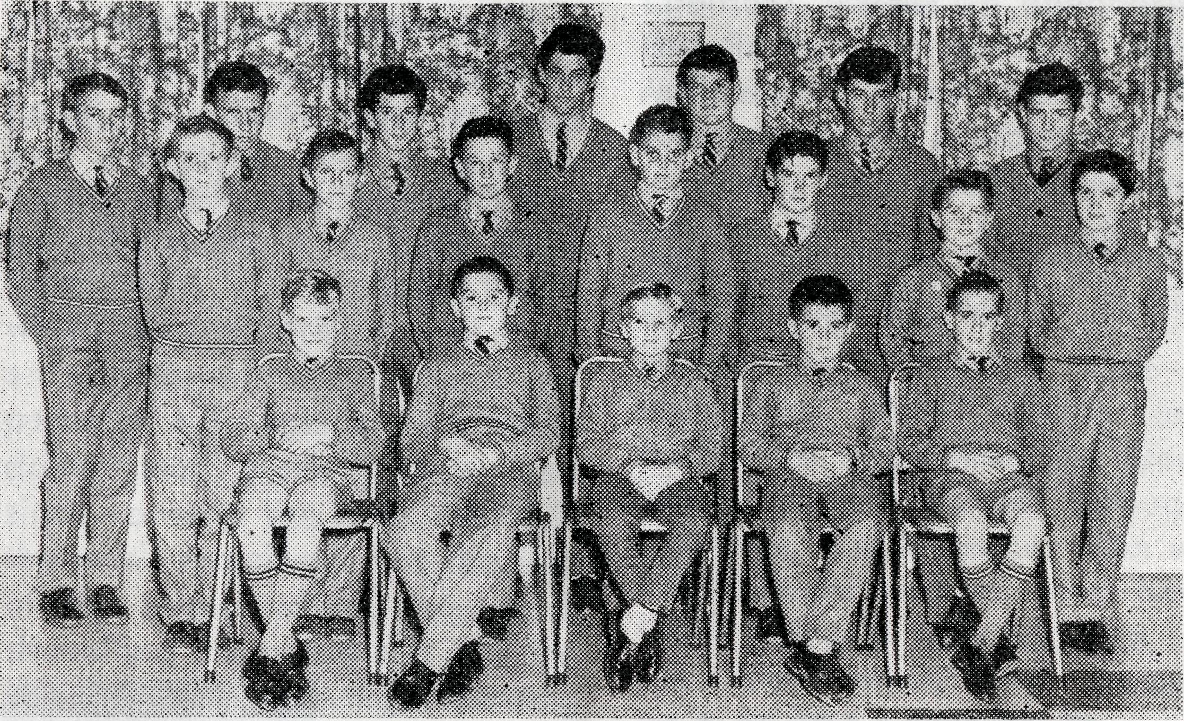
The boys of the Broken Hill Hostel.
END OF TERM EXCURSION
By Jim Dempster, Broken Hill Hostel
and five boys—together with all our luggage, packed into the Hostel bus. That night we were 360 miles away, at Hay, but by the Sunday evening we had arrived at Canberra and were viewing the lights of the city from the top of Red Hill.
It was 4.30 a.m. on Saturday, 28th August, when Mr. Kerr called us to get ready for the first day of our tour to Canberra and the Snowy. By 6 a.m. all was packed and we were on our way. There were eight of us—Mr. and Mrs. Kerr, Heather
»pc »JgAL AUSTRALIA*¹ ^SCSM'tfJB 1965

On Monday we visited the War Memorial and after lunch we saw the Royal Mint before leaving for Cooma. Tuesday and Wednesday we toured the Snowy Mountain Scheme visiting Eucumbene, Lake Guthega Power Station, Tumut Ponds Dam, Tumut No. 2 Power Station, Jyndabine, Adaminaby and Providence Portal.
By Thursday we were on our way to Wagga Wagga viewing
BETWEEN
Mrs. Coralie Buckland
The following article is part of a letter written by Mrs. Buckland to members of her family, in which she describes a recent trip made with her husband to some of the sheep stations in the Parish of the Murchison.
We left here on Monday morning, about half past ten, and went via Cue, where we stopped as Bernard had a couple of calls to make, then we went on the track to Glen
the Cotter Dam as we went. Friday night was spent in Mil-dura and before leaving for home on Saturday we saw Lock 2 and the weir which was flowing at flood level.
Then commenced a hectic trip to Broken Hill on a very wet, slippery, mud road. All in all we had a very enjoyable and pleasant trip which had lasted eight days and which covered 1,865 miles.
MONDAYS
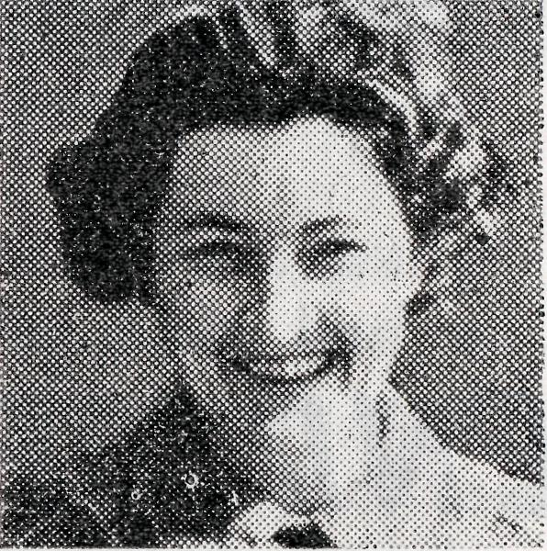
station, where we had a cup of tea and some sandwiches. When we left The Glen we made a detour up into the hills called the Weld Range, where there is a red ochre mine which was originally worked by the aborigines. The deposit is now only worked at certain times of the year when there is a market for the ochre, and since it was being worked
just then, Bernard wanted to go and talk to the men. To reach the men working at the 'face⁷ we followed the railway tracks along a tunnel which is only about six feet six inches high, and about four feet wide, and it is pitch dark, but we had our torch, and Bernard went first and I hung on to his belt behind!
About half-way along the tunnel (it is about Va mile long) there was a revolting smell, which the men told us was from an abandoned shaft, where apparently a kangaroo had fallen down and died. They had since covered the hole over but the smell remained. At the end of the tunnel where they work shovelling the ochre dirt into the skip, you can see light coming from the cave where the original ochre was obtained. They told us that in a day or so the tunnel and the cave would be completely joined, and one will be able to go right through from one side of the hill to the other.
They work in this tiny space, about six feet square and terribly dark, in spite of the little light high up coming from the cave and a couple of carbide lights, until they fill the skip, and then they push it back through the tunnel to the crushing plant about 100 yards from the tunnel mouth. Everything is covered in fine red dust—the men are com-
pletely covered in it, and all the trees, foliage and stones outside near the crusher are red with it, and so were we when we came out!
Quite early next morning we left Kalli, where we had stayed the night, and went to Milly Milly station. To reach Milly Milly homestead, one must go through a creek, which happened that day to be nice and full and wide. Here we saw the first vehicle we had met on our travels since leaving Cue—a four-wheel drive vehicle and trailer. It negotiated the creek safely, so we started through. However, it was deeper than we had thought and we must have been going a little too fast, as the 'bow wave' we created managed to get into the engine and there we were in the middle, stopped! Bernard looked out his window and saw that the bottom of the doors were under water, so he climbed out the window, on to the bonnet, and then to the bumper, where he opened the bonnet and surveyed the interior to see how wet it was.
Fortunately the nose was pointing up now, as we were actually on the way out and everything soon dried, so we started up again and got out without any difficulty at all. The only trouble was that Bernard slipped when on the bonnet and

THE REAL AUSTRALIAN, DECEMBER, 1965
THE REAL AUSTRALIAN, DECEMBER, 1965
19

stuck one foot and leg into the water. (I wish I had had the camera out to snap his face when he did it!) He had to change into his heavy boots as his shoes were soaked, not to mention the sock and leg of his trousers! They would have been wet anyway, as water had seeped through the holes in the floor where the seat belt bolts go through, and there was about two inches of water in the bottom of the car for our feet to slosh in. At Milly Milly, however, we were the grateful recipients of a hot cup of tea, and Bernard bailed out the car and dried it before lunch.
Later that week we passed through Nookawarra (another cup of coffee) and finding that the manager's wife was by herself and her husband up at the shearing shed, we called in at the shed on our way through to Mileura, and chatted to him for a few minutes. From here we went through Mt. Hale station (cup of tea!) and Koonmarra, then to Belele where we stayed the night.
Breakfast next morning was at six-thirty and we enjoyed a stroll around the gardens and the aviaries after the men had gone about their work. We left before nine for Meekatharra.
It was just like home to stay at the Royal Mail again. I did some washing, bought one or two things at the chemist and in the afternoon we read and relaxed. During the night it began to rain. Next morning service was held and the rain continued. It kept on in the afternoon. It continued at night. The path to the church door on Sunday night was just plain mud. We had intended to return on Monday to Cue, where Bernard would take school classes, etc., but as the rain continued it seemed that he would be stuck in Meeka for a while. A goods train left on Monday morning for Magnet, and as they said it would be several days before the road was opened again, he left the car there in Meeka and we travelled down in the guard's van in a 'dog box' type compartment.
You can imagine how grateful we were to have someone willing to mind the children for the week and give me the opportunity to see some more of the station womenfolk. One of the wives said to me, "You have no idea how nice it is to see another woman's face." Of course it would be most impractical to travel the road with Bernard more often than I do, even apart from the children angle, but I think that my trip has a definite value, if done now and again.
The Bush Church Aid Society
for Australia and Tasmania
FIELD STAFF:
DIOCESE OF ADELAIDE, S.A.
Ceduna-Penong, S.A.—Rev. R. H. Goodhew, Th.L Tarcoola, S.A.—Rev. J. Wyndham, Th.L.
DIOCESE OF WILLOCHRA, S.A.
Leigh Creek, S.A.—Rev. R. Keynes, Quorn, S.A.—Rev. A. McMahon, Th.L. Th.L.
DIOCESE OF BALLARAT, VIC. Heytesbury Mission, Vic.—Rev. A. Baker, Th.L.
DIOCESE OF RIVERINA, N.S.W.
Wilcannia, N.S.W.—Rev. B. O'Grady, Menindee, N.S.W.—Rev. R. Neve Th.L. Th.L.,
DIOCESE OF NORTH-WEST AUSTRALIA
Derby Mission.—Rev. B. Viney, Th.L., Derby, W.A.
Murchison Mission.—Rev. B. R. Buckland, Th.L., Mount Magnet, W.A.
Ord River Mission.—Rev. B. W. Green, Wyndham, W.A.
Port Hedland Mission.—Rev. B. Huggett, Th.L., Port Hedland, W.A.
MAIL BAG SUNDAY SCHOOL
Director: Miss R. Campbell.
HOSTELS FOR SCHOOL CHILDREN
BROKEN HILL, N.S.W.
Mr. and Mrs. W. KERR. Miss M. ATTWOOD.
PORT LINCOLN, S.A.
Mr. and Mrs. H. RICH. Miss A. MORRISON.
MOREE, N.S.W.
Mr. and Mrs. S. BENNETTS. Miss W. IKIN.

20
THE REAL AUSTRALIAN, DECEMBER, 1965.
THE REAL AUSTRALIAN, DECEMBER, 1965.

