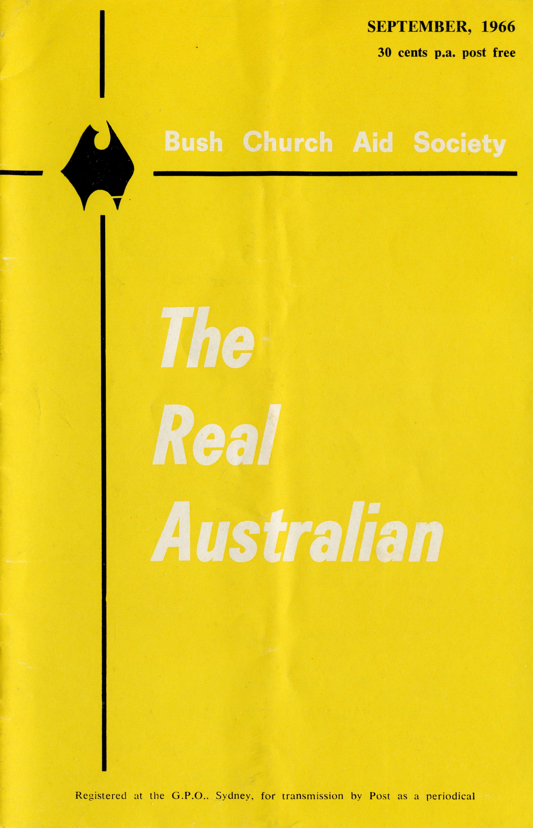
FLYING MEDICAL SERVICE STAFF:
Executive Officer: Mr. S. HUMMERSTON
Medical Officer: Dr. M. MUELLER, O.B.E.
Matron: Sister M. HOPE
Dentist: Mr. J. CROCKER Pharmacist: Miss N. PATTON
HOSPITAL CENTRES
CEDUNA, S.A.
The Murat Bay District Hospital-
Sisters V. HOLLE, L. MORGAN, J. STACK, E. MACKAY, Miss D. DUVER.
WUDINNA, S.A.
Matron: Sister J. ZILLMAN.
The Central Eyre Peninsula Hospital— ^{Sisters} ^{N}- WILKINS, D. WHYBURN,
Miss M. CHADWICK.
COOK, S.A. The Bishop Kirkby Memorial Hospital— _{Sisters} _{L} _{H},_{GGS} _{M} _{ROSS}
TARCOOLA, S.A.
The Tarcoola Hospital-
Sisters B. FOX, R. BOND.
COOBER PEDY, S.A.
The Coober Pedy Medical Centre— Sisters H. HEAVER, M. MACKENZIE.
Sister J. GRIFFEN.
RAWLINNA, W.A. The Nursing Hostel—
AIRCRAFT
VH-FMS—Beechcraft Baron B55. Pilot: Mr. J. LINDRIDGE.
RADIO CONTROL STATION
Cotrtrol Officer: Mr. K. ELLIS. Base Operator: Mr. A. E. CHADWICK.
EDGAR BRAGG & SONS PTY. LTD.. 130 BOTANY STREET. WATERLOO

The Bush Church Aid Society
for Australia and Tasmania
PRESIDENT
The Most Reverend, The Archbishop of Melbourne.
VICE-PRESIDENT
HONORARY TREASURER
Mr. R. T. Stokes
CHAIRMAN OF COUNCIL
The Revd. Canon E. Cameron.
COUNCILLORS
The Ven. G. R. Delbridge, the Revd. Canon R. M. Hudson, the Revds. C. A.
Baker, L. H. Broadley. E. V. Constable. O. W. C. Cooper, W. I. Fleming,
A. C. Miles, G. B. Muston, Messrs. H. M. Bragg, K. C. Lyne, E. Stockton.
FEDERAL SECRETARY
The Revd. C. W. Rich.
ASSISTANT FEDERAL SECRETARY
The Revd. L. J. Wiggins
VICTORIAN SECRETARY
The Revd. J. Stockdale
NEW SOUTH WALES SECRETARY
The Revd. B. D. Huggett
REPRESENTATIVE IN SOUTH AUSTRALIA
Mr. A. Kirkby, 7 Ruthven Avenue, Glandore, S.A.
HONORARY AUDITOR
F. W. A. Eagar and Co., 8 Belgrave Street, Manly, N.S.W.
SOLICITORS
Messrs. Maxwell and Boyd, 141 Elizabeth Street, Sydney.
HEAD OFFICE
B.C.A. House,
135 Bathurst Street, Sydney.
Phones: 26 3164, 26 3780.
Telegraphic Address: "Chaplaincy", Sydney.
VICTORIAN OFFICE
Morton House,
262 Flinders Lane, Melbourne.
Phone: 63-8962.
"AUSTRALIA FOR CHRIST"
THE REAL AUSTRALIAN, SEPTEMBER, 1966
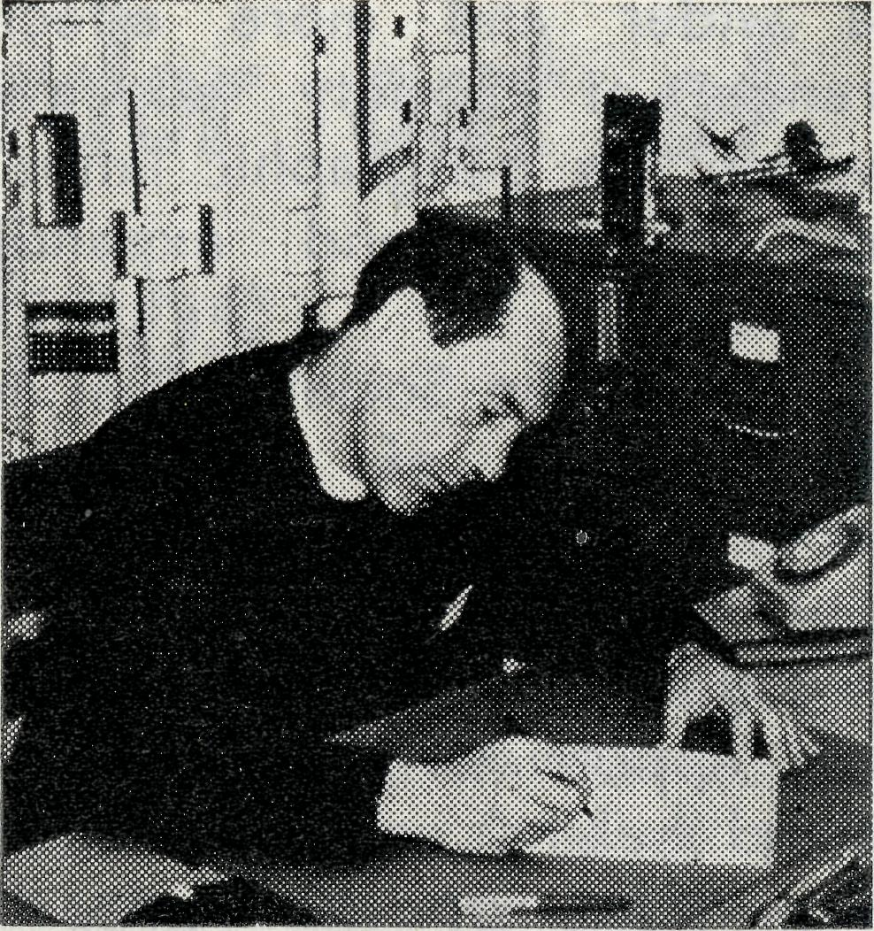
Recently I wrote on behalf of us all to our former President, the then Archbishop of Sydney, expressing our regret following the announcement of his resignation, thanking him for his leadership, and assuring him and Mrs. Gough of our continued prayers.
At our Annual Meeting which followed in the next few days, the Archbishop of Melbourne, then our Vice President, was nominated and elected President for the ensuing twelve months. I am very happy to be able to report that he has honoured us by accepting this position and we look foward to his active participation and guidance in Society affairs.
Even more recently I conveyed our prayerful congratulations and good wishes to the new Archbishop of Sydney following his election to the See of Sydney.
from the
FEDERAL
SECRETARY
All this has served to highlight in my mind, how much the Society—and so in turn, the Australian Church—relies upon these two great Metropolitan Dioceses. It is true that through the determined effort of our Deputation Staff the other Dioceses within the Provinces of New South Wales and Victoria are becoming increasingly aware of the Society task. It is also true that we are constantly encouraged by many gestures of support, prayerful and practical, from other parts of Australia and beyond. However, the practical fact remains that nearly all the staff recruitment, financial assistance and prayerful concern is drawn from the church people of these two cities. It may well be that it can be proved by statistics that this is as it should be and the matter ceases there, but I would think not. Surely the miracle of Society existence is bound up

THE REAL AUSTRALIAN, SEPTEMBER, 1966

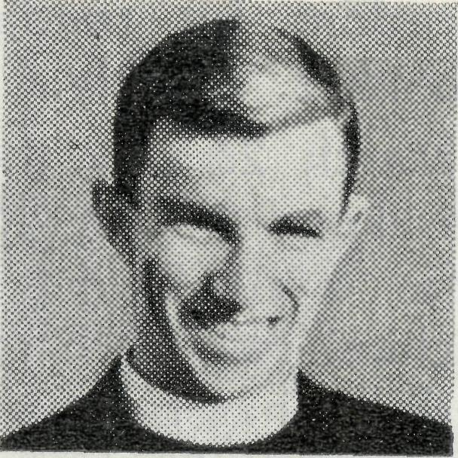
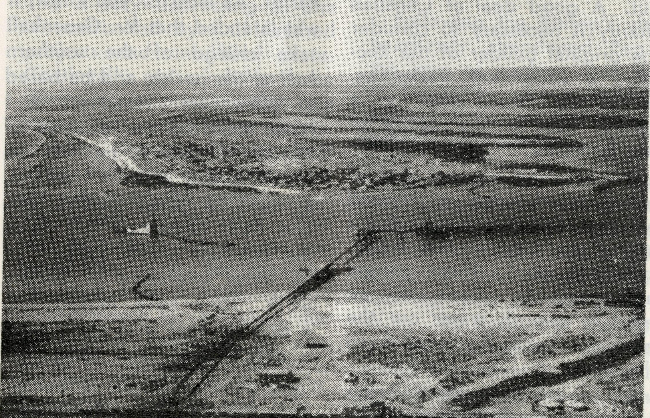
1966 began by my driving a new car from Perth to Hedland (distance equals Melbourne to Brisbane). Not far from Roebourne glutinous red mud meant 3i hours hard work and ir^ a further 30 miles I was faced with the Yule River running four feet deep. Here I sat for two nights and a day, humming, "Shall we gather at the river" and relieving the
THE REAL AUSTRALIAN, SEPTEMBER, 1966
with the fact that people are aware and care. I have always felt that the activities of the Society demonstrate a deep sense of mutual responsibility born of an earnest conviction to see the Gospel spread to the uttermost parts.
That this vision has been seen so keenly by the people of Sydney and Melbourne may be interpreted as a condemnation of others. One would hope that it will be understood that this is not being written in such vein but rather as a commendation of the existing situation. Truly those areas of Australia which the Society has been privileged to assist in the past and where today its personnel and financial assistance is at work would, if possible, express their deep gratitude to their brethren from the cities who have made these ministries possible.
From within the Society we believe that the stage is set for
The NEW VH-FMS
A Beechcraft Baron 8-55/ this aircraft is to replace the existing Cessnas in September, following a Service of Dedication at Banks-town Airport.
a wider and more effective range of Society endeavour within the geographic limits of our exciting and expanding continent.
We, as the Society, must ever be mindful of our responsibilities and be alert to opportunities of service. As we recognise and place on record our appreciation of those who stand behind us at present, so we would hope and pray that the day will come when we will have an even wider volume of support to enable us to fulfil our task to the glory of God.
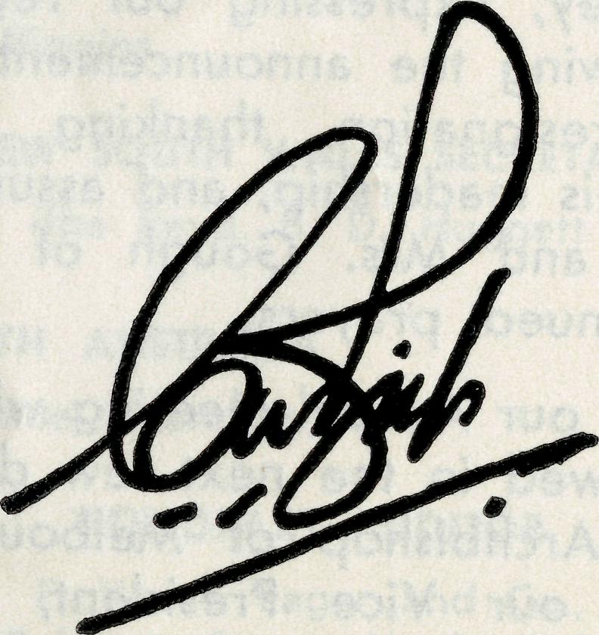
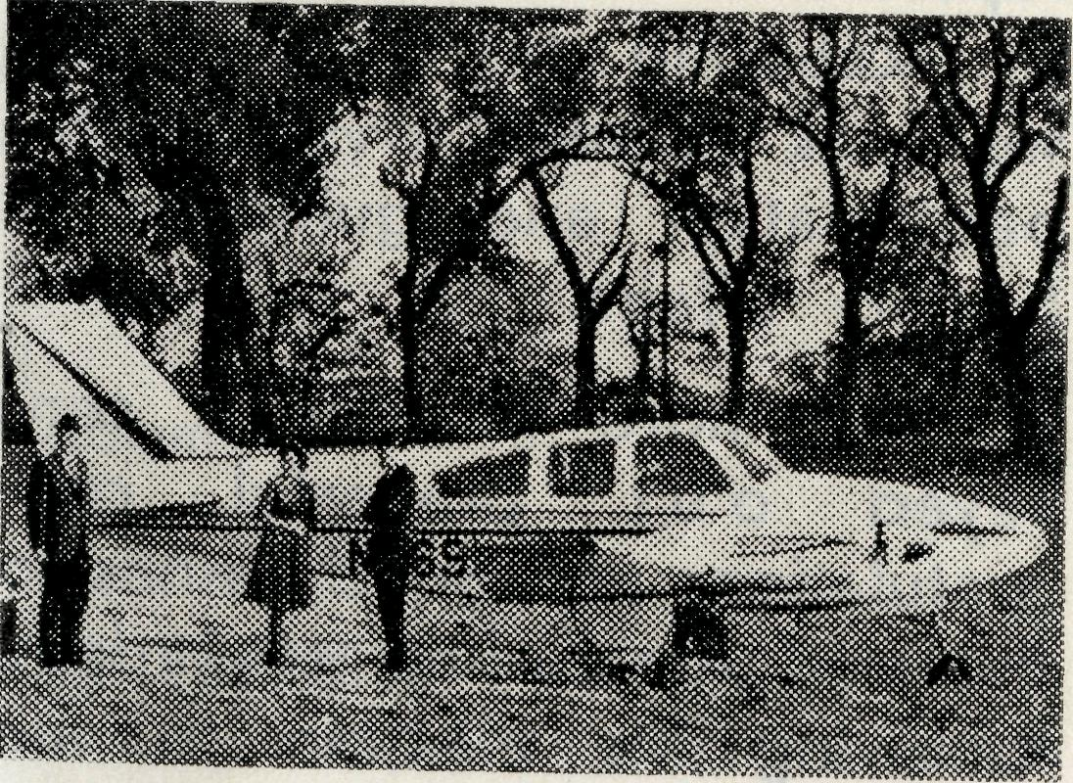

Order out of Chaos
The Revd. B. D. Huggett.
At last there is a degree of order discernible in the chaos at Port Hedland. Most of the construction work is over, the itinerant work force beginning to disperse and a more stable element taking its place. The first shipment of iron ore from Mt. Goldsworthy was despatched on schedule in April via an enormous ship rejoicing in the unlikely name of the "Harvey S. Mudd".
For* Hedland, centre for iron ore development. THE REAL AUSTRALIAN, SEPTEMBER, 1966

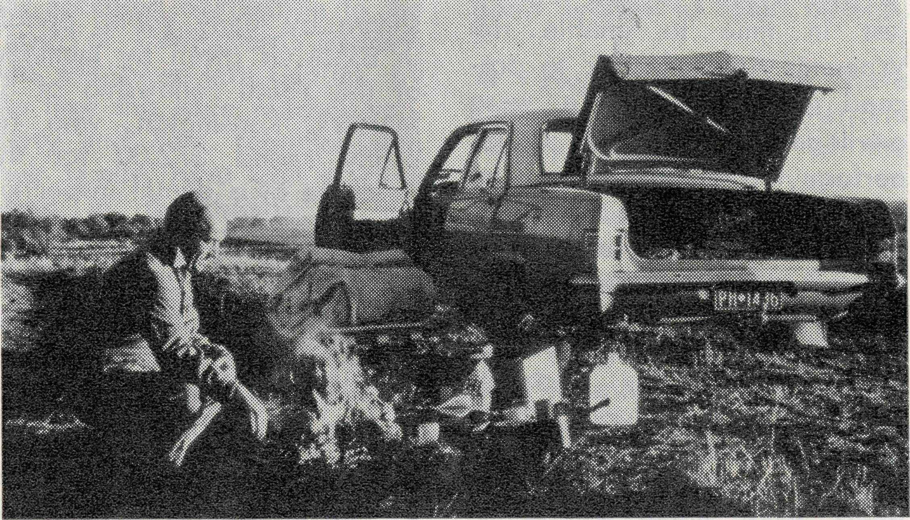
Baked beans for the Bishop!
boredom by reading a 1963 Women's Weekly.
March 26 saw the arrival of the Revd. John Redway# his wife, Eve, David (four) and Michael (eighteen months). Mr. Redway has been the Rector of Boyanup in Bunbury Diocese for the last four years and has come to Port Hedland as a worker priest.
Before training for ordination he graduated with an honours degree in engineering and is now engaged on survey work with Goldsworthy Mining, also acting as assistant to the Rector.
John's arrival was followed by "Cyclone Shirley". After tying down the caravan we battened down the hatches on the Rectory and prepared to sit it out. A good deal of Christian charity is necessary to consider the original builder of the Rectory, a competent tradesman, as all the floors slope to a central spot in the centre of our bedroom.
We shipped a good deal of water on the first night and woke to find Carolyn having a marvellous time in her indoor swimming pool. There ensued a fantasia-like scene as we tried to swoosh water out the back door while it poured down the walls.
By the third day the Redways were getting seasick in the caravan so they came in to join us. Our tally was now five adults,
four children and three dogs. The fifth adult was a friend of mine from Wittenoom (185 miles) who was stranded in Hedland with his eighteen month old son. The baby, used to the wide open spaces, suffers from claustrophobia and screamed magnificently for four days, pausing only to refuel with vast quantities of bread and butter. The situation was further complicated by the disappearance of an $80 dog I was minding for parishioners.
This year's great event in the Huggett home was the birth of Jennifer Louise (3.25 p.m., April 27: 71b. 14oz., bald). This coincided to the minute with the Revd. L. Greenhall's arrival in the Parish. As most of you know, it was intended that Mr. Greenhall take charge of the southern half of the parish, and be based at Wittenoom. However, as I have accepted the position of N.S.W. Secretary, he will be locum tenens at Port Hedland, at least for some months. Mr. and Mrs. Greenhall will need the constant prayer support of all those interested in Society work. They have moved into a situation that is in many ways a difficult one, and which will be a great drain on their physical and spiritual resources.
Since April everything we have done has been coloured
by the knowledge that we would be leaving the parish much earlier than expected. This is very depressing as one is surrounded by half finished projects and unfulfilled plans. Continually my mind has been drawn to the principle that one man plants and another waters.
After Synod, Bishop Witt came with me from Geraldton on a tour of the parish covering nearly 2,000 miles. This was in many ways a most unusual trip. It is, for example, the first time I have cooked baked beans for a bishop, for a campfire breakfast. It also seems the episcopal presence is good insurance in a 70 m.p.h. blowout!
The visit of Bishop and Mrs. Witt was a time of real blessing
and illustrated perfectly the function of a father in God to the priests under his care.
Following the Bishop's visit I heartlessly abandoned Peg to the joys of packing and went to Derby to take a children's mission in conjunction with the Bishop's adult mission.
My experiences were many and unexpectedly varied. They included a solitary eight mile hike in the Kimberleys, a holed sump in the Murchison and opening most of the gates in W.A. The Rectors of the three parishes concerned have excelled themselves in making my stay a memorable one. When I recover I look foward to sharing these experiences with you! •

THE REAL AUSTRALIAN, SEPTEMBER, 1966
THE REAL AUSTRALIAN, SEPTEMBER, 1966

• The Sydney Synod finished just in time to enable the Women's Auxiliary Fair to proceed as planned. We were privileged to have Lady Cutler perform the opening ceremony in the presence of the Archbishop of Sydney at one of his first official functions. The Society owes a deep debt of appreciation to all those who made this occasion one of keen fellowship and real practical support.
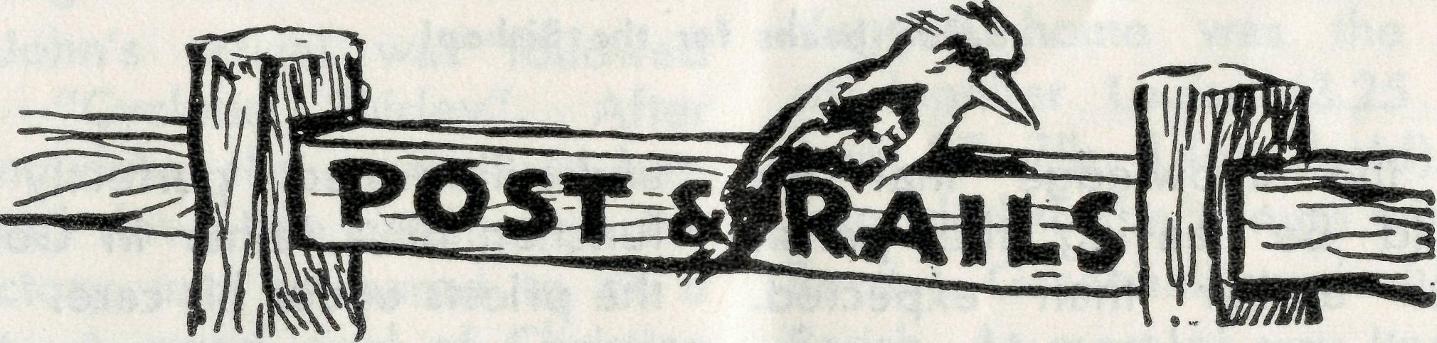
• The Rallies held at Sydney, Melbourne and Adelaide were all well attended, and reflected the widespread interest and practical concern of so many Church people in our particular ministry. The special offerings totalled $4,965.31 for Sydney, $1,560.00 for Melbourne and $579.57 for Adelaide. The Adelaide Rally was a 'first', and we trust it will become a regular feature, as a focus for the widening support our Society receives from our South Australian friends.
• An example of the interest shown by many young people in B.C.A. is given by members of the Youth Fellowship of St. Martin's, Kensington, who recently raised $72.00 for the purchase of a dental inspection lamp for Mr. John Crocker's surgery at Ceduna. G.F.S. members in Melbourne and Sydney have provided practical support as part of a 'missionary project', and the Sydney G.F.S. stocked a special stall at the recent B.C.A. Fair.
• Earlier this year, the Council decided to replace the existing aircraft used in the Flying Medical Service with a twin engined aircraft. Accordingly, arrangements have been made with Hawker De Havilland Aircraft Company for the supply of a Beechcraft Baron B55. The cost of the aircraft is to be met from our legacy funds and the operational use will, we trust, add considerably to the safety and effectiveness of the F.M.S. It is planned to have further details of the aircraft available for the next issue of the Real Australian.
THE REAL AUSTRALIAN, SEPTEMBER, 1966

- The Revd. Harry Goodhew has accepted nomination to the Parish of Carlingford, Sydney, and will have left Ceduna by the time this issue reaches you. Harry and Pam, together with their family, have won a warm place in the hearts of the parishioners of Ceduna and many will be sorry at their going. They are assured of the prayers of the Society and its supporters as their ministry continues in Sydney.
- The ministry of the Trans Line from Tarcoola is to be restored as the Revd. Brian Carter and his wife, Carolyn, leave St. Mark's, South Hurst-ville, during August to take up this difficult task. Mr. Carter has been a student in training for Society work and we would commend this young couple to your prayers as they begin this adventure in faith.
- Sister Beverley Smith is to leave the nursing staff of the F.M.S. and is returning to Sydney. Sisters Judy Stack and Ellen Mackay have come to us from Melbourne. To each we would convey the prayerful good wishes of the Society and its supporters as they seek to serve in the future.
- Girls are still the fashion! We welcome Judith Anne Wyndham and Susan Rebecca Keynes into the family and ex-
THE REAL AUSTRALIAN, SEPTEMBER, 1966
tend our congratulations and good wishes to their parents.
• Nearly 21 years have
elapsed since Miss Marjorie
Farr joined the staff of the
Society. During her years of
devoted service Miss Farr has
been a member of the staff
of each of the Society hostels,
the Old Folks' Home at Port
Lincoln, Penong and Ceduna
Hospitals and for the past
twelve months cared for the
single folk at Ceduna.
During these different spheres
of service many have come
under the influence of her
ministry and all who know her
have spoken of her deep
spiritual conviction, coupled with
untiring zeal. The Kingdom of
God must surely be the richer
because of her devotion and
we certainly will be the poorer
as she leaves us to retire. Some
find it difficult to imagine, as
no doubt she herself will, and
we would pray that she will be
sustained continually by God in
the days ahead.
• Head Office staff changes
are still the order of the day.
Miss Deirdre Briggs is soon to
leave us to go to New Zealand.
We have appreciated her ser
vice deeply and shall miss her
very able contribution. Miss
Eula Purdey has left us after
a short stay in a secretarial
position. We record our thanks
to them both.

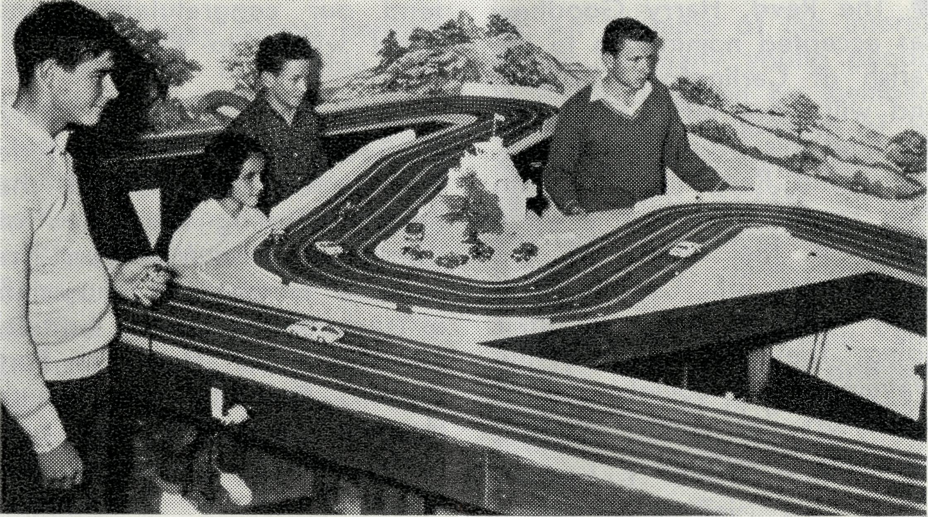
The Place of Prayer
The following pages represent a daily prayer calendar which is revised with each issue. We earnestly seek your prayers for the individual members of our staff. We suggest you remove these centre pages from the magazine and keep them for your regular devotional use.

The track, which is 58 feet long, has all the details of one of the big American or English circuits, with bends, pits and other characteristics.
Mr. Kerr said the boys at the hostel had made all the preliminary arrangements for the installation of the track and they were indebted to the various organisations who donated and gave assistance.
Mr. Kerr said it is hoped that the boys will team up to compete against each other and at present many of the lads have their own cars.
The photograph shows Jim Turner of White Cliffs, Heather Kerr, Trevor Green of Wilcan-nia and Greg Hajek of Tarcoola giving the cars a trial run on the new circuit, •
They're Racing!
A project which has been under way for almost 12 months has now been completed at the Bush Church Aid Children's Hostel in Lane Street.
The project, which has gained the support of all the boys staying at the hostel, is a miniature speedway which is estimated to be worth more than $200.
A number of local organisations and friends of the Hostel have donated materials and given advice for the construction of the track.
Supervisors at the Hostel, Mr. and Mrs. Kerr, said the interest shown in the project by the boys was great and it seemed that the racing of the miniature cars will turn out to be one of their main interests.
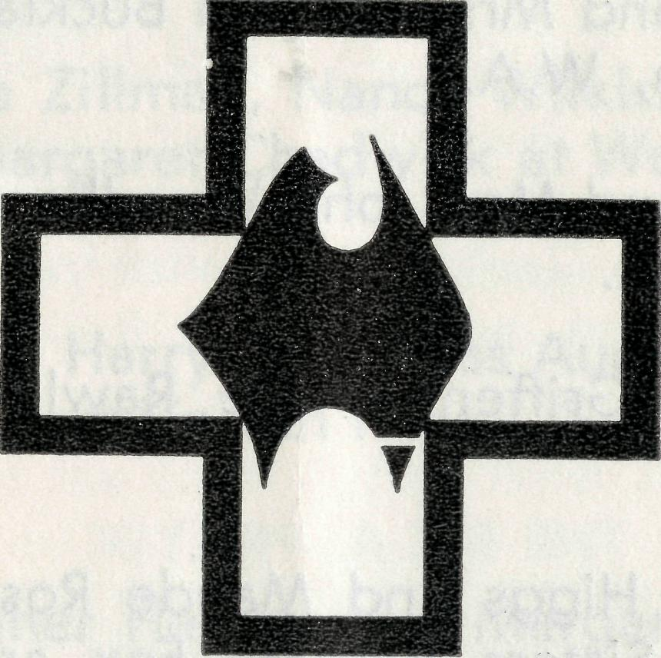
Further prayer items and information letters are sent at regular intervals to all members of the B.C.A. Fellowship of Prayer.
Membership in the Fellowship is invited from all who are concerned in the prayer support of our work. There is no joining or membership fee, although a badge pin (or brooch) may be purchased for 50c if so desired.
Send your name and address to the N.S.W. or Victorian Secretary and the prayer letter will be forwarded to you.

THE REAL AUSTRALIAN, SEPTEMBER, 1966
THE REAL AUSTRALIAN, SEPTEMBER, 1966

1st Miss Rose Campbell, Miss Barbara Hyett and all the helpers and scholars in the Mail Bag Sunday School.
2nd Mr. and Mrs. Sid Bennetts, Miss Lynette Mobbs, and the boys at Urallie Hostel, Moree, N.S.W,
3rd The Rev. and Mrs. Barry Green and the Ord River Mission, W.A.
4th The Rev. and Mrs. Brian Viney and the Derby Mission, W.A.
5th The Revd. and Mrs. Len Greenhall and the Port Hedland Mission, W.A.
6th The Revd. and Mrs. Bernard Buckland and the Murchi-son Mission, W.A,
7th The Revd. and Mrs. John Wyndham and the Norseman Mission, W.A,
8th Sister Jean Griffen at the Rawlinna Nursing Home,
W.A.
9th Sisters Lola Higgs and Maude Ross at Cook Hospital, W.A., and Sisters Barbara Fox and Rosemary Bond, at the Tarcoola Hospital, S.A.
10th The Revd. and Mrs. Brian Carter, and the North-West Line Mission, Tarcoola, S.A.
Uth Mr. and Mrs. Stan Hummerston and the administrative work within the Flying Medical Service.
12th Dr. Merna Mueller and the patients within the medical practice.
13th Miss Nicole Patton and the work at the Ceduna Pharmacy, S.A.
14th Mr. John Crocker and the work of the Ceduna Dental Service.
15th The Ceduna Mission, S.A.
16th Sisters Marion Hope, Vera Holle, Lilian Morgan, Judy Stack and Ellen Mackay and Miss Dorothy Duver at the Ceduna Hospital, S.A.
17th Mr. and Mrs. John Lindridge, Mr. and Mrs. Allan Chadwick and the flying within the Medical Service.
18th Mr. Kevin Ellis at the Radio Control Station, the Radio School Teacher and children.
19th Sisters Julia Zillman, Nancy Wilkins, Dorothy Whyburn and Miss Margaret Chadwick at Wudinna Hospital, S.A.
20th Mr. and Mrs. Harry Rich, Miss Audrey Morrison and the girls at the Port Lincoln Hostel, S.A.
21st Sisters Heather Heaver and Margaret Mackenzie at the Coober Pedy Medical Centre, S.A.
22nd The Rev. and Mrs. Ron Keynes and the Leigh Creek Mission, S.A.
23rd The Rev. Alan McMahon and the Quorn Mission, S.A.
24th The Rev. and Mrs. Brian O'Grady and the Wilcannia Mission, N.S.W.
25th Mr. and Mrs. Bill Kerr, Miss Myra Attwood and the boys at the Broken Hill Hostel, N.S.W.

THE REAL AUSTRALIAN, SEPTEMBER, 1966
THE REAL AUSTRALIAN, SEPTEMBER, 1966
11

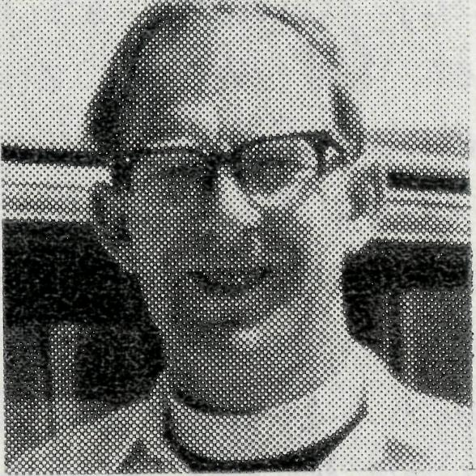
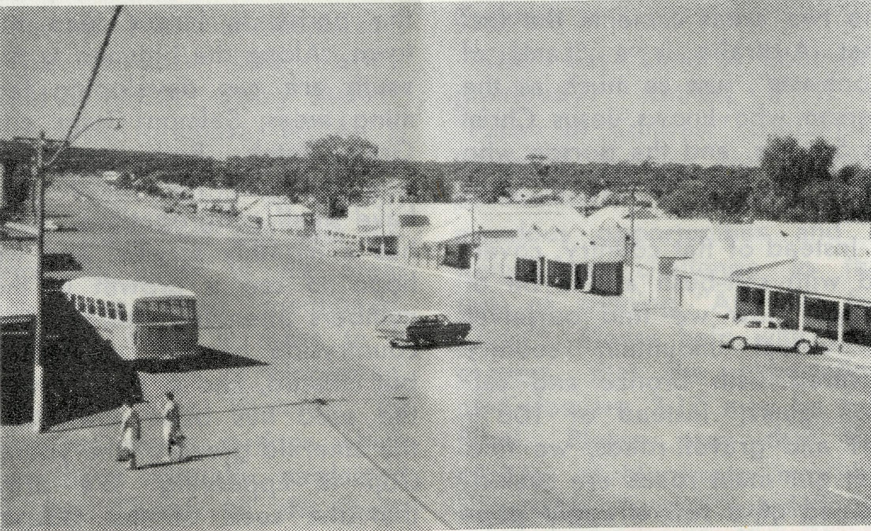
of Norseman was the next "reliable" supply of water, and in the months to follow I was to drive half the distance at least, and see what this means. Along the Eyre Highway, between Ceduna and Norseman, there are numerous government tanks, but the lack of rain means that they are often empty.
Norseman! It sounded interesting, but it was 770 miles away, and it wasn't part of the Far West Mission, and I wasn't
26th The Rev. and Mrs. Ray Neve and the Menindee Mission, N.S.W.
27th Mr. Alban Kirkby and the South Australian Representation.
28th A continuing supply of replacement staff, our Box Secretaries, supporters and friends of the Society.
29th The Revd. John Stockdale, Mrs. W. Hughes and the Victorian Committee.
30th The Revd. Bill Rich, the Revd. Les Wiggins, the Revd. Barry Huggett, Mr. Laurie Calder, Mr. Frank Burner, and Mrs. Joy O'Neill at Head Office, and the Council of the Society.
31st Give thanks to God always—-for personal blessing, for opportunities to serve Him, for the growth of the Society work since its formation.
THE B.C.A. PRAYER
O Lord our God, Who hast given unto us a fair land and abundant blessings, Make us ever mindful of those who live in lonely places. Bless, we beseech Thee, all members of the Bush Church Aid Society, and those whom they seek to serve. Grant that, through the ministry of the Word and Sacraments, through healing, through caring and instruction of the young, the message of Thy redeeming love may be proclaimed, and Thy Church strengthened in this our land, Through Jesus Christ our Lord. Amen.
A DAILY PRAYER
O God, we remember before Thee those whom Thou hast called to Thy service. Bless them this day, we beseech Thee, as we
pray for Call forth others
to stand with them in their task. Grant to them, as to us, the joy of service, the ability to achieve and the serenity of Thy peace, for Jesus' sake.
Amen.
12
THE REAL AUSTRALIAN, SEPTEMBER, 1966
NORSEMAN
The Revd. J. Wyndham,
"LAST RELIABLE WATER SUPPLY FOR 770 MILES"
Three years ago I used to read this sign nearly every day, because it stood nearby the house in which I was living at Ceduna. Actually, there are two signs—one at the entrance to Ceduna when coming from the east, the other on the way out at the other end of town, right outside the Hospital.
I hadn't been in Ceduna long when I found out that the town
Norseman. THE REAL AUSTRALIAN, SEPTEMBER, 1966

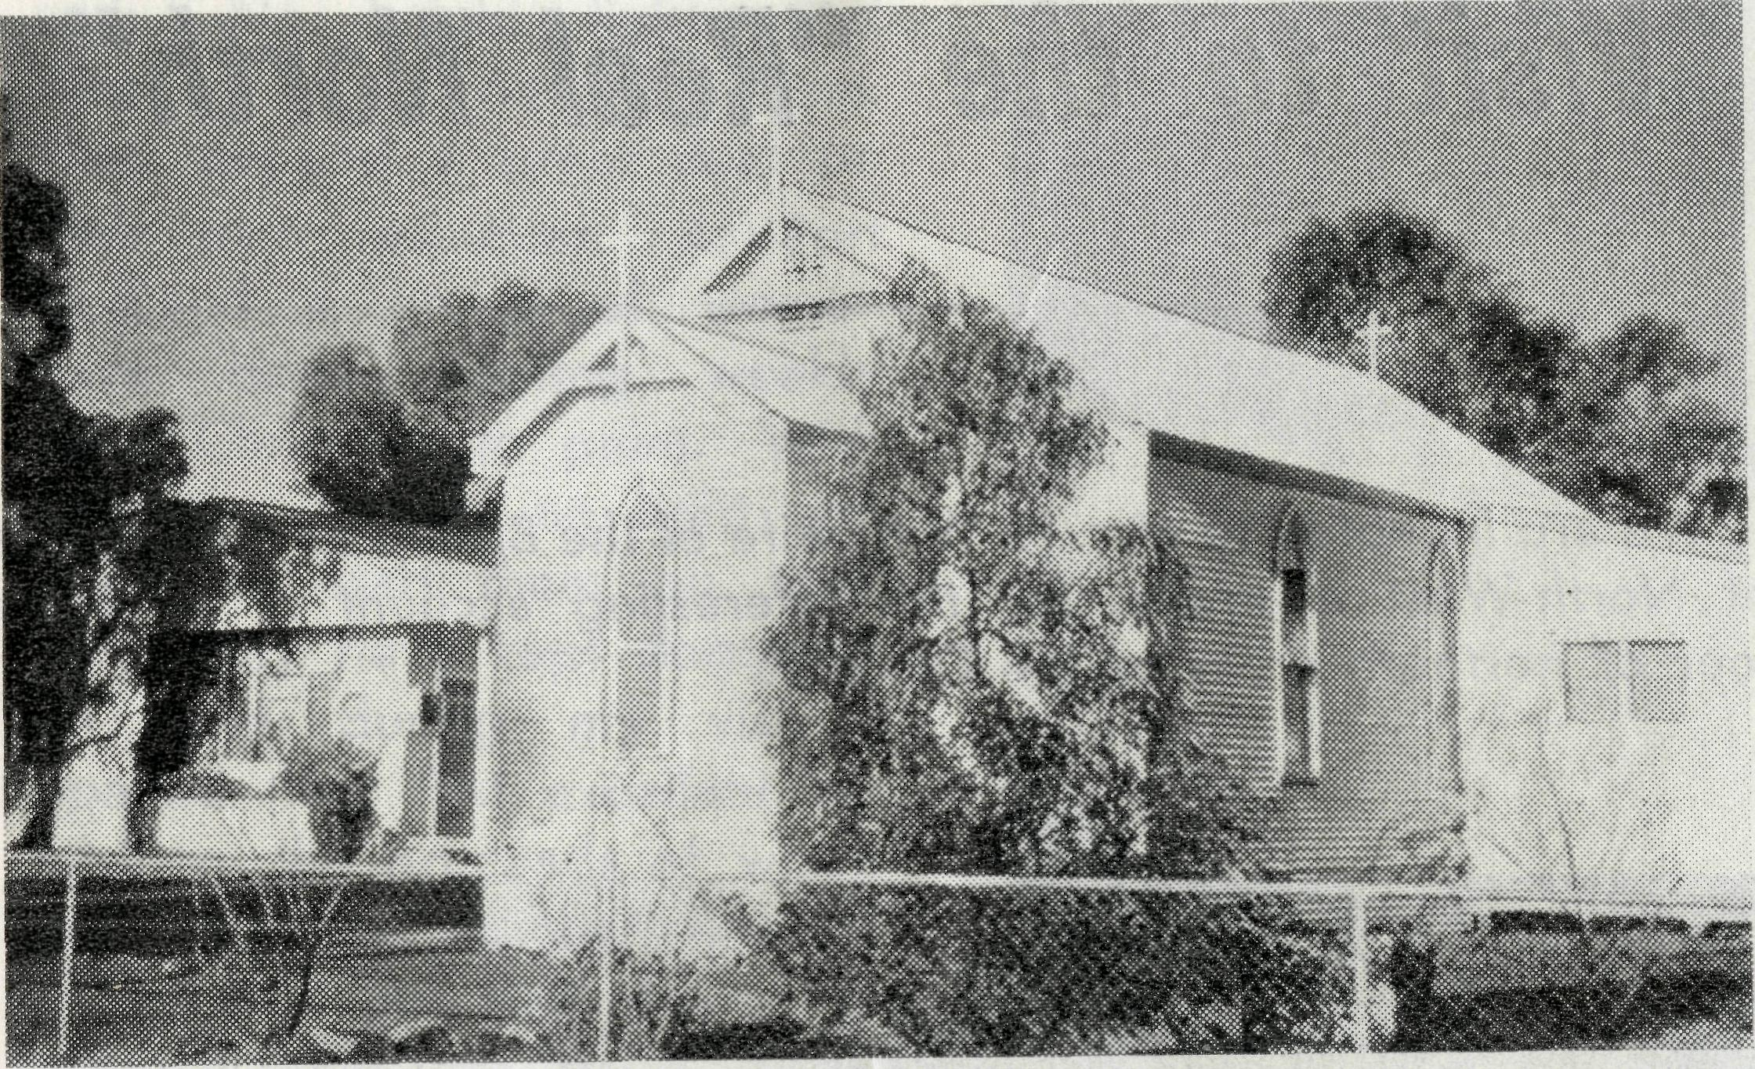
The Anglican Church and Rectory, Norseman.
likely to have an excuse to go that far west, and so it remained "interesting".
From Kalgoorlie, it was only 130 miles to Norseman, but Kalgoorlie was the end of the Trans Line, and Norseman wasn't in the North West Trans Line Mission. It might as well have been 770 miles and so Norseman still remained "interesting".
Now we're at Norseman, and Ceduna is 770 miles away, but there is no sign about the water supply, just a signpost which says, "Adelaide, 1,349 miles". No longer is Norseman "interesting"; it is FASCINATING!
After two years on the Trans Line, with the Nullarbor as one's travelling companion, Norseman can only be described as an oasis. The difference between the two areas cements the fact that Australia is a "Land of Contrasts", just as much as the person who knows Jesus Christ as Saviour, and the person who does not, are "People of Contrast".
Instead of flat country, covered with salt-bush and a bit of mulga, now we find ourselves in virtual mountain country covered with bronze and salmon gums. Instead of 100% dirt and gravel roads, we find that our main roads are sealed. Instead of a few straggly peppercorn trees in town, we find that there are trees everywhere
—about 40 around the Church and Rectory. Instead of one store, there are many stores. Instead of life being regulafed by the whistle of a diesel locomotive, the lives of most parishioners are regulated by the whistle at the goldmine. Instead of sheep being the main source of income, the mining of gold is. Instead of "living" in a train or a land rover, I live at home.
Norseman has two mines, one of which produces gold, and the other pyrites, used in the manufacture of sulphur. The Central Norseman Gold Mine, is perhaps the richest gold mine in Australia. It doesn't produce as much as the Kalgoorlie field, but produces nearly twice as much gold from each ton of ore.
This then is Norseman, but the parish is larger than the town. Along the bitumen to the south are two developing farming areas, Salmon Gums and Grass Patch. Both areas are now part of the parish and have small congregations. Each has a monthly service, and we hope to see a growth in the numbers attending church. The countryside here is undulating, but cleared, and at the moment the seed has been sown and the emerald green of the young crop is appearing. We pray that the seed of the Gospel will find as good a soil in which to grow. Further north
from Norseman is Widgiemool-tha, with its water pumping station and salt mine.
Perhaps I hear someone say, "What a cosy little Parish! What is B.CA. doing there?" First and foremost, B.CA. is here because the parish is run down, and unable to support itself. There are still vast distances to cover in the areas that have been mentioned. However, there is more to it than that. East of Norseman, along the Eyre Highway, lie some ten sheep stations which have been virtually neglected by the Church in the past. These stations will now form part of the Society's Norseman
Mission. The furthermost station is Eucla, almost on the South Australian border which has been visited in the past from Cedurta.
Did I say "Land of Contrast" previously? Rather, it Is a "Parish of Contrast" containing industrial, farming and pastoral communities. It presents tremendous opportunities and a tremendous challenge in the task of winning "Australia for Christ". Please help with your prayers, that the exhortation of Colossians 3:17 may be fulfilled. Please pray that the ministry at Norseman may be a reliable "water supply" Indeed, pointing people to Jesus Christ, the Living Water. •

14
THE REAL AUSTRALIAN, SEPTEMBER, 1966
THE REAL AUSTRALIAN, SEPTEMBER, 1966
15

Goldsworthy. The Rectory is directly opposite the new iron loading wharf and we watched the first shipment of iron ore leave.
Women in these areas are much to be admired. They have many months of hot, uncomfortable weather to contend
99
Visit to the "Real North”
We are indebted to Mrs. H. Witt, wife of the Bishop of the Diocese of North-West Australia, for this interesting account of a recent tour of northern areas of the Diocese.
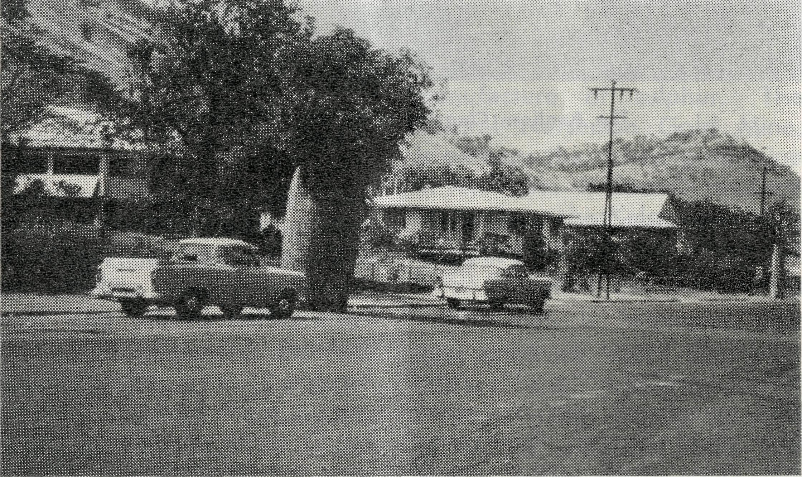
Wyndham.
I have just completed a A\ weeks' tour of the 'Real North' with my husband, and found it a most exciting and stimulating experience.
My first stop was at Port Hedland. This port is expanding rapidly due to the colossal Iron Ore development at Mount
with. No bright lights and theatres to alleviate boredom. They depend a great deal on their own resources. At Port Hedland a group of women have been meeting weekly since Christmas to paint. With only two lessons on light and shade to start them on their way, they have kept doggedly on, and during my visit I opened their first excellent exhibition, the proceeds of which they donated to our Church.
We had intended driving to Broome with the Revd. Brian Viney, but 2i inches of rain made this impossible. (One gets used to setbacks of this kind in the North West.) We had to divert an aircraft to be in Broome by Tuesday evening for Brian's induction.
It is wonderful to note the way all denominations work together in these remoter areas. At the reception following the service, Roman Catholics, Presbyterians and Methodists were busy helping with the supper.
After Broome we spent ten days in Derby where my husband conducted a mission, and we paid a brief visit to colourful Cockatoo Island and Koolan Island.
Tribute must be paid to the wives of B.C.A. priests in this Diocese. There are no Parish Halls, and the wives keep 'open
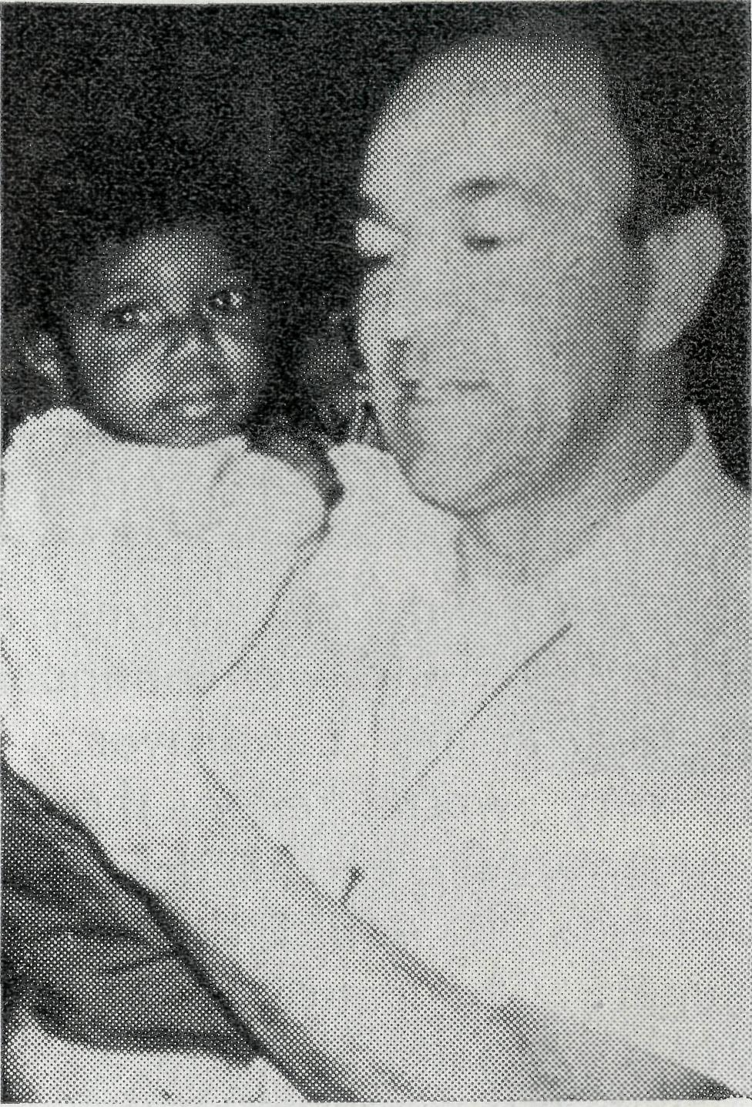
The Bishop with a young Australian.
house' for parishioners and passers through. All meetings are held in the Rectory lounges, and the wives do a tremendous job in Christian witness, and in helping 'the Fellowship' grow. They spend weeks on their own when their husbands are 'on the track', and open their homes for meetings when they return. At Derby, Margaret Viney provided the congregation with supper each night after the Mission Service.
We left Derby Sunday afternoon, and Brian drove us to his Parish boundary at Halls Creek, many hundred miles away. We spent the first night at Fitzroy Crossing, where the Bishop held an open air Service at the A.I.M. hospital attended

16
THE REAL AUSTRALIAN, SEPTEMBER, 1966
THE REAL AUSTRALIAN, SEPTEMBER, 1966
17

There were about 400 people present in the Chapter House on May 27, to hear the Revd. Len Greenhall speak of the present challenge of service with the Society and Bishop Sambell issue a challenge to the Society to fulfil her missionary task in the Australian Church.
Mr. Greenhall spoke of his experiences with the Bishop and Clergy in the Diocese of N.W. Australia saying that, "there was a real team spirit
by station folk, Sisters, school teachers and many aborigines. The next day was spent at Halls Creek where the prices of food stuffs made me gasp. The cost of living in this area is terribly high as all perishable foods have to be air-freighted from Perth.
Barry Green, of Kununurra, met us here and we continued the trip in his Landrover. It was very warm, even though it was winter, and I dread to think what it would be like in Summer. The cattle country is quite breath-taking i n its beauty. We called at several cattle stations en route, and saw masses of brolgas, and even a bower bird's nest at Ord River homestead.
We spent the night at Argyll Downs which is on Northern Territory time and so we arrived in Kununurra bright and early, about 8.30 a.m., after a 70 mile drive, in readiness for a meeting of the heads of churches and local clergy to discuss ways and means of working together in this area. There were Confirmations at Kununurra and Wyndham, several of the candidates being Aborigines.
At Kununurra there is no Anglican Church but we are
most fortunate as the Roman Catholic Church is at our disposal. Here again Jan Green keeps open house and station folk are always welcome when in town.
The highlight of my trip was the very last day spent at Forrest River Mission. We flew in by charter aircraft at 5.30 a.m. and the day commenced with a Service of Holy Communion. I spent most of the day looking around the Mission and talking to the Natives, who, incidentally, weren't the least bit shy. (The whole aboriginal problem is one that interests me greatly, but that is another story.)
During the afternoon we received a radio message to say the plane was grounded at Kununurra. So, to my delight, and the Bishop's and Barry's horror, we were obliged to do the return trip by launch, about 30 miles down the river. I sat back in my deck chair under the canvas awning to enjoy myself whilst the males groaned. Dusk was falling and there were no lights to read by. Fortunately, the tide was right, and we arrived in Wyndham in time to fly back to Geraldton and home.
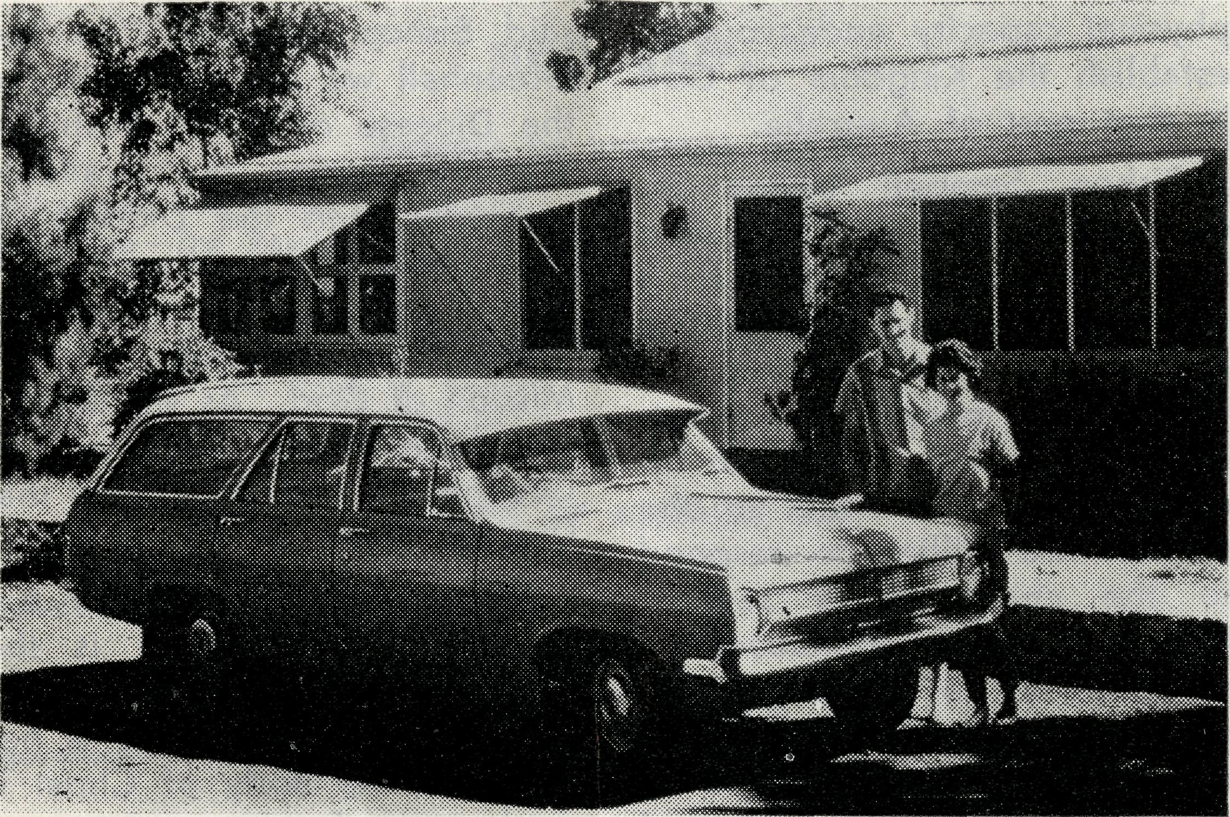
The R#vd. and Mrs. L. Greenhall at Port Hedland.
The Mission of the Church
and that the Bishop and Clergy were determined that the Church of God would become a living reality in the area". He went on to show, with the aid of coloured slides, that the problems of distance, of uncharted roads, of rain and dust, of new towns, of moving population, would make this task very difficult. However, he and his wife were convinced that this was the place of service to which God had called them, and they would, within the limits of their spiritual and

18
THE REAL AUSTRALIAN, SEPTEMBER, 1966
THE REAL AUSTRALIAN, SEPTEMBER, 1966
19

The Bush Church Aid Society

PORT LINCOLN, S.A.
Mr. and Mrs. H. RICH Miss A. MORRISON
physical capacity endeavour to establish the Kingdom of God in that part of Australia.
Bishop Sambell began by saying that he had never seen so many young people at a meeting of this kind. "It is good to see that a Society can draw young people to a meeting of this kind, and is an indication that the Youth of the Church are willing to respond to the challenge of service! Bishop Sambell continued, "I want to talk to you about our responsibility in sharing, in fulfilling the Mission of God to the World." The beginning of Mission was the spiritual renewal of the Church. "Renewal begins with our obedience, with our response in our own discipleship. The first call to any of us, who are concerned about the Mission of the Church, is not a call to give more to missions, it is a call to Discipleship, which gives all as a response to God's love for us.
The disciples were aware that after the Ascension, the Lord Christ trusted them to carry out His Mission and they returned to Jerusalem with great joy. "We are called to be the Body of Christ in the World fo-day. We are called to be a worshipping Church, a witnessing Body, His witnessing Church, a Church sent to preach the Gospel, a sent Church, a sharing Church,"
said Bishop Sambell. "In Len Greenhall we are not giving to the Diocese of N.W. Australia. We are sharing our available resources with the Diocese of N.W. Australia, a sharing with N.W. Australia with their resources for the sake of the Mission of God. As we do this we share in the work of Len Greenhall as the people of that Diocese share in his ministry."
Bishop Sambell said, "I believe that the Church is the Body of Christ and the only reason for her existence is her Mission. The Body of Christ is made up of many parts and the parts have their particular contribution to make, and I think of B.C.A. as being part of this body, with her very particular contribution to make to the life of the Church in Australia, in fact it is a very necessary part of the Mission of the Church.
Bishop Sambell charged the members of the Bush Church Aid Society "to keep the Church alive in this area of Mission, to personalise your prayer interest, to fulfil your own obedience and discipleship," and to all present he said, "we ought to give ourselves in the support of Len Greenhall and all others who represent us in the work of the Society, as we seek to fulfil our part in the Mission of God to the world." *
FIELD STAFF:
DIOCESE OF RIVERINA_{V} N.S.W.
Wikannia—The Revd. B. O'Grady. Menindee—The Revd. R. Neve.
DIOCESE OF WILLOCHRA, S.A.
Leigh Creek—The Revd. R. Keynes. Quorn—The Revd. A. McMahon.
DIOCESE OF ADELAIDE, S.A.
Ceduna/Penong—
Tarcoola—The Revd. B. Carter.
DIOCESE OF KALGOORLIE, W.A. Norseman—The Revd. J. Wyndham.
DIOCESE OF NORTH-WEST AUSTRALIA
Mount Magnet—The Revd. B. Buckland.
Wiftenoom Gorge—
Port Hed'and—The Revd. L. Greenhall.
Derby—The Revd. B. Viney.
Kununurra—The Revd. B. Green.
MAIL BAG SUNDAY SCHOOL
Director: Miss R. Campbell.
HOSTELS FOR SCHOOL CHILDREN
BROKEN HILL, N.S.W.
Mr. and. Mrs. W. KERR Miss M. ATTWOOD
MOREE, N.S.W.
Mr. and Mrs. S. BENNETTS Miss L. MOBBS
THE REAL AUSTRALIAN, SEPTEMBER, 1966

20
THE REAL AUSTRALIAN, SEPTEMBER, 1966

