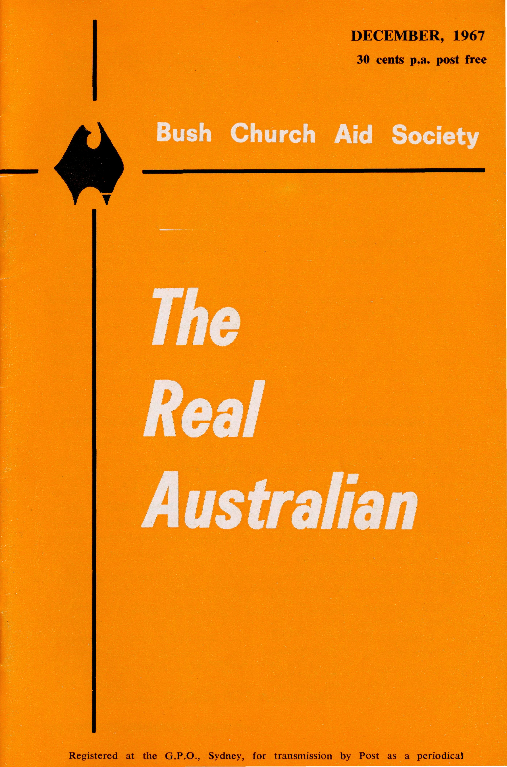
FLYING MEDICAL SERVICE STAFF:
Executive Officer: Mr. S. HUMMERSTON
Medical Officer: Dr. M. MUELLER, O.B.E.
Dentist: Mr. J. CROCKER Pharmacist: Mr. W. CARTER
HOSPITAL CENTRES
CEDUNA, S.A.
The Murat Bay District Hospital—
Matron: Sister J. ZILLMAN. Sisters V. HOLLE, H. HEAVER, J. GRIFFEN, W. HILL, Y. NEWNHAM.
WUDINNA, S.A. Matron: Sister N. WILKINS. Sisters E.
The Central Eyre Peninsula Hospital- MACKAY, D. WHYBURN, P. LLOYD,
Miss L. MOBBS.
COOK, S.A. The Bishop Kirkby Memorial Hospital— _{Sisters} _{L} HIGGS, M. ROSS.
TARCOOLA, S.A.
The Tarcooia Hospital-
Sisters B. FOX, R. BOND.
COOBER PEDY, S.A. The Coober Pedy Medical Centre— Sisters L. MORGAN, J. STACK.
AIRCRAFT
VH-FMS —Beechcraft Baron B55. Pilot: Mr. J. LINDRIDGE.
RADIO CONTROL STATION
Control Officer: Mr. K. ELLIS. Base Operator: Mr. A. E. CHADWICK.
EDGAR BRAGG a SONS PTY. LTD.. 130 BOTANY STREET. WATERLOO

The Bush Church Aid Society
for Australia and Tasmania
PATRON
The Most Reverend, The Primate.
PRESIDENT
The Most Reverend, The Archbishop of Melbourne.
VICE-PRESIDENT
The Most Reverend, The Archbishop of Sydney.
CHAIRMAN OF COUNCIL HONORARY TREASURER
The Revd. Canon E. Cameron. Mr. R. T. Stokes
COUNCILLORS
The Ven. G. R. Delbridge, the Revd. Canon R. M. Hudson, the Revds. C. A.
Baker, L. H. Broadley. E. V. Constable. O. W. C. Cooper, W. I. Fleming,
A. C. Miles, Messrs. H. M. Bragg, M. Job, E. Stockton.
FEDERAL SECRETARY
The Revd. Canon C. W. Rich.
ASSISTANT FEDERAL SECRETARY
The Revd. L. J. Wiggins
VICTORIAN SECRETARY NEW SOUTH WALES SECRETARY
The Revd. J. Stockdale The Revd. B. D. Huggett
REPRESENTATIVE IN SOUTH AUSTRALIA
Mr. A. Kirkby, 7 Ruthven Avenue, Glandore, S.A.
SOLICITORS HONORARY AUDITOR
Messrs. Maxwell and Boyd, F. W. A. Eagar and Co.,
141 Elizabeth Street, Sydney. 8 Belgrave Street, Manly, N.S.W.
HEAD OFFICE
B.C.A. House,
135 Bathurst Street, Sydney.
Phones: 26-3164, 26-3780.
Telegraphic Address: "Chaplaincy", Sydney.
VICTORIAN OFFICE
Morton House,
262 Flinders Lane, Melbourne.
Phone: 63-8962.
'AUSTRALIA FOR CHRIST"
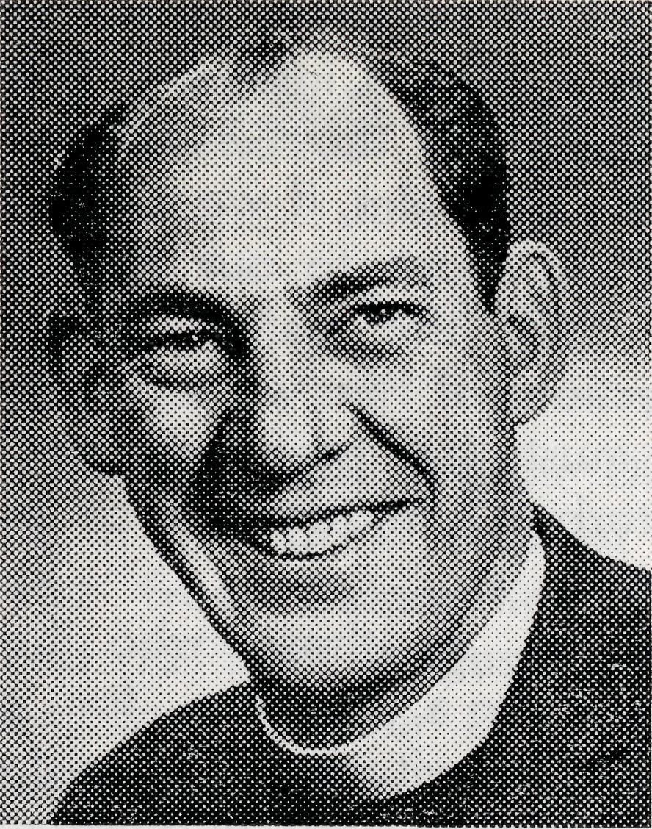
I am very conscious of the prayers and good wishes which have come to me from so many during these past months. tAy enforced absence placed a measure of strain upon many ! know, and I am sure that my first responsibility in returning to the task is to express appreciation to all who carried extra burdens during this time.
I write this in the eary days of my return to the Office, and though it may come to you at a time when there may be other things of practical concern within the Society, I would make some comment with regard to my visit overseas.
Although part of my trip was in a "tourist" capacity, I am inclined to think that I learnt more in this regard than from the more formal occasions. It is a very risky business for one who spent so short a time in any one place to make precise observations, for obviously they
From the
Federal
Secretary
may be based on a false premise. However, I met people in such divergent places as the magnificent and solemn grandeur of the Austrian Alps, again in the heart of cities almost frightening in their overwhelming mass. I dined in the company of a family in the "Expo" city of Montreal; I talked with dear friends in the solitude of a Texas ranch; and it fascinated me to find that in spite of the tensions of a multitude of different problems, from race riots to 'hippies', from ecclesiastical nonsense to personal piety, there was a single note standing out in it all; to me it seemed that the clarion call of Christ's redemptive love, obscured as it may be by differing forms of material tension, was the one constantly relevant fact. It was in this context that, interviewed by a newspaper on one occasion, I summed up my feelings by saying that I was conscious of the privilege of

THE REAL AUSTRALIAN, DECEMBER, 1967
THE REAL AUSTRALIAN, SEPTEMBER, 1967

"To the Ends of the Earth..."
being involved in the fighting of the same battle no matter how variant the battle fields might be.
In the conversations that I was allowed with great warmth and friendship by Church leaders in London, New York and Ottawa, I was made aware of what I felt was a deep sense of maturity of thought and action, the like of which we in Australia are yet to see. I found in so many places a spirit of urgency expressed in the context of earnest men seeking to make their Gospel relevant to a generation which on the surface appears to have been caught in the web of materialism. It seemed to me that difficult though the practical implications might be, there is a searching after loyalty to God and His purposes, which in so many ways transcends the frailty of human enterprise.
I am constantly mindful of a blessing used by the Rector of a small ancient city church in London, who sent us forth from his service with the words "May the Holy Spirit disturb you to do His Will". In these days of changing patterns affecting every facet of our human existence we bear a great responsibility. I am aware that change for the sake of change is an irresponsible action; at the same time I wonder if it is not a greater sin to resist any change, let alone radical, for
fear of consequence to personal pride or vested interests. If we take seriously the Gospel we so readily proclaim, if we would be anything more to our day and age than the palest of pale reflections of Him we serve, then we must be prepared to be "disturbed" in renewal of purpose.
To us, as those who have expressed a concern for the work and witness of Christ to the uttermost parts of this land, I believe there stands this challenge. I see afresh such demands as an "industrial revolution" in our vast North, the problem areas of dwindling populations in small towns and station country, and the ever-present open sore of the plight of the Aboriginal people.
May we each be filled with desire to look to our ultimate loyalty to God and be prepared to look closely to our lesser loyalties to see that there is no restricting conflict of interest as we strive together to engage in the battle for the souls of men to His Glory.
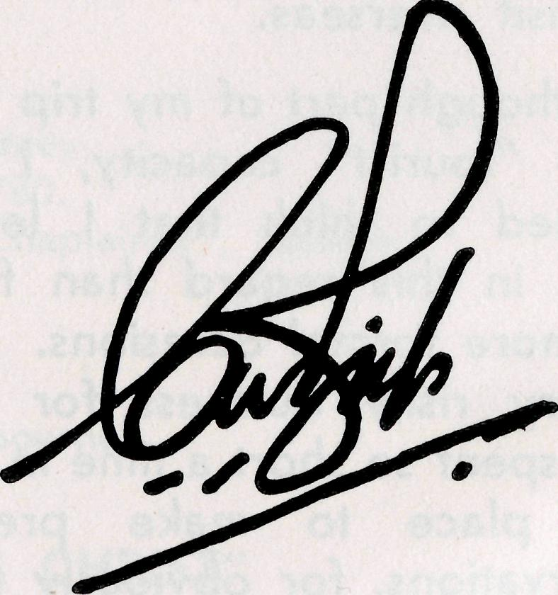
The Revd. B. Carter
The Tarcoola Mission District fills in that great strip of Australia from Kalgoorlie in the West to Port Augusta in the East; from Coober Pedy in the North to the Gawler Ranges in the South. Here are the gibber plains of the Great Victoria Desert, the Mulga and Saltbush sheep country, Mallee-covered sand hills and the flat, empty Nullarbor Plain. In this district is the entire length of the Trans-Australian Railway (over a thousand miles long); a diamond-shaped sheep station area of 30,000 square miles; and the booming opal mining town of Coober Pedy with a population of over 1,000 people. The people work for the Commonwealth Railways maintaining the track; for the big sheep stations or mine opal. It is rarely normal for people to make their permanent home in a lonely Railway camp or station outpost and so there is a constant change in population. The Missioner is always meeting people for the first and often the last time. ("Good-day! How are you going? How long have you been here?" "Oh, just a few weeks", is a typical conversation).
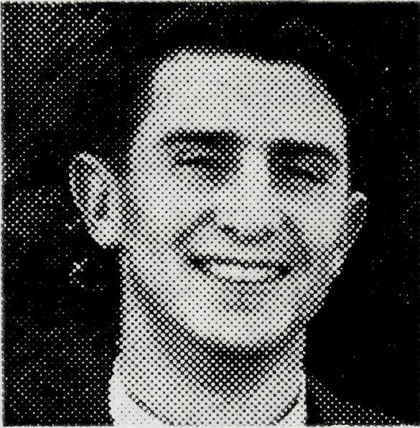
As you will imagine, the great problem is distance. Travel costs time and money and has to be organised. The roads are long, rough and dusty; and the trains come and go at awkward hours. If the population lived in one place, the Missioner could sometimes do a week's work in a day, and more effectively. As it is, he uses a car equipped with a variety of tools and special equipment (all necessary) and is allowed rail travel at one quarter fare, or may use the Railway Welfare Car (a carriage fitted as a self-contained living unit).
The pattern of work here consists of visits to the various locations several times a year. The larger line camps (12 houses or more) can be visited for School Scripture lessons and services, and the smaller camps are attended to by travelling on the famous "Tea and Sugar" train

THE REAL AUSTRALIAN, DECEMBER, 1967
THE REAL AUSTRALIAN, DECEMBER, 1967

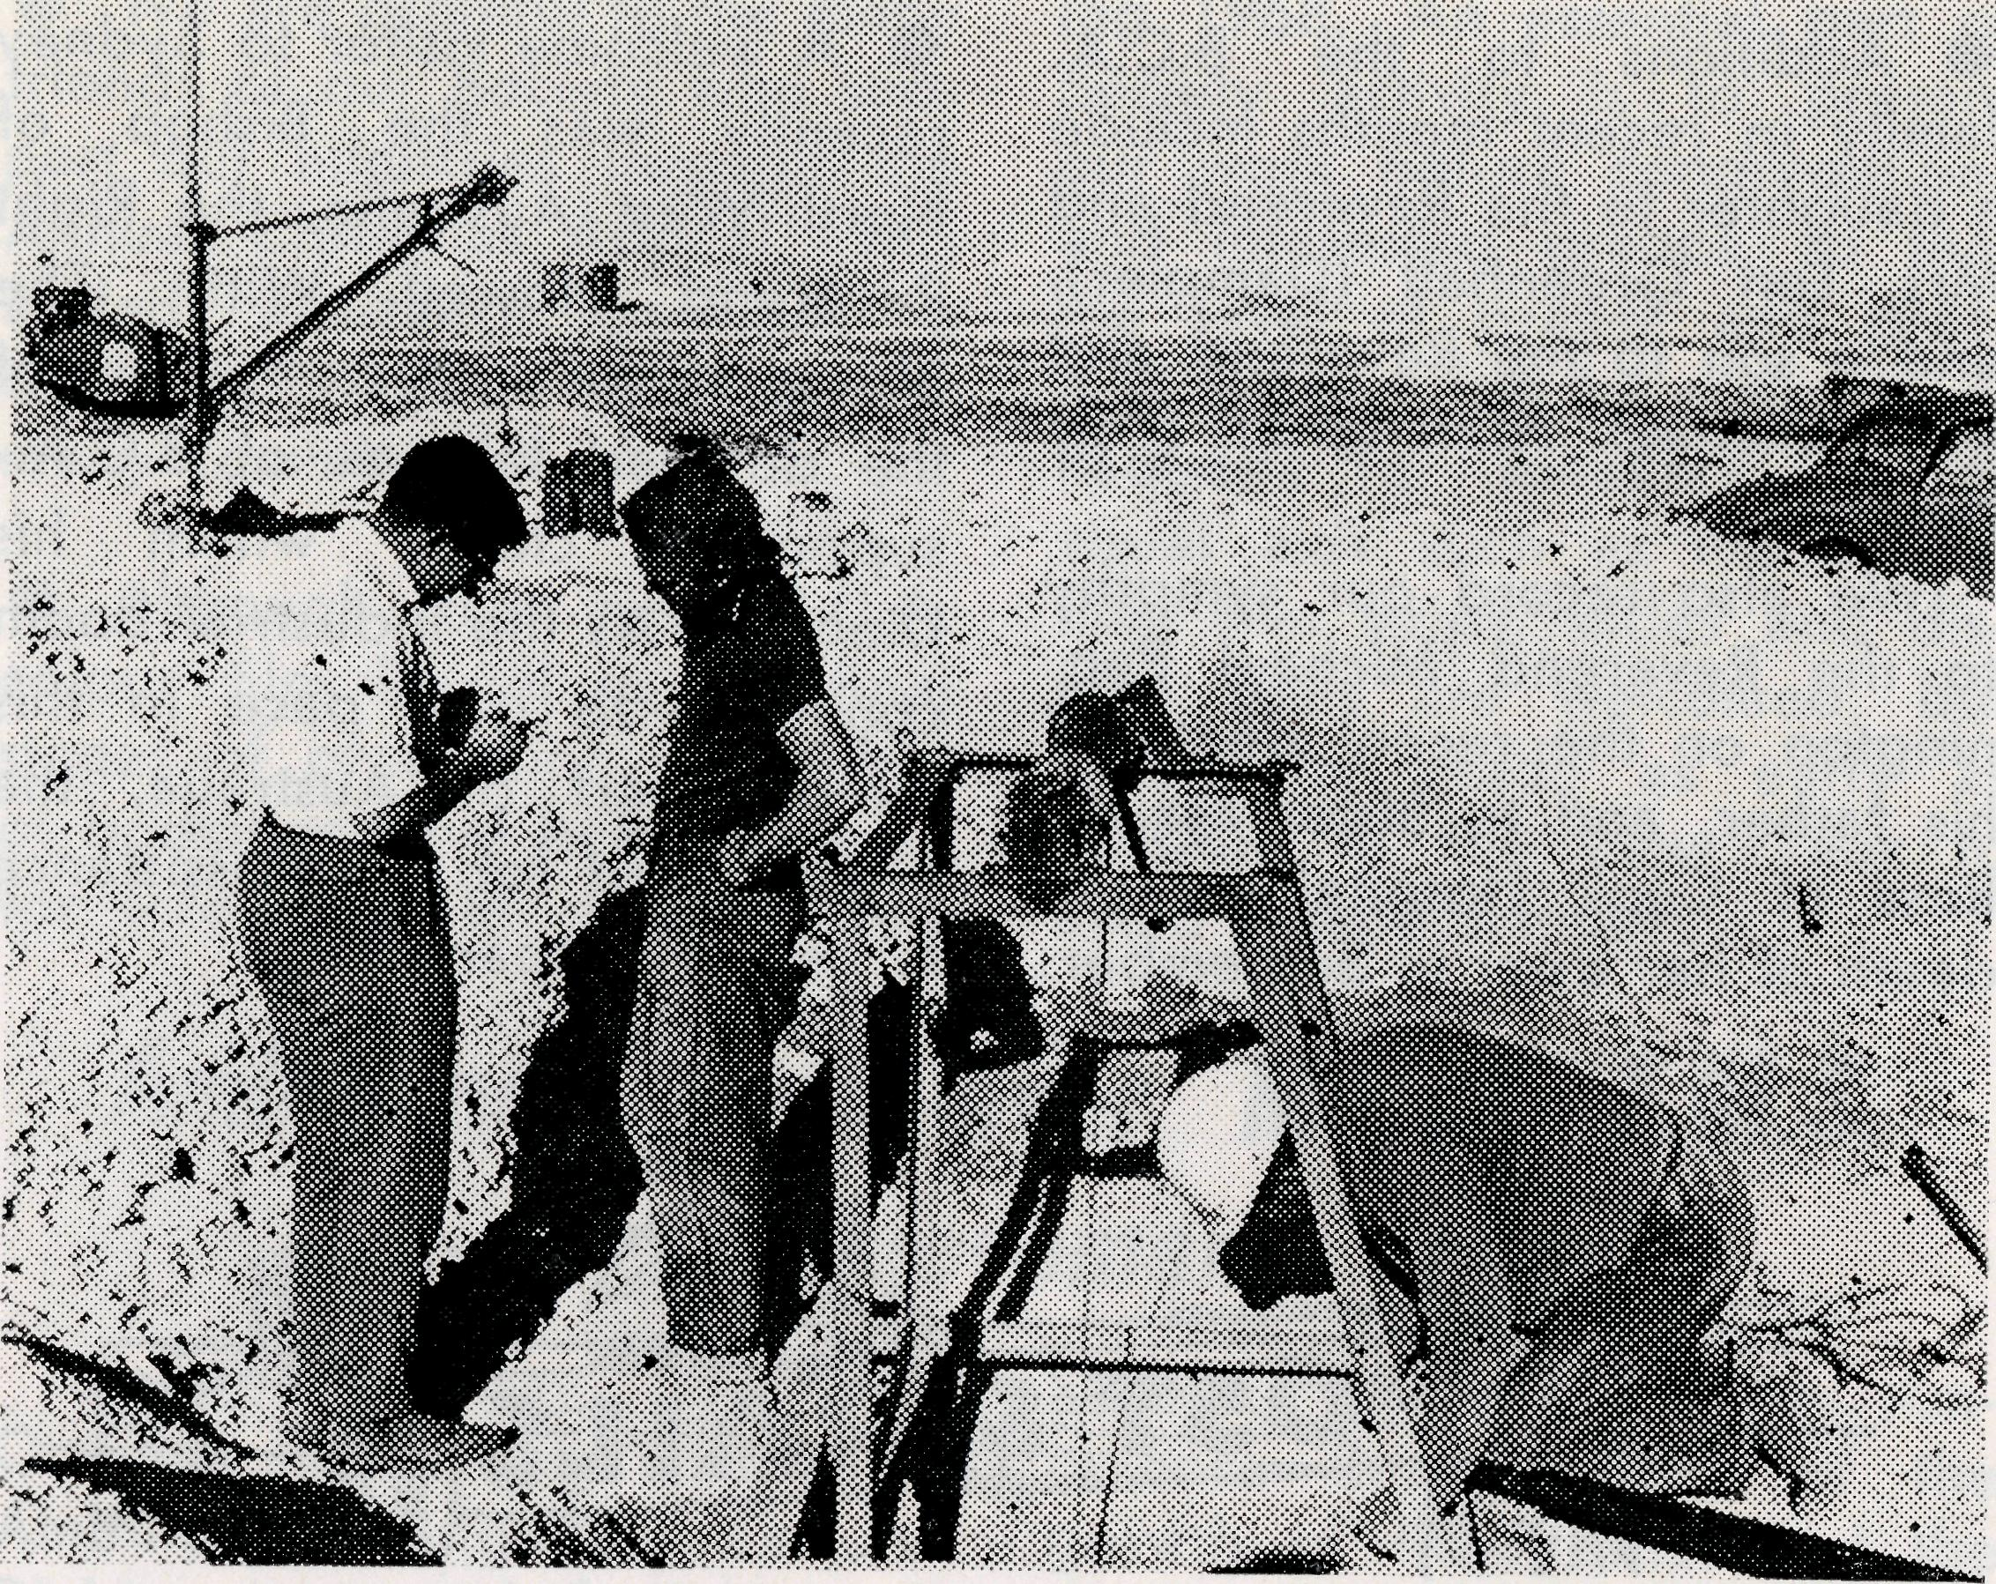
At another camp, "How are you off for reading matter?" "No good. We're down to the labels on the jam tins."
There are not many professing Anglican families here; but then there are not many Christian ministers — so all people are approached regardless of denomination.
Why is the Bush Church Aid Society concerned with this great, empty area? What is the
that delivers meat, groceries, pay and water and which stops at every camp for at least half an hour. But what can a clergyman do for a group of people in half an hour while they are getting paid and doing the week's shopping? The obvious answer—deliver Scripture tracts. The one used mostly is called "God Hath Spoken" and gives Bible passages under the headings of Sin, Judgment and the Salvation provided by Christ. The usual approach with a new face after greetings and discussing the weather and the Line is "I'd like you to have one of these—it contains passages out of the Bible that explain the basic facts of the Christian faith —about Jesus Christ and what He can do." Hundreds of these have been given out, and rarely has one been refused. Also the Baptism of children is performed while the train is at a camp. It is a case of 'Buy your meat, have the children baptised, and ask the guard to hold the train'. The sheep stations are visited where friendship and hospitality is often received from the managers and workers. Sometimes a Service of Holy Communion is held or a Children's Scripture lesson given; and Bibles and children's Bible story books are sold. The work at Coober Pedy is the
same as in any other town except that the Missioner doesn't knock on the front doors along the street, but on the dug-out entrances along the hillside. There is a large Italian, Yugoslav and Greek population here, and Scripture portions in these languages are used.
The spiritual needs in this Mission District are the same as anywhere else, as the heart of man is the same the world over. However, the basic problem of separation from the life of God is expressed in different ways. The restricted social life of the tiny communities often leads to a breakdown in personal relationships. In reply to being given a Scripture tract and being told that because it was God's word he could trust it, a man in a small camp once said, "Well, then, it's about the only thing a man can trust around here!" An environment of isolation and monotony leads to boredom, drunkenness and sometimes violence. At one camp I said to a man I knew "I hear there's been trouble here—Someone was stabbed?" "Yes, that's right," he replied. "And will the injured person be alright?" "Oh, yes." "And the bloke who did it, did they get him?" "Yes, it was me! I did the lolly a bit. Come up and the wife will get you a cup of tea."
The Revd. Brian Carter speaks to an opal gouger at Coober Pedy.
Missioner's purpose? It is not just to cover miles, wear out tyres or put up with hot weather. The answer is in the fact that God has given a command: "Go, tejl all people, to the ends of the earth." Because of your support, we can go. The message we tell has power to change people and unite them to God; it concerns Jesus Christ—who He is, what He has done and what He can do. And surely the empty Nullarbor and the edge of the Great Victoria Desert are the ends of the earth. •

THE REAL AUSTRALIAN, DECEMBER, 1967
THE REAL AUSTRALIAN, DECEMBER, 1967

• Additions to the B.C.A. family in recent months include a daughter to the Reverend and Mrs. Len Greenhall (Dampier), and a son to the Reverend and Mrs. Michael Pennington (Port Hedland).
We also record our sympthy to the Reverend Michael Pennington on the recent death of his father, and to Sister Maude Ross of Cook Hospital on the death of her sister in September.
• A welcome visitor to Sydney recently was the Bishop of North-West Australia, the Right Reverend Howell Witt. The Bishop spoke with enthusiasm of the devoted labours of B.C.A.-supported clergy within his Diocese. As the industrial boom continues to gain pace in this remote part of Australia, the urgent need for more assistance is very apparent.

- We are grateful to the many friends of our Society who support our ministries through the Annual Christmas Appeal. This added assistance provides a much appreciated lift to our many commitments.
- Although our new B.C.A. colour film is still in the final stages of production, a number of bookings have been received for screenings in parishes dur-
ing 1968. An essential part of Society activity is to present our work before congregations and interested groups, so that the level of prayer and practical support will be maintained. Requests for speakers, or for visual aids such as the B.C.A. film, film strips, slides and display units are welcomed, but should be made as early as possible in the New Year to avoid disappointment.

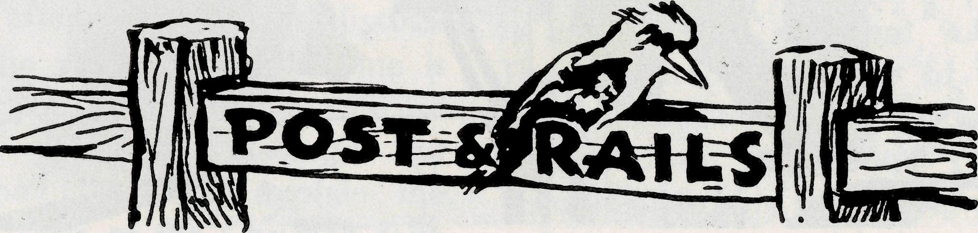
Ambulance Hand-over Marks FMS. Achievement
- The Reverend Blair Grace, with his wife, Lyn, and two children have settled happily at Norseman, in the Diocese of Kalgoorlie. The Induction Service was conducted by the Bishop-elect of Kalgoorlie, The Venerable D. Bryant, and all the clergy of the Diocese were present to add their prayers and moral support for the occasion.
- The Reverend John Wynd-ham, formerly our staff member at Norseman, has accepted an Army Chaplaincy, and with his wife, Jan, and family has proceeded to an Army base in Victoria. Our very good wishes and prayers go with them.
• We give thanks for the loyal and devoted ministry of Miss Rose Campbell, who has completed 21 years of service as Director of the Mail Bag Sunday School. Through the efforts of Miss Campbell and her staff, aided by voluntary teachers and helpers, many hundreds of children in outback areas (and overseas) have been enabled to receive a thorough grounding in Christian faith and practice. The ongoing spirit of the Mail Bag Sunday School is perhaps best illustrated by the article "Promotions and Prizes" in this issue.
THE REAL AUSTRALIAN, DECEMBER, 1967
On Wednesday, the 4th October, the St. John's Far West Ambulance Brigade, Ceduna Division, assumed the responsibility of the ambulance work in the Ceduna area. The Bush Church Aid Society has been responsible for this work for twelve years and this has been carried on by the personnel of the Society for this period of time.
The Society has handed the Volkswagen Ambulance over to the local St. John's Committee to use until such time as they are financial enough to secure their own vehicle. The handing over ceremony was attended by thirty people of the district and also the Country Liaison Officer of St. John's Brigade from Adelaide, Mr. R. Schilling. Mr. E.
THE REAL AUSTRALIAN, DECEMBER, 1967
Skinner, Chairman of the Ambulance Board, spoke of the growth of the district and the need to be responsible for this type of service and paid tribute to the Bush Church Aid Society for the work they had done and also their willingness to cooperate with the local people in this venture. Mr. R. Schilling spoke on the function of an Ambulance group and the work that had been carried on by the Society in Ambulance transport. The Flying Medical Service Executive Officer, Mr. Stan Hum-merston, was then asked to hand over the key of the Ambulance to the Chairman and was able to say how much the Society counted it a privilege to serve the community and assured thrm of our willingness to help in any way possible.

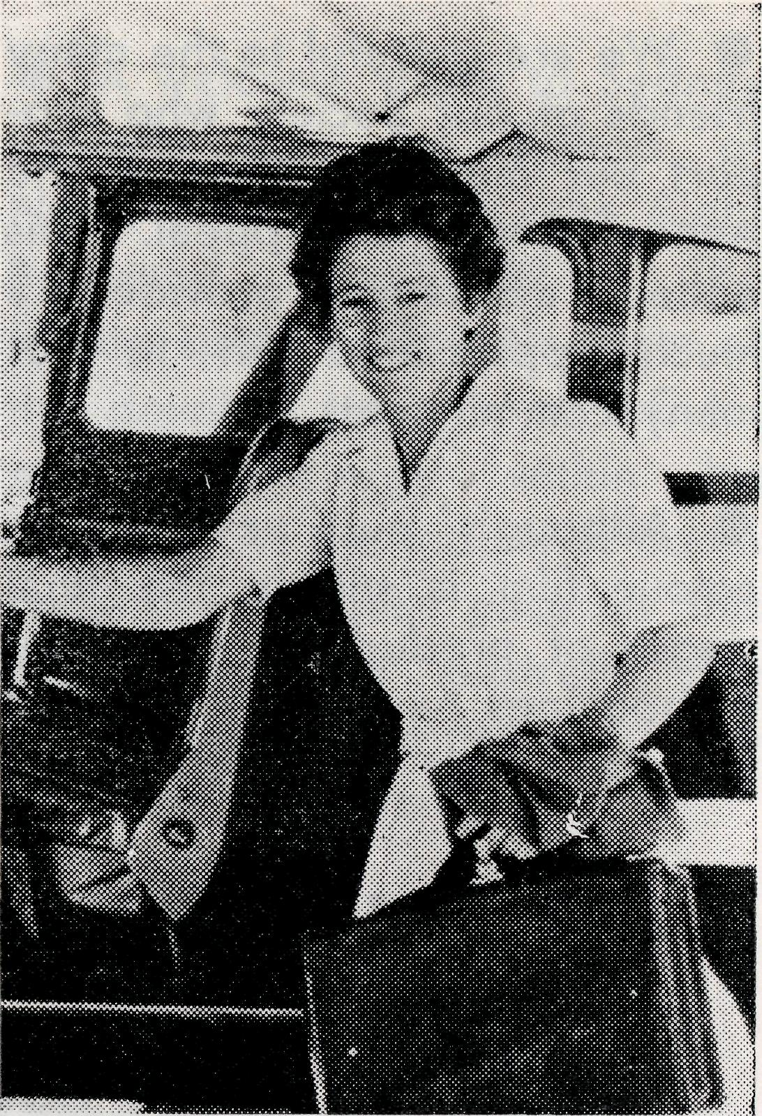
Dr. Merna
Mueller,
O.B.E.
Another milestone of achievement in the history of the Flying Medical Service will be reached at the end of the year when Dr. Mueller will resign from our Society to take up the town medical practice at Ceduna on a full-time basis. The population of Ceduna has steadily increased over recent years, and has now reached the stage where it can support its own medical practice, allowing the Flying Medical Service Medical Officer to give much more attention to the remote areas within the network. The appointment of Dr. Mueller to the town practice reflects the high esteem in which she has been held by the townspeople, and although we are sad to lose her from the "family", we rejoice with her in this new achievement.
The Executive Council of the Society has placed on record a Minute of appreciation for the Services of Dr. Mueller over the years. The Minute reads:
''The Society places on record its appreciation of the ministry of Dr. Merna A. Mueller as Medical Officer within the Flying Medical Service. Since her appointment in 1952, Council has been aware of the devotion and dedication shown by her to the network and its patients. Her untiring efforts in the face of extreme physical involvement have been a constant challenge to all who served with her and reflect a spiritual strength of great depth. Her contribution to Society endeavour has been unique and we thank God for her ministry."
8 THE REAL AUSTRALIAN, DECEMBER, 1967
The Place of Prayer
The following pages represent a daily prayer calendar which is revised with each issue. We earnestly seek your prayers for the individual members of our staff. We suggest you remove these centre pages from the magazine and keep them for your regular devotional use.
Further prayer items and information letters are sent at regular intervals to all members of the B.C.A. Fellowship of Prayer.
Membership in the Fellowship is invited from all who are concerned in the prayer support of our work. There is no joining or membership fee, although a badge pin (or brooch) may be purchased for 40c if so desired.
Send your name and address to the N.S.W. or Victorian Secretary and the prayer letter will be forwarded to you.
THE REAL AUSTRALIAN, DECEMBER, 1967

THE PLACE OF PRAYER - A DAILY PRAYER CALENDAR

1st Miss Rose Campbell, Miss Barbara Hyett and all the helpers and scholars in the Mail Bag Sunday School.
2nd Mr. and Mrs. Bob Brown, and the boys at Urallie Hostel, Moree, N.S.W.
3rd The Revd. and Mrs. Barry Green and the Ord River Mission, W.A.
4th The Revd. and Mrs. Bri^n Viney and the Derby Mission,
W.A.
5th The Revd. and Mrs. Michael Pennington and the Port Hedland Mission, W.A.
6th The Revd. and Mrs. Len Greenhall and the Dampier Mission, W.A.
7th The Revd. and Mrs. Bernard Buckland and the Murchi-son Mission, W.A.
8th The Revd. and Mrs. Bill Lawton and the Mullewa Mission, W.A.
9th The Revd. and Mrs. Blair Grace and the Norseman Mission, W.A.
10th Sisters Lola Higgs and Maude Ross at Cook Hospital, S.A., and Sisters Barbara Fox and Rosemary Bond at the Tarcooia Hospital, S.A.
11th The Revd. and Mrs. Brian Carter, and the North-West Line Mission, Tarcooia, S.A.
12th Mr. and Mrs. Stan Hummerston and the administrative work within the Flying Medical Service.
13th Dr. Merna Mueller and the patients within the medical practice.
14th Mr. and Mrs. Bill Carter and the work of the Ceduna Pharmacy, S.A., and Mr. John Crocker and the work of the Ceduna Dental Service.
15th The Revd. and Mrs. Ron Keynes and the Ceduna Mission, S.A.
16th Sisters Julia Zillman, Vera Holle, H. Heaver, Wendy Hill, Y. Newnham and Jean Griffen at the Ceduna Hospital, S.A.
17th Mr. and Mrs. John Lindridge, Mr. and Mrs. Allan Chad-wick and the Flying within the Medical Service.
18th Mr. Kevin Ellis at the Radio Control Station, the Radio Teacher and children.
19th Sisters Nancy Wilkins, Ellen Mackay, Dorothy Whyburn, Pamela Lloyd and Miss Lynette Mobbs at Wudinna Hospital, S.A.
20th Mr. and Mrs. Harry Rich and the girls at the Port Lincoln Hostel, S.A.
21st Sisters Lilian Morgan and Judy Stack at the Coober Pedy Medical Centre, S.A.
22nd The Revd. and Mrs. Ernie Carnaby and the Leigh Creek Mission, S.A.
23rd The Revd. and Mrs. Brian O'Grady and the Wilcannia Mission, N.S.W.
24th Mr. and Mrs. Bert Kennett, Miss Myra Attwood and the boys at the Broken Hill Hostel, N.S.W.
25th The Revd. and Mrs. Ray Neve and the Menindee Mission, N.S.W.
26th The Revd. and Mrs. Bill Jobling and the Mission District of Outer Mt. Isa, North Queensland.
27th A continuing supply of replacement staff, our Box Secretaries, supporters and friends of the Society.

10
THE REAL AUSTRALIAN, DECEMBER, 1967
THE REAL AUSTRALIAN, DECEMBER, 1967

28th The Revd. Canon Bill Rich, the Revd. Les Wiggins, the Executive and Council of the Society.
29th The Revd. John Stockdale, Mrs. Winifred Hughes and the Victorian Committee, and our Representative in South Australia, Mr. Alban Kirkby.
30th The Revd. Barry Huggett, Mr. Laurie Calder, Mr. Frank Burner, Mrs. Joy O'Neill, Misses Robin Gosper, Marilyn Palmer and Beverley Tonkies.

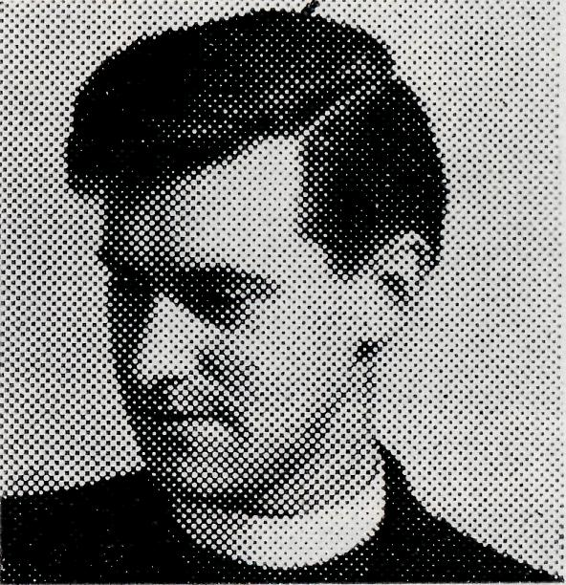
A Camel Train, a Shanty Town and Thou Beside Me in the Wilderness
The Revd. W. Lawton

31st Thanksgiving for blessings received, for opportunities of service and for the growth of the Society since its formation.
THE B.C.A. PRAYER
O Lord our God, make us ever mindful of those who live in the remote parts of our land. Bless, we beseech Thee, all those whom Thou hast drawn into the fellowship of the Bush Church Aid Society. Grant that, through the ministry of the Word and Sacraments, through healing, and through caring and instruction of the young, the message of Thy redeeming love may thus be proclaimed, through Jesus Christ our Lord. Amen.
A DAILY PRAYER
O God, we remember before Thee those whom Thou hast
called to Thy service. Bless them this day, we beseech Thee, as we
pray for . Call forth others
to stand with them in their task. Grant to them, as to us, the joy of service, the ability to achieve and the serenity of Thy peace, for Jesus' sake.
Amen.
By mid-October, the wild-flowers of the early Spring have withered. The expanse of gold and mauve and an array of indeterminate hues has crumbled to the dust of its origin. At the slightest gust of wind, the dry red earth rises, then settles lazily where once the flowers grew.
From Geraldton, travelling west, is 60 miles of green and red and gold—the green of Banksias past their flowering, the reds of Melaleucas and the golden Currawang. From a town of 13,000 people, along a road of breathtaking natural splendour, at a rise on the curve of the road, one looks down to Mullewa.
The curve in the road hides most of the houses and more recent development. The first sight of Mullewa is of the Church of Our Lady of Mt. Carmel, with its tall, mosque-like
minaret, evidence of Spanish architectural influence seen so frequently in the West. And then one becomes conscious of the railway line that has followed and intersected the road from Geraldton. For Mullewa seems an interminable railway station, the epitaph set over a graveyard of inactive men and motionless trains.
Whatever else one may see of Hospital, School, neat houses and gardens, one has already met the spirit of Mullewa in its Mediterranean church and vast railway yard.
A closer view of the town shows the Roman church to be at the extreme western end of the town. Yet it is still the centre for more than 60% of the population. On either side of the church is dereliction— greenish-grey pools of slime, the effluence from tin shanties

12
THE REAL AUSTRALIAN, DECEMBER, 1967
THE REAL AUSTRALIAN, DECEMBER, 1967
13

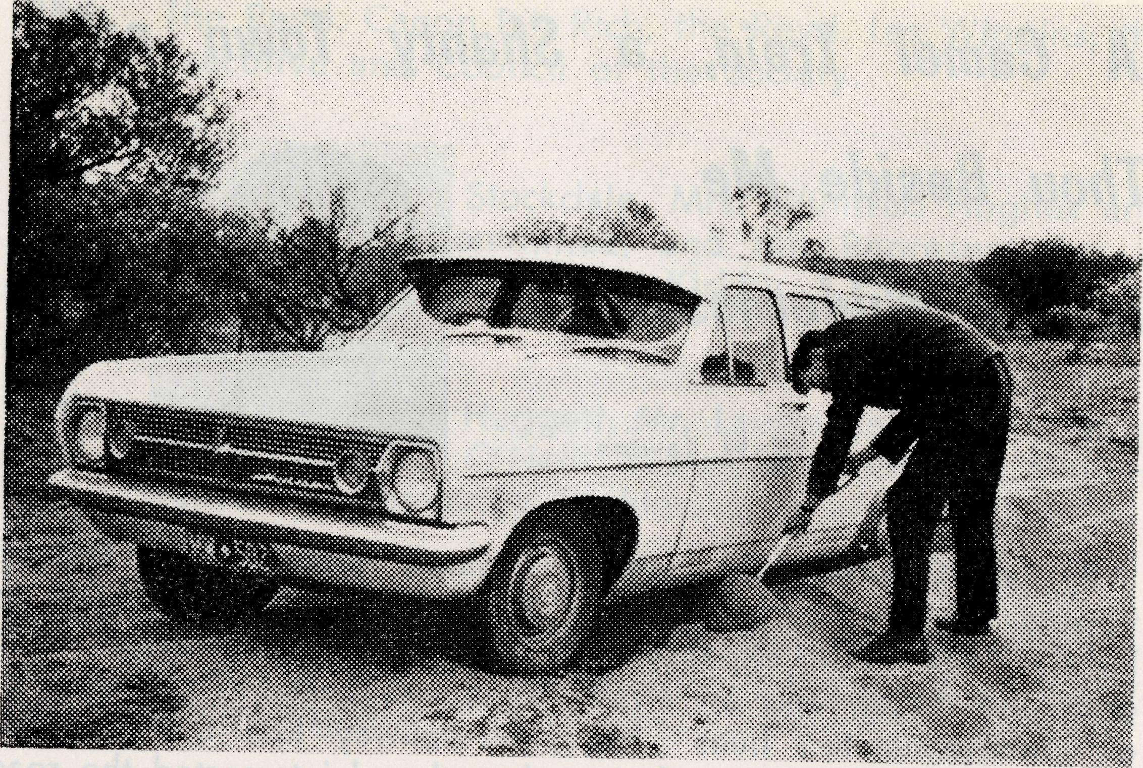
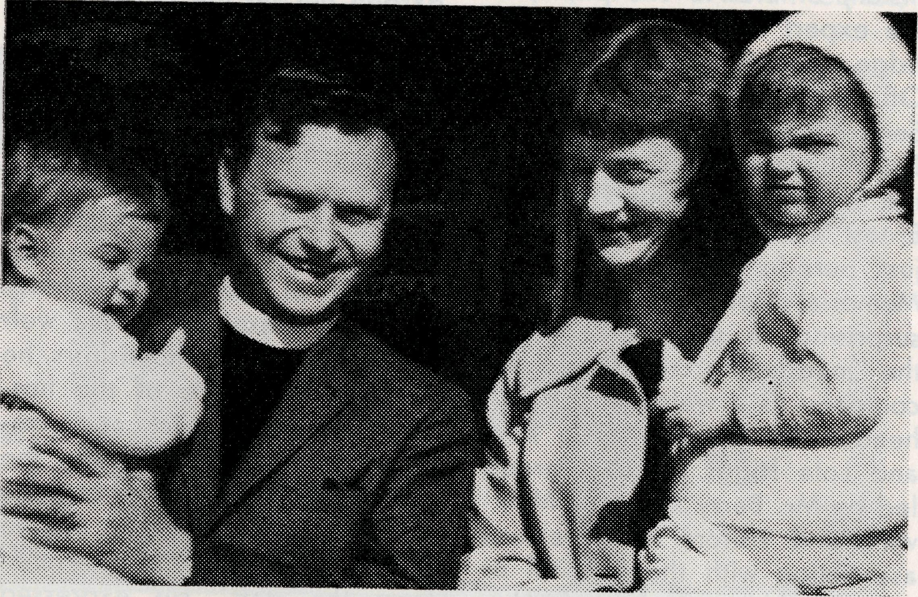
the railway line from Geraldton
in 1894 that created the town
ship. Everywhere around
Mullewa are the ruins of towns
which lived and died with the
gold-fields. Their mineral glory
is past. But Mullewa is different,
it has lived and died with the
railway.
The growth of the town is imperceptible and yet it is deceptive. Its general appearance is dilapidation and flies, heat and flies, tin sheds and always flies; but in streets away from the shopping centre, behind St. Andrew's Church, are neat suburban houses with neat suburban gardens. The houses are new, much newer than the old centre of the town.
The Revd. and Mrs. Blair Grace and family, at Kingsford Smith Airport, before leaving for their new work at Norseman, Western Australia.
THE REAL AUSTRALIAN, DECEMBER, 1967
THE REAL AUSTRALIAN, DECEMBER, 1967
The Revd. Bill Lawton digs into his new work.
overcrowded. Small dark children, incredibly filthy, must begin learning that many regard them as redundant second-class citizens. Here and there a family rises above the aimless, pointless existence of its neighbours and to credit of the white population there is acceptance without discrimination.
Moving from the Reserve towards the Roman church, once again the interminable railway line must be crossed. Mullewa is not just a Catholic town, it is a railway town.
If hors?, donkey and camel trains had made Mullewa a stopping-place in the late 19th Century, it was the opening of
14
It is in the midst of this development that St. Andrew's Church stands. For a minority group, this time the Anglican community, this is the centre of 25,000 square miles of parish. It is a parish with only two towns, Mullewa and Yalgoo.
The bulk of the parish is pastoral and agricultural country. If little is said about it, it is because there is a sameness in any description of it. But here in the wheat and sheep country is the real life of the parish. All that characterises town-life is absent here. The harsh, sunburnt country is the anvil that has forged men's characters. Their rewards may often be
great, and their hardships never as severe as those further inland, but one realises that this is the breed of men and women who have learned lessons of endurance and loneliness and self-reliance that have created legends for Australia.
The alien architecture and the ghost of a railway are only superficially the centre of our vision, even if they are the spirit of the town.
The 'lilies of the field' so abundant in early Spring, are a reminder that the life of man is nurtured by God, and to man in all his various needs we reach out with the word of the Gospel. •

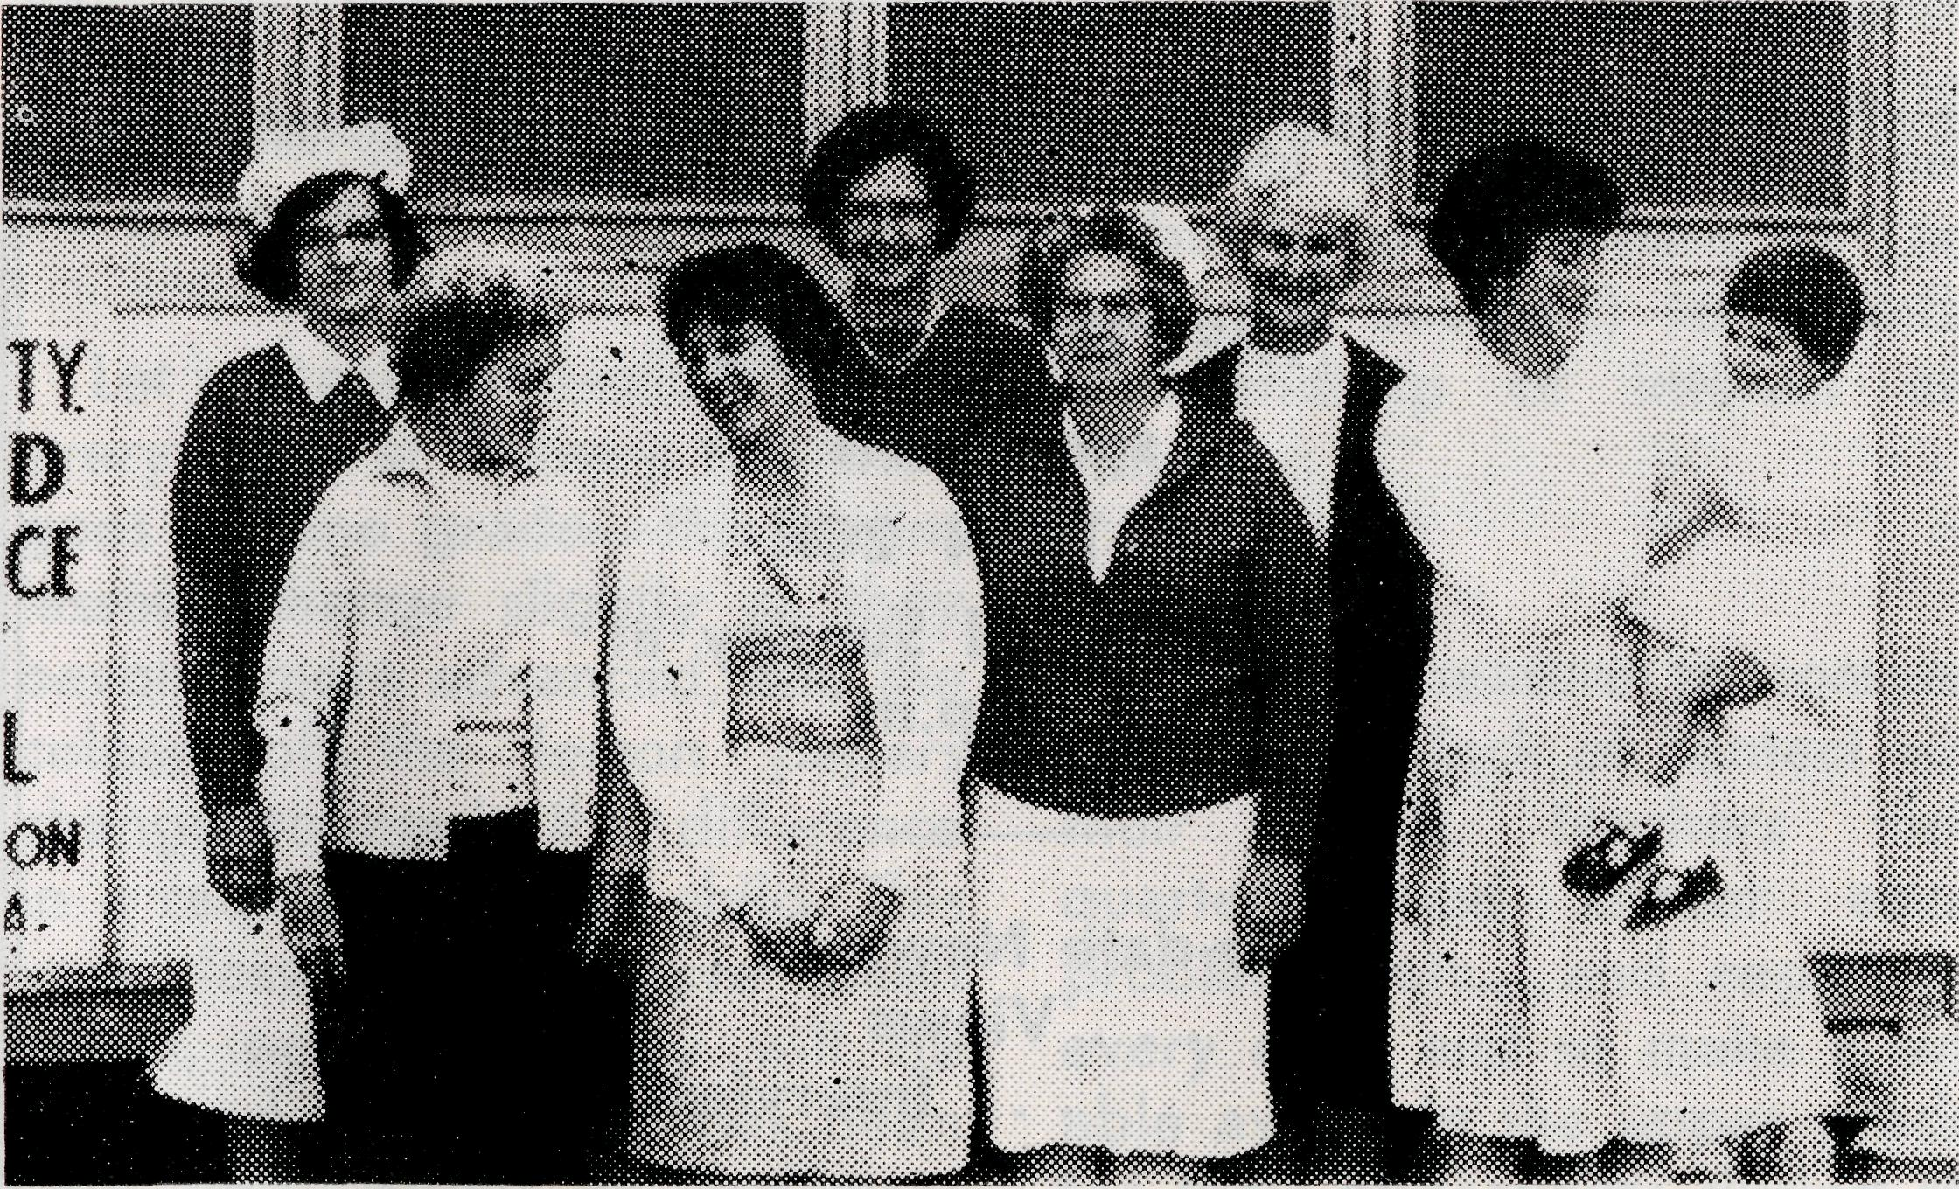
Thirty Years Young!
The Revd. Canon E. Cameron
The Hospital staff and some of the visitors for the Cook celebrations.
Looking down from the Beechcraft Baron upon the Nullarbor Plains, from the encroaching sands of the head of the Great Australia Bight to as far as the eye could see to the North, one was again struck by the sparsity of development; a scatter of buildings here and there, where people were valiantly striving to develop large areas of country; and then in the distance to pick up the little settlement of Cook on the Trans-line, looking so insignificant, yet looming large in the history of B.C.A. The plane, in the expert hands of John Lind-ridge, carrying the Executive Officer of the Flying Medical Service (Mr. Stan Hummerston), Dr. Mueller, Sister Holle, and the Chairman of Council (Canon Ernest Cameron) came to rest just outside the Bishop Kirkby Memorial Hospital and it was surprising to see, so far from the "maddening crowd", goodly company as a welcoming party, headed by Sisters Maude Ross and Lola Higgs, a local group led by Mr. Barry and Mrs. Mink-witz, and visitors with previous association with the hospital or area, in the persons of Mrs. Marj Dixon (Sr. Tarr) and Mrs.

M. Bernhardt (Sr. Horsburgh), Sister Page from Melbourne, and the Revd. Eric and Mrs. Constable who were in the Mission District from 1937 to 1941.
A buffet dinner was served in the hospital, and it is remarkable that in such a place such a varied menu could be provided. The piece-de-resistance was a large Pavlova decorated with a plentiful supply of luscious strawberries from the hospital garden—yes, from the hospital garden out on the Nullarbor.
In the evening Mr. B. Mink-witz, chairman of the local hospital auxiliary, presided at the gathering in the Community Recreation Hall to celebrate the 30th Anniversary of the establishment of the Bishop Kirkby Memorial Hospital. In his welcoming speech to the visitors, he outlined the place of the hospital in the district and emphasised its influence upon the community, not only from the medical side, but also of the spiritual uplift which emanated from the staff. He expressed gratitude for the establishment
and work of the hospital and of the continuing support of the B.C.A. Society.
Canon Cameron, in replying to the welcome, spoke of the influence of the life of Bishop Kirkby upon the Church in Australia and of his own association with him and the beginnings of the Society. What better memorial could there be to a man of his vision and determination to spread the Gospel and "win Australia for Christ" than this hospital which has played such a vital part in the life of the outback of our vast land. We thank God, too, for the consecrated people who have served in the hospital, Doctors and Sisters, whose sacrificial labours have enabled it to minister to the physical and
spiritual needs of those who have come within its scope.
Canon Cameron then entertained the company with a travelogue and colour slides of a trip through the Pacific, the U.S.A. and England.
Such an occasion would not be complete without supper, which was on a lavish scale, including a Birthday Cake which Sister Maude Ross was invited to cut.
Sunday's activities commenced with a Celebration of the Holy Communion in the hospital when there were over 20 communicants; during the afternoon the Trans-line Mis-sioner (The Revd. Brian Carter)

16
THE REAL AUSTRALIAN, DECEMBER, 1967
THE REAL AUSTRALIAN, DECEMBER, 1967

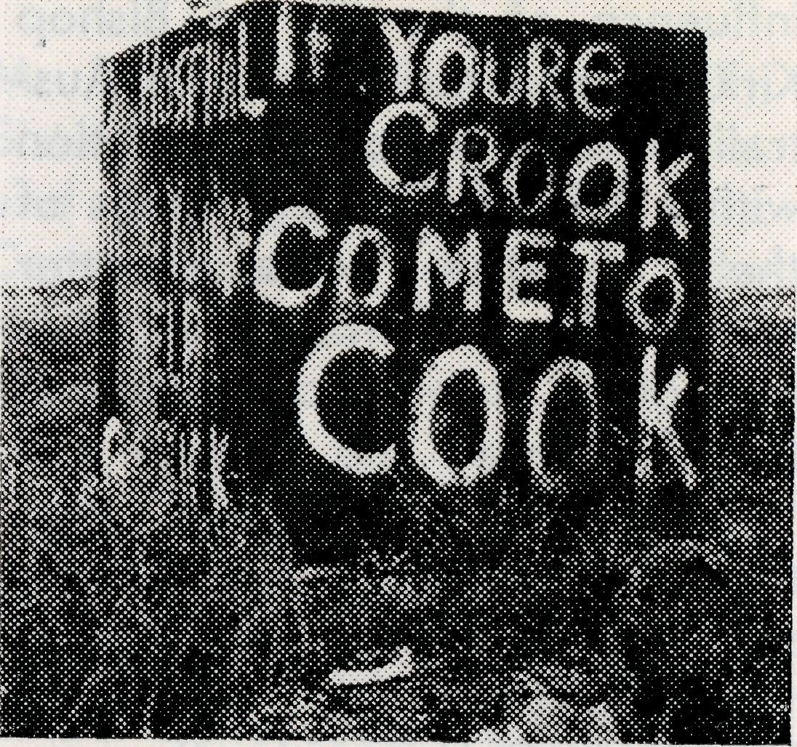
spoke at the Sunday School Prizegiving. Evensong was in the Community Hall at 7.30 and Canon Cameron preached at both Services.
We felt that the celebration was worthy of the occasion and leaving an impression on us that the local people were encouraged in their activities, and we were all the better for our fellowship with them.
The Ceduna party flew back in the bright moonlight at an altitude of 11,000 feet to get above and around heavy cloud and rain, and round about midnight saw in the distance the twinkling lights of Ceduna and then the landing lights of the 'drome to guide us in. •
It pays to advertise!
THE "BUSH PADRE"
speaks on
STATION 2CH
every second Sunday at 8.30 p.m.
Up-to-date News . . . . . . Views
. . . Interviews
Promotions and Prizes
Miss R. Campbell
Midst the general flurry of getting things finished before the end of the year, Sunday Schools have their share of activity with promotions and prize givings. Now you may say, "such things don't happen in a Mail Bag Sunday School where children are scattered far and wide over the continent and to the islands beyond. How could they possibly have promotions and prize givings? Why, they never see each other or their teachers!" Yet these things happen you know, and with a good deal of interest shown by all concerned.
Let us take promotions first— every year at Advent the child goes up one grade—this means lessons change slightly as they become more advanced, and the colour of the lesson papers change to mark the difference in a real way for the child. This year lessons may have been green, next year they will be gold and so the child has been "put up"—surely an important event in any young life!
There are two main divisions in our school; primary grades for pre-school to about 9 years, then upper grades from 10 years and on. A child may pass through all grades of the primary and have the one teacher during these years. Then, when able to read and write freely and memorise too, comes the promotion to the upper school where there are both men and woman teachers. This transition is generally marked by the gift of a Bible. The children continue with their new teacher through all the next six grades.
This, briefly, is the method followed though it gives little idea of the sustained effort by the children as well as parents who assist them, or the faithful and painstaking task of teachers who not only correct work sent in but by every means try (and generally succeed) to establish a friendship of interest and value.
In some measure to compensate for the lack of contact with their pupils, teachers meet quarterly and confer about problems, etc., and report on every child and so make a suitable award in the upper grades for their endeavours during the year. From personal knowledge

18
THE REAL AUSTRALIAN, DECEMBER, 1967
THE REAL AUSTRALIAN, DECEMBER, 1967
19

of the child the teacher can select a suitable prize.
In addition pupils who complete memory work, answers to all questions, as well as handwork for 90 per cent of the year, are sent a Certificate of Merit—this gives a real sense of achievement to both child and teacher.
There does not appear to be a feeling of loss because there
One of the mainstays of our Society's finances is the income received from legacies, bequeathed by those who in their lifetime have had a concern for the various ministries of our Society.
From time to time we are asked to supply some form of wording that will satisfy legal requirements. Our Solicitors (Messrs. Maxwell and Boyd) suggest forms of wording for use by those who may wish to remember the work of the Society in this way.
FORMS OF GIFT BY WILL Personal Estate:
I bequeath the sum of $
(or my shares in ) to the
Bush Church Aid Society for Australia and Tasmania, free of all probate, estate, succession,
is no ceremony for presentation of prizes. For children write about their prizes with enthusiasm, and always appear particularly pleased with their Bibles or Prayer Books, which they assure their teachers they will treasure. One mother wrote and said, "John was so pleased to see the label 'Awarded To', for it was just like children have in other schools". ®
legacy and other death duties whatsoever to be used by it for its general purposes.
Real Estate:
/ devise my house property
known as to The Bush
Church Aid Society for Australia and Tasmania, free of all probate, estate, succession, legacy and other death duties whatsoever to be used by it for its general purposes.
Share of Residuary Estate:
/ give devise and bequeath a
one share of my residuary
estate to The Bush Church Aid Society for Australia and Tasmania, free of all probate, estate, succession, legacy and other death duties whatsoever to be used by it for its general purposes.
The Bush Church Aid Society
FIELD STAFF:
DIOCESE OF RIVERINAy N.S.W.
Wilcannia—The Revd. B. O'Grady. Menindee—The Revd. R. Neve.
DIOCESE OF WILLOCHRA, S.A. Leigh Creek—The Revd. E. Carnaby. Ceduna/Penong—The Revd. R. Keynes. Tarcoola—The Revd. B. Carter.
“I Give, Devise and Bequeath”
DIOCESE OF KALGOORLIE, W.A. Norseman—The Revd. B. Grace.
DIOCESE OF NORTH-WEST AUSTRALIA
Mullewa—The Revd. W. Lawton.
Mount Magnet—The Revd. B. Buckland.
Dampier—The Revd. L. Greenhall.
Port Hedland—The Revd. M. Pennington.
Derby—The Revd. B. Viney.
Kununurra—The Revd. B. Green.
Carnarvon—Grant-in-aid.
Outer Mt. Isa—The Revd. W. Jobting. Religious Broadcasting—Grant-in-aid.
DIOCESE OF BRISBANE, QUEENSLAND Kilkivan (Cherbourg Mission)—Grant-in-aid.
MAIL BAG SUNDAY SCHOOL
Director: Miss R. Campbell.
HOSTELS FOR SCHOOL CHILDREN
BROKEN HILL, N.S.W. PORT LINCOLN, S.A.
Mr. and Mrs. H. KENNETT Mr. and Mrs. H. RICH
Miss M. ATTWOOD
MOREE, N.S.W.
Mr. and Mrs. R. BROWN

20
THE REAL AUSTRALIAN, DECEMBER, 1967
THE REAL AUSTRALIAN, DECEMBER, 1967

