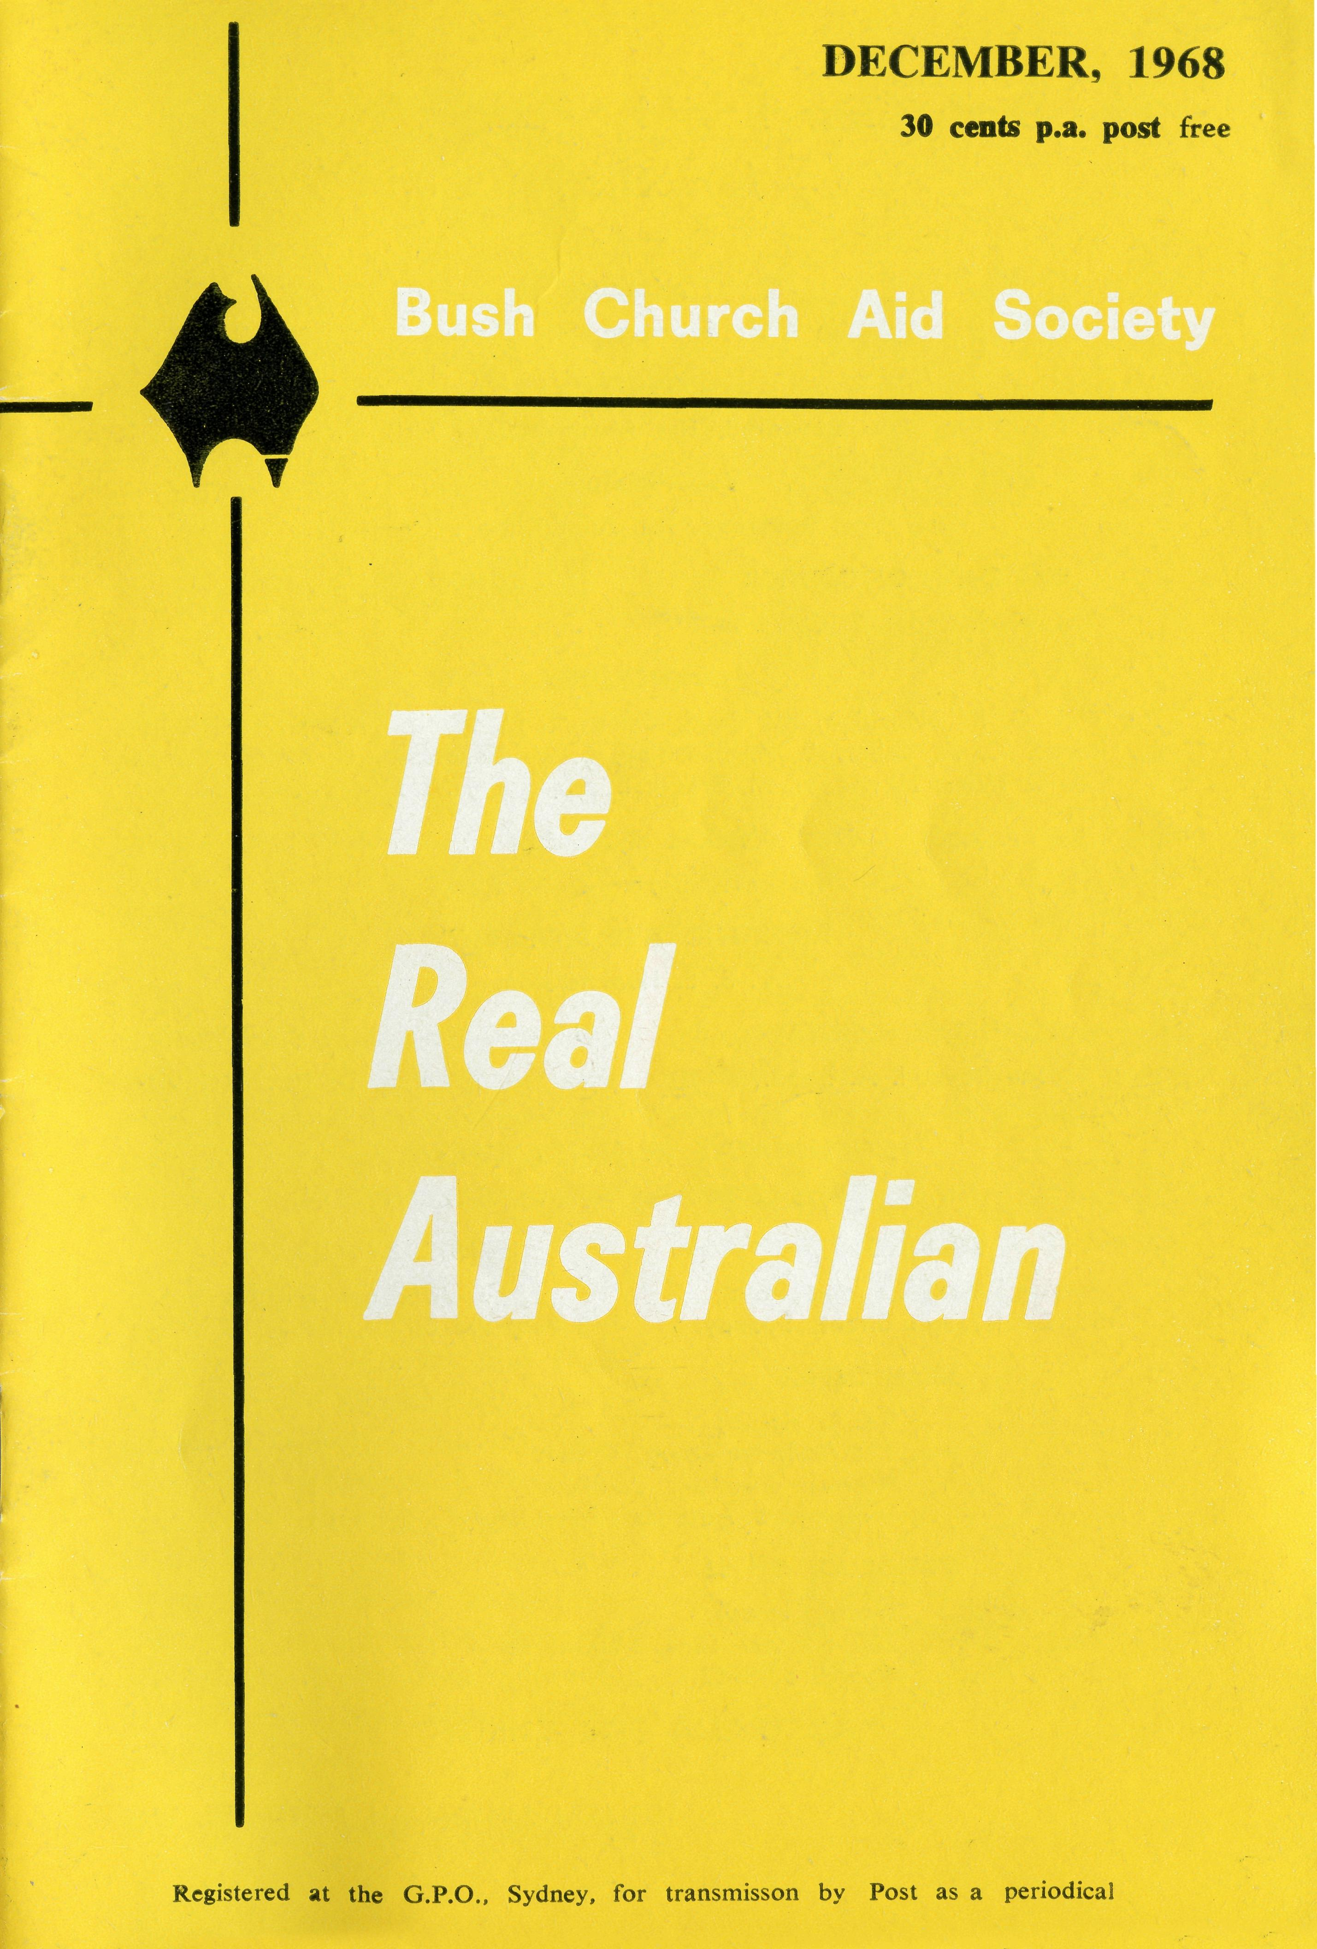
HOSPITAL CENTRES
CEDUNA, S.A.
Murat Bay District Hospital—
Matron: Sister J. ZILLMAN, Sister H. HEAVER. Mr. A. E. CHADWIGK.
WUDINNA, S.A. Matron: Sister N. WILKINS, Sister P.
Central Eyre Peninsula Hospital— LLOYD.
COOK, S.A.
Bishop Kirkby Memorial Hospital— sisters L. HIGGS, M. ROSS.
TARCOOLA, S.A. Tarcoola Hospital—
COOBER PEDY, S.A.
Sisters P. DARBY, J. STACK.
Coober Pedy Medical Centre-
l/l/laij the floy of- L^kndtmas brincf (Dlessina ror the Vfew UJear
"Glory to God in highest heaven. And on earth His peace for men on whom His favour rests."
Luke 2 : 14.
EDGAR BRAGG ft SONS PTY. LTD.. J30 BOTANY STREET. WATERLOO

The Bush Church Aid Society
for Australia and Tasmania
PATRON
The Most Reverend, The Primate.
PRESIDENT
The Most Reverend, The Archbishop of Melbourne.
VICE-PRESIDENT
The Most Reverend, The Archbishop of Sydney.
CHAIRMAN OF COUNCIL HONORARY TREASURER
The Revd. Canon E. Cameron. Mr. R. T. Stokes
COUNCILLORS
The Ven. G. R. Delbridge, the Revd. Canon R. M. Hudson, Canon G. Pearson,
the Revds. C. A. Baker, L. H. Broadley, E. V. Constable, O. W. C. Cooper,
A. C. Miles, Messrs. H. M. Bragg, R. Ctercteko, M. Job, E. Stockton.
FEDERAL SECRETARY
The Revd. Canon C. W. Rich.
ADMINISTRATIVE SECRETARY
Mr. S. E. Hummerston.
VICTORIAN SECRETARY NEW SOUTH WALES SECRETARY
The Revd. I. A. Booth The Revd. B. D. Huggett
REPRESENTATIVE IN SOUTH AUSTRALIA
Mr. A. Kirkby, 7 Ruthven Avenue, Glandore, S.A.
HONORARY AUDITOR
F. W. A. Eager and Co., 8 Belgrave Street, Manly, N.S.W.
SOLICITORS
Messrs. Maxwell and Boyd, 155 Castlereagh Street, Sydney.
HEAD OFFICE
B.C.A. House,
135 Bathurst Street, Sydney.
Phones: 26-3164, 26-3780.
Telegraphic Address: "Chaplaincy", Sydney.
VICTORIAN OFFICE
Morton House,
262 Flinders Lane, Melbourne.
Phone: 63-8962.
"AUSTRALIA FOR CHRIST"
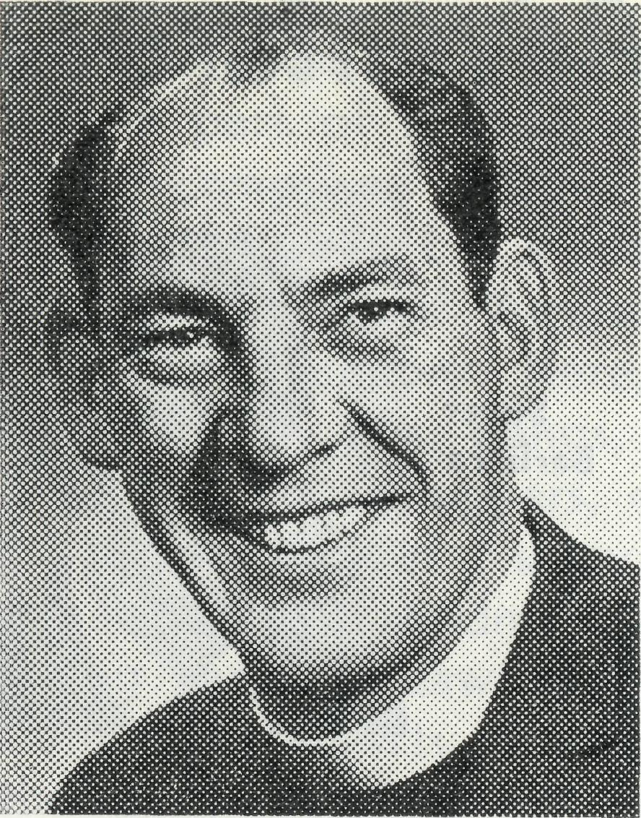
By the time this issue reaches you many will know of my decision to leave this task to someone else.
For twelve years the Society has been a way of life for my wife and me, so it has been with a great deal of personal concern that we have reached this conclusion.
We believe that such has been the turn of events over these past 12 months that God is leading the Society into a new phase of activity. We also believe that a different vision is required of the one who occupies my position within and beyond the Society. Thus it is that we are convinced that we are acting in the best interests of the Society and in turn, of the Kingdom.
From the
Federal
Secretary
We have keenly felt the privilege in being involved with you in this work and have been constantly aware of the role you, the supporters, play in so many ways. Our sense of gratitude for the personal concern of many is very real.
May God bless us all as we seek to continue to do His will.
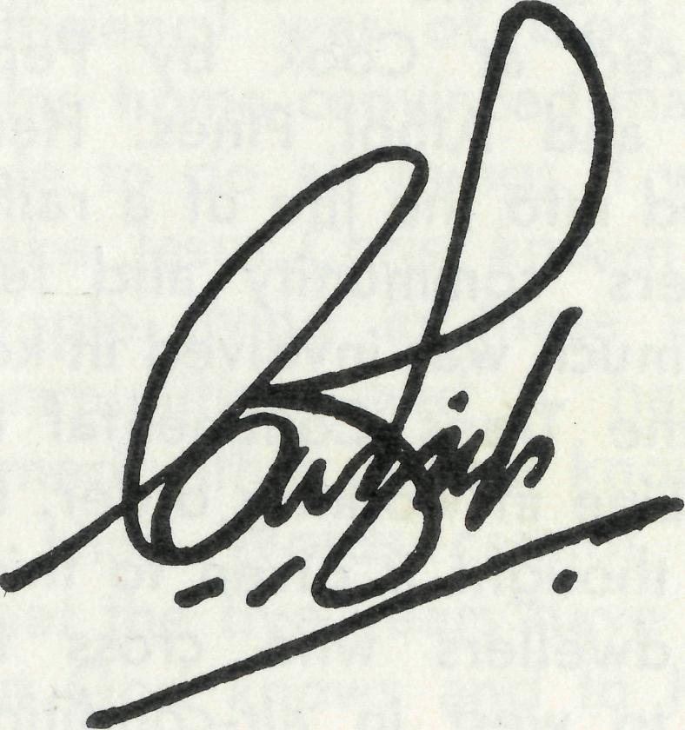

THE REAL AUSTRALIAN, SEPTEMBER, 1968
THE REAL AUSTRALIAN, DECEMBER, 1968

A Five Year Adventure!
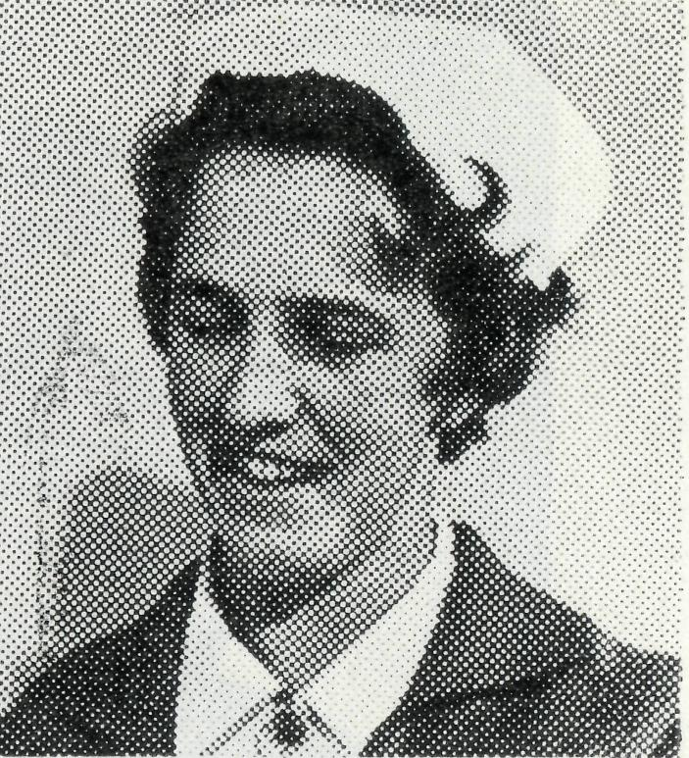
"Adventure" probably best sums up my five years association with B.C.A. in South Australia! During those five years I worked in four of the five hospitals maintained by B.C.A. First at Wudinna, then Cook, Ceduna and Tarcoola.
An adventure in so many ways. Geographically of course it was all new territory to me. At Wudinna, it was nearly three months before I was able to get to a vantage point and view the panorama of wheat, barley and oat crops. It was then that I learned the meaning of Jesus' words as He spoke of the fields being white already to harvest.
It was at Wudinna that the sight of long queues of wheat trucks waiting to unload at the silos became such a familiar sight, bearing witness to the predominant activity of the people in this particular area.
At Cook, treeless, flat and bare vistas took the place of the green and golden paddocks and the gums which had graced the Wudinna hospital were replaced at Cook by Pepper trees and Athol Pines. Here I settled into the life of a railway workers' community and learnt how much was involved in keeping the Trans Continental Railway Line in working order. How little thought is given to this by city dwellers who cross from east to west in air-conditioned

Sister
Barbara
Fox
comfort! The battle here was against heat and dust, but there were many compensations. The reviving south wind which invariably blew in across the plain each evening; the sunsets which lingered long in the western sky and, seemingly a vast nothingness between the viewer and the sun; the brilliance of the clear nights with stars and moon unrivalled by neon signs and city lights; the stillness and quietness which is almost deafening and the question which repeatedly springs to mind in the midst of such stillness and vastness "what is man that Thou art mindful of him?"
My sojourn at Ceduna was only short but here I saw the sea in so many of its moods. Again I had dealings with people whose livelihood was on the land and who were dependent on good seasons.
Tarcoola then became my home for a little over three
years and once more I found myself a part of a small community, comprised mainly of railway employees, but a service centre for some of Australia's largest sheep stations. Here, as well as section cars, gangs, tea and sugar trains, bombers, etc., we talked about shearing, crutching, bores, windmills, and the dog fence. I saw and experienced the effects of drought —the earth cracked, dry and desolate. I witnessed the miracle of growth after rain and the unforgettable sight of acres and acres carpeted with white, pink and yellow everlasting daisies, where only months before there was nothing but salt bush and sand.
There was "adventure" too in the realm of the medical work. One never knew what was "round the corner" and no two days were the same. The doorbell could herald in a patient with a laceration requiring little more than a band-aid or deep wounds requiring suturing; a case of an "upset stomach" or acute appendicitis; a babe with feeding problems or a babe dying with dehydration; a splinter in the hand or a bullet wound through the head; a woman in labour or an attempted suicide. There was certainly no end to the variety and the memories remain vivid of emergency calls by radio to the Doctor and the drama of
night landings.
Living itself was an adventure. The dropping of bread from an aircraft when the town was isolated by flood waters; the unexpected visitors who often literally "dropped" in for a meal or a "cuppa"!—the days of heat waves and dust storms. Leisure evenings were spent joining in with the activities of C.W.A. or a hospital auxiliary, perhaps a Saturday night at the pictures or an energetic game of battington — dining out or barbecuing by starlight half way down the airstrip!
However, it was in all of these things that I had the greatest adventure of all. In my surroundings, in the medical work, in living itself there was spiritual adventure. Discovering in my weakness the sufficiency of Christ, in weariness His strength, in confusion His direction, in tumult His peace, in loneliness His companionship, in want His provision, in joy His abundant joy. I went out with the awareness that I was not sufficient of myself, but that my sufficiency was of God, and I came home convinced that He is able to do all things. I went to make Jesus Christ known to the people living in these isolated communities, and I have returned with a deeper knowledge of Him. Words cannot convey what the five years have meant, but God knows and to Him be the praise. •

THE REAL AUSTRALIAN, DECEMBER, 1968
THE REAL AUSTRALIAN, DECEMBER, ly68

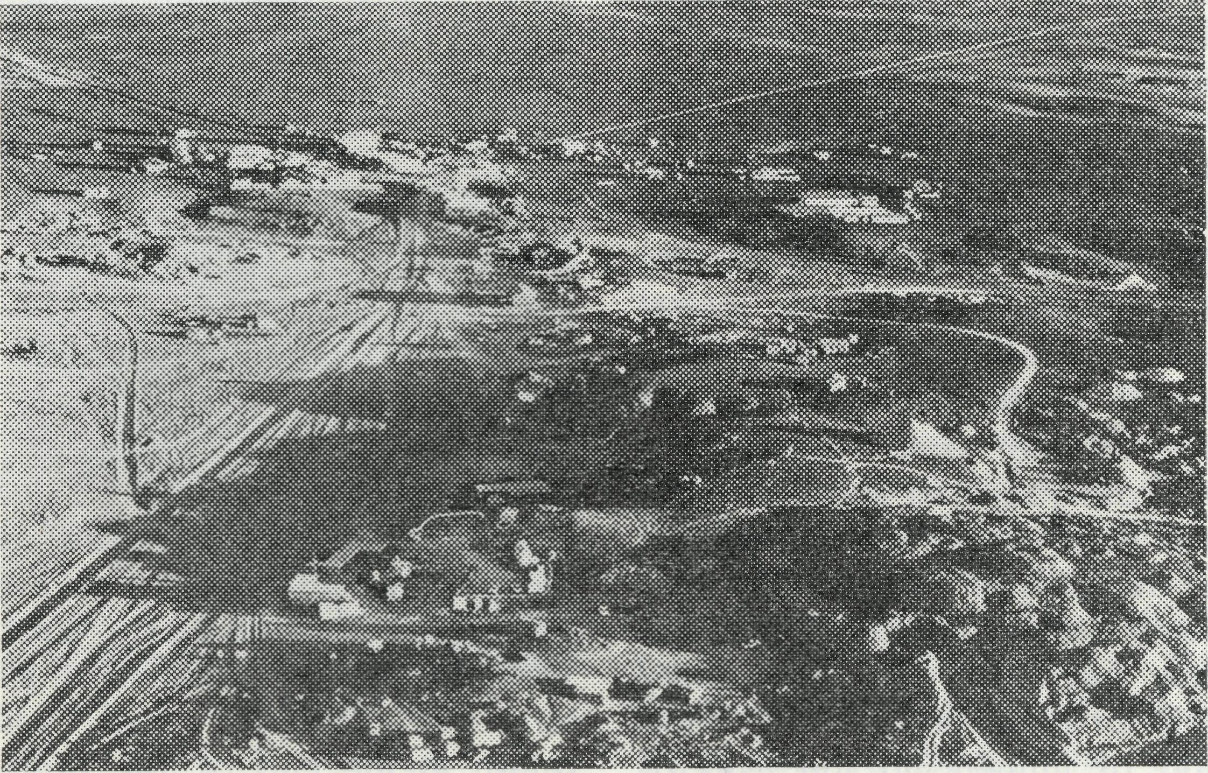
Oh, For an Opal!
The Revd. Brian Carter
Coober Pedy from the air.
One of the last frontier towns in Australia. Six hundred miles north west of Adelaide, out on the Gibber Plains at the edge of the Great Victoria Desert, Coober Pedy is the world's richest opal field.
Here, life is different. The average rainfall is three inches per year and the local water supply is rationed to 25 gallons per person per week, at a cost of over a dollar a hundred gallons. Over the century heat can start in October and last till April. Food costs reflect the distance from the cities, a pint of milk being 20c. The climate and cost of building material means that most people live in "dug outs", caves cut into the soft sandstone hills to form dwellings (when the family increases you dig a bit deeper).
The people are different too. They endure living conditions that most people would find intolerable. They come from all over the world, and dark beards and European accents mingle outside the stores on a Saturday morning. The population drops in the summer, but can rise to 1,500 in winter. Their aim in life
- to find opal — by sinking shafts through the sandstone or bulldozing away the overburden
- looking for the elusive gem stone that can bring the miner
$500 per ounce. If they dig in the wrong place they may have to live for months on credit from the store; if in the right place they may uncover a fortune, say $200,000. The brightly coloured gem, cut and polished, brings a high price in the fashion centres of the world. For this precarious possibility of becoming rich, the people endure the dirt and glare of white dust.
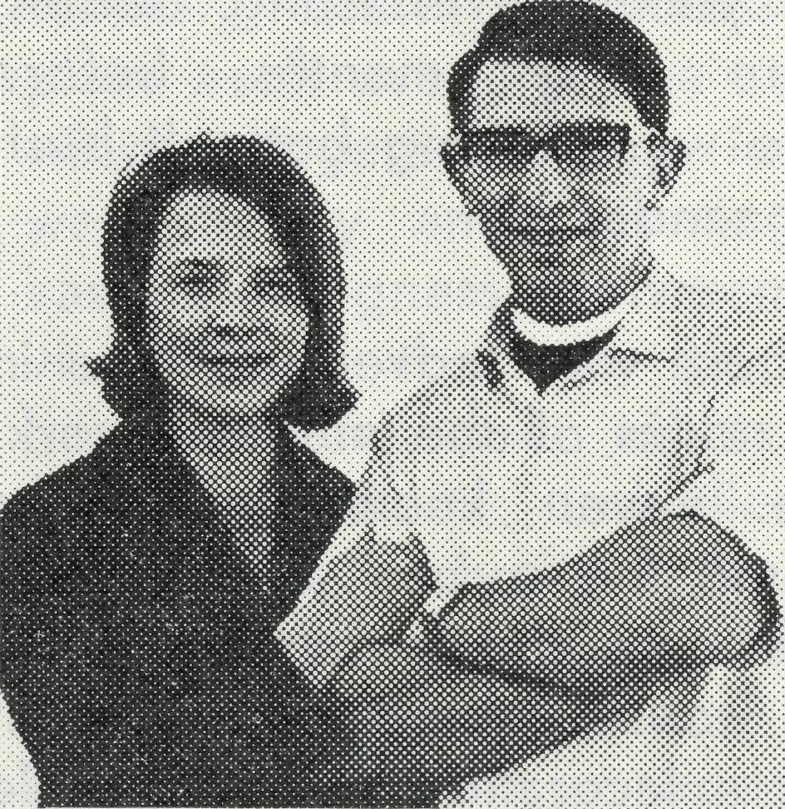
Brian and Carolyn Carter.
The Christian Church has not neglected Coober Pedy. A Lutheran lay missionary works amongst the numerous aborigines who are little removed from tribal life. A Roman Catholic priest is based here, with a unique underground church. The Bush Church Aid Society is also directly involved here in its efforts to make the Gospel of Christ known in the outback.
Two B.C.A. Sisters staff the local Medical Centre, treating the high occurrence of mining accidents and social diseases. As well they have a Sunday School of about forty children, and the Medical Centre is a source of Christian witness.
My own work brings me the 150 dusty, corrugated miles north from Tarcoola to Coober Pedy once a month for a five day stay. The pattern of work is a Scripture lesson in the school, visiting members of the congregation in their dug out homes, trying to make contact with the "outsiders", and then the Service and Bible Study on Sunday. The result of efforts in the past has brought together a more or less stable congregation of about twenty adults, with about fifteen communicants.
Many other people have been contacted, and Bible tracts have been left in their homes.
There is a Christian Church in Coober Pedy meeting in the name of the Church of England, with people from various denominations. We are grateful to God for this encouragement, especially as the congregation begins to see its responsibility of self-government and has interest in providing a building for Church and Sunday School. Our work here is clear; to grow together as part of the body of Christ in this town, to build up one another in faith, to encourage one another in love and good works, and to reach out to all men with the message that Christ is the way, the truth and the life. •

THE REAL AUSTRALIAN, DECEMBER, 1968
THE REAL AUSTRALIAN, DECEMBER, 1968

• Harry and Ruth Rich after three years at Port Lincoln went to Broken Hill for "a few months until we could find someone else". This stretched into a full year but now they can hand over the reins to Mr. and Mrs. Ron Hastie who will be ready for the first term in '69. Mr. and Mrs. Hastie are both school teachers and for the last three years Mr. Hastie has been studying at Moore College.
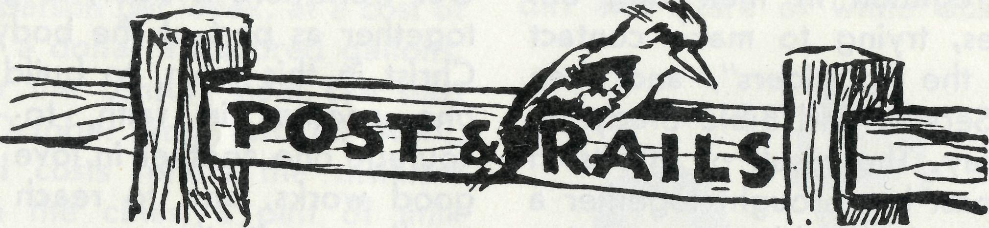
• Staff changes and movements of existing staff provide most of the news for this issue of Post and Rails.
A couple of lines in the "Real Australian" doesn't seem much reward after years of service. One of the problems in the life of an editor is that it is not always possible to pay adequate tribute to those who have completed their term. People such as those you read about in "Post and Rails" know that the success of their ministry is not that their name appears in print, but that they have had the opportunity and privilege of serving God and of influencing the lives of people in the outback.

- Welcome to Pauline Boyle, a D.C. Sister from Deaconess House, who will relieve at Coober Pedy for 6 weeks from November 27th.
- The annual Family Day will be held on Wednesday, January 8th, 1969, from 12 noon to 2 p.m. Bring your lunch and meet the troops (old and new). Either call at the office or meet near the kiosk in the Botanical Gardens.
• The Revd. Brian and Margaret Viney have completed their term at Derby. Brian is to undertake a migrant chaplaincy from England and will return to another post with the Society about March '69. Their place at Derby will be taken by the Revd. Bernard and Coralie Buckland.
• The Revd. Len and Elaine Greenhall have exercised a pioneer ministry in the iron ore development of the North West. They have now finished their term at Dampier and will return at the end of '68, probably to Melbourne.
THE REAL AUSTRALIAN, DECEMBER, 1968
• It was announced in the September "R.A." that B.C.A. had been invited to operate St. Gabriel's Girls' School at Charters Towers, Queensland, as a girls' hostel. Unfortunately for us this invitation has been withdrawn. A committee of local graziers has been formed which intends to purchase the school from the Diocese and continue to run it as a school.
• We welcome an ex-staff member back to the fold! The Reverend Alan Baker, at present
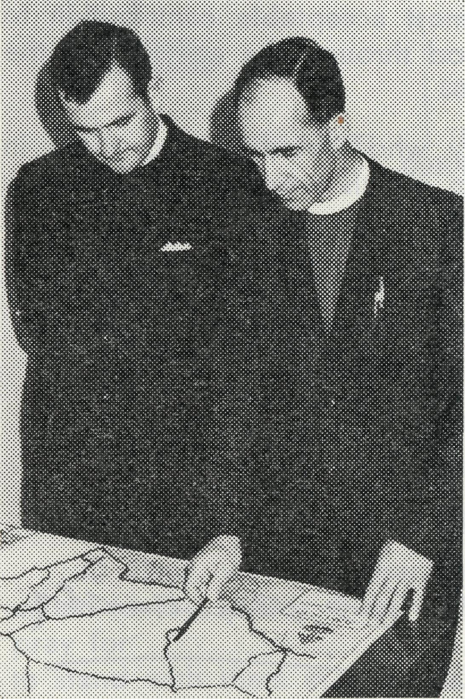
Bishop Grindrod and Mr. White examine a map of the area.
THE REAL AUSTRALIAN, DECEMBER, 1968
assistant priest at Darwin, will rejoin the Society on January 1st. He will be in charge of the parish of Nightcliff and have the oversight of the bush country from Bachelor to Adelaide River.
0 Our first recruit from Newcastle Diocese is the Revd. David Pullar. Before ordination Mr. Pullar worked as a stock and station agent in far west N.S.W. and it was here that he first became interested in the work of B.C.A. He is married and is at present Curate at Singleton.
• The Diocese of Riverina is to take a greater part in the ministry to an area that has been a Society concern for more than 40 years. Parts of Menindee and Wilcannia parishes are to be combined to form a new area under the leadership of the Reverend Charles White. Mr. White, at present resident minister at Kangaroo Valley, trained at Moore College and gained his Bachelor of Divinity from London University. He is married and has two children. The present rector of Wilcannia, the Reverend Brian O'Grady is to leave B.C.A. after eight years service to take a school chaplaincy in Melbourne. The Reverend Ray Neve will leave Menindee to begin the new mission at Kambalda.

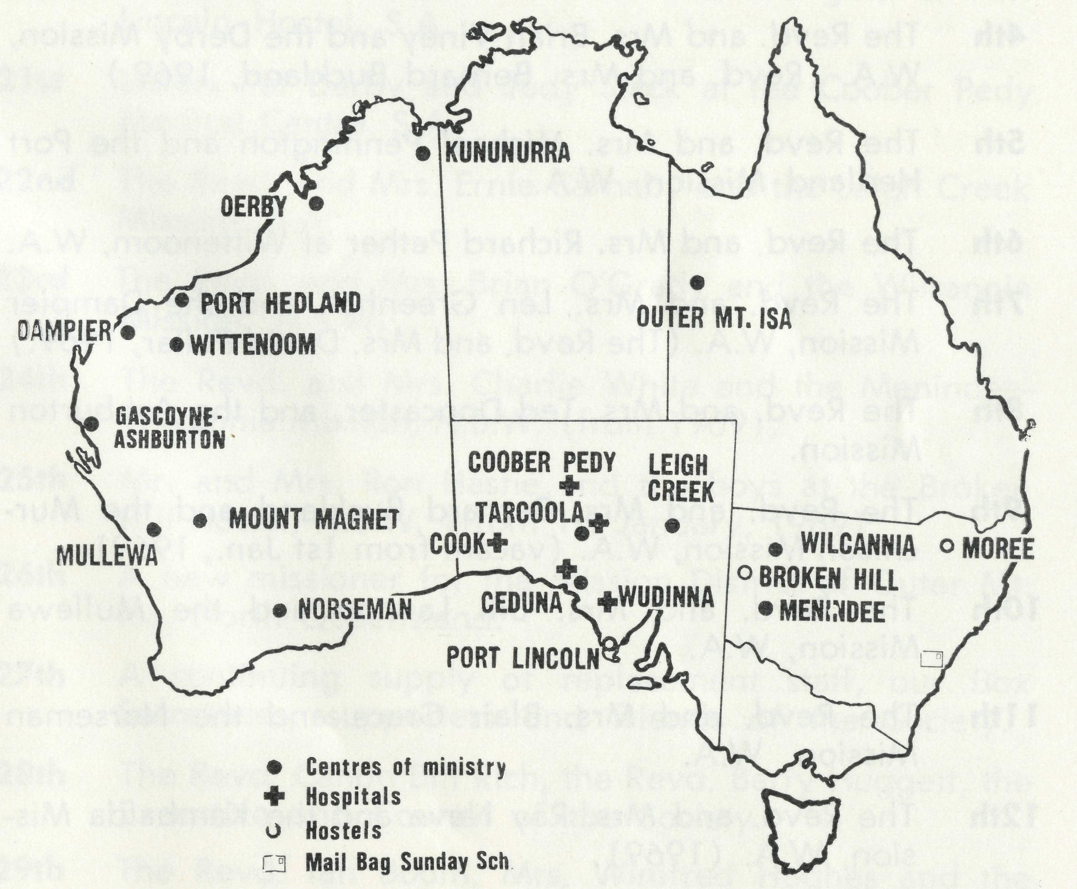
Resignation of Federal Secretary
At the Council meeting held today, the resignation of the Federal Secretary was received with great regret.
Canon Rich has been with the Society for the past 12 years; first when he responded to the call for young men to open up new work in the Diocese of the North West; then as N.S.W. Deputation Secretary and since 1963 as Federal Secretary of the Society. He has not spared himself in any way; in journeyings often throughout the length and breadth of the Commonwealth in order to bring help, comfort and encouragement to members of the Field Staff and to discuss with Diocesan Bishops and their Officers the need to strengthen and extend the ministry of the Word and Sacraments to the people of the "outback".
His has been a worthy and most acceptable contribution to the building of the Kingdom of God through the activities of the Society.
It is felt that there are many who would like to share in making a worthy testimonial to him on his retirement from active work with the Society.
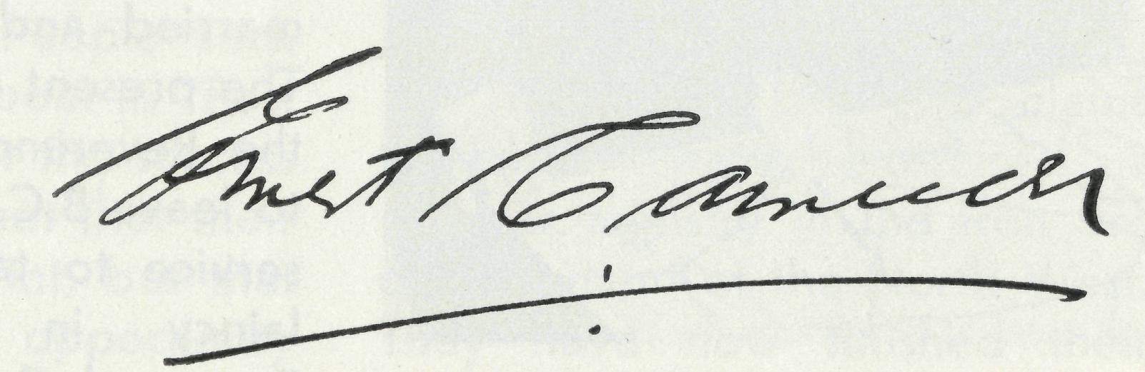
Chairman of Council.
To this end contributions may be sent to: The Administrative Secretary, The Bush Church Aid Society, 135 Bathurst Street, SYDNEY, N.S.W., 2000.
14th November, 1968.
The Place of Prayer
THE B.C.A. PRAYER
O Lord our God, make us ever mindful of those who live in the remote parts of our land. Bless, we beseech Thee, all those whom Thou hast drawn into the fellowship of the Bush Church Aid Society. Grant that, through the ministry of the Word and Sacraments, through healing, and through caring and instruction of the young, the message of Thy redeeming love may thus be proclaimed, through Jesus Christ our Lord. Amen.
A DAILY PRAYER
O God, we remember before Thee those whom Thou hast called to Thy service. Bless them this day, we beseech Thee, as we
pray for Call forth others
to stand with them in their task. Grant to them, as to us, the joy of service, the ability to achieve and the serenity of Thy peace, for Jesus' sake.
Amen.

THE REAL AUSTRALIAN, DECEMBER, 1968
THE REAL AUSTRALIAN, DECEMBER, 1968

THE PLACE OF PRAYER - A DAILY PRAYER CALENDAR

1st Miss Rose Campbell, Miss Barbara Hyett and all the helpers and scholars in the Mail Bag Sunday School.
2nd The Revd. Alan Baker and the Nightcliff Mission, NT. (1969).
3rd The Revd. and Mrs. Barry Green and the Ord River Mission, W.A,
4th The Revd. and Mrs. Brian Viney and the Derby Mission, W.A. (Revd. and Mrs. Bernard Buckland, 1969.)
5th The Revd. and Mrs. Michael Pennington and the Port Hedland Mission, W.A.
6th The Revd. and Mrs. Richard Pether at Wittenoom, W.A.
7th The Revd. and Mrs. Len Greenhall and the Dampier Mission, W.A. (The Revd. and Mrs. David Pullar, 1969.)
8th The Revd. and Mrs. Ted Doncaster, and the Ashburton Mission.
9th The Revd. and Mrs. Bernard Buckland and the Mur-chison Mission, W.A. (vacant from 1st Jan., 1969).
10th The Revd. and Mrs. Bill Lawton and the Mullewa Mission, W.A.
11th The Revd. and Mrs. Blair Grace and the Norseman Mission, W.A.
12th The Revd. and Mrs. Ray Neve and the Kambalda Mission, W.A. (1969).
13th Sisters Lola Higgs and Maude Ross at Cook Hospital, S.A.
14th The need for staff at the Tarcoola Hospital, S.A.
15th The Revd. and Mrs. Brian Carter and the North-West Line Mission, Tarcoola, S.A.
16th The Revd. and Mrs. Ron Keynes and the Ceduna Mission, S.A.
17th Sisters Julia Zillman and Heather Heaver at the Ceduna Hospital, S.A.
18th Mr. and Mrs. Allan Chadwick, at Ceduna, S.A.
19th Sisters Nancy Wilkins and Pamela Lloyd at Wudinna Hospital, S.A.
20th Mr. and Mrs. Graham Mantle and the girls at Port Lincoln Hostel, S.A.
21st Sisters Pat Darby and Judy Stack at the Coober Pedy Medical Centre, S.A.
22nd The Revd. and Mrs. Ernie Carnaby and the Leigh Creek Mission, S.A.
23rd The Revd. and Mrs. Brian O'Grady and the Wilcannia Mission, N.S.W.
24th The Revd. and Mrs. Charlie White and the Menindee-Wilcannia Mission, N.S.W. (from 1969).
25th Mr. and Mrs. Ron Hastie and the boys at the Broken Hill Hostel, N.S.W. (from 1st January, 1969).
26th A new missioner for the Mission District of Outer Mt. Isa, North Queensland.
27th A continuing supply of replacement staff, our Box Secretaries, supporters and friends of the Society.
28th The Revd. Canon Bill Rich, the Revd. Barry Huggett, the Executive and Council of the Society.
29th The Revd. Ian Booth, Mrs. Winifred Hughes and the Victorian Committee, and our Representative in South Australia, Mr. Alban Kirkby.
30th Mr. Stan Hummerston, Mr. Laurie Calder, Mr. Frank Burner, Mrs. Joy O'Neill, Misses Marilyn Palmer and Beverley Tonkies.
3ls1 lhanksgiving for blessings received, for opportunities of service and for the growth of the Society since its formation.

10
THE REAL AUSTRALIAN, DECEMBER, 1963
THE REAL AUSTRALIAN, DECEMBER, 1968

Ten Miles to Sunday School
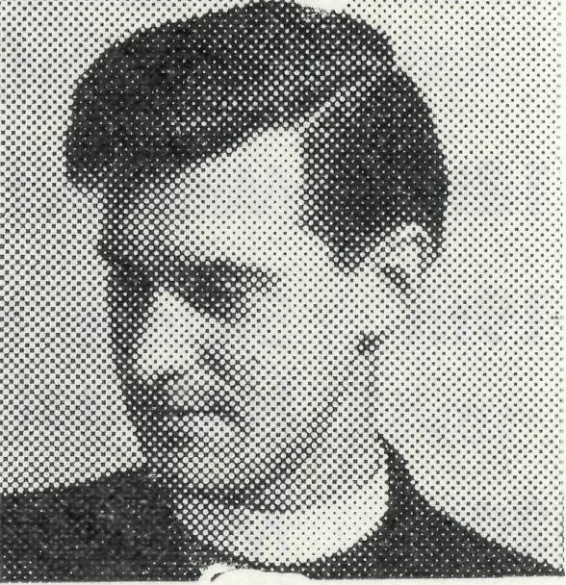
Our first mail in Mullewa brought a religious newspaper. There were comforting stories about the home scene, but it was too early for nostalgia. How curious and apt it seemed to see an article on the enthusiasm of the new missionary! Even at 33, the world could be an adventurous place—but is it still so at 35. The article had concluded with one question "Will disillusionment supplant enthusiasm?"; this question has been frequently before us.
Since that article came, there have been Prayer Letters and private comment from many parts of the world. In these was the Gospel in a new situation, with a background of new nationalism and a foreground of new life. Mullewa pales to insignificance.
Yet before we say that nothing has happened, it is worth reflecting on the past 18 months. There have been small material developments; the church has been painted and renovated, a hall is in the process of construction, a small group of young people are playing tennis. Not much to show for a ministry!
And what do these amount to?—a church committee more concerned than it was; a con-

The Revd. Bill Lawton
gregation prepared to give greater financial support; a Sunday School group seeking fellowship. No, it isn't much. Clearly, it is a very little work. But where a church committeeman can say of Jesus Christ, "He is my Saviour"; where another will ask for a Bible Study at Evening Prayer; where a child of nine can cycle 10 miles to Sunday School and where another of 11 can pray openly and unselfconsciously; then this little work has become God's Gathering.
No, I suppose that old god "enthusiasm" does not possess us now: we are in the truest sense of the word "disillusioned". One needs to be disillusioned about people and their aims and their fears, for they have not yet become REAL people. To be disillusioned about one's society is to begin to see it for what it is. One sees the Gospel which speaks of REALITY as opposed to illusion.
To escape illusion and to find reality, this is the meaning of Mullewa for us. Gossip and misunderstanding there are a-plenty, but they have no lasting power to hurt. You have helped sustain us; it is the certainty of your prayer that has assured to us the certainty of God's presence.
Summer, that appalling summer, will soon be upon us. The lethargy it brings makes it hard to recall a busy city, easy
Port Lincoln
Extensions
Opened
# Graham Mantle writes: "The service of dedication was held in the new loungeroom and the fact that the new wing had been lived in for a couple of months added to the sense of personal involvement on the part of the girls. We were grateful for the people who shared with us. The representation of the civic authorities by the Mayor and Mayoress, together with school, business and Church representatives (Anglican and Methodist) was a demonstration of the importance of the hostel in the minds of the leaders in the town." •
communications, a comfortable suburban life shared with people of like mind. Here, there are few friends, few "soul brothers", but these few are the congregation of the saints, elect and precious.
Mullewa is not a pretty place; yet even here is the Holy City, New Jerusalem. Those few who have entered her gates share the fellowship of the saints. •
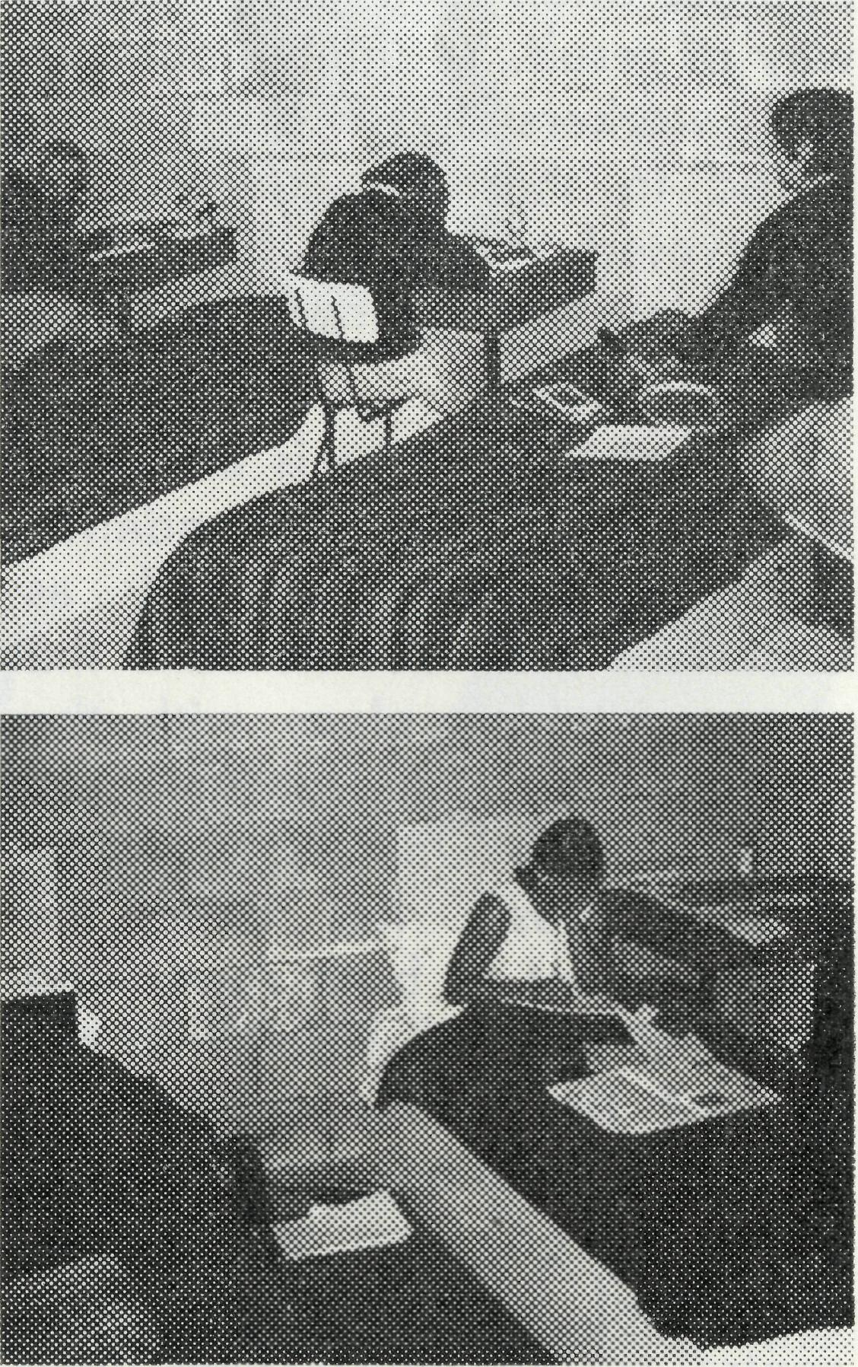
Such diligence in study is wondrous to behold!

12
THE REAL AUSTRALIAN, DECEMBER, 1968
THE REAL AUSTRALIAN, DECEMBER, 1968
13

for when children travel long distances and have ever-increasing homework, they are often disinclined to do more lessons on Sunday. While some parents tend to take children into town to Church or Sunday School, the attitude towards Sunday is changing just as much in the country as in the cities, and others disregard worship or instruction altogether. We do, however thank God for those parents who encourage their children to continue to use the lessons week by week, thereby showing their sense of responsibility towards God and their families.
Miss Campbell's retirement at the end of this year brings to an end 22 years of service with the M.B.S.S. Council has expressed its appreciation and joins her many friends in wishing her well as she takes a well
Mail Bag Sunday School
Miss Rose Campbell
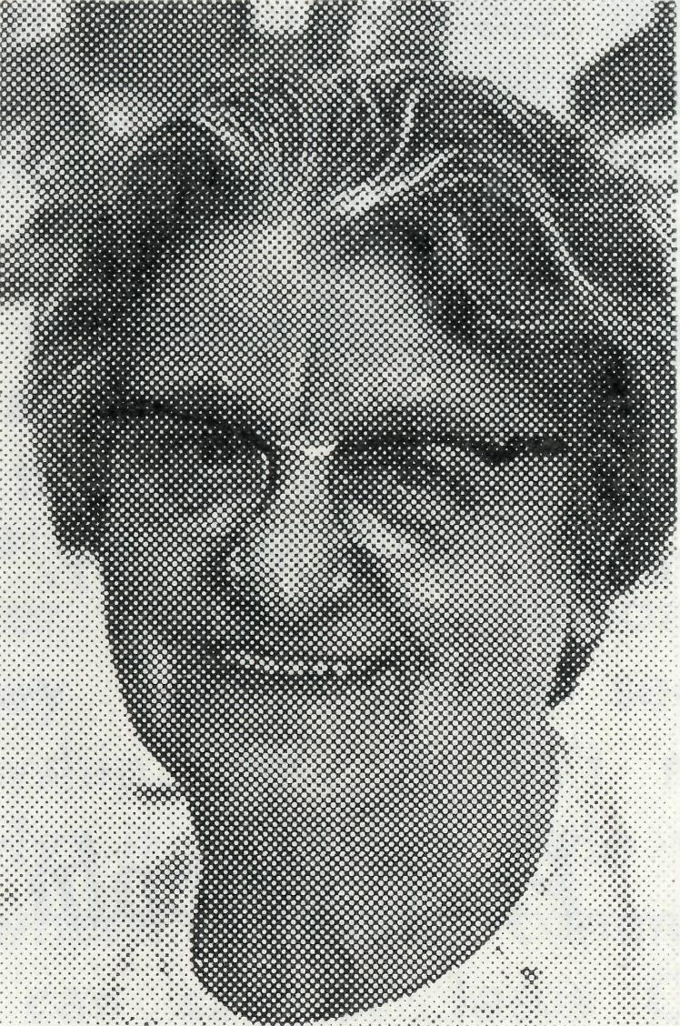
Miss Campbell.
Our "Real Australian" readers of many years' standing will no doubt have noticed from time to time the many changes in methods and places of ministry, also in personnel within the Society. In the Mail Bag Sunday School however, it has been a quiet ministry with no dramatic incidents to report, but rather a matter of planting the seed in faith when an opportunity offered, often seeing little in the way of result. Yet many teachers and workers have been prepared to share in this task in a devoted way and have had much joy and fellowship in so doing.
Though education is always a slow process, all correspondence schools, secular as well as Christian, have noted the changes taking place with the altering conditions for many of our children. One of the most striking causes has been the improvement in both roads and vehicles, with the result that the day of the small, one-teacher school is passing and children are gathered from several districts and taken by bus to a central school, which gives them many advantages.
This has had a marked effect on our Mail Bag Sunday School,

Changes can also bring challenges. tAr. Calder will face these with confidence and faith, backed by a loyal group of teachers and workers. No doubt there will be the continued
prayer support of many other folk also as together, by various means, they endeavour to lead children to know, love and serve our Lord and Saviour, Jesus Christ.
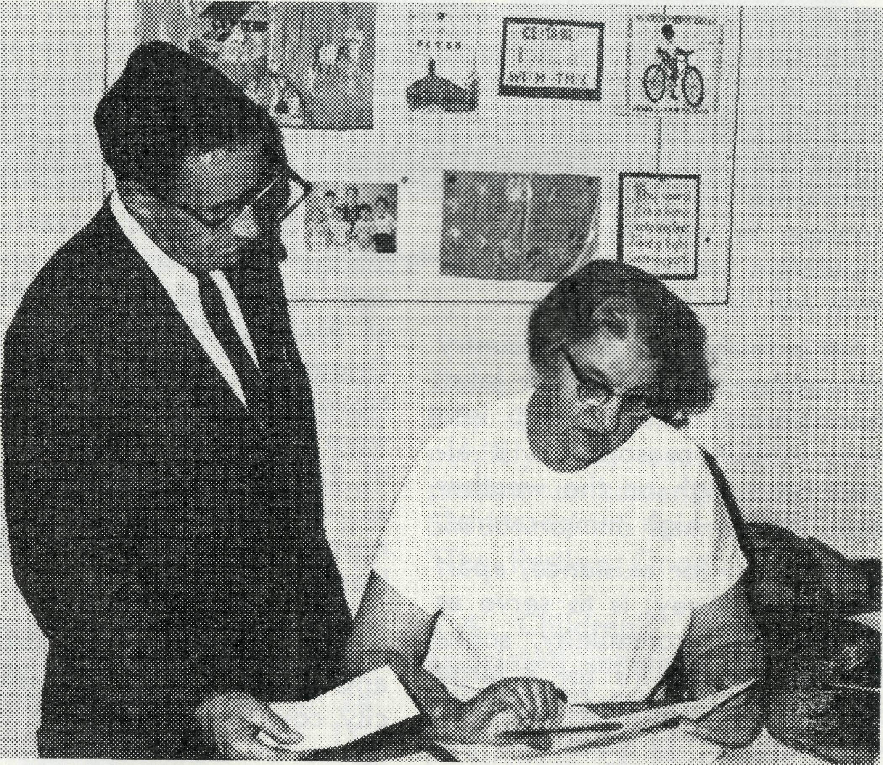
Miss Campbell and Mr. Calder examine some of the Mail Bag students' work.
earned overseas holiday. Miss Campbell has made reference in her article to the assurance she has that those who have supported her with their prayers will continue to support Mr. Laurie Calder, the new Director.

14
THE REAL AUSTRALIAN, DECEMBER, 1968
THE REAL AUSTRALIAN, DECEMBER, 1968
15

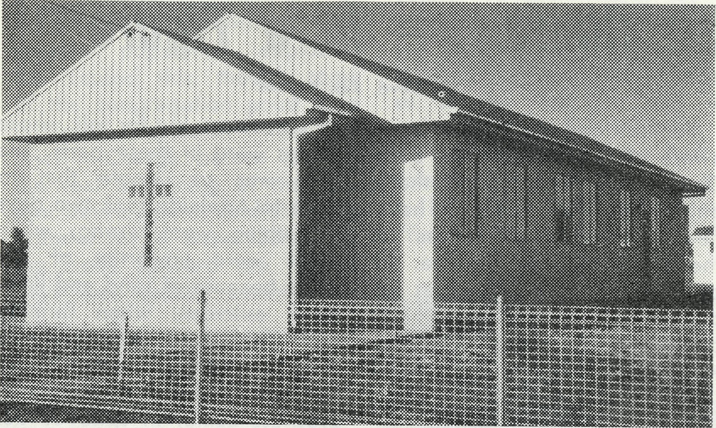
A 25 Year Old Building Fund!
The Revd. Ray Neve
The new St. Stephen's, Ivanhoe.
Ivanhoe, some 521 miles from Sydney in the Far West of New South Wales has a present population of 500-600 people. The nearest township is 100 miles away. Menindee, where the B.C.A. Missioner lives, is 127 miles west. There is a fairly large railway population, being one of the main changeover points for the train crews. Its importance in this regard will increase as well as its railway population when the Sydney-Perth rail link is complete.
Set in fairly open plain country without benefit of river or lake, dust storms come rolling into town in due season and it always rates high on the weather maps for its high temperatures.
Its reason for existence, apart from the railway, is to serve as an economic community, social and spiritual centre for a large pastoral area. The original centre was Mossgiel, 34 miles east but it moved west with the coming of the railway. Today as one passes through Mossgiel there is one house to be seen; among other things it once boasted an Anglican Church.
About 25 years ago some local people had a vision of building an Anglican Church so a building fund had its shaky start. For many years it remained
more or less dormant, but a more determined effort has been made over the past few years. Up to this present time the Presbyterian Church has been used for the Anglican Services. Various plans have been looked at and set aside as impractical or too expensive. However, a $5,000 bank loan and a Diocesan grant of $1,000 from the Riverina Church Fund finally made St. Stephen's, Ivanhoe a reality. The Church was opened and dedicated by the Bishop of Riverina, the Rt. Revd. John Grindrod, on Saturday, 9th November and the first services were held the next day. Most of the furniture has been given as a thanksgiving gift or in memory of loved ones by the Ivanhoe people.
Modest perhaps in structure and price compared with the city counterparts, it is to us the House of God. The exterior is all aluminium, with aluminium window frames and an open brick porch. It will thwart deterioration by the weather and make the interior cooler in this burning heat. The exterior has been painted white rice with pale olive trimmings. Around the building 33 trees and shrubs have been planted and thanks to the effort of the local police
officer, a small lawn has been started. It is a dual purpose building with a kitchen and vestry-cum-sleeping accommodation. The main part of the building has the provision of vinyl doors so that one has a permanent Church area of 20' x 33' for the regular congregation and then widening out to 24' with an added depth of 17', which can be used as a small hall, or opened up on special occasions when needed. The whole area has the same finish in regard to painting, light fixtures and floor finish so as to create continuity when opened up.
What has been the evangelistic outreach this year apart from Church Services and visiting?
There have been a number of Billy Graham T.V. films shown publicly and over 200 were present at screenings of "The Shadow of the Boomerang" and "The Restless Ones".
A Children's Mission with associated meetings for young people and adults both in and around Ivanhoe was led by Mr. L. Wallace of Open Air Campaigners at the end of November. There was a similar series of meetings with a short follow up last year in which we experienced God's blessing.
Humanly speaking there has not been much to see for the effort made yet we are aware of God's presence, His guidance and blessing. #

16
THE REAL AUSTRALIAN, DECEMBER, 1968
THE REAL AUSTRALIAN, DECEMBER, 1968
17

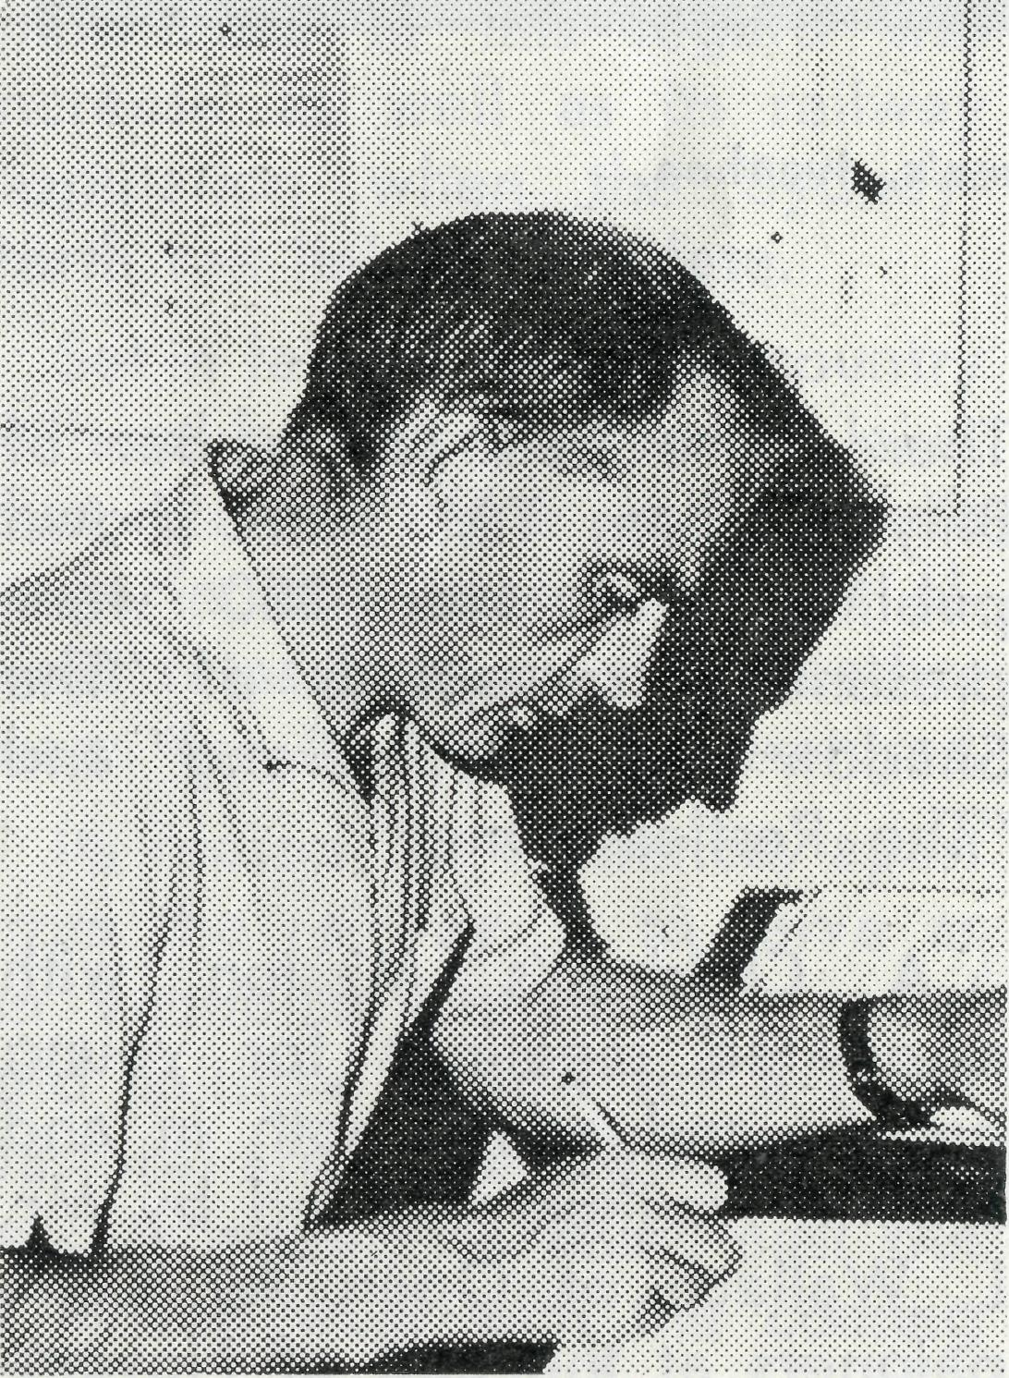
For as long as I have been aware of the work of the Bush Church Aid Society, and that's only about 25 years, I have heard repeated references to the work here at Ceduna. In print, in slides, in addresses by deputation speakers, stories have been told of this part of the world.
Ron Keynes — Rector of Ceduna.
It was on 8th May, 1921, that Reverend N. Haviland became the first Priest-in-Charge to the Mission District supported by the Society, and began his work here. And those early days were hard, not only for him and
Climax — In a Figure
The Revd. Ron Keynes
his successors, but for folk whose homes were in these parts. The area was so remote that to drive to Adelaide took two days if nothing went wrong; when roads were unworthy of the name because of sand and limestone outcrops; when farming was precarious and living a struggle, and money hard to find. Yet slowly and certainly, progress came, in spite of depression, drought and war. Hand-in-hand with the parish over those 47 years was the Society and its many supporters.
Figures are only a comparative guide, but these may give some idea of the struggle involved in growing to independence. The persistence in the struggle is the thing that points up the dogged faith and determination of the local Church. Old statements show a total offertory for the year as $224 in 1936; things were so hard in 1939 that $30.00 had to be borrowed for over a year to carry out repairs.
But now, as I pen this, the parish has been self-supporting for a whole twenty-two days. It is an experiment in faith as far as the Parish Council is concerned; but it is also the climax of much hard work and hard giving by
a comparative handful of dedicated Christians. No massive population explosion has caused this; though some of the congregation point to a different "explosion" from the Priest-in-Charge before last, as the real beginning of the present development! And they are grateful for it. Basic factors for the move forward are "better days" and greater commitment.
This greater commitment is reflected in the fact that offertories for the last financial year just passed $3,000; and the Church wheat-cropping programme helps to make self-support possible. But alongside this, place the fact that travelling costs met by the parish have risen from $46 in 1936 to $1824 in 1968.
Just figures? Have some more! No one denies that missionary giving is a reasonable guide to the vitality of a Church; and while comparisons can be odious, what does $16 in 1936 and $1137 in 1968 say? Certainly not that we in Ceduna are only concerned with ourselves. And it is common experience that the more one has, the less one is inclined to give to the Lord's work.
So the first climax has come to Ceduna. And we are all deeply thankful for the tremendous effort made by the Society supporters over those 47
years. We could never say an adequate thank you; except to say that we no longer appear to need your aid. You've helped us to our feet — and our second climax lies in front, as we continue to walk by faith in commitment to our Lord, and to keep our eyes on our own "fields white unto harvest". •
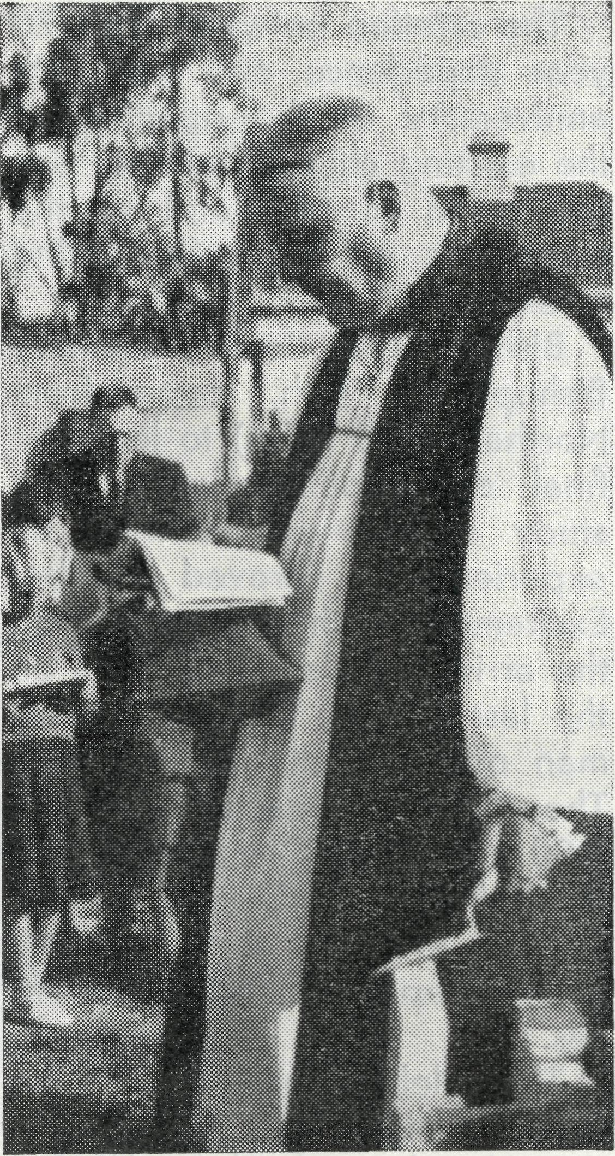
The Primate laying the foundation
stone of St. Michael's and All Angels',
Ceduna, in 1953.

TH£ REAL AUSTRALIAN. DECEMBER, 1968
THE REAL AUSTRALIAN, DECEMBER, 1968
19

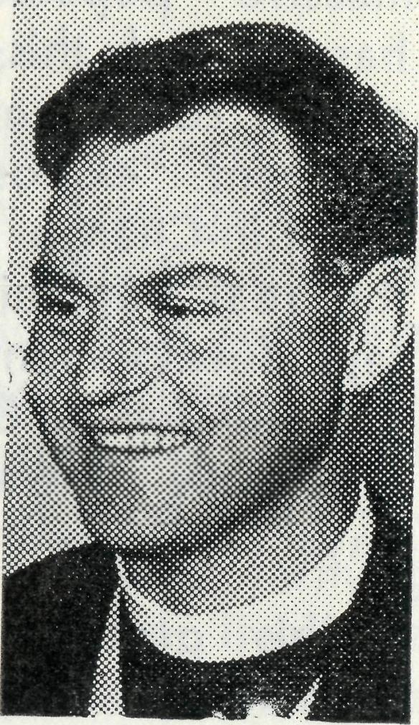
Goldfields Anniversary
The Bush Church Aid Society

For six weeks the parish study group had been working through the //Exile,/. The theme was "70 years away from home", and we had traced God's people through the exile they spent in Babylon, and tried to apply the lessons they had learnt, to our lives.
The relation between their 70 year experience and the 70th anniversary of the opening of the existing church building was too good to miss and so the stage was set for a fascinating week-end.
Bishop Bruce Rozier, auxiliary Bishop of Perth, came from Northam (390 miles) to lead the final discussion group of the study series — and what an experience it proved to be! Excitement gathered pace with the arrival of Canon Bill Rich on the last M.M.A. flight to Norseman on the Saturday morning. The Canon preached at the 8.00 a.m. Holy Communion and the Bishop at the Festival Service in the evening. Both services were deeply moving experiences.
The celebrations ended on the Monday night with a dinner in the Churches of Christ Mission Centre. A beautiful building and a fitting climax. Holy Trinity Church — one of the oldest, if not the oldest building in town and the Centre the newest — both dedicated to the cause of

The Revd. Biair Grace
the Gospel. At the dinner there were approximately 80 people and nearly all the clergy of the diocese were present. The Canon and Bishop Bryant (our Diocesan Bishop) were the speakers, and old photographs and church registers were circulated. These pictorial records caused quite a stir — especially the bushy beard on the first Rector, Mr. Burton. He used to ride his push-bike along the camel tracks to Coolgardie, 100 miles away and to Eucla, 450 miles to the east. The first Anglican service was held in Norseman on 19th January, 1896 and the building was opened for worship on 30th October, 1898.
For once the Church had made an impact on a mining town. Perhaps it was just the 70th anniversary of a building, but that building had been dedicated to God and that's what made the difference! •
FIELD STAFF:
DIOCESE OF RIVERINA, N.S.W.
Wilcannia—The Revd. B. O'Grady. Menindee—The Revd. R. Neve.
DIOCESE OF WILLOCHRA, S.A.
Leigh Creek—The Revd. E. Carnaby. Ceduna/Penong—The Revd. R. Keynes. Tarcooia—The Revd. B. Carter.
DIOCESE OF KALGOORLIE, W.A. Norseman—The Revd. B. Grace.
DIOCESE OF NORTH-WEST AUSTRALIA
Mullewa—The Revd. W. Lawton. Mount Magnet—The Revd. B. Buckland. Dampier—The Revd. L. Greenhall. Wittenoom—The Revd. R. Pether. Port Hedland—The Revd. M. Pennington. Derby—The Revd. B. Viney. Kununurra—The Revd. B. Green. Ashburton—The Revd. E. W. Doncaster.
DIOCESE OF NORTH QUEENSLAND Outer Mt. Isa— Religious Broadcasting—Grant-in-aid.
DIOCESE OF BRISBANE, QUEENSLAND
Kilkivan (Cherbourg Mission)—Grant-in-aid.
MAIL BAG SUNDAY SCHOOL
Director: Miss R. Campbell.
HOSTELS FOR SCHOOL CHILDREN
BROKEN HILL, N.S.W. PORT LINCOLN, S.A.
Mr. and Mrs. H. RICH Mr. and Mrs. G. MANTLE
MOREE, N.S.W.
Mr. and Mrs. R. BROWN

20
THE REAL AUSTRALIAN, DECEMBER, 1968
THE REAL AUSTRALIAN, SEPTEMBER, 1968

