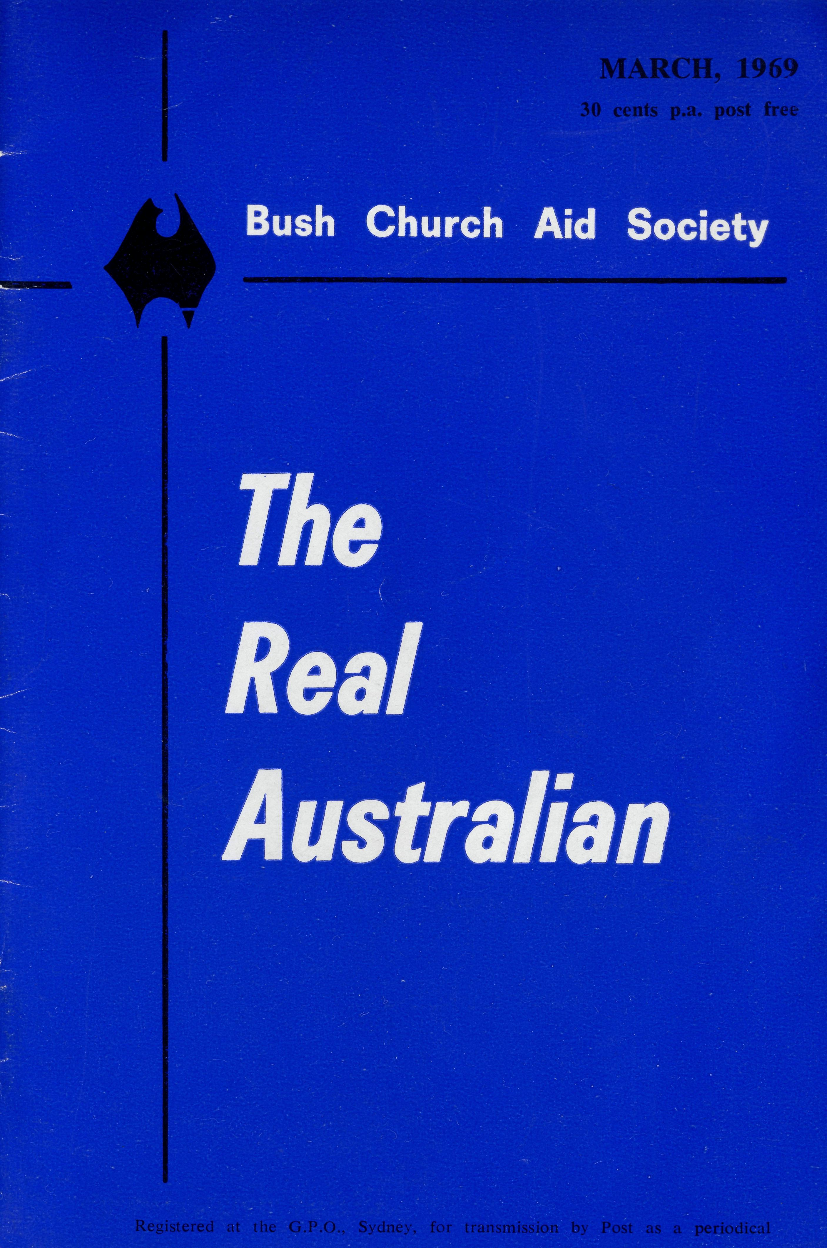
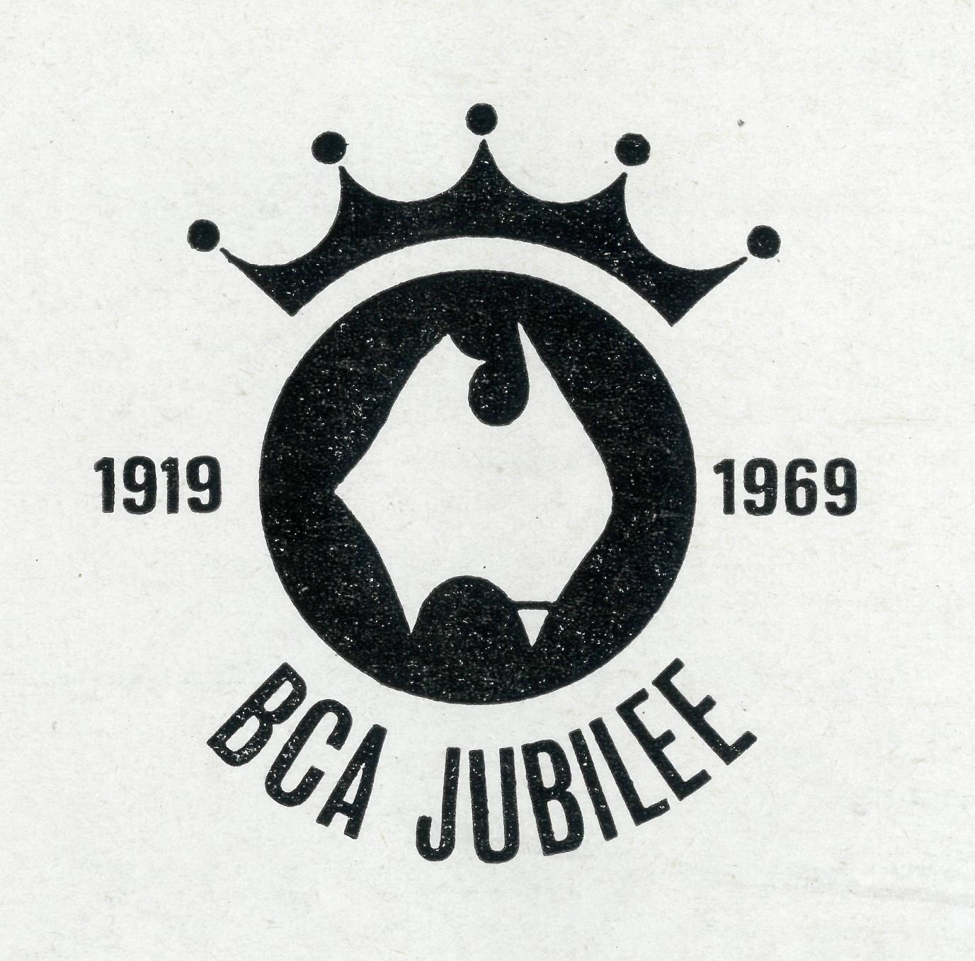
EDGAR BRAGG & SONS PTY. LTD.

The Bush Church Aid Society
for Australia and Tasmania
PATRON
The Most Reverend, The Primate.
PRESIDENT
The Most Reverend, The Archbishop of Melbourne.
VICE-PRESIDENT
The Most Reverend, The Archbishop of Sydney.
CHAIRMAN OF COUNCIL HONORARY TREASURER
The Revd. Canon E. Cameron. Mr. R. T. Stokes
COUNCILLORS
The Ven. G. R. Delbridge, the Revd. Canon R. M. Hudson, the Revds. C. A.
Baker, L. H. Broadiey, E. V. Constable, O. W. C. Cooper, A. C. Miles, G.
Pearson, Messrs. H. M. Bragg, R. Ctercteko, M. Job, E. Stockton.
FEDERAL SECRETARY
ADMINISTRATIVE SECRETARY
Mr. S. E. Hummerston.
VICTORIAN SECRETARY NEW SOUTH WALES SECRETARY
The Revd. I. A. Booth The Revd. B. D. Huggett
REPRESENTATIVE IN SOUTH AUSTRALIA
Mr. A. Kirkby, 7 Ruthven Avenue, Glandore, S.A.
SOLICITORS HONORARY AUDITOR
Messrs. Maxwell and Boyd, F. W. A. Eagar and Co.,
155 Castlereagh Street, Sydney. 8 Belgrave Street, Manly, N.S.W.
HEAD OFFICE
B.C.A. House,
135 Bathurst Street, Sydney.
Phones: 26-3164, 26-3780.
Telegraphic Address: "Chaplaincy", Sydney
VICTORIAN OFFICE
Morton House,
262 Flinders Lane, Melbourne.
Phone: 63-8962.
'AUSTRALIA FOR CHRIST'
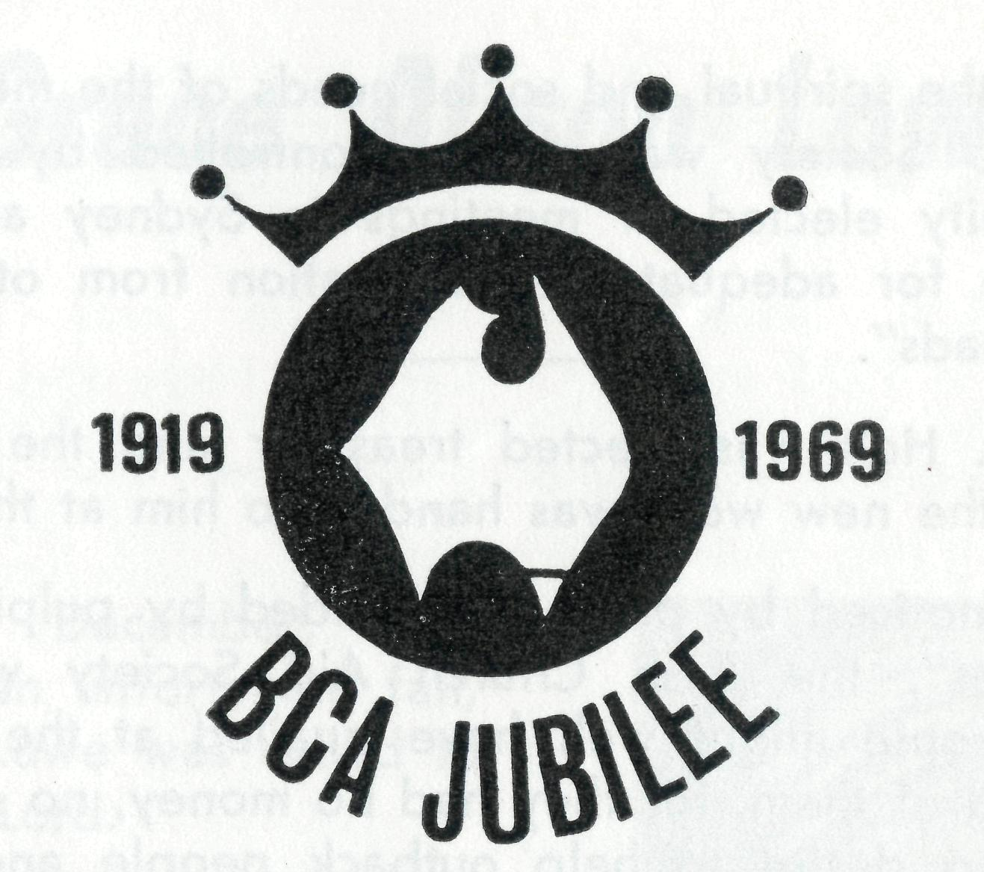
On 26th May, 1919, a meeting was arranged for the Chapter House of St. Andrew's Cathedral, Sydney, to "discuss the formation of a Society which could operate in all states, organise the resources of all capital cities and concentrate energy and service upon the neglected bush areas".
The evening turned out to be so wet that only twenty-five people were sufficiently interested to brave the heavy rain in order to attend. Perhaps it was prophetic that a society whose great strength lies in its care for the individual man or woman should have its beginning in a group so small that the individual members can still be remembered fifty years later.
The Right Reverend John Pain acted as Chairman and the others present were: Archdeacon D. J. Davies, Archdeacon F. B. Boyce, the Rev. S. J. Kirkby (later Bishop), The Rev. Canon W. A. Charlton (later Archdeacon), The Revds. H. J. Noble, G. A. Chambers (later Bishop), W. L. Langley (later Archdeacon), W. Greenwood, C. C. Dunstan, R. Rook, P. J. Bazeley, T. A. Carroll, H. M. Pearce, A. W. Coates, F. A. Carr, P. W. Dowe, C. A. Stubbin, Canon S. E. Langford-Smith, Canon E. H. B. Claydon, The Rev. A. E. Morris, Messrs. C. R. Walsh and T. S. Holt, Mrs. Bragg and Mrs. Foulcher.
They inaugurated a society to be called "The Bush Church Aid Society" which was empowered "to call, train and support clergy, Bush Brothers, catechists, lay evangelists, teachers, bush nurses and bush deaconesses. If invited by the diocesan Bishop it was to assist in the provision and maintenance of hostels, provide preaching missions in country centres and generally rouse interest in the work of the church in the bush so that full provision might

THE REAL AUSTRALIAN, MARCH, 1969
THE REAL AUSTRALIAN, MARCH, 1969

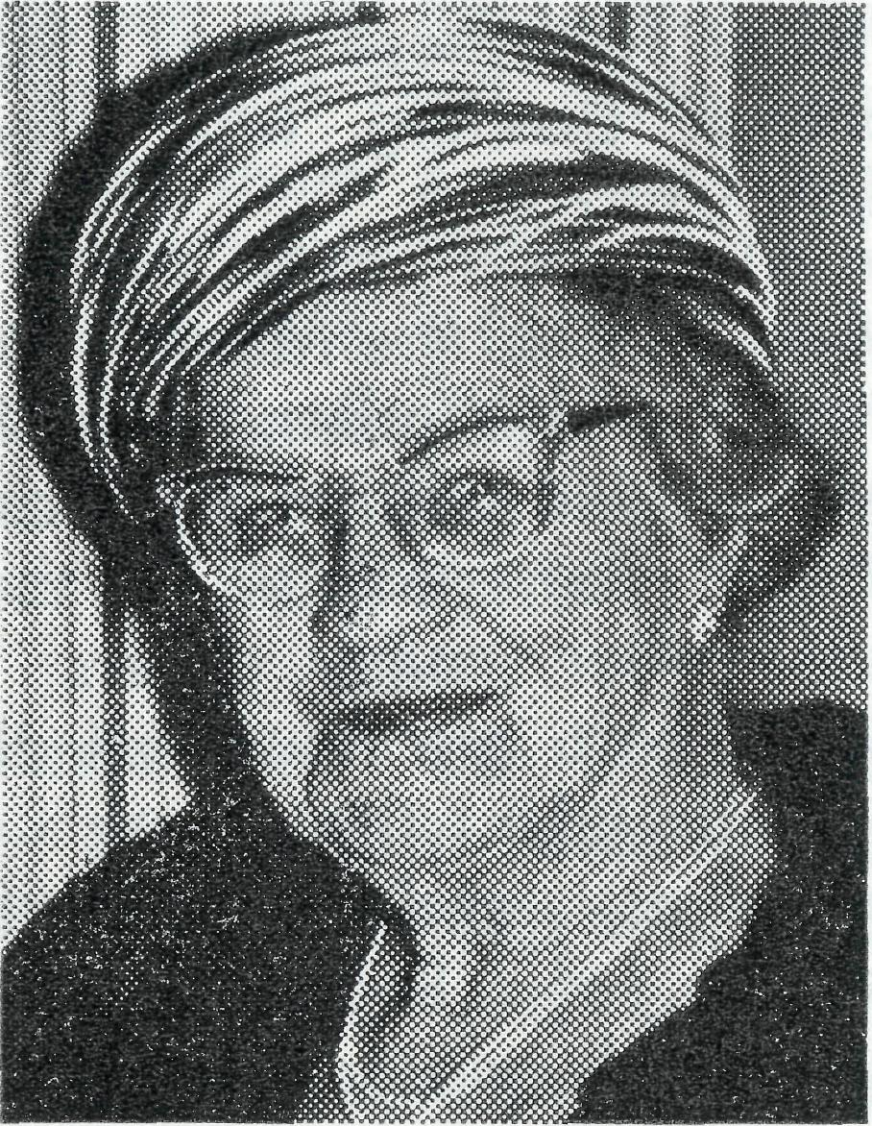
All supporters of B.C.A. Fairs will remember her sitting at the table by the Refreshments, where she delighted to use the little black metal cash box which had belonged to her husband in his shop in Oxford Street, over which she came to live as a bride, now the great store of Lowes Limited.
Mrs. Lowe's devotion will be an example to all members of B.C.A. She will be sadly missed but always lovingly remembered by her fellow members of the Women's Auxiliary. O
be made for the spiritual and social needs of the men and women outback'⁷. The Society was to be controlled by a Council of clergy and laity elected at meetings in Sydney and Melbourne with provision for adequate representation from other states ^{7/}as the work spreads⁷⁷.
Mr. T. S. Holt was elected treasurer and the first donation of $2.10 for the new work was handed to him at the meeting.
Thus "unnoticed by press, unheralded by pulpit and ignored by the masses", the Bush Church Aid Society was born. The twenty-five people might well have quailed at the magnitude of the task ahead of them, for they had no money, no office, nothing, only a burning desire to help outback people and a firm faith that where God called He would provide.
JUBILEE CELEBRATIONS!
THANKSGIVING SERVICES — Sunday, 25th May
St. Andrew's Cathedral, Sydney 7.15 p.m. — Preacher, The Primate
St. Paul's Cathedral, Melbourne, 3 p.m.
ANNUAL RALLIES
Adelaide — June Melbourne — August Sydney — July
Grace Alison Lowe
On 28th December, five weeks after an unfortunate fall, Mrs. Grace Lowe was called to be with the Lord.
Her funeral service at All Saints⁷ Church, Woollahra, was conducted by The Revd. Eric Mortley assisted by Canon Bill Rich. Canon Rich spoke warmly of her many years of devotion to the work of the Society.
Mrs. Lowe joined the Sydney B.C.A. Women's Auxiliary in 1937 after many years working for B.C.A. Hospitals through All Saints⁷, Woollahra Auxiliary. No one followed more avidly news from the field passed on by the successive missioners, and this humble little lady so disliked "fuss" that few know the extent of her generosity to the Society.
Until after her 95th birthday she continued to ascend the stairs at Bathurst Street to attend Auxiliary meetings and all other functions, and such was her vigour that in her late eighties she visited the United States to see her first great-great grandchild.

THE REAL AUSTRALIAN, MARCH, 1969
THE REAL AUSTRALIAN, MARCH, 1969

Nursing News
Mercy Flight from Wudinna

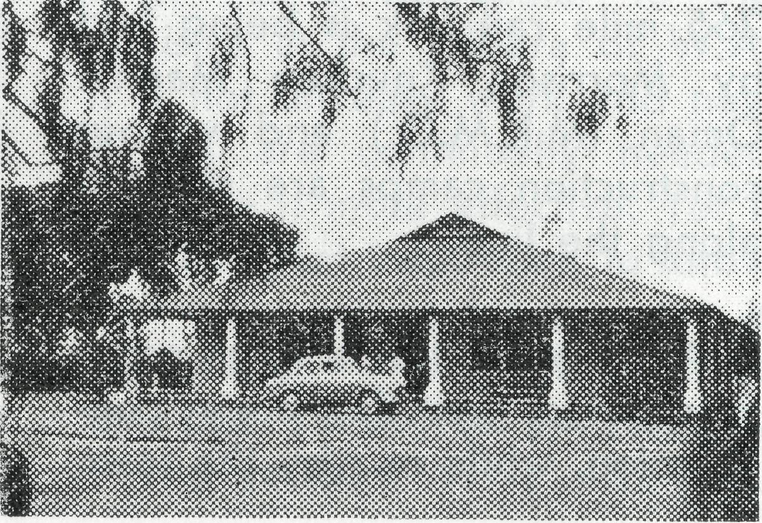
Sister Pam Lloyd
• The medical work at Ceduna began in 1925 and this aspect of Society activity has seen some of the longest terms of service with B.C.A. The most notable of these was Sister Florence Dowling who served from 1932-63.
On the 1st March both Ceduna and Wudinna hosptials were handed over to local committees. The people of these areas after many years of Society help are now well able to undertake this work for themselves, and so another chapter of Society history triumphantly closes.
Sisters Julia Zillman (9 years) and Heather Heaver (4 years) at Ceduna and Sisters Nancy Wilkins (9 years) and Pam Lloyd (2 years) at Wudinna have served God with great dedication. We count it a privilege to have had them on the staff and wish them God's Blessing as they leave B.C.A.
Although no longer members of the Society staff, Sisters Zillman and Heaver will remain at Ceduna, employed by the Hospital Board. Sisters Wilkins and Lloyd will give a further month for holiday relief at Cook, and then proceed to W.A. for holidays.
© Sister Judy Stack leaves Coober Pedy this month after 2i years on the field. As with the other nurses already mentioned we wish her God's Blessing as she returns to metropolitan nursing.
© Although Ceduna hospital is no longer a B.C.A. responsibility Mr. Allan Chadwick, former B.C.A. pilot, remains as part time Society employee.
• In referring to Wudinna Hospital special thanks should be given to Mr. Allen Richards who for the last ten years has been employed as a member of the hospital staff. His willingness to undertake many and varied tasks has been of tremendous assistance to the nursing staff.
© Despite extensive advertising throughout Australia our shortage of nurses remains critical. Two D.C. nurses are needed immediately for Tar-coola and two more will be required during this year. Please continue to make this need as widely known as possible.
The day began the same as other days. I was wrapping Christmas parcels when told to get ready to fly to Adelaide straight away.
I was shocked at the sight of the severely burnt little boy I was to accompany. Kneeling beside him in the plane I prayed that God's love would get through to him. I thought of him, his parents, sisters and their need of awareness of God's love, as I felt surrounded by it. I was so thankful for the help of trained first aiders and the willingness and speed of the local pilot as he filled the plane for take off.
The plane landed li hours later; the small patient was transferred to the waiting ambulance and taken to the Children's Hospital.
Soon after arrival at the hospital I was told that the
Wudinna Hospital
small boy was beyond medical help. The parents and 3 small sisters must be told and this is where we can help. We can tell them that God cares, that He loves them and can meet their every need. We can listen to them when they feel the need to talk and point them to God's word, 2 Corinthians 1:3, 4 expresses it much better.
"Blessed be the God and Father of our Lord Jesus Christ, the Father of mercies and God of all comfort, who comforts us in all our affliction, so that we may be able to comfort those who are in any affliction, with the comfort with which we ourselves are comforted by God."
B.C.A. is leaving Wudinna soon. Practical needs may be met. Please pray that spiritual needs will be met also. •

THE REAL AUSTRALIAN, MARCH, 1969
THE REAL AUSTRALIAN, MARCH, 1969

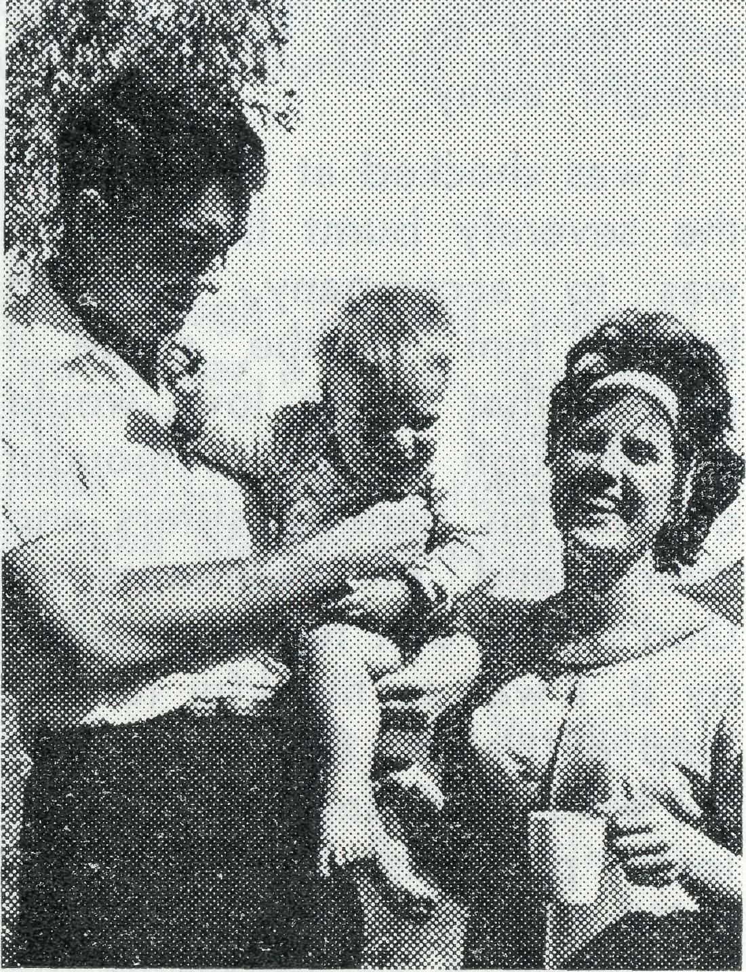
The Revd. Richard Pether with Ann and Ashley.
of Newman is rapidly taking shape. Wittenoom is at present awaiting the outcome of Han-wright Iron Mines survey and exploration work. It too, may soon become an iron ore mine-site but at present is a popular tourist centre and one which seems sure to remain such a centre for years to come.
As a newcomer to the ministry in this expanding part of Aus-
"The Confessions of a
Sandgroper"
The Revd. Richard Pether
To one who is a Sandgroper (West Australian) by birth, coming to serve in the North West of Western Australia is like still being in one's own backyard, only a little further back.
Yet the North West is a very different part of the State and one which seems very remote from the greener, more compact (and sandy) areas of the South West. Indeed one could be in another State so far does Perth seem from here.
Included in my area is Wit-tenoom, a former asbestos mining town near Wittenoom Gorge in the Hamersley Ranges; the iron ore minesite town of Newman and the railway under construction from Newman to Port Hedland. The 265 mile rail link is being laid by Morrison Knudsen Mannix Oman (M.K.M.O.) and various construction camps are situated along the line.
At Newman too, a large camp is situated for the mine construction, while nearby the town
tralia, I have been made aware of the real problems attached to such work.
A transient population, often only present for a few months before returning South, makes a long term "building up" ministry difficult. Travelling difficulties in wet weather, rough roads and the lack of many facilities available to clergy in city or more long term settled areas, make the going tough at times.
Yet some of these difficulties can be turned to good purpose, especially the lack of church buildings. For nowhere else can be taught so convincingly that the Church is people not a building, as when the Holy Communion is celebrated in camp mess halls, in dormitory rooms or in airline offices (somewhat cramped!)
Further the old complaint that the Church is only for "women and kids" has to take a backseat when one has all-male congregations for many services — and this in competition with pictures, the pub and a tough work schedule.
Accommodation for myself and clergy visiting these camps has always been generously provided by the companies
concerned so eliminating the tedious need to bring a swag roll and sleep under the stars.
The ministry to the pastoral industry represented by the cattle and sheep stations around the area has peculiar problems of its own. With the expansion of the North, many of the people on these stations do not feel as isolated as they once did and so the clergyman's role as a social visitor has declined. He can now concentrate on the important task of coming as a priest to minister to the spiritual needs of his people.
Here travelling time and expense plus lack of response in some cases (for station people are like any other people in this respect) together with the demands made by the growing towns (particularly in my case the town of Newman) places limits on this aspect of ministry, limits which often weigh on one's conscience but which are none-the-Iess real.
These then are the impressions I get as a newcomer to the ministry in the Pilbara of W.A. It is not an easy work and new thrusts are continually needed to make it more effective. Yet it is a constant inspiration to know that your prayerful support is behind us who minister here and that it is indeed our ministry —and yours. ©

THE REAL AUSTRALIAN, MARCH, 1969
THE REAL AUSTRALIAN, MARCH, 1969

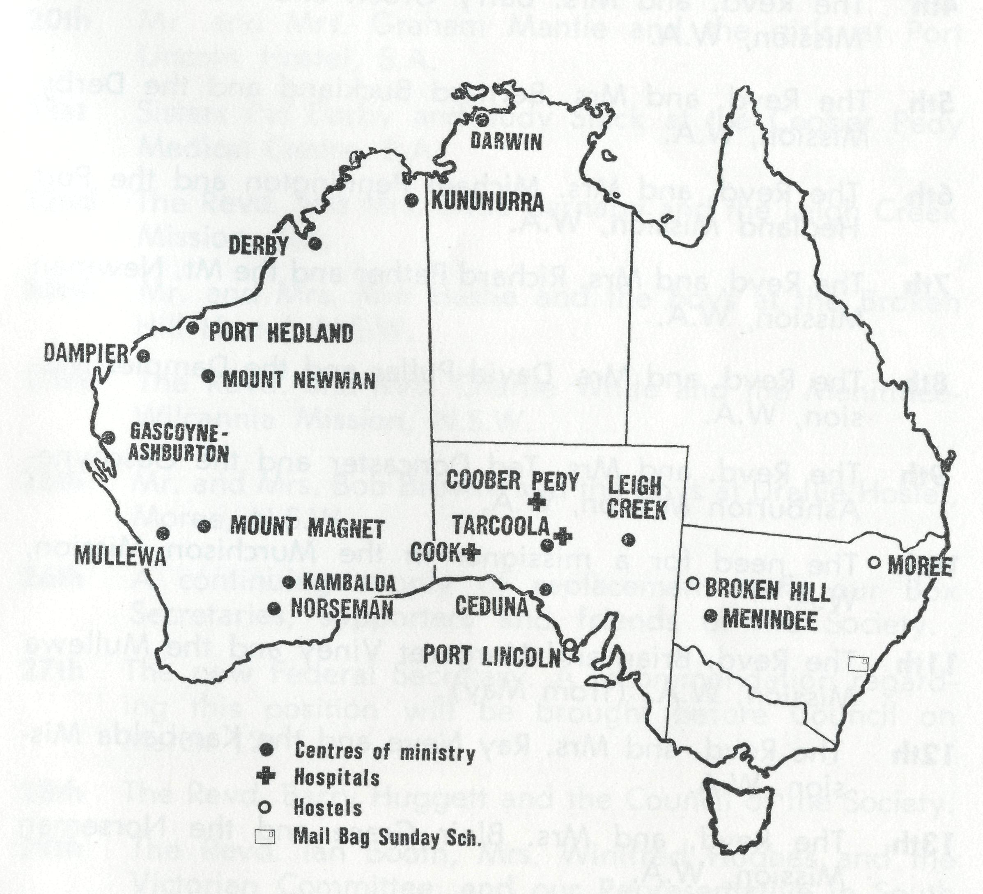
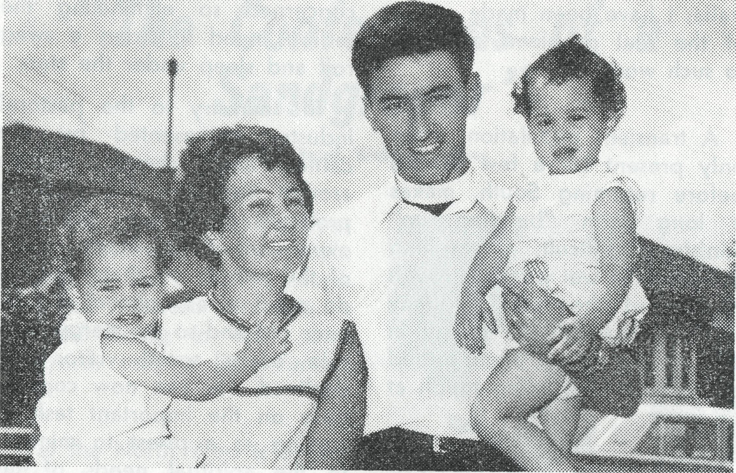
Barry and Jan Green from Kununurra visited friends on the South Coast
during January.
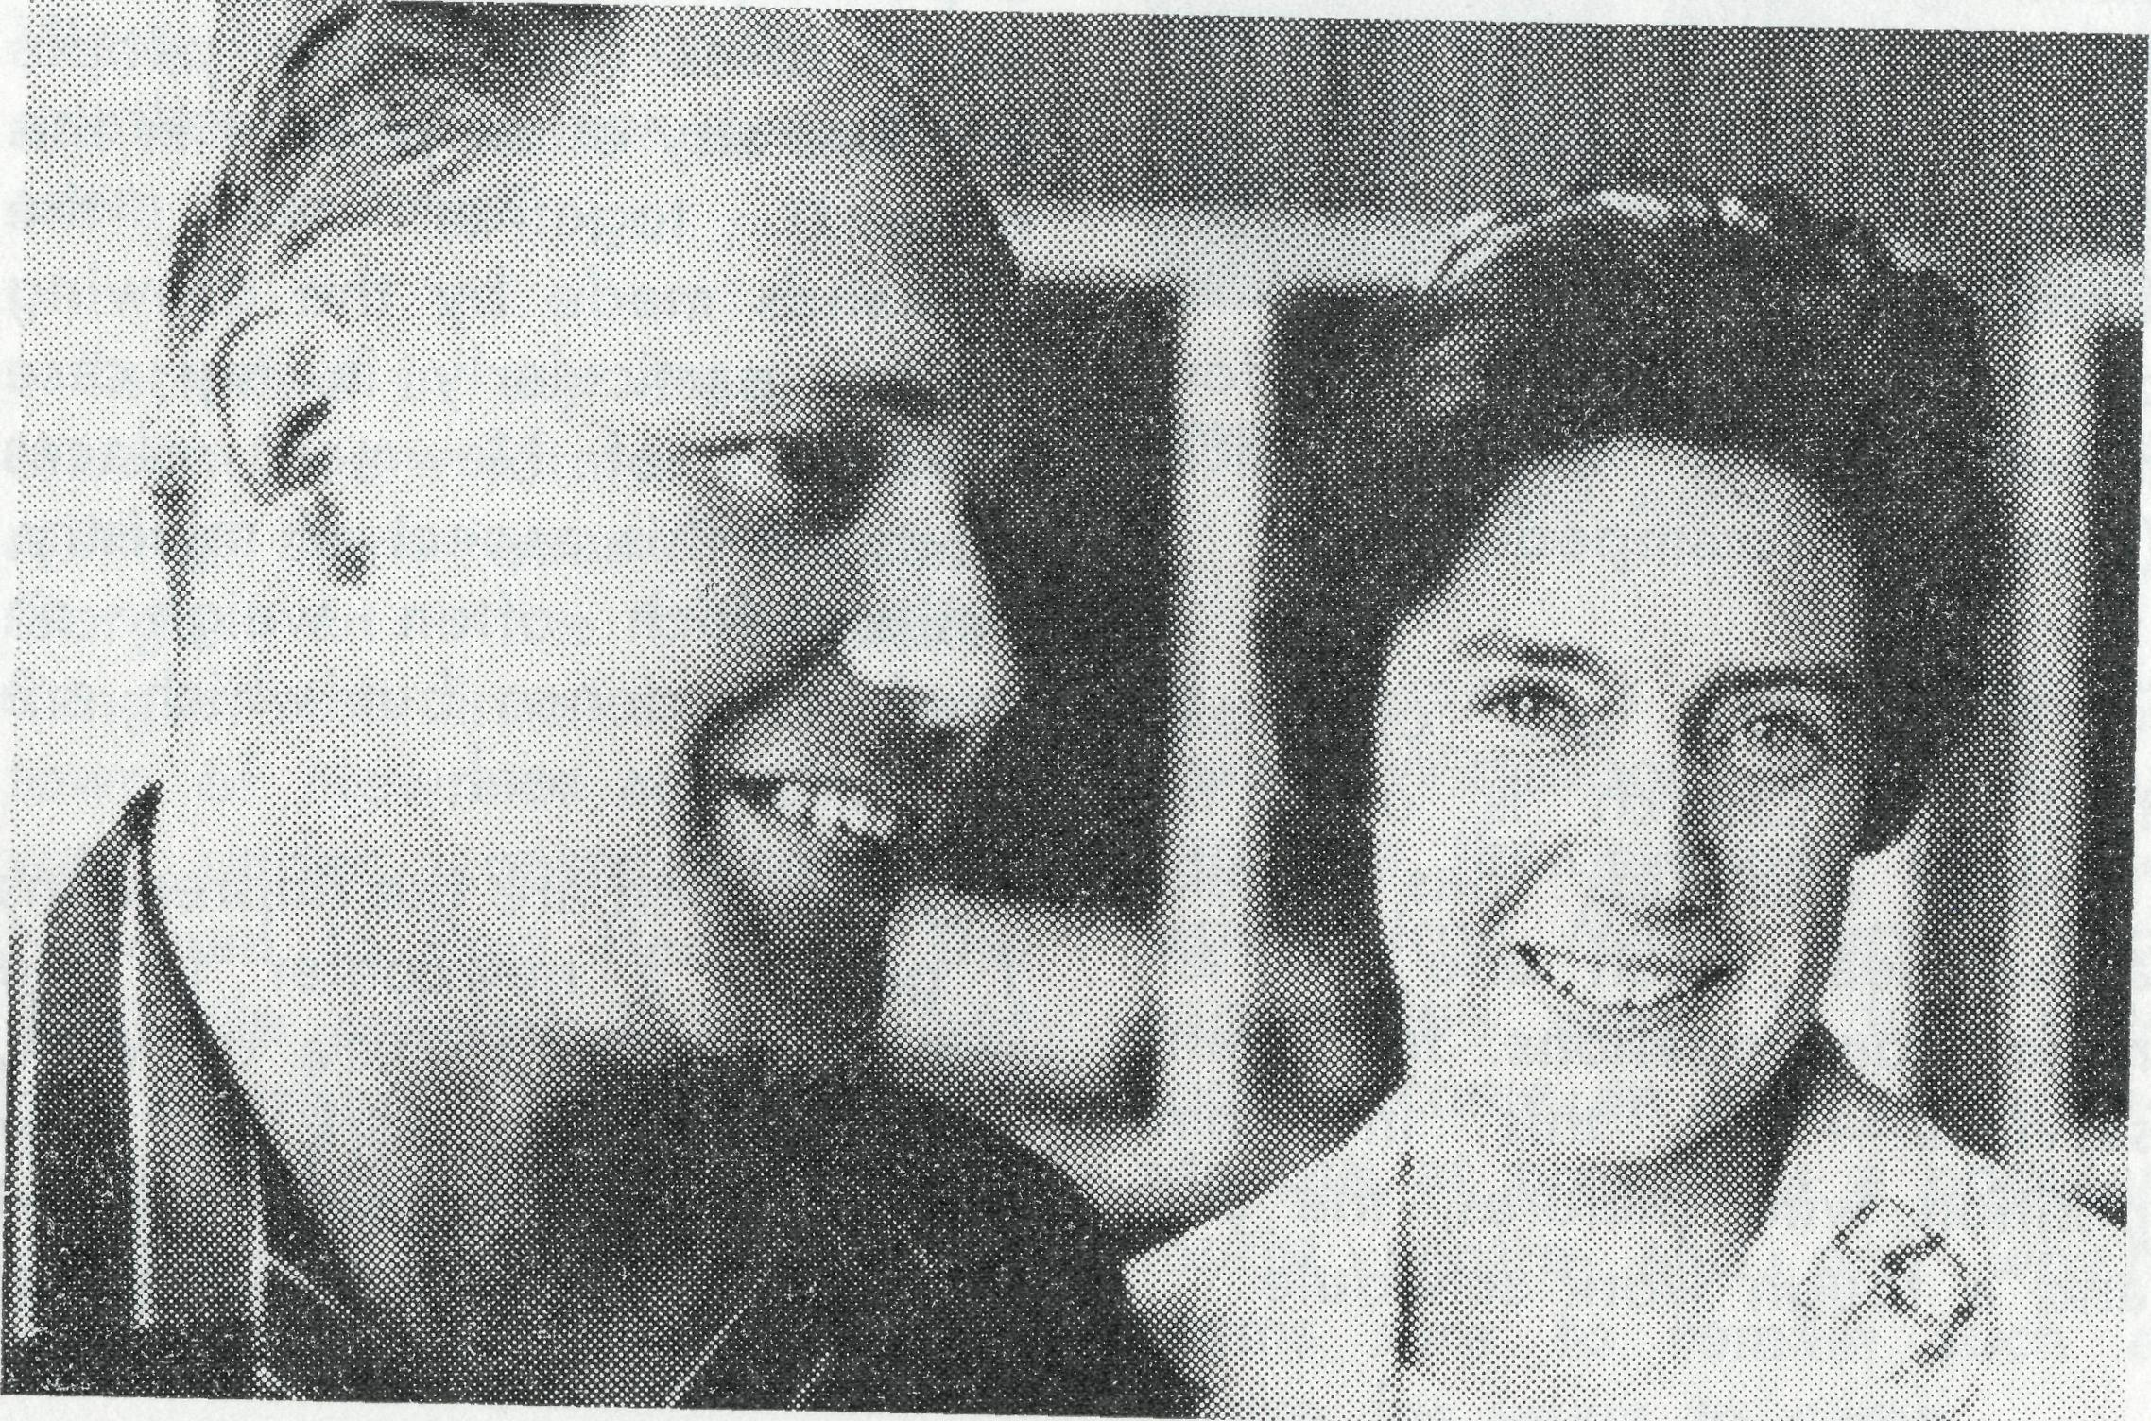
The Place of Prayer
The following pages represent a daily prayer calendar which is revised with each issue. We earnestly seek your prayers for the individual members of our staff. We suggest you remove these centre pages from the magazine and keep them for your regular devotional use.

The Revd. Brian and Margaret Viney from Derby, pictured at Mascot Airport,
en route to England. Brian is to be a migrant chaplain on the return
journey. They will be in Mullewa, W.A., in early May to take over from
8
Bill and Marg. Lawton.
THE REAL AUSTRALIAN, MARCH, 1969
• In response to many requests, a map showing the current areas of Society activity will appear as space permits. It is hoped that
this will help supporters pray more intelligently for the work.
THE REAL AUSTRALIAN, MARCH, 1969

THE PLACE OF PRAYER - A DAILY PRAYER CALENDAR

1st In this Jubilee Year give thanks for the blessings received over the past 50 years. Pray for further opportunities of service.
2nd Mr. Laurie Calder, Miss Barbara Hyett and all the helpers and scholars in the Mail Bag Sunday School.
3rd The Revd. Alan Baker and the Nightcliff Mission, N.T.
4th The Revd. and Mrs. Barry Green and the Ord River Mission, W.A,
5th The Revd. and Mrs. Bernard Buckland and the Derby Mission, W.A.
6th The Revd. and Mrs. Michael Pennington and the Port Hedland Mission, W.A.
7th The Revd. and Mrs. Richard Pether and the Mt. Newman Mission, W.A.
8th The Revd. and Mrs. David Pullar and the Dampier Mission, W.A.
9th The Revd. and Mrs. Ted Doncaster and the Gascoyne-Ashburton Mission, W.A.
10th The need for a missioner in the Murchison Mission, W.A.
11th The Revd. Brian and Margaret Viney and the Mullewa Mission, W.A, (from May).
12th The Revd. and Mrs. Ray Neve and the Kambalda Mission, W.A.
13th The Revd. and Mrs. Blair Grace and the Norseman Mission, W.A.
14th Sisters Lola Higgs and Maude Ross at Cook Hospital, S.A.
15th The Revd. and Mrs. Brian Carter and the North-West Line Mission, Tarcoola, S.A.
• THE REAL AUSTRALIAN, MARCH, 1969
16th The need for staff at the Tarcoola Hospital, S.A.
17th The Revd. and Mrs. Ron Keynes and the Ceduna Mission, S.A.
18th Give thanks for the opportunity of service at Ceduna and Wudinna Hospitals. Pray that any problems in the transition period may be overcome.
19th Mr. and Mrs. Allan Chadwick, at Ceduna, S.A.
20th Mr. and Mrs. Graham Mantle and the girls at Port Lincoln Hostel, S.A.
21st Sisters Pat Darby and Judy Stack at the Coober Pedy Medical Centre, S.A.
22nd The Revd. and Mrs. Ernie Carnaby and the Leigh Creek Mission, S.A.
23rd Mr. and Mrs. Ron Hastie and the boys at the Broken Hill Hostel, N.S.W.
24th The Revd. and Mrs. Charlie White and the Menindee-Wilcannia Mission, N.S.W.
25th Mr. and Mrs. Bob Brown, and the boys at Urallie Hostel, Moree, N.S.W.
26th A continuing supply of replacement staff, our Box Secretaries, supporters and friends of the Society.
27th The new Federal Secretary. A recommendation regarding this position will be brought before Council on March 12.
28th The Revd. Barry Huggett and the Council of the Society.
29th The Revd. Ian Booth, Mrs. Winifred Hughes and the Victorian Committee, and our Representative in South Australia, Mr. Alban Kirkby.
30th Mr. Stan Hummerston, Mr. Frank Burner, Mrs. Joy O'Neill, Misses Beverley Tonkies, Rosemary Aston, Lynette Shrives.
11
THE REAL AUSTRALIAN, MARCH, 1969

THE B.C.A. PRAYER
O Lord our God, make us ever mindful of those who live in the remote parts of our land. Bless, we beseech Thee, all those whom Thou hast drawn into the fellowship of the Bush Church Aid Society. Grant that, through the ministry of the Word and Sacraments, through healing, and through caring and instruction of the young, the message of Thy redeeming love may thus be proclaimed, through Jesus Christ our Lord. Amen.
A DAILY PRAYER
O God, we remember before Thee those whom Thou hast called to Thy service. Bless them this day, we beseech Thee, as we
pray for Call forth others
to stand with them in their task. Grant them, as to us, the joy of service, the ability to achieve and the serenity of Thy peace, for Jesus' sake.
Amen.
Further prayer items and information letters are sent at regular intervals to all members of the B.C.A. Fellowship of Prayer.
Membership in the Fellowship is invited from all who are concerned in the prayer support of our work. There is no joining or membership fee, although a badge pin (or brooch) may be purchased for 40c if so desired.
Send your name and address to the N.S.W. or Victorian Secretary and the prayer letter will be forwarded to you.
Please note that if you have made a bequest to the Flying Medical Service this must be changed. As the Flying Medical Service no longer exists, such legacies as are specially designated for this purpose will, on the death of the person making the bequest, simply lapse.
Legacies should be made to:
The Bush Church Aid Society for Australia and Tasmania.
The Society will continue in some avenues of medical work, and some money from legacies will be used in connection with this sphere of Society activity.
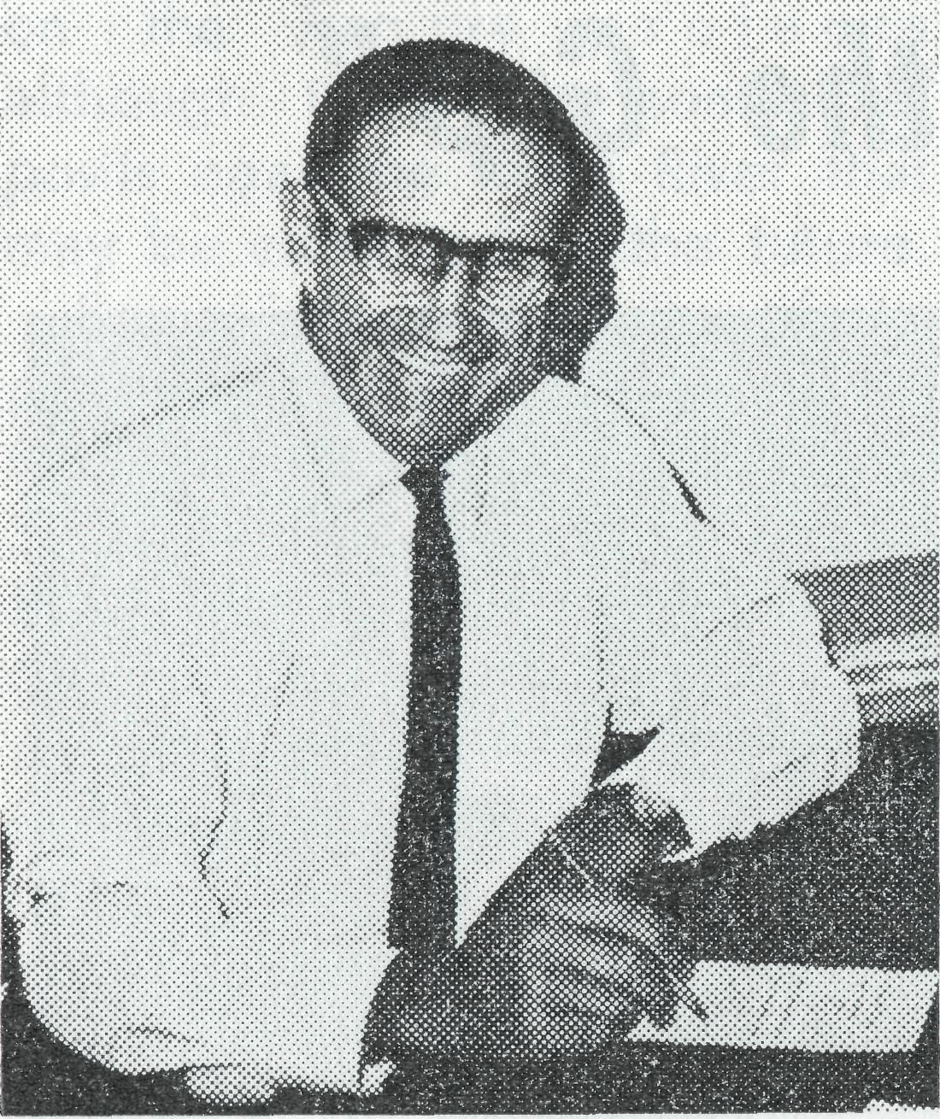
This is how you can help.
RECOMMEND to your relatives and friends in isolated places or those unable to attend Sunday School for any reason, that they enroll their children with the Mail Bag Sunday School.
PRAY for the Sunday School and its outreach for the teachers in the eleven grades, that God will from time to time provide replacement teachers.
GIVE to the work as you are enabled.
SEND your used postage stamps — for the sale of thousands of stamps provides us with funds for Sunday School extras in the way of Bibles, prizes, etc.
WRITE to me now (Mr. W. L. Calder, 135 Bathurst Street, Sydney) for further information, sample lessons or confirmation studies.
A Note from
the New MBSS Director
Imagine living 85 miles from Menindee in far west N.S.W. or at Come-By-Chance, or Doctors Creek or Jerramungup. How would you instruct your children in Bible Stories and the wonder of God's Care in this situation?
On the roll of the Mail Bag Sunday School we have children from these remote areas and many more in Australia and Overseas receiving spiritual guidance through the weekly lessons.
I have on my desk a letter from a Mother in an isolated area. She writes, "Having been a pupil of the Mail Bag Sunday School for quite a few years and receiving so much help, I was wondering if I could now enrol my eldest child as we are unable to attend Church or Sunday School."
We give thanks that we are able to help and make it possible for parents to give their children the opportunity to learn and understand the Gospel of our Lord Jesus Christ.

12
THE REAL AUSTRALIAN, MARCH, 1969
THE REAL AUSTRALIAN, MARCH, 1969
13

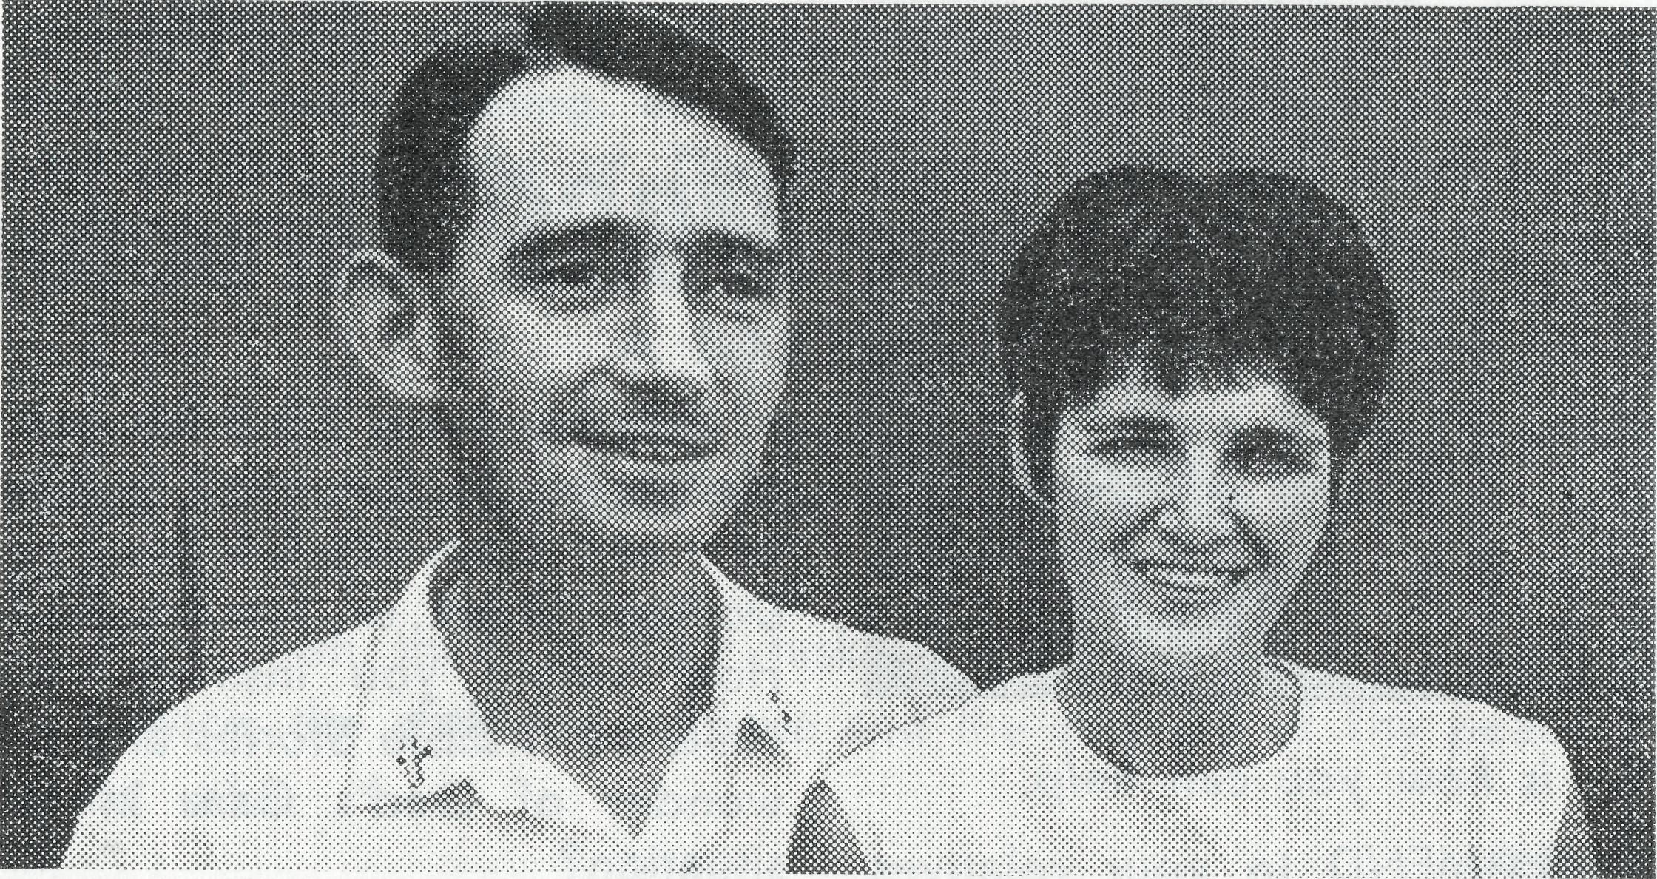
"Bridging the Gap"
The Revel Ted and Sue Doncaster.
HAVE YOU CHANGED YOUR ADDRESS?
If the Society does not have your correct mailing address would you please complete this form and return to us as soon as possible —
Name (Mr., Mrs., Miss, Rev.)
(Please Print)
Old Address
New Address
Last year the Society undertook a new venture in the Diocese of North West Australia in helping to create the Gascoyne-Ashburton Parish, commonly known as the "GAP". The Rev'd Ted Doncaster had for four years been Rector of Carnarvon which parish embraced that town and all the bush territory now in the "GAP". This meant an irregular ministry in the outcentres, and planning for the new parish seemed to get nowhere until a house became available for rent.
On June 1st, 1968, the "GAP" came into existence and since then regular services have been held in the towns of Shark Bay, Exmouth, Onslow
and Gascoyne Junction, together with more frequent visits to the sheep stations and other outposts. It is an area of varied activities: salt is produced at Useless Loop (no, the missioner is not called the Useless Rector of the Loop!), potash at Lake McLeod, Oil on Barrow Island, Amethysts are mined near Wyloo and there are other mining "shows" in the parish, sandalwood is cut at Nilemah, culture pearls are farmed at the Bay of Rest, and there is a prawning base at Learmonth. In addition there are 110 sheep or cattle stations plus numerous outcamps, and the United States Naval Communications Station at Exmouth, a town of about 2,500 people. We just miss out
on the iron-ore projects although there are some deposits near the Robe River that may be exploited in the future.
Some idea of the size of the parish may be gained from the fact that the two little churches, St. Andrew's-by-the-Sea at Shark Bay and St. Nicholas' at Onslow are almost 500 miles apart by road, and that to travel from the southernmost station to the most easterly one is a direct journey of 656 miles.
All this scattered activity means a lot of travelling by road, by plane and even by boat on occasions. It means that the missioner only has about eight nights a month home with his family in their small home, with the study tucked away in a corner of the dusty garage.
In the midst of all the prosperity in the North West it is good to see signs that the
people have not altogether lost sight of the things of God. People in the bush are often more aware of His presence than others because of their concern with the things of His creation, yet on the other hand they are more exposed to temptations arising from isolation and materialism and frustration. There is little place in the bush for the traditional concept of the organised church, for she must be free and flexible if she is to bridge the gap between the godly and the godless. The miner's hat becomes the font, the shearing shed bench becomes the Communion table, the kingdom of this world becomes the Kingdom of our God and His Christ.
Will you please give the people of the "GAP" a place in your prayers, often?

14
THE REAL AUSTRALIAN, MARCH, 1969
THE REAL AUSTRALIAN, MARCH, 1969
15

O Staffing the Murchison in W.A. continues to cause concern. The Rev. Bernard Buck-land, one of the most experienced priests with the Society, has served five years in this parish and has built up a very solid foundation. It will be a great loss if he cannot be followed promptly. Make this a priority prayer.
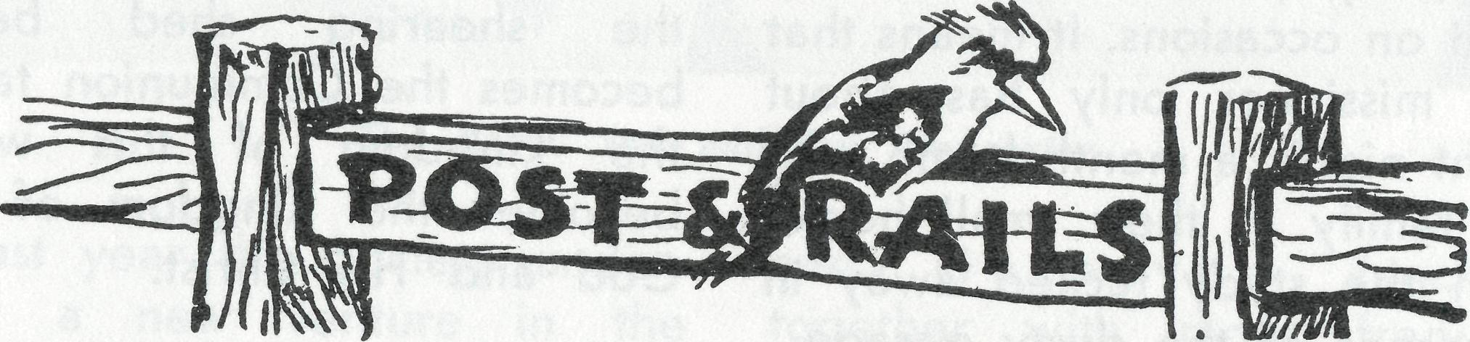
O The Revd. Bill and Margaret Lawton return to Sydney in March having completed their two years term of service at Mullewa. We hope that Mr. Lawton will be able to undertake some deputation work on behalf of the Society.
• We extend our very good wishes to Archdeacon G. R. Delbridge on his appointment as Bishop. He is to be responsible for the city of Wollon-gong and the southern part of the Diocese of Sydney.
u
°> The Rev. Ray and Mary Neve have arrived at Kambalda in W.A. They travelled by car from Melbourne and were able to renew friendships made during Mr. Neve's ministry at Ceduna eight years ago. The new mission district involves work in the new nickel town of Kambalda, the Trans-Australian Railway from Kalgoorlie to the W.A. Border, and north to Menzies, Leonora and Laverton.
• Please take special note of the Special Thanksgiving services shown on Page 2, and make every effort to be present. The Rallies will provide excellent opportunities for the new Federal Secretary to meet many of the Society supporters. Dates will be announced as soon as it is known when he will take up the position.
THE REAL AUSTRALIAN, MARCH, 1969
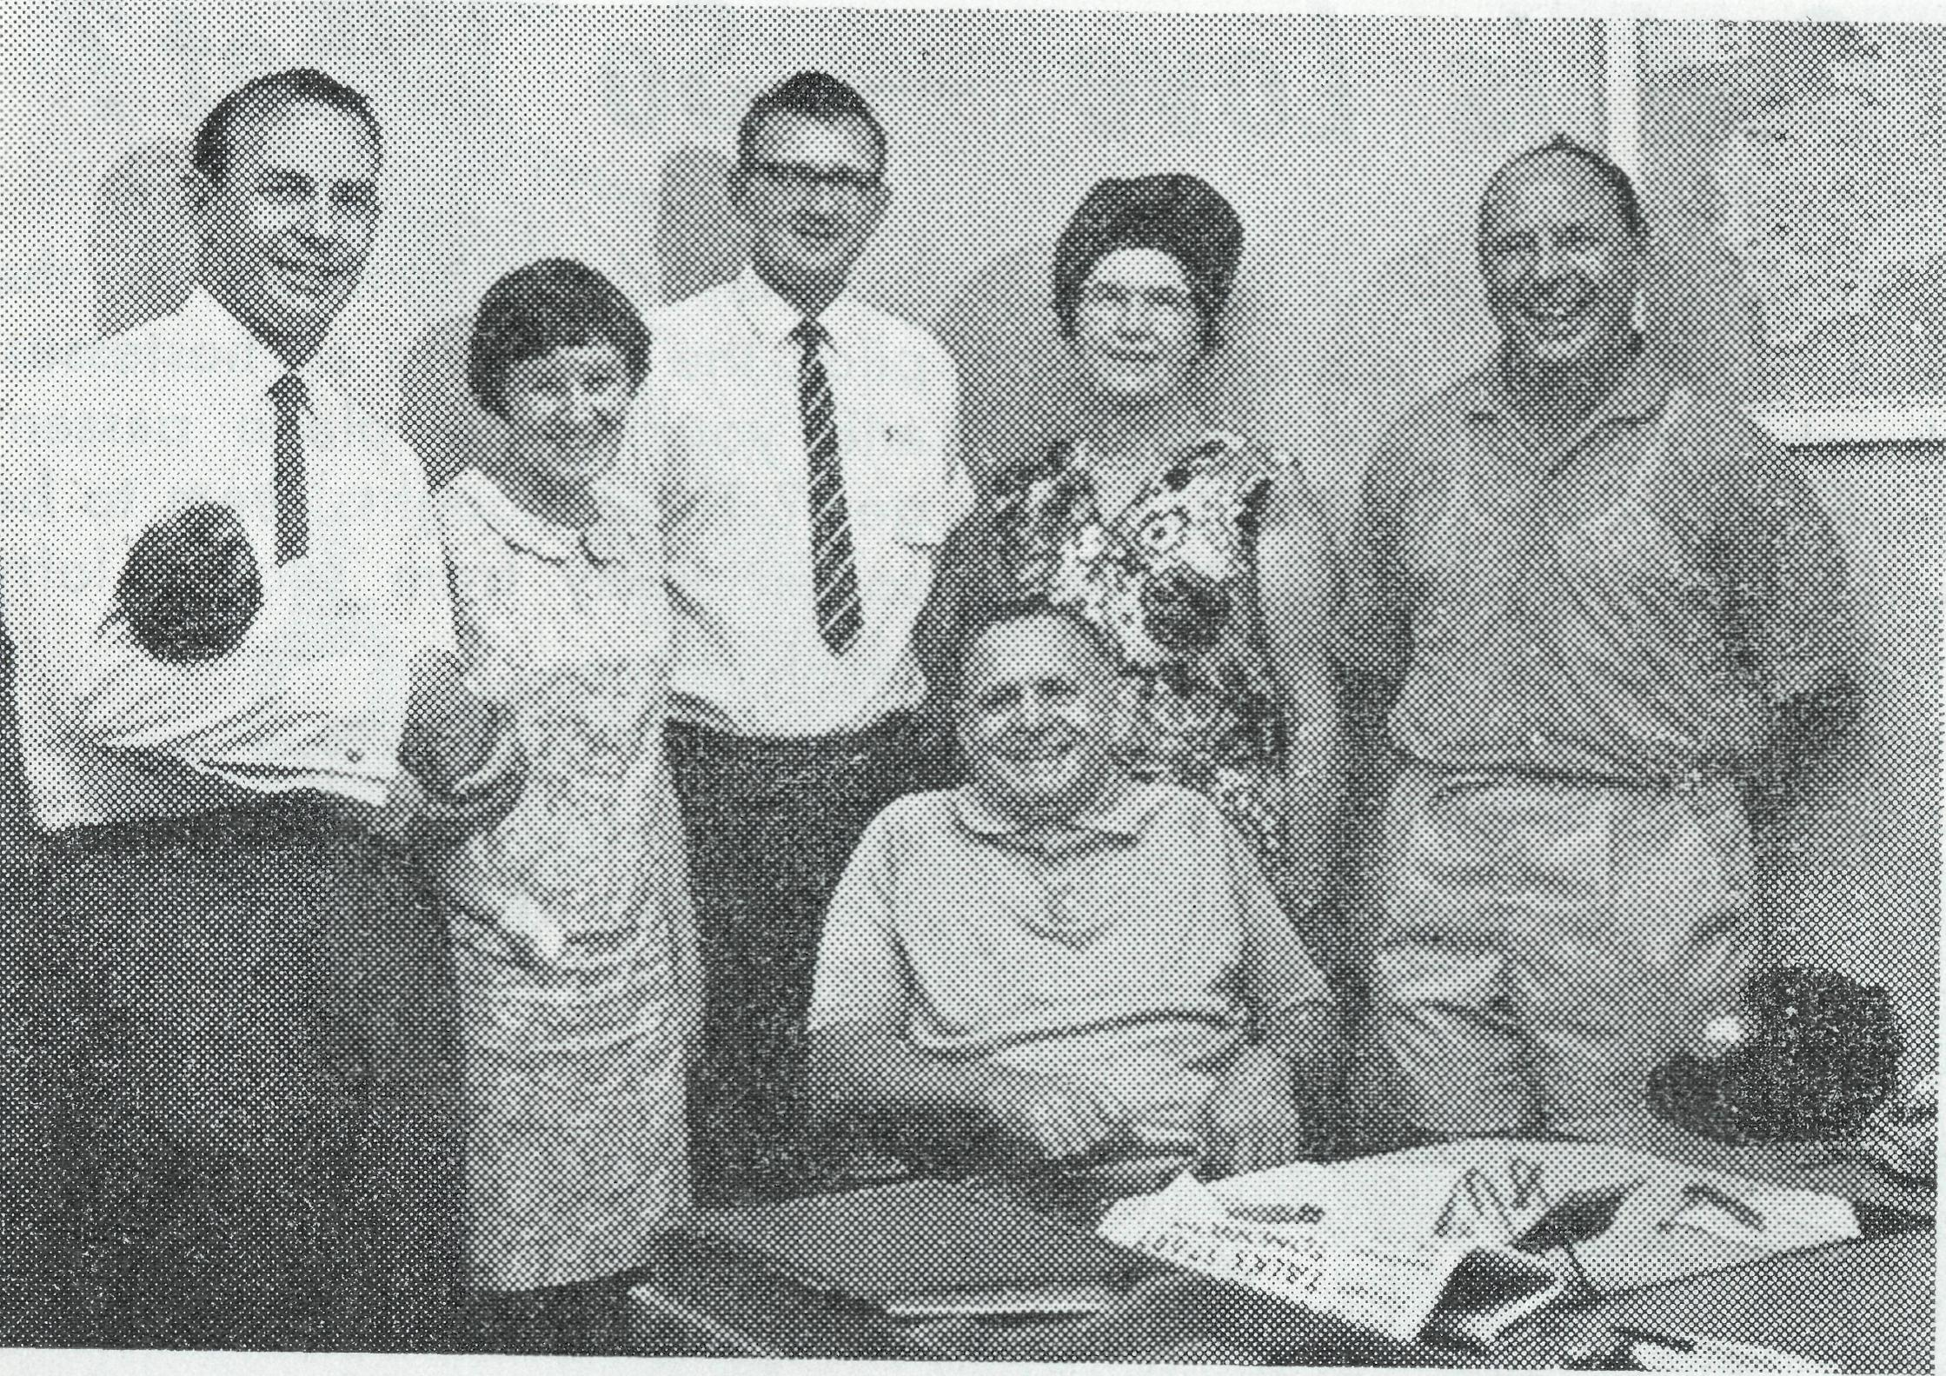
An informal conference of hostel workers was held at Head Office in January.
L. to R. Ron and Pam Hastie, Bob Brown, Ruth and Harry Rich.
Stan (Father) Hummerston presided!
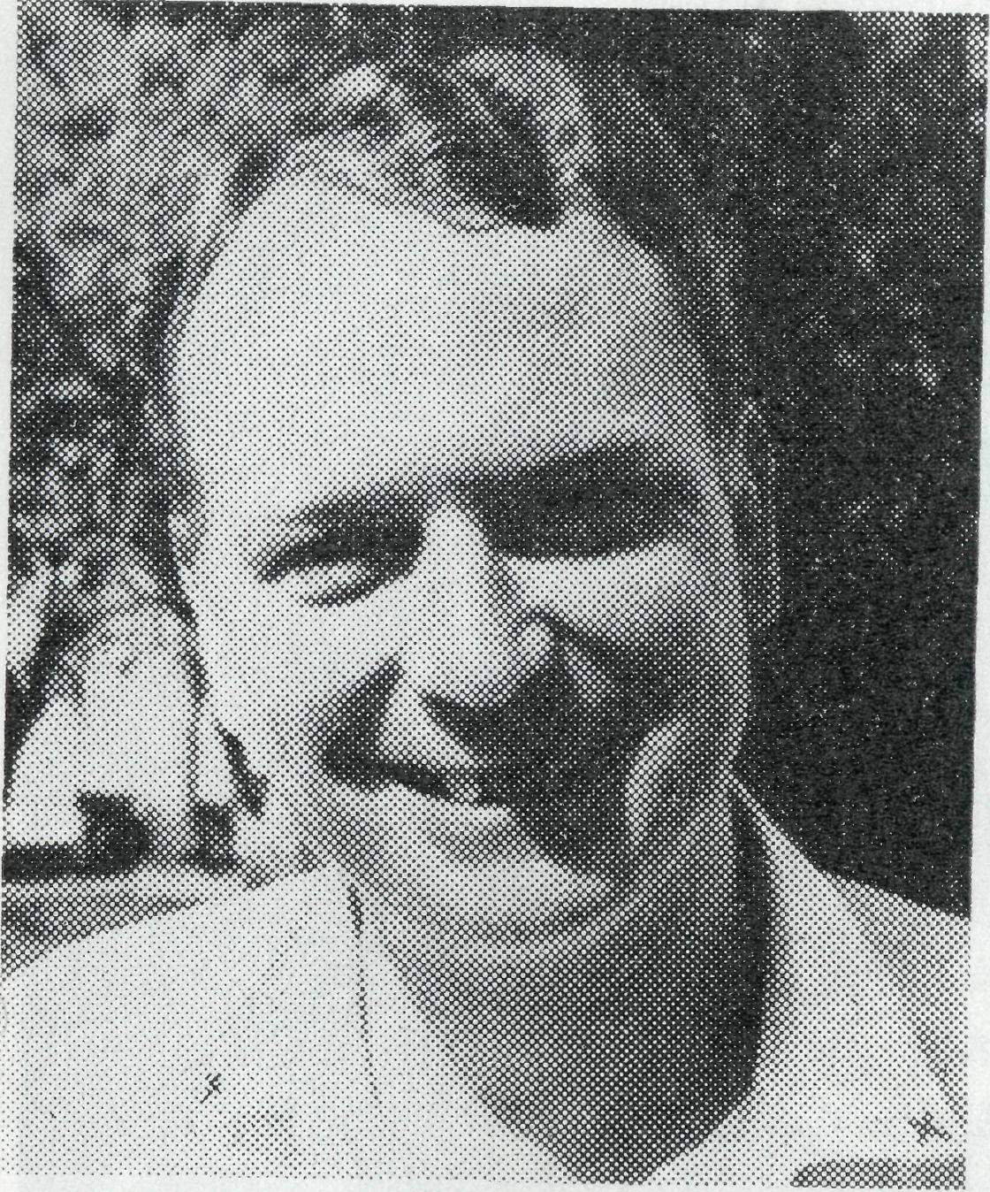
The Revd. Alan Baker, now in charge of the Nightcliff Mission, N.T., finished a term of service with B.C.A. at Tim-boon in 1965 and latterly has been assistant priest at Darwin. As well as Nightcliff he will have the oversight of bush country from Bachelor to Adelaide River.
Don't Forget The Bush Padre Programme!
2CH at 8.30 p.m. every second Sunday for up to the
minute news and interviews.
THE REAL AUSTRALIAN, MARCH, 1969
17

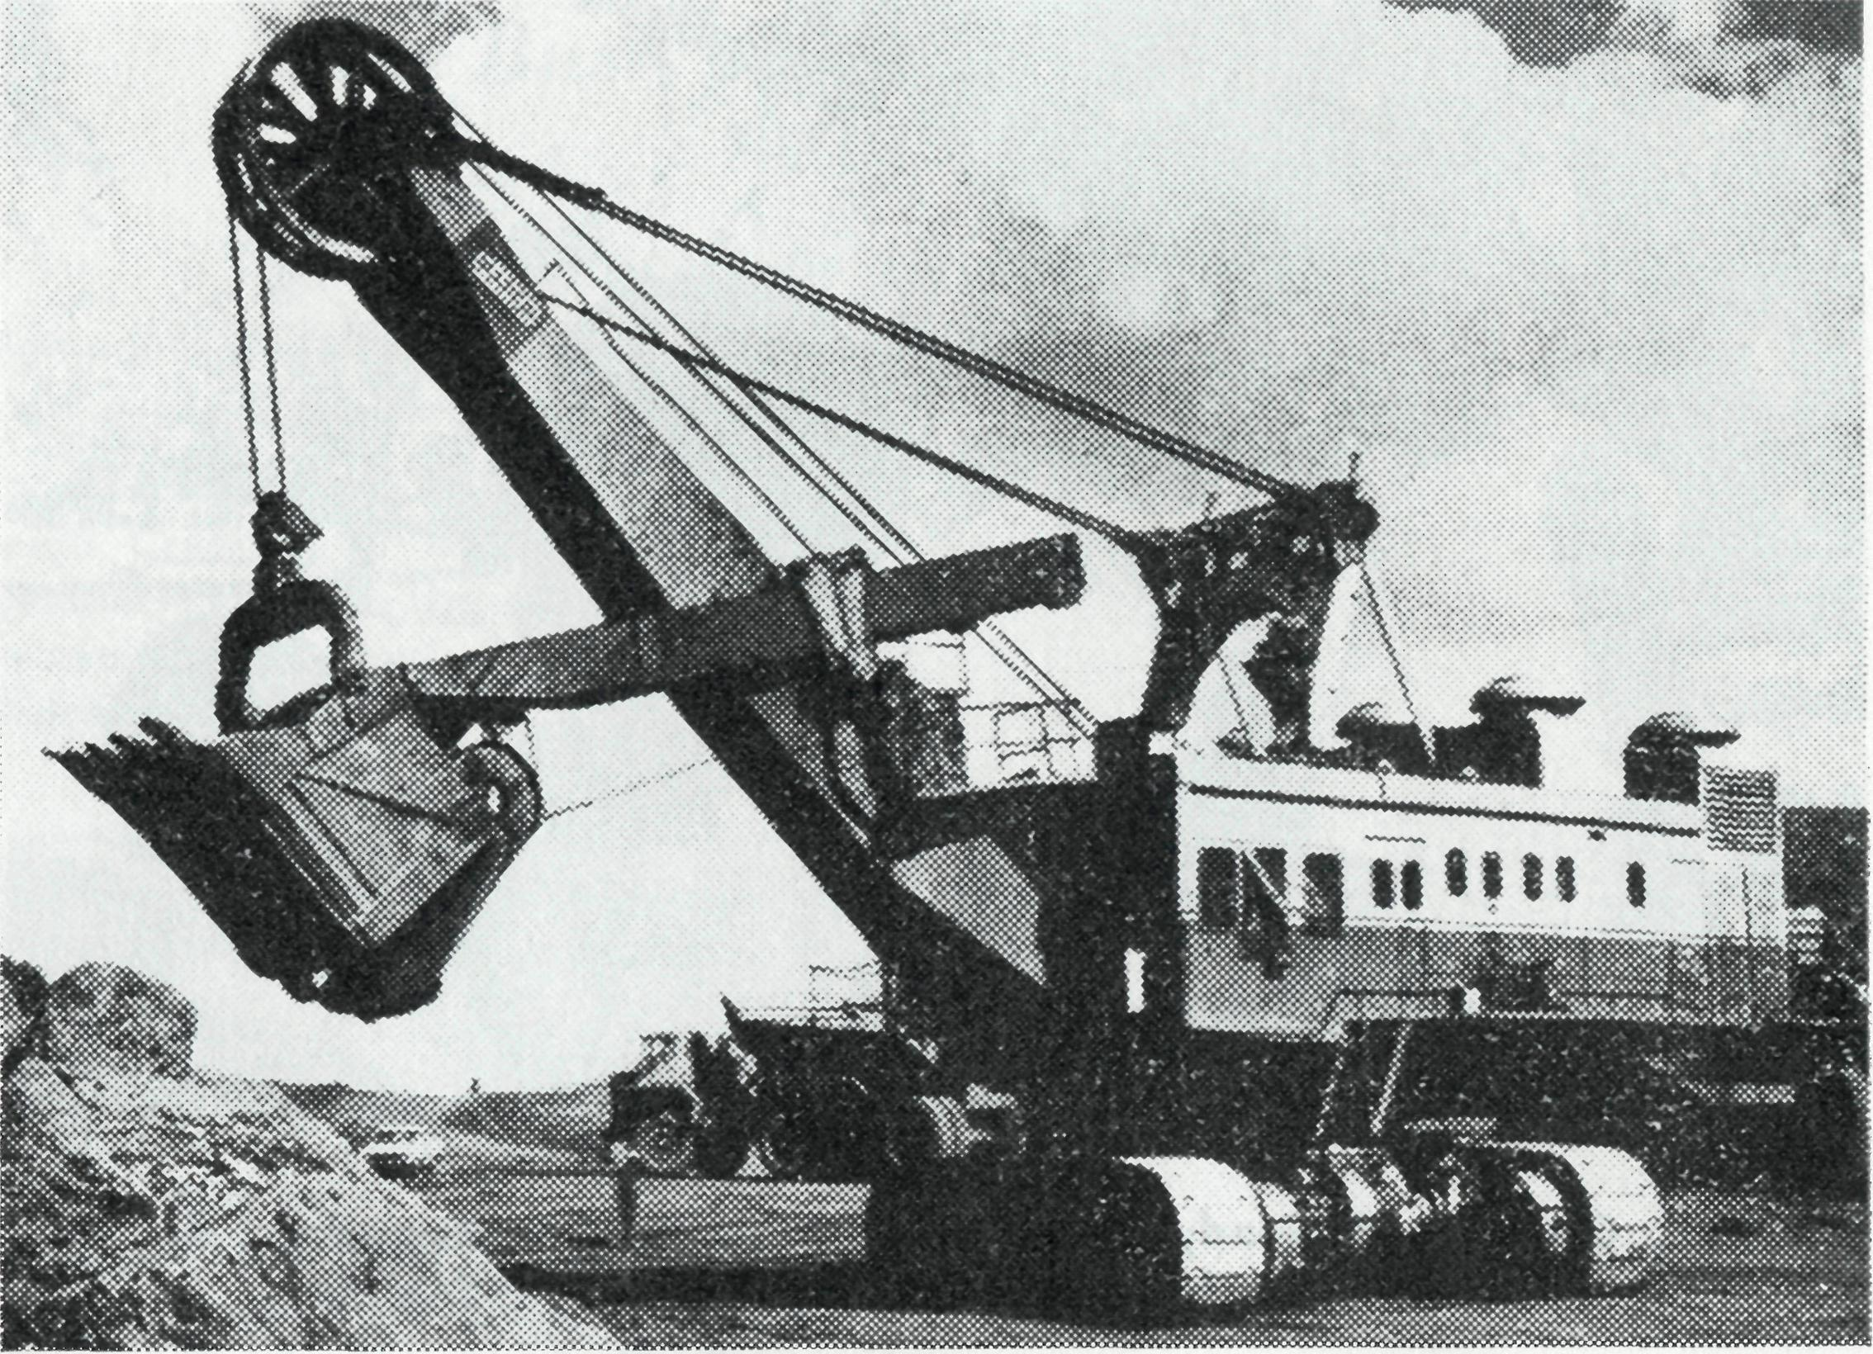
What does it mean to the pilot, the charming air hostesses, and your fellow plane passengers? Their thoughts seem to be so far away from such a lofty ideal.
Then what does it mean to the people of Dampier and district? To the folk who welcomed us, the committed church folk —does it mean an opportunity to serve—to witness to a loving God in an area where the accepted formal institutions of religion are absent either in part or in full?
God is Love - So What?
As a small boy in Queensland, I remember going into a church and seeing the large sign on the far wall "GOD IS LOVE" what did it mean? It was too high for my fingers to grasp, let alone my child's mind to understand its meaning.
Now twenty years later, what does it mean "GOD IS LOVE"? What does it mean when you are caught up in an air line strike which personally inconveniences you, by delaying you, and being irritated by overtired assistants trying to please too many people?
The huge Marion shovel loading ore at Mt. Tom Price.

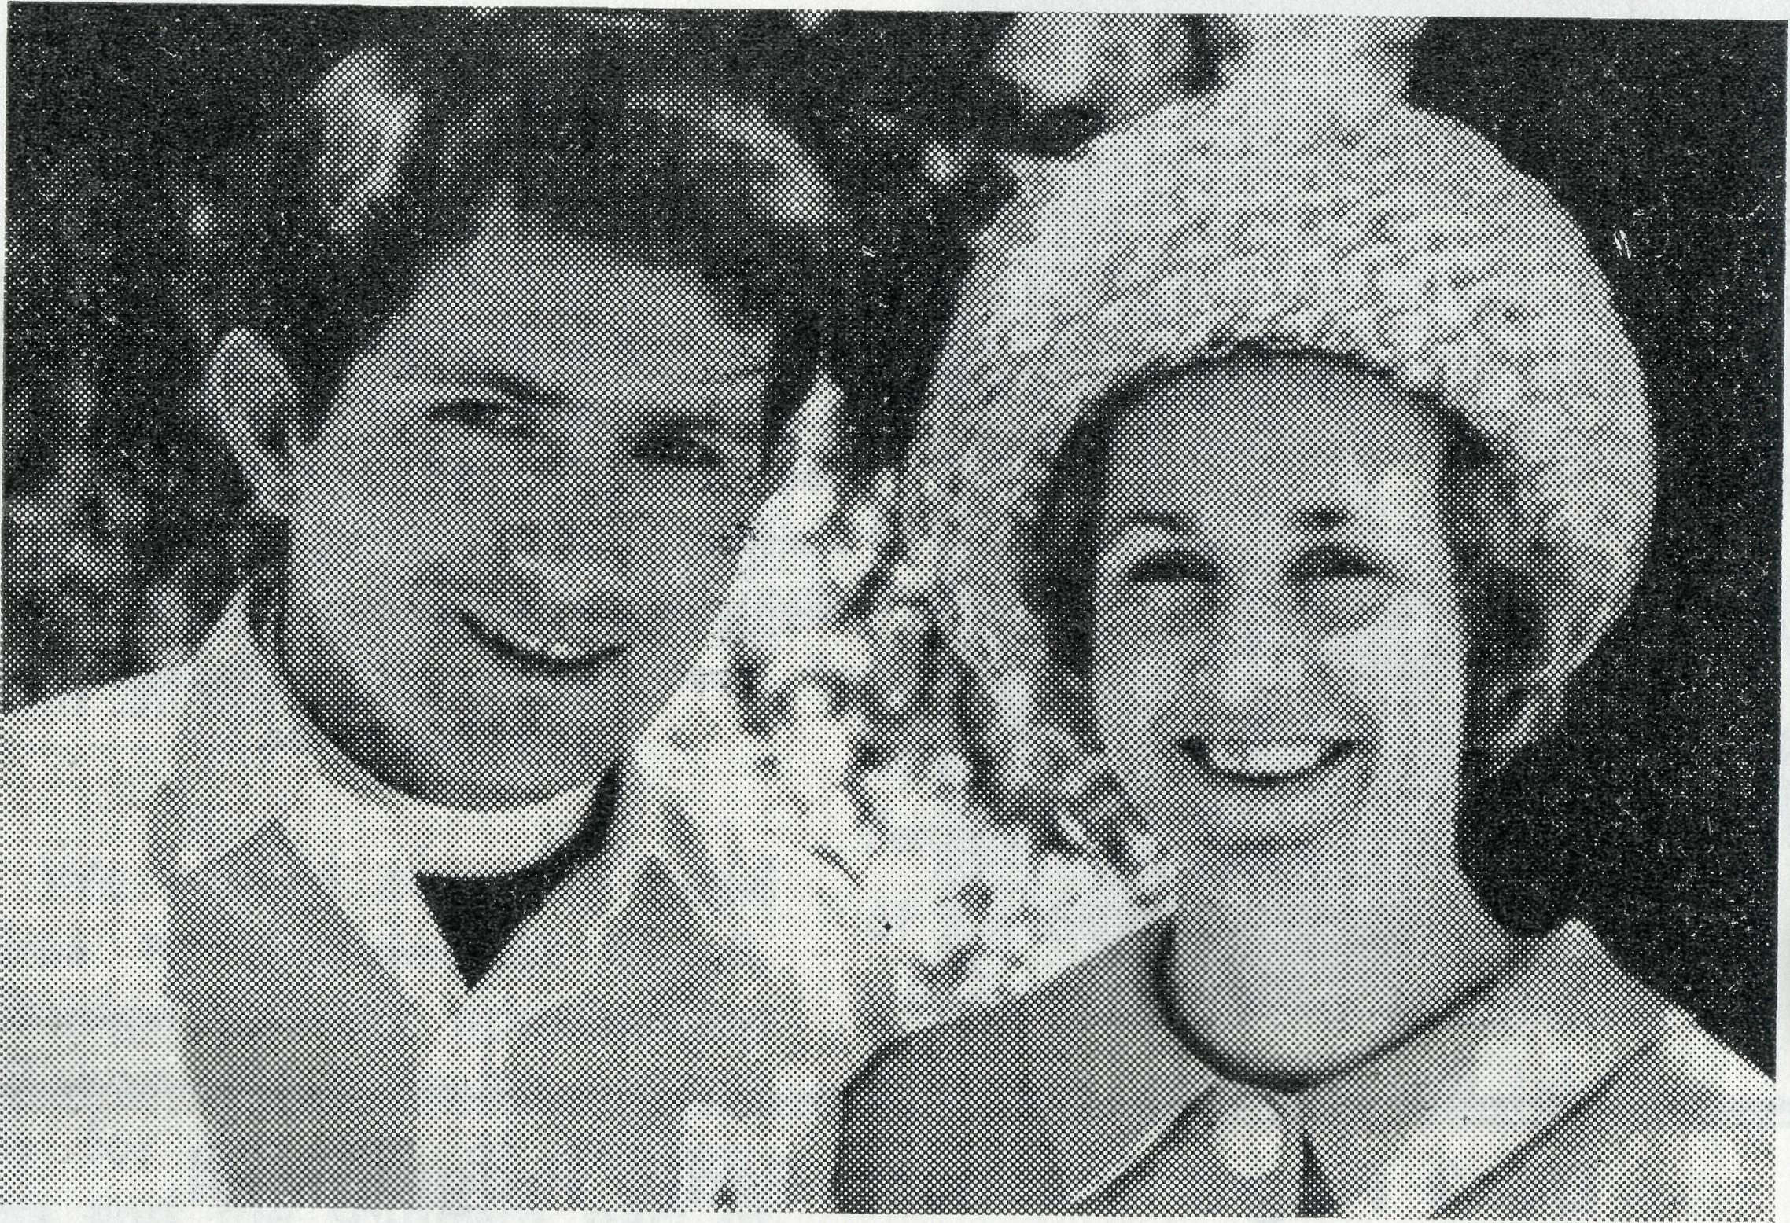
The Revd. David and Joy Pullar.
To the first congregation, what does it mean—an appor-tunity to worship, to have communion with each other and with Our Lord, or merely an opportunity to survey the "new man"?
What does it mean to the wives in their struggle to adjust to the heat and the dust—that fine red dust that always seems to come no matter how much one sweeps, washes and scrubs, to adjust to the fact of families and friends so far away? Is it a comfort? Or is it, as some find, too remote for them as they give up the struggle and collapse or leave?
What does it mean to the companies' officials — an
optional luxury where the pressure is on for bigger and better profits? Or to those who come to make a "fast buck"—is it something left behind in "civilization"? Or to the workers— separated from wives and families?
What does "God is Love" mean? To the graziers, all too often passed over in all this talk of the "developing north" —the "awakening giant"—and to the aboriginals—what does it mean?
And what will it mean to me in this new situation? God grant that I may find the answer in service, for the Love of God, who is Love Himself.

18
THE REAL AUSTRALIAN, MARCH, 1969
THE REAL AUSTRALIAN, MARCH, 1969

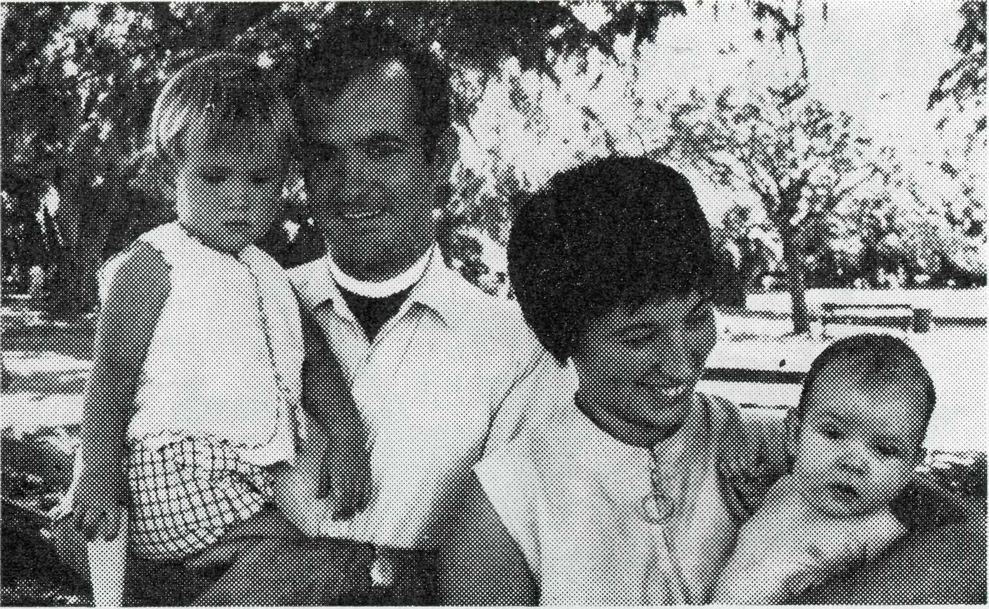
The Revd. Charlie and Wendy White are now resident at Menindee. Mr. White is responsible for Menindee, Ivanhoe and Wilcannia.
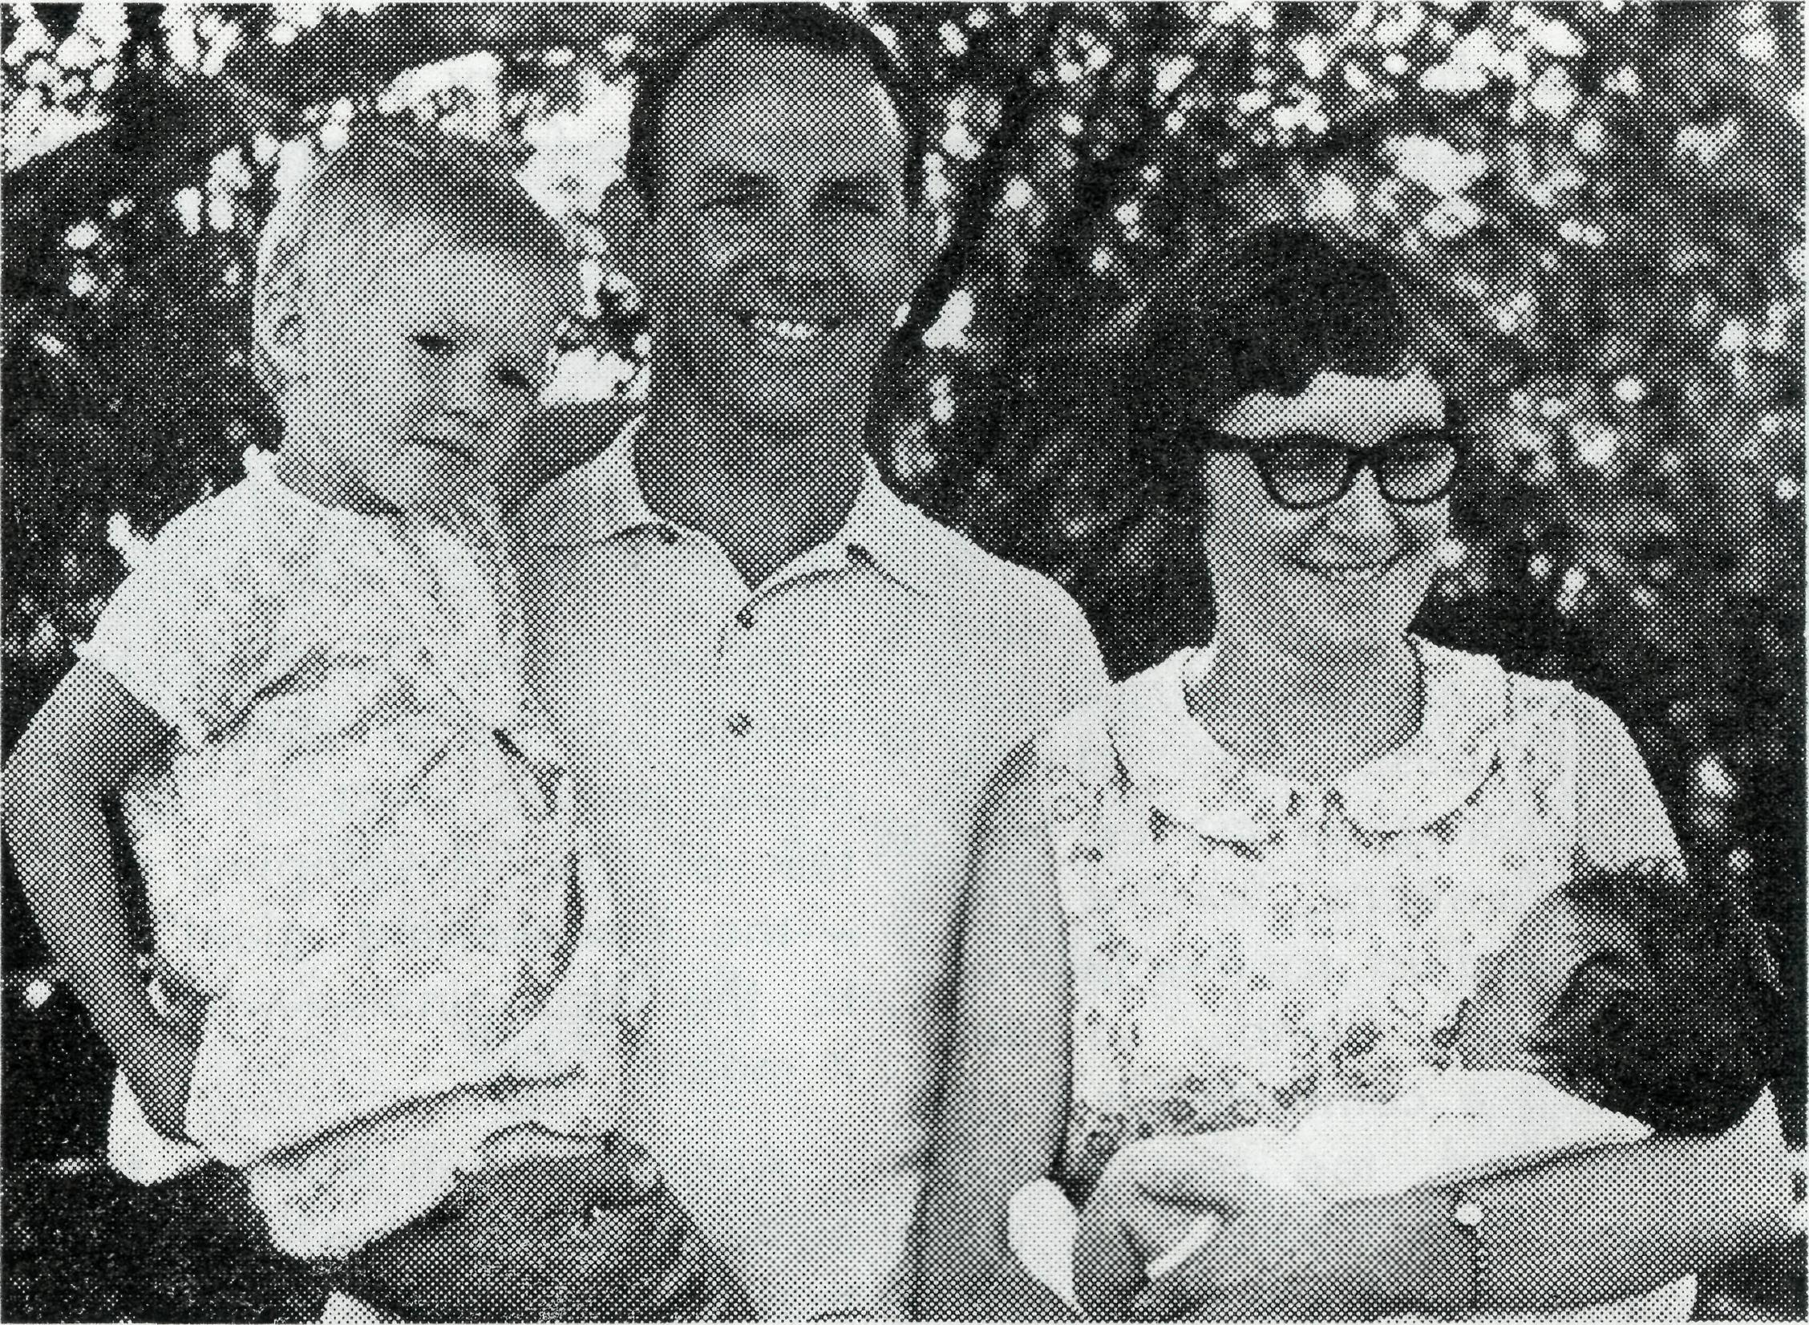
Ron and Pam Hastie replace Ruth and Harry Rich at Broken Hill hostel.
The Bush Church Aid Society
FIELD STAFF:
DIOCESE OF RIVERINA, N.S.W. Menindee/Wilcannia—The Revd. C. While.
DIOCESE OF WILLOCHRA, S.A.
Leigh Creek—The Revd. E. Carnaby. Ceduna/Penong—The Revd. R. Keynes. Tarcoola—The Revd. B. Carter. Quorn—Grant-in-aid.
DIOCESE OF KALGOORLIE, W.A. Norseman—The Revd. B. Grace. Kambalda—The Revd. R. Neve.
DIOCESE OF NORTH-WEST AUSTRALIA Mullewa—The Revd. B. Viney. Mount Mag tet— Dampier—The Revd. D. Pullar. Mt. Newman—The Revd. R. Pelher. Port Hediand—The Revd. M. Pennington. Derby—The Revd. B. Buckland. Kununurra—The Revd. B. Green. Gascoyne/Ashburton—The Revd. E. Doncaster.
DIOCESE OF NORTH QUEENSLAND Outer Mt. Isa—Grant-in-aid. Religious Broadcasting—Grant-in-aid.
DIOCESE Or NORTHERN TERRITORY Nightcliff—The Revd. A. Baker. Darwin—Grant-in-aid to Carpentaria College.
MAIL BAG SUNDAY SCHOOL
Director: N\r. W. L. Caider.
HOSTELS FOR SCHOOL CHILDREN
MOREE, N.S.W. Mr. & Mrs. R. BROWN.
BROKEN HILL, N.S.W. Mr. & Mrs. R. HASTIE.
PORT LINCOLN, S.A. Mr. & Mrs. G. MANTLE.
HOSPITAL CENTRES
COOK, S.A.
Bishop Kirkby Memorial Hospital— Sisters L. HIGGS, M. ROSS.
TARCOOLA, S.A.
Tarcoola Hospital—
COOBER PEDY, S.A.
Coober Pedy Medical Centre— Sisters P. DARBY, J. STACK.

THE REAL AUSTRALIAN, MARCH, 1969
THE REAL AUSTRALIAN, MARCH, 1969
21

