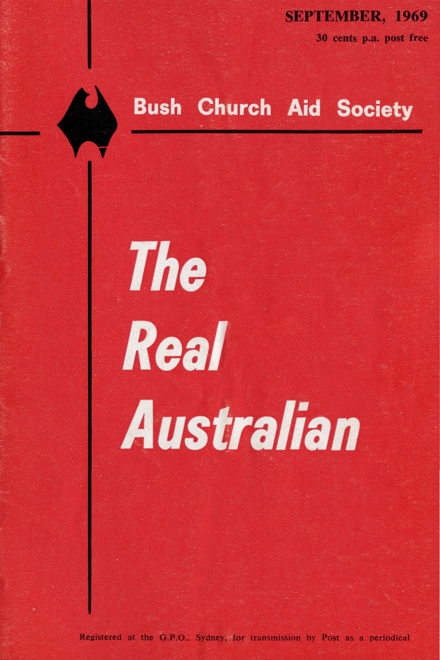
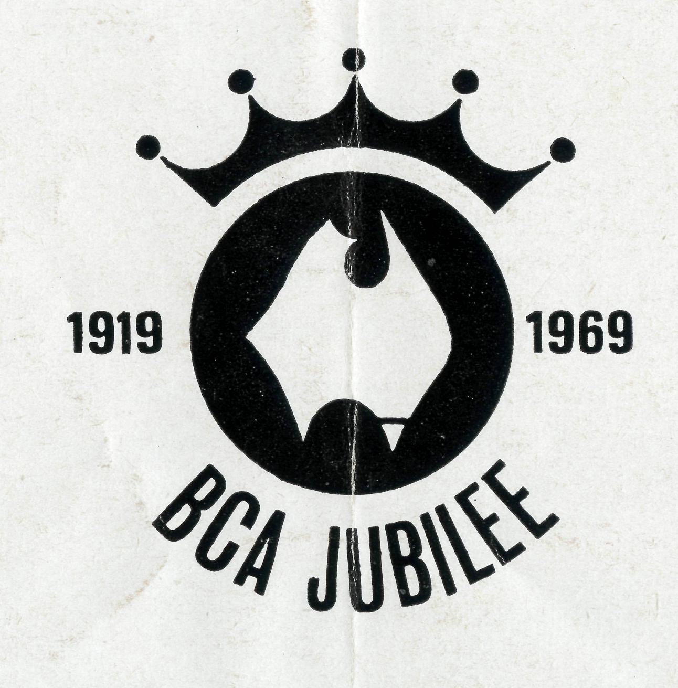
EDGAR BRAGG & SONS PTY. LTD

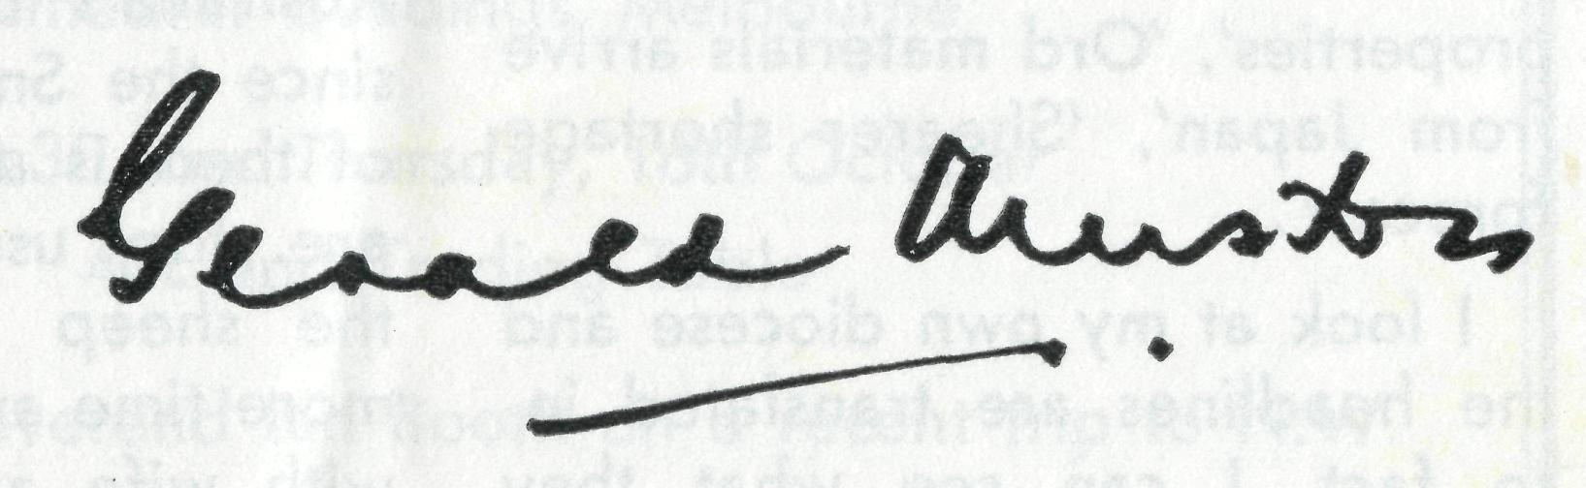
Federal Secretary's Letter
The Bush Church Aid Society
for Australia and Tasmania
PATRON
The Most Reverend, The Primate.
PRESIDENT
The Most Reverend, The Archbishop of Melbourne.
VICE-PRESIDENT
The Most Reverend, The Archbishop of Sydney.
CHAIRMAN OF COUNCIL HONORARY TREASURER
The Rt. Revd. G. R. Delbridge Mr. R. T. Stokes
COUNCILLORS
The Ven. R. G. Fillingham, the Revd. Canon R. M. Hudson, the Revds. C. A. Baker,
L. H. Broadley, E. V. Constable, O. W. C. Cooper, A. C. Miles, G. Pearson,
Messrs. H. M. Bragg, R. Ctercteko, M. Job, E. Stockton.
FEDERAL SECRETARY
The Revd. G. B. Muston.
ADMINISTRATIVE SECRETARY
Mr. S. E. Hummerston.
VICTORIAN SECRETARY NEW SOUTH WALES SECRETARY
The Revd. I. A. Booth The Revd. B. D. Huggett
REPRESENTATIVE IN SOUTH AUSTRALIA
Mr. A. Kirkby, 7 Ruthven Avenue, Glandore, S.A.
HONORARY AUDITOR
F. W. A. Eagar and Co., 8 Belgrave Street, Manly, N.S.W
SOLICITORS
Messrs. Maxwell and Boyd, 155 Castlereagh Street, Sydney.
HEAD OFFICE
B.C.A. House,
135 Bathurst Street, Sydney.
Phones: 26-3164, 26-3780.
Telegraphic Address: "Chaplaincy", Sydney.
VICTORIAN OFFICE
Morton House,
262 Flinders Lane, Melbourne.
Phone: 63-8962.
'AUSTRALIA FOR CHRIST"
l will always remember these last three months. To travel through areas where B.C.A. works, to see something of the extent and quality of that work, and to meet staff members and their families has been a thrilling and unforgettable experience. It has given me a deep sense of privilege to be involved in the work, which is of very real significance in the whole life of the Church in Australia today.
But B.C.A. is not just the staff members. I have also come to realise how big a part is played by all of you who support us with your prayers and your concern and your giving. Time and time again the men and women on the field told me how conscious they were of your interest and support, and expressed their thanks for it. They thank God for the Australia-wide family of B.C.A. — a rich and fruitful fellowship in the cause of the Gospel.
You will see elsewhere in this "Real Australian" details of the Jubilee Appeal for three rectories at Coober Pedy, Kam-balda, and Mt. Newman. I hope that we will all see this as an "extra" in this year of thanksgiving — that is the basis on which the Society has accepted the challenge. Though it is a major undertaking, it must not hinder the ongoing work to which we are committed.
B.C.A. is interested in buildings only insofar as they make it possible for God's love in Christ to be made known. It is the Gospel to which we are committed first and foremost. We are "allowed by God to be put in trust with the Gospel", and for that we give thanks.
May God bless you all.

THE REAL AUSTRALIAN, SEPTEMBER, 1969
THE REAL AUSTRALIAN, SEPTEMBER, 1969

But What of the Next Fifty Years...?
The Rt. Rev. Howell Witt
B.C.A. CENTRAL WOMEN'S AUXILIARY
Morning Coffee in CM.S. Fellowship Rooms Cathedral Buildings, Melbourne
at 10.30 a.m. Thursday, 16th October 40c and Trading Table
Speaker: The Reverend Ian Booth on a recent trip to N.W.
1969 is the Society's Jubilee Year. Marking fifty years of faithful service to those who live and work in the Australian bush.
A time of thanksgiving to Almighty God. A time to rejoice and be glad.
And a time of re-dedication.
... But to what?
What of the next fifty years?
When we speak of the twentieth century as a time of great change, we take it for granted that all the changes take place in the city. We still cling to our romantic notions of the wide open spaces of the bush, unchanging, undeveloped, untouched.
But in the last few weeks a number of headlines in Western Australian newspapers point to upheavals and developments in the bush. Headlines like 'Newman's first ore shipments leave', 'American investments in cattle properties', 'Ord materials arrive from Japan', 'Shearer shortage forecast'.
I look at my own diocese and the headlines are translated into fact. I can see what they
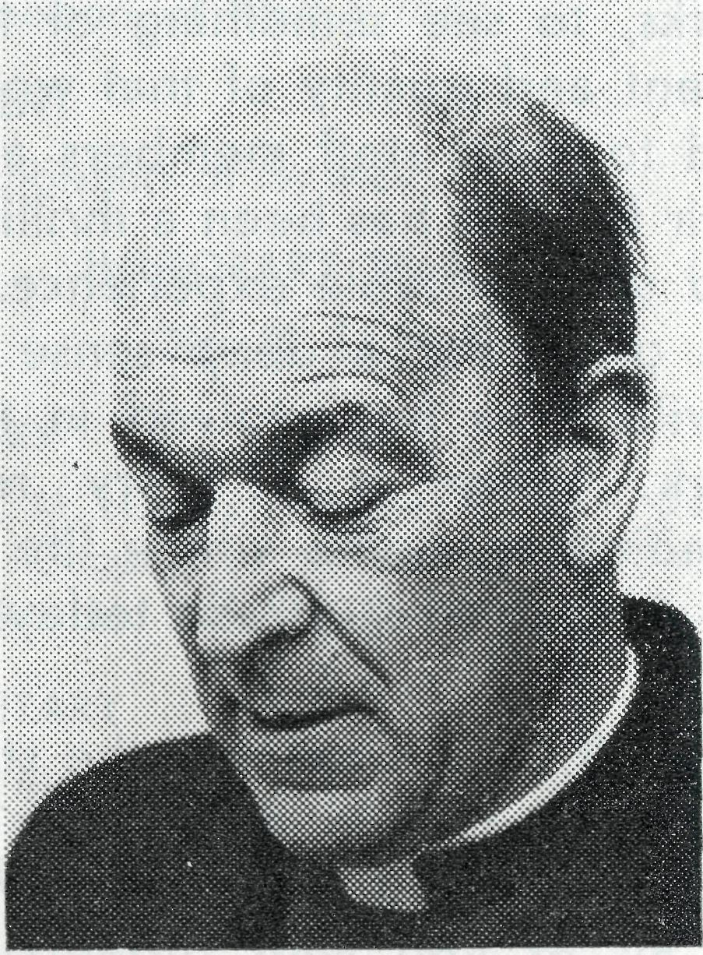

mean to me and the clergy whom the Society maintains in the north west. Two of them for example live in modern company towns; another will move in time to a town built around secret technological equipment; another works in Western Australia's (if not Australia's) fastest growing town; another is ministering to men working on Australia's biggest dam project since the Snowy. Yet every one of them is a bush parson. There are the usual long distances; the sheep and cattle stations; more time away from home than with wife and family.
On Sunday, 25th May, when you in Sydney met for your Jubilee Celebrations in St. Andrew's Cathedral, I and some of my clergy were conducting a mission to Port Hedland. For you it was a Cathedral service. For us mining camps, street corners, the drive-in theatre, public halls. The vast majority of the north west's population, attracted by stories of high wages and overtime, come for what they can get. And they are prepared to go without many things to get what they want. Family life, leisure, comfort, a great number of people will let these go by the board. Even more can do without Sunday services, church buildings, the Word and Sacraments. Yes, they think they can do without Jesus Christ Himself.
We think differently. Hence the Mission.
In many ways my clergy are anachronisms in the north west. Fools for Christ's sake. Men who want to give and serve changing populations of those who come to get. This seems to be the pattern of our ministry. No doubt we will continue to minister to the scientist more frequently than to the shearer; to the geologist as well as to the grazier; certainly to the come-and-go worker as much as to the stick-it-out pastoral ist.
For the bush is changing. But not the Gospel. The old picture of the outback is disappearing. Christ is the same yesterday, today and forever.
In such a situation who can doubt that for the Bush Church Aid Society the best is yet to be?

THE REAL AUSTRALIAN, SEPTEMBER, 1969
THE REAL AUSTRALIAN, SEPTEMBER, 1969

20 Years and Still Going!
The Cross on the Nullarbor

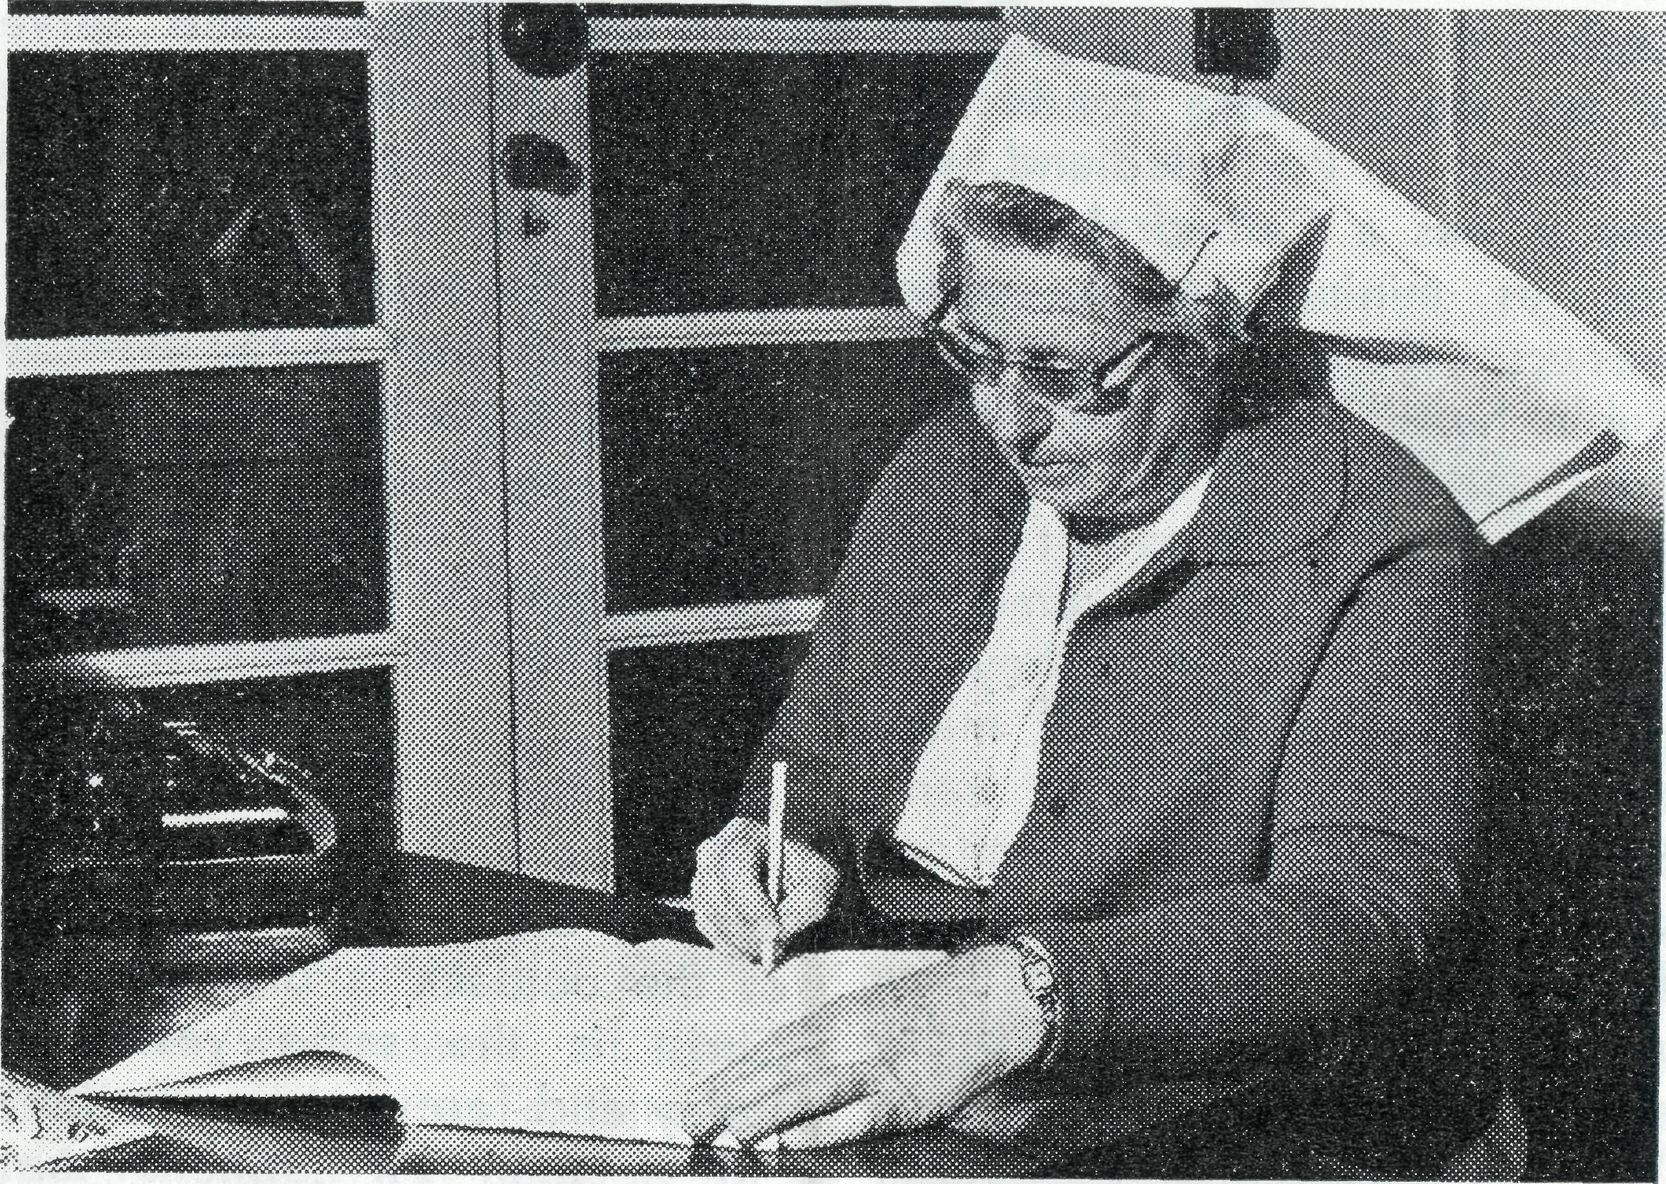
time. There were congratulatory telegrams and letters read out and the traffic manager sent a special representative, Mr. Jack Kinnean, who had been station master at Cook about 18 years ago.
The past and present P.M.G. technicians sent greetings and gifts of a pearl brooch and jewel case. The local people presented her with a suit case and the evening finished with an enjoyable supper. The church service on Sunday was well attended, mainly by Roman Catholics!"
Sister Maude Ross
The fifty year span of B.C.A.'s ministry has been studded with some truly remarkable records of service. Among the longest of these is Sister Maude Ross who in June notched up her twentieth year!
A special celebration was held at Cook Hospital to mark the occasion. Following is an extract from a letter to Head Office. "The evening for Maude's anniversary went off very well. There were more than 30 people packed into the hospital lounge room. Brian Carter came the 250 miles from Tarcoola and organized quite an hilarious
The weary traveller had already driven hundreds of miles along the Eyre Highway from Norseman that day. He was now on the last leg of that day's trip and night had fallen. This part of the Highway is along a beautiful bitumen road of first class standard but he is getting tired. After all, four hundred odd miles is quite a distance in one day. He sees a very faint light a long way ahead and sighs a great sigh of relief for that light means 'food, fuel and accommodation'.
He drives towards that light for over thirty minutes and it seems as though he will never reach that haven. Then suddenly, he is flying up the Pass and discovers to his amazement that the light toward which he has been driving is a floodlit Cross!
The Manager of the Motel at Eucla has erected this cross as a witness to the constant stream of travellers across the Nulla-bor. Steve Patupis knows what it is like to drive a lumbering semi across the Plain for he did it often years ago but now with his wife, manages the Motel.
On the Eastern side of Eucla, the cross can be seen for twenty
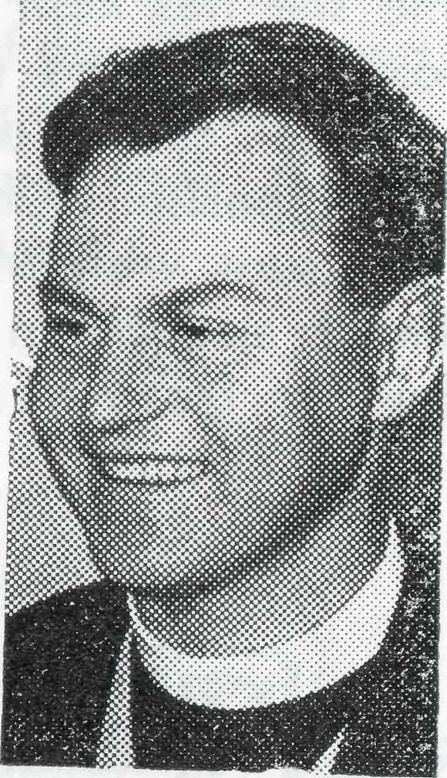
The Rev. Blair Grace
miles and is at the end of over two hundred miles of very rough road.
Every two months, a service is held at the Motel when over a dozen people gather to worship God and to hear His word. The service is held in one of the Mote! units and because of this, that particular unit (No. 1) is called the 'The Church at Eucla'. Steve gives his staff time off to attend the service which has to be held between the times that the tourist buses arrive.
The Cross on the Nullarbor! Visible during the day but showing light and giving guidance to weary travellers at night. What a parable!

THE REAL AUSTRALIAN, SEPTEMBER, 1969
THE REAL AUSTRALIAN, SEPTEMBER, 1969

• It is not only staff members who have long terms of service. Mrs. L. Nash has been the B.C.A. box secretary at All Saints', Cammeray for 31 years. During that time she has kept in touch with Box holders and generally fostered the cause of B.C.A. within the parish. All readers will I am sure wish Mrs. Nash good health and join in thanking God for her many years' work
• After being vacant since the beginning of the year an appointment has been made to the Murchison in North West Australia. The new rector is the Rev. Bill Smith at present rector of Dongara, W.A. Mr. Smith is a New Zealander and before coming to Australia was closely involved in Christian youth work, particularly with the C.M.S. League of Youth. He was a farmer before ordination, and holds a commercial pilot's licence. His wife, Margaret, is a Bachelor of Horticultural Science. The Smiths follow the Rev. Bernard and Coralie Buckland now in Derby.
for the Society.
This is a good opportunity to draw attention to the contribution made by the Box Secretaries throughout Australia. Theirs is a vital role in the outreach of the Society. Their job in maintaining supporter interest on the parish level needs real dedication. Please pray regularly for the sec. in your parish.
• The Rev. Brian Viney is to make an occasional trip from Mullewa to Perth to represent the Society on deputation. We are grateful for the co-operation of the Rev. Cyril Manuel of the Anglican Missionary Council in arranging these deputations.
• The Bishop of Willochra and former Organising Missioner of B.C.A., the Rt. Rev. T. E. Jones, has announced that he will retire at the end of August. Society supporters join with the people of Willochra in wshing the Bishop and Mrs. Jones God's blessing.
THE REAL AUSTRALIAN, SEPTEMBER, 1969
The Place of Prayer
THE B.C.A. PRAYER
O Lord our God, make us ever mindful of those who live in the remote parts of our land. Bless, we beseech Thee, all those whom Thou hast drawn into the fellowship of the Bush Church Aid Society. Grant that, through the ministry of the Word and Sacraments, through healing, and through caring and instruction of the young, the message of Thy redeeming love may thus be proclaimed, through Jesus Christ our Lord. Amen.
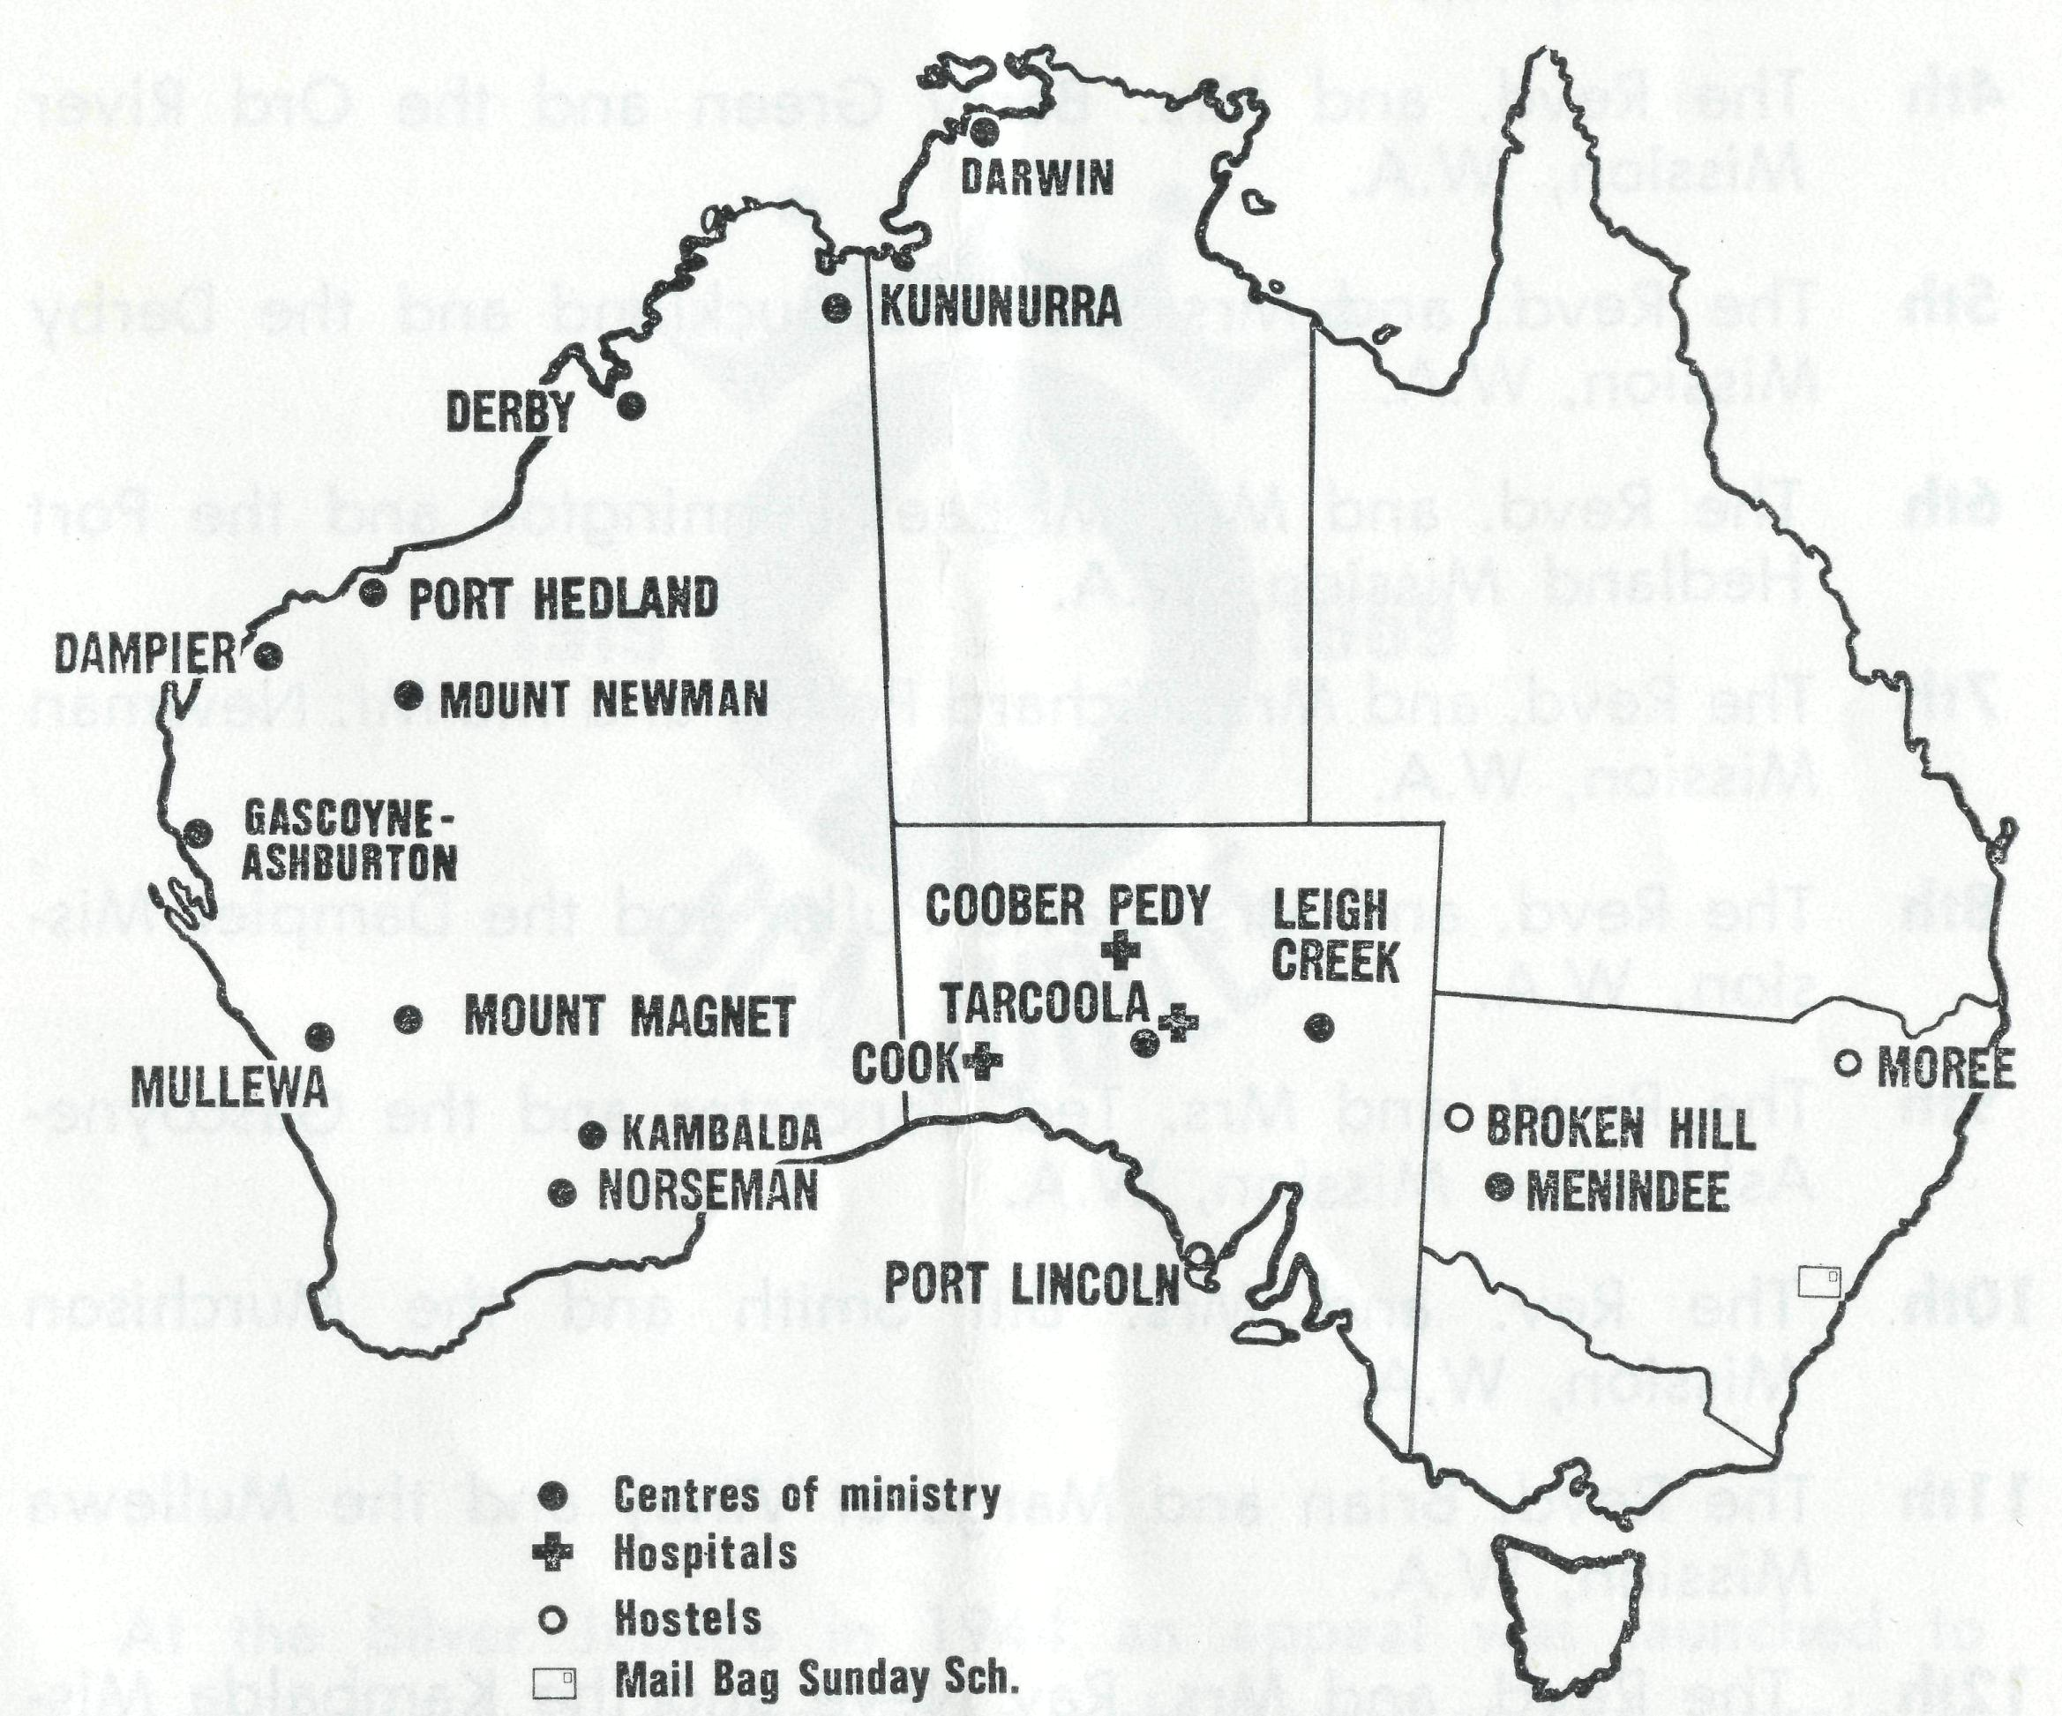
A DAILY PRAYER
O God, we remember before Thee those whom Thou hast called to Thy service. Bless them this day, we beseech Thee, as we
pray for Call forth others
to stand with them in their task. Grant them, as to us, the joy of service, the ability to achieve and the serenity of Thy peace, for Jesus' sake.
Amen.
THE REAL AUSTRALIAN, SEPTEMBER, 1969

THE PLACE OF PRAYER
1st In this Jubilee Year give thanks for the blessings received over the past 50 years. Pray for further opportunities of service.
2nd Mr. Laurie Calder, Miss Barbara Hyett and all the helpers and scholars in the Mail Bag Sunday School.
3rd The Revd. and Mrs. Alan Baker and the Nightcliff Mission, NT.
4th The Revd. and Mrs. Barry Green and the Ord River Mission, W.A.
5th The Revd. and Mrs. Bernard Buckland and the Derby Mission, W.A.
6th The Revd. and Mrs. Michael Pennington and the Port Hedland Mission, W.A.
7th The Revd. and Mrs. Richard Pether and the Mt. Newman Mission, W.A.
8th The Revd. and Mrs. David Pullar and the Dampier Mission, W.A.
9th The Revd. and Mrs. Ted Doncaster and the Gascoyne-Ashburton Mission, W.A.
10th The Rev. and Mrs. Bill Smith and the Murchison Mission, W.A.
11th The Revd. Brian and Margaret Viney and the Mullewa Mission, W.A.
12th The Revd. and Mrs. Ray Neve and the Kambalda Mission, W.A.
13th The Revd. and Mrs. Blair Grace and the Norseman Mission, W.A,
14th Sisters Lola Higgs and Maude Ross at Cook Hospital, S.A.
15th The Revd. and Mrs. Brian Carter and the Leigh Creek Mission, S.A.
8 THE REAL AUSTRALIAN, SEPTEMBER, 1969
JUBILEE RECTORY APPEAL
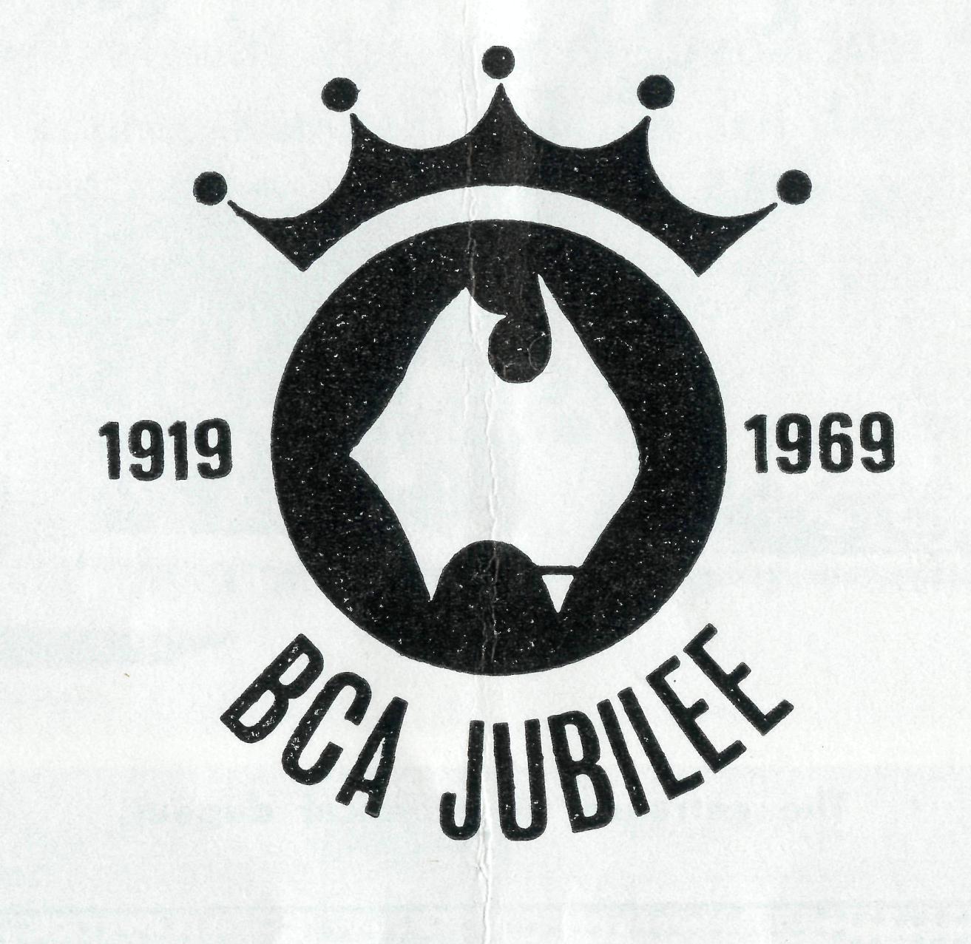
At the Silver Jubilee in 1944 an appeal was launched to purchase property and establish a girls' hostel at Port Lincoln in S.A.
As an expression of thanks to God for the blessings received over the last fifty years a special Jubilee Appeal is being made. The object of the appeal is to finance the building of rectories at Coober Pedy, Kambalda and Mt. Newman. We trust that this appeal will receive your full support.
THE REAL AUSTRALIAN, SEPTEMBER, 1969 9

1. COOBER PEDY
Diocese of Willochra Approximate cost — $10,000
This will be a dug-out, as are the majority of homes in Coober Pedy.
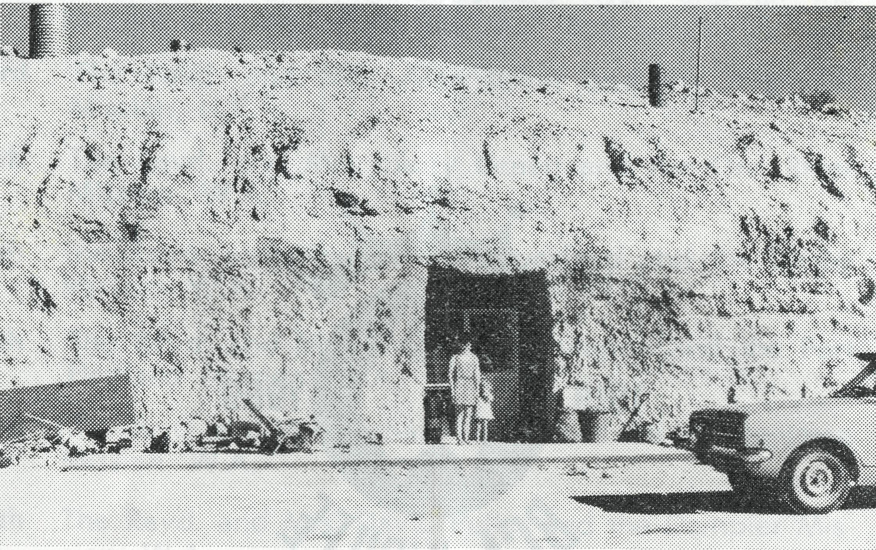
2. K AM BALD A
Diocese of Kalgoorlie Cost — $20,000
2 years ago the nickel mining town of Kambalda didn't exist. Now it is a bustling town of 3,000 people and growing by half a dozen families each week. The Diocese is quite unable to raise the money necessary to build a Rectory so B.C.A. has negotiated a loan on their behalf. This must be repaid at $1,040 a year. Eventually, of course, Kambalda will be self-supporting but it will be some years before they are able to make any significant contribution even towards the repayment of the Rectory loan.
The Revd. Ray Neve, one of the most experienced clergy with B.C.A., has only been at work in Kambalda since early this year but has already been able to build up a worshipping nucleus.

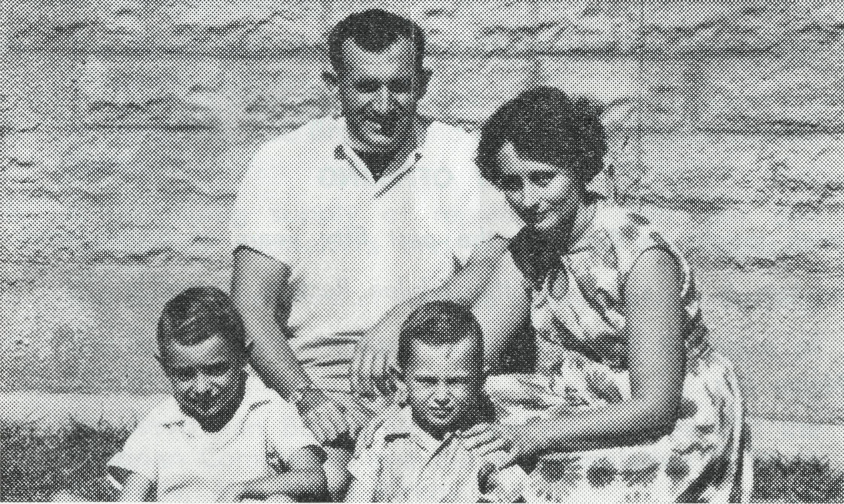
The entrance to a typical dugout.
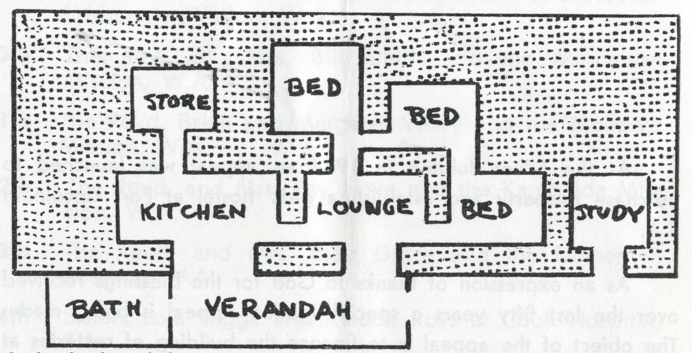
A sketch plan of the proposed Rectory. All detail such as doors and windows
has been omitted from the sketch. The shaded area shows the hill from which
the rooms are dug.
The Revd. Ray and Mary Neve with Andrew and David.

10
THE REAL AUSTRALIAN, SEPTEMBER, 1969
THE REAL AUSTRALIAN, SEPTEMBER, 1969

3. MOUNT NEWMAN
Diocese of N.W. Ausf. Cost — $20,000
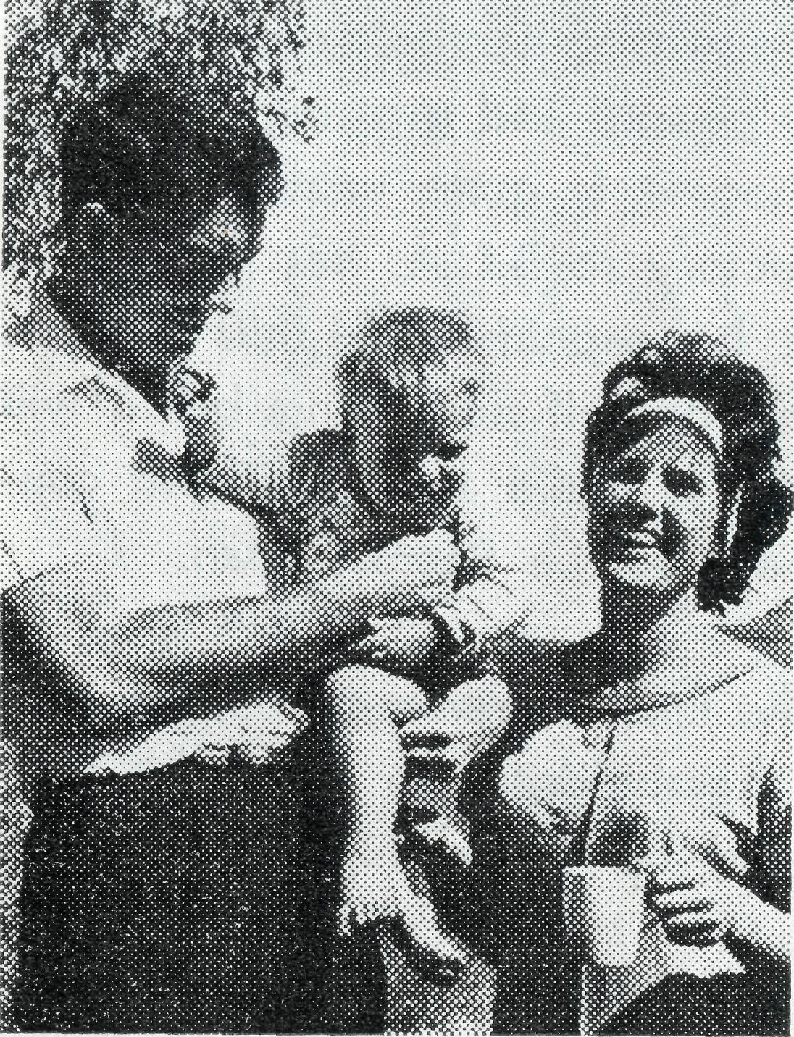
After prolonged negotiations the Diocese has been able to raise the necessary finance but is relying on Society help to meet the repayments of $1,040 per year. As no Rectory has been available the Revd. Richard Pether has been working as a storeman in order to be eligible for a company house.
The Revd. Richard Pether with Ann and Ashley.
Detach here
MY OFFERING
With thanks to God for the past fifty years of B.C.A. work I
enclose $ for the Jubilee Rectory Appeal.
Miss
Name Mrs
Mr. Rev.
Address
Postcode
A DAILY PRAYER CALENDAR
16th The need for staff at the Tarcoola Hospital, S.A.
17th The selection of the right man to minister in the new Coober Pedy Mission.
18th The "Jubilee Rectory Appeal" for the provision of rectories at Mt. Newman, Kambalda and Coober Pedy.
19th The re-organisation of the Head Office following Mr. Hummerston's appointment to N.W. Australia in December.
20th Mr. and Mrs. Graham Mantle and the girls at Port Lincoln Hostel, S.A.
21st Sisters Pat Darby and Anne Dau at the Coober Pedy Medical Centre, S.A.
22nd Give thanks for the financial help B.C.A. is able to give to Carpentaria College Darwin, the Bishops of Kalgoorlie and Riverina, and the Dioceses of Willochra and Nth. Queensland.
23rd Mr. and Mrs. Ron Hastie and the boys at the Broken Hill Hostel, N.S.W.
24th The Revd. and Mrs. Charlie White and the Menindee-Wilcannia Mission, N.S.W.
25th Mr. and Mrs. Bob Brown, and the boys at Ural lie Hostel Moree, N.S.W.
26th A continuing supply of replacement staff, our Box Secretaries, supporters and friends of the Society.
27th The Revd. Ged Muston and the Council of the Society.
28th The Revd. Barry Huggett and the Public Relations of the Society.
29th The Revd. Ian Booth, Mrs. Winifred Hughes and the Victorian Committee, and our Representative in South Australia, Mr. Alban Kirkby.
30th Mr. Stan Hummerston, Mr. Frank Burner, Mrs. Joy O'Neill, Misses Beverley Tonkies, Rosemary Aston.

12
THE REAL AUSTRALIAN, SEPTEMBER, 1969
THE REAL AUSTRALIAN, SEPTEMBER, 1969
13

Life at its Best
The preceding pages represent a daily prayer calendar which is revised with each issue. We earnestly seek your prayers for the individual members of our staff. We suggest you remove these centre pages from the magazine and keep them for your regular devotional use.
A Testimony
"Before coming to the West, my wife and I had often heard missionaries talk about actually experiencing the prayer support from back home. We had known about this but had not experienced it ourselves and it is a completely different thing. Now we have felt it ourselves and have come to know of a surety that people are praying. It is almost uncanny but out here you just know that you are not alone—that you have behind you not just a society, but a lot of people who are interested in you as a person and interested enough in the spread of the Gospel to pray."
If you would like to share in the prayer ministry, join the B.C.A. Fellowship of Prayer. Details from Head Office.
Further prayer items and information letters are sent at regular intervals to all members of the B.C.A. Fellowship of Prayer.
Membership in the Fellowship is invited from all who are concerned in the prayer support of our work. There is no joining or membership fee, although a badge pin (or brooch) may be purchased for 40c if so desired.
Send your name and address to the N.S.W. or Victorian Secretary and the prayer letter will be forwarded to you.
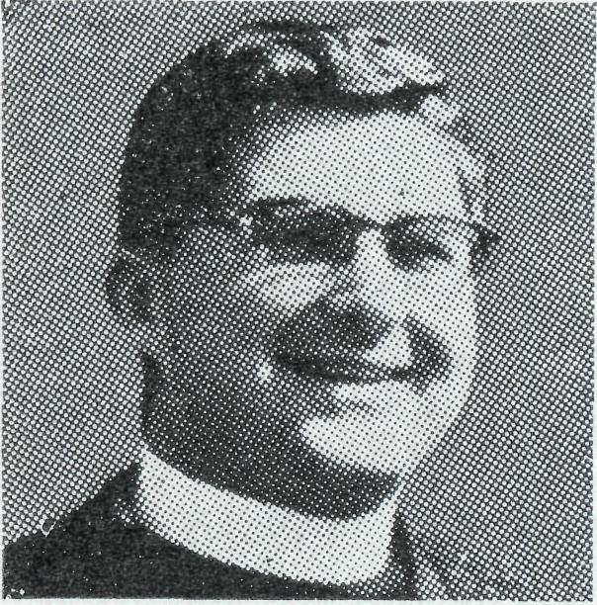
The Revd. Bernard Buckland
350,000 miles would be a fair estimate although of course no B.C.A. clergy keep a really accurate count. Sometimes I count the hours to the next town or station or the minutes to the edge of the bitumen and always the days until I get home again but never the miles. Of course it has taken eleven and a half years less holidays to do that but then you can add train and latterly air miles to the total and say 400,000 miles. Doing what? Ministering the Word and Sacraments to the people of Australia. IVe just today given a young man a booklet "Life at its Best" and surely this is. Here in Derby I live in a comfortable house, eat regularly (IVe put on 22 lbs. in the six months we've lived here), sleep very well and spend half my nights at home. My kiddies go to a school with 22 teachers, there is a hospital with five
doctors on the staff, we have services every Sunday and live in an excellent climate with some of the best scenery I have seen anywhere, even if I look at it as an Australian with pride in my own country. But all this counts for nothing, we were abundantly happy in Franklin Harbour Mission, in Ceduna and I have always looked on the Trans Line as one of the most enjoyable places I have worked in. We loved the Murchison and it was with real heart searching that we left for the Kimberleys. Why then "Life at its Best"? Surely because we know that here is where God wants us to be. He called us into being; through His grace we passed from darkness into light; He ordained me and sent me to these places, and I believe that if we were anywhere else we would be most miserable. Mind you Coralie does hate the cockroaches (I wonder whether that could be printed in that shuddery writing used in children's ghost comics, for that's how Coralie reacts as they troop out of the cupboard looking strong after their feast of Dieldrin), the school isn't all it could be, it does get hot and the cost of living is astronomical. I've been lost, and now after three weeks still bear the marks of blisters

THE REAL AUSTRALIAN, SEPTEMBER, 1969
THE REAL AUSTRALIAN, SEPTEMBER, 1969

gained after a day (literally) in a dry creek bed, and then the long walk when finally I abandoned the car in another creek. There were only five at 7 o'clock Communion but a young man who says he's an atheist came in for a cup of tea after people had gone home from Evensong.
This, of course, is the general pattern of our ministry, it's an ordinary parish, the problems are distance and lack of a nucleus to start things. The youth club has failed, we'll start again in a few months time on a different line; but the Bible study has twelve coming regularly on Monday nights. We have it from home to home, not all the hosts come to public worship, perhaps hearing the Word at home they may believe and be saved. Visiting a station the other week, having managed to get through a few creeks (still running after the wet and surprisingly cold as I waded them to test the depth and bottom), I found an old man who thirty years ago was in charge of one of the Church's native Missions, but had been forgotten about now on his own property, and he begged me to return soon so that he might attend a Communion service. I visit Cockatoo and Koolan Islands every month. There are a few committed Christian folk and some enquirers
but breaking through to the single men in their "cubes" is rather difficult. But perhaps we've made a start for I almost broke my ankle umpiring a basketball game, and afterwards found men coming up and speaking (about basketball!) and calling me by my Christian name. Perhaps I'll be able to speak about the One whose Name I am called to proclaim.
The parish paper went out this week ($5 will buy you a Life Subscription) but it is very difficult keeping the list current in a town where the population moves so quickly that many come and go before I ever meet them. We have people on six months and yearly appointments and no one does more than three years, except a few I meet behind the red iron wall in Broome. This latter is a completely new form of ministry to me — good, well illustrated, almost comic form Christian literature would be of great value in the gaol. But not material you wouldn't like to receive yourself!
I don't know whether this is really an article or a ramble through the parish, but let me conclude with a few practical points. I need good Christian literature, I need finance to be able to print local material, to buy and give books I know are needed. I need three metal suitcases approx. 20 x 20 x 10.

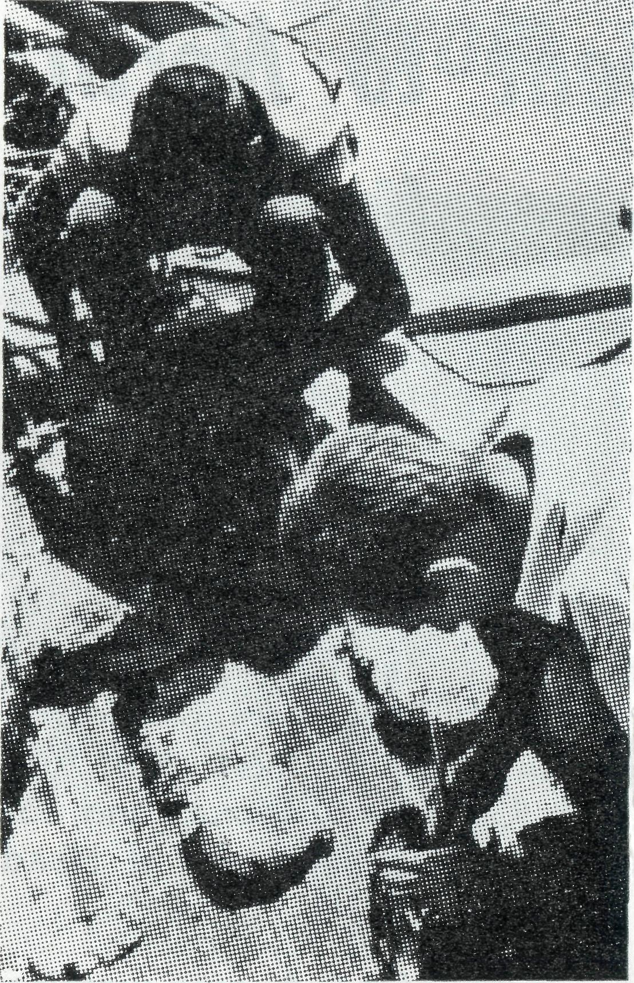
The B.C.A. office has a list of other items that they will gladly pass on to you but the cases are to carry things in. The travelling by car and heavy aircraft knock fibre cases about and what will happen when I spend ten days on a pearling lugger next week I don't know. I didn't tell you about that but the only way to get to Kuri Bay is by boat and the Pearls Ltd. boat will take me there for the first visit of an Anglican clergyman. Above all you can pray for us. It is very easy to get so busy we miss out our prayers, will you pray that we'll slow down enough to do the important things first, that we will be kept faithful in our own personal relations with God. If you would like to know more, or to form a personal link with us here, we would be most happy to hear from you. The office will give you our address.
Seeding oysters—Kuri Bay
Scouting Award
The author of the above article, the Revd. Bernard Buckland, was recently awarded the Medal of Merit for his work in Australian Scouting.
This award is given only to those who have shown outstanding service to the community through the Scouting movement.
Congratulations Bernard!

16
THE REAL AUSTRALIAN, SEPTEMBER, 1969
THE REAL AUSTRALIAN, SEPTEMBER, 1969
17

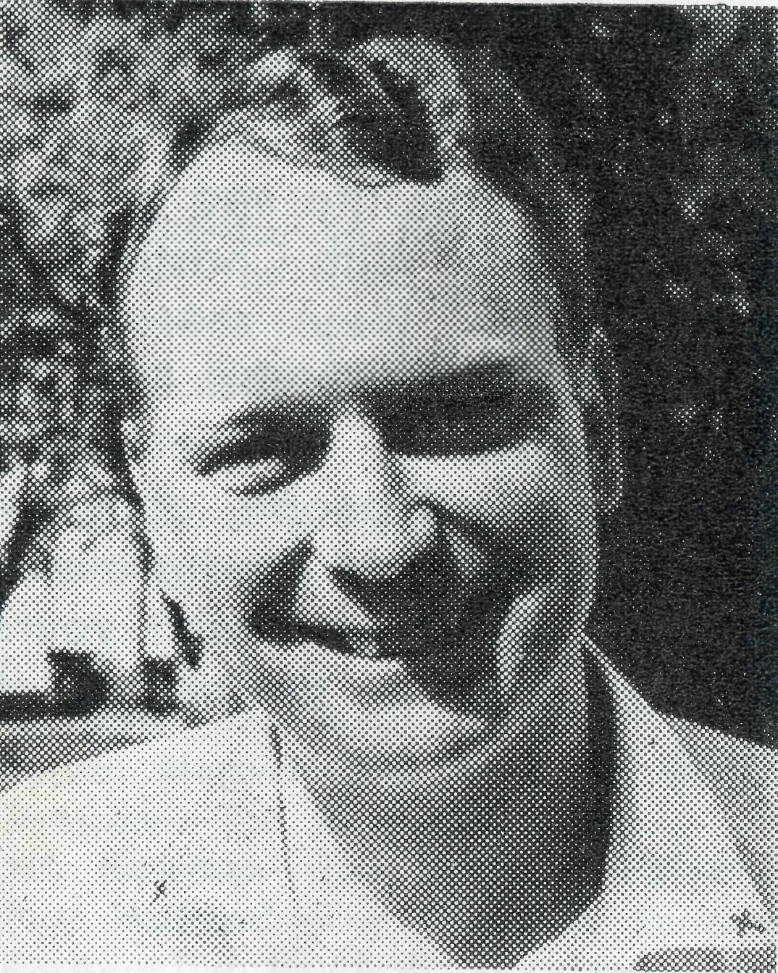
The Revd. Alan Baker
Some months ago I received a letter from a friend asking, "Where on earth is this place called Nightcliff?" His letter made it obvious that he had a mental picture of a place that was isolated and remote. In fact Nightcliff is a northern suburb of Darwin and only seven miles from the centre of the city. Prior to becoming a B.C.A. parish on the 1st January this year it was part of the Parish of Darwin.
As you drive through these northern suburbs, the first thing to catch your eye is the tre-
New Appointment to North West Australia
Mr. Stan Hummerston enters a new phase of his ministry in December. He has been appointed Administrator of the Diocese of N.W. Australia. He will live in Geraldton and will generally manage the business affairs of the Diocese as well as attending to Society matters in the West.
Mr. Hummerston's wide experience within B.C.A. gives him unique qualifications for his new work. With his wife Dorrie, he ran the Port Lincoln Girls' Hostel for six years, he then spent four years as the Executive Officer of the F.M.S. in Ceduna, and for nearly two years has been the Administrative Secretary at Head Office.
This appointment will bring the number of B.C.A. men working in Western Australia to eleven.
Mr. Hummerston is pictured discussing details of his new job with the Bishop of N.W. Australia.
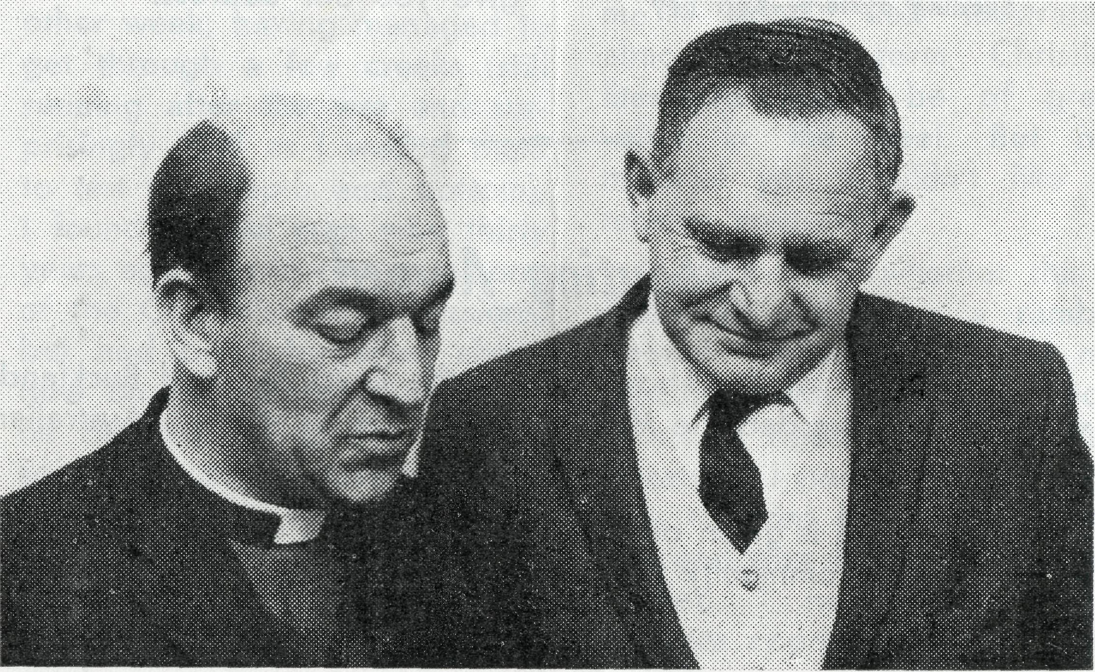
From the Top
mendous development that is taking place. The miles and miles of new homes under construction are a constant reminder that Darwin is Australia's fastest growing city. The annual growth rate in population is more than eleven per cent. Primary schools are being built at the rate of at least one every two years. Although there is only one secondary school in Darwin at present, a second under construction at Nightcliff will be opened at the beginning of the next year. A third is already planned for the new district of Casurina.
As I write this, I can see the painters putting the finishing touches to the new Rectory. Like the majority of homes here it is built on piers — a great advantage when it comes to drying clothes in the wet season. It should be ready for occupation within the next few days and naturally Sally and I are very much looking forward to moving into our new home.
The Parish of Nightcliff, however, extends beyond these fast growing suburbs. Included in the bush area is Batchelor, the town for the Rum Jungle uranium mine. After the drive of sixty

u
THE REAL AUSTRALIAN, SEPTEMBER, 1969
THE REAL AUSTRALIAN, SEPTEMBER, 1969
19

two miles south, as you enter this small town you feel as though you have stumbled upon a beautiful tropical oasis in the midst of the jungle. The homes, all with colourful and well kept gardens make it a most attractive place. Six hundred people live in Batchelor. Many of them are single men employed at the mine which is eight miles from the residential area. Regular services are held in the neat little Church of St. Francis, the only outcentre of the parish.
So far I have said little about the church, the people who seek
to live their faith here. Most of them are from southern states and have moved here to work for a period of two years or longer. They are young, enthusiastic people with a real commitment to Christ our Lord and a concern for the life and witness of His church. With Christians in every place they share the challenge to make the love of God known. In a community where we find people of many cultural and racial backgrounds we join our prayers with yours that we might be the people of God.

Some of the Aboriginal artifacts on sale at the Head Office at 135 Bathurst St.,
Sydney.

THE REAL AUSTRALIAN, SEPTEMBER, 1969
The Bush Church Aid Society
FIELD STAFF:
DIOCESE OF RIVERINA, N.S.W.
Menindee/Wilcannia—The Revd. C. White.
DIOCESE OF WILLOCHRA, S.A. Leigh Creek—The Revd. E. Carnaby. farcoola—The Revd. B. Carter. Quorn—Grant-in-aid. Diocesan Grant-in-aid—Diocese of Willochra, S.A.
DIOCESE OF KALGOORLIE, W.A. Norseman—The Revd. B. Grace. Kambalda—The Revd. R. Neve.
DIOCESE OF NORTH-WEST AUSTRALIA
Mullewa—The Revd. B. Viney.
Mount Magnet—The Revd. W. Smith.
Dampier—The Revd. D. Pullar.
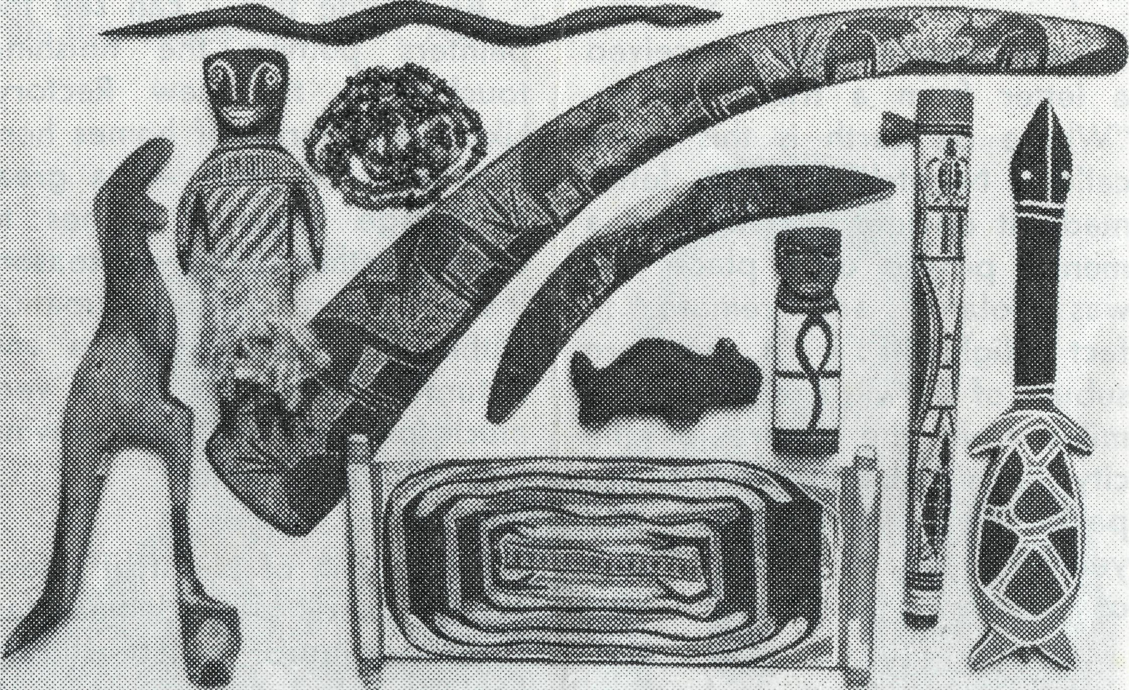
Mt. Newman—The Revd. R. Pether.
Port Hedland—The Revd. AA. Pennington.
Derby—The Revd. B. Buckland.
Kununurra—The Revd. B. Green.
Gascoyne/Ashburton—The Revd. E. Doncaster.
DIOCESE OF NORTH QUEENSLAND
Outer Mt. Isa—Grant-in-aid. Religious Broadcasting—Grant-in-aid.
DIOCESE OF NORTHERN TERRITORY Nightcliff—The Revd. A. Baker. Darwin—Grant-in-aid to Carpentaria College.
MAIL BAG SUNDAY SCHOOL
Director: Mr. W. L. Calcter.
HOSTELS FOR SCHOOL CHILDREN
MOREE, N.S.W. Mr. & Mrs. R. BROWN.
BROKEN HILL, N.S.W. Mr. & Mrs. R. HASTIE.
PORT LINCOLN, S.A. Mr. & Mrs. G. MANTLE.
HOSPITAL CENTRES
COOK, S.A.
Bishop Kirkby Memorial Hospital— Sisters L HIGGS, M. ROSS.
TARCOOLA, S.A.
Tarcoola Hospital—
COOBER PEDY, S.A.
Coober Pedy Medical Centre— Sisters P. DARBY, A. DAU.
THE REAL AUSTRALIAN, SEPTEMBER, 1969

