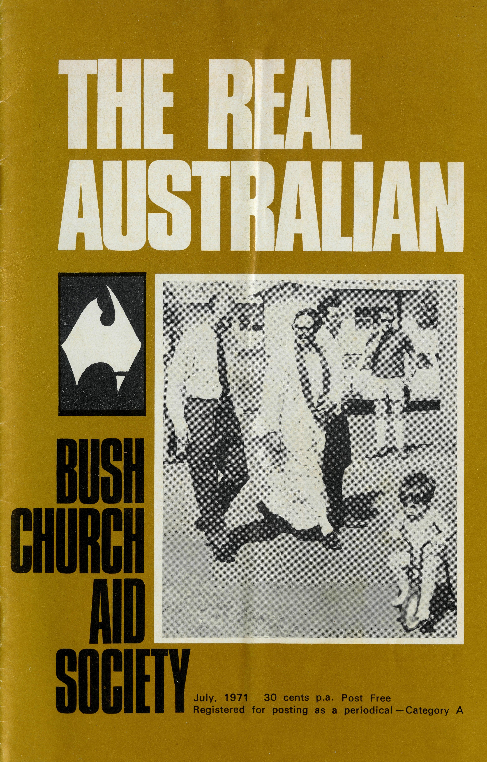
WOMEN'S AUXILIARY *ANNUAL FAIR
Tea and Coffee Bar Hot Luncheon 70 cents
Chapter House
Wed., 21st July 10.30 a.m.
THANKSGIVING SERVICE AND ANNUAL RALLY
FRIDAY, 6TH AUGUST SERVICE RALLY
6.30 p.m. Cathedral
Preacher:
8.00 p.m. Chapter House
Bishop Delbridge The Archbishop of Sydney
Speaker:
POST and RAILS
- At the Annual Meeting on May 13th, it was moved that a letter of congratulations be sent to the Archbishop of Melbourne, the President of the Society, on the occasion of his election to the Primacy. The Archbishop's reply reads, in part: "... I am grateful to the Council and Members for the congratulations and good wishes which you have so kindly sent. My association with the Bush Church Aid Society as its President has meant a great deal to me, and I am very thankful for the support of the prayers of its members which I know I have received, and shall continue to receive."
- The girls at Coober Pedy have been coping with an hepatitis outbreak. They inoculated 1300 people and, at one stage, were averaging 50 injections every 60 minutes. Rumour has it that Anne is now known as "Deadshot Dau".

- After 2i years at Kambalda the Reverend Ray and Mrs. Mary Neve are moving to Norseman in July. The Neves pioneered the work at Kambalda in January, 1969, and have had the great reward of seeing a number of people converted during their time there.
- Ron and Barbara Beard at Exmouth are feeling a lot more comfortable following the installation of an air-conditioner in the new Rectory. This was a gift from the Chapel congregation at Pearce R.A.A.F. base near Perth.
- Everybody has been thrilled with the progress made by Graham Buckland following a serious operation in Perth. We give thanks to God and pray for his continued recovery.

A house with an interior coating of red dust, no bed linen or china, temperature over the century, and a party which included two Bishops and an Archbishop, who were to be our guests for the night, was our introduction to Newman.
The visitors were in Newman in connection with the Archbishop of Sydney's B.C.A. tour, but due to the weather brought about by the latest cyclone, guests and hosts arrived at the Rectory at the same time. In all it was a distinguished party which had to survive a chaotic welcome.
Next day brought us face to face with reality. There were endless boxes and cartons to be unpacked, a house to be cleaned and polished, shopping for the weekend to be done, and preparations for a Church Service on Sunday to be made.
Our two months' stay in Dampier had prepared us for the different style of shopping in a Company town. For those who have two or three supermarkets and a number of other shops to choose from, as we had in Newcastle or Cessnock, it comes as a surprise to know that there is one shop—supermarket, drapers, newsagents, milk bar combined — in which to do all one's shopping. This can be an awfully frustrating business at times. "Sorry luv, we're out of it until the truck comes next week" is of little encouragement to a house-
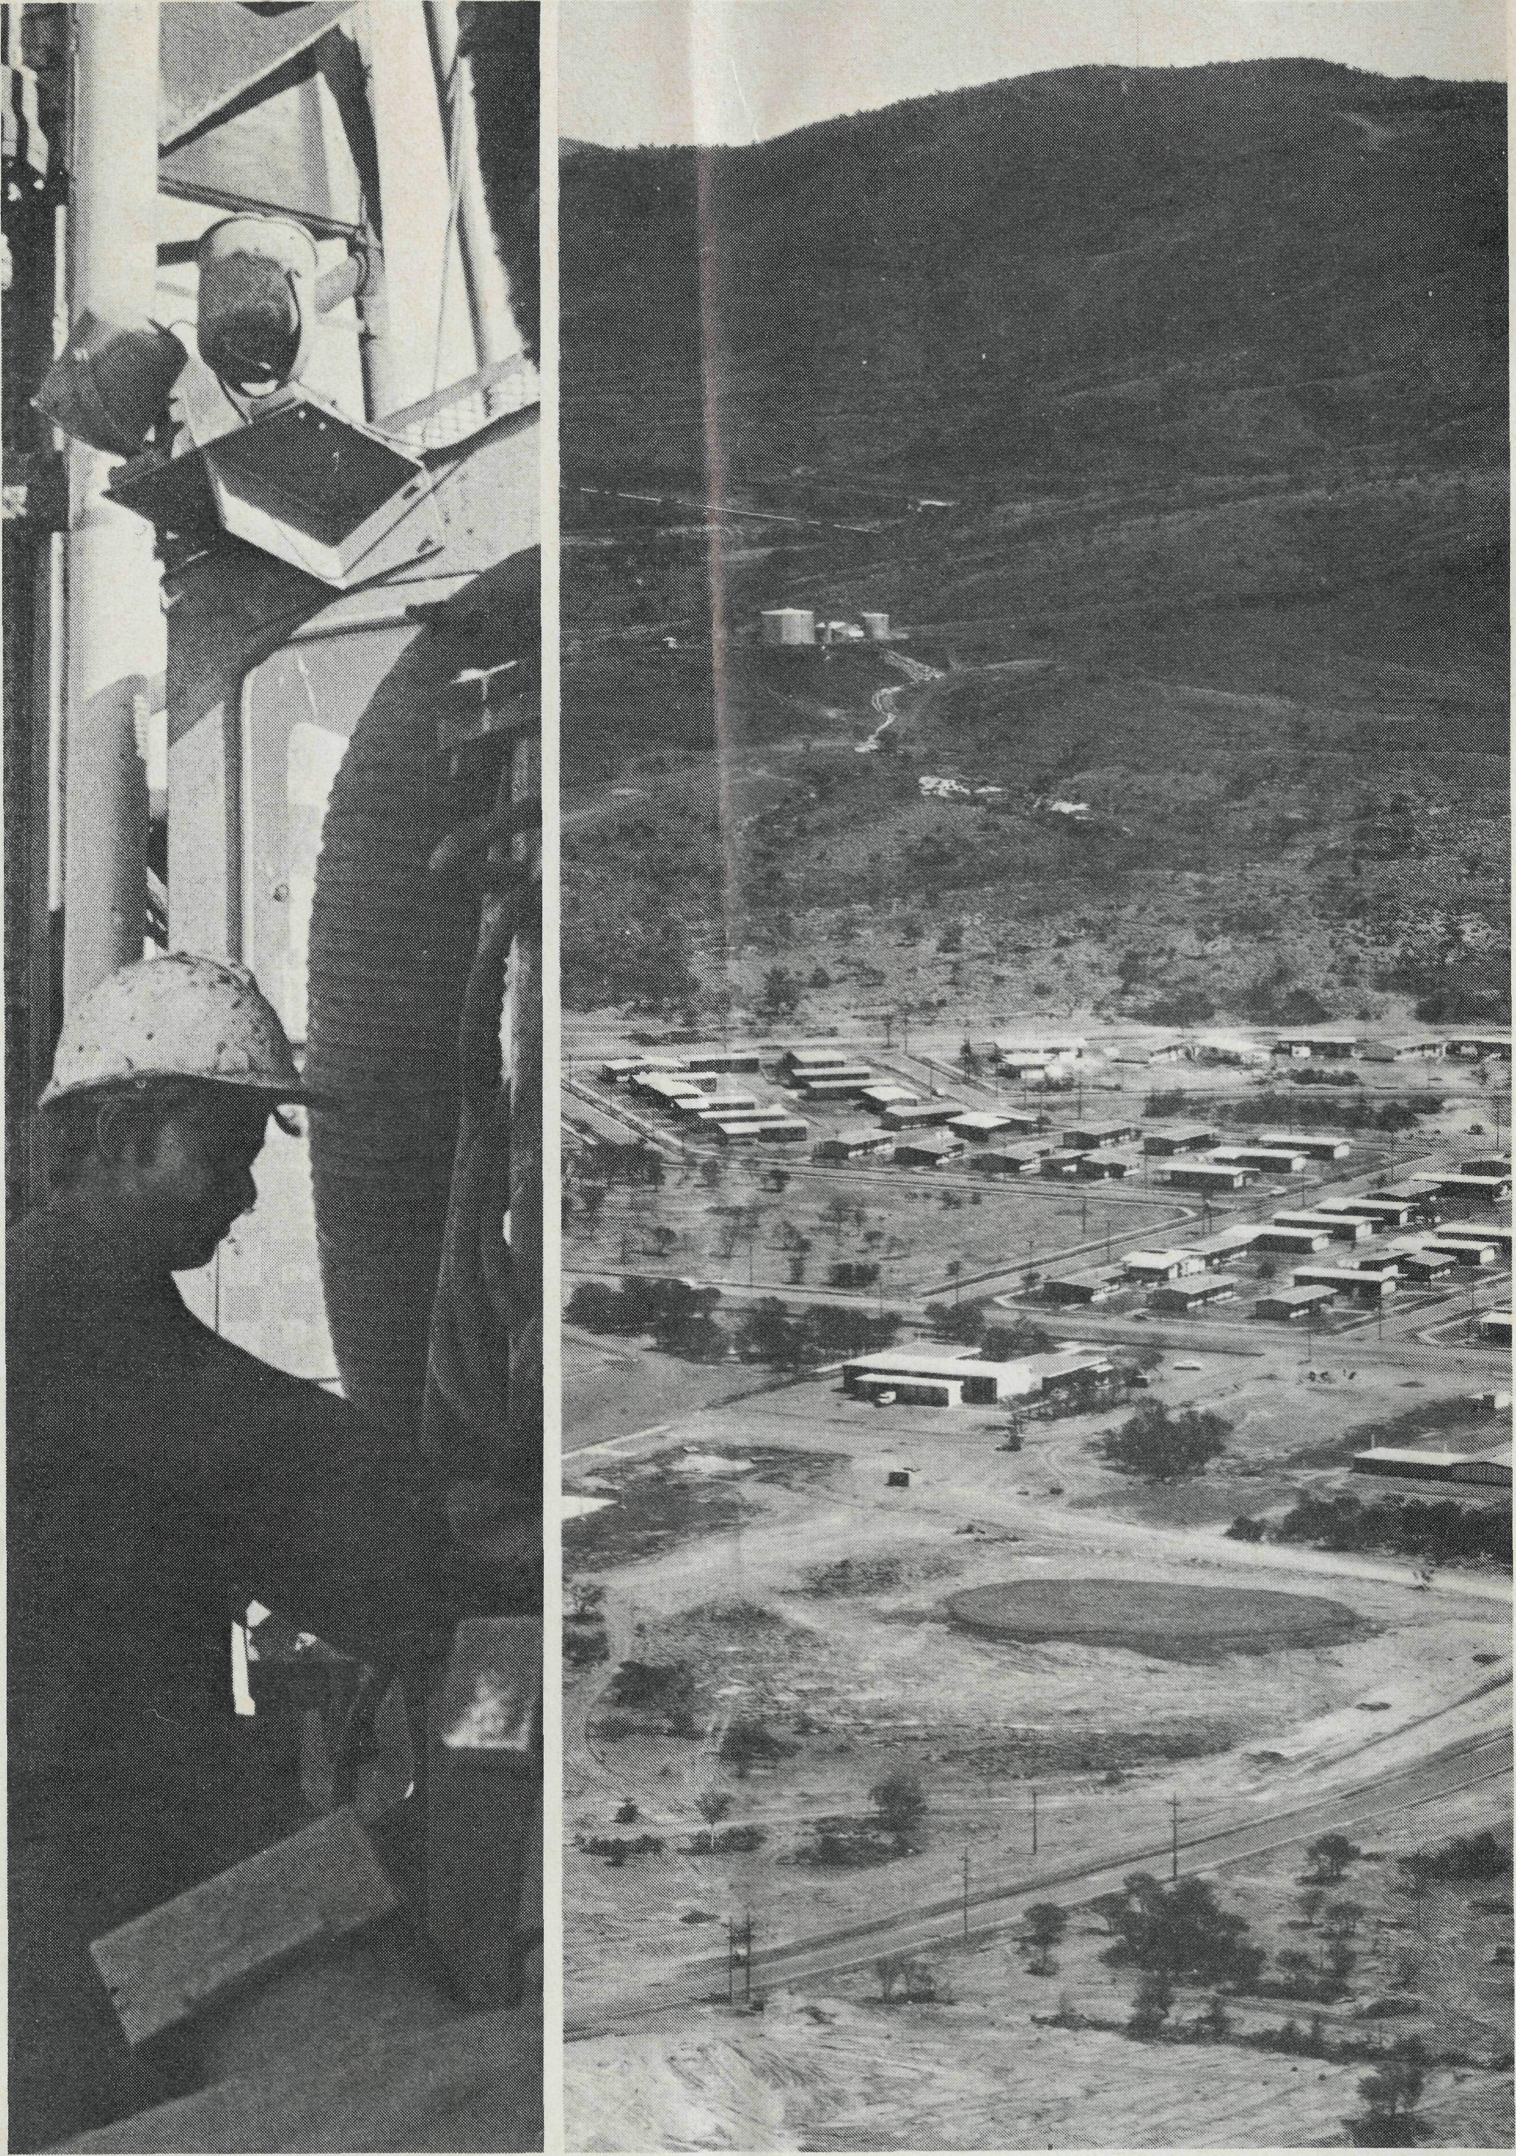
Above left: Driller at Mt. Newman.
Above right: Mt. Newman town with Mt. Whaleback in background.
Cover picture: His Royal Highness, the Duke of Edinburgh at Mt. Newman with the Revd. Ken Hagen.
HOW THE WEST WAS WON!
wife who has a cake nearly finished except for one ingredient.
In no time at all one learns to cope with living in an empty street (because all the houses are new); having no lawn or garden; and facing the limitations of a prosperous suburb that has grown up in the desert. This is the thing which so many people find daunts them at first. They have come, a great many of them, from more densely populated suburbs in the north of England, from Melbourne or Sydney, from Auckland or Wellington, with all the everyday conveniences.
Our Church Service on the first Sunday after our arrival brought home the fact that there was a lot to be done and it had to be done quickly if the Church was to make any impact in the community. Most of the regular worshippers had attended a Service at which the Archbishop preached. They did not attend on the next Sunday. The common answer to my inquiry was that "we only have a Service once a month and that was not the right Sunday!" Thankfully, this has been overcome since then and we now have a faithful band of regular Sunday worshippers.
In the months that have followed our arrival, a few ventures have been undertaken. On the Wednesday evenings of Lent some of the congregation met for Holy Communion and a study group; a Women's Fellowship

began meeting a month or so ago; and a Children's Mission has been held.
The Children's Mission proved to be a popular method of Christian teaching. The week-long course followed the pattern of a well-known series of lessons for Children's Missions entitled "Johnny and the Six Dreadful Giants". Fortunately, among our congregation we have a man who is quite talented as an artist. He produced some eye-catching posters as a way of advertising the Mission. It was fascinating to stand near the supermarket, where the notices were displayed, and hear the comments of passers by. Two ladies said that it was a gimmick to promote a new brand of detergent; another thought it was a travelling theatre group from Perth; whilst yet another lady thought that it was a Pop Group from the Eastern States.
The point of the Mission was to make Christianity exciting for the children and from the looks on their faces as the story continued day by day it achieved just this. Naturally, it was not all fun and games; a teaching lesson followed every story and this was followed up by activities planned to tie in with the Mission.
Because of the continuing need to educate children, during this year at any rate, a Mission in midterm will be followed up by a week-long Vacation School during the term holidays. This will provide the added opportunity to cover much of the Christian faith.
We are looking forward to the rest of this year with some excitement and interest. The town's population will have nearly doubled by the end of the year and further development is planned
for next year. The Community Hall should be finished before the end of 1971. In it is included a Sanctuary and Vestries for Church purposes which will be of tremendous assistance to our increasing congregation, who are finding our present Service venue — the Court House — a bit overcrowded.
With God's help and the prayer support of so many who have shown an interest in the work here, we hope to be able to do a small part of what we believe to be His will here.
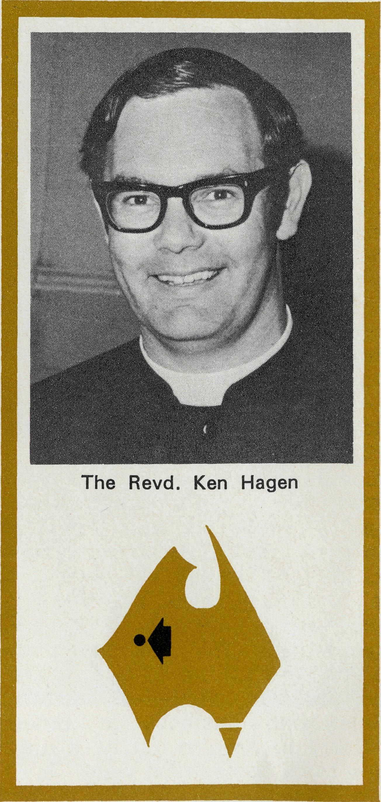
B.C.A. NURSES
ASSIST ANOTHER BUSH HOSPITAL
This month two B.CA. nurses began work at Laverton District Hospital in Poseidon country, 200 miles north of Kalgoorlie.
The staff situation at Laverton has been described by Government authorities as "chronically short" and B.C.A/s offer of help has been warmly accepted.
The two nurses involved are Sister Helen Wright from Chester Hill in Sydney and Sister Audrey Nixon from Carlton in Melbourne.
B.CA. is keen to extend this kind of missionary outreach through Government and the District Hospitals and has a number of contacts where nurses could be placed almost immediately. Nurses interested in this type of work should contact their State Office for further details.
The appointment of Sisters Wright and Nixon follows hard on that of Sisters Brann and Blondel who have already begun work at Derby Hospital in North West Australia.
Sister Helen Wright (below left) was Commissioned by the Revd. Barry Huggett at St. Mark's, Chester Hill. She was presented by Mr. Neville Harris, Mr. Peter Smith and the Revd. Alan Guyer (L. to R. below right).
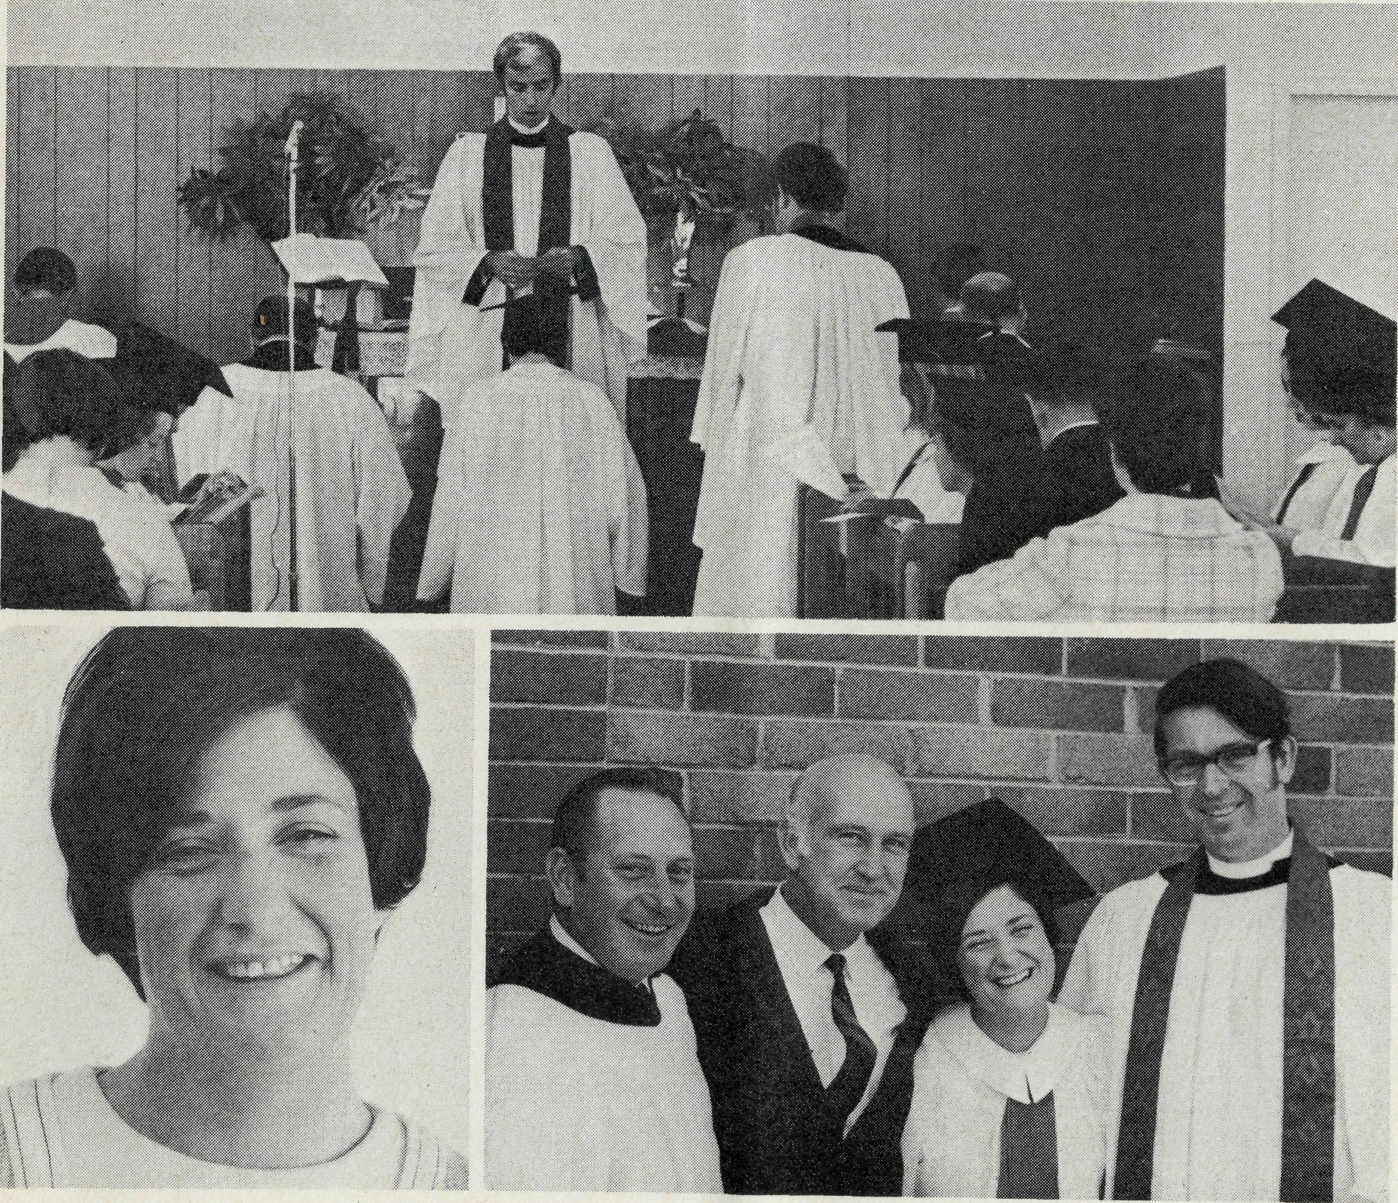

THE REAL AUSTRALIAN

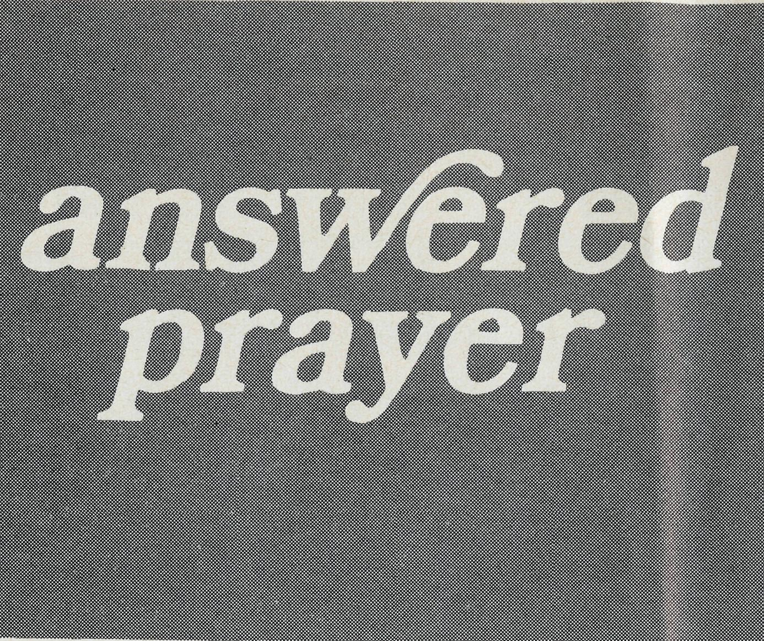
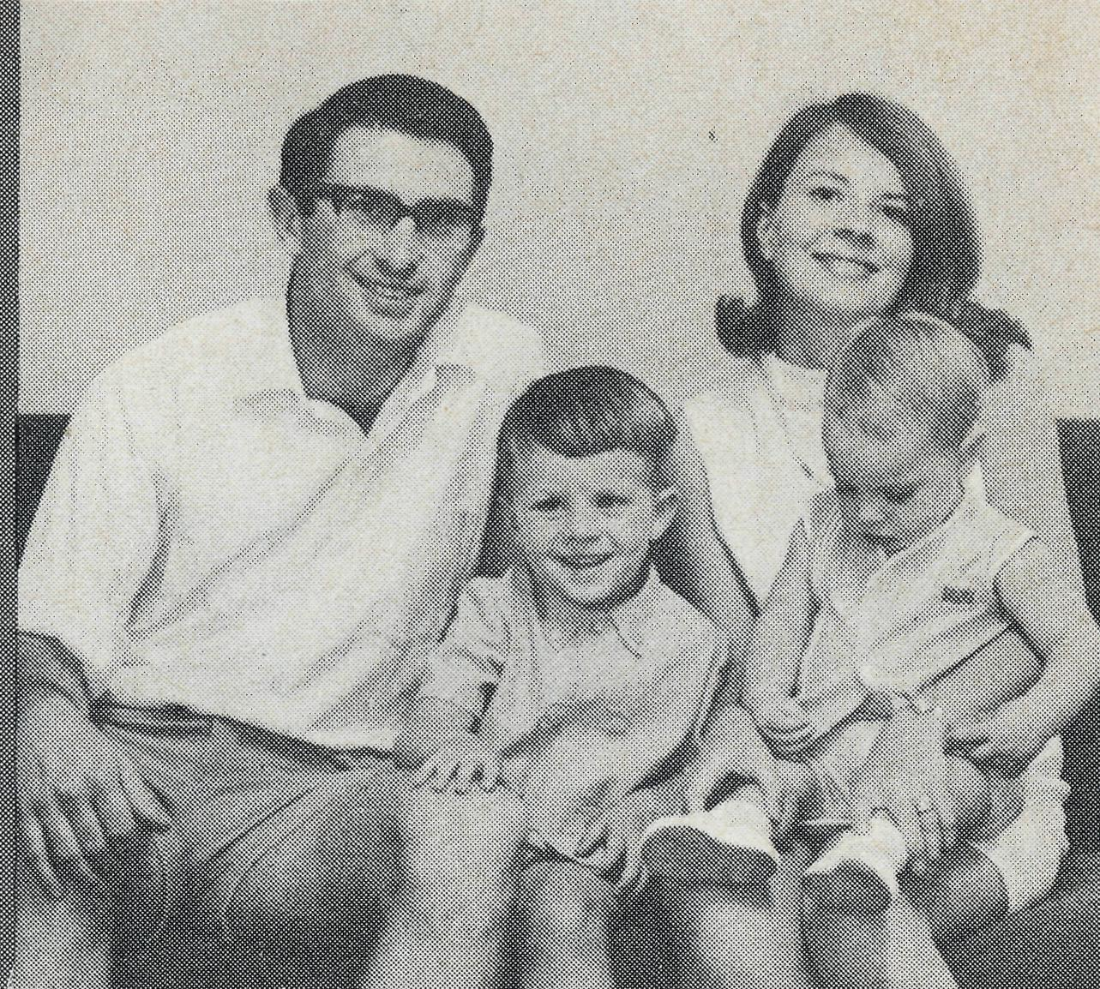
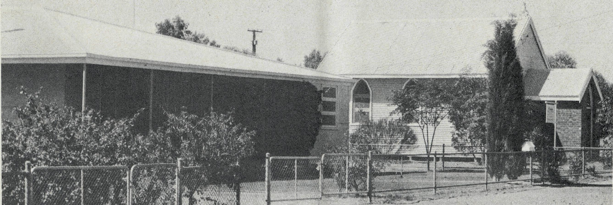
Rectory and Church at Leigh Creek-
One would expect the B.C.A. missioner of the Leigh Creek and Northern Mission (with its area of over 120,000 square miles covering the North Eastern quarter of South Australia) to be a seasoned traveller. That may be so, and I could write of hours behind a steering wheel and trailing a plume of dust across the salt flats and gibber plains of the North. But this year the drought has broken, and rain has turned the desert into a quagmire. So I've stayed put in Leigh Creek, listening to radio reports like: "The Leigh Creek to Marree road is impassable." . . . "The road north from Marree to Oodnadatta is open to four-wheel drive vehicles only." . . . "The Birds-ville Track is expected to be closed indefinitely."
This is not as bad as it sounds. The rain was desperately needed, and is worth staying home for. My wife has been delighted to have a husband around for so long, especially as our third son has just arrived! But also, being in Leigh Creek has given me the time to concentrate on some projects that I mentioned in the February issue of the B.C.A. Fellowship of Prayer Bulletin. If you
The Revd. Brian and Mrs. Carolyn Carter, Michael and Philip.
receive this publication and have been using it, thank you. I would like to tell you what has happened in regard to the things I mentioned, and about which you may have been praying.
- The relation of the Anglican Congregation to the United Congregation has grown stronger. We have worked out a mutually beneficial arrangement of alternating our services, and the way is becoming clear for us to share our resources (e.g., Anglican Congregation has agreed to help in maintaining the United Church halls, which are used for our combined Sunday School).
- The Parish Council has taken
Homestead on the Birdsville Track.
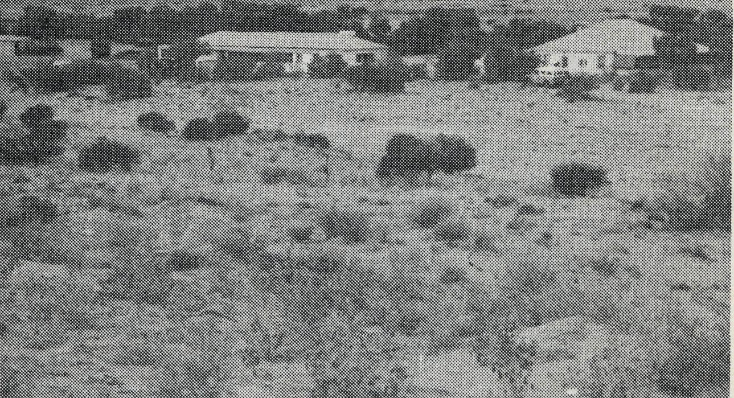
seriously the points raised at the Broken Hill Conference on Stewardship and at the April Vestry Meeting the congregation agreed to do all it could to reduce financial dependence on B.C.A. and the Diocese. Already this year we have started to send some money back to B.C.A. and the Home Mission Fund of the Diocese. 3. (a) The combined Churches' evangelistic visitation of the whole town is almost complete. The three clergy (myself, Methodist minister and R.C. priest) drew up a brief six point statement of Christian belief, and this, together with a T.E.V. Gospel of Luke, is being given to every family and single man in town by six teams of visitors.
- The combined Sunday School has become revitalised. From twenty children and two or three teachers last year it has grown to over sixty children and nearly ten teachers so far this year.
- The Bible Study Group has started and is continuing to meet on a week
night, in spite of the intensive demands of numerous town committees and activities. There has also started up a ladies' group, and even as I sit writing this, exiled away in the office, I can hear the girls going hammer and tongs in the lounge room on Proverbs 31, and how to be a good wife.
- The station trips are, as I said earlier, bogged down so far this year. But there are people out in the isolated homesteads who matter a lot. Most of them welcome a B.C.A. missioner, they enjoy the Bible films, they like to talk, some want their children baptised or to share in the Lord's Supper. I am anxious to get out on the road again.
- It has been good to see the progress here. Those who have shared in this work through the fellowship of prayer have not done so in vain. There is much yet to be done, and many opportunities for the Gospel stand open. The Church of God scattered over the North of South Australia want you to continue to stand with us.

THE REAL AUSTRALIAN

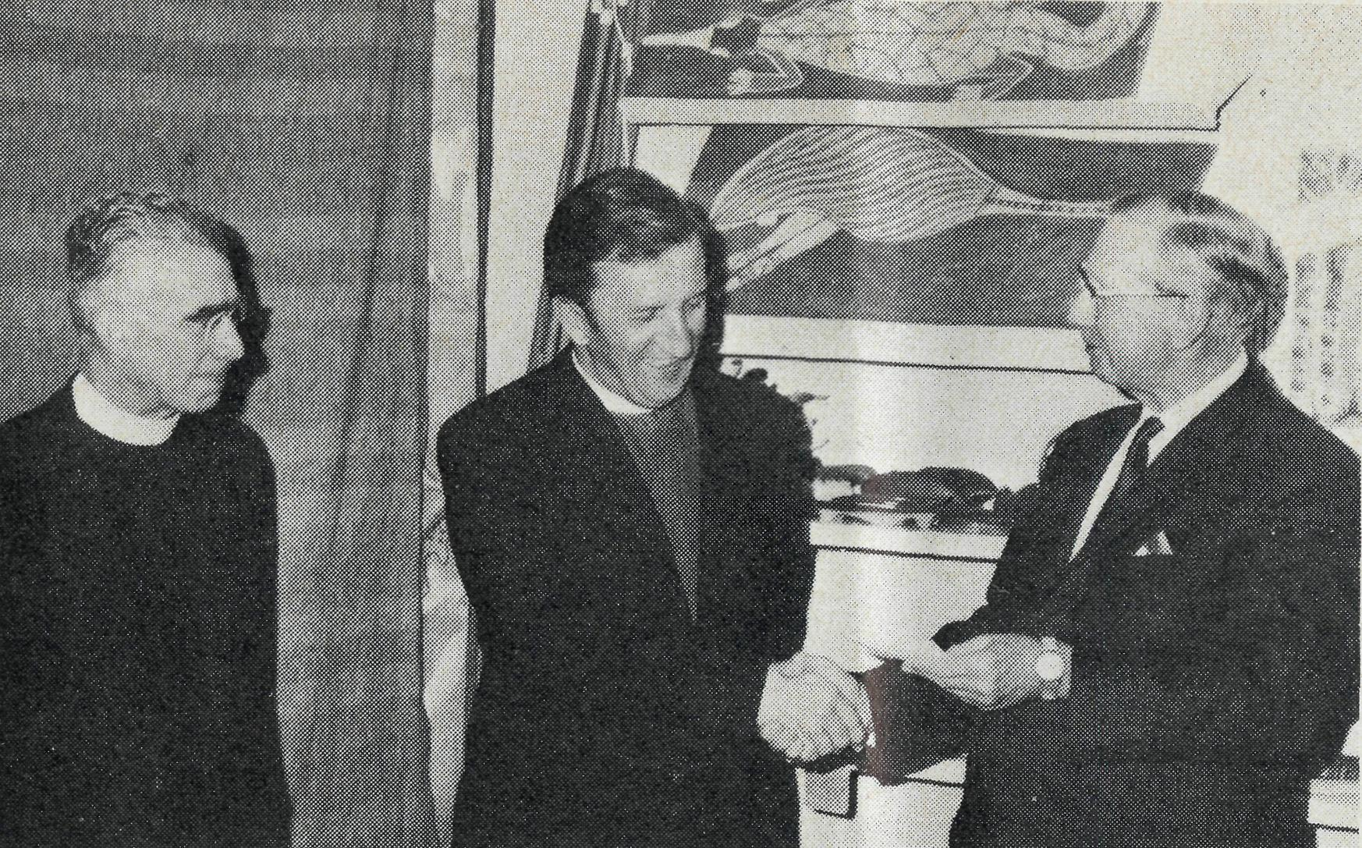
Brian Viney
PERTH
any
new job involves change
Presentation to Bishop Muston...
On 28th April, the retiring Federal Secretary, Bishop Gerald Muston was farewelled at an informal dinner at the Head Office. Mr. FL T. Stokes (right), presented Bishop Muston with a gold watch on behalf of the staff and Council. The Revd. Cliff Baker (left) chaired the evening.
For me the latest changes have been very great. Instead of living in a small town in some remote corner of Australia I find myself living together with my family in what seems to us to be suburban luxury. Instead of the rather public life of the Rectory we are now quietly tucked away in one of Perth's newer suburbs learning how to be parishioners in a parish run by someone else.
For more than twelve years we have been in the frontline of B.C.A. work. The task has been to take the Gospel to people in one remote corner or another. There has been the constant travelling over bush roads where we see more kangaroos than people, the joy of station visiting, the friendly hospitality of folk who are glad you've come. The thrill of ministering to people who themselves have travelled sixty or a hundred miles just to have the opportunity of sharing Christian fellowship, or to attend a worship service. Also the depth of fellowship with your neighbouring clergyman whom you see, perhaps, three times a year and with whom you^ compare notes over numerous cups of coffee until 3 o'clock in the morning.
Now it is different. The task is not so much the direct preaching of the Gospel but making people in the closer settled parts aware of what is going on in the Outback. Sunday by Sunday my task is now to introduce Christians in established parishes to the responsibility of sharing with B.C.A. clergy, nurses and other workers as they seek by word and deed to win Australia for Christ. I look for opportunities to speak to groups large or small. I want to introduce them to our workers, to encourage them to pray and urge them to share in the work financially as God enables them. Perhaps God may challenge some with a call to field service.
For me it is a privilege to have the task of publicising the work in Western Australia. We value your prayers and have been conscious of God's care as we have settled in. Margaret and I want to thank you for your support in the past and we pray that all our activities may be used to the glory of Almighty God.
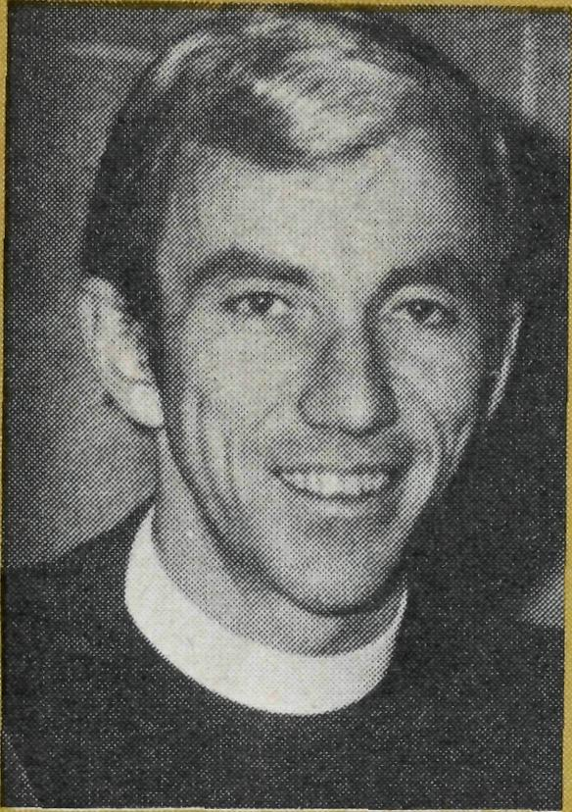
Barry Huggett
N.S.W.
Annual
Rally
August
6th
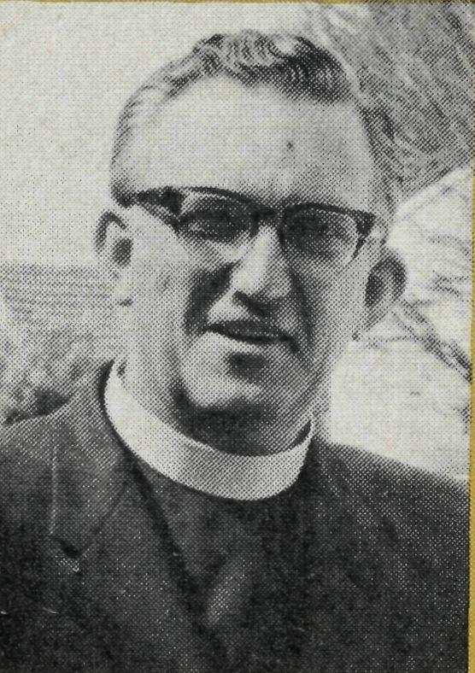
Ian Booth
VICTORIA
north west in the south east
In the absence of a Federal Secretary, not to mention an office girl, life has been a little tense on the administrative side. One of the most important changes necessitated by the appointment of a new Federal Secretary has been the alteration of the Rally date. This has been changed from the usual May date to Friday, August 6th. It is anticipated that the Rally (see back cover) will then provide an opportunity for supporters to meet the new Federal Secretary. People have been making appreciative noises about the Box Secretaries' Bulletin produced by Laurie Calder. We owe a tremendous debt to our Box Secretaries and the Bulletin is an attempt to keep them fully informed of all that is happening within the Society.
The postponement of the Rally has obviously meant the postponement of the associated Rally Appeal. As we normally rely fairly heavily on the infusion of income from the Rally Appeal, finances have been a little strained over the last month or so. Frank Burner, our Accountant, is really looking forward to your ready response to the Appeal!
The shop at 135 Bathurst Street, which normally sells Aboriginal artifacts, now has another string to its bow. One of Barry Rainsford's Parishioners at Coober Pedy is supplying us with some very fine opals in all price ranges. We are retailing these in the shop and they have excited a lot of interest. We have also been fortunate enough to obtain from Alice Springs a number of original water colours painted by the sons of the late Albert Namatjira.
As additional chairs were hurriedly set out to seat people arriving a few minutes before the programme commenced, it became obvious that the 1971 Adelaide Rally was to be a great success.
Nearly 500 people filled Christ Church Hall, North Adelaide, to capacity, on Monday, 19th April, to hear the Bishop of North West Australia, the Right Reverend Howell Witt, speak with pungent humour and dynamic challenge about the task facing the Christian Church in a diocese covering one quarter of Australia.
The Rally gave an opportunity for me to introduce to those present the recently established South Australian Committee of B.C.A. The large crowd was a very encouraging first effort for this committee.
But Adelaide was only the beginning of a wonderful week with Bishop Witt! Wednesday, 21st April, saw over one hundred people enjoying a delicious tea in the Chapter House, Melbourne. The Annual Rally which followed attracted the best attendance for many years. The Cathedral Verger had to hunt for the key to the gallery which had not been used for a long time!
On the Thursday, following tea with the clergy of the Rural Deanery of Geelong, Bishop Witt addressed another B.C.A. Rally in St. Paul's Church, Geelong West. Over to Launceston for the first of two Tasmanian Rallies in St. John's Hall, on Friday, 23rd April. Hobart had its Rally in Holy Trinity Hall on Monday, 3rd May, following the Bishop's leadership of a Mission in the parish of St. Aidan's, Lindis-farne.
In all, Bishop Witt challenged more than two thousand people to involvement in Christian mission in Australia.

THE REAL AUSTRALIAN

What's he gunna do
here?

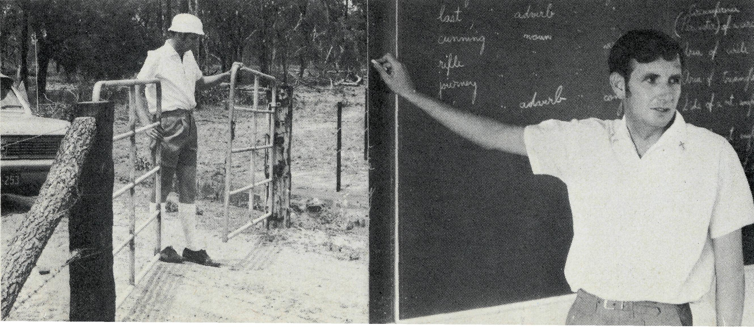
The Revd. Greg Ezzy
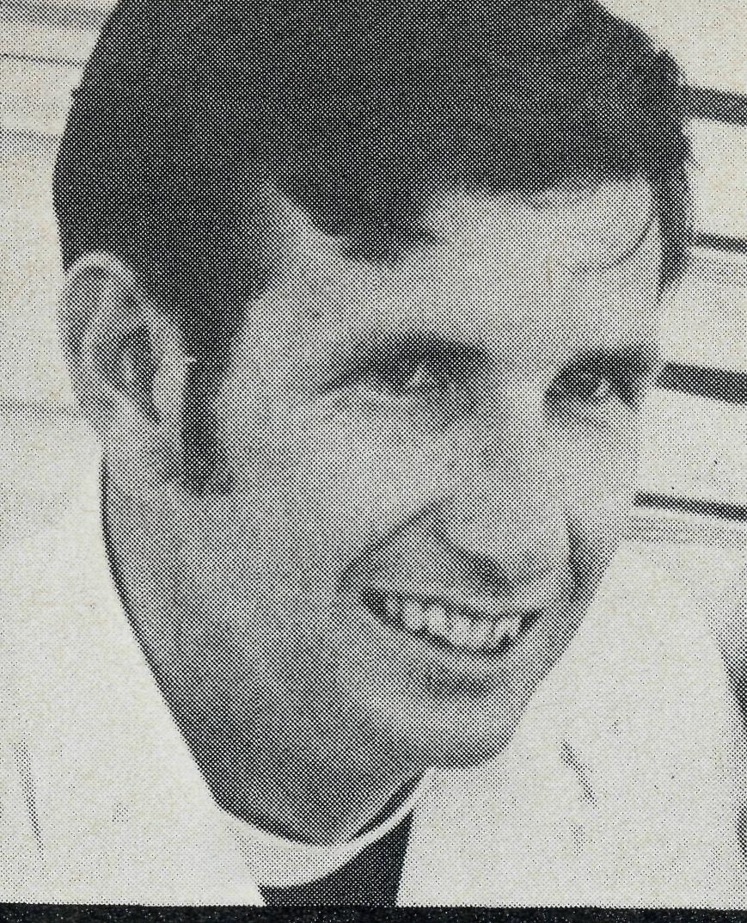
What a history! At first it was an overnight staging camp for bullock teams and coaches, with tales of the gold rush days and bushrangers. Later, a quiet railway siding and small centre for the grazing community. But even before the turn of the century, it boasted a coal mine, the remains of which are still evident. Black-water is certainly an old district. But today, it's as modern and young as tomorrow.
It's almost twelve months since I drove into my first B.C.A. Parish. Today I am still the only resident minister in town. Naturally I found no traditional pattern of ministry to follow, no parish machinery to keep oiled, and no routine of work to fall into. I confess quite honestly, during those initial weeks I spent a deal of time not at all sure just how to launch into this ministry.
On one occasion at that time I overhead a chap say "What's he gunna do here?" For once in my life I decided to be deaf and only wished that I knew how God expected me to participate in His mission, in this young and vibrant community.
Today however, is a different story. Slowly a pattern of ministry is unfolding. In the power of God's Spirit we are coming to
I0
grips with the open door for the Gospel and the building up of Christ's Church. I doubt if any two weeks are the same but let me share with you my schedule for the coming week, as it is before the inevitable changes, brought about by other calls that are made on one's time.
Tomorrow is Sunday. In the footsteps of the early disciples, the faithful people of God will come to the Centre for the breaking of bread and for prayers. I will preach and conduct the Service of Holy Communion. Together we will worship Him and together we will be strengthened by God's Spirit for our service and witness. At the moment a normal size congregation means about 30 adults and 10 children, drawn mainly from the mining community but including several from on the land. Later in the morning it's off to Dingo for a similar Service. It is tremendous to see people enjoying their worship of God. Here the congregation will be about the same size as that at Black-water but almost all will be from the grazing community. With the Service over, the real informality of the country is experienced as all enjoy each other's friendship over a good old Australian cup of tea, which like the wine at Cana, never seems to empty. It's a de
THE REAL AUSTRALIAN
lightful morning!
Back home again and the sun has passed the vertical. Breathing freely now because it should be fairly quiet, but must include a visit to nearby property people — a chance for the boys to go for a drive — and also a visit to a "young family inquiring seriously about the Christian faith.
Even in the bush, administration is time consuming and much of Monday must be spent in the office this week. Some visits to key parishioners will be necessary as well as some running around on behalf of the Kindergarten Association of which I find myself President. No doubt it will be night time before the necessary school work preparation is tackled.
A new day and it is on the road again. This is the Tuesday for my fortnightly Christian Education classes at Emerald High School and visitation of the Emerald Hospital some 50 miles from home. With the morning's work completed, it's time for something to eat normally with one of the Emerald clergy. Good fellowship! Back home there are a reasonable number of urgent visits to be made to parishioners this week and all my visiting time will be spent on these. Tuesday afternoon is marked down as good a time as any to start working through these.
Wednesday is one of the more
Station visiting
regulated days. It's known as the day of the school run. Leaving early, I am accompanied by a Methodist minister from Emerald one week and by a Presbyterian minister the next. Our first school is Duaringa at 9.00 a.m. some 53 miles away. On the homeward run we call at Dingo School and Bluff School arriving back in Blackwater in time for several classes here in the afternoon. Classes are combined to facilitate more effective teaching thus allowing one minister to have the older group while the other takes the younger ones. Christian Education in schools is reasonably well received here and as Bluff and Duaringa have no Sunday Schools, it is the only opportunity for formal instruction in the Christian Faith that the children in these centres receive.
Decisions, decisions, on Wednesday night when our monthly Parish Council Mfeeting is held. Among other matters on the agenda will be our Christian Education programme and modifications to our Centre to iron out several snags that we have encountered. Discussion of finance will as usual be a delicate situation. There is genuine appreciation among the concerned people for the support and fellowship that has come from being associated with the family of B.C.A. This is shown particularly in the desire of the Parish to be
Scripture teaching

able to reduce the Society's financial commitment to the Parish as quickly as possible, in order to allow similar areas to benefit from being a B.CA. Mission District.
Unfortunately, whenever something urgent crops up, it always seems to be visiting time that has to suffer. But all being well, there will be a couple of hours available for visiting on Thursday morning. After lunch, Industrial Chaplaincy is the order of the day. I head out to the Utah Mine and, for a couple of hours, am able to move about the plant amongst the work force meeting both the day and evening shift workers. This is a tremendous opportunity of opening lines of communication with men of differing backgrounds and establishing relationships which one prays might lead one step closer to the discovery of the reality of the living Christ whom we represent.
Friday will be a full day of preparation for Services. Besides the normal Communion Service, this Sunday, there will be the monthly Family Service later in the morning. The latter is proving very worthwhile. We gear the whole Service to the children's level but parents join in as well. It is a real encouragement to families to worship together. Attendances here have risen to 85. Sunday afternoon will see me on
the track for the start of a five-day country trip to the northern sector of the Parish, so on Friday there will be also the need to prepare for property Services. There will be at least one which is planned for Sunday night at Palmalmal.
Friendships are important and we enjoy many at Blackwater. When possible we have friends to dinner on Friday nights or go out to their homes. This week we will be playing host.
Saturday is the day before a country trip so the car must be checked, equipment packed, and loose ends tied up in the Parish to carry it over until I arrive back.
And so on paper one week ends and another starts. "What's he gunna do here?", one man asked. In the words of another "You're wasting your time out here as far as I'm concerned." But I guess Jesus himself knew that many would turn against His message. And our message is no different from His. But we are glad of the many opportunities to exercise a Christian ministry and as one launches out equipped with the Spirit of God, we are confident that He is accomplishing His purposes. It is a joy and it is exciting to be able to co-operate with God and to see His mission continuing in this coal and cattle country. Thank you sincerely for your fellowship and your share in Christ's mission here.
Some of the Blackwater congregation
The B.C.A. Prayer
0 Lord our God, help us to remember those who live in the remote parts of our land. We ask You to bless those whom You have called into the fellowship of The Bush Church Aid Society. Grant that, through the ministry of the Word and Sacraments, through healing, and through caring for the young, the message of Your redeeming love may be proclaimed, through Jesus Christ our Lord. Amen.
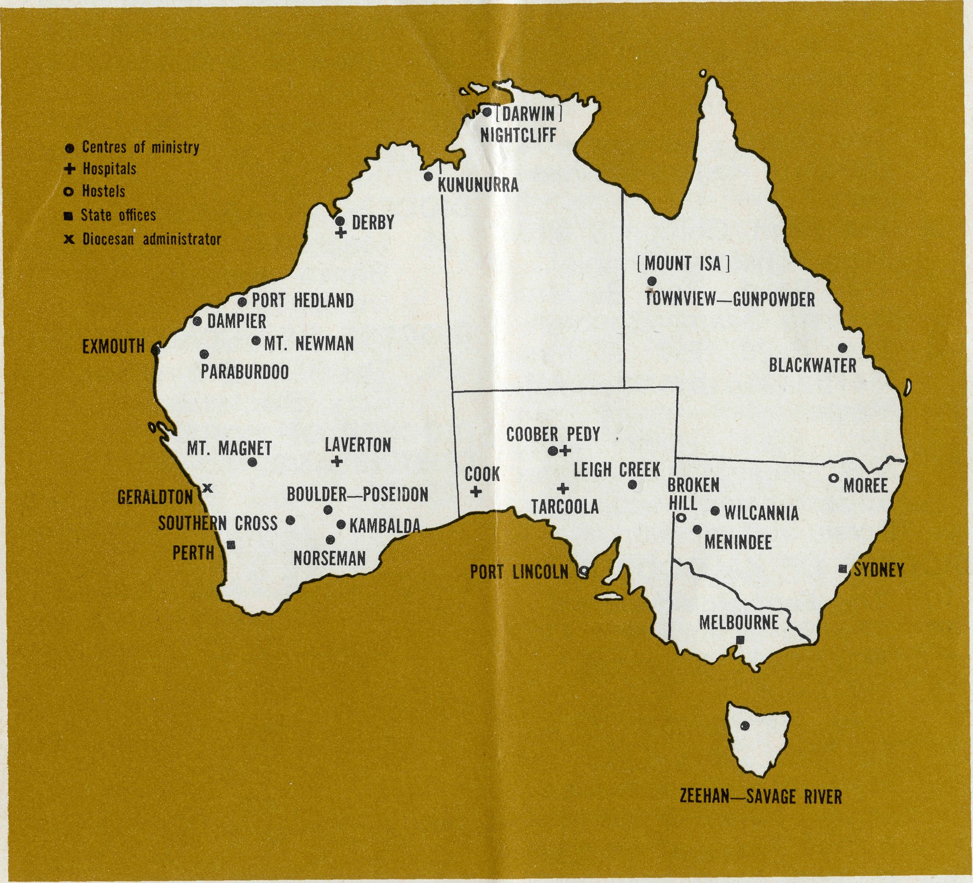

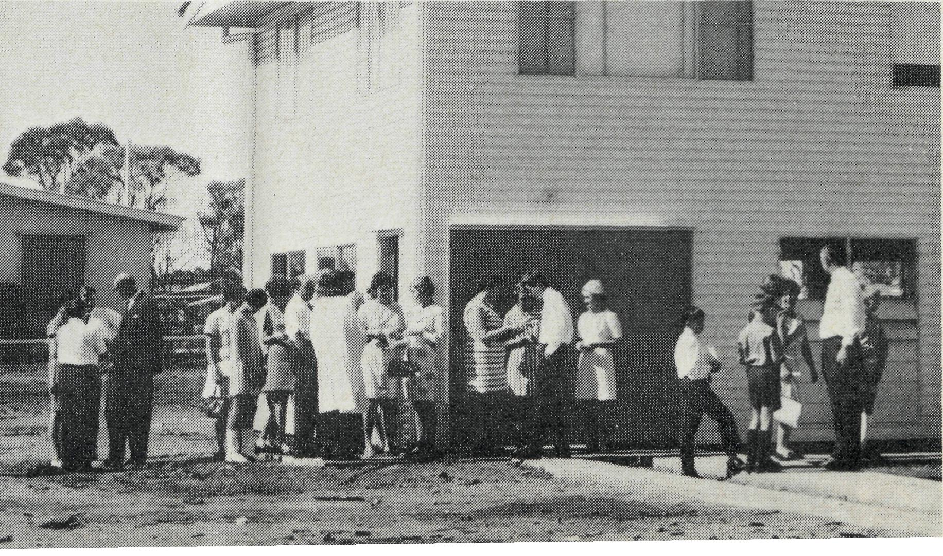
A DAILY PRAYER
O God, we remember before You those whom You have called to
Your service. We ask You to bless , assure them
of Your presence, and call others to stand with them in the task. Grant to them, as to us, the joy of service, the ability to achieve, and the serenity of Your peace, for Jesus' sake. Amen.
13

DIOCESE OF NORTHERN TERRITORY.
1. The Revd. Alan & Mrs.
Philippa Hoskin, Nightcliff.
DIOCESE OF N.W. AUSTRALIA.
- The Revd. Bill & Mrs. Jocelyn Ross, Kununurra.
- The Revd. Bernard & Mrs. Coralie Buckland, Derby. Sisters Joy Brann and Michelle Blondel at Derby Hospital.
- The Revd. Michael & Mrs. Heather Pennington, Port Hedland.
- The Revd. Ken & Mrs. Margaret Hagan, Mt. Newman.
- The Revd. Gordon & Mrs. Jean Williams, Dampier.
- The Revd. Ron & Mrs. Barbara Beard, Exmouth.
- The Revd. Bill & Mrs. Margaret Smith, Mt. Magnet.
- Mr. Stan Hummerston, N.W. Australia Diocesan Administrator, and Mrs. Dorrie Hummerston.
DIOCESE OF KALGOORLIE.
- The Kambalda Mission.
- The Revd. Ray and Mrs. Mary Neve, Norseman.
- The Revd. Ted & Mrs. Sue Doncaster, Southern Cross.
- The Revd. David & Mrs. Joy Pullar, Boulder-Poseidon. Sisters Helen Wright and Audrey Nixon at Laverton Hospital.
DIOCESE OF WILLOCHRA.
- Sisters Ruth Hold & Carol Allen at Cook Hospital.
- Sisters Heather Heaver & Maude Ross at Tarcoola Hospital.
- The Revd. Brian & Mrs. Carolyn Carter, Leigh Creek.

- The Revd. Barry & Mrs. Jenny Rainsford, Coober Pedy.
- Sisters Anne Dau & Shirley Manning at the Coober Pedy Medical Centre.
- Mr. Graham & Mrs. Nancy Mantle and the girls at Port Lincoln Hostel.
DIOCESE OF RIVERINA.
- The Revd. Charlie & Mrs. Wendy White, Menindee.
- The Revd. Eric & Mrs. Joan Baldwin, Wilcannia.
- Mr. Robby & Mrs. Margaret Roberts and the boys at the Broken Hill Hostel.
DIOCESE OF ARMIDALE.
23. Mr. Bob & Mrs. Irene
Brown and the boys at
Urallie Hostel, Moree.
DIOCESE OF ROCKHAMPTON.
24. The Revd. Greg & Mrs. Del
Ezzy, Blackwater.
DIOCESE OF NORTH QUEENSLAND.
25. The Revd. Peter & Mrs.
Fay George, Townview-
Gunpowder.
DIOCESE OF TASMANIA.
26. The Reverend Blair & Mrs.
Lyn Grace, Zeehan-Savage
River.
GENERAL.
- Replacement Staff, Box Secretaries and B.C.A. Supporters.
- Deputation and Public Relations work, Revds. Barry Huggett, Ian Booth, Brian Viney, Mr. Laurie Calder.

- Administrative work, the Federal Secretary, the Council and State Committees.
- Office staff (N.S.W.): Mr. Burner, Miss Smith, Mrs. O'Neill, Mrs. Wills, Mrs. Evans. (Vic): Mrs. Hughes.
WHERE TO FIND THEM
N.S.W. Secretary: The Revd. B. D. Huggett,
B.C.A. House,
135 Bathurst Street,
Sydney, N.S.W. 2000.
263164 263780 Telegraphic Address: "Chaplaincy" Sydney.
Victorian Secretary:
The Revd. I. E. A. Booth,
Morton House,
262 Flinders Lane,
Melbourne, Vic. 3000.
638962
West Australian Secretary: The Revd. B. L. Viney,
Box N1024, G.P.O.,
PERTH, W.A. 6001.
Phone: 25-7455.
Sth. Aust. Representative:
The Revd. E. G. Watkins,
77 Beulah Rd., Norwood, S.A. 5067.
President:
The Most Reverend, the Archbishop of
Melbourne.
Vice-President:
The Most Reverend, the Archbishop of
Sydney.
Chairman of Council: The Rt. Revd. G. R. Delbridge.
Honorary Treasurer: Mr. R. T. Stokes.
FIELD STAFF
DIOCESE OF NORTHERN TERRITORY.
Nightcliff—The Revd. Alan Hoskin.
DIOCESE OF N.W. AUSTRALIA.
Kununurra—The Revd. Bill Ross. Derby—The Revd. Bernard Buckland. Derby Hospital—Sisters Joy Brann
and Michelle Blondel. Port Hedland—The Revd. Michael
Pennington. Mt. Newman—The Revd. Ken Hagan. Dampier—The Revd. Gordon Williams. Gascoyne-Ashburton—The Revd. Ron
Beard. The Murchison (Mt. Magnet)—The
Revd. Bill Smith. Geraldton (Diocesan Administrator)—
Mr. Stan Hummerston.
DIOCESE OF KALGOORLIE.
Kambalda—
Norseman—The Revd. Ray Neve.
Southern Cross — The Revd. Ted
Doncaster. Boylder-Poseidon—The Revd. David
Pullar. Laverton Hospital — Sisters Helen
Wright and Audrey Nixon.
DIOCESE OF WILLOCHRA.
Cook Hospital—Sisters Ruth Hold and
Carol Allen. Tarcoola Hospital — Sisters Heather
Heaver and Maude Ross. Leigh Creek—The Revd. Brian Carter. Coober Pedy — The Revd. Barry
Rainsford. Coober Pedy Hospital—Sisters Anne
Dau and Shirley Manning. Port Lincoln (Girls' Hostel) — Mr.
Graham and Mrs. Nancy Mantle. Melrose-Peterborough—Grant-in-Aid.
DIOCESE OF RIVERINA.
Menindee—The Revd. Charlie White.
Wilcannia—The Revd. Eric Baldwin.
Broken Hill (Boys' Hostel) — Mr.
Robby and Mrs. Margaret Roberts.
DIOCESE OF ARMIDALE.
Moree (Boys' Hostel)—Mr. Bob and Mrs. Irene Brown.
DIOCESE OF ROCKHAMPTON.
Blackwater—The Revd. Greg Ezzy.
DIOCESE OF NORTH QUEENSLAND.
Townview/Gunpowder — The Revd.
Peter George. Religious Broadcasting—Grant-in-Aid.
DIOCESE OF TASMANIA.
Zeehan-Savage River — The Revd. Blair Grace.

