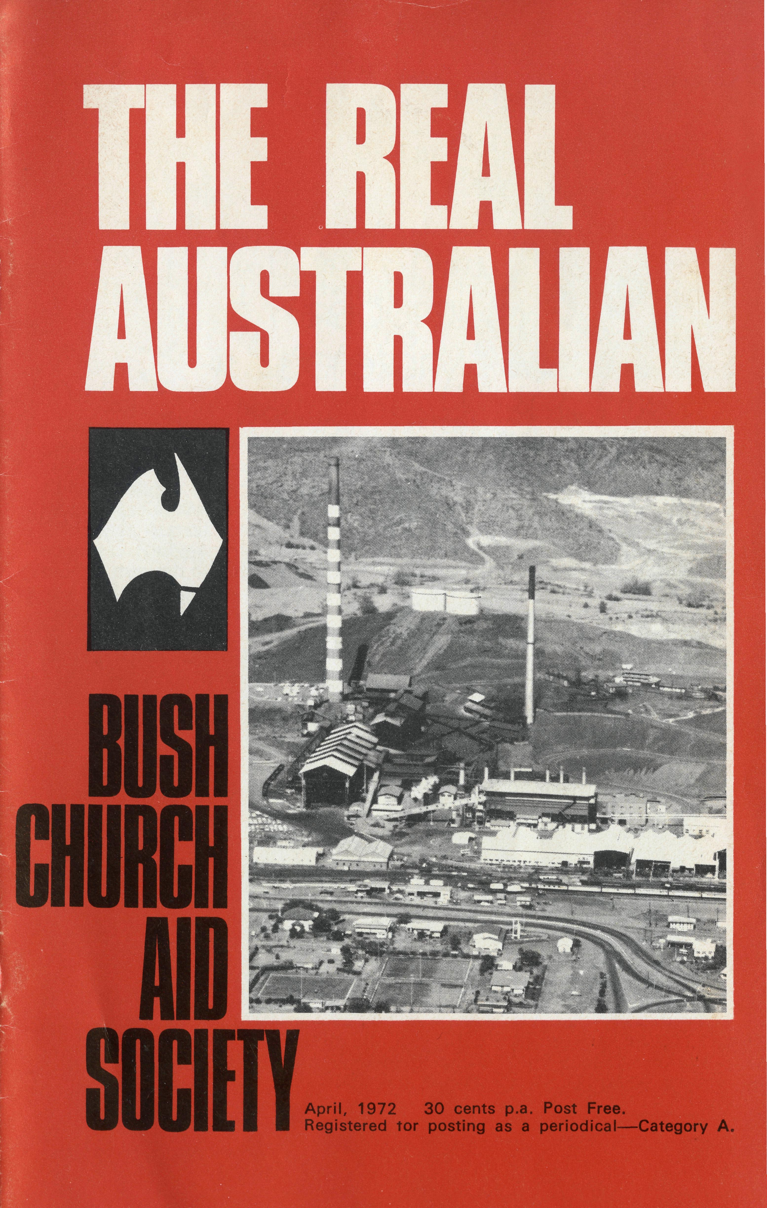
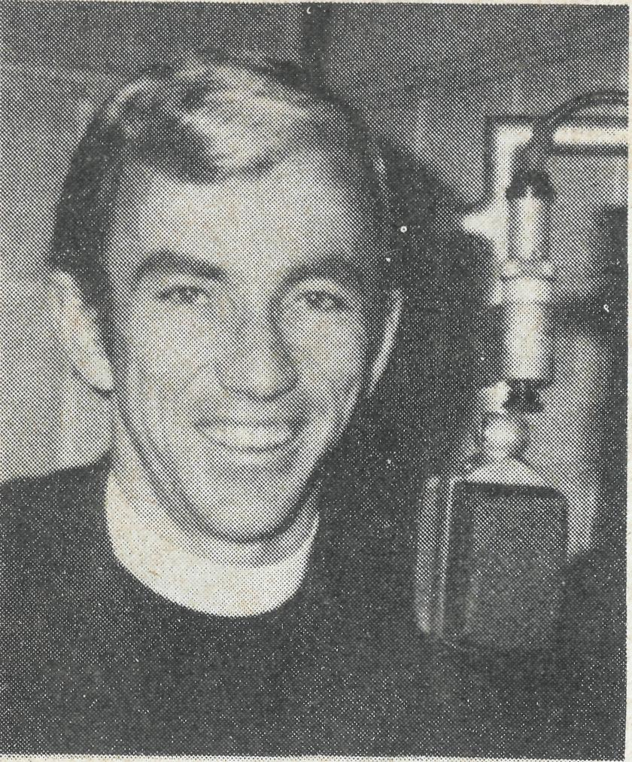
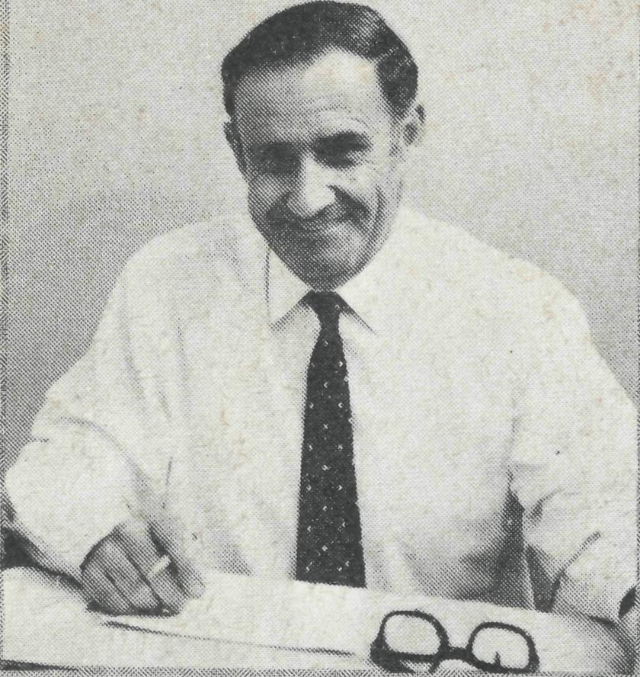
A Request From Laurie Calder...
Name
Address .
Other Remarks
"AUSTRALIA UNLIMITED" EVERY SUNDAY 2.CH - 1.04 p.m.
Up to the minute news and interviews with Barry Huggett.
P.M.G. regulations stipulate that to qualify for bulk postage rates, subscriptions to "The Real Australian" must be current. Accordingly, we are now attending to our files and bringing them up to date. In the rush of these present days things catch up with us very quickly, and it may be that your subscription has lapsed without you being aware of it.
On the other hand, perhaps you support B.C.A. through a box or general donation. In this case, part of your contribution has been used as a subscription to "The Real Australian", so if we have heard from you recently, all is in order. If you support B.C.A. by using your Church duplex envelope, we would appreciate knowing this so that we can mark you as a subscriber. Please use the appropriate box below.
Whatever your method of giving, be assured that we really appreciate your continued help and ask for regular prayer for the work.
□
Subscription, 30c \ _
Donation S Enclosed
I now give to B.C.A.
¹—* through Church envelope.

Please delete my name from the mailing list.
"1 My box has not been cleared ¹—^{l}for some time.
Delete whichever does not apply.
- Have now handed it to the Box Secretary.
- I have opened it and enclose cheque/postal order.
Ambassador Press Design

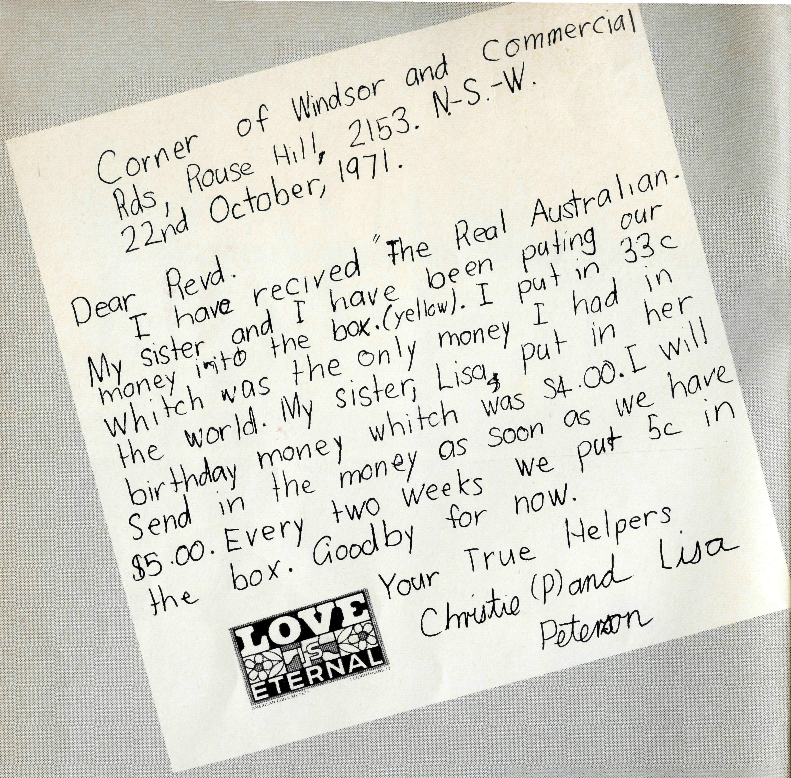
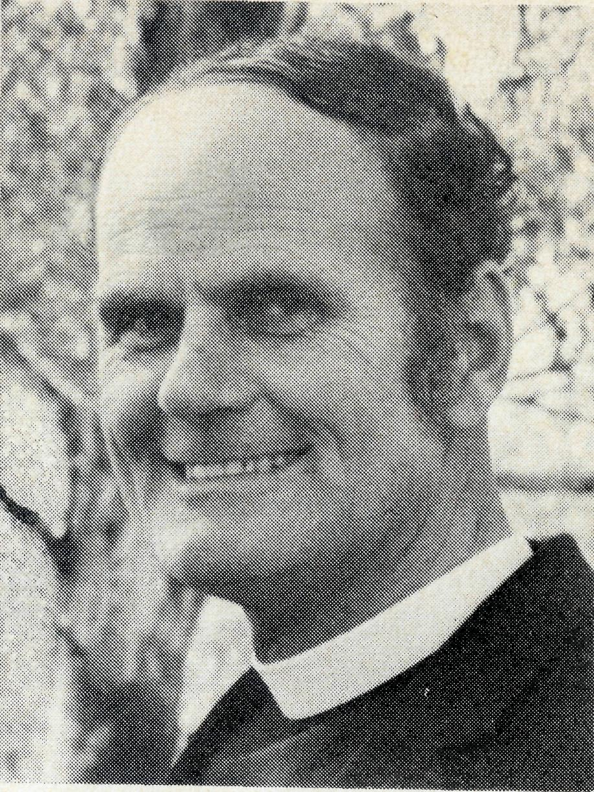
that Failed" a recent editorial (A.C.R.) quoted a Diocesan Bishop writing about those who failed in their missionary responsibility. Each individual who knows the love and joy in Christ wants to spread abroad the good news of the Gospel. This we do by our prayer concern for those serving in the outback. As I have visited B.C.A. places throughout Australia, more than one has said what a difference the prayer support has meant to him.
We hope folk will continue to pray as we face the need for clergy (for Southern Cross, W.A. and Menindee, N.S.W.), nursing sisters and Christian lay folk who will work in the new "instant towns" as pre-school kindergarten teachers, clerks, and indeed in any position.
We also face a most difficult year financially.
Yet again, we thank God for His goodness and look to His provision in the future. We expected to end 1971 with a deficit of $10,000. Due to the kindness of legacies and donations we were "in front".
Your Friend.
B.C.A. supporters really are quite superb! There are countless stories
that could be told by the administrative staff about the dedication of
those who are concerned that Christ be proclaimed in the outback.
Literally not a day goes by that we do not see some evidence of this
concern.
Difficult though it is to single out any group whose contribution stands
above the others, mention must surely be made of the pensioners. It
is an enriching experience to read the note which accompanies a
pensioner's donation to the Society. Almost invariably it is an apology
for not being able to give more! Then follows an assurance of prayer
for the work.
There are also those who give by legacies and who we are denied the
privilege of thanking at least in this life. In 1971, bequests totalling
$33,202 were left to B.C.A.
We give thanks for "The partnership in the Gospel" (Phil. 1:3-5) of
those whom God has called to this ministry.
Front Cover — Mount Isa.
S THE REAL AUSTRALIAN
from the
Federal
Secretary
May we give thanks to God together! A success story is always refreshing, (particularly in the Church where there is often so much pessimism) and the 1971 Christmas Appeal has been a real success. Nineteen hundred folk replied through our offices in Sydney and Melbourne. For this we praise God.
Those who responded to the Christmas Appeal will have noted that, although a receipt was written out for every donation received, these were not posted unless specifically requested. By following this procedure approximately $100 was saved and the total of the Appeal was consequently enlarged by that amount. As these arrangements appeared to be acceptable to everyone they will be followed in future Appeals.
Together with this response there has been a steady flow of "fan mail" approving "The Real Australian". The Reverend Barry Huggett, as Federal Public Relations Officer, is responsible for this magazine. Many tell us that they back up their interest with their prayer.
Under the heading "The Parish

THE JOYS
OF MOTORING
or...
how I went
on my
luxury
pay now
rest later
trip to
N.S.W.
The Revd. Peter George.
Photographs top to bottom.
One of the little puddles.
Peter, Philip, Fay and Lynette George,
The start of every trip.
Bishop's Chapel, Townsville, completely
destroyed.
St. Andrew's Church, Magnetic Island,
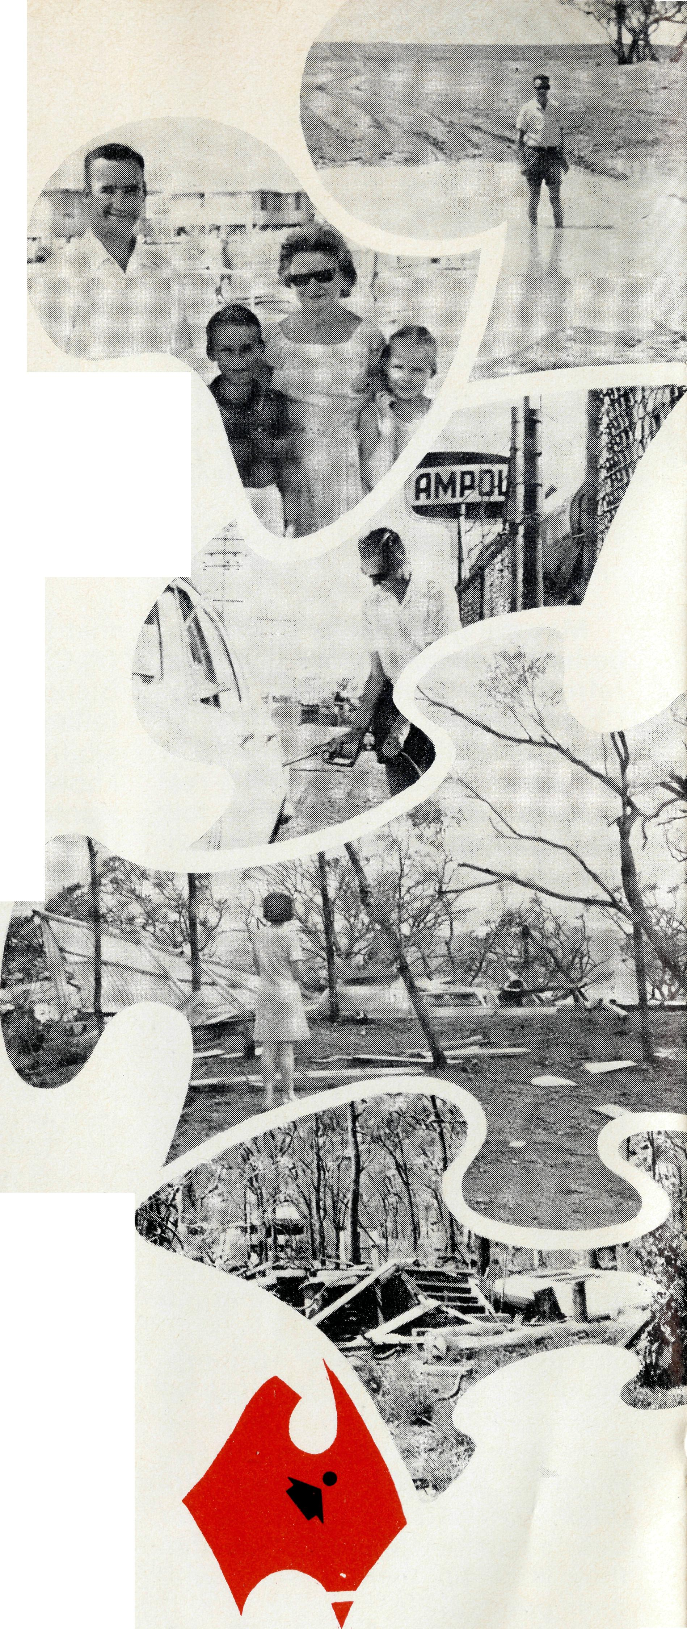
It was 2.30 on Christmas afternoon when I finally left Mt. Isa heading south for Sydney. Just 24 hours previously I had left Mt. Isa for Camooweal in the other direction, and in the course of the 250 miles round trip conducted a Christmas Service at
Camooweal, and arrived back in Mt. Isa just in time for a midnight Service.
Up early in the morning for an early morning Christmas Service, home again to do the packing, clean and close up the house, then to one of our Wardens' homes who had kindly invited me to have Christmas dinner with them.
After dinner was all over, with clouds gathering in the sky, I thought it wise to hurriedly leave the city and head south. I hoped to make Longreach which is some 400 miles from Mt. Isa. Most of the road between here and Long-reach of course, lacks any sign of bitumen whatsoever.
All went well for the first 150 miles. Then the clouds began to gather and just south of McKinley down came the rain. It rained and rained and rained. Slowly the wheels began to slide and slip, till finally I came to a halt sinking in the mud, some eight miles north of Kynuna, still 100 miles from Winton and some sort of security in a town.
It was 7.00 p.m. and I switched on the radio to hear the news, only to be informed that cyclone Althea had now turned into a rain depression and this depression was located south-west of Julia Creek. I quickly plotted this on the map, to discover that I was right in the middle of that rain depression. So, full of self pity and wondering just how long I might be there, whether it would be two or three weeks, I settled down for the night.
It rained solidly for two hours and the more it raihed, the more certain I was that I would be there for a long, long while. However, round about 9 o'clock the rain stopped and a strong,
cool wind was blowing across the country. Midnight I woke up and it was still clear, the wind still blowing.
Dawn broke on a grey day. The wind was still blowing and it wasn't long before I discovered that I had traction and I slowly limped into Kynuna, some eight miles away.
In Kynuna I was informed that there were some 12 to 15 cars already ahead of me and that they thought the road was clear through to Winton. So off I followed. It wasn't long before I found the cars ahead of me were bogged down. Right throughout the day we pushed one another out of bog holes, out of one into another. We travelled as a convoy and finally we ended up in one huge bog, all hopelessly bogged down, round about 2 o'clock in the afternoon, and still many miles from Winton.
Three hours later the ground had dried out considerably, one vehicle was freed, I was next in the line, and with 20 men pushing and pulling and with most of the air out of my tyres, I managed to get clear of the mud. Then came the job of course, of getting the mud out from under the wheels. I changed the two back tyres rather than pump them up. I had to take the wheels off the front so that I could clear the mud out and get some sort of steering. Soon I was on the way again and this time, without any further stops, arrived in Winton around about 7.30 that night.
I don't think I have ever been so tired in all my life, and as I drove into the motel (I decided to have a little bit of luxury for the night), the proprietor called out to his wife to "come and 'ave a look at this one, 'luv' " so "luv"

THE REAL AUSTRALIAN

came and had a look at this one, and this one could scarcely open his mouth, he was so tired.
The next morning the sun was shining and everyone seemed to be very optimistic about the road between Winton and Longreach, although 50 miles of this is still unsealed. I set off in high spirits only to find on arriving at the wet patch that I was the 53rd car in line. It was here that I learnt the news that the Thompson River at Longreach was lapping the Railway Bridge which meant that there was at least 15 feet over the road at Longreach. The men on the Railway Line felt sure that there would be no traffic going through to Longreach for at least ten days. And so I decided there and then that the only thing to do was retrace my steps to Mt. Isa, this time taking the road through Boulia which is further to the west and had escaped most of the rain.
So it was that after three days and 800 miles, I was still in Mt. Isa.
That day I read in the newspaper and in the local paper, that the road to Longreach was open. I knew of course, that that was so much rubbish. The next line said the road to Townsville was open though very slippery. I suspected that this too was rubbish, but there is something in man that makes him refuse to give up, and so at 3.30 on the Tuesday, I set off for Townsville. The road was dry although rough and I had a good trip right through to Charters Towers where I stopped at 1.30 a.m. in the morning.
I slept that night in the car, then early the next day had the car serviced and set off for Rock-hampton. Apart from the delays of three hours at a rain damaged
bridge, I made Rockhampton that night, the next day down to Mur-rurundi in N.S.W. and then on the Friday, I made it to Wollongong where I stayed overnight with my sister and her husband Bob Fin-ley, and then a final stretch to join Fay and the children at Corrimal for a hard earned holiday.
On our return to Mt. Isa we came through Townsville and it made me realise how very fortunate indeed I was to be stuck out in the mud rather than be caught up in the distress that so many people in Townsville experienced. I hadn't seen a cyclone-damaged town before, and I find it very difficult to describe. We went to park under the trees on The Strand which overlooks the water, large fig trees which normally give a lot of shade — there was no shade to be had when we parked under what was left of those trees. Of course, that was minor damage compared with the many, many houses we saw that still had their roofs off. Some had tarpaulins over, some had nothing, and we realised to some small extent the great fear that many people must have experienced that night as they heard their houses being torn down.
We realised too, the amount of damage that was done within the man who had no faith and trust in God. There is no doubt that even the man who did have faith and trust in God had experienced the testing of that faith to the utmost. I was thrilled to hear of the great attendance at a Thanksgiving Service held the Sunday after at St. James' Cathedral, when many, many people attended and testified to the way in which God had upheld them during this terrible time.
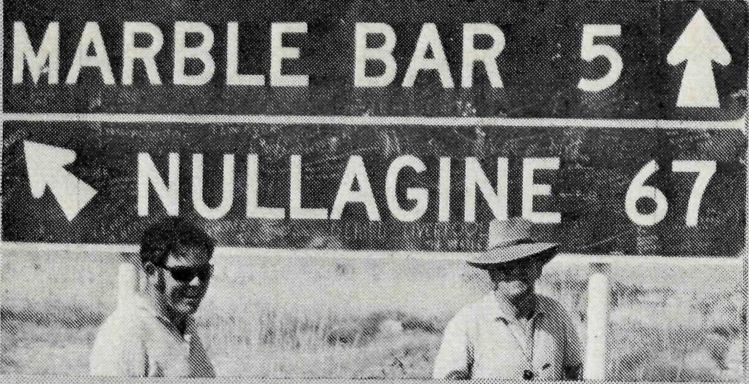
Recently I was reminded of my first visit to Nullagine five years ago. I was on my way up with the Bishop. We had been waiting in Geraldton until we had had news that one of the roads had been open after the cyclone. The inland way opened first, so on our very trying journey we found ourselves fording a river, still flowing strongly, and coming up the other side into a small settlement. We saw a phone box outside a larger galvanised iron clad building and pulled up in front where there were one or two other vehicles. This was the Conglomerate Hotel, Nullagine—also the store and the Post Office.
A white whiskered older man made his way over. "S'no good stoppin 'ere — the beer's hot," he said. He had obviously made the best of it, warm though it might be. "That doesn't bother us," said the Bishop. "Tell me," he went on, "Where's the Church in this town?" "Church," came
the answer, "There ain't no
Church 'ere and we ain't got no
need for one." The Bishop
said, "Well, meet your new Rector". My first introduction to my new Parish! Quite overwhelming!
In many ways Nullagine became the most enjoyable and satisfying of all the Bush visits I used to make. I never found the old man again, but I did find some who were extremely pleased to have a ministry. The first service
The
Nullgine Church
The Revd. Michael Pennington.
that I took (and this was the first, I was told that most could account for) consisted of three Baptisms followed by Holy Communion for those who wished to stay. The whole town came (the Reserve people as well) to the Baptisms at least, but next visit they came again and stayed. One of the four communicants was a part native woman who, with much joy, made her communion for the first time in eight years. Every child in the school — there were only 20 — used to come and the schoolmaster borrowed copies of the service to help the children to get to know it and to take their part.
The people of this isolated little bush town have a need for the ministry of the Church. This is now a need that is expressed. During the time that Ken and I were organising a joint visit so that I could introduce him and hand Nullagine over into his care they missed out on the first regular visit for the year. A newcomer wrote to me on P. & C. note paper, because when the townspeople met on that occasion they happened to be the P. & C, asking that the services be resumed.
It was a privilege to share in that service recently and to see signs of growth and to know that the old prospector was wrong. There is a Church in being in Nullagine. It is being built together of people.

THE REAL AUSTRALIAN

• The Right Reverend T. Jones, M.B.E., Bishop of Willochra and former Organising Missioner of B.C.A., has been made a Life Member of the Society. "T.J." as he was invariably called served with B.C.A. for nearly 30 years. He began as a B.C.A. missioner at Boggabilla, N.S.W., in 1929 and in 1935 was appointed Organising Missioner. The establishment of the Flying Medical Service was one of the Bishop's most noteworthy achievements. The only other person to hold an Honorary Life Membership is the Reverend Canon Ernest Cameron. Canon Cameron served on the B.C.A. Council for 21 years and for nearly 18 of these was Chairman. He was made a Life Member following his resignation from the Council in April, 1969.
Bishop Tom Jones and The Archbishop of Melbourne pictured at Bishop Jones' Consecration in 1958.
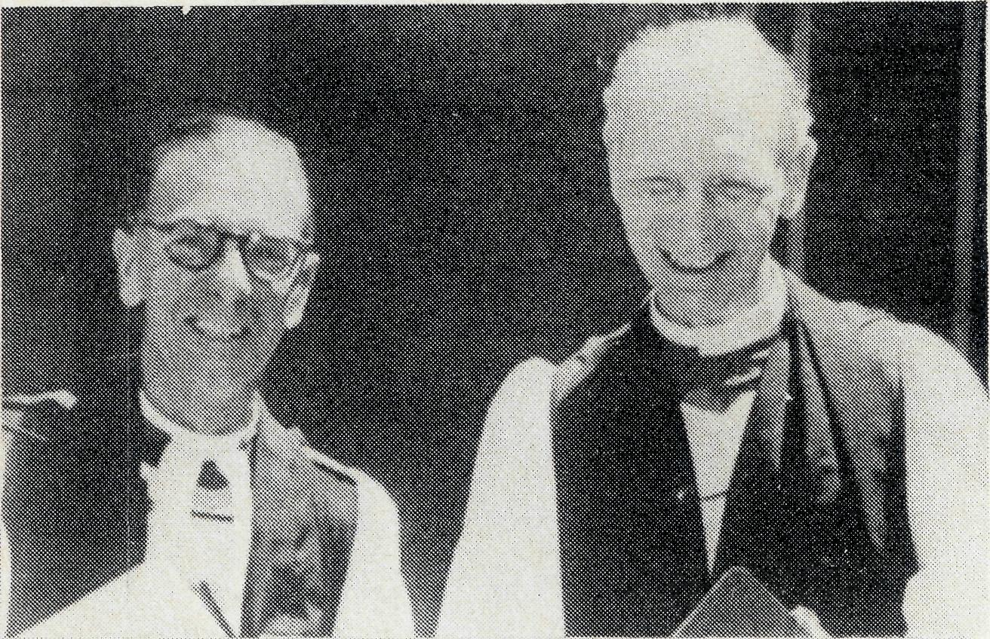
• An exciting new venture planned for 1972 is the holding of Regional B.C.A. Prayer Meetings. Organised by the Women's Auxiliary, meetings will be held in six of the Metropolitan Rural Deaneries during the second week in April.
• The Reverend Charlie and Wendy White are now settled at Kambalda. Mr. White's transfer means that there.is now a vacancy at Menindee. Please pray that the right man for this Parish will be found.
Charlie and Wendy White with Bishop Bryant at Kambalda.
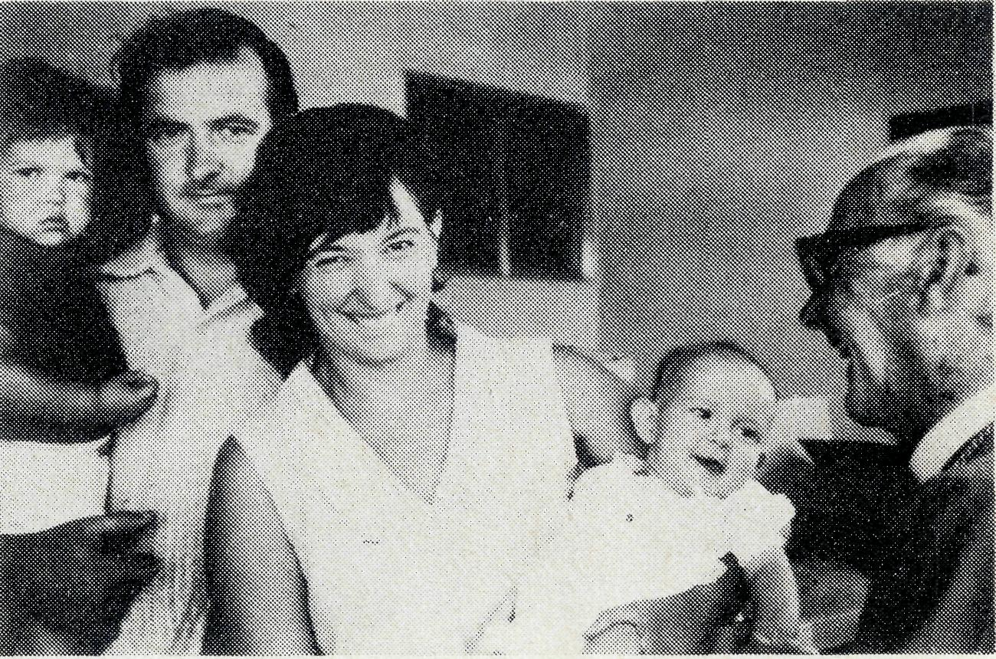
- The Tarcoola Medical Fund has now assumed full responsibility for the financial support of the Tarcoola Hospital. After her second term of service with the Society, we say farewell to Sister Heather Heaver and welcome back to Sister Lola Higgs. Lola will join Sister Maude Ross at Tarcoola.
- The rural recession is making itself felt in'the B.C.A. Hostels. A sudden decline in the number enrolled at Port Lincoln Girls' Hostel meant that the Hostel did not reopen this year and it is expected that Moree Boys' Hostel will close at the end of this year. By contrast Broken Hill is full with 20 boys enrolled. Our sincere thanks to Harry and Cath Pluckrose for their help at Port Lincoln last year.

- In July 1970, B.C.A. was able to avert a crisis at the seriously understaffed hospital at Laverton, 200 miles north of Kalgoorlie. In the intervening months since Audrey Nixon and Helen Wright went there, the hospital authorities have been able to recruit more nurses and the hospital is now fully staffed. This means the B.C.A. nurses can be withdrawn with the satisfaction of knowing that the emergency has been met and that a Christian witness has been exercised in the community during that time. Sister Audrey Nixon has gone to Cook Hospital to replace Sister Ruth Hold, who has returned to England.
- After thirteen years in bush dioceses, the last 3i of them with B.C.A., the Reverend Ted and Sue Doncaster have returned to the Diocese of Perth. We wish them well in their new position at Mun-daring.
- The people of Boulder deserve a pat on the back for having become self-supporting in such a short time. The Reverend David Pullar has left B.C.A. to become their full-time Rector. Please pray for them in these early months.
- Things are really bouncing in jthe Melbourne office now that
they have moved to the Clark Rubber Building. The new offices are bigger, brighter, better and cheaper! The address is, 3rd Floor, Clark Rubber Building, 196 Flinders Street, Melbourne—note that the phone number remains
the same, 63-8962. As well as a new address, the Melbourne office has a new member of staff. Miss Joan Fitzsim-mons has joined Mrs. Hughes and they now share the work, each working part time.
• Many supporters still faithfully collect used stamps on behalf of B.C.A. To make the $500 a year that comes to the Society from the sale of these stamps, approximately three million of them have to be sorted and packed. As* the profit margin is so small it is only the dedicated help of our many stamp voluntaries that makes this sort of income available.
Two B.C.A. stamp voluntaries, Mrs. Hall (left) and Miss Unwin hard at work.
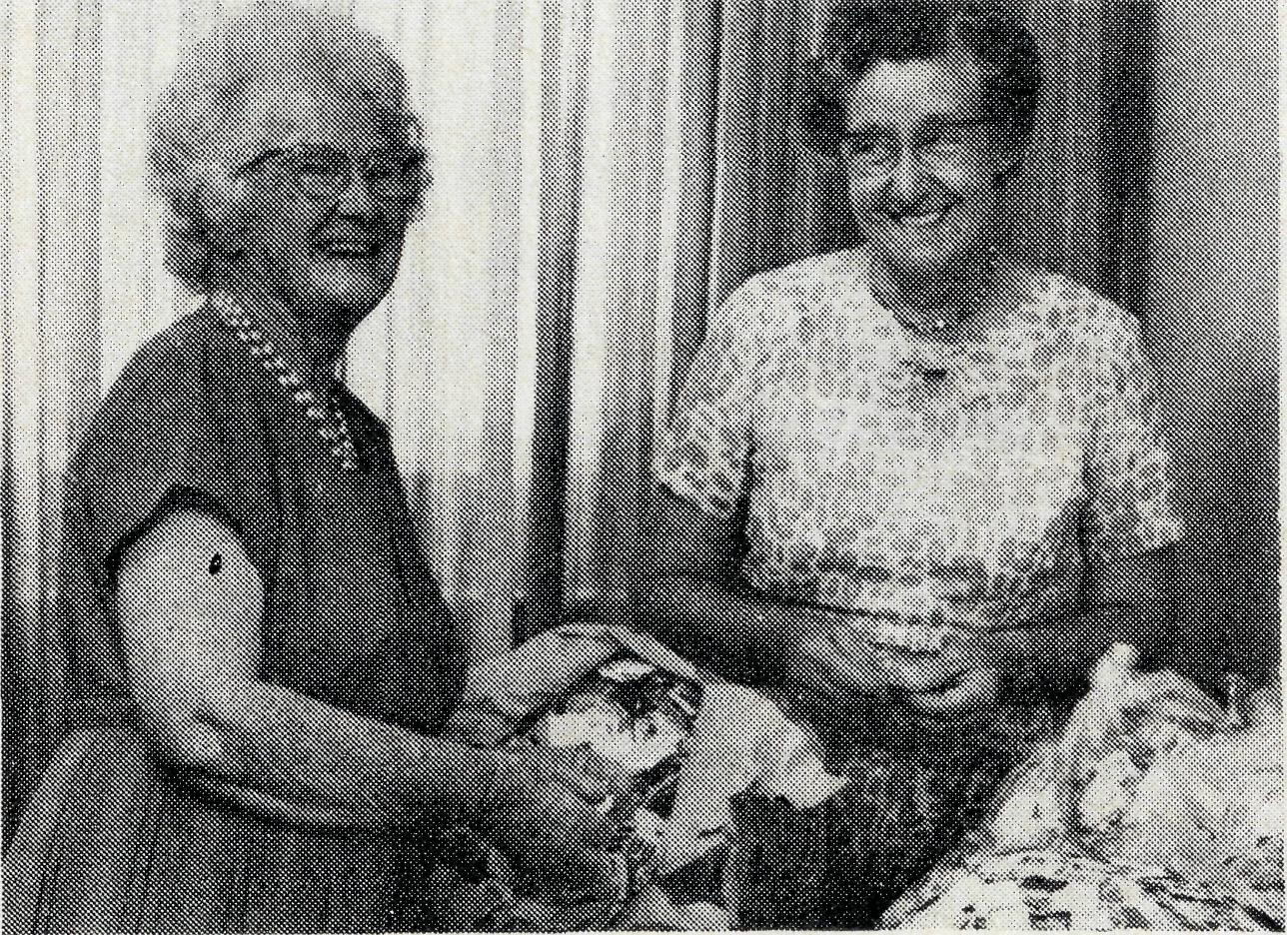
• A second generation B.C.A. worker has joined the Sydney office. Rosalie McLaughlin is the daughter of Arthur and Beryl McLaughlin, formerly at Broken Hill and Bowral Hostels. Mr. McLaughlin is now the Rector of Rozelle and Mrs. McLaughlin is an active member of the Women's Auxiliary.

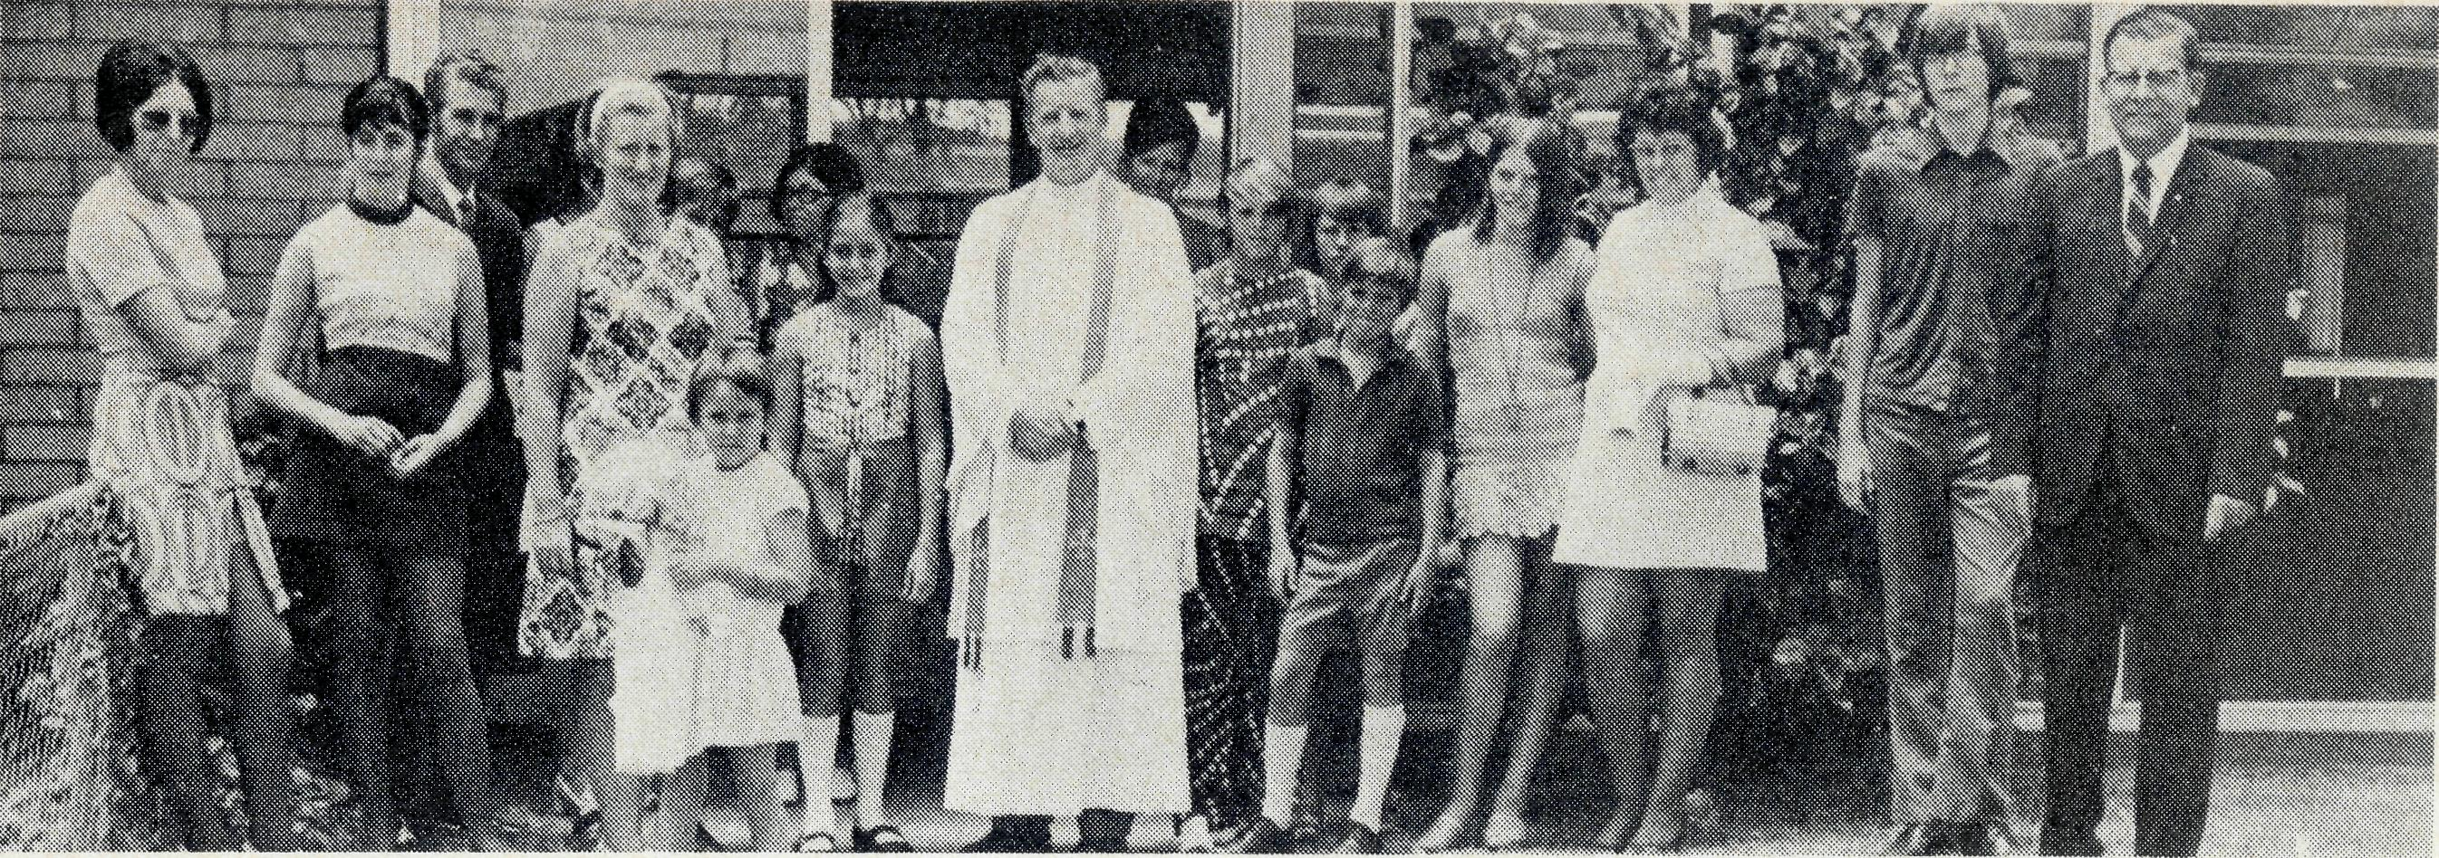
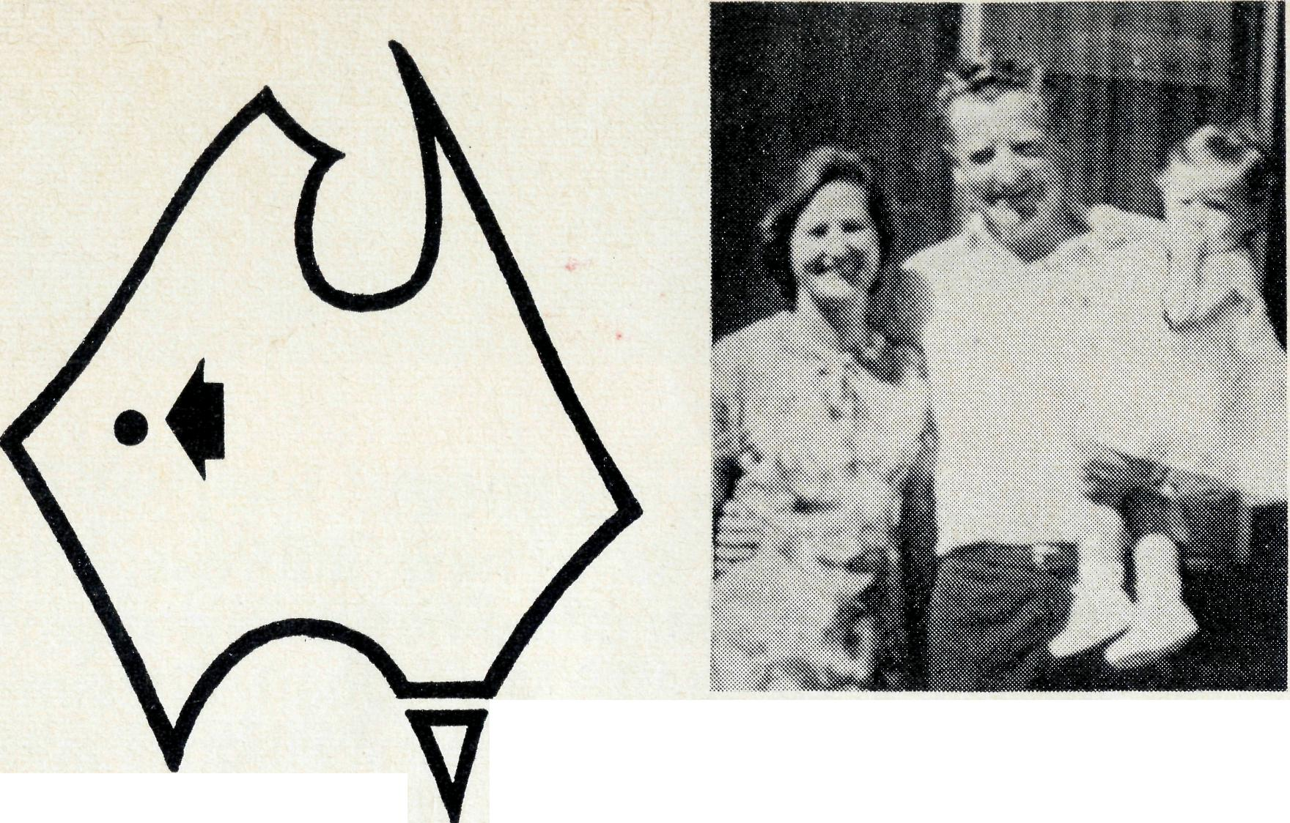
Beryce, Reg and Alyssa Clark.
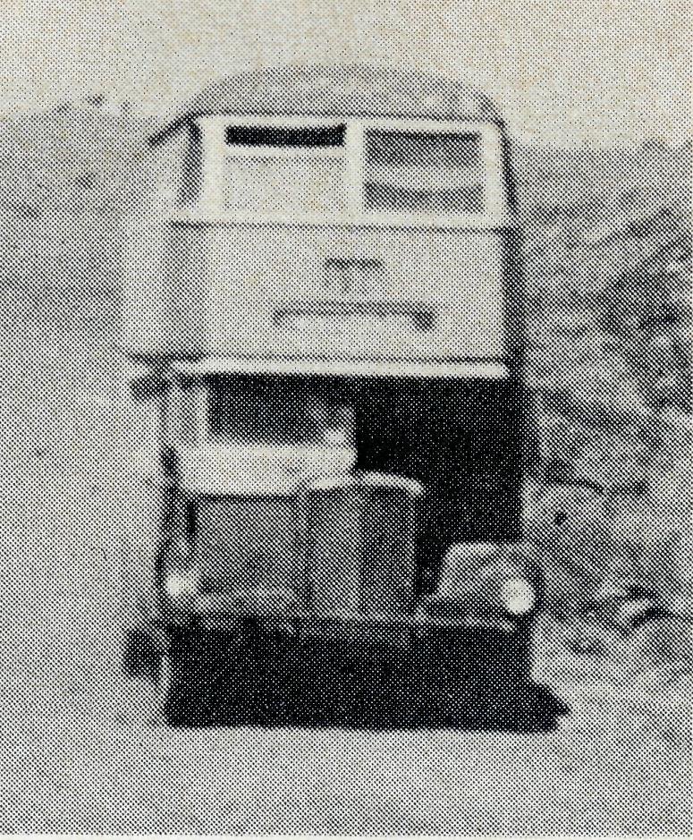
Who needs Atlanteans ?
Reg Clark and the Paraburdoo congregation.

Paraburdoo
Stretching out in front of us was the long, slow arch in the road which had at its furthest summit the Barradale Roadhouse. This was the last outpost of civilisation we were to see for some 230 miles, and the end of the sealed surface.
We had already travelled some 500-odd miles up from Geraldton on reasonably good, bitumen road. Now we braced ourselves for the next 500 miles of what we had been warned could be the tough, treacherous, and sometimes for the unwary or unskilful, disastrous track.
In the boot was an extra jerry-can of petrol, our emergency water ration, the second spare wheel and the steel tow rope we had purchased before departure, so we felt reasonably confident. But it was the constant "klunk" of the golf and cricket ball-sized, angular rocks that were slammed up against the underbody of our new Falcon, the thought of the punishment those tyres were taking or the sudden drop into a creek bed or "bull dust" patch (often so hidden as to preclude caution) of this mile-upon-mile of inhospitable road which tended to shake our assurance of reaching
io
The Revd. Reg Clark.
Paraburdoo without damage.
Not only was there the threat of that erratic surface, but also the nightmare experience of being suddenly enveloped in a dense cloud of dust as a huge oncoming cargo trailer thundered past, billowing the red dust in its wake. It was nerve shattering to have that momentary sensation of blindness as one sped on, not knowing where the road was or whom one might meet, head on, should another driver be endeavouring to overtake the trailer at that precise moment. We had already heard of three who had lost their lives in such a way a few days before!
We reached Dampier about 6 p.m. that night and dropped off Peter, a young Dutch migrant whose tour bus had developed gear-box trouble and stranded its passengers out in the never-never, and then found our appointed hosts, the Reverend Gordon Williams and his wife at the Rectory and enjoyed a much needed bath, meal and good night's rest.
With the aid of a hand drawn chart, specially prepared by our host, we set off next morning. Not knowing what time we would arrive at Paraburdoo, we pur-
THE REAL AUSTRALIAN
chased several essential items of food (excluding butter and meat) at the supermart. Imagine our surprise to see medium-large sized apples at 12c each, small oranges at 7c or half a small cabbage at 35c! Groceries were a little better but only a little.
The salt lakes at Dampier so entranced us that we missed the proper turn-off and ended up at Karatha, 12 miles off course. We soon re-located, however, and began wending our way down the railway road, crossing the track back and forth at the dictates of our chart. Nothing but the word "amazement" could describe our impressions of the mile-long ore trains with well over one hundred wagons and four great diesel engines coupled together to cope with the load.
Crawling up the steep slopes on to the vast plateau from which the Hamersley Ranges proudly rise, we were to see the sight of sights. It was not the rich, emerald green of the white barked ghost gums that lined the dry river beds, nor even the two, new, 120 ton WABCO ore loaders en route to Tom Price, with tyres that towered feet above Beryce's head as she posed for a photo. No, but it was a sight for sore old Sydneysider's eyes. There it was, coming directly at us, out on one
of the most isolated stretches of road in the Continent, rumbling along unmodified, unimproved ... a green, cream and brown Sydney double decker! . . . with destination clearly marked . . . WOOLLOOMOOLOO! We were later to discover that it was one of a number brought over under their own "steam" by a French firm contracting to Hamersley Iron . . . and they're still going strong!
It was about 6 p.m. as we turned a bend in the track and there before us lay a cluster of modern, cement brick bungalows gathered either side of a shopping complex under various stages of construction. This was Paraburdoo; we had reached our destination and it mattered not that, now, we ground to a halt with our first flat tyre. Having remedied that, we soon found the home of Hamersley's Personnel Officer, John Bryant, and his wife Pam (both Anglicans and active in their Faith) and were welcomed in for a brief rest and cool drink. We dared to beg a half pound of butter, but need not have. This and much besides had already been deposited in the fridge of house 386 and a pre-cooked casserole in the oven as well!
Our hearts were really thankful as we offered up our prayers to
11

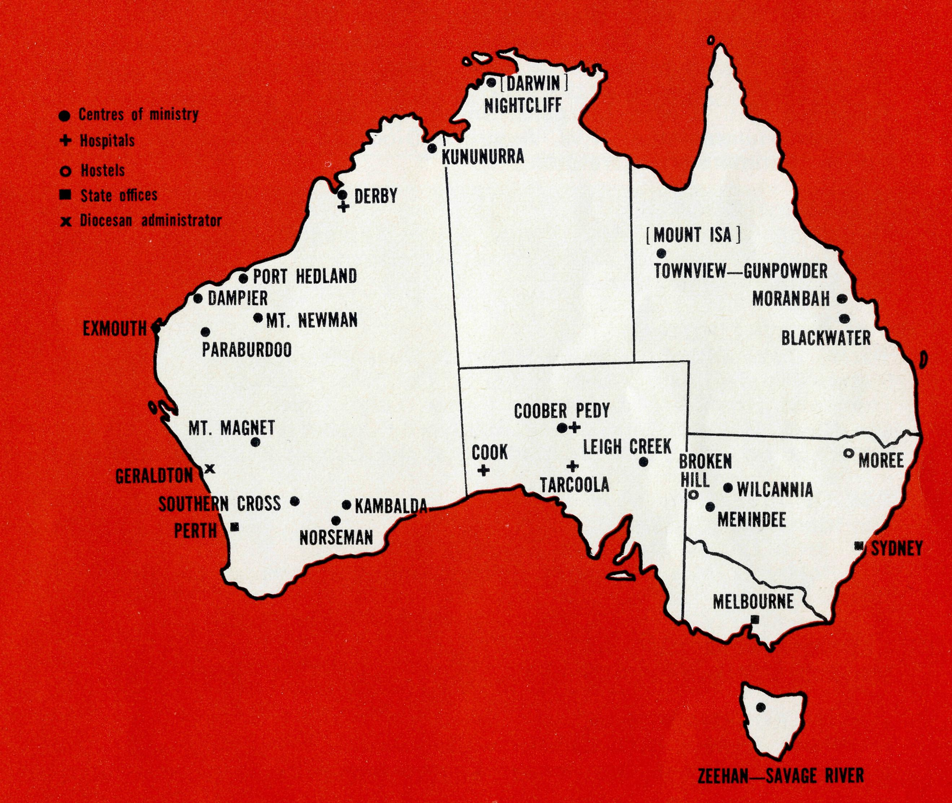
God that night for a safe arrival. But we were even more so for the knowledge that there were gracious, Christian folk such as these who could make us feel that it had all been worthwhile. Surely this had been the reason for our call, in the plan and purpose of God, to provide a Christian Ministry, on a regular basis, to His people and those yet to become such in this vast, northwestern Parish?
Of course, much has happened since the date of our arrival and the publication of this article, particularly in respect to Paraburdoo. We've all heard or read, on radio or TV newscasts and in the Press, something like, "New mining town goes into mothballs", or, "Hamersley Iron hit by Japanese drop in demand for iron ore". This does not mean we'll be ministering exclusively to a "ghost" town, pastorally caring for its "skeleton" staff! Tom Price, with about 8000 people is part of my Cure; and then there is Wittenoom plus the surrounding cattle stations, many of which are yet to be visited.
Pray for us, however, that we might bring the hope that is in Christ to the many who have become despondent. Remember our son, John, and his educational needs should we remain domiciled in Paraburdoo. Up to the present he has done well, praise God. Pray too for Bishop Witt and his Administrator, Stan Hummerston, that they might be given wisdom to make right decisions on the many important issues that now confront them. Lastly, give what you can to enable B.C.A. to continue to help this and those other Dioceses where there is such vital need for the ministry of the Word and Sacraments.
Sister B.Bossley
A large crowd attended the funeral of Sister Beryl Bossley in St. Barnabas' Church, Westmead, on 7th February, 1972. While Sister Bossley had been ill for many years, she had kept herself busy working almost up to the day of her death on 5th February.
It was in February 1936 that Sister Beryl Bossley joined the B.C.A. staff at Ceduna. With her coming, the staff was increased from two Sisters to three just before the first part of the present Hospital was built. As a member of the "pioneers" it is noteworthy that she went to Cook to open the Bishop Kirkby Memorial Hospital in September, 1937. She writes of a severe dust storm two days before the opening day! Their first in-patient was a new-born unwanted Aboriginal baby.
The baby was adopted by the B.C.A. and baptized Sydney James Cook (named after Bishop Kirkby). After three months, Sister Bossley left Cook Hospital in the hands of Sister D. Todd while she took Sydney James Cook to Penong where he spent the early days of his life.
Sister Bossley took over the Tar-coola Lady Dugan Medical Hostel in 1943. At that time they could only attend to out-patients. In 1945, she was happy to return to Cook where she noted the extra equipment which had been added to the hospital. It was in August 1947 that she was granted extended leave following a serious illness. While she returned to work at Cook, it seemed that she was not going to recover sufficiently and, in June, 1948, resigned through ill health.
However, after a few years of recuperation, Sister Bossley was not to remain idle. She joined the work of the Home Mission in Sydney and was soon a Sister in the Chesalon Hospitals. Her faithful work in this area has been well remembered. She was Matron of the special branch at Westmead at the time of her death.
THE B.C.A. PRAYER

A DAILY PRAYER
O Lord our God, help us to remember those who live in the remote parts of our land. We ask You to bless those whom You have called into the fellowship of The Bush Church Aid Society. Grant that, through the ministry of the Word and Sacraments, through healing, and through caring for the young, the message of Your redeeming love may be proclaimed, through Jesus Christ our Lord. Amen.
O God, we remember before You those whom You have called to Your service. We ask You to bless
, assure
them of Your Presence, and call others to stand with them in the task. Grant to them, as to us, the joy of service, the ability to achieve, and the serenity of Your peace, for Jesus' sake. Amen.

THE REAL AUSTRALIAN

Prayer calendar
and field staff directory.
DIOCESE OF NORTHERN TERRITORY.
1. The Revd. Alan & Mrs. Philippa Hoskin, Nightcliff.
DIOCESE OF N.W. AUSTRALIA.
- The Revd. Bill & Mrs. Jocelyn Ross, Kununurra.
- The Revd. Bernard & Mrs. Coralie Buckland, Derby.
- Sisters Joy Brann and Michelle Blondel at Derby Hospital.
- The Revd. Michael & Mrs. Heather Pennington, Port Hedland.
- The Revd. Ken & Mrs. Margaret Hagan, Mt. Newman.
- The Revd. Gordon & Mrs. Jean Williams, Dampier.
- The Revd. Reg & Mrs. Beryce Clark, Paraburdoo.
- The Revd. Ron & Mrs. Barbara Beard, Exmouth.

- The Revd. Bill & Mrs. Margaret Smith, Mt. Magnet.
- Mr. Stan Hummerston, N.W. Australia Diocesan Administrator, and Mrs. Dorrie Hummerston, Geraldton.
DIOCESE OF KALGOORLIE.
- The Revd. Charlie & Mrs. Wendy White, Kambalda.
- The Revd. Ray & Mrs. Mary Neve, Norseman.
- The Southern Cross Mission.
DIOCESE OF WILLOCHRA.
- Sisters Carol Allen & Audrey Nixon at Cook Hospital.
- Sisters Maude Ross & Lola Higgs at Tarcoola Hospital.
- The Revd. Brian & Mrs. Carolyn Carter, Leigh Creek.
- The Revd. Barry & Mrs. Jenny Rainsford, Coober Pedy.
- Sisters Anne Dau & Shirley Manning at the Coober Pedy Medical Centre.
DIOCESE OF RIVERINA.
- The Menindee Mission.
- The Revd. Eric & Mrs. Joan Baldwin, Wilcannia.
- Mr. Robby & Mrs. Margaret Roberts and the boys at the Broken Hill Hostel.
DIOCESE OF ARMIDALE.
23. Mr. Bob & Mrs. Irene Brown and the boys at Urallie Hostel, Moree.
DIOCESE OF ROCKHAMPTON.
- The Revd. Greg & Mrs. Del Ezzy, Blackwater.
- The Revd. Neville & Mrs. Evelyn Knott, Moranbah.
DIOCESE OF NORTH QUEENSLAND
26. The Revd. Peter & Mrs. Fay George, Townview-Gunpowder.
DIOCESE OF TASMANIA.
27. The Revd. Blair & Mrs. Lyn Grace, Zeehan-Savage River.
GENERAL.
- Replacement Staff, Box Secretaries and B.C.A. Supporters.
- Deputation and Public Relations work, Revds. Barry Huggett, Barry Green, Brian Viney, Ted Watkins, Mr. Laurie Calder.
- The Revd. Theo Hayman and the Administration of B.C.A. and the National Home Mission Fund, the Council and State Committees.
Office staff: N.S.W. Mr. Burner, Misses Smith & McLaughlin, Mrs. O'Neill, Mrs. Wills. Vic: Mrs. Hughes, Miss Fitzsimmons.
6.30 p.m. Thanksgiving Service St. Andrew's Cathedral. 7.30 p.m. Light refreshments — Chapter House, 8.00 p.m. Annual Rally — Chapter House.
Speaker:
The Right Reverend Bruce Rosier, Bishop of Willochra.
The Rally is B.C.A.'s showcase for the year — it's your opportunity to hear first hand news of what God is doing in the outback. Make up a party from your Parish and join us.
State Office Directory. . .
Federal Secretary, The Revd. T. J. Hayman —
Staff Administration.
N.S.W. Secretary, The Revd. B. D. Huggett —
Public Relations enquiries.
Asst. Secretary (N.S.W.), Mr. W. L. Calder —
Deputation bookings. Supporter enquiries.
Accountant, Mr. F. Burner —
Financial enquiries.
B.C.A. House,
135 Bathurst Street, Sydney, N.S.W. 2000.
26-3164, 26-3780. Telegraphic Address: "Chaplaincy" Sydney.
Victorian Secretary, The Revd. B. W. Green — 3rd Floor, Clark Rubber Building, 196 Flinders Street Melbourne, Vic. 3000. Phone: 63-8962.
West Australian Secretary, The Revd. B. L. Viney —* Box N1024, G.P.O., Perth, W.A. 6001. Phone: 25-7455.
Sth. Australian Representative, The Revd. E, G. Watkins 77 Beulah Road, Norwood, S.A. 5067.
President:
The Most Reverend, the Archbishop of Melbourne.
V ice-President:
The Most Reverend, the Archbishop of Sydney.
Chairman of Council:
The Rt. Revd. G. R. Delbridge.
Honorary Treasurer:
Mr. R. T. Stokes

I4
THE REAL AUSTRALIAN

