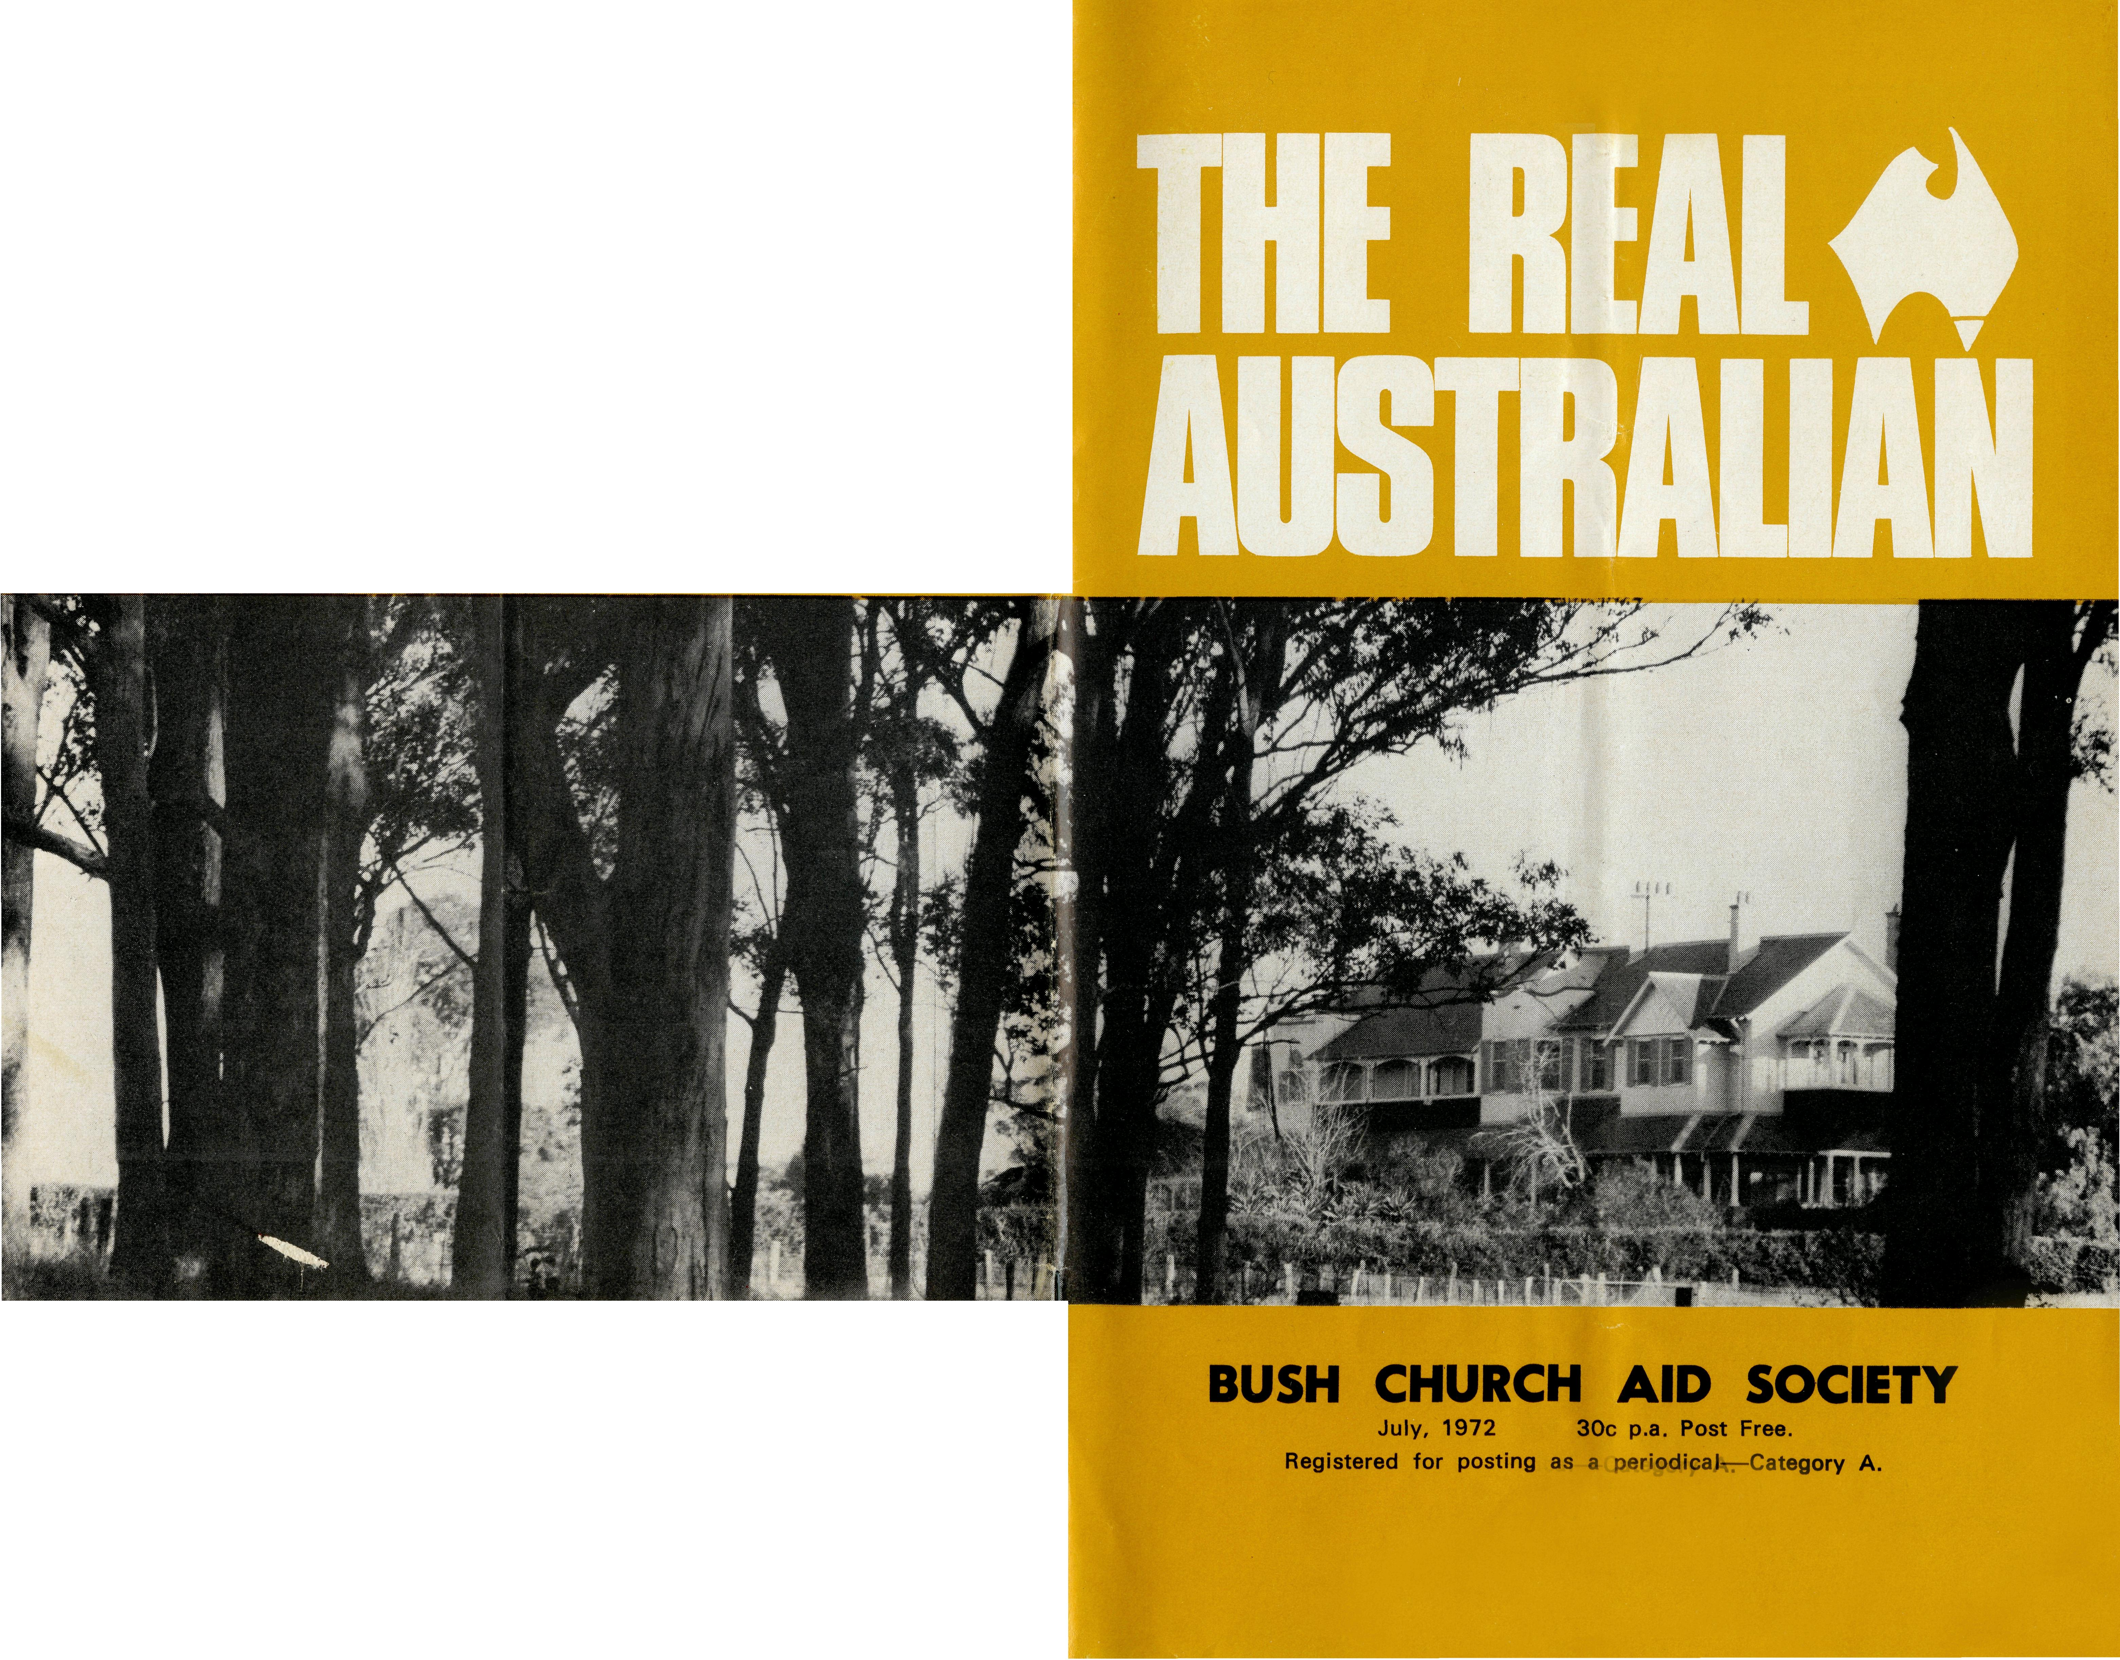
1972 B.C.A. COUNTRY CONFERENCE
Cover — Gilbulla.
GILBULLA September 8-10

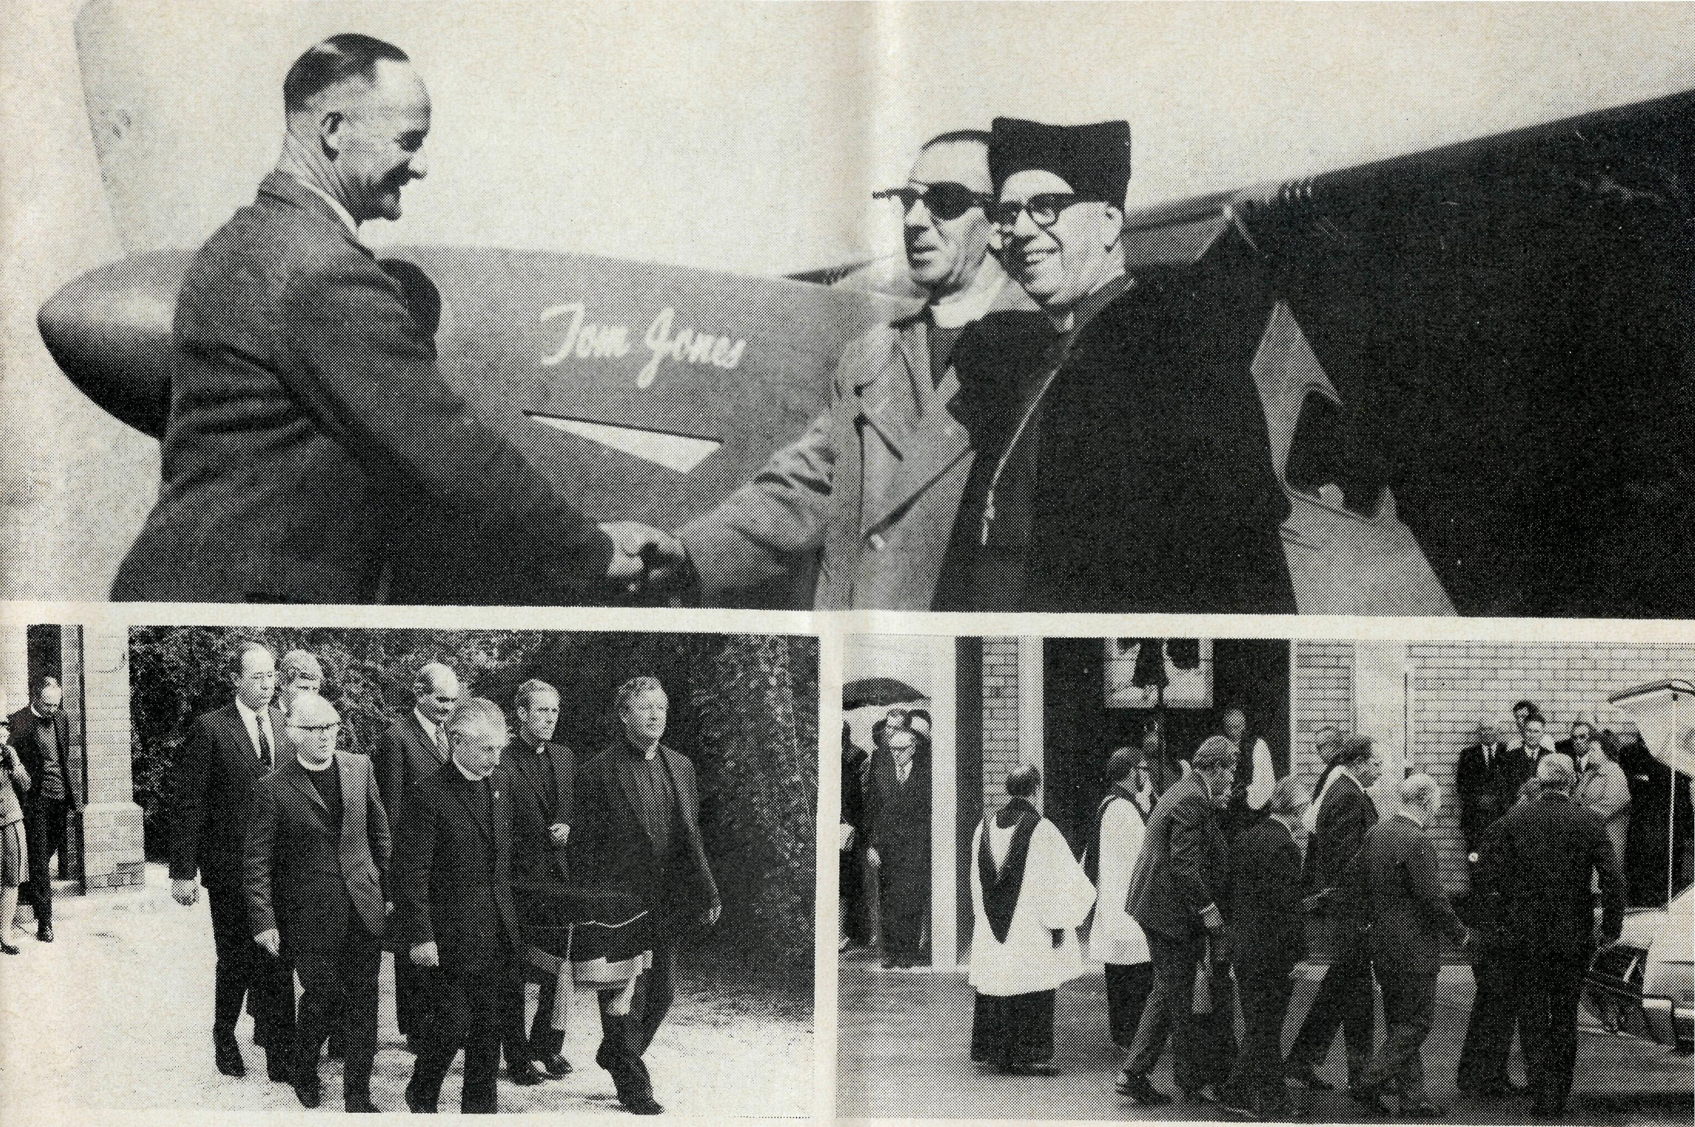
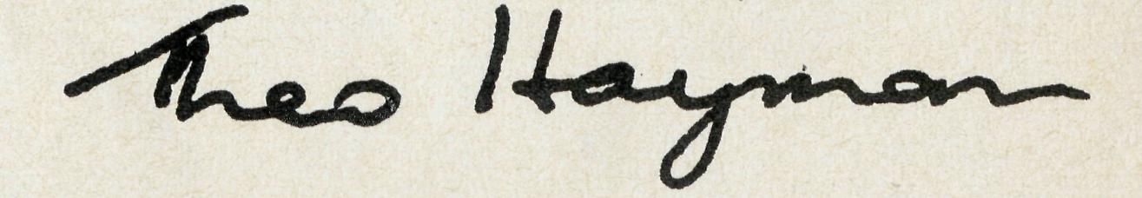
from the Federal Secretary
We would all know the words of our Lord when He said "All authority in Heaven and on earth has been given to Me. Go therefore, and make disciples of all nations, baptizing them in the name of the Father and of the Son and of the Holy Spirit, teaching them to observe all that I have commanded you; and lo, I am with you always to the close of the age."
If we believe in "Australia for Christ" then we should obey His commands to go to remote areas of Australia as much as overseas. Where the Society receives an invitation to supply men and women, we believe this to be the invitation of "Christ the King". He, who has all authority would have us carry out His Will. Some of us are called to go in person. Others, through prayer and gifts, just as really take part in the "big, wide, beautiful world of B.C.A.".
When the B.C.A. men. and women go to work in "instant towns" we have a sense of the apparent smallness of the business of the Church alongside that of the Company. The huge machines which are used in mining these days, and the vast number of men controlled by enormous financial interests, may seem to dwarf our efforts. Yet, if we believe all authority is given to God, we may humbly place ourselves in His Hands. The matter of housing for our B.C.A. personnel has been very difficult in brand new and fast expanding mining towns. Time and again, promises have failed. But somehow other accommodation has
been found, and, somehow, God sees to it that we have sufficient finance to be able to meet the basic needs of service.
Thus the B.C.A. man and his wife begins to work in brand new situations like Paraburdoo, Black-water or Moranbah. God moves in the hearts of men and women through these ministries. The results are beyond the capabilities of ordinary human endeavour.
The Reverend Canon W. Carter of South Brisbane, went recently to Blackwater (in the Rockhamp-ton Diocese) for a Parish Life Mission. He has written of the "fine group of vital people who attended. Greg and Del Ezzy certainly have developed a great relationship with the people and are doing a fine job in a difficult situation." The Holy Spirit has been at work as Christ's command has been obeyed.
The Bishop of the North West, the Right Reverend Howell Witt, spends a week in each Parish where there is often a harvest reaped from the faithful sowing by B.C.A. men and women.
I have just returned from the North West where it was a delight to visit six B.C.A. Parishes as well as Stan Hummerston in Geraldton, and the Reverend Brian Viney in Perth. Real problems exist in many areas, but there are signs also of profitable returns from your investment in prayer and giving.
May the blessing and presence of our Lord indeed always be with us.
THE REAL AUSTRALIAN
Your friend,
THE RIGHT REVEREND THOMAS EDWARD JONES,
Th.L., TTt.D., M.B.E.
Organising Missioner of B.C.A., 1934-58
Bishop of Willochra 1958-69
"T.J." as Bishop Jones was invariably called within the B.C.A., knew the hard
years when the Society was called to expand rapidly. In those early days
he knew of, and prayed for, every penny that came into the Society.
He shared in the anguish of trying to do so much with so little. It was his
straight forward business ability that enabled him to press forward to
the achievement of goal after goal.
Mission areas increased from small work in four dioceses to a much larger
area in eight dioceses. The Flying Medical Service in Ceduna and the
Bush Hospitals at Tarcoola, Cook and Rawlinna owe their origin to Bishop
Jones. One of his most noteworthy achievements was the establishment of
the first School of the Air. Based at Ceduna and using the existing radio
network, the school enabled isolated children to have daily contact with their
teachers.
He unceasingly sought personal gifts from many individuals and set the
pattern for personal giving and personal interest coupled with prayer. Many
of the legacies received today speak eloquently of the work of T J in
days gone by.
Those who knew T.J. loved him. He was a man who appeared to be gruff
and terse almost to the point of rudeness and yet underneath was a heart
of love. His staff realised that he gave of himself unstintingly on their
behalf. His encouragement to them was far more in deeds than in words, and
it was partly due to his inspiration that so many seryed for so long.
When he became a Bishop he did so with a long background of dealing
with men and his advice to his men came from the wealth of his experience.
It was the work done by each member of the Bush Church Aid Society
or later those within his diocese, that became the reward for his own
interest and service.
Top: Allan Chadwick, Bishop Tom Jones and Bishop t. T. Reed at the reception of VH-AEC "Tom Jones". Bottom: Bishop Jones funeral at Plympton.

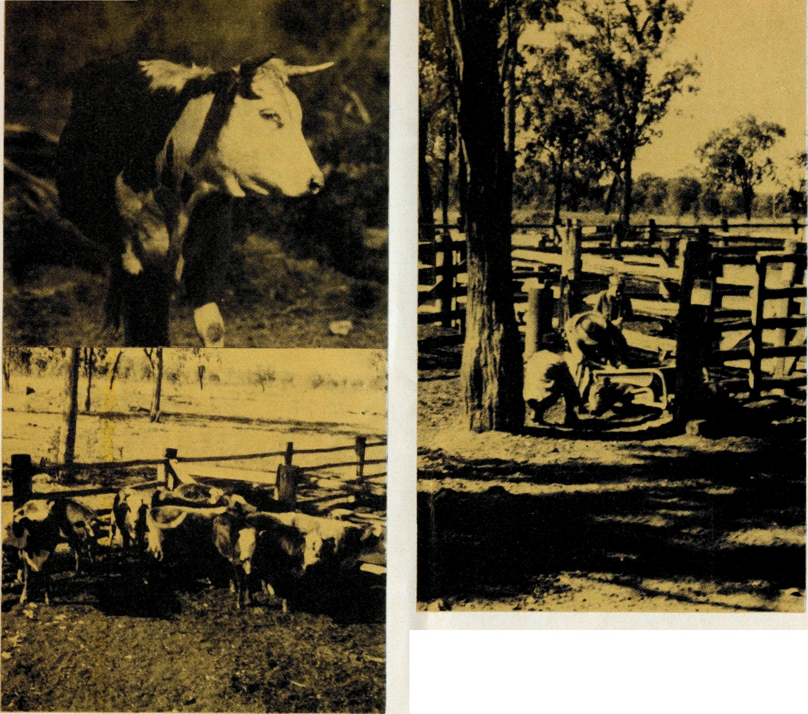
could we be raising your steak?
Revd. Greg Ezzy, Blackwater.
It is not very often that we feel the cold weather in Central Queensland. But I will never forget the Saturday morning when I witnessed the first cows branded with 2QE, our Parish irons.
We left home at 7 a.m. with white frost covering the lawn and a bitter westerly wind beginning to blow. Forty-five minutes later we drove through the gates to Woodlea, the property of Mr. and Mrs. Bob McKenzie and their boys, Mark and Ben. We headed for the cattle yards.
The sky remained bleak and grey all morning. Around the yards the wind was cold, the earth damp, and our toes numb. But, in spite of our discomfort, we were excited at the prospect of seeing the first 13 weaner heifers branded for the Parish Cattle Scheme.
Soon the action began. One by
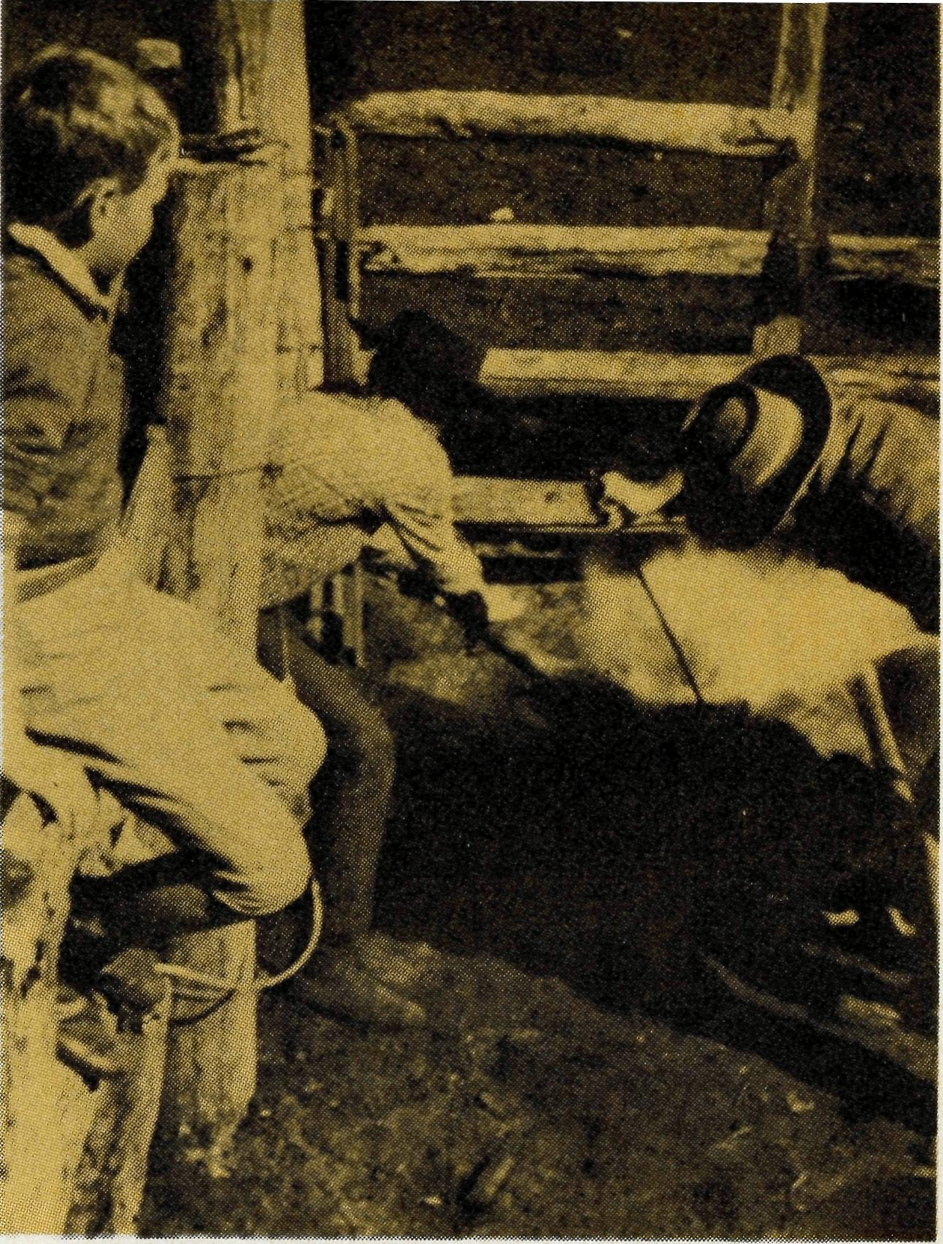
one the reluctant young cows were coerced along the narrow gangway. To come out into the yard, they must pass through the crusher. Sensing her fate, the cow tries to barge her way past the "crush" — but the experienced hands of the stockman quickly close it around the cow and she is thrown to the ground.
The red hot irons are taken from the fire and passed to the stockman who meticulously places them on the skin of the animal, attended by the smell of burnt hair, belching smoke and an occasional bellow from the cow.
As the grazier must take precautions to protect the cattle from disease, various inoculations followed.
Finally came the de-horning; not a very pleasant sight for the uninitiated. From our eldest boy Mark, leaning through the stockyard fence and watching the operation with great interest, came his reaction to the sight of blood — "ugh!"
And so the process was repeated 12 more times before we retired to the warmth of the

homestead for a good hot cup of tea and discussion on the future prospects of the Cattle Scheme.
That was the beginning. Today there are more than 140 beasts running on 13 different properties, with our Parish brand on them. Most have been purchased from loan money for which we negotiated with the Bank, and which was guaranteed by the graziers themselves. Some cattle have been straight out donations to the scheme.

Why are men bothered with the added work of being involved in a Church Cattle Scheme? Well, in fact, they initiated it themselves. I see it like this.

For the grazier it is a way in which he can make quite a substantial offering to the work of God's Church. Because he normally is not in a position to lay his hands on sufficient money to keep his property fully stocked, many
are only too willing to run a few extra head at no cost to the Church.

The Church cattle must take their chance with the rest of the herd in the face of disease, fire, flood and drought. But, all being well, eventually the grazier will consider it time to sell, and then it is that the beast with our brand, produces a very handsome cheque for the ongoing mission of our Church.
For us it will be several years before the Parish really benefits from the Scheme. In the meantime, it is a determined attempt by families who are involved in the work of God's Church, to accept responsibility for the financial obligations involved in the local work of the Church, as well as the overseas missionary work.
But until the day of self support, we continue to appreciate the generous support of B.C.A. for the ministry in this Parish. We are very thankful for your concern as together we seek to win "Australia for Christ".

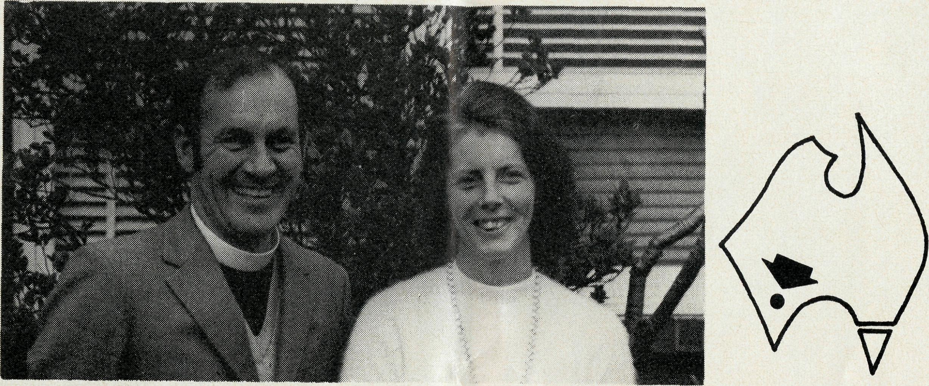
Southern Cross Vacancy Filled
The Reverend Gordon Thomas, his wife Joan and their family, leave Sydney on July 20 by the Indian Pacific to take up their new work at Southern Cross. Gordon trained at St. John's, Morpeth, was priested in 1961 and has served in the dioceses of Canberra and Goulburn, Melbourne and Sydney. He was latterly the Rector of St. Barnabas', Roseville East.
The Bishop of Kalgoorlie invited the Society to assist at Southern Cross in 1970 after drought and the imposition of wheat quotas had caused parish finances to plummet. Ted Doncaster was the first B.C.A. man in the parish.
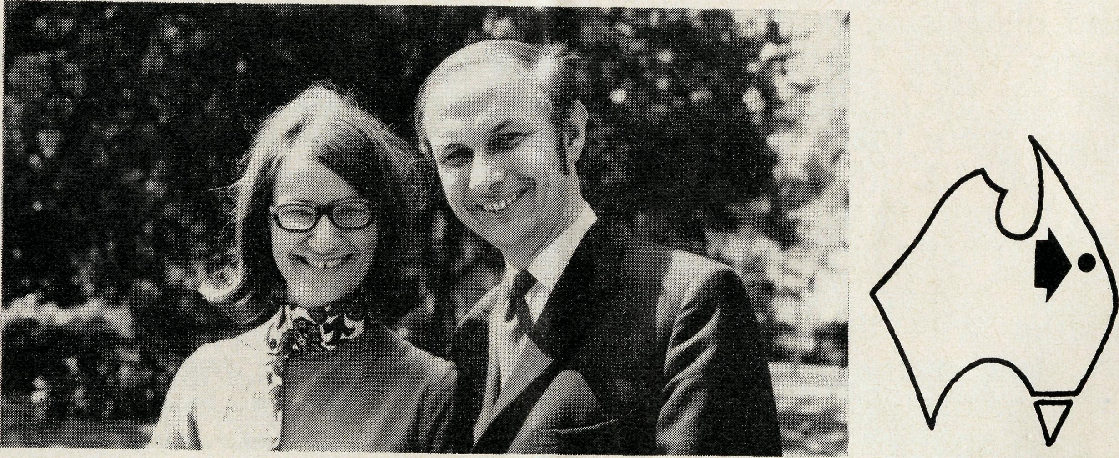
New Work at Moranbah
The Reverend Neville and Mrs. Evelyn Knott are rapidly establishing the ministry in the new Queensland coal town of Moranbah. After spending their first few weeks in a caravan, they have now moved into a Housing Commission home which has been modified to include a small worship centre. Although cramped, these facilities will suffice until the new community centre, which will include a chapel, is completed.
Neville is the official representative of all denominations in the town and was recently commissioned at a service in which the heads of the various denominations took part.
^{W} THE REAL AUSTRALIAN

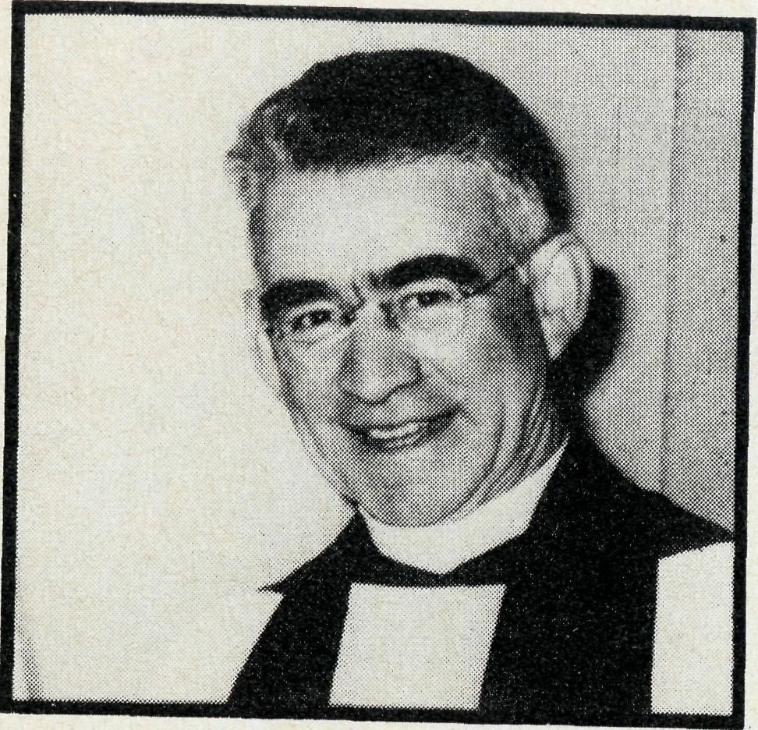
The Reverend Clifford Baker
When Cliff Baker died suddenly on the 7th April, he was still engaged in a very active ministry as the Rector of St. Swithun's, Pymble — a position he had held for 25 years. His links with the Bush Church Aid Society go back to 1936 when he joined B.C.A. and went as a caravan missioner to Menindee in far west N.S W where he stayed for three years.
in^l ^{subs}®q^{uent,}y served as the Acting Organising Missioner in 1946 and 47 and has retained a link with B.C.A. as one of the longest serving Council members, having exercised this ministry for more than 30 years.
All those who knew Cliff Baker, even those who only met him casually, could not but be impressed by his obvious sincerity, his rather puckish humour, and his dedication to Christ. Perhaps the thing that shone out above all, was that he was a gentleman His wisdom and mature judgement will be sadly missed on the B C A Council.
W.A. COMMITTEE FORMED
• A Committee to jointly promote the work of the Bush Church
Aid Society and the National Home Mission Fund has been formed
in Perth. Archbishop Sambell is President, Dr. I. 0. Thorburn is
Chairman, the Reverend Ted Doncaster is Vice-Chairman and the
Reverend Fred Buchanan is Treasurer.
PARISH SISTER FOR SOUTH HEDLAND
• The B.C.A. Council has agreed to supply a woman worker for
the new township of South Hedland, 10 miles from Port Hedland
in the Diocese of North West Australia.
Miss Carmel Grantham, who trained at Deaconess House, and who is currently serving at Redfern, Sydney, has been accepted for this position and will proceed to South Hedland in August.
BISHOP WITT AND PETER GEORGE AT RALLIES
• Following the Country Conference in September, Bishop Howell
Witt and the Revd. Peter George with Theo. Hayman and Barry
Huggett will address Rallies at Canberra, Newcastle, Parramatta,
and 3 regional Rallies in Melbourne. Numerous parish engagements
have also been made.

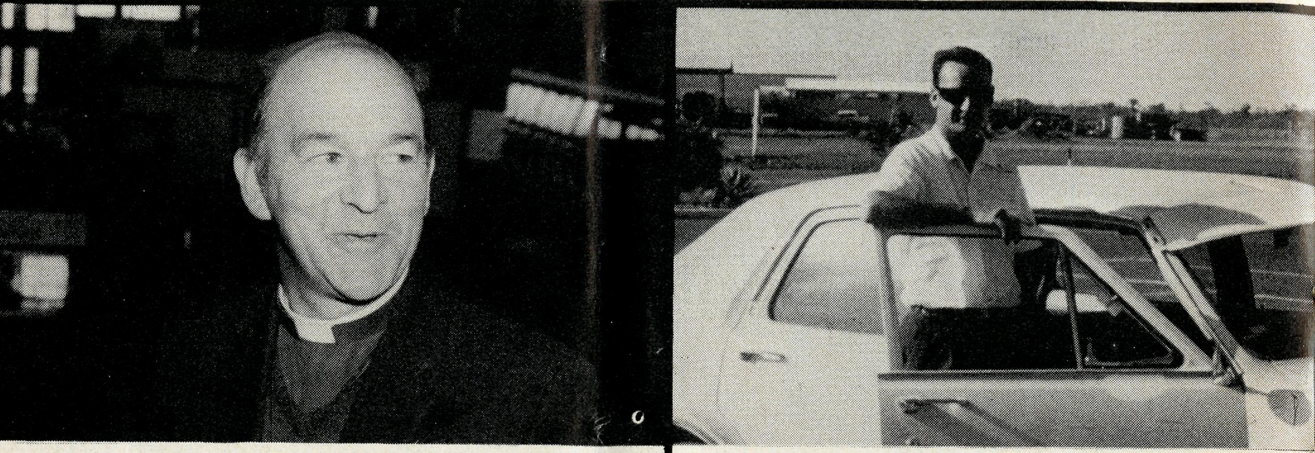
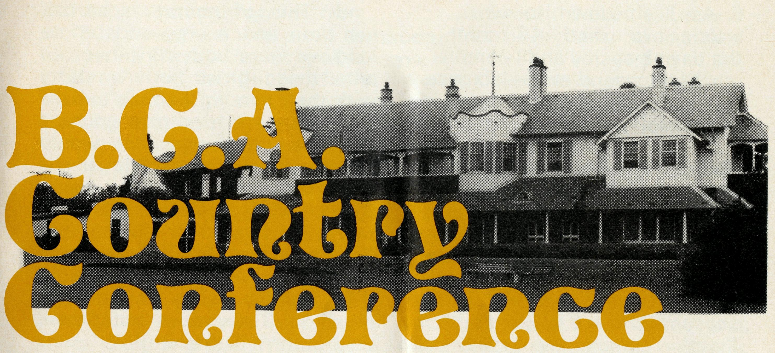
B.C.A.'s heaviest involvement at the moment is in the diocese of North West Australia. The Bishop of the North West the Right Reverend Howell Witt, will be our special guest at the Conference and will bring first hand news of the work that the men and women of B.C.A. are doing in his diocese.
The Reverend Peter George is the B.C.A. missioner at Townview-Gunpowder (Mt. Isa) in the diocese of North Queensland. Peter's ministry takes him from the suburbs of Mt. Isa, through the copper mining town of Gunpowder, and out into the cattle country to the north. His role at the Conference is to lead the Bible studies and to give us an insight into the opportunities facing a B.C.A. missioner.
GILBULLA September 8-10 1972

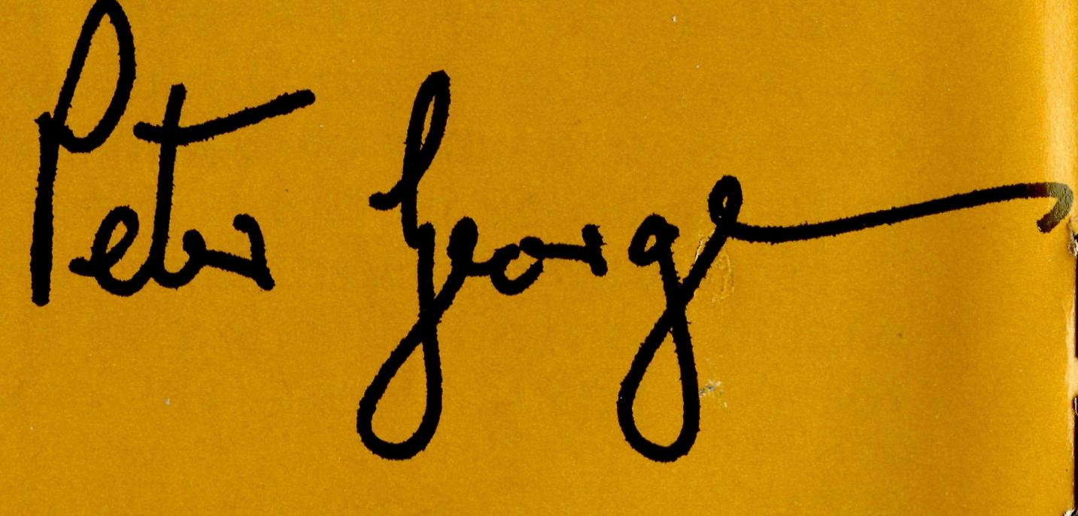
Phone:.
The Bishop owns up:
There comes a moment in every speech I make about the North West when I become aware of the glazed look and the furrowed brow. Nol It is NOT boredom. I NEVER bore people.
I'll tell you what it is. It's puzzlement, it's perplexity. "What on earth" these glazed lookers and furrowed browers are saying to themselves, "what on earth is he talking about?" And you can't blame them, can you? After all, the North West is a very, very different kind of world. That is why the Country Conference is so important. It gives us valuable time. Not only time to know one another (and this is vital for me) but also time to be questioned; time to explain.
I never mind seeing the glazed look or the puzzled brow at conferences. Because I know at the next meal or the next break or on the walk from chapel, I shall have the time and the opportunity of dealing with them. So bring your g.l. and f.b. to Gilbulla. And if you haven't got one. You can borrow one of mine.
From the Revd. Peter George
What a joy it is to be invited to share in the '72 Country Conference. Fay and I found the '70 Conference such a great time of fellowship and inspiration that an opportunity to join with the B.C.A. family for a similar week-end is tremendously exciting. If I am able to make some contribution towards the success of the Conference, so much the better, but I am sure that again it will be a case of receiving rather than giving.
The Conference promises to be one of those "happenings" not to be missed and we are praying that our B.C.A. friends will make it a must.
Sick of fog, smog and traffic jams? What you need to do is to get away from it all — so come to glorious Gilbulla for a relaxing two days of warm Christian fellowship.
Situated in rich dairying country at Camden, 40 miles from Sydney, Gilbulla is equipped with first class conference facilities.
Family groups are welcome and provision can be made for children.
Tariff: (Meals and accommodation) Friday evening to Sunday afternoon: Main House, $9.30; Long House, $7.80. Children under 14 — half rate. Children under 3—no charge.
Bookings are limited so don't risk disappointment — send your application now to B.C.A., 135 Bathurst Street, Sydney 2000.
Revd. Mr. NAME: Mrs-Miss
ADDRESS:
Postcode .Parish: _
I would prefer to be in
- Main House
- Long House
Limited accommodation is available for children.
Please state number and ages.
Enclosed is $3 deposit for each adult booking.
Day visitors will be welcome. Phone 26-3164 for programme details.

THE REAL AUSTRALIAN

As I sit down to write this article it is exactly 12 months to the day since Joy and I completed our 5£ thousand mile—six weeks trip from Sydney, and arrived in Derby.
Derby is situated on King Sound, 6 miles from the coastline and some 1,700 miles from Perth. It has a population of approximately 3,000 people—about half of these being Aboriginals. The climate is very tropical, consisting of a "wet" and "dry" season. Both are hot, but with the "wet" comes the rains and occasionally, cyclones. Derby is surrounded by mud flats and the waters of King Sound are tidal.
kind. This of course, absorbed her time and energy and before long we were both very involved with these girls, both on duty with their nursing training and off duty when we tried to encourage them to do things that would absorb their energy. One of the most interesting outings was a trip to Winjana Gorge, 80 miles away. To hear their obvious delight at being "free" and able to explore, climb and do those things which living in a nurses' home in Derby does not permit was quite enlightening!
The panel van was well loaded, with eight of the trainees and ourselves. More than once we
ward, but the highlight as far as work is concerned was a ten day stretch at Fitzroy Crossing where I filled in for the Public Health Sister. Imagine my surprise when working at one of the Aboriginal camps one afternoon to hear wail-ings and to see the evidence of some of their mourning rituals. This involved beating their heads with stones till they bled. Their grief cannot be complete till blood is shed. Of course, often there were a couple of trips to the hospital to suture the injured and give out disprins. Yes, these things still happen!!
Basket Ball is a popular game up here and this year I have the
inational would be of value and we have been fairly encouraged thus far by it. We have two of the Aboriginal trainees who are Christians on the committee so we feel this could be a good leadership training for them.
As we look back over the past 12 months, we realise that life has not been easy in Derby. There are several Protestant Churches — each with their own little following. How often it is frustrating and disappointing to find that after putting a lot of time and effort into arrangements, only one or two turn up — but — Derby is a place of transient people — people who are here from 6-24

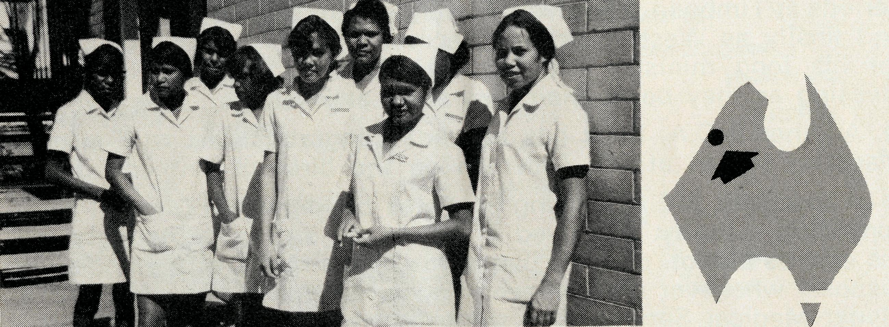
12 Months
Government Hospital...
Michelle and Joy
The secondment of Joy and myself to a Government Hospital was a new venture for B.C.A. and although neither of us had worked in a B.C.A. Hospital before, we knew enough about them to know that this situation would be completely different.
It had been planned that we would both work as ordinary ward Sisters (most staff stays only six months or less, so we were regarded as semi-permanent) but soon after our arrival Joy was appointed Tutor to the class of Aboriginal Nursing Aide Trainees. This had been in progress three months when she took over and is the only course of its
10
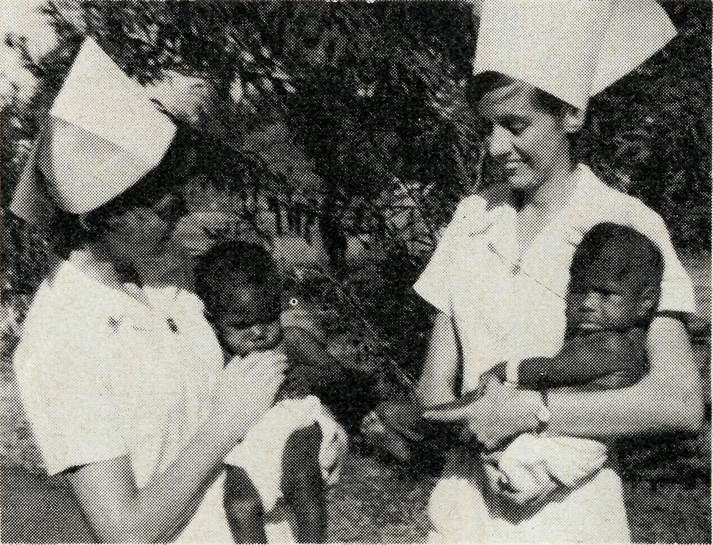
had to unload before crossing a creek bed.
Since then Joy has commenced another class of trainees, all of whom have now developed a real interest in the practical work and some of whom are managing the theory quite well. These girls really are delightful at times. One night one came home about 10.30 p.m. and, on finding her room locked, spent quite a comfortable night curled up in the bath tub. Very often is heard the cry "I forgot" or "I had to help mum at home" when no one came for study.
I have spent most of my time here working in the maternity
THE REAL AUSTRALIAN
responsibility of two hospital teams in the competition — the trainees' team, cheered on and supported by Joy at practices and matches, and a mixed hospital staff team in which I play. Both teams are doing quite well thus far in the competition. It certainly is a fast, and sometimes rough game, good for the weight watchers.
We are both spreading our wings and trying to perfect our musical talents, Joy on the accordion in Sunday School and I'm trying the organ in Church.
It was felt that a Nurses' Christian Fellowship Group which could be completely inter-denom-
months — who are out for promotion and extra pay — and so, with the greater frustration comes the greater challenge, of meeting with and trying to speak with these people. It is only a real awareness of God's calling to this work that encourages us to carry on.
In these areas there is an ever present need for Christian nurses to come and be prepared to stay — be it 12 months or two years. In the Kimberley Region especially there is a need at present for trained staff for the Leprosarium (16 miles away) and in Public Health work.
Sister Michelle Blondel, Derby.
11

• The Sydney Women's Auxiliary took the initiative in organising
a series of six prayer meetings during April. Each meeting was
located in a separate Rural Deanery and 131 women attended.
Each leader was provided with tape recorded prayer requests and several prayers written by staff members. The next series will be held in September and already fifteen homes have been offered.
- At the Annual Meeting the Revds. L. H. Broadley and W. J. Lawton were re-elected to the Council and Mr. R. H. Boyt and the Revd. B. V. Watt were elected to fill vacancies.
- After 14^ years with B.C.A. the Reverend Brian Viney has resigned as Western Australian Secretary to return to the Diocese of Melbourne. Brian first served with B.C.A. in 1958 as a stipendary lay reader at Apollo Bay. Since then he has served for varying periods at Timboon, Tarraleah, Menindee, Derby, Mullewa, Dampier and finally as West Australian Secretary in Perth. We thank God for his long ministry and we wish Brian and Margaret God's blessing as they begin their new work at Hastings.
- Another B.C.A. baby has arrived! Congratulations to Ken and Margaret Hagan at Mt. Newman on the birth of Anthony John.
- A link with B.C.A.'s flying past was broken when Mr. Bill Bedford died recently. Bill lived in Kyancutta and unhesitatingly put his skill as a pilot, plus the use of his own aircraft, at the Society's disposal whenever an emergency occurred during the days of the Flying Medical Service. Our sympathy is extended to his family.
- Our sympathy also goes to Mrs. Gladys Smith and her children following the death of her husband, the Reverend Jim Smith. Mr. Smith served with B.C.A. at Ceduna and Penong in 1956 and 1957. In 1957 he went to Streaky Bay where he remained until his death last May.
- We welcome Sister Dianne Kennaugh to the B.C.A. family. A D/C nurse, Dianne has also trained at Deaconess House. She is now serving at the Coober Pedy Medical Centre.
• In the last issue of 'The Real Australian' it was noted that
B.C.A. received $33,202 from cash legacies in T971. Our account
ant reports that for the first five months of this year we have
received $23,038. Praise God for the faithfulness of His servants.
If you would like to remember B.C.A., your solicitor will give you
advice as to how such a bequest is incorporated in a will.
• 480 people gave Bishop Rosier an enthusiastic welcome at the
Sydney Rally in May. A three screen audio-visual featuring past
and present work in the Diocese of Willochra was very favourably
received.
THE REAL AUSTRALIAN

THE B.C.A. PRAYER

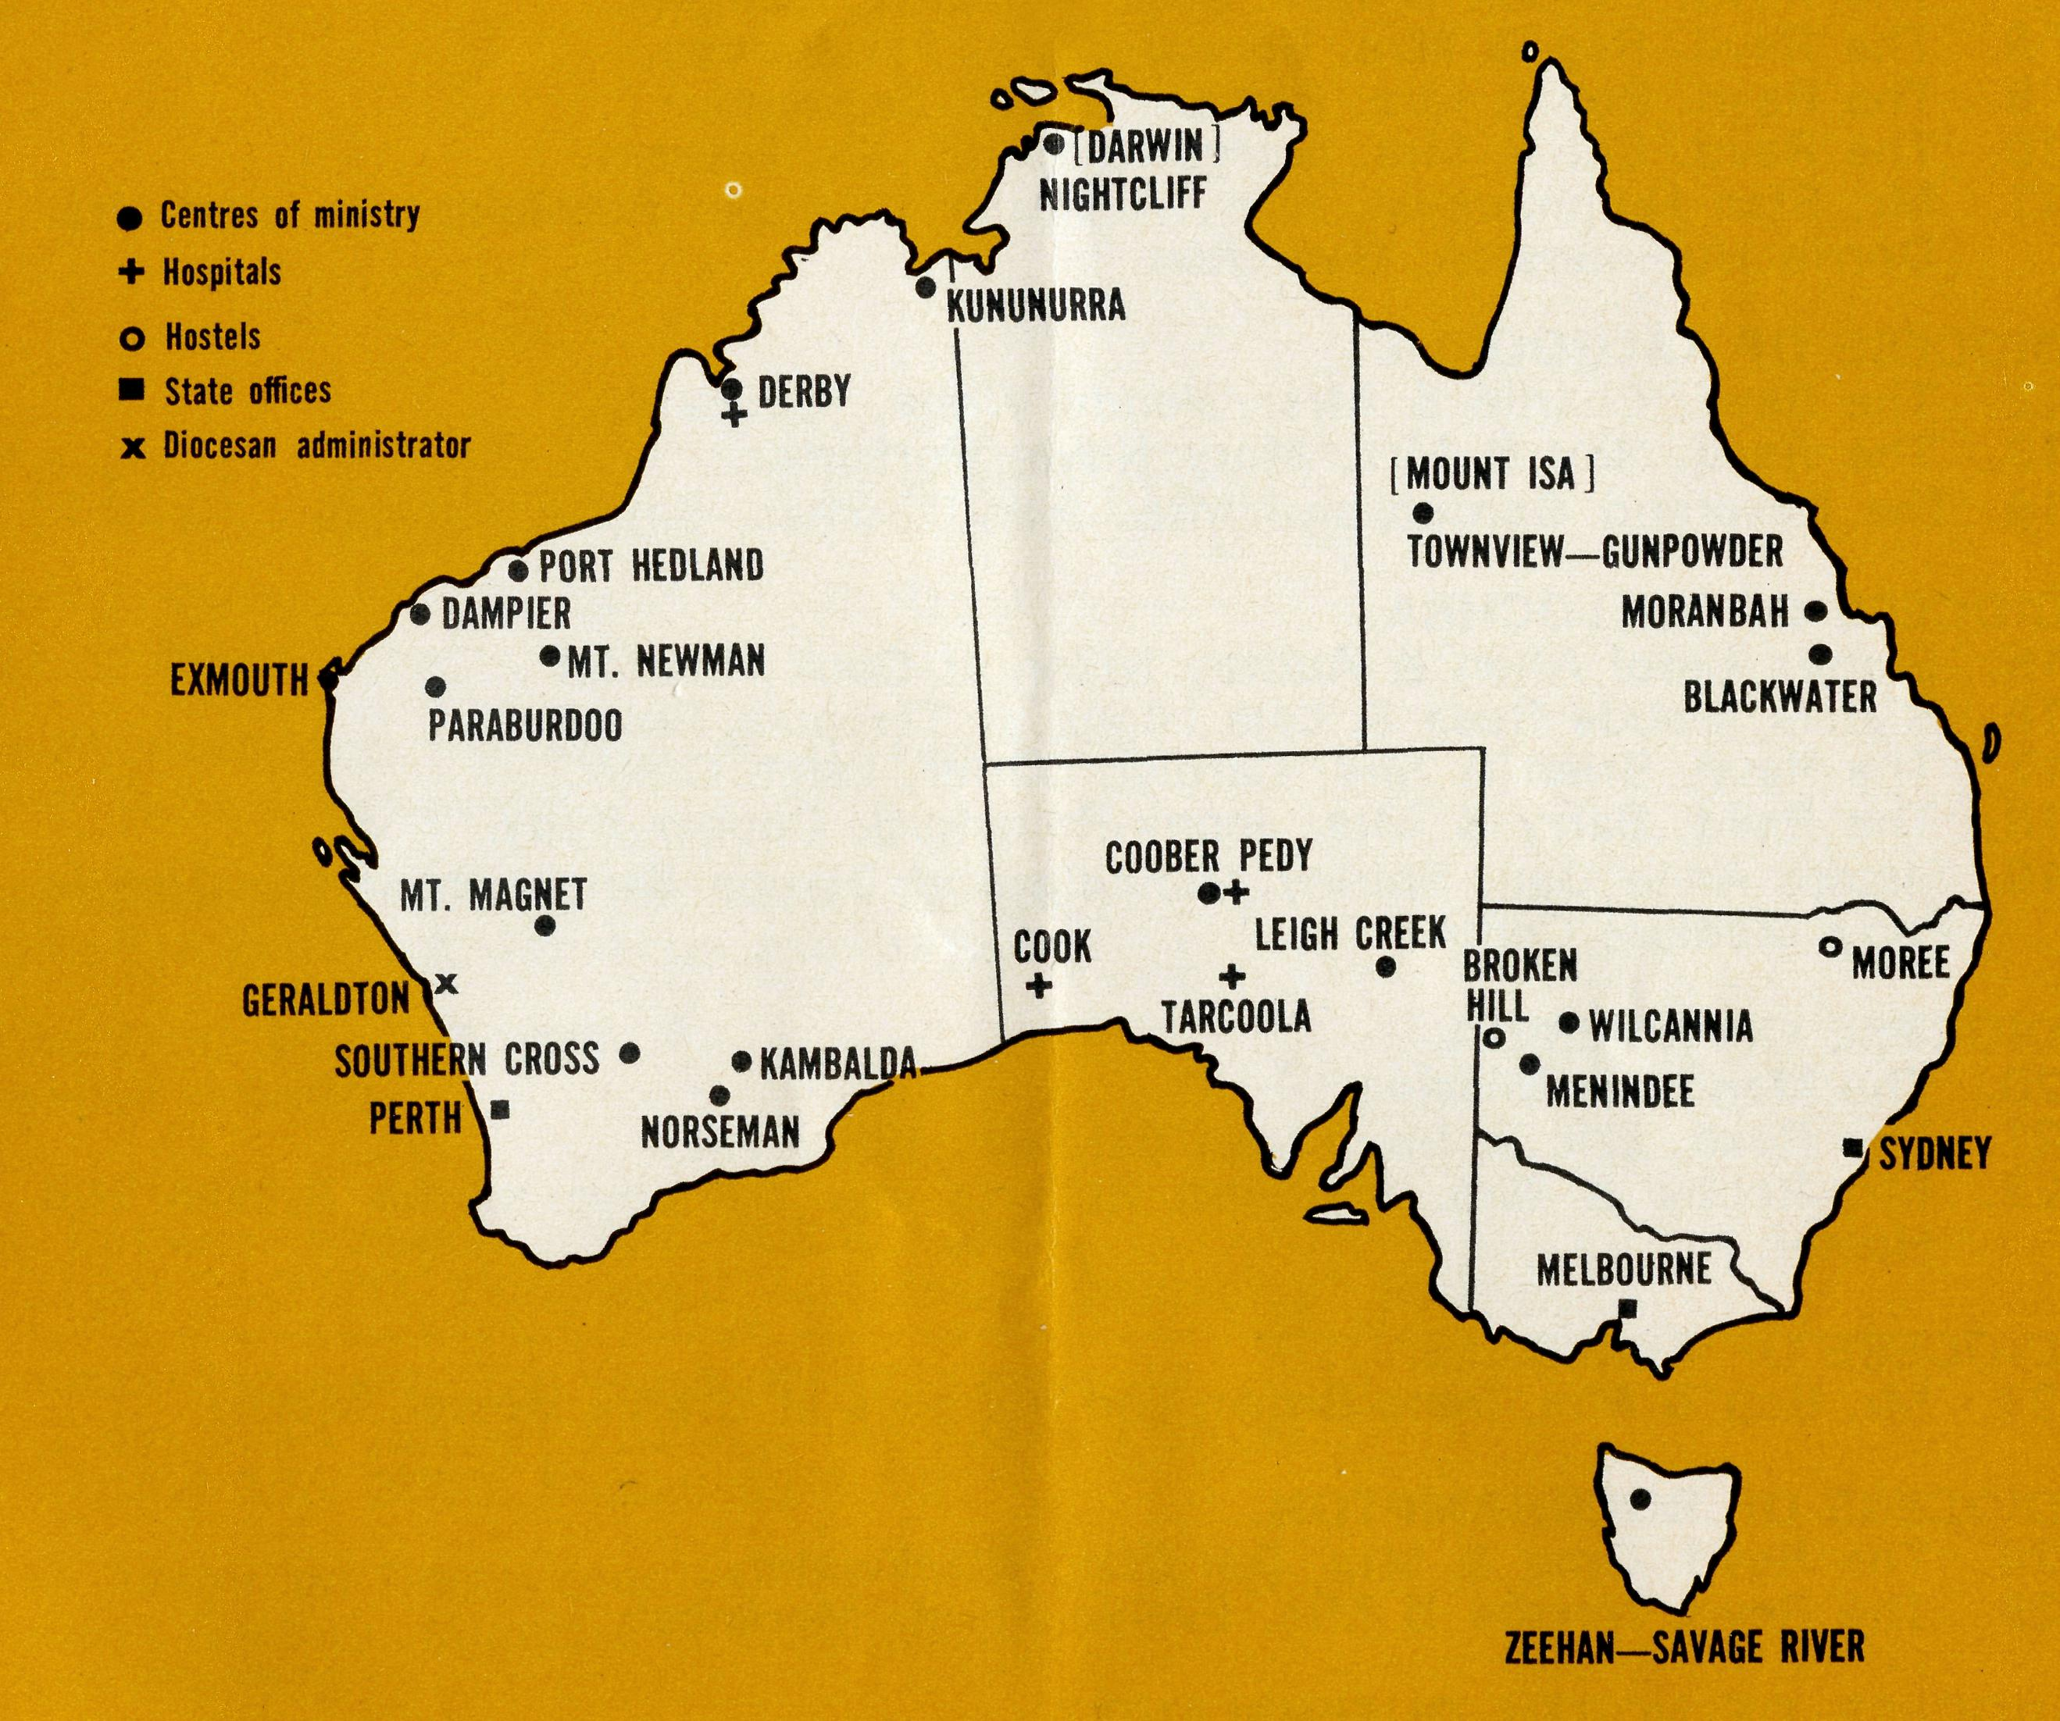

A DAILY
PRAYER
O Lord our God, help us to remember those who live in the remote parts of our land. We ask You to bless those whom You have called into the fellowship of The Bush Church Aid Society. Grant that, through the ministry of the Word and Sacraments, through healing, and through caring for the young, the message of Your redeeming love may be proclaimed, through Jesus Christ our Lord. Amen.
O God, we remember before You those whom You have called to Your service. We ask You to bless
, assure
them of Your Presence, and call others to stand with them in the task. Grant to them, as to us, the joy of service, the ability to achieve, and the serenity of Your peace, for Jesus' sake. Amen.

Women’s prayer meetings
Prayer calendar
and field staff directory.
DIOCESE OF NORTHERN TERRITORY.
1. The Revd. Alan & Mrs. Philippa Hoskin, Nightcliff.
DIOCESE OF N.W. AUSTRALIA.
- The Revd. Bill & Mrs. Jocelyn Ross, Kununurra.
- The Revd. Bernard & Mrs. Coralie Buckland, Derby.
- Sisters Joy Brann and Michelle Blondel at Derby Hospital.
- The Revd. Michael & Mrs. Heather Pennington, Port Hedland. Sister Carmel Grantham, South Hedland.
- The Revd. Ken & Mrs. Margaret Hagan, Mt. Newman.
- The Revd. Gordon & Mrs. Jean Williams, Dampier.
- The Revd. Reg & Mrs. Beryce Clark, Paraburdoo.
- The Revd. Ron & Mrs. Barbara Beard, Exmouth.

- The Revd. Bill & Mrs. Margaret Smith, Mt. Magnet.
- Mr. Stan Hummerston, N.W. Australia Diocesan Administrator, and Mrs. Dorrie Hummerston, Geraldton.
DIOCESE OF KALGOORLIE.
- The Revd. Charlie & Mrs. Wendy White, Kambalda.
- The Revd. Ray & Mrs. Mary Neve, Norseman.
14. The Reverend Gordon and Mrs. Joan Thomas, Southern Cross.
DIOCESE OF WILLOCHRA.
- Sisters Carol Allen & Audrey Nixon at Cook Hospital.
- Sisters Maude Ross & Lola Higgs at Tarcoola Hospital.
- The Revd. Brian & Mrs. Carolyn Carter, Leigh Creek.
- The Revd. Barry & Mrs. Jenny Rainsford, Coober Pedy.
- Sisters Anne Dau, Shirley Manning and Dianne Kennaugh at the Coober Pedy Medical Centre.
DIOCESE OF RIVERINA.
- The Menindee Mission.
- The Revd. Eric & Mrs. Joan Baldwin, Wilcannia.
- Mr. Robby & Mrs. Margaret Roberts and the boys at the Broken Hill Hostel.
DIOCESE OF ARMIDALE.
23. Mr. Bob & Mrs. Irene Brown and the boys at Urallie Hostel, Moree.
DIOCESE OF ROCKHAMPTON.
- The Revd. Greg & Mrs. Del Ezzy, Blackwater.
- The Revd. Neville & Mrs. Evelyn Knott, Moranbah.
DIOCESE OF NORTH QUEENSLAND
26. The Revd. Peter & Mrs. Fay George, Townview-Gunpowder.
DIOCESE OF TASMANIA.
27. The Revd. Blair & Mrs. Lyn Grace, Zeehan-Savage River.
GENERAL.
- Replacement Staff, Box Secretaries and B.C.A. Supporters.
- Deputation and Public Relations work, Revds. Barry Huggett, Barry Green, Ted Doncaster, Ted Watkins, Mr. Laurie Calder.
- The Revd. Theo Hayman and the Administration of B.C.A. and the National Home Mission Fund, the Council and State Committees.
14
Office staff: N.S.W. Mr. Burner, Misses Smith & McLaughlin, Mrs. O'Neill, Mrs. Wills. Vic: Mrs. Hughes.
THE REAL AUSTRALIAN

On Tuesday, September 12, 15 Sydney women will open their homes for B.C.A. prayer
meetings. This follows the outstanding success of those held in April. Attending a B.C.A. prayer meeting is
an enriching experience. Don't miss out — ring 26-3164 and ask for the location of your nearest prayer centre.
State Office Directory. . .
Federal Secretary, The Revd, T. J. Hayman —
Staff Administration.
N.S.W. Secretary, The Revd. B. D. Huggett —
Public Relations enquiries.
Asst. Secretary (N.S.W.), Mr. W. L. Calder —
Deputation bookings. Supporter enquiries.
Accountant, Mr. F. Burner —
Financial enquiries.
B.C.A. House,
135 Bathurst Street, Sydney, N.S.W. 2000.
26-3164, 26-3780. Telegraphic Address: "Chaplaincy" Sydney.
Victorian Secretary, The Revd. B. W. Green — 3rd Floor, Clark Rubber Building, 196 Flinders Street, Melbourne, Vic. 3000. Phone: 63-8962.
West Australian Representative, the Revd. E. W. Doncaster— Anglican Rectory, Mundaring, W.A. 6073 Phone: 95-1029
Sth. Australian Representative, The Revd. E. G. Watkins — 77 Beulah Road, Norwood, S.A. 5067. Phone: 42-2227
President:
The Most Reverend, the Archbishop of Melbourne.
Vice-President:
The Most Reverend, the Archbishop of Sydney.
Chairman of Council:
The Rt. Revd. G. R. Delbridge.
Honorary Treasurer:
Mr. R. T. Stokes
Ambassador Press Design

