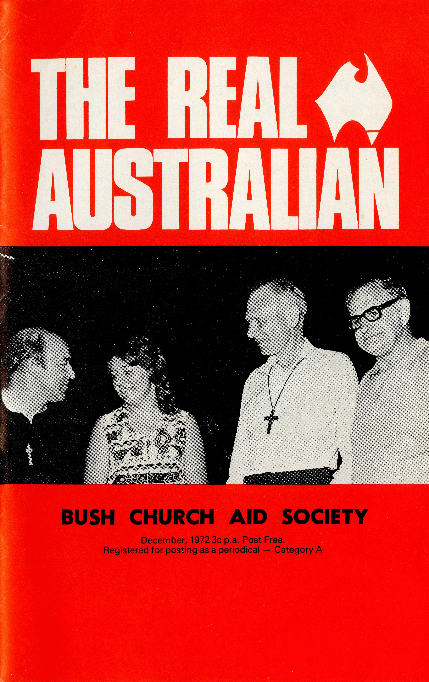
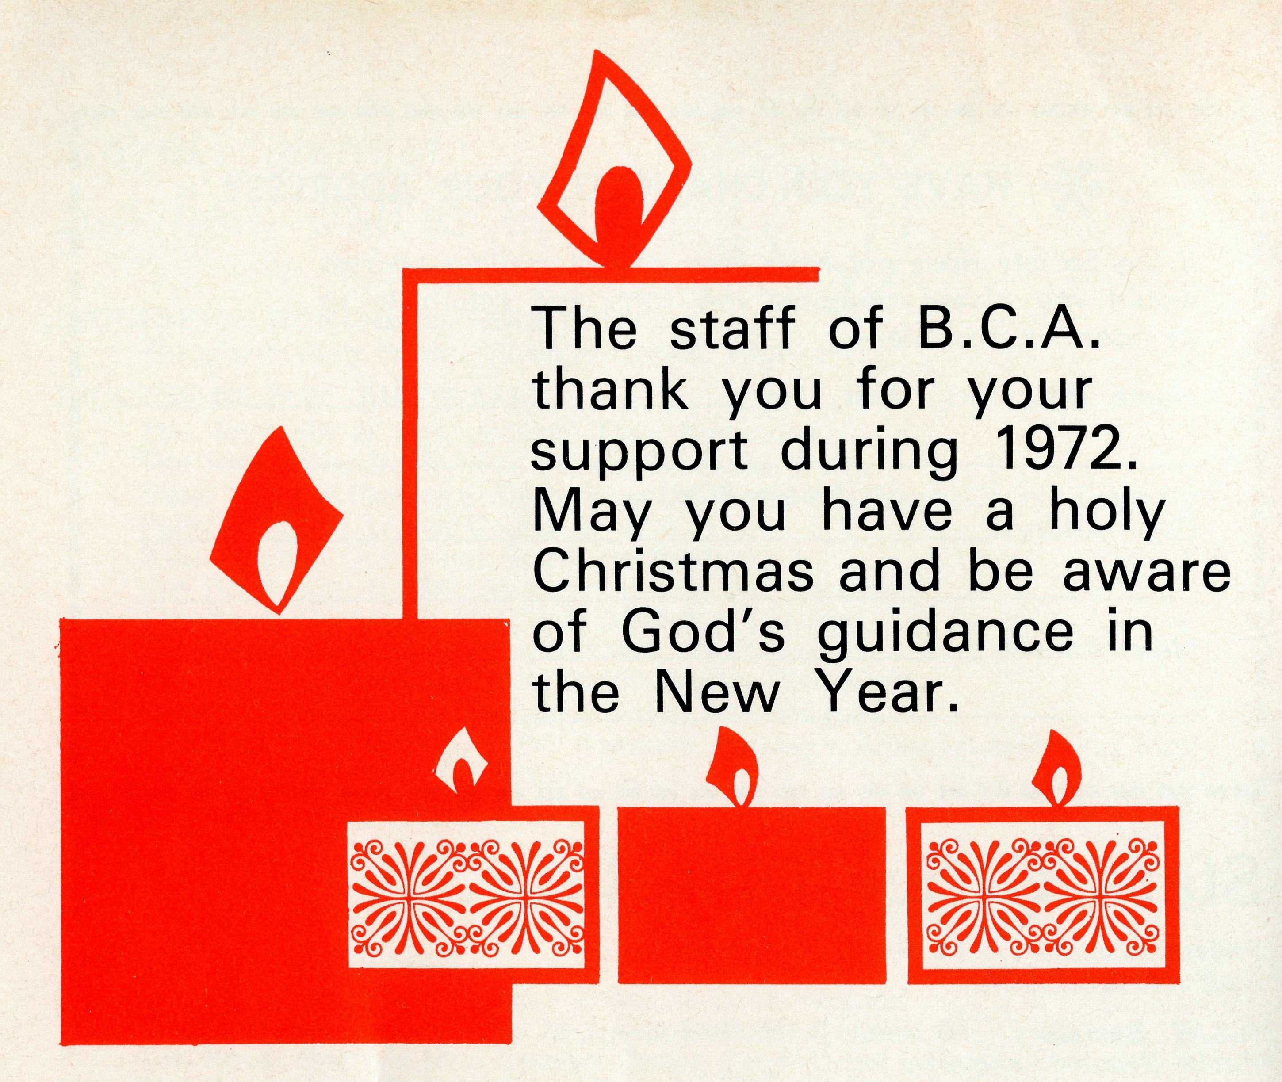
THE BUSH CHURCH MB SUCIETY FELLOWSHIP OF PRAYER
The B.C.A. Fellowship unites staff and supporters in prayer and interest. Regular bulletins are issued detailing current prayer requests of field staff.
Detach and fill in this form and send to:
I wish to become a member of The B.C.A.F. Secretary,
the B.C.A. Fellowship and 135 Bathurst Street,
undertake, with God's help, to: Sydney. 2000
BLOCK LETTERS PLEASE
• Pray regularly for the work of _{Revd}
B.C.A. and its members; Mr.
•Learn all I can of the spiritual Mrs.
needs of Australia and of the NAME_Miss
efforts of B.C.A. to meet them; ADDRESS
•Support the work of B.C.A.
financially and to use every
opportunity to make the . POSTCODE .
purpose and work of B.C.A.
more widely known. SIGNED DATE

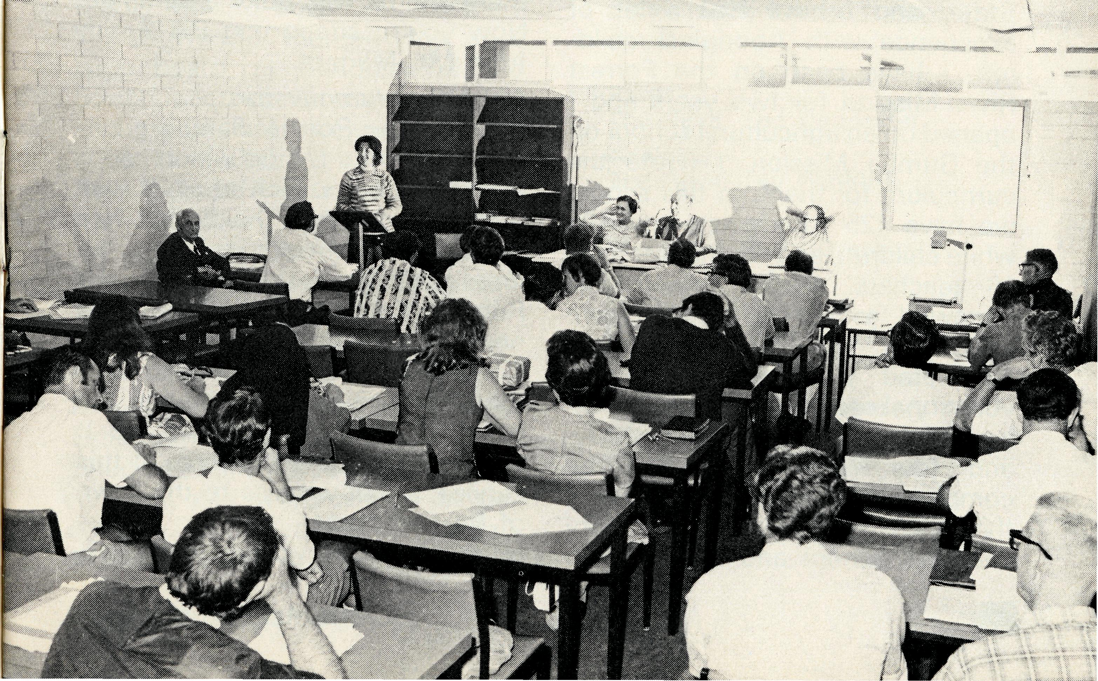
The Primate visits North West Australia
Synod in the High School, South Hedland, W.A.
Message by tape from Meekatharra
The Primate:
Here we are in the living room of Mr. and Mrs. Brandreth. He is the headmaster of the school here and it seemed to me that it might be a much better idea than having a monologue from me, that I ask those of us who are here in this room, just to say something about the work, because it happens that everybody here is working at something in this part of the diocese. It's pretty late, it's eleven o'clock at night but here is Bill Smith to say a few words.
The Reverend W. Smith: Well, good evening to you, Theo and to anyone else who is listening to the tape. I've recently got back from Synod in Port Hedland and found it a very worthwhile Synod. It was marvellous having everyone living in the same hostel, even the Port Hedland representatives were living with us. We all lived together, ate together, were able to argue into the night. Synod was, I think, a step ahead of anything in the past because of this aspect of fellowship. This fellowship was there, the chance to discuss things, a complete absence of any divisions, any parties or any particular power groups in it. Fifty-five motions, if you please, were passed in almost
Cover: Bishop H. Witt, Carmel Grantham, Archbishop F. Woods (the Primate) and Stan Hummerston.
record time (not all passed, says Stan). We had a happy time. We had our quota of four punctures on the way up and four punctures on the way back, which is quite normal for Murchison cars, so it seems. We've had a very happy time with the Primate here, we've had lunch by the Mt. Magnet Guild, afternoon tea by the Cue Guild and dinner by the Meekatharra Guild. To-morrow morning the Primate is going to be taken with Stan to a place called Paddy's Flat, a sort of a slum area two or three miles out of town, where several of the Aboriginal families are living in humpies; and some of the back streets of Meekatharra where you might see anything. He will see the school and the radio school.
The Primate:
This is back to me now. I am glad that Bill said something about Synod. I shall say a lot more about that when I do another tape on my own, but I enjoyed it tremendously, it was a really most exciting thing to be at and the fact that we all lived together, as he says, made a very great deal of difference. Now, David Blackman, is taking Bill Smith home in a short time and I am going to ask him to occupy the next little bit of the tape. David is on the staff of the Civil Aviation Board. Here he is. Mr. David Blackman: Good evening. His Grace has asked
THE REAL AUSTRALIAN
me to say a few words about Meekatharra from an itinerant's point of view, I've been here for 12 months with the Department of Civil Aviation, and we're beginning to know a little bit about the town. It's a strange town, it's a town that has no reason for being and it is generally a support town. A lot of Government work is here. Meekatharra has been affected by the downturn in the mineral industry in the North West, although this appears to be picking up again now. We've got the uranium out in the Yillerie area and from my point of view in Civil Aviation, I have noticed an upturn in the amount of flying that is going on, survey flying, geological flying and such like. Meekatharra seems to be developing. I'll say a few words about this evening. We had an extremely interesting sermon from His Grace, a very pleasant buffet dinner afterwards and again another very interesting address from His Grace. We have been singularly
honoured by his presence here. I have just returned to the congregation after many years absence, I haven't been a very good Christian for quite some time now, but I have been reasonably impressed so far by the strength of the Christian Church generally in Meekatharra and the warmth of the congregation.
The Primate:
Well now, David Blackman and Bill Smith have gone off to bed and I really ought not to ask our kind friends, Mr. and Mrs. Brandreth to go on with this, but if we don't, we certainly shan't get it done. Now here's Mrs. Brandreth, and I have asked her if she will tell you a little about her "School of the Air".
Mrs. Brandreth:
Well, at the moment I'm attached to the Meekatharra "School of the Air" and we have 66 pupils enrolled. We cover a radius of approximately 300 miles and it's quite an experience sometimes to

know that you have children in your class communicating over perhaps, close to five or six hundred miles. There are two other women teachers, Mrs. Judith Corrit, who is in charge and does the junior grades, I do grades 4, 5 and 7 and we have just had another part time teacher appointed to do grade 6. Our air time is so arranged that each grade has half an hour of schooling per day which really is very, very little and sometimes we feel a little frustrated in what we can do from this end, but after meeting a fair percentage of the children and speaking to parents, it's the contact we feel is the most important thing.
The Primate:
Now I am going to ask Martin Brandreth if he will say a little about his job here as headmaster of the school. He's been here only a year, but before he was here, he was at the Forrest River Mission.
Mr. Brandreth:
Good evening. Yes, I've been, I suppose, from the top end of the State to the bottom end of the State, and I have had a lot of experience with Aboriginal children. I have been on the Forrest River Mission for two years and I opened up an agricultural school on the Gumba Mission. I wrote the curriculum for them. In this school we have 125 Aboriginals and 125 white children, and for this we have 16 teachers. We're rather well endowed as far as buildings are concerned and we have just completed a manual arts pre-vocational centre, a home economics centre and a science laboratory, and four new rooms will be completed by the end of October. I think we've got a very, very beautiful school and the children
are now taking a lot of pride in it. We have a lot of problems here with the children's horizons. These seem to be so terribly limited and we find that we have to inject a sort of enthusiasm into them. My aim now is to try to take them on as many educational visits as I possibly can to let them see outside Meekatharra. It's amazing how many children, white and black alike who have not been out of Meekatharra and they're 10 or 12 years old.
The Church does play a role in the school, each Monday I insist that we have our Reverend friends in from all denominations. They come and take up the complete Monday morning, and we find they do quite a good job.
The Bush Church Aid Society is of great benefit and I think I'd like you to know this. We've been on Cockatoo Island as well. You're supporting the Reverend Bernie Buckland up there, and he used to come out to the Island, to the township of Kuri Bay and to Broome. He did a magnificent job there and he was quite a stimulus. Now you're supporting Bill Smith from Mt. Magnet. Mr. Stan Hummerston: After leaving Port Hedland we can look back on a Synod which had a number of firsts. First of all, it was the first time that the Synod has been held away from Geraldton, the first time that we've had the Primate of the Church of England at our Synod, to preach at our Synod Communion Service, the first time that a service has been held in the new Civic Centre at Port Hedland. It was good to see 200 people at this service, a real witness to the town of Port Hedland. Most of us, as you can imagine,
have travelled great distances. We from Geraldton, had to travel over 1700 miles there and back to attend Synod. It was a good experience for most of the people to see something of the North West. It was also the first time that Reg Clark and Ken Hagan have attended a Synod in the North West. From the Synod came motions too, that you should know about. One, appreciating the support that the Bush Church Aid Society is giving to the diocese. Being mindful of this assistance and the great help and prayer backing that the Society has given us, we were also mindful of our own efforts to do greater things towards becoming self supporting. It's good to say that every parish now in the diocese has contributed some funds to a car fund which we have, which will make it possible for at least every parish to make some contribution towards a new car rather than depending upon the Society for this. As you know, many of them are making some contribution to stipends, and we're glad to say that this is moving now. We showed for the first time, on a large board, at the back of the Synod meeting, the assistance that each parish had received, whether it be from B.C.A., whether it be from National Fund or whether it be from our own diocese, and it is interesting to note that the diocese almost gave all its assistance back to parishes. Some parishes which are being supported by the Society need new land.
It was the first time for Carmel Grantham to be in the diocese at a Synod and she made her contribution too. We heard a little of her work in South Hedland. She seems to have settled in well. . . .
DEPUTATIONS FOR 1973
We are always glad of and welcome opportunities to provide a speaker for Sunday Services, mid week meetings, youth groups or ladies organizations. The Society story is exciting, challenging and with slides or Audio Visual can be a very interesting segment in any programme. Bookings are now being made for the following speakers.
Perth-
The Revd. Ted Doncaster.
Adelaide-
The Revd. Ted Watkins.
Melbourne-
The Revd. Barry Green.
Sydney^
Mr. Laurie Calder.
(The Revd. Ron Beard.)
(The Revd. Theo Hayman.)
see State Office Directory for addresses and phone numbers inside the back cover.

THE REAL AUSTRALIAN

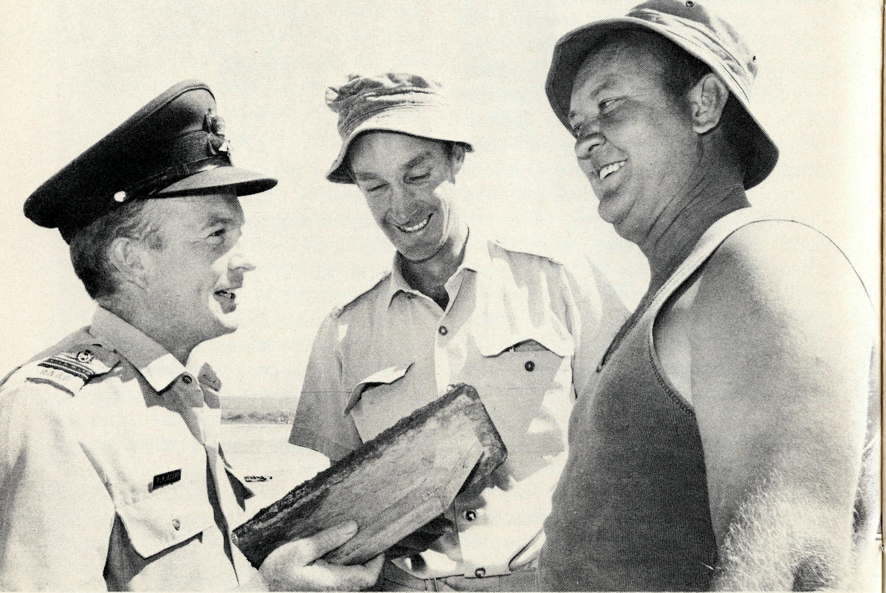
Padre at Learmonth
When the advance party of No. 5 Airfield Construction Squadron, RAAF, arrived at Learmonth, in March 1970, they were greeted by an old boy who had been a squadron member 18 years earlier.
The ex-member is Fit. Lt. Ron Beard and he has now rejoined the Squadron as their Church of England Chaplain, being already the B.C.A. missioner at Exmouth.
THE REV. RON BEARD NOW BECOMES THE N.S.W. SECRETARY FROM 1ST FEBRUARY, 1972.
a word to boxholders
Our sincere thanks to all those who continue to contribute to the Society by using our collection boxes. Financial support from this means is increasing year by year enabling the Society to reacR out to people in its medical, hostel and pastoral ministry. If there is no box secretary in your Parish, we would be grateful if you would clear the box yourself, forward a postal or money order, or cheque, and we will send a receipt and a new label to reseal the box. Alternatively if in town, you could bring the box to our office.
Exmouth
"Radical" was the comment from a visiting Presbyterian dignitary, after one of our services. Actually it was just Evening Prayer, 1662, read, and then an old fashioned sing-song of C.S.S.M. choruses followed by an attempt to learn a new hymn.
Our song leader is a Scotsman, with a delightful brogue and our soloist is the A.I.M. Deaconess from Melbourne. The congregation is a variety of American sailors and families, with R.A.A.F. fellows and their families, and a number of civilians thrown in. One thing is certain, there is plenty of joy and fellowship both in the service and the supper that follows. Naturally there is a first rate sermon from the B.C.A. padre, backed up by the prayers of the congregation. You know it really makes a difference when the congregation stop criticising and start praying for their preacher!
Let me tell you about the Wednesday night Bible Study. I go along but it is conducted by an American Chief Petty Officer and about 25 adults attend. We just went through Isaiah. Each night we studied from four to ten chapters, sometimes taking 2\ hours. One night we had just over 90 references to look up in the New Testament.. Hours of preparation and prayer had gone into the study by the leader, and hard work though it was, attendances did not drop. Now we are on John's Gospel and often referring back to Isaiah.
It is a strain being the minister of a multi-racial and multi-denominational congregation, but I am
very thankful to God for the privilege. I have come to the conclusion that a minister's job can be defined in simple terms by the statement "to help men get to Heaven". If we all keep that thought in mind we won't get side-tracked on to non-essential or even wrong activities. However it will mean that we do all kinds of things for people that will help them along the road to Heaven. I took over a so-called rebellious class of 2nd and 3rd year High School students this-year and began by telling them I was here just for that purpose — to help them get to Heaven. Then I gave them a copy each of Matthew's Gospel in their language, T.E.V. and we started to read together what Jesus said and did. They ask me questions, or I ask them for comments. Their interest is amazing, discipline is solved and three have been Confirmed two weeks ago, several are turning up at Church on Sunday nights. One last thing, money, I call it "God's Housekeeping". Three years ago our income paid to keep the car on the road and little else. B.C.A. paid stipend, rent, and bought the car. Last year we started a budget in Exmouth of $20 a week. This year it was raised to $55. Each month the Church committee has reported a slight surplus.
The treasurer said to my wife, "I really did not think it would work." Barbara replied, "It is just a matter of faith. We did our part, we told the people all about the needs and provided weekly envelopes, the rest we left with the Lord." B.C.A. supplies the stipend and perhaps next year the parish will do something to help with that too.

THE REAL AUSTRALIAN

over the ranges
from the Federal Secretary
Perhaps you attended the intercessions for missions on St. Andrew's eve recently. In a preview of the service and prayers, I noticed the§e words:
"For those whose work is prospering, we pray that they may practise always the humility of Christ and realise their dependence on Him." We are indeed grateful to God for His hand upon us for we have prospered. God has been good to us in answer to prayer, both financially and in manpower. Many have been faithfully praying for Menindee and, even before folk had read the last "R.A." of the need at Wilcannia and Exmouth, God had answered prayer with clergy volunteers. Please read the "Post and Rails". We have prospered too with more nurses (even though we still need another three!) Reports of God's goodness come from parishes, where, for example, a young man, "down and out" called at the B.C.A. missioner's door. He was given hospitality for a
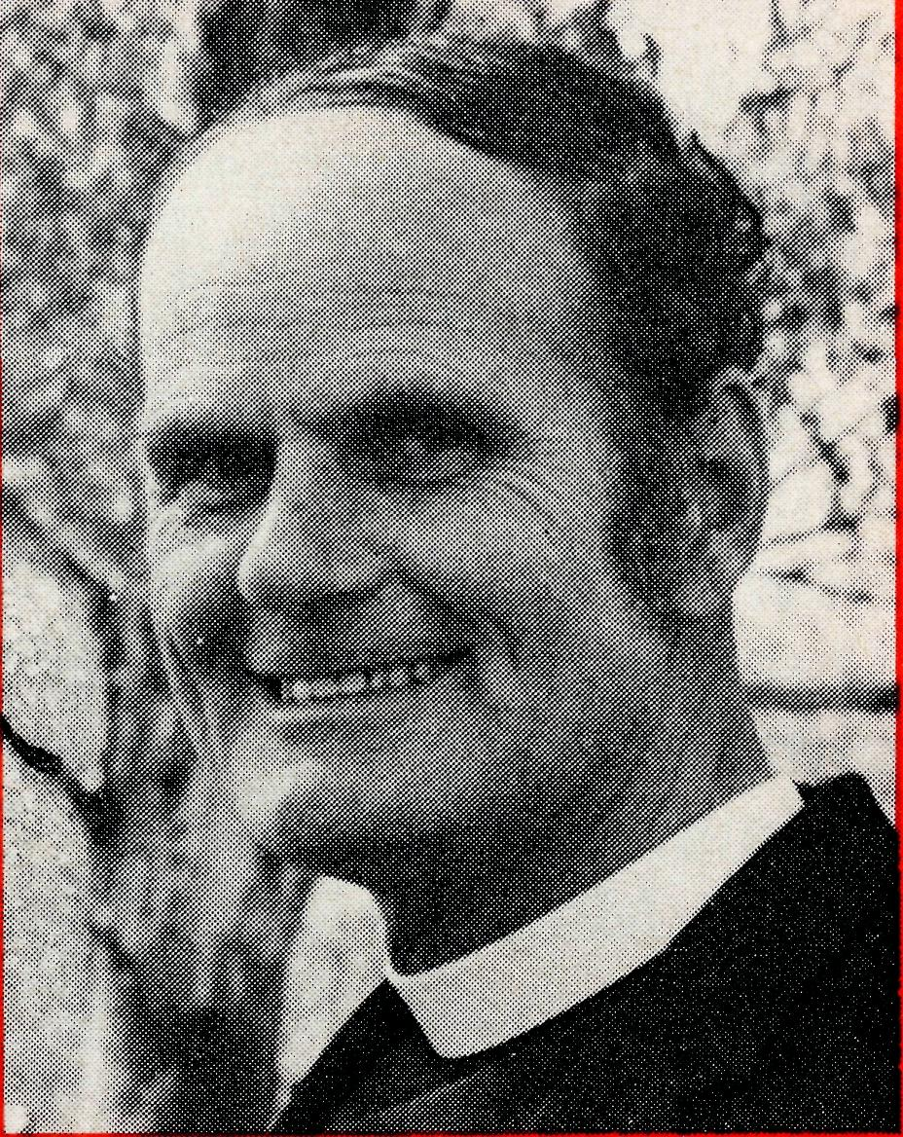
week. He found a job locally in the mine, but better still, he was found by God. He picked up a Bible and through the counselling of the missioner, he was converted, began studying the Bible and became a regular member of the church. Before long he was helping with the youth work. Now he believes he is called to the ministry! We pray for humility as we depend on God.
We depend on God, whether we know it or not. But knowingly we acknowledge Him for what He is and all that He has done. A testimony, to be worthwhile, must be a living and continuing experience.
THE REAL AUSTRALIAN
"He came unto His own", said John in his Christmas message. Our dependence on that glorious Christmas birth, death and resurrection, makes real the next verse, For "to all who receive Him, who believed in His name, He gave power to become the children of God; born ... of God." Praise be to Him. Your friend,
Monday mornings are always hectic with Christian Education classes at the school but add to that today the preparation for an "over the Kimberleys" trip. Bags not packed yesterday had to be completed, final calls made to people with request instructions of what to do while I was away, calls at the various agencies to ask what mail, papers and freight there may be for the places to be visited and then to school at 9.10 a.m. The folk at Mt. Hart were expecting me for lunch which meant that I should leave by 11 a.m. On racing back to the Rectory at 10.30 a.m. I found someone waiting to see me and then what with fueling the aircraft and loading up it was noon before I left. The Cessna 182 that I now hire from a local firm makes travelling easier. The manager was away but this gave me more time with the station hands at Mt. Hart. We talked of many things. Before I left $15.00 worth of literature had been sold and other publications distributed. I use a number of "Decision " magazines, Bible Society pamphlets, Scripture Gift Mission material and also some large books sent from one of the B.C.A. supporters in Victoria. On to Silent Grove. Tuesday morning began with an early rise and off by 6.30 a.m. for
Revd. Bernard Buckland
Mornington. Usually the manager is out on the run when I have called. To-day, however, I met the new manager, his wife and children, all at home. (There is some advantage in making your first visit of the day before 7 a.m.!) More Christian literature was sold and we had prayer together. I was pleased to discover there was a connection here with my ministry in Ceduna. Mrs. Bunch is a sister of Iris Irvine who used to work at the Ceduna B.C.A radio base. Glenroy. . . . Mt. House. It was good to meet, with the family I knew so well, two other families from Kimberley stations. This is the advantage of a longer ministry of four or five years. Folk want to talk to you, are prepared to listen and read.
At Gibb River, I met the three families, and was kindly lent a vehicle to visit a bullcatcher and his wife, whom I knew well, but who were camped out in the bush. My travelling library of paper backs was in demand and many books were exchanged at each stop. Mt. Elizabeth for the night. Mr. Lacey was head stockman on the Forrest River mission and is always anxious for the ministry of his church. After tea, his son Peter took the battery out of the Toyota

•SISTER JOY BRANN, after an interview with the Director of the College of Nursing Australia, has been appointed Course Tutor to the Public Health Diploma Course. Although Joy will be based in Perth, much of her work will be the supervising of the training of Aboriginal nursing aides. With most of the W.A. Aborigines in the Kimberleys, she will be spending time in Derby and Kununurra. She will remain in the B.C.A. and seeks your prayer for this important post.
• NURSES are still needed for Tarcoola and Kununurra. Here is a plea for triple certificate sisters to do welfare work or mothers and baby clinics in a remote area. The plea is urgent. Two new nurses join our family, Sister Patricia Lund, from England, has gone to Cook. From Cook, Sister Carof
II
THE REAL AUSTRALIAN
and we had slides with a Jungle Doctor film strip. I was reminded of my hurried departure when I missed the cassette commentary recording Once again I felt the need for a light weight A.C. plant of 1500 watts and one of those light weight Eiki movie projectors. At Communion the next morning, I did find the cassette for hymns. A friend in Victoria is making more hymn recordings which will be welcome. I hope the people know them!
My next stop at Mitchell River was the first for me. At other times the people were not at home. I received a warm welcome . . . then Mitchell Plateau. Only ten men are here at this bauxite mine. Production has yet to begin. Over lunch all but one of the men spoke to me, a distinct improvement compared with earlier visits. . . . Kalumbaru . . . loaded here with tomatoes and watermelons for Troughton Island. This rises twenty-nine feet above the sea, is about three quarters of a mile long and a quarter of a mile wide. Two families are there as lighthouse keepers. We had slides, the Jungle Doctor film strip and the sale of many books and four Bibles.
On Thursday a visit to Theda, where I exchanged Kalumbaru watermelons and Troughton Island fish for eggs and books! At Doongan, I had prayer and books were sold to my Roman Catholic hostess as well as to others. Drysdale River. . . and then to find Ellanbrae. Navigation is difficult and the station is hard to find. I have never actually seen the homestead from the air as it is hidden in trees at the creek bank. It was getting dark. I had given myself a four minute over the E.T.A. mark before turning back. I thought I was south of the
IO
homestead and my prayer was a quick but fervent, "Lord, where is this place?". I swung north and there it was. It had been hidden by a high ridge. It was a very pleasant evening with the manager and his three visitors.
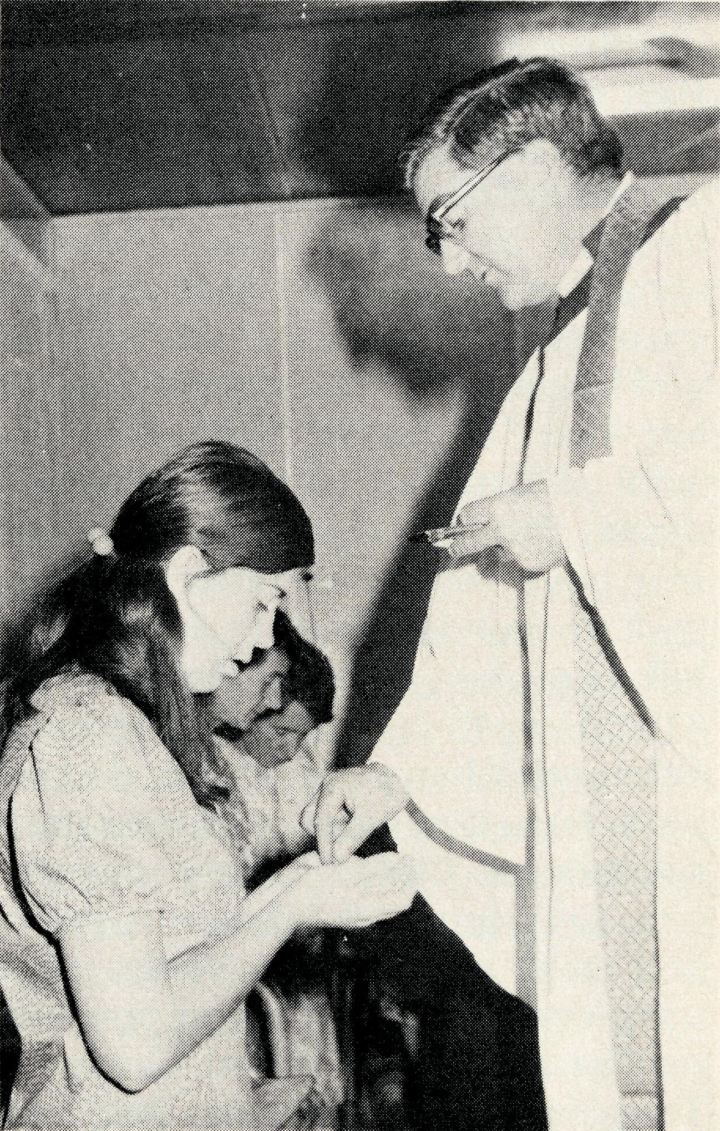
An outback home service.
At Wyndham and Kununurra I had some Scout business to attend to for I am now an Assistant Area Commissioner (Development). I picked up David and Ann McDougall at Wyndham having left the last of the Theda eggs for David to give out on the reserve, and we went to Kununurra. David, Bill Ross and I form the chapter of the Kimberley Rural deanery and we met together for prayer and discussion of Synod. It was a much longer flight down to Tablelands for the night. The last of my children's books went here and other Christian literature was sold.
There is a real ministry in this literature distribution for it is almost the only way to continue assistance after the yearly visit. Saturday was an easy day. Lans-downe and Fossil Downs. Here were a number of people to see. We had a service that evening, with five of the Aboriginal families and five of the European staff present on the homestead verandah. It was a simple service with a reading, prayer, hymns and a message. At breakfast the next morning the governess, who also is the relief cook, said, "Mr. Buckland, I forgot to give you this last night." "This" was an envelope which proved to be her pay packet. The ministry in the bush is appreciated. It was strange to be at Fitzroy Crossing for a service of Holy Communion on a Sunday. Unusual? Services are usually here on Wednesday. Leopold Downs for noon and lunch. One of the men wanted to slip out when he heard that the parson was coming. But
the lady of the house persuaded him to stay to discover that the parson "wasn't one of those" (what ever that might be!). Nookanbah . . . Camballin. Here a service and then to Liveringa to stay with a fine Methodist couple. Luiluigui. . . and then out to Arjorie in the desert for my first and I believe the first visit for any clergyman. I was surprised to find the place so easily and was impressed to see the work carried out by the young couple. I found I had baptised their children in Derby. Udialla was another small station where the whole family had to work hard to build up a place with very little capital. I arrived home to the family at Derby at 5.00 p.m., just in time to shower and change for a wedding at six. Tuesday was mail day and it was good to be home. But by 6.30 a.m. Wednesday I was off to Cockatoo and Koolan Islands where I am writing this. Please pray for my wife and children as well as for me.

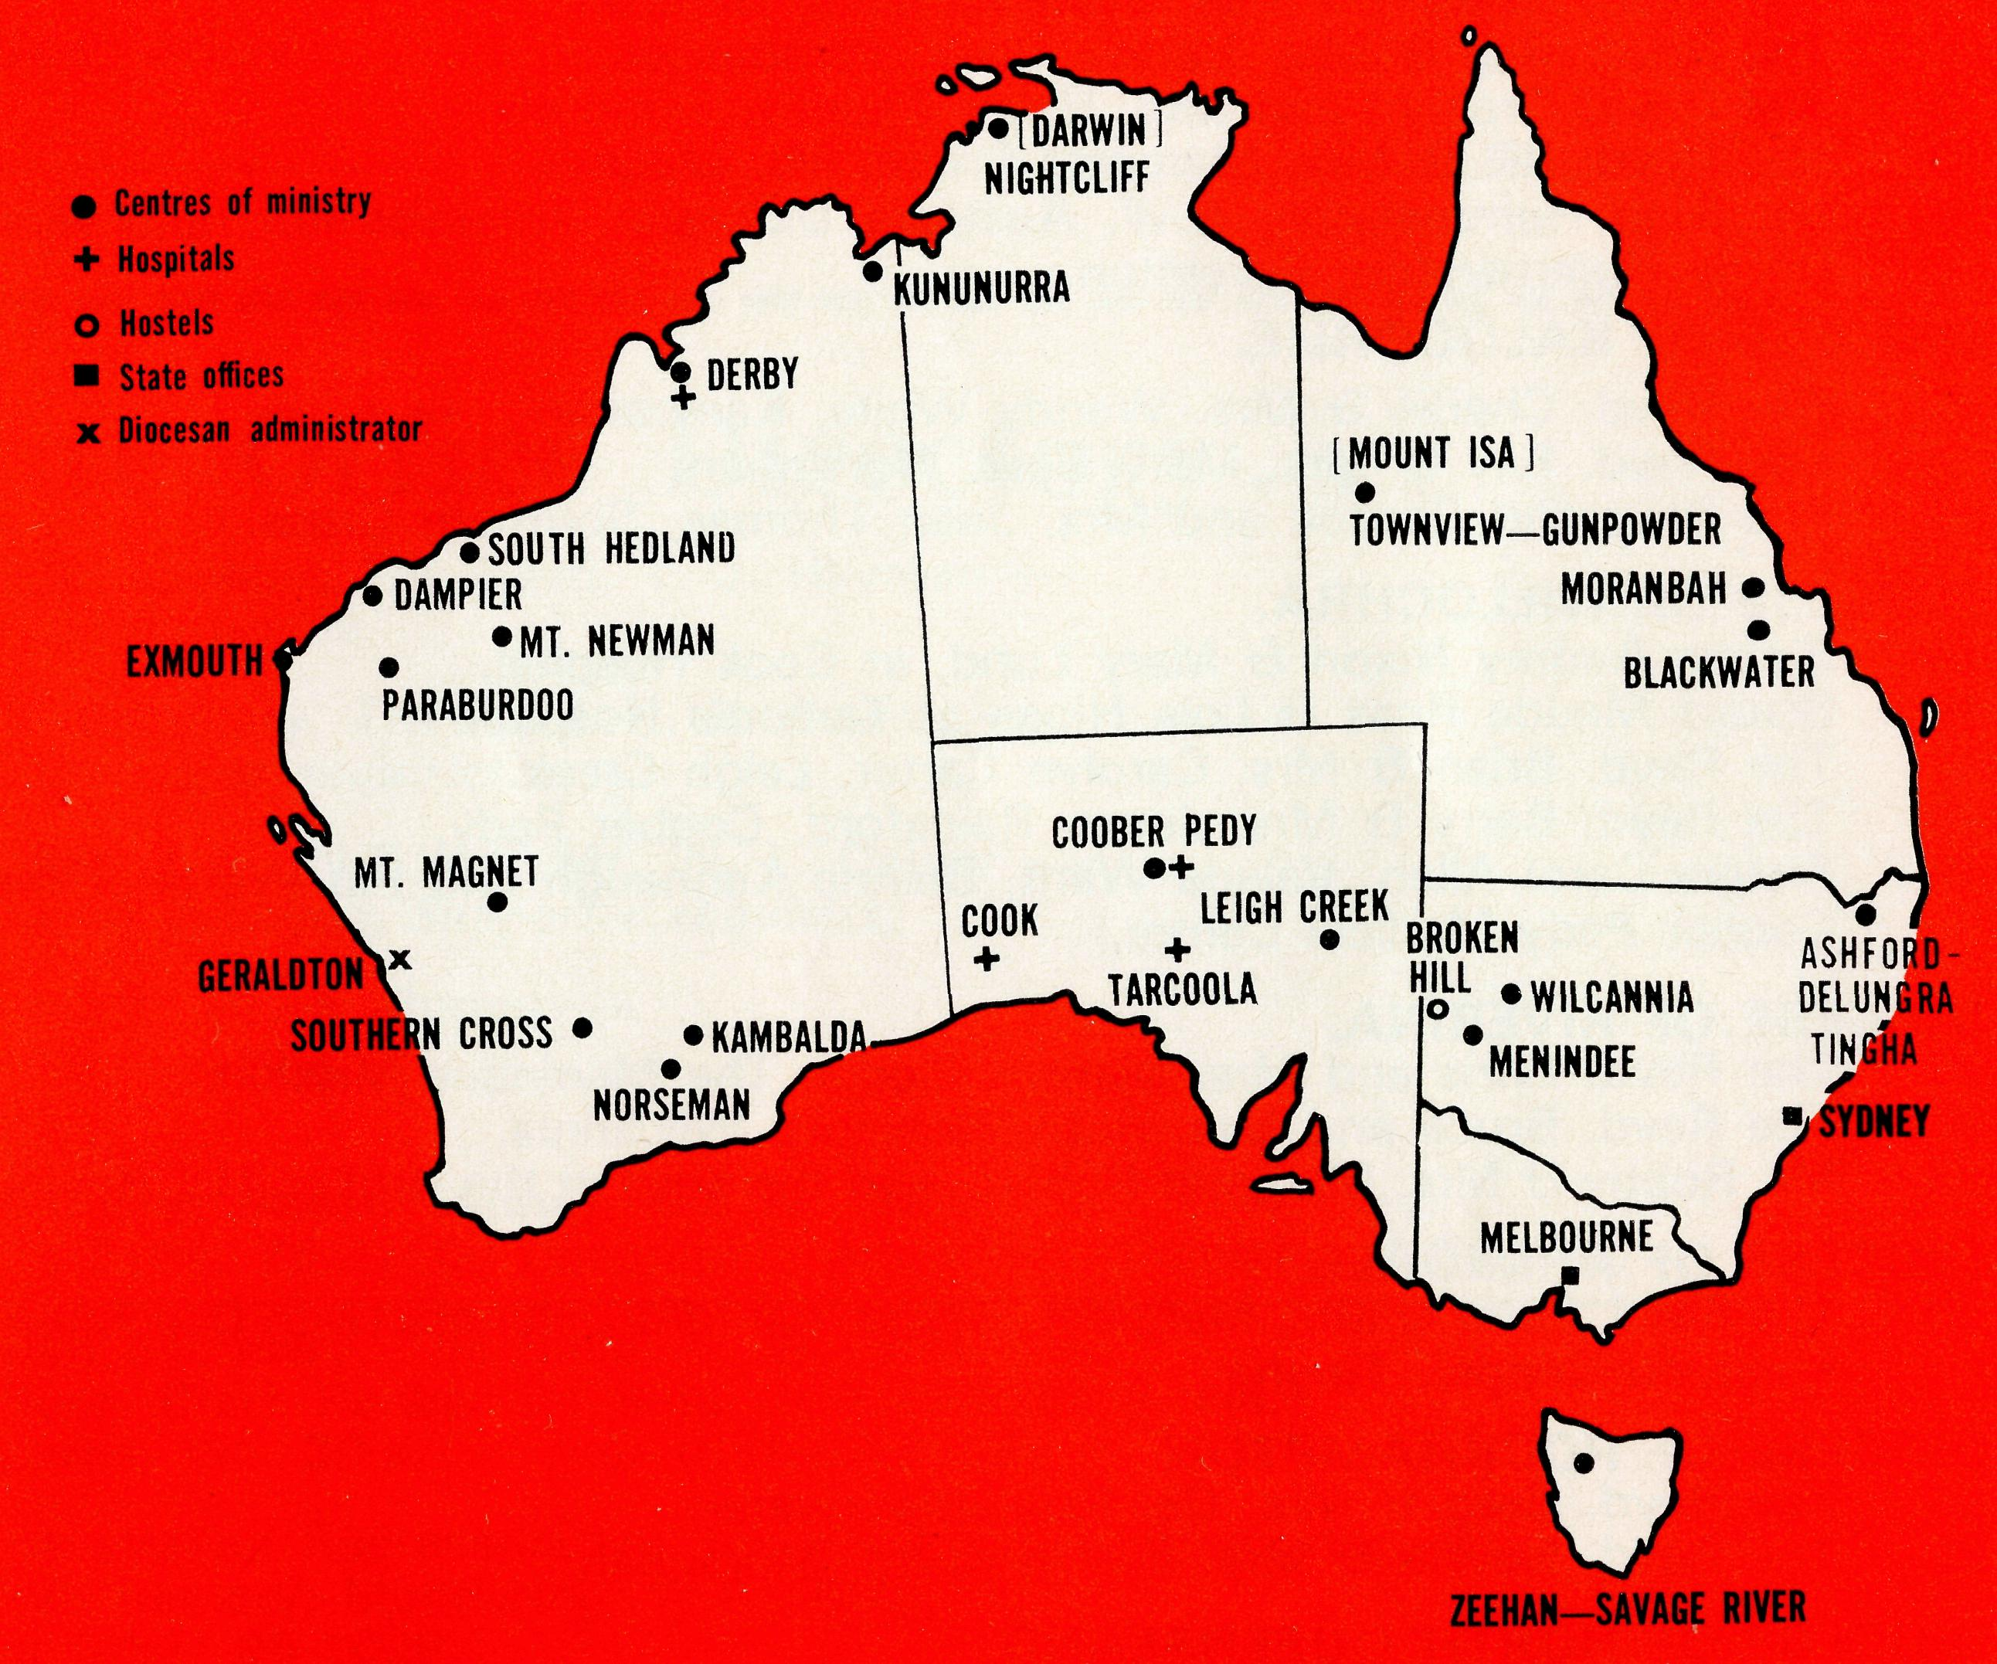
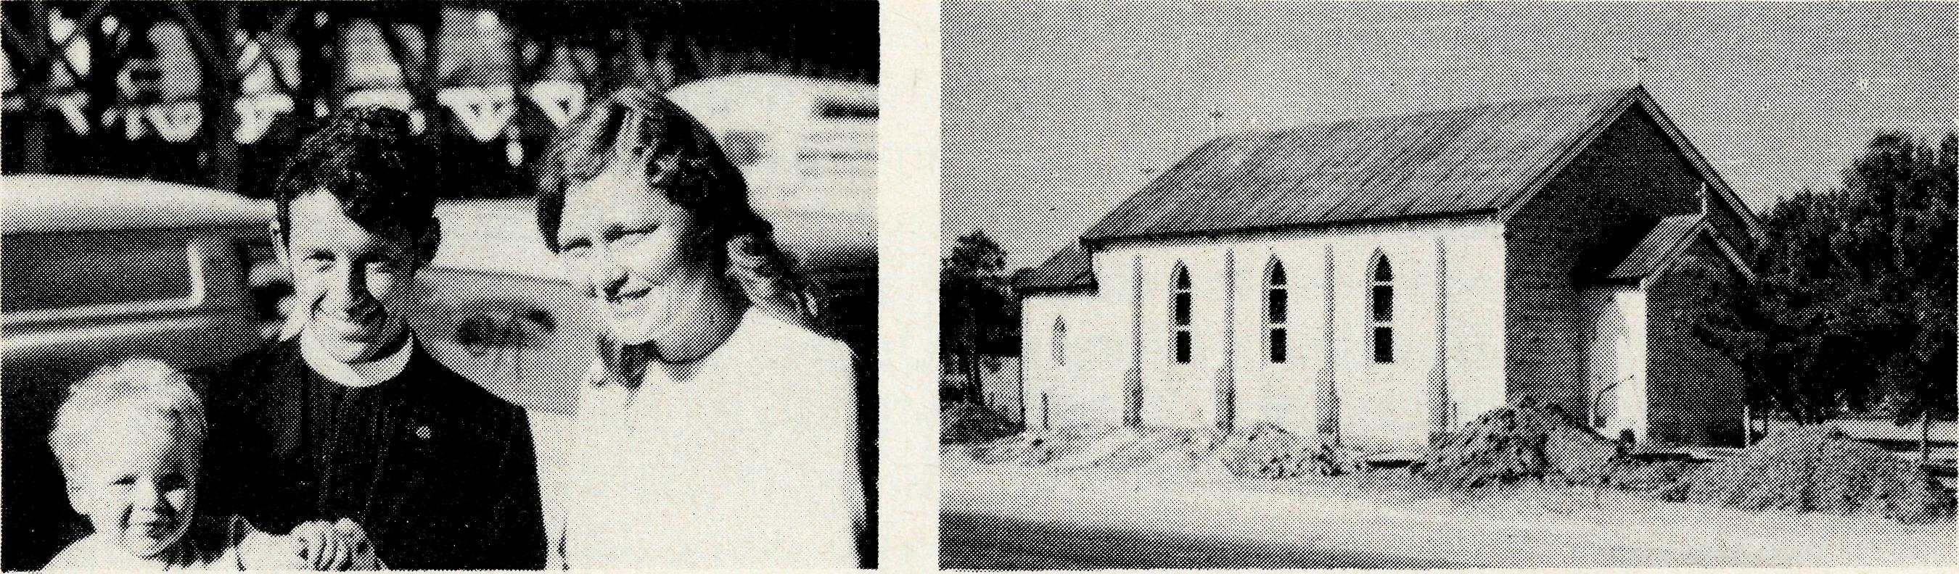
Allen, after holidays is going to Coober Pedy to take charge. Sister Valerie Want from Newcastle will also join the staff at Coober Pedy. There will then be four members of staff again following the end of service for Sisters Anne Dau and Shirley Manning whose contribution we valued. • BOB AND IRENE BROWN reluctantly finish six years with the Society at the Urallie Hostel for boys, Morde. For some years the need for the hostel has diminished with more high schools and school buses travelling greater distances. Although the hostel is closing, Bob and Irene will remain with their family in Moree. Bob is the Rector's Warden.
Holy Trinity Church, Menindee.
Justin, Marilyn and Chris Clerke.
•The Reverend ERIC AND MRS. BALDWIN will leave Wilcannia at the end of this year after three years of faithful service and this on top of overseas missionary service. Already the Reverend CHRIS CLERKE, Marilyn and Justin are at Menindee whom we welcome into the B.C.A. family. •The Reverend GRAHAM THURLEY, Helen and Matthew (1 year) leave for Exmouth mid February after a valedictory in Launceston, Tasmania. •The BISHOP TOM JONES memorial is to be at the Willochran Diocesan Centre, Melrose, S.A. Contributions are invited to the Tom Jones hall or new wing in the sleeping quarters.
•We are grateful to BARRY HUGGETT for the broadcasts on 2CH (Sunday at 1.04 p.m.) even after his new appointment in Melbourne. Ron Beard will commence at the microphone early in February.
- We are grateful to God for those who continue to have a very real concern for the Society and its ministry. Earlier this year the folk at St. James, Castlecrag (Sydney Diocese) held a fancy dress parade and raised approx. $200 to assist finances. More recently the ladies at St. Georges, Stanwell Park held a B.C.A. coffee morning. The Federal Secretary was present to lead in prayer and show slides of the work.
- Our very warm thanks and appreciation to Mrs. Coxon our Box Secretary at St. Faiths, Narrabeen for nearly fifteen years. Mrs. Coxon, whose interest in B.C.A. dates back to the very early days, has maintained and demonstrated a vigorous concern. She is assured of our best wishes and prayers as she lays down the task at the end of this year. We also commend her husband's health to God.
THE B.C.A. PRAYER

A
DAILY
PRAYER
0 Lord our God, help us to remember those who live in the remote parts of our land. We ask You to bless those whom You have called into the fellowship of The Bush Church Aid Society. Grant that, through the ministry of the Word and Sacraments, through healing, and through caring for the young, the message of Your redeeming love may be proclaimed, through Jesus Christ our Lord. Amen.
0 God, we remember before You those whom You have called to Your service. We ask You to bless
, assure
them of Your Presence, and call others to stand with them in the task. Grant to them, as to us, the joy of service, the ability to achieve, and the serenity of Your peace, for Jesus' sake. Amen.

THE REAL AUSTRALIAN

Prayer calendar
and field staff directory.
DIOCESE OF NORTHERN TERRITORY.
1 The Revd. Alan & Mrs. Philippa Hoskin, Nightcliff.
DIOCESE OF N.W. AUSTRALIA.
- The Revd. Bill & Mrs. Jocelyn Ross, Kununurra.
- The Revd. Bernard & Mrs. Coralie Buckland, Derby.
- Sister Michelle Blondel at Derby Hospital. Sister Joy Brann, Course Tutor for Public Health Diploma Course in W.A.
- Sister Carmel Grantham, South Hedland.
- The Revd. Ken & Mrs. Margaret Hagan, Mt. Newman.
- The Revd. Gordon & Mrs. Jean Williams, Dampier.
- The Revd. Reg & Mrs. Beryce Clark, Paraburdoo.
- The Revd. Graham and Mrs. Helen Thurley, Exmouth.

- The Revd. Bill & Mrs. Margaret Smith, Mt. Magnet.
- Mr. Stan Hummerston, N.W. Australia Diocesan Administrator, and Mrs. Dorrie Hummerston, Geraldton.
DIOCESE OF KALGOORLIE.
- The Revd. Charlie & Mrs. Wendy White, Kambalda.
- The Revd. Ray & Mrs. Mary Neve, Norseman.
- The Reverend Gordon and Mrs. Joan Thomas, Southern Cross.
DIOCESE OF WILLOCHRA.
- Sisters Audrey Nixon & Mary Lund, at Cook Hospital.
- Sisters Maude Ross & Lola Higgs at Tarcoola Hospital.
- The Revd. Brian & Mrs. Carolyn Carter, Leigh Creek.
- The Revd. Barry & Mrs. Jenny Rainsford, Coober Pedy.
- Sisters Carol Allen, Valerie Want, Dianne Kennaugh and Pat Watts at the Coober Pedy Medical Centre.
DIOCESE OF RIVERINA.
- The Revd. Chris and Mrs. Marilyn Clerke, The Menindee Mission.
- The Revd. Bruce and Mrs. Ruth Woolcott, Wilcannia.
- Mr. Robby & Mrs. Margaret Roberts and the boys at the Broken Hill Hostel.
DIOCESE OF ARMIDALE.
23 The Revd. Peter & Mrs. Margaret Swane, Ashford-Delungra (with Deaconess
Maureen Cripps). Tingha.
DIOCESE OF ROCKHAMPTON.
- The Revd. Greg & Mrs. Del Ezzy, Blackwater.
- The Revd. Neville & Mrs. Evelyn Knott, Moranbah.
DIOCESE OF NORTH QUEENSLAND.
26 The Revd. Peter & Mrs. Fay George, Townview-Gunpowder.
DIOCESE OF TASMANIA.
27 The Revd. Blair & Mrs. Lyn Grace, Zeehan-Savage River.
GENERAL.
14
- Replacement Staff, Box Secretaries and B.C.A. Supporters.
- Deputation and Public Relations work, Revds. Ron Beard, Barry Green, Ted Doncaster, Ted Watkins, Mr. Laurie Calder.
- The Revd. Theo Hayman and the Administration of B.C.A. and the National Home Mission Fund, the Council and State Committees. Office staff: N.S.W. Mr. Burner, Misses Smith & McLaughlin, Mrs. O'Neill, Mrs. Wills, and Mrs. Warwick. Vic: Mrs. Hughes.
- The National Home Mission Fund.
THE REAL AUSTRALIAN
* HAVE YOU CHANGED YOUR ADDRESS?
If the Society does not have your correct mailing address would you please complete this form and return to us as soon as possible—
Name (Mr., Mrs., Miss, Rev.)
(Please Print)
Old Address
New Address
State Office Directory. . .
Federal Secretary, The Revd. T. J. Hayman —
Staff Administration.
N.S.W. Secretary, The Revd. R. N. Beard. — Public Relations enquiries.
Asst. Secretary (N.S.W.), Mr. W. L. Calder —
Deputation bookings. Supporter enquiries.
Accountant, Mr. F. Burner —
Financial enquiries.
B.C.A. House,
135 Bathurst Street, Sydney, N.S.W. 2000.
(02) 26-3164, 26-3780. Telegraphic Address: "Chaplaincy" Sydney.
Victorian Secretary, The Revd. B. W. Green —
3rd Floor, Clark Rubber Building, 196 Flinders Street,
Melbourne, Vic. 3000. Phone: (03) 63-8962.
West Australian Representative, the Revd. E. W. Doncaster — Anglican Rectory, Mundaring, W.A. 6073. Phone: (092) 95-1029.
Sth. Australian Representative, The Revd. E. G. Watkins — 77 Beulah Road, Norwood, S.A. 5067. Phone: (082) 42-2227.
President:
The Most Reverend, the Archbishop of Melbourne.
Vice-President:
The Most Reverend, the Archbishop of Sydney.
Chairman of Council:
The Rt. Revd. G. R. Delbridge.
Honorary Treasurer:
Mr. R. T. Stokes.
Ambassador Press Design
15

