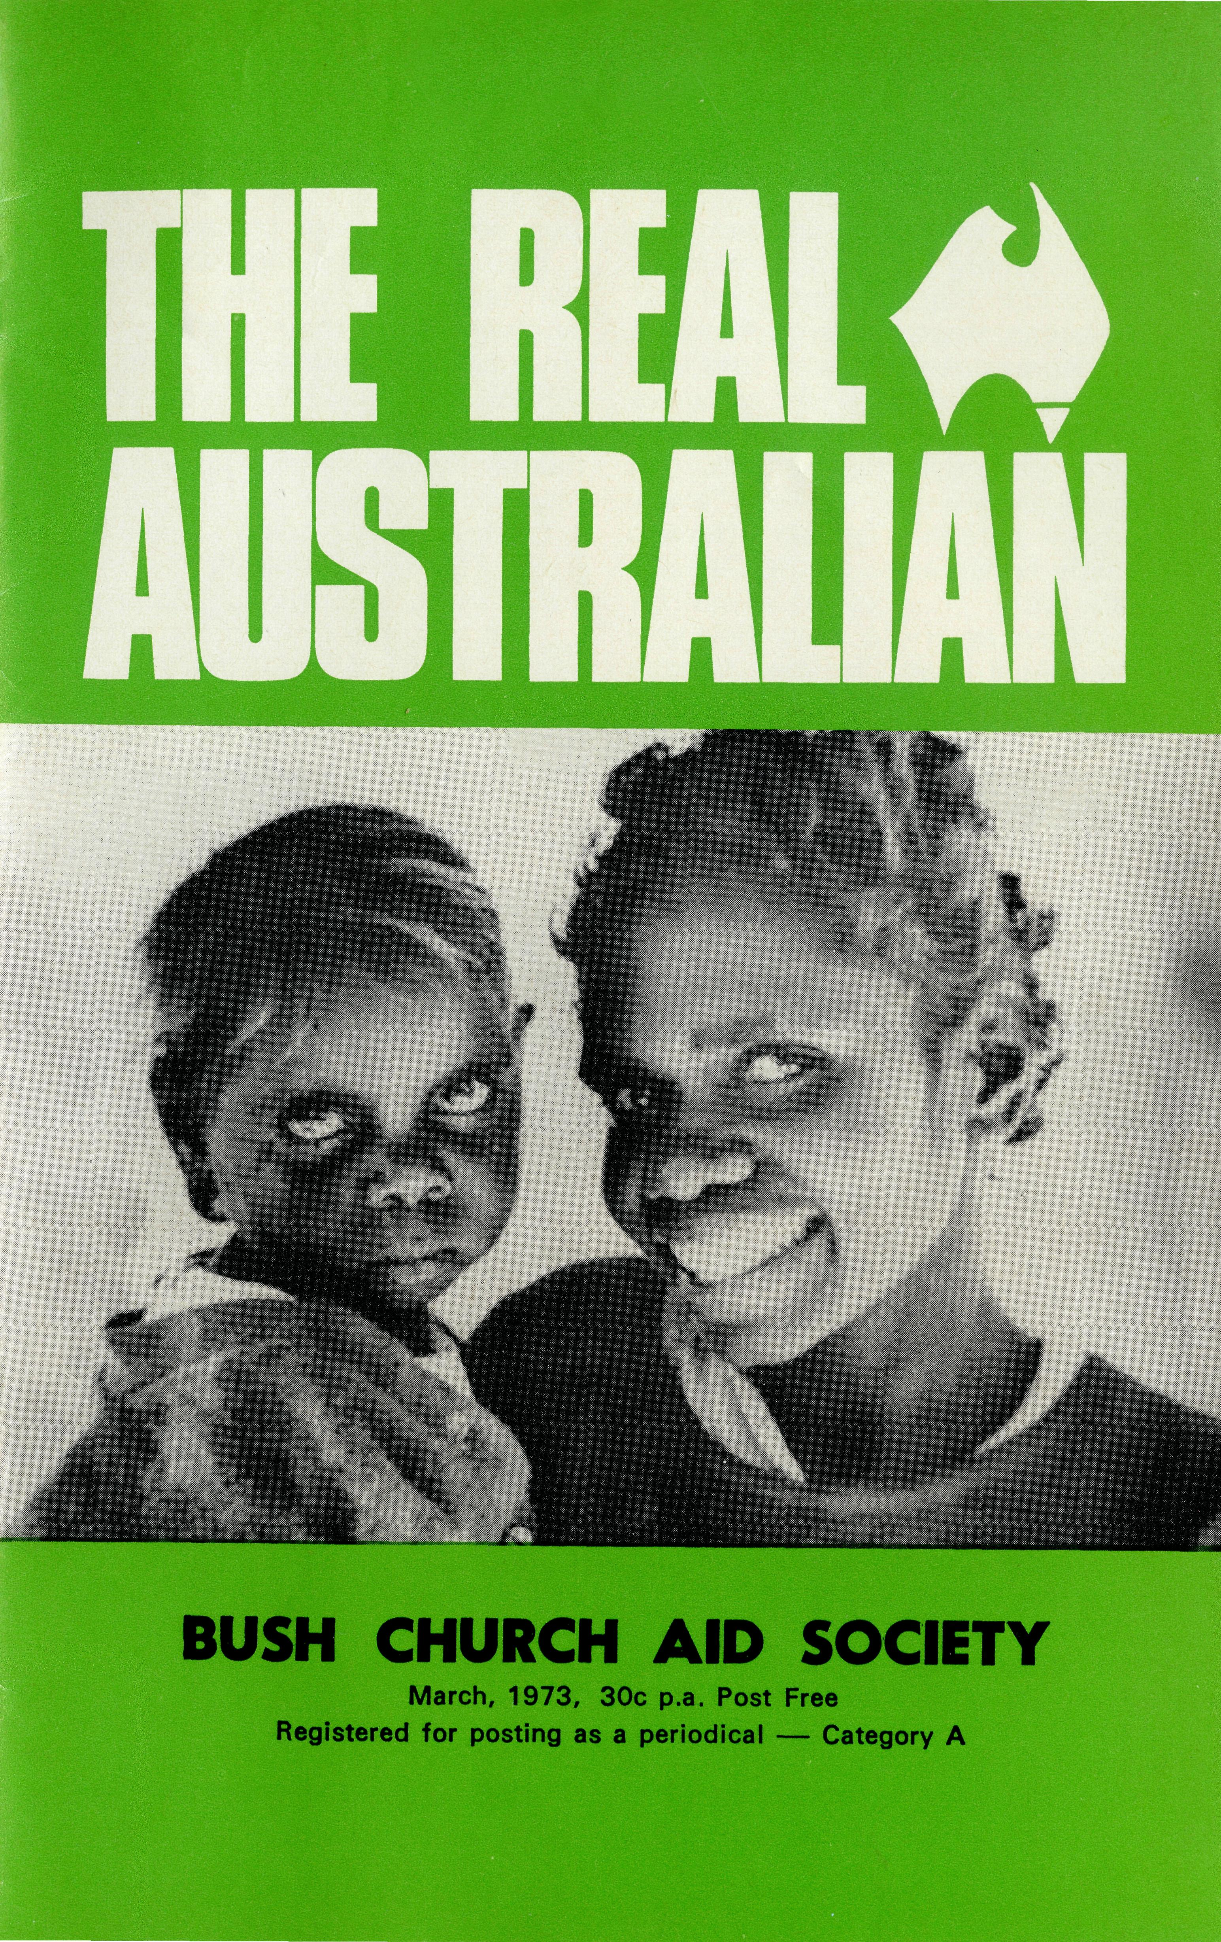
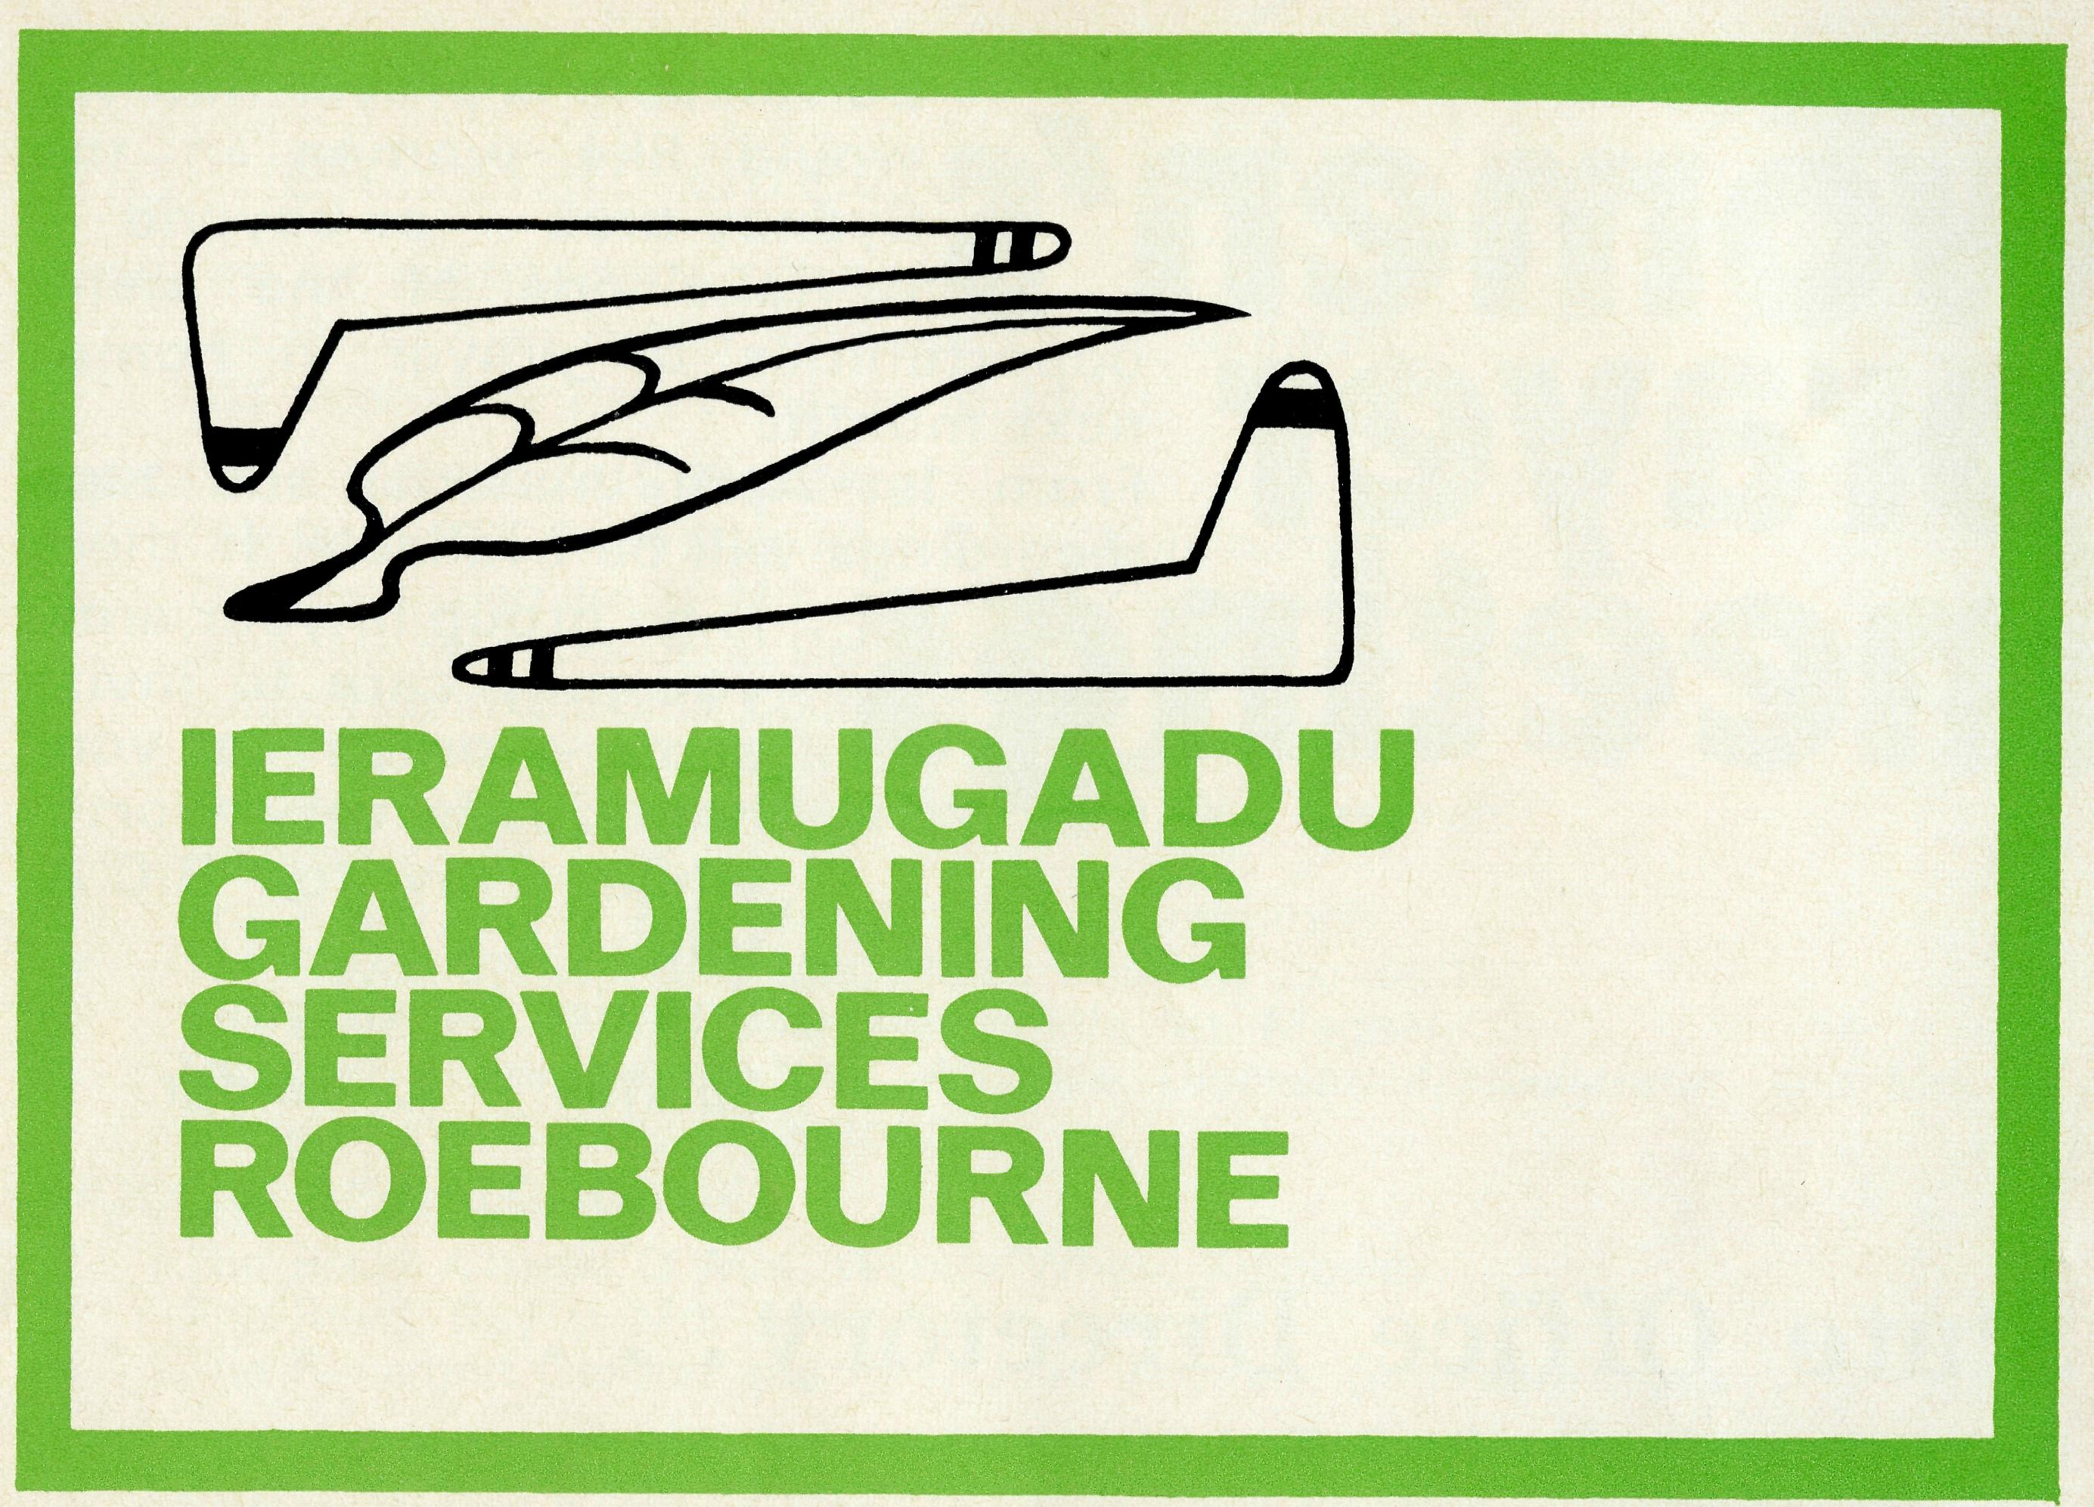
One of the most difficult things for Aborigines to obtain is employment. In the West Pilbara area of North West Australia, there are many Aborigines. The cessation of the Wittenoom Asbestos mining threw great numbers of them out of work.
While there are thousands of people employed locally because of the iron ore mining, the work required is too technical for the present ability of the Aborigines.
"With this situation the Aboriginal people of Roebourne (near Dampier) began to behave in a manner typical of any groups of people confronted with a poverty aggravated despair situation. Drunkenness and anti-social behaviour are not the prerogative of the Aboriginal people alone."
The Church wanted to help. Handouts are bad. A "Gaolhouse"
gift shop was commenced at Dampier with the purpose of raising funds to buy equipment and to assist the Aborigines. A land-rover, two lawn mowers, a chain-saw and other items were purchased. The Church guaranteed work first for one day a week for the leramugadu Gardening Service.
The success story is that now work is available six days a week, if required. The Aborigines are capable of many forms of gardening, tree lopping, lawn mowing and casual labour.
The name, "leramugadu" came from the Aboriginal word of the Ngaluma language for Roebourne. The word is the actual name of a permanent pool which was the first water source in the area.
Well done, Gordon Williams and West Pilbara Church folk!

from the Federal Secretary
When travelling around the places where B.C.A. staff work, it is obvious that, in more than half the areas, there are large numbers of Aborigines. These folk are members of a parish who require a ministry in the same way as any other person in the outback. Yet the Aborigine is not like "every other" person. To be different, vastly different, is not to be inferior.
When we try to view the European Australian Christian Church through the eyes of the Aborigine what do we see? The Church, for them, is part of the western cul-
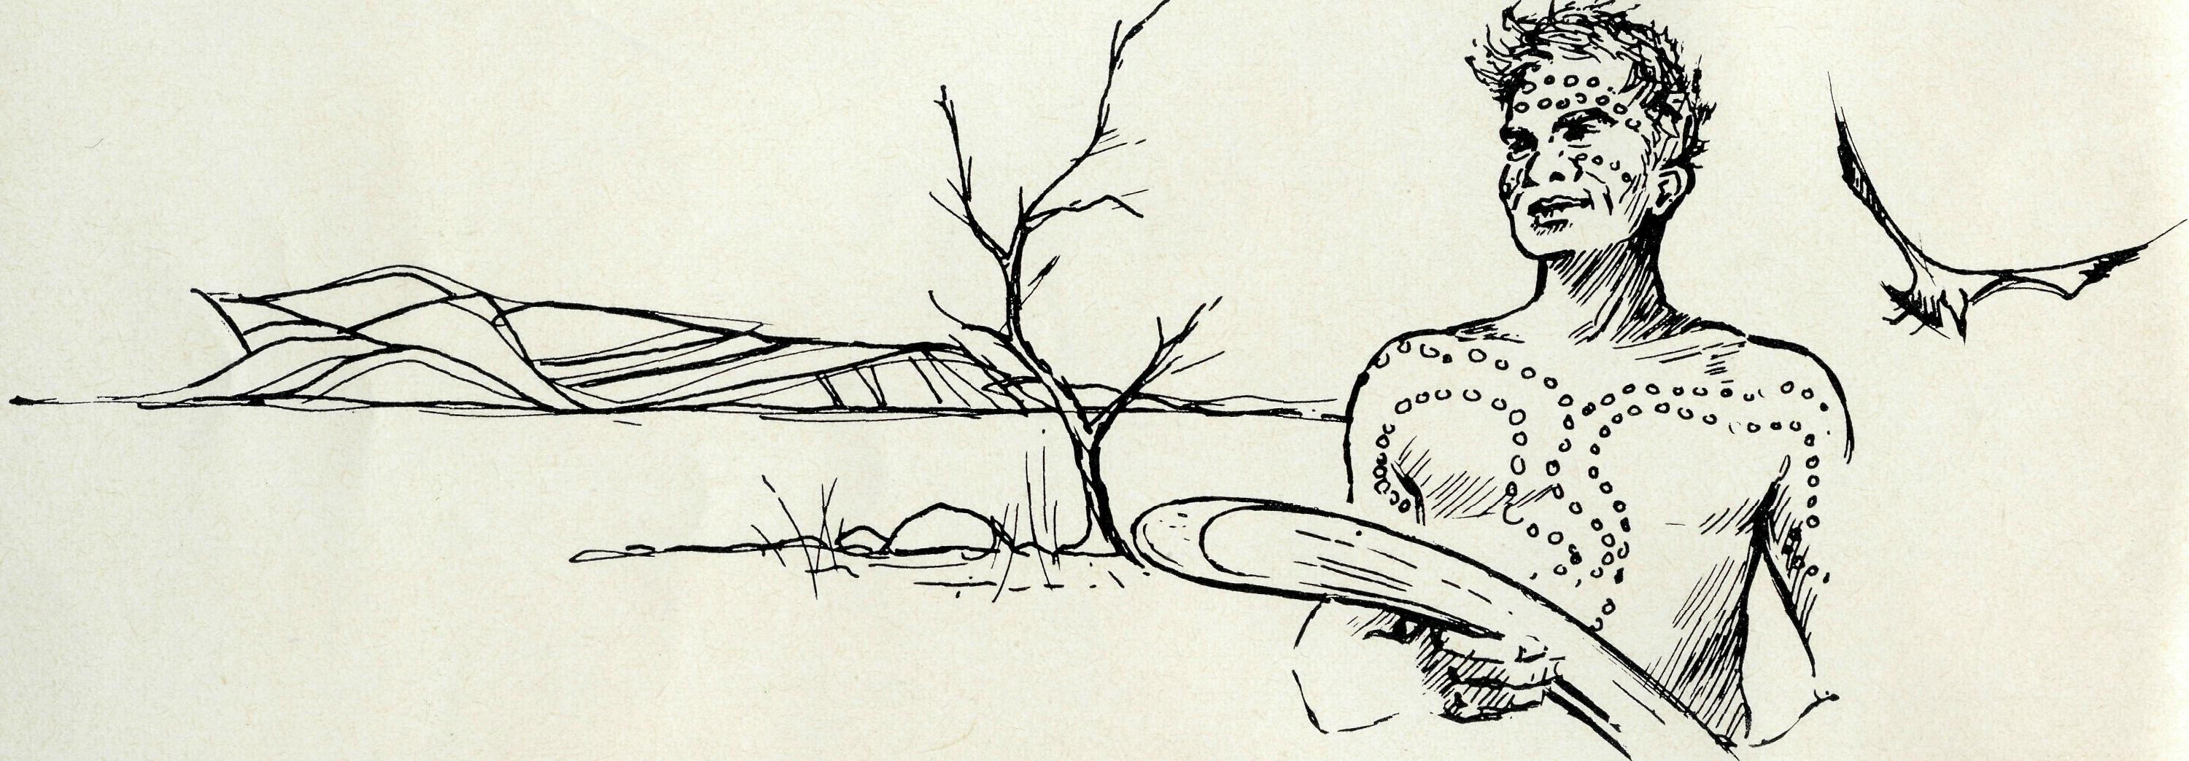
ture, a culture of materialistic greed, hard and grabbing. To them our culture is atheistic though some may do lip service to God. Many an Aborigine thinks God is white. One asked "How can I bow my knees to a white God?"
Doctors in Western Australia made a survey in which they reported, "one of the most striking and heartening findings was the spirit of the Aboriginal people, even under the most trying circumstances. Their enthusiasm for the things of their own culture,
their willingness to communicate it, their joy at speaking about their own language, their capacity for laughter and their delight in physical expression were most evident. This was true for all communities that we visited, even though living in the most squalid reserves."
Governments, doctors, teachers and the general public can improve these Aborigines' material lot, but only the Church can offer them Christ. When "there is a clear understanding among the Aboriginal people of their uniqueness", the task of presenting
Christ calls for more than human grace.
Christ died for all and rose again that all might share His abundant, life through the Holy Spirit. May we pray for those who, in the Society, have the privilege and the responsibility to seek to draw all men, black and white, to Christ. May we earnestly pray for the outpouring of the Holy Spirit in power. Through Him alone may Christ be adequately understood and received.
Your friend,
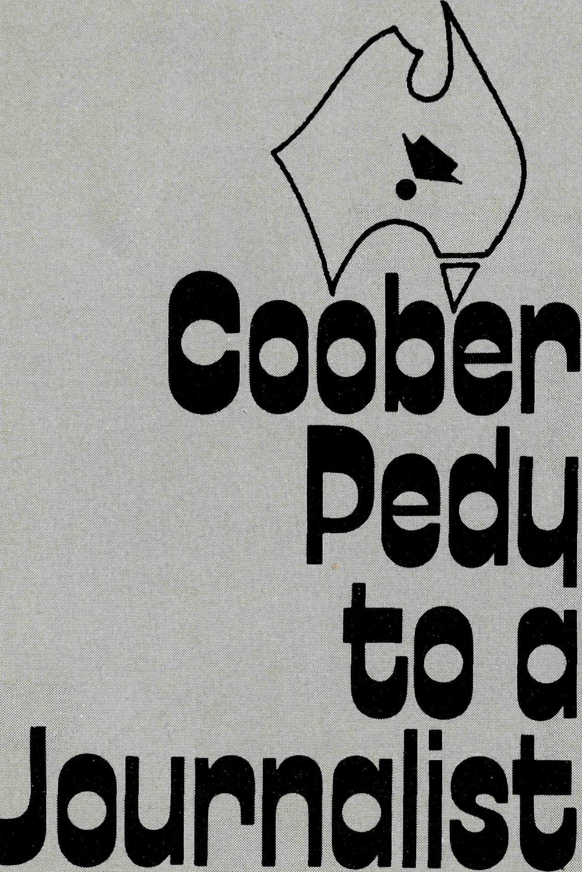
"What a town" says Kevin All-church at Coober Pedy, "when it was suggested I go to Coober Pedy to establish a weekly paper I thought 'Gold Star' Publications are out of their mind. I visualised a township of two men and a dog living in a cave. The Tourist Bureau, and other sources of information are devoid of material on the district and I set out convinced that I was headed for a 'hick' town in the middle of the desert.
Somebody must have planted me in the wrong place! Though a country town with country people, Coober Pedy is a mushrooming cosmopolitan centre, unique in the world. It lives and breeds a fantastic personality all of its own.
Where else could you find a town hundreds of miles from anywhere where the vast majority of the adult population have travelled overseas?
The work force, is almost entirely self employed, money flows like water, and the hospitality of the locals is out of this world. Battling
Although the people of Coober Pedy are their own greatest knockers, they have created a township of which they can be proud. Its most striking feature is the way in which the people of so many different nationalities have welded together to form a happy, friendly Australian outback town. All things are judged through the eye of the beholder and for these people battling out an existence, living in sheds, while facing the tremendous hardships of opal mining and raging dust storms, temperatures of 130 degrees, Coober Pedy does not present a pretty picture, but it is the sharing of these severe conditions which have been responsible for building the character of the town, and weeding out those who are less able to measure up to the demands of the desert.
The men deserve high praise but for the women a special medal should be struck for courage."
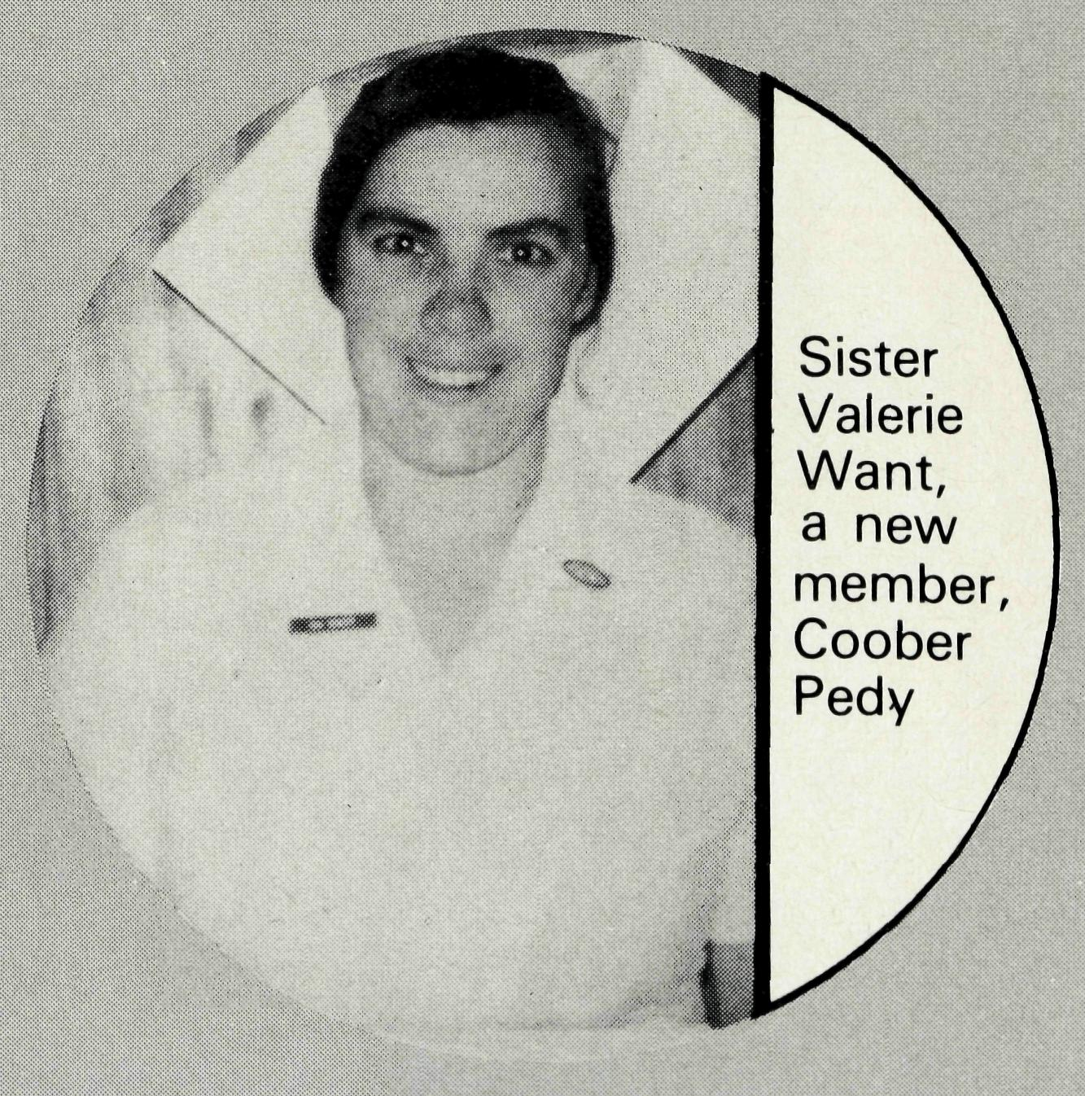

THE REAL AUSTRALIAN

Nightcliff
St. Peter's, Nightcliff, Darwin, is unique. With the Cathedral in the centre St. Peter's is in the outer suburbs of the fastest growing capital of Australia. The average weekly congregation of 160 is increasing, yet we are still dependent on B.C.A. support. In our budgeting, we are gradually taking over the financial responsibility. Our appreciation of the prayer support from B.C.A. members is beyond description.
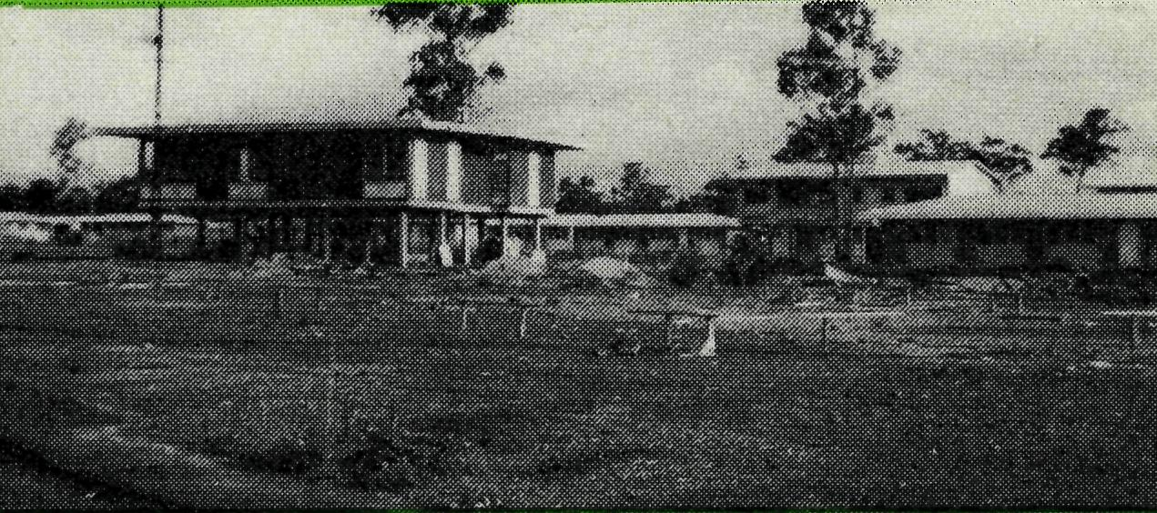
Since coming here two years ago, we have seen two new suburbs established. Housing is in great demand. Those wanting a Government house must wait a year. The average rental for a furnished house is $60 a week.
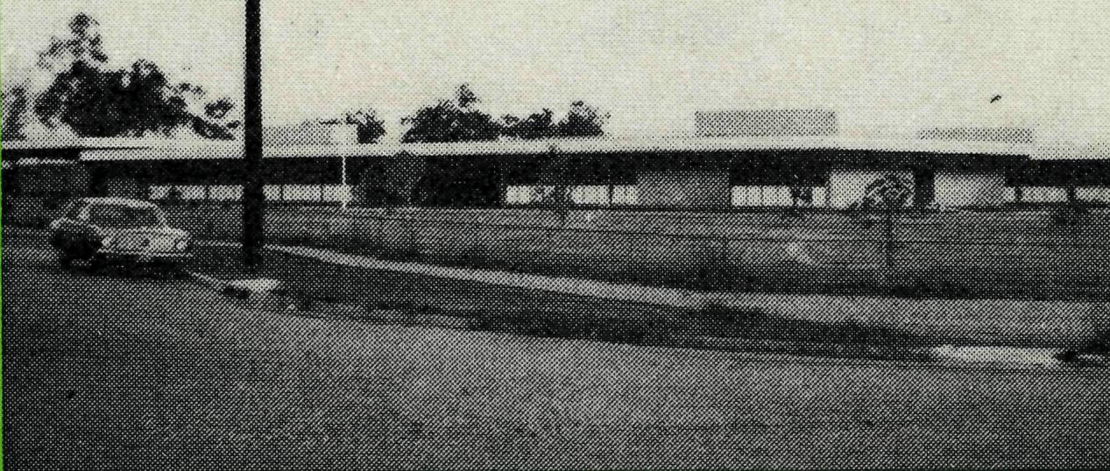
Schools rise rapidly. At least one new Primary School is built each year. We attempt to cover all schools with Religious Instruction. This year our programme is curtailed by our attempt to service two more new schools.
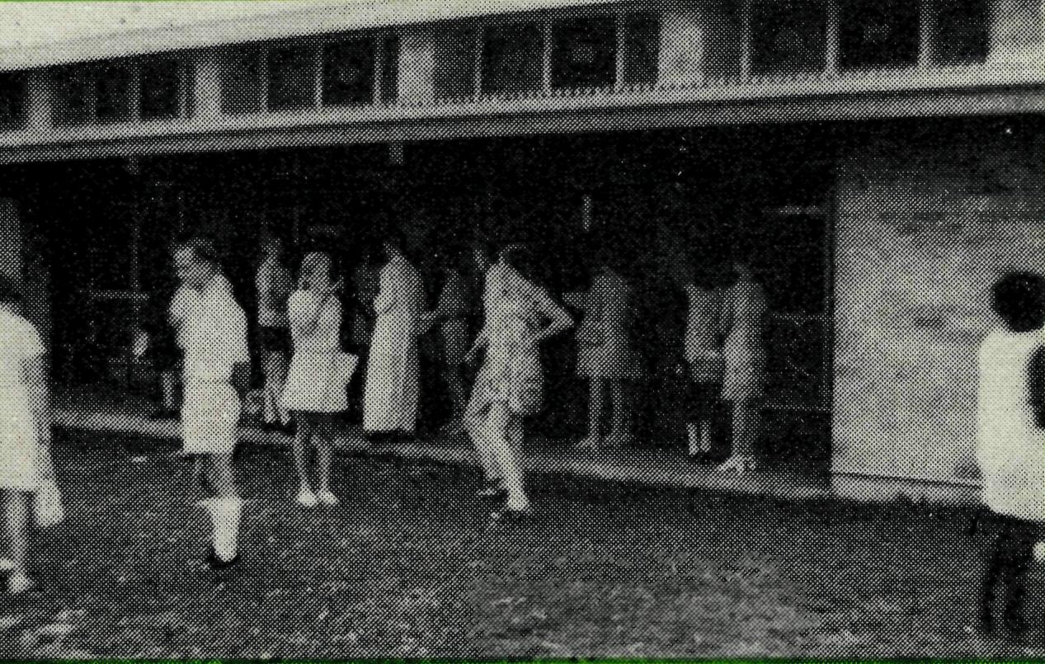
In the Church family there are many public servants. Other folk include the Church Missionary Society workers and those of the Summer Institute of Linguistics. We are happy to have some Aborigines worship with us. Either they are residents of Darwin or maybe visiting from one of the C.M.S. Missions.
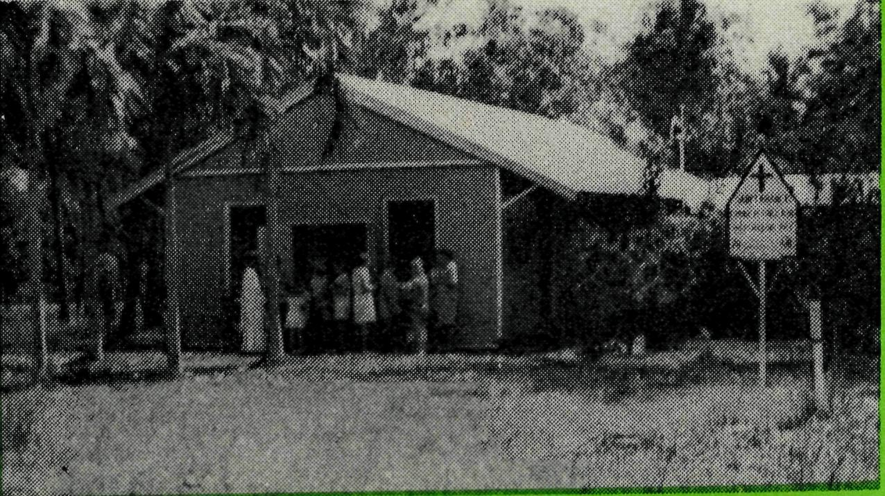
In our bush area, 80 kilometres south of Darwin, there is the pretty little Church of St. Francis', Batchelor. When the Rum Jungle Uranium Mine closed, the small community moved out. However now, making use of the available housing, some new folk are beginning to move in.
THE LEAST BUSHY CHURCH IN B.C.A. STILL NEEDING HELP. Alan Hoskin
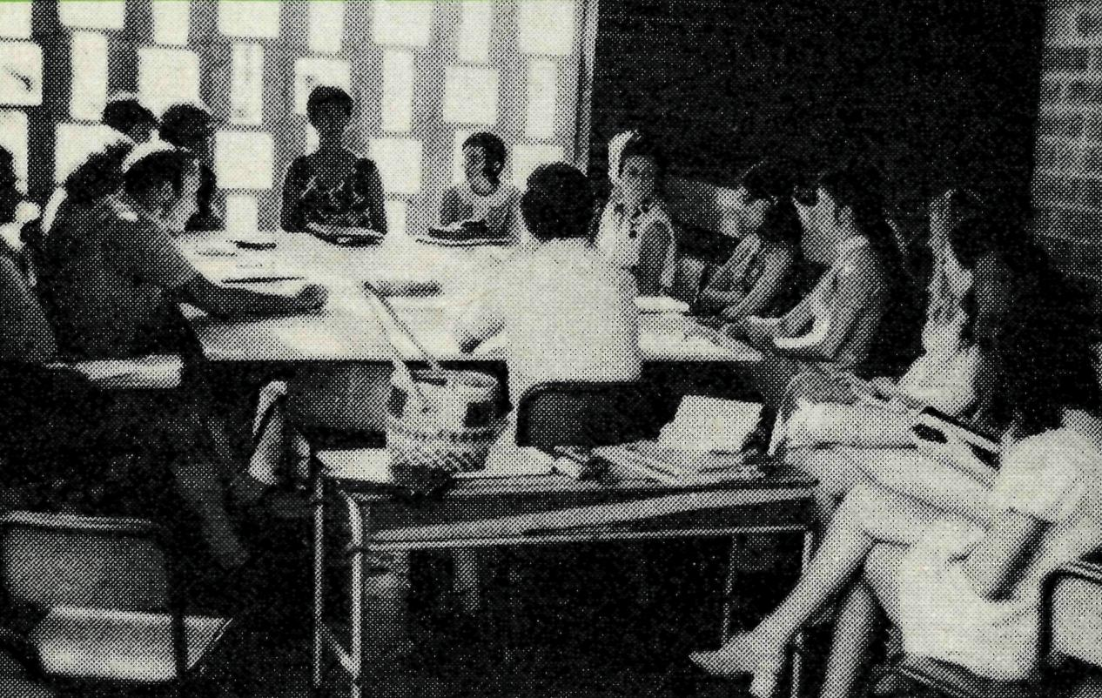
Considering the large number of children in the parish (only dogs outnumber children in Darwin!) our Sunday School is very small at about 70. Nevertheless, we seek to ensure a good standard through the teacher training course. It would seem that as soon as we train a teacher, the family is moved and we must start again.
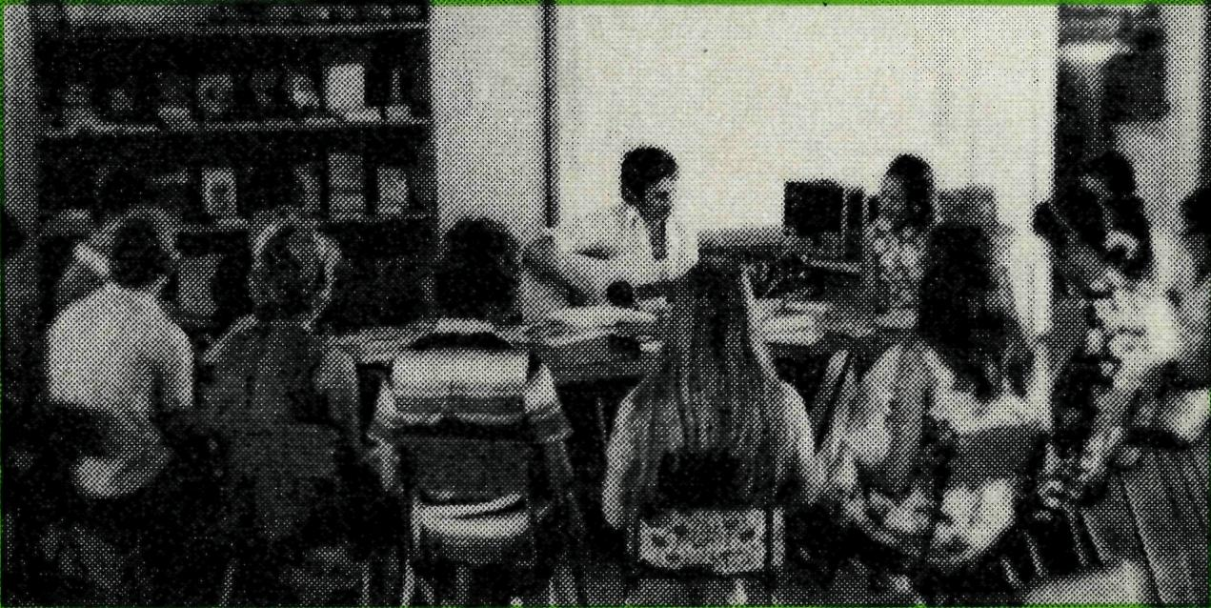
We are pleased to have a very active, keen core of Christian young people. We have two Bible Studies each week. These youth form the nucleus of Pete's Club which seeks to reach out to the many young people in the community.
HEREIN LIES OUR CHIEF DIFFICULTY
Most of our people are only here for two years. Darwin is not their home. They are only visitors, some of whom take a holiday from Church while they're here. If it is possible, Darwin is even more materialistic. "You go north to get rich quickly." On the other hand, the cost of living is very high, making things very difficult for public servants, and especially for those who are missionaries.
We have had to establish and pay off the Rectory and Church building (which is fast becoming inadequate).
In our acute staffing shortage, we are very grateful indeed for Deaconess Pam Eagleton who will come as a parish worker, living in one of our new areas. We are very grateful to have her, especially with her ability among the youth.
Have you ever been to Darwin? Not only are we in the tropics, but the humidity is extremely high. This brings a disinclination to go out. Dress is very relaxed in Darwin and our fans constantly revolve. Please pray that despite all the difficulties, folk may value worship and join us, as strangers together. Pray that we may have a friendly approach with the right words to say in season. You help us by your prayers (II Cor. 1:11). Thank you for all that you have done and are doing.

THE REAL AUSTRALIAN

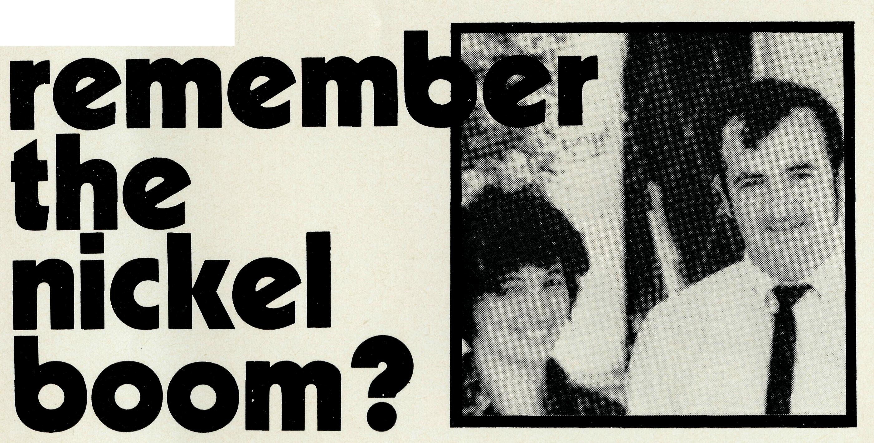
A few years ago, nickel was a fairy tale. The names of Poseidon and Tasminex were household words. Share prices soared to incredible heights.
Most of this boom centred around the goldfields of Western Australia at Kalgoorlie. Geologists, prospectors and many others poured into the area. Sleepy little outback towns buzzed with excitement. With gold prices falling new hope was given to many people. This might be what they were waiting for. Even the Diocese might be strong enough to remain independent. So it seemed then. Australia was on the verge of the greatest thing since iron ore — nickel.
However, when you read of Poseidon today, it is only in the finance pages and then usually with financial troubles. Difficulties mount up.
The world demand for nickel declined and only by hard work would the mining companies survive. That sums up the role of the Church in the most fruitful of the nickel discoveries, Kambalda, W.A. The Church is faced with a good deal of hard work.
Kambalda is managed by the Western Mining Corporation and they wonderfully produced a beautiful mining town. Retaining many gum trees, the town is a picture. Even though nickel was discovered in the middle of the town, yet the two halves have good shopping facilities.
Amenities abound in the town. There are over forty clubs and organisations. Among the 3.000 folk, there is a great cross-section of population from the highly skilled to the unskilled, from the highly educated to the uneducated.
B.C.A. placed a man in Kambalda in 1969 and since then, the parish has gone through several changes.
Attached to Kambalda is a large area north of Kalgoorlie, known as the "north country". It is traditionally pastoral and gold country. Menzies, Leonora and Laver-ton are support towns. Two new centres have appeared since the boom. They are Mt. Windarra, run by Poseidon and Perseverance, owned by Australian Selection. Our ministry continues to both the mining and pastoral areas.
Wendy and hare quite used to
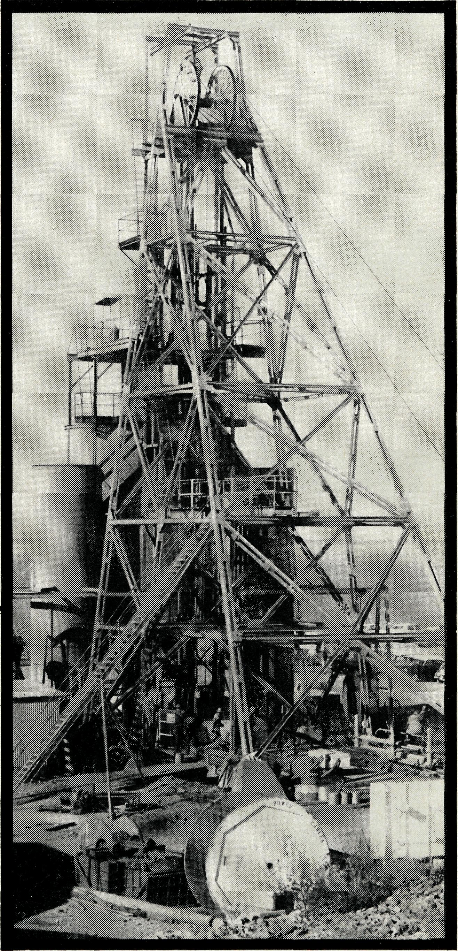
the farming folk but we must continue to learn the ways of mining. By that I mean not so much how to get nickel out of the ground, but how miners "tick". Like every other group, they have their own characteristics. However, they are a people whom God loves and for whom Christ died and so we seek to win them for Him.
One of the ways we have been able to get a little entry is through sport. I have been elected as secretary of the Rugby League Club. (Last year Charles was chosen as the "best and fairest" in his team which won the competition. Ed.).
We hold services, teach in schools, run youth clubs in the normal parish way. Few people think of Kambalda as "home" and even the youth have a restlessness, not usual in stable communities.
Charles White
We thank you sincerely for your prayer. Believe me, we need it. Please keep on praying that we will be able to communicate the Gospel. Specially we need prayer for our work among the young people. The Church Hall is of the "goldfish" variety. With the abundance of windows, it is impos-
sible to keep out the undesirables. Even if they cannot enter, they can cause trouble without. This has meant the abandoning of our hall for youth groups. We now meet in cramped conditions in the Rectory double garage. The youth group has become rather a family club where very many enjoyable evenings are held.
We need prayer for contacts in the northern country especially at the Perseverance Mining Camp, where 100 men live together. At first they made it clear that I was not wanted by being openly rude. But when I persevered, they seemed surprised and now almost accept me. Nevertheless, I feel inadequate as I seek to minister to them. Pray also for our work in Laverton as this year will see a great change when Poseidon build more houses for the work force.
I believe the night is far spent and the day is at hand. May the Lord help us in the fellowship of B.C.A. to be more determined than ever to win Australia for Christ.
Photographs —
Salt Lake Shaft Kambalda Nickel Mine.
Charles and Wendy White.

THE REAL AUSTRALIAN

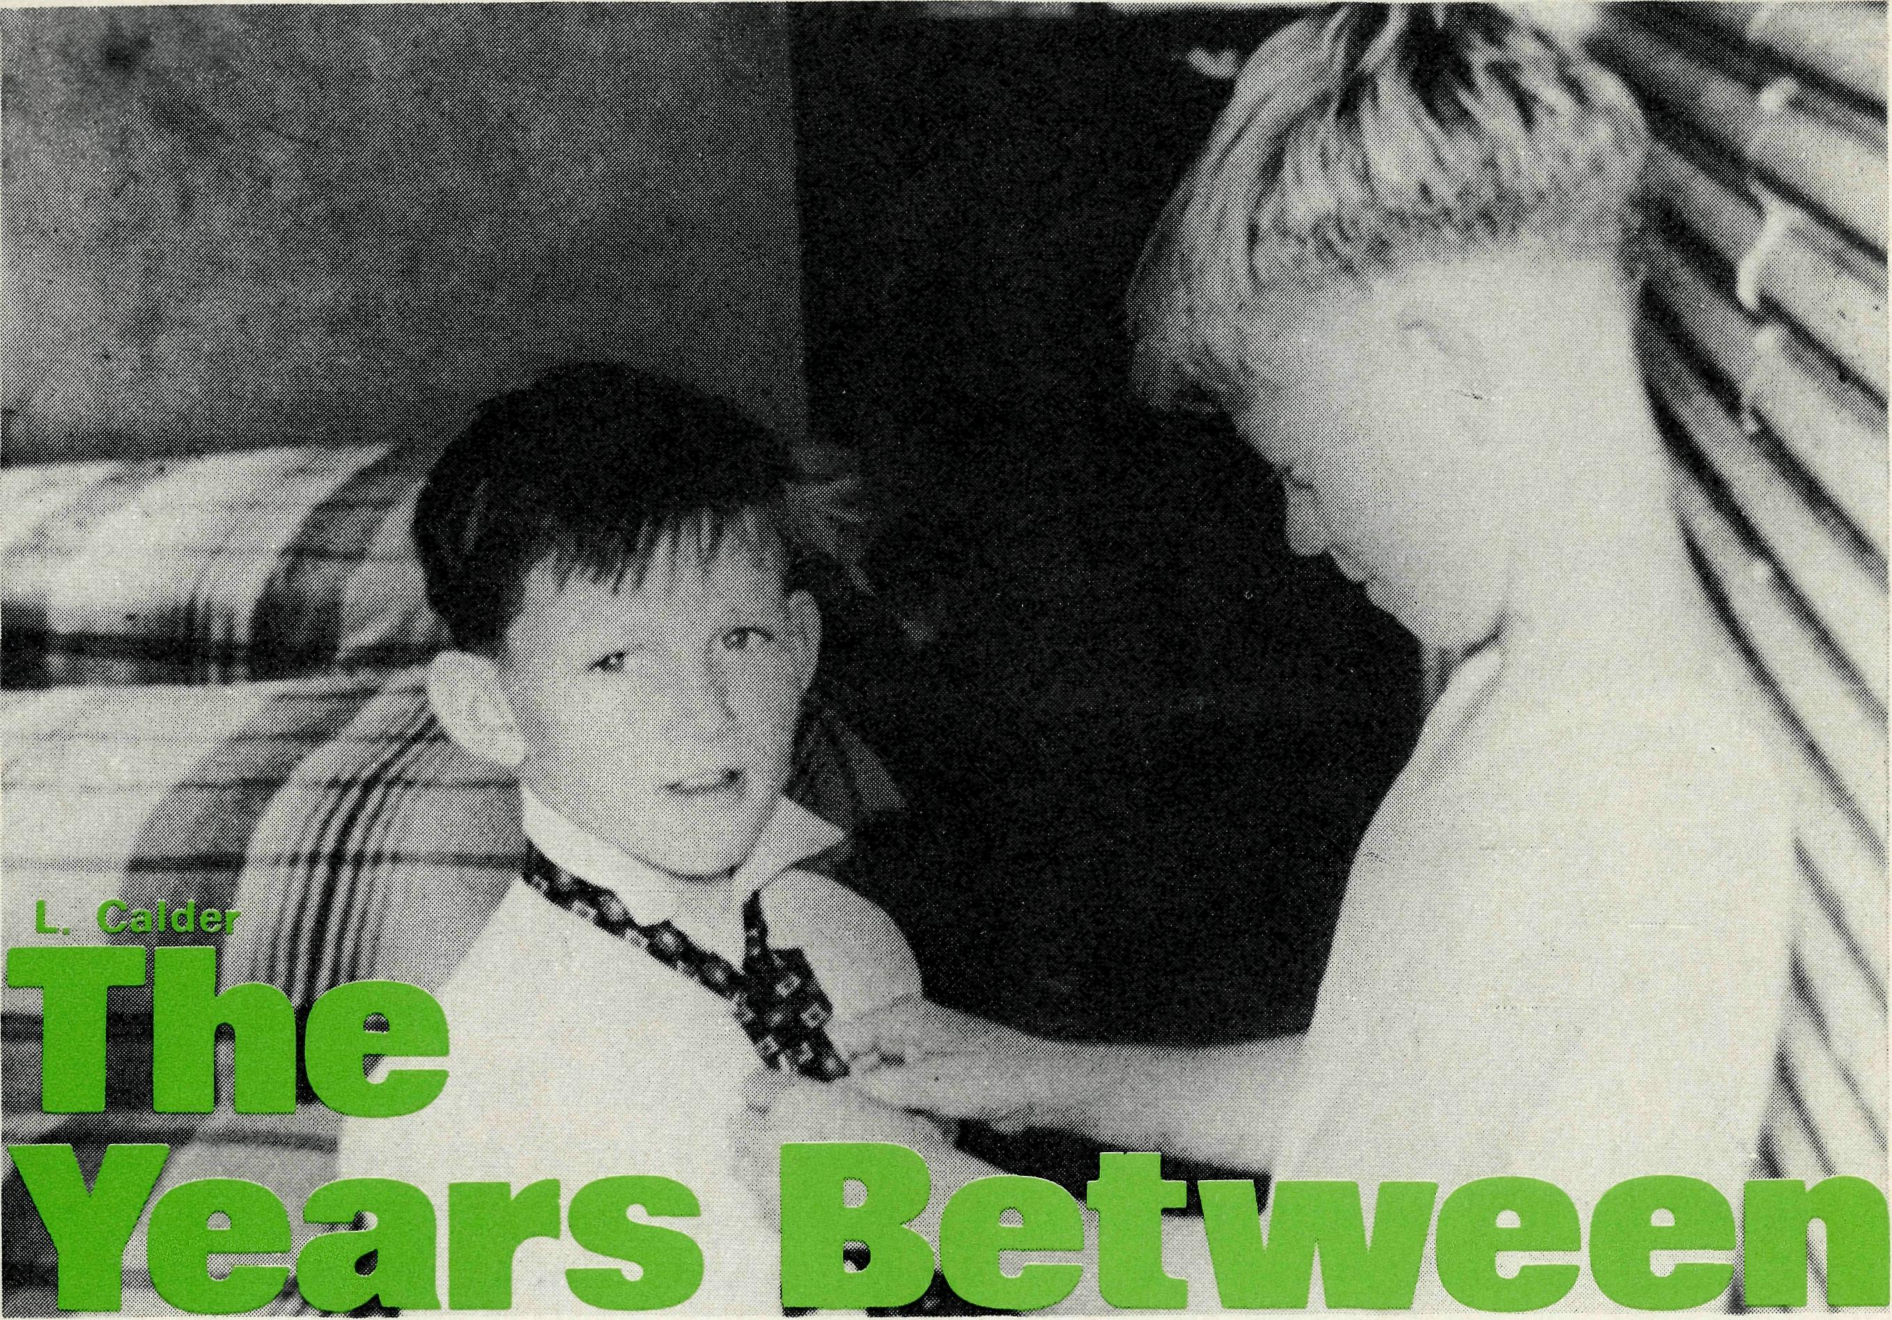
ONE TRAVELLER IN THE BIG WIDE BEAUTIFUL WORLD OF B.C.A.
Dear Mr. Hayman,
1 have had one of the B.C.A.'s little bark huts for many years. I am a regular subscriber and use the prayer lists daily.
While on a holiday recently in W.A., I had planned to visit a B.C.A. mission. On passing through Norseman we found the Church and Rectory and made ourselves known to the Neves. Mr. and Mrs. Ray Neve insisted on us coming in for a cup of tea. As there were six of us, I was rather reluctant, but their invitation was so sincere, we accepted.
As my son and his family all belong to a lapidary club, rock specimens soon became the popular topic of conversation. We thoroughly enjoyed our visit and I want to say how greatly we admired what they are doing there.
As my daughter-in-law said, the Church and Rectory grounds were an oasis — the green lawns and the garden stood out from the bare, red earth everywhere. They have made that little spot devoted to God's work, a thing of beauty and it must have taken long, weary hours of watering to achieve so much.
I wanted you to know how much we were impressed by the Neves and their work for God.
Yours sincerely,
(A Supporter).
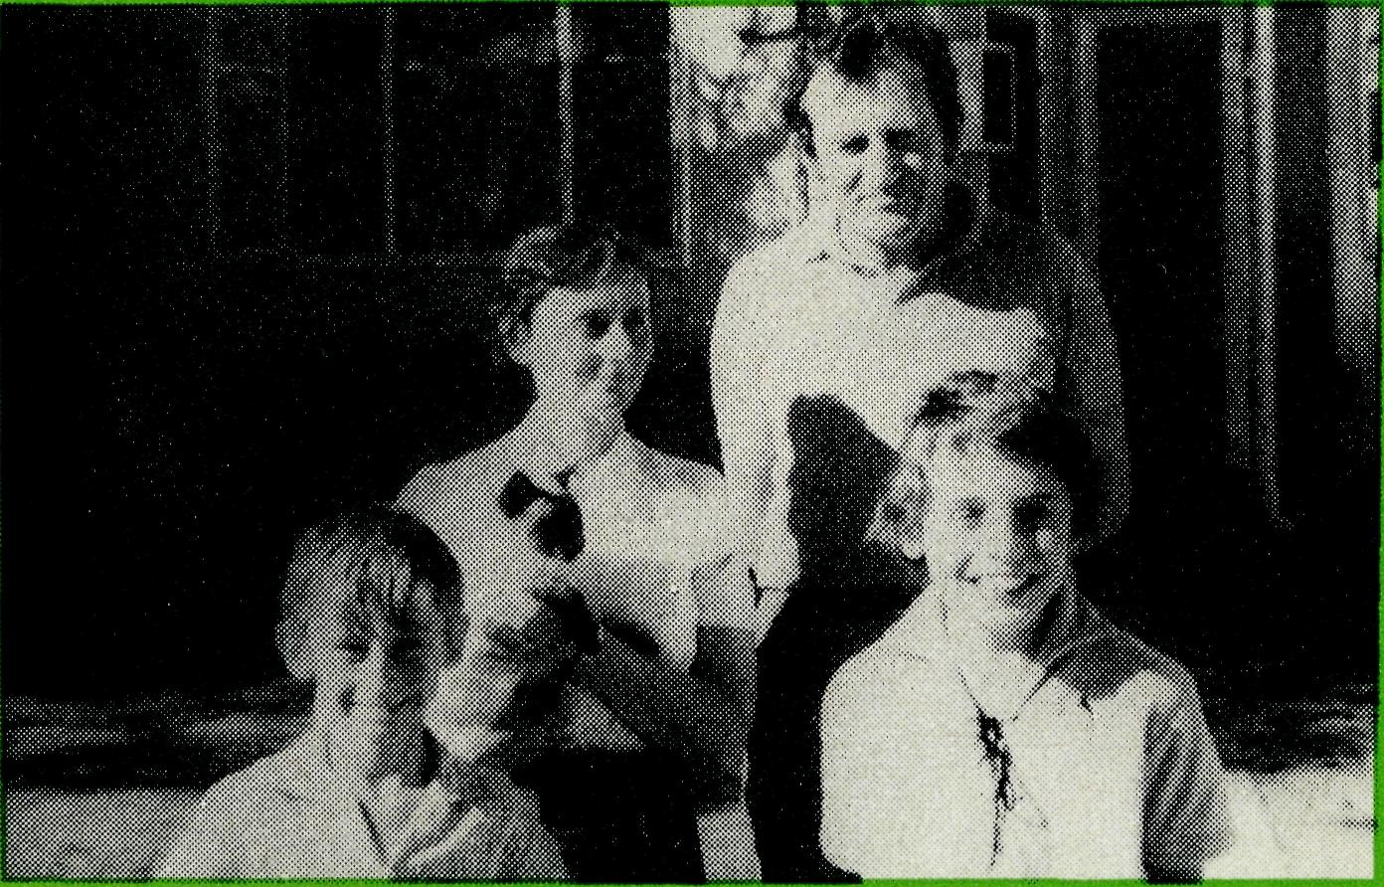
Ray and Mary Neve David and Andrew
When I first met Robin, Dallas and Cleave they were typical country lads from a large sheep grazing property in the far west of N.S.W., aged from 6 to about 10. Together with my wife, I had just arrived at our B.C.A. Broken Hill Hostel to care for these boys and the others who made up our "family" of 30.
The year was 1956 and, for the sheep farmers, there had been some good seasons and good prices. In view of this, the parents of the three boys had decided on an extended holiday in New Zealand. So Robin, Dallas and Cleave, in a closer sense, became "our boys". They settled down to the school work ahead of them and we faced the enormous task of finding the correct routines and methods associated with running such a large home. We sought to maintain a balance between rules and kindness, discipline and love. Our aim of course, was, under
God, to make our home a Christian home away from home.
The months went by and our three boys continued in a more or less normal pattern. They were involved in tennis, football, marbles, bike riding and rigging up home made wireless sets and aerials. In order to assist (or perhaps, hinder us), they often gave us advice and at times sought to escape their rostered duties. On one occasion the rising bell mysteriously disappeared. Sometimes they applied themselves diligently to their school work and home studies. They participated each day in morning devotions and attended Church and Sunday School on Sunday. Cleave spent a goo'd deal of time counting his marbles and his pocket money, Dallas was occupied almost full time in organising his two brothers and Robin enjoyed reading and resting.
In 1960 the two older boys left

THE REAL AUSTRALIAN

- MRS. WINIFRED HUGHES of the Melbourne B.C.A. office has resigned after nine years of faithful service. Many Victorians would know Mrs. Hughes personally. With a "one secretary" office, she has had to do all the work necessary with the recording of names, changes of addresses, keeping of books, etc. She has been the abiding factor in the many changes that have occurred with Victorian clergy secretaries. Thank you, Mrs. Hughes.
- DEACONESS PAM EAGLETON has been accepted by the Society for a new position as assistant in the Nightcliff Parish, Darwin. Miss Pam Eagleton, who came from Tamworth, N.S.W., received her training in Deaconess House and in Sydney parishes. For three years she has been working with the Reverend Ernest Carnaby in Woomera, South Australia. Ernie Carnaby is well known to B.C.A. supporters. He is now in C.M.S., Adelaide.
for Adelaide to complete their education and Cleave stayed on at Broken Hill. Pauline and I returned to Sydney.
This week, 13 years later, the mother, on holiday, sought us out to spend an evening with us. The years between have brought many changes. The father has had a serious illness. He can engage only in lighter duties. Both parents live in Adelaide, where the mother has taken a position to assist finances. Cleave spends some of his time on the N.S.W. property, but, because of continued bad years, has taken other employment also. The two older boys are running a property in the south east of South Australia in a higher rain belt, and are learning to overcome difficulties. All three boys are married and each has two children.
The mother, in looking back,
had a very deep appreciation of the work of B.C.A. Hostels. She commented "There was something about life at the Hostel that has helped the boys to cope with hard times and ride out the difficulties." As I conversed with her, I wondered' if this "something" was perhaps a glimmer of faith and if God is indeed watering the seeds that were sown. I pray that this might be so. In any case, we are assured that your prayers and gifts over the years have helped mould the lives and characters of a good many boys (and girls) like Cleave, Dallas and Robin.
The years between are important. We look to God that, as so many of our outback boys and girls look back, He will give the blessing and there will be those who will find peace, joy and a very real faith.

- Our congratulations to EVELYN and NEVILLE KNOTT on the birth of Andrea Louise, their first baby. Because there is no hospital at Moran-bah, mid Queensland, Evelyn had to go early into Mackay Hospital, 134 miles away.
- We welcome LOUISE DREW who is now working in our Sydney office, taking the place of Rosalie McLaughlin.
- The Reverend BILL ROSS and JOCELYN expressed thanks to the Auxiliary and many others for the parcels of clothing which they have received. These are put into a shop and are sold cheaply, particularly to Aboriginal folk. The proceeds are then used to assist in the Aboriginal Welfare Fund. Cool cotton dresses, without sleeves, and children's clothing, come into demand. All clothing is welcome.
- We may not be good enough for the Olympics, but some of the B.C.A. areas have had record temperatures. These, unfortunately, have been too consistent. Perhaps now the temperature will go down a little. Cyclones have been lashing the coast of North West Australia. The school at South Hedland lost its roof. Yet we praise God for welcome rain inland.
- Due to a sudden, intense attack of ill health, it was not considered wise that the Reverend Bruce Woolcott should go to Wilcannia. Although now improved in health, he is to remain close to specialists.
- As published elsewhere, we are grateful to Sydney C.E.B.S. for their kind contribution enabling a new power plant to be sent for Coober Pedy Hospital and Church Hall, a new tape recorder for Southern Cross, a secondhand duplicator to be sent to Kambalda and more vents permitting the youth facilities under the Rectory at Townview to receive air conditioning. This year the G.F.S. have a project to train a youth worker in North West Australia.
- The Reverend GORDON WILLIAMS and JEAN have-taken over a position as "worker-priest" in Wickham at the other end of the parish of West Pilbara. We are praying for the right successor who will live in Dampier. This is a fast growing area with much work to be done.
- MRS. BEVERLEY WILLS has served in our Sydney office for six years. She now has the exciting expectancy of the birth of her first baby and has left our office this month. Those who rang our office would have been greeted cheerily by Beverley's "Good morning, Bush Church Aid Society".
- Just before Christmas SISTERS MAUDE ROSS and LOLA HIGGS left Tarcoola, with heavy hearts, as there have been no sign of Christian replacements. We are very grateful to Maude and Lola, particularly as both have served well with the Society previously and returned feeling the call to this special piece of work.
- Congratulations tonhe Reverend BARRY and PEGGY HUGGETT on the birth of their fourth daughter. Father, mother and baby are all well.

I0
THE REAL AUSTRALIAN
II

THE B.C.A. PRAYER
FINANCES
Some folk ask us about our income. They have no difficulty to see where it is spent! Except for one very small grant we do not receive any diocesan grants.
Last year $116,166 was received from individuals and parishes. Legacies, for which we are extremely grateful, amounted to $70,659 and the Women's Auxiliary was a great help, furnishing for example, Carmel Grantham's "Church House" at South Hedland.
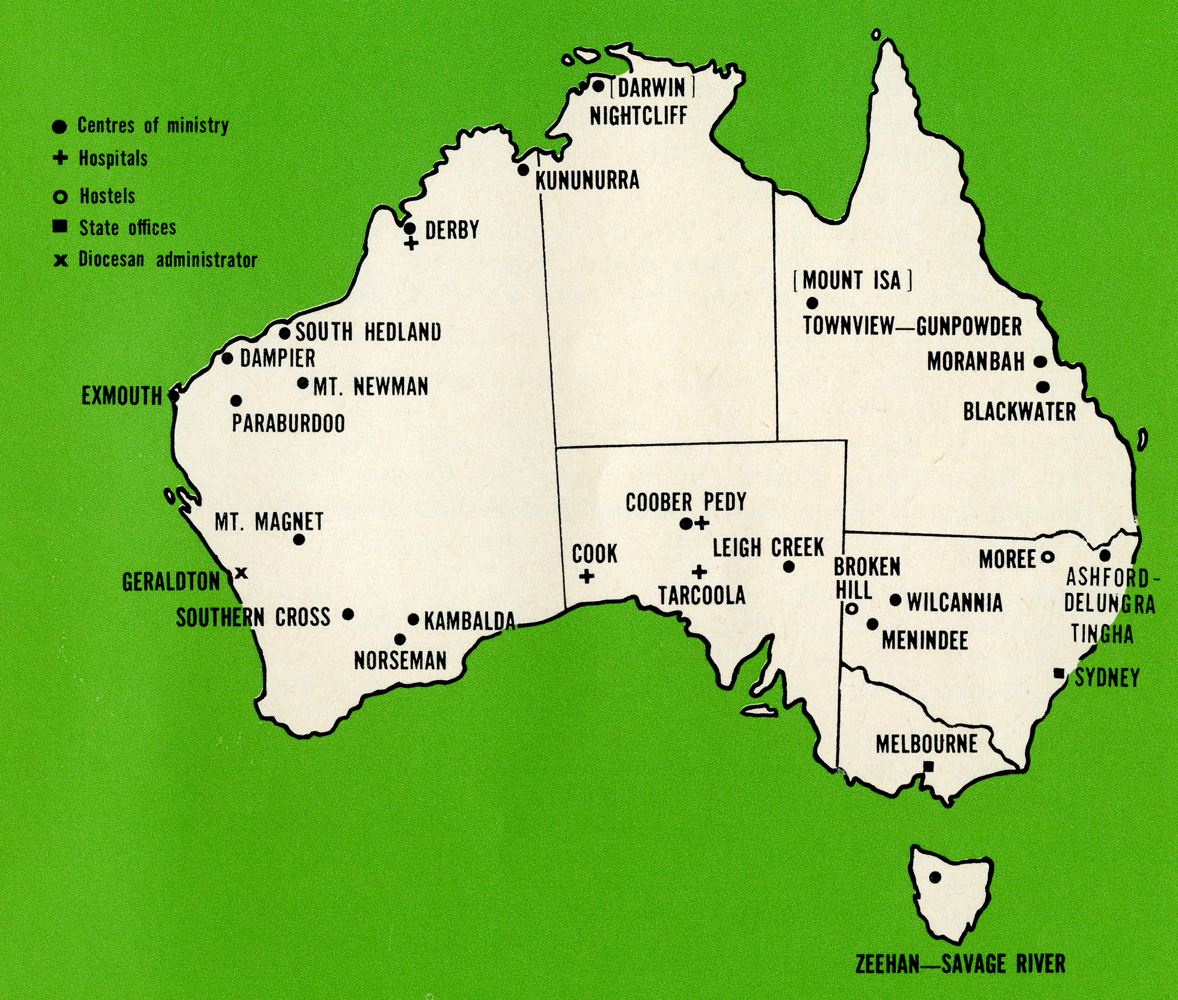
Other amounts were received — $4,542 from B.CA. parishes towards stipends; $386 from used stamps; $12,901 from rents; dividends and interest on bequests; sales from the gift shop; Government medical grants and the sale of assets no longer required, the proceeds of the latter being transferred to other Society work.
This year our budget expenditure is $250,560 and includes:
$
B.CA. clergy and women parish workers 124,848
Medical services 31,060
Hostel expenditure including improvements 1972 9,721
Property maintenance 3,810
A diminishing grant for Port Hedland 1,875
Provision for unexpected challenges 10,000
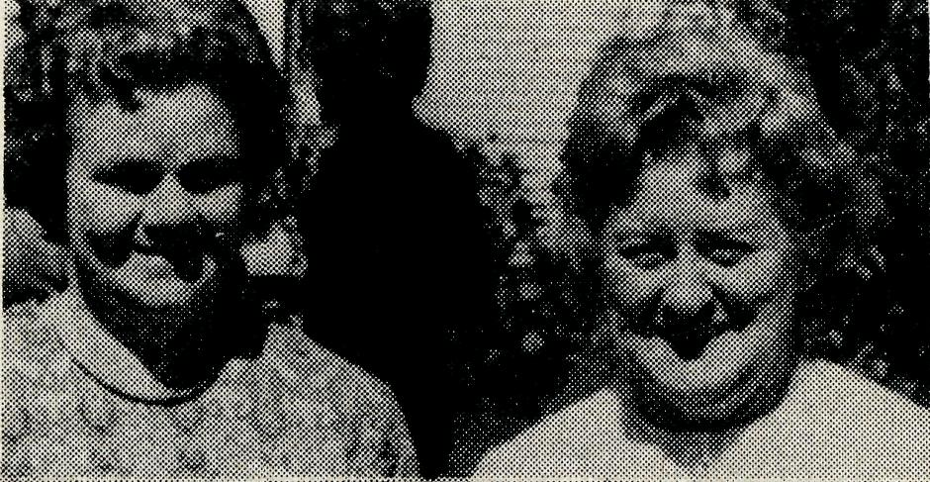
The budget is $39,908 greater than last year. We praise God for His help to pay our way last year and for another record Christmas offering both in Sydney and Melbourne. It was fantastic how immediate was the response. We are ever mindful of the kindness of folk who give over and above their support to their local Church work. The folk served by B.C.A. are likewise urged to rise to their responsibilities. So we go forward in faith through this year.
■
0 Lord our God, help us to remem ber those who live in the remote parts of our land. We ask You to bless those whom You have called into the fellowship of The Bush Church Aid Society. Grant that, through the ministry of the Word and Sacraments, through healing, and through caring for the young, the message of Your redeeming love may be proclaimed, through Jesus Christ our Lord. Amen.

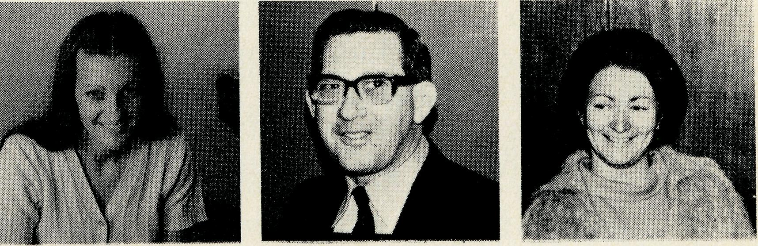
Miss D. Smith Mrs. J.O'Neil
Mrs.D.Warwick Mr. L. Calder
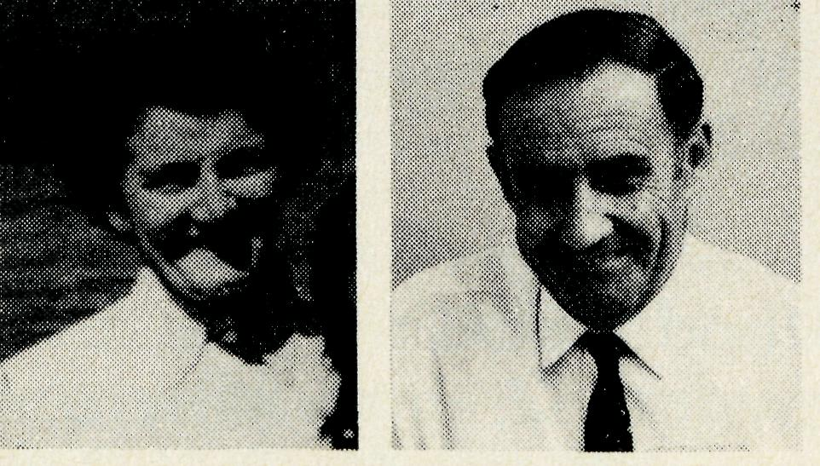
Staff at Sydney Office
Miss L. Drew Mr. F. Burner Mrs. B. Wills
A
DAILY
PRAYER

0 God, we remember before You those whom You have called to Your service. We ask You to bless
, assure
them of Your Presence, and call others to stand with them in the task. Grant to them, as to us, the joy of service, the ability to achieve, and the serenity of Your peace, for Jesus' sake. Amen.

THE REAL AUSTRALIAN

Prayer calendar
Woman’s prayer meetings
and field staff directory.
DIOCESE OF NORTHERN TERRITORY.
1 The Revd. Alan & Mrs. Philippa Hoskin, Nightcliff and Deaconess Pam Eagleton, Nightcliff.
DIOCESE OF N.W. AUSTRALIA.
- The Revd. Bill & Mrs. Jocelyn Ross, Kununurra.
- The Revd. Bernard & Mrs. Coralie Buckland, Derby.
- Sister Michelle Blondel at Derby Hospital. Sister Joy Brann, Course Tutor for Public Health Diploma Course in W.A.
- Sister Carmel Grantham, South Hedland.
- The Revd. Ken & Mrs. Margaret Hagan, Mt. Newman.
- Dampier.
- The Revd, Reg & Mrs. Beryce Clark, Paraburdoo.
- The Revd. Graham and Mrs. Helen Thurley, Exmouth.

- The Revd. Bill & Mrs. Margaret Smith, Mt. Magnet.
- Mr. Stan Hummerston, N.W. Australia Diocesan Administrator, and Mrs. Dorrie Hummerston, Geraldton.
DIOCESE OF KALGOORLIE.
- The Revd. Charlie & Mrs. Wendy White, Kambalda.
- The Revd. Ray & Mrs. Mary Neve, Norseman.
- The Reverend Gordon and Mrs. Joan Thomas, Southern Cross.
DIOCESE OF WILLOCHRA.
- Sisters Audrey Nixon & Mary Lund, at Cook Hospital.
- Tarcoola Hospital.
- The Revd. Brian & Mrs. Carolyn Carter, Leigh Creek.
- The Revd. Barry & Mrs. Jenny Rainsford, Coober Pedy.
- Sisters Carol Allen, Valerie Want, Dianne Kennaugh and Pat Watts at the Coober Pedy Medical Centre.
DIOCESE OF RIVERINA.
- The Revd. Chris and Mrs. Marilyn Clerke, The Menindee Mission.
- The Revd. Colin,and Mrs. Judith Ware, Wilcannia.
- Mr. Robby & Mrs. Margaret Roberts and the boys at the Broken Hill Hostel.
DIOCESE OF ARMIDALE.
23 The Revd. Peter & Mrs. Margaret Swane, Ashford-Delungra (with Deaconess
Maureen Cripps). Tingha.
DIOCESE OF ROCKHAMPTON.
- The Revd. Greg & Mrs. Del Ezzy, Blackwater.
- The Revd. Neville & Mrs. Evelyn Knott, Moranbah.
DIOCESE OF NORTH QUEENSLAND.
26 The Revd. Peter & Mrs. Fay George, Townview-Gunpowder.
DIOCESE OF TASMANIA.
27 The Revd. Blair & Mrs. Lyn Grace, Zeehan-Savage River.
GENERAL.
14
- Replacement Staff, Box Secretaries and B.C.A. Supporters.
- Deputation and Public Relations work, Revds. Ron Beard, Barry Green, Ted Doncaster, Ted Watkins, Mr. Laurie Calder.
- The Revd. Theo Hayman, Administration. The Council & State Committees. Office Staff: N.S.W.: Mr. Frank Burner, Misses Doris Smith &- Louise Drew, Mrs. Joy O'Neill & Mrs. Dora Warwick. Vic:
- The National Home Mission Fund.
THE REAL AUSTRALIAN
So valuable is prayer that we would like women in the Sydney area — or beyond — to take one of the many opportunities of prayer in homes next month.
From 1st April, material and tape recordings will be available. If there is no group in your area, you may care to invite some women to your home. It is very worthwhile. Pray for B.C.A. folk.
Enquire by ringing 26.3164 - L. Calder.
State Office Directory. . .
Federal Secretary, The Revd. T. J. Hayman —
Staff Administration.
N.S.W. Secretary, The Revd. R. N. Beard. — Public Relations enquiries.
Asst. Secretary (N.S.W.), Mr. W. L. Calder —
Deputation bookings. Supporter enquiries.
Accountant, Mr. F. Burner —
Financial enquiries.
B.C.A. House,
135 Bathurst Street, Sydney, N.S.W. 2000.
(02) 26-3164, 26-3780. Telegraphic Address: "Chaplaincy" Sydney.
Victorian Secretary, The Revd. B. W. Green —
3rd Floor, Clark Rubber Building, 196 Flinders Street,
Melbourne, Vic. 3000. Phone: (03) 63-8962.
West Australian Deputationist, the Revd. E. W. Doncaster — Anglican Rectory, Mundaring, W.A. 6073. Phone: (092) 95-1029.
Sth. Australian Representative, The Revd. E. G. Watkins — 77 Beulah Road, Norwood, S.A. 5067. Phone: (082) 42-2227.
President:
The Most Reverend, the Archbishop of Melbourne.
Vice-President:
The Most Reverend, the Archbishop of Sydney.
Chairman of Council:
The Rt. Revd. G. R. Delbridge.
Honorary Treasurer:
Mr. R. T. Stokes.
Ambassador Press Desk

