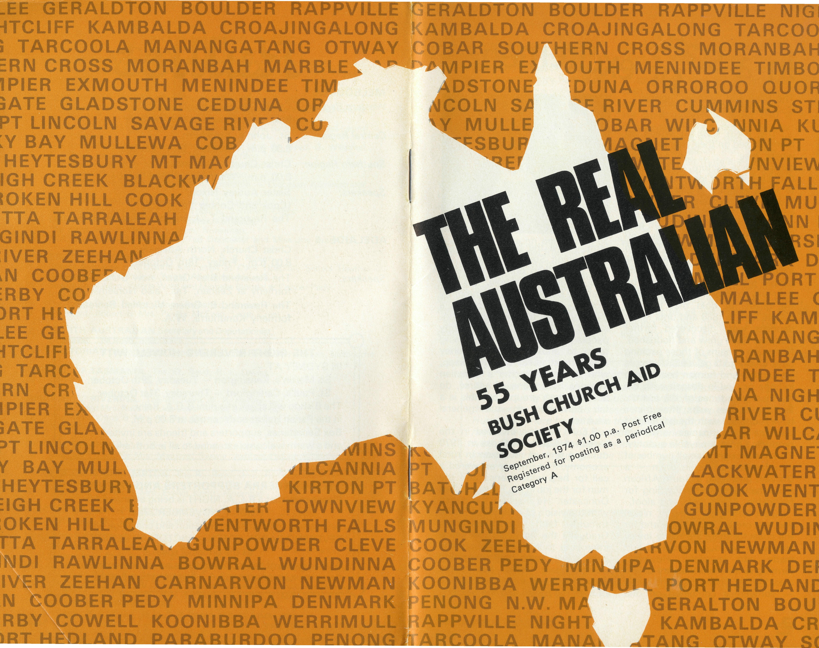

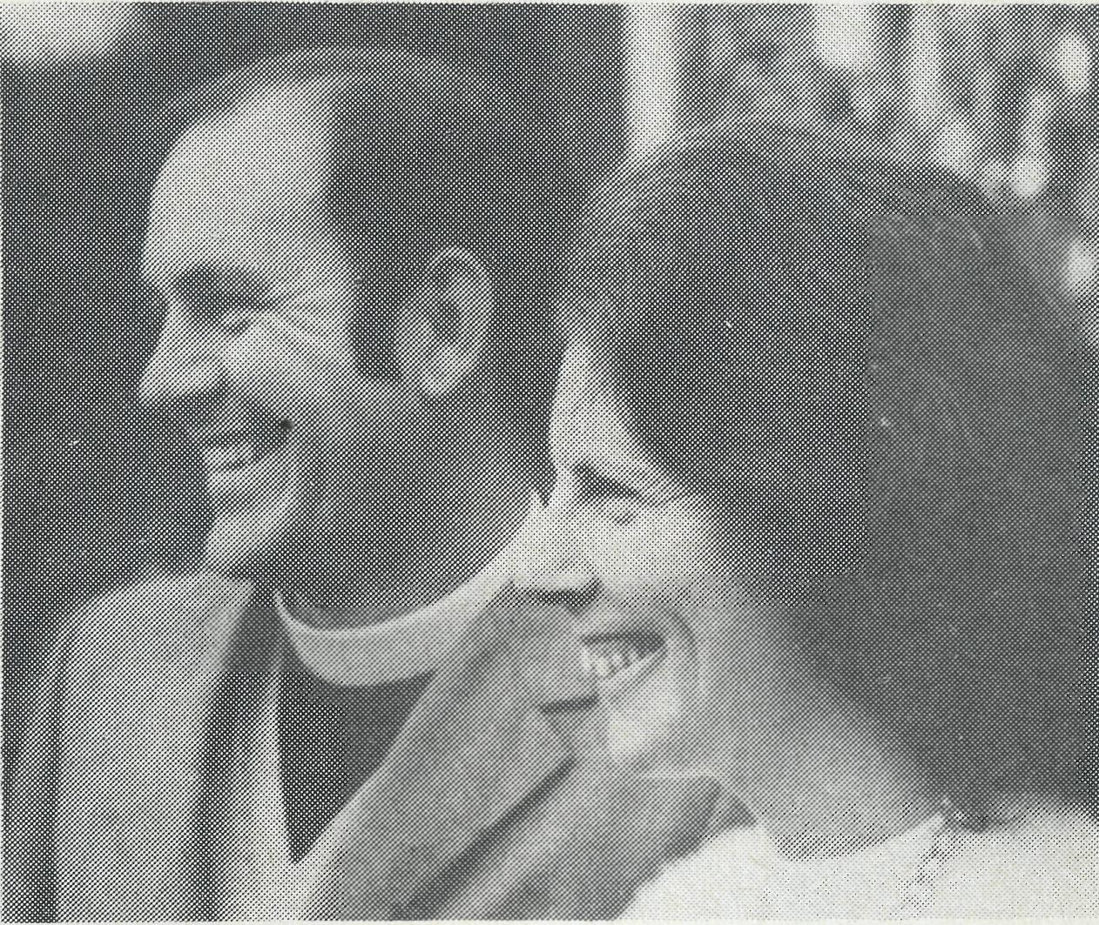
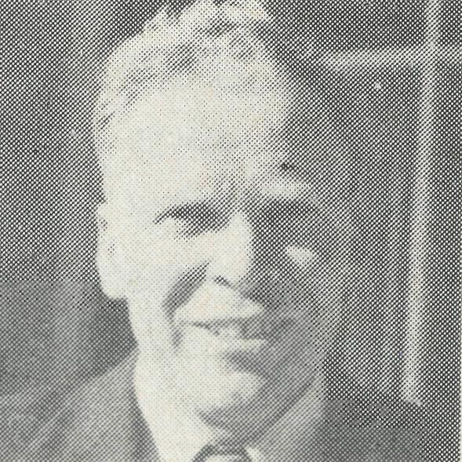
in a state of excitement

Joan and Gordon Thomas
The Reverend Reg Langshaw, who served at Wilcannia, in B.C.A., is to be the New South Wales Secretary. Later this year, he will leave his present parish of St. George's, Hurstville, where he has been the Rural Dean, to take up his new duties. He will bring a wealth of experience into the work. Well accepted within Sydney diocese, he will be known shortly throughout the State.

The Reverend Gordon Thomas, Southern Cross, W.A.
"The town through which so many passed on their way to somewhere else. . . ." So runs the caption to a picture of Southern Cross in a book of local history, and to some extent it is still the same today. The excitement must be somewhere else! Situated 233 km west of Kalgoorlie and 383 km east of the capital, Southern Cross is on Route 94 — the Great Eastern Highway linking Perth with the eastern States. A great many people pass through the town on their way to somewhere else. It was the quest for gold that brought people here in 1888 and until richer deposits were discovered further east, the town grew and flourished. Not much remains of those exciting days when gold galvanised people into action and human hearts rose in hope or died in despair with the fluctuating fortunes of the search. In the past two years three mines have reopened with the backing of the major companies and are producing gold in payable quantity. This has brought a small number of new families to live in town — a Bolivian geologist, a South African mine manager — some aching for friendship, others cold and aloof.
Apart from gold, gypsum, nickel and iron ore are mined here and for the collector there are many lovely stones to be found, polished and made into jewellery. However, farming is the main industry of the area. Wheat, sheep, pigs and cattle — sometimes combined on one
farm — are the backbone of life surrounding Southern Cross.
In effect then our ministry is to two groups of people. To the relatively stable farming community who in the main welcome a ministry, and to the mobile, unsettled and often very unhappy people who move from one mining town to another making money which most never seem to keep, who do not welcome a Christian ministry. Exceptions, of course, do occur in both groups, but this is a fair comment on the general situation.
B.C.A. became involved in the parish of Southern Cross in 1970 during a time of recession in rural economy. The Society answered a call for help with finance and the man for the job in the Reverend Ted Doncaster. He inspired the parish with the vision of a vigorous future through faith and dedication. Gradually the financial position is improving to the point where the parish will reach self-supporting status again. This has come through the prayer, faith and giving of both the parish and the Society.
THE REAL AUSTRALIAN
Folk here are very grateful to B.C.A. for the continuation of the Church's ministry during the past four years.
In many ways ministry here is the same as ministry anywhere. A regular pattern of Sunday Services, Scripture in schools, visiting from door to door, mid-week Bible study, Ladies' Guild and a monthly Christian-Paperback book club which Joan leads and which is proving popular with a group of young wives. We have been able to build up a very good paperback library through the kindness of the ladies of St. John's, Heidelberg in Victoria who have provided the money, and through many gifts of books and magazines from all over.
There are no pulpits in any of our centres. To preach one must stand on the floor close to people. Not so unusual you may think. Yet it does remind us that it is possible to be "six feet above contradiction" in one's ministry. It is possible to be a
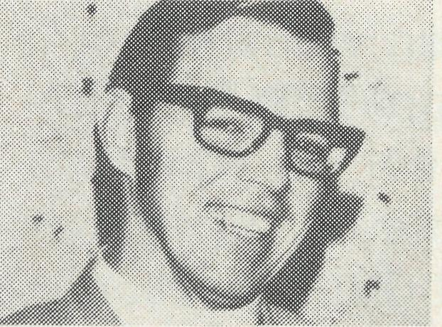
Revd. Arthur Horrex
stop press
good student of the Bible and to have a good understanding of people and yet not know just how to relate the two. We must stand with an open Bible close to people praying that God would so breathe His Spirit upon His Word that it may be a hammer of destruction for all that is unworthy and a lava of regeneration for all that is new.
To know that there are people of God praying for each area where there are members of B.C.A.'s family is a great strength and comfort. There are days when everything seems to go wrong and hearts are "smitten like grass and withered" (Psalm 102:4), and then to reflect upon the prayers of the saints and to experience their effect is a joy. God has given to His Church many wonderful people. In the name of Him who endured the cross for us all we thank you for sharing in this ministry of God's love and man's only hope.
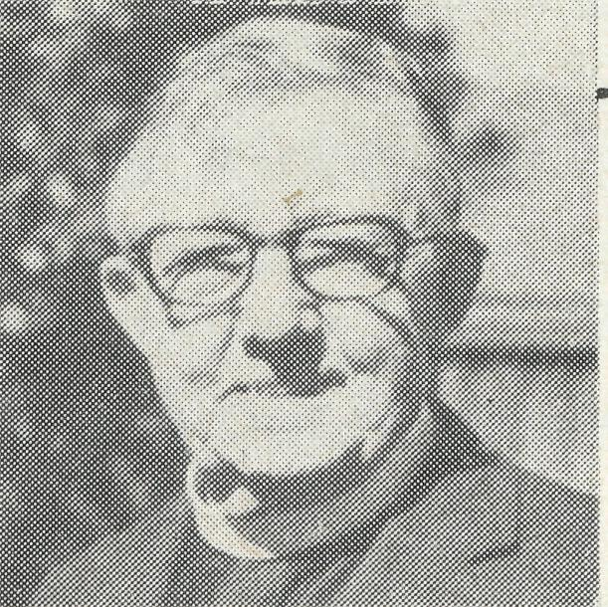
Revd. Reg Langshaw
These photographs can be added to the map obtainable from the state offices (see next page).
NEWS FLASH

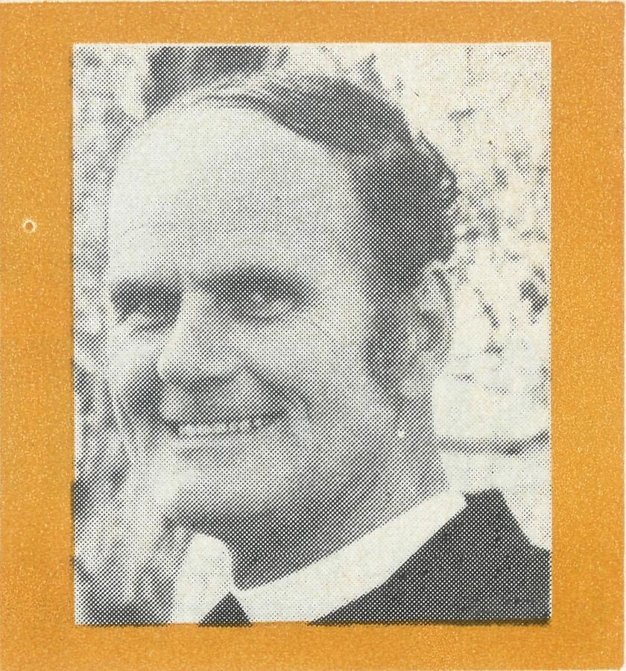
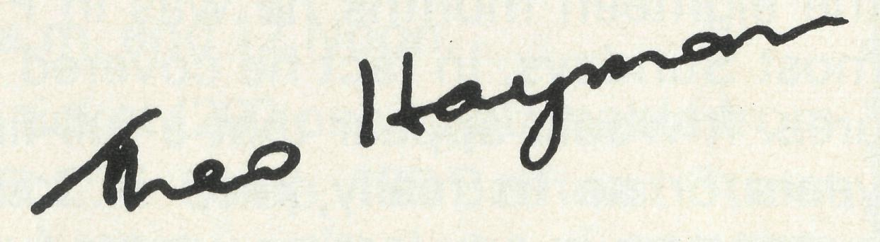
The danger of inflation for us is very real. Costs soar and giving remains the same or less ("I can't afford to give because . . ."). But I have confidence in God and our many members that this will not be so; that in fact giving will increase.
It is very encouraging, for example, to know that Glen Iris, Victoria, probably like others, decided that if they must spend a certain sum on their organ they will give away an equal amount to help others. This sort of action collectively and individually is the thoughtfulness which makes a world of difference to us and to those whom we seek to help. Many in remote areas are really struggling. Can we do more to help them? We need to help them for Christ's sake.
God is good. It is a great answer to prayer to have Arthur and Anne Horrex go to Kambalda, Western Australia, and Jim and Ruth Stocks to the Boys' Hostel at Broken Hill, N.S.W. We warmly welcome them into the family of B.C.A. Yourfriend,
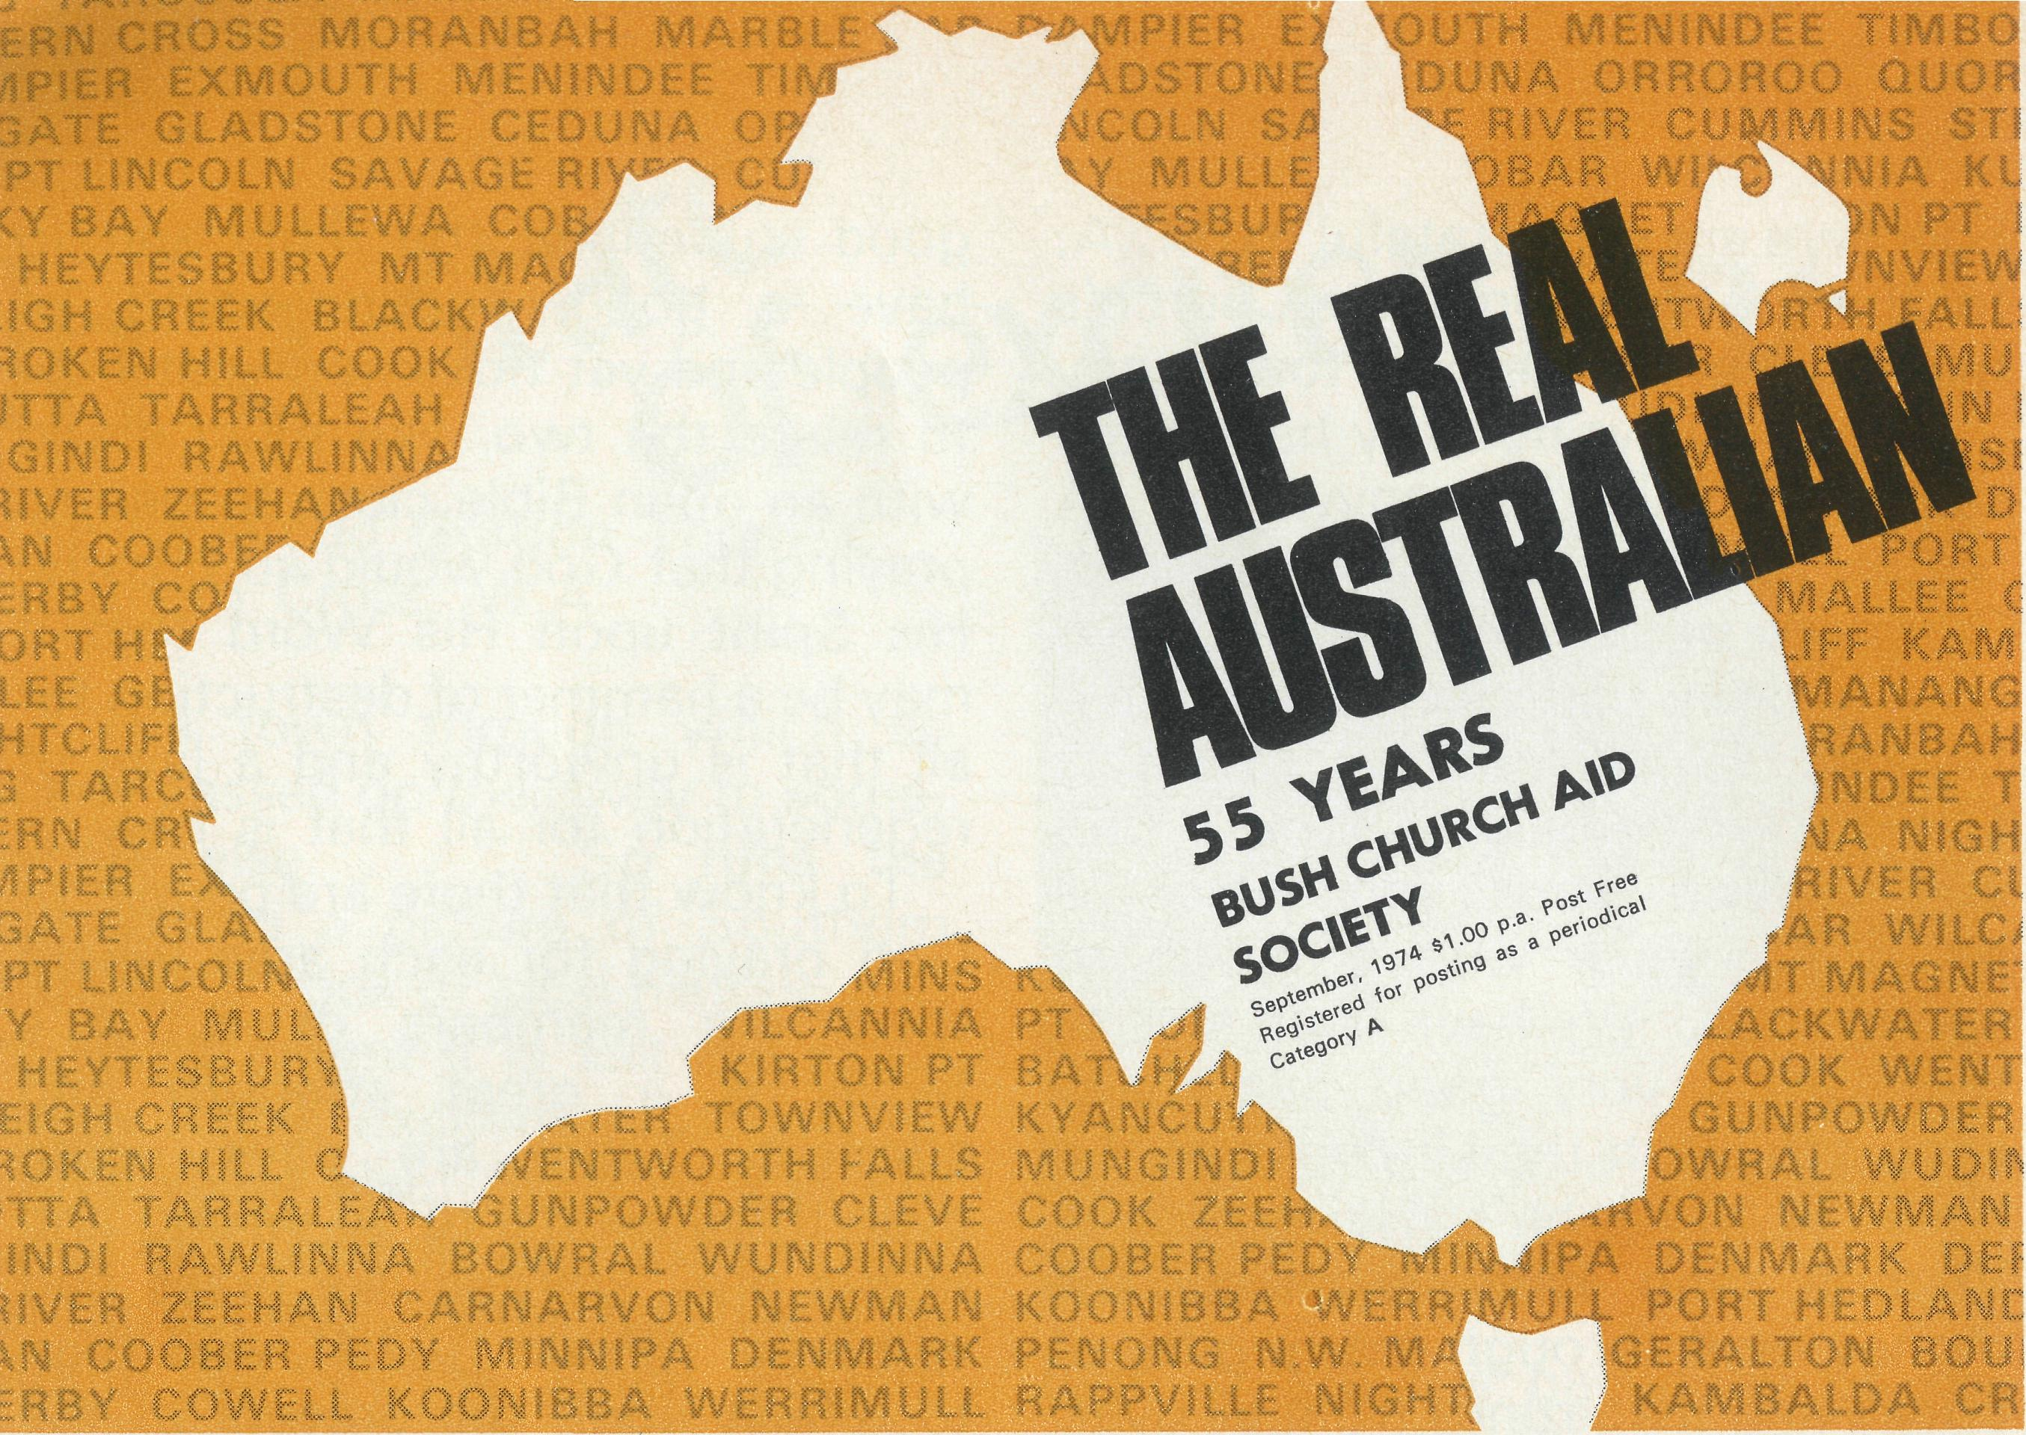
These are all the places where we have been privileged to serve in the 55 years of B. C.A. A glance will reveal that, through God's goodness we were able to bring a number of parishes to become self-supporting. The map below is the one available from any State office, showing the people who serve in our Society today. Additions to the map can be made from photos in this copy of "The Real Australian".
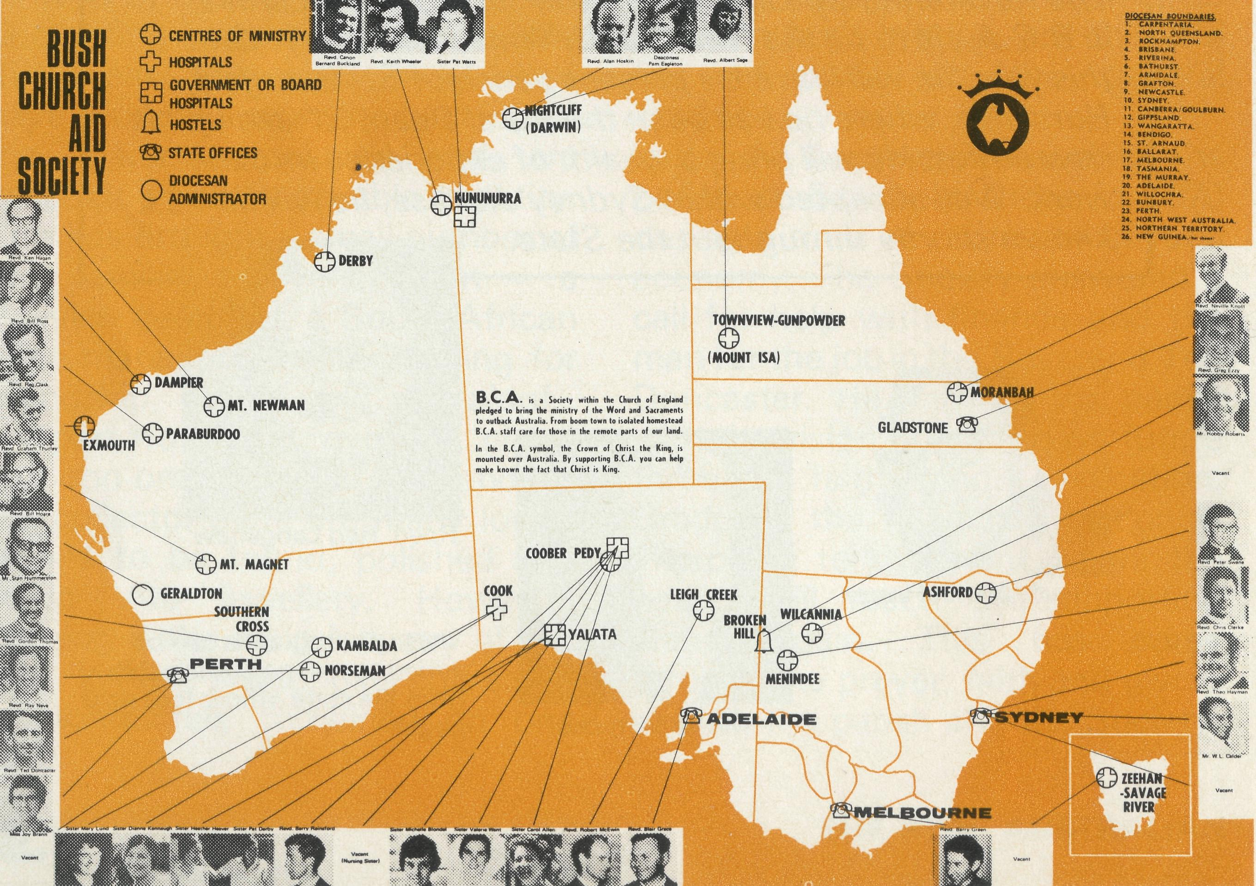
from the Federal Secretary
As participants in the National Home Mission Fund, the Conference in Darwin sponsored by that body in July was an interesting one. The requests for the consultation came from the Bishops of the three "missionary" dioceses recognised by the General Synod of Australia. By missionary is meant those dioceses which are not able to support adequately their Bishop and his work, because they have only two or three self-supporting parishes. The three missionary dioceses are Carpentaria, Northern Territory and North West Australia. Other dioceses also struggle to maintain their administration and episcopal oversight. In these, as well as in the missionary dioceses, the B.C.A. is happy to accept the challenge to help by supplying men and supporting them in parochial areas.
It was an exercise in caring to see the diocese and the plight of a missionary Bishop through his eyes. For everything, yes nearly everything, such a Bishop is dependent, like a mendicant, on the goodwill of others outside the diocese with very little certainty of a continuance of such help.
With inflation running high (and how many times do we hear that) the difficulty in Australian missionary dioceses, and those who are struggling, is worse. When we, as a Society, are challenged to help, we wonder if we can. Yet we feel we must.

The Revd. E. Constable at B.C.A. Conference 1970
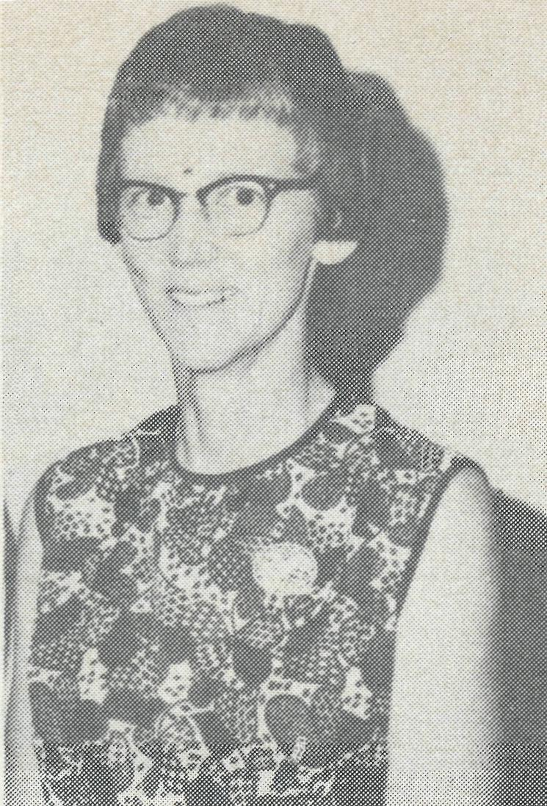
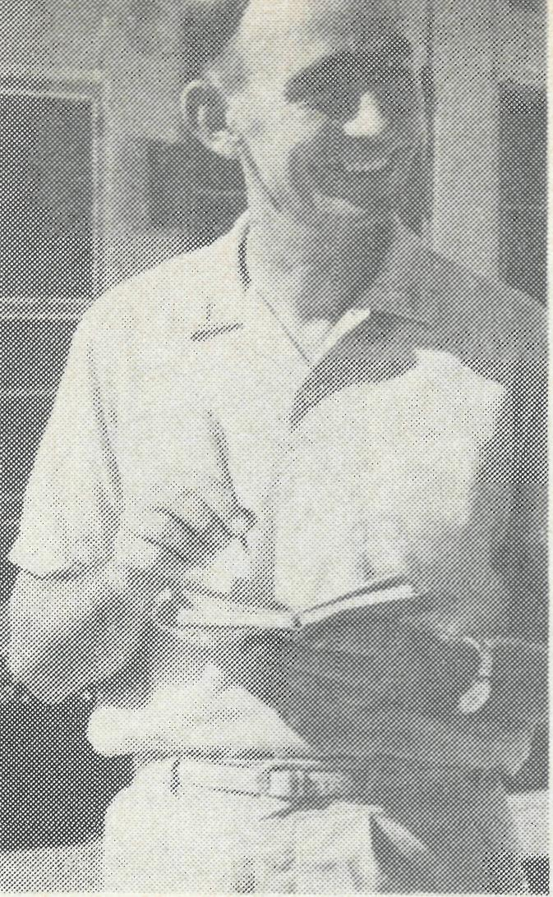
WESTERN SUPPORTERS
from a correspondent in Perth
Sister Joy Brann
Revd. Ted Doncaster
Deputation work in Western Australia was virtually non-existent until 1971 when the Reverend Brian Viney commenced visiting parishes and schools to tell of the task confronting B.C.A. and the National Home Mission Fund. In mid-1972 he left the West to take up an appointment in Victoria, and, before he went, a small committee was set up to continue his work. Dr. Ian Thorburn is the Chairman, the Reverend Ted Doncaster his deputy, the Reverend Fred Buchanan is the Treasurer, while Miss Helen Wills attends to the secretarial duties. Meetings are held every two or three months and the committee manages to keep supporters supplied with quarterly envelopes. The committee members help in the planning of deputations and rallies, keeping the mailing list up to date, and meet any local expenses.
A display board was set up in the Synod Hall in South Perth last year, and this introduced three deputations. During the last twelve months the amount of $2,141 has been sent on to B.C.A. and $1,403 to the National Home Mission Fund. These figures may seem small, but our efforts are limited by the fact that, whatever deputations are carried out, are done in spare time voluntarily.
Assisting the Reverend Ted Doncaster in the deputation work in parishes have been Sister Joy Brann and Sister Michelle Blondel — they have been a real asset, telling of their experiences in Derby and elsewhere. These have been of great interest to the women's groups to whom Joy and Michelle have spoken. During the last year a small band of women has been meeting as an auxiliary group and offering some assistance to those in B.C.A. Other people have been making their contribution by supplying goods for the opportunity shops, the sale of hand painted crockery and so on. One supporter sent in a special cheque to be used for Christmas gifts for some of the B.C.A. Rectors. How grateful we are for all these signs of interest in the work!
Our efforts may seem small, but they would be even smaller if it had not been for the fact that the Reverend Brian Viney was able to do so much in the eighteen months he was in Perth when he could do deputations on most Sundays. In fact he covered almost every parish in the metropolitan area. It would appear that a full-time effort would be essential every few years or so to really keep in touch with the parishes and our regular supporters in any lasting way: a full-time deputationist for six months or a year. We praise God for what has been done and for the faithful supporters we have over here in the West.
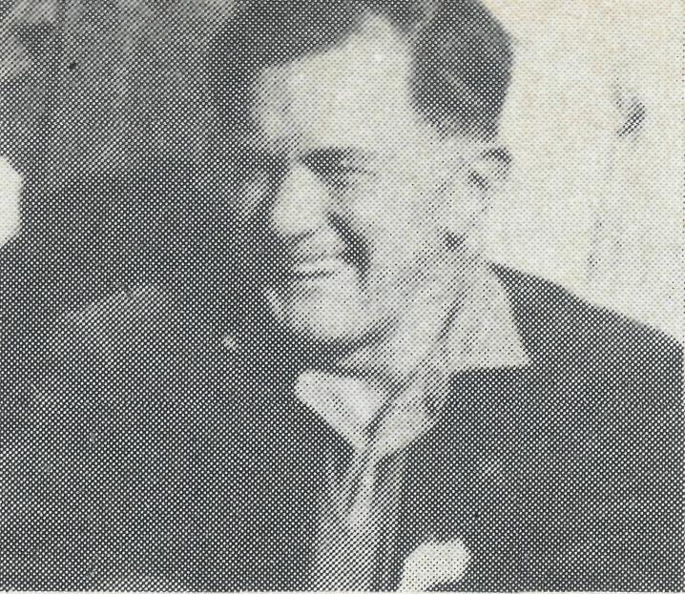
THE REVEREND ERIC CONSTABLE
It is with great regret that we, the members of the Victorian Committee of B.C.A., record the tragic death of the Reverend Eric Victor Constable at Djakarta, Indonesia, on 29th June last.
Eric had been associated with B.C.A. for over 40 years, being a candidate in the early '30s and going to the field in 1937. During his time at Penong, S.A., he will be remembered, for example, for his kindness to James Cook, the Aboriginal baby left on the doorstep of Cook Hospital. Eric served for many years on the Victorian Committee, of which he was elected chairman in 1970, and was a member of B.C.A. Council.
In June, 1973, he asked for leave-of-absence that he might carry on some temporary work in C.M.S. fields overseas. It was while returning to Australia that he met his untimely death.
Eric was always most enthusiastic over the work of B.C.A. and loved the people of the outback. He could never do enough to help forward the work of the Society.
The members of the Committee give thanks to God for the interest and service of this trusted servant (and, of course, this gratitude is shared by us all, Ed.).
The Reverend John Brook, who is now in Sydney, has heard from the local congregation that three well-dressed men went to All Saints' Church and told the gatekeeper that they wished to see the Vicar. Apparently they then went straight into the Vicarage and stabbed Mr. Constable and his Indonesian servant to death. The gatekeeper, who was not an employee of the Church, wounded one of the three men as they fled out to the street, and the wounded man was picked up by the police. The gatekeeper himself was wounded by the other two. Mr. Brook said that there could not possibly have been much money in the Vicarage, so the motive for the murder remains a mystery.
The B.C.A. Women's Auxiliary, Sydney, would be delighted to have your company at
MORNING TEA AND INSPECTION OF BISHOPSCOURT (Greenoaks Avenue, Darling Point, Sydney)
WEDNESDAY, 16th OCTOBER, 1974. Between 10.00 a.m. and 12 Noon.
Admission is by ticket (200 only) obtainable from Mrs. J. O'Neill, B.C.A. Shop, 135 Bathurst Street Sydney, or Mrs. A. McLaughlin, phone 82-1072.

THE REAL AUSTRALIAN

THE BATTLE TO ‘LET THE LORD’
The Reverend Keith Wheeler, Kununurra.
On the feast of Pentecost there was a battle of communication. It is very dear to me that God has, through Jesus Christ, poured out His Holy Spirit and that the Spirit is available to those who turn to Him in repentance and faith. Daily we should keep on being filled with the Holy Spirit, be renewed in the Spirit of our minds, walk in love and let the Holy Spirit lead us into all truth. But here came the battle. How can I adequately communicate this to others?
Whatever the congregation thought, I was left leaden winged. Then came the insight. It arose out of the story of David and Goliath. David, a mere slip of a lad, entered upon the battle with the words in his mouth, "the battle is the Lord's".
How often we take thin'gs into our hands! On my first trip to the Aboriginal settlement of Oombul-gurri, it was suggested that I might like to take a horse to the lovely "Camera Pool", the source of the water supply six miles away. We talk about being "tossed to and fro and carried about" . . .! Once I got on the horse and exerted my will, I lost my freedom and was taken for a ride! You can imagine what happened. And so it is whenever I
have taken the reins of my life, "self" is one of the giants that Jesus has dealt with.
Pray that we, in the Christian congregation, may not become too involved in all the doings of the community. They say that a rolling stone gathers no moss, but it is easy to gather a good deal of moss even in six months. There is so much doing in the community that the things of God can be pushed out. Or we may become petty with the "in-talk" of the differences of denominations.
Another kind of giant is the very real distance and isolation. To go to the Aboriginal settlement of Oombulgurri, which was formerly the Forrest River mission, we first travel 113 km to Wyndham. Here, every fortnight, there is a service on Sunday evening. The next day we look across the harbour to Oombulgurri. It is forty-five miles across and by boat takes us about two hours. It might be possible by 'plane but would be a very long and involved journey by car around miles of swamps and across rivers. Even by boat, tides, the number of passengers, the mechanical condition of the boat, all have a bearing upon whether the 'minister' can make the trip or not.
On one occasion, we crossed under the able captaining of an Aborigine, Eric Gerrard. We stayed
the night, intending to return at first light. That night, therefore, to ensure the earliest departure and to fit in with the tide, we went to move the launch, the "Aligu", further downstream. After dark we boarded the launch and set adrift before starting the engine. Unfortunately the motor refused to start, no matter how many times we tried. In the heat and humidity, under cover of the dark, a full squadron of very active and hostile insects (thankfully non-malarial) were desperate to make the most of the opportunity! About an hour later (after I had asked the Lord for a miracle and tried to be thankful for our misery) we anchored on the opposite side of the wide river with no way of getting back except through crocodile territory. Remembering the large and strange skeleton of that water creature near the settlement, I was not content to stay there but even less willing to take to the water!
Then, somehow, a small dinghy drifted near us. It was the Lord's answer, but one I was about to resist. There being no other volunteers, over the side I went into the row boat for the long haul back. The dinghy became a "Little Toot", working overtime for an hour until we reached the "promised land" of the settlement. In co-operation with Him, the battle was the Lord's.
The epic journey had by no means ended. Early the next day we tried again a number of times to start the boat. Eventually there was a spark and the engine burst into life with the throttle jammed full on. Then the moment came, when the gears were engaged. We sprang forward midst shouts and jeers, for we ran right into the large net which, the day before, had caught the biggest barramundi I had ever seen. Now the net had made another catch. When we disentangled "Aligu", she refused to start again. Humiliating? Returning to the settlement, Louisa and Robert Roberts, a lovely Christian couple, were most kind. We dined outside with them in luxury. The Aboriginal children everywhere were making a "joyful noise" and the whole of God's creation was so beautiful that it sang its own anthem of praise to the Lord.

We indeed have a big area with Kununurra as the base, going 418 km to Halls Creek, the station country and Wyndham by road and Oombulgurri by boat. With our trust in Him; for "my help cometh from the Lord", we will manage, for the battle is His.
(Since this was written, the National Home Mission Fund has been able to promise the payment of air fare for Keith Wheeler to visit Oombulgurri — Ed.)

THE REAL AUSTRALIAN

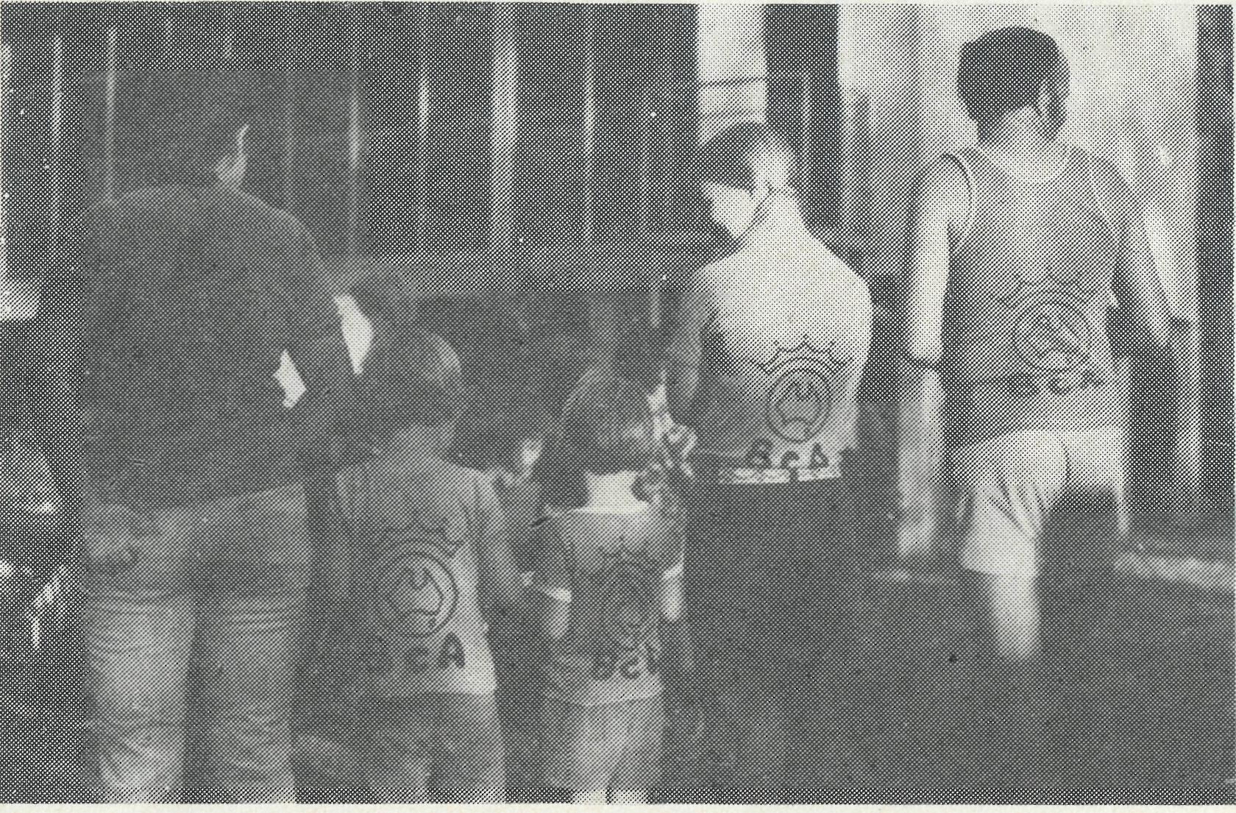
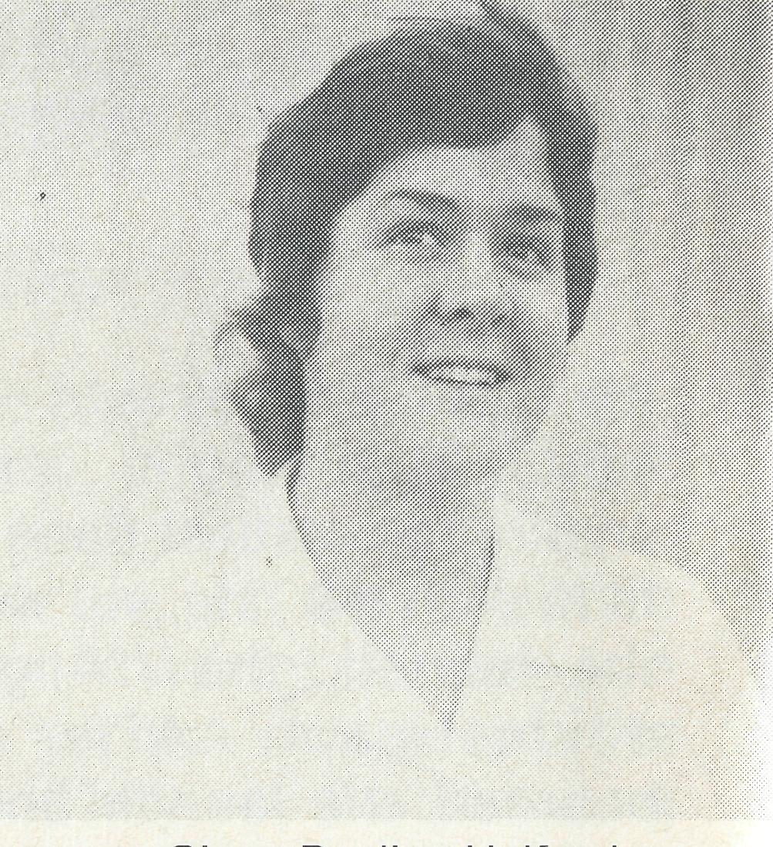
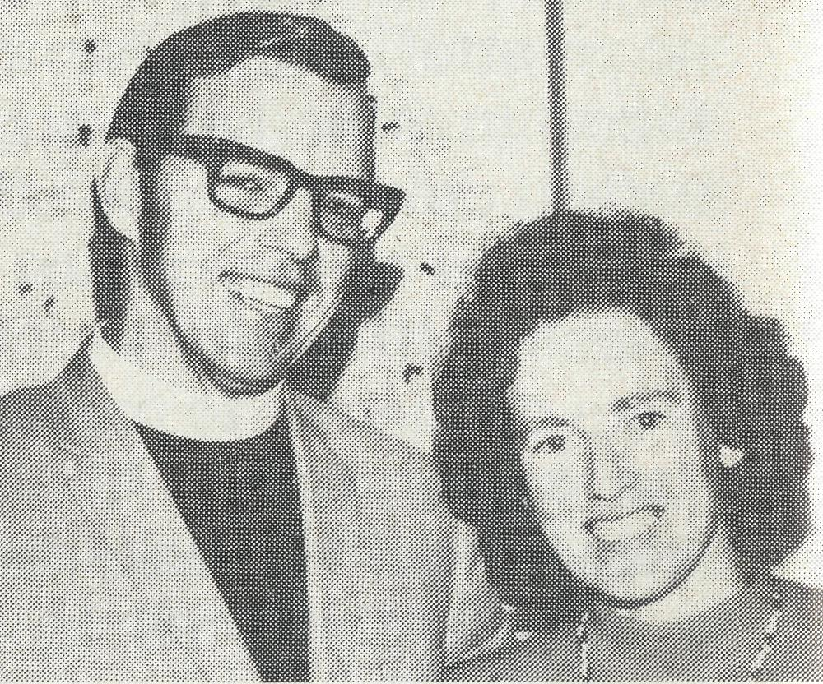
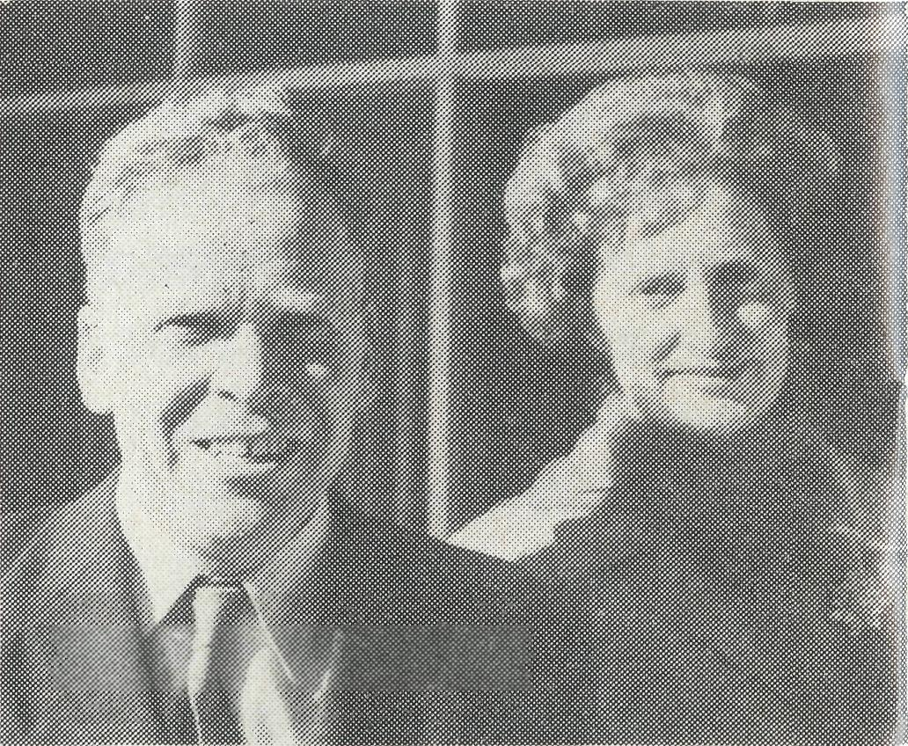
Sister Pauline Halford
Arthur and Anne Horrex
NIGHTCLIFF'S OWN "BACK TO B.C.A.Alan and Philippa Hoskin and Pam Eagleton report that they have 30,000 people in their part of Darwin. There is a great need for the preparation of one, and perhaps two new parishes four miles out from St. Peter's. This will reduce the number — one day — to 20,000. The change in population is constant. Two years come very quickly. Some, however, are staying longer. There is a massive job to be done.
WEST PILBARA (DAMPIER) Bill and Jocelyn Ross have 12,000 in five or six towns. Bill reports, "Some twenty-two women and three men have been involved in conducting 21 periods of Religious Instruction each week and three High School seminars during the year. Some have moved away, some "retired", but the bulk are carrying on valiantly. Nearly all of us have come from a place where there is an Anglican church building, and for some it is difficult to adjust to something less inspiring and without identity. The only true identity we can seek is in the Lord Jesus Christ himself, and the Holy Spirit is able to inspire those who are open to Him no matter what their surroundings. The church is the people." If you have never had a church building you do not miss it, but if you have come from beautiful "St. Haven-on-the-hill", it is hard not to have any church building.
Jim and Ruth Stocks
• 2CH, Sydney, have changed their policy for all Sunday broadcasts. The B.C.A. session is for five minutes some time on each Sunday afternoon.
• We are grateful to Sister Pauline
Halford for her kindness in helping
us in the hospital at Coober Pedy
between her two certificates of
training. Pauline came from Two
Wells, near Adelaide — it was good
to have a South Australian.
NURSES, NURSES, NURSES,
Who will take up the challenge of
service?
- Sister Pat Darby is engaged to Warren Charlton of Ceduna. We wish them God's blessing as they are married in October. Who is there for Yalata?
- The Reverend Arthur Horrex was commissioned by the Archbishop of Perth in Kambalda on 22nd August. We are very grateful to Arthur and Anne, who went from Robertson in N.S.W. with Angela (6¹/₂) and Grant (3¹/₂). May we praise God and continue to pray for them in the ministry in Kambalda.
- Mr. Jim and Mrs. Ruth Stocks came as an answer to prayer — both theirs and ours — to be the parents at our Boys' Hostel in Broken Hill. Jim and Ruth believed that they were called to this type of work. They have four boys, Bruce 15, Mark 14, Robert 12, Grahame 10 and now they enlarge their family with a couple of Davids, Bobby, Paul . . . nineteen of them. Bruce went with his parents to have a look, at the beginning of August, as he is to stay in St. Marys, N.S.W., to complete this year. Jim and Ruth will be relying on your prayers as they begin this month.
- Our thanks are gladly given to Margaret and Robby Roberts for the four years of service in charge of the Boys' Hostel, Broken Hill. The grounds are beautifully kept
and, more importantly, there is an air of quiet co-operation among the boys. Quiet? Well, most of the time!
- Helen and Graham Thurley have a baby daughter, Andrea. It was good that Graham could be in Tasmania where Helen was at the time of the birth.
- Albert Sage has had a nasal operation. He feels better already. Gunpowder community is growing and the management would like more visits.
- The Reverend Barry and Mrs. Jenny Rainsford have indicated their willingness to stay on at Coober Pedy for their fifth year. Praise God.
- Upon request, the Commonwealth Railways kindly moved Keith Anstee to Cook. His wife, Rhonda, is a nursing sister and will be a great help to Dianne Kennaugh in the Bishop Kirkby Memorial hospital at Cook. Keith and Rhonda aim, one day, to go to a Bible college. Their fellowship is much appreciated by Roslyn and Dianne.
- The Reverend Colin and Mrs. Judith Ware quite suddenly cut short their long service leave to accept the parish of Pine Rivers, north of Brisbane. Please pray for someone to continue the good work at Wilcannia (not forgetting a clergyman for Zeehan and Strath-gordon, Tasmania).
- In an attempt to keep postage costs to a minimum we are not now writing a letter of thanks for every package of used stamps received. To all who have sent used stamps recently — our warm thanks — particularly to St. Oswalds's, Haberfield G.F.S., St. Martin's, Kensington and St. Nicolas', Coogee. Keep the stamps coming as we need half a ton by October.

10
THE REAL AUSTRALSAN
II

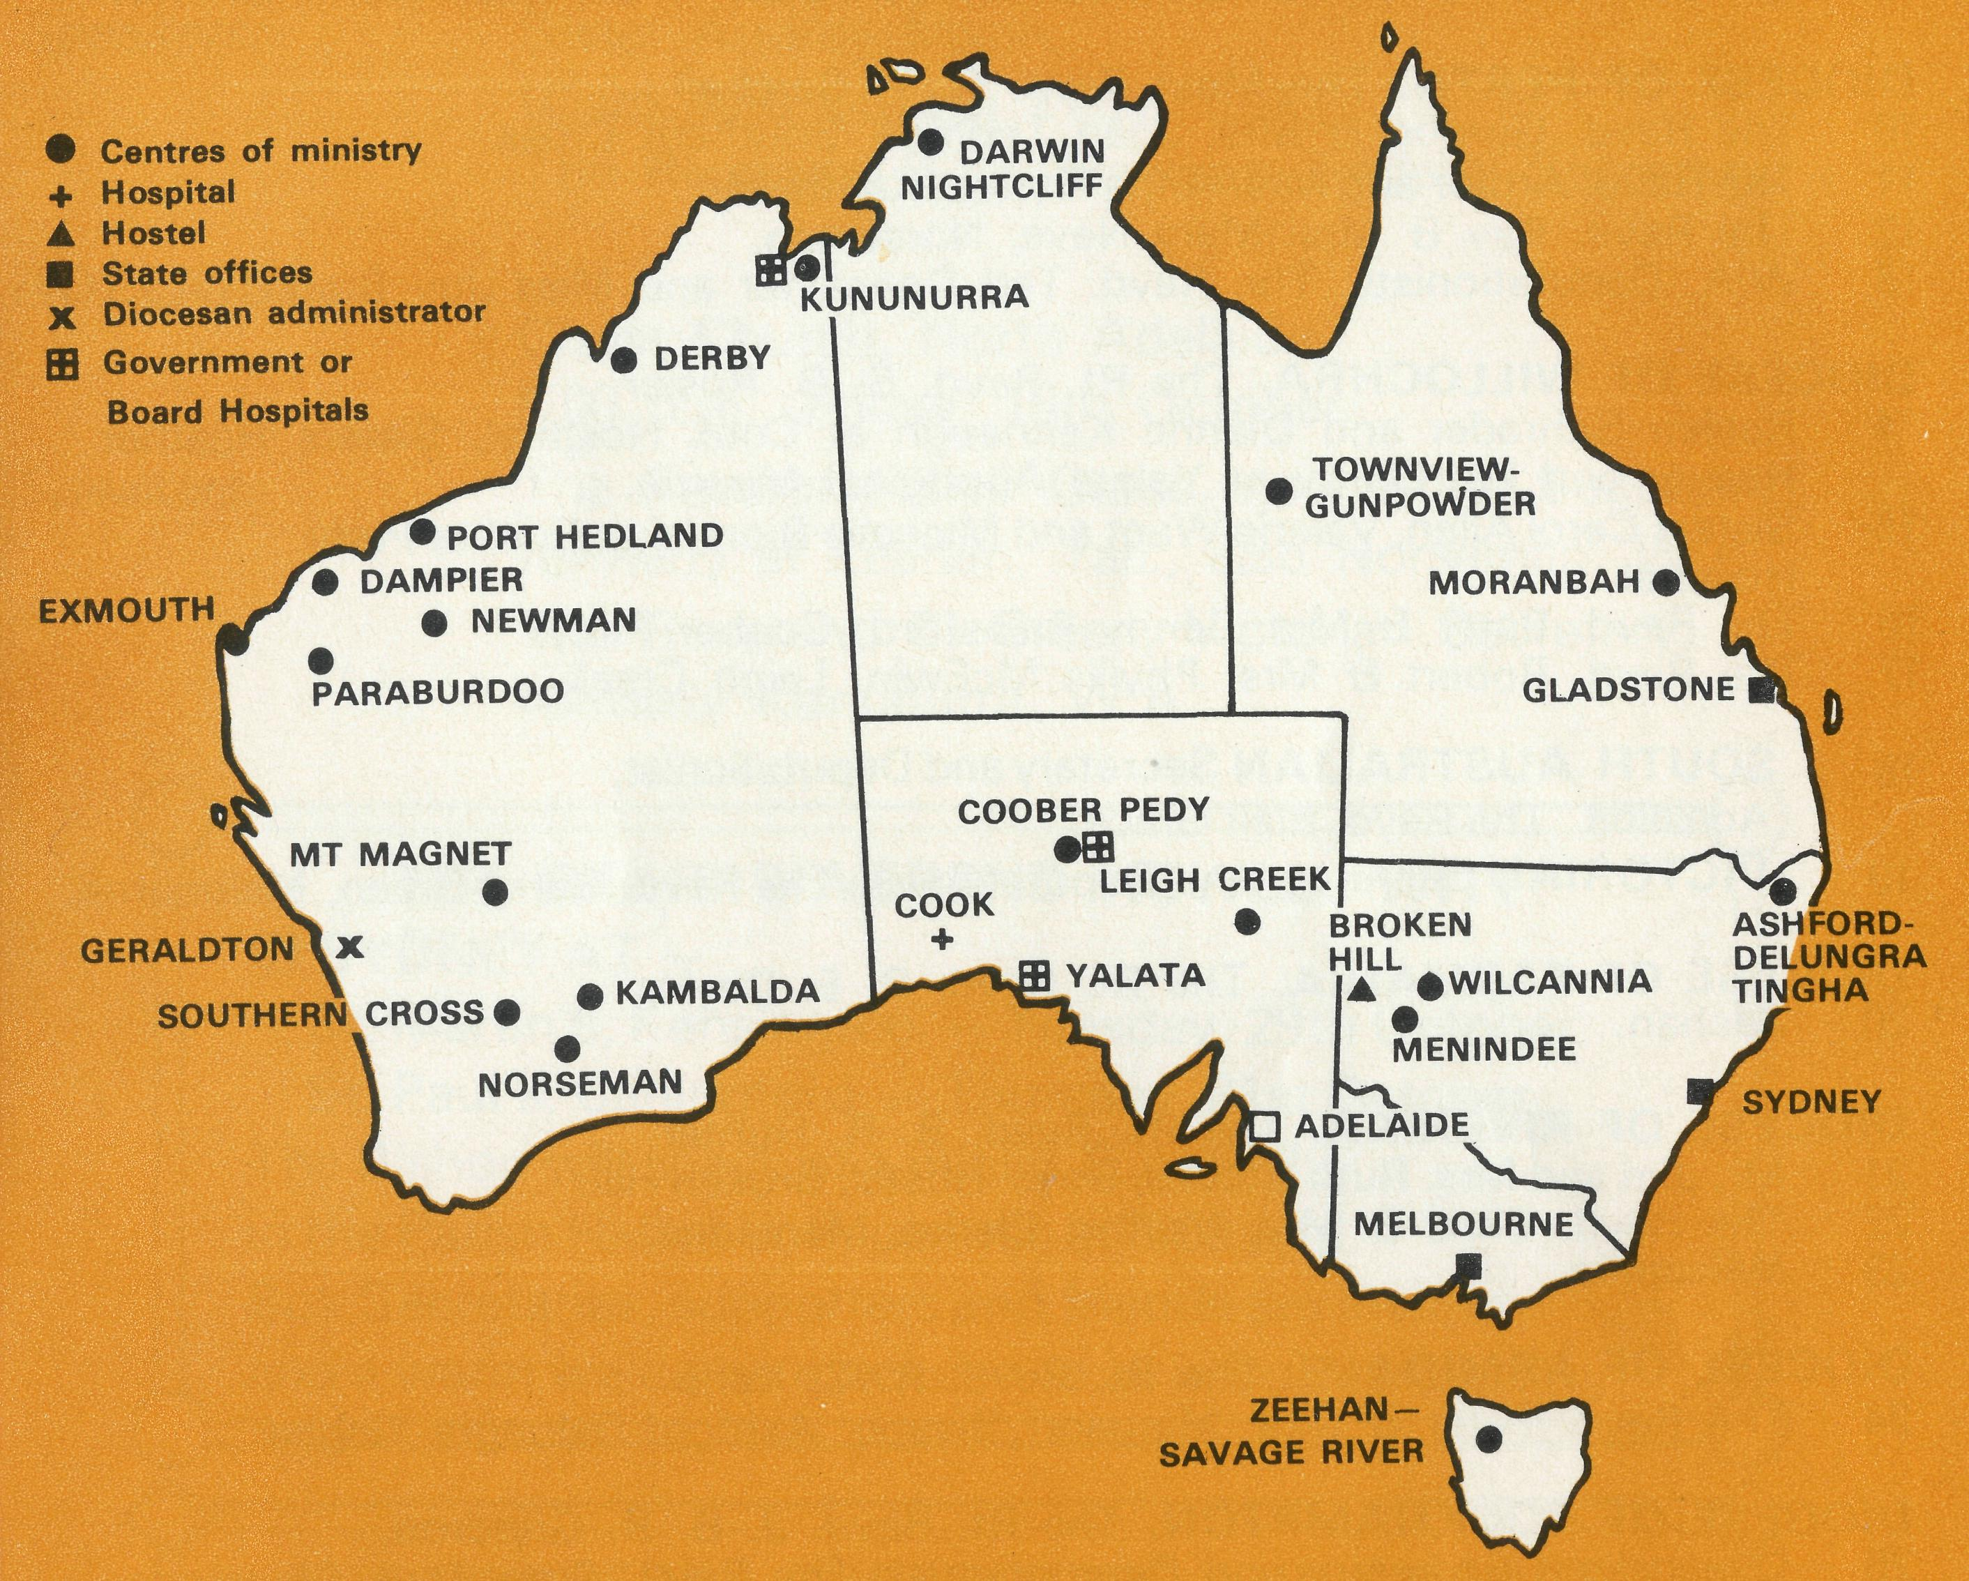
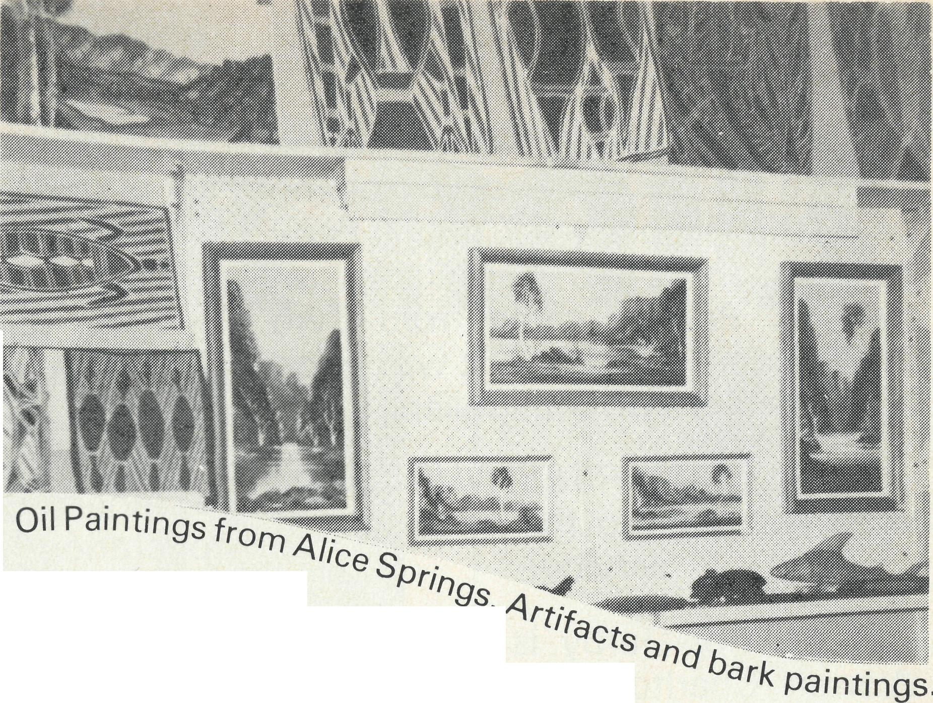
looking
for overseas
THE B.C.A. PRAYER
gifts?
SYDNEY SHOP
Opals, rough as well as polished and jewellery Authentic Aboriginal artifacts covering a wide variety from boomerangs to beautiful bark paintings, also water colours. Special: Limited supply of oil paintings from Alice Springs.
MELBOURNE SHOP
Opals and Souvenirs, drop in and see them for yourself,
3rd floor, Clark Rubber Building, 196 Flinders Street, Melbourne.
State Office Directory. . .
Federal Secretary — The Revd. T. J. Hayman.
N.S.W. Secretary — The Revd. R. N. Langshaw.
Asst. Secretary (N.S.W.) - Mr. W. L. Calder.
Financial enquiries — Mr. C. McLaughlin.
B.C.A. House, 135 Bathurst Street, Sydney, N.S.W. 2000
(02) 26-3164, 26-3780. Telegraphic Address: "Chaplaincy", Sydney.
Victorian Secretary — The Revd. B. W. Green,
3rd Floor, Clark Rubber Building, 196 Flinders Street,
Melbourne, Vic. 3000. Phone: (03) 63-8962.
Queensland Secretary — The Revd. G. Ezzy,
31 Anderson Street, Clinton Park, Gladstone, Qld. 4680
West Australian Deputationist — The Revd. E. W. Doncaster, Anglican Rectory, Mundaring, W.A. 6073. Phone: (092) 95-1029.
Sth. Australian Secretary — The Revd. B. S. Grace,
22 Conyngham Street, Glenside, S.A. 5065. Phone: (082) 79-3026.
President — The Most Reverend, the Archbishop of Melbourne. Vice-Presidents — The Most Reverend, the Archbishop of Sydney and Mr. H. M. Bragg.
Chairman of Council — The Rt. Revd. G. R. Delbridge. Honorary Treasurer — Mr. R. T. Stokes.
A DAILY PRAYER

O God, we remember before You those whom You have called to Your service. We ask You to bless
, assure
them of Your Presence, and call others to stand with them in the task. Grant to them, as to us, the joy of service, the ability to achieve, and the serenity of Your peace, for Jesus' sake. Amen.

Name .
□
Enclosed
Magazine sub. $1.00 or Donation
Address
□
Enrol me as a member of B.C.A. Prayer Fellowship. (Please tick appropriate square)
O Lord our God, help us to remember those who live in the remote parts of our land. We ask You to bless those whom You have called into the fellowship of The Bush Church Aid Society. Grant that, through the ministry of the Word and Sacraments, through healing, and through caring for the young, the message of Your redeeming love may be proclaimed, through Jesus Christ our Lord. Amen.

MELBOURNE
Western Region:
Central Region: Southern Region: Speakers:
ADELAIDE
Speakers:
PRAYER CALENDAR
DIOCESE OF NORTHERN TERRITORY. The Rt. Revd. K. B. Mason
1 The Revd. Alan & Mrs. Philippa Hoskin, and-Deaconess Pam Eagleton,
Nightcliff.
DIOCESE OF N.W. AUSTRALIA.The Rt. Revd. H. A. J. Witt
- The Revd. Keith & Mrs. Monica Wheeler and Sister Pat Watts, Kununurra.
- The Revd. Canon Bernard &■ Mrs. Coralie Buckland, Derby.
- The Revd. Ken & Mrs. Margaret Hagan, Newman, The Revd. Kevin Hall (grant), Port Hedland.
- The Revd. Bill & Mrs: Jocelyn Ross, Dampier (and the Revd. G. Williams).
- The Revd. Reg & Mrs. Beryce Clark, Paraburdoo.
- The Revd. Graham & Mrs. Helen Thurley, Exmouth.
- The Revd. Bill & Mrs. Joan Hoare, Murchison.
- Mr. Stan & Mrs. Dorrie Hummerston, Geraldton — Diocesan Administrator.
DIOCESE OF PERTH. The Most Revd. G. T. Sambell
- The Revd. Gordon & Mrs. Joan Thomas, Southern Cross.
- The Revd. Arthur and Mrs. Anne Horrex, Kambalda.
- The Revd. Ray & Mrs. Mary Neve, Norseman.
- W.A. Deputationists, The Revd. Ted Doncaster and Miss Joy Brann.
DIOCESE OF WILLOCHRA. The Rt. Revd. S. B. Rosier
- Roslyn Schrader and Dianne Kennaugh at Cook Hospital, Sisters Heather Heaver and Pat Darby at Yalata Aboriginal Mission.
- Sisters Carol Allen, Valerie Want and Michelle Blondel at Coober Pedy Hospital.
- The Revd. Barry & Mrs. Jenny Rainsford, Coober Pedy.
- The Revd. Robert & Mrs. Phyllis McEwin, Leigh Creek.

- SOUTH AUSTRALIAN Secretary and Deputationist, Adelaide. The Revd. Blair Grace,
- VICTORIAN Secretary and Deputationist, The Revd. Barry Green, Melbourne.
DIOCESE OF TASMANIA. The Rt. Revd. R. E. Davies
20 Zeehan.
DIOCESE OF RIVERINA. The Rt. Revd. B. R. Hunter.
- Mr. Jim and Mrs. Ruth Stocks, Boys' Hostel, Broken Hill.
- The Revd. Chris & Mrs. Marilyn Clerke, Menindee.
- Wilcannia.
DIOCESE OF ARMIDALE. The Rt. Revd. R. C. Kerle.
24 The Revd. Peter & Mrs. Margaret Swane, Ashford-Delungra-Tingha.
DIOCESE OF ROCKHAMPTON. The Rt. Revd. J. B. R. Grindrod.
- Queensland Secretary and Deputationist, The Revd. Greg Ezzy, Gladstone.
- The Revd. Neville & Mrs. Evelyn Knott, Moranbah.
DIOCESE OF NORTH QUEENSLAND. The Rt. Revd. H. J. Lewis.
27 The Revd. Albert & Mrs. Lareine Sage, Townview.
GENERAL
14
- The Federal Secretary, The Revd. Theo Hayman, The Council, State Committees. Staff Replacements.
- N.S.W. Secretary, the Revd. R. N. Langshaw, Assistant Secretary (N.S.W.) Mr. Laurie Calder, Box Secretaries, B.C.A. Supporters and Deputations.
- Office Staff: N.S.W., Mr Colin McLaughlin, Miss Doris Smith, Mesdames Joy O'Neill, Lilian Phipson & Dora Warwick. Vic: Miss Rosemary Renouf.
- National Home Mission Fund.
THE REAL AUSTRALIAN
Christ Church, Essendon.
8.00 p.m., Monday, 14th October.
St. John's, Blackburn.
8.00 p.m., Tuesday, 15th October.
Christ Church, Ormond.
8.00 p.m., Wednesday, 16th October.
Sister Audrey Nixon,
(Cook and Coober Pedy, S.A.)
The Reverend T. J. Hayman, Federal Secretary.
Christ Church, North Adelaide.
8.00 p.m., Friday, 18th October.
The Reverend Blair Grace, now State Secretary,
formerly at Zeehan, Tas., also Norseman, W.A.
The Reverend B. Green, Victorian Secretary,
formerly Kununurra, W.A.
THE RIGHT REVEREND HOWELL WITT
IN SYDNEY AT-
St. Martin's, Kensington — Tuesday, 29th October.
St. Paul's, Carlingford — Thursday, 31st October. The Bishop will speak at a mini B.C.A. Rally in the Parish Hall at both centres at 8.00 p.m. Box Secretaries, supporters and friends are invited and a warm welcome extended to all in both areas.
FOR CANBERRA SUPPORTERS AND FRIENDS
Please note that a B.C.A. NIGHT is being arranged for
FRIDAY, NOVEMBER 29th. An evening of interest, information and challenge with REVEREND BARRY GREEN - VICTORIAN SECRETARY
as the principal speaker Audio visuals of the work and full support programme. Enter the date in your diary. Venue to be advised.
1974-AMBASSADOR PRESS, 51 Good St., GranviHe 2142-32564
15

