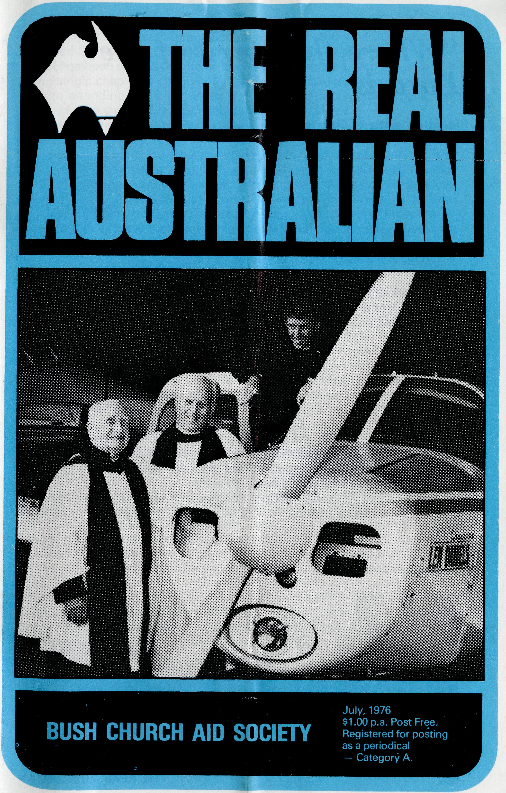
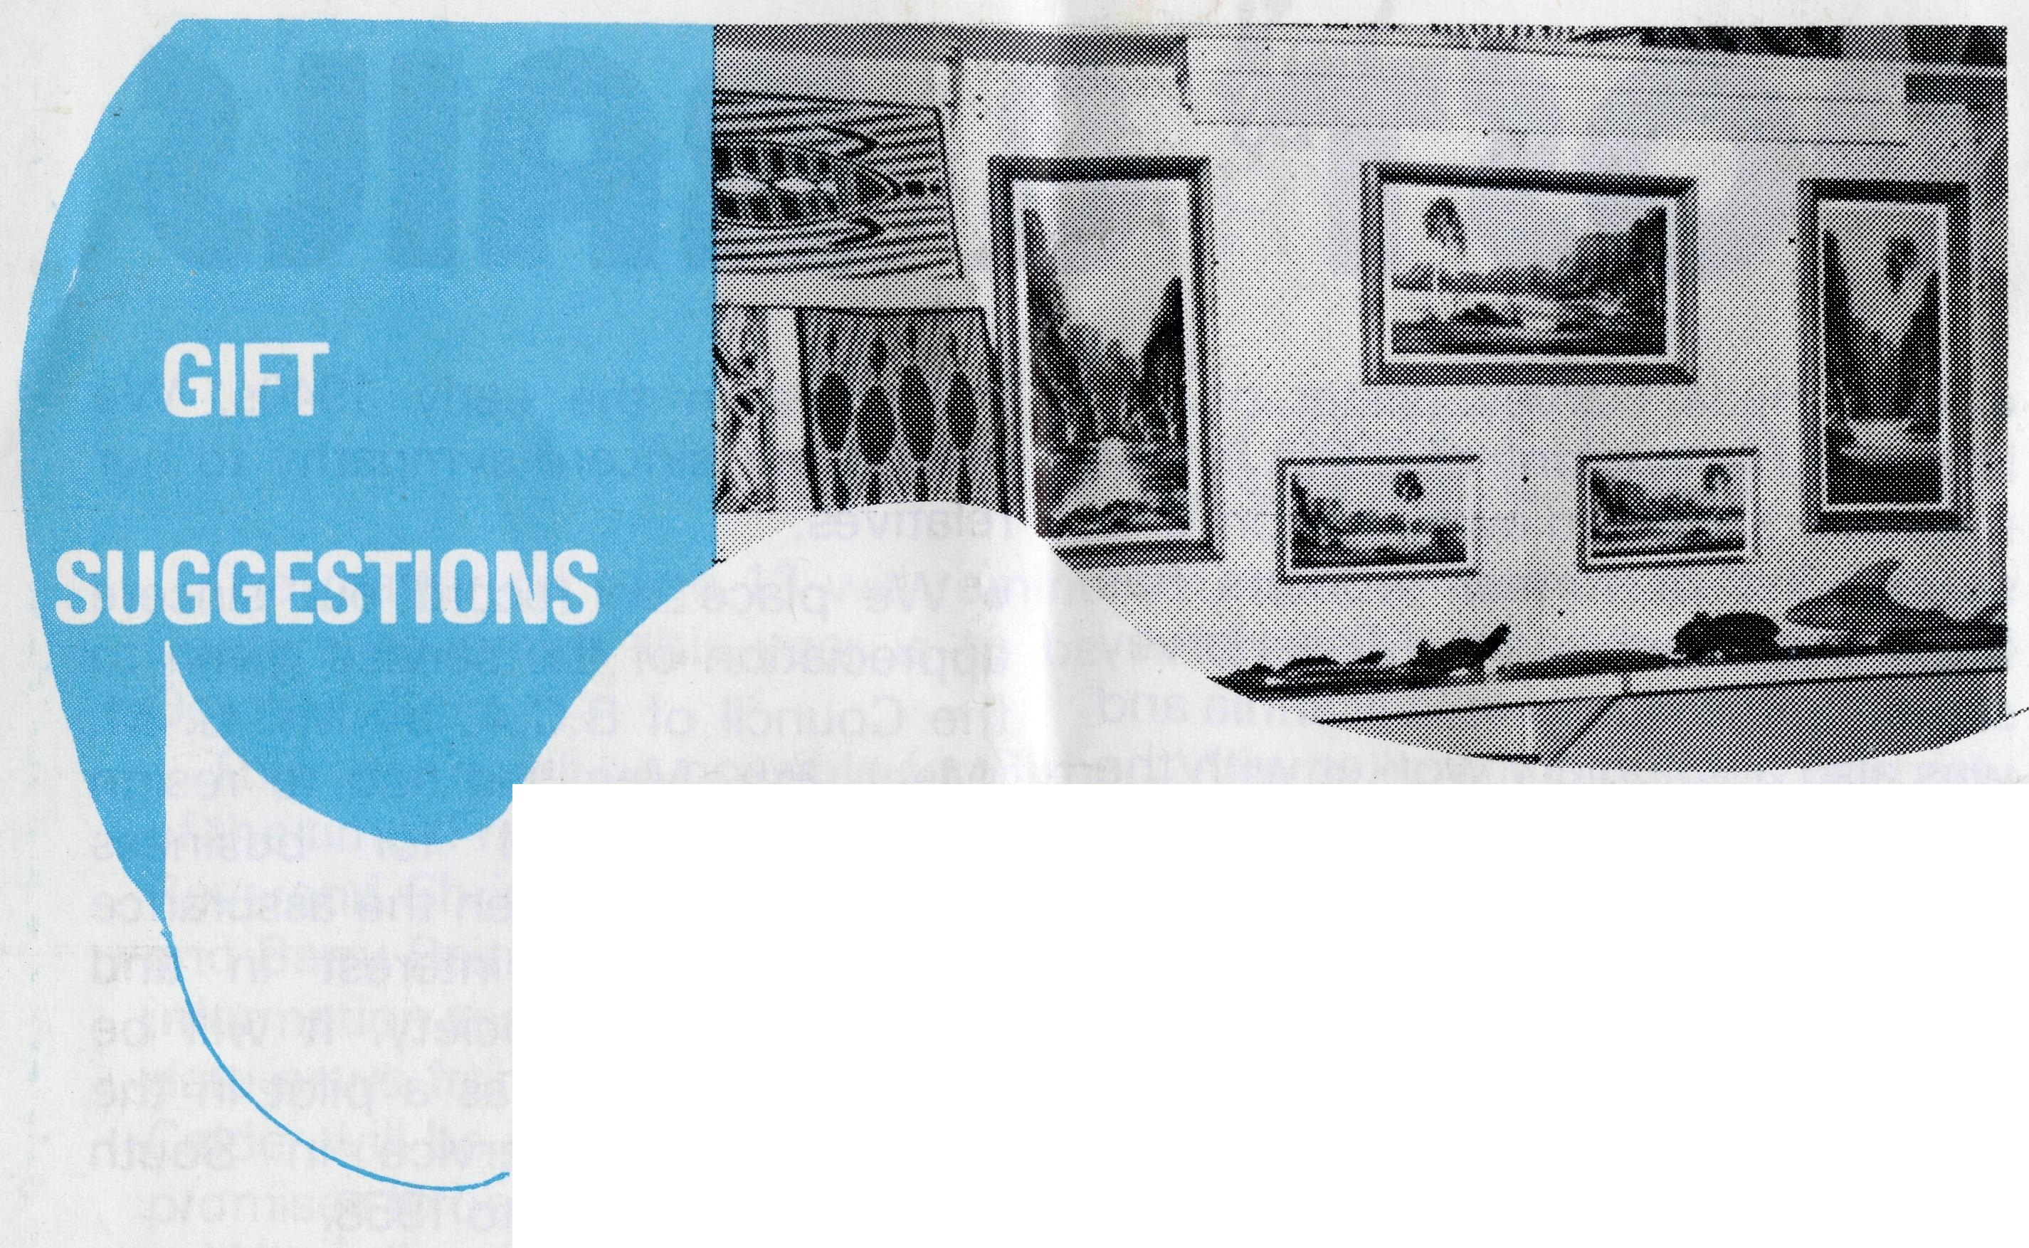
SYDNEY SHOP
Opal jewellery: Opals (polished or rough).
Authentic Aboriginal artifacts —
Boomerangs, etc., Bark Paintings, Water colours.
Special — Limited supply of oil paintings from Alice Springs.
MELBOURNE SHOP
Opals and Souvenirs — drop in and see them. 3rd Floor, Clark Rubber Building, 196 Flinders Street, Melbourne.
State Office Directory. . .
Federal Secretary — The Revd. T. J. Hayman.
N.S.W. Secretary and Editor — The Revd. R. N. Langshaw.
Asst. Secretary (N.S.W.) - Mr. W. L. Calder.
B.C.A. House, 135 Bathurst Street, Sydney, N.S.W. 2000
(02) 26-3164, 26-3780. Telegraphic Address: "Chaplaincy", Sydney.
Victorian Secretary — The Revd. B. W. Green,
3rd Floor, Clark Rubber Building, 196 Flinders Street,
Melbourne, Vic. 3000. Phone: (03) 63-8962.
Queensland Secretary — The Revd. G. Ezzy,
P.O. Box 37, Dalby, Qld4405. Phone: (074) 62-2071.
Western Australian Deputationist — The Revd. E. W. Doncaster,
Anglican Rectory, 49 Berkeley Crescent, Floreat Park, W.A. 6014.
Phone:(092)87-1304.
South Australian Secretary — The Revd. B. S. Grace,
77 Beulah Rd., Norwood, S.A. 5067. Phone: (08) 42-2227.

President — The Most Reverend, the Archbishop of Melbourne. Vice-Presidents — the Most Reverend, the Archbishop of Sydney, Bp. G. R. Delbridge and Mr. H. M. Bragg. Chairman of Council — Archdeacon R. G. Fillingham. Honorary Treasurer — Mr. R. T. Stokes.
1976-AMBASSADOR PRESS, 51 Good St., Granville 2142-34273

"Where the Spirit of the Lord is ..."
Revd. Albert Sage, Townview
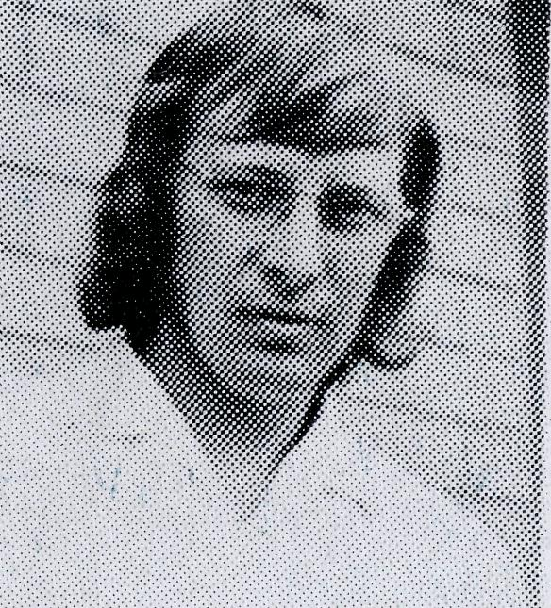
Revd. A. Sage
The work of the Spirit never ceases to amaze me. In our parish He has led us into some wonderful areas of thanksgiving and joy. He has given us new insight into God's love and the Christian life.
In the part of North Queensland covered by the B.C.A. Parish of Townview (Mount Isa) and Gunpowder there are constantly new and exciting things happening with situations of real need that require a deep and supporting ministry.
The ministry at The Monument has begun with wonderful signs in its infancy. It is a town attached to the phosphate mining venture some 120 km south of Mount Isa. It is a new and modern town. People only began to reside in it at the beginning of the year. I have established a monthly visitation in conjunction with one of the other clergy and together we take a combined worship service and the next morning we take individual Communions with those who desire.
I know in the Kingdom of God that numbers are not the things that count but the quality of lives. At The Monument we have an indication of both.
Congregation at Townview
Modern buildings in the area
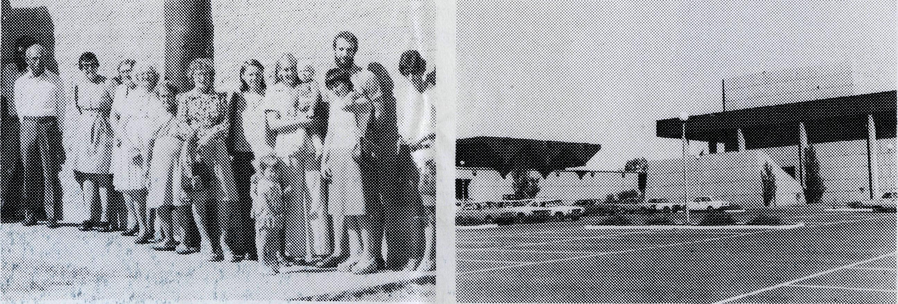
The town has a total population of between 100 and 130, and our combined Service attracts a dozen adults and as many children. A Sunday School has been started by one of the Anglican mothers with the help of a young single chap who can play the guitar. They had at last count over 30 children attending week by week. It is run on an Ecumenical basis, the material and support being supplied here from St. Luke's.
This willingness to become responsible for a constant Christian witness is the cause for great joy.
In Duchess (one of the smaller outlying areas), we recently had the first baptism in twenty years. Again it was a combined venture with another child being baptised by the Roman Catholic priest. We held our Services together under a large Poinsiana tree behind the local hotel. The total group took part in both the Services. It was a wonderful witness for all concerned as virtually the whole area population (approximately 100) were there. The Service made the State news and of course received good publicity in the local area. Again a cause for thanksgiving that the church is receiving publicity of its ministry.
The mining town of Gunpowder, 90 km north of Mount Isa, still exercises a significant part of the ministry in the outer area. The people in this town recently went through a period of uncertainty because of the fluctuations in the mining industry. Some of oqr very strong Christian families have moved on to other areas but the strength of commitment is still there and the ministry is deeply appreciated and brings much joy. It was good to be able to exercise an involved ministry during the time of uncertainty.
Many interesting things are happening at the home base of the parish. All of the clergy of Mount Isa have recently joined with the school Principals' Association on a total Ecumenical approach to primary education. This involves seven schools including the School of the Air and covers some 4,000 pupils. St. Luke's has played a leading part in the implementation of this scheme. It has been a real step forward in faith and the constant support of the home congregation has been wonderful. The inclusion of the School of the Air has been a wonderful step forward. With two of the teachers I myself have begun a weekly presentation of Religious Instruction to over 100 scattered children. This aspect of ministry is something that we have struggled for against difficult odds for the last three years. It is a real cause for joy and thanksgiving that it is now a reality.
As always the constant demands in so many areas place a great responsibility on the family at home and it is always a cause of constant thanksgiving for the understanding and support that comes from the family. They enjoy being part of the total ministry and often have become involved in some of the work outside Townview, e.g. the baptism at Duchess.
The people of St. Luke's as always are extremely grateful for the total support that they receive from B.C.A. This fellowship and experience of belonging to a wider ministry is something that brings great happiness to many of our families.

THE REAL AUSTRALIAN

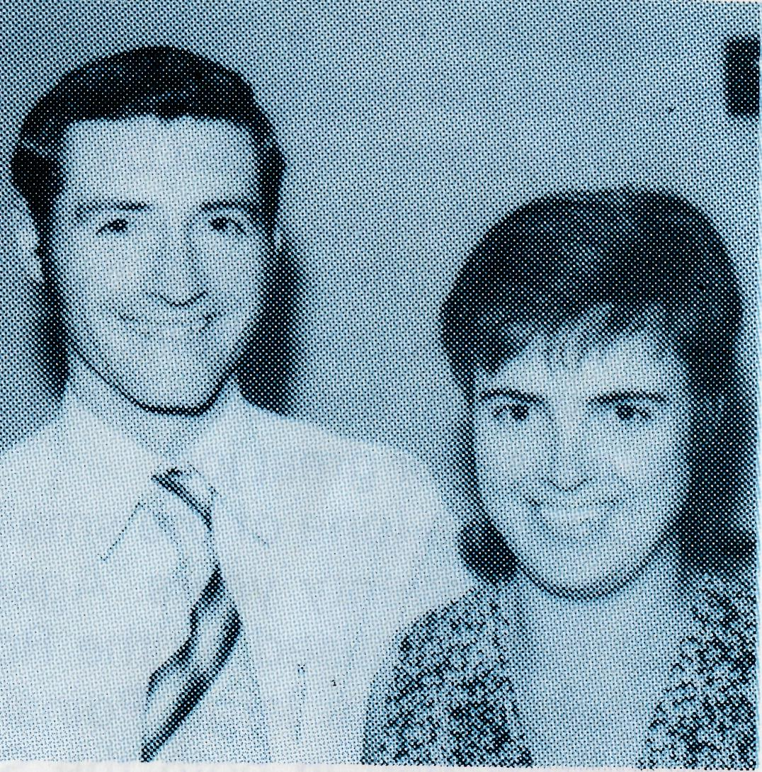
Richard and Pam Crew
WHAT'S THAT? . . .
Rapid thoughts from DARWIN
GO TO CHURCH? "Oh no," says one, "we go camping down the track most weekends." - "Bit difficult with footy starting Sunday mornings," says another. — "Fred's so busy with his work that Sunday is the only day we have together." - "We're trying to get as much done on our house as possible."
It's the old, old story!!
BUILDING?. . . REBUILDING?. . . SHIFTING?. . . Darwin is alive with them all!
Even the churches are in on the act. St. Peter's Church rebuilt; the Rectory due for completion soon; and the Cathedral Complex Appeal to be launched. And all the time, like gathering living stones, God is building up our congregations. Praise be! Some are alive to God!
MUSICAL PULPITS? Yes, it's the game the five Anglican clergymen in Darwin take to playing on Sunday mornings! Last year and this, St. Peter's, Nightcliff, has been operating in conjunction with Christ Church, Darwin! and the taking of services is shared. Hopefully we look forward to the appointment of a minister for St. Peter's.
VISITING? Most important. Been top of my list since the cyclone. Main
taining the link or making new contacts with people has been an
experience. You share and talk about difficulties and challenges folk have
had to face. Visiting sure has its varieties . . . must see that parishioner
whose father just died; two more follow-up Confirmees to catch up on; a
new couple arrived from Sydney; C.M.S. nursing Sister in hospital from
one of our stations; that couple have just arrived back in Darwin, were here
before the cyclone; out to see parishioners on the staff of Kormilda
Aboriginal College — Baptism interview (one family, mum and three
children); yes, "Myrtle 1" (can't quote names!) is getting on fine after a
disturbing time following Tracy; "Myrtle 2" is experiencing God's strength
to cope with a problem husband; "Myrtle 3" opened up today, things
aren't right with their marriage; must call and say goodbye to mother from
England who's been visiting daughter in Darwin
CHILDREN? Need to look up my list to see what school I'm to be at for R.I. today. . . . Can go any morning to the children's ward at the hospital,
^ THE REAL AUSTRALIAN
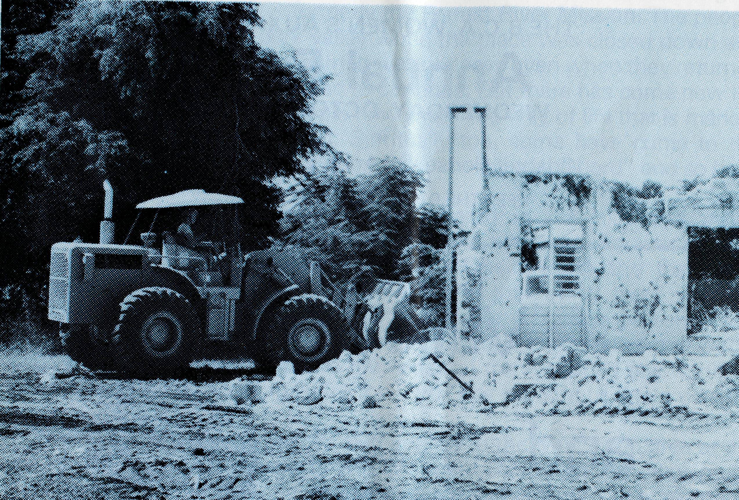
Demolishing an old cathedral site
here Arch books are a hit! Sunday mornings are definite at nine (time of Sunday School) - and we've lots of new faces this year.
What's that? ... No, don't dare call teenagers children. Just made it to speak to the lunchtime I.S.C.F. group about "Fellowship" ... the young working-age S.U. group is meeting at our flat this Saturday night
MARRIED? February 8th. Kind of a team, really. Richard's Parish Treasurer and Sunday School teacher. Yes, plan to be in Parish work all this year. Makes my fourth year altogether
^OPERATIONANDREW"? No, nothing to do with hospitals. It's a Home Outreach programme designed to communicate the Gospel to a small group of friends using your own home. It's on in August. Really in my work it's on all the time. What opportunities there are when visitinq to speak to people of what God has done.
RESPONSE? Well, I always have in mind a balance between the words ot Paul, viz - "I planted, Apollos watered, but God gave the growth" and the explanation Jesus gave of the Parable of the Sower
This smiling trio, the Reverend Leonard Daniels (left), Archdeacon R G Fillingham (centre) and the Reverend Chris Gierke (on 'plane) was caught at the conclusion of the dedication of Chris Clerke's Piper Cherokee 'plane on April 11th at Bankstown aerodrome. The dedication service was widely reported both in church and secular press. Mr. Daniels was both thrilled and humbly grateful for the honour that was accorded him in the naming of the 'plane and in his being able to share in the service of dedication

THE B.C.A. WOMEN'S AUXILIARY
Annual Fair
WEDNESDAY, OCTOBER 20th
in Chapter House, St. Andrew's Cathedral
KEEP THE DATE FREE AND COME!!!
Valleys
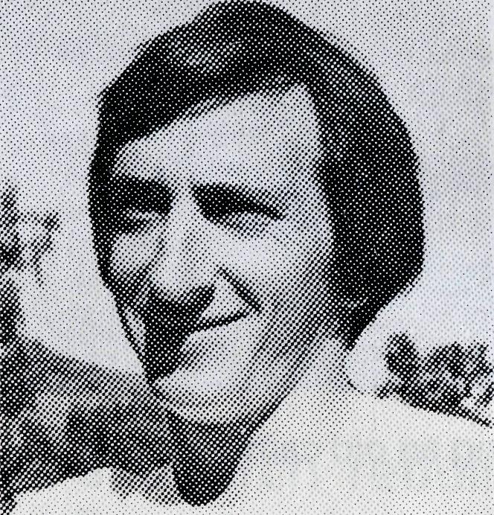
and
Hills
Revd. Keith Wheeler
Writing from Kununurra, Keith Wheeler has fastened on the theme of "Hills and Valleys". Hills and valleys are characteristic of Keith's area for it is in the Kimberleys and anyone who has flown over the area can readily appreciate the fact. It is very much a land of hills and valleys and so it was possible for the Ord River Scheme to come into existence, based as it is on Lake Argyle. The walls of the dam have been built up out of some of the valleys to make a huge water storage area possible.
Kununurra also knows something about economic hills and valleys. When the Ord Scheme was conceived, the hills of economic hope were built high. The vista of prosperity through the production of crops of cotton and other things was indeed as high as the hills. However, with the passage of time, the economic scene has run down into a valley! The cotton scheme has finished; spiralling costs, insect and other problems make the outlook rather grim. There's a darkness in the valley economically and the local people are trying to look up out of it to see the hills of hope again.
In the congregation at Kununurra there has also been this hill and valley experience. In their personal life and experience some folk have been down in the valley, but thank God some have also come to ascend to the hills to find new life and hope through personal commitment and faith in Christ.
6 THE REAL AUSTRALIAN
Hills and valleys have also marked the experience of the Aboriginal Reserve at Oombulgurri - formerly the Forrest River Mission. The people themselves walked in a dark valley when the place was closed down and they were moved into Wyndham. It was not easy even when they returned for the valley experience seemed to continue. But there has come new life and hope, for some of the people now share in a way of life that is marked by enterprise and achievement. Spiritually too, some have come to the hills. Through Christ they have come into "the hill of the Lord" and so have entered the Promised Land.
Keith and Monica themselves also shared in the hills and valley experience in recent weeks. Their seven month old son, Luke, was smitten with gastro-enteritis. It involved hospitalisation in Perth and there was darkness in the valley. But, writes Keith, "in that valley there was the assurance which both Monica and I had of the victorious presence and peace of our Lord together with the consciousness of the prayers of God's people throughout Australia and the sense of the Society's fellowship in Christ. We are on the hill again for the Lord "has brought us into a wealthy place" (Psalm 66:12).
The theme of hills and valleys also applies to the Murchison area at the present time and especially to Mt. Magnet. This town has very much depended on the "Hill 50" gold mine, its life and activity. Older residents can look back to days when everything flourished and life flowed on at a "hill high level". Recently the news has come that the mine has closed so that there is darkness in the valley. What is to happen to the town and to its people? The Reverend Bill Hoare, his church officers and Bishop Witt all face problems as they try to see what is the best thing to do. The prayer support of all friends of the Society can help and encourage them as it did Keith and Monica Wheeler. We know it will not fail to come.
One of the hills near Kununurra
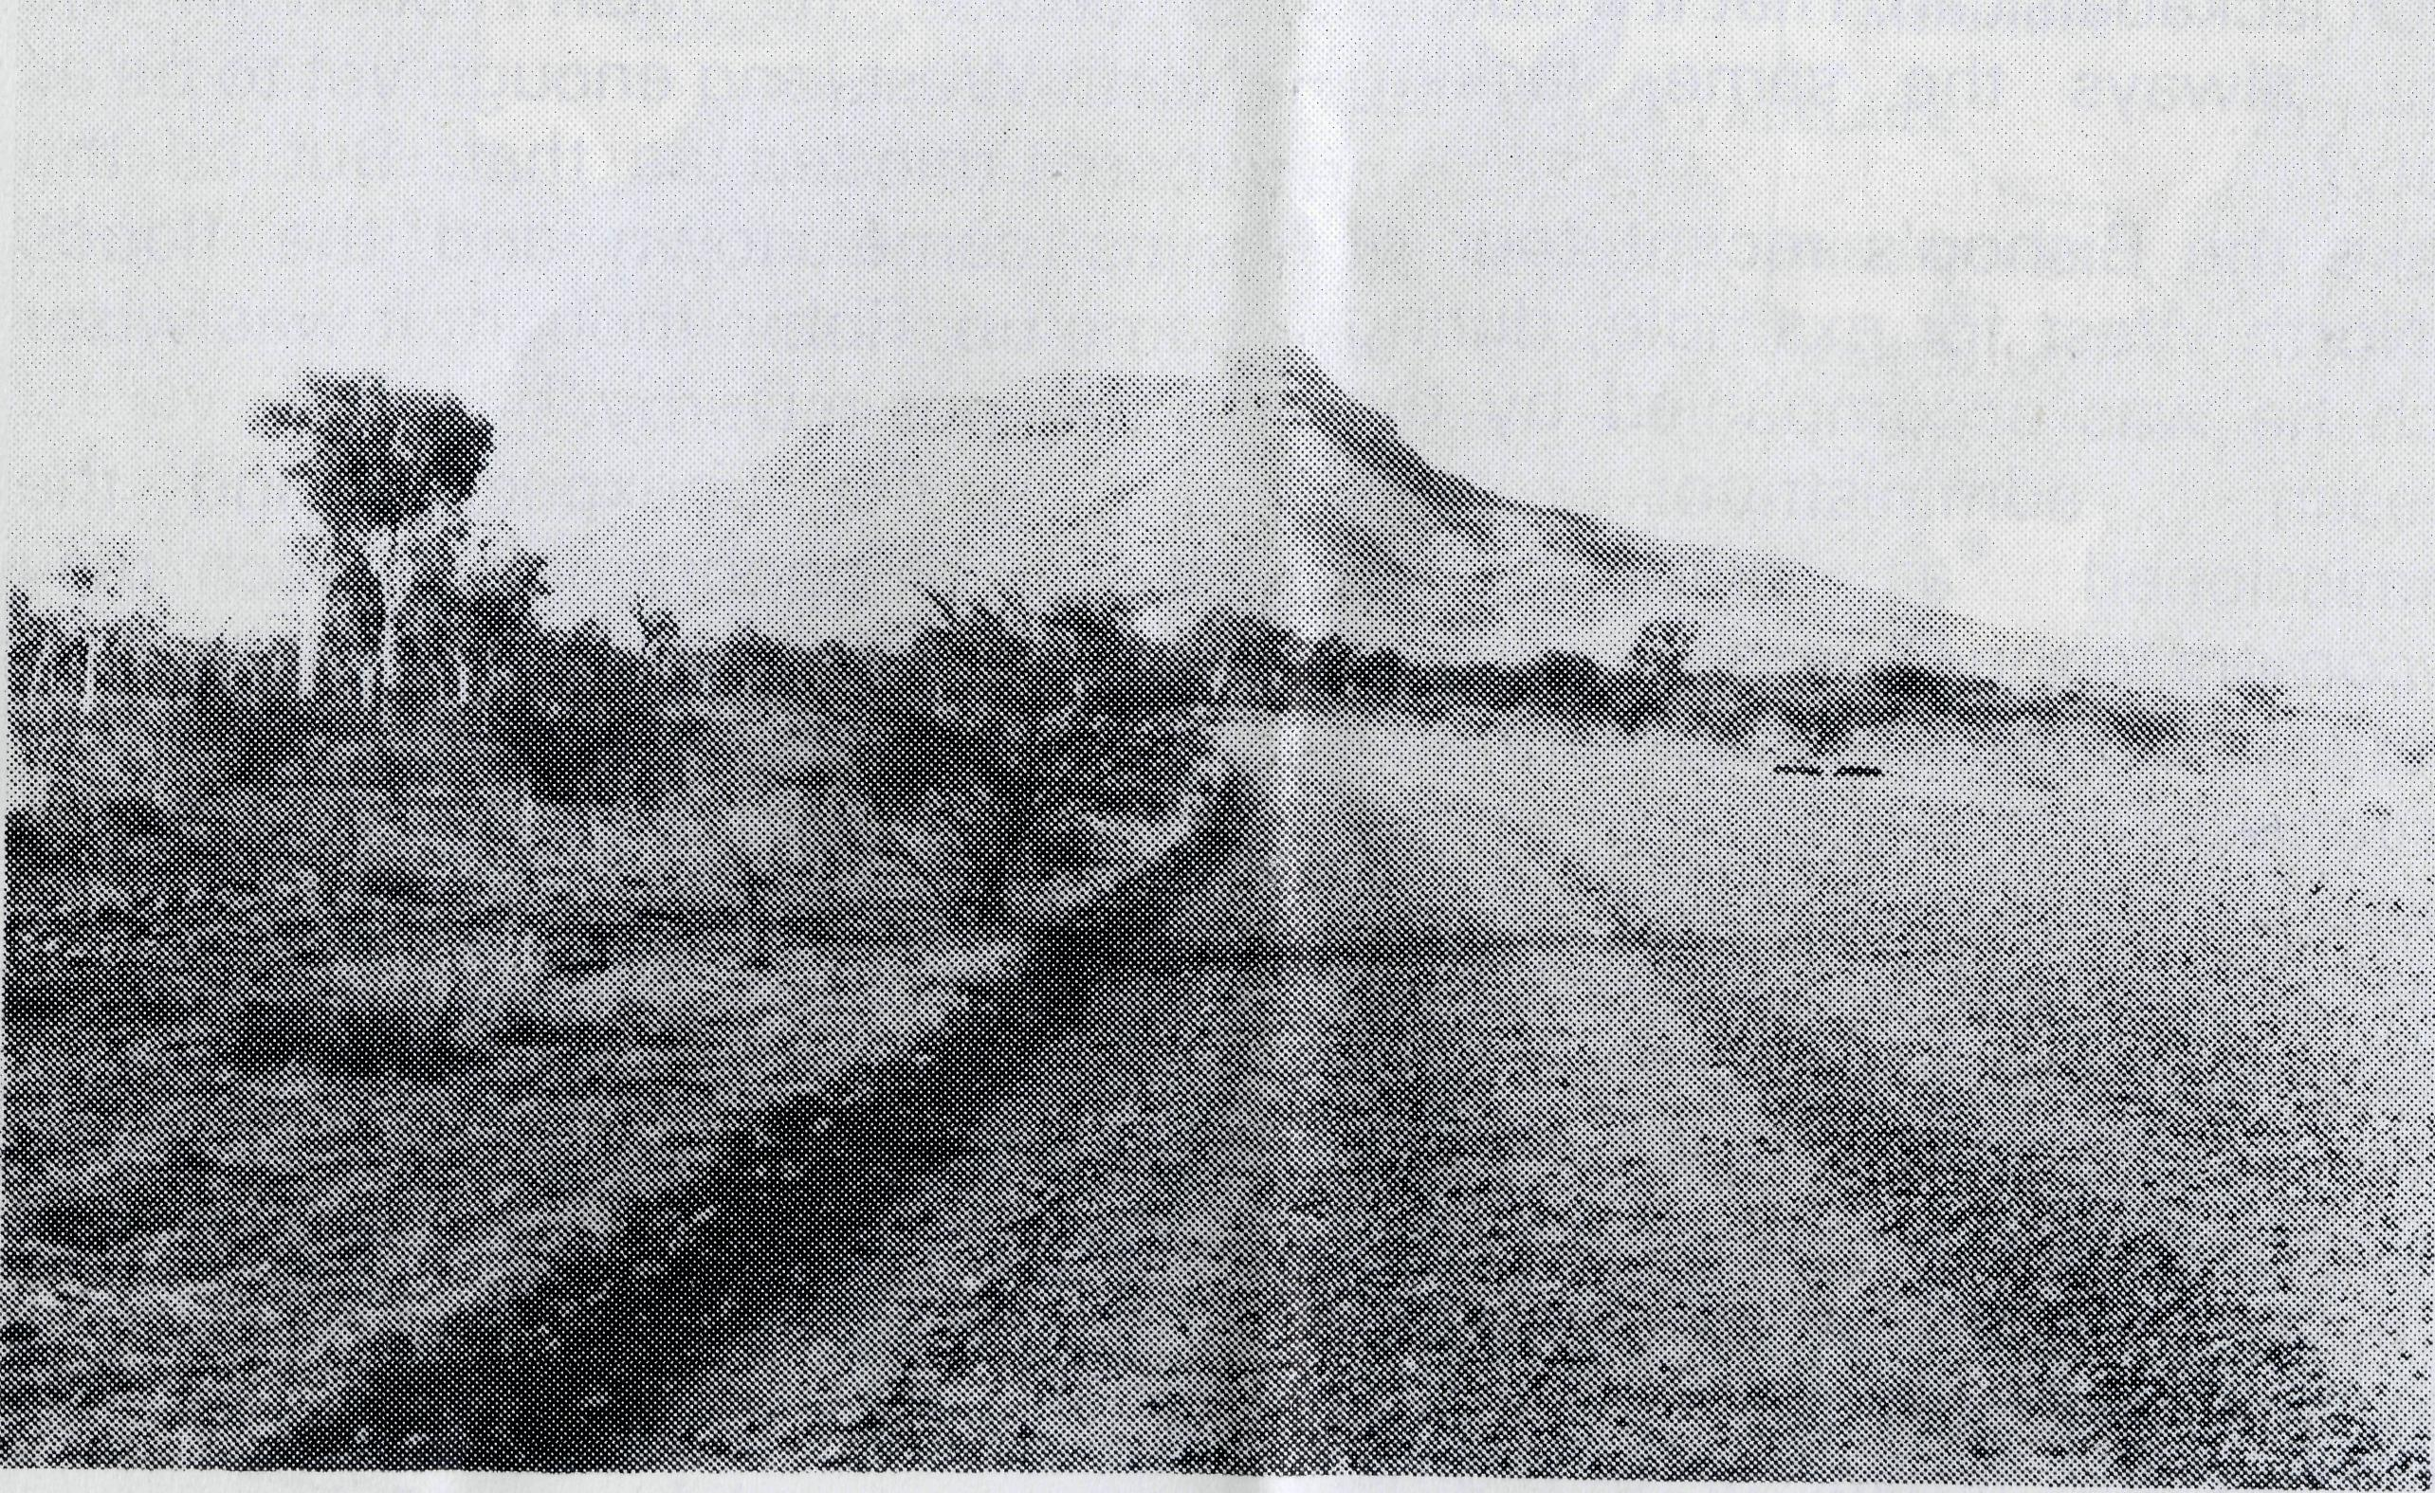

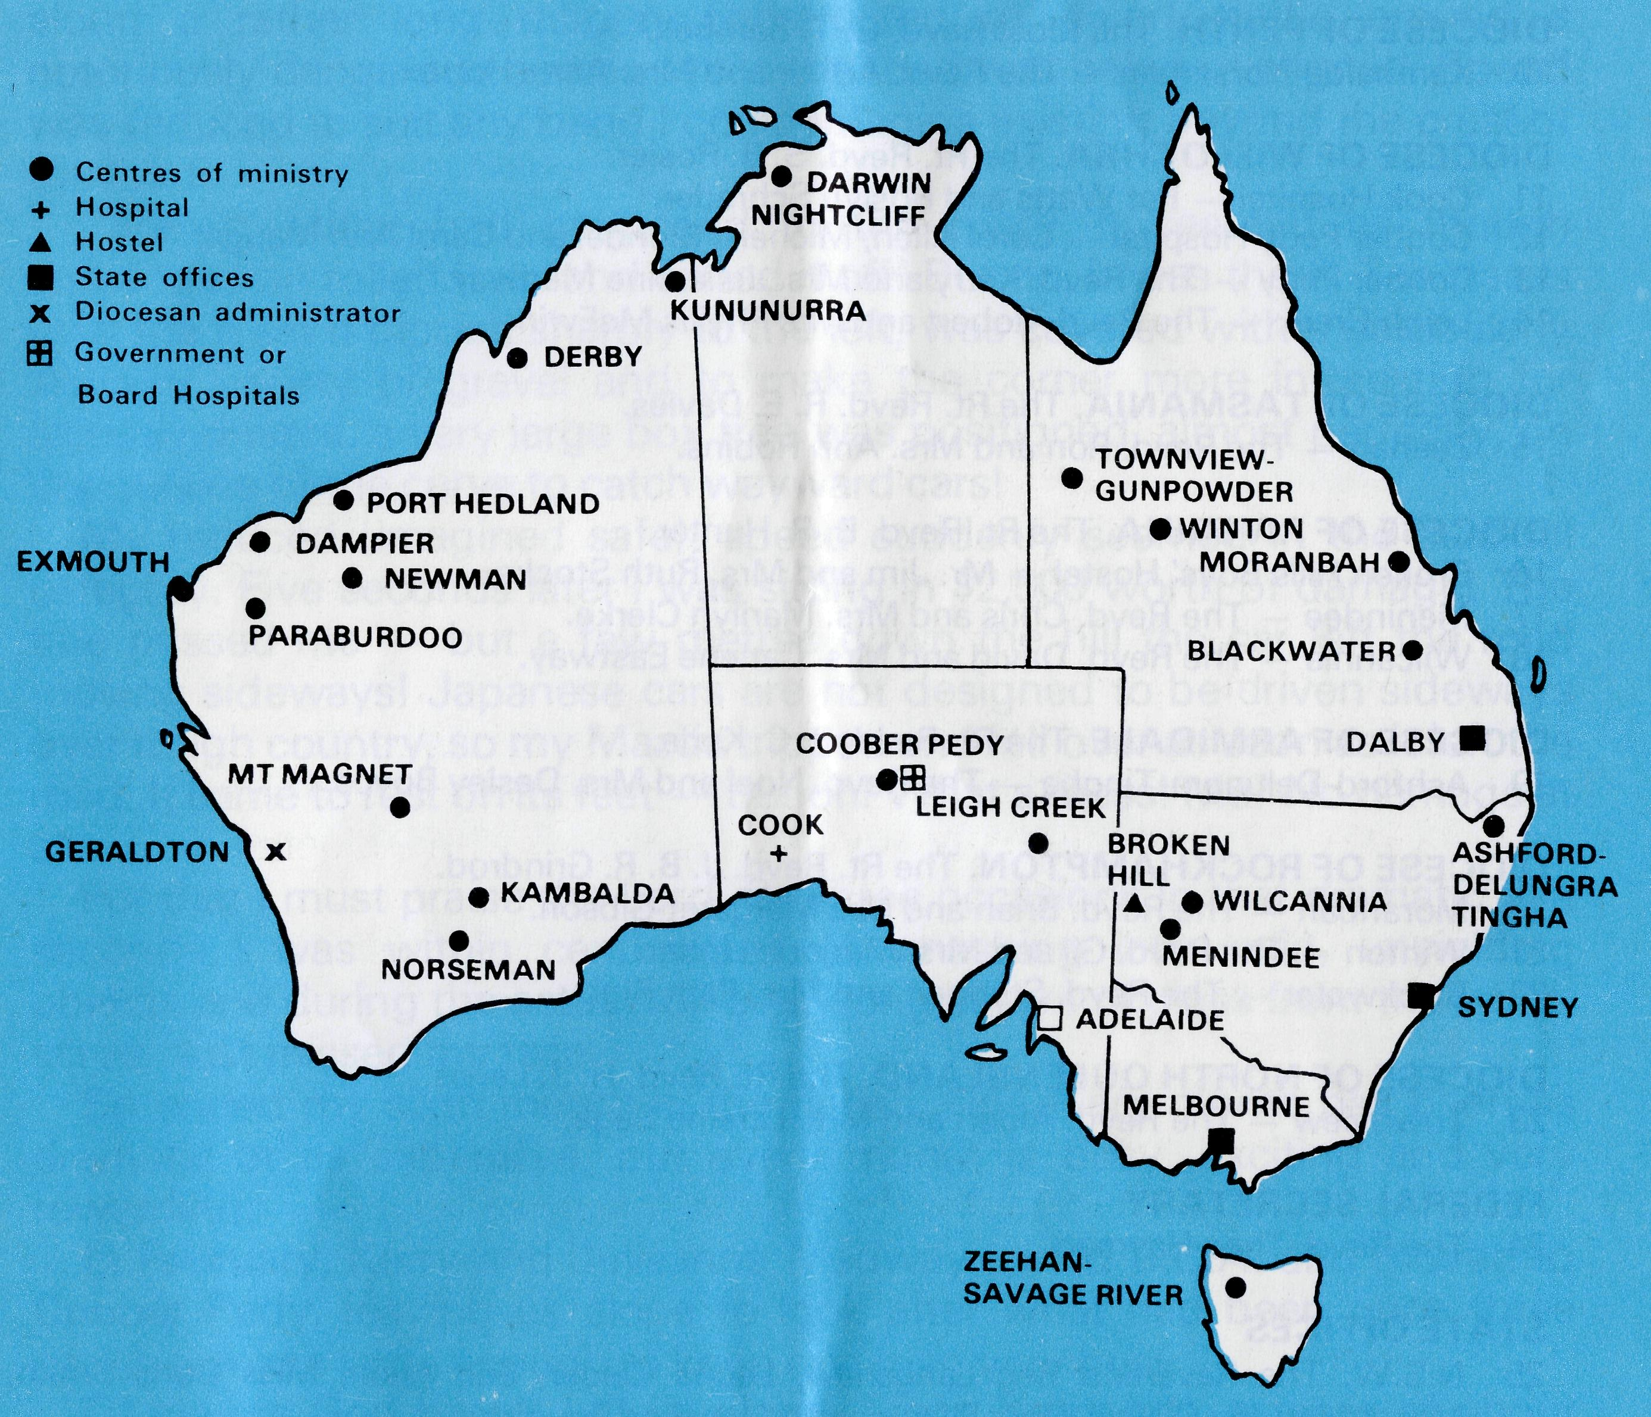
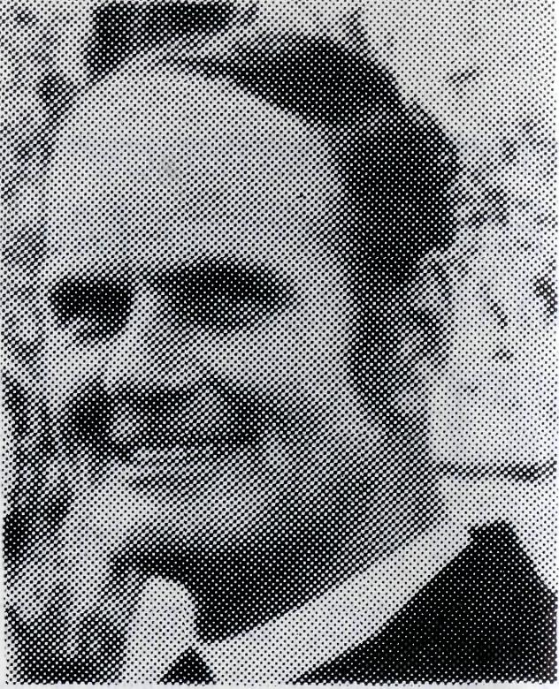
from the Federal Secretary
In certain quarters there is a surprising resistance to the Society because it is "old" and "institutional". Thank God, both medically and spiritually new and free ways of service are always opening up.
Our nursing sisters speak of "things my tutor sister never taught me". Improvisation, confidence in fresh applications of treatment have to be adopted suddenly.
In the ministry the men have a remarkable variety and freedom. Take an example from the article "Top to Bottom" in the W.A. Anglican Messenger, writing about the North West. "How dare they say that the Church Liturgical is the church lackadaisical? That it's dull, in a rut, always the same, lacking variety?
Take the Bishop's recent tour of
the North West for example, during
which he was accompanied by the
diocesan administrator and
commissioned a number of newcomers to the Diocese.
Variety? Off the cuff extemporised, spontaneity?
Listen to this. Graham Thurley was 'done' twice. First at Tom Price in a kindergarten which is also the church centre, and secondly at Paraburdoo in a kindergarten which isn't. As a result of his commissioning he has also had his kitchen re-designed thanks to the arrival of a brother
priest, Bill Ross, who flew over from Karratha for the occasion.
Dalba Primmer however, next on the list, was commissioned in Newman Community Hall. As the cleaners moved out after Saturday night's 'do'; the Christians moved in to prepare for Dalba's Doings.
Captain Mike Tobin, C.A., whose base of operations is to be South Hedland was the first on the trip to be commissioned in a 'proper church' as the saying goes. True, the church was St. Matthew's, Port Hedland, and it had just undergone its umpteenth cyclone, but nevertheless it is Port Hedland's parish church and it was there on a hot, steamy and stormy Ash Wednesday night that the Diocese's very first Church Army officer began his ministry.
Robin Burnand's contribution to the uniqueness of the commissioning tour was to break all traditions in Broome.
He did this very simply by not turning up, thus becoming the first clergyman to be inducted while not amongst those present. Not his fault, of course; he hasn't been in the North West long enough yet to be as absent-minded as that. But as the rains came down and the floods came up, Robin thought it was wiser to stay put in Derby."
It is the unexpected and the seizing of opportunities which may never come again which makes the missioner witness in surprising ways. A service in a home in the outback can never be the same as one held in a church. Yet the opportunity to worship is there. Rich moments of fellowship come in a common sharing.
Your friend,
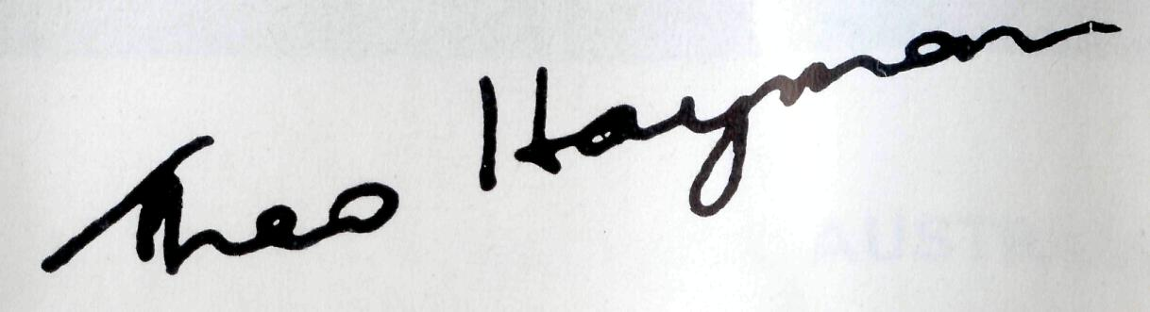
THE B.C.A. PRAYER
A DAILY PRAYER
0 Lord our God, help us to remember those who live in the remote parts of our land. We ask You to bless those whom You have called into the fellowship of The Bush Church Aid Society. Grant that, through the ministry of the Word and Sacraments, through healing, and through caring for the young, the message of Your redeeming love may be proclaimed, through Jesus Christ our Lord. Amen.
O God, we remember before You those whom You have called to Your service. We ask You to bless
, assure
them of Your Presence, and call others to stand with them in the task. Grant to them, as to us, the joy of service, the ability to achieve, and the serenity of Your peace, for Jesus' sake. Amen.

PRAYER CALENDAR AND FIELD STAFF DIRECTORY
DIOCESE OF NORTHERN TERRITORY. The Rt. Revd. K. B. Mason.
1 Darwin — Pam Crew (nee Eagleton).
DIOCESE OF N.W. AUSTRALIA. The Rt. Revd. H. A. J. Witt.
- Kununurra — The Revd. Keith and Mrs. Monica Wheeler.
- Derby — The Revd. Robin Burnand.
- Newman — The Revd. Dalba Primmer, Port Hedland (grant). The Revd. Kevin Hall.
- Dampier — The Revd. Bill and Mrs. Jocelyn Ross.
- Paraburdoo — The Revd. Graham and Mrs. Helen Thurley.
- Exmouth — The Revd. Bert and Mrs Thelma Wrightson.
- Murchison — The Revd. Bill and Mrs. Joan Hoare.
- Geraldton — Mr. Stan and Mrs. Dorrie Hummerston — Diocesan Administrator.
DIOCESE OF PERTH. The Most Revd. G. T. Sambell.
10 Kambalda-Norseman — The Revd. Arthur and Mrs. Anne Horrex.
DIOCESE OF WILLOCHRA. The Rt. Revd. S. B. Rosier.
- Cook Hospital — Pat Watts and Roslyn Schrader.
- Coober Pedy Hospital — Carol Allen, Michelle Blondel and Carol Ann Mauger.
- Coober Pedy — The Revd. Kerry and Mrs. Julieanne Medway.
- Leigh Creek — The Revd. Robert and Mrs Phyllis McEwin.
DIOCESE OF TASMANIA. The Rt. Revd. R. E. Davies.
15 Zeehan — The Revd. Ron and Mrs. Ann Robins.
DIOCESE OF RIVERINA. The Rt. Revd. B. R. Hunter.
- Broken Hills Boys' Hostel — Mr. Jim and Mrs. Ruth Stocks.
- Menindee — The Revd. Chris and Mrs. Marilyn Gierke.
- Wilcannia — The Revd. David and Mrs. Carlene Eastway.
DIOCESE OF ARMIDALE. The Rt. Revd. R. C. Kerle.
19 Ashford-Delungra-Tingha — The Revd. Noel and Mrs. Desley Boyce.
DIOCESE OF ROCKHAMPTON. The Rt. Revd. J. B. R. Grindrod.
- Moranbah — The Revd. Brian and Mrs Margaret Gibson.
- Winton — The Revd. Gil and Mrs. Marjorie Linden.
- Blackwater — The Revd. Stephen and Mrs. Pam Rigby.
DIOCESE OF NORTH QUEENSLAND. The Rt. Revd. H. J. Lewis.
23 Townview — The Revd. Albert and Mrs. Lareine Sage.
FEDERAL SECRETARY
24 The Revd. Theo Hayman.
STATE OFFICES
- N.S.W. The Reverend Reg Langshaw, Laurie Calder, Eric Atkin, Miss Doris Smith, Mesdames Joy O'Neill, Dora Warwick and Lay Lee Boughton.
- VICTORIA. The Revd. Barry Green, Miss Rosemary Renouf.
- QUEENSLAND. The Revd. Greg Ezzy, Dalby (Deputationist and Secretary). W.A. The Revd. Ted Doncaster (Deputationist).
- SOUTH AUSTRALIA. The Revd. Blair Grace.
GENERAL
- Staff Replacements, The Council, State Committees.
- Box Secretaries, B.C.A. Supporters.
- National Home Mission Fund.

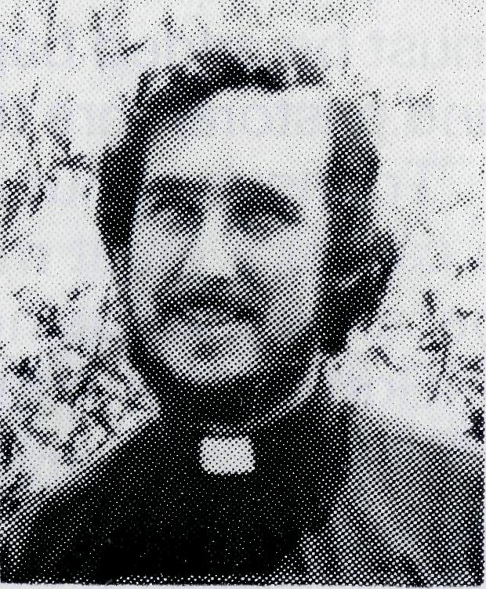
"BUMPS -... BUSY-NESS AND BLESSING"
Revd. Noel Boyce
Revd. Noel Boyce, Ashford
"Better take it easy/' I thought to myself. For the first time I was driving along a rather long detour, constructed to divert traffic around a notoriously dangerous corner, while the road was being re-aligned. Speed was reduced to suit any bend I could imagine existing beyond the crest of the road.
"Yoiks!" What had happened to the road? It seemed as though someone had rolled it up and carted it off! But no, it was there. Ten paces over the crest it dipped sharply to the left, was covered with a particularly slippery variety of gravel and to make the comer more interesting for Sunday drivers, a very large box tree was positioned, almost perfectly, on the outside of the curve to catch wayward cars!
My reduced (imagined safe), speed suddenly seemed in the suicidal category. Five seconds later I was sitting in $2,500 worth of damage! The tree missed me — but a few metres down the hill the car left the road moving sideways! Japanese cars are not designed to be driven sideways over rough country, so my Mazda tripped and fell over as soon as it left the road. It came to rest on its feet — but oh! What a mess! Me? No damage at all.
For that I must praise the Lord. On three occasions in that dramatic five seconds I was within centimetres of smashing into solid, unyielding objects and during the actual roll-over, long slivers of glass from the windscreen just missed my face.
So ended my sixth month in the parish. Not every month has been as dramatic or as expensive, but every month is busy, exciting and very rewarding.
In February, Kerry and Julieanne Medway joined B.C.A. and moved to Coober Pedy, leaving us alone to look after what had been once three parishes, each large enough to keep one man very busy.
Of course God hasn't left us alone. Since Kerry left, a team of about eighteen people have been helping with the services on Sundays and others have been helping with the many Scripture classes I have to take each week. Still the amount of work that cannot be fitted in is very considerable.
What are the things that make each month BUSY?
For me 13 Sunday Services per month; up until the end of Term 1, 40 classes of Scripture per month (this has been reduced to 12 a month through the help of 3 ladies); 18 Bible Studies and 3 Parish Council meetings each month, plus the usual mixture of Ministers' Fraternals,

10
THE REAL AUSTRALIAN
11

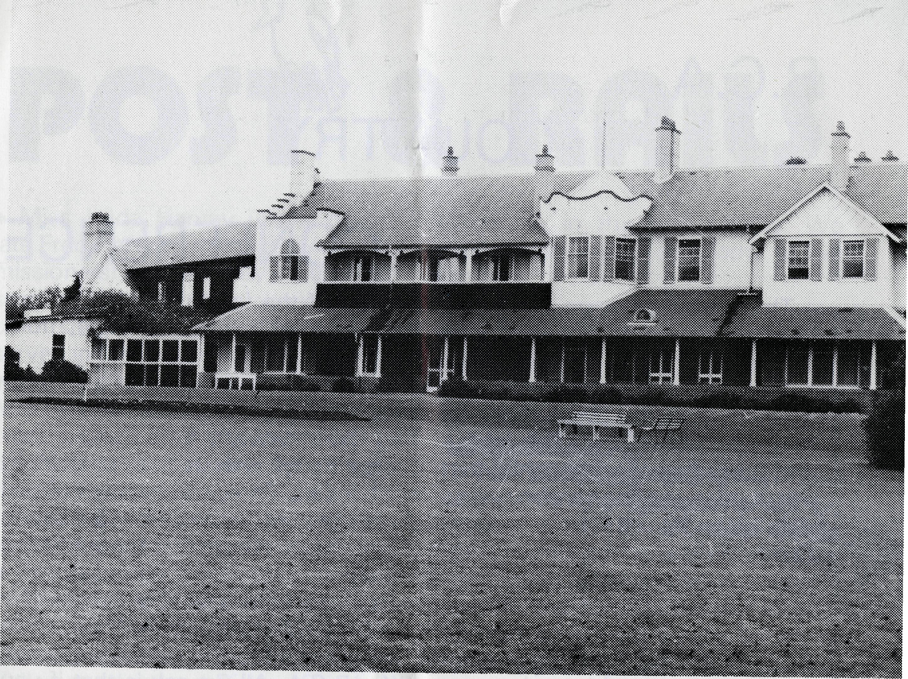
Parents' and Citizens' meetings and the functions run by the local school and pre-school that an interested parent must attend. To the above list must be added baptisms, funerals, weddings and the hours of counselling and pastoral care that must attend each one.
To move about and do these jobs requires me to sit behind the wheel of a car for a great many hours. Yes, I'm kept busy, but I'm not complaining because I like being busy and it is a privilege to be busy in the Lord's work. God's work in this parish can be exciting too!
How about setting out on a nice sunny morning with nothing more than a packed lunch, only to have it rain so hard from midday that you are cut off from home for two nights by flood waters? It happened to me last February. I was fortunate that I was able to spend the time with a Christian family and enjoy their hospitality until the floods subsided - I guess that could be listed under the heading of "blessings".
More exciting than a great flood is the request, "Mr. Boyce I want to become a Christian." The words came from a 12 year old boy who has been attending the Ashford Sunday School for some years now. It was exciting when the same boy brought along to church and Sunday School a school friend who had been saying, "There is no God or else my dad wouldn't have run away."
It is also exciting to see someone developing such a hunger for a deeper knowledge of God's Word that he is prepared to travel 50 km both ways to a Bible Study each week.
Excitement abounds in God's work here and so do the rewards. I consider it a great personal reward to see four young people come to a personal knowledge of the Lord Jesus Christ; rewarding it is to see Christian men and women growing in their Christian life, developing a loving concern for one another! It is rewarding when a young couple, with no real ties to the church or the Lord, say, "What you have told us about Baptism has been quite new to us. We will give it serious thought before going ahead and having our child baptised."
Christian concern was well demonstrated when I had my car accident in April. Within an hour of the accident I had had three offers of cars to use. Later when it became obvious that the car trip to Perth, we had planned for the May school holidays, would have to be cancelled, a Christian friend from the parish offered his car for us to drive to Perth! Though we did not accept the offer it was very encouraging to see and experience such consideration and concern.
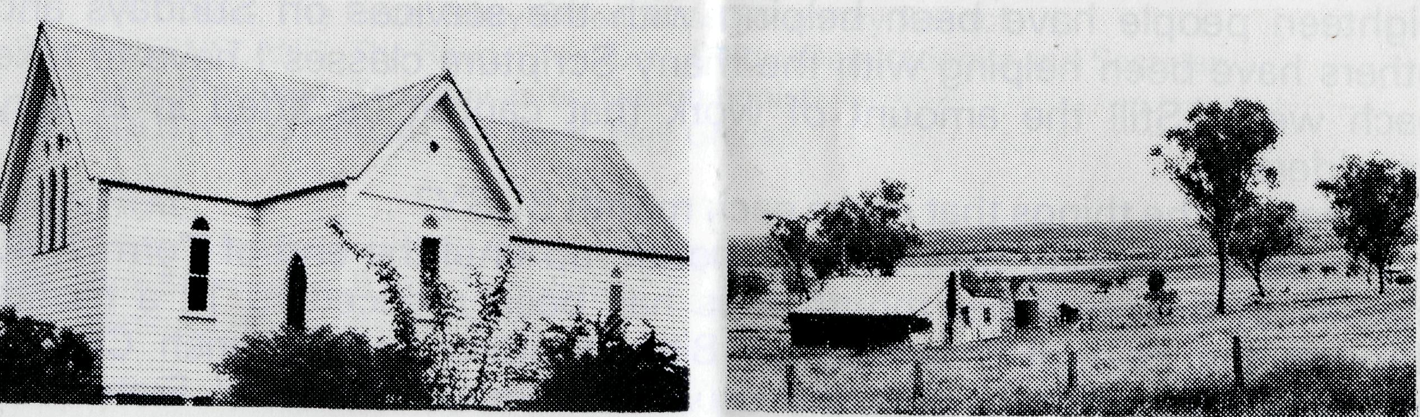
Church at Ashford
Ashford countryside
There are many things, worthy of mention, but space forbids! Let this suffice to assure you that in the Parish of Ashford/Delungra/Tingha thinqs are BUSY, EXCITING and REWARDING.
B.C.A. COUNTRY CONFERENCE
Gilbulla - October 22-24,1976
This weekend amid the rich pastureland of the Camden district will
provide a time of warm Christian fellowship in a relaxed atmosphere.
The programme arranged will include:
Worship Services — Bible Studies — Prayer Times —
Information Sessions — with free time as well.
(See page 14 for additional information.)
(meals and accommodation)
Friday evening to Sunday afternoon:
Main House - $18.00 Long House - $16.00
Children 3-14 years — $8.00
Children under 3 years — $4.00
DAY VISITORS VERY WELCOME
Directions, etc., will be forwarded on application.
Phone 26-3164 for information and programme details.
Bookings are limited so don't risk disappointment —
send your application now to:
B.C.A., 135 Bathurst Street, Sydney 2000.
13

B.C.A.
COUNTRY

THE REAL AUSTRALIAN
CONFERENCE
The matter on page 13 will remind you of the fourth B.C.A. Country Conference which this year is to be held at Gilbulla, Menangle, from October 22-24.
This year it will be possible for Bishop Witt to be with us again for part of the time (Friday evening and Saturday) and as well we hope to have the Reverend Chris Gierke (Menindee), Reg Clark (recently from Paraburdoo) and Barry Rainsford (recently from Coober Pedy) with us both to share in information sessions and in giving Bible Studies. There will be other up-to-date news from the field — especially North West Australia — for Laurie Calder will be in that area in August/September. Altogether the weekend promises to be one full of purpose and help.
We realise that not everyone who would like to, will be able to come for the full time. If this is your case TRY AND COME FOR ONE DAY or SOME SESSIONS. Each day's programme will be helpful and interesting to all who are interested in and concerned for B.C.A. All we ask is that if you decide to come for only part of the time, that you let us know by calling the office on 26-3164.
We realise that we cannot give completely full or detailed information in these pages, so if you have questions please don't hesitate to get in touch with us.
:
Revd.
Mr.
NAME: Mrs §
Miss
ADDRESS:
Postcode
Phone: Parish:
Long House
I would prefer to be in Main House
Limited accommodation is available for children. Please state number and ages.
Enclosed is $3 deposit for each adult booking.
14

- Miss Hilda Harvey (sister of the late Fred Harvey, one of B.C.A.'s first missioners) passed away in April and so the list of former workers has been shortened again. Miss Harvey served in the Hostel at Wilcannia and was also a voluntary worker with the Mail Bag Sunday School for some twenty years. She was a member of the Women's Auxiliary and played the piano at the Annual Sydney Rally for a number of years. We extend our sincere sympathy to her relatives.
- The second B.C.A. Rally to be held in Brisbane was a source of great encouragement. It was held on May 16th at Holy Trinity Church, Fortitude Valley and featured Bishop Grindrod of Rockhampton as the chief speaker and a presentation of the three-screen audio visual — "Those Magnificent Men" by the Reverend Barry Green our Victorian Secretary.
- A day of fellowship was arranged in Adelaide and held at St. Bartholomew's, Norwood, on Saturday, June 26th. Sessions were held in the morning and afternoon and it was possible for Sister Pat Watts, the Reverend Robert McEwin, the Reverend Kerry Medway and Mr. and Mrs. Jim Stocks to be present and share in the programme. The day proved to be full of interest, encouragement and stimulation being attended by a goodly number of supporters of the Society.
- The list of former workers was further reduced in April when Miss Beryl Gurrier-Jones passed away following a car accident. With her sisters Herberta and Yvonne, Miss Gurrier-Jones served in the Hostel at
Wilcannia in the early 1940s. We extend our sincere sympathy to her relatives.
- We place on record our sincere appreciation of the service given to the Council of B.C.A. by Mr. G. M. (Mac) Job. Mac has had to resign from the Council for business reasons but has given the assurance of his continued interest in and support for the Society. It will be recalled he served as a pilot in the Flying Medical Service in South Australia from 1954 to 1958.
- You will see in the Prayer Calendar that two names have been added to those appearing under the heading of State Offices - N.S.W. These are Eric Atkin, who has become the accountant, and Mrs. Lay Lee Boughton. We welcome each of them into the B.C.A. family and look forward to a long association together.
- The Annual Sydney Rally was voted by many as "the best ever". Over 500 people came to the Chapter House of St. Andrew's Cathedral and shared in a varied programme in which music was presented by the "Philippian Singers"; the Reverend Reg Clark was interviewed about his work at Paraburdoo; Bishop Witt entertained and challenged as the chief speaker and the audio visual "Chosen and Sent" was premiered.
- At the Annual Meeting of the Society held in Sydney on June 4th it was seen that the income for the year showed an agreeable increase, so that the year to the 31st December, 1975, closed with a surplus of income over expenditure.
15

