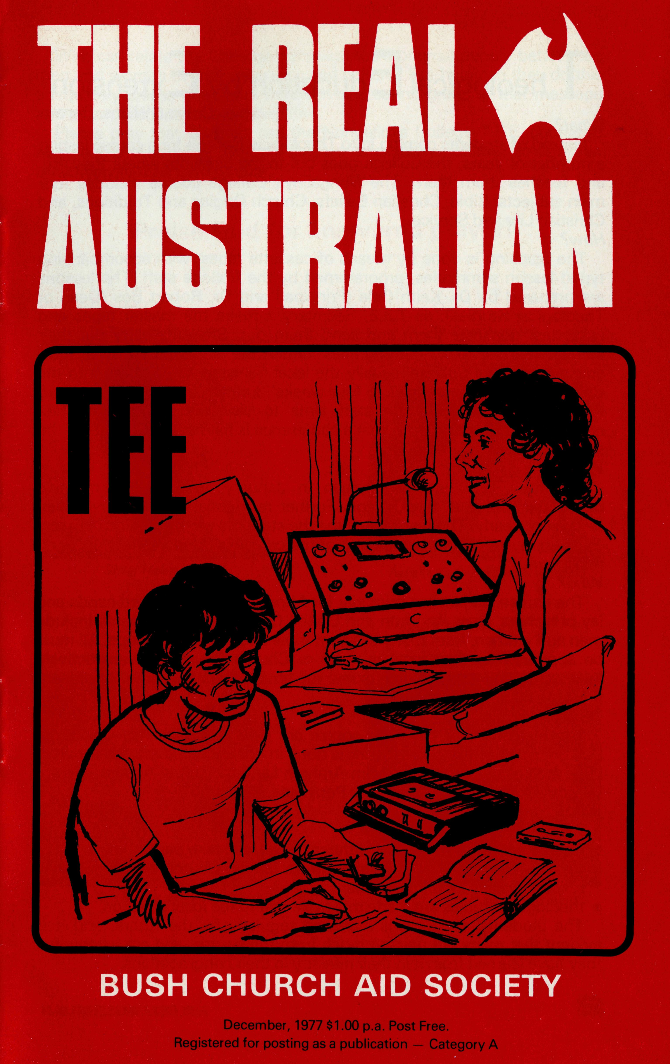
The staff of B.C.A.
thank you
for your support
during 1977.
May you have a holy
Christmas
and be aware of
God's guidance
in the New Year.
STURT DESERT PEA
We always welcome opportunities to provide a speaker for Sunday services, mid-week gatherings, youth groups, ladies' organisations, etc.
The Society's story is both exciting and challenging and, with slides or an audio visual, can be an interesting part of any programme. Please contact your State Office to make arrangements.
State Office Directory. . .
Federal Secretary — The Revd. T. J. Hayman.
N.S.W. Secretary and Editor — The Revd. Wakely Wade.
Asst. Secretary (N.S.W.) - Mr. W. L Calder.
B.C.A. House, 135 Bathurst Street, Sydney, N.S.W. 2000.
(02) 26-3164, 26-3780. Telegraphic Address: "Chaplaincy", Sydney.
Victorian Secretary — The Revd. B. W. Green,
3rd Floor, Clark Rubber Building, 196 Flinders Street,
Melbourne, Vic. 3000. Phone: (03) 63-8962.
Queensland Secretary — The Revd. G. Ezzy,
P.O. Box 37, Dalby, Qld 4405. Phone: (074) 62-2071.
Western Australian Deputationist — The Revd. E. W. Doncaster,
Anglican Rectory, 49 Berkeley Crescent, Floreat Park, W.A. 6014.
Phone: (09)387-1304.
South Australian Secretary — The Revd. B. S. Grace,
350 King William Rd, Adelaide, S.A. 5000. Phone (08)212-4838.
Patron — The Most Reverend Sir Frank Woods.
President — The Most Reverend Sir Marcus Loane, Archbishop of Sydney.
Vice-Presidents — Bp. G. R. Delbridge and Mr. H. M. Bragg.
Chairman of Council — Archdeacon R. G. Fillingham.
Honorary Treasurer — Mr. R. T. Stokes.
1977-AMBASSADOR PRESS PTY. LTD., 51 Good St., Granville 2142-35669

I heological t ducation by txtension
Coryn O'Nians, Darwin
What?
Instead of students coming in to Theological College for a course lasting a number of years, the College goes out to the students where they are, and teaches them there. The Nungalinya College course includes four main subjects: Bible, Christian Beliefs, Church Origins and Traditions, and Christian Life and Service. How?
The teaching is done by means of cassette tapes, with accompanying typed lesson summaries, programmed by the College staff. The lessons are prepared by Dr. Keith Cole (Principal) and Dr. Robert Bos (Dean of Theological Studies); as T.E.E. Secretary, I make the master tapes and cassettes, duplicate them and send them out. Students carry out their studies in their own communities under the supervision of a tutor approved by the College, usually the local minister; some come into the College for a course of three to four weeks' duration once or twice a year. A member of the College staff aims to visit the students in their communities annually. Each year a conference is held at the College for the staff and tutors. When?
The first T.E.E. students began in January 1976 with a month's residential course at the College. Further residential courses have been held twice yearly. The rest of the time the students work at their own pace. The minimum time for completion of the course is three years: there is no maximum. Who?
The course is intended primarily for Aboriginal ministers, ordinands and lay preachers, from Anglican and United Churches. The students include men and women, from many different tribal and language groups. All must be approved by their local minister or Church Council. All are actively involved in their local Church, some full-time, others part-time. At present there are 60 of them enrolled. Where?
The residential parts of the course are held .at Nungalinya College in Darwin; most of the course work is done in communities scattered over a large area of the country — from Arnhem Land to Central Australia, North Western Australia and Cape York Peninsula. Why?
T.E.E. has several advantages: —
- more students, and in many different areas, can take part;
- the students are not taken away from family, Church and community responsibilities for long periods;
- theological studies are made more relevant to the local situation.
The students' progress is assessed regularly by the tutors, and it is evident that many are gaining much from the course, and are using what they have learned from it in their ministry in their congregations.
Who can relate the Christian message to Aboriginal people better than men and women of their own race and culture? But how can they do this adequately unless they have themselves a sound grasp of that message and its implications for everyday life?
Please pray that God will use the Nungalinya College T.E.E. course to help equip Aboriginal Church leaders and future leaders to minister effectively to their own people.
Praise God for answered prayer!
NEW FACES
To Cook Hospital
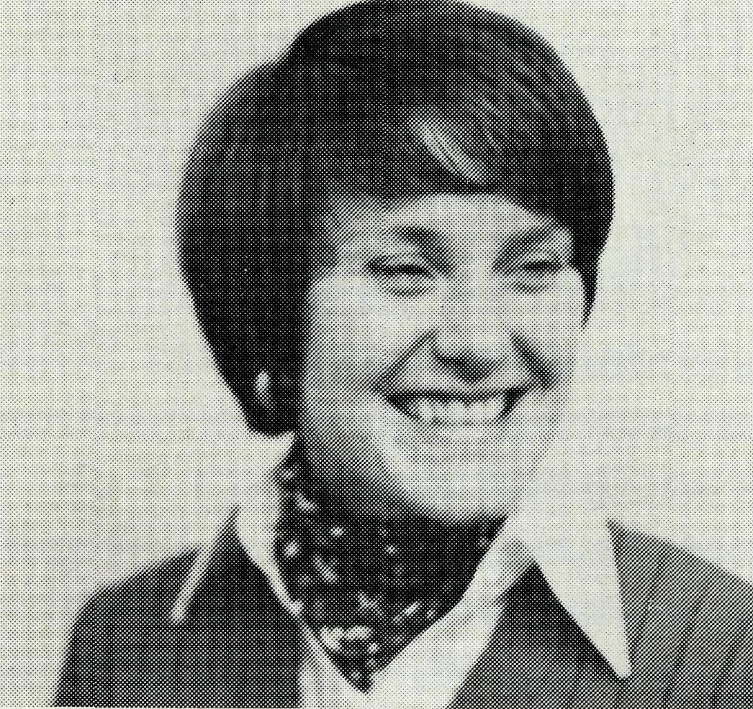
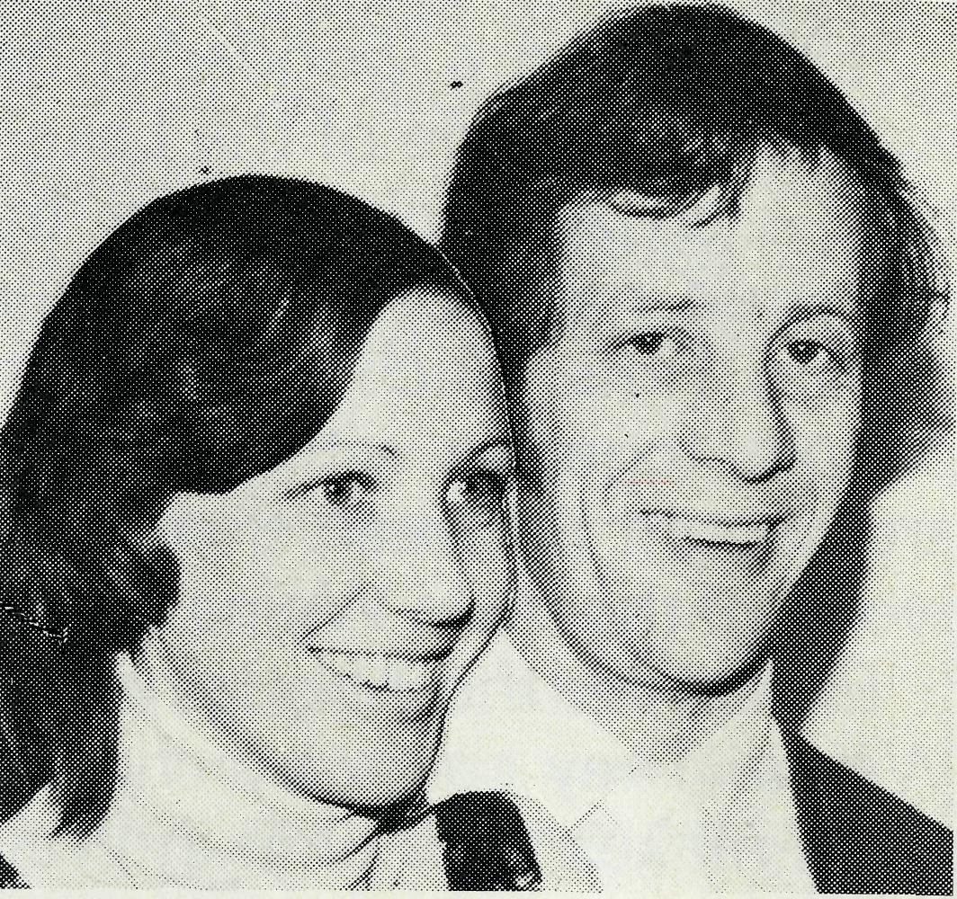
To Tarcoola Hospital
Sister Helen Bible
Nurses Keith 8- Rhonda Anstee
IN BCA
To Exmouth Parish
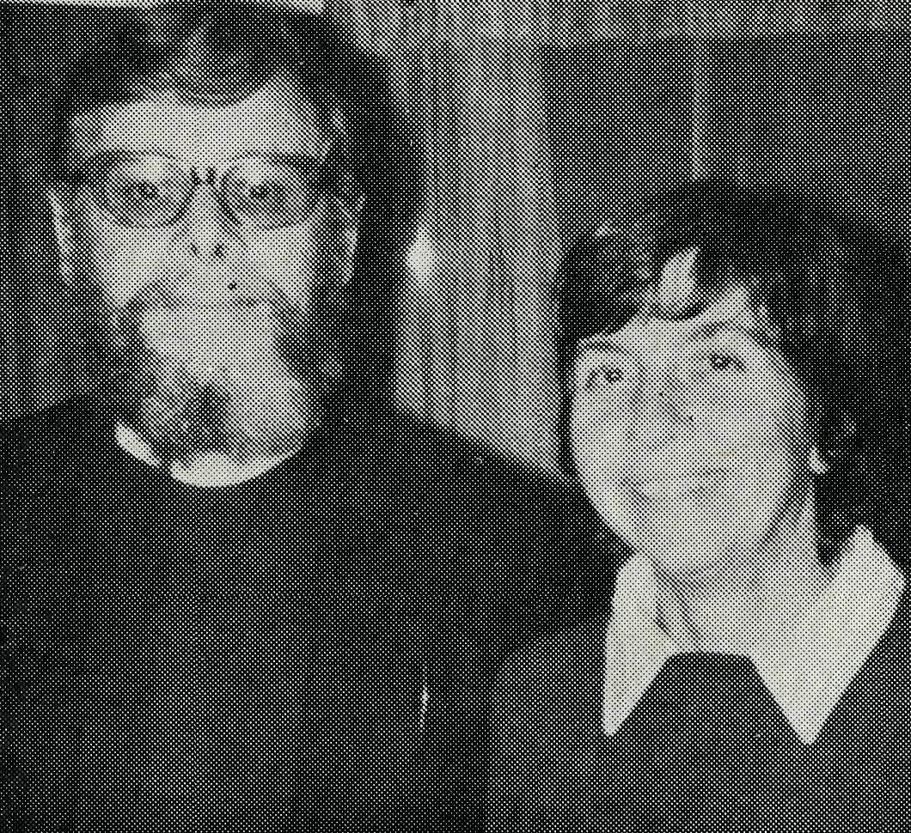
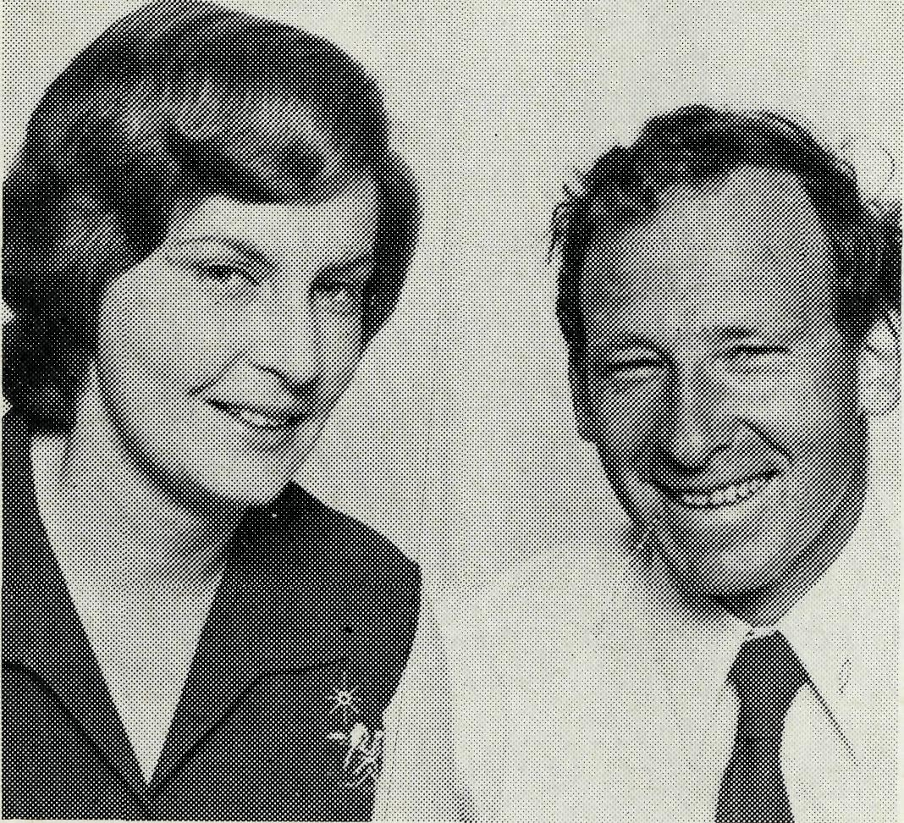
To Broken Hill Hostel
Mr. Ken 8 Mrs. Pam Young
Revd. Peter 8 Mrs. Betty Mills
FIELD STAFF

THE REAL AUSTRALIAN

WEIPA'S MANY FACES
Malcolm Babbage
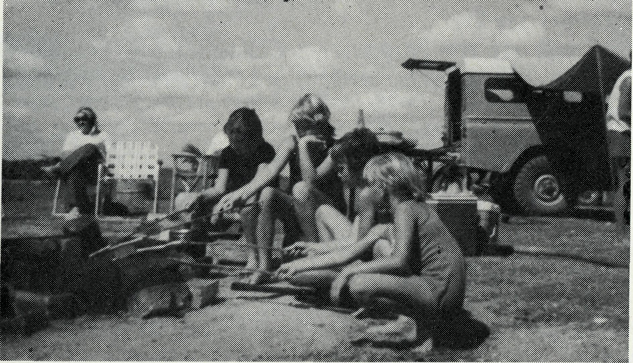
It had been a wonderful barbecue. The kids had been playing in the water at the edge of the Lake and the parents had almost finished eating. Ina - an Aboriginal elder from Weipa South (the Aboriginal Reserve) gathered most of the children around and started to tell stories of the Dream Time. Such opportunities for real interaction are rare. Ina and her people, together with a couple of hundred Islanders from the Torres Strait are caught between their traditional cultures and the highly mechanized world of the main Weipa North town of three and a half thousand.
Except for the Aboriginals, almost every person has reason for being in Weipa. They came by choice — moved by some vision, a vision which often makes their time in Weipa a means not an end; they are content to 'use' Weipa and go on.
The Islanders we minister to come mainly for jobs. Seiko left his family in the Islands ten months ago to stay with friends in Weipa South while he waited for a job with the Mining Company. He is presently waiting for the Aboriginal Council to assign him a home and there is a chance that eventually Comalco will provide a house in Weipa North. A long separation in difficult circumstances but worth the wait.
Fishermen come in and out of Weipa for supplies and new faces. For the few Christians the Church's ministry provides refreshing fellowship.
Our primary ministry is in the European Community. Most come looking for money. Amongst the single men the turnover is several hundred percent a year. They often have only one goal and they feel transitory and have few roots. Others, both married and single, come — to escape; to salvage families; to pay off debts; to get away from a past which will rarely be asked about; or for some, simply to get a new experience or advance in their careers.
Many have big chips on their shoulders, deep scars which need healing. One couple, who were active in the Church in Sydney, have come both to save and to escape. They are reticent to become involved — they have seen members of their family, willing workers in the Church, pressured and overworked: "I still get nervous every time you come", he said, afraid I was going to put the 'hard word' on them.
Some people call Weipa the "Nursery of North Queensland". There are young couples saving for their homes and starting their families — lots of pre-schoolers and primaries needing to hear the Gospel.
There are those who come, become involved and want to stay. Geoff and Eileen with their two children came nearly three years ago after closing his business in Tasmania. Geoff has been working with a contractor, but Comalco needs their home for another company coming in, so now they are caught (housing is desperately scarce and expensive). They either leave and start again, or move every few weeks from one 'leave house', (a house empty while its regular occupants are on leave), to the next. For five weeks in October while Chris was in Sydney they lived in our house. Geoff and Eileen, with too few others, provide the backbone of community and Church life.
Praise God for those in Weipa, who, for whatever reason they came, are deeply committed and share a vital concern for the souls of those around us. Jack is a widower, he lives in the single men's 'Dongas' and works as a mechanic. He radiates the love of Christ to those all around, and works unstintingly in the community and the congregation.
Certainly challenging, at times frustrating, occasionally disheartening, but overall an exciting arid richly blessed ministry to a spiritually needy people.
STOP PRESS
• It is with profound regret B.C.A. has received the resignation of Mr. Laurie Calder, Assistant Secretary (N.S.W.), after 22 years of cheerful and faithful service in the Society. It is on specialists' advice and his own doctor's insistence that Laurie has resigned from December 16th.
Noel Boyce Ashford
On Our Own Again?
Over five years ago three small parishes in the Armidale Diocese were finding the going very hard. Inflating costs with diminishing incomes lead to the situation where they could not afford to keep a full-time clergyman. The future looked rather bleak.
Ashford, Delungra and Tingha are geographically fairly close together and so the idea of combining them and running the combined parish with two full-time clergymen was born. However, the finances were so depressed that it seemed impossible even to pay only two men.
Now, what does a church out in the bush do when it has such problems? Why, it looks for some bush church aid!
On the invitation of the Bishop of Armidale, B.C.A. provided a full-time Missioner for three years, who shared the running of the combined parish with, first a Deaconess and then a Clergyman, paid by the parish. In the fourth year B.C.A. gave $2000 towards expenses and in 1977 $1000.
At the end of this year B.C.A. will cease to provide financial support and
the combined parish of Ashford, Delungra and Tingha will seek to pay their
own way.
¹ Continued over page.

THE REAL AUSTRALIAN
THE REAL AUSTRALIAN

from the Federal Secretary
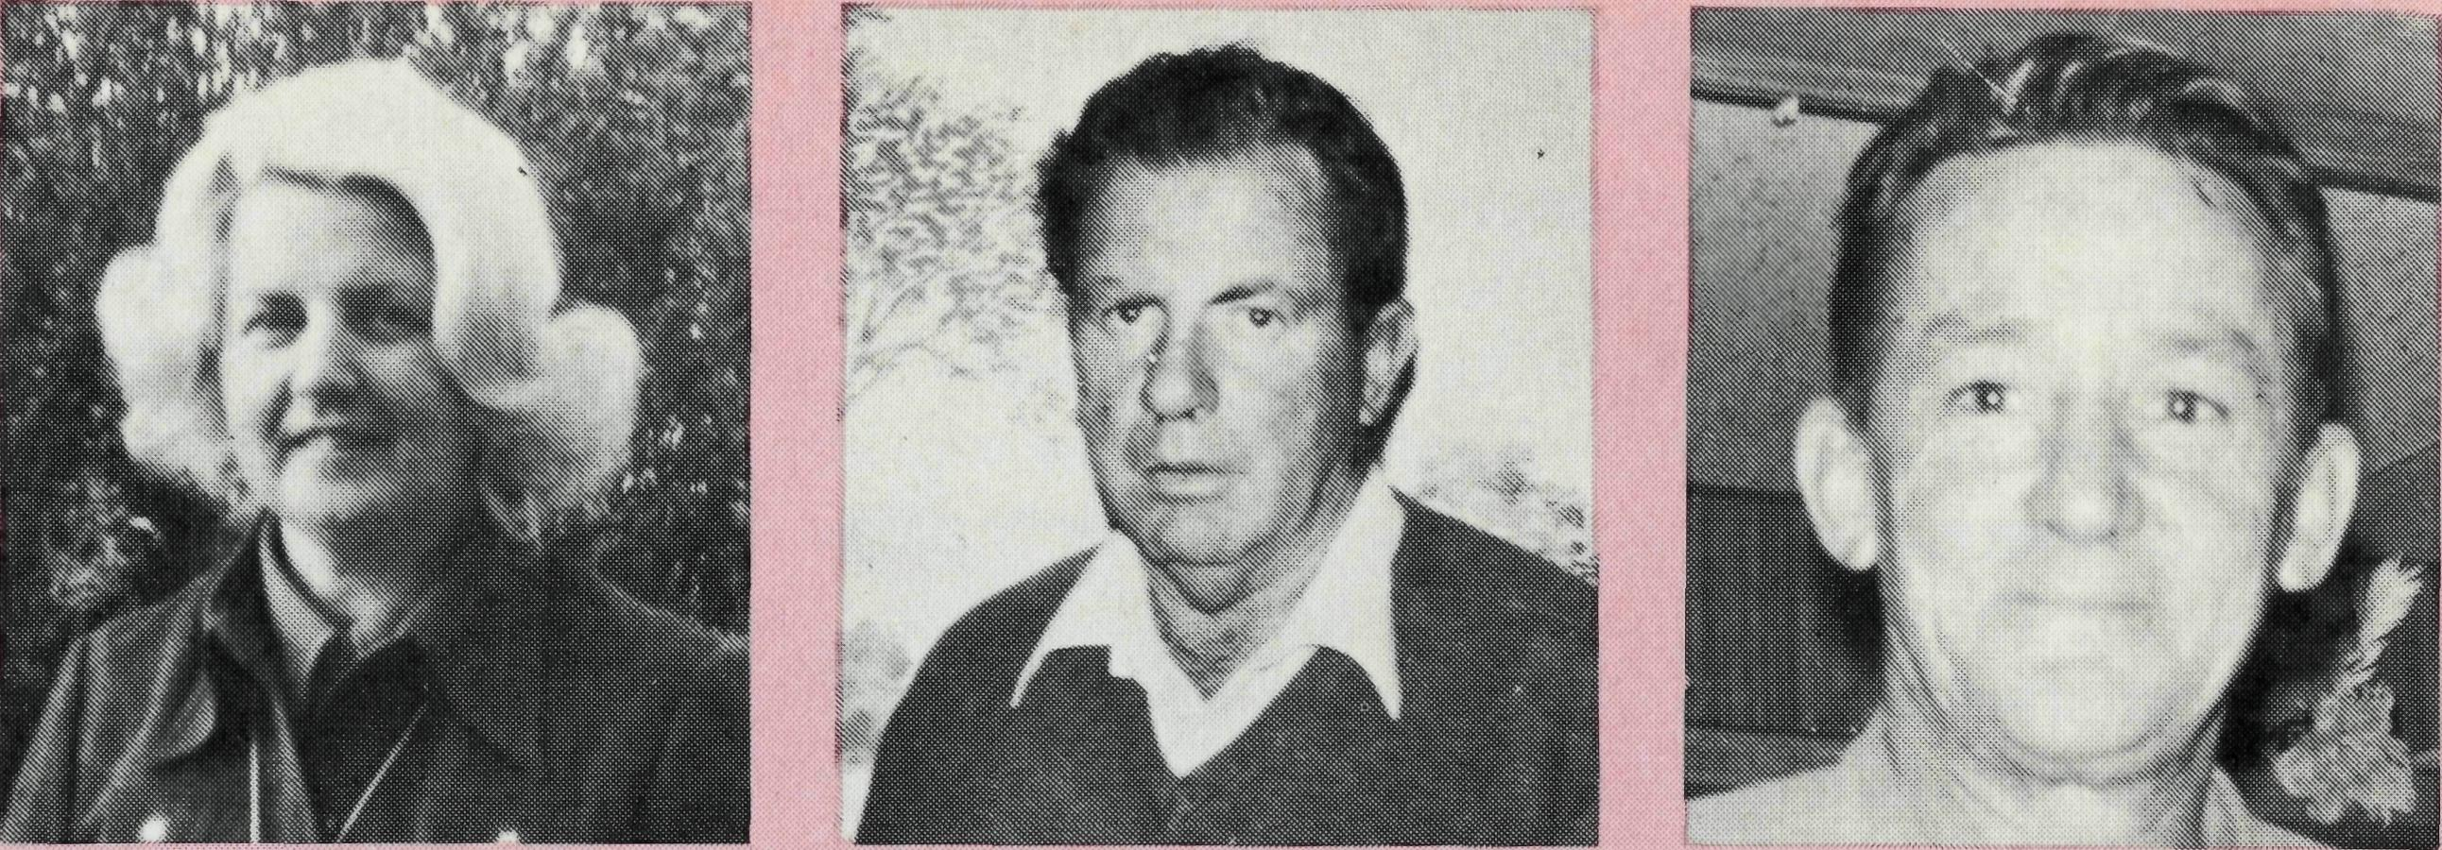
What has the aid of B.C.A. meant to us? Let me introduce three members of the parish, who will tell you in their own words: Margaret Parker —
"It has been a privilege for our parish to have been connected with the B.C.A. family for the past five years. When the parish had its birth, finance was a big problem. B.C.A. came to the rescue, subsidising us right up to the present time. Thank you B.C.A. for your help." Eric McGuffick —
"We in the combined parish have received great blessing from combining in fellowship and spiritual sharing of the Word and we can thank God for the financial help of the Bush Church Aid Society and the help of the Reverend Theo Hayman. Thank you B.C.A. May God continue to bless your work in remote areas of Australia." Athol Thompson —
"Our heart-felt thanks go to B.C.A. for their support, not only for the money so generously given over the past 5 years, but also for the fellowship that we have experienced through the visits of other members of B.C.A. to our parish.
"The spirit of fellowship, brought into our midst by these people, has strengthened our awareness of our fellow Christians and our need to place our entire lives in the hands of the Lord Jesus Christ.
'"The money supplied by B.C.A. meant that we have retained a full-time ministry and this has enabled a real teaching ministry to be carried out. I feel that this has not only increased our numbers but has also helped to deepen people's spiritual commitment in a wonderful way. We would ask that you continue to pray for our parish as we will certainly ask God's continual blessing upon the work of B.C.A."
Yes, God has really used the Bush Church Aid Society to help extend His Kingdom here in our part of the bush. Let me share with you some of the recent blessing we have experienced.
In a series of special mission efforts — in August by 18 students from the Adelaide Bible College in Delungra — in September by 3 members of Ambassadors for Christ in Ashford — we have seen 30 people find new life in Christ. Every member of B.C.A. who has prayed for God's Word in Ashford, Delqngra and Tingha can rejoice with us and praise God for the great things He has done.
On our own again — Yes. ON OUR OWN? JESUS HAS SAID, "I WILL NEVER LEAVE YOU . . ."
5 THE REAL AUSTRALIAN
Who would ever think that money was a bother to anyone? We all need money. We handle it every day and cannot get on without it. Yet to some folk money is a real hindrance.
You may think that this is the beginning of an appeal! The Society needs finance and is very grateful indeed for small gifts as well as large. We praise God for His help to us. With the challenge of new ministries, "new" or added funds are urgently required.
Money can be a spiritual problem. The love of money for some is the root of very great evil. Materialism shuts out God.
Our B.C.A. missioners work in mining towns in the outback of Australia. In ten of the ministries we support, the clergy work among men who earn a very high wage. Clearly the numbers in the towns are such and the salaries are such that there should be no need for the Society's help, except that the numbers of committed folk are so few and that many move so quickly.
A Company film, advertising the wealth and advantages of working in one of the remote mining situations, "ihows men being asked why they chose to work there. Naturally each one gave the one answer — money. From the legitimate use of money, paying off of homes and debts, men and women move on to a lust and greed.
Money becomes a goal, a master. As "no one can serve two masters" (Matthew 6 v. 24), materialism becomes the "religion" and God is not allowed to be worshipped in their lives.
Please pray for those who work in this environment of high wages.
THE REAL AUSTRALIAN
Though the numbers of Christians are few, the amount of counselling among non-Christians is great, with attended problems of materialism.
On the brighter side it is most encouraging to hear the testimony of those who step forward in faith and, in commitment to their Master, give a tenth (and more) to God. In one mining town a family felt convinced that they should be free from the money master. Their finances were in a mess. Despite their wages, they were in debt. Yet, having made the stand, and being determined to bring to God their tenth, in no time tensions eased. Their finances came much more tidy.
Another family made their own personal commitment to give a tenth of their income to God on a Sunday. Little did they know that the headquarters of his Company had sent a letter, received on the Monday, in which was the news of a rise equalling the tenth they had pledged. A thankful re-assessment and increase was made.
In a letter I have just received from Newman, the congregation thrilled the Reverend Dalba Primmer by deciding that, for the first time, a tenth of their Church income would be given to the Society.
I was reading in Deutoronomy 8, v. 17, "Beware lest you say in your heart, 'my power and the might of my hand has given me this wealth'. You shall remember the Lord your God, for it is He who gives you power to get wealth; that He may confirm His covenant."
Your friend,

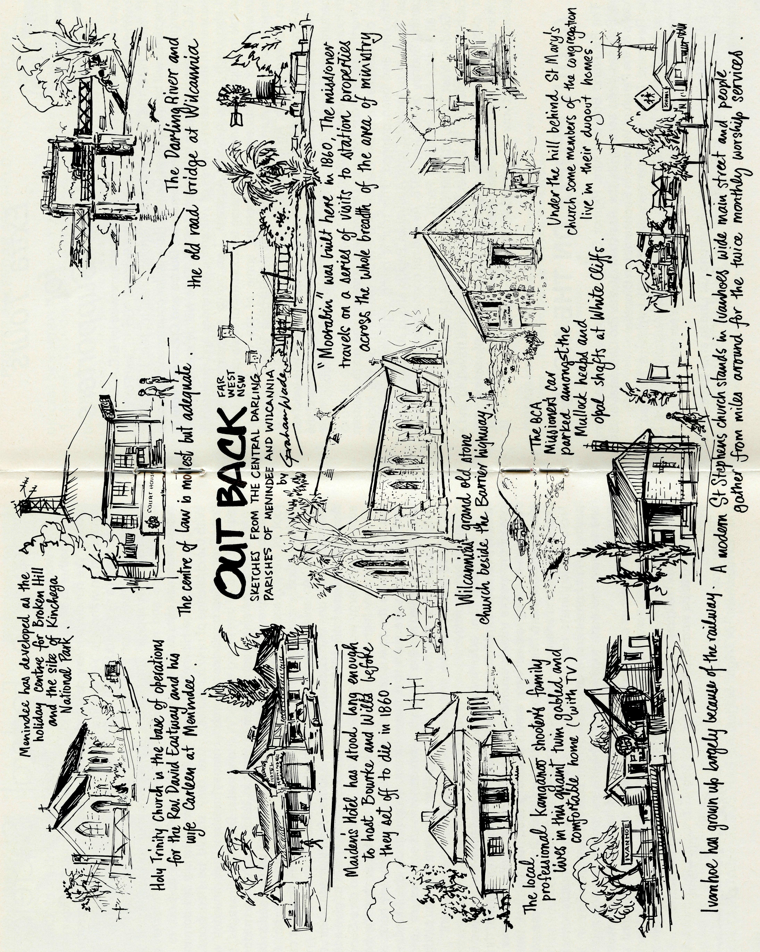

Extra Tours
for
B.CA. Supporters
Two additional tour programmes have been approved by B.C.A. Council following the success and enjoyment of the first two "Go ... See For Yourself" tours held this year. Following similar lines to the 1977 tours, connections will be available at Central Railway for country and interstate passengers, and the tour itinerary includes Dubbo and Cobar en route to the B.C.A. Mission district in Western N.S.W. Time will be spent with the missioners in the Mission Centres of Wilcannia, Menindee and Broken Hill, and also Leigh Creek in South Australia. Two nights' accommodation is available in Wilpena Pound before going to Adelaide for three nights. Time is available for sightseeing and meeting some of the B.C.A. folk in Adelaide, and the return is made through the Barossa Valley, Mildura, Swan Hill and Griffith. An inclusive fare covers coach travel with Golden West Tours, dinner, bed and breakfast accommodation and some lunches, and the fare is $523. A brochure is available from the B.C.A. office, and the departures are Thursday, 6th April, 1978 and Thursday, 5th October, 1978, both tours being 14 days' duration.
A north-western tour flying to Darwin and covering the north-western areas of Australia between Darwin and Perth, returning on the Indian Pacific has also been planned. This tour is being organised by Golden West Tours in association with Australian Pacific and is the tour WC501 departing Sydney on 6th July, 1978. Air and rail connections may be made from all capital cities including Perth. All enquiries may be made direct with Golden West Tours, 283 Main Street, Katoomba, N.S.W. 2780.
Each tour promises to be a great time of fellowship while travelling and a first class holiday. You will also have the chance of seeing and experiencing at first hand the work and conditions of the B.C.A. Missioners. Contact your nearest B.C.A. office for details.
ABOUT PEOPLE ON THE MOVE
• The Reverend Bob and Mrs. Rigmor George move from Wollongong where Bob has been serving as the Assistant at the Pro-Cathedral of St. Michael's to the Parish of Winton in Rockhampton Diocese.
- The Reverend Dalba Primmer because of health problems has had to resign as Missioner in Newman Parish in North West Australia. He will be returning to Canberra-Goulburn Diocese in the New Year and we trust to better health.
- Our B.C.A. Missioner in Winton, the Reverend Gil Linden after three years in that far-flung parish is moving to the Parish of Park Avenue in Rockhampton.
PRAYER CALENDAR AND FIELD STAFF DIRECTORY
DIOCESE OF NORTHERN TERRITORY. The Rt. Revd. K. B. Mason.
1 Darwin — Coryn O'Nians (Nungalinya College).
DIOCESE OF NORTH WEST AUSTRALIA. The Rt. Revd. H. A. J. Witt.
- Kununurra — The Revd. Royce and Mrs. Susan Thompson.
- Derby — The Revd. Ron and Mrs. Ann Robins.
- Newman — The Revd. Dalba Primmer, Port Hedland (grant). The Revd. Kevin Hall.
- Dampier — The Revd. Bill and Mrs. Jocelyn Ross. Mr David and Mrs Helen Mansfield.
- Paraburdoo — The Revd. Graham and Mrs. Helen Thurley.
- Exmouth — The Revd. Peter and Mrs. Elizabeth Mills.
- Murchison — The Revd. Bill and Mrs. Joan Hoare.
- Geraldton — Mr. Stan and Mrs. Dorrie Hummerston — Diocesan Administrator.
DIOCESE OF PERTH- The Most Revd. G. T. Sambell.
10 Kalgoorlie — grant. The Revd. Canon Norman Apthorp, The Revd. Roger Williams.
Kambalda — grant. The Revd. Robert Hanson.
DIOCESE OF WILLOCHRA. The Rt. Revd. B. S. Rosier.
- Cook Hospital — Nurses Mr. Keith and Mrs. Rhonda Anstee.
- Tarcoola Hospital — Kay Trappel, Pat Watts, Helen Bible.
- Coober Pedy — The Revd. Kerry and Mrs. Julieanne Medway.
- Gawler Ranges and Trans. Line — The Revd. Robert and Mrs. Phyllis McEwin.
- Leigh Creek — The Revd. Chris and Mrs. Marilyn Clerke.
DIOCESE OF TASMANIA. The Rt. Revd. R. E. Davies.
16 Zeehan — grant. The Revd. Roy Dixon.
DIOCESE OF RIVERINA. The Rt. Revd. B. R. Hunter.
- Broken Hill Boys' Hostel — Mr. Ken and Mrs. Pam Young.
- Menindee — The Revd. David and Mrs Carlene Eastway.
- Wilcannia — vacant.
DIOCESE OF ARMIDALE. The Rt. Revd. P. Chiswell.
20 Ashford-Delungra-Tingha — The Revd. Noel and Mrs. Desley Boyce.
DIOCESE OF ROCKHAMPTON. The Rt. Revd. J. B. R. Grindrod.
- Winton — The Revd. Robert and Mrs. Rigmor George.
- Blackwater — The Revd. Stephen and Mrs. Pam Rigby.
DIOCESE OF CARPENTARIA. The Rt. Revd. H. T. U. Jamieson.
23 Weipa — The Revd. Malcolm and Mrs. Chris Babbage.
FEDERAL SECRETARY
24 The Revd. Theo Hayman.
STATE OFFICES
- N.S.W. The Revd. Wakely Wade, Laurie Calder, Eric Atkin, Miss Doris Smith, Mesdames Joy O'Neill, Dora Warwick and Nina Allan.
- VICTORIA. The Revd. Barry Green, Miss Rosemary Renouf.
- QUEENSLAND. The Revd. Greg Ezzy (Deputationist and Secretary). W.A. The Revd. Ted Doncaster (Deputationist).
- SOUTH AUSTRALIA. The Revd. Blair Grace.
GENERAL
- Staff Replacements, The Council, State Committees.
- Box Secretaries, B.C.A. Supporters.
- National Home Mission Fund.

10
TH E REAL AUSTRALIAN
THE REAL AUSTRALIAN
11

THE B.C.A. PRAYER
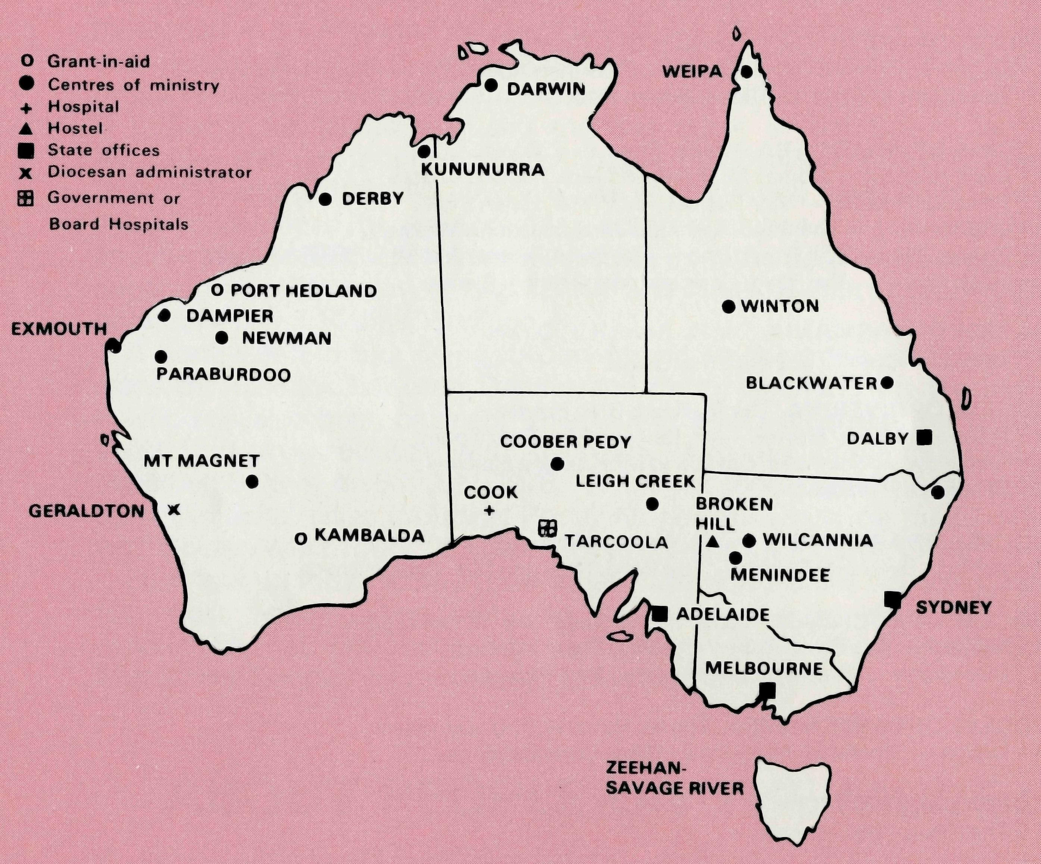
A DAILY PRAYER
0 Lord our God, help us to remember those who live in the remote parts of our land. We ask You to bless those whom You have called into the fellowship of The Bush Church Aid Society. Grant that, through the ministry of the Word and Sacraments, through healing, and through caring for the young, the message of Your redeeming love may be proclaimed, through Jesus Christ our Lord. Amen.
O God, we remember before You those whom You have called to Your service. We ask You to bless
, assure
them of Your Presence, and call others to stand with them in the task. Grant to them, as to us, the joy of service, the ability to achieve, and the serenity of Your peace, for Jesus' sake. Amen.

Dalba Primmer Newman
Like the Rain
My word is like the snow and the rain that comes down from the sky to water the earth. They make the crops grow and provide seed for sowing and food to eat. So also will be the word that I speak — it will not fail to do what I plan for it; it will do everything I send it to do.
Isaiah 55:10-11TEV These words from Isaiah 55 have really "come alive" to me in recent months as a result of people coming to me from time to time, at the Newman Rectory, who wish to talk about some problem in their life that they believe can only be resolved by opening their hearts to God in the presence of a clergyman. Each time such people sit in the Rectory lounge and begin to unburden their hearts I feel a deep sense of privilege and humility that a person with no visible contact with the worshipping life of the Church can feel so confident about being able to trust the Minister and to receive effective counsel from him. I believe this says a lot that is positive and good about the ongoing ministry of the Church and not just isolated individuals. I have become increasingly thankful that B.C.A. provides the ministry to people in places like Newman, for without B.C.A's practical support people would most likely be denied someone to minister to them in their greatest hour of need.
The following real life situations are concrete examples of how people have been helped in the moment of crisis by the ministry from God's Word. The words of Isaiah 55 are certainly true in the experience of the ministry in Newman and they are given as examples to encourage us all as we continue to see that God rs very much alive and at work in our midst. JOHN
The heavy metal door clangs shut behind John as he walks hesitantly from his cell in the local lock-up. He has been arrested and gaoled for possessing drugs which were intended for sale locally in Newman. Five days alone in his cell, with lots of quiet and time to think. John came from a Christian home and I was visiting him at the request of his parents. Before leaving I asked if he would like me to pray with him — tears came to his eyes — someone still cared and he hadn't been thrown on the garbage heap after all. He approvingly nodded and then said yes.
The following day John appeared before the local J.P's. who released him on bail pending his hearing before the magistrate in Port Hedland. John visited me each afternoon for the next several days and in his own words he "came to receive strength and courage to keep going" and he confessed how "that he needed something as drastic as this to pull him up in his tracks and make him come to his senses". He also spoke about how he had left God out of his life and what a mess he had made of managing it as a result.
13
It was simply wonderful to see and experience the obvious signs of God
THE REAL AUSTRALIAN

Preaching to the Sound of Stamping Feet!
Royce Thompson tells of the congregation at Wyndham which mainly consists of Aboriginal people encouraged and "rounded up" by two fine Christian ladies who grew up at the old Forrest River Mission (now Oombulgurri). They are a "lively lot" understandably — red back spiders keep them on their toes. There is nothing quite like preaching to the sound of stamping feet, says Royce.
at work in John's life over the following days. As we looked at Christ's parable we noted that the story began with the son at home with his father and that this gives us the picture of what God wants us to be "at home with HIM". Secondly we saw that the son's sin was leaving home and going to a far country, and we noted that Sin is turning our back on God. Repentance was coming to his senses and walking back home, and Forgiveness was accepting what the Father had to offer, which was restoration of sonship. John, in a simple prayer, claimed his Father's forgiveness, handed his life back to God and so came home to his Heavenly Father. One really felt "the joy in heaven over this one sinner that repented".
At John's request we celebrated Holy Communion at an informal service at the Rectory, with two other Christians present from our worshipping congregation, on the night before he was to go to Port Hedland to stand trial. It was indeed a most meaningful service to us all and God indeed blessed us as we gathered around His table. TOM
Tom drops into the lounge chair like a ton of bricks and apologises profusely for wasting my time but he just had to talk to someone as he was going out of his mind with worry. What should he do? His wife had left him and the children and was going initially for two weeks "to sort herself out" before leaving for good or deciding to continue with the marriage. Tom loved his wife, his children and his family were the most important things in his life. What should he do? Tom talked on, I listened and eventually gave some sound practical advice, and so Tom was ministered to in Christ's Name in a moment of crisis. Thank God for B.C.A. and the ministry it provides in Christ's Name.
The joy of sending forth
The Reverend David Livingstone shortly to retire from St. Anne's, Ryde, Sydney, the parish from which the first B.C.A. Organising Missioner, the Reverend, later Bishop S. J. Kirkby came, had the delight recently in sharing in the commissioning service for Sister Helen Bible who is going out to serve with B.C.A. at the hospital in Tarcoola, South Australia. Mr. Livingstone was a former missioner and later N.S.W. Secretary of the Society.
The Rocky Path
The Clerke family were staying at Mr. & Mrs. David Bottom's Wir-ryilka Station some miles out of Menindee whilst they awaited the move to Leigh Creek. Chris continued to assist in the parishes of Menindee and Wilcannia with services.
Chris, with Marilyn and the children, had flown to a number of centres in the mission district to take services one Sunday in October. On the way home between Wilcannia and Menindee they encountered very adverse flying conditions with a rapidly approaching dust storm on one side and a severe rain storm with lightning on the other. A narrow path lay between, although there was certainly some turbulance.
They arrived home safely. That evening at family prayers Chris reminded the family of the provision of the pathway between the storms. Young Jason, nevertheless, could not contain himself with the comment, "a pretty rocky path, Dad!" Exorcism?
When Wakely and Graham Wade arrived at the door of St. Mary's Church, White Cliffs, recently with the Missioner, David Eastway, David advised everyone to stand back when he opened the church door to allow the snakes to crawl out! One wonders if this is a strange sort of exorcism. After an enthusiastic and inspiring service the congregation retired for afternoon tea to one of the dug-out homes in the area. There one of the local graziers, Mr. Jack Turner, accounted stories of the time when he was a boy in the B.C.A. Hostel at Wilcannia and acted as one of the maintenance team that the Reverend Len Daniels had to keep his aircraft flying.
"...and daddy too!"
Barry Green earlier this year when visiting the Hummerstons in Gerald-ton was very impressed with the naturalness and reality of their family prayers. He perceived this was one of the strong points of the Hummer-ston's home life. Dorrie when asked about this said that it was the thing that they placed a lot of value on and they felt that it made a big difference in their family life and their understanding of one another and trust in the Lord. She told this delightful story, "Many years ago when one of their children first spontaneously prayed, the prayer was, 'Please God help mummy to be patient'. Dorrie looked up to see Stan grinning from ear to ear. The pause lengthened then the little voice said, 'and daddy too'."
Golden West "Go ... see for yourself" Tour No. 1
This tour to B.C.A. posts in
western N.S.W. and Leigh Creek in
South Australia was an outstanding
success. The folk on tour gained a
much greater appreciation of the
Society's work and are full of priase
about what the Society's missioners
are doing. Miss Margaret Woolcott
who is the Secretary to the Bishop in
Parramatta, Bishop Donald
Robinson, who was a tour member when asked by Mr. Laurie Calder whether she would recommend this sort of tour to her friends said, "Yes, I certainly would. I have visited some of these places before, Leigh Creek in particular — other places I've not been to and I was anxious to see them, but having come on this tour I would certainly recommend anyone who had the interests of B.C.A. at heart, to come and see for yourself just what is going on on these mission stations in these isolated parts of Australia."

14
THE REAL AUSTRALIAN
THE REAL AUSTRALIAN

