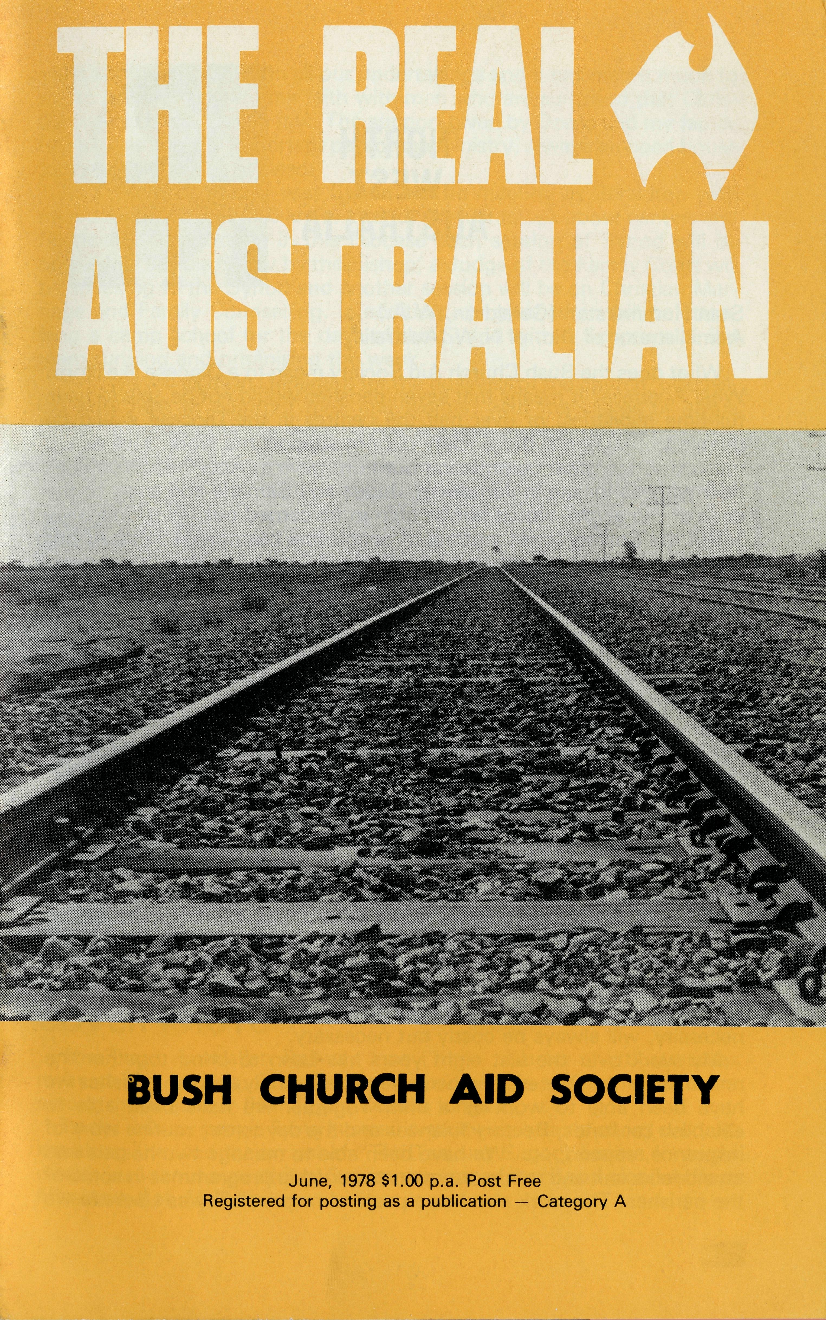
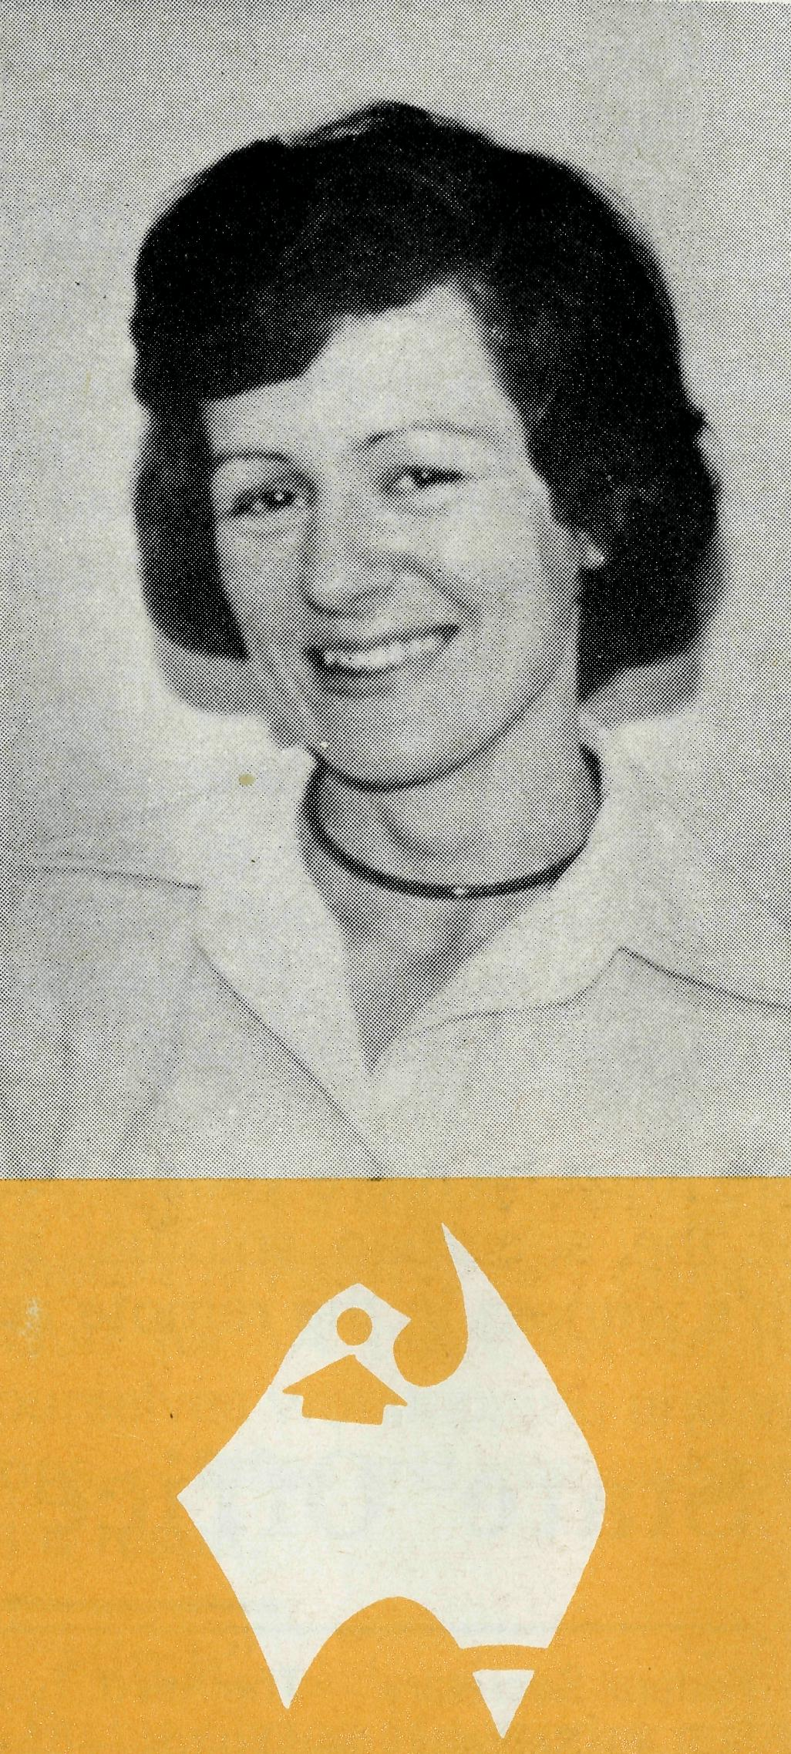

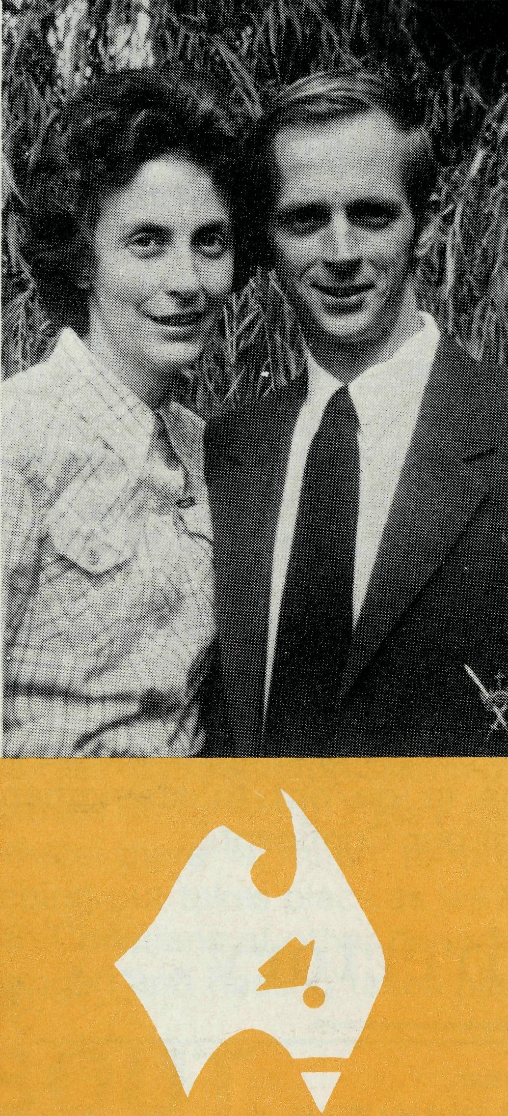
Captain Les and Mrs. Patricia Fernance and their two children, Faith and Warren, moved to Lightning Ridge, N.S.W. in May. Lightning Ridge is an opal mining community with a population of about 3,000 although many more are there in the holiday seasons. This is a new ministry and Les will be the first resident full-time Christian worker there. The congregation, made up of both Anglicans and folk of other denominations, is looking forward to Les' ministry among them and their community.
Sister Patsy Dahl arrived in Darwin from Sydney at Easter time to serve as Deaconess in the Parish of St. Peter's, Nightcliff. B.C.A. has had links with this parish ever since its formation (Revd. Alan Baker, Revd. Alan Hoskins and Deaconess Pam Crew).
Darwin, a city with a rapidly growing population (before Cyclone Tracy, Christmas 74, 48,000; after Cyclone Tracy, 10,000, now over 50,000) is a place with great needs. Patsy will no doubt find the special course she did in counselling before going North, of immense value.
1978-AMBASSADOR PRESS PTY. LTD., Granville 2142-36210

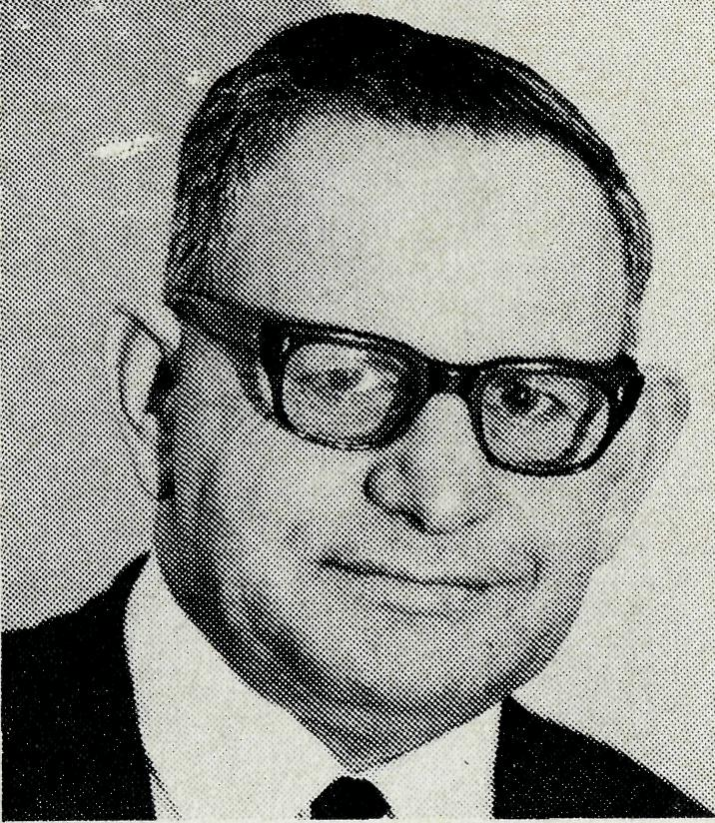
NORTH
WEST
AUSTRALIA
Stan Hummerston (Geraldton, W.A.) Administrator of Dio. of N.W. Australia.
What does the Bush Church Aid Society mean to a Diocese like North West Australia? It means that seven parishes would not be able to have full-time ministries; or over half the centres in the Diocese would be unable to function if the Society did not support the work. This would mean that the great commission our Lord gave in Acts 1-8, "You shall bear witness for me in Jerusalem, Judea and Samaria and away to the ends of the earth" would not be able to be carried out.
But the Society is not a group of people just belonging to B.C.A. but individuals who are members of the Body of Christ, His church, who see that the challenge of presenting the Gospel does not end in Sydney or Melbourne but to the uppermost part of Australia.
This has meant that for over twenty years the Bishop and Diocesan Council have been able to seize the opportunity to go into new areas in the Pilbara and the church has been there from the beginnings of these new towns.
Large numbers of people who come to these new areas are there seeking worldly gain and a quick dollar, but through the ministry of the church many who did not seek God have found Him because you cared and you provided the prayer and financial support for the clergy who were able to meet men and women in their daily needs and talk to them of the One who came into this world for the sake of all men.
What now of the future? Surely now that these areas are being established and men are earning high wages, the Society's role must be diminished. Firstly, each centre is now undertaking more responsibilities and within the Diocese parishes are helping others in need and because of you the Diocese has been able to function more efficiently by first looking to see how any new work may be undertaken, then asking B.C.A. to assist in some way. Because of great distances the ministry, of necessity, will always be costly but necessary.
My work over the last eight years has been to bring together the resources of the Diocese and because there are only thirteen parishes we have been able to work as a unit. Together we have been able to establish car funds, Rectory finances and the day to day routine work of insurance, stipend, etc. We have been able to manage two hostels and an old folks unit and to run our own stewardship programmes in some of the parishes. The work also has a pastoral responsibility as I believe we
must witness for Christ in all our undertakings and it has meant much to me to be able to share my faith with men who are surprised that Christianity and business can mix. The support given by Dorrie and my family has always been an important part of the ministry, always an open house to share with those in need.
In September of this year Synod will be meeting in Geraldton with men travelling over 2,000 km to attend, not just to talk about canons and financial statements — in this Diocese each session of Synod will be opened by a Bible Study by the Bishop; a Judge of the Family Court will be speaking to the Synod and another session will be on Christian Marriage and Family Counselling. In addition, clergy children will be attending a camp school for the days of the Synod with a Scripture Union team running and organising the week.
Yes, we will all be in Geraldton for the business of the church, discussing how best to confront men and women with the claims of Jesus Christ. By sharing in the work of B.C.A., you share in this too.
GO . . . SEE FOR YOURSELF
Last year B.C.A., through Golden West Tours, had two very successful coach tours of the B.C.A. posts to Wilcannia, Menindee in Western N.S.W. with the Hostel in Broken Hill, then on to Leigh Creek in South Australia and home via Adelaide and Mildura.
This year an Under 30s Safari Camping Tour is timed for the Spring school vacation.
A "Last Frontier Tour" to North West Australia lasting 25 days is leaving on July 6. The plan is to fly to Darwin, travel by coach down the Western Australian coast through the B.C.A. centres of Kununurra, Wyndham, Derby, Broome, Dampier, Exmouth, Paraburdoo to Perth, thence by Indian Pacific train home.
In October another tour of Western N.S.W. and South Australia is planned.
If you are interested there are brochures available from Sydney office.
COVER PHOTO
The Trans Australian Railway Line (Trans Line for short) stretches away to the horizon. The "long straight" of this railway line 478 km across the Nullarbor Plain is the world's longest.
To the railway people living in small settlements spaced about every 80 km along the Line the arrival of "The Tea and Sugar" once a fortnight means just about everything. See centre spread story and pictures from Missioner Rob McEwin.

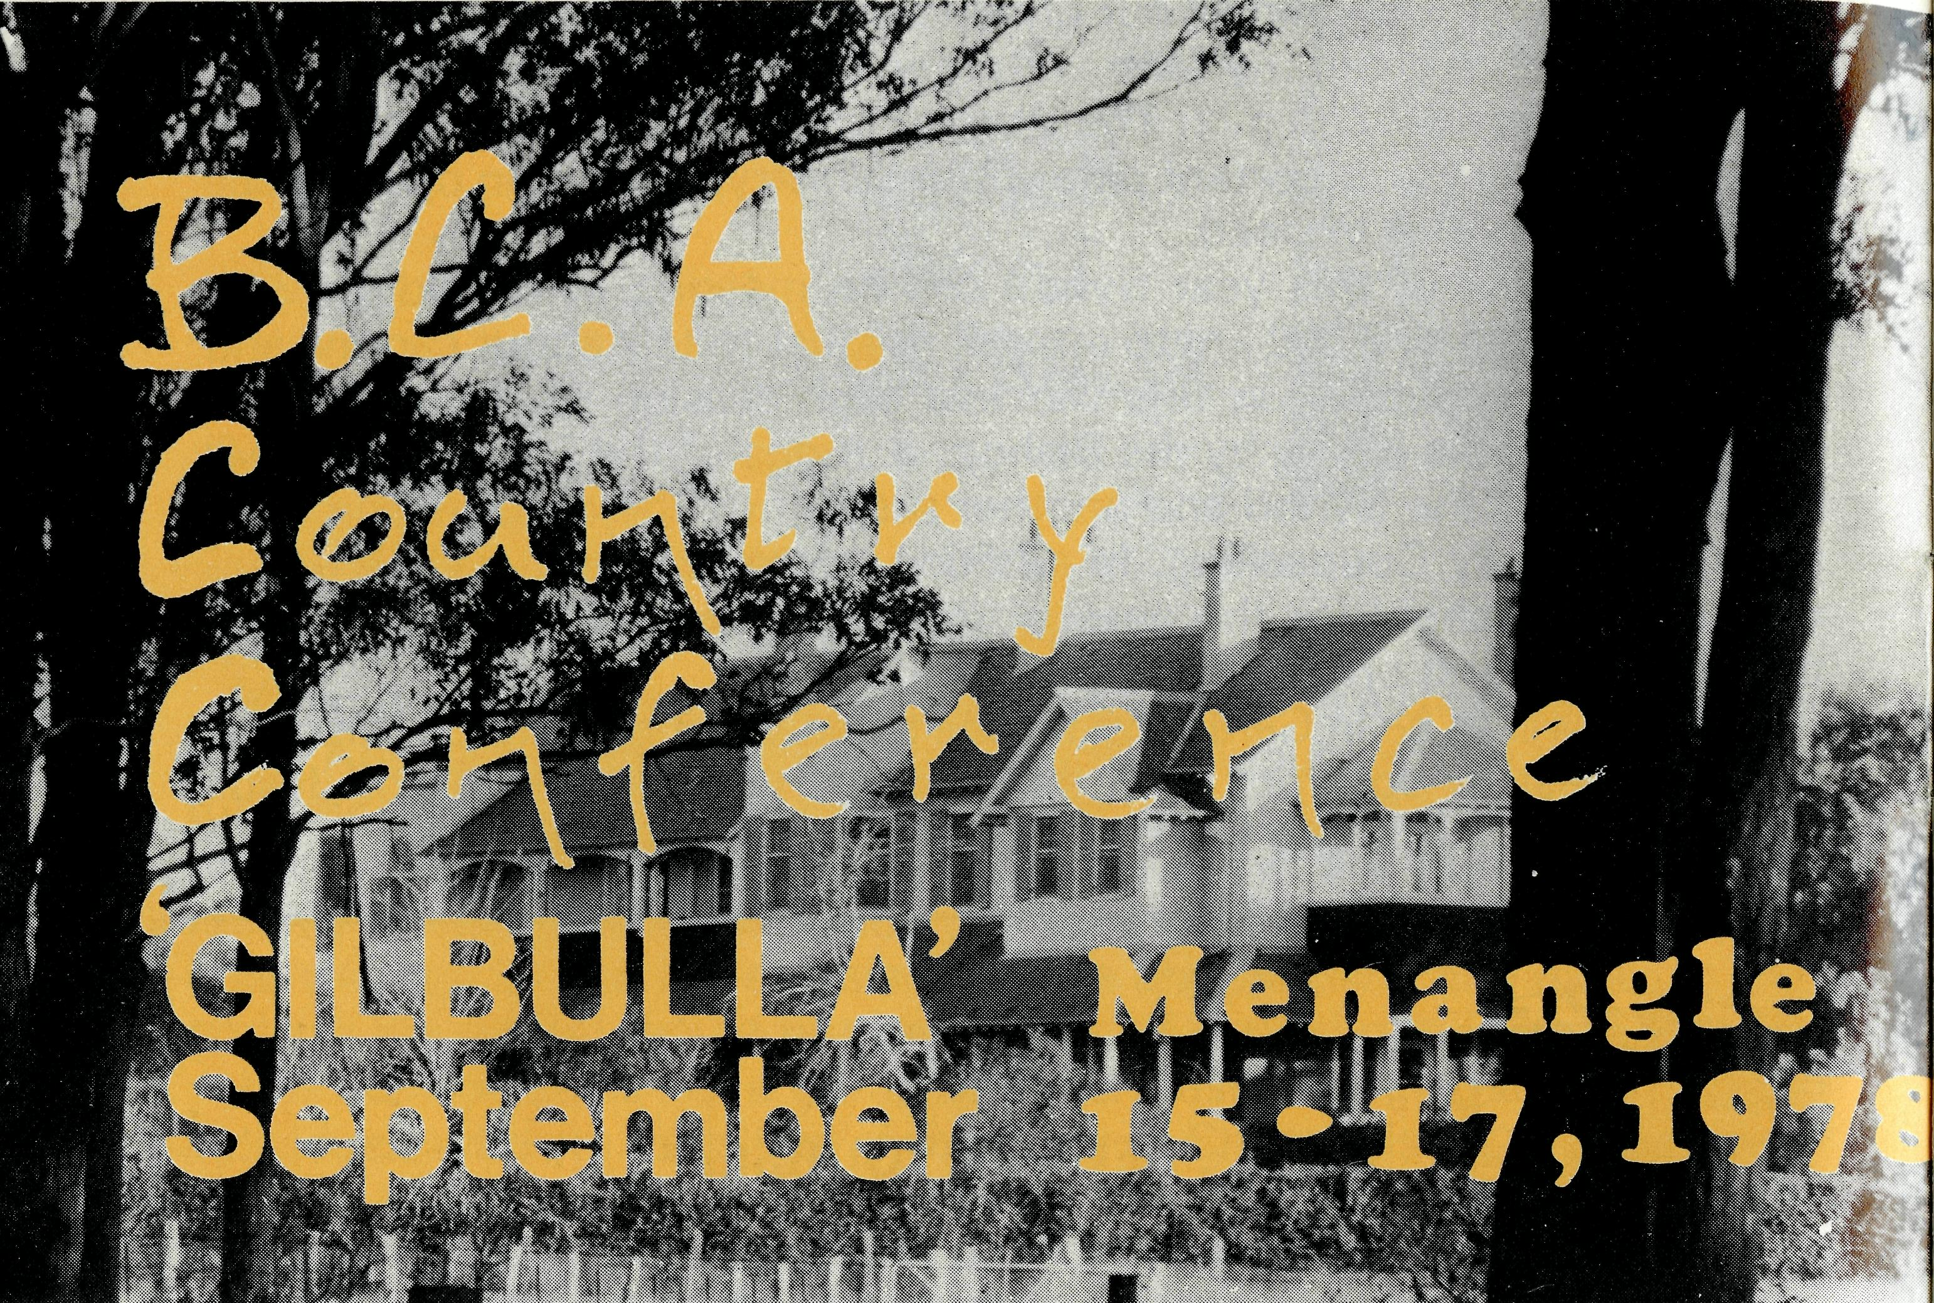
We would invite you to enjoy with us two relaxing days of warm Christian fellowship, a chance to renew friendships, an opportunity to be up-to-date with B.C.A.'s enterprise in the outback, and make a well deserved escape from the grime and grit of the dusty, dirty city.
Situated in rich dairying country at Menangle near Camden, 40 miles from Sydney, Gilbulla is equipped with first class conference facilities.
Family groups are welcome and provision can be made for children.
Tariff: (Meals and accommodation) Friday evening to Sunday afternoon: Main House, $22.00; Long House, $19.00. Children under 14 - $10.00 Children under 3 — $5.00
Bookings are limited so don't risk disappointment — send your application now to B.C.A., 135 Bathurst Street, Sydney 2000.
Revd. Mr. NAME: Mrs. Miss
ADDRESS: __
_Postcode.
_Parjsh:
Phone:
I would prefer to be in
- Main House
- Long House
Limited accommodation is available for children.
Please state number and ages.
Enclosed is $5 deposit for each adult booking.

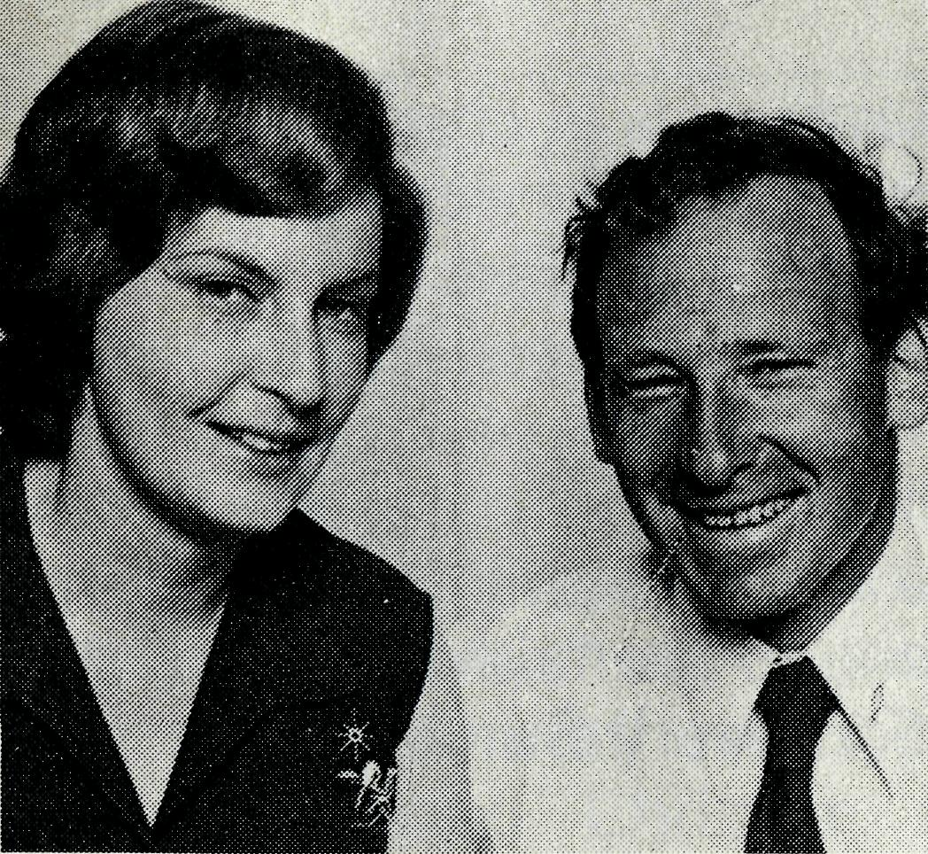
HOSTEL
FIRST
IMPRESSIONS
Pam and Ken Young
Like many other newcomers to Broken Hill, we were expecting a hot, dusty town, when we arrived in January to take up the position of House Parents at the B.C.A. Hostel. To our surprise we found a pleasant city, with all the facilities we could require. The Hostel was also a surprise — a rather attractive old house, shaded by tall gums and set in a large area of lawn and garden.
We waited with mixed feelings for the first children to arrive. They descended on us all at once — a noisy, active and friendly bunch. It was obvious how much they would miss the property or small township that was home and the close knit family life they were leaving behind. Some would see their family only twice in the next term.
We pray that through caring for these 22 children, that the message of Christ's redeeming love may be proclaimed. At present some of the older children have closed their minds to this message, but we pray that as they come to know and trust us, we will have the opportunity to share our faith with them. Already there are incidents that encourage us . . . the interest shown in the film The Cross and the Switchblade, which was shown recently on local television ... the keenness of one of the older boys to be confirmed in the Anglican Church and assist as a server in the morning Eucharist... the close questioning that Ken was faced with, as he went through the booklet / Object at devotion time after tea. . . .
Every now and then when we are out at the weekend the boys will start to question Ken. Basic questions such as, "What is a Christian?" ... "Isn't it enough just to believe?" . . . etc., will arise. We praise God for the opportunity to witness to these children and we trust that in His time they will know Him as Saviour.
We know how closely we are being watched by the children and how critical they are of our actions. We strive to be patient and understanding and to be consistent and fair in our discipline. Taking time to help individual children with their own interests is very important. So often tears or squabbles are simply means of gaining attention.
The children are very active and are used to working hard on the property. They need to get out at weekends and use their pent up energy. Sunday is usually a full day out swimming, biking, fossicking or just exploring the local district. Recently we spent a whole weekend camping at Menindee Lakes, the local "tourist resort". While at Menindee we at-

from the Federal Secretary
tended the Anglican Church where David Eastway is in charge. Here the children had the opportunity to feel a part of the Service, by doing a Bible reading, collecting the offering and reading prayers.
For children who have had very little contact with any church, I feel this type of service is very valuable for them. Next term we hope to camp on a property near Mootwingee and we will take the opportunity to hold our own service again. We hope that by linking our worship of God with our every day activities, the children will come to see faith in God as part of their lives and not as a one hour obligation every Sunday.

It is on your mustn’t miss list?
THE B.C.A. WOMEN'S AUXILIARY
ANNUAL FAIR

Chapter House of St. Andrew's Cathedral
George Street, Sydney
WEDNESDAY, JULY 19th
from 10 a.m;
Features:
Great variety of Stalls — everything from produce to potholders.
Revive your drooping spirits at the TEA and COFFEE BAR.
Refreshments — Delicious Hot Lunch — $1.60
'— Sandwiches with sweets — $1.00

It is good to rejoice and to praise the Lord! Even before we had a vacancy to staff the Tarcoola Hospital, two Christian nursing sisters applied. A third may go to Coober Pedy.
Sister Helen Bible, who has been at the Tarcoola Hospital, found that she had to do some extra nursing in a larger hospital before going overseas for her next training course. She was able to get into the Whyalla Hospital from the beginning of May. Sister Kay Trappel, who has served so well in Tarcoola, often on her own, was due to leave also.
Hence, it is a delight to have Sisters Janet Stiff and Merryl Howard at the Tarcoola Hospital. Coming from England, they have been in Australia two years and have served already in the outback.
An added interest is the fact that Tarcoola is the junction of the North Line joining the East-West Line. Passengers can travel already through Tarcoola to beyond "Manguri" Siding, near Coober Pedy.
The news is good of the new folk who have gone out lately to serve in various dioceses through the B.C.A. While we are still looking for clergy to fill vacancies, we are encouraged by God's goodness to us in the supply of men and women. And now the Reverend Jim Hudson and Margaret have volunteered to go to Normanton in August.
We are encouraged also by the very real spirit of co-operation among our members throughout Australia. Challenged as we have been by entering five new areas, we needed a definite lift in support. Our accountant, Eric Atkin, tells me that the donations and box openings lately have indicated the real concern of people to help in this new work.
In the Scriptures, it would seem that the Church in Corinth, though presumably quite strong, was weak in giving. Yet to the Corinthians (2 Cor. 8) Paul speaks of the wonderful way the Churches in Macedonia, though poor, "were extremely generous in their giving" and "insisted on the privilege of having a part in helping God's people in Judea". We indeed, are grateful to those who have "given as much as they were able" to help God's people and the spread of the Gospel in the outback. We have made a good beginning this year and pray that it may continue.
This has been a confirmation of the faith in accepting invitations to place clergy in new areas. Join us in praising the Lord.
Your friend,
Theo Hayman

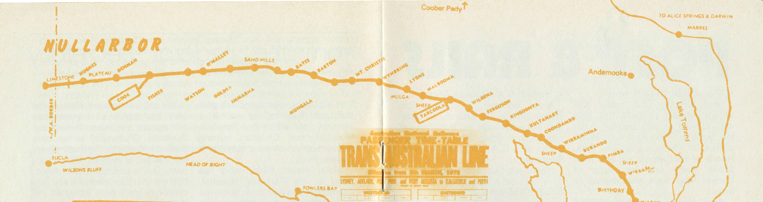

SLEEPERS
Revd. Rob McEwin (Pt. Augusta, S.A.) Missioner, Trans Line 8- Gawler Ranges

Some wake, some move and some just lie there. When those that lie there move — there is disaster When those that move just lie there — there is no progress When those that wake — wake to God's plan and purpose for them,
then the world could be turned upside down.
The Trans and North-West Mission has two parts:
- The Railway Line people.
- The pastoral country people.
Trains seem to be part of my life. In my theological training days it was the Adelaide-Sydney journey; while in Leigh Creek *it was the Central Australian Line with all its delightful variableness — (one assistant station master when asked if the Ghan was on time replied, "Yes, it's coming today".).
Now it is half the Trans Australian Railway Line — 822 km from Port Augusta to Cook — "the Queen city of the Nullarbor". Siding names read like an "I've been everywhere" — Fisher, Watson, Ooldea, Immar-na, Bates, Barton, Bookaloo, Mungala, Mt. Christie, Wynbring, Lyons — 28 sidings from Port Augusta to Cook and another 22 on to Kalgoorlie.
The first difference between the Trans and the Central Railway is speed. The Trans Line trains are 2 to 3 times faster than those on the Central Line.
The second is the number of trains — the Trans has 19 each way each week while the C.A.R. has 8, yet the Trans trains are about twice as long.
Thirdly, while much of the Trans Line passes through country similar to the Central Line, the big difference is the Nullarbor Plain with its "long straight" of 478 km. The Nullarbor is one of the few places in South Australia where there is a horizontal horizon for 360 km.
As well as the Trans Line there are some 50,000 sq. miles of station country — west of Lake Torrens and between Port Augusta — Iron Knob in the south and Coober Pedy in the north. There are some 40 sheep and cattle stations plus the opal mining town of Andamooka.
Paul's words to the church at Ephesus seem to have special relevance, "Awake O sleeper and arise from the dead and Christ will give you light". This verse speaks of three metaphors about people's relationship with God — sleeping — awake, death and life, dark and light. It points up the watershed between belief and unbelief. The symbolism of these metaphors is threaded through Scripture from the beginning and is most obvious in John's Gospel. It is in this Gospel that the bridging verse occurs when Jesus says, "Truly, truly, I say to you, the hour is coming and now is when the dead will hear the voice of the Son of God and those who hear will live". The Christian then is one who is awake to spiritual realities seeing the eternal implication and sharing God's life in him.
Christians desire that everyone would hear the voice of God's Son and live. It is no less the desire of those involved with the Society. Please pray that in one way or another those who sleep will be awakened to God's plan and purpose for their life and that those who are awake will see more clearly the implications of their faith.

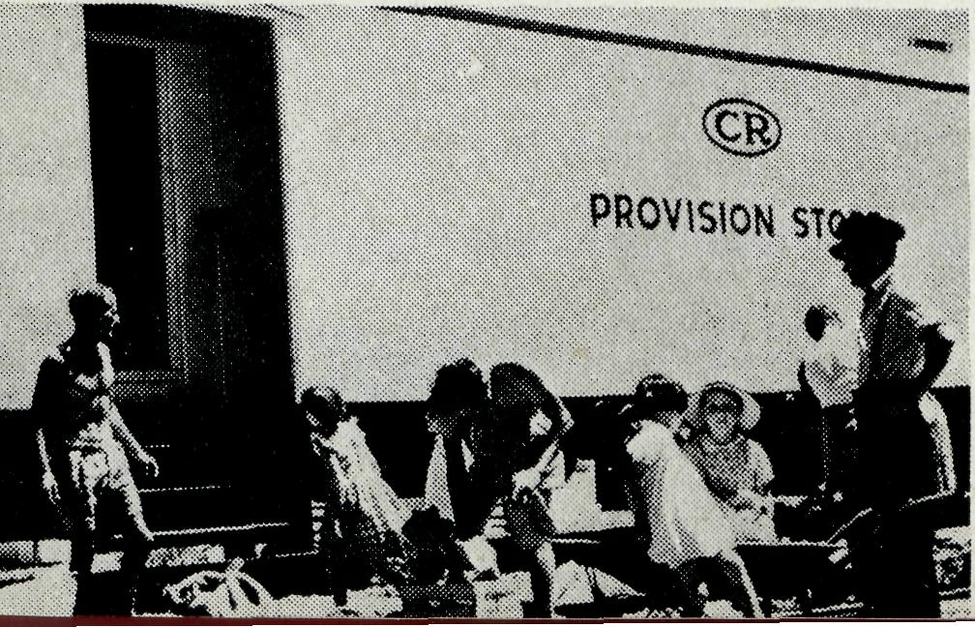
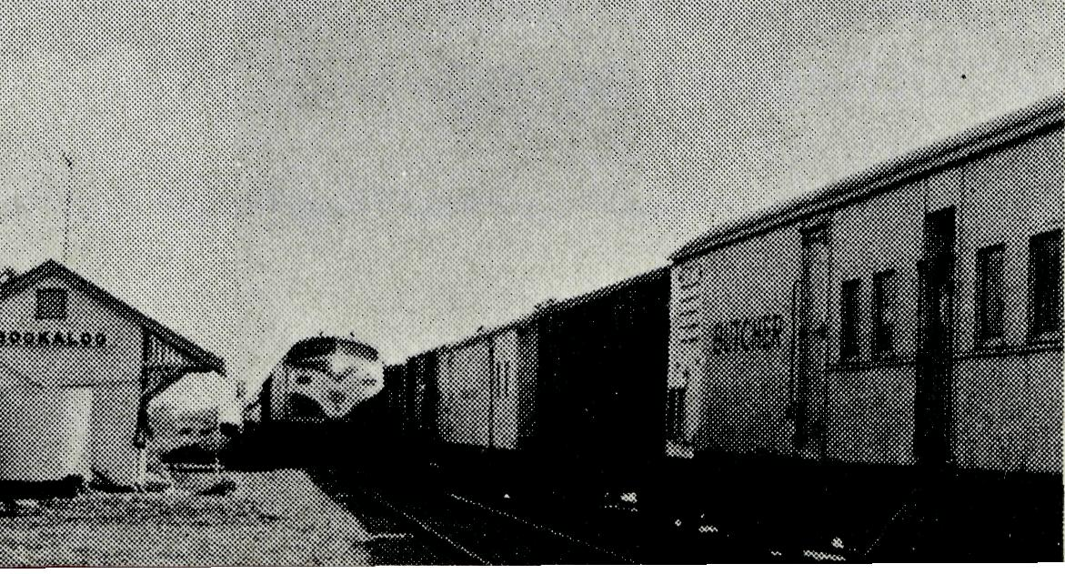
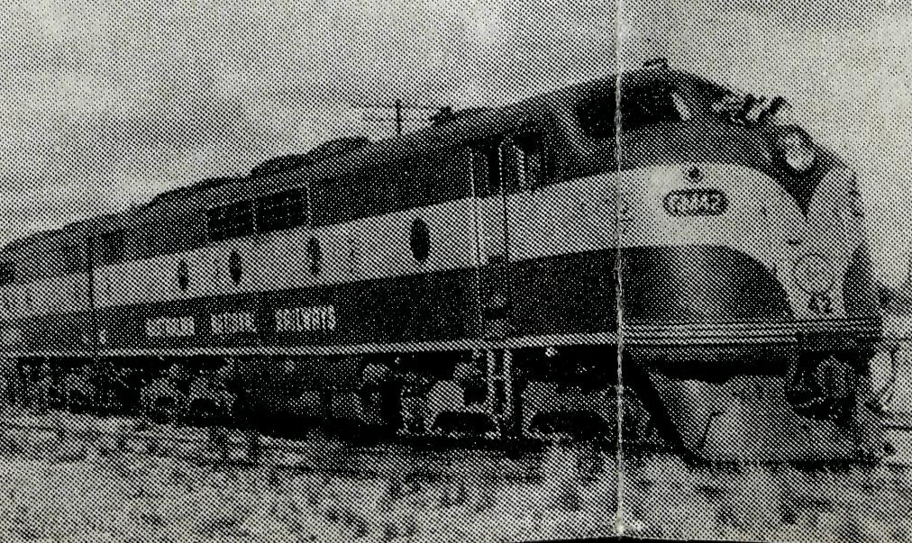
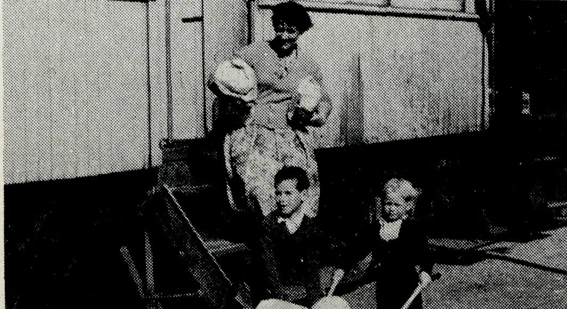
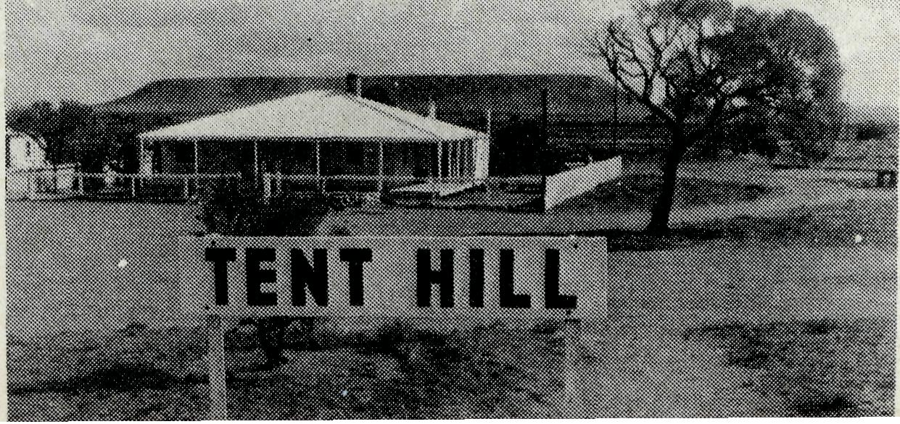

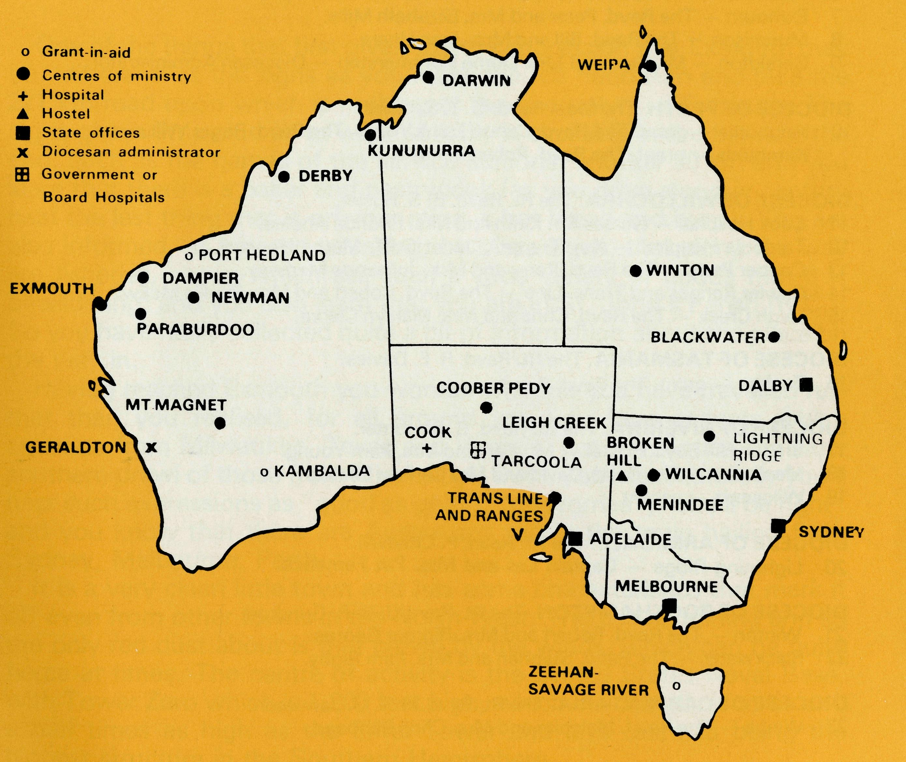
• Thank you Department
Miss Unwin, who made that urgent request to have folk help with cutting around stamps in our last issue of "The Real Australian" wishes to thank particularly Mrs. Hendy of McCallums Hill and Miss Mavis Avery and her sister of Gymea who have volunteered to help.
Also thanks is given for the number of folk who supplied Arch Books and made donations towards the purchase of Arch Books to be used by Chris Clerke and Stephen Rigby in their ministries.
• For Stamp Collectors
From June onward there will be available in the Sydney shop, 135 Bathurst Street, packets of foreign and Australian stamps from 25 cents upwards.
• Sydney Rally
About 500 people attended the Sydney Annual Rally on Friday 28th April. It was a great occasion with "The Joysingers", a gifted group of young people, who came from Canberra at their own expense to sing at the Rally, helping us to give praise and thanksgiving to God for His many blessings on the Society in the last year.
Coach loads of people came from as far away as Castle Hill and the Blue Mountains. We are grateful to Mr. John Cronshaw of Golden West Tours who ran the bus from Katoomba and donated to the Society the sum total of the fares paid.
io
• New B.C.A. Display Maps
Maps suitable for display on notice boards, in church porches and in parish halls are available on request from State Offices. They indicate all B.C.A. posts and are well illustrated.
There are two sizes: large 24" x 1714" (71 cm x 45 cm); small 12" x 8.5/8" (30.5 cm x 22 cm).
• The Trowel
This Sunday School teaching manual featured the children of the outback and the ministry of B.C.A. in a couple of special lessons recently. We prepared some project sheets useful to further illustrate the work of our missioners and nurses, etc., and the brief stories on page 13 of the March issue of "The Real Australian" to be used in conjunction with these lessons. Some thousands of the project sheets Nos. 1 and 2 have been sent out.
Anyone interested in this sort of material for use among children should write to —
"The Trowel",
Board of Education,
Box A287,
Sydney South 2000. and indicate that they would like a sample copy of the Teachers Manual suitable for their particular age group of children which featured lessons on the Children of the Outback and the Bush Church Aid Society work amongst them. We would be happy to supply quantities of the project sheets from our Sydney office as required.
THE B.C.A. PRAYER
A DAILY PRAYER
O Lord our God, help us to remember those who live in the remote parts of our land. We ask You to bless those.whom You have called into the fellowship of The Bush Church Aid Society. Grant that, through the ministry of the Word and Sacraments, through healing, and through caring for the young, the message of Your redeeming love may be proclaimed, through Jesus Christ our Lord. Amen.
O God, we remember before You those whom You have called to Your service. We ask You to bless
, assure
them of Your Presence, and call others to stand with them in the task. Grant to them, as to us, the joy of service, the ability to achieve, and the serenity of Your peace, for Jesus' sake. Amen.

PRAYER CALENDAR
FIELD STAFF DIRECTORY
DIOCESE OF NORTHERN TERRITORY. The Rt. Revd. K. B. Mason.
1 Darwin — Miss Coryn O'Nians (Nungalinya College), Sister Patricia Dahl (Nightcliff
Parish).
DIOCESE OF NORTH WEST AUSTRALIA. The Rt. Revd. H. A. J. Witt.
- Kununurra — The Revd. Royce and Mrs. Susan Thompson.
- Derby — The Revd. Ron and Mrs. Ann Robins.
- Newman - The Revd. Don and Mrs. Libby Wilson, Port Hedland (grant). The Revd. Peter Thompson.
- Dampier - The Revd. Bill and Mrs. Jocelyn Ross. Revd. David and Mrs Helen Mansfield.
- Paraburdoo — The Revd. Graham and Mrs. Helen Thurley.
- Exmouth — The Revd. Peter and Mrs. Elizabeth Mills.
- Murchison — The Revd. Bill and Mrs. Joan Hoare.
- Geraldton — Mr. Stan and Mrs. Dorrie Hummerston — Diocesan Administrator.
DIOCESE OF PERTH- The Most Revd. G. T. Sambell.
10 Kalgoorlie — grant. The Revd. Canon Frank Watts, The Revd. Roger Williams.
Kambalda — grant. The Revd. Robert Hanson.
DIOCESE OF WILLOCHRA. The Rt. Revd. B. S Rosier.
- Cook Hospital — Nurses Mr. Keith and Mrs. Rhonda Anstee.
- Tarcoola Hospital — Kay Trappel, Janet Stiff, Merryl Howard.
- Coober Pedy — The Revd. Kerry and Mrs. Julieanne Medway.
- Gawler Ranges and Trans. Line — The Revd. Robert and Mrs. Phyllis McEwin.
- Leigh Creek — The Revd. Chris and Mrs. Marilyn Clerke.
DIOCESE OF TASMANIA. The Rt. Revd. R. E. Davies.
16 Zeehan - grant. The Revd. Roy Dixon.
DIOCESE OF RIVERINA. The Rt. Revd. B. R. Hunter.
- Broken Hill Boys' Hostel — Mr. Ken and Mrs. Pam Young.
- Menindee — The Revd. David and Mrs Carlene Eastway.
- Wilcannia — vacant.
DIOCESE OF ARMIDALE. The Rt. Revd. P. Chiswell.
20 Lightning Ridge — Captain Les and Mrs. Pat Fernance.
DIOCESE OF ROCKHAMPTON. The Rt. Revd. J. B. R. Grindrod.
- Winton — The Revd. Robert and Mrs. Rigmor George.
- Blackwater — The Revd. Stephen and Mrs. Pam Rigby.
DIOCESE OF CARPENTARIA. The Rt. Revd. H. T. U. Jamieson.
23 Weipa — The Revd. Malcolm and Mrs. Chris Babbage.
FEDERAL SECRETARY
24 The Revd. Theo Hayman.
STATE OFFICES
- N.S.W. The Revd. Wakely Wade, Eric Atkin, Miss Doris Smith, Mesdames Joy O'Neill Dora Warwick and Nina Allan.
- VICTORIA. The Revd. Barry Green, Mrs. Shirley Bailey.
- QUEENSLAND. The Revd. Greg Ezzy (Deputationist and Secretary). WA. The Revd. Ted Doncaster (Deputationist).
- SOUTH AUSTRALIA. Vacant.
GENERAL
- Staff Replacements, The Council, State Committees.
- Box Secretaries, B.C.A. Supporters.
- National Home Mission Fund.

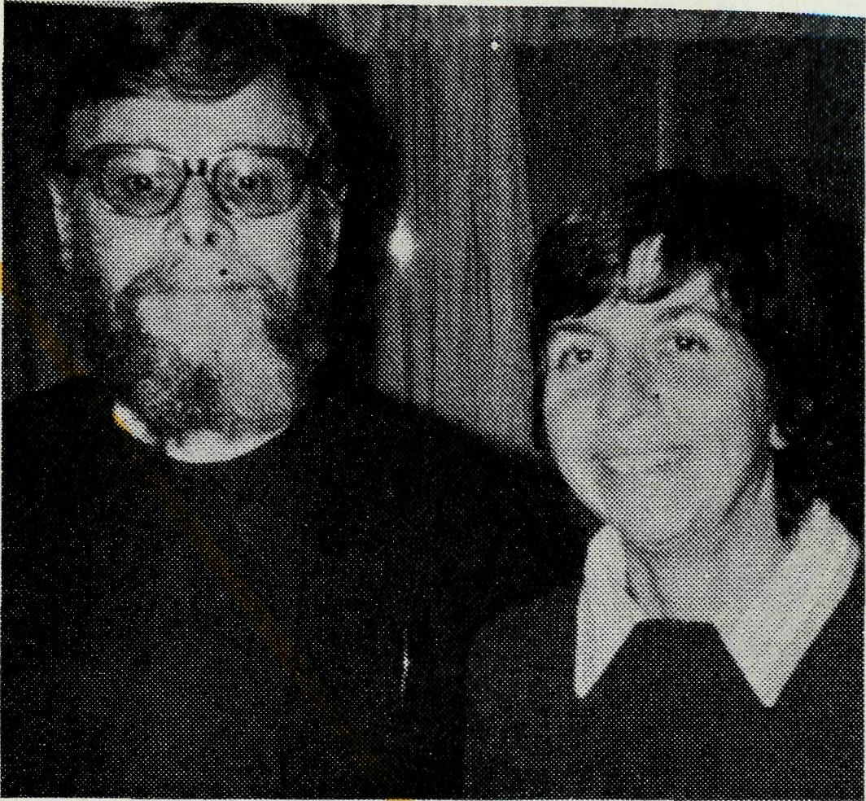
Exmouth
Is
Different!
Revd. Peter & Mrs. Betty Mills
One of the things that first gives you the impression that Exmouth may be "different" is the signs as you make the left hand turn and take the 221 km road upon which is nothing at the end only . . . Exmouth. The signs give a little clue as to what actually is available in the town at the end, such as the names of the service stations, another 20 km and you learn that there is a baker and pastrycook (as you drive along in century heat the last thing that is on your mind is hot bread and buns). You are also informed, as you are travelling, by these signs, that along the way are fisheries, shops which sell such a wide variety of goods that it is bewildering, and you also learn that you are in St. John's Parish (R.C.). So you have really collected quite a bit of information about the place on the way in.
Having reached Exmouth you wonder whether you have travelled further than you realised, for all around you you hear accents which emanate from Milwaukee, Texas and Virginia, not to mention the slow southern drawl of those from Mississippi. But if you listen carefully you'll hear such expressions as "good as gold", "no worries", "she'll be right" and you know that there are Australians too in the town hailing from Sydney, Melbourne, Perth.
It is a very clean little town and has some characteristics that mark it off even from other towns in the North West. There is no mining and so the only red dust about is that blown by the winds, which can be quite fierce at times. The centre of activity is the United States Naval Base, with Tower Zero which is 1,200 feet high, which incidentally is three and a half times as high as the Eiffel Tower and lays claim to being the highest structure in the Southern Hemisphere.
The people who live here in Exmouth are by and large transients, a fact of life which is shared with most towns of the North West — there are U.S. Naval personnel, R.A.N, personnel, maintenance technicians both American and Australian, as well as M.M.A. staff, meteorological people, shop keepers, as well as S.E.C., P.M.G. and the usual services.
With regard to the Gospel the variety of backgrounds of worshippers provide again something that is a little "different". We have Baptists, Episcopalians, Methodists, Roman Catholics, Lutherans and
13

Pentecostals, and we find that these backgrounds make for rich Christian fellowship for we do lots of things together. The Bible Study members vary from Baptist Fundamentalist to Roman Catholic Charismatic. So it can be seen that the studies can be much varied and interesting.
Exmouth is a friendly little town, you do not get lost in an impersonal metropolis; but the people and their positions in town become very real to you and often genuine grief is felt as people move out and go on their way to the U.S. or other parts of Australia.
We worship together continually, we Anglicans have a Holy Communion Service in the A.I.M. (Australian Inland Mission) buildings in the town, and there is also a very nice Chapel in the Base. The American Chaplain there shares with me a great deal and we have a good working relationship.
What is the nature of the ministry here? Leaving out the Stations and Onslow which is also part of this parish, it is evident that one must seek to bring Christ to people passing through. It is essentially a sowing ministry not a reaping one, and it is interesting, too, to see people worshipping who otherwise would not normally worship. The community structure is close knit and the Christian Church is very much part of that structure. There is no TV here and so the opportunity and desire to read is greater than "down south" and this makes for interesting studies and conversations.
These are my first impressions of Exmouth, it is a warm place to be (in both senses of the word). It is a place where the Faith is very much alive and where there is much to praise God for. A place where much broadening out takes place as we find ourselves worshipping and working with Christians of other denominations — ideas and misconceptions are changed and healing takes place as a result.
GETTING OUT OF THE GHETTO
"We are delighted that in the last month a young Christian couple have come to live here. It is encouraging just to have people here, who have clearly committed their lives to Christ, and who in fact came because they believed God had led them here." So writes one of our B.C.A. Missioners in one of the instant mining towns of the North West of Australia.
Another one writes, "Will you pray along with us that people from southern and eastern states will feel the Call of God to come and move into these areas to work as Christians in these places and so help to extend the Kingdom of God in remote Australia".
Yet another quote, "It distresses us to read letters from people back east who seem to be living in a comfortable spiritual hot-house environment".
There must be more young Christian people who are prepared to get out of the suburban spiritual ghettos to go out to strengthen the church's witness in the remote areas of our Continent.
State Office Directory. . .

ABOUT
PEOPLE
• Moving On
The thanks of the Society for the work and ministry of Sister Kay Trappel in Tarcoola is here expressed as she proceeds on to further nursing training. Kay endeared herself to the people of Tarcoola, especially the children. I wonder what's going to happen to "Cheesecake" (pet lamb) now? Also Sister Helen Bible is off overseas soon for further nursing experience. We wish her well and are grateful for her short period of service with the Society at Tarcoola.

- "Hitch-Sister Grace Hitchcock affectionately known to all the B.C.A. family, especially those in South Australia, as "Hitch" has retired. She has served the Society in many capacities with much of her time and energy being given voluntarily. Her conscientious care for the work of B.C.A. and her loyal commitment to Our Lord is here acknowledged with great gratitude.
- Wings — almost but not yet
The Reverend Bob George, new Missioner at Winton, has corrected the Editor about one detail printed in the March "R.A.". He has not got his pilot licence yet and requests our continuing prayer.
Federal Secretary — The Revd. T. J. Hayman.
N.S.W. Secretary and Editor - The Revd. Wakely Wade.
B.C.A. House, 135 Bathurst Street, Sydney, N.S.W. 2000.
(02) 26-3164, 26-3780. Telegraphic Address: "Chaplaincy", Sydney.
Victorian Secretary — The Revd. B. W. Green,
3rd Floor, Clark Rubber Building, 196 Flinders Street,
Melbourne, Vic. 3000. Phone: (03) 63-8962.
Queensland Secretary — The Revd. G. Ezzy,
P.O. Box 37, Dalby, Qld 4405. Phone: (074) 62-2071.
Western Australian Deputationist — The Revd. E. W. Doncaster,
Anglican Rectory, 49 Berkeley Crescent, Floreat Park, W.A. 6014.
Phone: (09)387-1304.
South Australian Secretary — Vacant.
350 King William Rd, Adelaide, S.A. 5000. Phone (08)212-4838.
Patron — The Most Reverend Sir Frank Woods.
President — The Most Reverend Sir Marcus Loane, Archbishop of Sydney.
Vice-Presidents — Bp. G. R. Delbridge and Mr. H. M. Bragg.
Chairman of Council — Archdeacon R. G. Fillingham.
Honorary Treasurer — Mr. R. T. Stokes.

15

