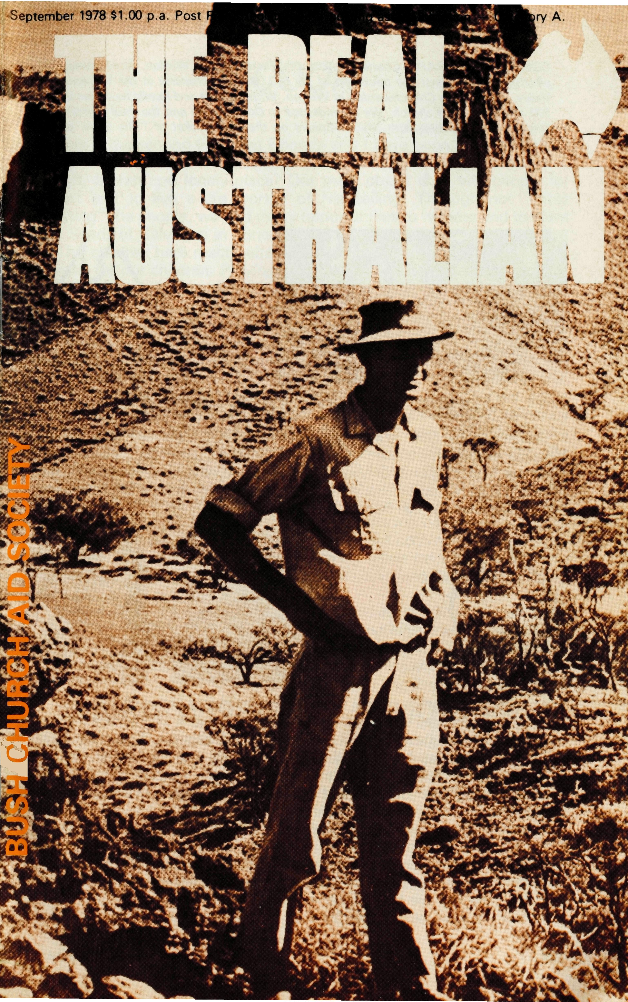
the place to find
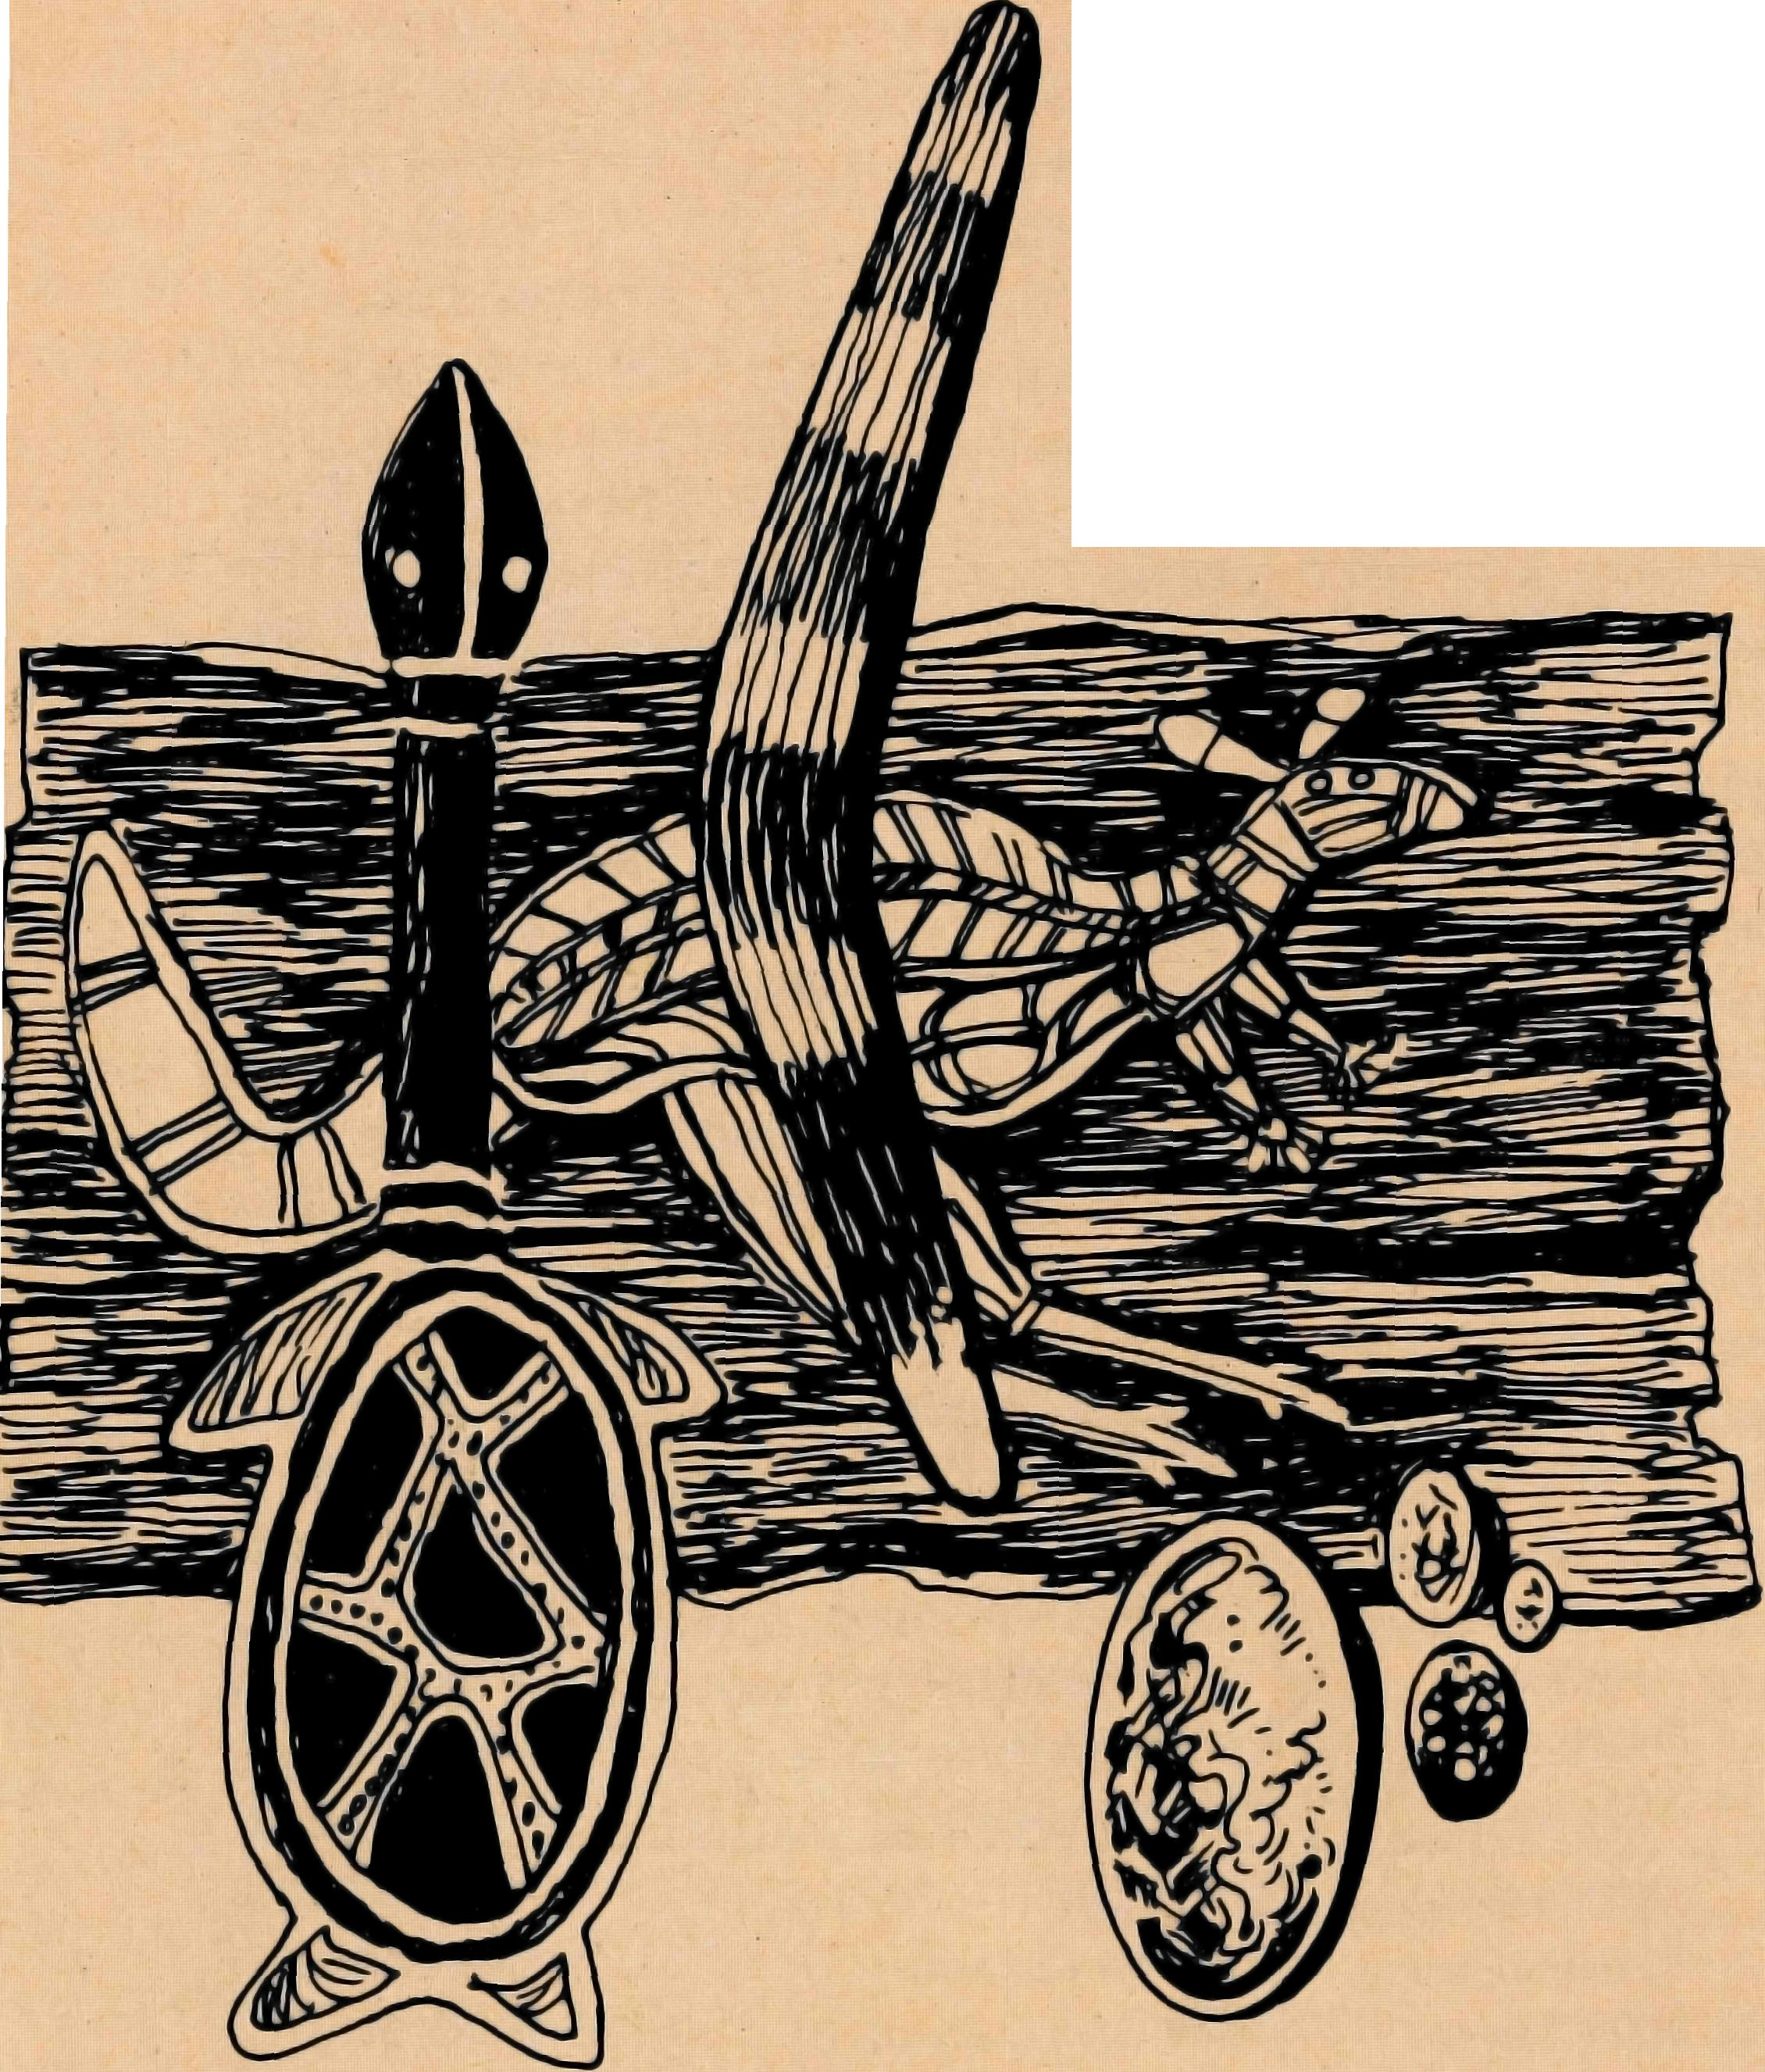
Real
Australian
Art
ABORIGINAL ARTIFACTS & PAINTINGS OPAL STONES & JEWELRY
AT THE BUSH CHURCH AID SOCIETY H.Q.
The gifts you buy help twice. First to provide income to Aboriginal people who paint and carve. Then the proceeds help the Churches work in remote Australia through the B.C.A.
The BCA Shop
135 BATHURST ST. SYDNEY BETWEEN PITT & CASTLEREAGH ST.
1978-AMBASSADOR PRESS PTY. LTD., 51 Good St., Granville 2142-36376

COVER PHOTOGRAPH: Charles Phillott_{f} of "Carisbrooke", Winton_{f} Queensland, photographed against the backdrop of his 640,000 acre property in the Williams Valley. Charles is a Churchwarden at Winton. With his wife and family he drives in 100 miles to attend church. We are indebted to Doug Bag/in and the Paul Ham/yn Group for this photograph which appears on the front jacket of "The Book of Australia".
NURSES TO TARCOOLA
Sisters Janet Stiff and Merryl Howard have been serving at the Hospital at Tarcoola since the beginning of May. Janet and Merryl have been out from England for about two years and have already served for a time in a bush situation. Sister Kay Trappel stayed on for a few weeks to help them settle in but has now returned home.
MISSIONER TO CARPENTARIA
The Reverend Jim Hudson and his wife, Margaret, and their two children Christopher 4 years and Heather 2 years, in early August arrived at Normanton in North Queensland. Normanton a town now 110 years old is situated on the lower part of the Gulf of Carpentaria in the centre of a vast parish ("Steak for Breakfast" country for those who know Elizabeth O'Connor's book). Jim will be very busy with not only Normanton but Karumba, Croydon, Georgetown, Forsayth and Burketown, not to mention the many cattle stations scattered throughout the area. Hailing from Victoria, Jim says, "We realise that there will be difficulties and hardships the like we have never experienced in Gippsland, but we are sure that we have been called by God to this important ministry".
2 THE REAL AUSTRALIAN
COOK
Keith and Rhonda Anstee
This is the second time that Rhonda and I have been to Cook to live, and we know the Lord called us on both occasions. Why come to this tough, barren and lonely place? Our main object is to win people for Christ and to live a life worthy of His calling. Through not "Bible bashing" the people, we find many opportunities to witness and to plant the Seeds of Salvation in none too receptive hearts.
The children here react quite obviously to the attention we consider normal for our children. Praying and Bible stories are as much a part of our little ones' lives as cuddles and discipline. Praying and Bible stories arouse the other children's curiosity; affection sometimes arouses something I could only define as envy, and discipline, which I am sure is a necessity in even the best organised households, at times, arouses curiosity, sometimes hostility, as although abuse is common, discipline is not.
We have not had too much difficulty fitting in at Cook. We had some problems at first, the normal resentment towards change and someone new, but things have settled down now, and Timothy and Narelle have been a great help in this respect. I think this is probably because the people can find something in common with us as parents.
Both Rhonda and I see patients, though I usually see the men and Rhonda the women. That way a lot of embarrassment is avoided. Not all our work is medical. At least half of our patients are visitors who want to sit down and have a cup of tea and a chat about nothing in particular, or about a real problem with which they want either help or a shoulder to cry on. Sometimes, after five sets of visitors in one day, we just can't look at the tea pot without feeling ill!
Sunday School and Religious Instruction at School are most enjoyable, but a lot of hard work. I take the battington and games night, as these nights tend to get a little rough, and we take 9's and over clubs, which the children seem to enjoy. We usually enjoy this night also, but Rhonda complains that she always ends up having to clean up the mess.
We have just had a visit from Chris and Marilyn Clerke (Leigh Creek). Chris took me for a flight over Cook, and I had a look at Cook from a different angle. I feel a lot more isolated after seeing how alone Cook appears from the air. A trip to the fifty mile Donga by car with Kay Trappel was a much slower trip, but equally as interesting. We really value the fellowship of these visitors, and also Rob McEwin (Missioner for the Trans Line). Both he and Chris are wonderfully 'handy' and we wonder if one of the courses at the theological college is a general 'fix-it' course.
Well, that is Cook at the moment, in the middle of nowhere, rough but beautiful. Please pray with us that many at Cook will be won for Christ.
THE REAL AUSTRALIAN

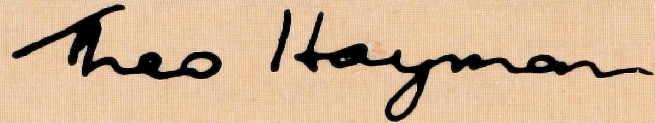
MIND WHAT IS MINED
We are grateful for those who support the Society still through boxes or through appeal envelopes, thereby remaining members. The amount from the boxes, more often than not, is handed to the parish treasurer for inclusion in the parish income and is forwarded to us. Hence the parish still gains the benefit and we the knowledge of the support.
May we suggest that folk who wish to use the parish envelope let us know. Perhaps the humble dollar keeps the direct communication open, so that there may be channels of information, followed by the very valuable interest and prayer.
Speaking about communication, we were very grateful to receive from one member the entire cost of the transceiver for one of our areas. This most generous gift enables the missioner often to have contact with his wife at home and certainly to have the means of calling for help either for himself or someone else who has broken down on the road in a remote area. We are grateful for others who have included this as a private or parish project.
Your friend.
THE REAL AUSTRALIAN
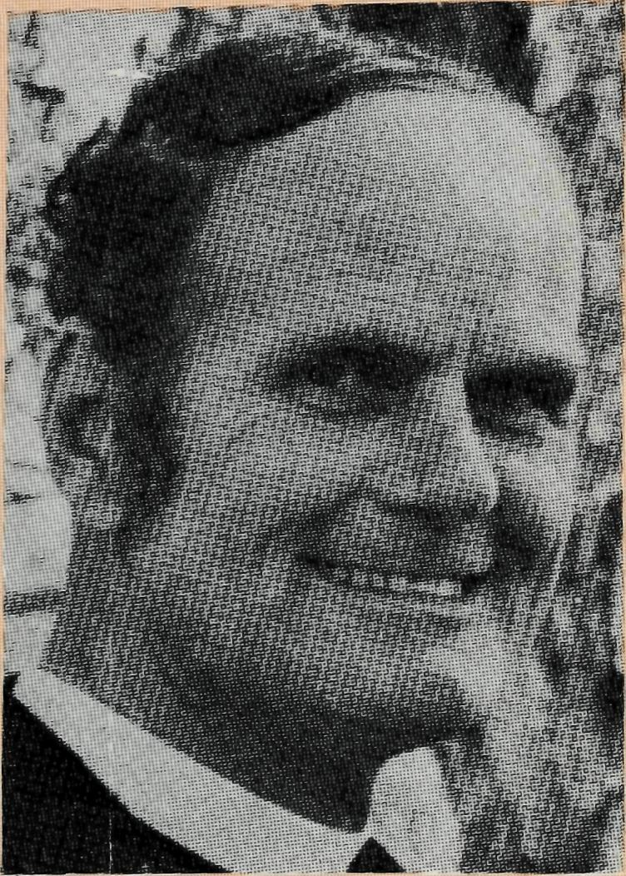
from the Federal Secretary
As I travel around Australia, both on deputation and visiting those whom we support as B.C.A. folk in various positions, I am all the more convinced of the value and need for membership. The friendships, love and support given thereby is warmly appreciated by those who have gone to remote areas. In fact some of them would not continue without the prayer support they receive.
Membership as such involves financial support starting from as little as a dollar a year. Of even more value than finance is the interest and prayer of a vast "family" of members.
Increasingly pressure is being brought upon individuals to make their contribution to every missionary society through the parish Church by means of envelopes. Some members have told us of their intention to give in this way. We are very grateful both for the knowledge of this, so we can continue membership, and for the support received through the parish. In many instances, however, we are not aware of this change in financial support and we lose the very precious interest and prayer support because we lose the name of the person.
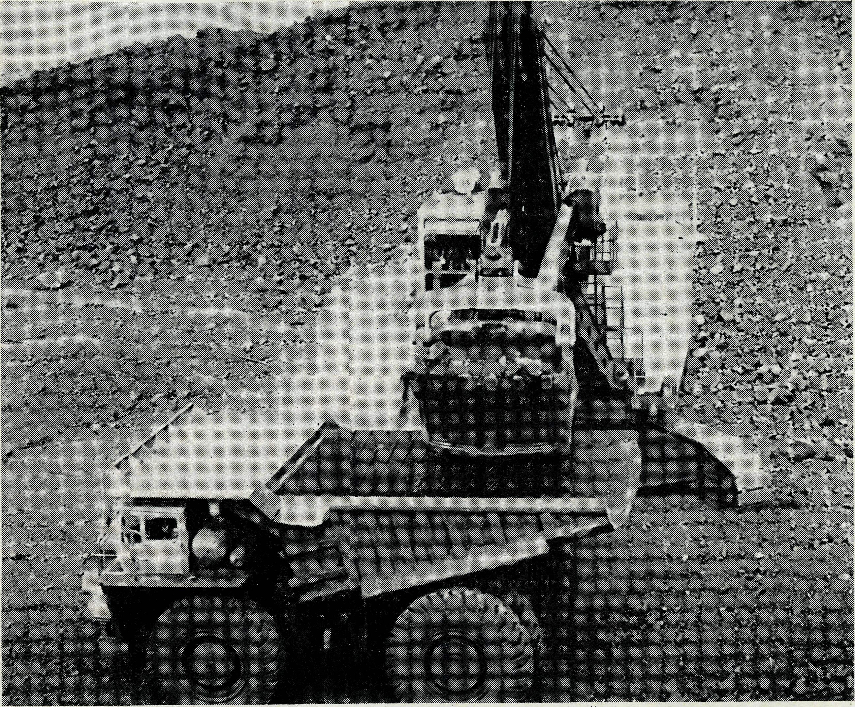
Revd. David Mansfield. Assistant Dampier
"Men put an end to darkness and search out to
the farthest bound the ore in gloom and deep
darkness. They open shafts in a valley away
from where men live .. .
Man puts his hand to the flinty rock and
overturns mountains by the roots . . . and the
thing that is hid he brings forth to light
It is interesting just how accurately these words found in Job 28 describe the iron ore mining industry of Australia's North West. As a B.C.A. Missioner working in this area, I am involved daily with men and women related to this field of industry. Perhaps the thing that has struck me most is the terrific opportunities for wealth that have attracted many people here.
Imagine how this affects the attitudes, outlooks and lifestyle of those we seek to reach for Christ; the self-reliance, the apathy, the smug
THE REAL AUSTRALIAN 5

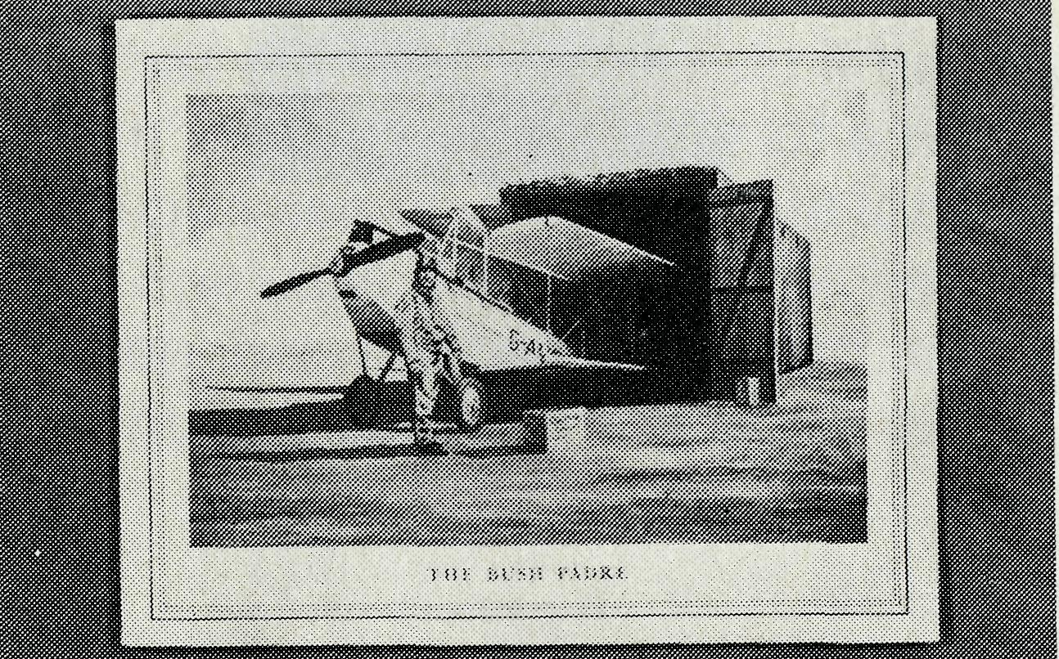
satisfaction, the hunger for ever greater wealth and the security it is meant to give. This level of affluence erodes too the quality of family life and priority of relationships. Consider the challenge this offers to those who seek to proclaim the Gospel in these areas. What then is the cutting edge of the Gospel in this climate? Return with me briefly to Job 28. That previous description is followed by the piercing question, "But where shall wisdom be found?"
This must be the question we put to those who mistakenly think they have found wisdom or the answer to life in the pursuit of material treasures. And we must make known the answer to that question. The answer is . . . "Christ the power of God and the wisdom of God". (1 Cor. 1:24) Yes, true wisdom is to be found only in Christ.
At a recent mine inspection we were told of the huge dimensions of the ore deposit we stood upon, it was a big piece of rock indeed. But how sad I thought. Fancy being impressed with a piece of rock that can be measured, weighed and exhausted and to ignore those riches which are unsearchable and inexhaustible found in Christ's power and love.
Another feature of life here is the variety of backgrounds from which people come. I am meeting people from different countries and cultures. In the same street a company director and an unskilled labourer live side by side. This aspect of the community adds unique challenges and opportunities. The isolation and scattered nature of the parish here is a constant source of frustration. Tension always exists between 'breadth' or 'depth' of pastoral care of the four young and vulnerable congregations in this parish. Only so much can be done which never seems enough, so the tension is not easily resolved.
I hope these few comments give you some insight into the ministry B.C.A. conducts in these mining towns of the North West. We are very human and I find discouragement a constant menace. So pray that we may be bold — that we will endure and not lose heart. Remember too the small and faithful Christian congregations who seek to grow in Christ and make a stand for Him in these places. Pray that God will enabl² men and women to respond to His wisdom and put their trust in the true riches of life.
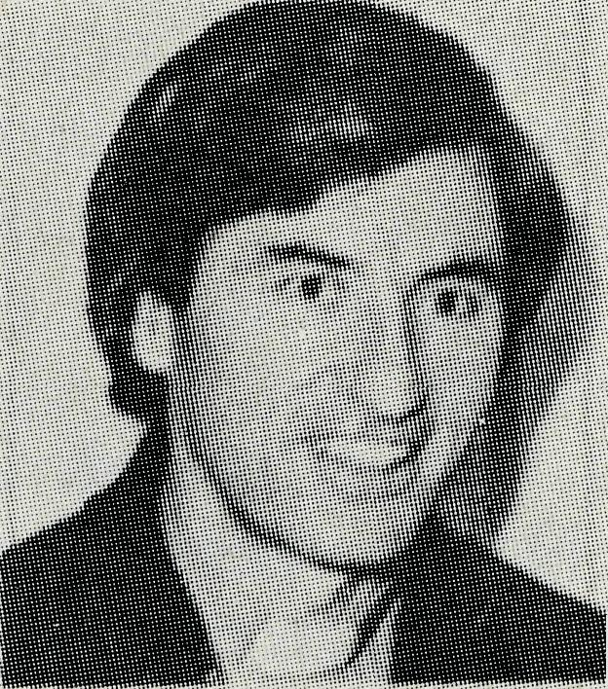
It is with profound regret we announce the resignation of our Victorian Secretary, the Reverend Barry Green, who is accepting appointment to the Parish of Bulleen, Victoria, from the beginning of October. Barry served as a Missioner in the Diocese of North West Australia at Kununurra from May '65 to December '69 and I became Victorian Secretary in September 1971. Through his obvious commitment to our Lord, happy manner and many gifts he has made a great contribution to the work of the Society. We wish him, his wife Jan, and family, God's best in their new sphere of service.
THE REAL AUSTRALIAN
B.C.A. Christmas Cards
The Card is attractively printed in colour and contains a brief statement about B.C.A. The front is a reproduction of a painting by the Melbourne artist Daryll Marsh of the Reverend Len Daniels with his Cirrus Moth at Wilcannia in the 1920s. The cost is 50 cents per packet of ten cards with envelopes.
Quite an occasion
Melbourne's 59th Anniversary gathering at St. John's, Camber-well, on May 27th was a really great gathering of the B.C.A. family in Victoria. A feature of the occasion was the opportunity given to former field staff to recount a story or two. The Reverend Tom Gee, M.B.E. recalled his early days in Ceduna in 1928 arriving on February the 1st to take up residence in a shack with kero tins as chairs, tables and cupboards and helping to administer ether at an operation in the hospital and succeeding in putting himself to sleep. Tom and Lynn Morgan, Brian Viney, Eric Baldwin, David McDowell, Alan Baker and John Stockdale vividly retold memorable events in their B.C.A. experience.
THE REAL AUSTRALIAN
The Cave is getting cramped
The Catacomb Church of Coober Pedy is becoming too small for the congregation. The Reverend Kerry Medway, our Missioner there, is considering not only tunnelling extensions to the church dug-out but selling the Rectory now on the top of the ground and using the proceeds to construct a dug-out one adjacent to the Catacomb Church.
Some WITTism probably apocryphal
- When Ron Robins moved from Zeehan on the wild and wet west coast of Tasmania to Derby in his Diocese of North West Australia (the day Ron arrived by air in Derby it was 45° Celsius) Bishop Howell Witt was reported to have said it was from the 'frig into the frying pan'.
- Why did the Bishop call his dog Isaiah — because one "eye is higher" than the other.
New Confirmation Studies
The Council of the Society is considering the production of a completely new Confirmation Studies Book designed not only for use by young people, and adults in isolated situations but also in suburban and country parishes.
Welcome
We welcome Mrs. Phyllis Linton onto the South Australian office staff, taking the place of Grace Hitchcock, whom we thank most sincerely for many hours of work without pay since her retirement.

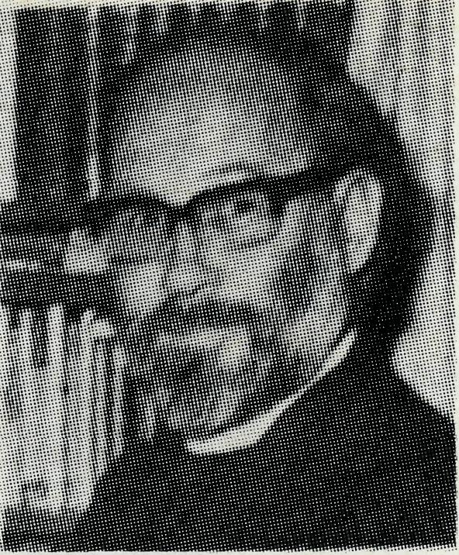
THE MURCHISON A GRIM PICTURE
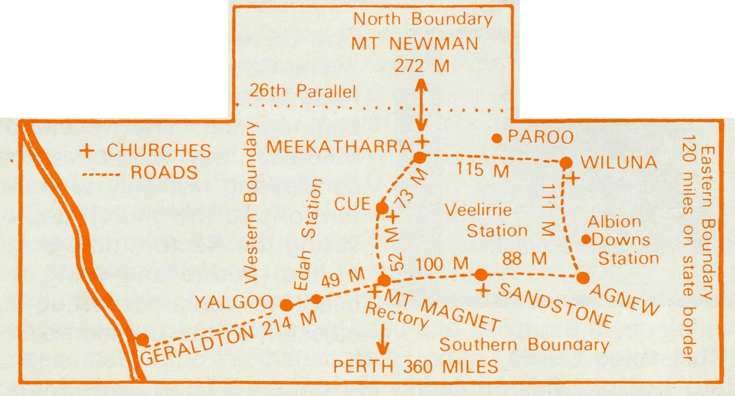
have encroached further and further into inhabited areas. Some evidence of dingoes exists in areas west and south of Mt. Magnet. These play havoc with flocks. Usually cattle will form a barrier, and the presence of men will scare off most dingoes, but men are now fewer in number, and I have heard that packs of dogs are hunting and bringing down cattle too. A few years ago these would have been hunted down. What can a pastoralist do if he has only a wife and two daughters to help him look after a quarter of a million acres. The days of large numbers of employees on a station are long gone. Now it is one man, and I do know of one case where the wife has had to go to the nearest town to work to keep her husband in food to keep the station working, even in the minutest sense in the hope of better days to come.
Just over two years ago most of the gold mines then operating closed because there was insufficient return for the gold that was brought to the surface. Well over two hundred people left Mount Magnet alone. Others left Yalgoo, Cue and Meekatharra.

Revd. Bill 8- Joan Hoare Death and decay. It didn't start like this. When we first came to the Murchison, nearly five years ago, there was hope of better things to come. They have not materialised. The reasons are many. Drought, economic depression here and in other parts of the world, lack of interest in a primary production sphere when there are other newer things and increasing costs. These are just a few reasons.
THREE YEARS OF DROUGHT
There has been an almost complete drought for the last three years. Of course some people have had a little rain, and it has been sufficient to tide them over. But they are in the minority. The majority have not had rain. There is water, underground, in most places where there is a well or a bore, and that is in most paddocks. I know quite a few of them, and can now say that it is unlikely that I will die of thirst, even on the hottest of summer days, (so long as I am 'mobile'). But underground water does not grow food for stock, they weaken and eventually perish. Sheep starve, lambs cannot be reared. The pastoralist's living sinks to the ground and becomes a smelly heap of corruption. Meanwhile the sun still shines,
One station, three years ago, tallied more than thirteen thousand sheep through the shearing shed, last year it was slightly more than three thousand. This year only one hundred and sixty seven could be found. But it is not all sun and no rain that has caused this. As expenses have had to be cut on all stations, men have had to be sacked. Less men going round the windmills, less trapping and baiting of dingoes taking place, water getting scarcer in the desert areas have all meant that dingoes
THE RAILWAY CLOSES
The railway that ran through the centre of the Murchison closed down some months ago and there began a general exodus of all railway employees from the towns of Yalgoo, Mount Magnet, Cue and Meekatharra. A sort of domino effect took place and continues even now. Not as many support people were required so quite a few left, taking with them a number of the older people. This in turn reduced the demand on shops and other utilities, and many of the shops had to close. This resulted in fewer employment opportunities, so the younger and more mobile people left to seek employment in Perth or the mining towns of the Pilbara.
The effect on those left here in the Murchison has been generally demoralising. Men on the stations are demoralised because there is now no point in planning for forward work. Wives have told me that their husbands tend to drift along without much purpose, and where this happens deeply there can be many sorts of upsets in family life and other interpersonal relationships to the detriment of community life. I have been asked on a number of occasions if I will be forced to leave because of the low numbers in the area (and in church). The reply I have always given is that while there are people to minister to I.feel sure that the B.C.A. will always support that ministry.
COMMUNITIES DIE
It is not only people who die. Communities die also. It is often very sad to see townsites that are no longer towns, with not even a house in sight or a single living person to be found. That has happened here in the Murchison many times. But I find it sadder still to see towns dwindling, to listen to the people who are left.

THE REAL AUSTRALIAN
THE REAL AUSTRALIAN

There is faith that the rain will someday begin again, and that the grass and shrubs will grow, that money will be found to start new flocks. That new projects will open and men will be employed on the land and under it.
AN ESSENTIAL CARING MINISTRY
Faith and hope, and the last, the greatest is here too. Love. The love of God is taken to and shown to those who are left here. We invite you, the members of the Bush Church Aid Society to share with us in this your missionary ministry with your continuing prayers, your continuing financial aid, your interest and your love too for these people, white and black. God bless you all.
THE B.C.A. PRAYER
0 Lord our God, help us to remember those who live in the remote parts of our land. We ask You to bless those.whom You have called into the fellowship of The Bush Church Aid Society. Grant that, through the ministry of the Word and Sacraments, through healing, and through caring for the young, the message of Your redeeming love may be proclaimed, through Jesus Christ our Lord. Amen.

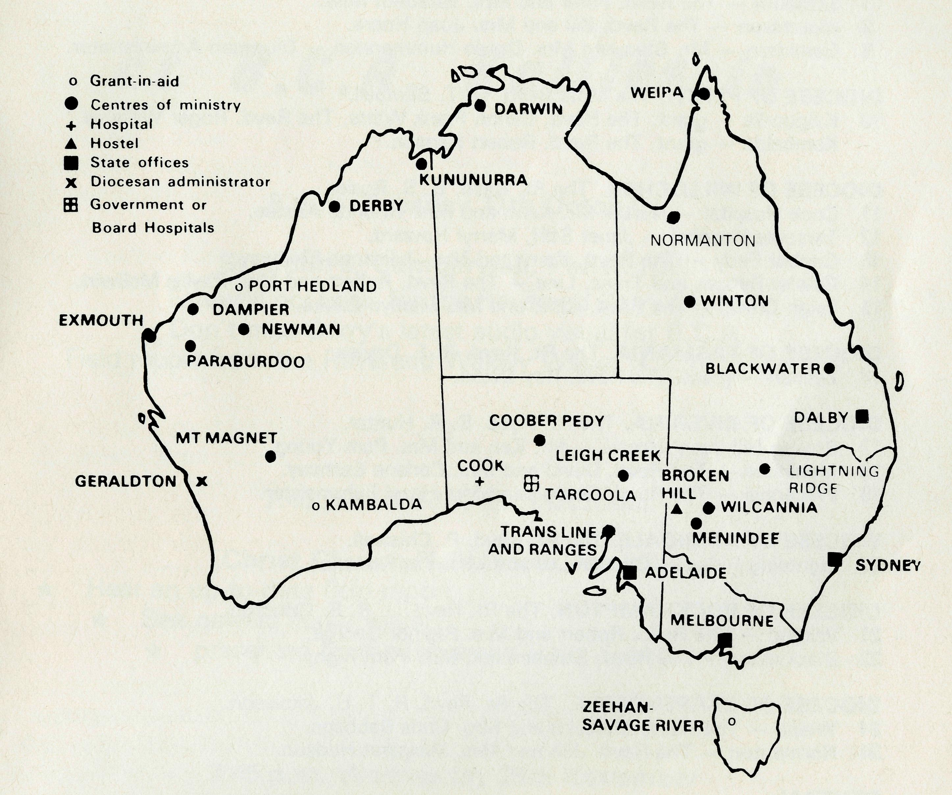
"Go . . . see for yourself"
We must apologise that owing to the fact that the June issue of "The Real Australian" was a little late out from our printers, folk who at the last minute wanted to book on the "Last Frontier Tour" to the North West of Australia, missed out because the bookings were closed by the tour operators. The keen interest by so many people certainly justifies having the tour again next year.
Those interested in the tour leaving Sydney on October 5th for western N.S.W. and South Australia, are urged to apply immediately if they are going to have an opportunity of going on that trip. Ring Mrs. J. O'Neill on the Sydney office number.
Sydney Fair
We thank all who contributed to the success of the Sydney B.C.A. Women's Auxiliary Fair in July.
10
B.C.A. Nurses get together
There has been a Nurses Committee formed in Sydney. It had been a persisting concern of some ex-staff nurses that an official Nurses Committee was necessary within B.C.A. In the overall aim of the Society of "Australia for Christ" the well-being of individual nurses while serving with the Society and afterwards, the selection and recruitment of suitable people for service and provision of spiritual and practical support by fellow nurses and others, were considered legitimate areas of needed interest for such a committee. The Committee has met several times and has some proposals to present to the Council of the Society.
It was felt by some members of the Committee that the term "Committee" presents to some a wrong concept of what this group is intended to be and perhaps the title "B.C.A. Nurses Fellowship" may be more appropriate enabling any ex-B.C.A. nurse to be involved as they feel able. The Secretary of the Committee, Miss Michelle Blondel, would welcome any comments on this observation.
THE REAL AUSTRALIAN
A DAILY PRAYER
0 God, we remember before You those whom You have called to Your service. We ask You to bless
assure
them of Your Presence, and call others to stand with them in the task. Grant to them, as to us, the joy of service, the ability to achieve, and the serenity of Your peace, for Jesus' sake. Amen.

13
PRAYER CALENDAR
FIELD STAFF DIRECTORY
DIOCESE OF NORTHERN TERRITORY. The Rt. Revd. K. B. Mason.
1 Darwin - Miss Coryn O'Nians (Nungalinya College), Sister Patricia Dahl (Nightcliff
Parish.
DIOCESE OF NORTH WEST AUSTRALIA. The Rt Revd H. A. J. Witt.
- Kununurra — The Revd. Royce and Mrs. Susan Thompson.
- Derby — The Revd. Ron and Mrs. Ann Robins.
- Newman - The Revd. Don and Mrs. Libby Wilson, Port Hedland (grant). The Revd. Peter Thompson.
- Dampier - The Revd. Bill and Mrs. Jocelyn Ross. Revd. David and Mrs. Helen Mansfield.
- Paraburdoo — The Revd. Graham and Mrs. Helen Thurley.
- Exmouth - The Revd. Peter and Mrs. Elizabeth Mills.
- Murchison - The Revd. Bill and Mrs. Joan Hoare.
- Geraldton — Mr. Stan and Mrs. Dorrie Hummerston — Diocesan Administrator.
DIOCESE OF PERTH. The Most Revd. G. T. Sambell.
10 Kalgoorlie - grant. The Revd. Canon Frank Watts, The Revd. Roger Williams.
Kambalda — grant. The Revd. Robert Hanson.
DIOCESE OF WILLOCHRA. The Rt. Revd. B. S. Rosier.
- Cook Hospital — Nurses Mr. Keith and Mrs. Rhonda Anstee.
- Tarcoola Hospital - Janet Stiff, Merryl Howard.
- Coober Pedy — The Revd. Kerry and Mrs. Julieanne Medway.
- Gawler Ranges and Trans. Line - The Revd. Robert and Mrs. Phyllis McEwin.
- Leigh Creek - The Revd. Chris and Mrs Marilyn Clerke.
DIOCESE OF TASMANIA. The Rt. Revd. R. E. Davies.
16 Zeehan — grant. The Revd. Roy Dixon.
DIOCESE OF RIVERINA. The Rt. Revd. B. R. Hunter.
- Broken Hill Boys' Hostel - Mr. Ken and Mrs. Pam Young.
- Menindee — The Revd. David and Mrs. Carlene Eastway.
- Wilcannia — The Revd. George and Mrs Hazel Fuhrmeister.
DIOCESE OF ARMIDALE. The Rt. Revd. P. Chiswell.
20 Lightning Ridge — Captain Les and Mrs. Pat Fernance.
DIOCESE OF ROCKHAMPTON. The Rt. Revd. J. B. R. Grindrod.
- Winton - The Revd. Robert and Mrs. Rigmor George.
- Blackwater — The Revd. Stephen and Mrs. Pam Rigby.
DIOCESE OF CARPENTARIA. The Rt. Revd. H. T. U. Jamieson. 24 Weipa — The Revd. Malcolm and Mrs. Chris Babbage.
24 Normanton — The Revd. Jim and Mrs. Margaret Hudson
GENERAL.
Federal and N.S.W. Office.
25 Federal Secretary, The Revd. Theo Hayman.
N.S.W. The Revd. Wakely Wade, Eric Atkin, Miss Doris Smith, Mesdames Joy O'Neill, Dora Warwick and Nina Allan.
- VICTORIA. The Revd. Barry Green, Mrs. Shirley Bailey.
- QUEENSLAND. The Revd. Greg Ezzy (Deputationist and Secretary). WESTERN AUSTRALIA. The Revd. Ted Doncaster (Deputationist).
- SOUTH AUSTRALIA - Vacant. Mrs. Phyllis Linton (Office).
- The President, The Most Revd. Sir Marcus Loane, Chairman, Archdeacon Robert G. Fillingham, Honorary Treasurer, Mr. Richard Stokes, The Council, State Committees, Staff Replacements.
- Box Secretaries, B.C.A. Supporters.
- National Home Mission Fund.
come and see what
God HAS DONE
at B.C.A. Rallies in Melbourne
8 p.m. Tuesday 17th October
St. John's, Camberwell, Parish Hall.
Farewell occasion for the Reverend Barry Green.
Don't miss Barry's latest audio visual for B.C.A.
Field report from the Reverend Wakely Wade, N.S.W. Secretary.
Adelaide
7.45 p.m. Friday 20th October
Christ Church Hall, North Adelaide.
Hear an up-to-date field report * See newest audio visual
* presented by the Reverend Barry Green
Canberra
7.45 p.m. Wednesday 29th November
St. John's, Canberra, Parish Centre.
Hear from the Reverend David Eastway, Missioner at Menindee. See Barry Green's newest three-screen audio visual.
STOP PRESS
• The Reverend George and Mrs. Hazel Fuhrmeister are to go to minister in Wilcannia Parish in October. Praise God for the Fuhrmeisters! They are no strangers to B.C.A. having served at Minnipa and Quorn from 1950 to 1963.
THE REAL AUSTRALIAN

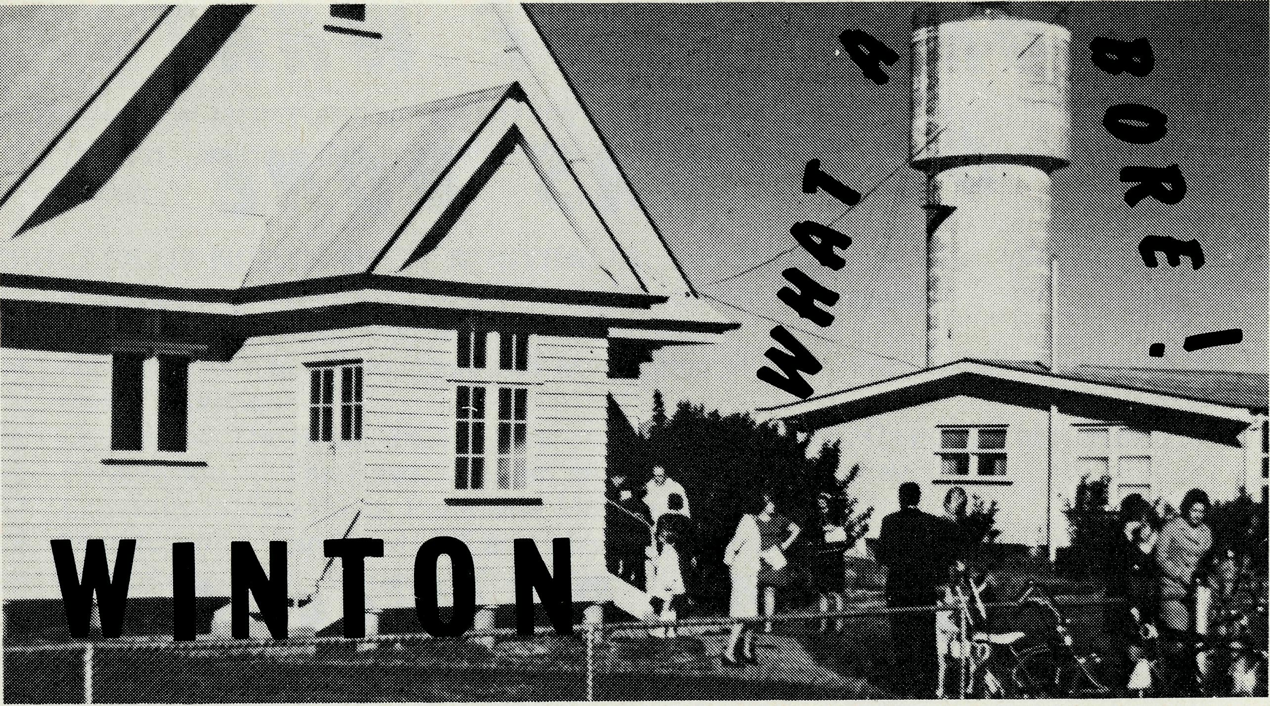
Revd. Bob George
If there's one thing we are not short of out here, it's water. Strange though it may seem, this Western Queensland town has a prolific water supply. The water is near boiling when it comes up from the ground, and has a distinct sulphur smell, but is clean and good enough to drink, once you acquire the taste.
Bore water does have advantages, its purity and its temperature. No need for a hot water service here. But it does have its disadvantages too. It has to be cooled for household use, as well as for watering purposes. Something which proves to be an inconvenience in the heat of summer.
Water, however, in this vast thirsty land is precious. I am convinced that God must have a sense of humour. Here we seem to hang on every cloud which passes over, and yet when it does rain, the countryside becomes a network of waterways, and roads impassable. Water, so necessary on one hand, and often an inconvenience when it comes, on the other. Maybe God is showing us in this scene of contrasts, the transient nature of this water. The "water" Jesus offers us of course, is far more lasting (John 4:14).
One of the most difficult things faced in a very scattered parish, apart from travel in the wet, is the establishment of meaningful relationships. The three outcentres are Corfield, 50 miles north of Winton, Boulia, 250 miles west, and Bedourie, another 120 miles south west again. It is a very difficult thing to share your faith and yourself, as Paul suggests in 1 Thess. 2:8, when contacts are very fleeting. Please pray that our contacts with people will be worthwhile. Bridges of friendship must be built, and then every appropriate opportunity taken to cross these bridges with the "Good News", when the Holy Spirit gives the signal.
In all centres I am responsible for Uniting Church and Anglican people, because of the co-operative nature of the parish here. This means that both denominations share their resources, including the minister. In Winton separate services are held in the respective buildings — one in
the morning and one in the evening, but in the outcentres combined services are held. The system appears to be working well. Our aim is to function as "the body of Christ" in Winton, united together, at the same time retaining our identity as Anglicans and Uniting Church people.
Overall, numbers of people attending services have been encouraging. Because of commitments on the land and distances to travel, many people cannot be regular at church. The pressure of life on the land also shows in regard to regular attendance at Bible Study or times of fellowship. But still these aspects must be catered for, even if attendances are small.
One area of further encouragement is the ministry among children. There is no better tonic for flagging spirits than to see kids who are keen to learn about Jesus. Our "Wednesday School" caters for those who want more than what Religious Instruction in the State School provides. There are some 35 children who come regularly. Thank God for five teachers. The need of course is for more. If all the children on the roll came on any one Wednesday, we could not cope.
Opportunities for Christian growth are immense in Western Queensland. Possibilities for sharing the "Good News" present themselves continually. Please continue to pray that these may be capitalised upon. "To the thirsty," Jesus said, "I will give water without price from the fountain of the water of life". (Revelation 21:6).
State Office Directory. . .
Federal Secretary — The Revd. T. J. Hayman.
N.S.W. Secretary and Editor — The Revd. Wakeiy Wade.
B.C.A. House, 135 Bathurst Street, Sydney, N.S.W. 2000.
(02) 26-3164, 26-3780. Telegraphic Address: "Chaplaincy", Sydney.
Victorian Secretary — The Revd. B. W. Green,
3rd Floor, Clark Rubber Building, 196 Flinders Street,
Melbourne, Vic. 3000. Phone: (03) 63-8962.
Queensland Secretary — The Revd. G. Ezzy,
P.O. Box 37, Dalby, Qld 4405. Phone: (074) 62-2071.
Western Australian Deputationist — *The Revd. E. W. Doncaster,
Anglican Rectory, 49 Berkeley Crescent, Floreat Park, W.A. 6014.
Phone: (09)387-1304.
South Australian Secretary — Vacant.
350 King William Rd, Adelaide, S.A. 5000. Phone (08)212-4838.
Patron — The Most Reverend Sir Frank Woods.
President — The Most Reverend Sir Marcus Loane, Archbishop of Sydney.
Vice-Presidents — Bp. G. R. Delbridge and Mr. H. M. Bragg.
Chairman of Council — Archdeacon R. G. Fillingham.
Honorary Treasurer — Mr. R. T. Stokes.

14
THE REAL AUSTRALIAN
THE REAL AUSTRALIAN
15

