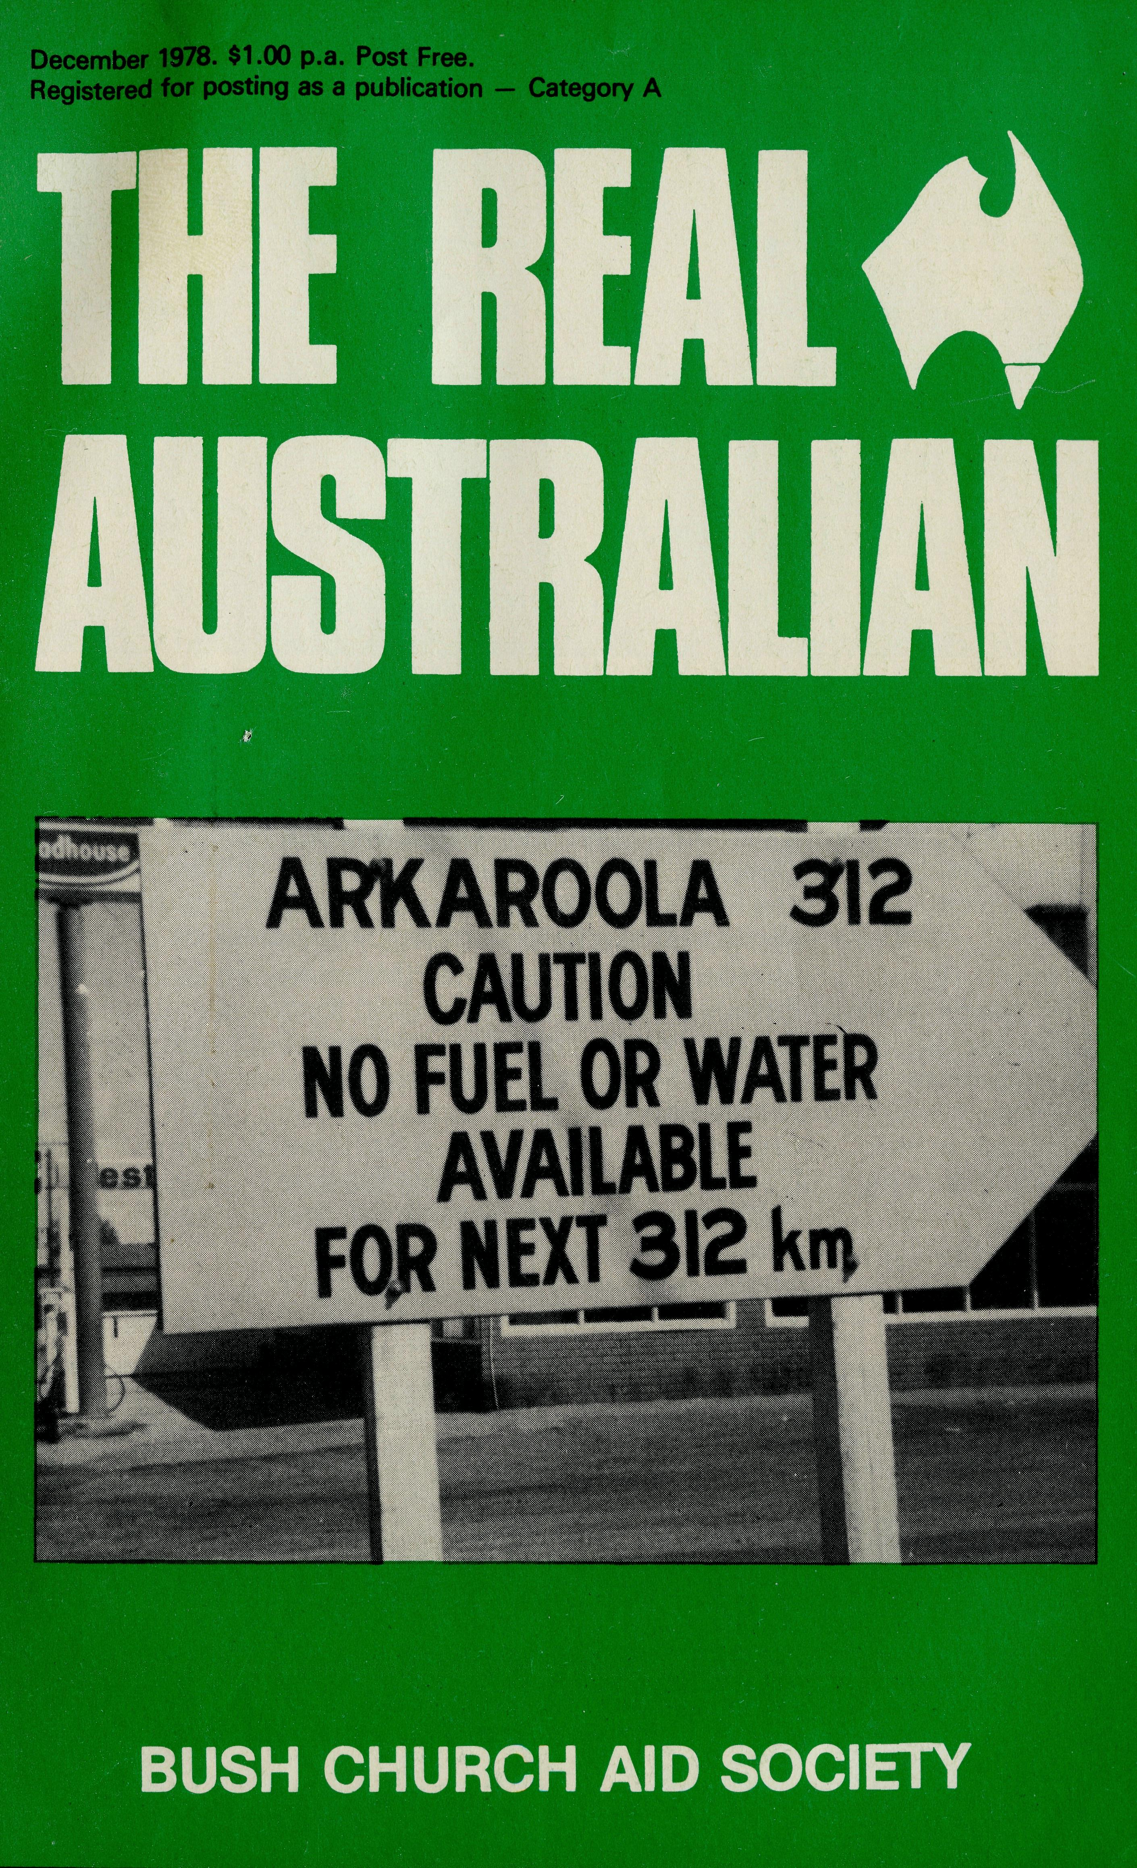
mmanuel
god with us
May we wish you a very happy and blessed Christmas. May Christmas be a very joyous festival of praise to God.
Ever felt lonely? While it is perfectly possible to be lonely in the city, it is more possible in some parts of the remote parts of Australia. Despite modern aerial transport, despite the wonderful means of communication, many times there are those who feel despondent and alone - both lay christians and clergy. EMMANUEL -GOD WITH US.
To me it is a wonderful thrill to hear someone say, as they go out of a church, "I pray for your B.C.A. folk every day." Many of those who have served in B.C.A. have been very warm in their thanks for the wonderful prayer support they have received. Many times in the outback they have been wonderfully strengthened by the knowledge of God being with them. May I suggest we also pray for all christians in B.C.A. areas.
But the wonderful Christmas message of "Emmanuel" is very much more than the knowledge of God's presence. The Emmanuel was the birth of Jesus Christ, the marvellous and true mystery of OUR GOD born and coming to live among us. The glorious testimony we have is that God through Jesus Christ, is at work among us still, saving, blessing, guiding and giving us victory by the Holy Spirit.
Your friend,
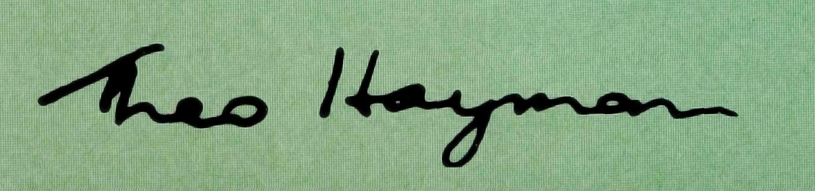

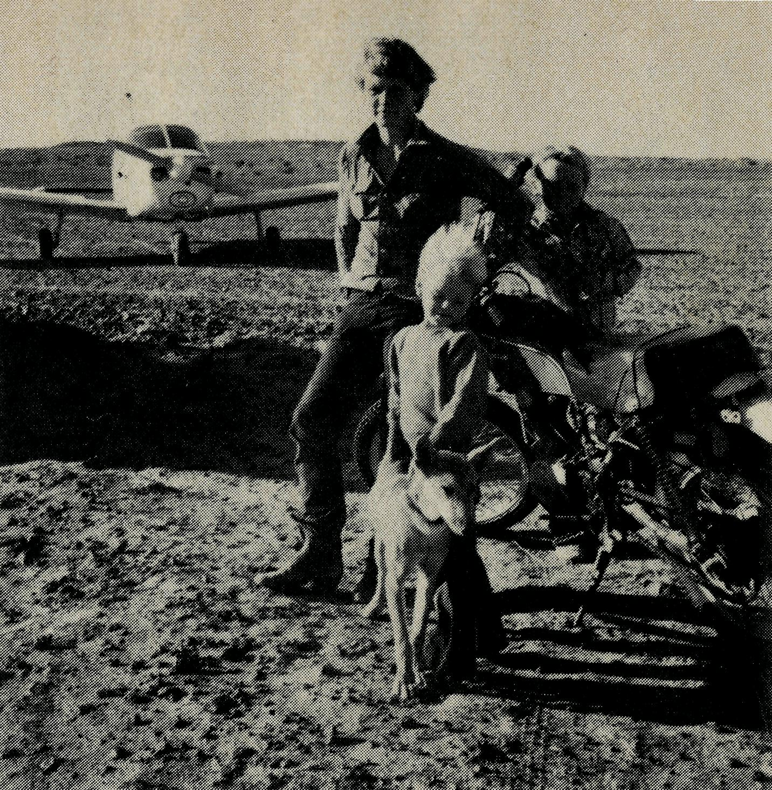
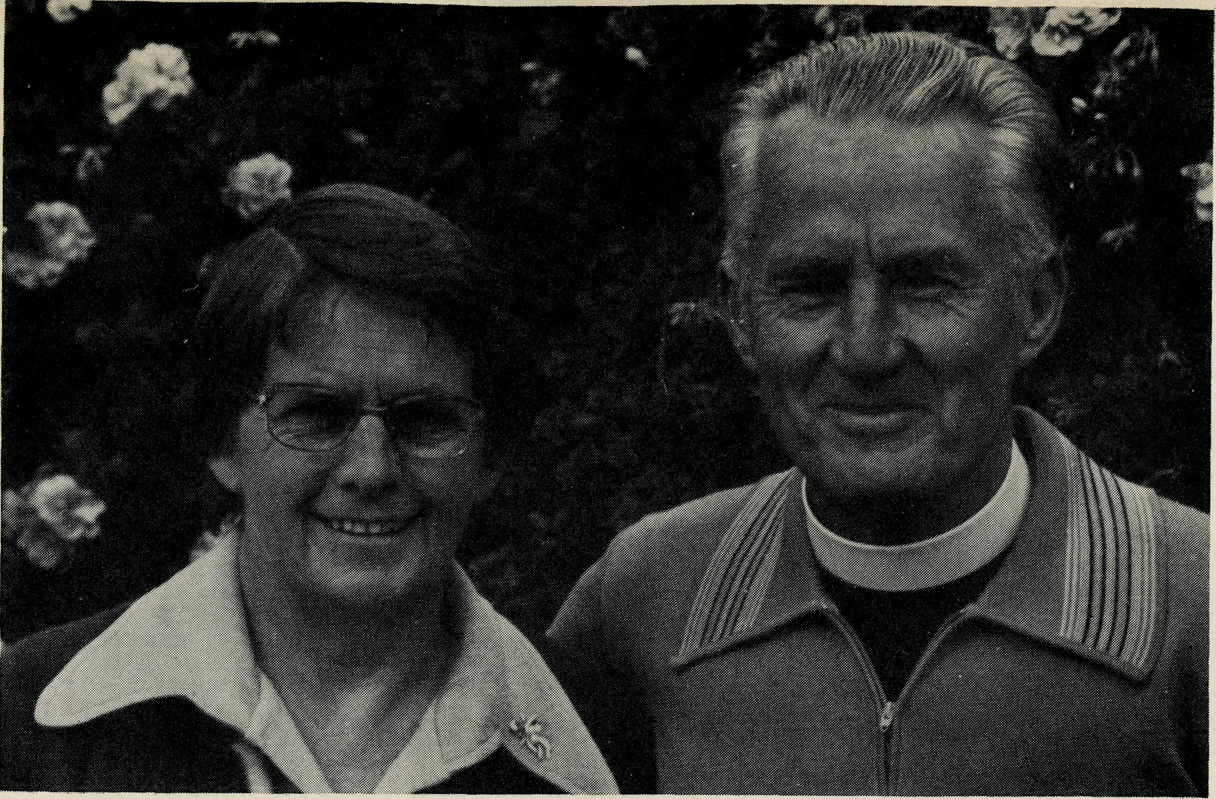
WELCOME BACK
The Reverend George and Mrs. Hazel Fuhrmeister commenced their ministry in Wilcannia in October. The Fuhrmeisters are no strangers to the outback, having served on the field with B.C.A. for thirteen years, firstly, in Minnipa Parish on Eyre Peninsula and then Quorn, north of Port Augusta, both in Willochra Diocese, South Australia. Prior to studying for ordination in Moore College, George went through Melbourne Bible Institute and served for five years as an Evangelist in rural areas. They come now from many years of experience in Gippsland being at Lang Lang and Rosedale. George was appointed Rural Dean whilst at Rosedale. Their family being grown-up they felt free and willing at the Call of God to go to the extensive far-western N.S.W. parish of Wilcannia.
COVER PHOTOGRAPH: A significant sign — Leigh Creek Mission area. Opposite page, top: Anthony, Matthew and Wayne Daw of Mulka Station on the Birdsville Track with their pet dingo in the foreground and in the background the Reverend Chris Clerke's Piper Cherokee aircraft the "Len Daniels". Bottom: Moomba Gas Fields, S.A.
THE REAL AUSTRALIAN
ALL THINGS
TO
ALL MEN
Revd. Chris Clerke, Leigh Creek
When people ask "What would you like us to pray for?" I often mention the need for wisdom to adapt to different situations. In a few moments one can move from the spotless cleanliness of an outback hospital, with starched white table linen and sparkling silverware, to an Aboriginal camp, where the people have little idea of hygiene and a baby has to compete with dogs and flies for a dirt covered bottle. Or one can move from the air-conditioned recreation hall at Moomba gasfield with indoor swimming pool, to the roughness of a stock camp, where not even a tent is used and the stockmen (and jilleroos too) have only blankets and tarpaulin as a swag to keep them warm and dry whatever the weather.
Of course people are all different, and I find it quite hard at times to "change pace" to fit in with different people. Having spent a morning with Christian people who work in executive positions in Leigh Creek, I may spend the afternoon with a group of stockmen who have little education and little interest in the Gospel. I need wisdom to understand each new person and situation, and to listen for the questions people are really asking, not to just offer a comment that was some help in a previous situation.
You might think and pray about the missioners' needs for wisdom and flexibility as I outline my diary for a recent few days when I had hired some movie films to use in the area.
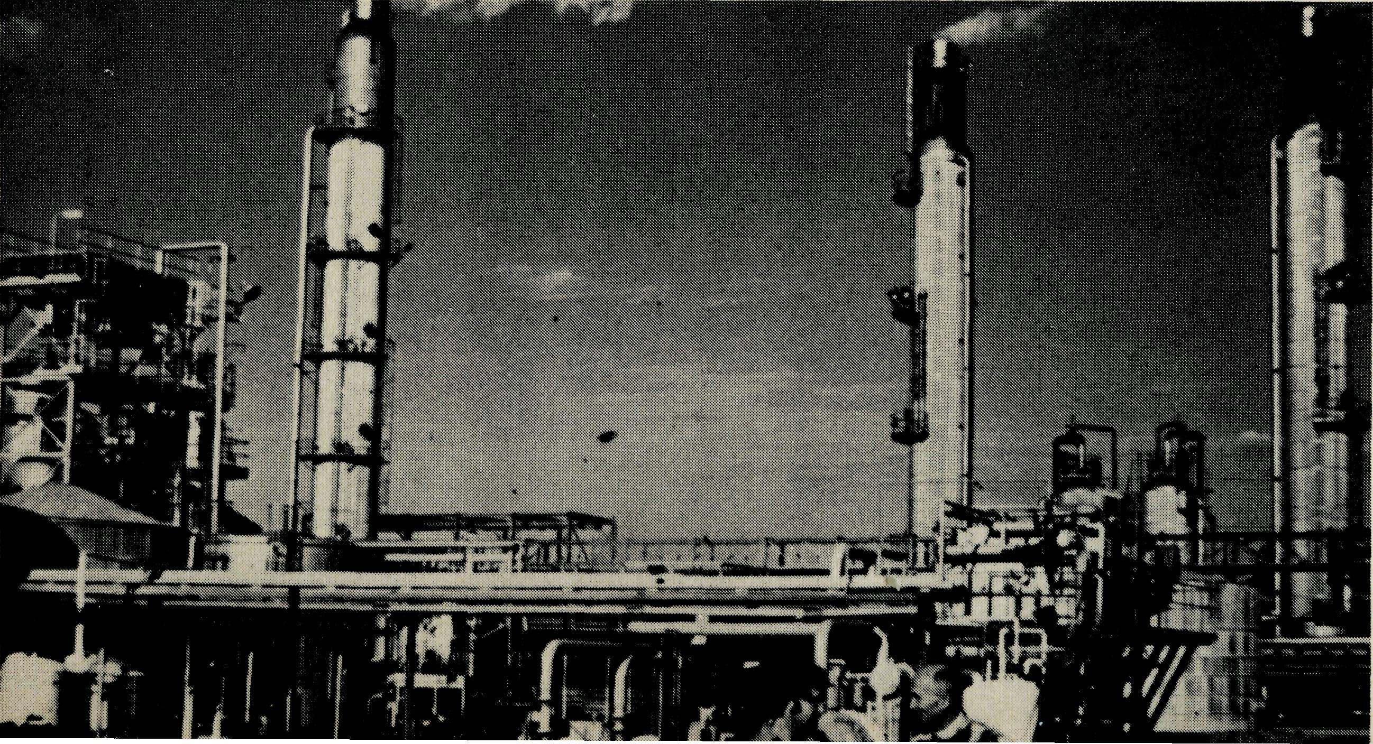

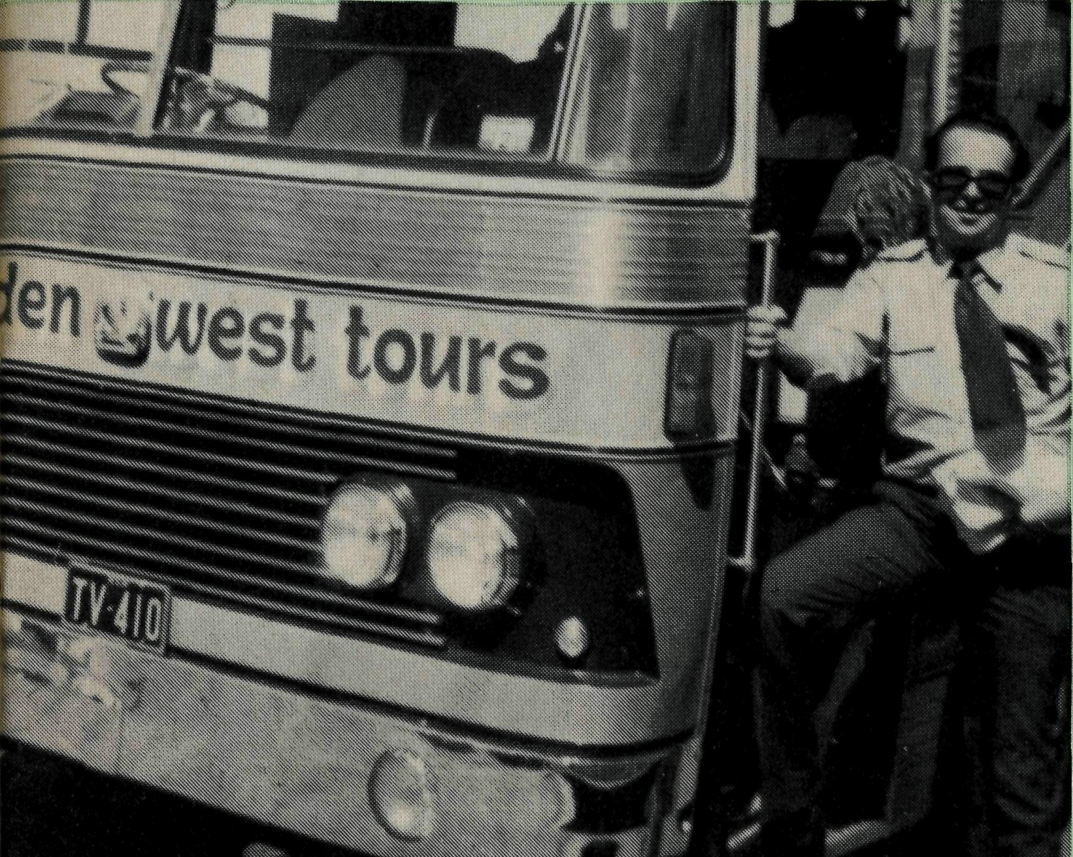
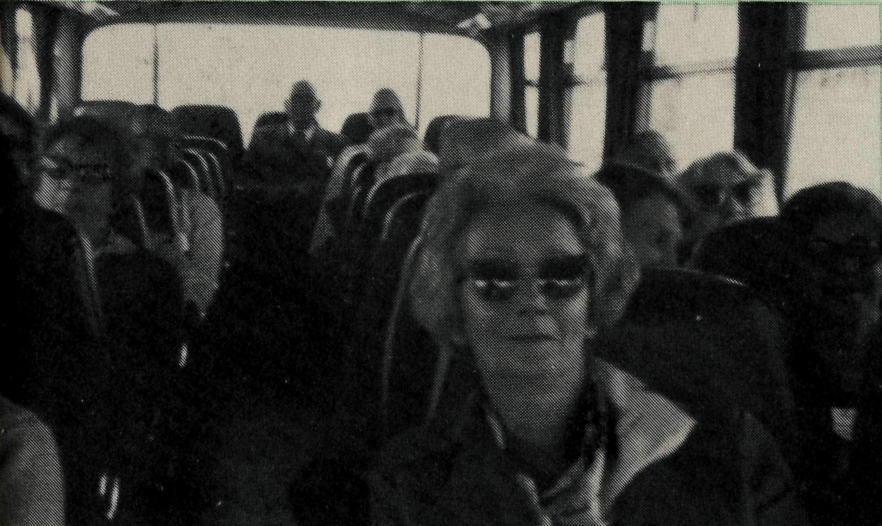
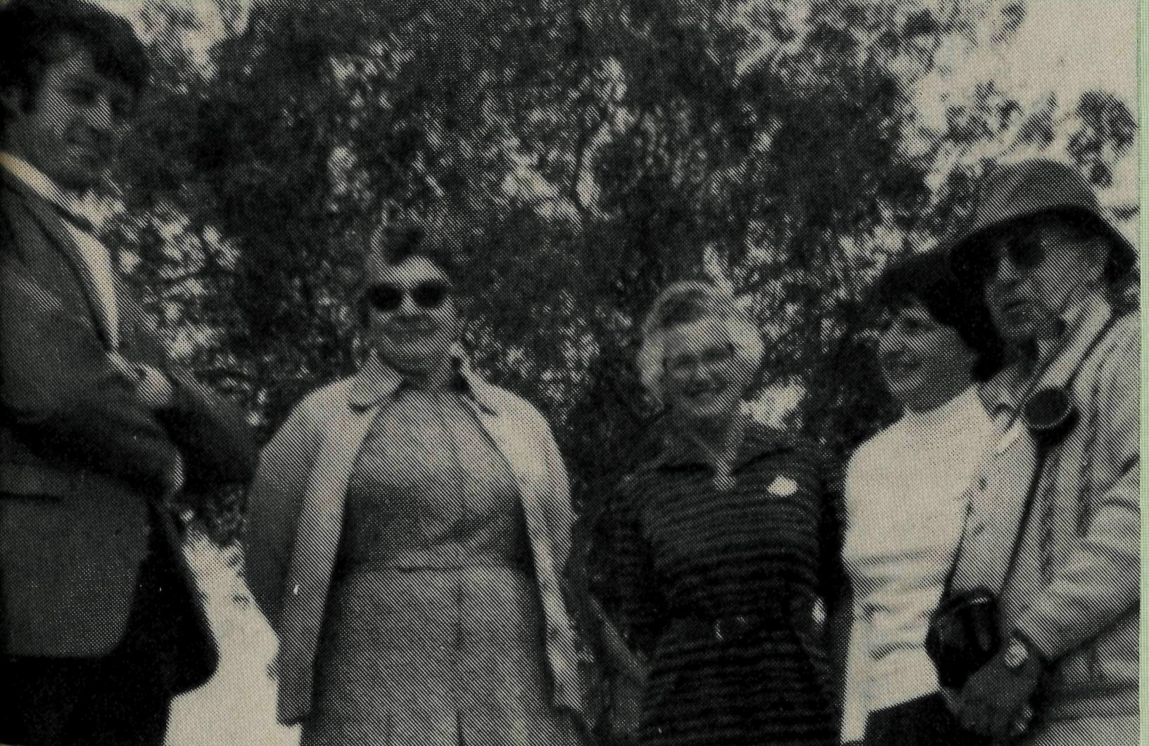
Monday — morning. Leigh Creek Area School, Secondary Pupils Seminars. Screened Fact and Faith Film, "Signposts Aloft" and discussed Faith with students along with local visiting of ministers of the Uniting Church, Roman Catholic Church and the Lutheran Church.
Afternoon — Flew to Olary and organised hall keys, generator etc., for Service this evening. Evening Service in Olary hall and screening of "Signposts Aloft". Stayed the night with Mr. and Mrs. K. Treloar of Wiawera Station. Tuesday — morning. Visit Olary School for Scripture lesson.
Afternoon — Fly to Quondong Station to stay with Mr. and Mrs. David Hodge. Meet shearing team working there. Film screened again and brief evening service.
Wednesday — Fly briefly to Sturt Vale Station to use their telephone to contact Pine Valley Station to see if I can land and visit there. AM O.K. so fly to Pine Valley and meet Mr. and Mrs. Arthur Moxam. They have a large family and I show children's filmstrips in the afternoon. Discuss baptism of youngest children, and arrange a time to come back. Fly home to Leigh Creek that evening.
Thursday -— morning. Answer mail etc.
Afternoon — Fly to Muloorina Station where I am to stay the night with Mr. and Mrs. Bill Mitchell. Muloorina Station is run by a number of families, descendants of the late Elliott Price, who, almost with bare hands and courage opened up the area for grazing. A lot of the families are there and gather in the Mitchell's lounge for evening prayers and the screening of "Signposts" and another film, "He restoreth my soul".
Friday — Spend the morning in the cattle yards with the men. I am not much help but learn a lot.
Afternoon — Fly home to Leigh Creek.
Saturday — morning. Catch up with mail again.
Afternoon — Fly to Moomba gasfield with Peter Cranwell, a Christian man who works in Leigh Creek. In the recreation hall we screen "He restoreth my soul" and say a few words to the men. I have a bad cold and go to bed. Peter stays up late talking with the men.
Sunday — Early morning thunderstorms, but we safely depart for Leigh Creek. Peter gets out and Marilyn and family come with me to Blinman for a morning service. Very few there but new "An Australian Prayer Book" copies have arrived, so good chance to informally look at and use some of our new Prayer Book. Return to Leigh Creek for lunch and Evening Service.
This week was much busier than most — having the films I wanted to use them to advantage. About $100.00 worth of books and Bibles were sold during the week.
We trust that in many ways people came into real contact with God's Word. Please pray that "I may become all things to all men, that I may by all means save some". (1 Cor. 9:22)
4 THE REAL AUSTRALIAN
GO . . . SEE FOR YOURSELF WITH GOLDEN WEST TOURS IN '79
Week-end to Lightning
Ridge Friday, 23rd —
Sunday, 25th
MARCH
An opportunity to visit The Ridge, do some opal fossicking or noodling and to see first hand the area of ministry of B.C.A.'s Captain Les Fernance.
Leave Sydney Friday 6.30 p.m. travelling to Bathurst, then express coach through the night, arriving Lightning Ridge 7 a.m. Sat.
Sunday Service in St. George's Church 9 a.m., arriving Sydney Sun. 10.30 p.m.
Tour fare includes Motel, bed and breakfast, lunch and tea Sat. and lunch Sun. $82.00 adult twin share.
17 Day Coach Tour
Queensland & The Centre
Visiting B.C.A. Centres
EARLY JUNE
Blackwater, Winton, Mount Isa, Tennant Creek, Alice Springs, Ayers Rock, Goober Pedy, Port Augusta, Barossa Valley. Price $850.00.
“Last Frontier Tour"
North-West Australia
25 DAYS — EARLY JULY
Fly to Darwin, by coach down the Western Australian coast through the B.C.A. centres of Kununurra, Wynd-ham, Derby, Broome, Dampier, Ex-mouth, Paraburdoo to Perth, by Indian Pacific train home.
* Direct all enquiries to Mrs. Joy O'Neill on 26-3164. Early bookings would be appreciated.
Three photographs from the "Go . . . see for yourself" Tours.
Top: Mr. John Cronshaw, Principal of Golden West Tours.
Middle: A happy bus load.
Bottom: A group from the tour talk with the Reverend Chris Clerke,
Missioner in the Leigh Creek and Northern Mission area of South Australia.
THE REAL AUSTRALIAN

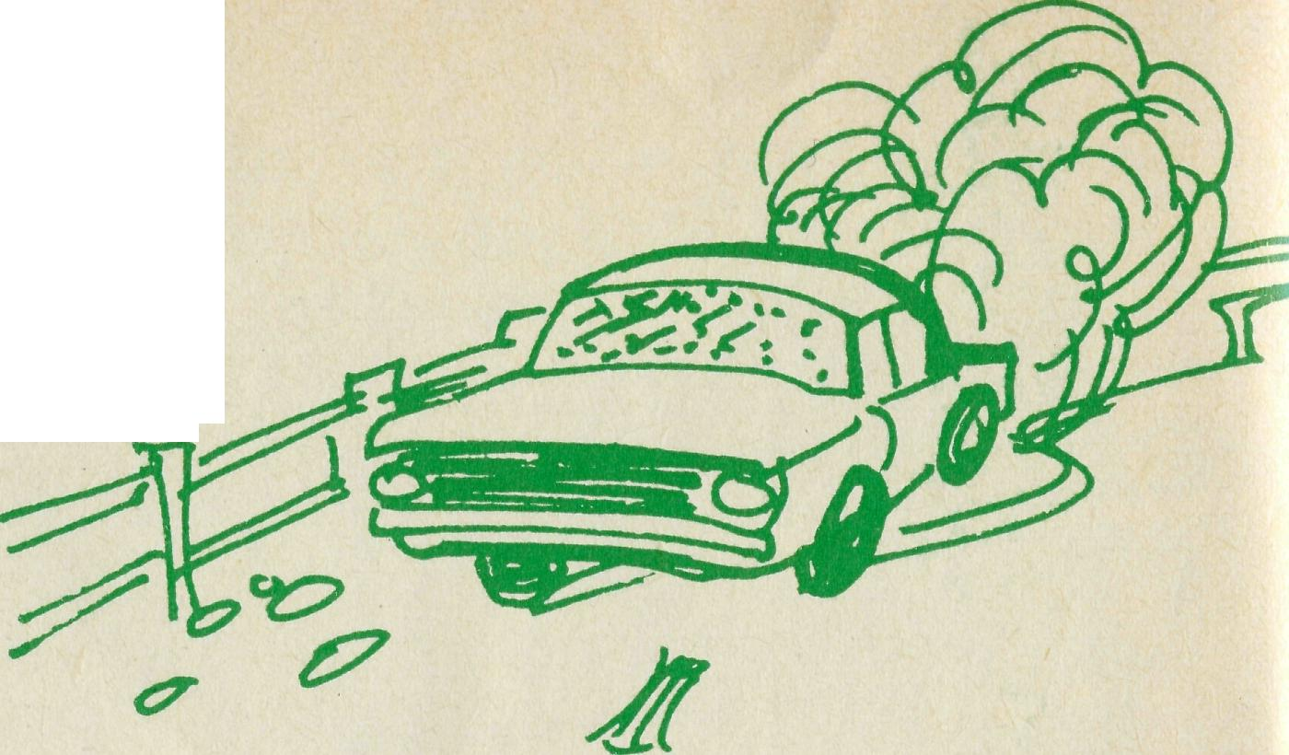
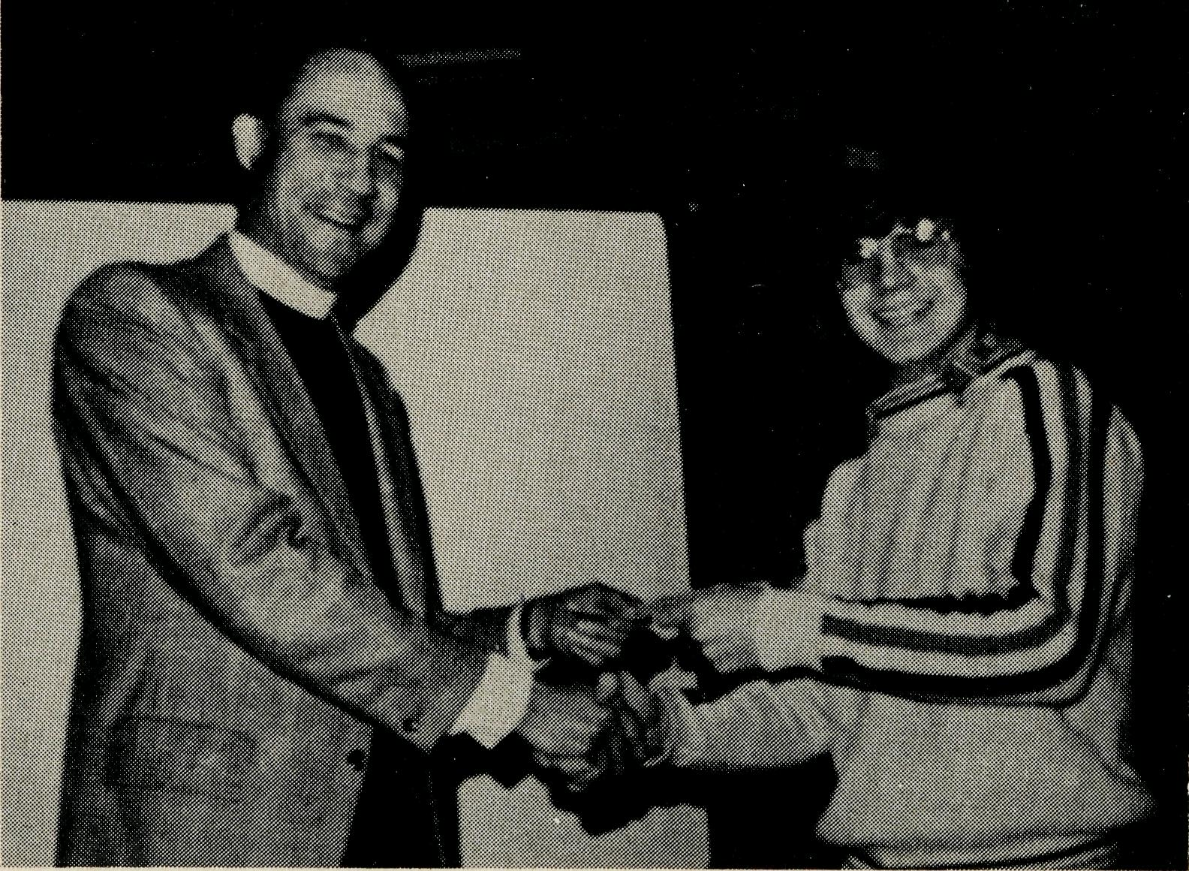
A Layman's Viewpoint
THE MURCHISON PARISH AT EASTER Des Carmody
Good Friday is one day in Western Australia when the hotels do not open. In most areas in which I have been this is strictly observed. Sandstone, a small forgotten settlement 100 miles east of Mount Magnet is only a shadow of its former goldmining glory. Then it had a large population and was serviced by a railway, no less, from Mount Magnet and hence 240 miles to Ge/aldton. This line now has been pulled up and Sandstone has settled down to a one horse pub, a post office, a shire office, a few scattered old weatherboard dwellings, not forgetting the Anglican Church, which is part of the Murchison Parish, and a police station.
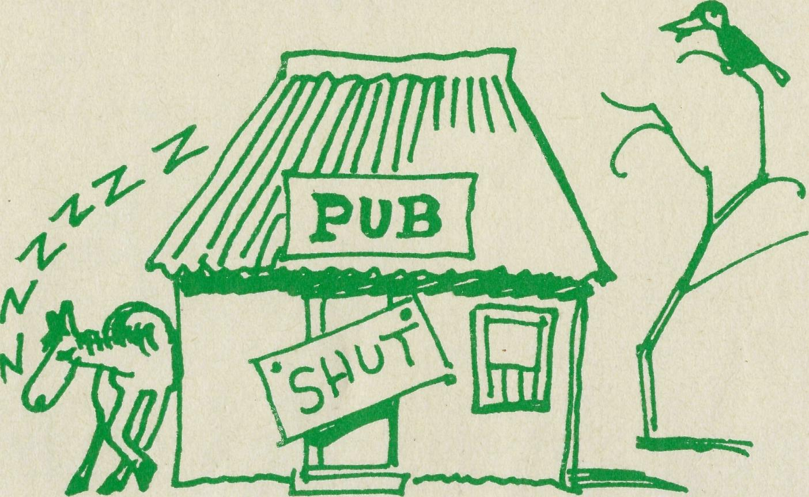
One Easter I was assisting the Rector with the round of Easter Services when it became expedient to hold a service at Sandstone on Good Friday, as it could not be programmed into the Sunday round of services, which covered a distance of some 580 miles. We set out early in the afternoon to do some station visiting on the way, as the service was not until 8.30 that evening. The Bush Church Aid Rector was one of those enthusiastic super optimists who thought he could fit just another station in and still get back in time for the Service. The inevitable happened, and we had to take a short cut along a fence line for 15 miles, avoiding mulgas, stoney outcrops and rabbit burrows at 40-50 miles an hour without clouting the fence.
Driving was made hazardous by the fact that the Falcon had previously stood out in the open during a cyclone. The pitting of the windscreen resulting from the sandblasting it had been subjected to, made the journey extremely "hairy". However, Sandstone rolled over the horizon at about 8.15 p.m. We drove around to the church on the outskirts of the settlement and opened up. When we turned on the lights we discovered there was no power; we then
6 THE REAL AUSTRALIAN
attempted to light the candles on the Communion Table, only to find they had wilted in the extreme heat. After we had made what preparations we could for the service, we sallied forth to find out what we could about the lighting.
The only building from which any light came was the local pub — it having its own power supply. On making enquiries, it turned out the reason there were no lights in the town was due to the fact that the local policeman's wife had that morning, given birth to a baby son. What better place to "wet its head" than the "local" which was duly opened up for the occasion, Good Friday or not.
An occupational hazard of such an occasion is how time just slips away not to mention the fuel in the tank of the township's diesel power plant. The observation being made that the lighting situation would have to be rectified if there was going to be any church service that evening, the policeman commissioned the post office boy to roll out a 44 gallon drum of blackjack to fill her up. The boy having had too many "sherbets" to do anything about starting the diesel, it devolved upon the Rector to swing the flywheel of the diesel while a certain truckie bled the air out of the fuel lines until she finally "hit up'
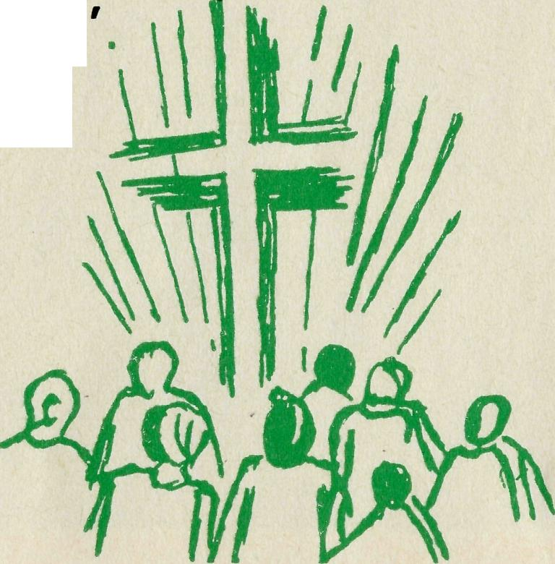
The service duly got under way about 9.45 p.m., people coming to it from up to 75 miles away. Fortunately, time is of little consequence in the Murchison, one having more of a seasonal outlook on life, but the people of "the bush" do appreciate the opportunity to remember the One who was prepared to sacrifice everything to put into life an eternal dimension.
THEY DID- IT AGAIN
Regular readers of "The Real Australian" will remember that last year there was a news item about the Youth Fellowship at Berkeley on the South Coast of N.S.W. presenting the Society with a cheque, the proceeds of a Wake-a-thon. Featured here is Gary Burgess giving the Reverend Wakely Wade, N.S.W. State Secretary, a cheque for $200 proceeds of this year's Fellowship Wake-a-thon.
THE REAL AUSTRALIAN

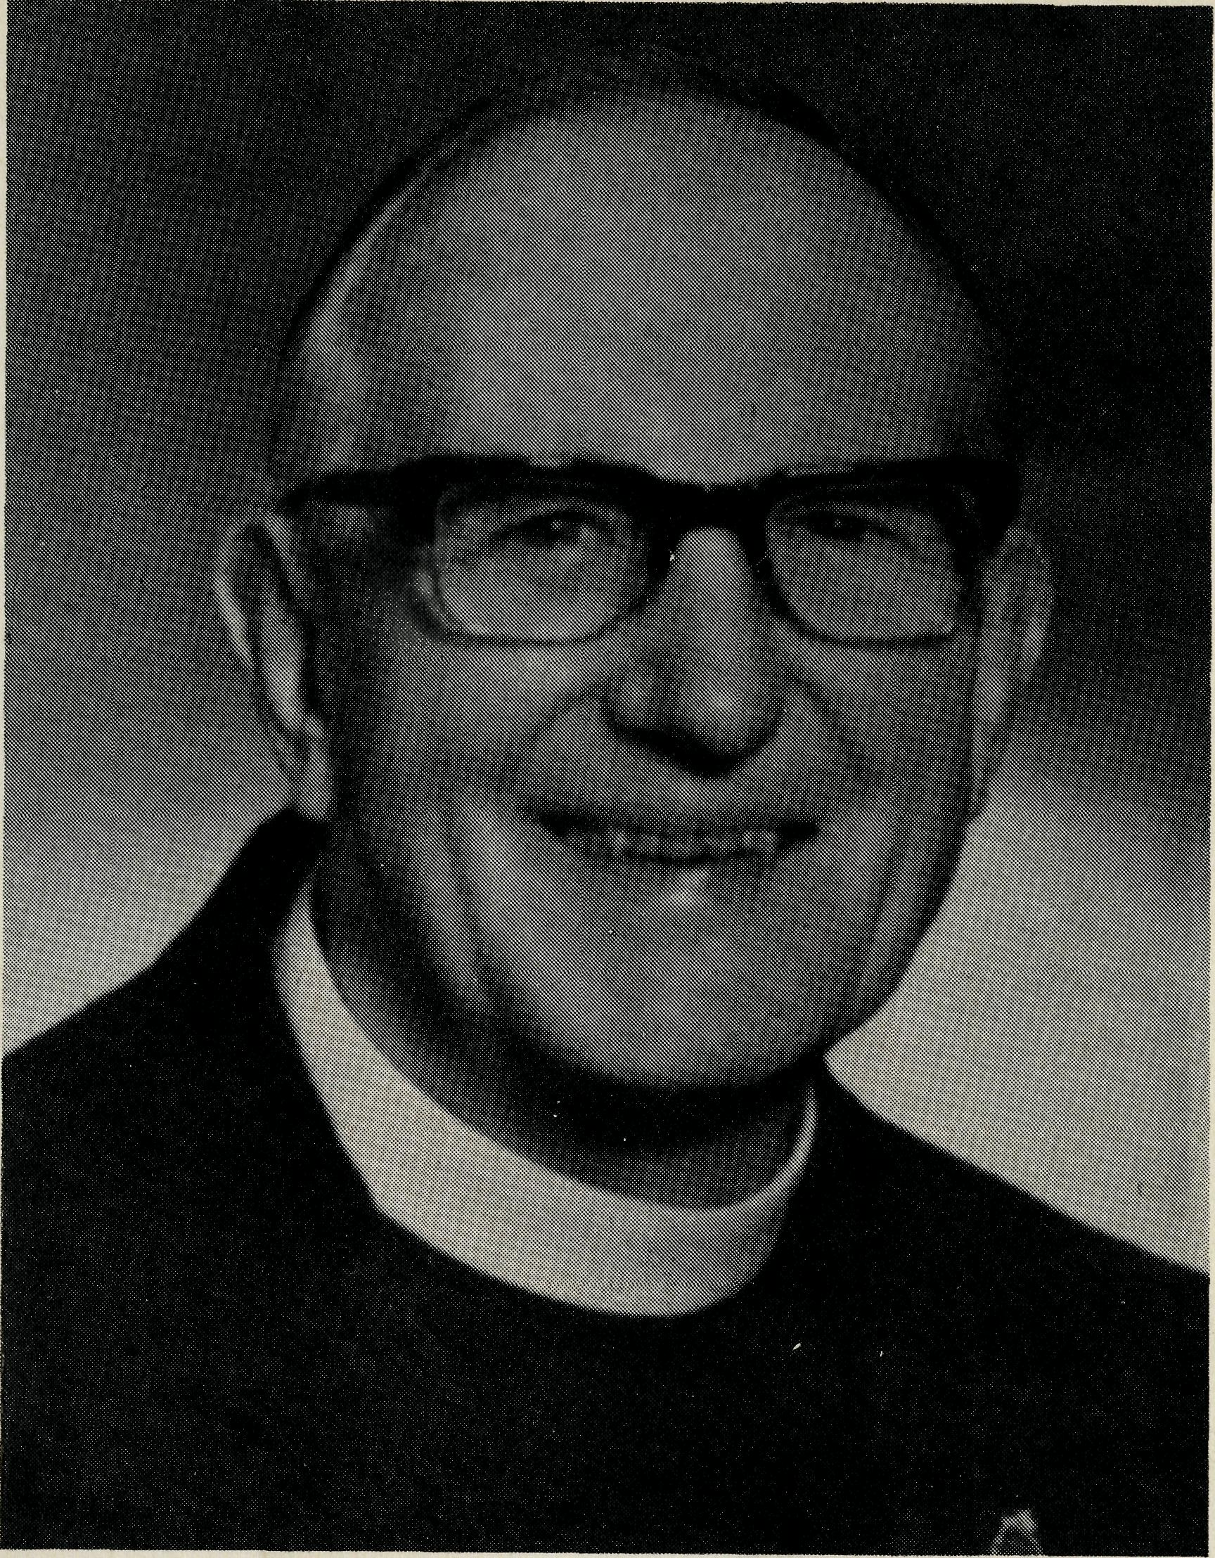
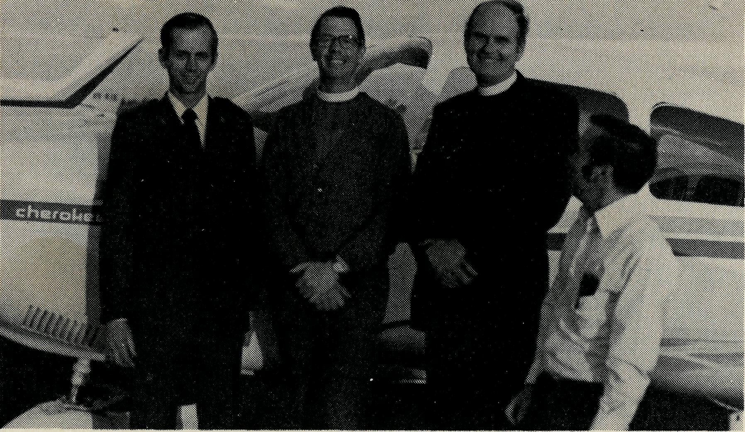
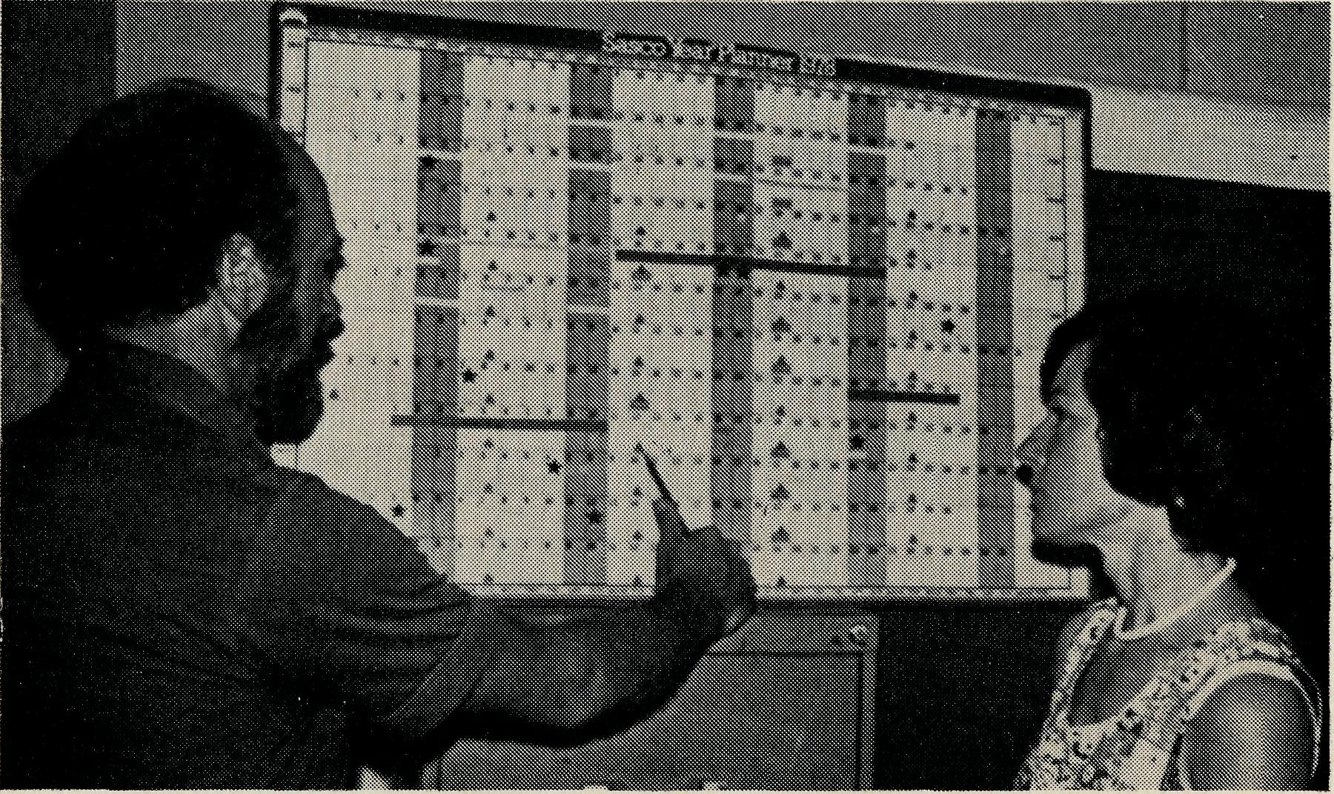
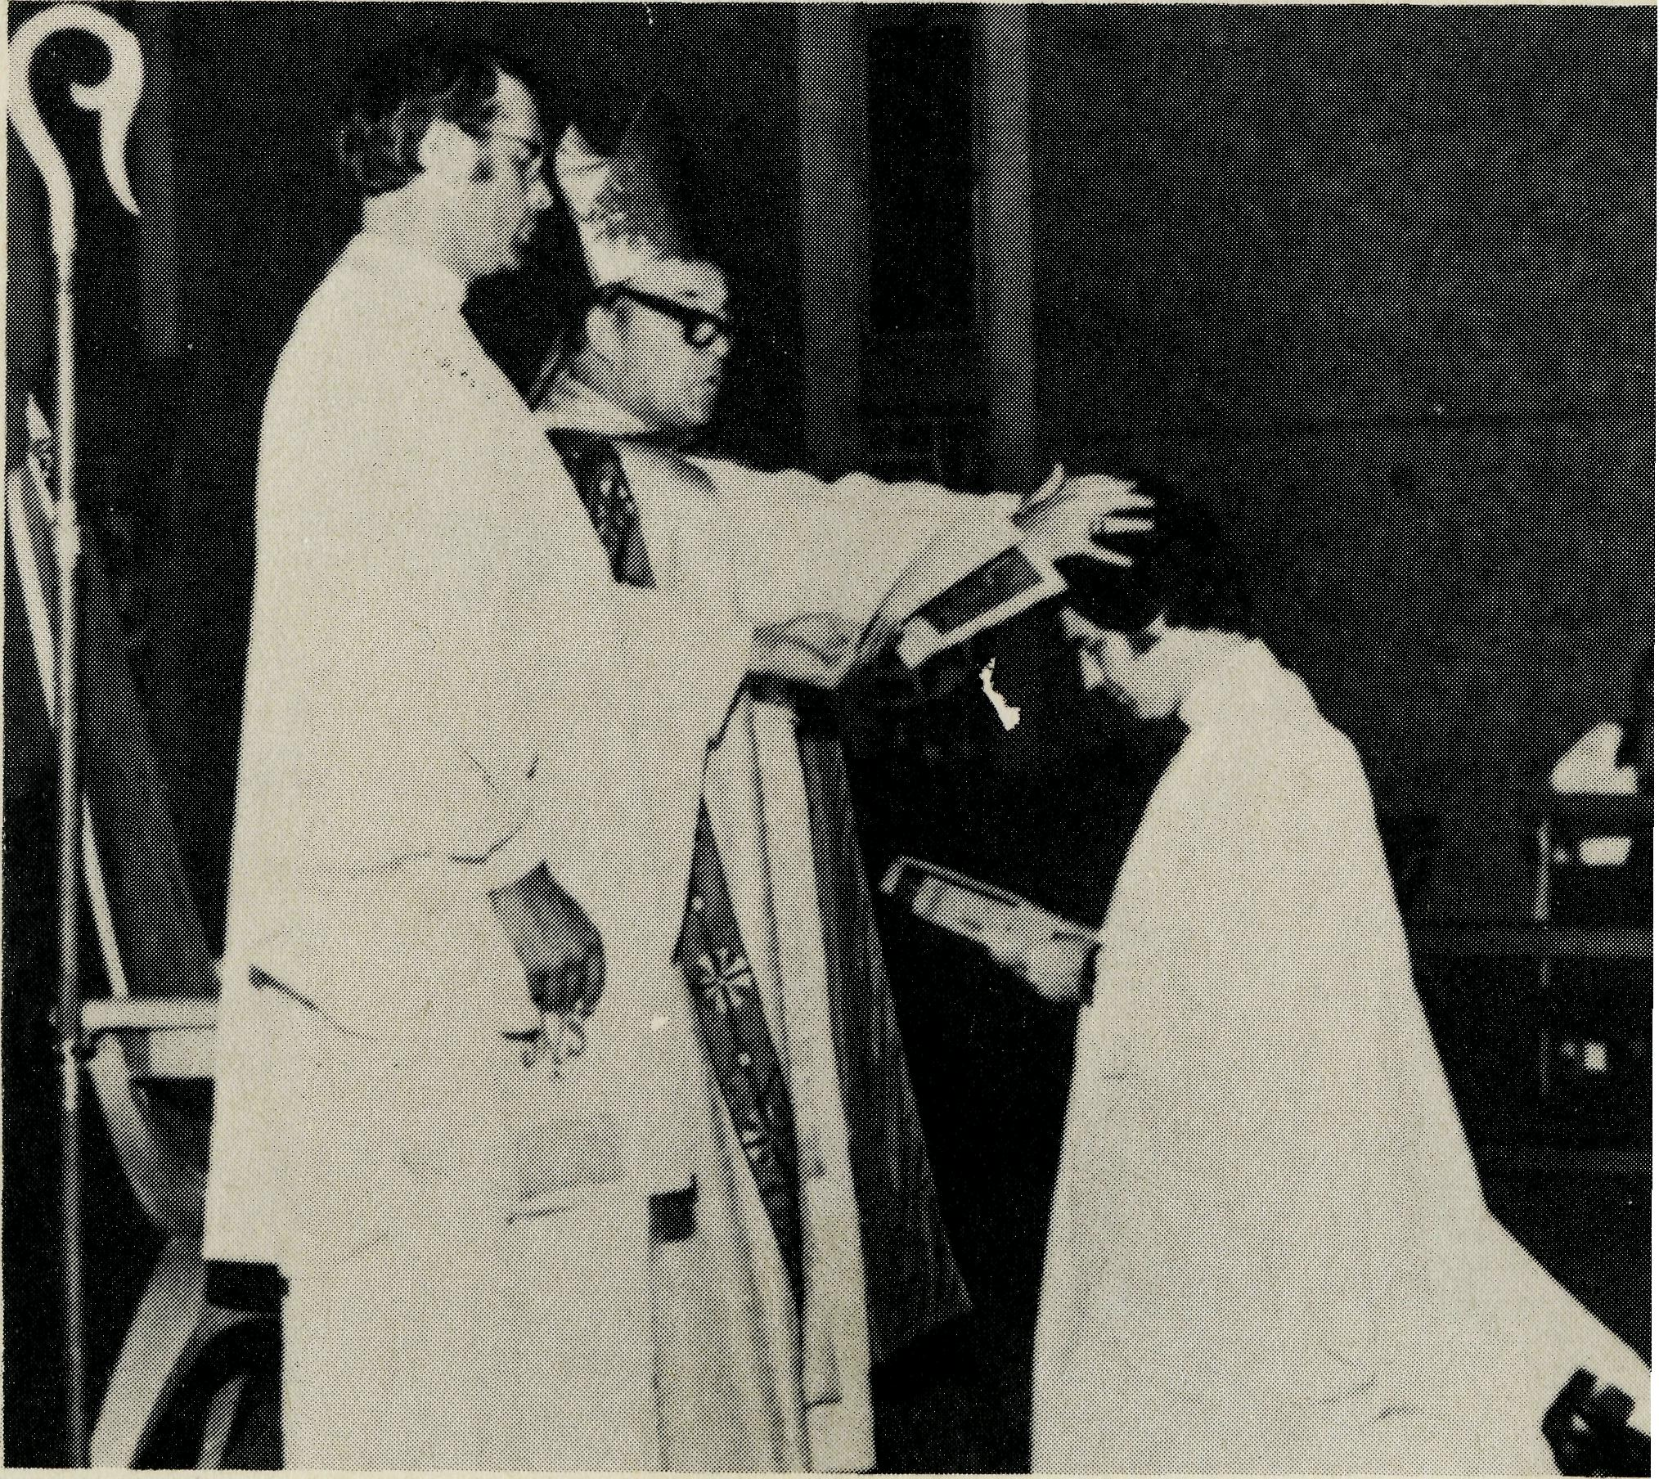
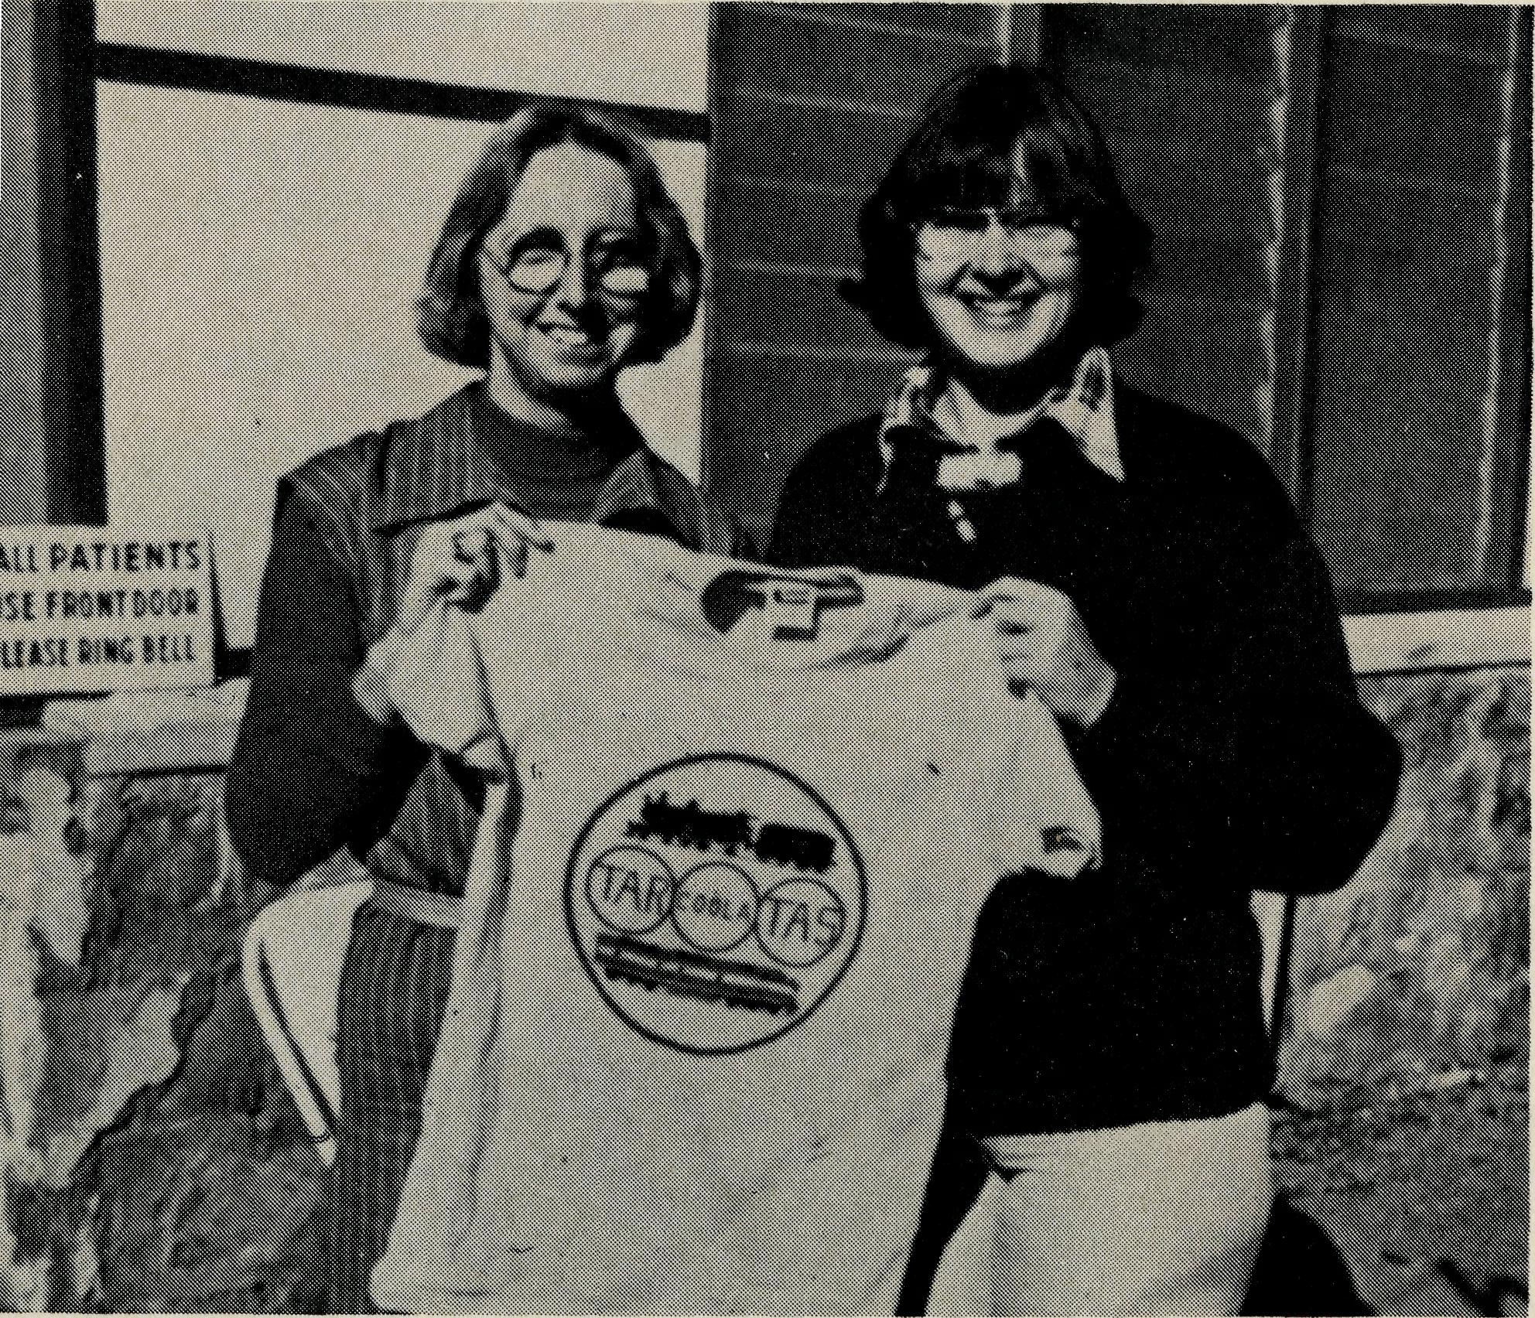
2. Lightning Ridge, IM.S.W.
8. Darwin, NT.

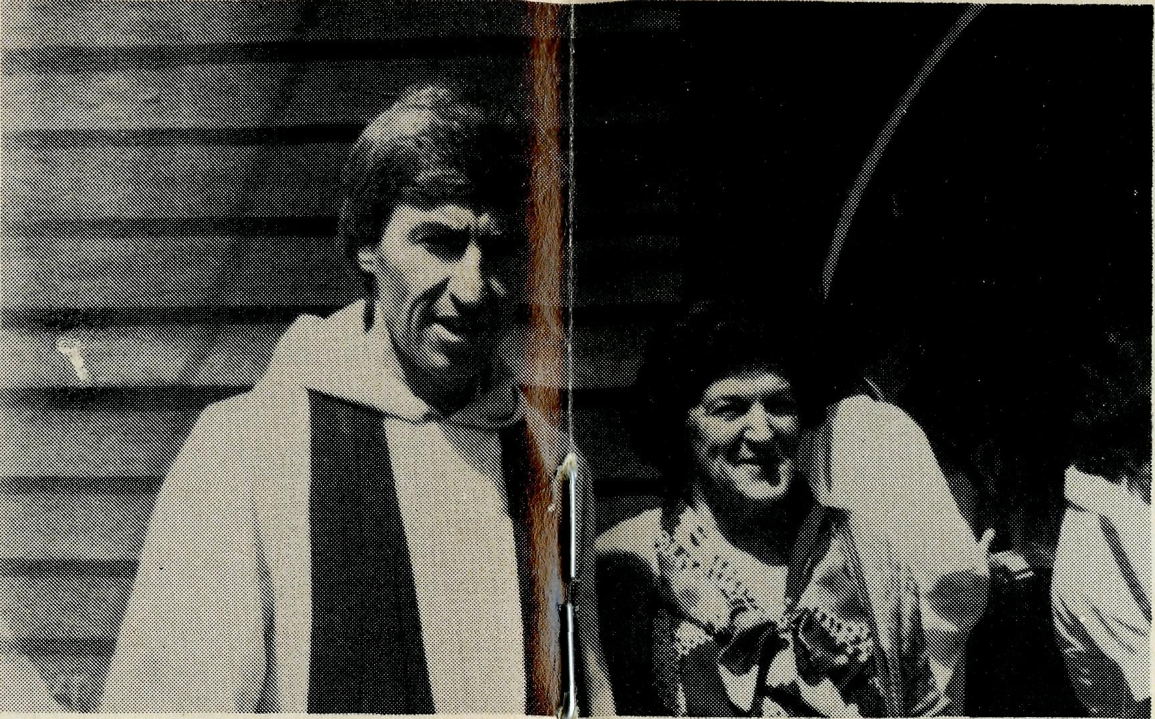
3. Croajingalong, Vic.
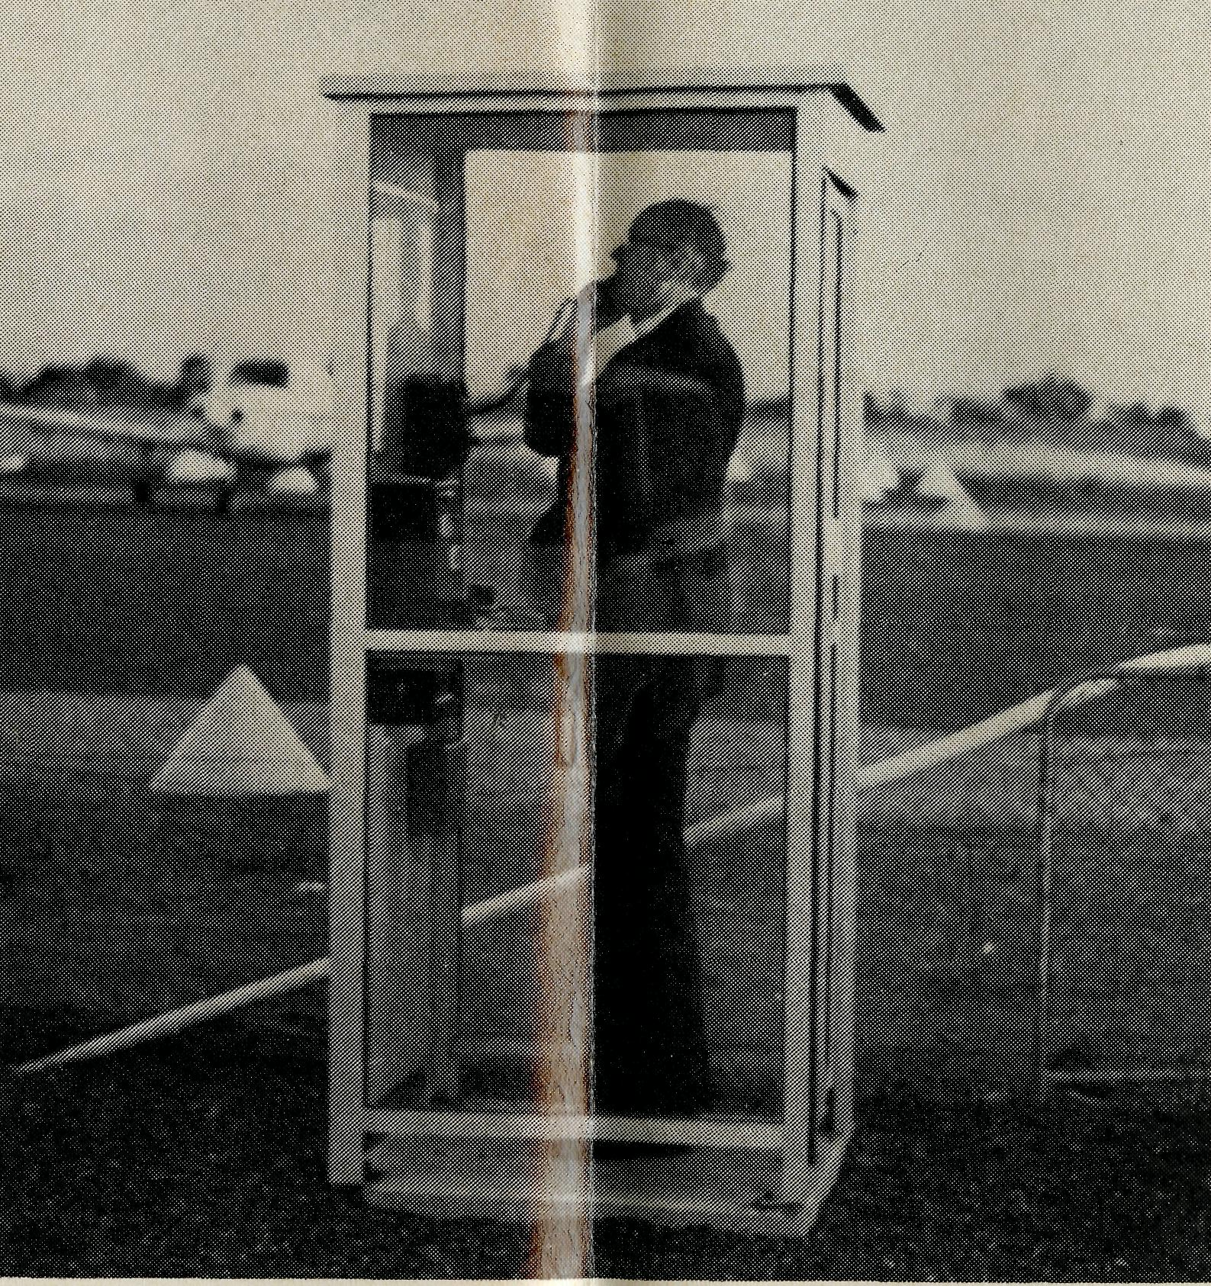
4. Jubilee.
1. Keeping in Touch.
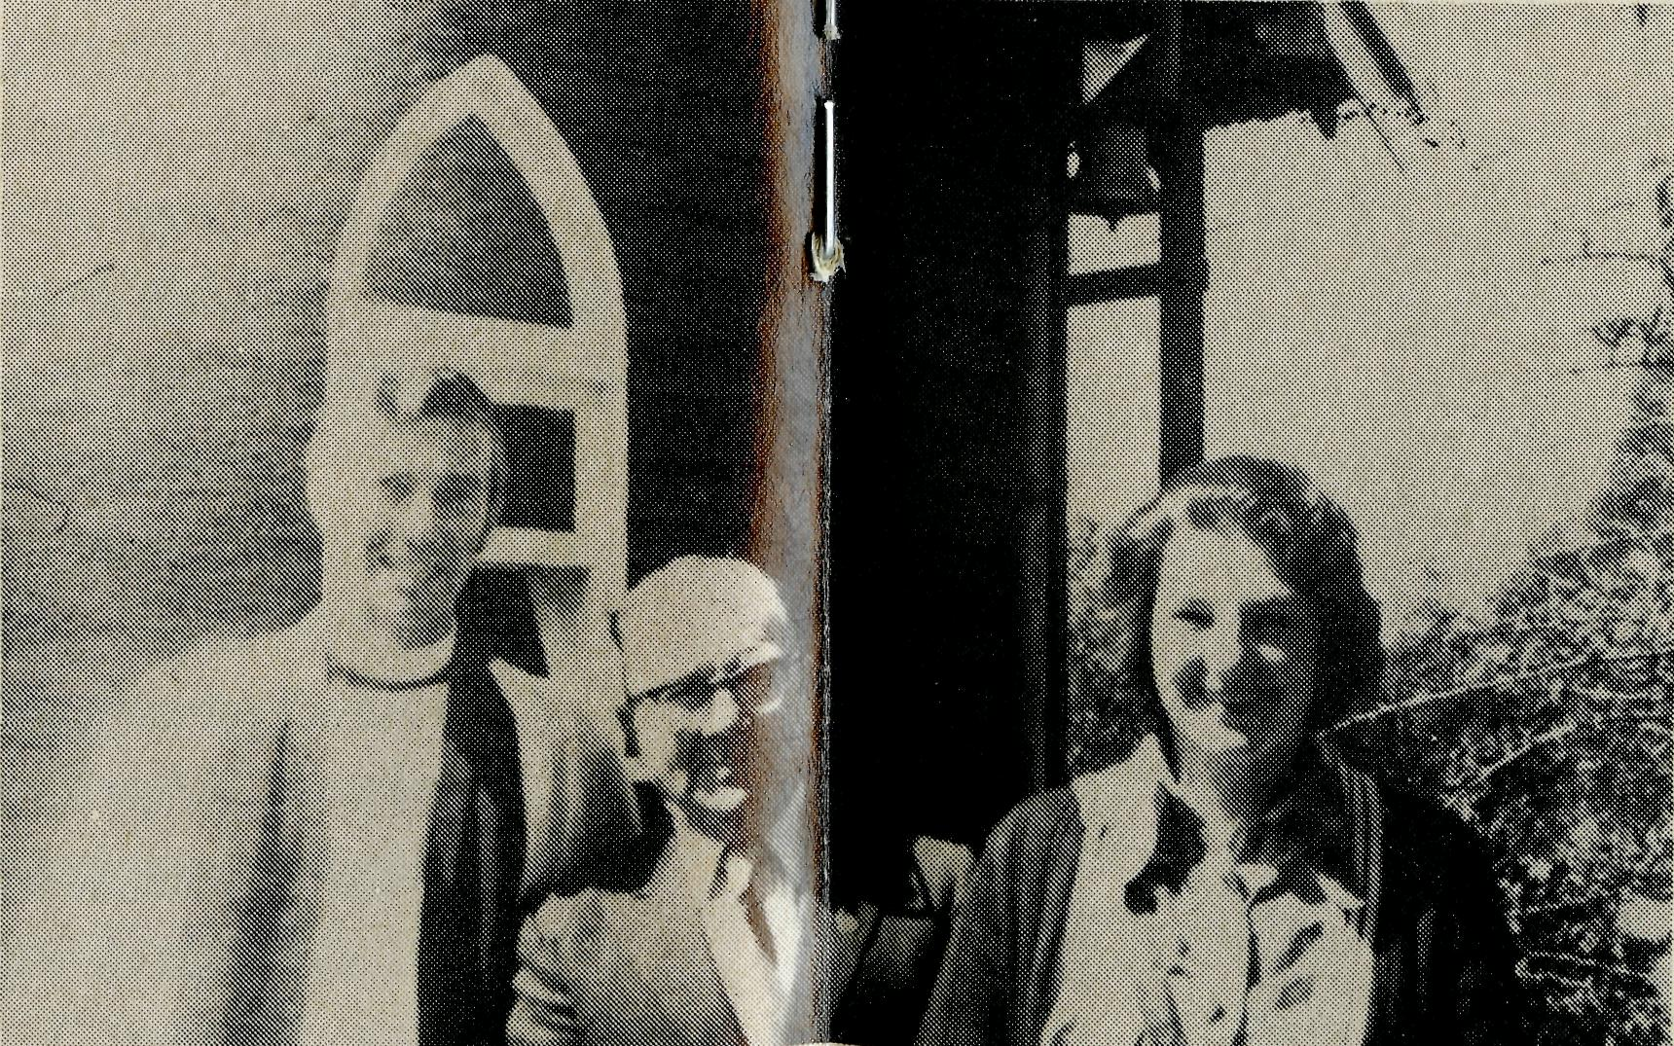
PHOTOGRAPHIC ROUND UP OF 1978
Key on page 10

7. Tarcoola, S.A.
6. Celebration.
5. Ordination, W.A.

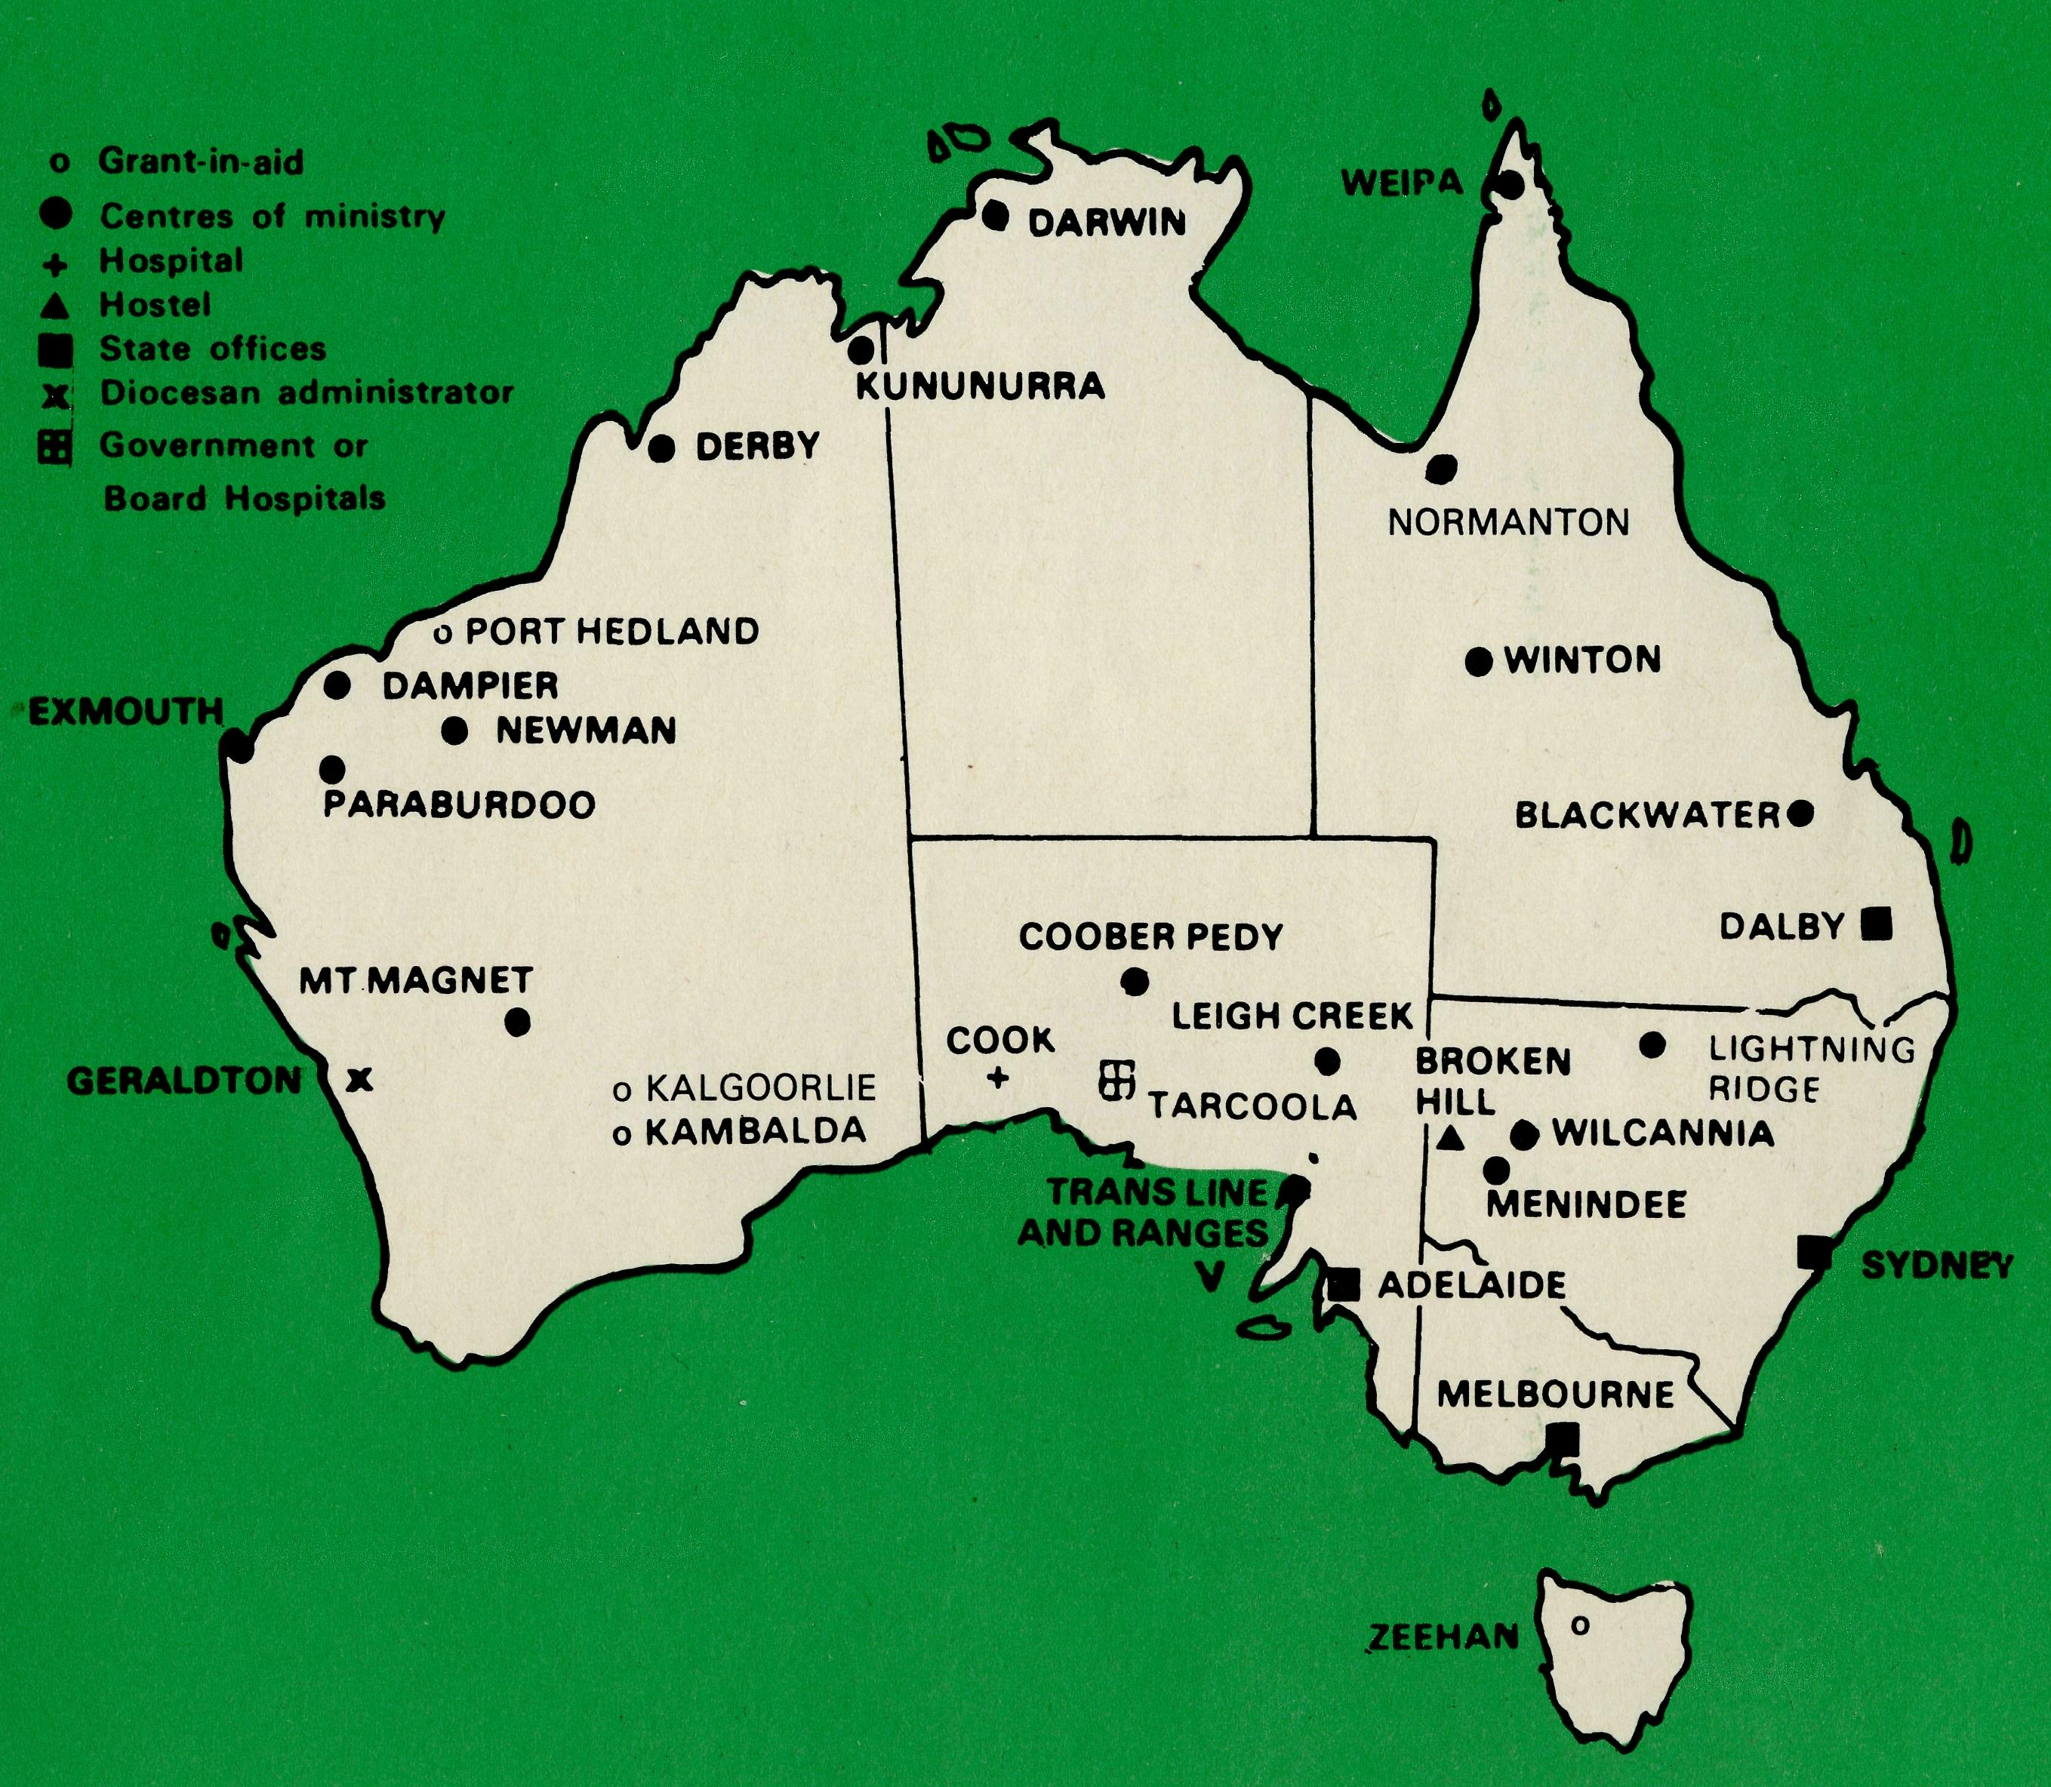
PHOTOGRAPHIC ROUNDUP KEY
1. Keeping in Touch.
"Out in the bush keeping in touch with The Bush". At Lightning Ridge Aerodrome, N.S.W., the Federal Secretary talks to Cook, S.A.
2. Lightning Ridge. N.S.W.
In May, Captain Les Fernance of the Church Army, supported by B.C.A. began his ministry in Lightning Ridge. Pictured here (left to right) the Captain, the Rt. Reverend Peter Chiswell, Bishop of Armidale, the Federal Secretary and the pilot who flew the Bishop and Mr. Hayman in for the Commissioning Service.
3. Croajingalong, Vic.
From 1922 until 1952 B.C.A. was involved in the Croajingalong area centred on Cann River. Pictured here is the Rev. Barry Green with Mrs. Harriet Connley, local resident and ex B.C.A. Nursing Sister at Cann River at the St. John's Church 50th Anniversary celebrations.
4. Jubilee.
The Reverend Tom Gee, M.B.E., Dip.E.E., Th.L., Queen's Silver Jubilee Medal, 1977. We salute Mr. Gee who in January of this year (1978) celebrated a twofold Golden Jubilee, 50 years residence in Australia and 50 years Christian service of amazing variety and usefulness, beginning with his appointment as a Lay Missioner with B.C.A. on the West Coast of South Australia on the princely pay of ten shillings a week to cover all his expenses including feed for his horse!
5. Ordination, W.A.
David Mansfield, ordained Deacon in Holy Cross Cathedral. Geraldton in February, by Bishop Howell Witt. Rev. Bill Ross, B.C.A. Missioner at Dampier stands by.
6. Celebration.
The present Vicar of St. John's, Cann River, is the Rev. Barry Rainsford, a former B.C.A. Missioner. Photographed with Mr. Rainsford at St. John's celebrations are Mr. Doug. Harmer who helped build the Church and Mrs. Rhonda Smith, granddaughter of the first Anglican minister in the area, the Rev. B. T. Syer.
7. Tarcoola, S.A.
Jan and Merryl, B.C.A. Nurses, hold the gold and green T. shirt of Tarcoola. The children in one of the craft clubs run by the nurses, silk-screen printed the emblem on the shirts. They were proudly worn by young and old at the schools'.Sports Day at Cook in August (T.A.R. stands for Trans Australian Railway and T.A.S. for the new Tarcoola-Alice Springs Line).
8. Darwin, NT.
Sister Patsy Dahl discusses with her Rector, the Rev. Jim Taylor, some forward planning in the Parish of St. Peter's, Nightcliff. in Darwin, NT.
PERSONAL
A hitch about "Hitch".
Miss Grace Hitchcock although she has retired from the office of B.C.A. in South Australia, has not retired as the "unattached" Box Secretary of that State. So she will still do the "unattached" box collecting and will send out the necessary reminders to folk in March and September of each year.
B.C.A. Baby.
Our congratulations to Don and Libby Wilson at Newman with the birth of Carolyn Ruth, a little sister for Hugh and Derek, on 17th October 78.
I0
Stop Press: The Revd. Ernest Horth, Vicar of St. Aidan's, Parkdale, has been appointed B.C.A. State Secretary for Victoria.
THE REAL AUSTRALIAN
THE B.CA PRAYER
A DAILY PRAYER
0 Lord our God, help us to remember those who live in the remote parts of our land. We ask You to bless those.whom You have called into the fellowship of The Bush Church Aid Society. Grant that, through the ministry of the Word and Sacraments, through healing, and through caring for the young, the message of Your redeeming love may be proclaimed, through Jesus Christ our Lord. Amen.
0 God, we remember before You those whom You have called to Your service. We ask You to bless
, assure
them of Your Presence, and call others to stand with them in the task. Grant to them, as to us, the joy of service, the ability to achieve, and the serenity of Your peace, for Jesus' sake. Amen.

POST & RAILS

PRAYER CALENDAR
FIELD STAFF DIRECTORY
DIOCESE OF NORTHERN TERRITORY. The Rt. Revd. K. B. Mason.
1 Darwin — Miss Coryn O'Nians (Nungalinya College), Sister Patricia Dahl (Nightcliff
Parish),
DIOCESE OF NORTH WEST AUSTRALIA. The Rt Revd. H. A. J. Witt.
- Kununurra — The Revd. Royce and Mrs. Susan Thompson.
- Derby — The Revd. Ron and Mrs. Ann Robins.
- Newman — The Revd. Don and Mrs. Libby Wilson, Port Hedland (grant). The Revd. Peter Thompson.
- Dampier — The Revd. Bill and Mrs. Jocelyn Ross. Revd. David and Mrs. Helen Mansfield.
- Paraburdoo — Vacant.
- Exmouth — The Revd. Peter and Mrs. Elizabeth Mills.
- Murchison — The Revd. Bill and Mrs. Joan Hoare.
- Geraldton — Mr. Stan and Mrs. Dorrie Hummerston — Diocesan Administrator.
DIOCESE OF PERTH. The Most Revd. G. T. Sambell.
10 Kalgoorlie — grant. The Revd. Canon Frank Watts, The Revd. Roger Williams.
Kambalda — grant. The Revd. Robert Hanson.
DIOCESE OF WILLOCHRA. The Rt. Revd. B. S. Rosier.
- Cook Hospital — Nurses Mr. Keith and Mrs. Rhonda Anstee.
- Tarcoola Hospital — Janet Stiff, Merryl Howard.
- Coober Pedy — The Revd. Kerry and Mrs. Julieanne Medway.
- Gawler Ranges and Trans. Line — The Revd. Robert and Mrs. Phyllis McEwin.
- Leigh Creek — The Revd. Chris and Mrs Marilyn Clerke.
DIOCESE OF TASMANIA. The Rt. Revd. R. E. Davies.
16 Zeehan — grant. The Revd. Roy Dixon.
DIOCESE OF RIVERINA. The Rt. Revd. B. R. Hunter.
- Broken Hill Boys' Hostel — Mr. Ken and Mrs. Pam Young.
- Menindee — The Revd. David and Mrs. Carlene Eastway.
- Wilcannia — The Revd. George and Mrs Hazel Fuhrmeister.
DIOCESE OF ARMIDALE. The Rt. Revd. P. Chiswell.
20 Lightning Ridge — Captain Les and Mrs. Pat Fernance.
DIOCESE OF ROCKHAMPTON. The Rt. Revd. J. B. R. Grindrod.
- Winton — The Revd. Robert and Mrs. Rigmor George.
- Blackwater — The Revd. Stephen and Mrs. Pam Rigby.
DIOCESE OF CARPENTARIA. The Rt. Revd. H. T. U. Jamieson. 24 Weipa — The Revd. Malcolm and Mrs. Chris Babbage.
24 Normanton — The Revd. Jim and Mrs. Margaret Hudson,
GENERAL.
Federal and N.S.W. Office.
25 Federal Secretary, The Revd. Theo Hayman.
N.S.W. The Revd. Wakely Wade, Eric Atkin, Miss Doris Smith, Mesdames Joy O'Neill, Dora Warwick and Nina Allan.
- VICTORIA. The Revd. Barry Green, Mrs. Shirley Bailey.
- QUEENSLAND. The Revd. Greg Ezzy (Deputationist and Secretary). WESTERN AUSTRALIA. The Revd. Ted Doncaster (Deputationist).
- SOUTH AUSTRALIA - Vacant. Mrs. Phyllis Linton (Office).
- The President, The Most Revd. Sir Marcus Loane, Chairman, Archdeacon Robert G. Fillingham, Honorary Treasurer, Mr. Richard Stokes, The Council, State Committees, Staff Replacements.
- Box Secretaries, B.C.A. Supporters.
- National Home Mission Fund.
• The Reverend Graham Thurley
has accepted nomination to the
Parish of Hastings in Melbourne
Diocese. He commenced his
ministry there in November,
succeeding another ex B.C.A.
Missioner, the Reverend Brian
Viney, as Vicar. We are sorry to
lose Helen and Graham from
B.C.A. field staff. They first went
to serve in Exmouth in February
1973, moving to Paraburdoo
almost three years ago. Many in
the Diocese of the North West
have cause to be grateful to God
for the Thurley's work amongst
them.
"Wonderful World"
The Reverend Barry Green's latest and regrettably last three-screen audio visual prepared for our Society received high praise from many who saw it at the Rallies in Adelaide, Melbourne and Canberra held in October and November.
• Pam and Ken Young, our Hostel
Parents at Broken Hill, will not
forget Tuesday the 26th Sep
tember, 1978 in a hurry. That day
there was a State-wide teachers'
strike and most of the children
were home from school at the
hostel when a severe hail storm
struck the city. The hail soon
blocked all the gutters and the
torrential rain that followed
caused the roof over the hallway
of the hostel to collapse bringing
down debris and heaps of red mud
on the floor. A matter of gratitude
to God that nobody was hurt and
the Youngs said the children were
very good, particularly the older
boys who set about cleaning up
the mess and being very helpful.
• We are pleased to report that
the Murchison has had a little rain
but much more is needed and
some parts are still very dry. The
Missioner, the Reverend Bill
Hoare, now has a new vehicle in
exchange for that Falcon which
had more than 200,000 kilometres
on the clock.
- "Opal Chips" is the popular magazine for Coober Pedy's Catacomb Church. Two items that are reported by Kerry Medway in their Chatter Page will be of interest. During the May school holidays a group of fourteen enthusiasts from Balwyn parish in Victoria stayed in the church hall and carried put many repairs to the Church and Rectory. The group ably led by Ansett Pilot, John Bleakley, with Mavis, an Avis Rent-a-Bus had an enjoyable time on the opal fields and did some excellent work as well. Also reported is the visit of Warren and Pat Charlton and their baby, Emma, to Coober Pedy. Pat (nee Darby) was a B.C.A. Sister at Coober Pedy Hospital from 1967 to 1969. Kerry reminds the people of Coober Pedy that in those days there was no resident doctor and this sometimes necessitated 24 hours duty for Pat and the other B.C.A. Sister at the hospital. Many were glad to see Pat again. The Charltons now live in Ceduna.
- Your earnest prayers are invited for the calling of men of God's choice to fulfil the vacant position of State Secretary in South Australia as well as for replacement field staff at Paraburdoo.

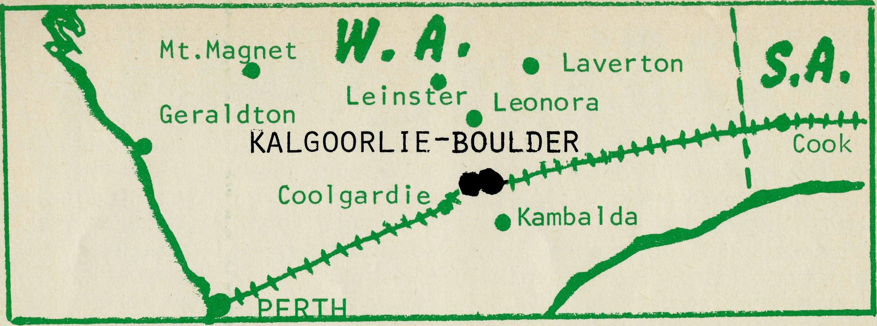
Revd. Canon F. Watts
I came to the Parish of Kalgoorlie/Boulder in February of this year.
Being new to the goldfields I received an interesting kaleidoscope of impressions. I found in the Twin Cities' as they are called, a fierce pride in their proud and impressive past and a hesitancy in face of their uncertain future.
The towns were both conceived from that mixture of bold adventure and rich rewards that marked the Goldrush days at the turn of the Century.
The vast wealth has left a legacy of impressive buildings at which today's tourists gaze with admiration.
But fortunes rose and fell. Known ore bodies petered out. The falling gold prices made some mines uneconomical and prospecting less attractive. In the early '70s nickel finds caused another boom period — only to be followed by a period of recession. Most experts agree this is only temporary but it has caused the closure of mines like Windarra and decimated the mining town at Laverton.
In the boom times Kalgoorlie was proud that it was the seat of a Bishop. He in turn was supported by a Dean at St. John's pro Cathedral and assistant priest in the Kalgoorlie Parish and Boulder (a parish in its own right) had a Rector. But the slump of 1973 saw the end of this arrangement. The Kalgoorlie Diocese, after almost 60 years of independence, became once more part of the Diocese of Perth. The Parishes of Kalgoorlie and Boulder became one parish. Now there is a Rector in Kalgoorlie (Canon Frank Watts) and an Assistant Priest in Boulder (Revd. Roger Williams). As well as their parochial responsibilities they have the spiritual ministry to the vast area of country that was part of the old Kalgoorlie Diocese.
The struggling mining towns of Coolgardie, Leonora, Gwalia, Menzies, Laverton and the widely scattered stations are amongst these centres. How are two men to tackle this vast area that in the past taxed the abilities of four men!
In addition to these responsibilities we are supposed to be responsible for Anglicans along the Trans Line as far as the South Australian border. The only way that some of these responsibilities are being met, however inadequately, is by a warm spirit of trust
and co-operation in the local fraternal. The Uniting Church Inland Missioner, the Revd. Bill Cornford, takes a good deal of responsibility for the pastoral stations. The Baptist pastor, Les Leske, regularly goes down the Trans Line to the South Australian border. The Anglicans and R.C.s regularly visit the townsites, and include the schools and hospitals in regular ministry.
What of the future? Many are optimistic that the area will boom again. Nickel will recover in three to five years as stock piles are used up. The price of gold is creeping up (now $160 an ounce). If it goes over $180 an ounce some now neglected mines will become commercially viable again.
The unemployment in the mining industry has driven many miners back into the field as prospectors and more mining claims are being registered each week than for many years past. Geologists agree that this vast area of arid bush is still geologically among the richest in Australia. The School of Mines, the most respected in the world is full and receiving enquiries from around the world. This paradox of boom and recession is perhaps best illustrated by Leinster, a new town, grafted on to the inhospitable desert by the skills of modern technology.
A stable, growing, well serviced community based on nickel mining is thriving only a few hundred kilometres from Windarra and Laverton communities also built on nickel which are now dying.
B.C.A. gives a grant of $2,000 which helps to finance the vast travelling mileage involved in bringing a monthly ministry to the precarious and isolated communities.
State Office Directory. . .
Federal Secretary — The Revd. T. J. Hayman.
N.S.W. Secretary and Editor — The Revd. Wakely Wade.
B.C.A. House, 135 Bathurst Street, Sydney, N.S.W. 2000.
(02) 26-3164, 26-3780. Telegraphic Address: "Chaplaincy", Sydney.
Victorian Secretary — Acting, the Reverend B. W. Green,
3rd Floor, Clark Rubber Building, 196 Flinders Street,
Melbourne, Vic. 3000. Phone: (03) 63-8962.
Queensland Secretary — The Revd. G. Ezzy,
P.O. Box 37, Dalby, Qld 4405. Phone: (074) 62-2071.
Western Australian Deputationist — The Revd. E. W. Doncaster,
Anglican Rectory, 49 Berkeley Crescent, Floreat Park, W.A. 6014.
Phone: (09)387-1304.
South Australian Secretary — Vacant.
350 King William Rd, Adelaide, S.A. 5000. Phone (08)212-4838.
Patron — The Most Reverend Sir Frank Woods.
President — The Most Reverend Sir Marcus Loane, Archbishop of Sydney.
Vice-Presidents — Bp. G. R. Delbridge and Mr. H. M. Bragg.
Chairman of Council — Archdeacon R. G. Fillingham.
Honorary Treasurer — Mr. R. T. Stokes.

14
THE REAL AUSTRALIAN
THE REAL AUSTRALIAN

