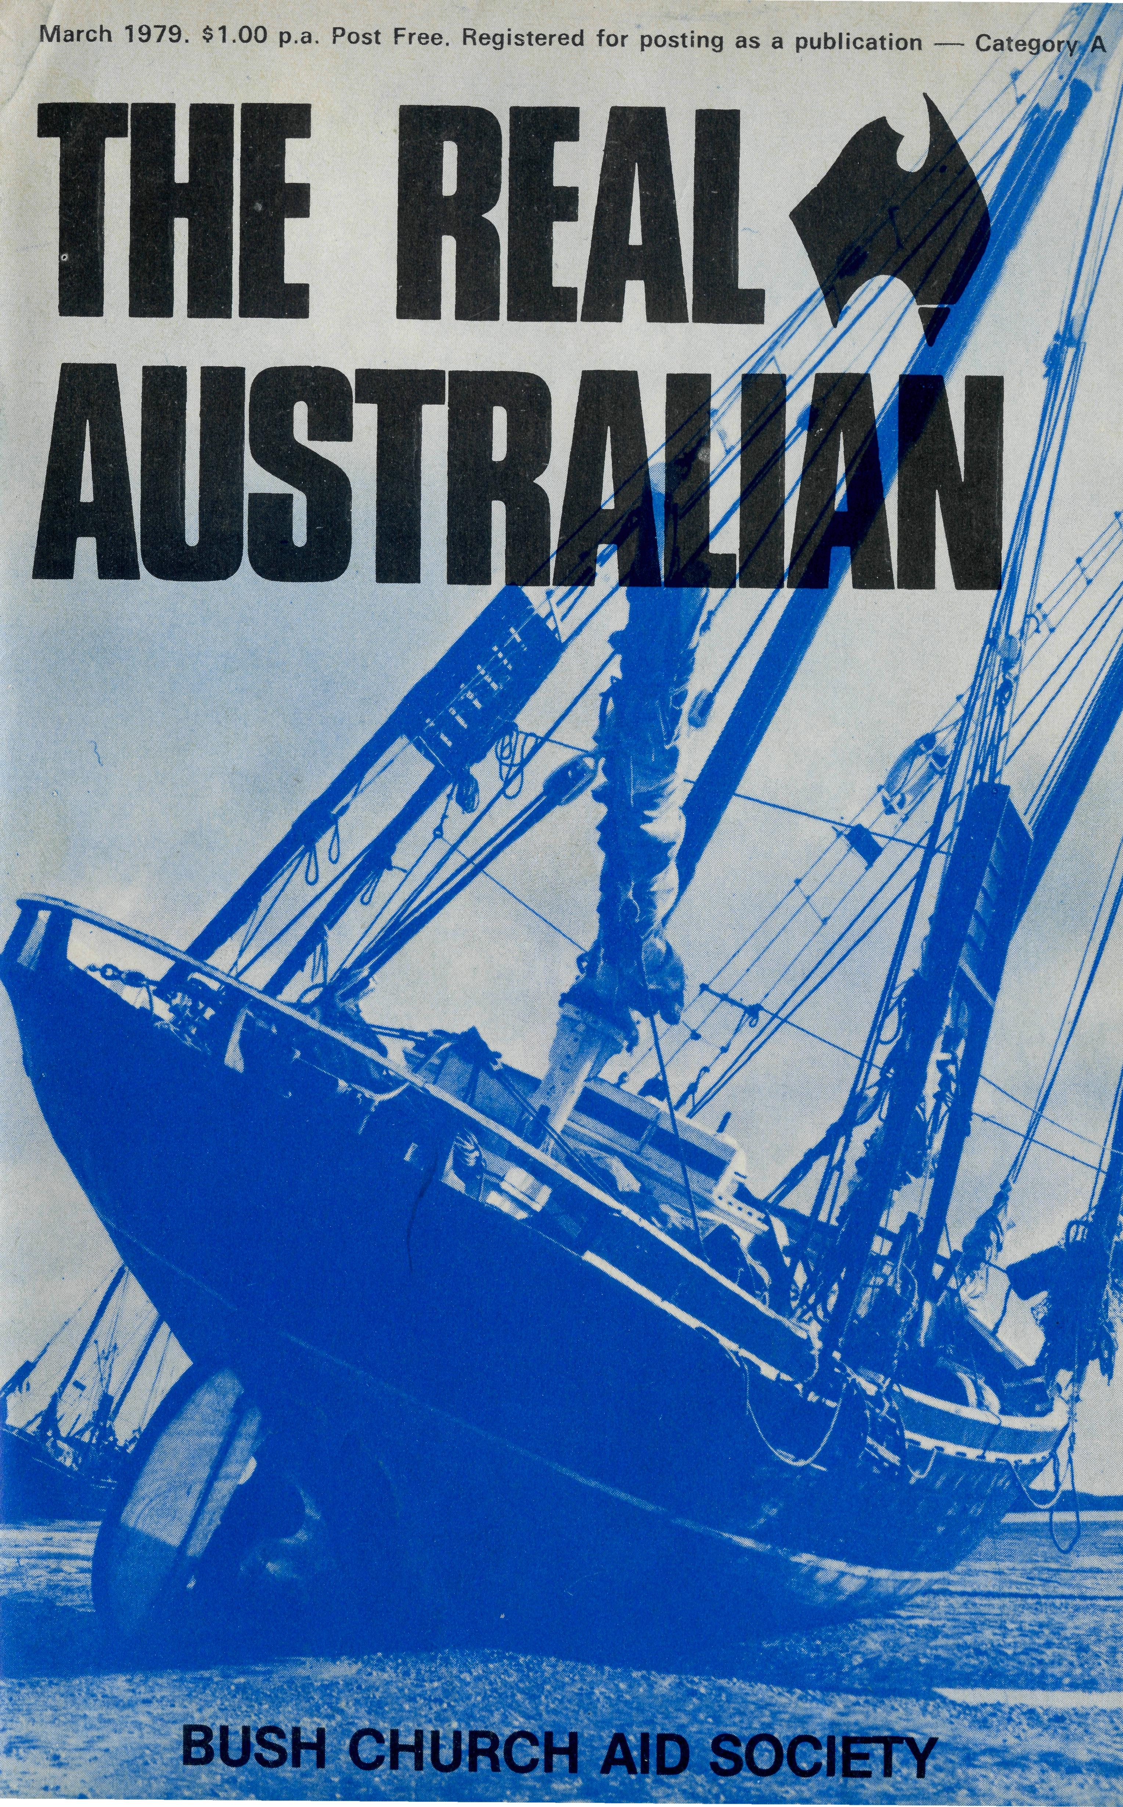
Friday May 25th
SYDNEY 60 YEARS
CELEBRATES ^{0F}
B.C.A.'s SERVICE
FOR CHRIST IN OUTBACK AUSTRALIA
ST. ANDREW'S CATH6DRAL
Bishop Graham Delbridge will be the preacher for the occasion at the Thanksgiving
SERVICE § *30pttl CATHEDRAL
Light refreshments in the Chapter House at 7.30 p.m.
RALLY f'OOpttl ^{CHAPTER} HOUSE
Missioner Chris Gierke from Leigh Creek, S.A. The Three Screen Audio Visual "Wonderful World"

State Office Directory.
Federal Secretary — The Revd. T. J, Hayman.
N.S.W. Secretary and Editor — The Revd. Wakely Wade.
B.C.A. House, 135 Bathurst Street, Sydney, N.S.W. 2000.
(02) 26-3164, 26-3780. Telegraphic Address: "Chaplaincy", Sydney
Victorian Secretary — The Revd. Ernest Horth,
3rd Floor, Clark Rubber Building, 196 Flinders Street,
Melbourne, Vic. 3000. Phone: (03) 63-8962.
Queensland Secretary — The Revd. G. Ezzy
P.O. Box 37, Dalby, Qld. 4405. Phone: (074) 62-2071.
Western Australian Deputationist — Canon E. W. Doncaster
Anglican Rectory, 49 Berkeley Crescent, Floreat Park, W A 6014
Phone: (09)387-1304.
South Australian Secretary — The Revd. David Eastway
350 King William Rd., Adelaide, S.A. 5000. Phone (08) 212-4838.
Patron — The Most Reverend Sir Frank Woods.
President-- The Most Reverend Sir Marcus Loane, Archbishop of Sy
Vice-Presidents — Bp. G. R. Delbridge and Mr. H. M. Bragg.
Chairman of Council — Dean Lance Shilton
Honorary Treasurer — Mr. R. T. Stokes.
Printed by Ambassador Press Pty. Ltd., Granville I

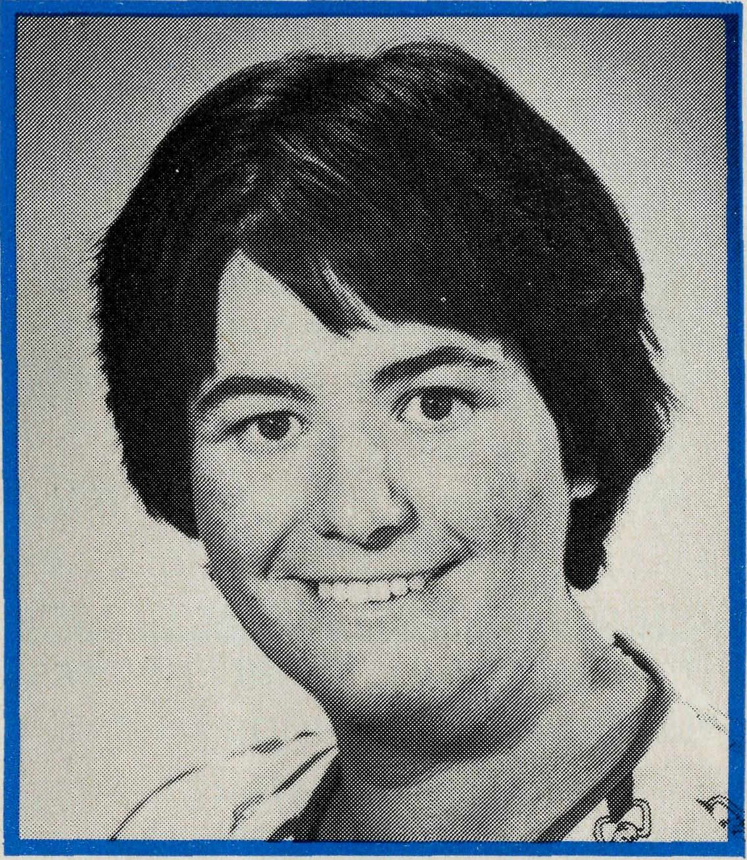
from the Federal Secretary
Sister Helen Plumb
Helen who hails from Bega on the far south coast of N.S.W. is now the Nursing Sister in charge at Tarcoola Hospital in South Australia. Her bright witness, cheerful manner and efficient concern will no doubt commend her to the station and railway folk of that outback town. She offered to the Society while doing her midwifery training at Launceston Hospital in Tasmania. It is not the first time that Helen has been to Tarcoola, she went out in a voluntary capacity to see just what it was like for a period last year. Whilst in Tasmania she has been an active member of the congregation of St. John's, Launceston where Canon Ian Booth, a former B.C.A. missioner and Victorian State Secretary is the Rector.
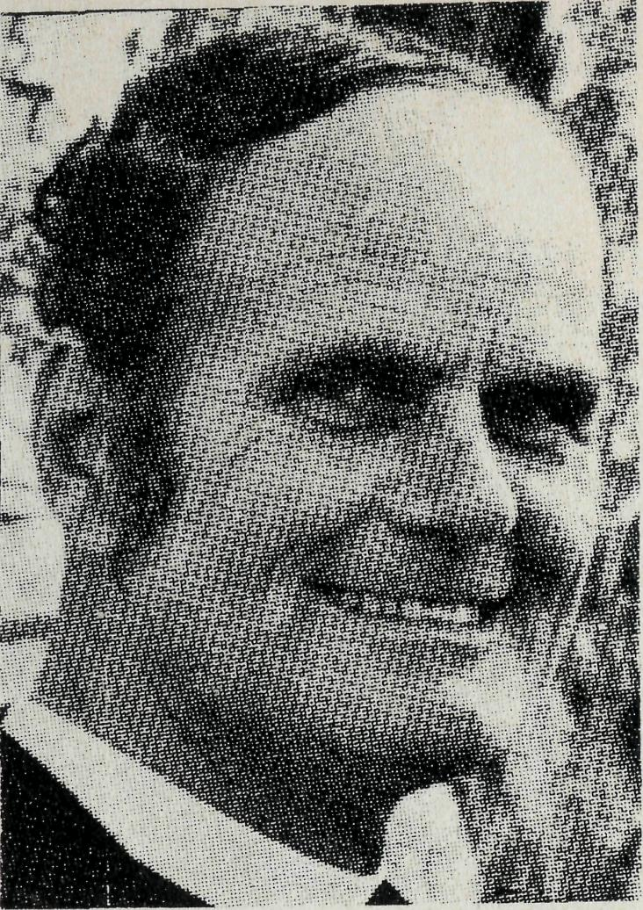
We welcome the "Year of the Child", especially as the late Mrs. Maureen Bomford, wife of the Anglican Rector of Springwood, N.S.W., had so much to do with the promotion of it. In this edition you will read about the B.C.A. pioneer work in Mail Bag Sunday School. Later, again primarily for outback children, there was a Confirmation study book. This has been rewritten by the Dean of Sydney, the Very Reverend Lance Shilton, our present Chairman. It is based on the new Prayer Book and will be available shortly as the only Confirmation study of its kind in Australia.
The School of the Air in its present personal form was pioneered by B.C.A. There had been a system of broadcasts from a school class called the "School of the Air". However, correspondence schooling is parallel but different from that taught in the schools and provided no personal incentive for the sheep station children to settle down to their books. The Society's struggle against the then bureaucratic opposition was well worth it for the benefit of the outback child. It proved so satisfactory that now all Royal Flying Doctor Service networks have the "School of the Air".
Medically, help in the care of children has been part of the constant work of our Sisters. Especially our pioneering of the "flying dentist" greatly benefited many outback children who would have seen a dentist only on holidays!
Among the most responsive of people to the Gospel have been the children of the outback, who would remember your Scripture lesson from a month before! The care of children is indeed very important.
In closing we regret that Archdeacon Robert Fillingham has had to resign from a number of committees and from the Chairmanship of B.C.A. His interest in the Society has been strong for a number of years. He has been a very valuable jovial friend and adviser with a breadth of experience and always interested in people. We have been proud to have him as our Chairman.
Your friend.
Two Front Tassie
To Tarcoola To Normanton
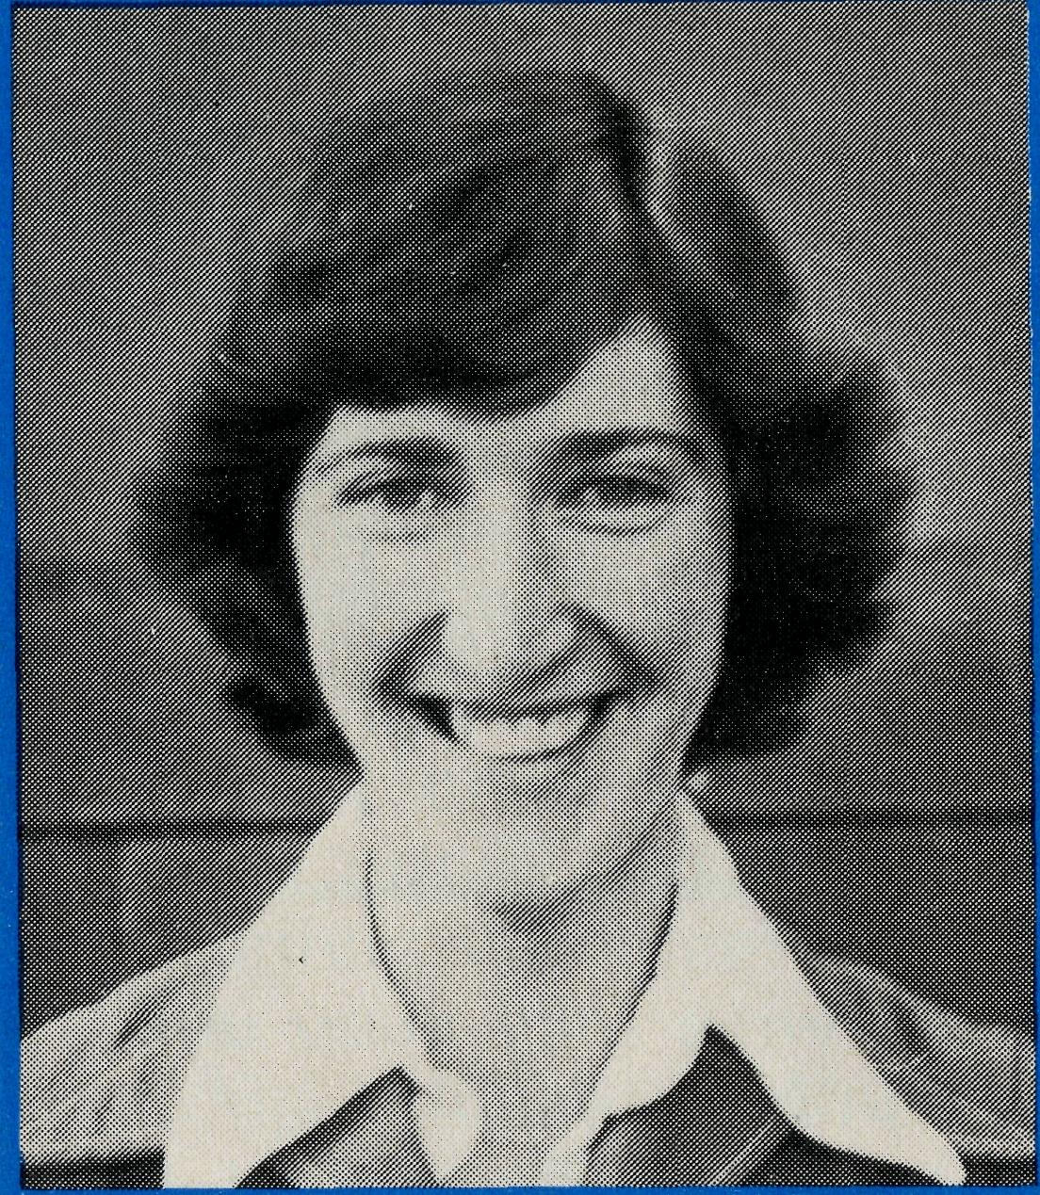
Miss Anne Watkins
Anne is an English girl who becomes the very first "Associate Field Staff member of B.C.A. having commenced duties as the teacher-in-charge of the Carpentaria Pre-School Kindergarten in Normanton at the start of the school year. It was in Tasmania whilst teaching there that Anne felt the call to serve God in Australia's outback and offered to B.C.A. Her parish, the Cathedral Parish of St. David's, Hobart, has assured her of its prayerful support as she goes to work in our tropical north in the fellowship of the Society.
* Associate Field Staff (A.F.S.) membership of B.C.A. is a new category similar to M.S.A. classification within the Church Missionary Society.

THE REAL AUSTRALIAN
THE REAL AUSTRALIAN

on outside activities. On Saturday mornings there is an open art and craft club for all age groups and the children have great fun with boxes, glue, and paint just doing what they like.
Sunday School always gives us a blessing as the children are so receptive to God's Word. They love singing and always choose the choruses with energetic actions and for some time now their favourite song has been about rebuilding the walls of Jerusalem. It gave us great joy to hear a little boy singing at the top of his voice as he was going down the street, "Nehemiah you must go, you must go, you must go to Jerusalem."
Tarcoola is expanding and will continue to do so for some while. The present population is about two hundred people. The hospital serves a large area around Tarcoola as well as along the track. It therefore provides a vital service for the people of the area.
B.C.A.'s involvement here is an important link for these people to the Christian way of life. We have a good back up in our work by Rob McEwin who teaches Religious Instruction at the school and holds a church service on his regular visits. Although our stay here will be short we ask the Lord that, the love, peace and happiness He has given us in our lives will reflect on the people here.
CONGRATULATIONS
It is with great pleasure we learn that our deputationist in Western Australia, the Reverend Ted Doncaster has been made a Canon of St. George's Cathedral, Perth, by Archbishop Sambell.
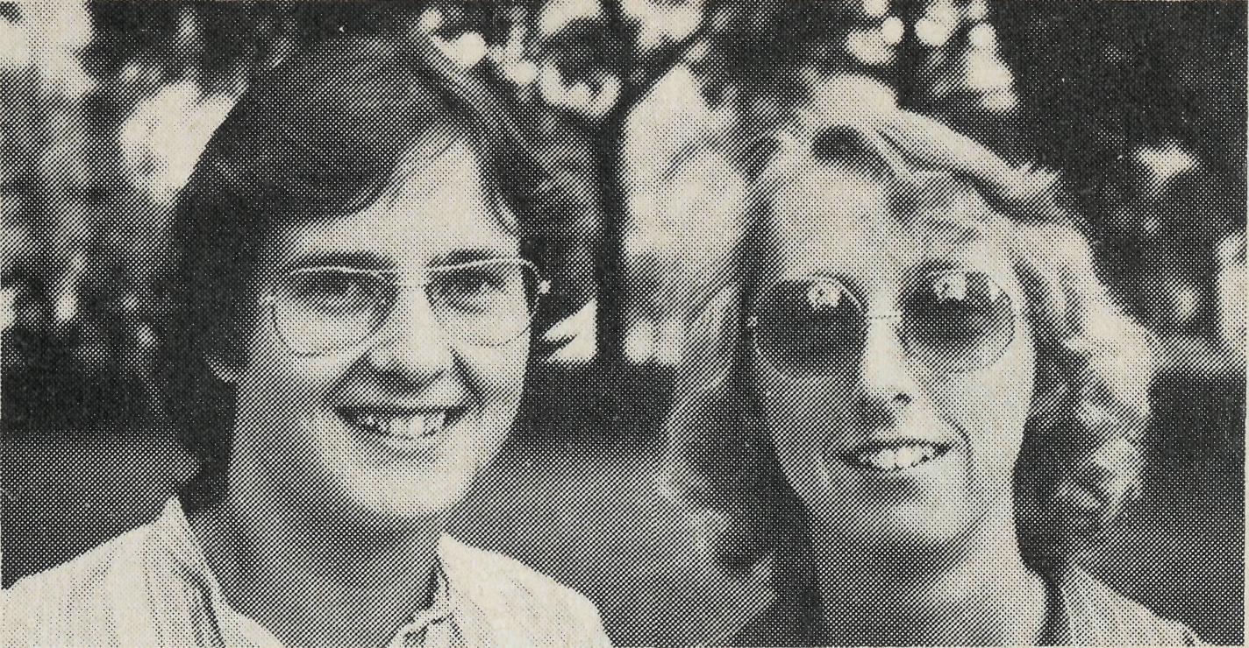
J ARCOOLA HOSPITAL
SISTERS JANET STIFF AND MERRYL HOWARD
Jan and I praise the Lord for the opportunity of working for B.C.A. at Tarcoola. We knew little of Tarcoola prior to our appointment and even less about the life along the Line. Tarcoola, now an important railway junction, is surrounded by five sheep stations, Commonwealth Hill being the largest. This combined with the beautiful position of the town set in the middle of low hills makes Tarcoola a rewarding and pleasant place to work.
Our day always starts with a warm greeting from our friendly dog Dasher who is constantly on a diet. At eight o'clock every morning the Flying Doctor's radio schedules start, they broadcast five times a day giving us contact with the doctor when necessary. Otherwise they keep us up-to-date with the happenings in the surrounding area.
In our daily clinics we have a steady flow of patients, some for routine visits such as baby weighs, others for minor illnesses and casualties on the track. This is where the bulk of our time during the day is spent. It is only on the odd occasion that we have an in-patient.
Out of clinic hours we are never short of things to do, there is always preparation for the children's clubs and Sunday School and the hospital being built on two plots of land there is an enormous garden needing endless attention.
The hospital is considered a general meeting place for the ladies of the town. We thank the Lord that we are looked to in other ways outside our nursing duties. During the day the kettle is always on the boil for pots of tea. Contrary to the idea that the British are great tea drinkers, Jan and I are still battling to acquire a taste for so much of it!
Each week a Macrame-cum-craft night is held at the hospital, which is always well attended by town and station ladies. On some evenings the amount of Macrame or craft done is debatable, but the time is certainly enjoyed by all.
Two evenings a week we hold clubs for the children. We vary the activities to suit both the girls and the boys. Some of the winter activities were tie-dyeing material, mobile making, games and the most popular one cooking. The main reason for this is that the children always taste what they make and take some home for the family to try. Now the summer is here we are concentrating
4 THE REAL AUSTRALIAN
Hospital Help
We wish to record, albeit belatedly, our appreciation of the willing service of Sister Margaret Halliday of Sydney, who relieved at the Bishop Kirkby Memorial Hospital in Cook for the month of January in 1974, 1975 and 1976. Margaret is now in France doing a special course in preparation for overseas missionary service. This year we were very pleased to have the help of Dr. Phebe Uy from the Philippines, at Tarcoola Hospital in February; and Sister Elizabeth Pike and Mrs. Elizabeth Hake in January at Cook when Rhonda An-stee was in hospital in Perth for treatment on a spine injury.
THE REAL AUSTRALIAN
Groote Eyiandt
Late last year the Bishop of the Northern Territory, the Right Reverend Ken Mason, asked B.C.A. to find an ordained man and his support for Groote Eyiandt. He would be called upon to minister to the Gemco miners and give support to the Aboriginal Church on Groote and to fly regularly to Nhulunbuy on the Gove Peninsula. We praise God that the Reverend Bruce Hansford, at present priest in charge of St. John's, Lilydale, in Melbourne Diocese has been accepted for this task, and with his wife, Marcia, and two children, Michael and Christopher, will be going to Groote in March.

SUNDAY SCHOOL COMES IN A JIFFY BAG
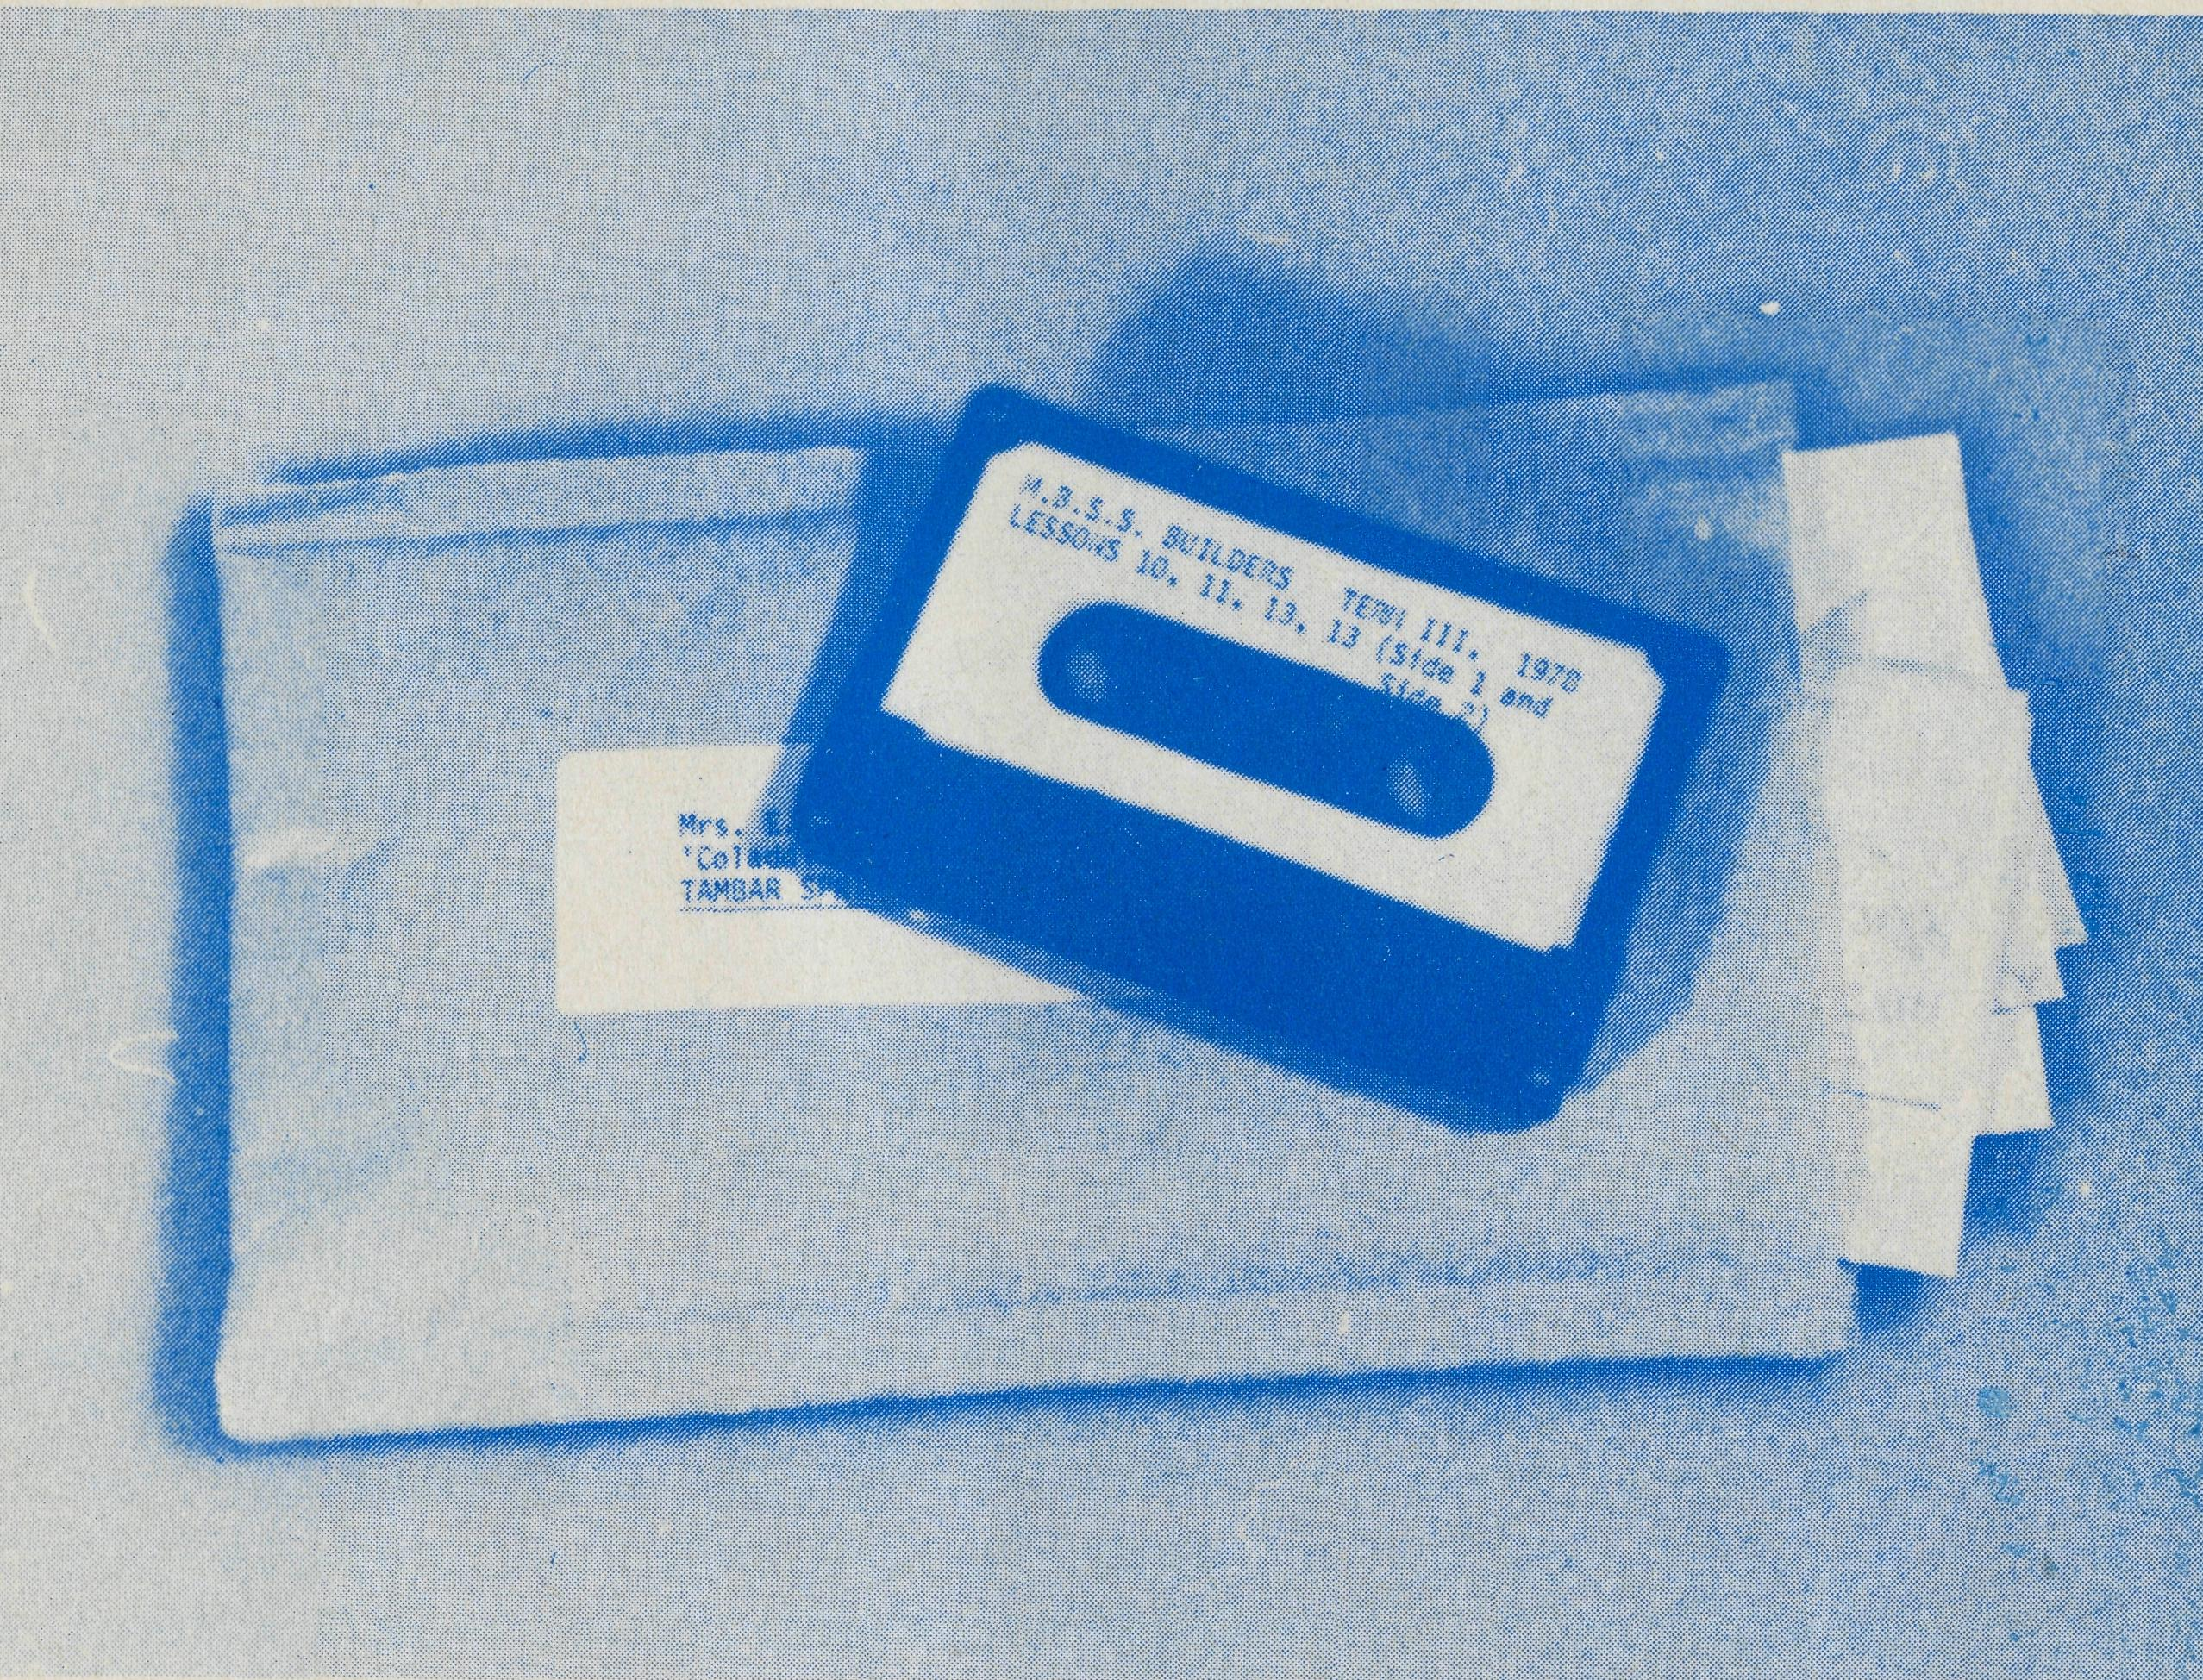
Children in isolated areas of Australia will not be forgotten in the International Year of the Child as far as their Sunday School lessons go — or at least we hope they won't. For many years the work of the Mail Bag Sunday School has helped clergy and parents present the Gospel to children. It would seem that the Bush Church Aid Society was the pioneer in the organization of an extensive Sunday School by correspondence, having begun in this field on Advent Sunday in 1922 with the Reverend A. J. H. Priest preparing lessons assisted by Mr. T. N. Griffen. An interesting note occurs in the report of S. J. Kirkby, first Organizing Missioner of B.C.A. for 1922, "Deaconess Shoobridge of East Gippsland who has been the pioneer of this branch of work in the Anglican Church in Australia, has encouraged us much by adopting our lesson system for the numerous scholars in her district". Later Miss Rose Campbell was responsible for the leadership of the Mail Bag Sunday School for a number of years followed by Mr. Laurie Calder until 1970 when it was resolved to hand it over in N.S.W. to the Anglican Board of Education. In other States the local Diocesan Christian Education Organizations undertook to care for the Religious Education of outback children.
THE REAL AUSTRALIAN
Although B.C.A. is no longer responsible, it would wish to commend the Mail Bag Sunday School and indeed other organizations seeking to teach the Word of God to people in remote areas of our great country.
You may ask what is today's Mail Bag Sunday School about?
• It is a service for children who are prevented by distance, circum
stance, etc., from attending a weekly Sunday School.
e.g. A 12 years old girl living on a fishing trawler in the Gulf of Carpentaria.
- Its regular age grade lessons are based on the Trowel syllabus — it is therefore Biblical and Australian.
- Its interesting lessons are presented on cassettes in such a way that there is family involvement, particularly at the infant school age level, and primary lessons are designed so that a child can work (without supervision) with written activity material. Simple lesson aids reinforce the teaching.
- Parents are asked to contribute towards the cost but in many cases cannot afford to meet total costs — particularly where a large family is involved.
We believe it has a real part to play in the life of the Church in isolated areas of Australia and it would be ironical, if in the Year of the Child when the rights of a child and "care" are the themes that some of our children should be denied the right to learn more of Jesus Christ. B.C.A. has made a sizable grant to Mail Bag Sunday School for 1979.
If you wish to know more about Mail Bag Sunday School or wish to assist in the maintenance and extension of its important ministry write to:
Mail Bag Sunday School,
Anglican Board of Education,
P.O. BoxA287,
Sydney South, N.S.W. 2000.
YES, THERE'S STILL ROOM FOR YOU —
but be quick if you wish to share in the 1979
"GO . .. SEE FOR YOURSELF" TOUR TO THE
"LAST FRONTIER" by plane, coach and train to and from North
West Australia, 25 days.
Departure 5th July, 1979. Cost $1,672.00.
Contact Mrs. Joy O'Neill on (02) 26-3164.
THE REAL AUSTRALIAN 7

Revd. Ron Robins — Derby, W.A. It sounds very exciting and many trrJ^s it is. Why? Because the Lord's ministry is reaching out to jaf^jpje all over the Kimberleys. Yes, it goes by sea, by land, by air_{v} /?/m I -
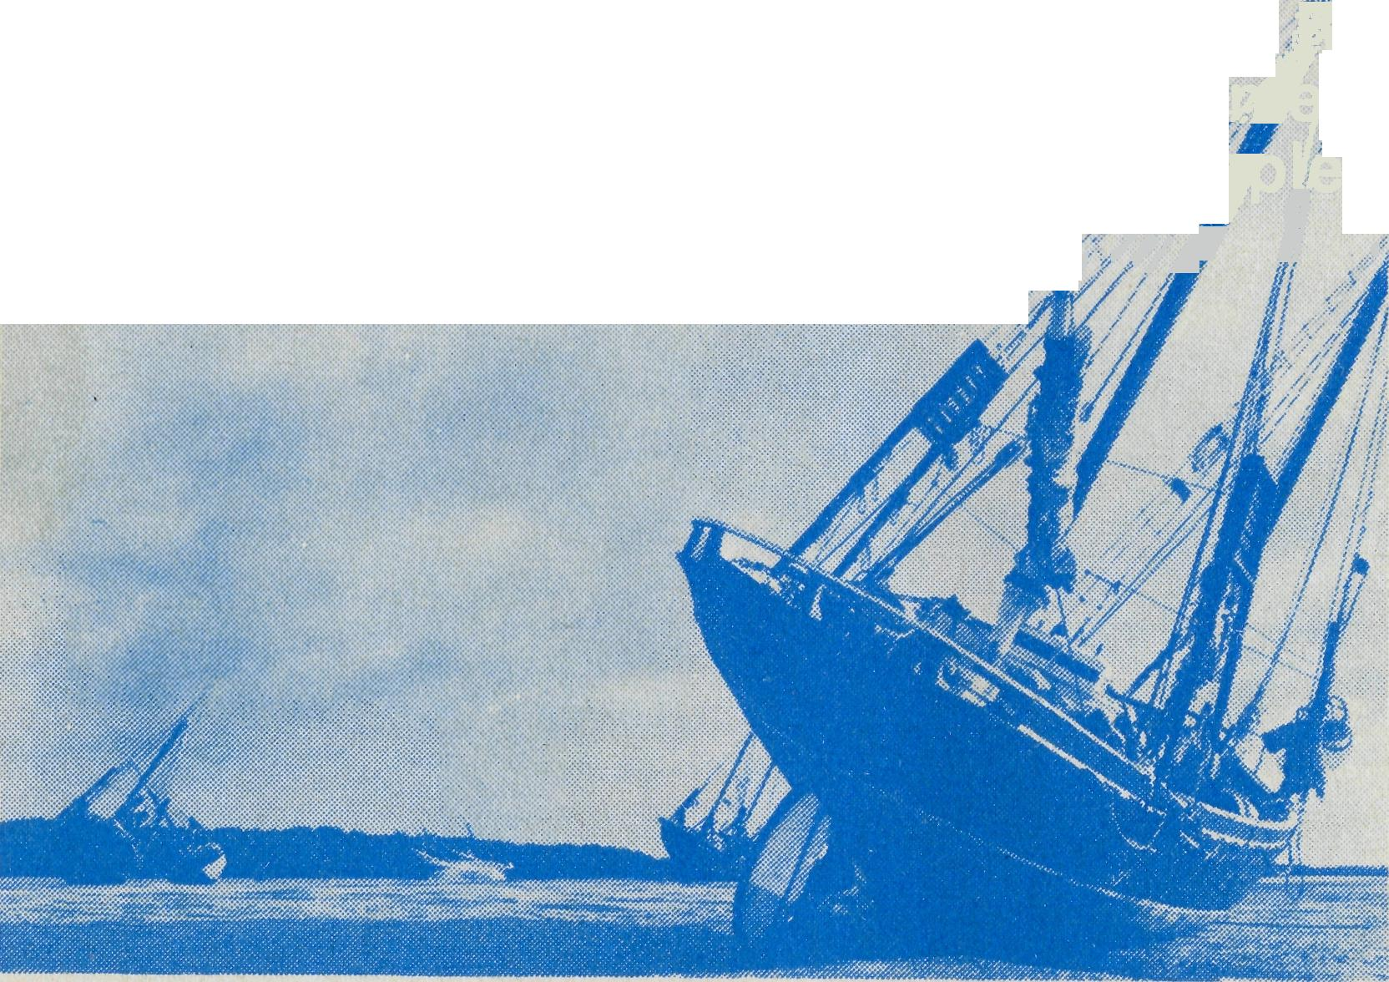
SY SEA > BY LAND > BY AIR
Pearling Luggers at low tide Broome, N.W. Aust.
around the cattle yard and then it's off to Fossil Downs across more land bringing people the Good News of Jesus Christ.
And now by air. This time it's over to Koolan and Cockatoo Islands by a small twin engine plane hired by Dampier Mining Company. Over on these iron ore islands there are schools to be visited and many families to talk to. By plane each week come representatives of the churches to make plain to these people that Jesus cares about them.
And so it is that wherever there are people in outback Australia, wherever there is a need that the church can minister to, and whether that ministry has to go by sea, land or air, IT WILL BE DONE because we are people who love one another as Jesus has loved us. Pray for us that this ministry travelling as it does by sea, land and air, will continue to be blessed by God and above all pray for those whom B.C.A. ministers to in your name.

By sea from Broome in a pearling lugger and some 26 hours later I arrive at Kuri Bay where there is a thriving pearling industry. It is a very beautiful trip in and out of tropical islands with the lugger ever moving forward in the aqua coloured Indian Ocean; beautiful that is if it is calm; but if there is a swell or rough seas, something the opposite, something best left unsaid or left to the imagination. I am no sailor but go I must because some 50 to 60 Thursday Islanders eagerly await their Rector who can usually only get there once a quarter. How many churches in our big cities would be full fifteen minutes before the scheduled service time with practically the whole congregation in prayer or reading their prayer or hymn book?
How many communities have their leader get up at 5.30 a.m. in the morning and hear him saying morning prayers at the door of each hut where his men are getting ready for the next day's work? Such is the calibre of the head man Alum Mene at Kuri Bay. I minister to the Thursday Islanders in Jesus' Name in both Word and Sacrament and I know it is appreciated. What more reward do I want. Back to Broome with a prayer for smooth seas and then back to Derby to my wife and family and to preparations for the next trip in a couple of days, this time over land to Fitzroy Crossing.
Fitzroy Crossing is some three hours drive across flat, scrubby land to a dumpy little town which spreads itself out as far as possible along the Fitzroy River. Hot, dry and thirsty. Yes, that's the town and it could also describe the spiritual condition of the place. A new hospital with some four nurses and four times as many patients need to be visited, and then across land into the hot dry dust to visit some of the cattle stations nearby.
At Brooking Springs two teenage girls need to have Confirmation Classes and to be encouraged to follow Jesus Christ. These girls have all their school lessons over the outpost radio. One can sense that they appreciate a more personal approach from the Rector. Will they be faithful? A talk to the men who are busy

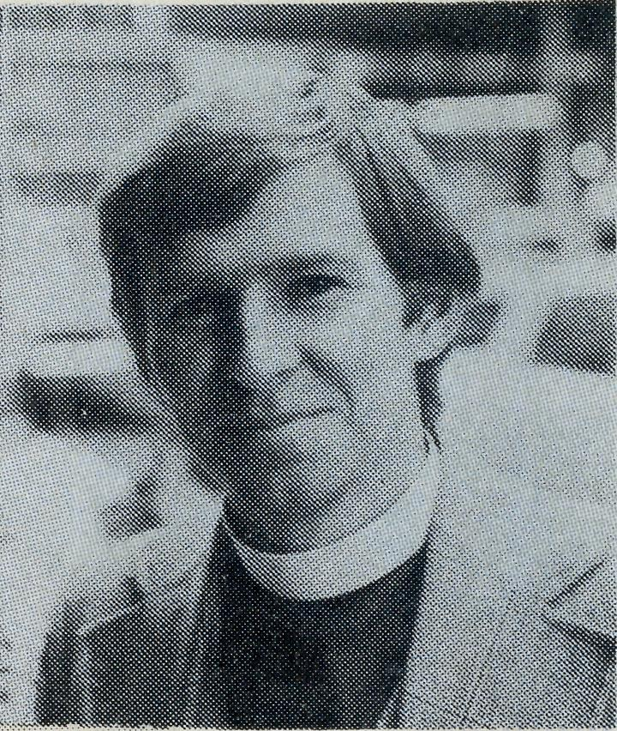
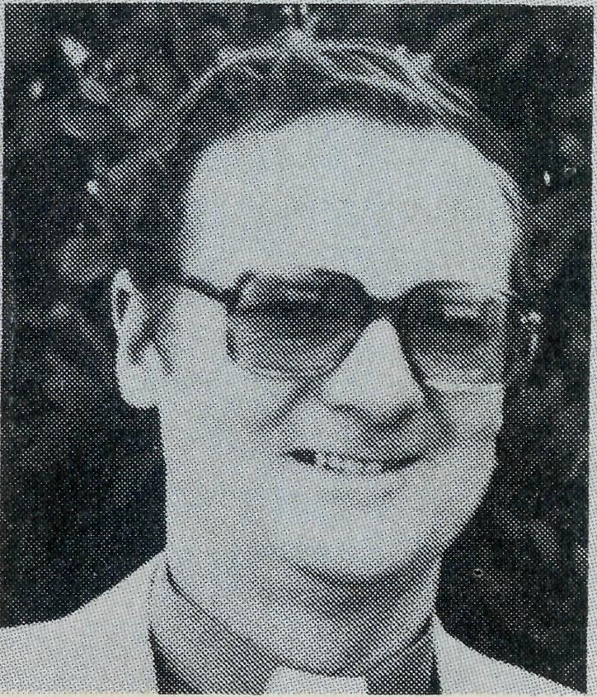
Revd. David Eastway
Revd. Ernest Horth
- The Reverend David Eastway, formerly missioner in Menindee/ Ivanhoe Parish, N.S.W., accepted the invitation of the Society to be the South Australian Secretary and with his wife, Carlene and children, Karina and Paul, moved to Adelaide in February. After some twelve months without a State Secretary the South Australian Committee is much encouraged and have given the Eastways a very warm welcome.
- We welcome the Reverend Ernest Horth to the family of B.C.A. In accepting the position as Victorian Secretary he said "I am looking forward to the new challenge especially as I believe God has directed me to this task. It's rather exciting wondering what He has in store". Ernest comes from an interesting and varied background having been converted while in the R.A.A.F., trained for Holy Orders in Ridley College, serving his curacies in St. Paul's Cathedral Parish, Sale, and Holy Trinity, Moe, in the Diocese of Gippsland and St. Faith's, Narrabeen, in Sydney. Then a term of service as an Army chaplain full time from 1968 to 1974 after which he became the Vicar of St. Aidan's, Parkdale, from which he felt the call of God to serve with the Society. His wife, Ida, a nursing Sister, worked with the Leprosy Mission in India from 1959 to 1962. They have two children, Kathryn, 12 and Louise, 11.

THE REAL AUSTRALIAN
THE REAL AUSTRALIAN

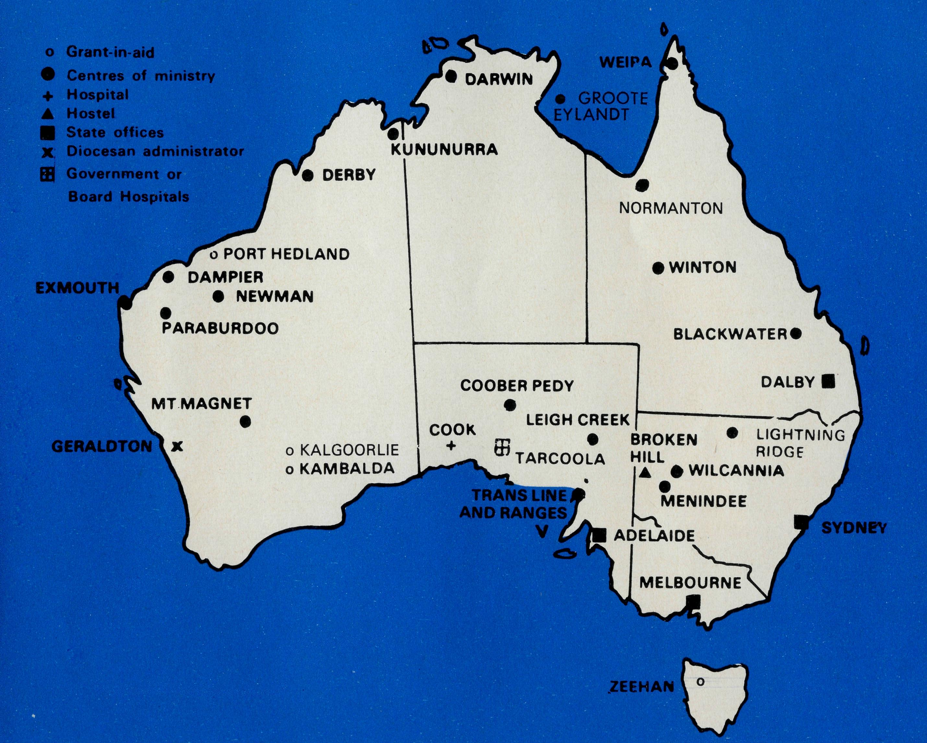
Adelaide
The Medways from Coober Pedy had an encouraging visit to Adelaide at the invitation of the South Australian Committee in October last. Both Julieanne and Kerry spoke at a very successful luncheon occasion at St. Matthew's, Marryatville, capably organised by Mrs. R. Perry and Kerry addressed the Rally at Christ Church, North Adelaide. Christmas Appeal
We rejoice in the goodness of our God — gifts from all States amounted to $17,803 (when this copy had to go to the printer) as against $15,729 last time. This indicates an increase of over 12%. We thank all who gave so generously.
• The Parish of St. Andrew's, Cronulla has had a particular interest in the Youngs and have adopted them as their own missionaries serving with B.C.A. The parish heard that the hostel's washing machine had broken down and repairs couldn't be effected and so they sent $400 to the Youngs to rescue them from a very awkward predicament. Here is a note that the parish received from the Youngs, "We were really overwhelmed with the gift from St. Andrew's people. We felt a little like Nehemiah when he was building the walls, we not only have enough to buy a washing machine, but also a dryer. Would you please thank the people sincerely for their generous gifts and prayer support, Yours in Him, Ken and Pam Young".
io
Worthwhile Youth Idea
A Sydney Rector had an outing for his Confirmation Class one day in the May school holidays last year. His objective was to enlarge the view of the Church and its mission in the minds of the young people. They visited the great Synagogue to inspect a biblical archaeological exhibition, called at the Church Missionary Society to hear about overseas missionary work and climaxed their day by coming to B.C.A. House to meet the Federal Secretary and to see an audio visual about B.C.A. work Australia-wide.
• Mrs. Maisie McLeod, a former field worker and enthusiastic organiser of prayer support for B.C.A. at Nuffield Village, considered last year's Country Conference at Gilbulla, Menangle, (N.S.W.) held in mid-September, to be the best ever. Unfortunately numbers were down on previous years, but those who attended expressed how much they valued the fellowship one with another and the ministry of the Reverend David Eastway (Menindee) and Captain Les Fernance (Lightning Ridge) with their first-hand reports from the field, and the Reverend Tony Lamb's thought-provoking Bible Studies.
OUT SOON!
NEW B.C.A. PUBLICATION
A Confirmation Handbook
"YES CERTAINLY"
THE REAL AUSTRALIAN
THE B.CA PRAYER
A DAILY PRAYER
0 Lord our God, help us to remember those who live in the remote parts of our land. We ask You to bless those.whom You have called into the fellowship of The Bush Church Aid Society. Grant that, through the ministry of the Word and Sacraments, through healing, and through caring for the young, the message of Your redeeming love may be proclaimed, through Jesus Christ our Lord. Amen.
0 God, we remember before You those whom You have called to Your service. We ask You to bless
, assure
them of Your Presence, and call others to stand with them in the task. Grant to them, as to us, the joy of service, the ability to achieve, and the serenity of Your peace, for Jesus' sake. Amen.

PRAYER CALENDAR

FIELD STAFF DIRECTORY
NORMANTON

DIOCESE OF NORTHERN TERRITORY. The Rt. Revd. K. B. Mason.
- Darwin — Miss Coryn O'Nians (Nungalinya College), Sister Patricia Dahl (Nightcliff).
- Groote Eylandt — The Revd. Bruce and Mrs. Marcia Hansford.
DIOCESE OF NORTH WEST AUSTRALIA. The Rt. Revd. H. A. J. Witt
- Kununurra — The Revd. Royce and Mrs. Susan Thompson.
- Derby — The Revd. Ron and Mrs. Ann Robins.
- Newman — The Revd. Don and Mrs. Libby Wilson, Port Hedland (grant). The Revd. Peter Thompson.
- Dampier — The Revd. Bill and Mrs. Jocelyn Ross, Revd. David and Mrs. Helen Mansfield.
- Paraburdoo — Archdeacon Randal Deasey — Locum Tenens.
- Exmouth — The Revd. Peter and Mrs. Elizabeth Mills.
- The Murchison — The Revd. Bill and Mrs. Joan Hoare.
10 Geraldton — Mr. Stan and Mrs. Dorrie Hummerston — Diocesan Administrator.
DIOCESE OF PERTH. The Most Revd. G. T. Sambell.
11 Kalgoorlie — grant. The Revd. Canon Frank Watts, the Revd. Dennis Reynolds.
Kambalda — grant. The Revd. Robert Hanson.
DIOCESE OF WILLOCHRA. The Rt. Revd. B. S. Rosier.
- Cook Hospital — Nurses Mr. Keith and Mrs. Rhonda Anstee.
- Tarcoola Hospital — Sister Helen Plumb.
- Coober Pedy — The Revd. Kerry and Mrs. Julieanne Medway.
15 Gawler Ranges and Trans. Line — The Revd. Robert and Mrs. Phyllis McEwin.
1 6 Leigh Creek — The Revd. Chris and Mrs. Marilyn Clerke.
DIOCESE OF TASMANIA. The Rt. Revd. R. E. Davies. 1 7 Zeehan — grant. The Revd. Roy Dixon.
DIOCESE OF RIVERINA. The Rt. Revd. B. R. Hunter.
- Broken Hill Boys' Hostel — Mr. Ken and Mrs. Pam Young.
- Menindee — Vacant.
- Wilcannia — The Revd. George and Mrs. Hazel Fuhrmeister.
DIOCESE OF ARMIDALE. The Rt. Revd. P. Chiswell.
21 Lightning Ridge — Captain Les and Mrs. Pat Fernance.
DIOCESE OF ROCKHAMPTON. The Rt. Revd. J. B. R. Grindrod.
- Winton — The Revd. Robert and Mrs. Rigmor George.
- Blackwater — The Revd. Stephen and Mrs. Pam Rigby.
DIOCESE OF CARPENTARIA. The Rt. Revd. H. T. U. Jamieson.
- Weipa — The Revd. Malcolm and Mrs. Chris Babbage.
- Normanton — The Revd. Jim and Mrs. Margaret Hudson, Miss Anne Watkins. (A.F.S.).
GENERAL.
Federal and N.S.W. Office.
26 Federal Secretary. The Revd. Theo Hayman.
N.S.W. The Revd. Wakely Wade, Eric Atkin, Miss Doris Smith, Mesdames Joy O'Neill, Dora Warwick and Nina Allan.
- VICTORIA. The Revd. Ernest Horth, Mrs. Shirley Bailey.
- QUEENSLAND. The Revd. Greg Ezzy (Deputationist and Secretary). WESTERN AUSTRALIA. The Revd. Canon Ted Doncaster (Deputationist).
- SOUTH AUSTRALIA — The Revd. David Eastway, Mrs. Phyllis Linton.
- The President, The Most Revd. Sir Marcus Loane, Chairman, Dean Lance Shilton, Honorary Treasurer, Mr. Richard Stokes, The Council, State Committees, Staff Replacements, Box Secretaries, B.C.A. Supporters.
31 National Home Mission Fund.

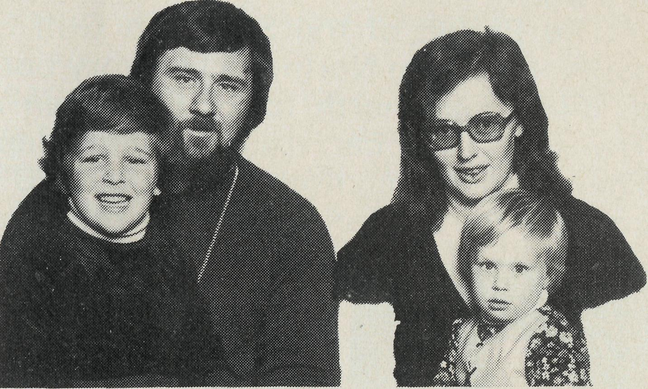
First Impressions
PLUS
from the Hudsons
For a Gippslander accustomed to abundant supplies of rain, green grass and rich vegetation; coming to North West Queensland is like going to another land.
The sight of masses of salt pan, or areas where there are trees no more than 12-15 feet high; animals which look like living skeletons, are grim reminders of the harshness of the climate.
To enter the Southern Gulf from the east means travelling over about 250 kilometres of rough, corrugated road. Fortunately the road is both straight and wide allowing the driver to "find" the best route.
Along the way are the remains of the past. Old machinery from the late 19th Century remind us of the large communities once here, they remind us of man's thirst to conquer and control the land and to reap its mineral wealth. Mullock heaps tell of man's search for gold and tin. A community which once had 10,000 people now has 200. Buildings of the past age, the courthouse, police station, and shire hall are all being repaired and restored.
The town of Normanton, too, has its surprises for the Southerner. Everything looks and feels drab and dirty. The town is old with wide unsealed streets. Rain last fell in April but was only a passing shower. Last year's wet season didn't happen so now water restrictions are in force.
There is a cultural shock too. The population of the town is about 1000 people, 75% of these are Aboriginal, most live within the town.
People are shy and retiring. They are very wary of strangers but become very friendly after the initial shyness passes.
There are difficulties associated with a community which is divided amongst itself. There is racial tension, the Aboriginal disliking the paternalism of the European, and the European rebellion to providing aid and grants to only the Aboriginal, while he (the European) does without.
On the brighter side is the night life — sunset each day sees a transformation of the area. Because of the heat the animals rest
13
THE REAL AUSTRALIAN

in the shade, but come dusk cats and dogs, especially dogs, seem to appear from nowhere. Like people they like to communicate and spend most of the night "talking" to the acquaintance across town. It is said there are more dogs than people in this town, I think it's true.
The Parish of the Southern Gulf covers the area implied in the name. From the Northern Territory border south to 19° lat., eastward to 144° then north to 17.5° S., an area of about 100,000 miles. Transport is by car, train or plane, depending on weather conditions. There are six centres and about 30 stations to be visited. It is a country thirsty for water and the Gospel. Pray for us.
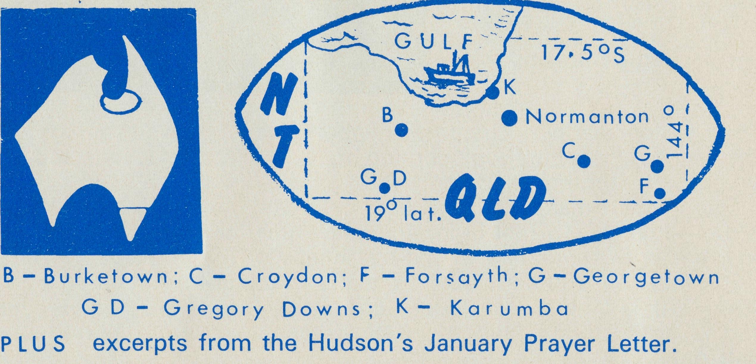
A busy week was spent just before Christmas, visiting all the centres, mostly by plane. How we enjoyed singing the familiar carols and hearing the "Good News" of the birth of our Saviour. Some highlights of the week included holding a service whilst a storm raged outside. The rain drummed so loudly upon the roof we were twice forced to stop and wait for the noise to abate. The next night 120 miles away in the little church of St. Augustine's, Forsayth, insects attracted by the lights, the power for them coming from leads connected to my car battery, made the conducting of the service most difficult and uncomfortable. But there is also a brighter and happy side for more than 250 people attended services throughout the parish over the Christmas week. Seven babies were baptized and through them we were able to emphasize that our Lord was once a helpless baby like they are now.
Thank you too for your many prayers which you are offering on our behalf. We saw the answer to prayer in the completion of the Community Church of St. James and St. John in Karumba. Our first service was held there on Christmas Day and we saw 32 in attendance. Since building began a short time ago, a Sunday School has been formed and a real wave of hope for the future can be witnessed among the people.
The weather has been oppressive of late. Daily temperatures are in the high thirties to early forties. The humidity is very high which results in us moving about like run down clockwork toys, but we
are not alone for in Normanton, the practice is to stop during the heat of the day, most work being done during the early morning. As I write this letter arrangements are being made for the installation of our air conditioning unit which will make life much more pleasant and provide relief for the occupants of the rectory.
As we look to the year ahead, we seek your prayers for our programme. We hope to have Kevin Cullen, of the Church Army, with us during late June and early July, to conduct an evangelical mission. We hope too, to have the Christian Women's Convention here during September. We seek your prayer that men.and women may be drawn to Christ and touched by His Holy Spirit. Also, pray for the growth of commitment within the care groups within each centre.
I give, devise & bequeath
One of the mainstays of our Society's finances is the income received from legacies, bequeathed by those who in their lifetime have- had a concern for the various ministries of our Society.
From time to time we are asked to supply some form of wording that will satisfy legal requirements. Our Solicitors suggest forms of wording for use by those who may wish to remember the work of the Society in this way.
FORMS OF GIFT BY WILL Personal Estate:
/ bequeath the sum of $ (or my shares in ) to
the Bush Church Aid Society of Australia, free of all probate, estate, succession, legacy and other death duties whatsoever to be used by it for its general purposes.
or Real Estate:
/ devise my house property known as to the Bush
Church Aid Society of Australia, free of all probate, estate, succession, legacy and other death duties whatsoever to be used by it for its general purposes.
or Share of Residuary Estate:
/ give devise and bequeath a one share of my
residuary estate to the Bush Church Aid Society of Australia, free of all probate, estate, succession, legacy and other death duties whatsoever to be used by it for its general purposes.

14
THE REAL AUSTRALIAN
THE REAL AUSTRALIAN
15

