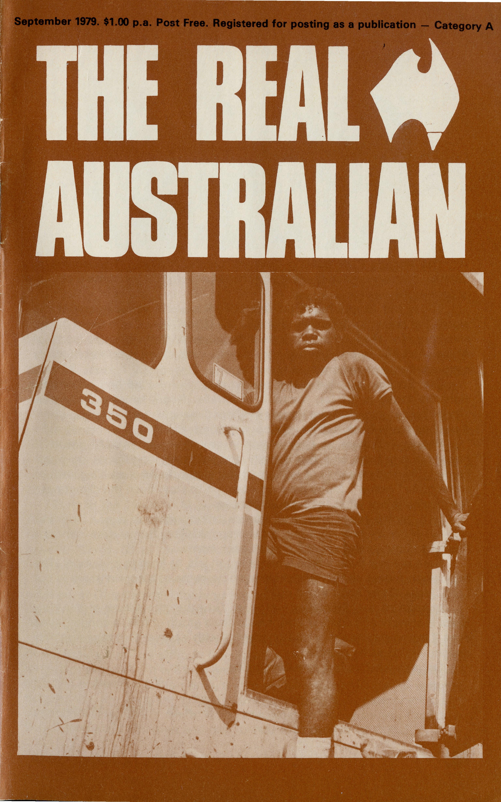
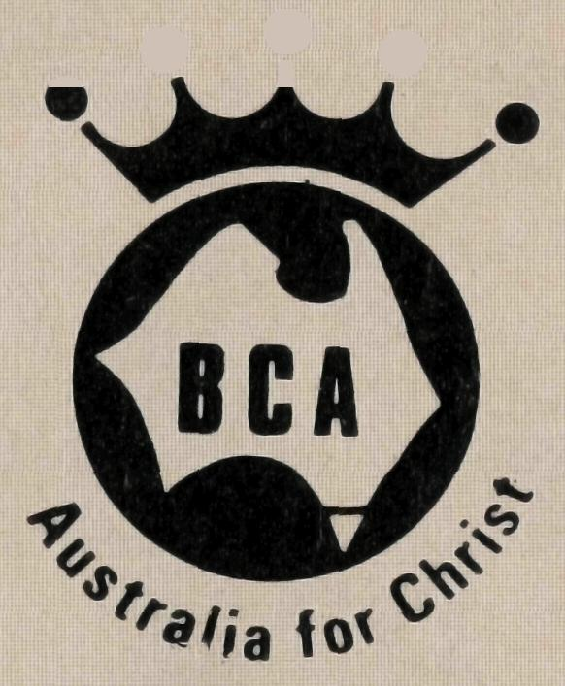
DIAMOND JUBILEE
1979
1919
CELEBRATIONS
MELBOURNE
CENTRAL RALLY in St. Paul's Cathedral Chapter House, Wednesday, 26th September, at 7.30 p.m. Speaker: The Revd. Ernest Horth on his recent field tour. Special musical items.
ADELAIDE
FAMILY RALLY, Christ Church Parish Hall, North Adelaide, Friday, 19th October, at 7.45 p.m. Speaker: The Revd. George Fuhrmeister, Missioner from Wilcannia. Western N.S.W. Attractive Children's segment, special music and audio visual. WOMEN'S LUNCHEON, St. Matthew's, Kensington, Thursday, 18th October. Speaker: Mrs. Hazel Fuhrmeister.
CANBERRA
RALLY. St. John's, Reid Parish Centre, at 7.45 p.m. Thursday, 29th November. Field report from the Revd. Chris Clerke, Missioner Leigh Creek, S.A. Music from "Joysingers", audio visual. Key note address: Capt. Kevin Cullen C.A.
State Office Directory. . .
Federal Secretary — The Revd. T. J. Hayman.
N.S.W. Secretary and Editor — The Revd. Wakely Wade.
B.C.A. House, 135 Bathurst Street, Sydney, N.S.W. 2000.
(02) 26-3164, 26-3780. Telegraphic Address: "Chaplaincy", Sydney.
Victorian Secretary — The Revd. Ernest Horth,
3rd Floor, Clark Rubber Building, 196 Flinders Street,
Melbourne. Vic. 3000. Phone: (03) 63-8962.
South Australian Secretary — The Revd. David Eastway,
350 King William Street, Adelaide, S.A. 5000. Phone (08) 212 4838.
Queensland Hon. Secretary — The Revd. R. W. Herbert, 60 Prospect Street, Wynnum North,
4178. Phone: (07) 396 4354
Western Australian Hon. Deputationist — The Revd. G. W. Thomas, 4 River Road, Kelmscott,
W.A. 6111. Phone: (09) 390 5351.
Patron — The Most Reverend Sir Frank Woods.
President — The Most Reverend Sir Marcus Loane, Archbishop of Sydney.
Vice-Presidents — Bp. G. R. Delbridge, Mr H. M. Bragg, Archdeacon R. G. Fillingham.
Chairman of Council — Dean Lance Shilton.
Honorary Treasurer — Mr R. T. Stokes.
Printed by Ambassador Press Pty. Ltd., Granville 2142.

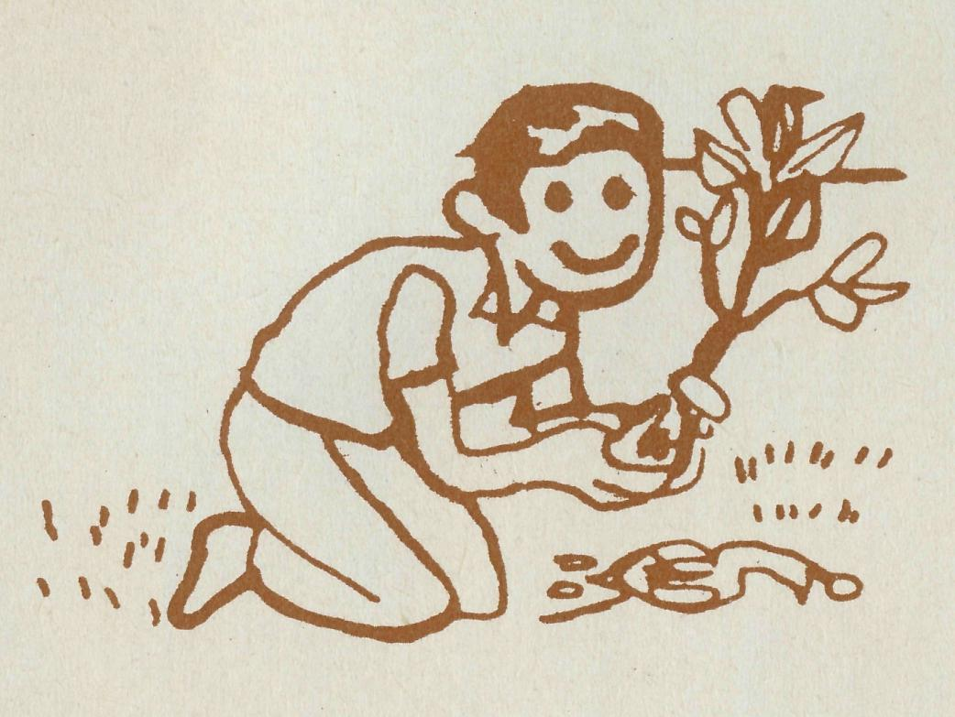
from the Federal Secretary
CHURCH PLANTING
The Apostle Paul, visiting Iconium, Lystra, Philippi, Thessalonica or Corinth, not only preached the gospel but also sought to establish a church or group of believers.
Today this is very much the work of Missions in various parts of the world. For reasons which vary this church planting is easier in some places and countries than others. It is wonderful news that, in some parts of Africa, Asia and South America almost every week there is a new church or congregation somewhere.
Our Society is called to follow the example of Paul and other missionaries today in mining towns in Australia. Nearly always these new "metropolitan suburbs" are remote in sheer distance on the ground, where there has never been a town, school or church building.
People live there as they would in any "keep-to-myself" group of houses in any large city. But socially and spiritually conditions are much harder. There is no sense of belonging. Most people have an allegiance to some other "home". Many have no intention to stay. Even the climate and the locality is not what they would choose.
In a mining town, men and women come with one aim — to make money. Most do not want any local responsibility. Some even continue financial commitments to the church back home.
Here is a real evangelistic work, a tough job, as hard as anywhere. The population moves so fast that those who do come to a commitment in our Lord Jesus Christ soon move on.
In spite of the difficulties we praise God that the power of the Holy Spirit is at work and some missioners do see a group of folk, a congregation even if members change, a church planted with a prayer that the roots may deepen and God be glorified.
Do pray for this first rate evangelism.
THE REAL AUSTRALIAN
Your friend.
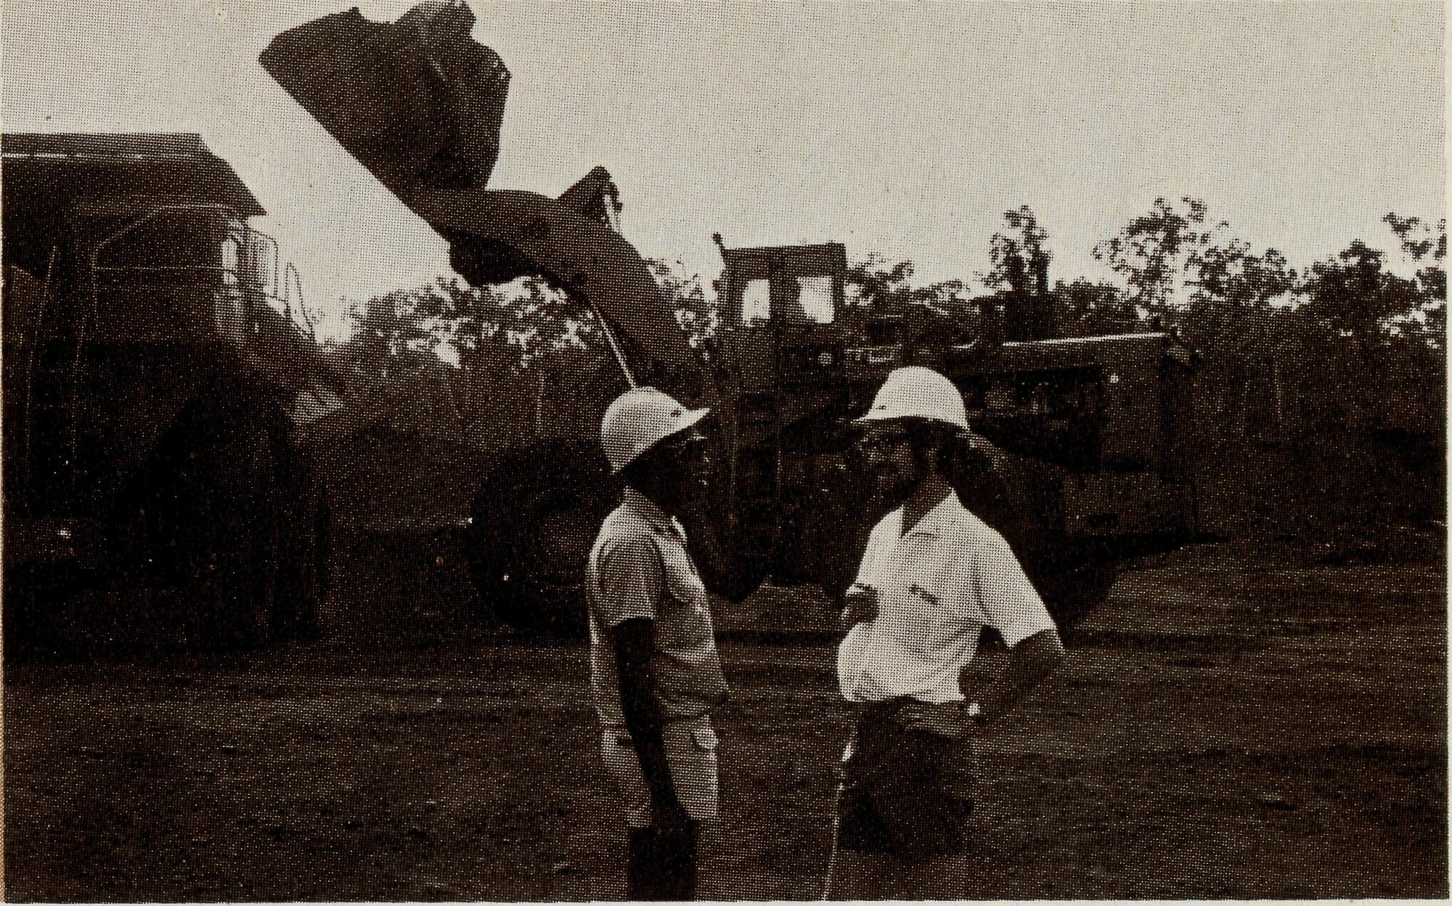
LIFE'S BEAUT ON GROOTE
Bruce & Marcia Hansford, Michael (4), Christopher (1)
So says the T-shirt message. We tend to agree after our first few months on Groote Eylandt, especially in these cool months.
My main responsibility is ministry to the people of Alyangula, a mining town of some 1,000 people, which includes the ship terminal and administrative offices of the Groote Eylandt Mining Company, a wholly-owned subsidiary of B.H.P.
A straight 12 km bitumen road south leads to the Concentrator Plant, which separates high grade ore from the "tailings" by non-chemical means. Many of GEMCO's employees work here. It is only a few kilometres from Angurugu, formerly a C.M.S. Mission Station and now a township (population 700) run by an Aboriginal Council with the help of several C.M.S. personnel.
Early in the 1960s, C.M.S. took out a mining permit on behalf of the Aboriginal people, and ensured that when manganese deposits were found to be of commercial proportions, the Aborigines of Groote got a fair reward. Some 50 of them are employed by GEMCO, there being no unemployment problem at Angurugu.
As there is no house available for us at Alyangula at present, and the position of Chaplain at Angurugu has been vacant since the departure in January of the Reverend David Woodbridge, we are living in the Rectory at Angurugu.
This has disadvantages; we are taking longer to get to know the people of Alyangula, and are difficult to contact when required. However, in the long term especially, it will be a great benefit to have lived in the Aboriginal situation at least for a short time, and to be developing friendships with the people. We are enjoying good fellowship with C.M.S. missionaries and other Christians, and it is a splendid combination of our sense of call to a B.C.A. industrial situation and our 15-year membership of C.M.S.
THE REAL AUSTRALIAN 3

now a
confirmation
My work at Alyangula is typical of the mining towns in many ways; working with individuals rather than groups. We are seeking the time and place to start a Bible Study Group (which hopefully will be established by the time you read this), following the Christian Women's Convention Travelling Safari (a small attendance from Alyangula), and a session for men on 19th July with our Federal Secretary.
We meet for worship (10-15 people usually) each Sunday at 9 a.m. in the school library (air-conditioned, carpeted, flexible seating arrangement, no maintenance worries — suits me). Sunday School follows, led mostly by Angurugu folk with fifty children on the roll from various denominations. On Tuesdays, I take five classes of Religious Instruction (not in five different schools as in my former parish), and two Angurugu ladies take two each.
While it is a new appointment as far as B.C.A. involvement is concerned, much good work has been done over the years at Alyangula; however, we are the first people to have it as our primary task, and, of course, people are leaving and arriving all the time.
As I'm at present the only clergyman resident on the island, I assist as one of a team in planning and leading Angurugu and Umbakumba services, particularly Holy Communion three or four times a month. Umbakumba, an hour's rough drive away on the east coast, is a smaller Aboriginal township with a clergy vacancy and a faithful congregation mostly of women.
Teamwork is the essence of the work here — it's good to be a part of the team. More about that, and about my monthly trips to Nhulunbuy, Gove Peninsula, in a future article.

study book
for individual or group use
new prayer bookDased
clear and helpful from
BCA
Written by Dean Shilton — profusely illustrated by Graham Wade. A book of 13 Studies for people preparing for Confirmation or simply wanting a refresher course on Church membership.
A BCA 60th Anniversary project.. continuing to serve the church in Australia

WESTERN AUSTRALIA CELEBRATES!
The sixtieth birthday of the Bush Church Aid Society was celebrated with great gusto over in Western Australia recently when St. Nicholas' Church, Floreat Park, was filled to overflowing for a Service of Thanksgiving attended by people from all over the State. A special choir led the singing and also offered a couple of anthems in addition to the B.C.A. song, "Australia for Christ". The lessons were read by Stan Hummerston (in his 22nd year of service with the Society) and by Canon Bill Rich (a former Federal Secretary). Bishop Stanley Goldsworthy of Bunbury led the prayers (it was in his Diocese, at Denmark, that B.C.A. first became involved in W.A.) while the Bishop of North West Australia, Bishop Howell Witt, preached a thought-provoking sermon on the B.C.A. motto "Australia for Christ". Barry Green's latest audio visual "A Wonderful World" was shown by the Federal Secretary, the Rev. Theo Hayman who handled the three projectors with dexterity. As the Archbishop was overseas, Bishop Michael Challen exhorted the congregation to give thanks and to pray without ceasing for God's blessing on the Society. It was indeed a great night. — happy birthday B.C.A.I
ORDER FORM.
Available for your next Confirmation preparation series directly from BCA or your Christian Bookseller The Bush Church Aid Society
NSW: B.C.A. House, 135 Bathurst Street, Sydney, N.S.W. 2000. (02) 26-3164, 26-3780. Telegraphic Address: "Chaplaincy", Sydney.
VIC: 3rd Floor, Clark Rubber Building, 196 Flinders Street, Melbourne, Vic. 3000. Phone: (03) 63-8962.
S.A: 350 King William Street, Adelaide, S.A. 5000. Phone (08) 212 4838.
Please send me
copies of "Yes Certainly" at $2.50 per copy
I enclose □ cheque □ money order □ postal note for the amount of $_
Please add postage (45c per single copy)
REV MR NAME MRS _ MISS
ADDRESS

THE REAL AUSTRALIAN
POSTCODE

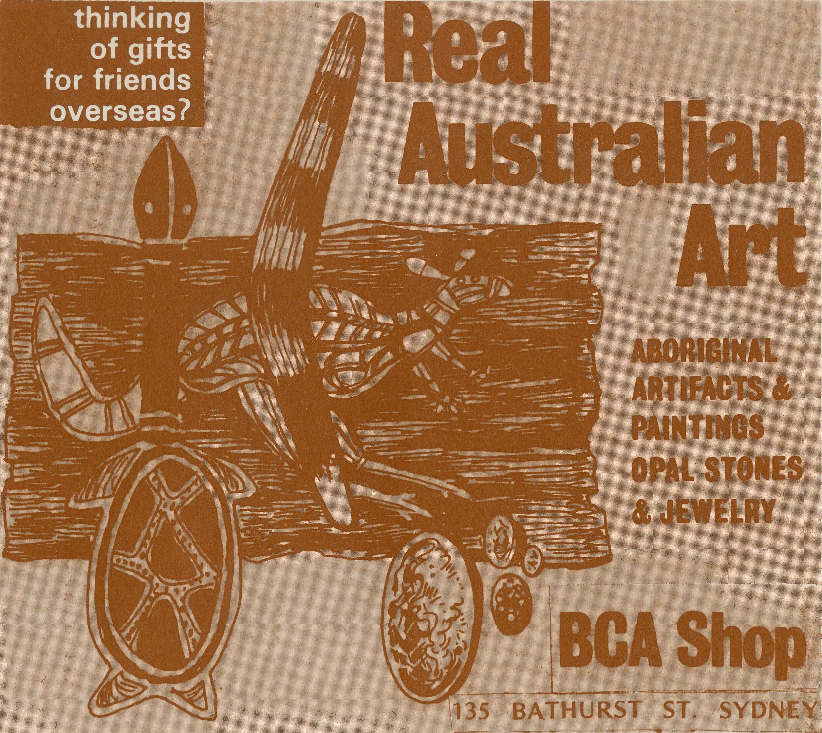
GOLDEN WEST - B.C.A.
"GO SEE FOR YOURSELF"
TOUR TO
CENTRAL
AUSTRALIA
18 DAY MOTEL ACCOMMODATED TOUR
Departing 25th May, 1980
Blue Mountains, Sydney, Coffs Harbour, Brisbane, Rockhampton, Emerald, Winton, Mount Isa, Tennant Creek, Alice Springs, The Olgas, Ayers Rock, Edge of Simpson Desert. Coober Pedy, Port Augusta, Broken Hill, Wilcannia, Dubbo, Sydney.
* Please note those places in colour are B.C.A. centres of ministry.
TOUR DETAILS: Motel accommodation on a twin basis, dinner bed and breakfast, picnic style lunches on all days except day in Alice Springs, coach travel in a coach suitable for outback touring.
Fare to be confirmed by January 1980, but expected to be no more than
$850. BOOKINGS: Now open. $50 deposit payable to confirm seat.
Mrs. Joy O'Neill, Mr. John Cronshaw,
B.C.A. House, Golden West Tours,
135 Bathurst Street, 283 Main Street,
SYDNEY 2000 KATOOMBA 2780
6 THE REAL AUSTRALIAN

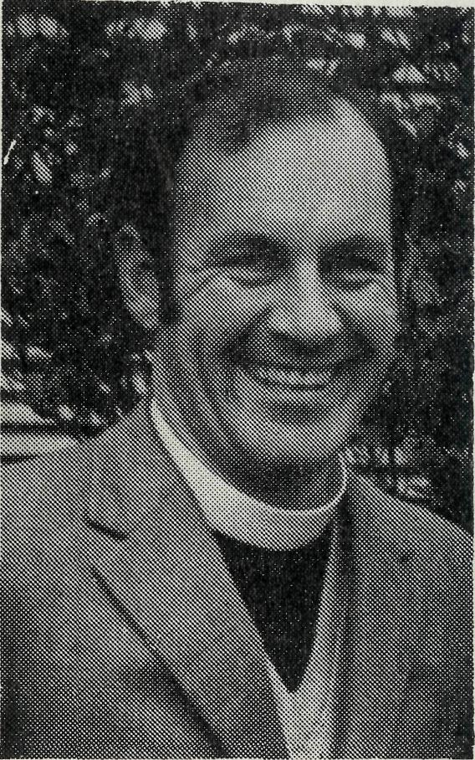
The Reverend Gordon Thomas, Rector of Kelmscott in Perth diocese, is no newcomer to B.C.A. having served for three years as a Missioner at Southern Cross, W.A. He is taking over from Canon Ted Doncaster from the end of September as B.C.A. honorary deputationist in W.A.
Fun at William Creek Gymkhana
This was the title of an article in the Winter 1979 issue of "Airdoctor" magazine of R.F.D.S. which included this paragraph.
"We were delighted to meet the Reverend Chris Clerke from the Leigh Creek and Northern Mission who had his puppet theatre for children set up on the grounds, and at one stage during the day had a huge circle of little ones sitting on the ground singing their hearts out."
Avgas Hike
The cost to keep the Reverend Chris Clerke's plane the "Len Daniels" in the air has dramatically increased lately with the drastic rise of Avgas from 26 cents per litre to 38 cents.
THE REAL AUSTRALIAN
Another B.C.A. Baby
Bob and Rigmor George of Win-ton are rejoicing in the new addition to their family, Linda Robyn, born at Townsville on 29th June.
Michael Peterson
A young man from Sydney (encouraged by what Owen Davies had to say at the Sydney Rally about how Christian young people could help in the outback) spent his recent mid year semester break from the N.S.W. Institute of Technology helping in the parish of Wilcannia in Western N.S.W. Thanks Michael.
The Wombat Ladies
Over 60 ladies from this town near Young in N.S.W. turned out to meet the B.C.A. nurses from Cook Hospital, Keith and Rhonda Anstee and their children Timothy and Narelle, on Tuesday, 17th July. The Wombat people have been wonderful in their support and interest so the Anstees say and they were thrilled to meet them all. Keith and Rhonda spoke of the work and showed some slides. Tim, too, aged four, had been looking forward to meeting the Wombat ladies but seemed a little disappointed apparently, according to his father, he had expected "lady Wombats".

LIFE AT THE RIDGE

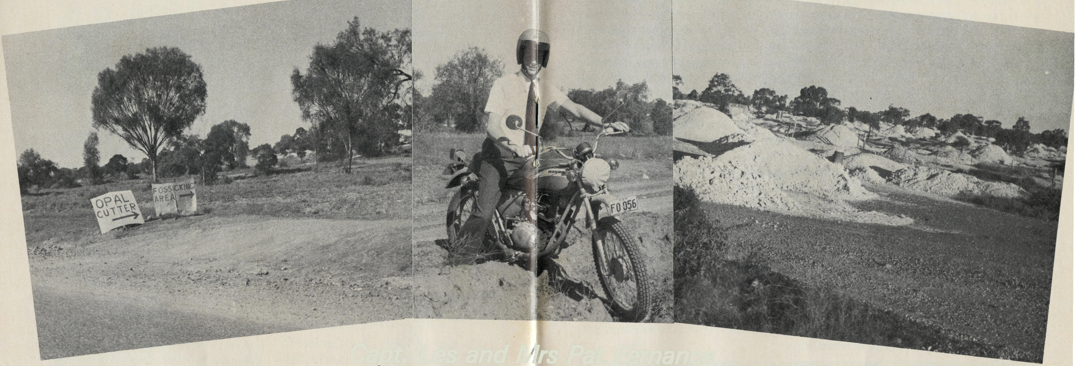
Capt. Les and Mrs Pat Fernance

At times the weather is delightful, but there are occasions when temperatures can be extremely uninviting even up to 120 degrees in the shade.
We have experienced good rainfall since being here. This is unusual as this area is classed as semi-arid. People tell of the drought when not a blade of grass could be seen. It's hard to imagine especially when one sees the lush foliage and grass at present.
A first impression of the Ridge is that of a very commercialised atmosphere, similar to that of the Gold Coast, minus the Meter Maids. Opal signs, shops and stalls are in abundance. Old car bonnets make excellent signs advertising opal in the mine fields.
At present there exist one hotel, three caravan parks, two motels and a huge bowling club which hints strongly that a lot more than bowling is done. There is a reasonably sized drive-in theatre, a laundromat, three or four various kinds of garages, two grocery stores, a hardware, hairdresser, doctor, tourist centre, two butchers and a number of other gift and clothing stores which contribute towards making life a little more civilised out in the North West of New South Wales.
O THE REAL AUSTRALIAN
About five years ago the town took off and is still rapidly developing, boasting unofficially of a population of 3,500 whilst only 700 names appear on the electoral roll. Previously the town consisted largely of a number of homes, a good quantity of rough miners' huts, one store, a post office and a police station.
One of the noted opal buyers considers that at its present rate of growth and because of the cosmopolitan nature of the place, the Ridge is likely to become the Las Vegas of Australia. There are already strong rumours of a casino being established here as well as enclosed facilities for a nudist camp.
It's a funny place Lightning Ridge, you never know what to expect.
Amidst this situation we find ourselves ministering to peopie, encouraging and sharing the Gospel of God's grace and love. At times the life in the church is beautifully harmonious and at other times there are various tensions and disunity as someone gets upset over something or someone. How true it is, "If one suffers, all suffer." That's how it is in families, a continuous relationship of growing, learninq and sharing toaether.
THE REAL AUSTRALIAN 9

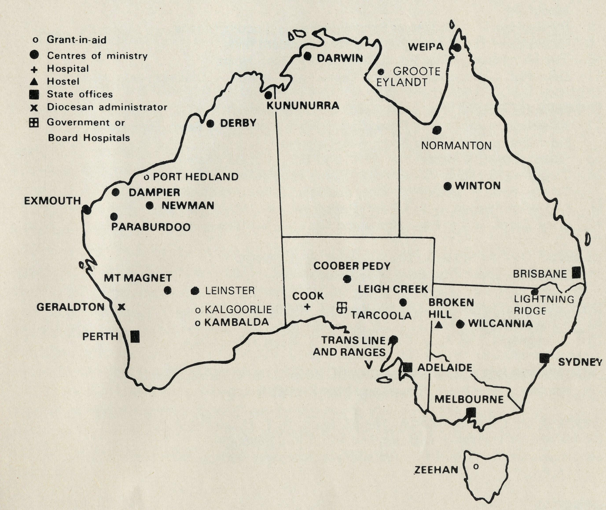
There is a healthy attitude among some members to their task of outreach and we see a pretty good response towards their witness. The weekly Bible study group has a constant flow of new faces as both locals and visitors attend from time to time. Ladies Fellowship which meets each week for prayer discussion and study is having a strengthening effect on many of the women involved. Pat has also gained more experience and confidence in leading the group, helping them to participate more actively.
We have been praying for more men in our congregation and we were surprised to list 50 fellows whom we could readily invite to a men's tea without any hesitation. A good relationship appears to be growing among the men.
The Junior Youth Club begun this year is now developing into a worthwhile group. Their spiritual interest is a great joy. Thanks for all the prayer support. We have needed every one.
God has been doing many good things here and He's been sorting us out as well. It is interesting to see how He presents you with entirely new circumstances and situations to cope with. It is even more interesting to see how one either does or doesn't cope also.
Things haven't been easy, in fact in many ways they have been extremely hard yet we have seen good progress. The first twelve months were busy establishing a pattern of ministry, relationships and sorting out differences and completing buildings.
I find that in visiting the mine fields, a motor bike is a good means of transport, providing that you don't end up down a shaft. It also tends to put people off guard a bit. What's this a bikey preacher? Well I did say that you never know what to expect at the Ridge.
COMING OUT - GOING OUT
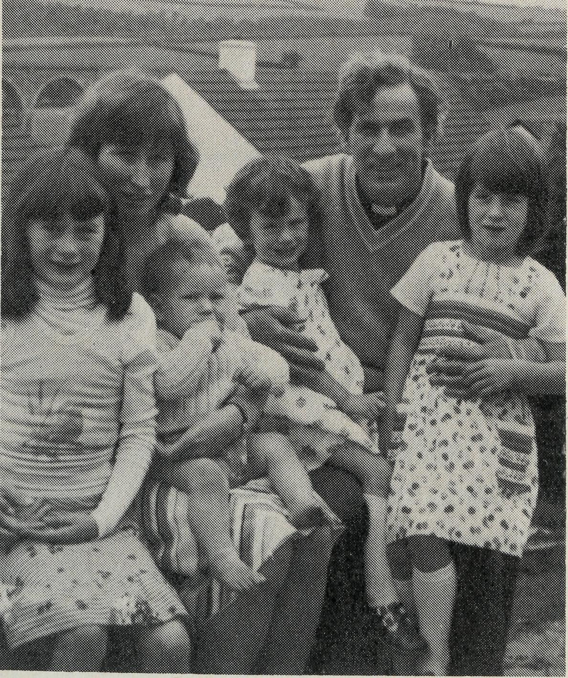
The Reverend Tom Williams with his wife, Carol, and children Joy (8), Alice (6), Elizabeth (3¹/₂) and Graham (1) come from Liskeard in Cornwall, England, in September to Sydney. They will then after a short break proceed to North West Australia. Tom is an Australian originally from Lithgow, N.S.W. He prepared for Christian service in Sydney Missionary and Bible College, Croydon, and Oak Hill Theological College, England. Carol is English so you might especially remember her and the children as they adjust to the conditions of North West Australia.
io
THE REAL AUSTRALIAN
THE B.CA PRAYER
A DAILY PRAYER
0 Lord our God, help us to remember those who live in the remote parts of our land. We ask You to bless those whom You have called into the fellowship of The Bush Church Aid Society. Grant that, through the ministry of the Word and Sacraments, through healing, and through caring for the young, the message of Your redeeming love may be proclaimed, through Jesus Christ our Lord. Amen.
O God, we remember before You those whom You have called to Your service. We ask You to bless
, assure
them of Your Presence, and call others to stand with them in the task. Grant to them, as to us, the joy of service, the ability to achieve, and the serenity of Your peace, for Jesus' sake. Amen.

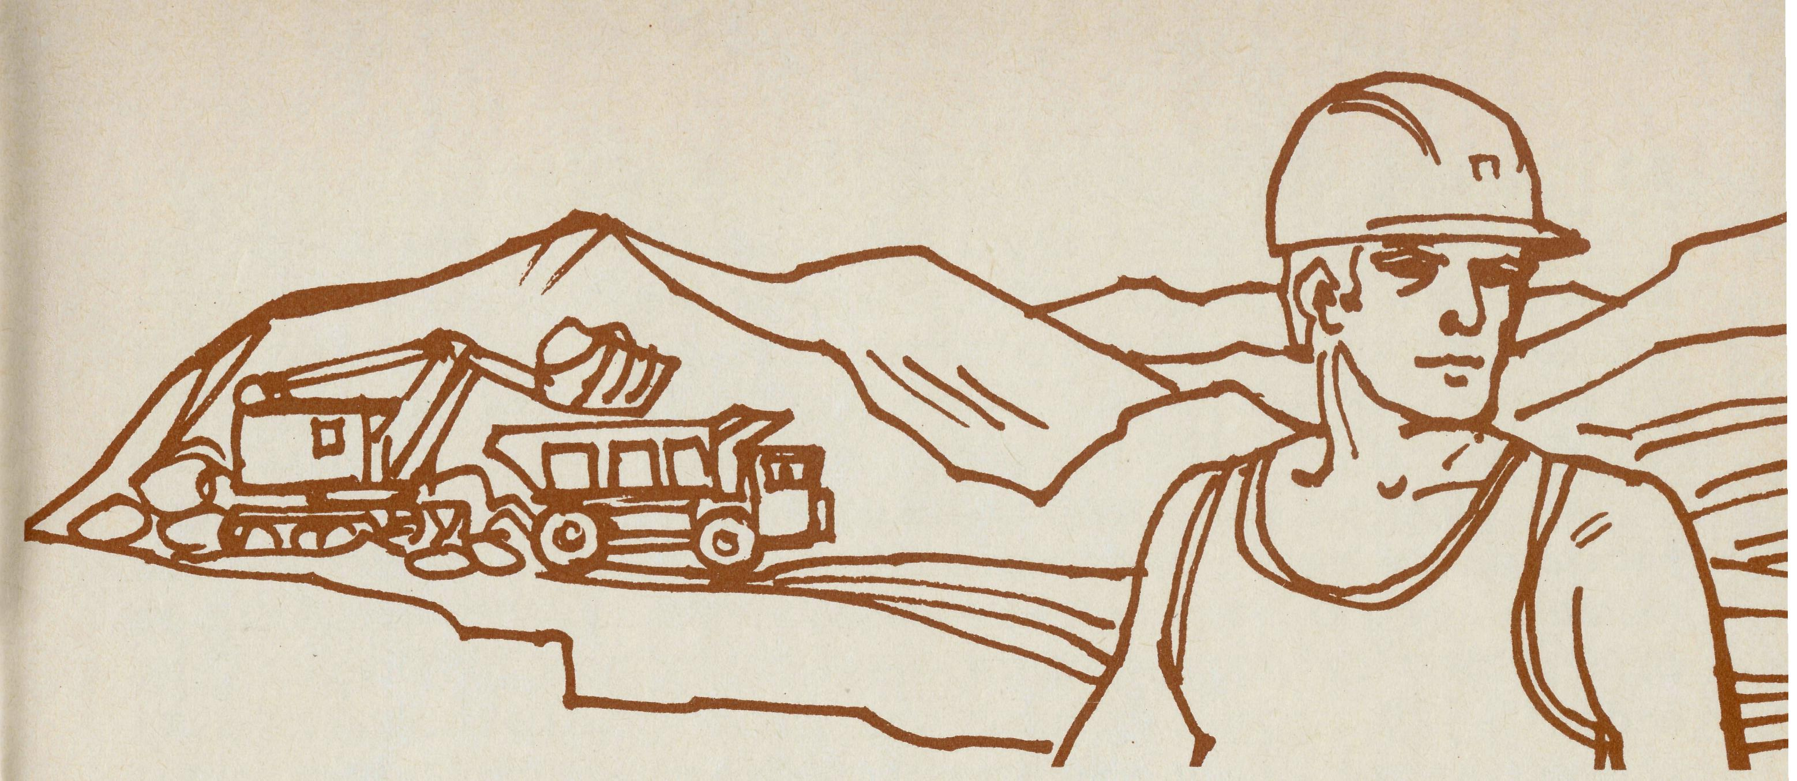
PRAYER CALENDAR
FIELD STAFF DIRECTORY
DIOCESE OF NORTHERN TERRITORY. The Rt. Revd. K. B. Mason.
- Darwin — Miss Coryn O'Nians (Nungalinya College), Sister Patricia Dahl (Nightcliff).
- Groote Eylandt — The Revd. Bruce and Mrs. Marcia Hansford.
DIOCESE OF NORTH WEST AUSTRALIA. The Rt. Revd. H. A. J. Witt.
- Kununurra — The Revd. Royce and Mrs. Susan Thompson.
- Derby — The Revd. Ron and Mrs. Ann Robins.
- Newman — The Revd. Don and Mrs. Libby Wilson.
- Port Hedland — grant, The Revd. Peter Thompson, Telfer — The Revd. John West.
- Dampier — The Revd. Bill and Mrs. Jocelyn Ross, The Revd. David and Mrs. Helen Mansfield.
- Paraburdoo — Archdeacon Randal Deasey — Locum Tenens.
- Exmouth — The Revd. Peter and Mrs. Elizabeth Mills.

- The Murchison — The Revd. Bill and Mrs. Joan Hoare.
- Geraldton — Mr. Stan and Mrs. Dorrie Hummerston — Diocesan Administrator.
DIOCESE OF PERTH. The Most Revd. G. T. Sambell.
- Kalgoorlie — grant. The Revd. Canon Frank Watts, The Revd. Dennis Reynolds. Kambalda — grant. The Revd. Robert Hanson.
- Cook Hospital — Nurses Mr. Keith and Mrs. Rhonda Anstee.
- Tarcoola Hospital — Sister Helen Plumb and Lynne Mclver.
- Coober Pedy — The Revd. Kerry and Mrs. Julienne Medway.
- Mid-West Mission — The Revd. Robert and Mrs. Phyllis McEwin.
- Leigh Creek — The Revd. Chris and Mrs. Marilyn Clerke.
DIOCESE OF TASMANIA. The Rt. Revd. R. E. Davies.
18 Zeehan — grant. The Revd. Roy Dixon.
DIOCESE OF RIVERINA. The Rt. Revd. B. R. Hunter.
- Broken Hill Boys' Hostel — Mr. Ken and Mrs. Pam Young.
- Wilcannia — The Revd. George and Mrs. Hazel Fuhrmeister.
DIOCESE OF ROCKHAMPTON. The Rt. Revd. J. B. R. Grindrod.
22 Winton — The Revd. Robert and Mrs. Rigmor George.
DIOCESE OF CARPENTARIA. The Rt. Revd. H. T. U. Jamieson.
- Weipa — The Revd. Malcolm and Mrs. Chris Babbage.
- Normanton — The Revd. Jim and Mrs. Margaret Hudson, Miss Anne Watkins. (A.F.S.)
GENERAL
25 Federal Secretary. The Revd. Theo Hayman.
N.S.W. The Revd. Wakely Wade, Eric Atkin, Miss Doris Smith, Mesdames Joy O'Neill, Dora Warwick and Nina Allan.
- VICTORIA. The Revd. Ernest Horth, Miss Chris Craig.
- QUEENSLAND. The Revd. R. W. Herbert (Hon. Secretary) WESTERN AUSTRALIA. The Revd. Gordon Thomas (Deputationist)
- SOUTH AUSTRALIA. The Revd. David Eastway.
- The President, The Most Revd. Sir Marcus Loane, Chairman , Dean Lance Shilton, Honorary Treasurer, Mr. Richard Stokes, The Council, State Committees.
- Staff Replacements, Box Secretaries, B.C.A. Supporters.
- National Home Mission Fund.
THE ECUMENICAL MISSION TO BLACKWATER - LENT 1979
Rev. Stephen Rigby
Through the Mission to Blackwater this year we have made important discoveries about what it means to be the Church in a highly mobile mining community. For the first time we have seriously tried to relate the Christian Gospel to a people who are fragmented by companies, shift work, and an inherent desire to get as much as you can while you can. The Church is learning to bring good news which meets the needs of the total mining milieu. No matter what we say, the churches of Blackwater have to exhibit a loving oneness which approaches the true image of God. This oneness (a better word than unity because it is a process) has tremendous power to speak to people. The key to effective evangelising is the loving caring community of believers who demonstrate they are Christians by their love.
The Anglican, Catholic and Uniting Churches were responsible for the organising and financing of the Mission. Also the prayer support in the months before came from these churches. Later some encouragement came from the Baptist Church and the Christian Assembly (Brethren).
Over 90 individuals from the different churches shared in studies on the theme of Discipleship based on Matthew's Gospel. Eleven homes were used for the meetings over a four week period late in Lent. The leaders and hostesses were prepared by U.C.A. Chairman, the Reverend Duncan Harrison.
TO CHILDREN
Peter and Margaret Stenhouse of the Children's Bible Crusade led a rather hectic programme in the primary schools. Besides conducting an afternoon session on three consecutive days at Blackwater State School they also visited the schools at Blackwater North, Bluff, Dingo, and Duaringa. Both Peter and Margaret showed a real love for children as well as their musical and teaching talents. R.E. and Church School teachers were able to assist with organising and counselling the children. During the period at Blackwater State School over 200 children attended and numbers indicated a desire to accept Jesus as Saviour and Lord.

THE REAL AUSTRALIAN
13

TO YOUNG PEOPLE
For Peter Edson of Campaigners for Christ this was a first time on mission by himself and what a wonderful first this was for Peter. A young married man with a background in physical education, folk rock and a keen love for teenagers, he was a real hit. The high school staff were astonished as he casually sat in front of 400 Blackwater monsters (sorry — students) charmed them with his songs, and spoke from the heart about life and the Gospel. For nearly one hour he had those kids in the palm of his hand. Peter was more than a good entertainer, he engaged the young people in dialogue on other occasions at home meetings, the swimming pool, the Dragline Cafe, and at the high school in the lunch hour. Not only did he challenge the unchurched masses but he also found time to build up the Christian young people. We look forward to his return to Blackwater in the not too distant future.
TO ADULTS
Our Missioner is well known to Central Queensland, the Reverend Dr. Grove Johnson, professor of liturgy at Manly Seminary and formerly parish priest at Yeppoon. He came to us with a wealth of ecumenical experience and it appears he gained a lot himself from the mission. "Those four days among you were one of the creative experiences of my life," he said. The two night meetings at the Cultural Centre attracted 100 and 150 people. The morning meeting at the Catholic Church was mainly women and children. The men's dinner at the Uniting Church attracted 50 men in a splendid atmosphere. Numbers built up during the mission and on the Saturday night while the Lion's Beer Festival was on at the southern end of town, over 100 people came. On the mission's last night Dr. Johnson said that we the churches of Blackwater who had found oneness in Jesus Christ must continue to grow in love and share in the task which Jesus has given us and that is to teach, preach, heal, baptise, witness and spread the good news of God's kingdom. We are not bent on creating a single church or denomination in Blackwater but the need for mission is bringing us together more and more and in a real sense we are becoming identified intimately with the good news. Can we be so bold as to say that we are the good news through being what we are, a loving, caring community.
"COME OVER THE DRUMMOND RANGE AND HELP US!"
Like the Macedonian call to St. Paul is the way our Missioner, the Reverend Stephen Rigby described the conviction he had in accepting the Bishop of Rockhampton's invitation to go to the parish of Blackall and leave Blackwater. Although Stephen and Pam will be no longer serving with the Society, they see their future service at Blackall as an extension of B.C.A. experience — providing a ministry in the outback. Blackwater now becomes an ordinary parish in the diocese, B.C.A. simply giving a finishing financial grant to assist it in its first year of independence.
14
THE REAL AUSTRALIAN
THE VITAL LINK
A few years ago — a story from Canon Ted Doncaster
One hot, dusty day I arrived in Onslow at the end of a long trip in the bush, and after a shower went down to the dining room of the Beadon Hotel to seek out a quiet corner for the evening meal, for I was pretty tired. A little later a tourist bus pulled up and the dining room was swamped with people, so bang went my
solitude! One of the ladies at my table eventually spotted the crosses on the collar
of my shirt and asked the inevitable "Are you a clergyman?" to which I replied
"Yes". "Which church-?" she enquired. “C. of E.” I said. “Do you live here?” she
asked. "No!" I replied, being my usual conversational self. "Where, then?" she
persisted. Waxing eloquent, I answered: "Carnarvon". "Well," she said, "and
what is your name?" (I was beginning to wonder if It was Census time again!)
"Ted Doncaster,” I replied. "Oh!" ^she exclaimed, "I know you!" Well, I declared
that I had never met her before, but she insisted and the truth came out that she
was a member of the B.C.A. Prayer Fellowship, worshipped at St. Andrew’s, Summer Hill, and prayed for me and my family on the 8th of every month, as it was on the Prayer Calendar in those days.
I cannot tell you how much that meant to me; to that people, hundreds of them, on the other side of the vast continent were praying daily for our ministry in the “far west” of Western Australia. I never cease to relate the story,
because prayer support for those at work in the outback is the very core of the
B.C.A. family life. “Pray without ceasing.”
Just the other day – from Rev. Bill Hoare: Leinster
Praise God for protection in the constant travelling. A sudden break in rear axle housing on a very lonely track caused two cold nights (ice on the van) out in the bush. Only three cars passed in the two days. I am grateful that I had my transceiver radio to let folks know that I was in trouble, unhurt but that my vehicle could not be towed by an ordinary car. Through the radio they let Joan know that I would not be home. Suitable help eventually came.
The B.C.A. Fellowship unites staff and supporters in prayer and interest. Regular bulletins are issued detailing current prayer requests of field staff.
Detach and fill in this form and send to: The B.C.A.F. Secretary, 135 Bathurst Street, Sydney. 2000
BLOCK LETTERS PLEASE
Revd
Mr.
Mrs.
NAME_Miss
I wish to become a member of the B.C.A. Fellowship and undertake, with God's help, to:
ADDRESS.
- Pray regularly for the work of B.C.A. and its members;
- Learn all I can of the spiritual needs of Australia and of the efforts of B.C.A. to meet them;
.POSTCODE.
. DATE.
SIGNED.
•Support the work of B.C.A. financially and to use every opportunity to make the purpose and work of B.C.A. more widely known.
15
THE REAL AUSTRALIAN

