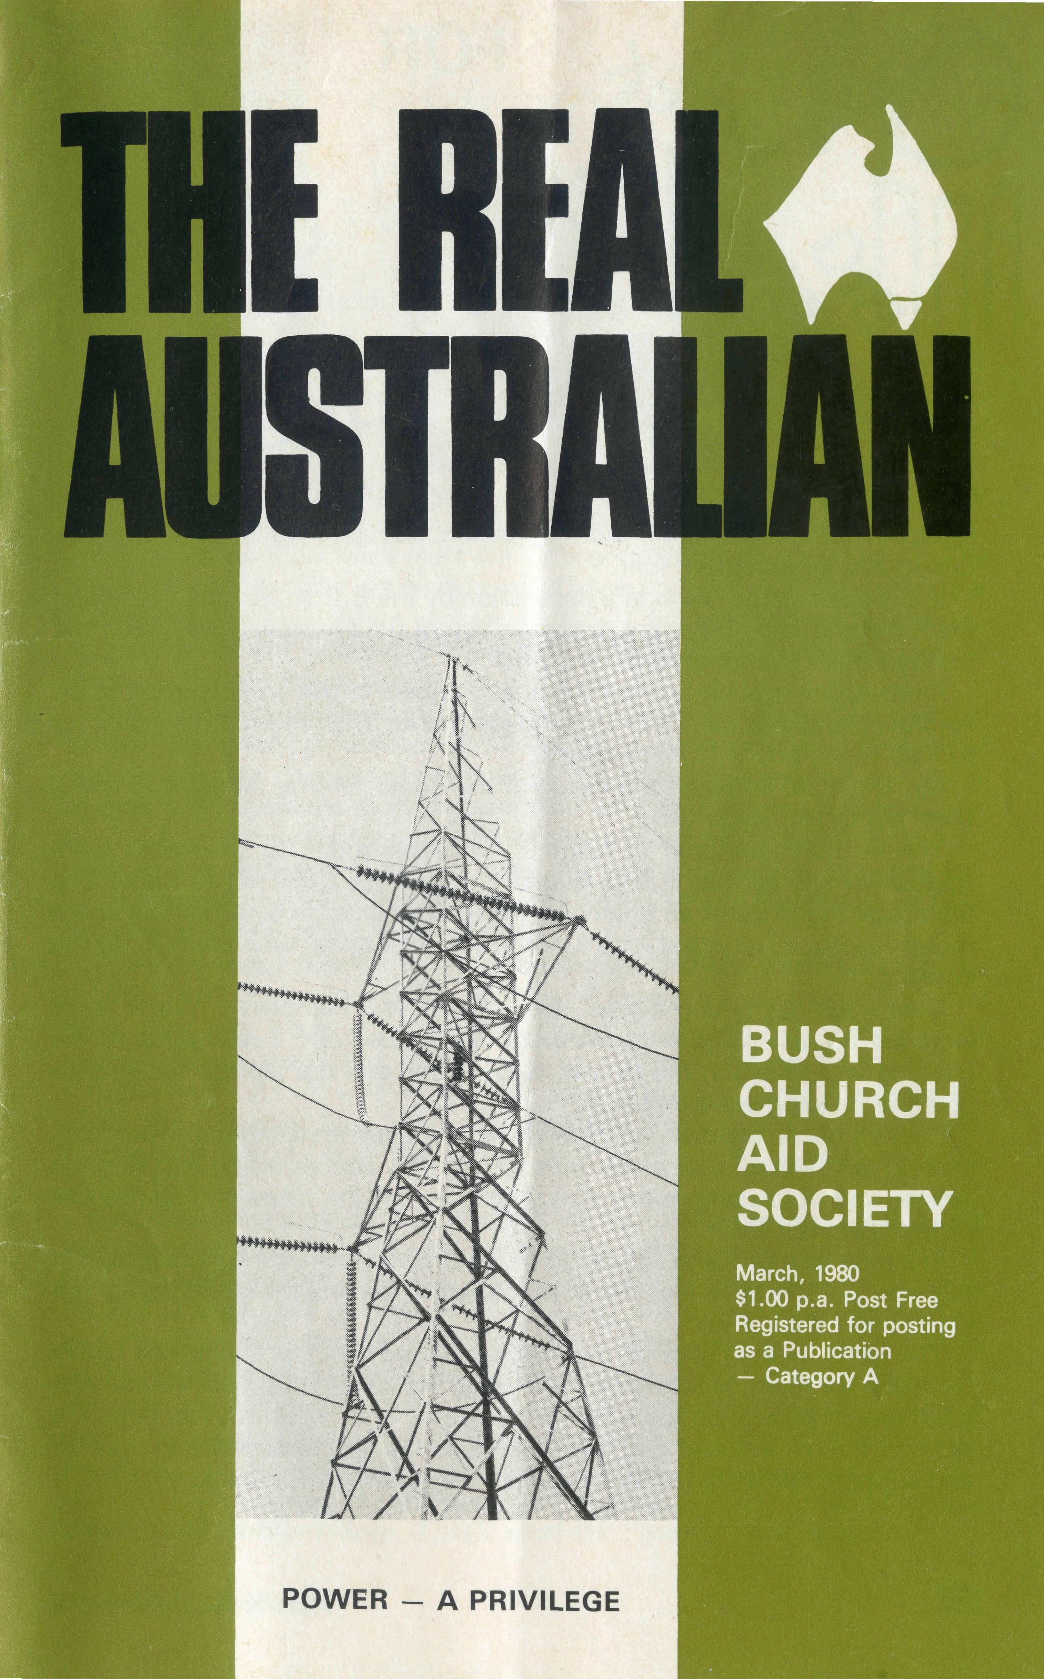
WE'LL COME!!
We always welcome opportunities to provide a speaker for Sunday services, mid-week gatherings, youth groups, ladies' organisations, etc.
The Society's story is both exciting and challenging and, with slides or an audio visual, can be a very interesting and helpful part of any programme. Bookings can be made in
Perth — The Revd. Gordon Thomas for W.A.
Adelaide — The Revd. David Eastway for S.A.
Melbourne — The Revd. Ernest Horth for Vic. & Tas.
Sydney - The Revd. Wakely Wade for N.S.W. & C
See the State Office Directory in this copy for addresses and 'phone numbers.
State Office Directory . . .
Federal Secretary — The Revd. T. J. Hayman.
General Secretary N.S.W. — The Revd. Wakely Wade.
N.S.W. Secretary — Youth — The Revd. Malcolm Babbage.
B.C.A. House, 135 Bathurst Street, Sydney, N.S.W. 2000.
(02) 26-3164, 26-3780. Telegraphic Address: "Chaplaincy", Sydney.
Victorian Secretary — The Revd. Ernest Horth,
3rd Floor, Clark Building, 196 Flinders Street,
Melbourne, Vic. 3000. Phone: (03) 63-8962.
South Australian Secretary — The Revd. David Eastway,
350 King William Street, Adelaide, S.A. 5000. Phone: (08) 212-4838.
Queensland Hon. Secretary — The Revd. R. W. Herbert, 60 Prospect Street, Wynnum North,
4178. Phone: (07) 396-4354.
Western Australia Hon. Deputationist — The Revd. G. W. Thomas, 4 River Road, Kelmscott,
W.A. 6111. Phone: (09) 390-5351.
Patron — The Most Reverend Sir Frank Woods.
President — The Most Reverend Sir Marcus Loane, Archbishop of Sydney.
Vice-Presidents — Bp. G. R. Delbridge, Mr H. M. Bragg, Archdeacon R. G. Fillingham, M.B.E.
Chairman of Council — Dean Lance Shilton.
Honorary Treasurer — Mr R. T. Stokes.
Ambassador Press Pty. Ltd., Granville 2142.

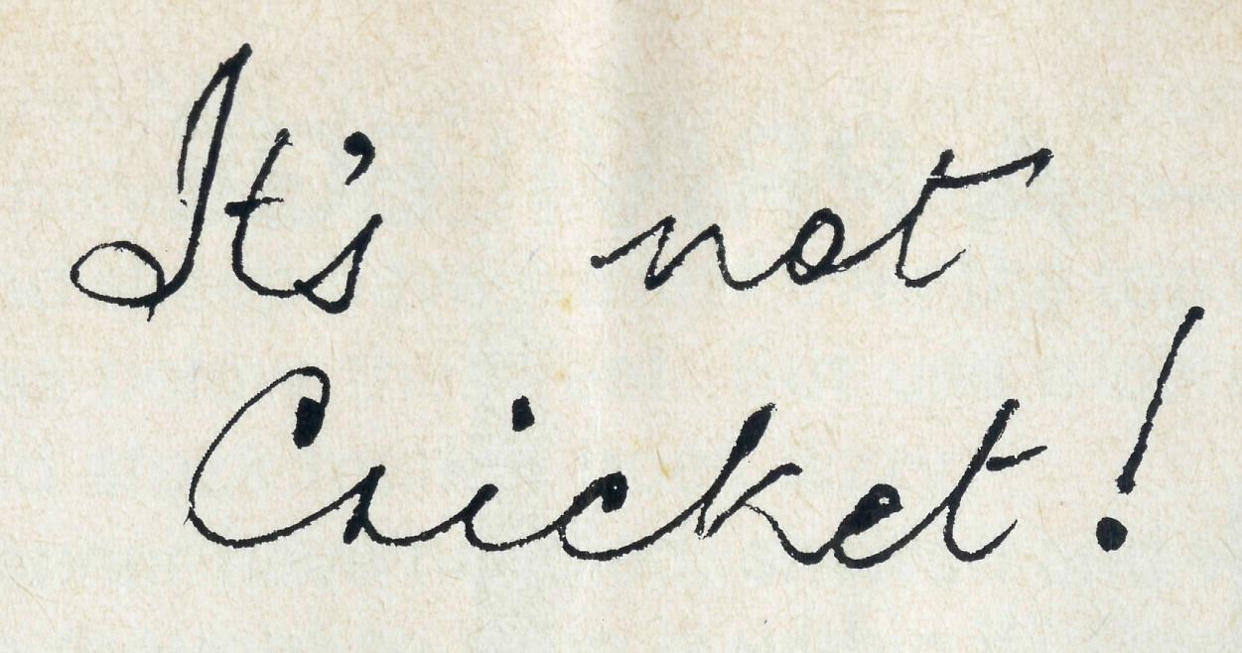
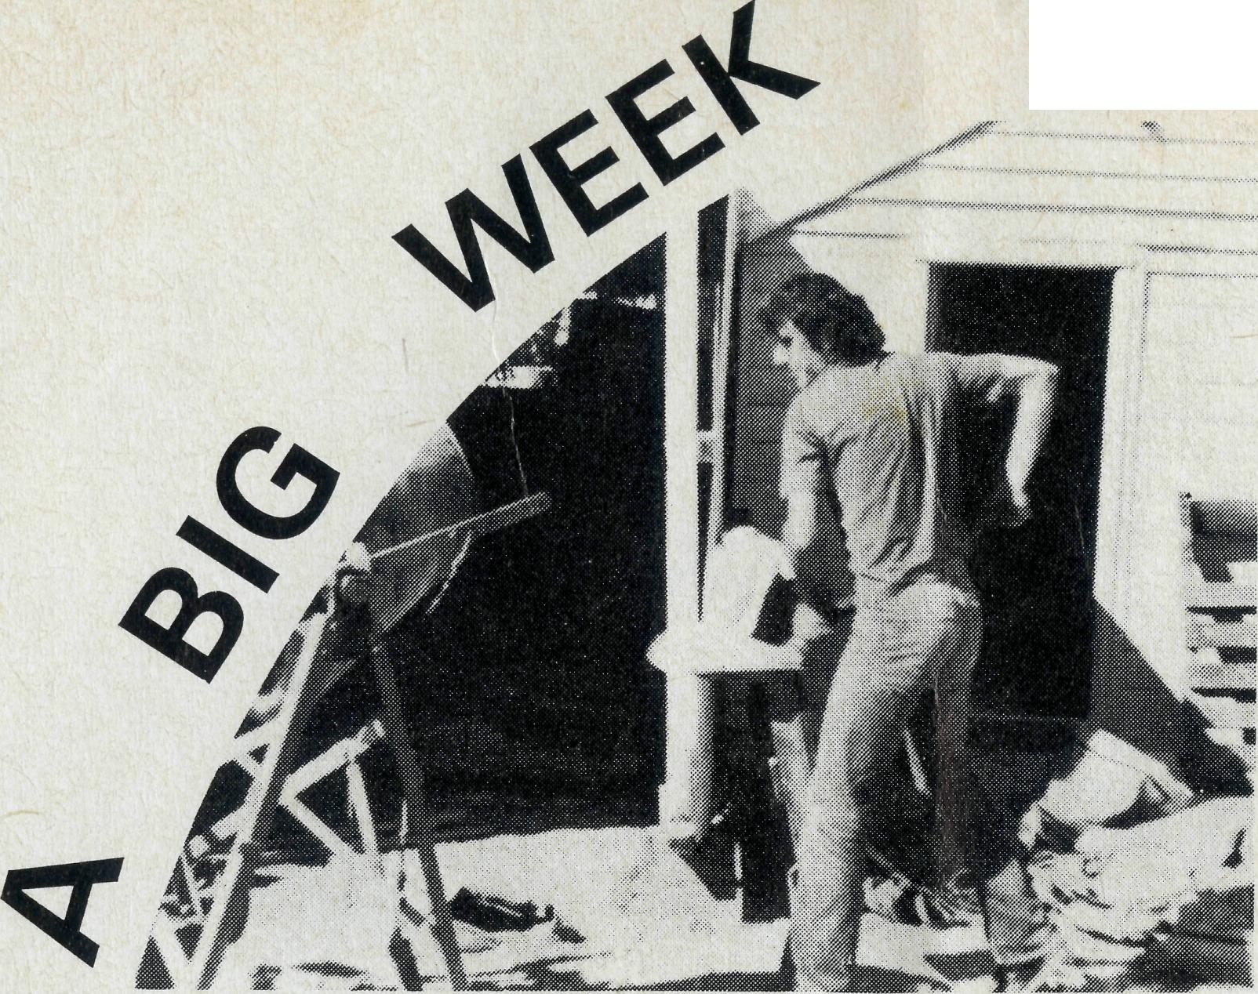
FOR THE
COOK
HOSPITAL
It is some time since the hospital, opened in memory of Bishop S. J. Kirkby in 1937, received a major renovation, but last August Cook Hospital underwent an extensive refit.
It all began as the result of a deputation by the B.C.A. Federal Secretary, the Reverend Theo Hayman, to the Church of St. Andrew, Ruse, Airds and Kentlyn (near Campbelltown, N.S.W.).
Keith Arthur and his brother Ray are members of the congregation of St. Andrew's and also own and run a building firm. They offered their services to help repair any B.C.A. property.
Mr. Hayman, knowing the needs of the Cook Hospital, suggested that a team might like to go there.
The Arthurs gathered a team of Christian men, all of whom were tradesmen and set out late in August to drive the 2,800 km to Cook. The team was made up of an engineer, two electricians, two carpenters and a motor mechanic together with Keith's wife, Georgina, who went to do the cooking.
Over a ten-day period a great deal of work was completed. Water tanks were set up, extensive electrical work was carried out; a new ramp to the building was finished, the kitchen was refitted and the stumps which support the building were replaced.
It was a hectic ten days which involved the team in repairing the hospital, sharing in Christian fellowship with the nursing couple, Keith and Rhonda Anstee and of chasing one or two rabbits across the never-ending flatness of the Nullarbor Plain.
In a tape sent by Keith Anstee to St. Andrew's Church, he commented in this way — "We have enjoyed their fellowship and we are afraid we are going to miss them a lot".
The team, looking back on the experience, are very grateful for the Lord's provision for them, in all the miles travelled the only mechanical trouble was a flat tyre in Bowral on the way back to Ruse. They all now know what the work of B.C.A. involves and therefore have found a new desire to pray for and support the work of the Gospel in the Australian outback.
Revd. D. Anderson
2 THE REAL AUSTRALIAN
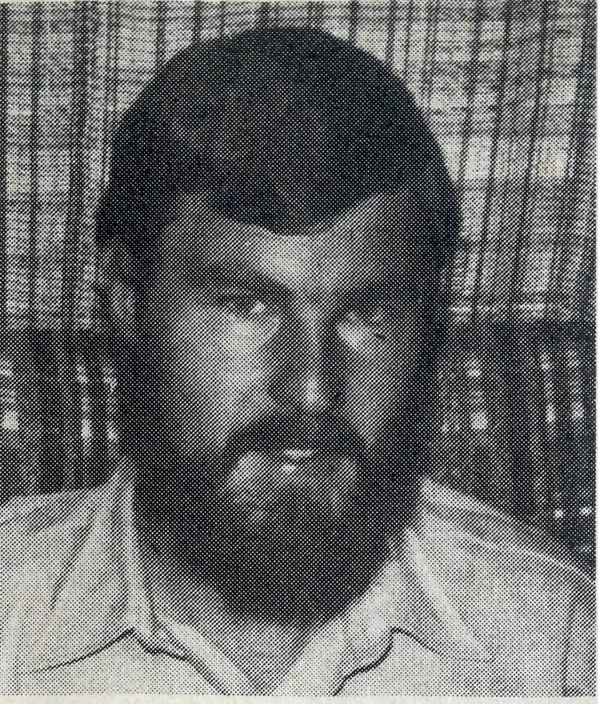
Revd. Bob George: Winton, Qld.
It's just not cricket when the Test matches are not telecast to country areas. At Winton we do have TV, but only one channel. When the ABC lost the rights to telecast the cricket, armchair sportsmen in Western Queensland were stumped. After all, cricket is compulsory viewing for any fair-dinkum Australian sportsman! When there is a power strike, it's not just the cricket we miss out on in the bush, but the other benefits of this medium.
It's just not cricket when there is a Telecom strike, or a postal strike. The telephone and the letter are heavily relied upon in the bush. Communication is very important whichever way you look at it, but especially in the church. As a parish we are working at the communication problem, trying to share the gospel in a relevant way.
The most encouraging aspect has been amongst children. ''Wednesday School" has grown in numbers and enthusiasm. As one child comtnented as she was working on a lesson pre-activity, "I never knew religion was so enjoyable". The children come because they want to. On some days at 4p.m. the local pool must be far more inviting than a hot stuffy building, but the children arrive often half an hour early. We pray that the "building blocks" of understanding about God, will one day form a strong foundation of faith and obedience for these children.
There are many barriers to effective communication. The chaos that industrial strife causes in this regard is more than obvious, especially in the bush. One way we as a parish have sought to reduce the "barriers" of understanding about the church is to produce a parish paper called, "Tuckerbag". As the title implies, the paper provides "food for thought" about the Christian faith. It is the misunderstandings which keep people from a vital faith in God. "Tuckerbag" tries to show what it really means to follow Christ.
God does communicate to us through the Word. As a co-operating parish we have seen this over and over again in answer to prayer and in spiritual growth. Anglican and Uniting Church folk meet as one body for worship, instead of separately as before. Bible studies, an ecumenical prayer group and morning tea after the service have provided opportunities for us to communicate better with one another as we grow in the Christian faith. The writer to the Hebrews has shown us all how God communicates: "In the past God spoke to our ancestors many times and in many ways through the prophets, but in these last days he has spoken to us through his Son" (1:1-2a). Communicating the Good News of Jesus Christ is for all of us, our responsibility and privilege. That's what the "game" is all about.
THE REAL AUSTRALIAN 3

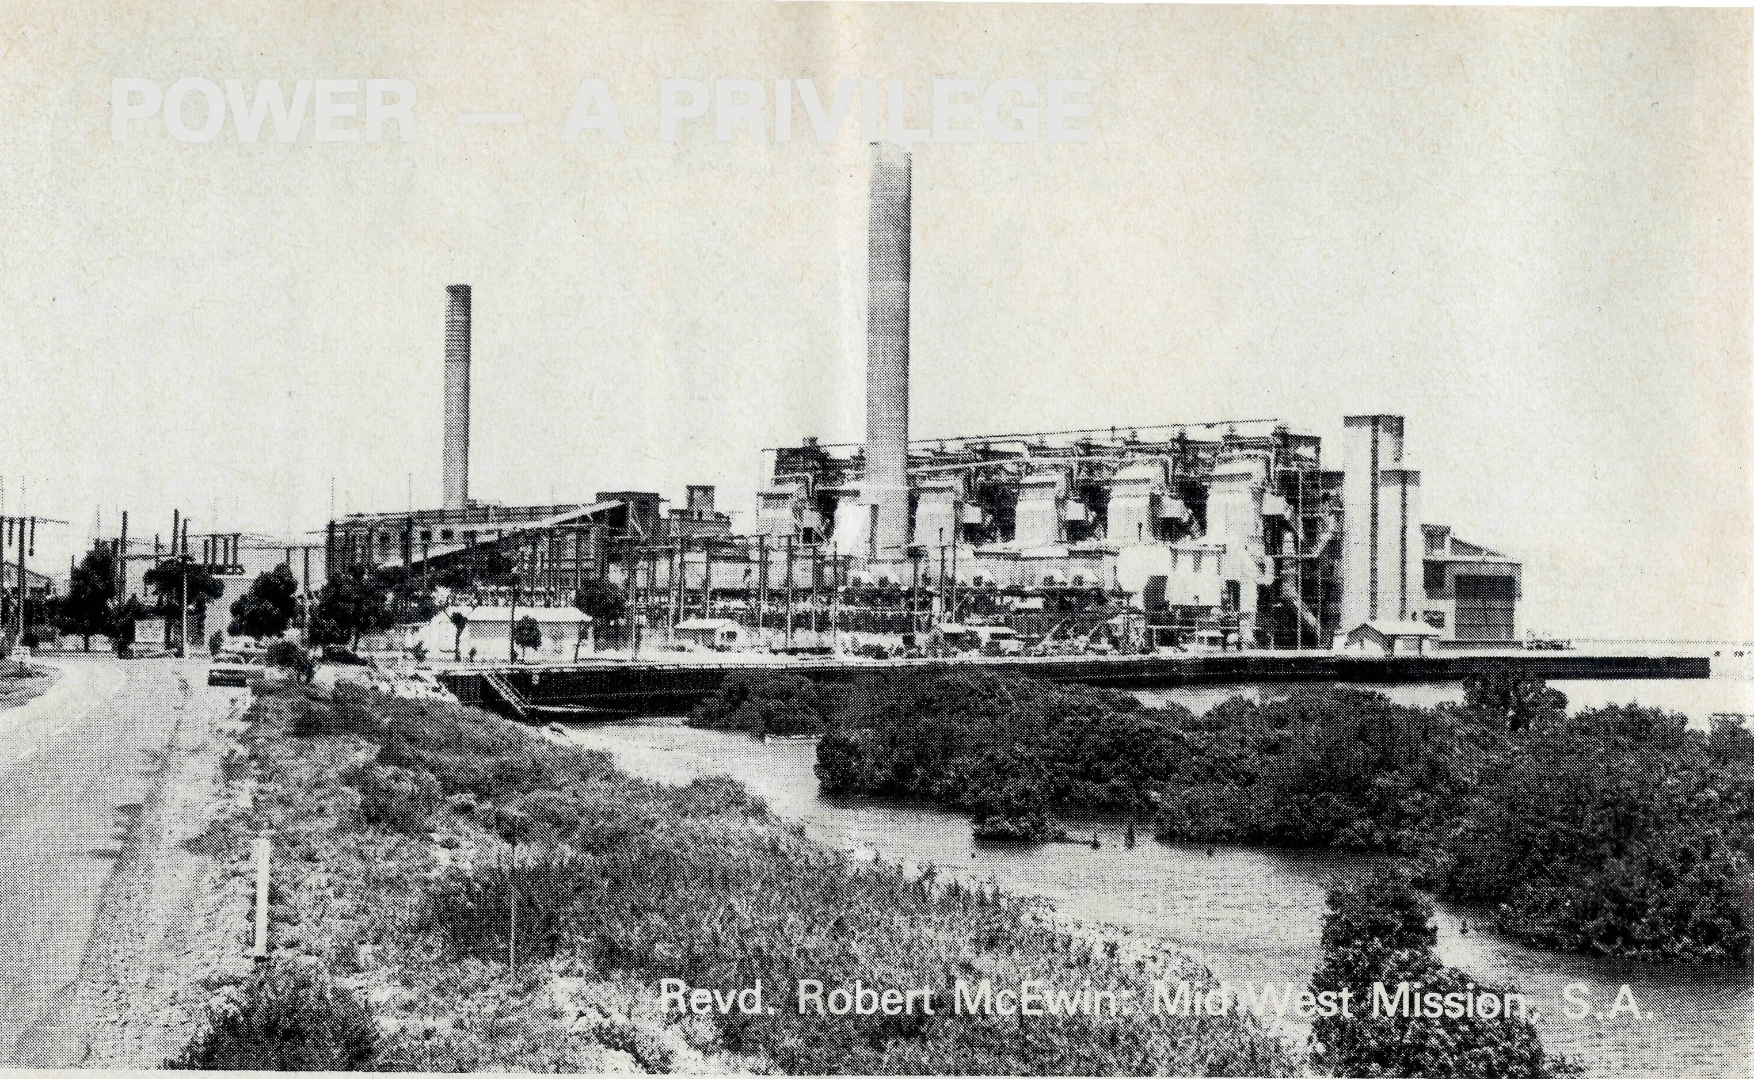
POWER - A PRIVILEGE
My study window overlooks the Thomas Playford Power Station in Port Augusta which is one of the main generating stations of electrical power for South Australia. How much do we take the provision of this power for granted?
When I visited a station property recently they were busy installing a 240v power supply system for two families and several station hands who lived there. Previously they had existed with 32v. A number of families now have 240v, others 32v, some even rely entirely on kerosene fridges and lights or candles. Nearly all the properties have LP gas for cooking — but not all use it all the year because the old wood stove is streets ahead of the electric one-bar radiator for winter.
Incredible it may seem — but what a contrast. Man on the moon and people without 240v. It is unbelievable! According to one station lady her city acquaintances do not accept that she still uses candles and the like.
Most of us who can flick switches to turn on our air conditioners, toasters, vacuum cleaners, TVs and fridges, etc., tend to forget the privilege we have. Maybe the energy crisis may help us to remember. But there certainly is a contrast of power. How would you feel with 57° C in the shade and no air conditioner because of insufficient 240v power? It has to be lived to be felt.
This contrast is not confined to what we use in our homes — it is shared by those who live. Some have so much (so it seems) power at their finger tips — they are able to flick switches left, right and centre — yet in truth they have no real power. Others without switches have a much deeper resource of power available to them and they only bend their knees — the power that moves mountains, mountains of unbelief and scepticism.
There is a new impetus in the power game — Uranium — but really it is
*"* THE REAL AUSTRALIAN
older than Adam. In the Mid West Mission there is one of the biggest deposits of combined minerals ever found in Australia — Roxby Downs. For generations men and sheep have walked over the top of them with little thought as to what was below their feet. But use a core drill in the right place and the share and stock market goes dizzy.
How many in like manner have handled, shelved and walked around the Word of God with little thought to Who is within it? Open and read a little and God can speak giving a spiritual dimension to a person's life.
Just like what could happen to the couple who were living together in the bush. They bought a Bible and then wanted to get married. They wanted a ceremony with prayers so they made a 500 mile round trip over a weekend for the service. They sensed there is something in being Christian — why else would someone tramp around the bush seeking contact with the people who live there.
The crisis of power is seen in the life of a family visited regularly by bush padres who on one visit started talking about baptism. Their children had not been baptised. Over the years they have come to sense something of what being a Christian is all about, they realise something of the stand they are making and at the same time they are asking — "Please clarify our thinking about the Christian faith". They desire the power of God in their lives.
Then there is the family who almost before you say hello ask if they can have a service. They realise the peed for Christian fellowship and the need for hearing God's Word read and sharing in the Sacraments. It is all too long between passing parsons. The encouragement and refreshment from sharing together in worship is highlighted only by its infrequency.
The lady, who had recently read a fascinating biography of a present day piece of Christian work among people in real need, found she was unable to accept that God was at work in the many incredible coincidences. It seems that she found it hard to accept that God has the power to do what Hesays He will.
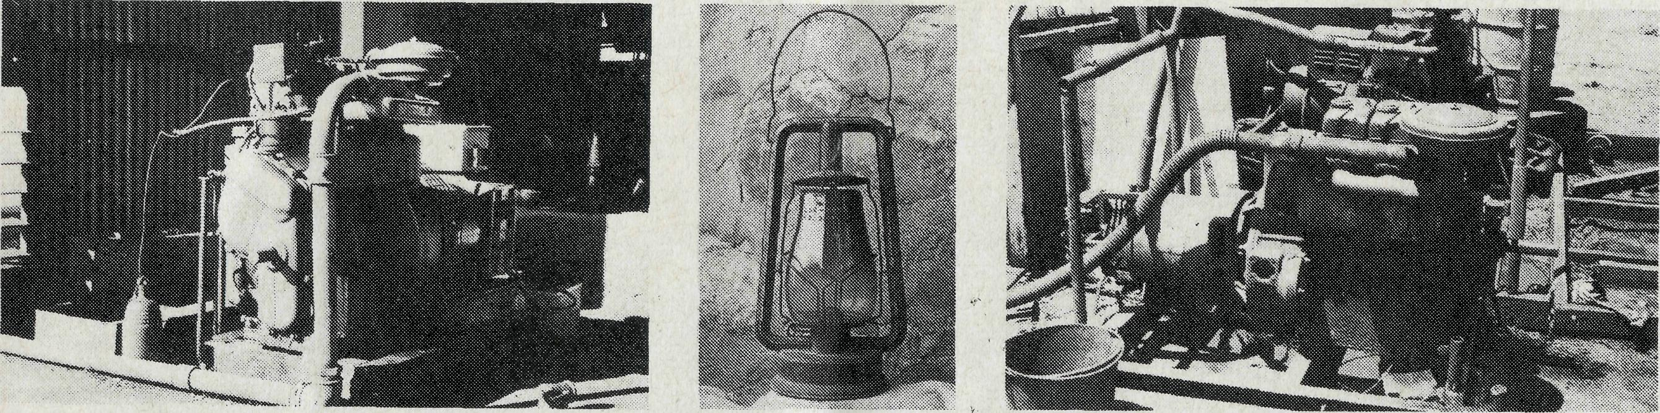
Being human we are all involved in a contrast of power — some with the ease of using whatever they like whenever they like — some with no chance of being anything but hot when it is hot.
Being Christian we are involved in a different contrast of power — some who know and love the God and Father of our Lord Jesus Christ, some who are delving into the Word of God to find out about Him, some who have handled, shelved and walked around the Word of God.
Please pray that this contrast of power will be resolved in the lives of men and women in the remote areas of our country as in the cities, so all will come to understand and know God's power.
THE REAL AUSTRALIAN 5

"Good ol' Farr"
JOIN THE CROWD AT ST. ANDREW'S
RALLY! SYDNEY RALLY!
FRIDAY, 18th APRIL, 1980
6.30 p.m. - THANKSGIVING SERVICE - CATHEDRAL

Preacher: The Reverend Theo Hayman, Federal Secretary
Light refreshments in the Chapter House 7.30 p.m.
8.00 p.m. - ANNUAL RALLY - CHAPTER HOUSE
Speaker: The Revd. Rob McEwin, Mid West Mission, S.A.
Special singing — New Audio-Visual
Miss Marjorie Farr passed away on 9th November, 1979. As a child she came from England with her parents and family and lived on the land at Tamworth. She became a typist with the State Electricity Commission and rose to a position of responsibility.
Working then in the city, she became a Mail Bag Sunday School teacher for several years, using her country experience to understand the children's isolation.
In February, 1946, she volunteered to serve in B.C.A., with a greatly reduced salary and extended working hours. For the next twenty years Marjorie Farr was prepared to serve wherever asked, with a willing cheerfulness that made her a real gem. She served in the Hostels at "Coorah", Went-worth Falls, Mungindi and Wilcan-nia. She was prepared to cook, do the huge washing, scrub floors and all without the modern facilities of electric stoves, refrigerators or air conditioning. Recently Mrs. Don Carrington of Nungalinya College,
Darwin, paid tribute to Miss Farr's spiritual ministry to her as a Hostel girl at Mungindi.
Marjorie Farr was to go to South Australia to share the Hospital work at Cook and Penong. There came a time of sudden staff shortage at "the Old Folks' Home" at Port Lincoln and there was a cry at short notice for a cook. The Reverend Canon Tom Jones remarked, "the only person to call on is good ol' Farr who will cope with any situation" — and she did.
Then she went on to care for some single men working on the Radio Base in with the B.C.A. Flying Medical Service at Ceduna.
THE REAL AUSTRALIAN
One of the gifts which Marjorie Farr exercised was writing letters. These were a source of comfort and strength to many people and upon her passing, the list was so great that it seemed impossible to write a personal note to each address in her well filled book. Miss Farr retired in 1966 to Blackheath and later to Mowll Village.

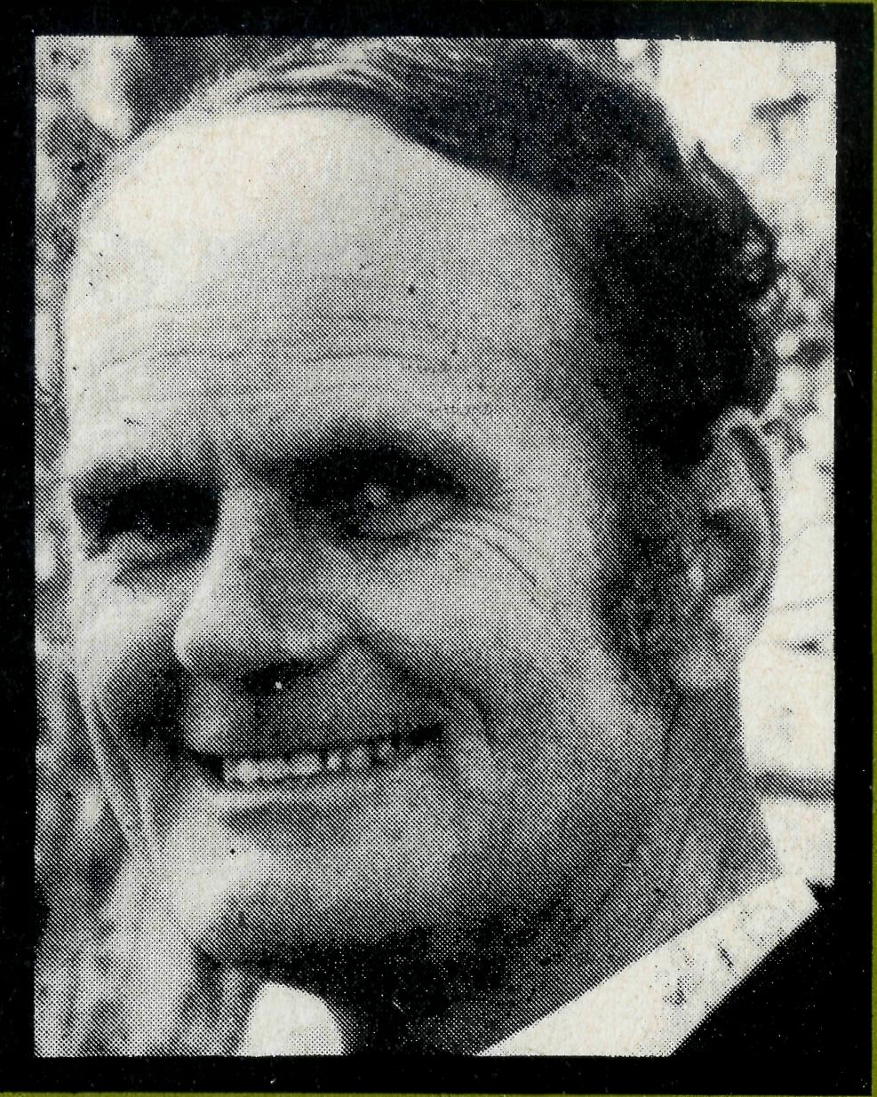

from the Federal Secretary
PIONEERS
"What do you do," asked the Bishop of Gippsland, the Right Reverend A. W. Pain, in 1919, "when you have new settlers living in new areas who plainly need a ministry, and there is no diocesan finance to provide one? Let's begin an Australian Society, to ask the folk in the city to help those in remote areas." So he called on faithful folk to join together and the Bush Church Aid Society began vigorously in faith and with prayer. As soon as possible we moved on to the next needy area.
The same challenge is with us today, the maintaining of ministry in gigantic "old" outback parishes and the new ministries where there has never been a parish before.
We have a wide open country with many new frontiers. A diocese such as Rockhampton wonderfully battles to become self-sufficient. Then suddenly new towns spring up with costs beyond their means.
Ever heard of Middlemount? It is being built this year north of Blackwater, and this is only one of a number of new coal mining towns.
Pioneering is always costly. Last year we were fortunate to have a good cash balance to help us. Even so we were thrilled and thankful to God to exceed our income budget.
In 1980, inflation and the expanding ministry are going to test us challengingly. May we have an active faith in God.
Your friend.
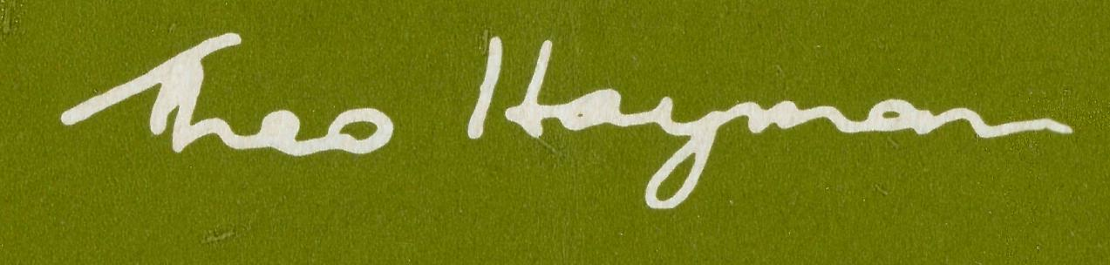
THE REAL AUSTRALIAN

TO TARCOOLA, S.A.
MEET THE
NEW
FIELD STAFF
TO DARWIN, N.T.

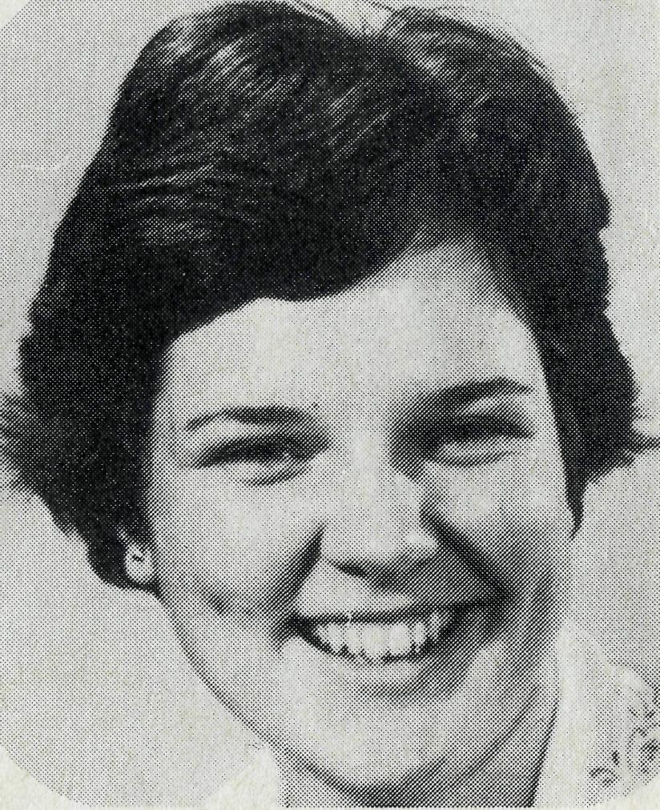
SISTER LOUISE HOWARD joined Sister Helen Plumb at Tarcoola Hospital at the end of January. Louise, from St. Matthias', Centennial Park, did her general nursing training at the Nursing Education Centre of Prince of Wales, Prince Henry and Eastern Suburbs Hospitals. She has been active in the life of her parish and served on the Church Committee. Those who know her well speak of her ability to adapt and quiet cheerfulness in changing situations, qualities so valuable in outback nursing. Members of B.C.A. 's Nurses Fellowship are thrilled about Louise going out as we are sure Helen must be.
TO WEIPA, OLD.
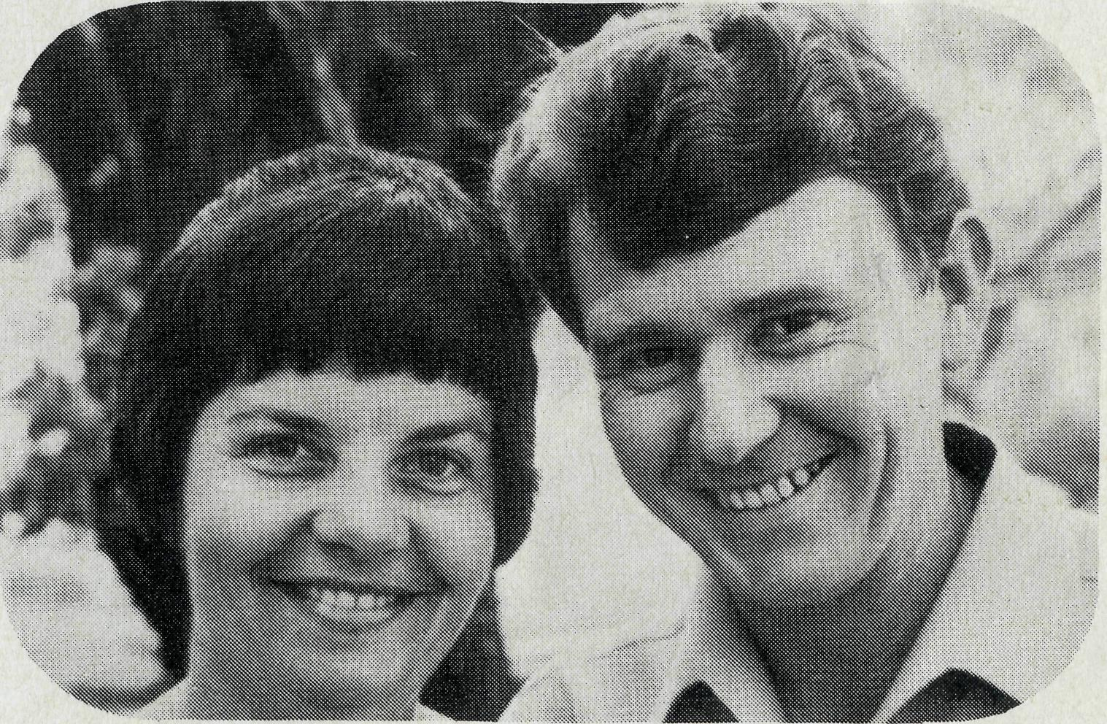
THE REVEREND LEX AND MRS. RHONDA CAREY with their children Andrew (11), Peter (9), Elizabeth (3) and David (10 months) leave Imbil, Qld., at the end of February for Weipa. Lex and Rhonda have considered missionary work for some time and clearly felt B.C.A. 's request to them to go to Weipa as the Lord's call. Although Lex has only served a reasonably short time as Priest-in-Charge at Imbil, Archbishop Arnott released him with his blessing saying, "I will be very sorry to lose him even temporarily, but Hamish Jamieson (Bishop of Carpentaria) will certainly get a treasure."
TO PARABURDOO, W.A.
THE REVEREND ADRIAN AND MRS. WILLEMIEN MOORE in February commenced their ministry with B.C.A. in the Parish of the South Pilbara, North West Australia, which embraces Paraburdoo, Tom Price and Wittenoom. Bishop Howek Witt is delighted to have recruited the Mooresfor thisJbhallenging area. Adrian, who has been the Priest-in-Charge at St. James', Pakenham in Melbourne since 1975, now skvells the sizeable team of Victorians serving with the Socipy throughout Australia. The Moores have two children shphen (7) and Marika (5).
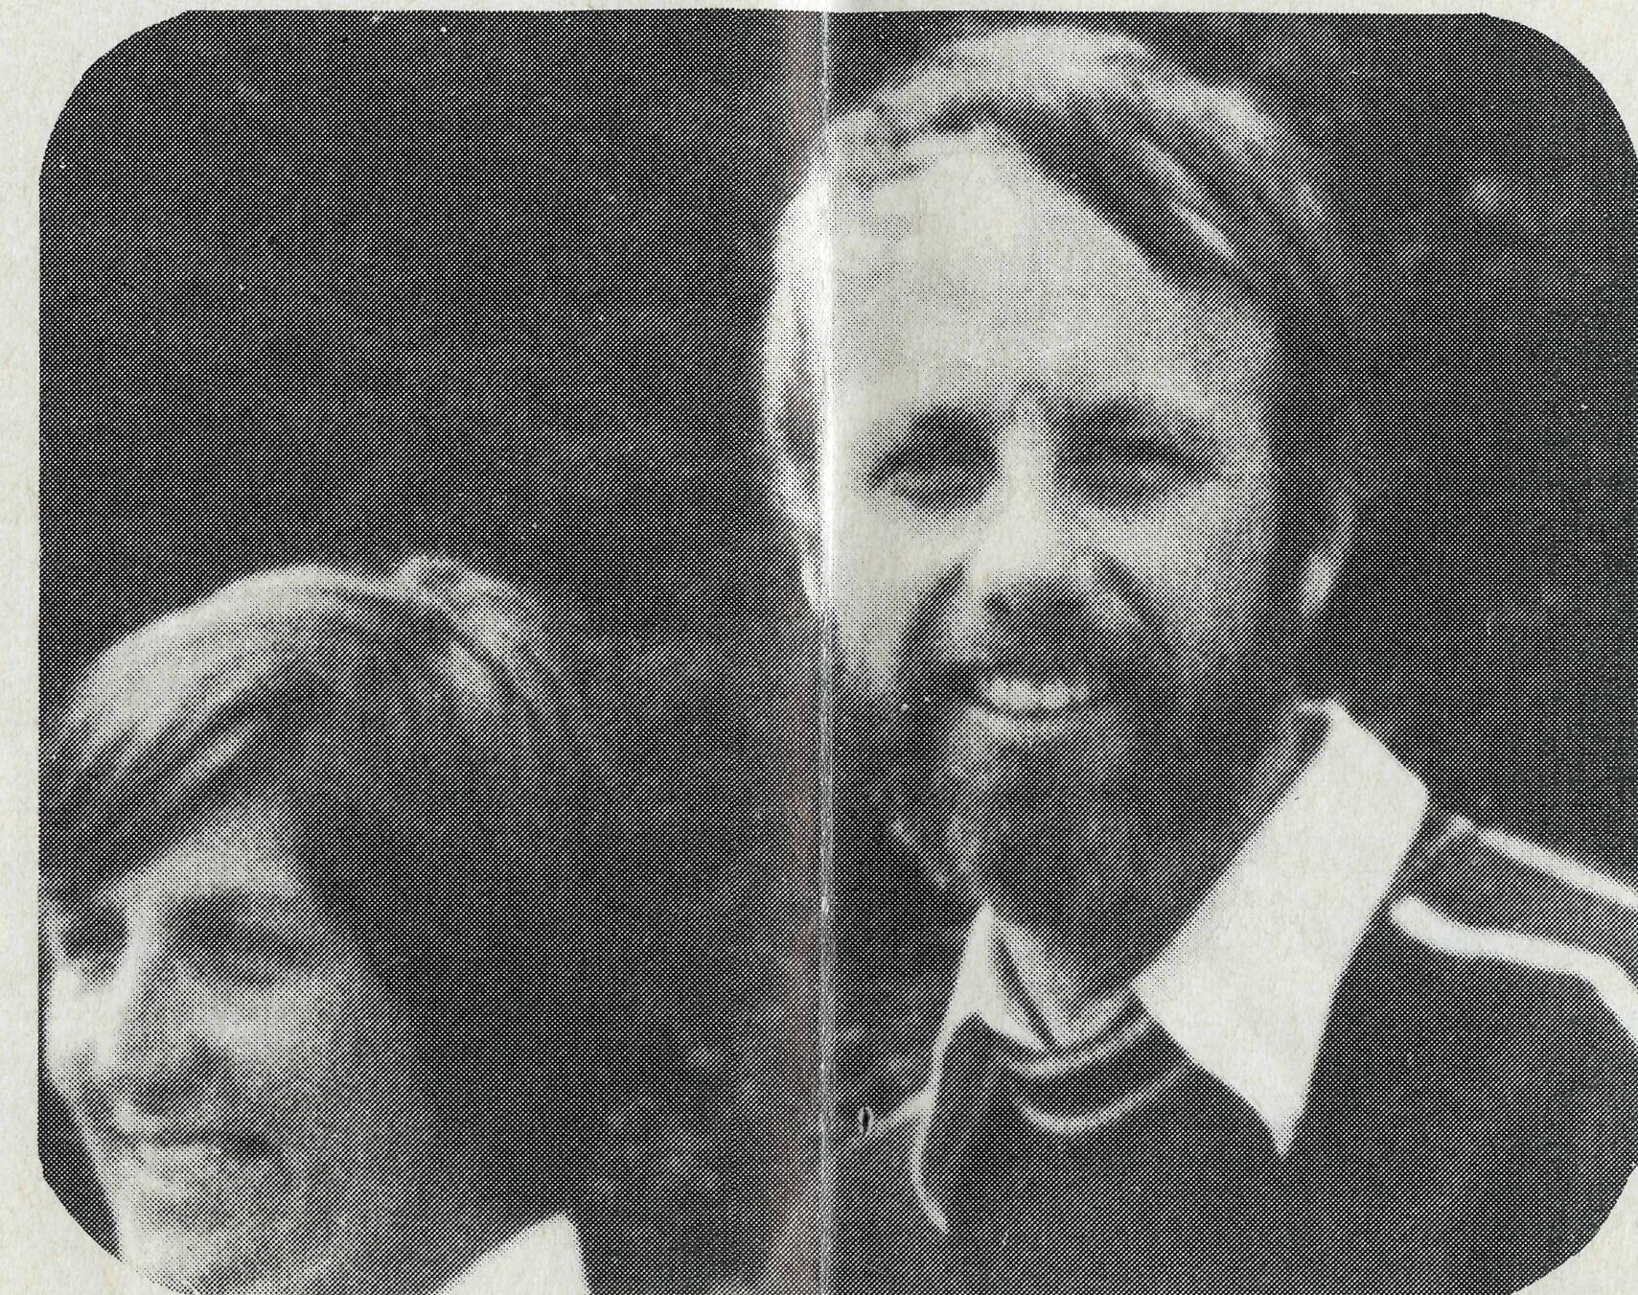
TO LEINSTER, W.A.
The Lord said: —
"Whom shall I send, and who shall go for us?"
THE REVEREND AND MRS.
The Parish of the Murchison perhaps the largest in the world. . . .
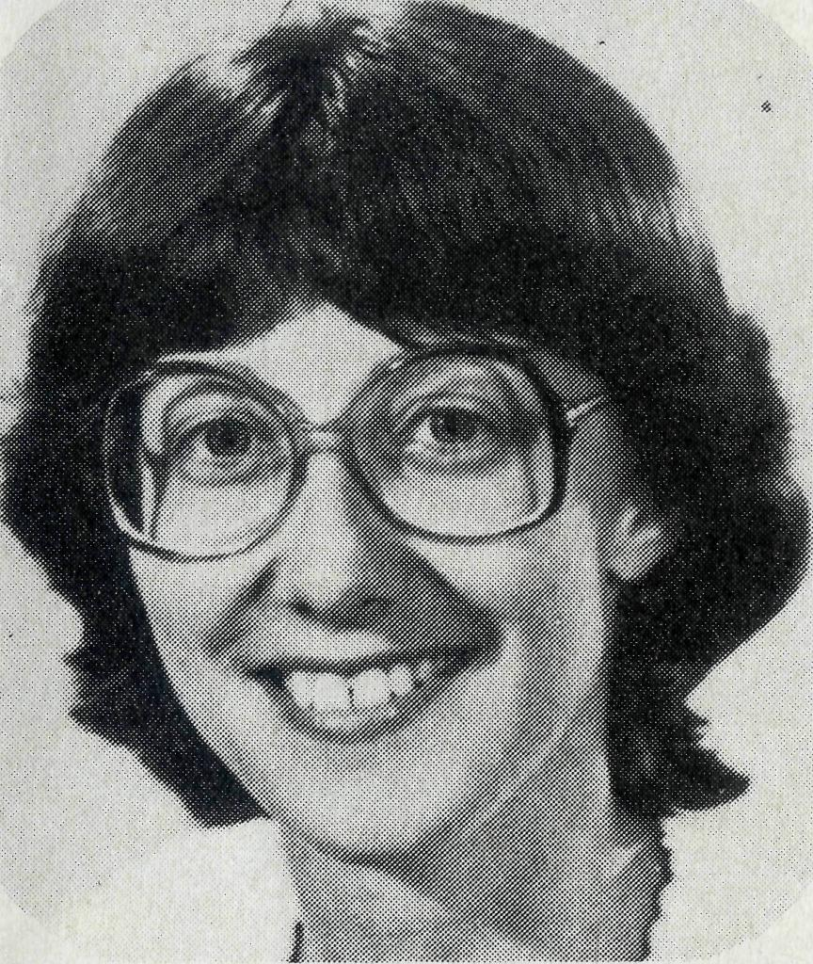
MISS PAULINE CLEMENTS. Who has been serving as the Parish Sister in St. Matthew's Parish, Manly, NS. W., commenced work in Darwin at St. Peter's, Nightcliff, in February. Darwin is a rapidly growing city of 62,000. Climatic conditions and the spiritual needs of people can make great demands upon Christian workers there. Therefore, it is good to report that the Sydney parishes of Manly, McCallum's Hill and Peakhurst have assured Pauline of regular prayerful and practical support in her new sphere of ministry.
TO EXMOUTH, W.A.
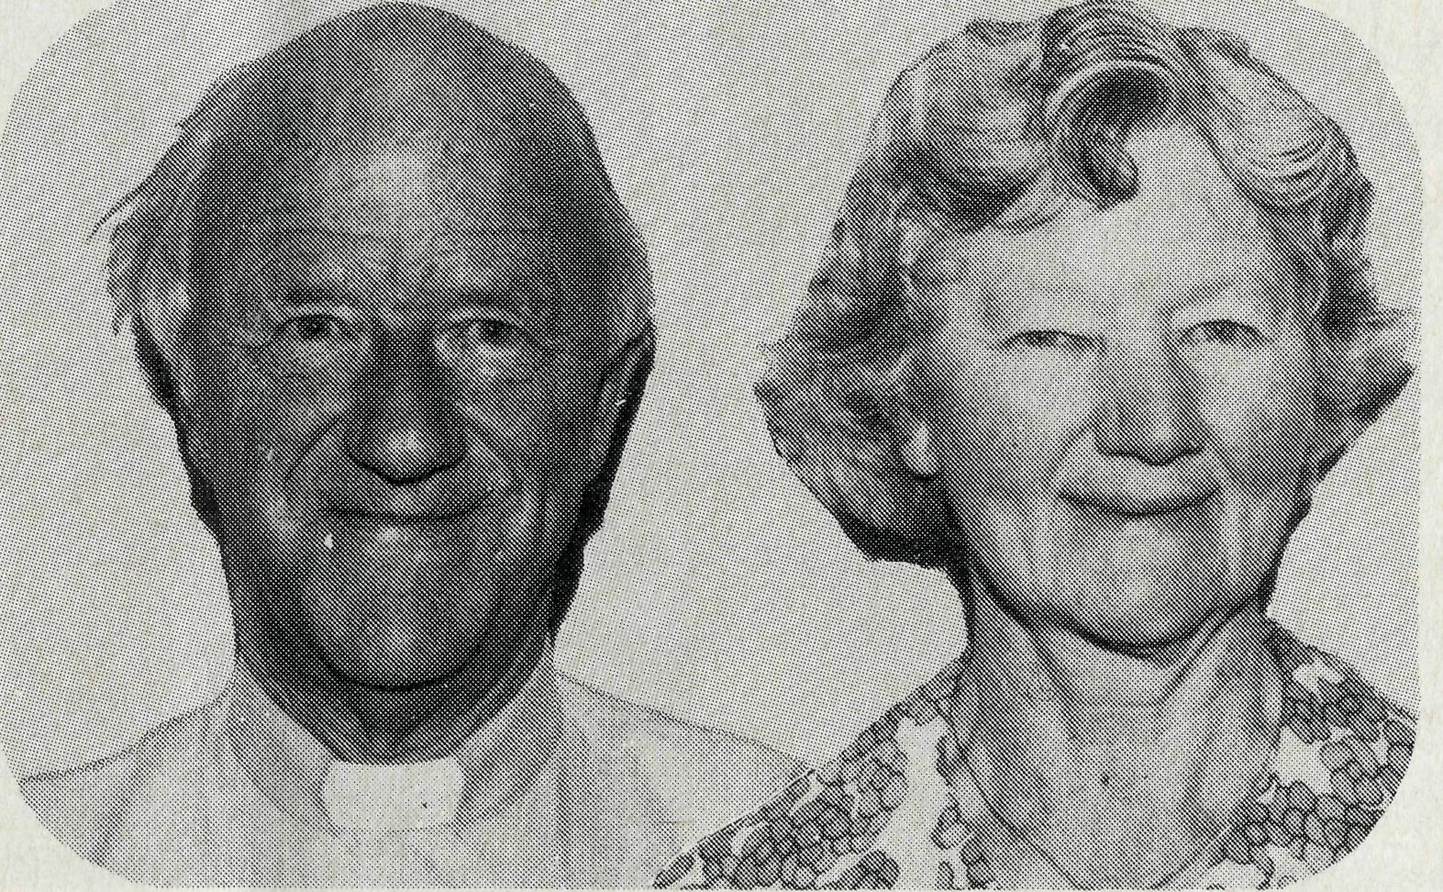
THE REVEREND KEN AND MRS. MADGE PRENTICE
go to Exmouth, in the Diocese of North West Australia in March for a term of service of two years. Ken and Madge served for 25 years with C.M.S. in the Diocese of the Upper Nile and Soroti, where he was an Archdeacon. They returned to the Diocese of Melbourne in 1963 and have served in the Parish of Christ Church, Hawthorn '63-'71 and St. Theodore's, Wattle Park since '71. Ken must have heeded Bishop Howell Witt's statement that "today's bush diocese can offer older, more experienced clergy a worthwhile, exciting and demanding challenge in their ministry. "

• A gentleman who had been
daily using the B.CA. Prayer and A
Daily Prayer on our map page for
over fifteen years made a couple of
suggestions which enabled them, I
believe, to be helpfully revised.
• Just a move up the coast you
might say. The Reverend Peter and
Mrs. Betty Mills are off to serve at
Derby leaving Exmouth after two
years of valuable ministry there. The
move, although within the same
diocese, North West Australia,
would be about the distance be
tween Rockhampton and Cairns on
the eastern coast.
• After six years of service with
the Society in North West Australia
The Reverend Bill and Mrs. Joan
Hoare are moving on. They lived in
Mount Magnet for five years and for
the last twelve months in Leinster
with Bill ministering in the vast
parish of the Murchison with great
concern and constant hard
travelling. His training as an elec
tronics engineer, prior to his ordina
tion, sometimes gave Bill unusual
opportunities to witness. After
quickly and expertly repairing some
erratic washing machines in Mount
Magnet or was it Meekatharra,
some of the locals listened with a
new deeper respect as he told them
why it was he served the Lord. No
longer young, the Hoares are happy
to be going closer to Perth where
Joan will see certainly more of Bill
and they'll both have the opportun
ity of seeing more of their children
and grandchildren. They have our
J
erful good wishes and gratitude i job well done.

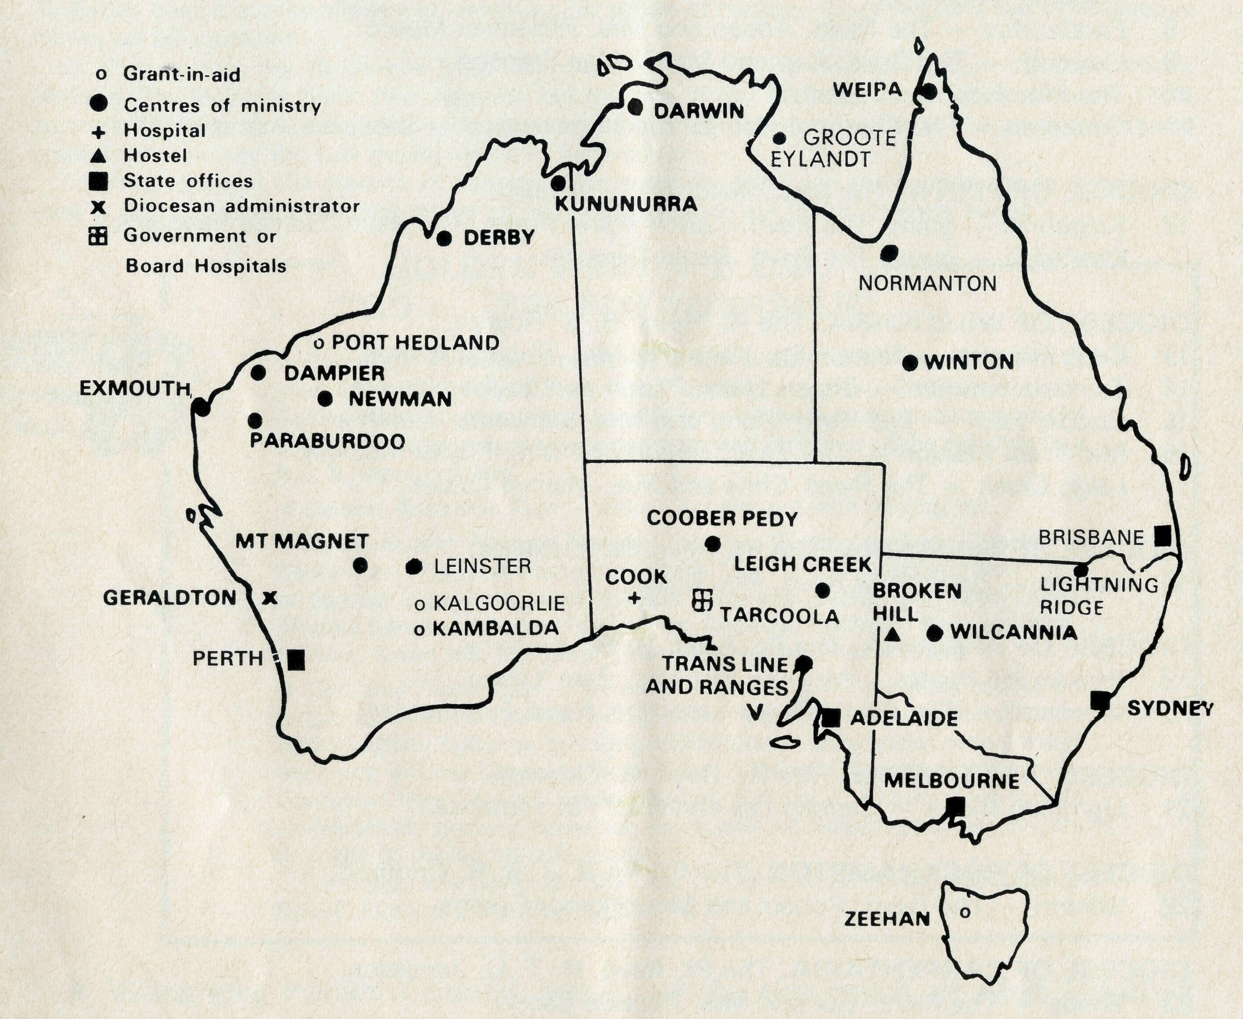
- We regret to announce that on doctor's orders Miss Coryn O'Nians has had to return south and relinquish her work as Librarian and Secretary Tutor of the T.E.E. courses at Nungalinya College in Darwin. Coryn's task in the College was a vital one and her contribution to the development of Aboriginal Christian leadership was appreciated. We wish her a quick recovery in health and best wishes for the future.
- A belated thank-you to those kind people who sent sufficient patchwork covers for the beds at the Broken Hill Hostel. This gift together with towels, etc., was most welcome and very much appreciated. Ken & Pam Young.
• "One of the most important
things I learned from the trip is to
pray. God has given me a desire to
pray for the work of the Bush
Church Aid Society around
Australia, especially in and around
Wilcannia, as He has shown me
how the church operates there." I
believe this sentiment expressed by
Michael Peterson after his stay with
the Fuhrmeisters at Wilcannia
would be echoed by many who
have shared in the Golden West .—
"Go . . . see for yourself" Tours.
——— ADELAIDE ———— DAY OF FELLOWSHIP
Sat.,3rd May,10a.m.-3.30p.m.
Colonel Light Gardens
in AH Saints' Hall
Revd. C.Clerke - Leigh Creek
ALL B.C.A.SUPPORTERS INVITED
THE REAL AUSTRALIAN
THE B.CA PRAYER
A DAILY PRAYER
0 Lord our God, help us to remember the people who live in the remote parts of our land. We ask You to bless those whom You have called into the fellowship of The Bush Church Aid Society, and call others to stand with them in the task. Grant that, through the ministry of the Word and Sacraments, through healing, and through caring for the young, the message of Your redeeming love may be proclaimed, through Jesus Christ our Lord. Amen.
0 God, we remember before You those whom You have called to Your service. We
ask You to Bless ,
and assure them of Your Presence. Grant to them, as to us, the joy of service, the ability to achieve, and the serenity of Your peace, for Jesus' sake. Amen.

• Wilcannia Parish Council has made the request that if a parish is changing over to the Australian Hymn Book and previously used the Book of Common Praise or Hymns Ancient and Modern Revised, they would be very happy to have the surplus books to use in their various centres such as White Cliffs, Tibooburra and Tilpa.
THE REAL AUSTRALIAN
PRAYER CALENDAR
FIELD STAFF DIRECTORY
DIOCESE OF NORTHERN TERRITORY. The Rt. Revd. K. B. Mason.
- Darwin — Sister Pauline Clements (Nightcliff). Vacant (Nungalinya College).
- Groote Eylandt — The Revd. Bruce and Mrs. Marcia Hansford.
DIOCESE OF NORTH WEST AUSTRALIA. The Rt. Revd. H. A. J. Witt.
- Kununurra — The Revd. Royce and Mrs. Susan Thompson.
- Derby — The Revd. Peter and Mrs. Betty Mills.
- Newman — The Revd. Don and Mrs. Libby Wilson.
- Port Hedland — grant, The Revd. Peter Thompson.
- Dampier — The Revd. Bill and Mrs. Jocelyn Ross, The Revd. Tom and Mrs. Carol Williams (Wickham).
- Paraburdoo — The Revd. Adrian and Mrs. Willemien Moore.
- Exmouth — The Revd. Ken and Mrs Madge Prentice.

- The Murchison — Vacant.
- Geraldton — Mr. Stan and Mrs. Dorrie Hummerston — Diocesan Administrator.
DIOCESE OF PERTH. The Most Revd. G. T. Sambell.
12 Kalgoorlie — grant. The Revd. Canon Frank Watts, The Revd. Dennis Reynolds.
Kambalda — grant. The Revd. David Cockram.
DIOCESE OF WILLOCHRA. The Rt. Revd. B. S. Rosier.
- Cook Hospital — Nurses Mr. Keith and Mrs. Rhonda Anstee.
- Tarcoola Hospital — Sisters Helen Plumb and Louise Howard.
- Coober Pedy — The Revd. Kerry and Mrs. Julieanne Medway.
- Mid-West Mission — The Revd. Robert and Mrs. Phyllis McEwin.
- Leigh Creek — The Revd. Chris and Mrs. Marilyn Clerke.
DIOCESE OF TASMANIA. The Rt. Revd. R. E. Davies.
18 Zeehan — grant. The Revd. Roy Dixon.
DIOCESE OF RIVERINA. The Rt. Revd. B. R. Hunter.
- Broken Hill Hostel — Mr. Ken and Mrs. Pam Young.
- Wilcannia — The Revd. George and Mrs. Hazel Fuhrmeister.
DIOCESE OF ARMIDALE. The Rt. Revd. P. Chiswell.
21 Lightning Ridge — Captain Les and Mrs. Pat Femance.
DIOCESE OF ROCKHAMPTON. The Rt. Revd. J. B. R. Grindrod.
22 Winton — The Revd. Robert and Mrs. Rigmor George.
DIOCESE OF CARPENTARIA. The Rt. Revd. H. T. U. Jamieson.
- Weipa — The Revd. Lex and Mrs. Rhonda Carey.
- Normanton — The Revd. Jim and Mrs. Margaret Hudson, Miss Anne Watkins. (A.F.W.)
GENERAL
25 Federal Secretary. The Revd. Theo Hayman.
N.S.W. The Revd. Wakely Wade, The Revd. Malcolm Babbage, Eric Atkin, Miss Doris Smith, Mesdames Joy O'Neill, Dora Warwick and Nina Allan.
- VICTORIA. The Revd. Ernest Horth, Miss Chris Craig.
- QUEENSLAND. The Revd. R. W. Herbert (Hon. Secretary) WESTERN AUSTRALIA. The Revd. Gordon Thomas (Deputationist)
- SOUTH AUSTRALIA. The Revd. David Eastway.
- The President, The Most Revd. Sir Marcus Loane, Chairman, Dean Lance Shilton, Honorary Treasurer, Mr. Richard Stokes, The Council, State Committees.
- Staff Replacements, Box Secretaries, B.C.A. Supporters.
- National Home Mission Fund.
WE HAVE A DILEMMA
Should we in our Prayer Calendar and Field Staff Directory identify the location of our Field Staff by the centre in which they live or the area in which they serve?
It is easy to simply use the town where they live but it can be misleading. Some examples: (1) against day 7 we have Dampier — The Reverend Bill and Mrs. Jocelyn Ross, The Reverend Tom and Carol Williams (Wickham). The Ross' have been living in Dampier for some time and Bill serves as the Missioner and Rector in what is called the Parish of the West Pilbara, embracing not only Dampier but Karratha, Roebourne, Wickham, Pannawonica and some other small centres as well. The Reverend Tom Williams is moving soon to Wickham to be Bill's Assistant and the Ross' will be moving house from Dampier to Karratha, so the two Missioners within this large and growing parish will be strategically situated for the development of the work. By contrast we are inconsistent, I must confess, (2) against day 2 it is Groote Eylandt — The Reverend Bruce and Mrs. Marcia Hansford. Now there are three separate centres on Groote Eylandt, Alyangula, the Gemco Mining Town, Angurugu and Umbakumba, both Aboriginal Communities. The Hansford's principal responsibility is the mining town Alyangula, but because of shortage of housing there he has had to live at Angurugu, and owing to the fact there is no other clergyman on Groote, he also ministers at Umbakumba. To further complicate the problem of identifying his sphere of ministry, Bruce regularly flies to Nhulunbuy (Gove) on the mainland.
(3) Then against day 16 there is listed Mid-West Mission — The Reverend Robert and Mrs. Phyllis McEwin. The McEwins live in Port Augusta, but the area of Mr. McEwin's work is out along the Trans Australian Railway Line to the Western Australian border, to station folk in the Gawler Ranges and north and south of the line and the opal mining centre of Andamooka.
The illustrations of this dilemma of ours could be multiplied. Have you any suggestions as to how you think it could be resolved without taking up too much space on our Prayer Calendar page?
GOLDEN WEST - B.CA.
"GO ... SEE FOR YOURSELF"
- Giving you a unique opportunity to visit areas of B.CA. ministry and to meet some of the Field Staff whilst enjoying a holiday. Coach travel with Golden West Tours is in comfortable long distance touring coaches, motel accommodation at every overnight stop, and each tour will be escorted by a B.CA. representative.
- Central Australian Tour — Sorry, booked out with waiting list.
- Adelaide and Flinders Ranges Tour — 15 day — Dep. Sydney 23
September. This is similar to the original "Go see for yourself" Tour
so popular in previous years. It visits Wilcannia, Broken Hill, Leigh Creek, Flinders Ranges, Wilpena Pound, Port Augusta, Adelaide, Barossa Valley, Mildura, Swan Hill, Leeton and back to Sydney. Fare $716.00.
* Lightning Ridge Tour — weekend August 8-10 — a chance to visit the
Ridge, to do some opal fossicking and to see B.CA.'s work there. Leave
Sydney Friday 6.30 p.m. travelling to Bathurst, then express coach through
the night, arriving Lightning Ridge 7 a.m. Saturday. Sunday Service in St.
George's Church 9 a.m., arriving Sydney Sunday 10.30 p.m. Tour fare in
cludes Motel, bed and breakfast, lunch and tea Saturday and lunch Sun
day. $88.00 (based on twin share).
For details and bookings: Mrs. Joy O'Neill, B.CA. House, 135 Bathurst Street, Sydney, 2000. Phone (02) 26-3164.
• As the result of Miss Unwin's expertise and untiring work, together with that of her helpers, the used stamps sent to B.CA. by supporters meant $1,750.00 extra for the funds of the Society in 1979. We are most appreciative of all who made this result possible. So that it might continue in 1980, let's have your used stamps.
13

SIGNIFICANT OBSERVATIONS
ALONG THE TRACK
Last year theJrlorth family over a five-week period travelled 7,600 km by road and 500 \M by air visiting members of the B.C.A. field staff at Darwin, Normanton, Qibote Eylandt and Winton. Mrs. Ida Horth reported eloquent-ly and in detJf to the Melbourne B.C.A. Rally, seeking to enlist prayerful concern for the staff she had visited. Mrs. Horth spoke from her position of Christian wife and mother, and a former missionary nurse. Here are some significant observations from the address.
ADJUSTMENTS. In going to live “along the track” one has to adjust to many fearsome things, heat, dust, bad roads, wet season, floods, cyclone threats, snakes, fogs, insects and creepy crawlies of all kinds. Sometimes it is just an easy adjustment which is needed, at other times there may be real fear to overcome.
The Hansford's dog cornered a death adder under the house not many days before we got to Groote Eylandt. It was caught and killed. The locals say that no one has ever been bitten by a snake which is little comfort for Marcia with two small active boys. Margaret Hudson is full of praise to God for overcoming fear of the roads. At one stage she was unable to face going around the parish with Jim for fear of being stranded in some lonely place. They spent two days bogged on the Normanton to Burketown road early in their ministry.
HEALTH. A big concern of mine is in the area of maintaining good health, part of which means a good diet. In the north during the winter the essential fresh food mostly comes from the coastal areas. To a place like Winton food comes on the train; to Darwin and Normanton by road, while Weipa and Groote Eylandt are supplied by a barge which sails from Brisbane or Cairns approximately every three weeks. In the wet season when most means of transport may be disrupted at some time, the prices are high especially for fruit, vegies and milk. I paid $1.12 for half a cabbage at Darwin. The homemaker needs to know when the food arrives in the shop and buy up at once or miss out. The freezer has become an essential part of the life in the home.
The wet season seems to be the worst time for infections of various kinds especially for those who have not had time to acclimatise. We need to be aware of the Hansfords in this regard who have already done battle with "wogs". Last year the Hudsons had to contend with "boils". SEPARATION. Margaret Hudson tells how recently Jim was overdue home. He had left on Sunday after lunch on a four-day drive over outback roads for one end of the parish. He was due back on Wednesday between 1-2 p.m. after having taken several services and called at station properties. It was 5.30 p.m. and the agreed dead line hour was 6 p.m. when she would need to find help. As she made her plans she realised again what it means to live in an isolated place surrounded by so much open space, where much

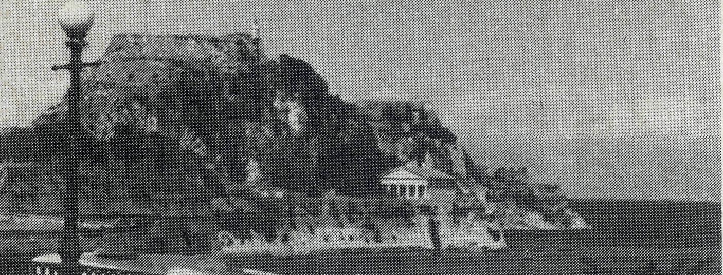
NOT OUTBACK AUSTRALIA BUT. . .
*by Bishop John Reid
During July and August 19791 acted as Chaplain to the Anglican congregation at Holy Trinity, Corfu, Greece. It was a time of very great delight for my wife and I. The congregation consists of about fifteen regulars and thirty to forty tourists. There is one service on Sunday and opportunities for fellowship during the week.
The Chaplaincy is greatly appreciated by those English speaking people and they supported it generously and enthusiastically. Besides conducting the services and visiting parishioners, the Chaplain is frequently called in to assist in times of crisis for a people who are English speaking. A young School Master from South Australia and his girl friend from South Africa were involved in a serious car accident while we were there. My wife and I were called in to the hospital to wash and feed them and to find young people in the taverns who would give blood for transfusions.
The Chaplaincy is one of many throughout Europe which is staffed by the Intercontinental Church Society^ and is maintained through the sacrificial giving of many church people. There are now flocks of Australians who move across Europe on holidays and it occurred to me that there could be those Australian church people who may from time to time care to support the work of I.C.S. as it ministers to so many of our people. Because the B.C. A. Society has had some links with the I.C.S. in the past, I am grateful that this can be brought to your attention through the "Real Australian" and that theB. C.A. is willing to forward any gifts received by the I. C. S. These chaplaincies are a real outreach to many people.
*The Right Reverend John Reid is an Assistant Bishop in Sydney Diocese.
■\Col. & Con. now I.C.S. — The Colonial and Continental Church Society (Col. & Con.) became with changed conditions The Commonwealth and Continental Church Society and has once again changed its name. It is now The Intercontinental Church Society.
can go wrong so easily. The stress level was beginning to be felt and very soon the children would become aware thus adding further to their concern of Dad being away. Just on 6 p.m. in walked Jim, nothing spectacular. Had he gone to a station to phone Margaret when he knew he would be late it would have added an hour or so to the trip. On that occasion one of Jim's visits had been to a station where the people had not seen a priest in 11 years. They were all thrilled about the contact, asked for a service over the radio and linked the children up with Mail Bag Sunday School.
Jim Hudson, like Bob George at Winton who is in a similar ministry, is having a transceiver fitted in the car.
"It was evident that the active use of Prayer Fellowship Notes and belonging to the B.C.A. family are an important life source to our isolated staff."
Are you a member of the B.C.A. Prayer Fellowship?

14
THE REAL AUSTRALIAN
THE REAL AUSTRALIAN

