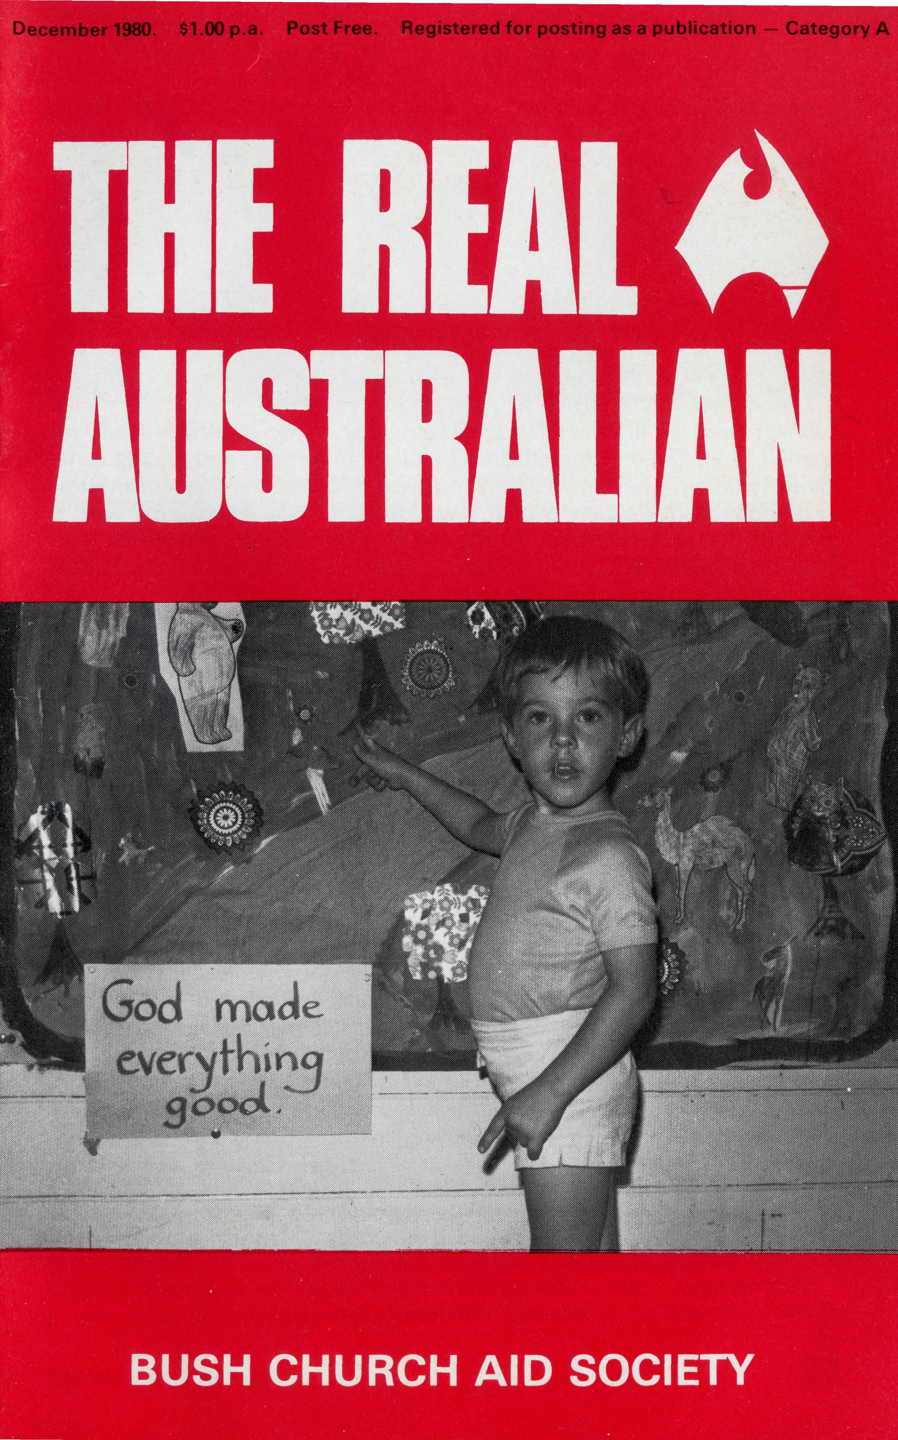
It was 118° fahrenheit in White Cliffs, that opal mining town in western New South Wales, when I took a Christmas service there. It was the Saturday before Christmas and the little stone St. Mary's Church was well attended by the people of the town and folk from the grazing properties around about.
A Mrs. Harris invited me to her dug-out home for lunch. How good it was to get out of the heat! In the dug-out home it^was a pleasant 7 8° fahrenheit.
Over lunch Mrs. Harris apologised to me for her son who laughed during my sermon. The text I had chosen from the Gospel was John 1.14, "The Word was made flesh and dwelt among us, we beheld His glory, the glory as of the only begotten of the Father, full of grace and truth".
The word "dwelt" I explained could be translated "lived as in a tent or tabernacle". I spoke of the body being likened to a tent frequently in the Bible and the tent is a temporary dwelling erected for a specific purpose. As an aside I said nobody would live in a tent in White Cliffs in summer. This was when the Harris boy laughed. His mother explained they had lived in a tent for the first two years in White Cliffs.
In a country like Australia it's not hard for some to associate Christmas with a tent if they are among the thousands camping by the beach or lakes during this mid summer holiday period. To others a tent simply suggests a circus big-top with its short season in town providing a brief time of exciting spectacle.
But I want to take your minds away from big-tops, marquees, auto or continental tents to a unique tent - Christ's tent.
Clearly Jesus' human existence - the Word becoming flesh - His body constituted the tent where He the Son of God lived for a short time for us men and our salvation. Truly one of us accepting all the limitations of a human existence. Therefore truly and wonderfully understanding us. Not only this but that body unstained by sin He offered as a perfect sacrifice for our sins. No wonder we can with great joy call Him Jesus our Saviour. This is the true joy of Christmas.
Christmas 1980
Yours sincerely in Him,

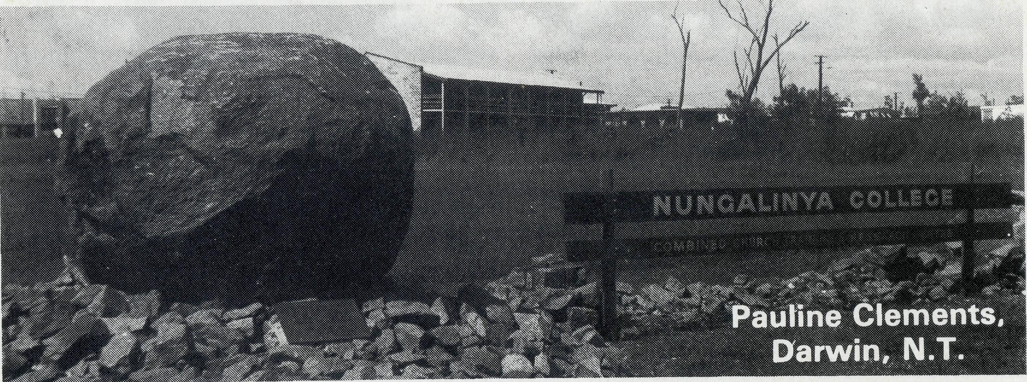
OUR ROCK
'Tor who is God, but the Lord? And who is a rock, except our God?" Psa. 18:31.
3 WEEKS AT TARCOOLA
As a city girl I was privileged to spend three weeks with Sister Helen Plumb at B.C.A/s Tarcoola Hospital in January 1980, having offered to be involved in a holiday programme for the local children. As I arrived in the New Year period, the shops (Post Office and General Store — the heart of the town) were shut, and I spent the first few days talking with Helen and Joan Osborne, the housekeeper, admiring the country and drinking tea. Tarcoola, far from being a couple of tin sheds in an arid, flat desert as I was led to expect, is a town of 200-odd people in (at that time anyway) lush, undulating green country. I spent New Year's Eve at a local station (about 100 km away), to which Helen had been invited. We arrived four hours late due to an unexpected patient who required 50-odd stitches.
The station was a palace and the people were marvellous. We stayed overnight and left after lunch the following day. When the shops finally reopened I met some of the children I had come to help, and we did some things together. They had recently formed a club and their first activity was to do odd jobs for elderly people. I wondered if I was wasting my time, if they had that much initiative! At the end of my first week, two teachers arrived from Adelaide to run a holiday programme sponsored by the Education Department and I was able to let them take over. With three of us we divided the children (20-30 usually) into infants, primary, and secondary age and did folk-dancing, softball, cooking, tracking, even a sleep-in and a concert night. I was pleasantly surprised at the interest and care which most parents showed for their children, and at the care the children showed for one another. Quite a change from the city lifestyle. One family took the teachers and myself to see the local attractions — the racecourse, old township, new railway line, gold mines etc., for which we were most grateful. I did not spend as much time with Helen as I wished to but Sister Marj. Dickson came to do relief work a week after I arrived and they were both kept fairly busy.
I came back from Tarcoola a changed person — my knowledge of people and life had broadened tremendously, as well as my appreciation of nature and the outback, and I found my self-confidence and self-motivation increased. I praise God for this time and I pray that He might equally bless those through whom He has so richly blessed me.
During my stay I came to appreciate the importance of the role which the
Sisters play in the "local" community — Helen is widely respected and
loved by the town and station people and was called upon to do everything
from delivering puppies (at midnight) to running the fortnightly Flying Doc
tor clinics and accommodating the Flying Dentist's team overnight, among
many other routine duties. Judith Cabrera of Adelaide
COVER PHOTOGRAPH
Todd George at Winton Wednesday School (Sunday School on Wednesday). Todd is the son of the Reverend Bob George, B.C.A. Missioner serving in this vast Western Queensland parish.
The need for lives to be built on solid foundations is especially true in a place like Darwin. Darwin's largely floating population of 50,000 includes people of a multitude of cultures. Many people in the North face increased pressures by living here, such as isolation with no backup support of relatives that often exerts a pressure that leads to marriage breakdowns; heat and humidity with the strains it brings that can lead to excessive drinking and alcoholism with all its complexity of problems; the legalised casino that is surely bringing in an influx of undesirable tourists and the spread of gambling. Darwin is certainly a place that needs the witness of Christians whose lives are firmly established on the Rock, who are prepared to reach out to such people.
The lifestyle of Darwin (and no doubt that of other centres in the North) does not have a good influence on Aboriginal people, and it is very sad to see and hear of many getting caught up in the problems that have mainly been associated with the white culture. And so there is also the great need for the
Aboriginal people of the North to realise that any other foundation to life but Jesus Christ is sinking sand. This is where the ministry of Nungalinya College seeks to equip Aboriginal people to take the message of the Gospel to their own people. Nungalinya College is — to use its full title — a Combined Church Training and Research Centre. Established in 1973, it is a joint venture of the Anglican and the Uniting Church and primarily has a ministry to Aboriginal people and those working in close relationship to them in various parts of Northern Australia. "Nungalinya" is an Aboriginal word of the Larrakeyah people meaning "old man rock" or "big rock". It is the name of the long, low reef that can be seen out at sea at low tide from Casuarina Beach, not far from the College site. It is a very sacred place for the Larrakeyah people and when the College was being named they suggested "Nungalinya". It is a very suitable name for a College whose desire is to see many Aboriginal people build their lives on the only solid Rock.
(Continued over)

THE REAL AUSTRALIAN
THE REAL AUSTRALIAN

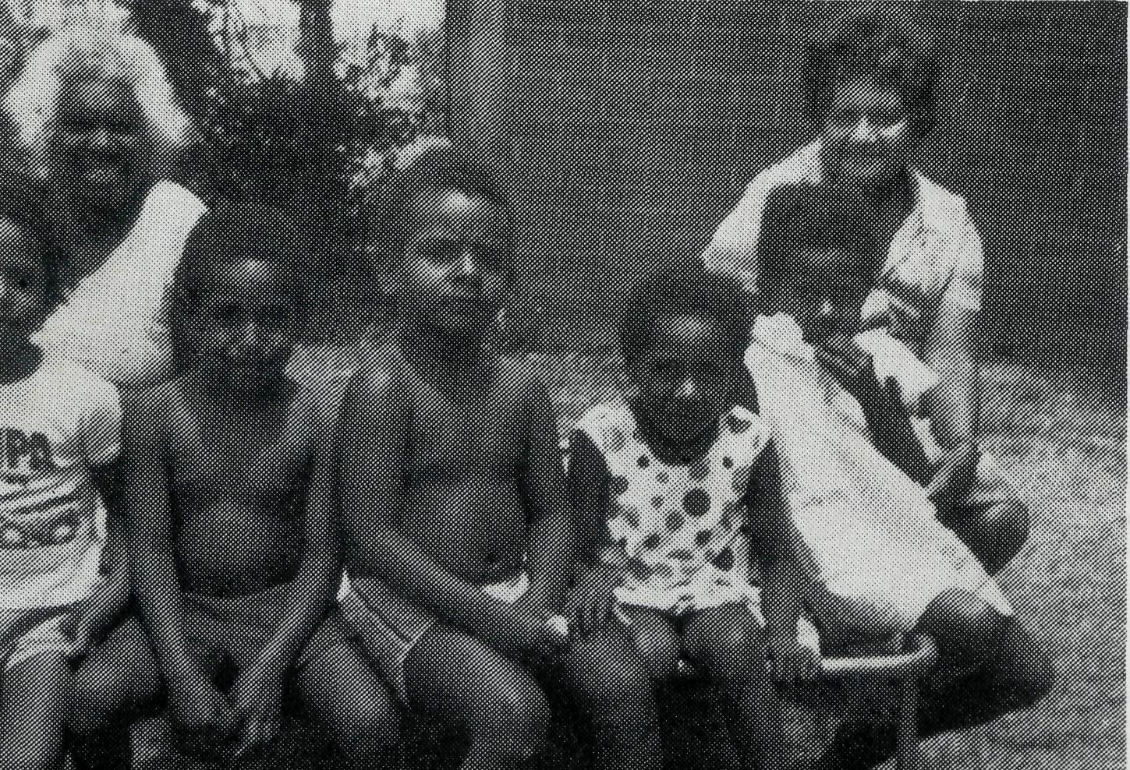
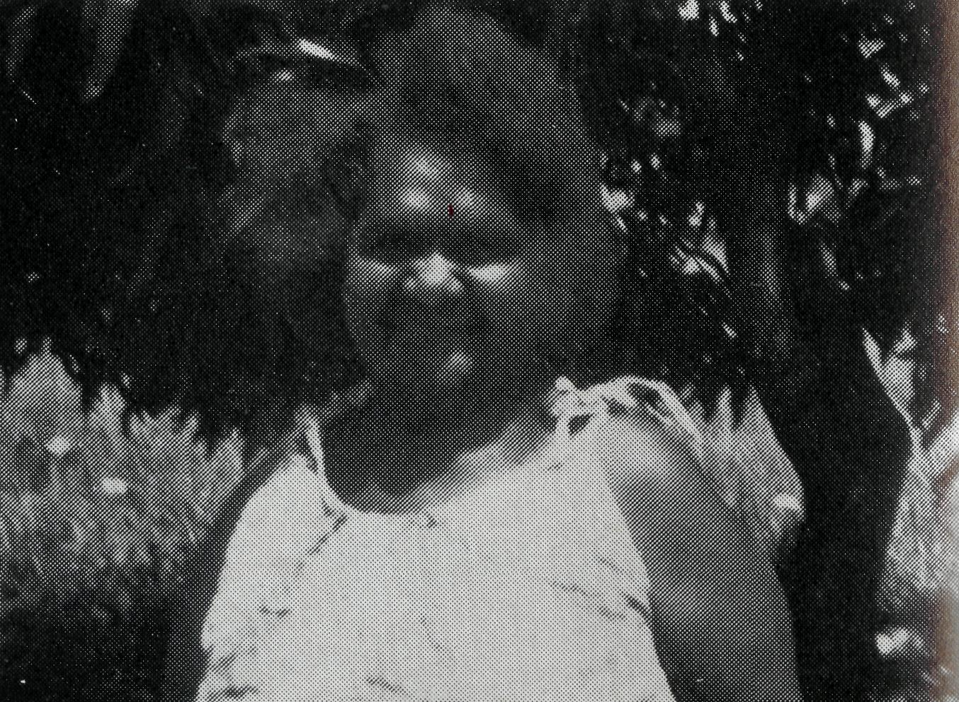
Poor stewardship
This is the understandable accusation levelled by some B.C.A. supporters who received more than one copy of the September issue of "The Real Australian". B.C.A. had nothing to do with this regrettable situation. The people handling the new computer mailing system for "The Real Australian" were responsible.
Reunion Day — Sydney
In conjunction with Golden West Tours there is planned an outing to Katoomba on Australia Day, Monday 26th January 1981, catching from Central the 8.10 a.m. electric inter-urban train where in the front carriages you will find our group. On arrival at Katoomba at 10.13 a most interesting day is planned. Contact Mrs. Joy O'Neill at Sydney office as we must know numbers.
The College's ministry includes theological education of Aboriginal lay preachers, church leaders and ordinands. At present there are three Aboriginal men studying for ordination at the College. There is a full-time course being taught in English as a second language. The College is also involved in organising community development courses to assist people working in positions of responsibility in Aboriginal communities, and also from time to time running orientation courses for new workers. The ministry is continuing to develop and expand which is exciting, but which is also creating urgent needs especially of student accommodation and other building requirements.
Since commencing work at the College at the beginning of July, I
have seen a large variety of people from different areas come within the ministry of the College. Clergymen, nurses, community workers, carpenters, town clerks, lay preachers — Scottish, Irish, Australian from many different communities, mixing with one another, all one in Jesus Christ.
My part in the team of workers at Nungalinya involves work in the library and in the recording studio, producing teaching cassettes for the Aboriginal people to take back with them to their own communities. The work as librarian mainly involves cataloguing and ordering of new books, but most importantly being available to help out whenever there is a need. It is a joy and is most rewarding to be sharing in this work of helping to build lives on the Rock.
‘COME FOLLOW’
The Revd. Lex Carey, Weipa, Nth. Old.
The following brief life story, as told by Mrs. Laura Scott, declares the wonder and greatness of God's faithfulness. Mrs. Scott is an Aboriginal, born at Mapoon in 1919. She lived at Mapoon for thirty-five years, where she married and had six children. The next twenty-five years of her life were spent on Thursday Island before moving to Weipa South in 1979.
Her life story is full of hardship and tragedy, but today her face and life radiate the presence and peace of Jesus.
'It was one night in 1943 when I had a vision of Jesus. I saw Him write on the ground "Follow Me", I answered back in a surprised voice, "me to follow You", and I turned my head away from Him then looked back and He wrote across the top of "Follow Me", "Come".
Next morning I told my husband what had happened and even though we were not Christians he said "Do what He says".
That same morning a policeman came to our home with a letter. It was a message from the office saying, "we need you", I went to the office and found our school teacher waiting for me and she said, "Come, follow me". I knew then that God really had called me to follow Him and I helped teach in our school for eleven years.
In 1954 I moved to Thursday Island to take one of my children to hospital. When I arrived with my six children we did not know anybody and had nowhere to go. The years that followed were hard. My husband drank too much and gave us a lot of trouble, he was always in and out of gaol and could not provide for us. I got work but not much money.
In three months we lived in three different rooms and on two occasions when we had a home, we went away for a little while and when we came home we found that our home was taken by somebody else and our possessions were put out in the yard and were all ruined. But I always followed Jesus and I was appointed an Elder in the Church. I knew that Jesus was more important than material things and He always gave me the strength to start again.
Some Weipa South people.
Mrs. Laura Scott.
Last year I had another blow, I had a stroke and was left partly paralysed down my left side, I could not lift my arm and I dragged my left leg, it was a big handicap. I saw some other people at Weipa South who had been healed by God and I asked the Church Elders to pray with me and as they put their hands upon me and prayed, all the feeling which I had lost eighteen months ago, came back into my body and I was healed in a few minutes.
I still have a lot of hard times with my family but I give them all to Jesus and I don't have to worry about anything.'
I have written this story just how Mrs. Scott told it, but some detail has been left out. Her life is an encouragement and inspiration to us here in Weipa and I pray that it will also bring blessing to you.
THE REAL AUSTRALIAN 5

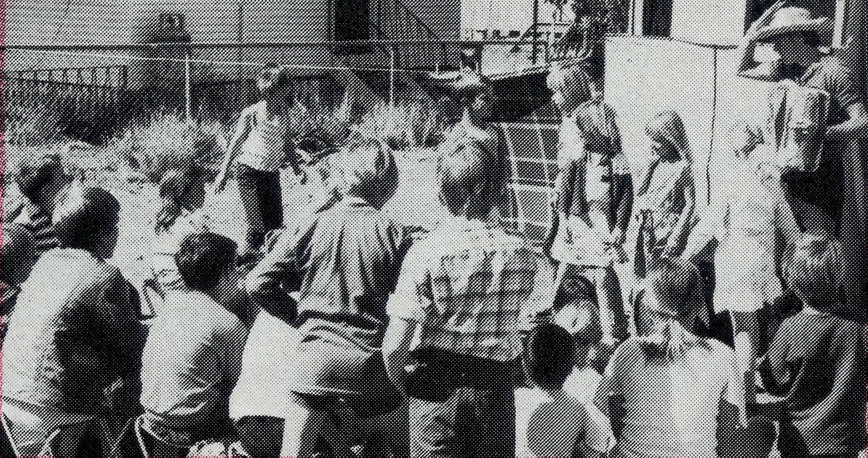
GOD MOVES IN WINTON - B.C.A. Youth Mission
In August seventeen young people from Sydney led by the Reverend Malcolm Babbage, together with Sister Margaret Walsh from Mt. Isa reached out with the Gospel in as many ways as possible to the people of Winton.
Camping at the back of the old Rectory on the Winton Church ground provided an ideal situation from which to minister.
The children came across from Primary School immediately opposite the Church complex to the "Woolshed". What an exciting time it was to share with these eager children. Almost double the number that normally attend the Church's Wednesday afternoon outreach came together to hear, to learn, to play, and to be loved by this radiant and joyful team of young people. During the lunch break many of the children came across to watch our puppets as they portrayed "The Lion, The Witch and The Wardrobe" and learnt in a parabolic form the sacrifice of Jesus Christ for them.
We had additional opportunity to witness and minister to the children of the town by attending the Religious Instruction classes at the High School, Primary School and

Convent School in Winton and also at the one-teacher schools at Cor-field and Mahrigong.
One of the great desires of the Reverend Bob and Mrs. Rigmor George, was to reach out to the teenagers of the town. Rigmor's inspiration was to have a campfire on the main street in a vacant block of land opposite two of the town's five pubs. Our musical group "The Bushwhackers" played on their guitar, accordian and electric piano and many came out of curiosity from the pubs and around the town to see what was going on. We reached out and had the privilege of leading two young shearers, Bill and Pat, into a personal relationship with Jesus Christ as their Saviour.
On Sunday morning at Church three of the members of the team dressed up as clowns and performed a brilliant skit which demonstrated the importance of a personal relationship with Jesus Christ rather than simply the forms of outward "goodness". A morning coffee at one of the cattle stations was another opportunity to meet with some of those who were appreciative of the encouragement brought by the enthusiastic members of the team. (Com. page 13)
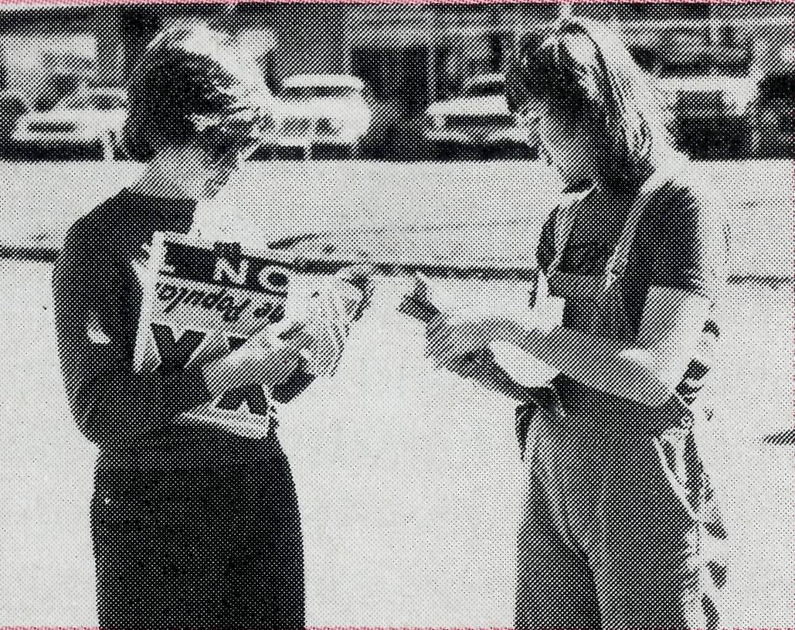
Wedding Anniversary shared
Noel and Ann Trimble of Rosebud, Victoria, earlier this year celebrated their 40th (Ruby) Wedding Anniversary. When inviting friends to enjoy the day with them they asked that no gifts be given. However, they expressed on the invitation that if people must give a gift, then a bowl be provided for donations to the Bush Church Aid Society. Congratulations Noel and Ann your 40th Anniversary, and for sharing your day with B.C.A.
- The Reverend Bert Bovis spent several months in late 1980 in the parishes of Port Hedland and Newman in North West Australia doing door-to-door visiting. Although now retired Bert gave freely of his time and expertise. What an encouragement he was to the clergy and people of these parishes.
- The Society wishes to acknowledge with real appreciation the ready help by way of temporary assistance at the hospitals at Tarcoola and Cook from Mrs. Mallon, Mrs. Elizabeth Hake, both from N.S.W., and Sister Marjorie Dickson and her husband, Jock, from South Australia.
- It may not be generally known, but the Victorian branch does a great job in collecting used stamps. Thanks, and keep up the good work, Victoria.
- Our most esteemed and loved former Federal Secretary, the Reverend Theo Hayman, was duly Instituted and Inducted to the Parish of St. Stephen's, Willoughby, on Friday, 14th November. I'm sure our prayers go with him and Joyce as they commence this new ministry. Further I am persuaded that we will never lose an outstanding Deputationist for the Bush Church Aid Society wherever Theo may be.
- Sister Ivy Gwynne passed away in Toowoomba, Old, in September and it was most appropriate that the Reverend John Greenwood, formerly Organising Missioner should have ministered to her since his coming to Toowoomba in January 1979. Mr. Greenwood wrote:
"Ivy Gwynne was one of the old school nurses who was dedicated to her Lord and Master and willing to serve Him no matter what the difficulties may be. She was at Cann River, Victoria, for 22 years and during those years became well known in the Croajingalong area.
The B.C.A. Council of the day agreed to my suggestion that Ivy Gwynne be given the opportunity to visit the workers in South Australia for whom she prayed. It was, I know, a great thrill to her that she actually saw Ceduna and the Nullarbor Plain and became associated with the Flying Medical Service during her Long Service Leave. She had no desire to visit other parts of the world but readily accepted the opportunity to visit B.C. A. centres about which she had read but never seen.
She now knows the joy of the nearer Presence of her Lord and Saviour whom she served with sacrifice and devotion."
THE REAL AUSTRALIAN 7

NEW FACES ON THE FIELD

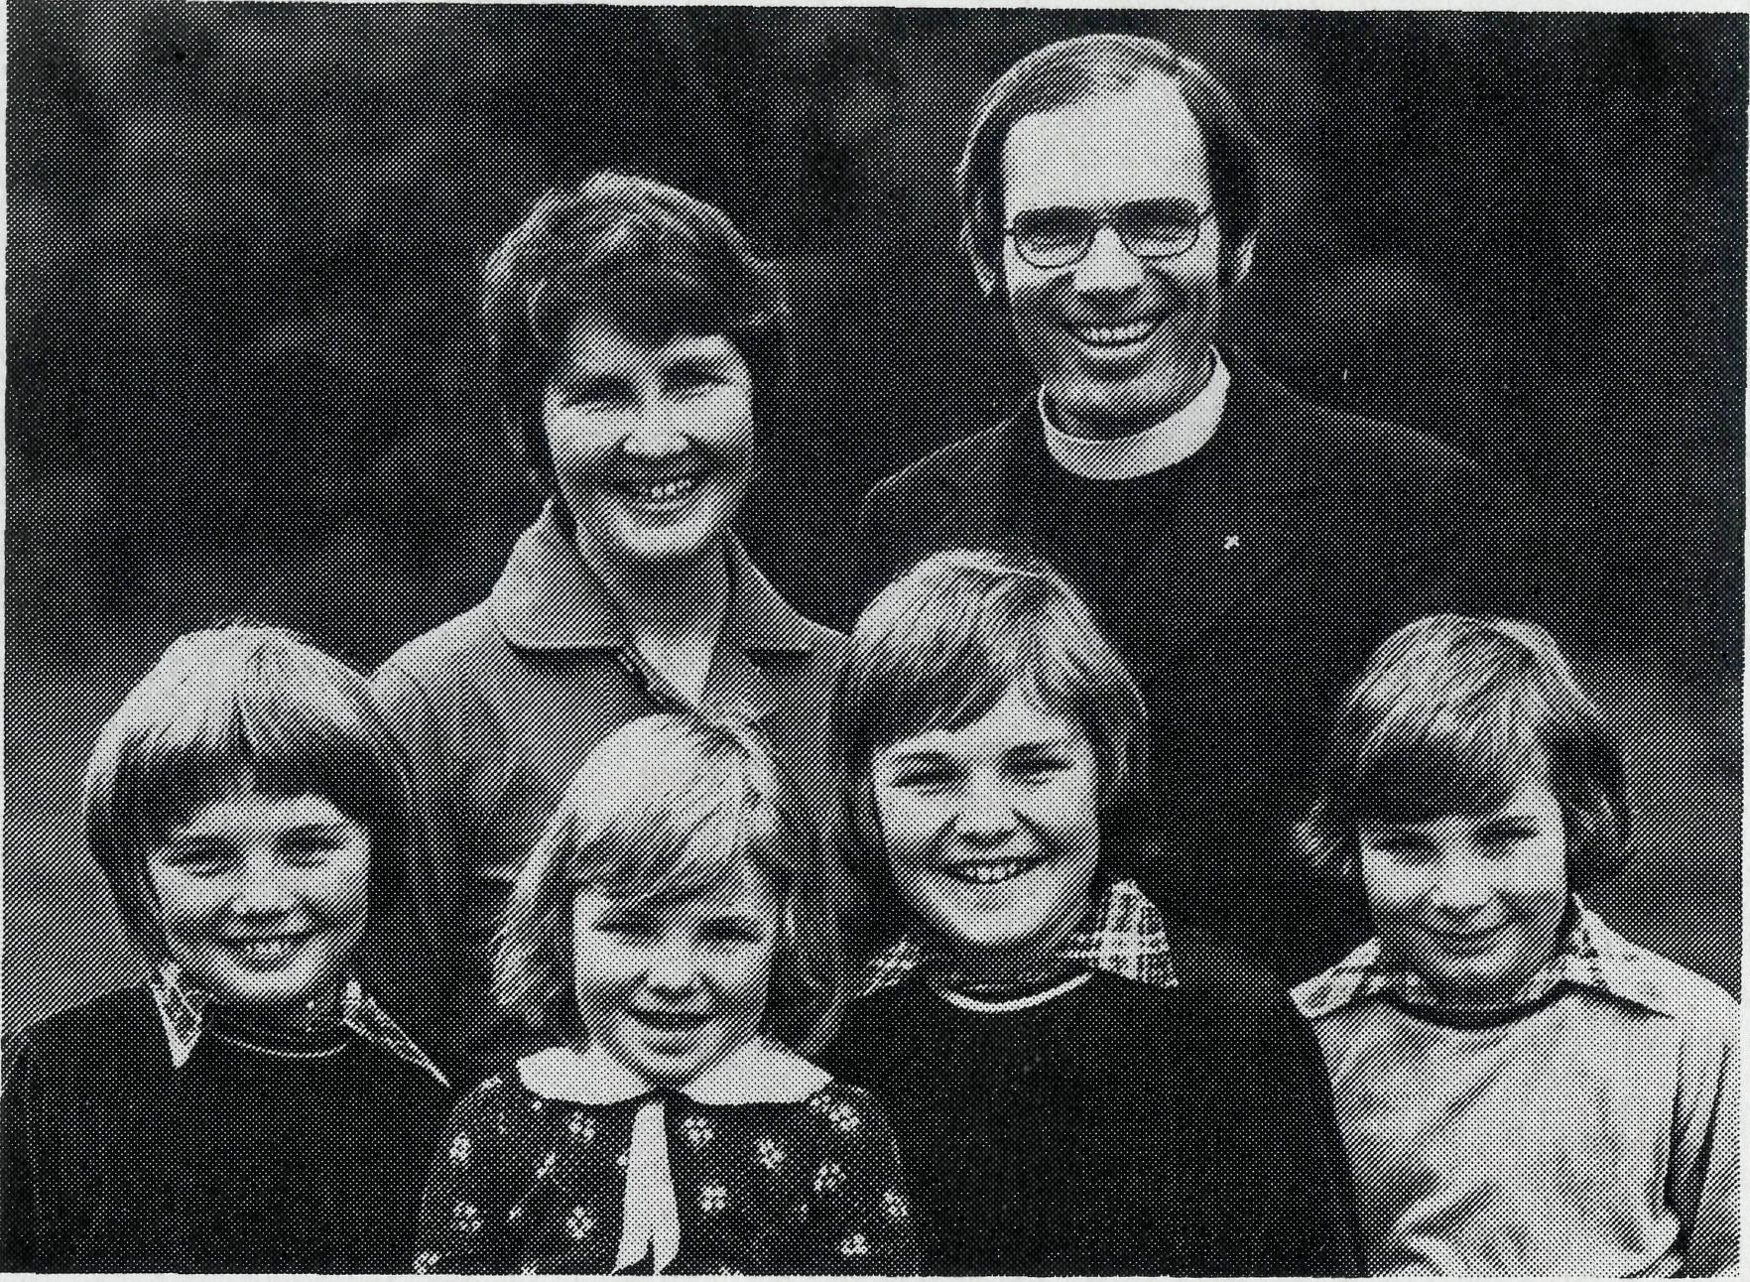
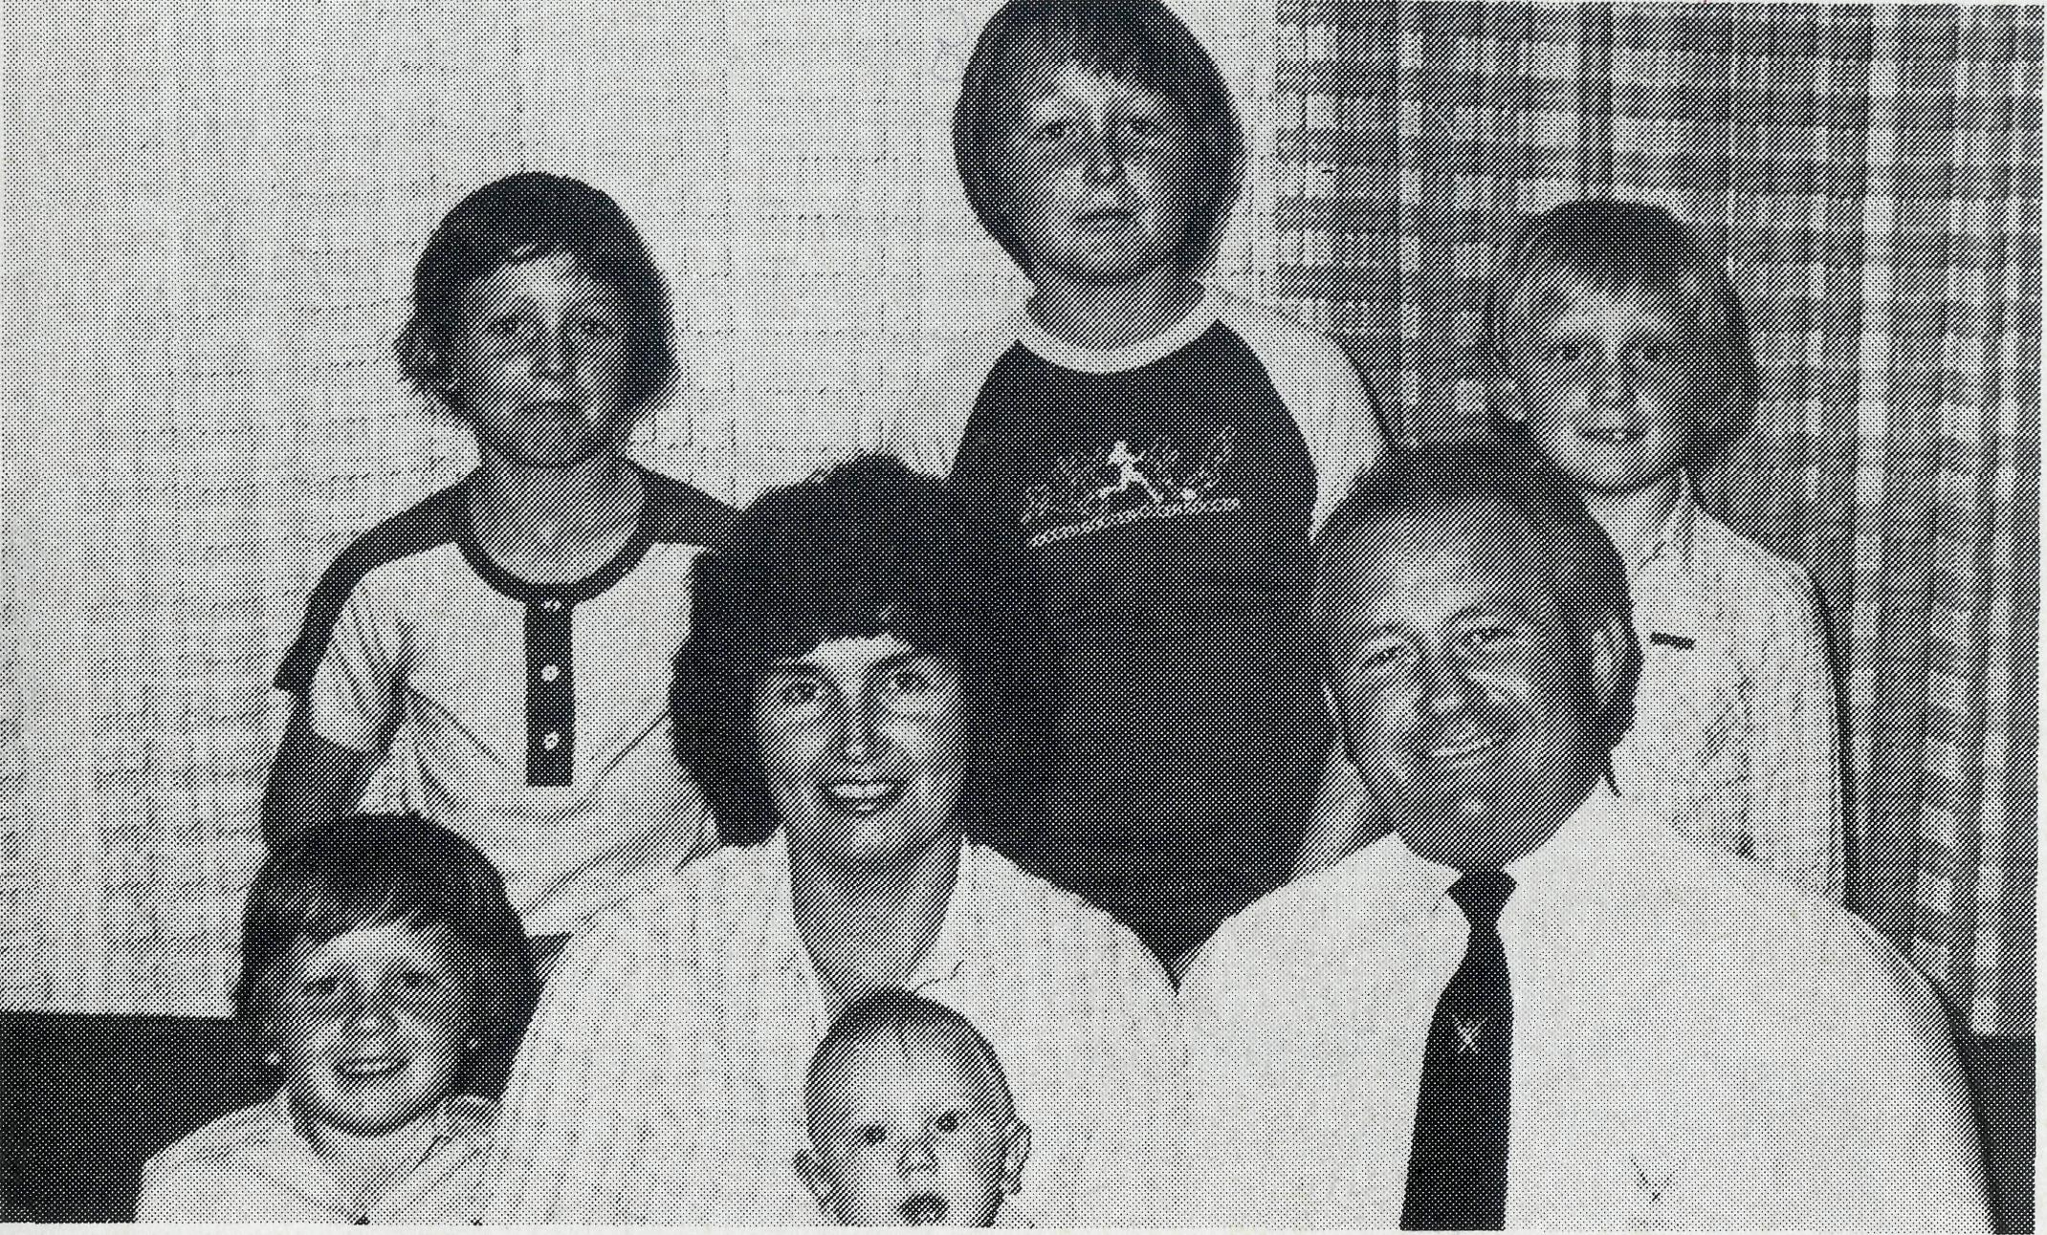
TO SOUTH HEDLAND, W.A.
TO MIDDLEMOUNT, OLD.

In November the Reverend Clem and Mrs. Val Watts accompanied by their children Malcolm (11), Andrew (9), Rohan (7¹/₂) and Vannessa (4¹/₂) went to South Hedland in the Diocese of North West Australia from Emerald in Melbourne. Clem is tackling this new and challenging task from a depth of business, theological and pastoral experience. He was an Accountant with nine years service with the Reserve Bank before training in the Melbourne Bible Institute and Ridley Theological College. His Curacies were in the parishes of Berwick and Blackburn and he has had two five-year incumbencies at St. Luke's, Springvale North and then at St. Mark's, Emerald. Clem and Val have had a keen interest in and support of B.C.A. over many years. A senior clergyman in Melbourne, a B.C.A. Council Member, after speaking of Clem's outstanding abilities as a preacher, organiser and counsellor, said "I could not think of a better man for the job".
Captain John and Mrs. Dianne Symons with their family of five boys Martin (10), Paul (8), Craig (6), Christopher (4) and baby Aaron (15 months), are going to the new coal mining town of Middlemount in Queensland in January 1981. John, a commissioned officer of the Church Army and his wife, Dianne, feel assured Middlemount is the place where God is calling them to serve as members of B.C.A. field staff. John's background particularly has prepared him for this sort of task. He comes from Wollongong, the coal mining and steel works centre on the South Coast of N.S.W. and is by trade a fitter. After his conversion he was Confirmed as an adult in All Saints', Figtree. Now after training in the Church Army College and gaining further experience as a parish evangelist in Dee Why Parish, he is keenly looking forward to commencing his ministry in Queensland.

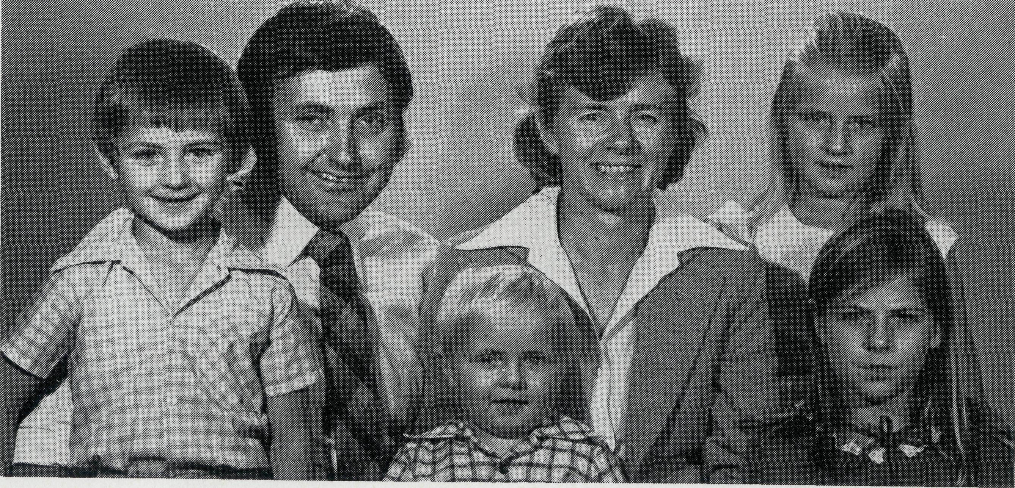
TO ZEEHAN, TASMANIA
The Reverend Brian and Mrs. Denyse Roberts with their children Elizabeth (9), Heather (7), Luke (5) and Peter (2) leave also in January to serve at Zeehan on the rugged, cold and wet West Coast of Tasmania. The climate in this part of Australia is a tremendous contrast to all the other areas of B.C.A.'s concern. Brian has been serving for the last two years as the Assistant in the growing parish of St. John's, Camden. To go out to work for Christ in the fellowship of the Society is the fulfilment for Brian of a long-felt call. Before commencing training for the ministry Brian, for a number of years, assisted at the B.C.A. Rallies in Sydney taking full responsibility for all the lighting and special effects. People of the parishes of Camden, Figtree and Panania have made a particular commitment to follow the ministry of the Roberts in Zeehan with prayer and financial support.

THE B.CA PRAYER
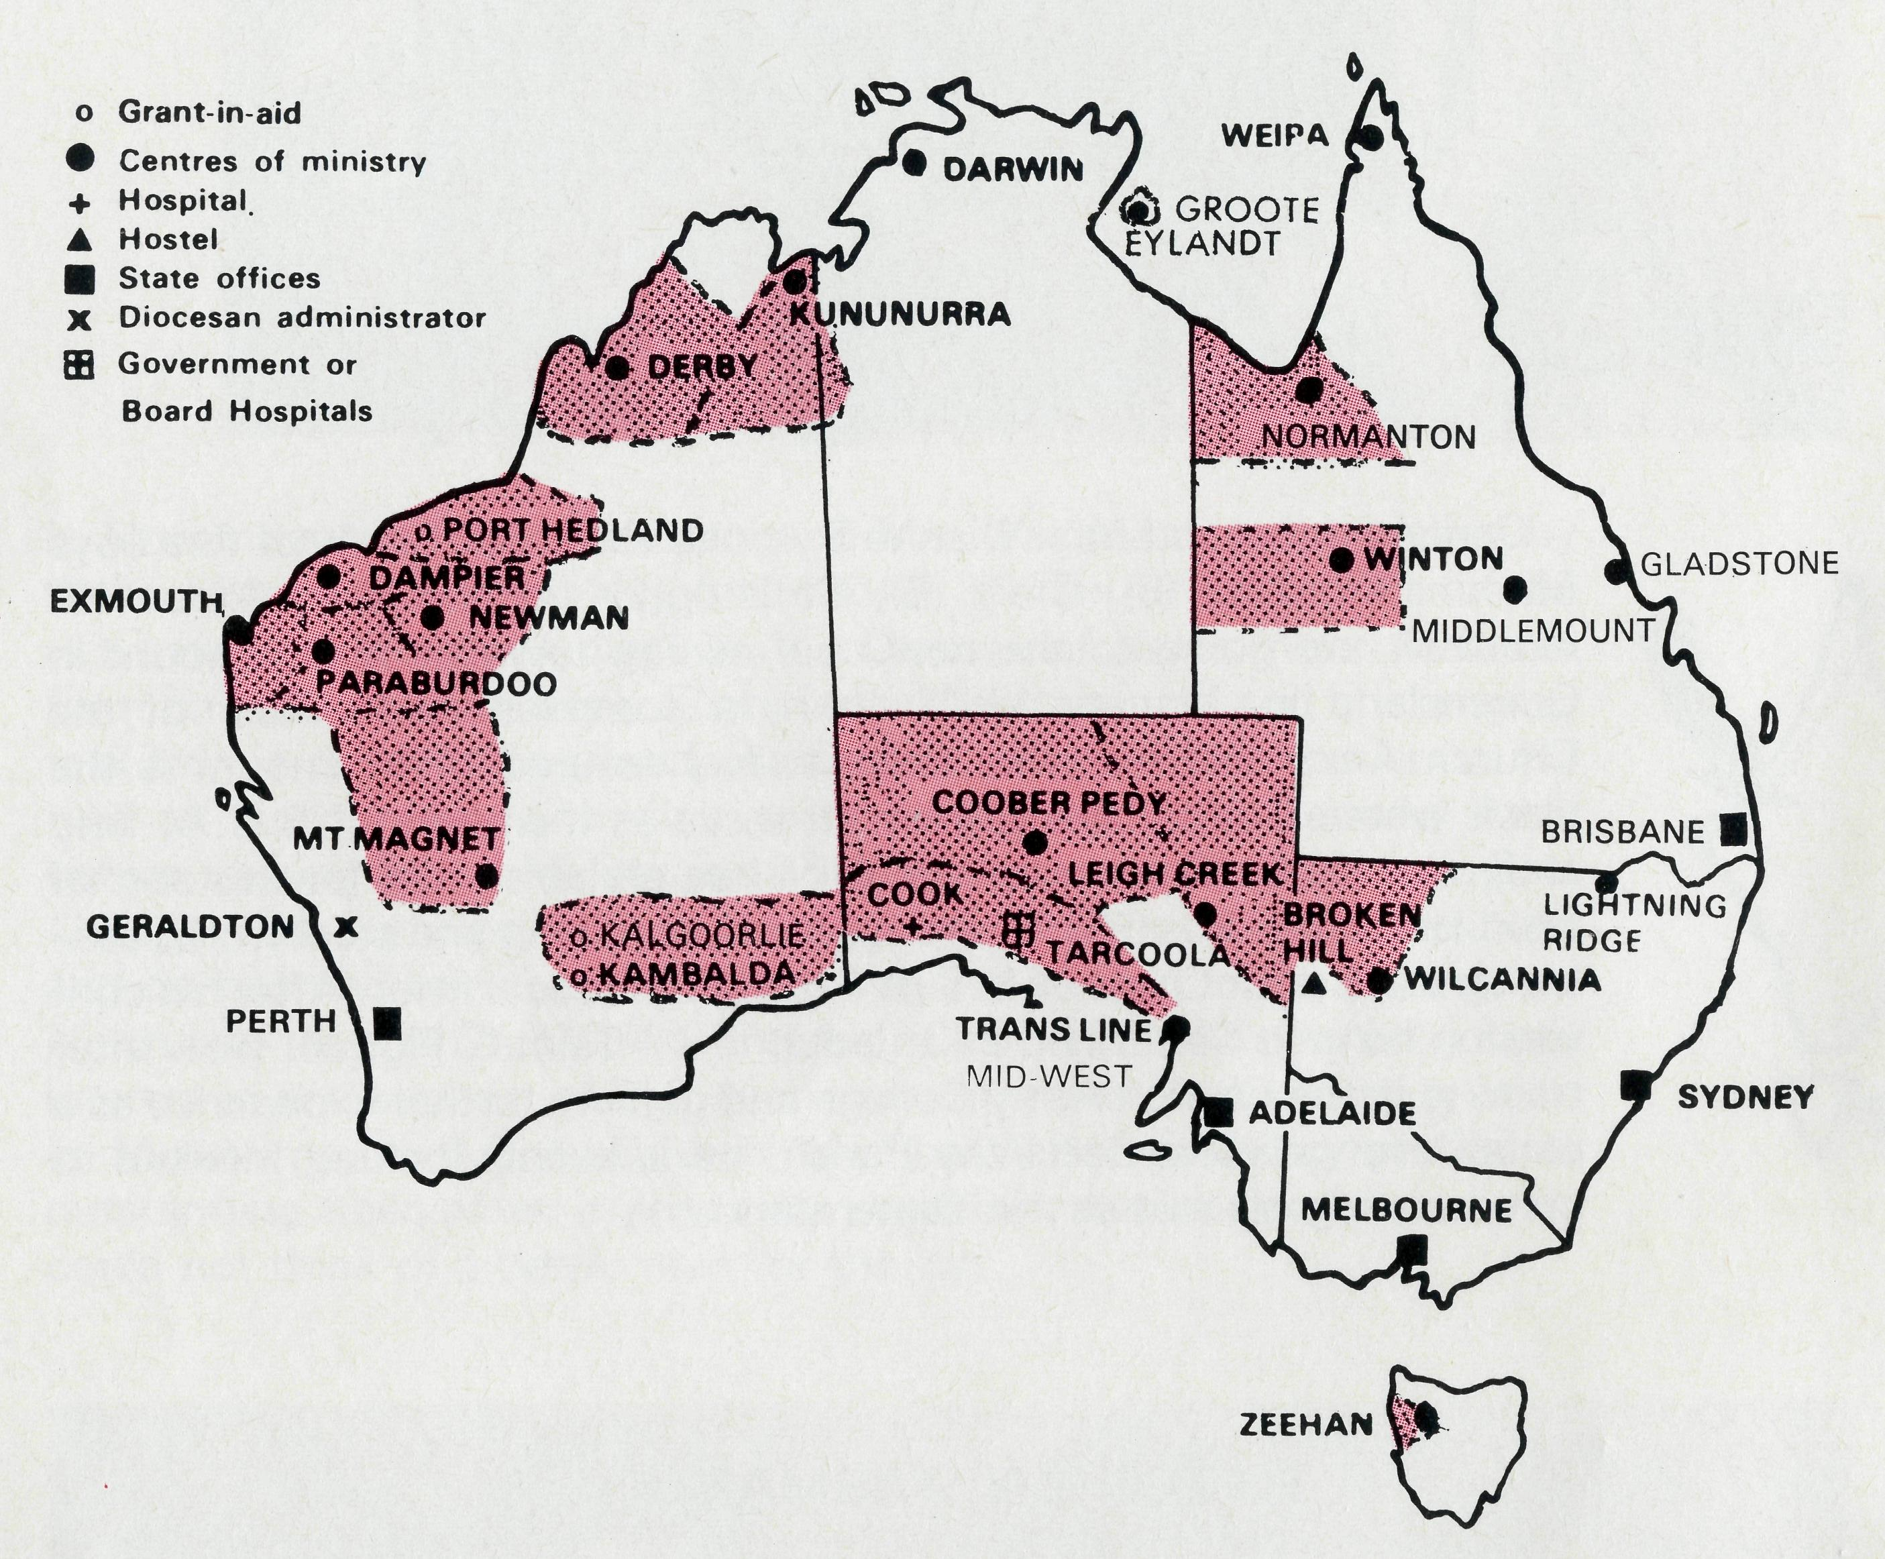
A DAILY PRAYER
PRAYER CALENDAR
0 Lord our God, help us to remember the people who live in the remote parts of our land. We ask You to bless those whom You have called into the fellowship of The Bush Church Aid Society, and call others to stand with them in the task. Grant that, through the ministry of the Word and Sacraments, through healing, and through caring for the young, the message of Your redeeming love may be proclaimed, through Jesus Christ our Lord. Amen.
0 God, we remember before You those whom You have called to Your service. We
ask You to Bless ,
and assure them of Your Presence. Grant to them, as to us, the joy of service, the ability to achieve, and the serenity of Your peace, for Jesus' sake. Amen.
THE REAL AUSTRALIAN

FIELD STAFF DIRECTORY
DIOCESE OF NORTHERN TERRITORY. The Rt. Revd. K. B. Mason.
- Darwin — Sister Pauline Clements (Nungalinya College).
- Groote Eylandt — The Revd. Bruce and Mrs. Marcia Hansford.
DIOCESE OF NORTH WEST AUSTRALIA. The Rt. Revd. H. A. J. Witt.
- Kununurra — The Revd. Royce and Mrs. Susan Thompson.
- Derby — The Revd. Peter and Mrs. Betty Mills.
- Newman (East Pilbara) — The Revd. Don and Mrs. Libby Wilson.
- South Hedland - The Revd. Clem and Mrs. Val Watts. Port Hedland — grant, The Revd. Peter Thompson.
- Dampier (West Pilbara) — The Revd. Roy and Mrs. May Buckingham, The Revd. Tom and Mrs. Carol Williams (Wickham).
- Paraburdoo (South Pilbara) — The Revd. Adrian and Mrs. Willemien Moore.
- Exmouth — The Revd. Ken and Mrs. Madge Prentice.
10 Geraldton — Mr. Stan and Mrs. Dorrie Hummerston — Diocesan Administrator.
DIOCESE OF PERTH. The Most Revd. G. T. Sambell.
11 Kalgoorlie — grant. The Revd. Canon Frank Watts, The Revd. Dennis Reynolds.
Kambalda — grant. The Revd. David Cockram.
DIOCESE OF WILLOCHRA. The Rt. Revd. S. B. Rosier.
- Cook Hospital — Sisters Sue Baker and Anne Ross.
- Tarcoola Hospital — Sisters Helen Plumb and Louise Howard.
- Coober Pedy — The Revd. Kerry and Mrs. Julieanne Medway.
- Mid-West Mission — The Revd. Robert and Mrs. Phyllis McEwin.
- Leigh Creek — The Revd. Chris and Mrs. Marilyn Clerke.
DIOCESE OF TASMANIA. The Rt. Revd. R. E. Davies.
17 Zeehan — The Revd. Brian and Mrs. Denyse Roberts.
DIOCESE OF RIVERINA.The Rt. Revd. B. R. Hunter.
- Broken Hill Hostel — Mr. Ken and Mrs. Pam Young.
- Wilcannia — The Revd. George and Mrs. Hazel Fuhrmeister.
DIOCESE OF ARMIDALE. The Rt. Revd. P. Chiswell.
20 Lightning Ridge — The Revd. Les and Mrs. Pat Fernance.
DIOCESE OF ROCKHAMPTON. The Rt. Revd. J. B. R. Grindrod.
- Winton — The Revd. Robert and Mrs. Rigmor George.
- Gladstone — The Revd. Clyde and Mrs. Janice Andrews, Blackwater — Grant.
- Middlemount — Capt. John and Mrs. Dianne Symons.
DIOCESE OF CARPENTARIA. The Rt. Revd. H. T. U. Jamieson.
- Weipa — The Revd. Lex and Mrs. Rhonda Carey.
- Normanton (Southern Gulf) — The Revd. Jim and Mrs. Margaret Hudson, Miss Anne Watkins. (A.F.W.)
GENERAL
26 Federal Secretary. The Revd. Wakely Wade.
N.S.W. The Revd. Malcolm Babbage, Eric Atkin, Miss Doris Smith, Mesdames Joy
O'Neill, Dora Warwick, Nina Allan and Vivien Bentley.
27 28
29 30
VICTORIA. The Revd. Ernest Horth, Miss Chris Craig.
QUEENSLAND. The Revd. R. W. Herbert (Hon. Secretary)
WESTERN AUSTRALIA. The Revd. Gordon Thomas (Deputationist)
SOUTH AUSTRALIA. The Revd. David Eastway
The President, The Most Revd. Sir Marcus Loane, Chairman, Dean Lance Shilton,
Honorary Treasurer, Mr. Richard Stokes, The Council, State Committees.
Staff Replacements, Box Secretaries, B.CA. Supporters.
31
The Anglican National Fund and other Christian Agencies.

Port and South Hedland with a population of over 14,000 and growing day by day, look like two small scabs on the red soil and spinifex pigmentation. It is growing and very busy. Helicopters whirl in the skies taking pilots out to land on the gigantic ore ships to navigate them to the giant mining complexes in the port; helicopters hurry out each day to the exploratory oil rigs off the Hedland coast; helicopters buzz off into the hinterland with modern prospectors. Jet planes roar in the distance taking those who wish to the capitals of Australia within a few hours. Giant ore trains hauling the ore from the open cut mining towns of Newman, Shay Gap, Goldswor-thy, rattle to a stop at the mammoth crushing and ship loading infrastructure.
A modern thriving mining complex.
It is summer with the temperature every day over 40 degrees C — humid because of the town's proximity to the sea and intensely hot as it is on the fringe of the Great Sandy Desert. People from other tropical climes have "never known such a debilitating heat". The population rush from air-conditioned car to air-conditioned house or shop. The barometer is constantly observed, weather forecasts often assume more importance than the news, this is the land of the cyclones — three in 1980! A modern tropical mining complex.
The surrounding country is barren, flat and covered with unfriendly spinifex with either dried up river beds or raging torrents — land of extremes, land to be avoided by the inexperienced.
12
A modern barren tropical mining complex.
A young woman cocooned in her air-conditioned house miles away from her family and friends sits in the kitchen. Intense loneliness shows in her face, she is here for a few years because the work and the money are good. They will buy a house in half the time it takes down south. She has just got her husband and children off for the day, feels tired, depressed and lonely. Two years of heat and isolation have taken the joy out of her. The weather makes a walk a chore, anyway where is there to walk to? No one is outside to talk to in the street, the people in the street change so quickly that you tire of making new friends. A modern barren lonely tropical mining complex.
GOD MOVES IN WINTON - continued
The woman reassures herself saying to herself aloud, "the money makes it worth it". How many times has she said that; she doesn't sound so sure. Her tension rises and she puts on the kettle for a cup of tea. Perhaps a little drink of sherry would not hurt. This habit started at five in the evening last year, now it is nine in the morning, sip, sip, sip. The mining mammoth has started to break not only the iron ore, but the life of this family.
There is a knock on the door, hurriedly she hides the sherry bottle, glances at her tired and untidy face in the kitchen mirror, a tidy up first? What does it matter, it will just be another salesman after the wealth of the North West.
The open door to her surprise reveals another young woman of about the same age. She asks if she
THE REAL AUSTRALIAN
can come in. A cup of tea is offered, what can she want? The visitor seems so relaxed and happy, obviously only been here a few weeks — give her time and she will be caught in the syndrome and joining her in a morning sherry. No actually she has been here for five years — five years in Port Hedland — she loves the place! How did she manage in this dreadful place, what secret did she have that made such a difference to her life?
This was the beginning of the great change. The visitor was a Christian and came to ask Mrs. "Port Hedland" to a morning coffee and fellowship. The Parish of Port Hedland seeks to bring Christ with His joy and His peace to the lost and lonely, whether it be in Port Hedland, South Hedland, Golds-worthy (100 kilometres away), Shay Gap (200 kilometres away), Telfer (500 kilometres away), or numerous sheep and cattle stations. The harvest is truly plenteous but the
Winton as a town was greatly blessed through the presence of the Mission Team in their midst. But it didn't only operate one way.
There was no member of the team who did not return without having grown in his relationship with Jesus

Christ and his understanding of some of the challenges that lie before the Church of God as it seeks to take the Gospel to the outback areas of Australia. The team is rearing to go again.
The Future
During the Easter break each year the town of Lightning Ridge doubles in size as tourists pour in by the hundreds to seek for the elusive treasure: opal. We believe that it may be God's Will for us
THE REAL AUSTRALIAN
labourers and the wherewithal are not sufficient to meet the cries for help. People have found that money and things do not bring happiness. People can see the fallacy of the world without Christ. The clergy and the wonderful witness of the laity goes on day by day, encouraged by your prayer and support, in a very real sense you are with us knocking on the door and bringing His joy.
"I want to live, live out, not wobble through my life somehow, and then into the dark — I must have God."
When can we say not "A modern barren lonely tropical mining complex"
But "A mining complex" may be modern and tropical but no longer barren or lonely — Christ is there. It is not the beginning that brings Glory to God but the continuation and finishing. Let us continue each day together with Our Lord.
to take a team to Lightning Ridge over the Easter break. There are other possibilities to go further afield.
Pray for plans for the future. If you would like to go on such a Mission, please contact Malcolm Babbage at B.C.A.'s Sydney Office.
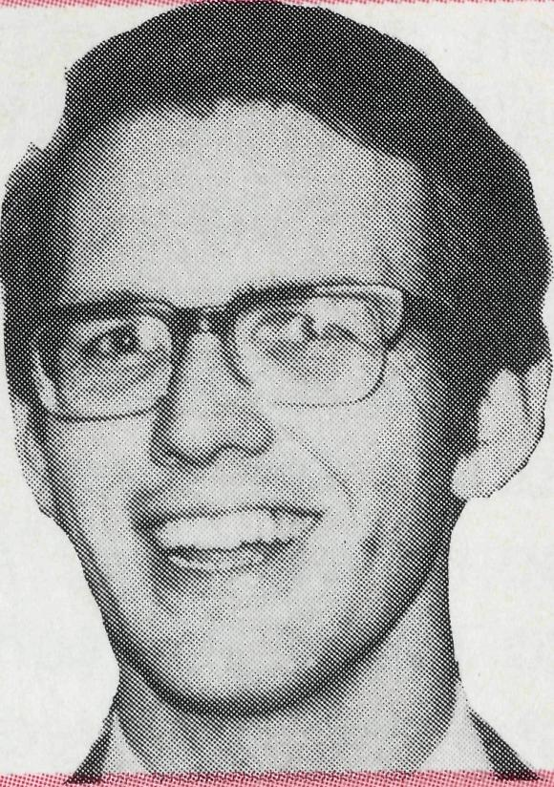
STOP PRESS
13
With pleasure we announce that the Revd. Malcolm Babbage has accepted the post of B.C.A. General Secretary N.S.W.

Hazel Fuhrmeister Wilcannia, N.S.W.
When the Lord plans a day isn't it wonderful what can fill it! I woke at 6 a.m., had a Quiet Time and committed the day to the Lord. I knew several people were coming during the day, so I asked the Lord to so work out their comings and goings that no one would 'bump' into the other and I would calmly trust Him and take one step at a time. This particular day will always be remembered, that the Lord answers prayer abundantly above all that I could ask or think ....
George was away so I listened on the transceiver but didn't hear anything from him. I tuned in to the news at 7.45, then at 8 a.m. the four children I had promised to look after while their mother went to Broken Hill, came in for the hour before school. As they left at 9.10, another lady with small children came to share a problem. At 9.30 another mum called in with one child, so we all had a cuppa together and some sharing and fellowship. The first one left and the other stayed and we talked of her particular need. Just as she left at 10.40, Frank and Betty Beitzel arrived from their stay at White Cliffs. I prepared an early lunch for them and started to do some banking. Another lady called to show me some correspondence she had received, which caused her much heartache. I also had to write
14
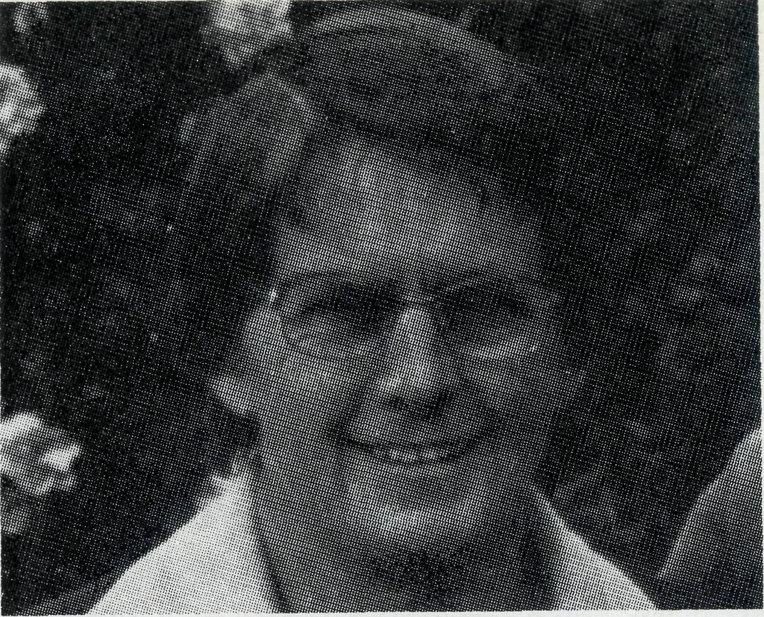
a short article for the local school paper and that had to be in to the school by lunch time. When the Beitzels were ready to leave they needed petrol, so they drove me to the supply place so that I could meet up with the lady with whom I was to do 'Meals on Wheels'. Returning from that round, I typed out and took the notice to the school and returned to find a couple just arriving — they had lunch with me. By 2.30 they drove out, I finished the banking and took it to the Bank, got the mail and brought back a heavy S.U. parcel — then returned to the shop for some milk and bread. At 3 p.m. I came home to collect one child to care for, then the other three for afternoon tea. A teacher who was staying with me at the time, came from school and shared in that too.
One boy and I cleaned up the church lawns of mandarin peelings left by some children, re-wrote the notice board which someone had had a 'game' with, replanted a shrub that had been pulled out and then I got tea for six. After tea we played indoor games, read stories and some did homework. There had been three phone calls during this time about a funeral to be held. At 8.30 p.m. the parents of the children came and gathered their flock then the teacher and I sat and shared the
THE REAL AUSTRALIAN
15

there has been a ready response to discussion on spiritual matters, while others have come for further light and are searching the Word themselves. We praise the Lord for several who really came into a personal relationship with Jesus Christ — may we be faithful in helping, encouraging and bearing a clear witness to His Grace as sufficient for their every need. Thank you for your continued prayer . . . pray on with us that they themselves may continue to witness to others, as they have already begun to do.
day; I read my mail and we were to bed by 10 p.m.
Praise the Lord for such dovetailing, which I haven't found so perfect ever before.
While I was at home George was continuing reaching out to station homesteads, unvisited during our time and some that had not been visited for some years before that, but as in Joshua's time "there remains very much land yet to be possessed". (Joshua 13:1).
Perhaps most pleasing in all the work is to find here and there hearts prepared of the Lord. In some cases
GOLDEN WEST - B.C.A.
"Go see for yourself" B.C.A. areas of ministry in outback Australia
in 1981. Here are the proposed tours —
Central Australia and North West Australia, (or part of) JULY-AUGUST
Central Australia 19 days (Adelaide and
Melbourne connections) 13th JUNE
Lightning Ridge 5 day tour
Via Dubbo, Coonabarabran 23rd OCTOBER to
27th OCTOBER
Give Mrs. Joy O'Neill a ring on 264-3164 for details and bookings on any of the above tours.
State Office Directory . . .
Federal Secretary — The Revd. Wakely Wade.
General Secretary N.S.W. — The Revd. Malcolm Babbage.
B.C.A. House, 135 Bathurst Street, Sydney, N.S.W. 2000.
(02) 264-3164, 264-3780. Telegraphic Address: "Chaplaincy", Sydney.
Victorian Secretary — The Revd. Ernest Horth,
3rd Floor, Clark Building, 196 Flinders Street,
Melbourne, Vic. 3000. Phone: (03) 63-8962.
South Australian Secretary — The Revd. David Eastway,
350 King William Street, Adelaide, S.A. 5000. Phone: (08) 212-4838.
Queensland Hon. Secretary — The Revd. R. W. Herbert, 60 Prospect Street, Wynnum North,
4178. Phone: (07) 396-4354.
Western Australia Hon. Deputationist — The Revd. G. W. Thomas, 4 River Road, Kelmscott,
W.A. 6111. Phone: (09) 390-5351.
Patron - The Most Reverend Sir Frank Woods.
President — The Most Reverend Sir Marcus Loane, Archbishop of Sydney.
Vice-Presidents — Mr H. M. Bragg, Archdeacon R. G. Fillingham, M.B.E.
Chairman of Council — Dean Lance Shilton.
Honorary Treasurer — Mr R. T. Stokes.
THE REAL AUSTRALIAN

