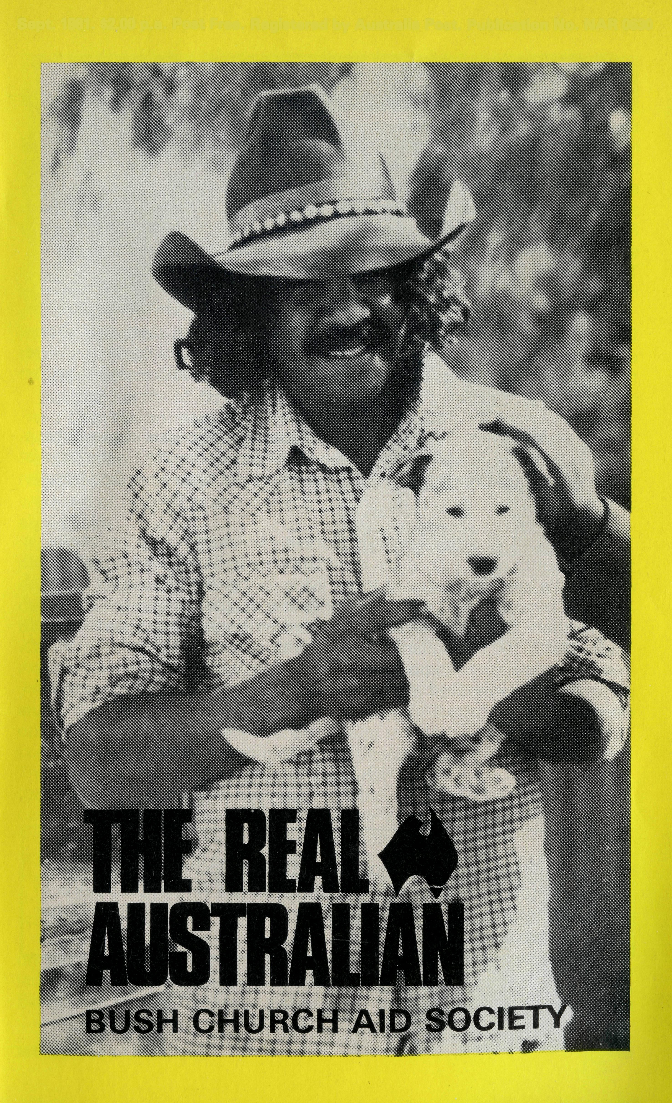
Sept. 1981. $2.00 p.a. Post Free. Registered by Australia Post. Publication No. NAR 0630
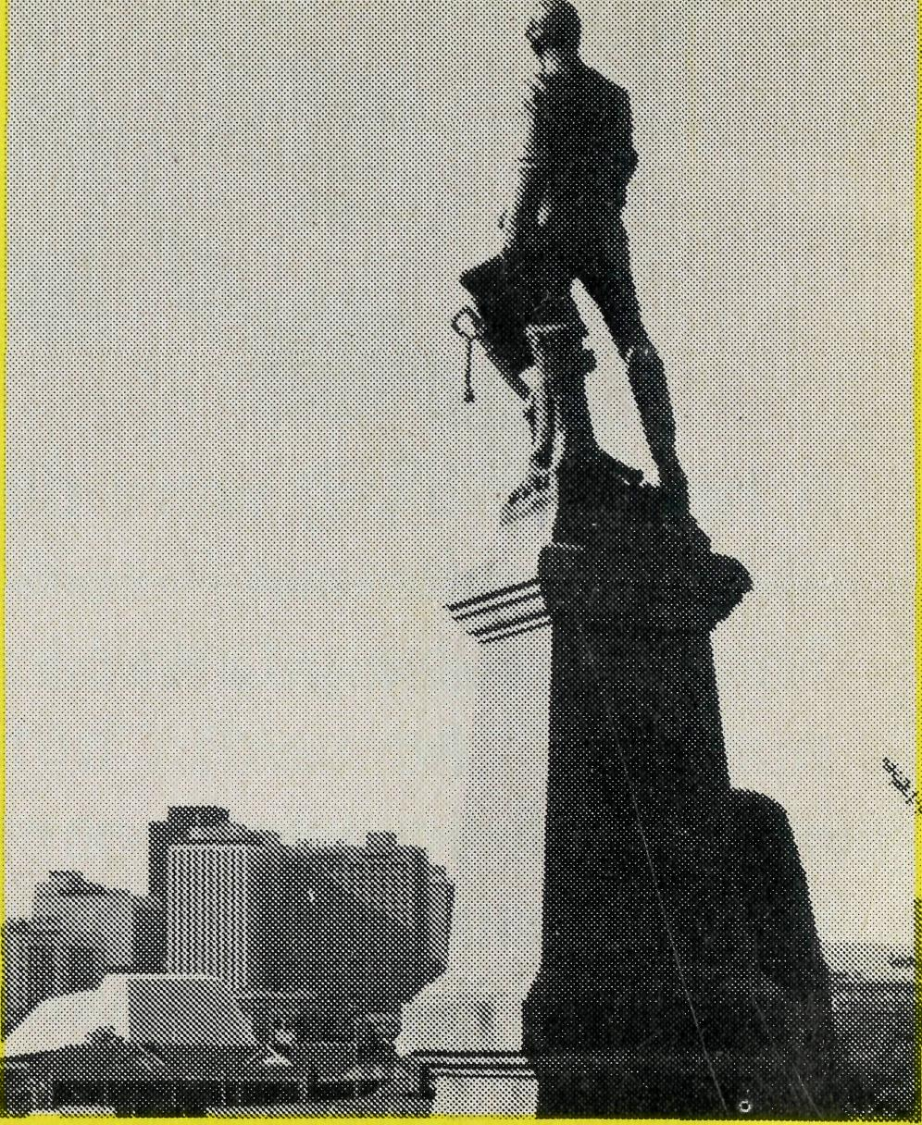
RALLIES

ADELAIDE
Friday, 7.45 p.m.
25th September, 1981
at Christ Church,
North Adelaide
Speaker: Rev. Kerry Medway,
B.C.A. Secretary — Youth
Former Missioner at Coober Pedy,
S.A.
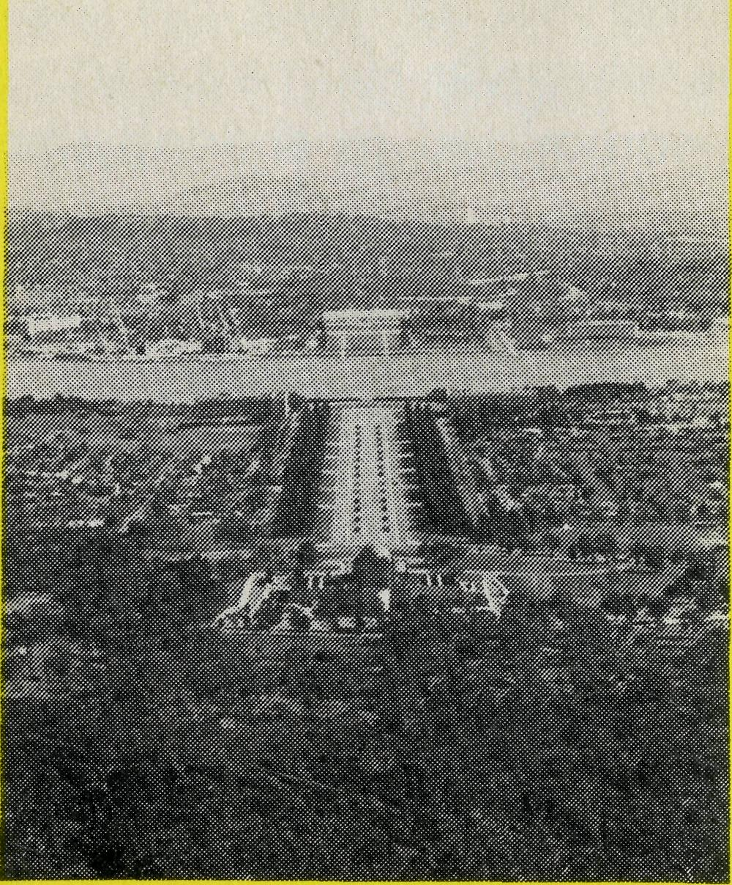
CANBERRA
Thursday, 7.45 p.m.
15th October, 1981
at Parish Centre,
St John's,
Reid
Speaker: Rev. Kerry Medway,
B.C.A. Secretary — Youth
Former Missioner at Coober Pedy,
S.A.
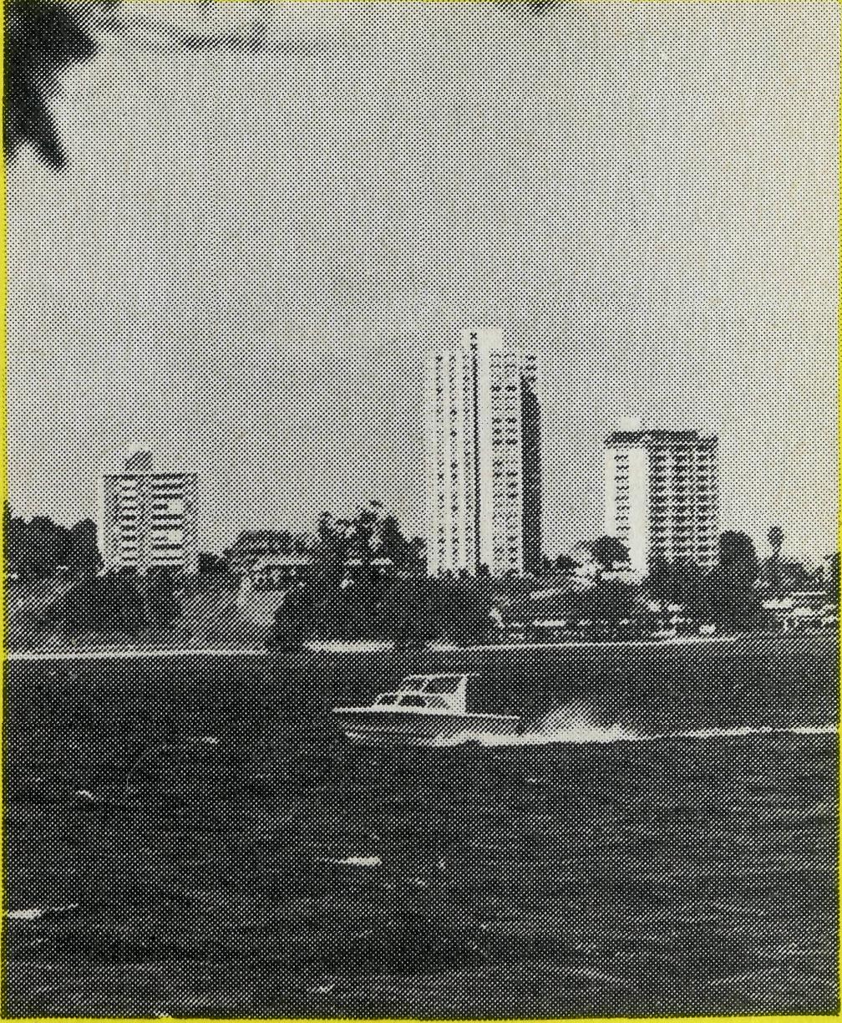
PERTH
Sunday, 7.30 p.m.
27th September, 1981
at North Perth
Speaker: Rev. Ken Prentice,
B.C.A. Missioner, Exmouth
plus . . . Shelley Riverton Singers
Printed by Ambassador Press Pty. Ltd., Granville 2142.

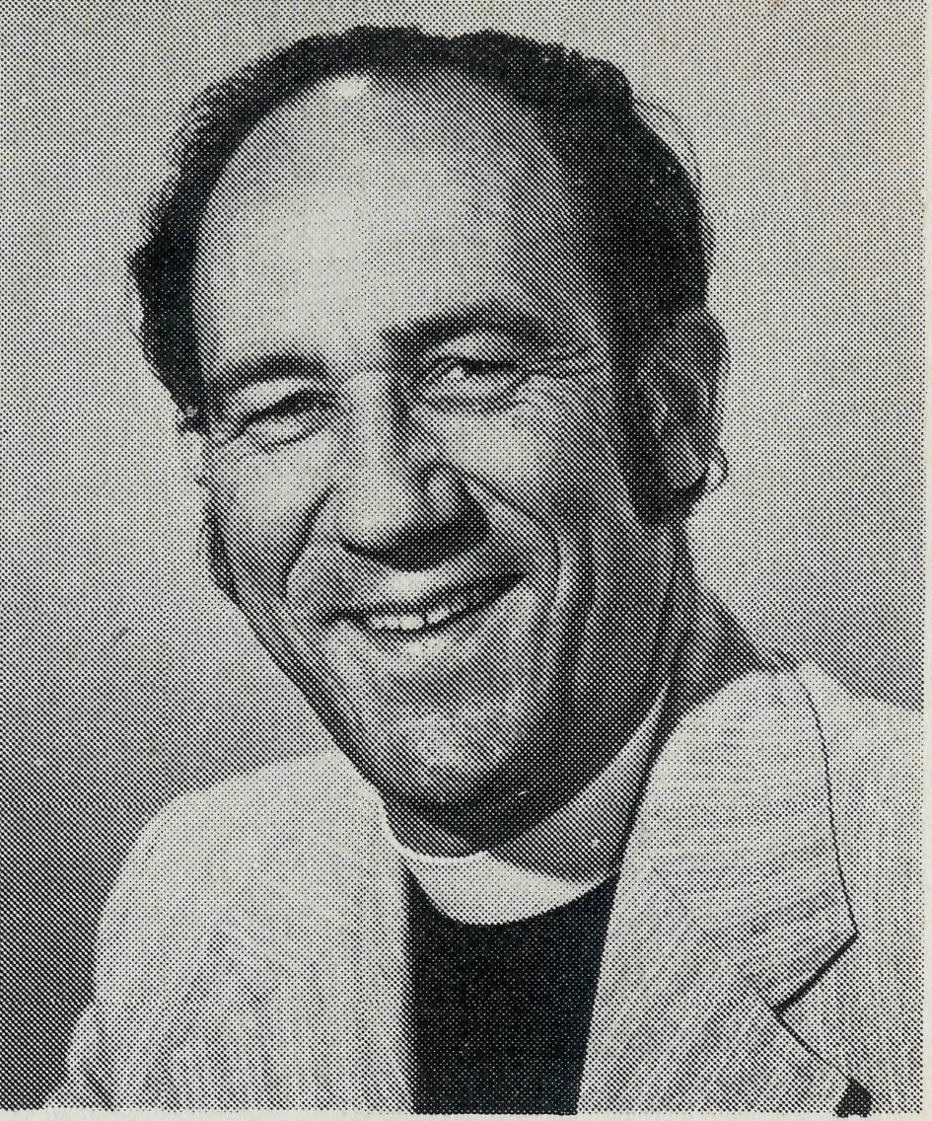
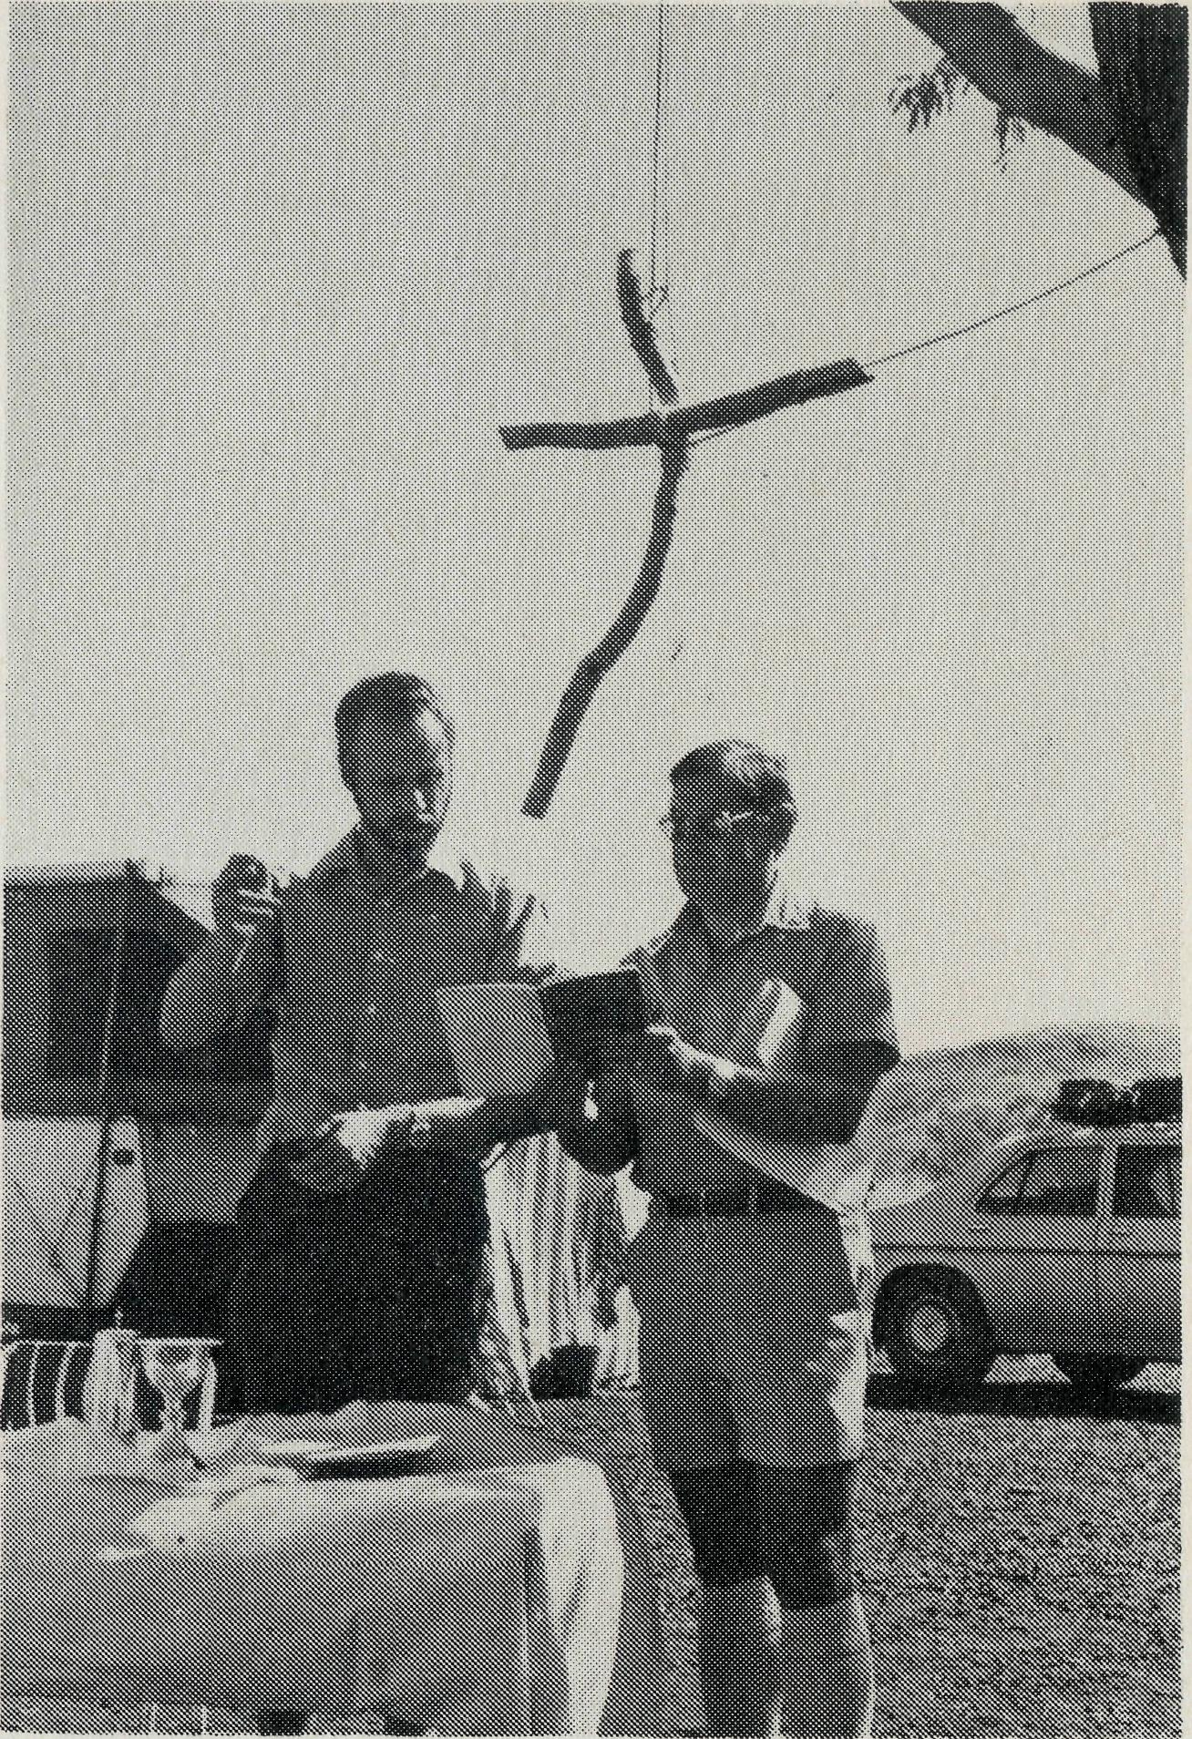
The picture shows Rev. Adrian Moore of Paraburdoo and Rev. Donald Wilson of Newman (right) celebrating the Eucharist at the combined parish camp. (Reprinted from Anglican Messenger, W.A.)
which were only a short car trip from the camping area, was delightfully fresh. A group walked along the floor of the gorges round to Circular Pool, a trip of some three hours.
Mr Wilson said he believed it was quite an achievement to get three groups to come away for a weekend such as this. "We learned much from each other but really the time was too short to establish any meaningful depth of fellowship."
He said it was unfortunate too that the party had to spend so much time getting the vehicles into shape for the return journey.
Wakely writes .
Baring-Gould was not only a prodigious hymn writer ("Onward Christian Soldiers" is his best known one) but he was the father of sixteen children. The story is told of him that at one special occasion for children in the Parish, he looked down at one little girl and said, "And whose little moppet are you?" The child burst into tears and through sobs replied, "I'm your's, daddy."
Dr. Paul Tournier, the outstanding Swiss Christian psychiatrist, tells of one of his patients who had deep emotional problems. The youngest of a large family, the patient recounted how she overheard her father saying to her mother, "We could have done without that one!"
The God and Father of our Lord Jesus Christ both knows and cares about every individual. His love and discipline of His people narrated in the Bible is the pattern of true fatherhood. Jesus alone reveals to us what God is really like.
The aim of B.C.A. field staff — missioners, nurses and other workers — is to reach out to other individuals in outback Australia showing by word and deed God's love. Why should those living in the more populous areas of Australia have all the "goodies"? Surely the people of, say, the Parish of the Southern Gulf of Queensland, centred on Normanton, a parish which covers about 100,000 square miles but with a scattered population which overall would amount to possibly no more than 2,500, should have the opportunity to know God and worship Him as their fellow Australians elsewhere.
Your friend,
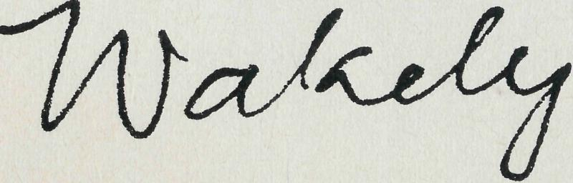
Federal Secretary B.C.A.
COVER...
An Aboriginal stockman holding his Blue Heeler pup at Oodna-datta, South Australia. B.C.A. youth will be holding missions in Oodnadatta, Cook and Tarcoola during the August/September School holidays.
REAL AUSTRALIAN EDITOR: Hugh Stringleman SUB-EDITOR: Kerry E. Medway
THE REAL AUSTRALIAN

HARDSHIP BRINGS REWARD
Life is not easy for parishes in the North West. At a recent Combined Parish Camp at Wittenoom every vehicle or trailer was in one kind of trouble or another either on the way there or on the way home.
One vehicle holed a fuel tank, the suspension in one of the trailers was twisted, there was a broken axle and a broken cam shaft. One vehicle had to be towed most of the way there and all the way back. Roads in the North West take their toll.
But the Rector of Newman, the Revd Don Wilson, says that the 50 men, women and children from Paraburdoo, Tom Price and Newman had a very worthwhile weekend of fellowship and learning about Christ.
"We used our newly compiled songbooks to great effect at two evening sing-alongs and at the open-air communion service on the Sunday morning. The guitarists were Libby Wilson and the Revd Adrian Moore of Paraburdoo.
"Adrian had prepared for six study/discussions, but we actually only had two, one of which was on conversion and proved profitable. The ranger came out on the Saturday evening and showed some excellent slides of the gorges together with the flora and fauna. This coincided with the arrival of a tourist bus from Sydney carrying pupils from the King's School who also watched the slides.
"We had an impromptu concert on the Sunday evening with much laughter and some talent displayed. Swimming at the Fortescue Falls,
THE REAL AUSTRALIAN

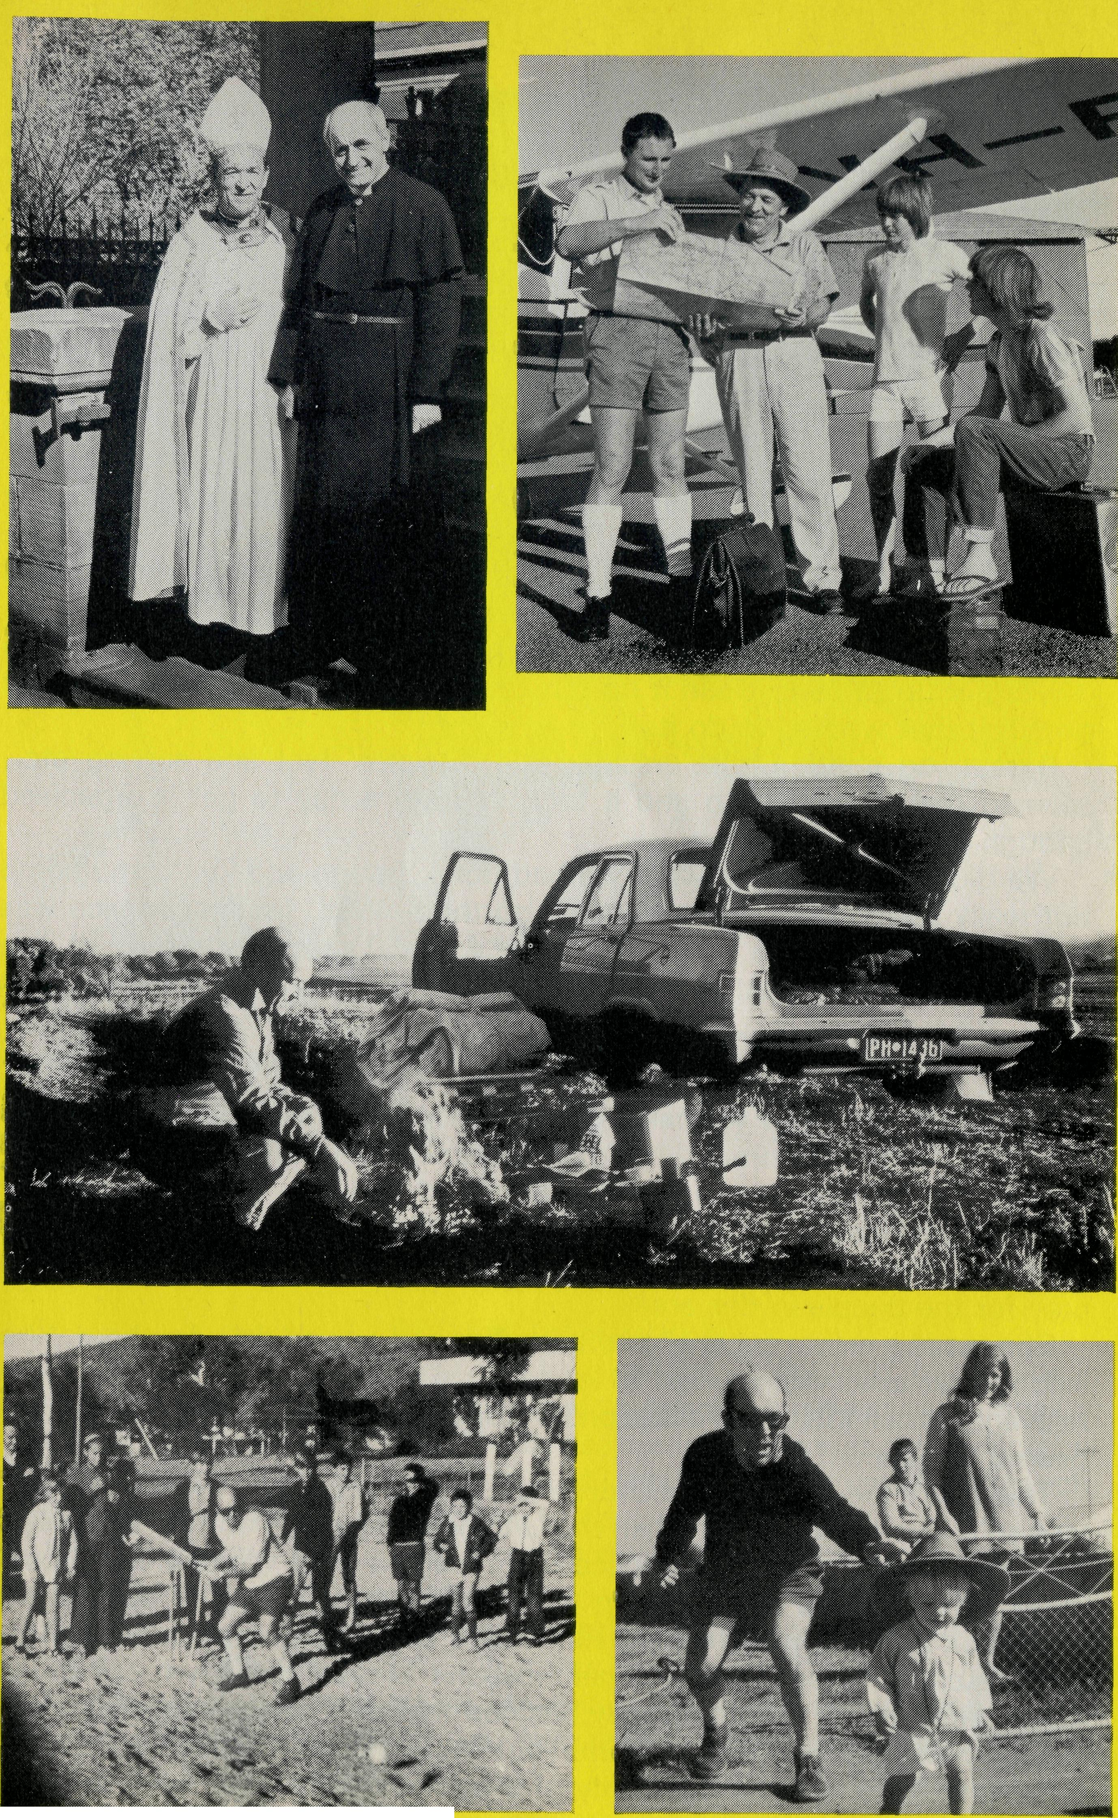
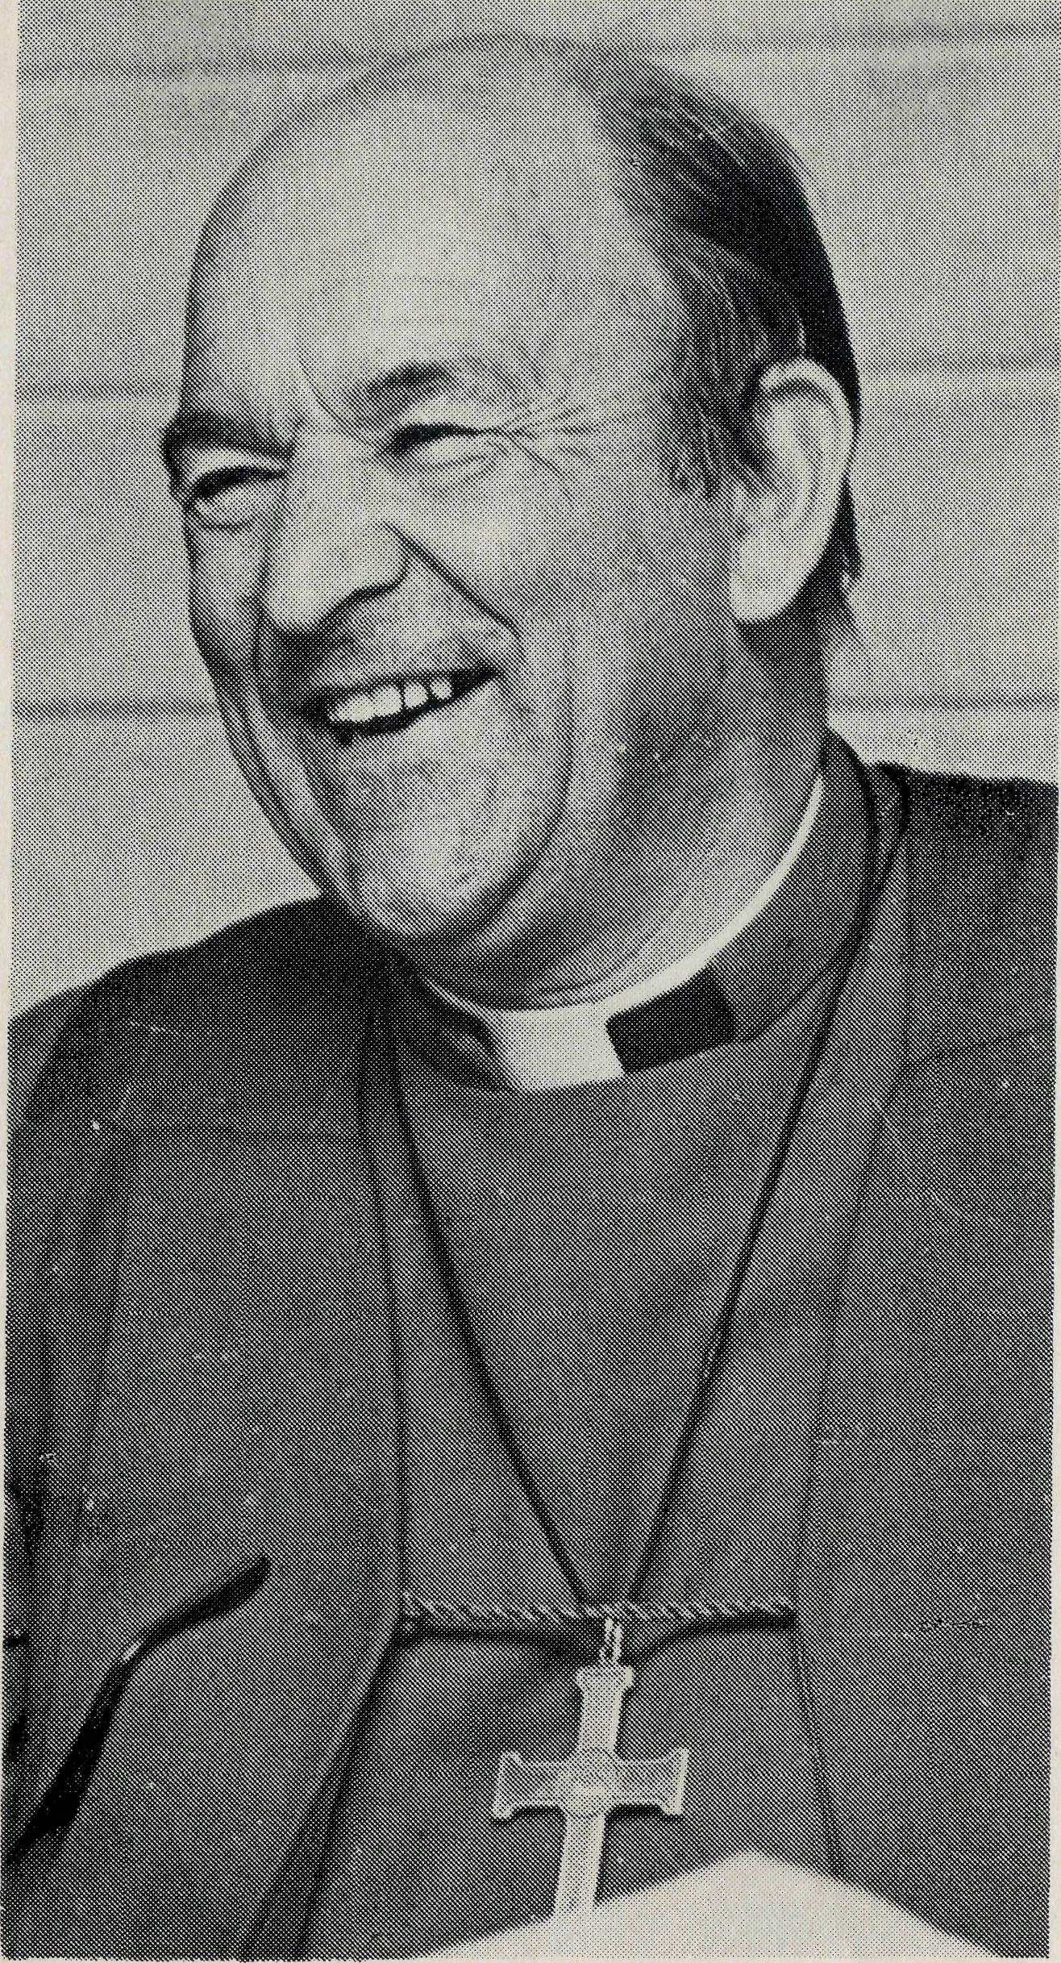
On looking back on the ministry of our Bishop, the Right Revd Howell Witt, one is conscious of a great many achievements, some of which are apparent in bricks and mortar. Also the number of ordained clergy has doubled in the diocese over the past 15 years.
The lasting impressions, however, are his constant ministry to his clergy and people in all parts of this large diocese; his ability to find time for all who sought his counsel and guidance, and his
TRIBUTE TO THE BUSH BISHOP
by STAN HUMMERSTON, GERALDTON, W.A.
sensitivity, which enabled him to get alongside people in the city, on the stations, and on the Aboriginal reserves.
The Bishop's practice of spending at least a week each year in the homes of his clergy, sharing not only in the work but also their home life, enabled him to weld the diocese into a real family. The stories which he related from one end of the diocese to the other also helped to foster a sense of belonging between the various parishes, in spite of the vast distances which separate them.
Unselfish sharing
Often the Bishop's program required him to spend more time in other homes than in his own, and so tribute must be paid to Mrs Witt and his family for their unselfish sharing of their husband and father.
The people of the diocese are grateful for this sacrifice which they have made.
The Bishop's own testimony is "I know whom I have believed and am convinced that he is able to guard what I have entrusted to him for that day" (II Timothy 1:12b). This message of assurance in Christ for all who will commit themselves to Him has been the Bishop's message to this diocese. We rejoice that he will be sharing this same message with the people of the Diocese of Bathurst.
THE REAL AUSTRALIAN
THE REAL AUSTRALIAN

"CLEANING UP" THE CHURCH
ERROL and ANNE SORENSEN, MT MAGNET, W.A.
Soon after we first arrived at Mt Magnet in West Australia earlier this year we paid our first visit to one of our outlying churches — at a place called Sandstone.
The church was in an indescribable mess — the door was broken and as the church had not been used for some months the dust and cobwebs, leaves and general debris that had come in the door made it look like our Western Mining pile of rubbish.
We felt a bit disheartened at all this and the whole Sandstone situation looked hopeless.
We used to think that if a local congregation didn't care about the church it was not up to us to clean it up but somehow this was different and we both felt that we had to do it.
Something about Christ washing the disciples' feet and serving etc., seemed real so we set to and it took us both a day to get it organised enough to have a service.
We did not tell anyone what we had done though and just came home not really seeing how services would go there. Well, the first service was beaut, the second was better and there were 50 people at the third! The town only has a population of about 25 families and there were people from miles around.
PRAYER
After this service, a woman from a station a fair way out told me the following. They had come from South Australia about three years previously with their grown-up son and daughter and families. They had felt very strongly that they were meant to go to the Sandstone area and not long after they had moved, this woman felt that the Lord was wanting her to pray for the people in this area.
She made a prayer cycle of all the families and prayed daily for them. She said that as she began to get to know them so her praying became more relevant to their individual situation but for two and a half years nothing appeared to happen.
They were the only ones at church on the rare occasions there was a service so it was decided that when the Uniting bloke came to their station on his runs they would hold a service there instead of at the church. Round about this time she had a dream vision that God was locked up in a big black box and she was keeping Him there. She was greatly upset by this (understandably) and she and her husband prayed about what it could mean. After much searching they decided that they weren't meant to just have occasional services at home but were meant to use the church whenever there was the possibility of a service even if they were the only
6 THE REAL AUSTRALIAN
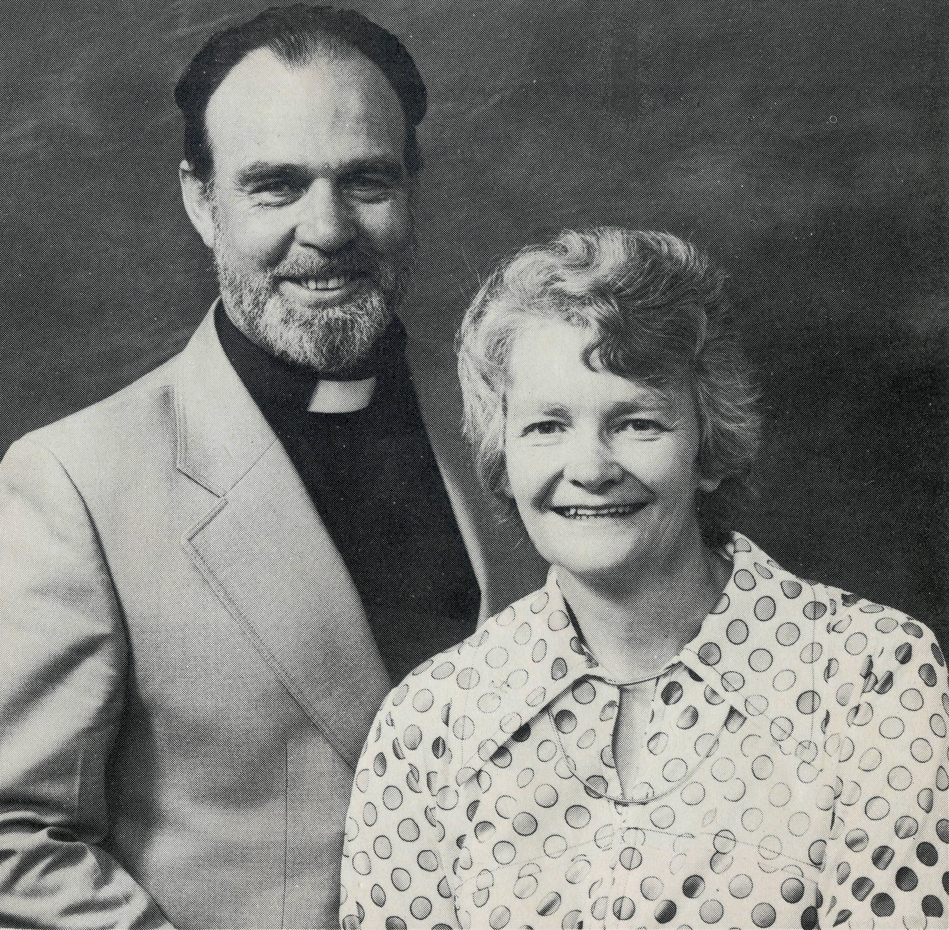
ones — it was to be a witness. In the second half of 1980 there were some uniting services but not many, and they were held in the church.
BEGAN TO HAPPEN
About this time there seemed to be a general "softening" of attitude in Sandstone and although nobody came to church apparently a number of people noticed some changes. The last service last year was held in October and there had not been another one until after we had cleaned the church, and then things began to happen!
I am so grateful that she told me all this, we don't often see what has gone before as clearly as this showed us — it impressed us as to her faithfulness and obedience and also that the Lord uses people to "prepare the way" — I think especially by prayer.
I am sure you will be heartened by this account, and encouraged to keep praying and believing as we are. Naturally this woman is delighted with what is happening now.
THE REAL AUSTRALIAN M

B.C.A. Scrap book
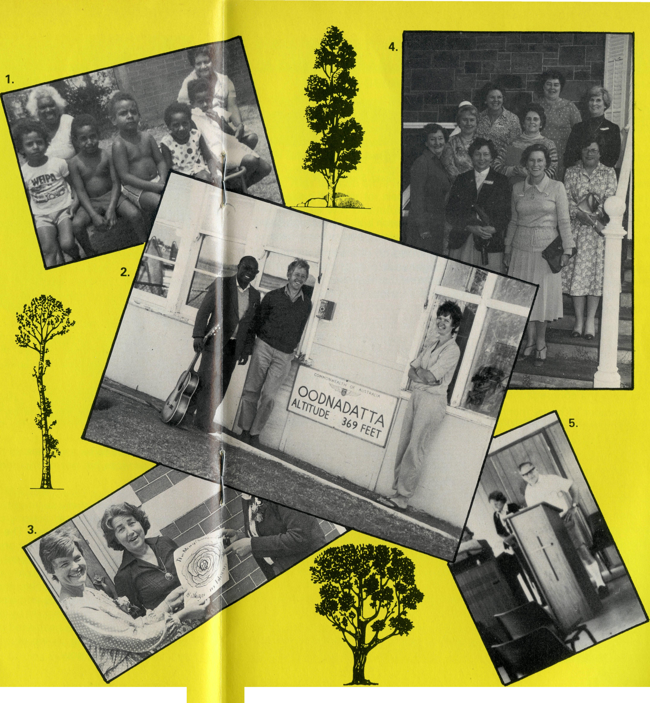
- Jean George and Joyce Charger with children from Weipa South Sunday School.
- Chris Clerke, B.C.A. Missionerat Leigh Creek with Matt Nyagwaswa from African Enterprise, Tanzania, and Helen Murchland, Uniting Church Sister at Oodnadatta.
- Former B.C.A. Missioner's wife, Jenny Rainsford, is the newly appointed Gippsland Mothers' Union President. Jenny is pictured with Mrs Joan Chynoweth, wife of the Bishop of Gippsland. (Picture from Gippsland Anglican May'81.)
- 110 women gathered recently in Port Lincoln for a reunion of residents of the former B.C.A. Hostel. Former B.C.A. Hostel administrators, Stan and Dorrie Hummerston, Isabel Dodd (nee Beck), and Graham and Mrs Mantle attended the reunion. Pictured are girls from 1944-45, Pat Gordon, Rhonda Cronin, Rhonda Scholz, Mary Aerfeldt, Yvonne Noble, Bessie Kotz, Shirley Woolford, Myra Kobolt and Emily Gray. (Photo Port Lincoln News.)
- Diocesan Administrator of North West Australia, B.C.A.'s Stan Hummerston.
THE REAL AUSTRALIAN
THE REAL AUSTRALIAN

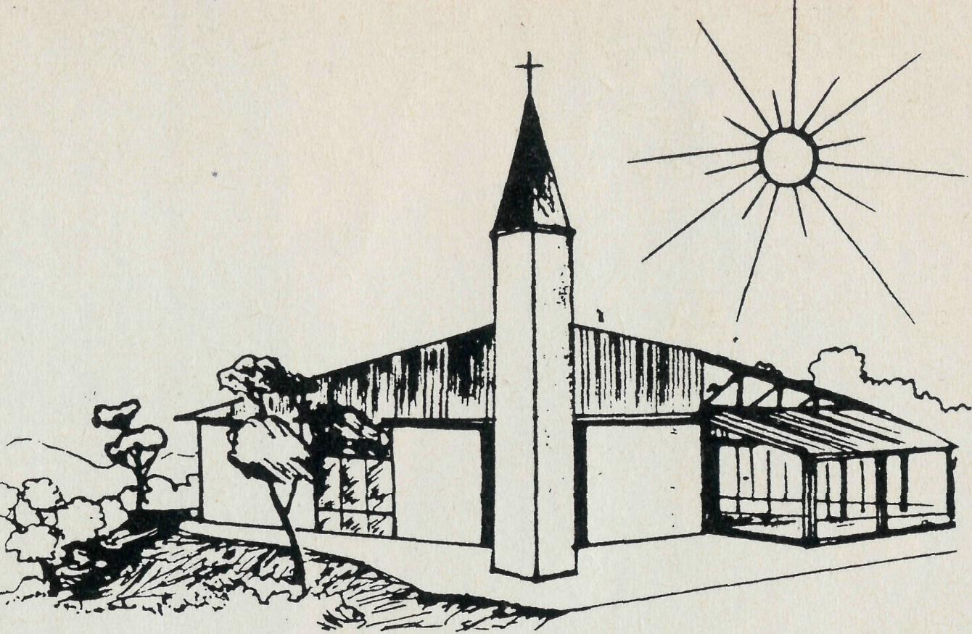
DEDICATION AT LEIGH CREEK
by
Chris Clerke
Church of the Good Shepherd at Leigh Creek South.
The occasion of the Dedication of the new church building in Leigh Creek South was a natural opportunity for special rejoicing and witness here.
A new township is being built about 16 km south of the present town of Leigh Creek coalfield to make way for larger scale mining operations. The Electricity Trust of South Australia, which runs the coal mine, has provided the centre as a replacement for buildings the various churches established in the original town.
To help make it a special time of ministry we invited a number of visitors to share with us. A team from Open Air Campaigners spent a week in the town and area during the week before the dedication of the building. After-school children's meetings were conducted through the week, ending with a family night, and these activities saw a number of families come into contact with the congregation for the first time.
A number of home meetings were also arranged, and the team helped local ministers to lead religious instruction seminars with the secondary students in Leigh Creek area school.
The ministry of team members was also shared in the surrounding districts when Michael Carlisle and Graham Sharman accompanied me on visits to Moomba, Oodnadatta and Stuart Creek cattle station. Michael's singing of country and western gospel songs was much appreciated.
Also visiting Leigh Creek that week was Trevor ("Fuzzy") Kitto, a youth work resource person of the Uniting Church in Adelaide. "Kinderkrist", a rock gospel musical group, presented a Saturday night concert and helped with music in the dedication service.
Our Bishop and other Denominational leaders and representatives joined us for the Sunday morning dedication service for the joint-use building. A few days later the local congregations gathered for a presentation by the Covenant Players — a Christian Drama group.
Naturally enough it was a busy and happy time, but the most important work done at any such time is the work of God's Spirit in the hearts of particular people.

RAIN AT WILCANNIA - BLESSINGS
GEORGE & HAZEL FUHRMEISTER, WILCANNIA
Our Parish Hall is now lined — praise the Lord. It looks so different that a small child, sitting on my knee, at Tuesday School said in a hoarse whisper, while the story was being told, "Where is the old hall?" I tried to explain that this was the same hall, but she was not convinced!
Mr Brian Bell and his family came and "camped" in their caravan on our back lawn while the lining work went on. It was really great to have them there. Also the two older members of their family stayed in the house with us, making it easier for sleeping and their continuing of their school work. The weather was beautiful and morning or afternoon teas were served in the sun. The day the work was to be finished and the Bell family were preparing to move off, the rain fell all day.
Glorious rain! But a caravan in the back yard needed moving quickly else there would be no getting it out. This accomplished with a little difficulty at the gutter, and then they moved off for home early in the afternoon. Rain had been heavier between Wilcannia and Cobar and we were concerned that there may have been deep water at a couple of places — so we rang the Motel until they said they had arrived.
As we shared with Brian and Beverley of the Lord's leading about the lining of the hall and their doing the job, we realised that the Lord had given the very same verse for guidance to both of us — Joshua telling the people that as they stepped into the water they would see the Lord working for them (Joshua 3:13). We each did just that and our "crossing" was accomplished likewise.
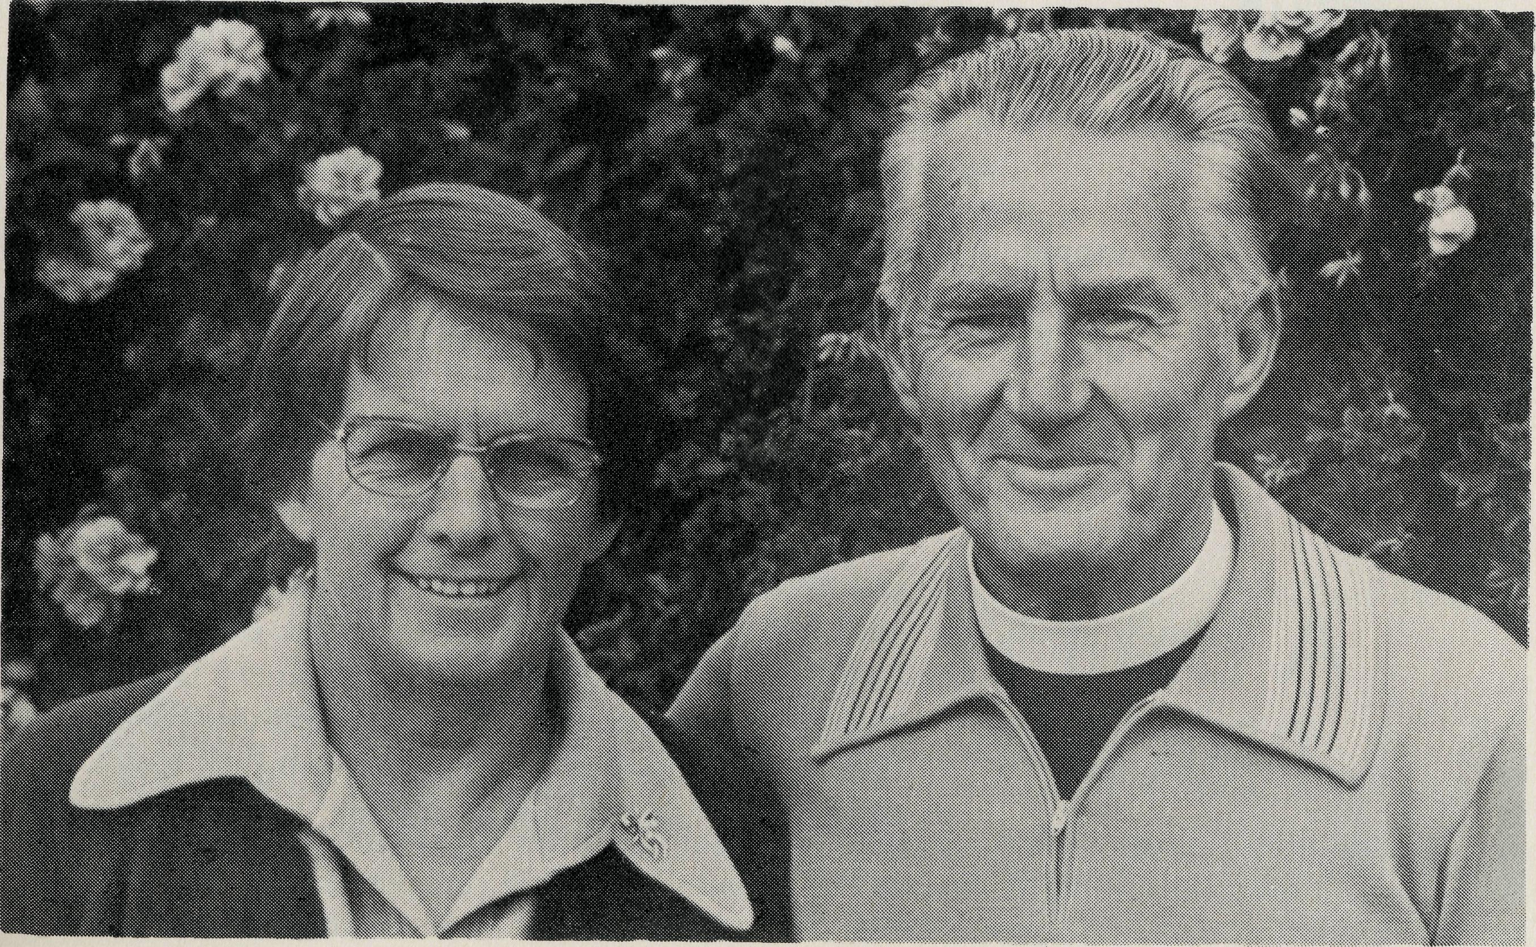

IQ
THE REAL AUSTRALIAN
THE REAL AUSTRALIAN
II

PRAYER CALENDAR

THE B.C.A. PRAYER
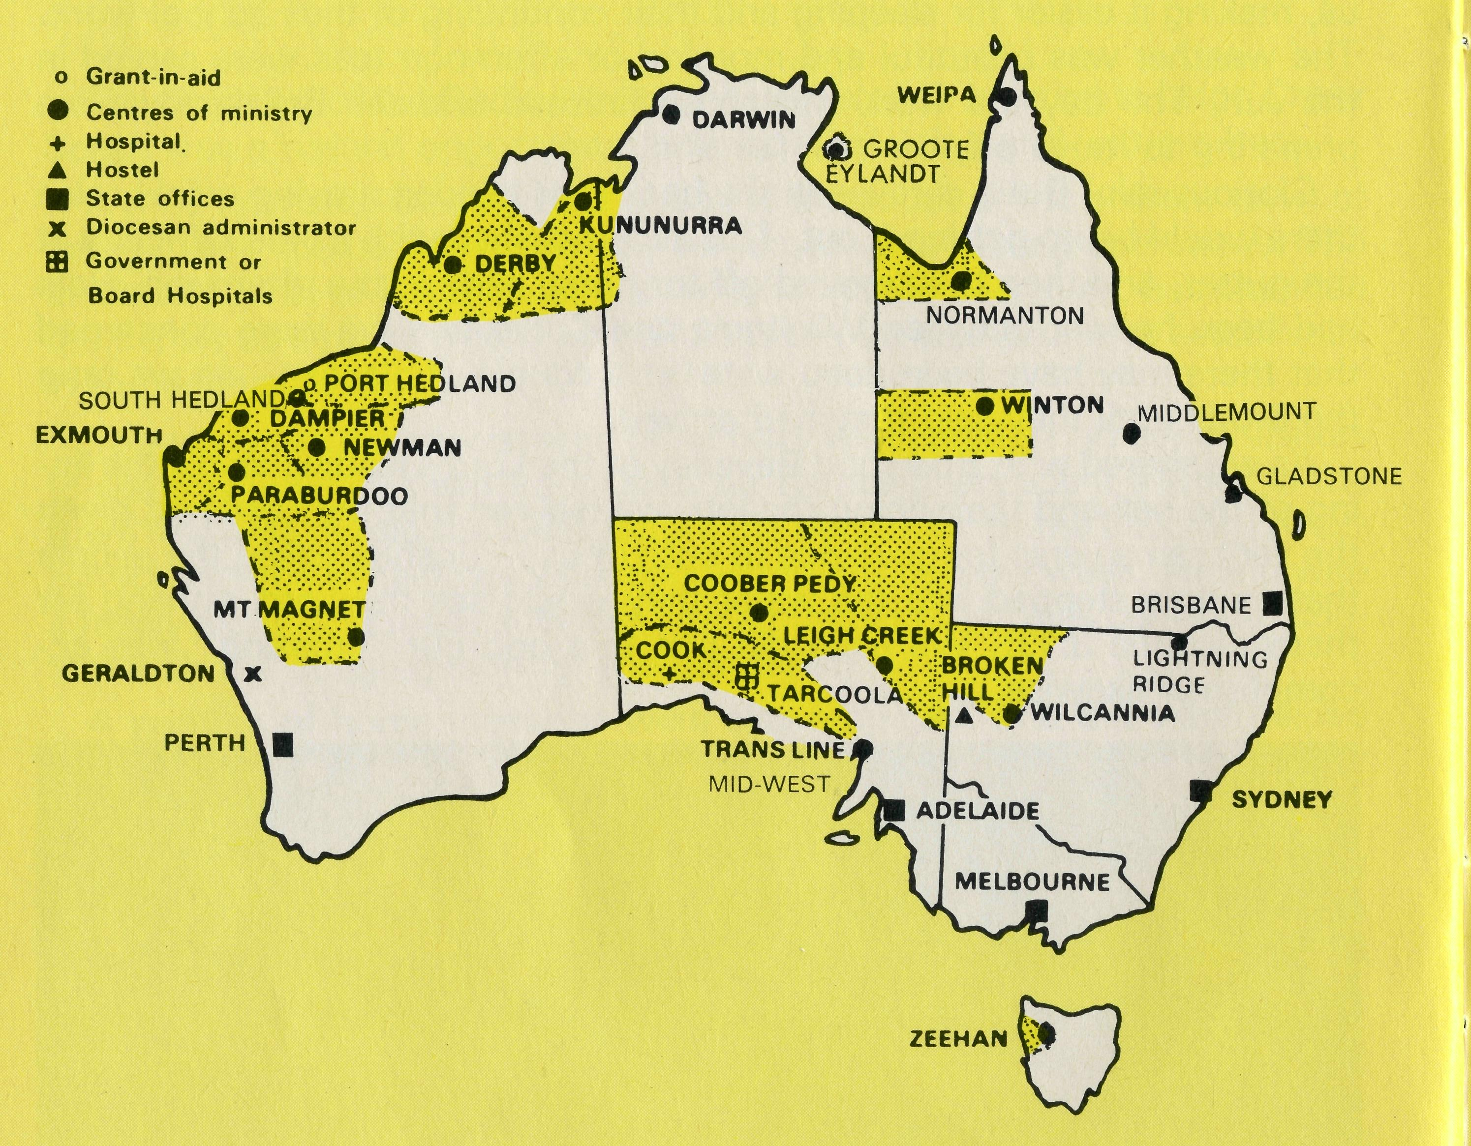
A DAILY PRAYER
0 Lord our God, help us to remember the people who live in the remote parts of our land. We ask You to bless those whom You have called into the fellowship of The Bush Church Aid Society, and call others to stand with them in the task. Grant that, through the ministry of the Word and Sacraments, through healing, and through caring for the young, the message of Your redeeming love may be proclaimed, through Jesus Christ our Lord. Amen.
0 God, we remember before You those whom You have called to Your service. We
ask You to Bless ,
and assure them of Your Presence. Grant to them, as to us, the joy of service, the ability to achieve, and the serenity of Your peace, for Jesus' sake. Amen.
THE REAL AUSTRALIAN
FIELD STAFF DIRECTORY
DIOCESE OF NORTHERN TERRITORY. The Rt. Revd. K. B. Mason.
- Darwin — Vacant (Nungalinya College).
- Groote Eylandt — The Revd. Bruce and Mrs. Marcia Hansford.
DIOCESE OF NORTH WEST AUSTRALIA.
- Kununurra — The Revd. Royce and Mrs. Susan Thompson.
- Derby — The Revd. Peter and Mrs. Betty Mills.
- Newman (East Pilbara) — The Revd. Don and Mrs. Libby Wilson.
- South Hedland - The Revd. Clem and Mrs. Val Watts. Port Hedland — grant, The Revd. Peter Thompson.
- Dampier (West Pilbara) — The Revd. Roy and Mrs. May Buckingham, The Revd. Tom and Mrs. Carol Williams (Wickham).
- Paraburdoo (South Pilbara) — The Revd. Adrian and Mrs. Willemien Moore.
- Exmouth — The Revd. Ken and Mrs. Madge Prentice.

- Geraldton — Mr. Stan and Mrs. Dorrie Hummerston — Diocesan Administrator.
- Mt. Magnet (Murchison) — The Revd. Errol and Mrs. Anne Sorensen.
DIOCESE OF WILLOCHRA. The Rt. Revd. S. B. Rosier.
- Cook Hospital — Sister Anne Ross. Sister Marj. Dickson (relieving)
- Tarcoola Hospital — Sisters Helen Plumb and Marie Ann Parchert.
- Coober Pedy — Vacant.
- Mid-West Mission — The Revd. Robert and Mrs. Phyllis McEwin.
- Leigh Creek — The Revd. Chris and Mrs. Marilyn Clerke.
DIOCESE OF TASMANIA. Vacant.
17 Zeehan — The Revd. Brian and Mrs. Denyse Roberts.
DIOCESE OF RIVERINA.The Rt. Revd. B. R. Hunter.
- Broken Hill Hostel - Mr. Jim and Mrs. Ruth Stocks.
- Wilcannia — The Revd. George and Mrs. Hazel Fuhrmeister.
DIOCESE OF ARMIDALE. The Rt. Revd. P. Chiswell.
20 Lightning Ridge — The Revd. Les and Mrs. Pat Fernance.
DIOCESE OF ROCKHAMPTON. The Rt. Revd. G. Hearn.
- Winton — The Revd. Robert and Mrs. Rigmor George.
- Gladstone — The Revd. Clyde and Mrs. Janice Andrews.
- Middlemount — Capt. John and Mrs. Dianne Symons, Blackwater — Grant.
DIOCESE OF CARPENTARIA. The Rt. Revd. H. T. U. Jamieson.
- Weipa — The Revd. Lex and Mrs. Rhonda Carey.
- Normanton (Southern Gulf) — Vacant.
GENERAL
26 Federal Secretary. The Revd. Wakely Wade.
N.S.W. The Revds. Malcolm Babbage, Kerry Medway, Eric Atkin, Miss Doris Smith, Mesdames Joy O'Neill, Dora Warwick, Nina Allan and Vivien Bentley.
- VICTORIA. The Revd. Ernest Horth, Miss Chris Craig.
- QUEENSLAND. Mr. Allan Sauer (Hon. Secretary).
WESTERN AUSTRALIA. The Revd. Gordon Thomas (Deputationist)
- SOUTH AUSTRALIA. The Revd. David Eastway
- The President, The Most Revd. Sir Marcus Loane, Chairman, Dean Lance Shilton, Honorary Treasurer, Mr. Richard Stokes, The Council, State Committees.
Staff Replacements, Box Secretaries, B.C.A. Supporters.
31 The Anglican National Fund and other Christian Agencies.
THE REAL AUSTRALIAN

COMMITMENT
A hen and a pig were discussing their commitment in the farmyard.
"My commitment," said the hen, "is an egg a day."
The pig gave a grunt to indicate he was unimpressed. "Your commitment is nominal," he said, "but when my commitment of ham and bacon is given, it will be a total commitment."
When Jesus spoke of commitment He said, "If any man would come after me, let him deny himself and take up his cross daily and follow me." (Luke 9, vs. 23)
Jesus saw Christian commitment as putting God first, obeying His call, even if it involves hardship, and following Jesus wherever He may lead.
Praise the Lord for thousands of Christians committed to sharing the gospel of Jesus in outback Australia.
B.C.A. goes beyond. _{How} _{deep|y} _{am} , _{committed?}
POST & RAILS
BISHOP'S STAFF!
Anne Sorensen from Mt Magnet saw where Bishop Witt was to "lay up his staff on the altar". Picturing all the North West clergy piled on an altar, Anne was somewhat mystified at this gesture. Hubby, Er-rol, sorted out this confusion explaining the difference between the "staff" and the Bishop's Staff!
MISSIONERS URGENT
B.C.A. wishes to thank Rev. Barry Schofield from Picton, N.S.W., for the six-week ministry he is now enjoying at Coober Pedy. Missioners are needed for Coober Pedy, S.A., Normanton, Qld.
SUPPORTER DIES
A young blind woman, Sue Newman, died recently. Sue had an enthusiastic interest in B.C.A., and often visited the Sydney office with bulging money boxes.
Our sympathy to her family at Werri Beach, N.S.W.
$2,000 - STAMPS
Joy O'Neill reports that money received from the sale of used stamps in 1980 was $2,074.46. Thanks to Miss Unwin and helpers and all who have given stamps through Melbourne and Sydney offices.
VESTRIES & PARISH COUNCILS
Please consider B.C.A. when formulating your 1982 budgets. Help us to help those outback.
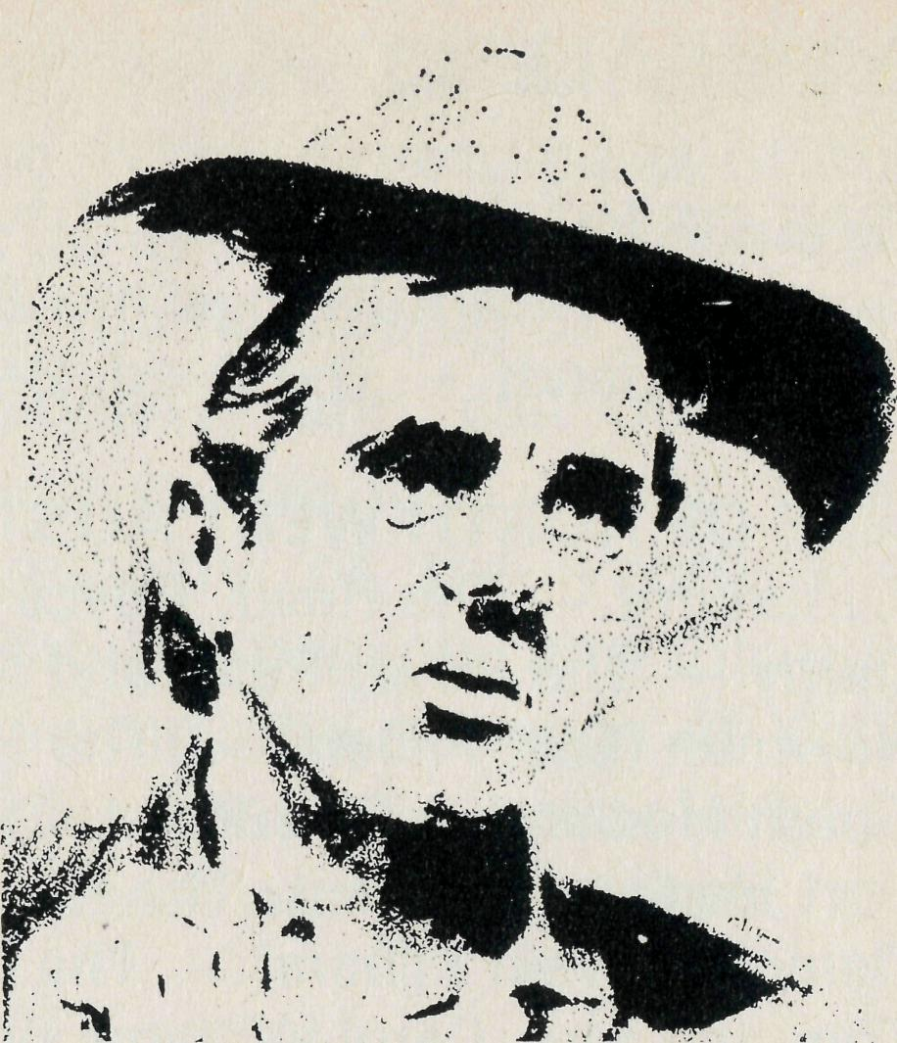
A little oil of Christian love will save a lot of friction.
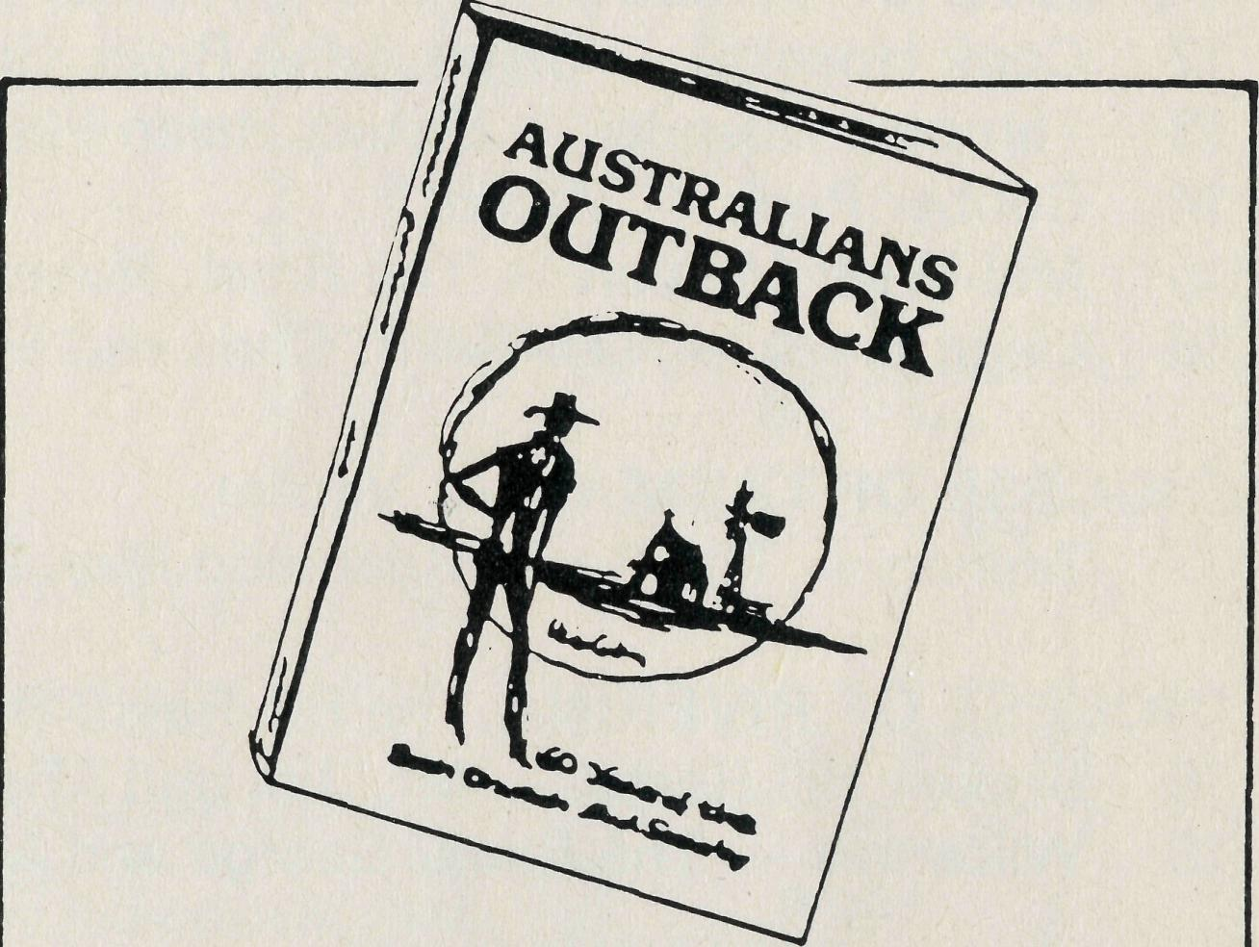
AUSTRALIANS
OUTBACK
60 Years of Bush Church Aid by Helen Caterer MBE
Another AIO publication
due August. $5.95
A book which tells the story of how the Anglican Church has cared for the spiritual, medical and social needs of people in the remote parts of Australia for the past 60 years.
ORDER YOUR COPY FROM THE
B.C.A. SHOP
135 BATHURST ST., SYDNEY
(or your state office)
BUSH CHURCH AID STATE OFFICES
- N.S.W. Rev. Malcolm Babbage, 135 Bathurst St, SYDNEY 2000 (02)264 3164,264 3780
- VIC. Rev. Ernest Horth,
196 Flinders St, MELBOURNE 3000 (03) 63 8962
* S.A. Rev. David Eastway,
350 King William St, ADELAIDE 5000
(08) 212 4838
* QLD. Mr. Allan Sauer,
33 Tunney St, MT. GRAVATT 4122 (07) 343 3330
* W.A. Rev. Gordon Thomas,
4 River Rd, KELMSCOTT 6111
(09) 390 5351
PLEASE CUT OUT AND RETURN
B.C.A. NEEDS YOU!
I wish to be more involved with B.C.A.
* I WISH TO KNOW □
(Receive Real Australian and other literature by post)
- I WISH TO PRAY □ (Receive B.C.A. Prayer notes)
- I WISH TO GIVE □ (Please enclose your donation)
- I WISH TO GO □
(I am interested in serving God in outback Australia)
PLEASE RETURN THIS SLIP TOGETHER WITH YOUR NAME AND
ADDRESS
TO YOUR STATE SECRETARY

14
THE REAL AUSTRALIAN
THE REAL AUSTRALIAN

