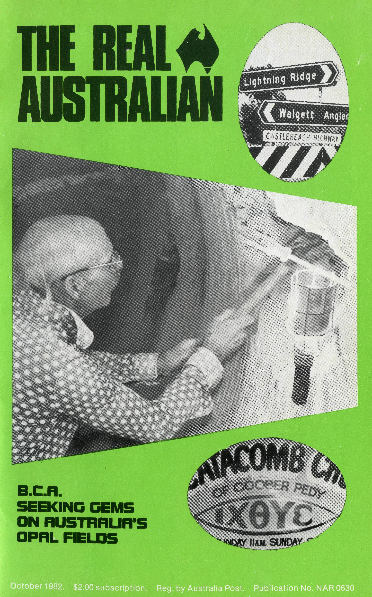
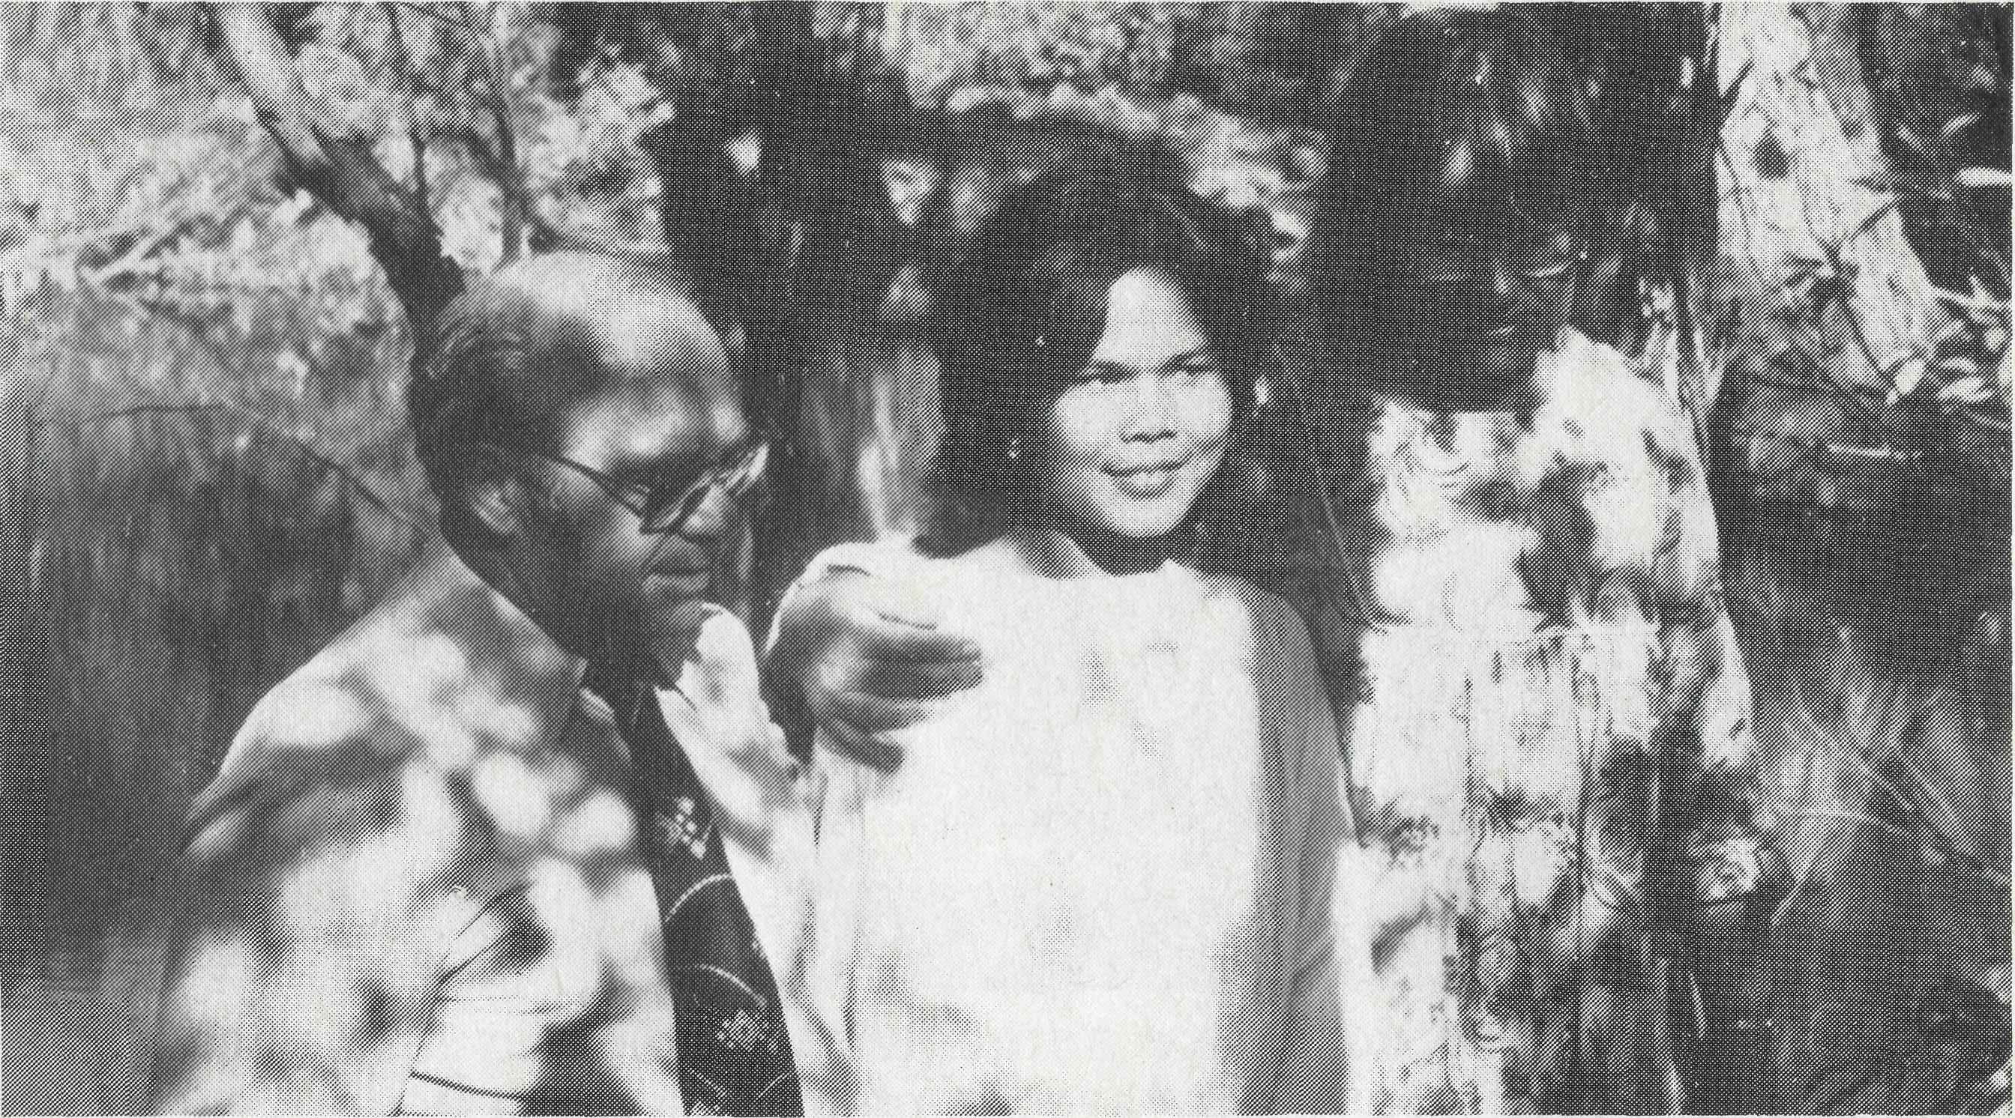
BUDDHIST CONVERT BAPTISED
At Leigh Creek two people were baptised in the Aroona Dam. One of the new Christians was a young woman from Thailand, a Buddhist. One Sunday she wandered into the new community church at Leigh Creek and listened to Chris Gierke's sermon about God's love. Local Christians Tom and Val Robinson (pictured abov? with Leek) led this young Buddhist to Jesus. Leek's testimony was broadcast over the short wave radio in Thailand and her mother miraculously heard her daughter speak of her love for Jesus and was touched by God.
PRAY FOR B.C.A. OUR MINISTRY TO OUTBACK AUSTRALIA HAS FAR REACHING EFFECTS

 | please put off and |  | return
 |  | Mr/Mrs
 |  | Miss/Rev
 |  | Address
 |  |  | P/rnde
 |  | 1 WISH TO:
 |  | □ KNOW | (Receive the Real Australian)
AUSTRAUA Yf^OR CHRIST
 |  | □ PRAY | (Please send a Prayer Fellowship Application)
 |  | □ GIVE | □ (1 would like a B.C.A. money box.)  □ (Please inform me of needs
THE BUSH CHURCH AID SOCIETY |  |  | regularly)
NSW 135 Bathurst Street, Sydney, | 2000 | □ GO | (1 am interested in serving God in
Phone: (02) 264 3164 |  |  | Outback Australia)
Printed by Ambassador Press Pty Ltd. 51 Good Street, Granville 2142

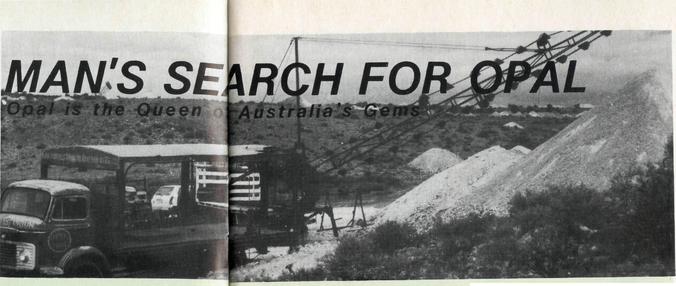
All enquiries to:
REAL AUSTRALIAN EDITOR
Kerry E. Medway
THE BUSH CHURCH AID SOCIETY 135 BATHURST STREET, SYDNEY, 2000 Phone (02) 264 3164
B.C.A.
STATE OFFICE
CONTACTS.. .
Federal Secretary: The Revd. Wakely Wade.
General Secretary N.S.W.: The Revd. Malcolm Babbage.
N.S.W. Secretary Youth: The Rev. Kerry
Medway.
B.C.A. House, 135 Bathurst Street,
Sydney, N.S.W. 2000. (02) 264-3164,
264-3780.
Victorian Secretary: The Revd. Alan Hoskin, 205 Flinders Lane, Melbourne, Vic. 3000. Phone: (03) 63-8962.
Sth. Australian Secretary: 350 King William Street, Adelaide, S.A. 5000. Phone: (08)212-7804.
Queensland Hon. Secretary: Mr. Allan Sauer, 33 Tunney St., Mt. Gravatt, 4122. Phone: (07) 343 3330.
Western Australia Hon. Deputationist: The Revd. Gordon Thomas, Box N1024 G.P.O., Perth, W.A. 6001. Phone: (09)390-5351.
Rev. Ken Prentice, Wollaston College, Wollaston Road, Mt. Claremont, W.A. 6010. Phone (09) 383-3124.
COVER PICTURE
Coober Pedy opal miner Ralph Underwood searching for an elusive fortune in opal.
When displayed under light, opal flashes its spectrum of colour, seeking to entice men and women with its beauty and many are trapped into searching for their fortunes in Australia's vast outback.
The rare black opal with its pin-fire red at Lightning Ridge, big discoveries of milky white opal at Coober Pedy, the treated matrix, and painted lady opal of Andamooka and opalised fossils at White Cliffs have attracted many miners into the Australian outback.
Men and women from all countries of the world struggle in oppressive heat and isolation, crawling, gouging, sweating and blasting for an illusive fortune in opal.
Not all have come to "get rich quick", some have fled the "rat-race" of city life and others have abandoned wives and children to live in obscurity in Australia's "Opal Never Never" land.
Man's search for opal is similar to God's search for man. The Bible indicates that God is at work seeking out gems for His Kingdom (Malachi Chapter 3 verse 17).
Just as opal buried deep in the earth fails to display its natural beauty, so too does man, buried in his sinful and rebellious attitude toward God, fail to display his natural beauty. Instead, hatred, selfishness, envy, etc. , flaw his character.
The opal miner seeks to bring opal from its dark tomb to the light, to reveal its beauty. So too has God reached into the darkness of this world to bring mankind into the wonderful Light of His Kingdom.
Winning opal miners for Christ is not easy.
B.C.A. Missioners struggle to relate the reality of God's love and saving power to men and women on Australia's opal fields.
God has revealed a threefold formula for winning opal miners for Christ.
A. PRAYER AND FASTING
We praise God for thousands of prayer supporters who uphold our B.C.A. team each day in prayer. B.C.A. men know the worth of fervent prayer to bring about faith increase and a change in rebel lives.
B. LOVE AND CARE
B.C.A. Missioners display God's love, by visiting men in the pubs and opal clubs and befriending women and kids in the harsh isolation of the opal fields.
C. PREACHING POWER
B.C.A. men proclaim the Word
of God with power. God's word is sharper than any two edged sword and has the power to move mountains. God is jolting opal miners from their atheism by miracles of healings and men are submitting to Christ.

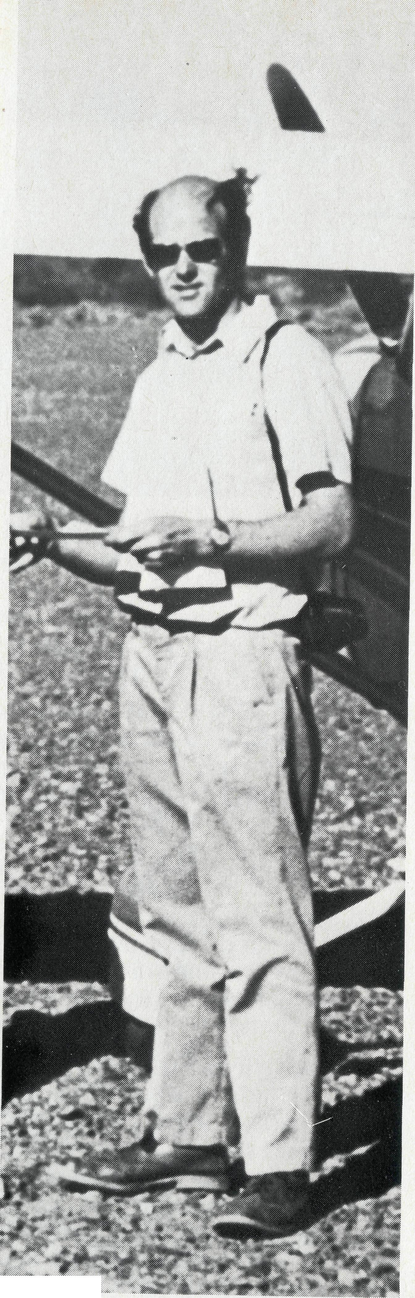
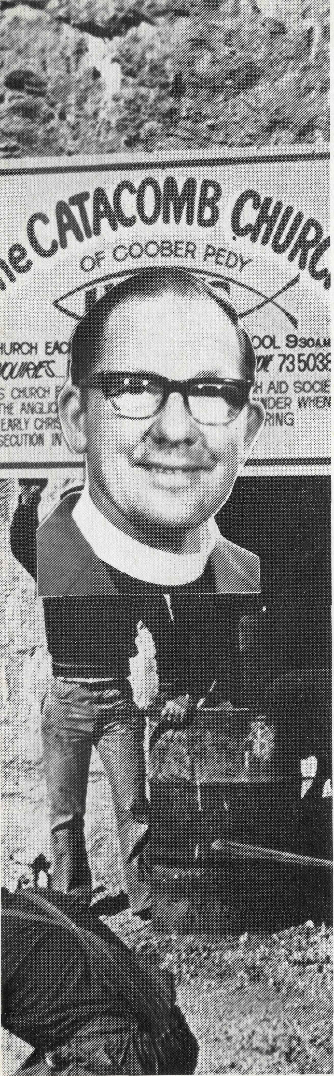
?-. . * A
ANDAMOOKA
Opal was discovered at Andamooka in 1930 and the fields grew until 1971 when 3,000 miners worked over an area of 13 kilometres. Following no new significant opal discoveries, Andamooka has declined to a population of less than 400.
The main road to Andamooka winds along a graded creek bed, unsealed road, for 140 kilometres from Woomera to Lake Torrens.
Andamooka has a colourful ethnic community, with opal miners who are self sufficient and have a strong determination. It was here the film "The Last of the Knuckle Men" was made. A small building was erected some years ago as a community Church and a group of faithful Christians meet for Church and Sunday School.
B.C.A.'s Rob McEwin visits Andamooka to encourage the faithful and to seek out opal miners for Christ. Rob also visits the nearby Roxby Downs-Olympic Dam uranium site, which has transformed Andamooka with many men leaving the gamble of looking for opals to settle for a regular wage.
A couple of years ago a B.C.A. Missioner was able to help an opal miner to discover God. This man with a fearsome reputation had some years before been involved in a knife duel in the main street of Andamooka.
COOBER PEDY
Coober Pedy, 650 kilometres from Port Augusta and 700 kilometres from Alice Springs, is Australia's largest opal mining community with 4,000 people, producing 90% of the world's opal.
Coober Pedy is famous not only for its opal, but also for its underground dugout homes. It is now a popular tourist centre with over 65,000 tourists passing through on the way to Ayers Rock and Alice Springs. Coober Pedy has a cosmopolitan population with about 70% coming from various countries overseas.
B.C.A. has cared for Coober Pedy for many years. First with the B.C.A. Flying Medical Service, established in 1938 and then B.C.A. began a hospital in Coober Pedy in 1964 and built an underground church in 1977. B.C.A. Missioners in Coober Pedy, the Reverend Bill and Mrs. Gwen Ostling seek to bring a loving concern to opal miners and their families. Bill and Gwen minister to the members of the underground church called the Catacomb Church and this church has seen many men and women touched by the power of God. Recently a leading man in the community joined the Church after his daughter was miraculously healed of cancer and sometime later his wife was baptised.
Thank God for B.C.A.'s care for Coober Pedy.

THE REAL AUSTRALIAN
THE REAL AUSTRALIAN

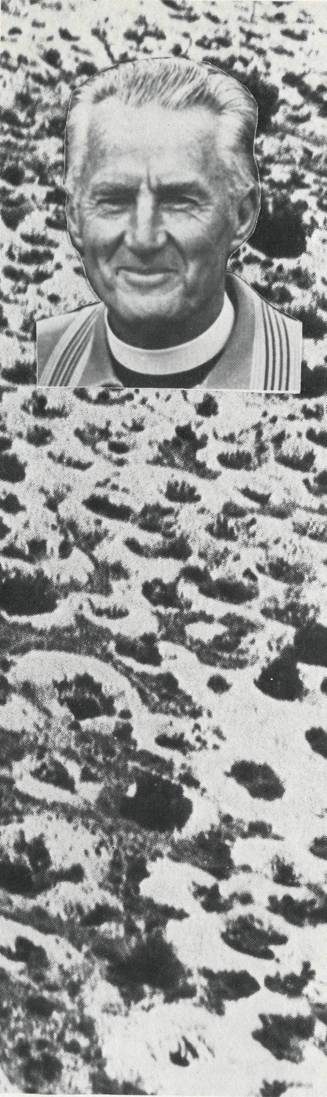
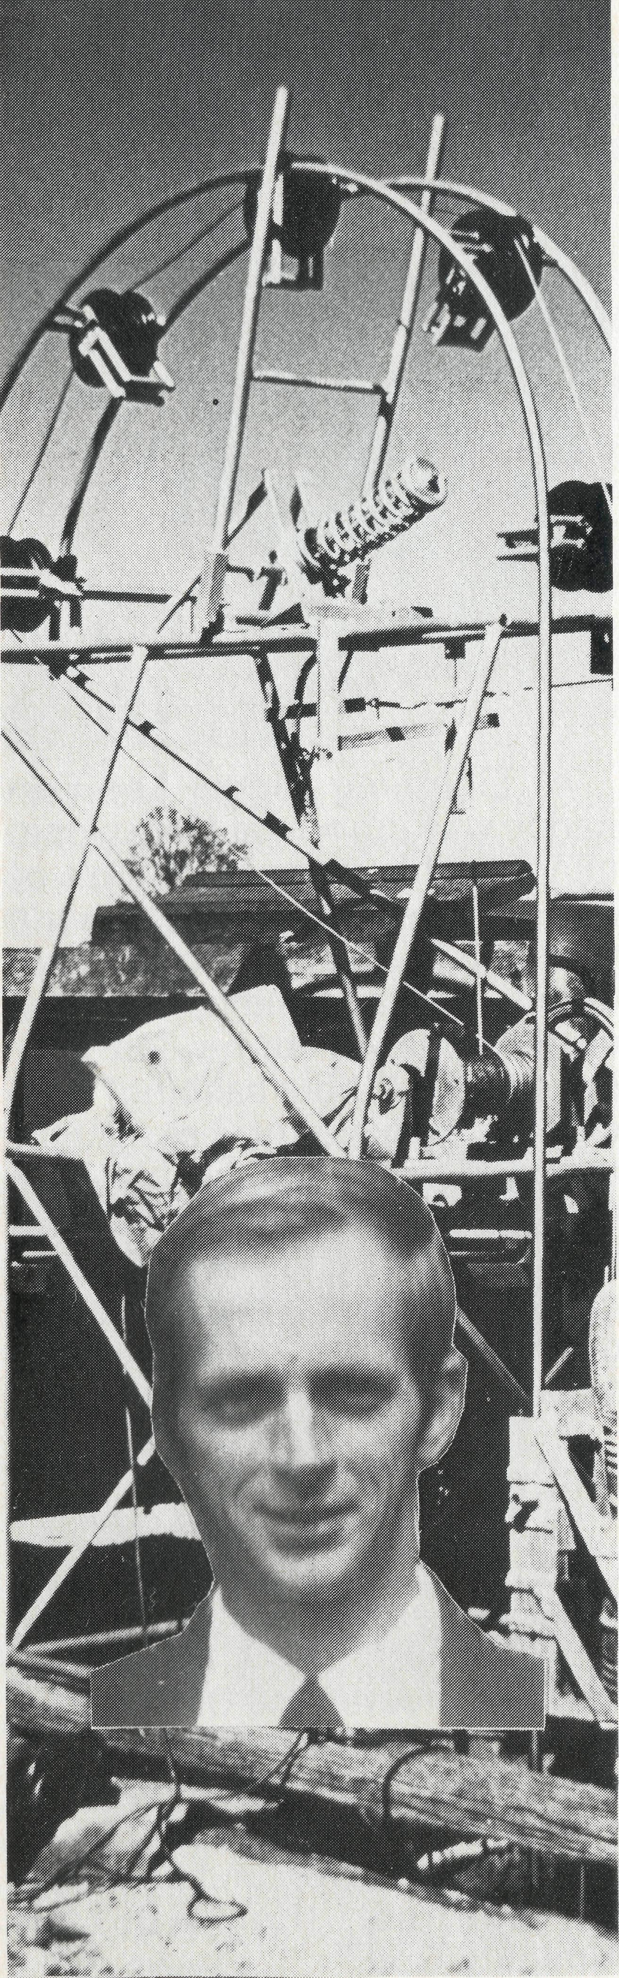
WHITE CLIFFS
Approximately 200 opal miners live at White Cliffs opal field, 100 kilometres north west of Wilcannia. White Cliffs is the grand-daddy of Australia's opal fields, with opal first being discovered in 1887 by two kangaroo shooters.
White Cliffs resembles a luna landscape or giant ant's nest with hundreds of opal mining shafts dotting the landscape. Amongst the opal miners are shearers, pensioners, retired school teachers and engineers, pottery-makers and various folk skilled in arts and crafts.
An old stone church stands in White Cliffs as a witness to those searching for opal that there is a God, and He cares. B.C.A. Missioner the Reverend George and Mrs. Hazel Fuhrmeister visit White Cliffs from Wilcannia regularly and hold church services and seek to win opal miners for Christ. George and Hazel follow a long list of B.C.A. Missioners at Wilcannia who have cared for White Cliffs opal miners during the past 60 years.
Recently a retired diesel engineer and his wife plastered the inside walls of the church building. This man, who is also the church organist and parish representative, became very ill and only after much prayer was healed and is back on the job again.
Hallelujah. B.C.A. brings God to the opal fields.
THE REAL AUSTRALIAN
THE REAL AUSTRALIAN
LIGHTNING RIDGE
Situated 770 kilometres northwest of Sydney and 80 kilometres from Walgett, Lightning Ridge is the home of the rare black opal. A "guesstimate" of the 'Ridge's population is about 3,000 and it is a cosmopolitan community. The people of Lightning Ridge are very determined individuals. Opal miners have fled the "rat-race" of the city with unions restricting them from working and have carved out a life on the opal fields at Lightning Ridge. Many miners "rough it" at the Ridge during winter and move back to their homes in other places during the warmer months.
B.C.A. Missioners Rev. Les and Pat Fernance have sought to encourage the local Christians at St. George's Anglican Church to reach out into the community with God's love. One young man's marriage fell apart and he was riddled with guilt and lost all purpose in life. He sought help from B.C.A.'s man at the 'Ridge and has now discovered a new reason for living. Another man with a price on his head was fleeing from the underworld. He sought refuge and help from the Fernance's and heard of God's love for him. Some time later, after moving on, he wrote to say thanks for his new life and God's protection.

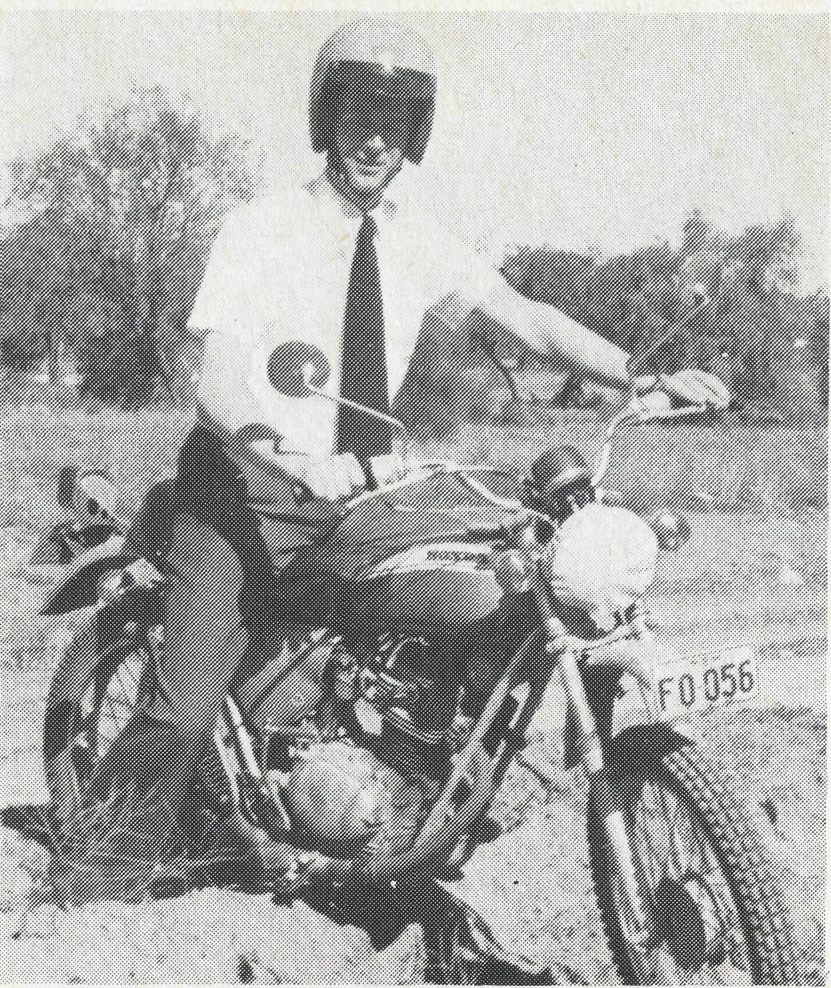
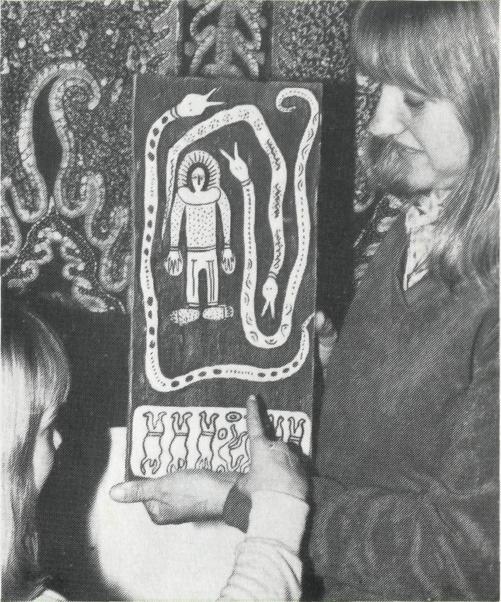
OPAL MINER CHASED
D0C5 OF BRHLOO
BRRRY RRINSFORD
Rector of Yarram, Victoria says ....
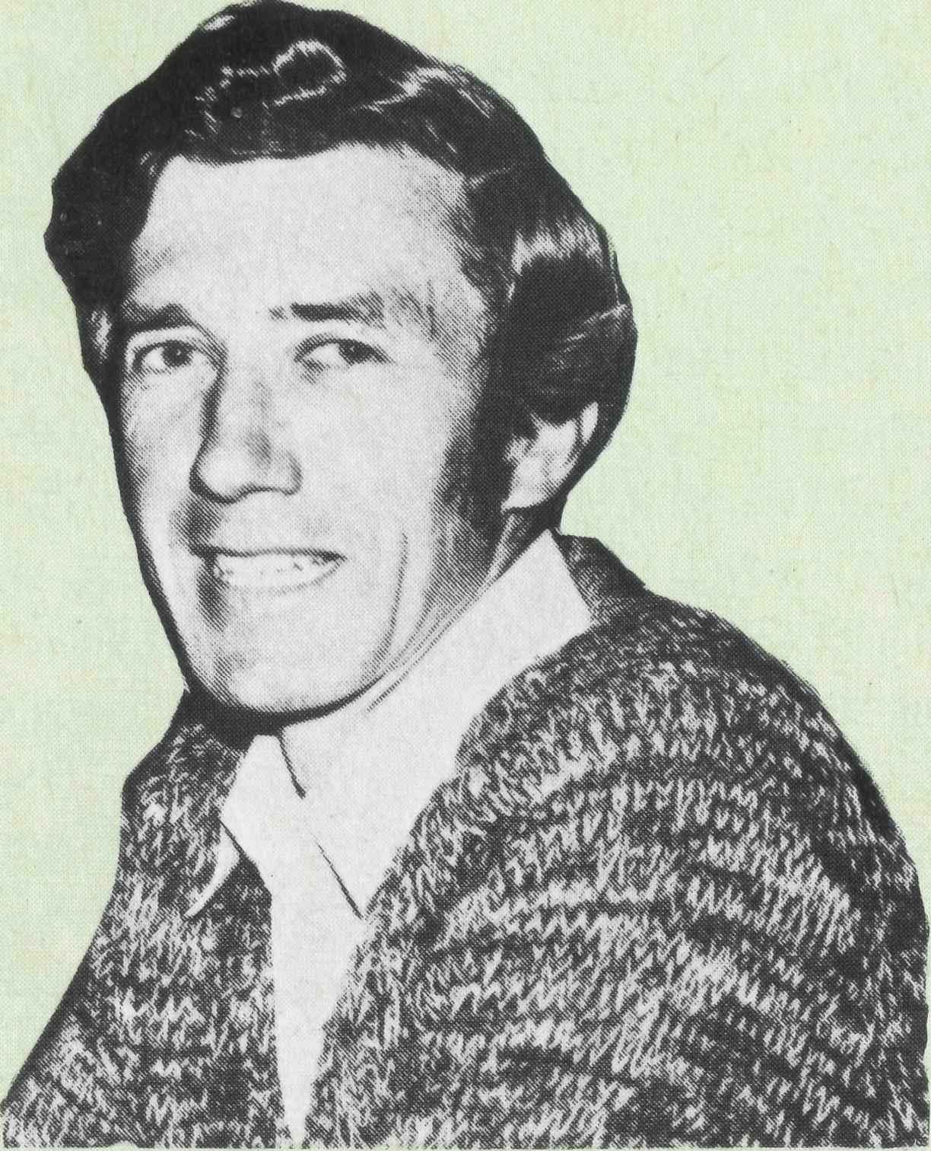
"Serving with B.C.A. for five years put iron in our souls, steel in our nerves and cast us on the Lord who supplied all our needs. Our experience on the opal fields taught us a lot about people and enriched our experience for future blessings in parish life."
Barry and Jenny Rainsford were B.C.A. Missioners at the Coober Pedy opal fields from 1970 to 75.
For experience you will never get in a city ministry, contact the Reverend Wakely Wade, B.C.A., 135 Bathurst Street, Sydney 2000. Phone (02) 264 3164.
B.C.A. MAN BAPTISED
Les Fernance was visiting a home at Lightning Ridge, and as he rounded a corner he was drenched. A water hose accidently popped out of a nearby tank and Les was baptised.
At Lightning Ridge, Les Fernance was introduced by an opal miner to his partner. A look of horror appeared on the miner's face and he ran off into the opal dumps. Les and the miner chased the runaway as he fled fearing another "Bible bashing" session as he called it. Les caught the man and showed this man God's love. He had been deeply hurt and his wife had recently died. Now Les is welcome at the opal miner's camp and he is seeking after the things of God.
MICHELLE BELIEVES IN GOD
A 15-year-old teenager at Coober pedy wrote the following for a project in the Catacomb Church Youth Club. "I believe in God, He created the Universe — there are some things I don't understand, but I also believe in eternal life and when I die I know I will go to heaven and continue my spiritual life with our Almighty God."

CULTURE SHOCK
After 25 years of ministry in Sydney and sailing on Sydney harbour, Coober Pedy proved a major culture shock for Bill and Gwen Ostling.
Life in the outback is not the same as in the city and Bill had to learn as all B.C.A. men do, that because you wear a dog-collar, you have to earn the right to preach to men in the bush.
Bill and Gwen have now settled into their underground home and are providing a loving ministry to the many opal miners and their families at Coober Pedy. The Catacomb Church recently held a great Family Camp at Mabel Creek shearers' quarters, with the Reverend Geoff Bingham from Adelaide encouraging the 80 folk who attended.
WHITE CLIFFS' KIDS
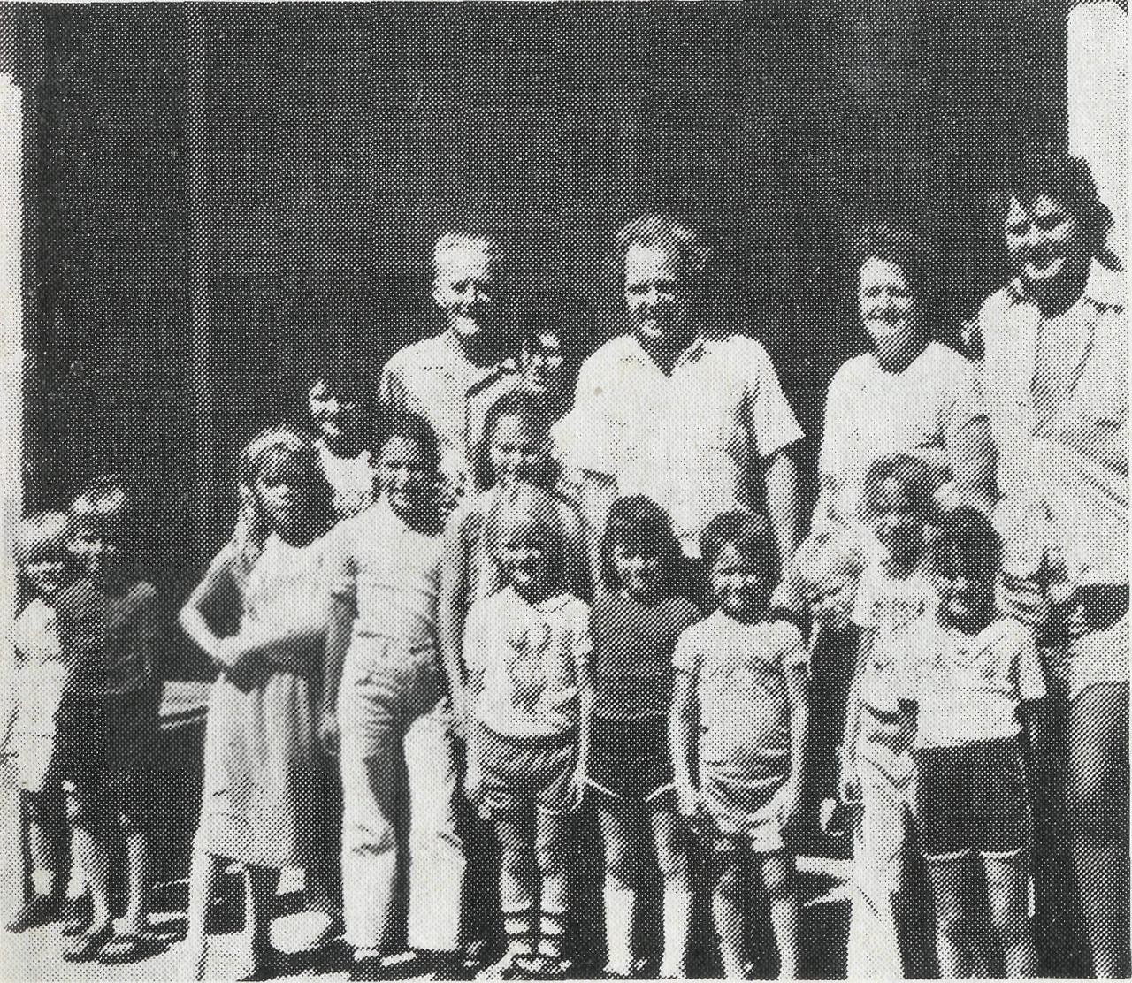
Pictured above is the Reverend George Fuhrmeister with a teacher and kids from the White Cliffs School. Last year three children attended a Church-run holiday camp and one young girl opened her heart to Jesus and began to read her Bible.
The Aboriginal bark painting being
examined above is just one of the
many Aboriginal Dreamtime stories
captured in picture and on sale at
the
B.C.R. SHOP
135 BRTHURST STREET
SYDNEY 2000
For Aboriginal art
Boomerangs
Didgeridoos
Spears
Coober Pedy Opal
Shop now for Duty-free
overseas Christmas
presents
KIDS SHOW CARE
Coober Pedy's Adventure Club kids are raising money for a World Vision boy in Lebanon. They have set up a stall near the Catacomb Church and sell locally made artifacts to visiting tourists.

THE REAL AUSTRALIAN
THE REAL AUSTRALIAN

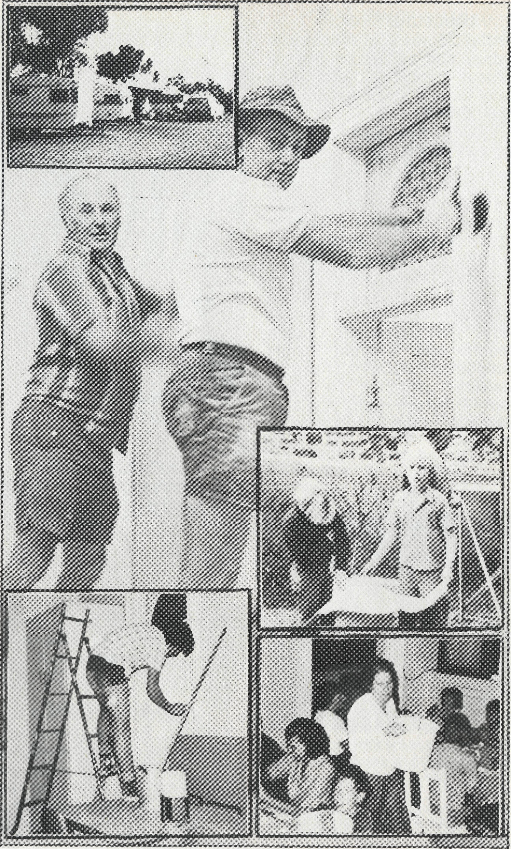
"DUST, DUST"
Wrote Ruth and Jim Stocks as the B.C.A. Hostel at Broken Hill was literally knocked down around them.
In response to B.C.A.'s urgent Hostel Appeal, a team of builders and their families trekked to Broken Hill during the May school holidays to offer their services in a Hostel "Working Bee" which within two weeks saw the Hostel miraculously fire-proofed. "The miracle began," said Brian Bell, "when at midnight Sunday, the truck arrived with all the materials and the team swung into action and unloaded tonnes of timber and iron in just one hour instead of the expected four."
Dust, sheets of iron, sawdust and piles of rubble were taken away and the Hostel's new look was coated in fireproof fibro and paint. Long hours, tired children, cramped caravans, great fellowship and Bible studies encouraged our B.C.A. Hostel parents.
Extensions are still under construction with the Len Daniels room and the Auntie Mann wing. The renewed Hostel is expected to be officially dedicated in late 1982 in memory of Alb Kirkby.
Pictured left: Builders Lyndon Peake and Brian Bell lead a team of workers as they renovate the B.C.A. Hostel at Broken Hill. Photo by courtesy of the Barrier Daily Truth.
Top left insert: A city of caravans in the Hostel backyard to house the builders and their families. Many caravans were loaned by residents of Broken Hill.
B.C.A. HOSTEL RE-UNION
Laurie and Pauline Calder recently returned to Broken Hill for a 25 year re-union. The Calders were B.C.A. Hostel parents to 30 boys in the 1950s and celebrated a Re-Union Dinner with many of their "boys".
"A wonderful night," said Laurie, "truly an unforgettable experience," he exclaimed as the memories came flooding by . . . "There was John, who invariably had his boots on the wrong feet. There was also Robert, probably our biggest problem child, who is now taking his children to church and Sunday school, only, he assured us, as a result of his B.C.A. Hostel training. And there was Barry, now living 160 kilometres from Broken Hill, and unable to get in to the dinner, who sent us a message to say that whilst he was at the Hostel he didn't take too kindly to our discipline. But now in retrospect, and with children of his own, he greatly appreciated the training and care and concern we offered him in his childhood.
"What a re-union," said Laurie and Pauline.
Bottom left insert: Mark Griffiths painting inside the Hostel. Top right insert: Michael McRae and Tony Bright checking plans for Brian Bell in the Hostel yard. Bottom right insert: Beverly Bell "feeding the 5,000". Some nights there were 37 for dinner at the Hostel during renovations.

ID
THE REAL AUSTRALIAN
THE REAL AUSTRALIAN
II

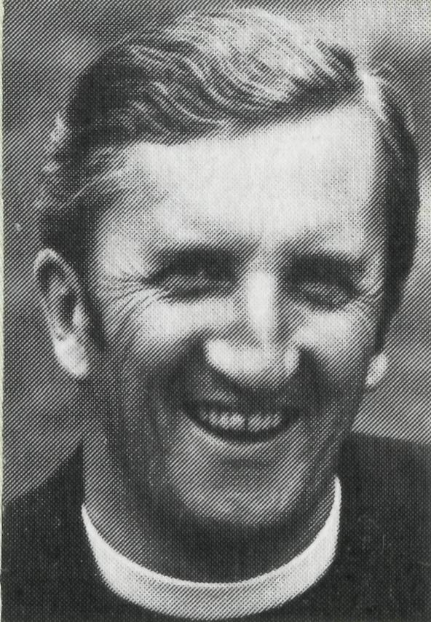
THE B.C.A. PRAYER
HEAR
LANCE SHILTON AT THE B.C.A. RALLIES
O Lord our God, help us to remember the people who live in the remote parts of our land. We ask You to bless those whom You have called into the fellowship of The Bush Church Aid Society, and call others to stand with them in the task. Grant that, through the ministry of the Word and Sacraments, through healing, and through caring for the young, the message of Your redeeming love may be proclaimed, through Jesus Christ our Lord. Amen. .
IN PERTH
Thursday, 14th October
at St. Mary's Hall,
River Road, KELMSCOTT.
IN ADELAIDE Friday, 29th October at Christ Church Hall, NORTH ADELAIDE, 8 p.m
PEOPLE WANTED
There are still some vacancies forourtourto Lightning Ridge in October and Tasmania in December. Don't forget our North West tour in July 1983.
Contact B.C.A. or Golden West now for further details.
HEAR BISHOP GED MUSTON AT THE B.C.A. RALLY
IN MELBOURNE
Friday,
5th November
at the
Uniting Church Assembly Hall,
Little Collins Street,
at 8 p.m.
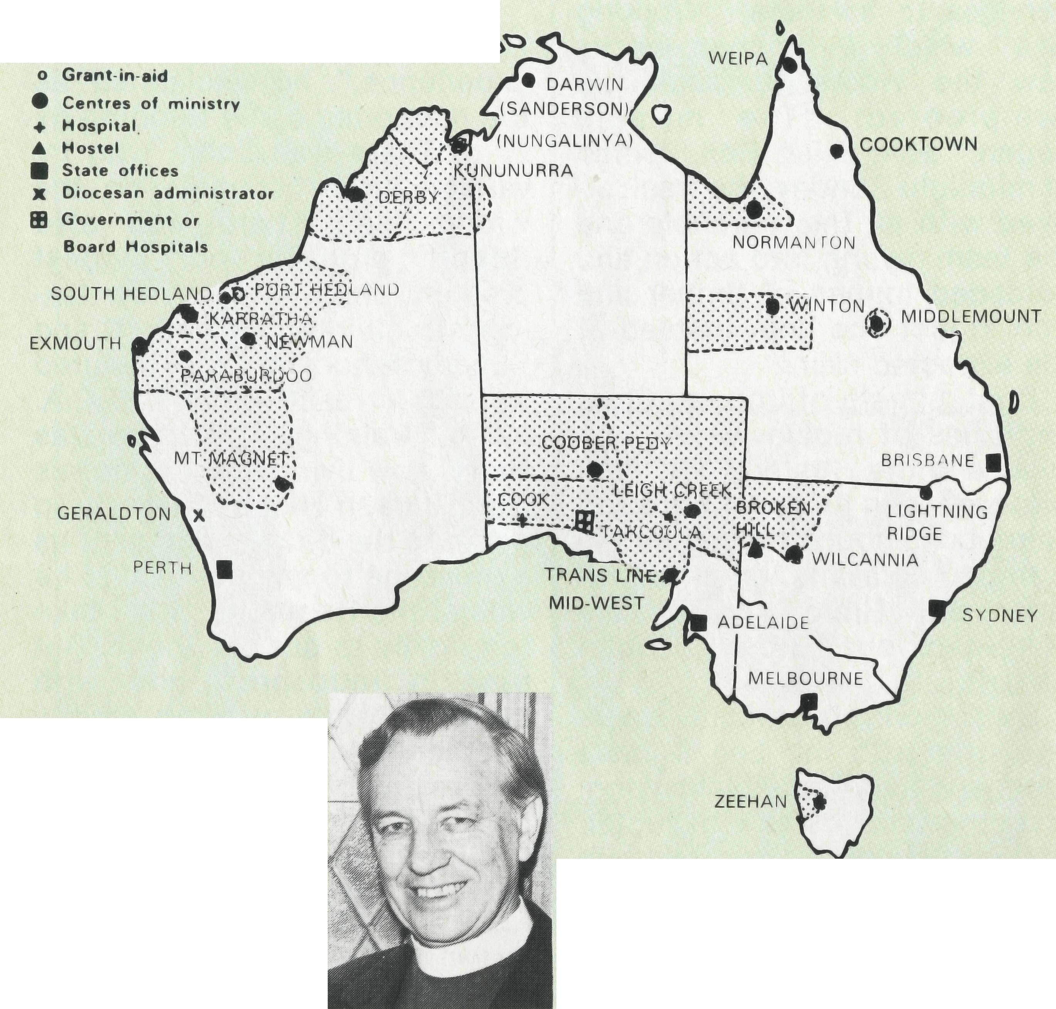
PRAYER CALENDAR
FIELD STAFF DIRECTORY
DIOCESE OF NORTHERN TERRITORY. The Rt. Revd. K. B. Mason.
- Darwin — Sanderson — Rev. Robert and Mrs. Rigmor George.
- Nungalinya College — Mrs. Gwen Newell.
DIOCESE OF NORTH WEST AUSTRALIA. The Rt. Revd. G. B. Muston.
- Kununurra — The Revd. Tom and Mrs. Carol Williams.
- Derby — The Revd. Peter and Mrs. Betty Mills.
- Newman (East Pilbara) — Rev. Arthur and Mrs. Pat Williams.
- South Hedland — The Revd. Clem and Mrs. Val Watts. Port Hedland — grant, The Revd. Peter Thompson.
- Karratha (West Pilbara) — The Revd. Roy and Mrs. May Buckingham.
- Wickham — Revd. Angus and Mrs. Anne McDonald.
- Paraburdoo (South Pilbara) — The Revd. Adrian and Mrs. Willemien Moore.

- Exmouth — Rev. Peter Harradence
- Geraldton — Mr. Stan and Mrs. Dorrie Hummerston — Diocesan Administrator.
- Mt. Magnet (Murchison) — The Revd. Errol and Mrs. Anne Sorensen.
DIOCESE OF WILLOCHRA. The Rt. Revd. S. B. Rosier.
- Cook Hospital — Sister Margaret Walsh.
- Tarcoola Hospital — Sister Marj. Dickson and Sister Rosslyn Jinks.
- Coober Pedy — Rev. Bill & Mrs. Gwen Ostling.
- Mid-West Mission — The Revd. Robert and Mrs. Phyllis McEwin.
- Leigh Creek — The Revd. Chris and Mrs. Marilyn Clerke.
DIOCESE OF TASMANIA. The Rt. Revd. P. Newell.
18 Zeehan — The Revd. Brian and Mrs. Denyse Roberts.
DIOCESE OF RIVERINA.The Rt. Revd. B. R. Hunter.
- Broken Hill Hostel — Mr. Jim and Mrs. Ruth Stocks and Allison Steep.
- Wilcannia — The Revd. George and Mrs. Hazel Fuhrmeister.
DIOCESE OF ARMIDALE. The Rt. Revd. P. Chiswell.
21 Lightning Ridge — The Revd. Les and Mrs. Pat Fernance.
DIOCESE OF ROCKHAMPTON. The Rt. Revd. G. Hearn.
- Winton — vacant as from 1/2/82.
- Middlemount — Capt. John and Mrs. Dianne Symons.
DIOCESE OF CARPENTARIA. The Rt. Revd. H. T. U. Jamieson.
- Weipa — The Revd. Lex and Mrs. Rhonda Carey.
- Normanton (Southern Gulf) — Vacant from July '81.
- Cooktown — Revd. Bob and Mrs. Betty Gooch.
GENERAL
27 Federal Secretary. The Revd. Wakely Wade.
N.S.W. The Revds. Malcolm Babbage, Kerry Medway, Eric Atkin, Miss Doris Smith, Mesdames Joy O'Neill, Dora Warwick, Nina Allan and Vivien Bentley.
- VICTORIA. The Revd. Alan Hoskin, Miss Chris Craig.
- QUEENSLAND. Mr. Allan Sauer (Hon. Secretary). WESTERN AUSTRALIA. The Revd. Ken Prentice (Deputationist)
- SOUTH AUSTRALIA — Vacant
- The President, Archbishop Donald Robinson, Chairman, Dean Lance Shilton, Honorary Treasurer, Mr. Ray Ctercteko, The Council, State Committees. Staff Replacements, Box Secretaries, B.C.A. Supporters.
13
THE REAL AUSTRALIAN

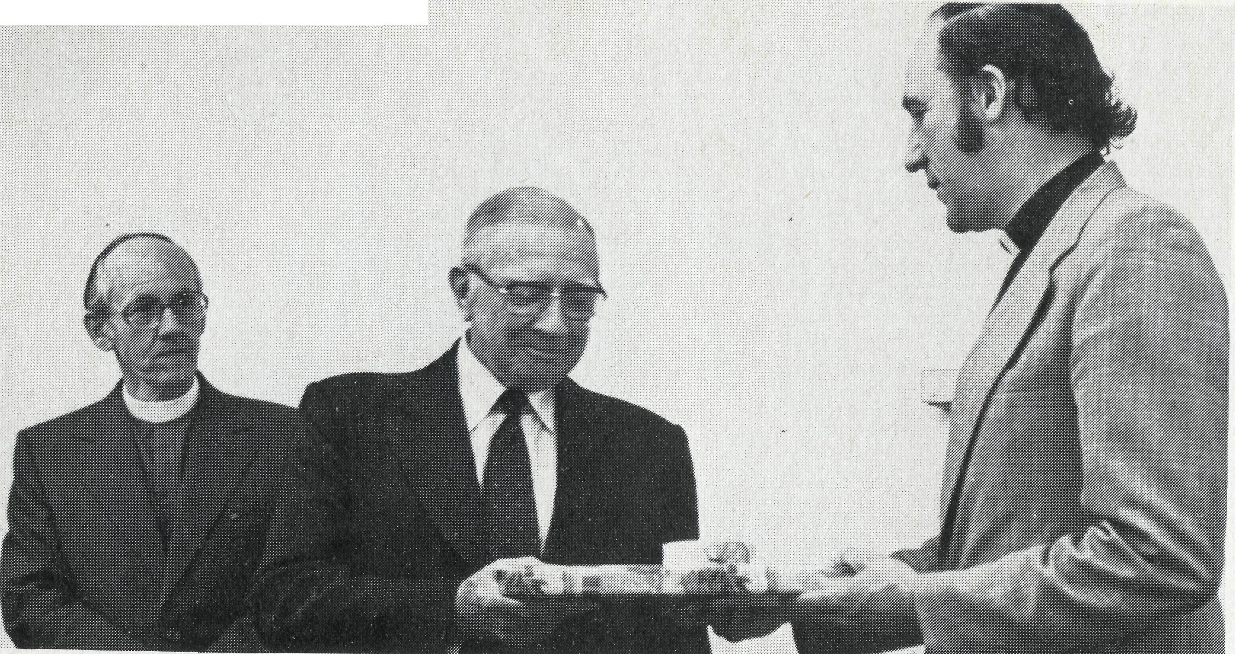
Wakely writes
POST & ROILS
* NEW PRESIDENT
At the Annual Meeting of B.C.A., Sydney's Archbishop Donald Robinson was elected President of B.C.A. The Anglican Primate, Archbishop John Grinrod was elected as B.C.A/s Patron. A newly elected member of B.C.A. Council was Mr. John Cronshaw of Golden West Tour fame. B.C.A/s 1982 budget was estimated at $850,000, and if present trends continue we will be about $198,000 behind budget by the end of the year. Help!
* FRANK WATTS
The Rector of Kalgoorlie, Canon Frank Watts has been named as the GOLD FIELDS' CITIZEN QF THE YEAR Frank, whose outback ministry was assisted for many years by a B.C.A. grant, received his award for outstanding service to the community.
B.C.A.'s Rob and Phyllis McEwin and children were recently involved in a head-on smash. They were travelling a narrow track in the Gawler Ranges and at a blind corner slammed into a Land Rover. Their station waggon was a "write-off" but fortunately no-one was hurt. The accident happened on Day 16, the day we pray for the McEwins in our Prayer Notes. The McEwins say thank you to all who prayed that day.
B.C.A.'s Missionary Deputationists in Perth, Ken and Madge Prentice, have settled in and have a number of opportunities to share in the Perth Diocese. Ken and Madge will be in Perth until December.
• B.C.A. MAN UP IN THE AIR
Former B.C.A. (vlissioner Royce Thompson, now an Army Chaplain in Queensland has just completed a three-week parachuting course.
14
* MUM HIT BY CAR
Clem Watts' mother was hit by a car and has been in Gosford Hospital with a fractured pelvis. Clem and Val at South Hedland have seen 26 families, many holding key positions in the Church, move away in the past 12 months.
Arthur and Pat Williams have arrived in Newman after a long drive from Sydney. They met many B.C.A. folk on their journey to the West. They are staying in a caravan until the new Rectory is built. A highlight for Arthur and Pat was a return visit to Mt. Magnet, their old B.C.A. mission post.
* GOOCHS WELCOMED
Bob and Betty Gooch were warmly welcomed to Cooktown. Bishop Hamish Jamieson and Archdeacon Tony Matthews led a joyful Church service at Cooktown and a Confirmation Service at a property 80 kilometres away at Lakeland Downs. Betty is staging a war with the cockroaches and ghekos (someone thought they were baby crocodiles) but praise God there are no snakes around, yet!
B.C.A.'s new missioners-at Leinster in Western Australia, are Reverend Don and Mrs. Celia Miller, from Newport, Victoria. The Millers will commence their ministry on October 1.
Ruth Stocks was rushed to hospital with a suspected heart attack. Fortunately this proved to be a false alarm. Jim and Ruth are rejoicing at becoming grandparents in April this vear.
Sister Ann Metcalfe and Mrs. Betty Henwood have been relieving at Cook and Reverend Stuart Thorne at Winton. Thanks. Pray for new missioners to be found for Normanton and Winton.
THE REAL AUSTRALIAN
When Princess Beatrice of the Netherlands visited Australia about three years ago the Dutch Australian Association made a presentation to her of a black opal from Lightning Ridge. Opal being the most distinctively Australian of our precious gem stones. Ninety-five per cent of the world's opal is mined in Australia. It is significant that B.C.A. provides ministry in all the mam opal mining areas of our country, Lightning Ridge, Goober Pedy Andamooka (Mid-West Trans Line), Winton and White Cliffs (Wilcannia Parish).
This issue of "The Real Australian" focuses on these places and the people there.
We all have our precious things and ones. Peter, our Lord's impetuous follower and later a rock-like leader in the early Church spoke of precious things and a Precious One in a letter to Christians (1 Peter 1:17 118 2-4-8) A precious faith proven to be so invaluable through the furnace of 'trouble and trial is to be reckoned much more valuable than gold. No monetry measure can be put upon the worth of Christ's blood shed for us on the cross so we could be redeemed from a meaningless life style which would lead us nowhere.
An opal miner at Coober Pedy said these words, "I came to Coober Pedy looking for my fortune in opal but I found something of far greater value I found Jesus and now I am going back to my home in the city to put our family life together again."
This was made possible through the support given by you to B C A
ministry in one of our opal mining towns. Keep it up, stick with us, people
are precious. ^{M}
Sincerely,
Picture above: Rev. Wakely Wade thanks retiring B.C.A. Honorary Treasurer, Mr. Richard Stokes, after 22 years as treasurer. Mr. Stokes was elected Vice-President of B.C.A. Council at the Annual Meeting. B.C.A/s new president, Archbishop Robinson, looks on.
15
THE REAL AUSTRALIAN

