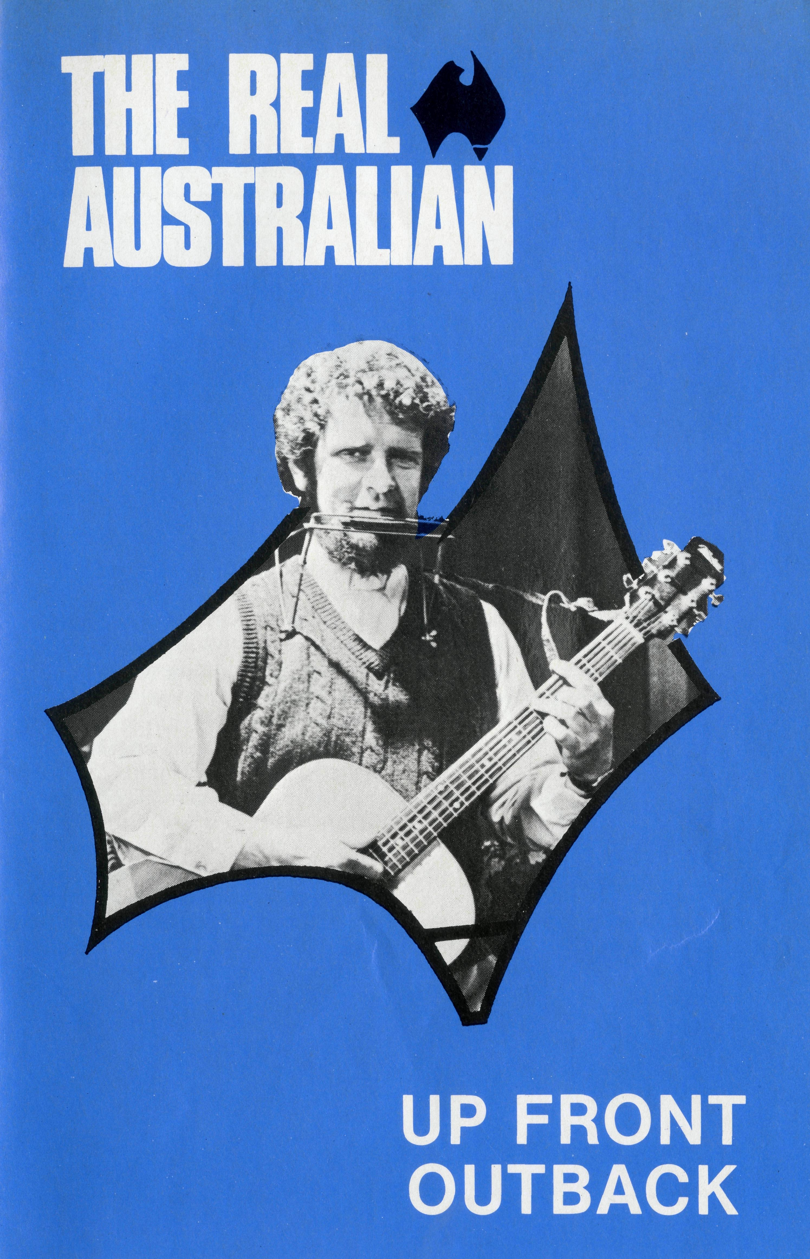
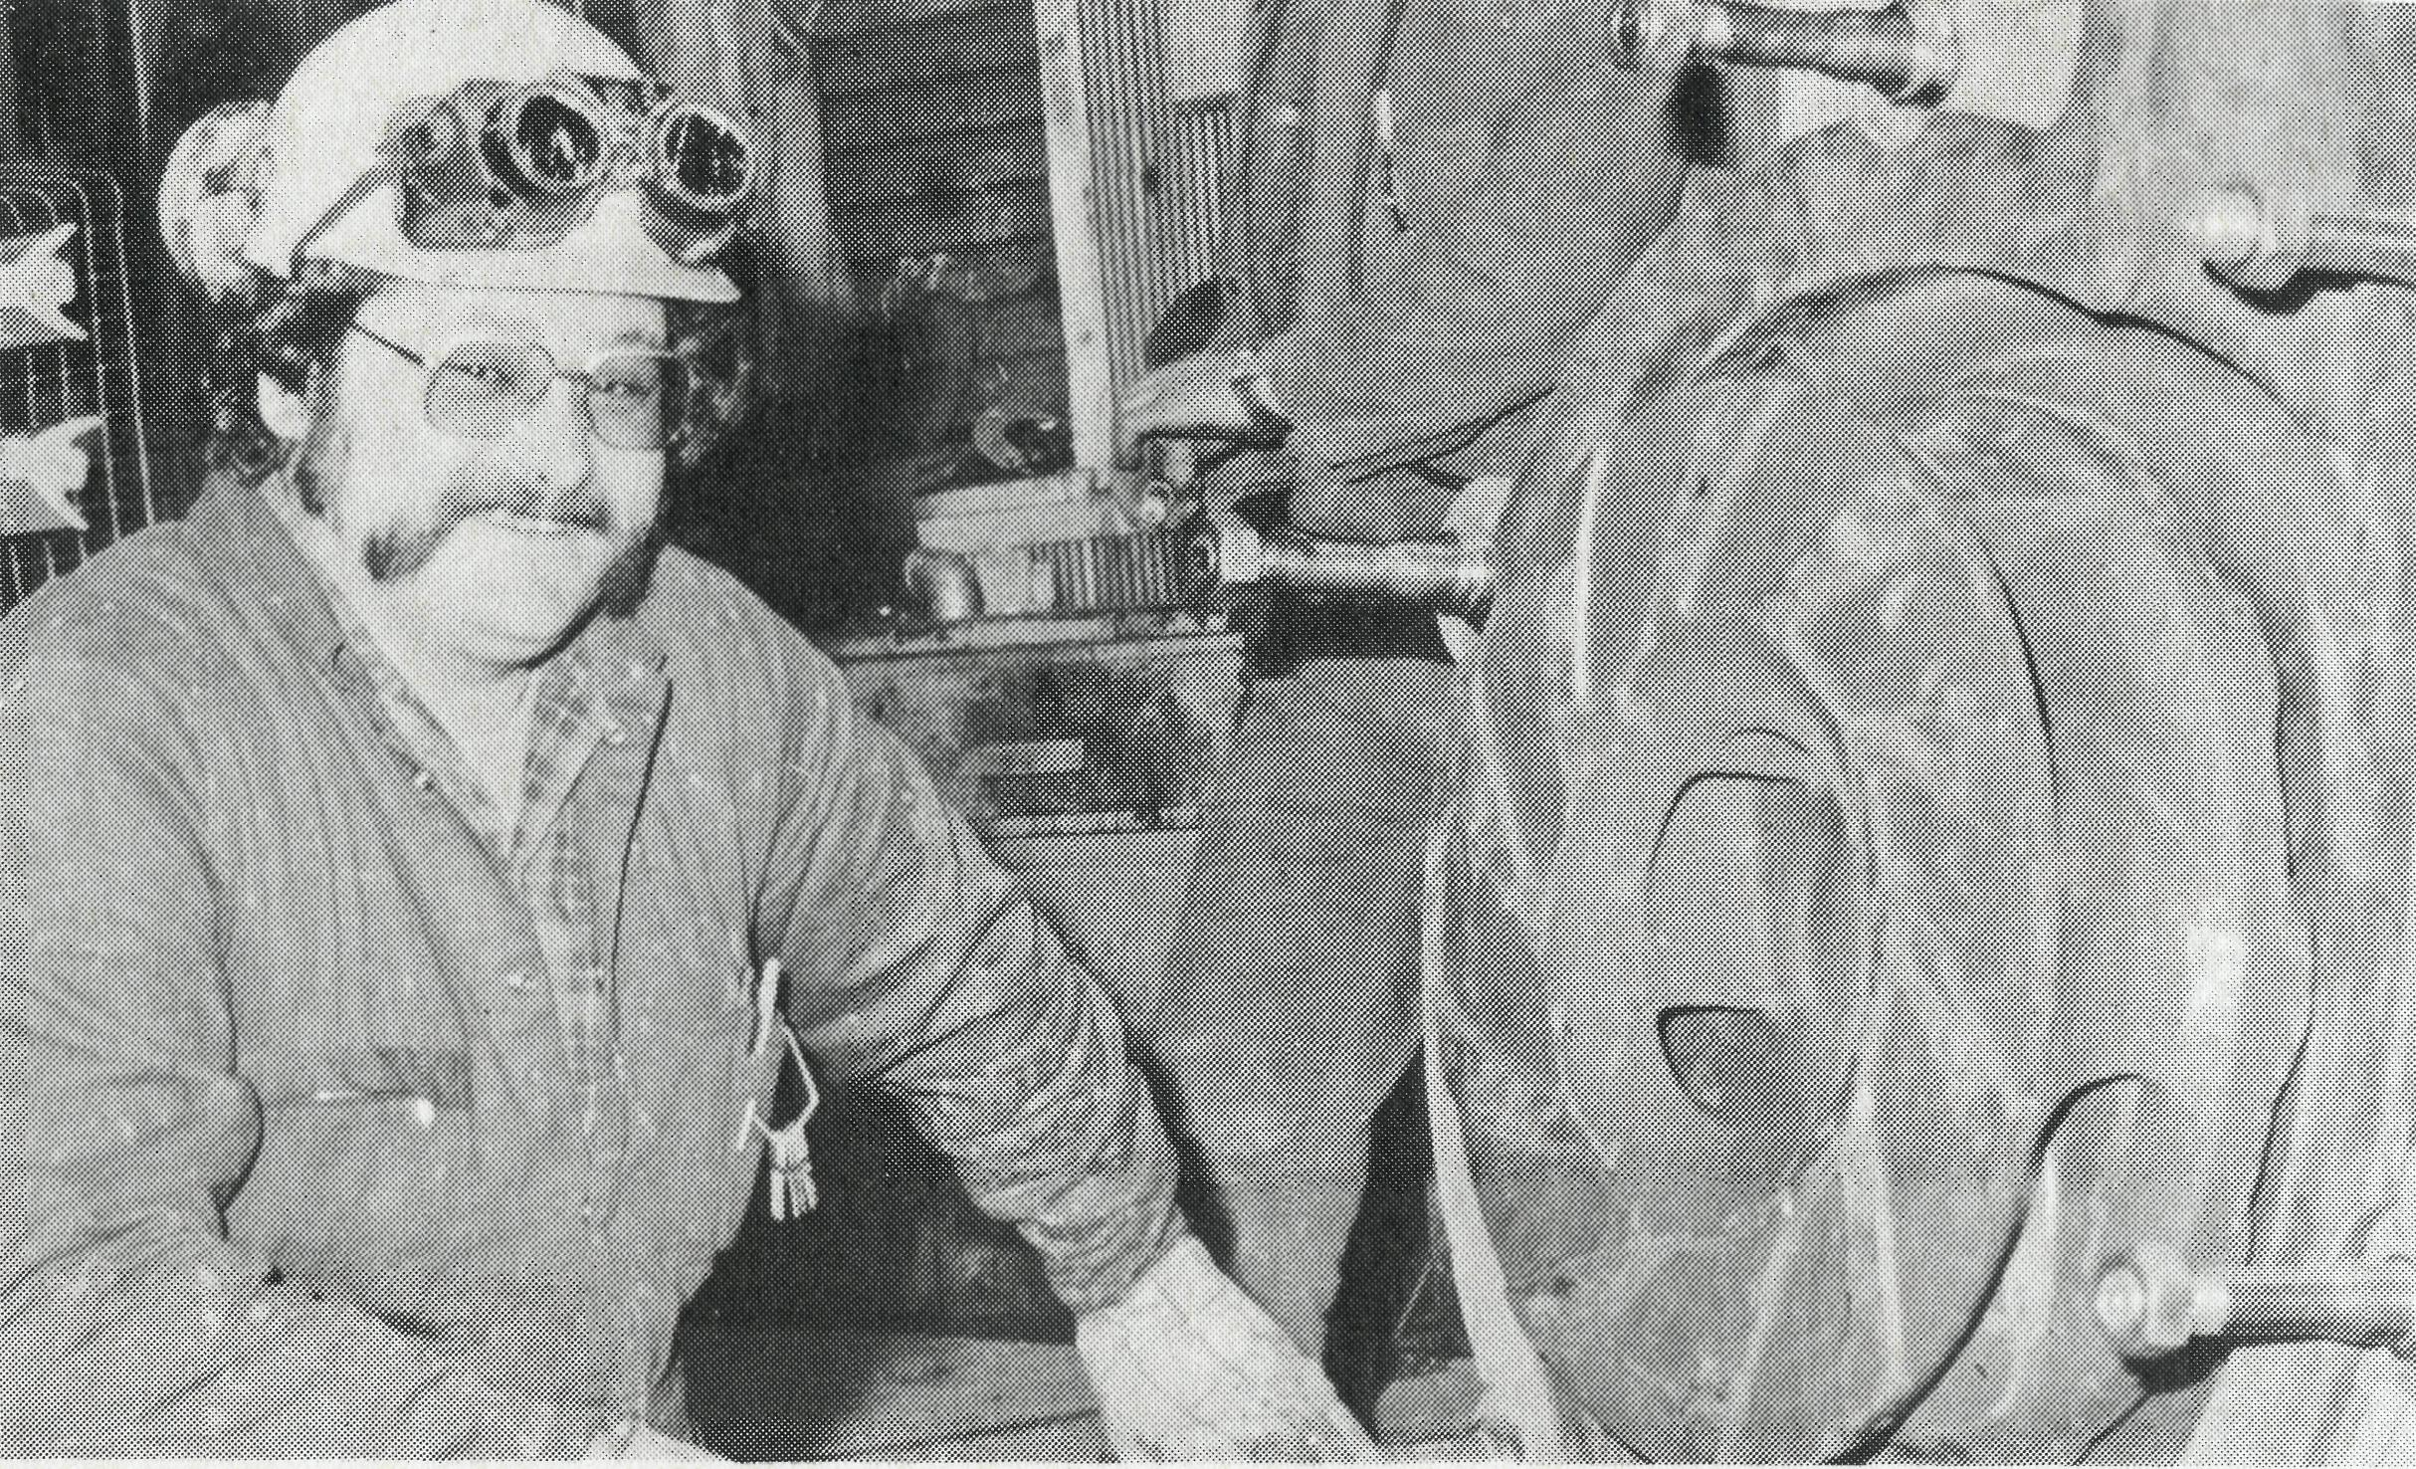
MINING MEN
Mr. Harry Nikas mine fitter
Photo by courtesy of Renison Limited, Tasmania.
Mining towns can be lonely, depressing, tough and unforgiving. Lives either become hardened or broken. But the scriptures are full of encouragement to step out in faith and to live it out whatever the situation. It was through the faith lived out by the congregation in Zeehan, Tasmania, that Harry became a Christian. Contacts made through the church's Christian film cinema, the Sunday night fellowship hour brought Harry face to face with the reality of the Gospel. B.C.A. congregations are able to meet the need of mining company personnel searching for reality.
CONTINUE TO SUPPORT B.C.A.'s TASK OF MINING FOR MEN IN OUTBACK AUSTRALIA.
I WISH TO: □ KNOW
D PRAY
please cut off and return
(Receive the Real Australian)
(Join the Prayer Fellowship. Please send me the Prayer Notes)
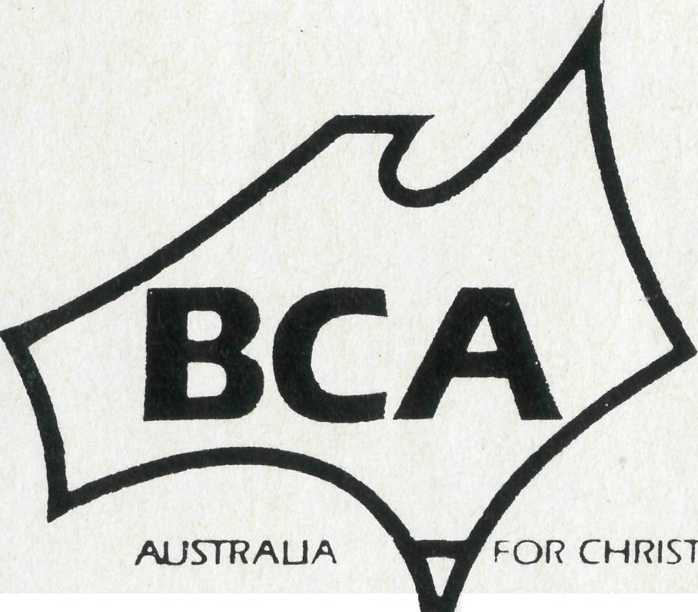
THE BUSH CHURCH AID SOCIETY  NSW 135 Bathurst Street, Sydney, 2000 Phone: (02) 264 3164 | □  D | GIVE GO | □ (I would like a B.C.A. money box.)  □ (Please inform me of needs  regularly)  (I am interested in serving God in Outback Australia)

Printed by Ambassador Press Pty. Ltd., Granville 21
March 1985. $3.00 subscription. Reg. by Australia Post. Publication No. NAR 0630

comfort in a pharmaceutical laboratory or an exclusive suburb of Melbourne? Perhaps one of Peter's letters will supply a better understanding.
"I was at the Lake Argyle Tourist resort taking another of my open air services at the backside of the pub. At the conclusion I pointed out that I had some New Testaments available, free of charge, to anyone who would like to read one. A young couple remained behind, looking at them I sensed that they were interested in hav-
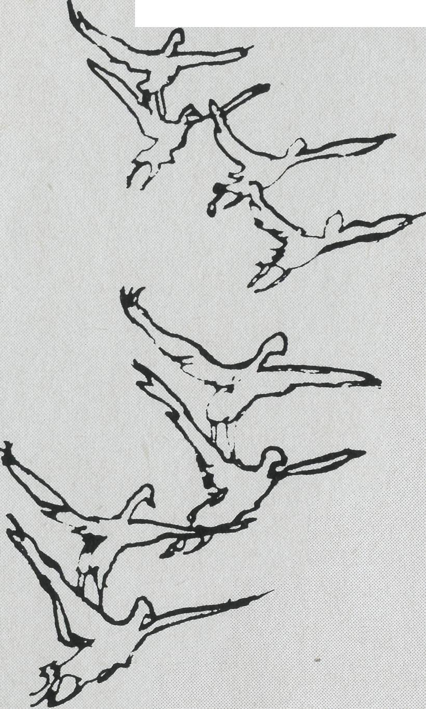
“WHETHER WE LIKE IT OR NOT.”
SYDNEY WEATHER FORECAST:
18/12/84 A warm to very warm and humid day with moderate NE winds, fresh at times near the coast. Mainly sunny at first but the chance of an afternoon thunderstorm.
COMPARE — KUNUNURRA: 18/12/84 At the moment it's rather like a sauna, with temperatures of 40 °-43 ° each day combined with extremely high humidity. The slightest exertion makes a sodden mess out of a clean shirt.
Peter Harradence has now served in this energy draining environment for twelve months. His attitude to the condition is well described in a poem he supplied.
"Weather" Whether the weather be hot, Or whether the weather be not. Whatever the weather, we'll
weather the weather, Whether we like it or not.
Why slog it out in conditions that are less than favourable? Why not work in air conditioned
ing a chat. "I need to drive back to Kununurra tonight", I said, "but would love to have a cup of tea first. Are you going to invite me to share a cup with you?" They agreed, so I joined them beside their little two-man (or two-persons) tent in the Caravan Park and they soon began to share their story. Bob and Sue have both had some kind of Christian experience but had wandered far from it. They were unmarried, living together and moving across the North looking for a job. Bob had a real drink problem which caused him to become quite violent. Sue was afraid of the harm he might do to her when he was drunk but had such emotional problems she was too scared to leave the one guy who loved her — at least when he was sober!
I loved these two young people, their openness and honesty and their genuine seeking again for the Lord. Because I felt for them I could not offer them easy solutions and put three heavies upon them:
- They would need to consider carefully their relationship. They could not expect God to forgive and bless them whilst they were living in a wrong relationship with each other.
- Bob would need to give up drink completely and make a resolution every morning to have no drink that day.
- They both needed to commit
themselves to a loving, caring
Christian Church where they
could receive the support of
other Christians.
They appreciated my frankness (as I had appreciated theirs) but I realised that I needed to give them time — particularly to consider the first point. I was most disappointed to learn that they were travelling on to Darwin next morning and I would have no opportunity for further counselling. I held their hands and prayed with deep feeling for them both and then committed them to the Lord. I wish I could say that I heard later that they had both been truly converted, had married and were in fellowship in a lively Church — but I don't know what has happened to them. Bob did give me the address of his parents in Melbourne and when I am there on holidays, I will try to make contact and see if they can tell me more about this couple for whom I still pray".
Please pray for this young couple and Peter. Peter chose Kununurra because the Lord Jesus chose Peter.
"You did not choose me, but I chose you and appointed you that you should go and bear fruit and that your fruit should abide; so that whatever you ask the Father in my Name He may give it to you. This I command you, to love one another." John 15:16-17.

THE REAL AUSTRALIAN

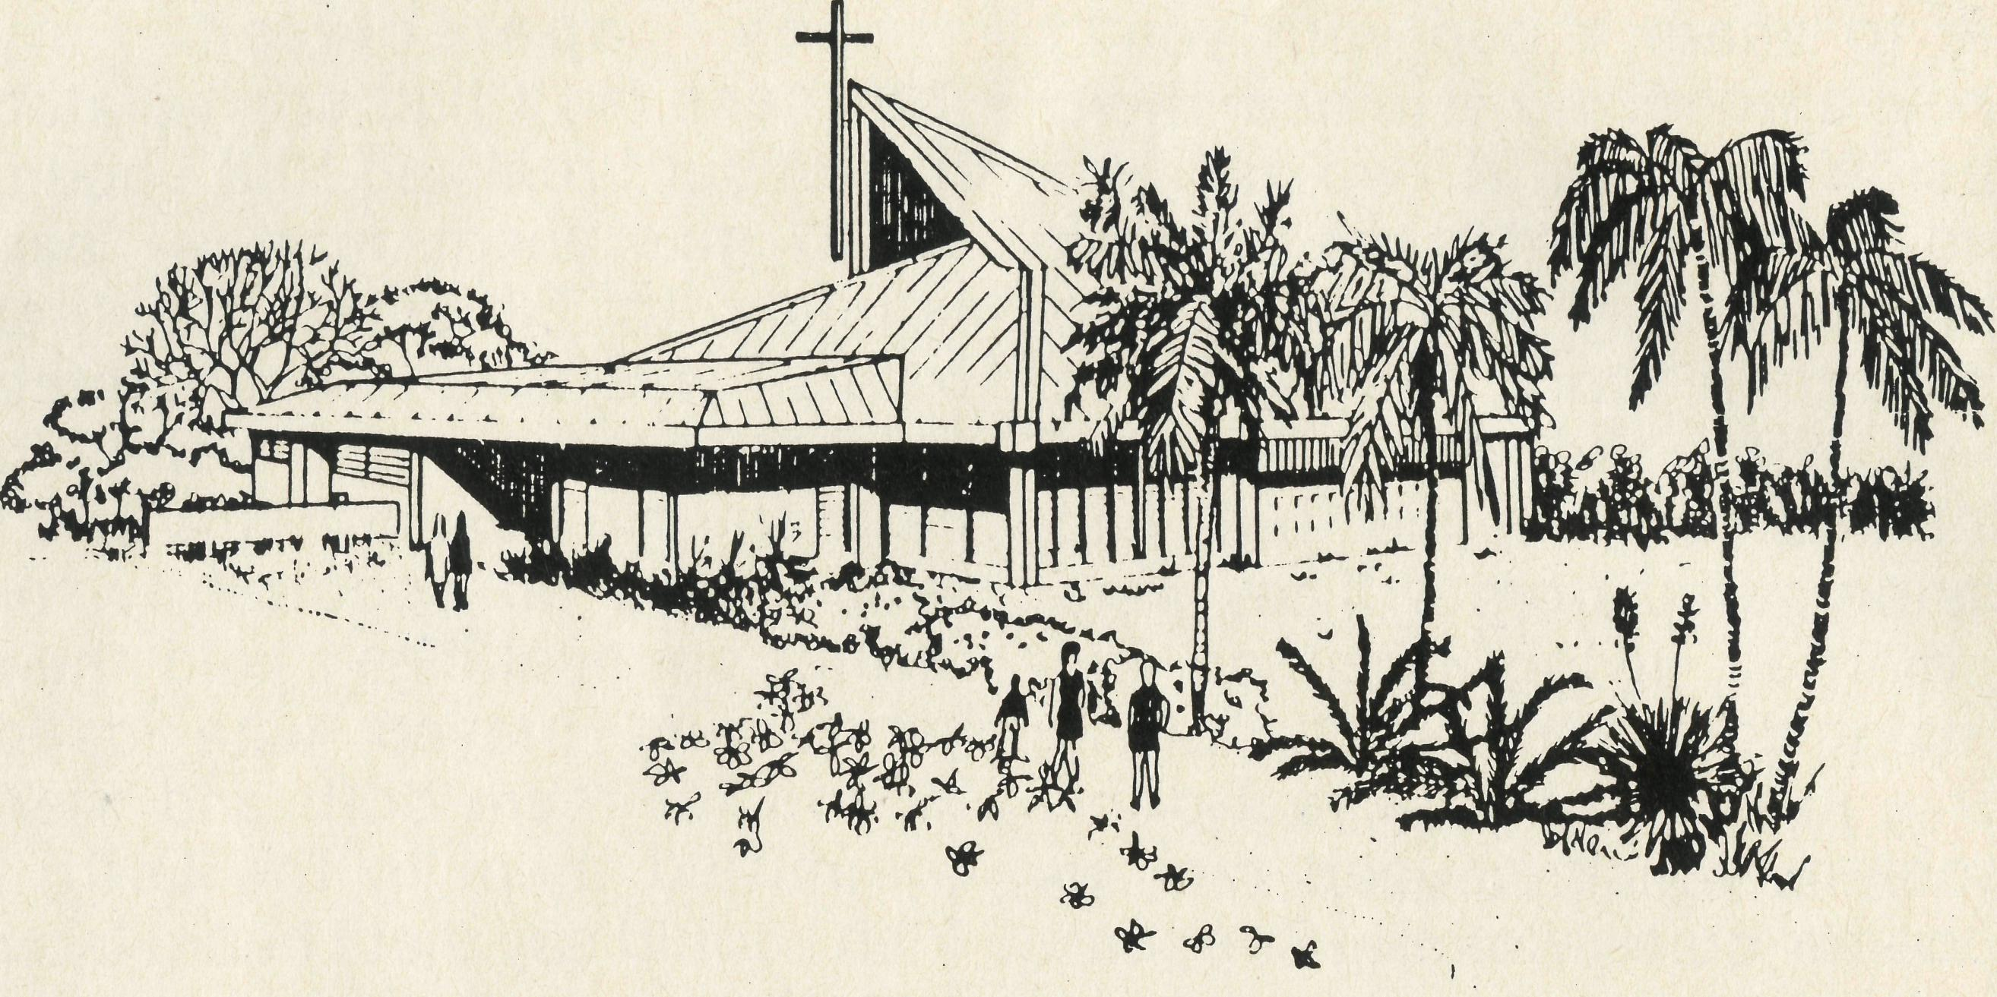
"WELL! WE'VE STARTED"
ST. JAMES ANGLICAN CHURCH, SANDERSON
"Well! we've started!" That was the comment of many St. James folk to representatives of four other parishes in the Diocese as they gathered together on a block of land at Sanderson. The proof of the statement was the partial excavation of a piece of dirt in readiness for the laying of the concrete slab for the new church. The occasion was a brief service of acknowledgement of God's leading in the project, held on Sunday afternoon, the 4th November.
Approximately 60 adults and children gathered together to publicly demonstrate to the community round about that something significant was being built in their midst. People around would have received the message by the number of cars parked around the block, and the joyful singing filtering through the air.
The gathering on this occasion was also to openly acknowledge God's leading of this project. All through the stages of development, the Parish Council and the building sub-committee have been very aware of God's superintending process. The service provided us with an opportunity to thank God, and to seek His continuing guidance in the project.
The contract period is 22 weeks, so hopefully around the middle of March next year we will have our own church building. For those who expect a beautiful, completed, and fully equipped church, there will be disappointments. There will be but a 'shell'. The congregation (as well as any others who are willing to help) will be responsible to finish off the building to a stage of occupancy. The advantage of this will be not only a cost-saver, but
also to draw the congregation together into a unity of purpose and effort to complete the building for use. The incentive before us, will be to spend Easter 1985 in our very own building.
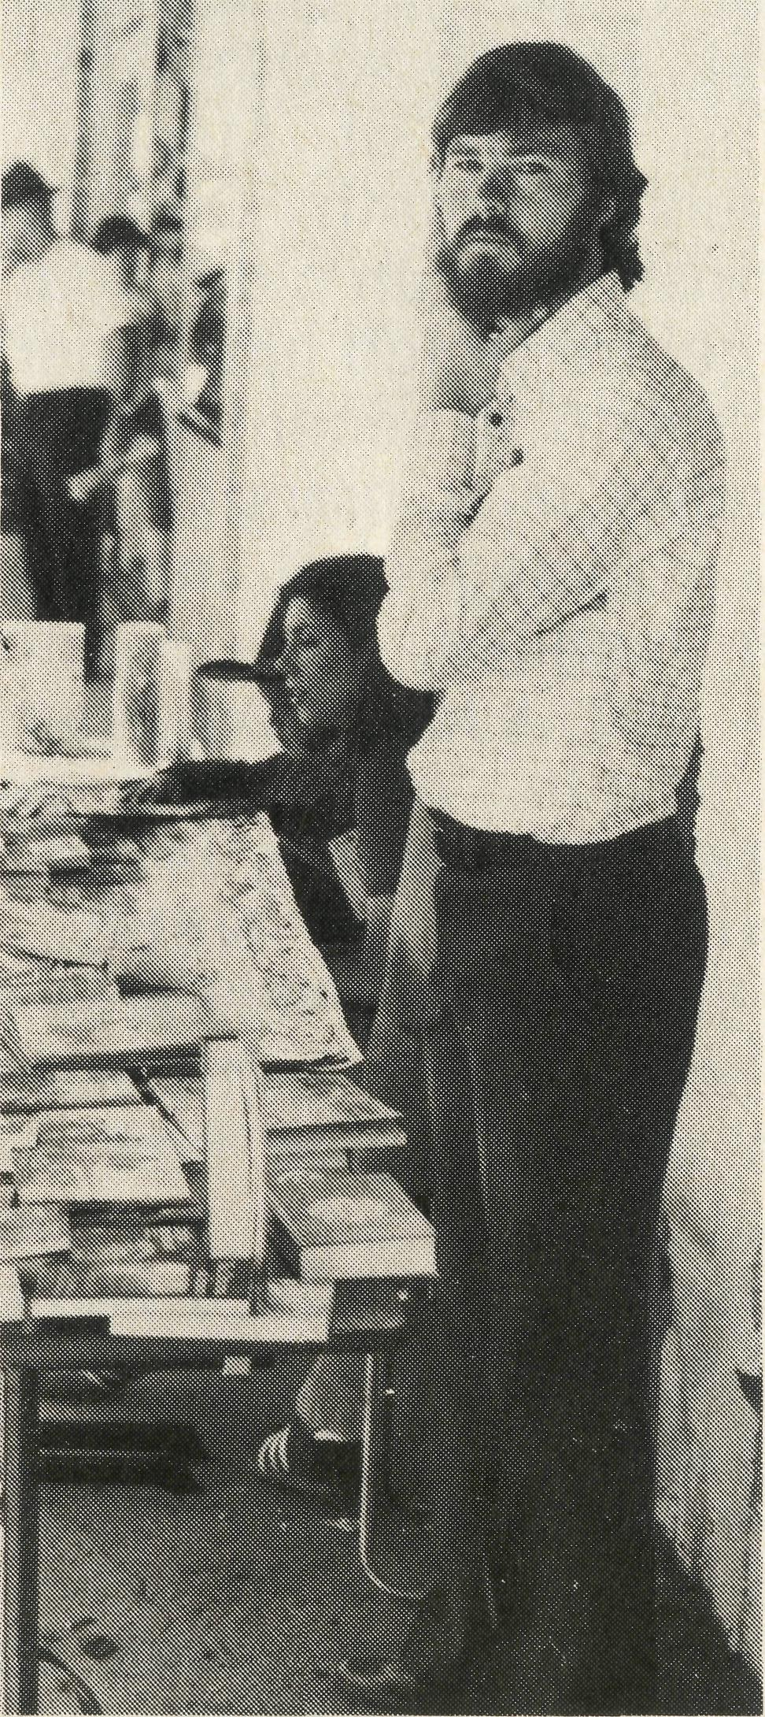
As a congregation at Sanderson, we are conscious of many things. God has been very good to us. Our friends both inside and outside of the diocese have been very generous in prayer and financial support. We look forward to the completion of this "bricks and mortar" building, so that we as the real church — the believers at St. James, may continue to worship and witness to our Lord, and serve the community in which He has placed us.
Bob George — Rector
All enquiries to:
REAL AUSTRALIAN EDITOR
Brian Roberts
THE BUSH CHURCH AID SOCIETY
OF AUSTRALIA
135 BATHURST STREET,
SYDNEY, 2000
Phone (02)264 3164
B.C.A.
STATE OFFICE
CONTACTS.. .
Federal Secretary: The Revd. Wakely Wade.
General Secretary N.S.W.: The Revd. Brian Roberts; Communications Officer: Mr. Peter Oram, B.C.A. House, 135 Bathurst Street, Sydney, N.S.W. 2000. Phone: (02) 264-3164, 264-3780.
Victorian Secretary: The Revd. Alan Hoskin, 205 Flinders Lane, Melbourne, Vic. 3000. Phone: (03) 63-8962.
Sth. Australian Secretary: Rev. Bruce Cliff, 350 King William Street, Adelaide, S.A. 5000. Phone: (08)212-7804.
Queensland Hon. Secretary: Mr. Allan
Sauer, 28 Doughty Avenue, Holland Park
4121.
Phone: (07)397 1501.
Western Australia Hon. Secretary: The Revd. Peter Brain, St. Luke's Rectory, 78 Pitchford Avenue, Maddington 6109. Phone: (09)459-5169.
FRONT COVER B.C.A. strikes it rich in the goldmining town of Beaconsfield, Tasmania. The Reverend Greg Jones is our new man for the gold town of Mt. Magnet. Greg's musical gifts will be treasured by the christians of Mt. Magnet parish.

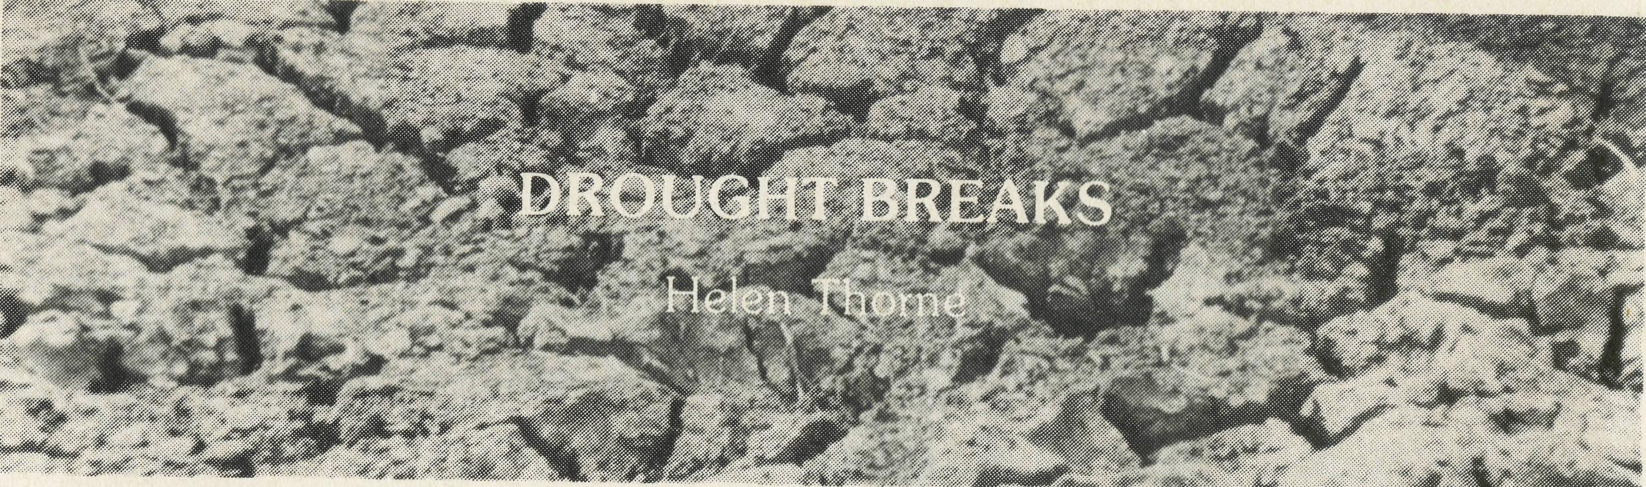
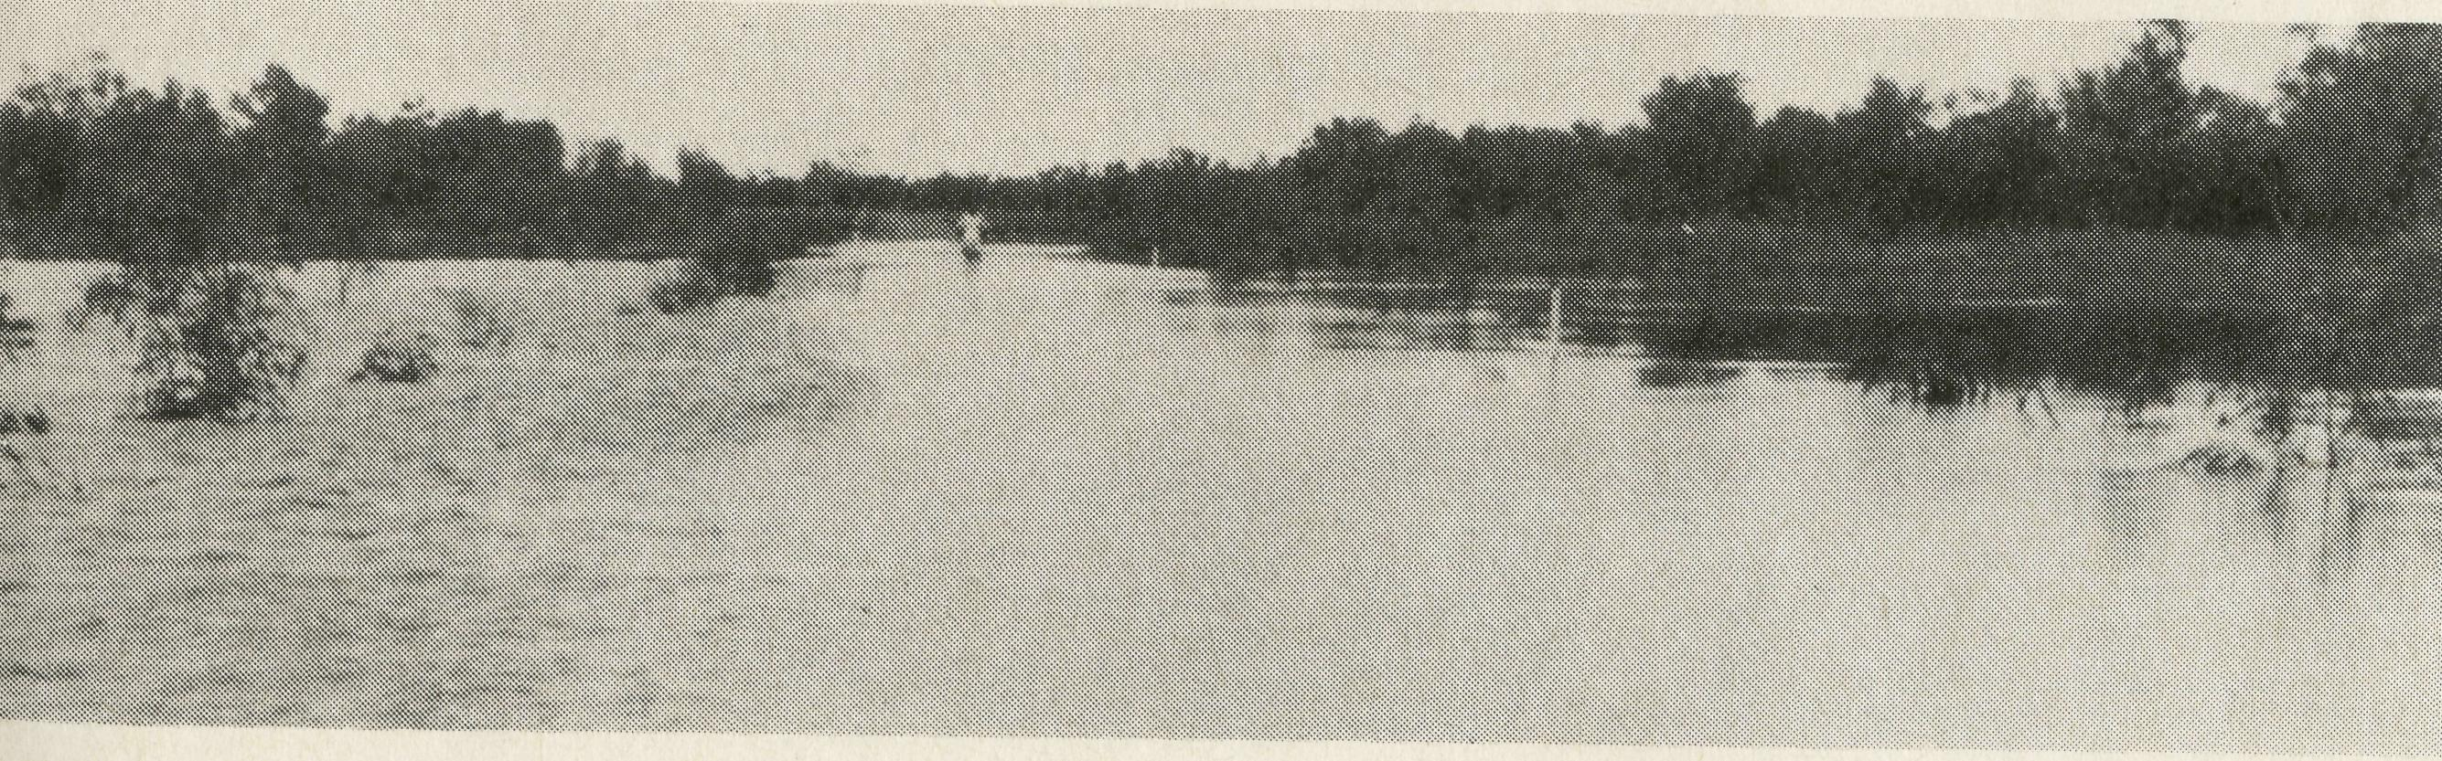
COAL, CATTLE AND CHRISTIAN COUNSEL
It was the early hours of the morning .. . startled by the ring of the telephone . . . jerked back to the land of the living by a woman's voice ... "he's killing me".
Recognising the voice our B.C.A. man rushed round to the Bank Residence and was confronted by a very angry situation. This was the dramatic beginning of a counselling situation that after six months saw the lady come into a living relationship with Jesus as her Lord and Saviour. Things are not always this way but there are many hurting people needing pastoral care, loving counsel and the gospel in remote mining towns of Australia's outback.
The Society is currently being invited to extend its ministry base in remote Australia. Biblically based Christian counsel is vital in the mining towns of the outback. Towns where isolation, climate and social pressures take their toll on young families. Often the Christian minister is the only person to turn to.
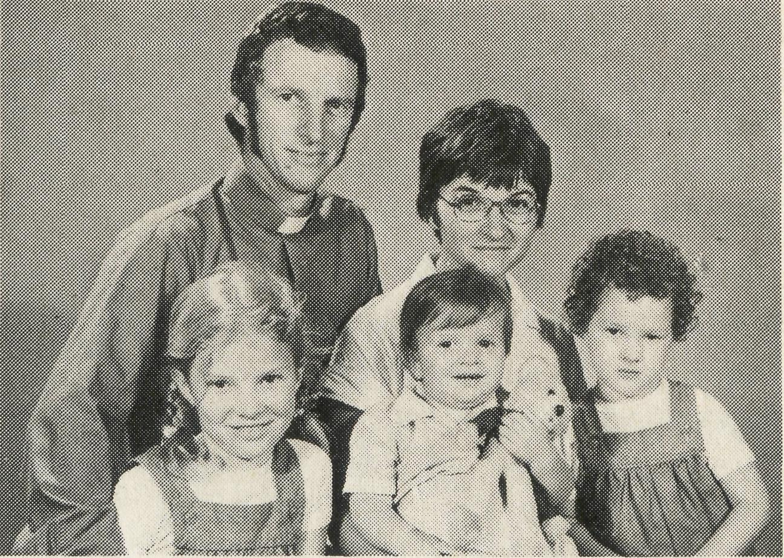
Of all the areas B.C.A. has been asked to provide ministry for, the towns of Collinsville and Glenden in North Queensland have a special challenge. The towns are inland from the sea-bound town of Mackay and Bowen in north Queensland. Collinsville is an older coal mining centre which has experienced growth in recent years, and Glenden is a brand new town also housing coal miners and their families, and is situated over 100 kilometres south of Collinsville. Within the parish, further to the south, is the small rural town of Nebo, and throughout the whole area there are a number of cattle stations. It is a challenging task with a great variety of people to minister to in Christ's name.
The Reverend Rod Williams and his wife Hazel and their three children from Cronulla, in Sydney, are just commencing their ministry in this new B.C.A. parish. Rod is no stranger to the outback or to mining towns, having taught for a time at Kam-balda, near Kalgoorlie, in Western Australia. Also Rod and Hazel helped out for a short time in providing Services at Coober Pedy in the time between Kerry Medway's and Bill Ostling's ministries there. Give thanks for the call of Rod and Hazel and pray that they will find ready acceptance in the parish.
Reverend Rod and Mrs. Hazel Williams, Kay, Linda and Philip.
There's no more delicious smell than rain on parched ground, And the thunderous noise on an old tin roof is a glorious sound; As it soaks into cracks in the sun-baked earth, It fills our hearts with thankfulness, happiness and mirth.
The world seems a beautiful sparkling place, Like an eager child who has just washed his face, There is hope for a plentiful season ahead, That cattle, sheep and all creatures will be well fed.
Happy children squeal with delight as they squelch and splosh through
the mud, And hilarious mirth as a venturesome child slips over with a thud. Oh plenteous rain so refreshing and filling As you tumble off gutters and downpipes are spilling.
There are birds on the dams that were once parched and dry And hope in folks' hearts for plans gone awry Grass clothes the pastures once sear, black, desolate For the hardship, losses and long waiting, it compensates.
In the creeks the frogs croak their own song of thanks We praise Him for His bounty and overflowing tanks, God gives His outpouring on good and bad just the same, As He gives His forgiveness when we trust Jesus' name.
In our lives there are seasons, some bleak, drear and long But then God sends times of springtime and song, He knows how much of sorrow and song we each need, So leave all with Him and on His word feed.

THE REAL AUSTRALIAN
THE REAL AUSTRALIAN

BROKEN HILL HOSTEL PHOTO ALBUM

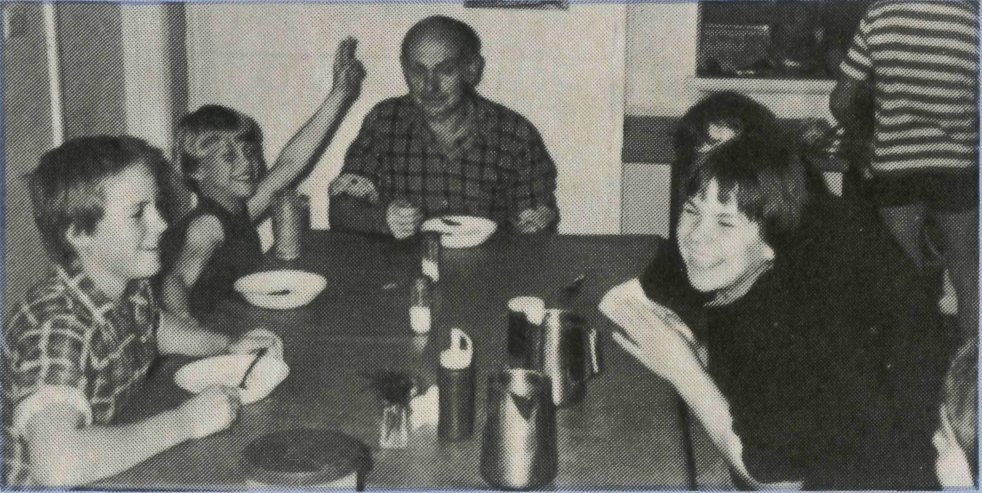
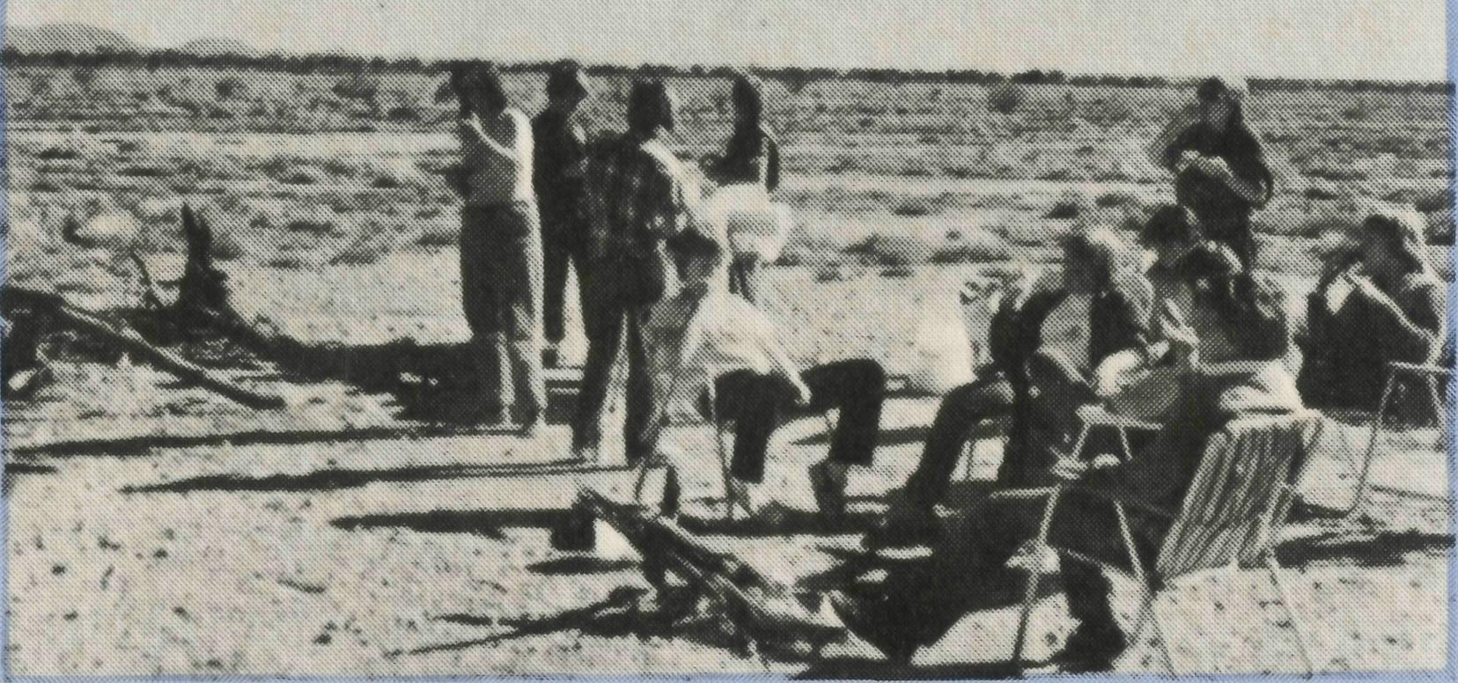
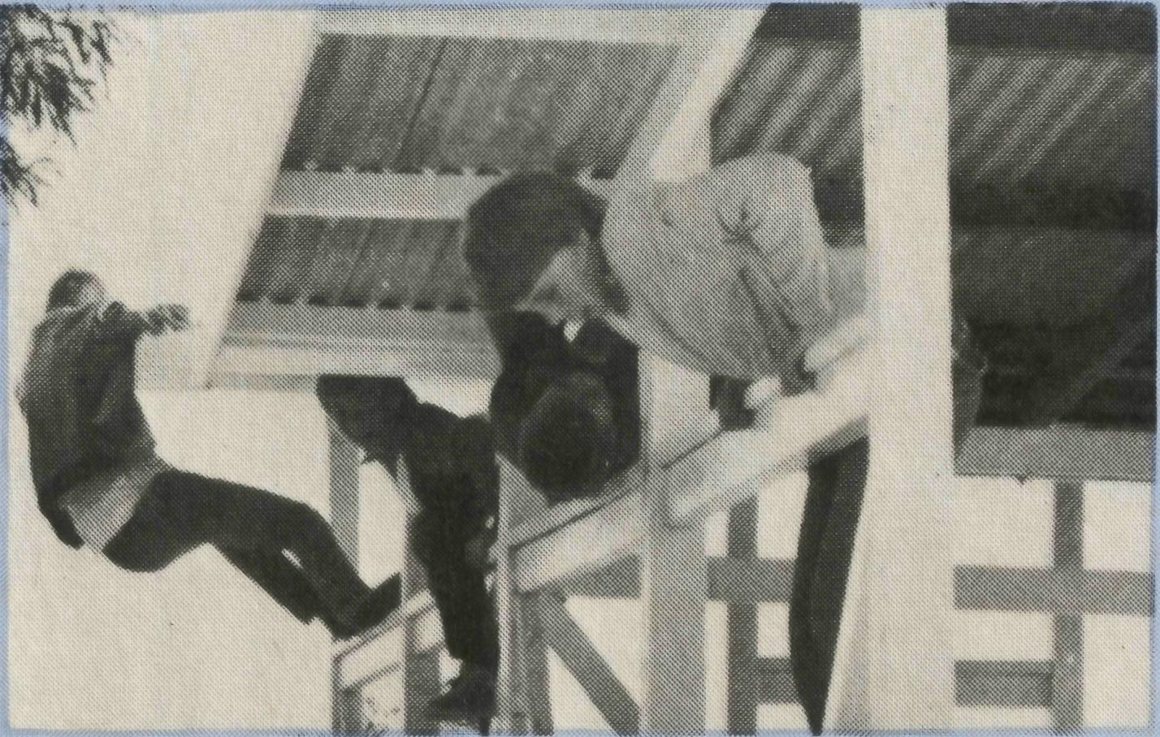
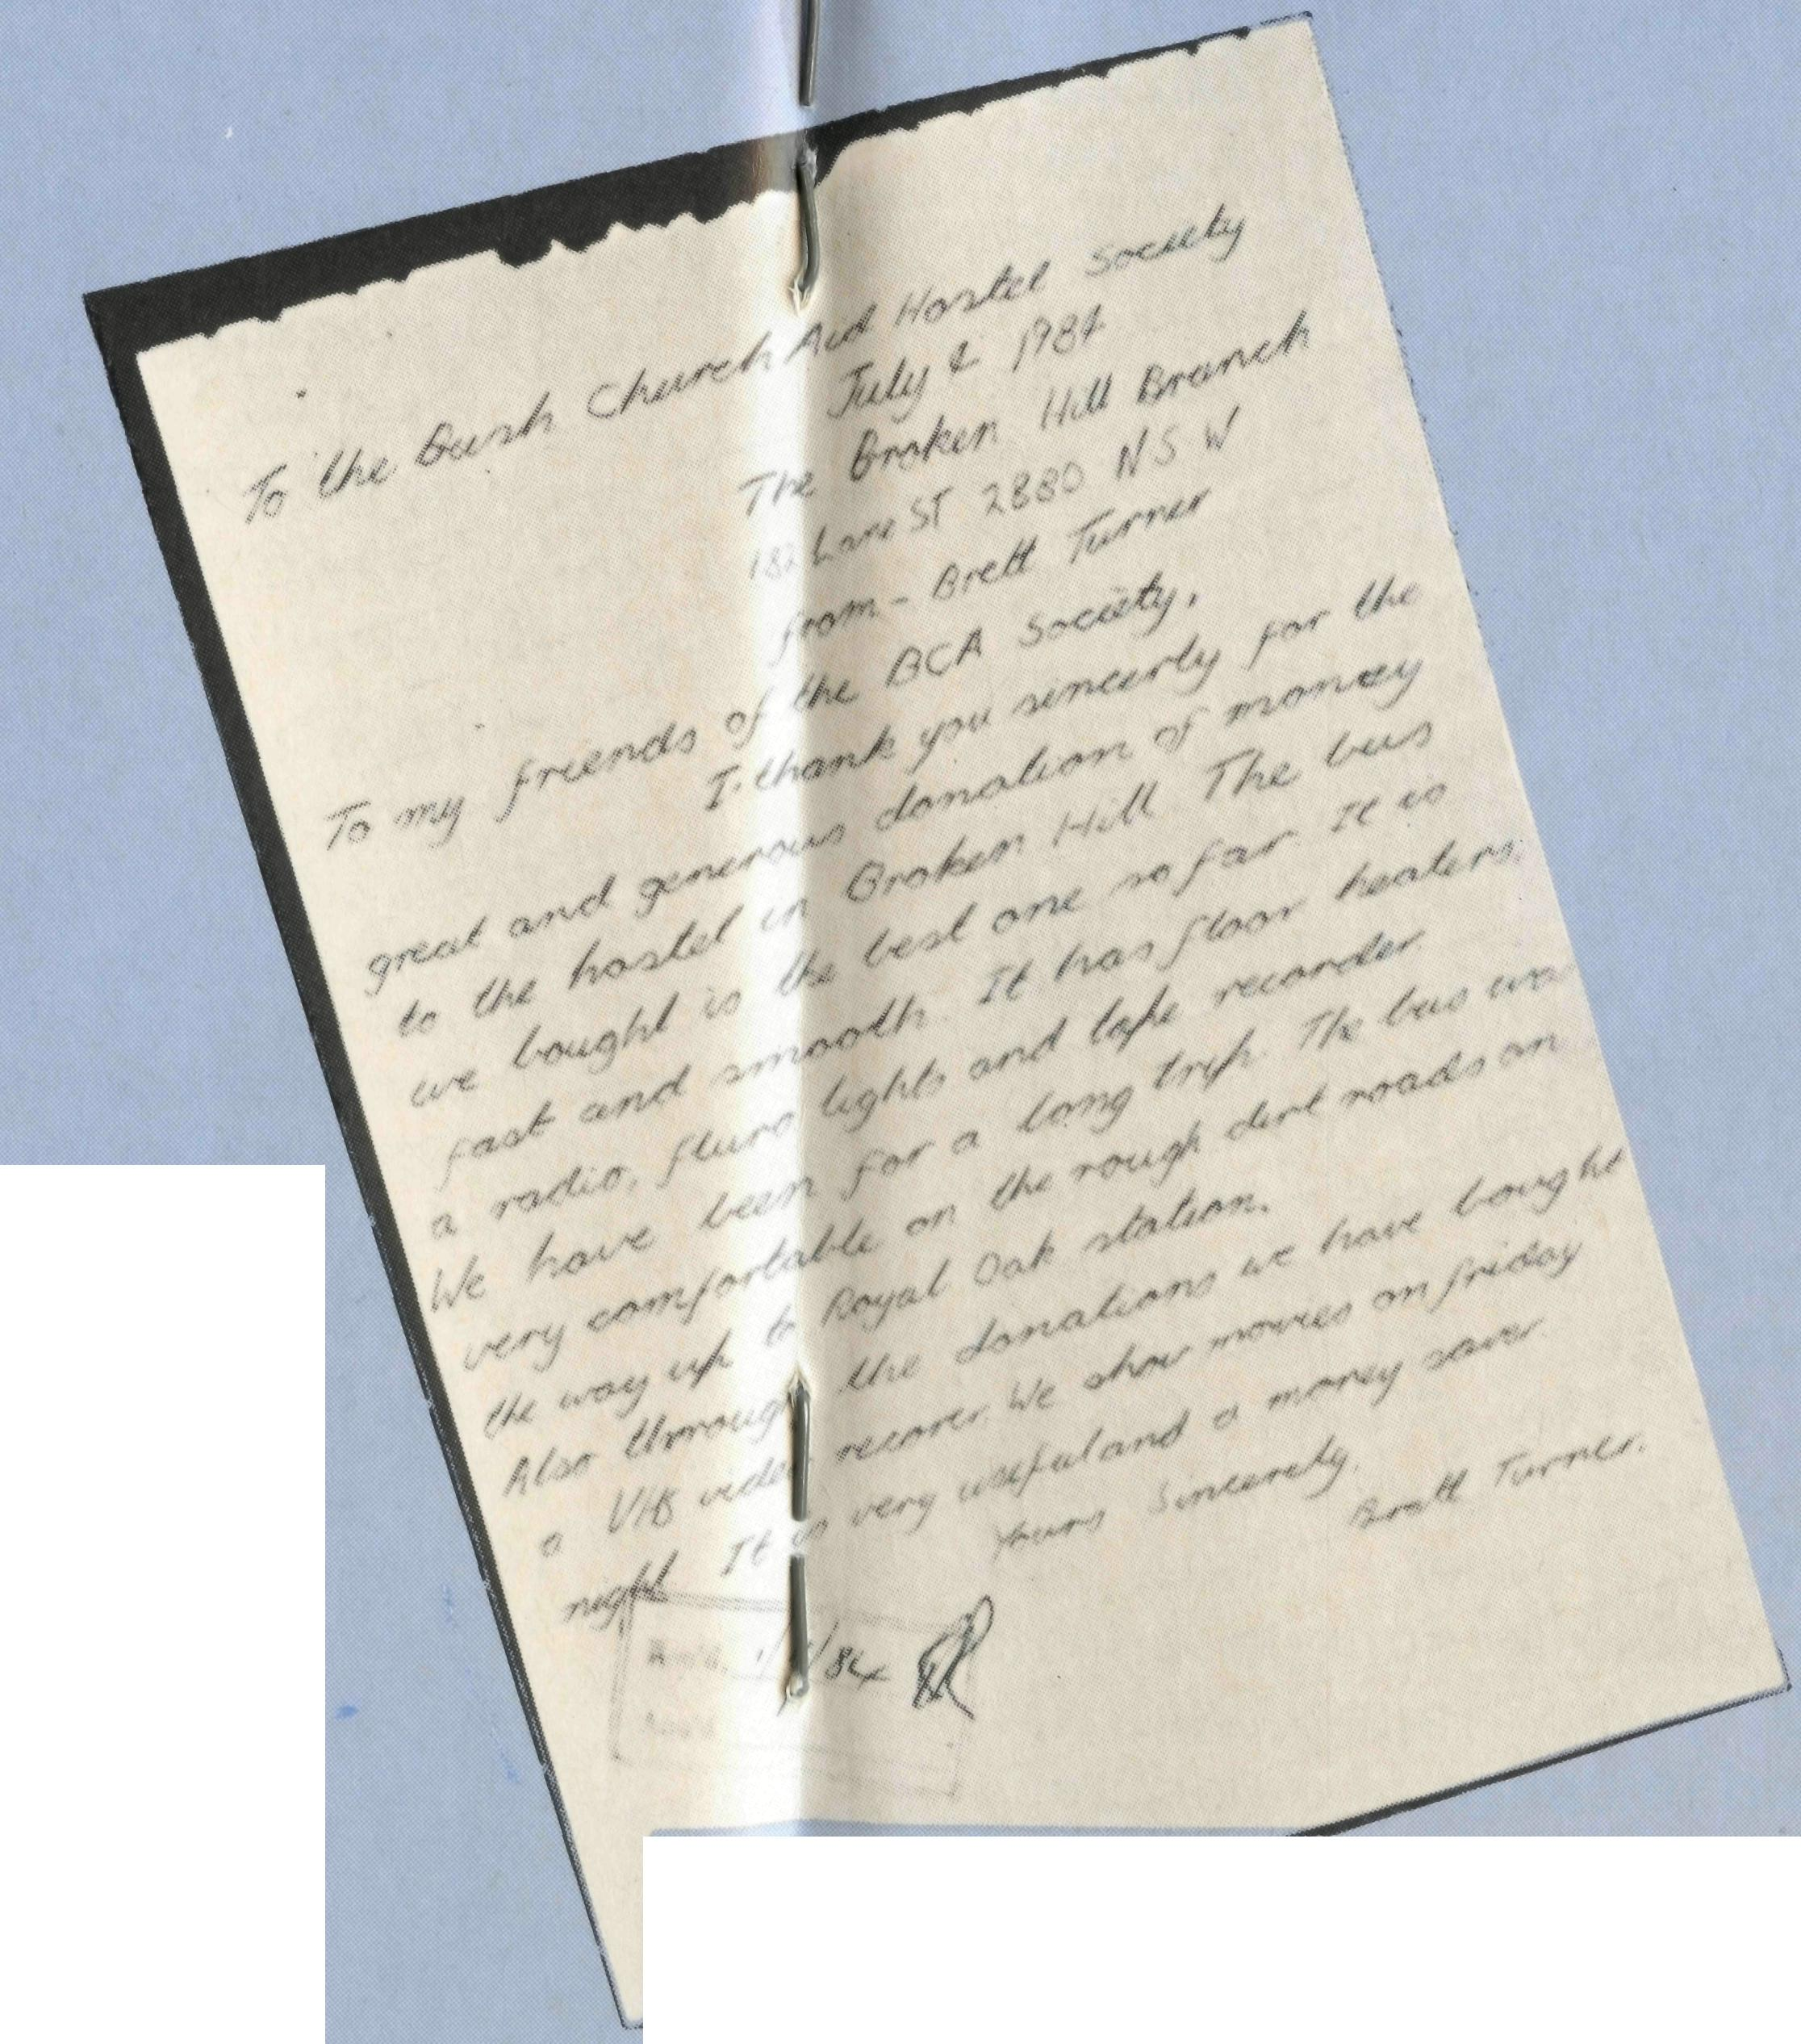
Picnic lunch on a weekend bus trip away.
"Before the new bus came we had to .. ."
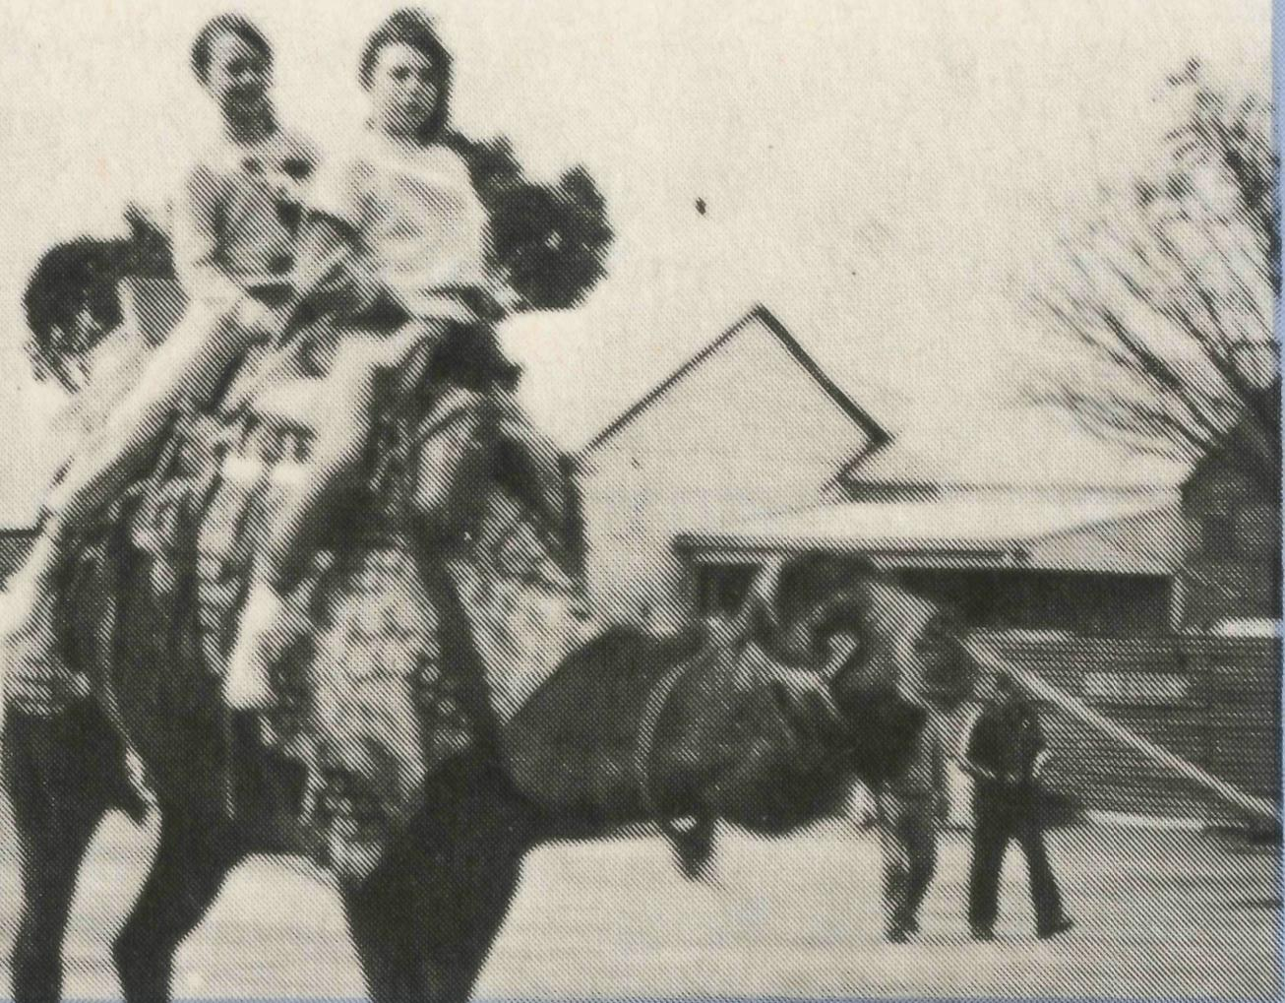
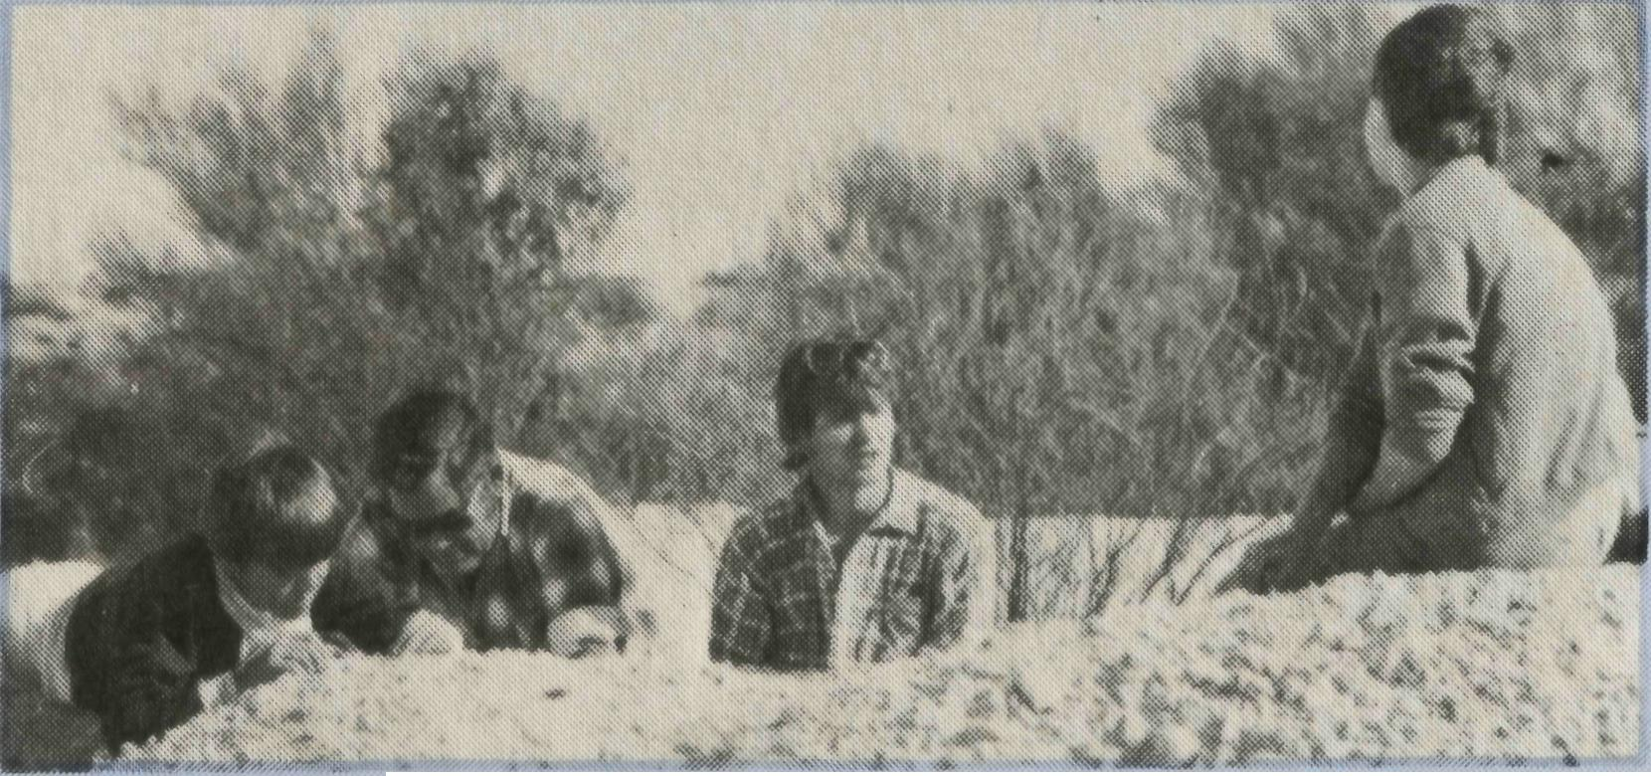
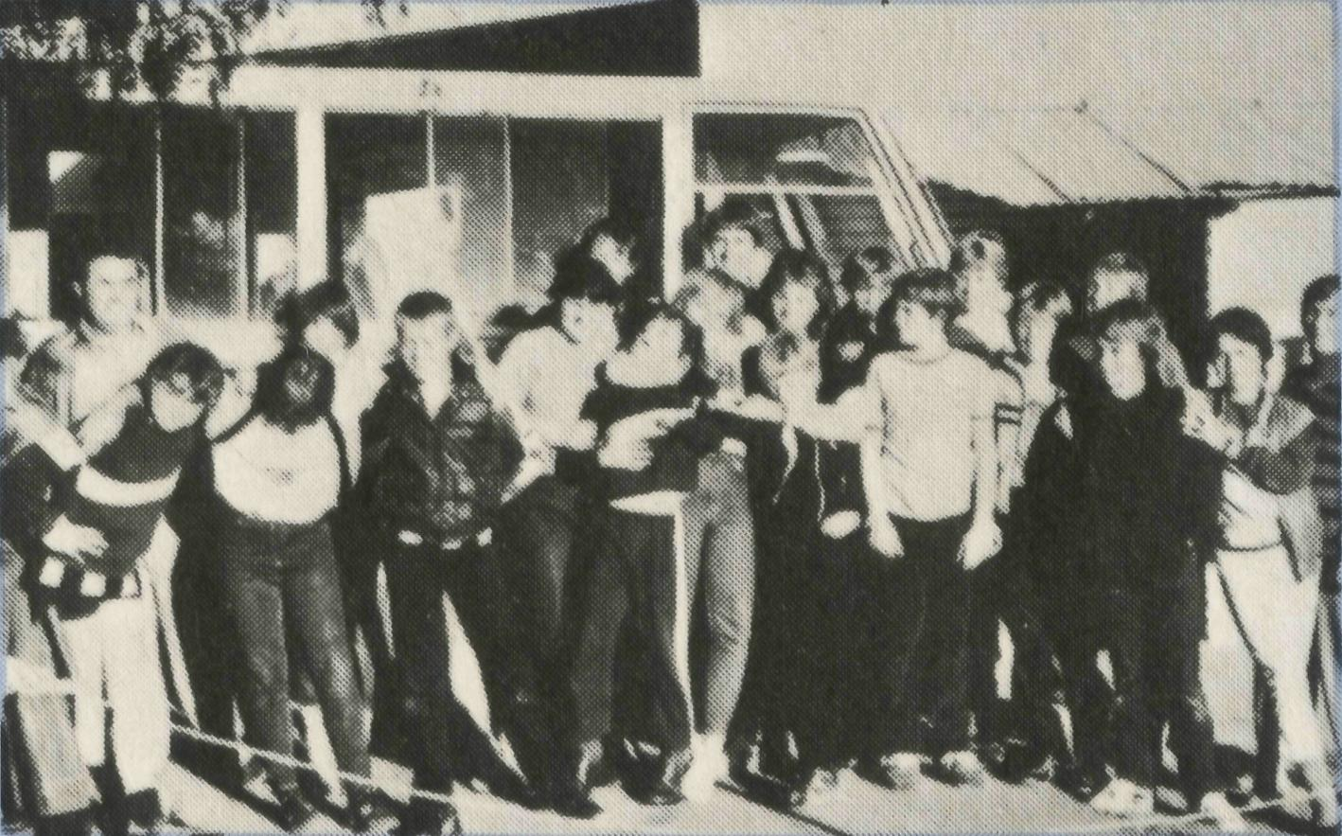
"SCHOOL'S IN AGAIN"
Yes! They all can fit in.
One of the many thank you letters the Sydney Office received as a result of the purchase of a new bus for the Hostel.
B.C.A.'s Hostel Parents, Tony and Barbara Pickering, together with Hostel Assistant Janita Anabel, provide a Christian home atmosphere for children from isolated areas whilst they’re attending school in Broken Hill.
Brian Bell, builder of the boys' shower and toilet facilities in 1984, enjoys breakfast time. The new day is obviously well under way.
The framework being tested for strength.
Noodling at White Cliffs.

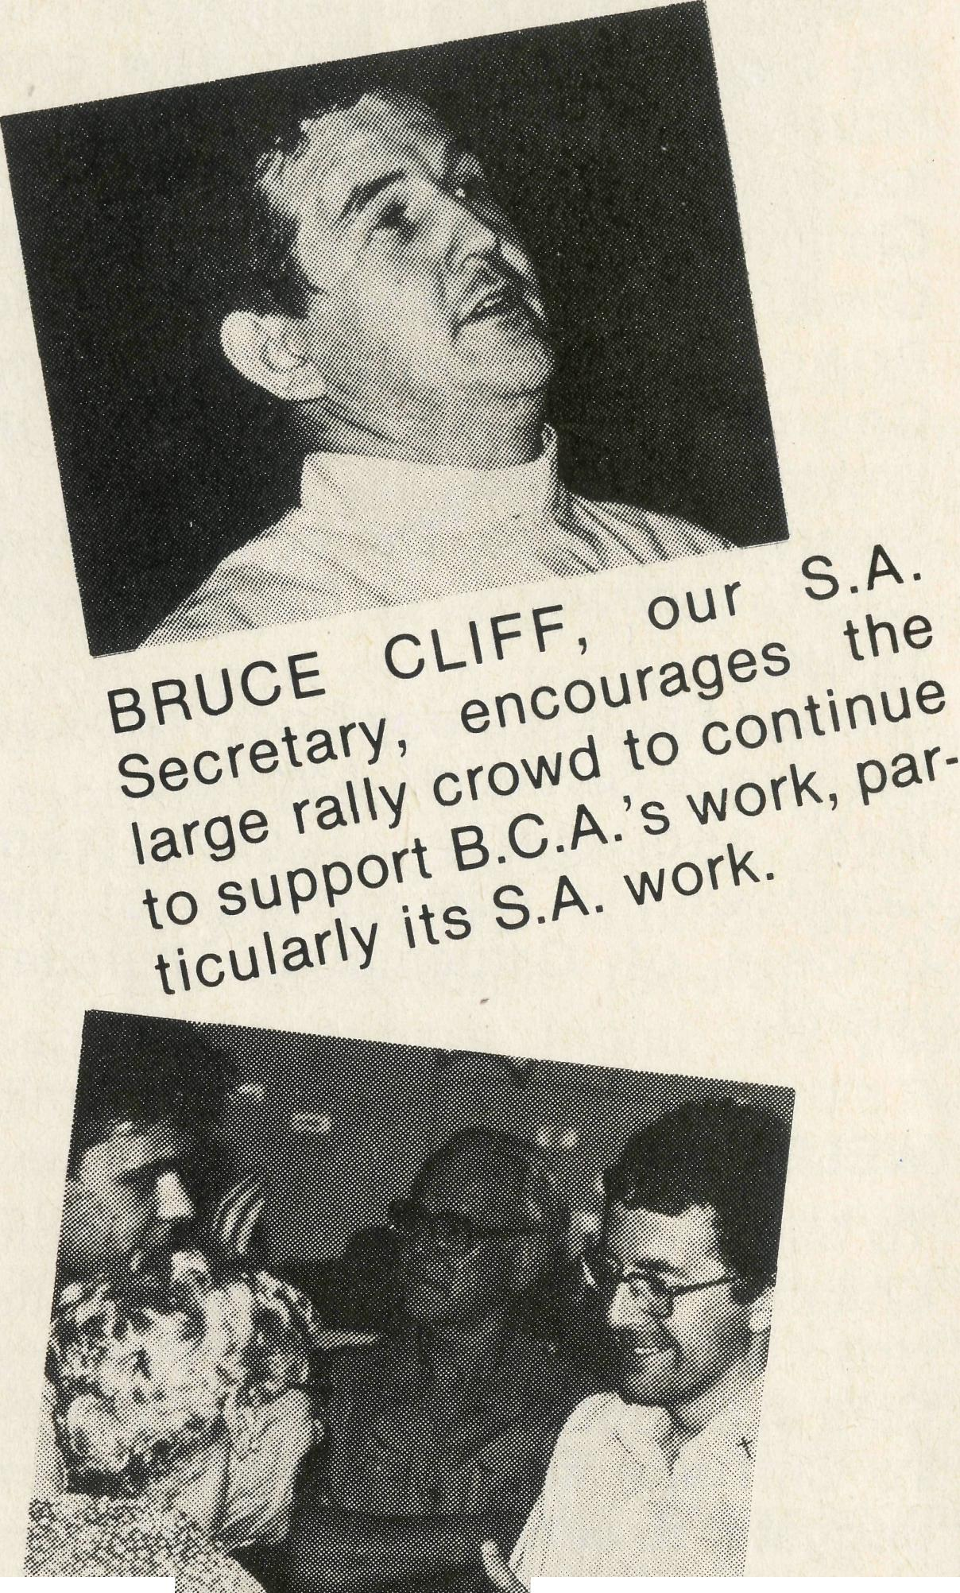
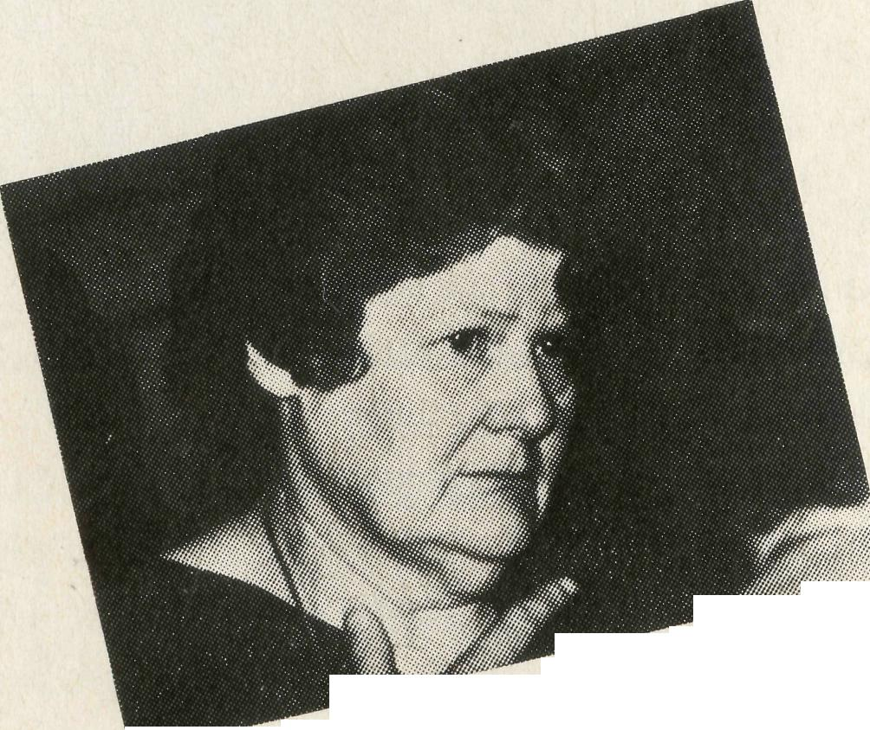
“Rally ‘85”
Blacktown
10th April, ‘85 Wednesday
Christ – Rally - 7.45 p.m.
Sydney
12th April, ‘85 Friday
St. –Andrew’s Cathedral
Thanksgiving Service 6.30 p.m.
Chapter House Rally 7.45 p.m.
Canberra
15th -April, ‘85 Monday
StMark’s S Library
Luncheon 1.00 p.m.
Belconnen Churches Centre
Rally 7.45 p.m.
Liverpool
17th April, ‘ 85 Wednesday
St. Luke’s Hall — Rally — 7.45 p.m.
Newcastle
19th April, '85 Friday
St. Augustine’s Merewther
Rally 7.45 p.m.
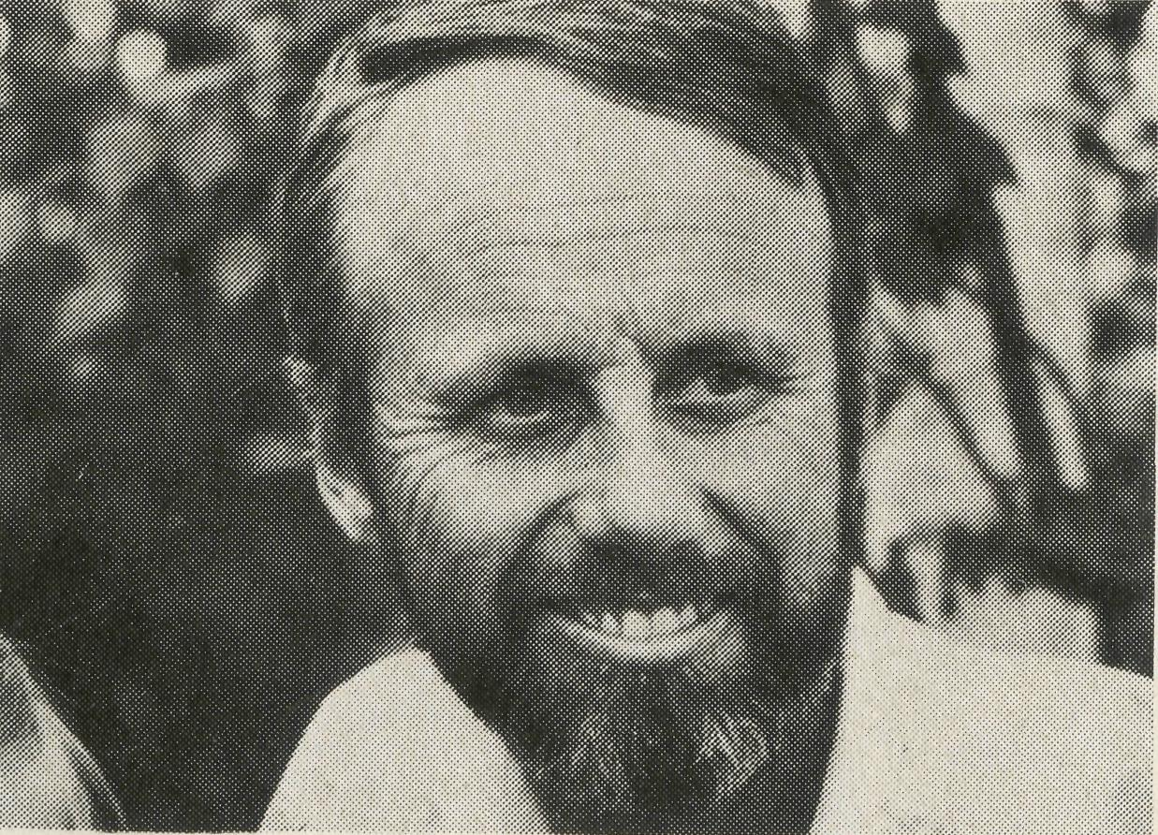
Rev. Adrian Moore –
B.C.A. Missioner at Port Hedland
Guest Missioner

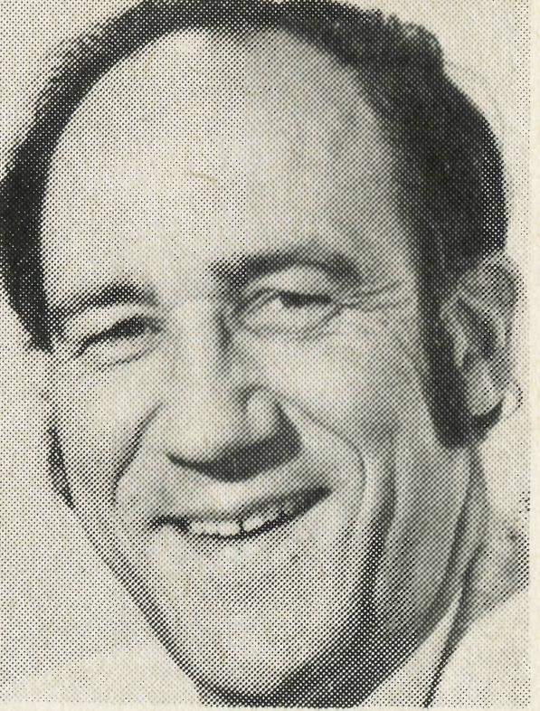
Wakely writes . . .
Cook is a tiny town on the Trans-Australian Railway line in the middle of the Nullabor. It is isolated and it is lonely, situated about equal distance from Port Augusta in South Australia and Kalgoorlie in Western Australia on the longest straight stretch of railway line in the world.
Here B.C.A. has a hospital because early B.C.A. missioners recognised the medical needs of the people of Cook and the other small communities and camps along the Trans-line. The hospital was built by the Society in 1936 in memory of the first leader of B.C.A., the Reverend, and later Bishop, S. J. Kirkby who died in 1935, fifty years ago. The B.C.A. nurses stationed here need to be most competent and resourceful, for the nearest doctor is the Flying Doctor based at Port Augusta, nearly 1000 kms. away. There are regular medical scheds on the R.F.D.S. radio-Transceiver network and in cases of emergency the doctor can be contacted by Transceiver. The Flying Doctor visits Cook twice a month for clinics and the Dentist flies in once a month as well. Nevertheless, accident or illness can come at any time and our nurses have been confronted with, for
example, premature births, shooting accidents and heart attacks. It is not only the local people who come under the care of B.C.A. nursing staff, but quite often folk on the prestigious passenger train, the Indian Pacific, require their immediate and expert attention.
Of course the ministry exercised by the B.C.A. hospital staff is not only a medical one. There are opportunities taken to share the love of God through activities for both local children and adults.
The Bishop Kirkby Memorial Hospital is in urgent need of renovation and improvement, especially the staff quarters. Plans have been prepared and approved, and B.C.A. Council wishes to go ahead with these renovations in 1985. The South Australian Minister for Health, Dr. John Cornwall has agreed to match dollar for dollar for the project costing overall $100,000, so B.C.A. has to raise $50,000.
Your friend,
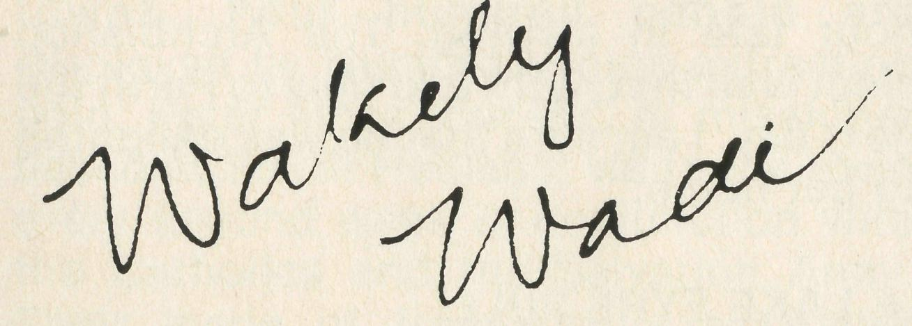
All gifts for the Bishop Kirkby Memorial Hospital renovations are tax deductible.
Make cheques out to B.C.A. Bush Nursing Homes and Hospitals Fund and send to your State B.C.A. Office.
PHOTO REPORT . . .
ADELAIDE RALLY '84

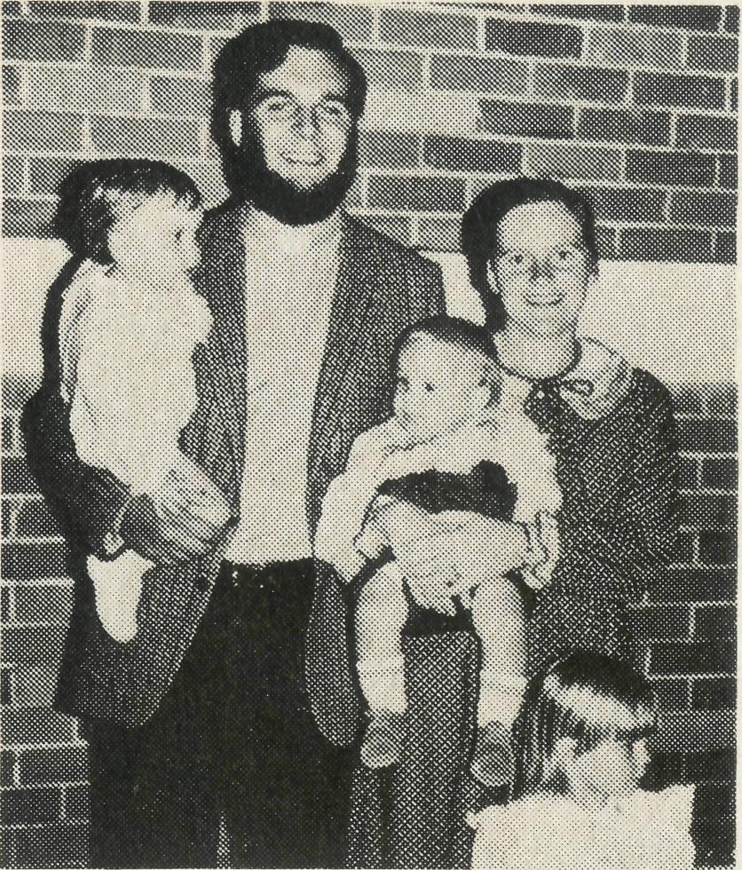
• BROWNSCOMBES' UPDATE
POST & RAILS
- FAREWELL
- To Stan and Dorrie Hummerston, the Diocesan Administrator in Geraldton, to "Retirement" in Adelaide.
- To Sister Lynn Pickersgill from Cook Hospital, to work with the Royal Flying Doctor Service. Lynn now continues as a "tentmaker" with the society.
- Chris and Marilyn Clerke from Leigh Creek, to a special appointment to Principal/Superintendant of Gnowangerup Bible College in Western Australia.
- Stuart and Helen Thorne from Win-ton, to retirement at Georges Hall, Sydney.
- Lex and Rhonda Carey from Weipa, to St. Peter's Cathedral, Armidale.
- Bob and Betty Gooch from Cooktown, to Administrator of the Diocese of Carpentaria, Thursday Island.
- WELCOME
- To Michael and Elizabeth Birch from Chaplain at the Royal Newcastle Hospital and Educator in Pastoral Care at St. John's Morpeth to Winton.
- To Cliff and Megan Ainsworth from Boggabri to serve at Lightning Ridge.
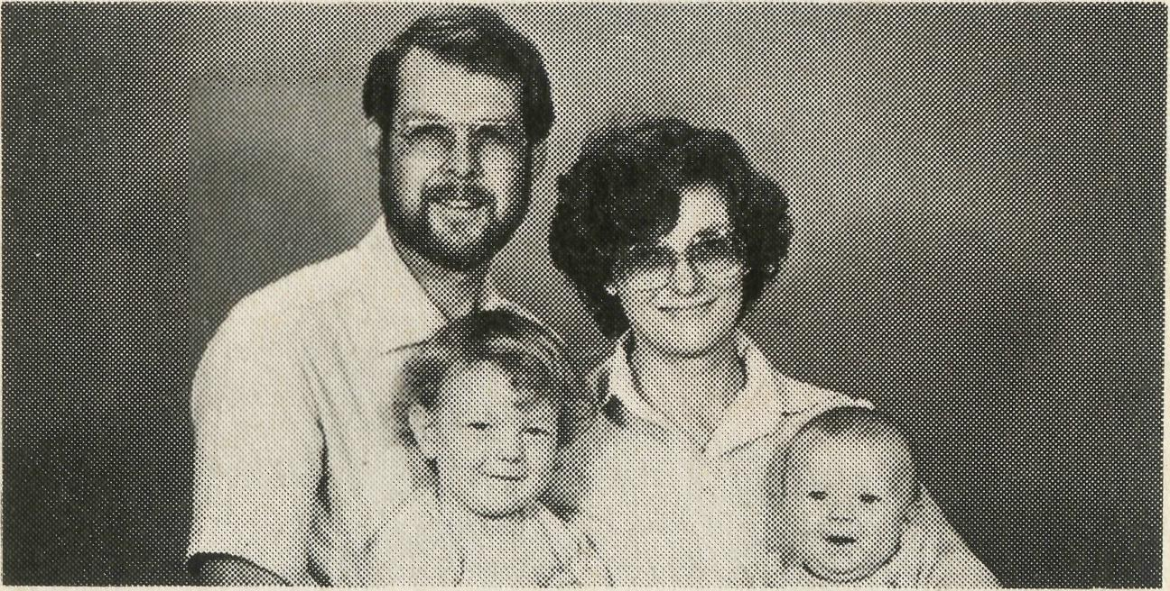
- To Greg and Rhianon Jones from Beaconsfield, Tasmania, to serve at Mt. Magnet.
- Ron Bundy, and Margaret, who is currently Assistant at Holy Trinity, Adelaide, to go to Palmerston in the Northern Territory in October 1985.
- To Mr. Martin and Mrs. Kim Weatherston from the Parish Administrator, Wynberg, South Africa, to Administrator of the Diocese of North West Australia, Geraldton.
* OVERSEAS SUPPORT
We recently received a donation from the Combs Women's Institute, Suffolk, England, for the work of the Society. It seems that Janet Stiff and Merryl Howard went to a November meeting of the Institute some years ago and told of their work as medical sisters serving with the Society in South Australia.
* HAIR RAISING DRIVE
FOR ARCHBISHOP
Errol and Anne Sorrenson, who were our B.C.A. mission team at Mt. Magnet, have now settled in Derby, North West Australia. In a recent letter, Anne reported: "We left Mt. Magnet on the 10th November and the whole of October was one big nightmare. Packing, farewells, and a hair raising drive for Errol with the Archbishop of Perth — pretty hair raising for the Archbishop too! The Archbishop had been doing a tour of the North West and Errol had to pick him up about 450 kilometres north of Magnet and there was to be an Evening Service and supper that evening. About a quarter of the way home, the car's temperature gauge showed very hot and they discovered a split in the radiator hose. They had to crawl home without any air conditioning, the temperature in the 40's and conserving water to keep filling up. They both looked exhausted on arrival at Magnet but the Archbishop rallied magnificently for the Service. Errol had rung from Meekathara saying forget the Service, but the people didn't want to and were all waiting, even though they were an hour late in arriving. The Archbishop slept well that night and flew to Perth the next day. I am sure that he was delighted to get home."
* LAKE EYRE FULL
Keith and Rhonda Anstee have recently experienced something denied to a majority of Australians. They have seen Lake Eyre full. Keith passed by on a school crosscountry expedition to Maree, while Rhonda flew over it between Oodnadatta and Maree on her way to an Outreach Nursing Education Workshop. They reported that it was incredible (water as far as the eye can see
in some places). The early explorers would have been convinced that they had found the inland sea. The one advantage of flying, over driving, is that the school party was plagued by mosquitoes but in the plane, not one.
• ECUMENICAL RELATIONSHIPS IN QUILPIE BOUND AHEAD
Recently we learnt that David Heussler offered to drive his Roman Catholic counterpart to the Birdsville races. After a busy weekend of meeting people and a gruelling drive home, David offered his counterpart the opportunity to drive the last 100 kilometres into Quilpie. He promptly drove into three kangaroos putting the B.C.A. car off the road for two months. David said relationships between the two churches have never been better.
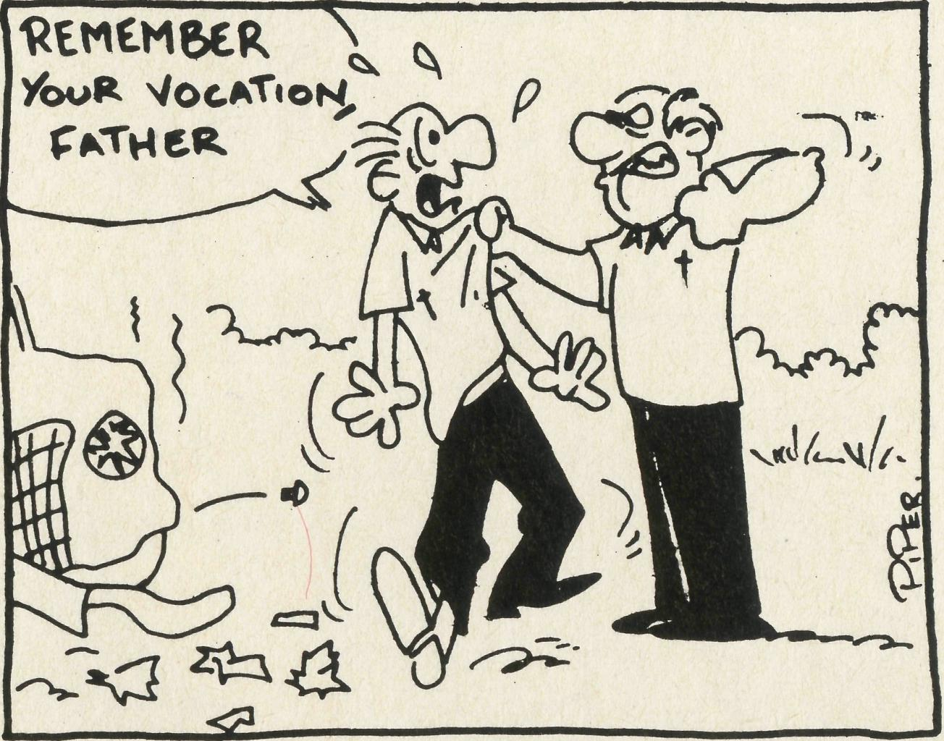
from Queensland's Sunday Sun.
• TELFER
Telfer is one of Australia's most remote towns. Four hundred people are employed by Numont Mining extracting gold. Peter Moss, our B.C.A. missioner based at South Hedland, visits the town every second week in conjunction with the Catholics and the Salvation Army. Their mode of transport is a charter plane, half the cost of which is met by the Company. This travel arrangement really does not provide ample time to catch up with the pastoral calls that Peter needs to make. Peter feels that four or five days in Telfer every couple of months is what is needed, please stand with him in prayer as he seeks to make suitable travel arrangements to allow his ministry of the Word to take full effect.
Tim Brownscombe our missioner in training has spent the last year working as the Assistant at St. John's Mudgee. He was deaconed in March and priested in September. He reports "my role in the parish, apart from taking services in various country centres, has been teaching scripture in the primary schools, leading several Bible Study Groups, and hospital visitation and taking the occasional funeral. Since September, I have found the added dimension of celebrating the Lord's Supper an immensely rewarding part of my ministry. And what does 1985 promise for us? First, we will spend another year in Mudgee. We expect to be here until the Bishop calls us to return to the Northern Territory, probably early 1986. Also another addition to the Brownscombe clan. We are expecting our fourth child sometime in April." Please continue to stand with Tim and Kerry in prayer that they might be adequately equipped for the task that lies ahead of them as they seek to minister with the Bush Church Aid Society in the Diocese of Northern Territory. Pray also for healthy and happy family life and prayer for Elizabeth, four years old, that her hearing difficulties will be overcome.
PROPOSED CONSTITUTIONAL CHANGES
At the Annual General Meeting of the Society on Thursday, May 23 1985 in St. Andrew's House, Sydney, at 9.45 a.m., revised Articles of Association for the Society will be presented for adoption. Details of the proposed changes can be inspected at any State office of B.C.A.

12
THE REAL AUSTRALIAN
THE REAL AUSTRALIAN
13

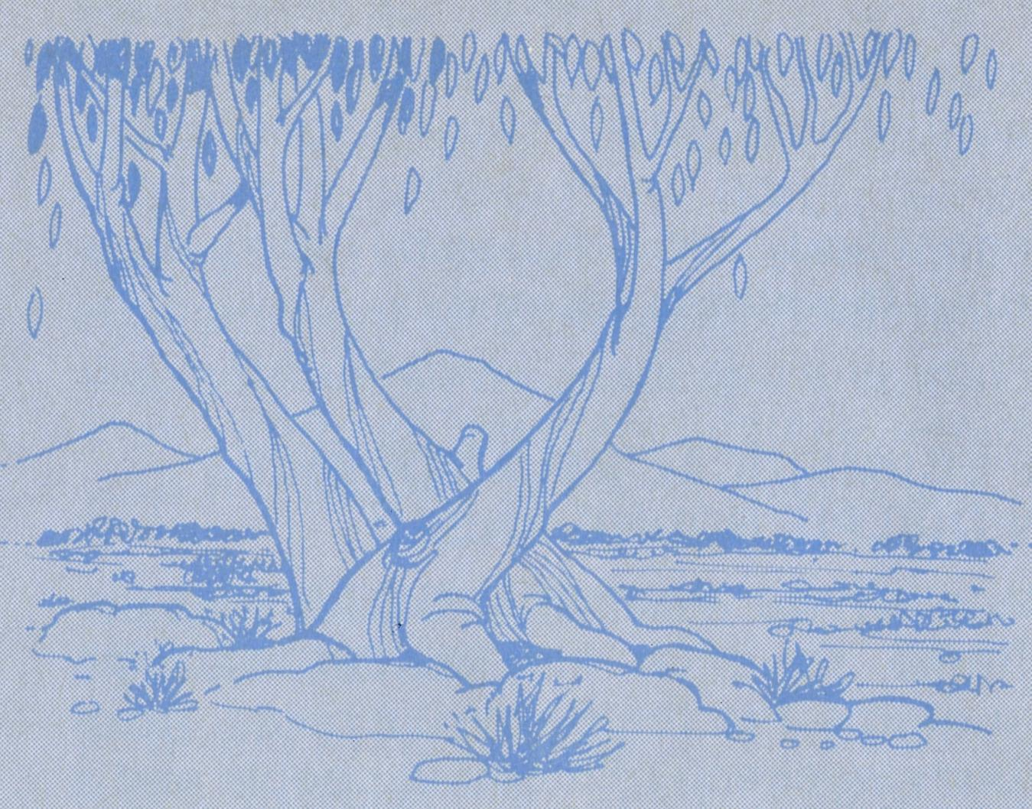
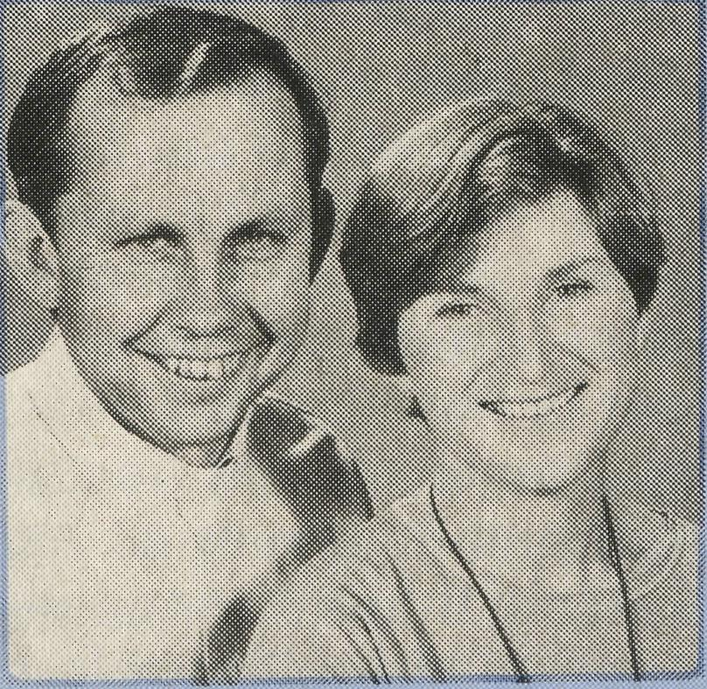
PRAYER CALENDAR
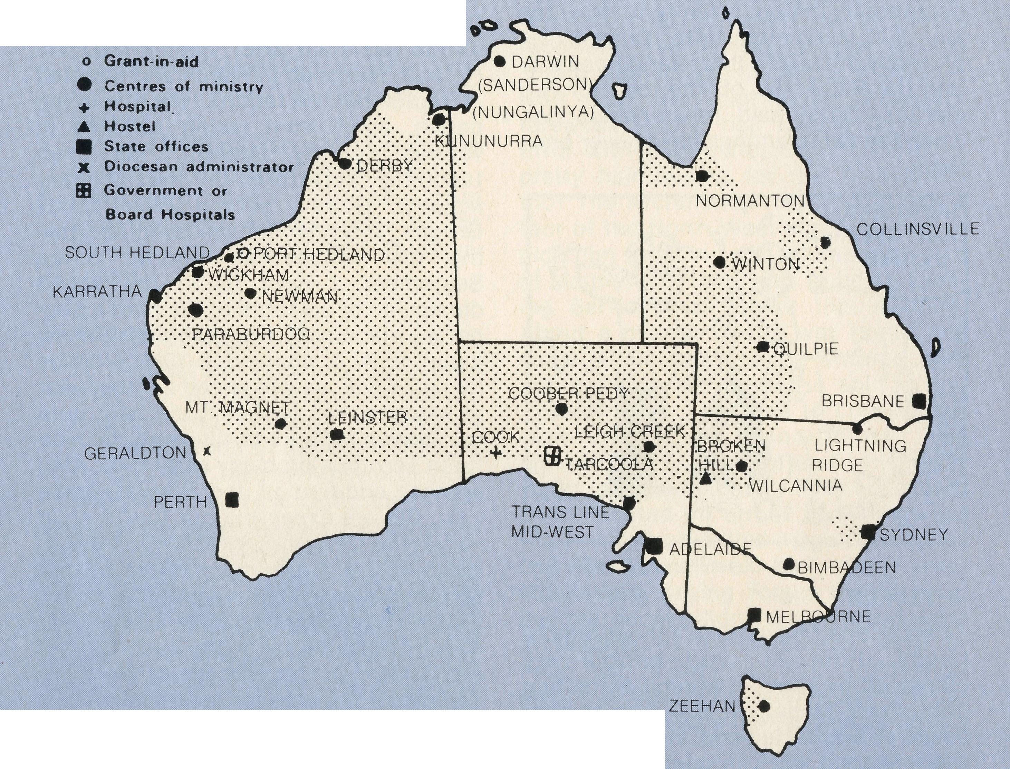
THE B.C.A. PRAYER
O Lord our God, help us to remember the people who live in the remote parts of our land. We ask You to bless those whom You have called into the fellowship of The Bush Church Aid Society, and call others to stand with them in the task. Grant that, through the ministry of the Word and Sacraments, through healing, and through caring for the young, the message of Your redeeming love may be proclaimed, through Jesus Christ our Lord. Amen.
TO WINTON — QUEENSLAND

The Reverend Michael and Mrs. Elizabeth Birch are our new B.C.A. mission team in Winton, Diocese of Rockhampton. Michael and Libby have three children, Anne, 6, Timothy, 4, and Peter, 1. Michael was born in Sydney and completed his secondary education in Canberra. Before he was ordained he worked at the Commonwealth Public Service as a clerk. Michael has a wide pastoral experience being assistant clergyman at Mudgee, Chaplain at Royal North Shore Hospital, assistant at St. Alban's, Epping, assistant at Parkes, rector of Denman in Diocese of Newcastle, and comes to us from the Royal Newcastle Hospital where he was chaplain and also Educator in Pastoral Care at St. John's College, Morpeth. The Birches continue the fine work of Stuart and Helen Thome in Winton.
FIELD STAFF DIRECTORY
DIOCESE OF NORTHERN TERRITORY. The Rt. Revd. C. Wood.
- Darwin — Sanderson — Revd. Robert and Mrs. Rigmor George.
- Nungalinya College — Mrs. Gwen Newell. Bimbadeen N.S.W. — Pastor Graham Paulson.
DIOCESE OF NORTH WEST AUSTRALIA. The Rt. Revd. G. B. Muston.
- Kununurra — The Revd. Peter Harradence.
- Derby — Revd. Errol and Mrs. Anne Sorensen.
- Newman (East Pilbara) — Revd. Arthur and Mrs. Pat Williams.
- South Hedland — Revd. Peter and Mrs. Alison Moss.
- Port Hedland — The Revd. Adrian and Mrs. Willemien Moore.
- Karratha (West Pilbara) — The Revd. George and Mrs. Jacqueline Sansom.
- Wickham — Revd. Angus and Mrs. Anne McDonald.

- Paraburdoo (South Pilbara) — The Revd. Gordon and Mrs. Ann Hargreaves.
- Geraldton — Mr. Martin and Mrs. Kim Weatherstone.
- Mt. Magnet (Murchison) — The Revd. Greg and Mrs. Rhi Jones.
- Leinster — The Revd. Don and Mrs. Celia Miller. DIOCESE OF WILLOCHRA. The Rt. Revd. S. B. Rosier.

- Cook Hospital — Sister Margaret and Jack Barnes and Sister Marie Ann Parchert; Sister June English (Relief Sister).
- Tarcoola Hospital — Nurses Mr. Keith and Mrs. Rhonda Anstee. Tentmaker. . . Sister Lynn Pickersgill.
- Coober Pedy — Revd. Martin and Mrs. Vivien Bleby.
- Mid-West Mission — The Revd. David and Mrs. Margaret Griffin.
- Leigh Creek — The Revd. Des and Mrs. Judi Arthur (from May '85).
DIOCESE OF TASMANIA. The Rt. Revd. P. Newell.
19 Zeehan — Revd. Walter and Mrs. Eleanor Wheeldon.
DIOCESE OF RIVERINA. The Rt. Revd. B. R. Hunter.
20 Broken Hill Hostel — Mr. Tony and Mrs. Barbara Pickering.
- Wilcannia — The Revd. Mapson and Mrs. Ruth Williams. DIOCESE OF ARMIDALE. The Rt. Revd. P. Chiswell.
- Lightning Ridge — Revd. Cliff and Mrs. Megan Ainsworth. DIOCESE OF ROCKHAMPTON. The Rt. Revd. G. Hearn.
- Winton — The Revd. Michael and Mrs. Elizabeth Birch. DIOCESE OF NORTHERN QUEENSLAND.
- Collinsville — Glendon — The Revd. Rod and Mrs. Hazel Williams. DIOCESE OF CARPENTARIA. The Rt. Revd. A. Hall-Matthews.
- Normanton (Southern Gulf) — The Revd. John and Mrs. Jennifer Summerell. DIOCESE OF BRISBANE. The Rt. Revd. J. Grindrod.
- Quilpie — Revd. David and Mrs. Kay Heussler.
GENERAL
- VICTORIA. The Revd. Alan Hoskin, Mrs. Chris Hernfield.
- SOUTH AUSTRALIA — The Revd. Bruce Cliff, Mrs. Jenny Smith.

- QUEENSLAND. Mr. Allan Sauer (Hon. Secretary). WESTERN AUSTRALIA. The Revd. Peter Brain (Hon. Secretary).
- Federal Secretary. The Revd. Wakely Wade. N.S.W. The Revds. Brian Roberts, Eric Atkin, Mr. Peter Oram, Miss Margaret Woolcott, Mesdames Jacqueline Griffiths, Dora Warwick, Nina Allan, Vivien Bentley, Margaret Sadler.

14
THE REAL AUSTRALIAN
THE REAL AUSTRALIAN
15

