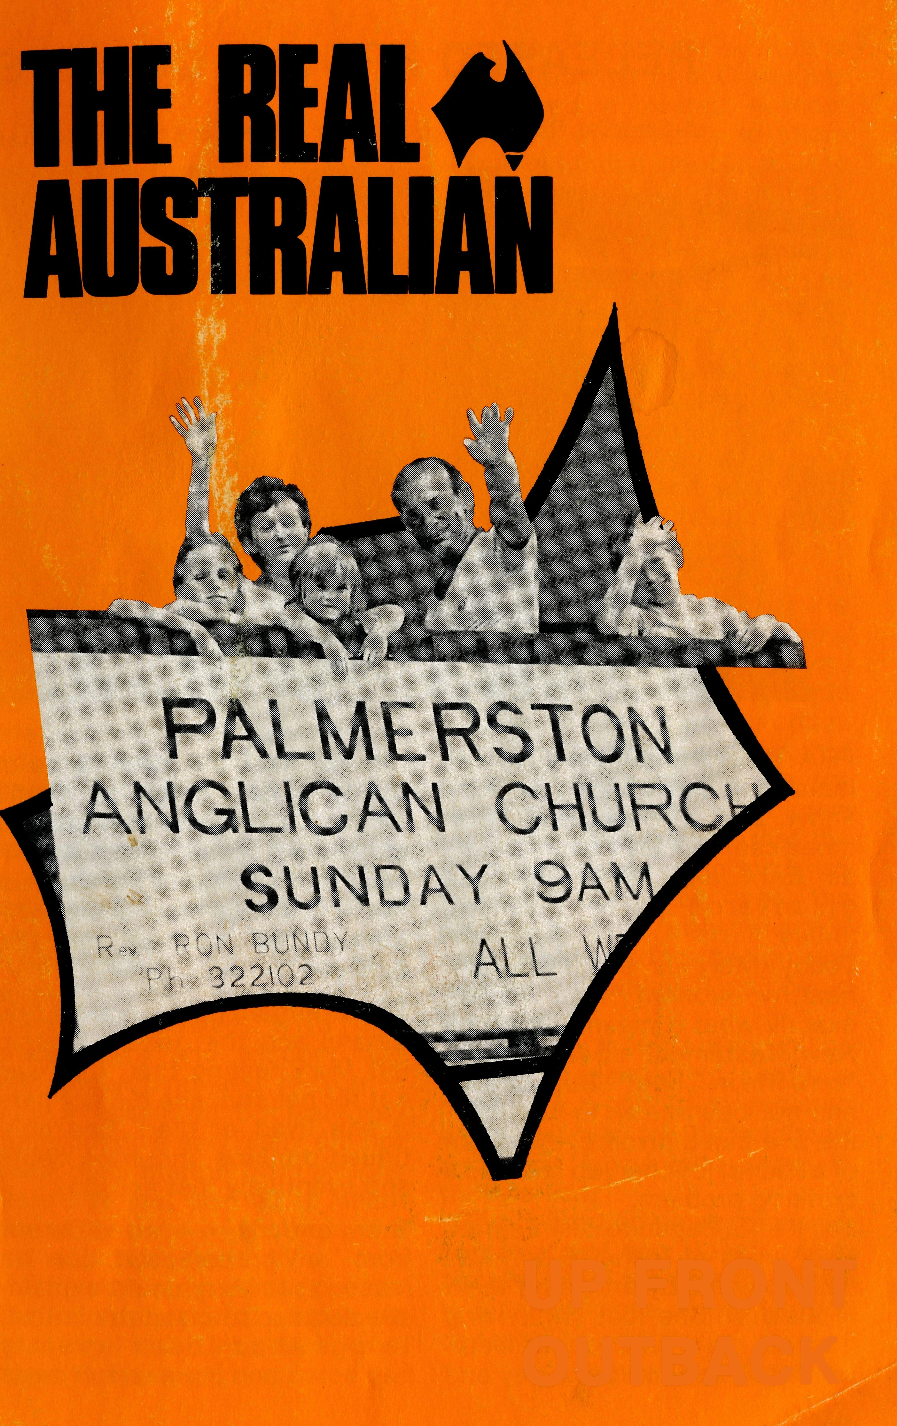
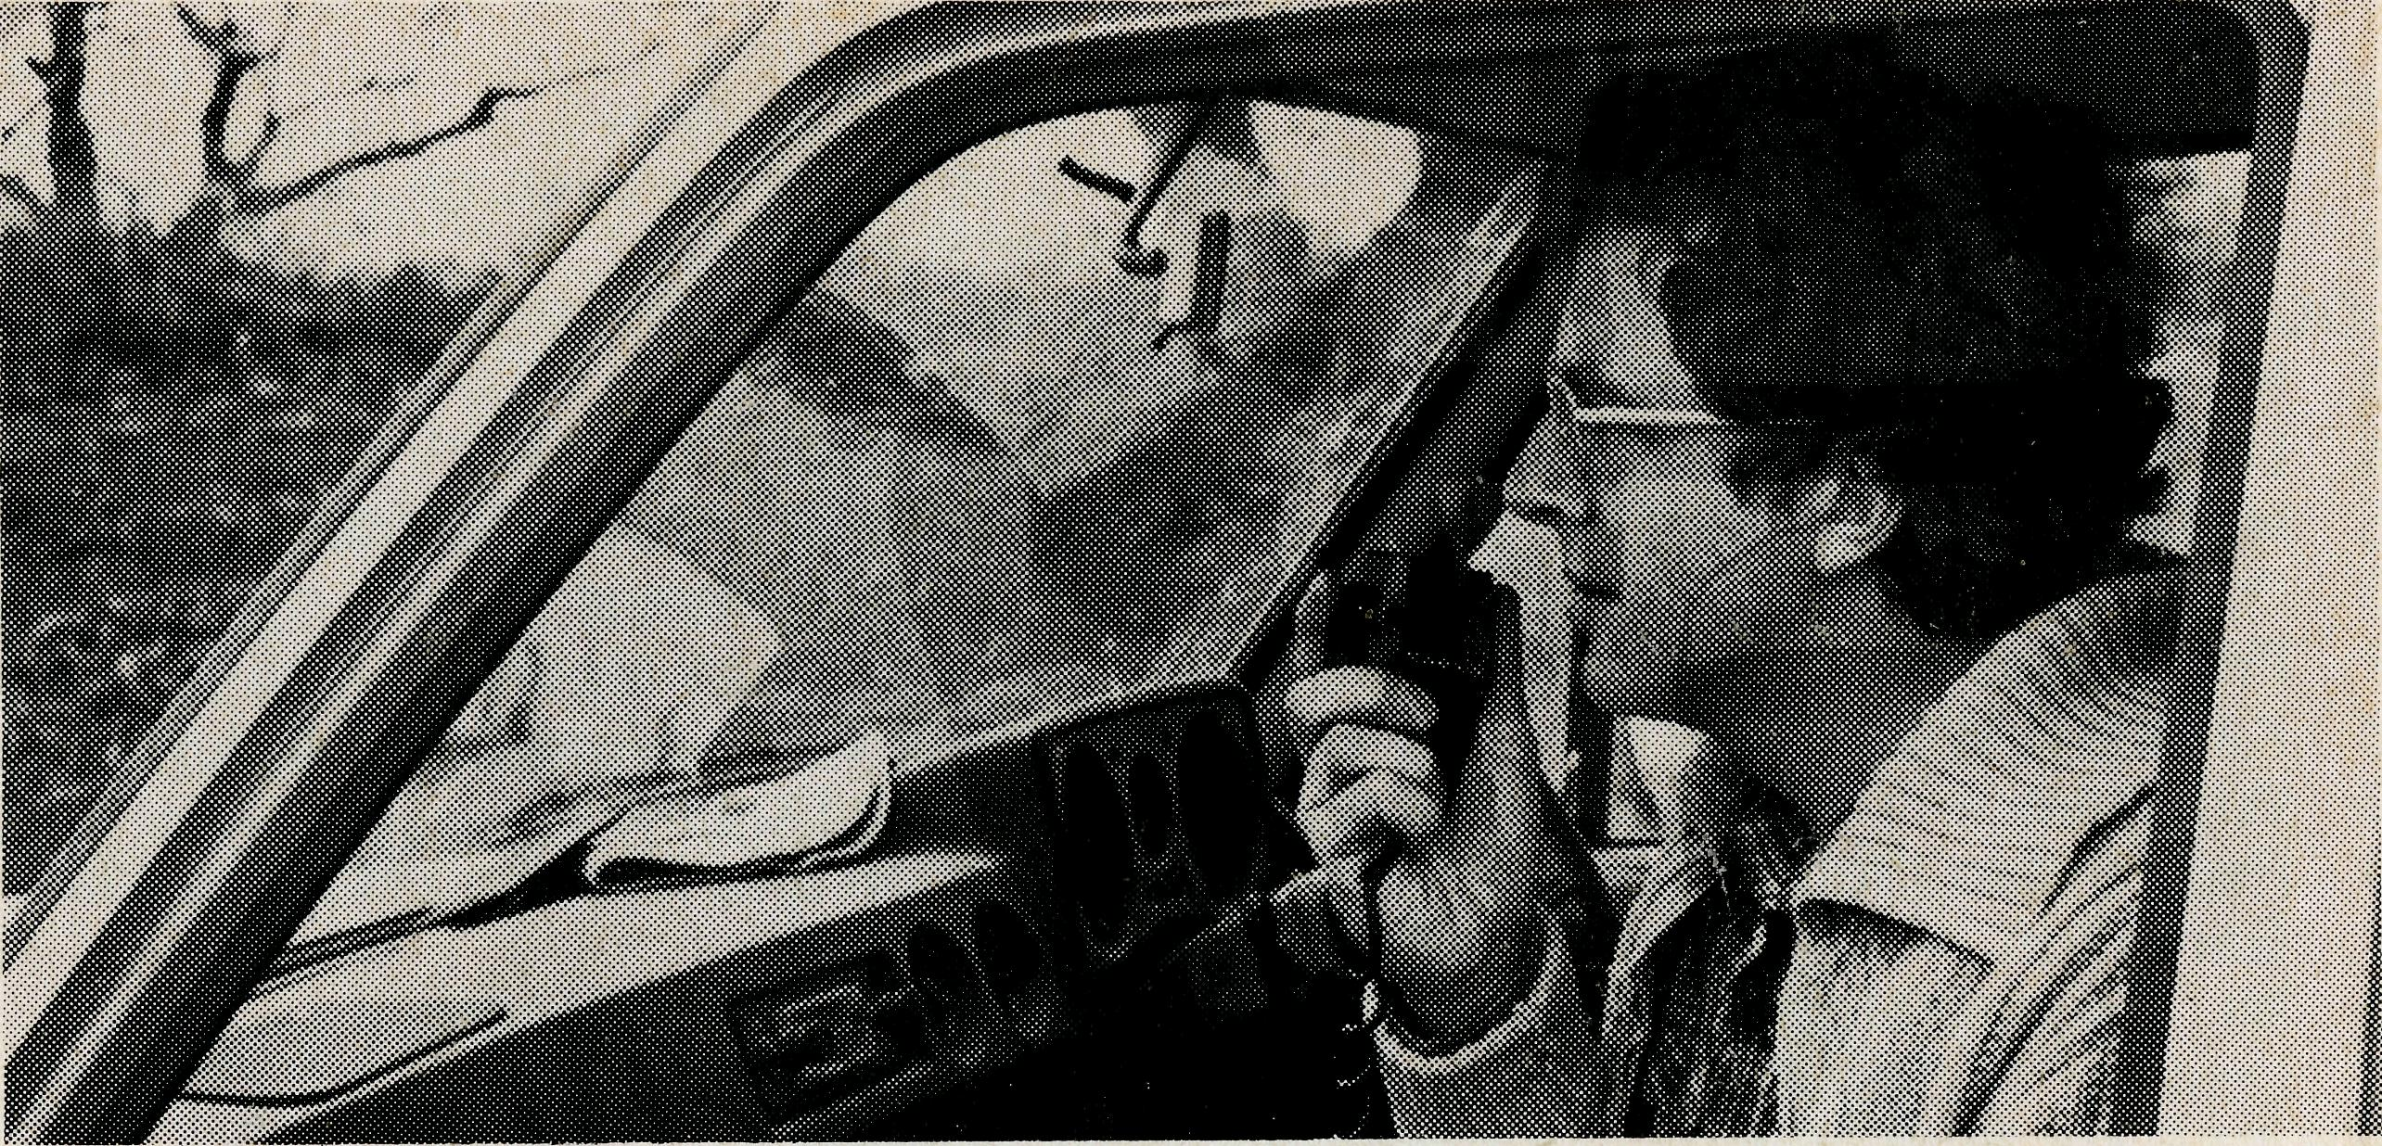
WHY PRAY?
UP FRONT OUTBACK
Martin Bleby, our B.C.A. man at Coober Pedy, had this to say:
"Today another B.C.A. supporter from Mildura on a tour called in briefly to say hello and let us know they were praying for us. After he left, Sam said 'Dad, how come so many people pray for us when there is really nothing hard here?' 'The reason we find nothing too hard here, Sam,' I replied, 'is precisely because so many people are praying for us. If they weren't we would probably find it much too hard. I doubt we would even last here very long.' "Isn't it great how Sam's very question testifies to the protection and blessings of prayers with which the Lord surrounds our family."
I WISH TO:
- KNOW
- PRAY D GIVE
Be Up Front Out Back in Prayer. Apply for the B.C.A. Prayer Notes today
(Receive the Real Australian)
FOR CHRIST
(Join the Prayer Fellowship. Please send me the Prayer Notes)
THE BUSH CHURCH AID SOCIETY
NSW 135 Bathurst Street, Sydney, 2000
Phone: (02) 264 3164
D (I would like a B.C.A. money box.) D (Please inform me of needs regularly)
D GO
(I am interested in serving God in Outback Australia)

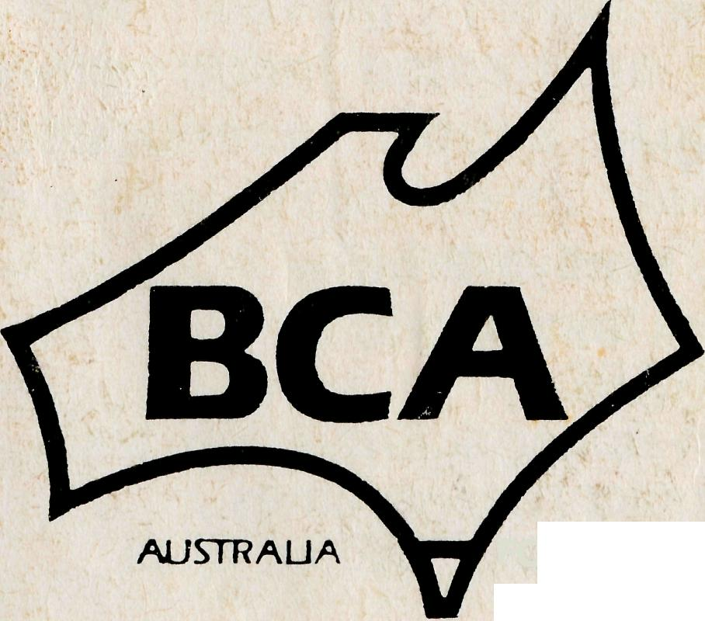
Printed by Ambassador Press Pty. Ltd., Granville 2142.
March 1986. $3.00 subscription. Reg. by Australia Post. Publication No. NAR 0630

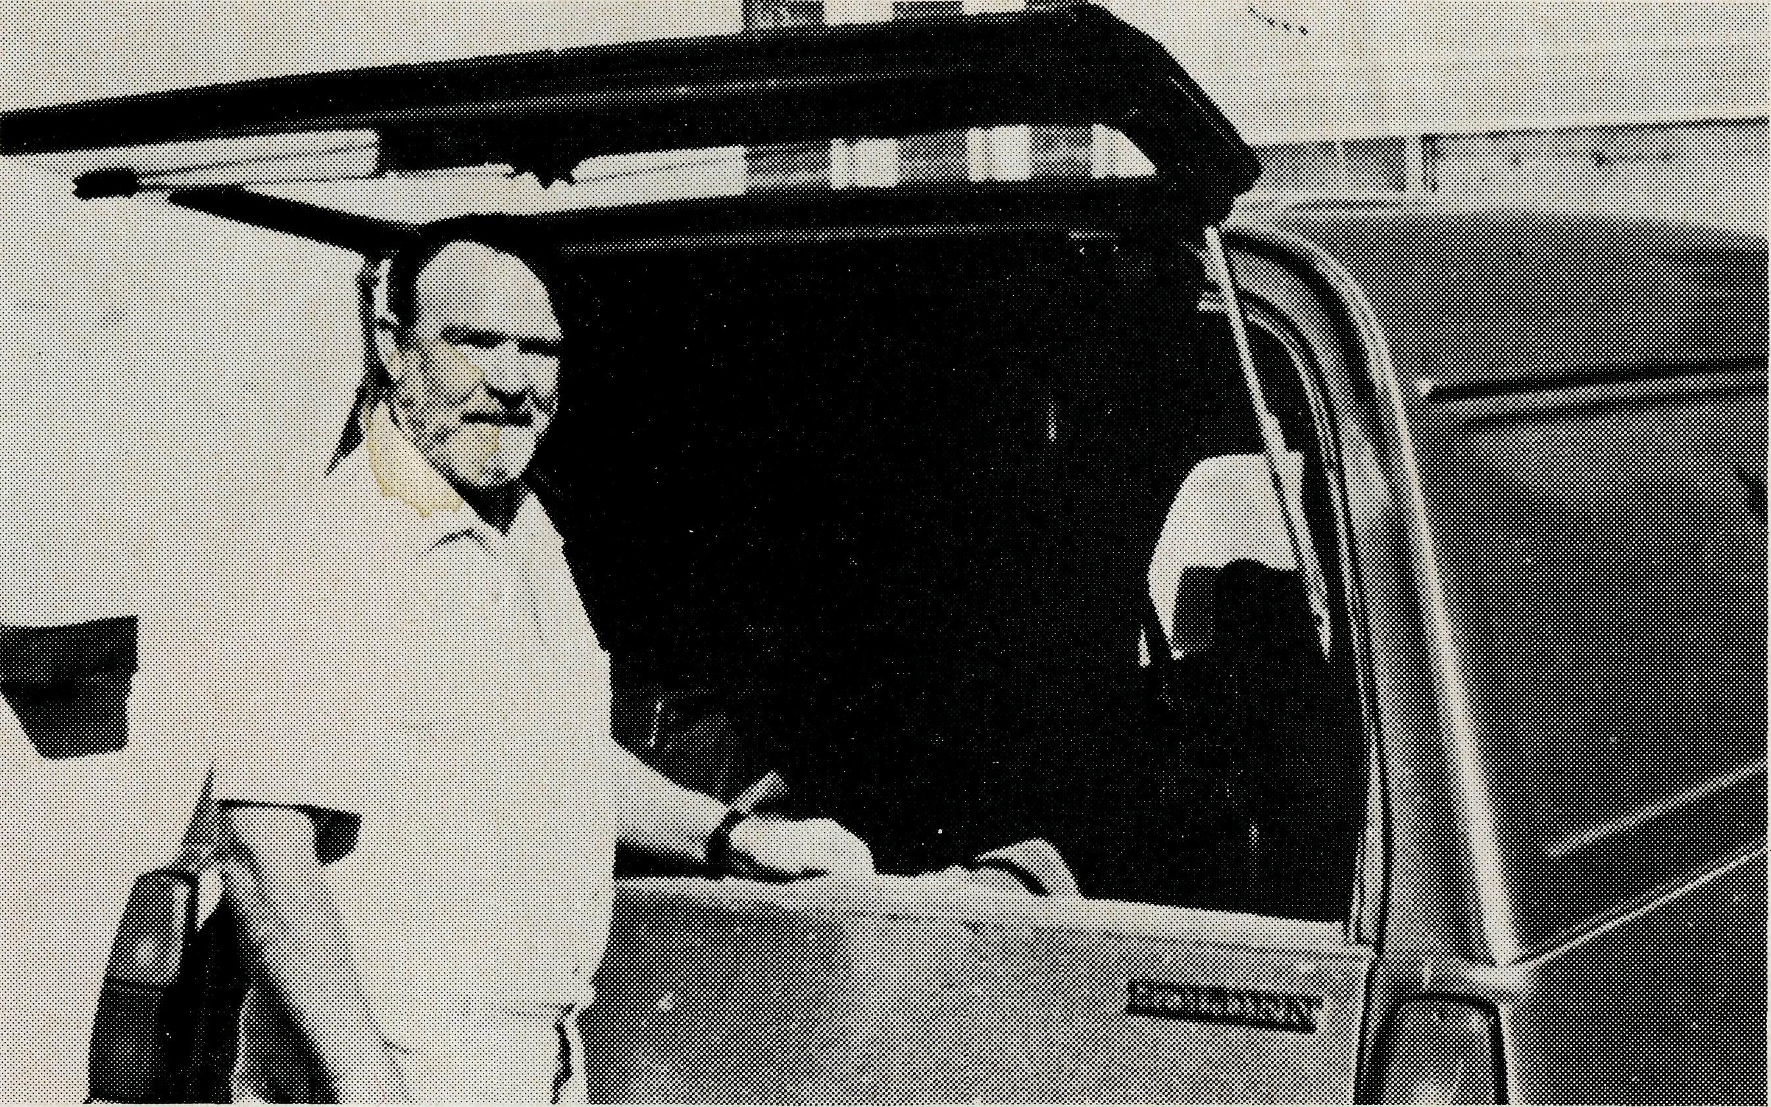
RELEASED FROM A CONCRETE BLOCK
A Special Report on Errol and Anne Sorensen's Ministry
PRAYING faithfully for people in isolated areas whom you don't know, and will probably never meet can still lead to miracles, as Errol and Anne Sorensen discovered after meeting "Mary".
Today Mary is an intelligent, healthy woman who knows exactly what it means when the New Testament speaks about "new life in Christ". But her path has not been easy. In her "old" life she faced divorce, the death of a friend, lost her job and had a drinking problem. Mary's life began to disintegrate after years of trying to solve all her problems by drowning them in alcohol. She lost her driving licence, more than once, incurred debts she could not pay and
did not have the confidence or ability to get herself out of the "muddles" that her lifestyle was continually producing. And it was in this stage of her life that the friend she was living with committed suicide in the backyard.
The aftermath of the inquest, the funeral and the general gossip left Mary feeling that, if it was not for her son, she did not care if she lived or died. She continued drinking, incurring debts and eventually lost her job.
Then one day — no different from any other, and for no reason that Mary could explain, she decided to clean the house. Things had been greatly neglected and it was a full day's
job. Afer everything was cleaned she went to bed. The next morning Mary woke up, and knew that God had touched her life, and that she no longer needed to drink anymore. Anne said "for Mary it was a transformation of the world and herself. She had not sought God or asked Him to intervene in her life, she certainly had no faith that he would or even could act to overwhelm her with such love and peace. All that day and for many days afterwards she could only marvel at it and try to tell other people what had happened to her.
"Unfortunately, the world (and sometimes the church) is not always endowed with the discernment and wisdom that will understand and rejoice in such a happening. But Mary was quite positive and really did not need confirmation from anyone else, she just wanted to share her experience with others she felt would understand." Mary's next step was to put her life in order, and it was about this time that Errol and Anne came to meet her.
Anne went on to say — "It is at this period that new Christians really need fellowship — most of all the opportunity to share with likeminded people all the wonderful things God is doing in their lives. And perhaps it was helpful to Mary that we were available just at the time she needed to be able to talk freely to someone."
Anne and Errol also found Mary's work at picking up the pieces of her life inspiring. Anne said that Mary now had a fairly responsible job, and was nearly at the end of her financial problems, and was reading and enjoying the bible. Mary believes that her new life — which she compares to being released from a block of concrete — comes from people praying for her during her crisis. But Anne and Errol believe that although some of the prayers came from people who knew Mary, they also believe that the BCA supporters who pray so faithfully but rarely see the results of their prayers could have contributed to the spiritual climate in which God could reach her."
Anne hopes that the story will be an encouragement to continue praying for people in isolated areas, and also for the field staff and their wives who serve in these areas.
"God is not tied down to our expectations of how He will reach people, but in his time unfailingly reaches those whom He has chosen."
Errol and Anne Sorensen

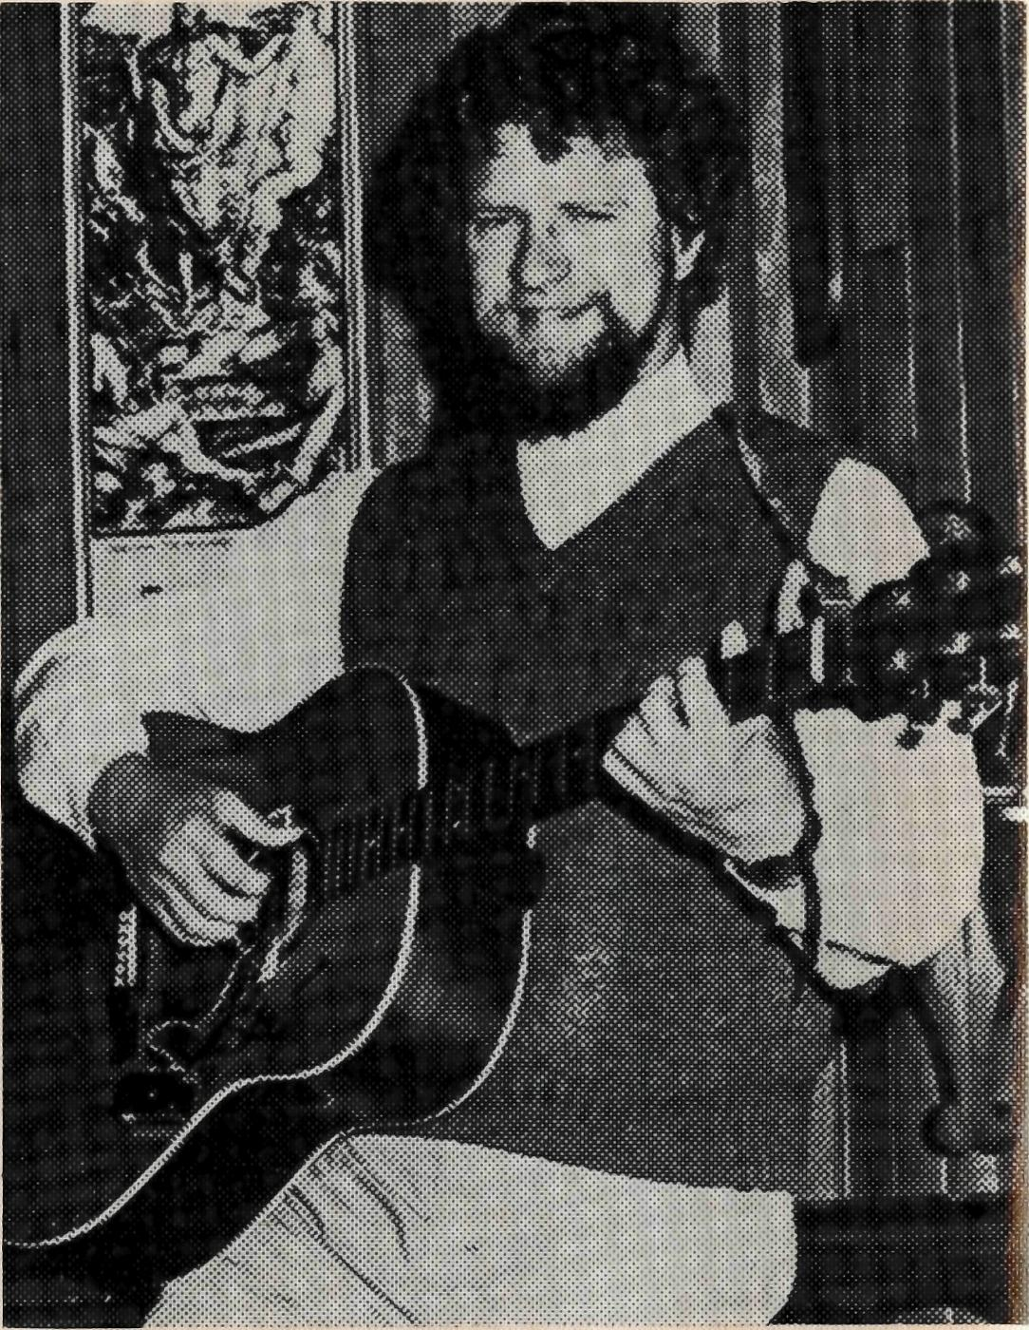
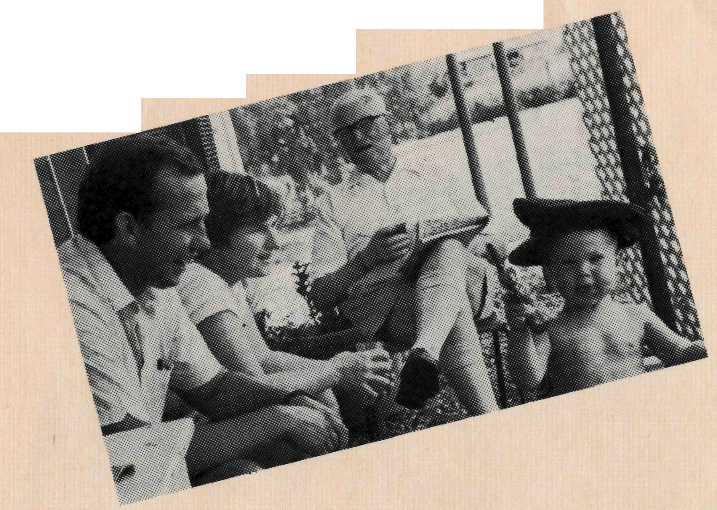
The Reverend Mike Birch, his wife Libby and their three children moved from Newcastle to Winton, where parish and missioner are receiving much encouragement.
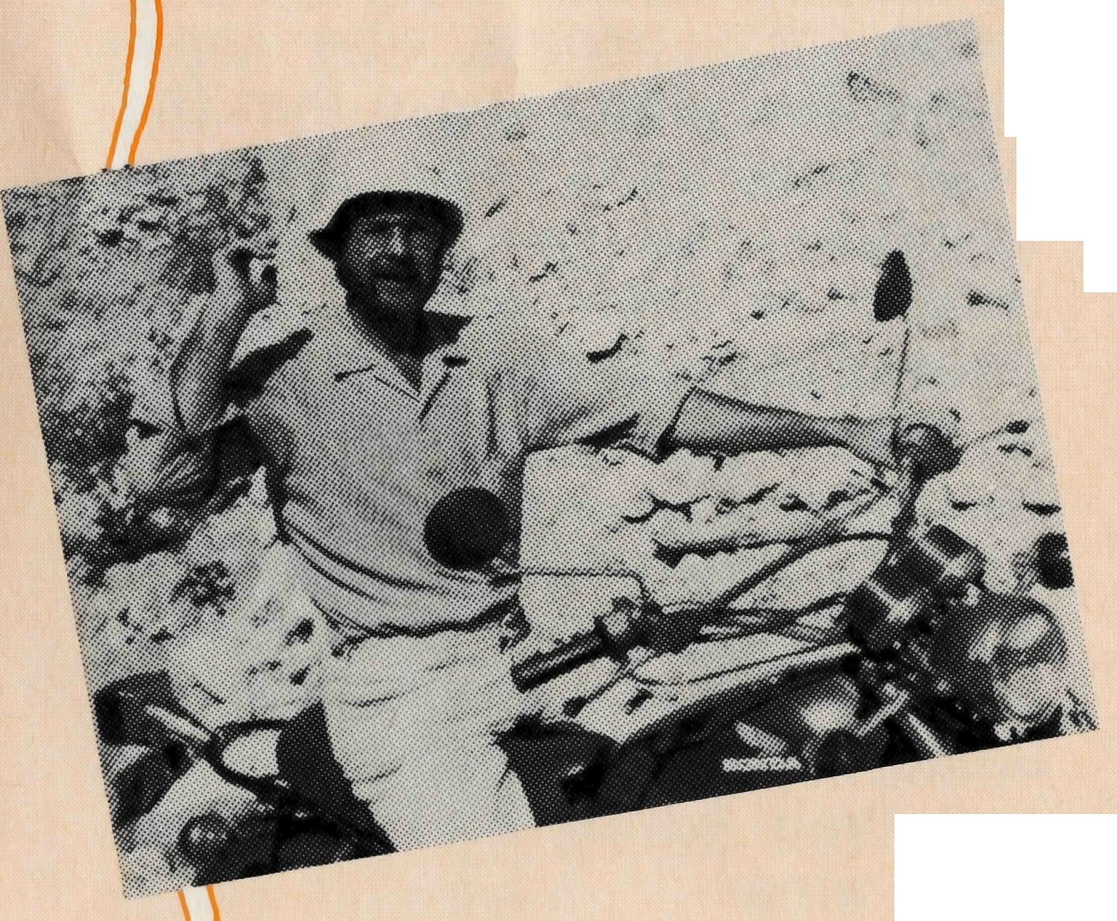
HIGHLIGHT '85
REPORT OF 1985s HAPPENINGS NEW MINISTRIES AND MISSIONERS:
The Reverend Greg Jones, with his wife Rhi and their three young daughters, left the lush green pastures of Beaconsfield, Tasmania, for the harsh, dry, hot parish of Mt Magnet. The work flourishes like wildflowers after spring rains.
From one of the local "pubs" in town come the sounds of Greg's music, which is well received.
The Reverend Cliff and Mrs Megan Ainsworth and their two boys moved from Boggabri to Lightning Ridge — just over the hill so to speak. Cliff finds his travel around the parish is much easier (and economical) by motor bike.
The Reverend Chris Clerke — our flying missioner "flew" from Leigh Creek to the Gnowangerup Bible College in WA. Chris has been seconded by BCA to work in the UAM Aboriginal Bible College, and is finding his work very rewarding.

The Reverend Rod and Mrs Hazel Williams and their family moved from Sydney to commence work in the new area of BCA responsibility — Col-linsville — in Queensland. A ministry that really didn't work out all that well, but now with different understanding, BCA, the parish and the Bishop look forward to forge a new ministry for the Lord in 1986.
The Reverend Des and Mrs Judi Arthur and four children moved from Sydney to fill the vacancy at Leigh Creek, and are enjoying their work in this mining community. Des' Birdsville Bookstall at the annual Race Day was a great success and will be repeated.

THE REAL AUSTRALIAN
THE REAL AUSTRALIAN

HOSTEL:
* Bob Pearce, our Assistant to the Hostel Parents at Broken Hill, came to us as an exponent of Judo. While he does not use this skill to exercise discipline among the young people at the Hostel, he has used another of his gifts in helping lead some of the children to a knowledge of and faith in Christ. Praise the Lord!
The Reverend Ron Bundy tells of the "hoardes" of people who met in the worship area of his Rectory at Palmerston on Christmas Day for the commencement of his ministry there. Ron, with his wife Margaret and their three children, is the first Resident Minister of any denomination in this new suburb of Darwin.
NURSING:
* A massive renovation program at Cook Hospital commenced mid-year. The Hospital is now exceptionally well equipped for both the spiritual and medical ministries. The South Australian Health Commission contributed $50,000 to the overall cost. But more importantly the help from the South Australian BCA Committee and the Hospital Staff and the tireless drive and effort of the Reverend Bruce Cliff (SA Secretary) have meant that we have this most functional resource serving the outback people of South Australia.
HIGHLIGHT 85

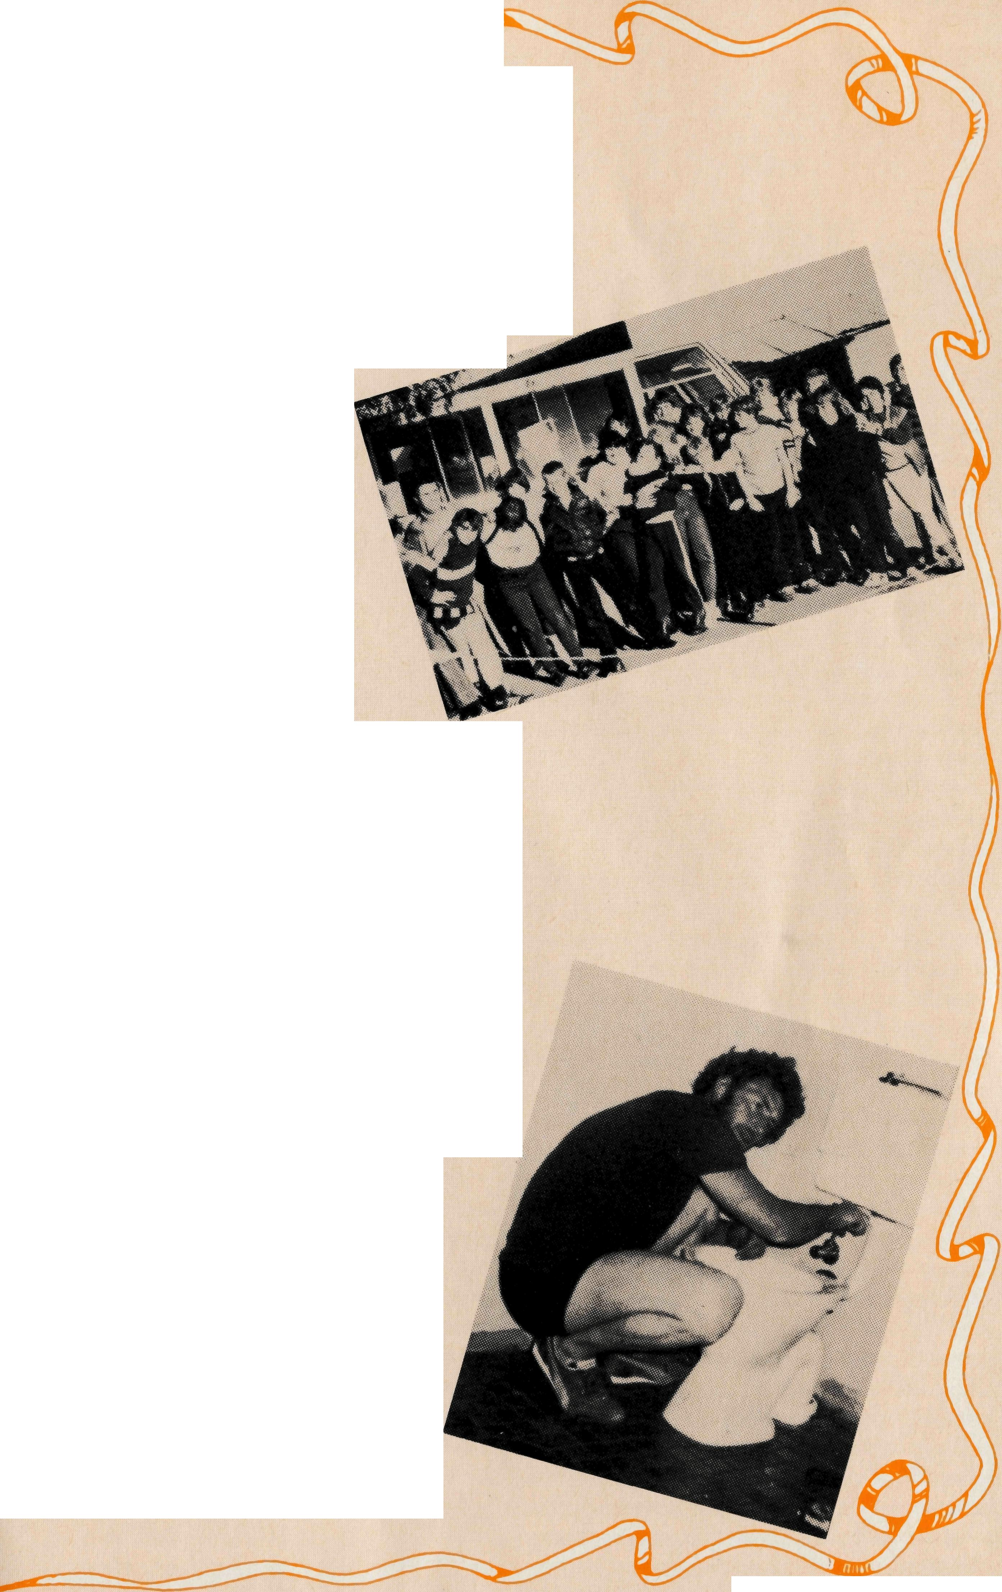
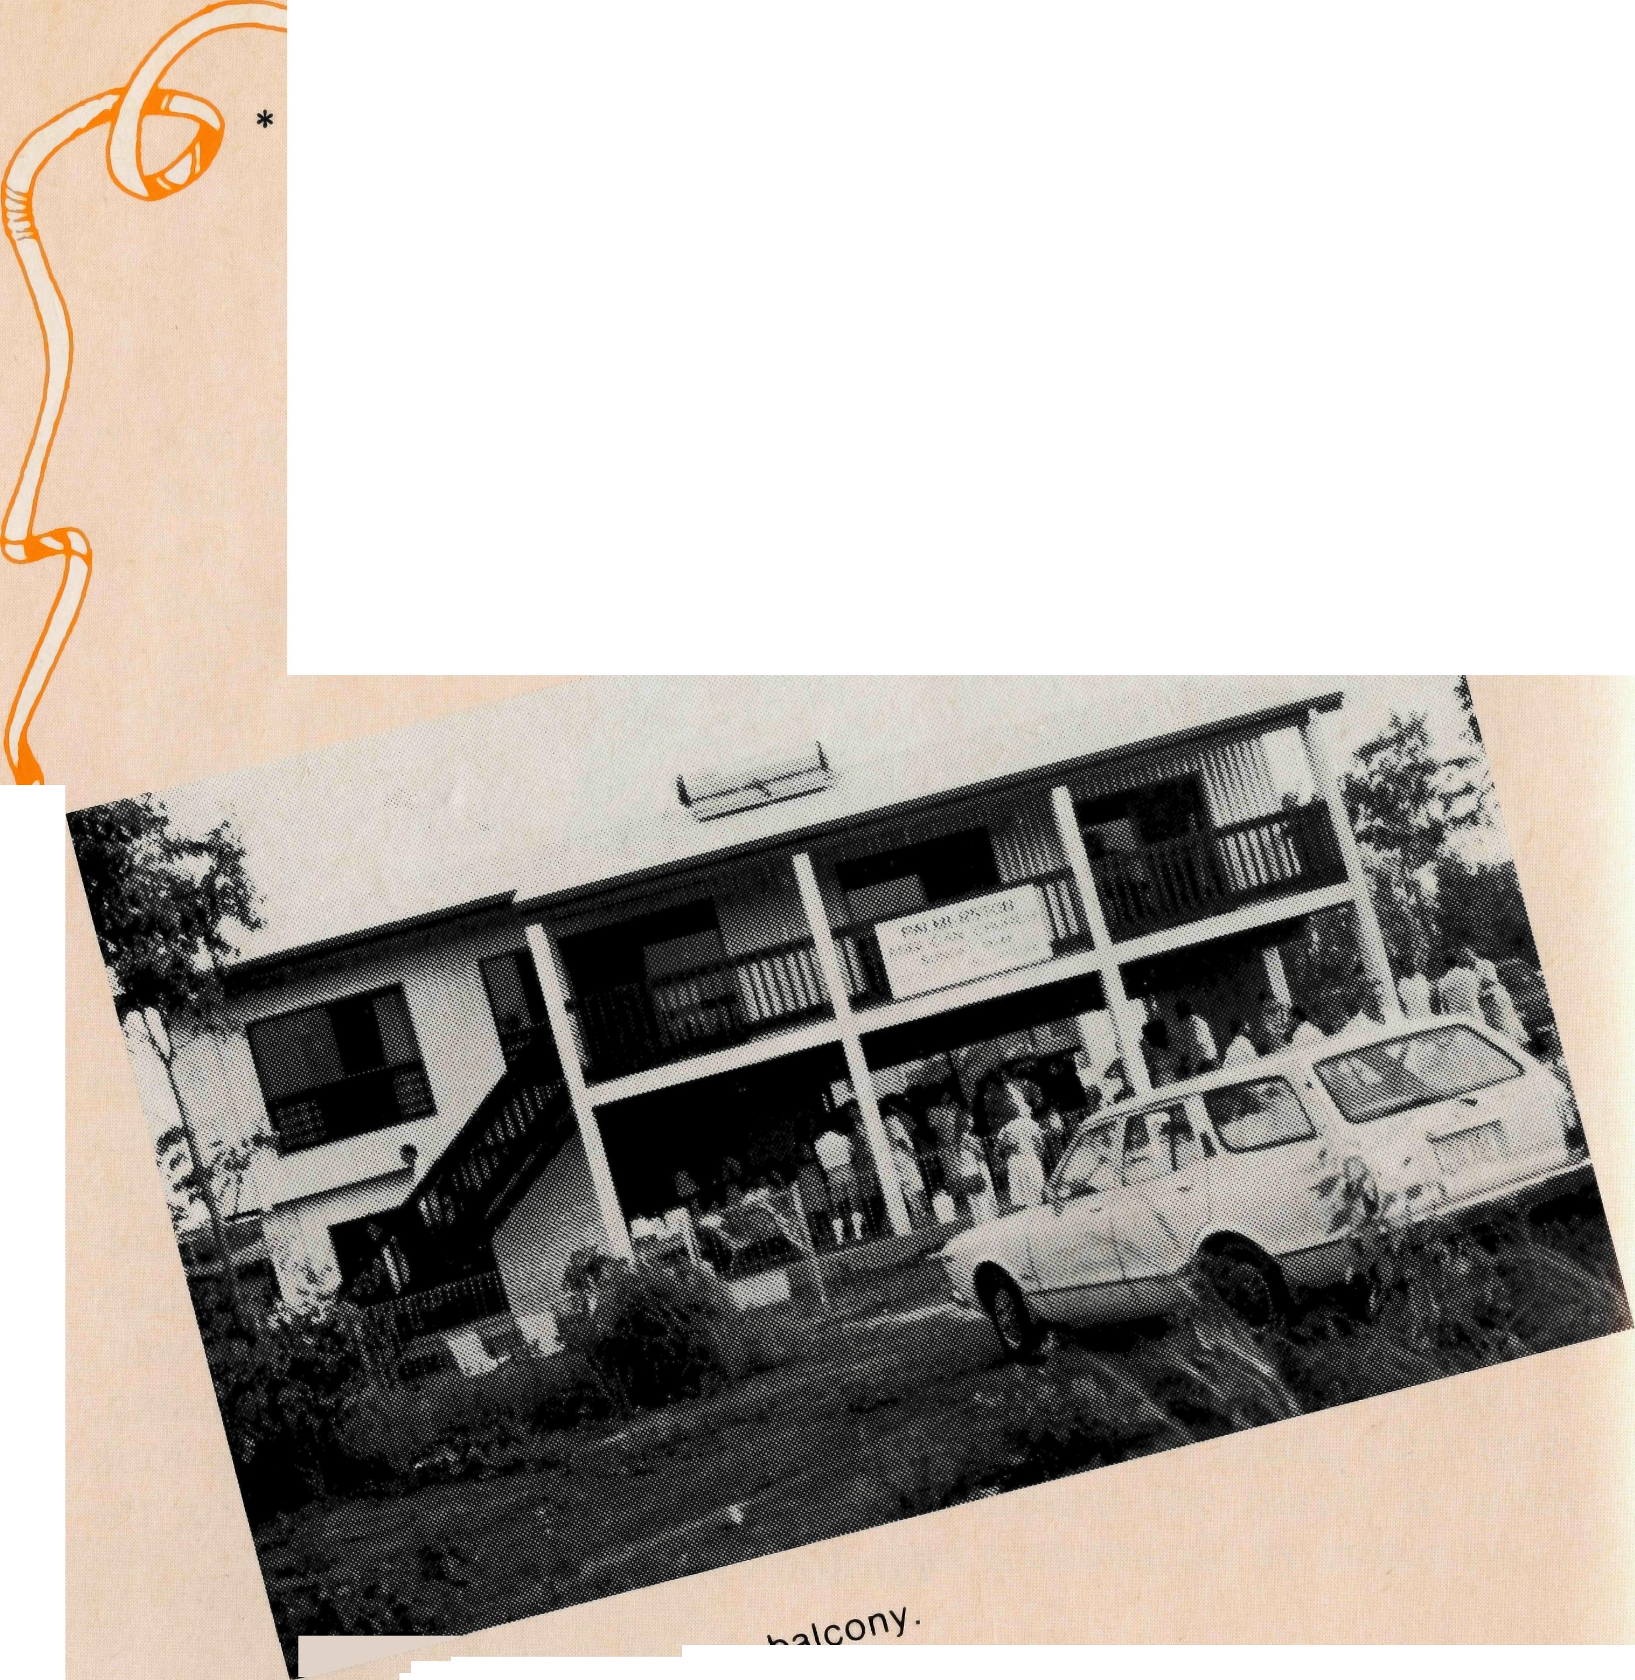
FINANCE:
* Mr Ray Ctercteko, BCA Honorary Treasurer, says of 1985 "A very satisfactory operation, with great support from our constituents, in particular from legacies. During 1985 we were able to perform all our commitments, and with thanks to God we are in a stable condition for 1986." BCA's Budget for 1986 is in excess of $1 million.

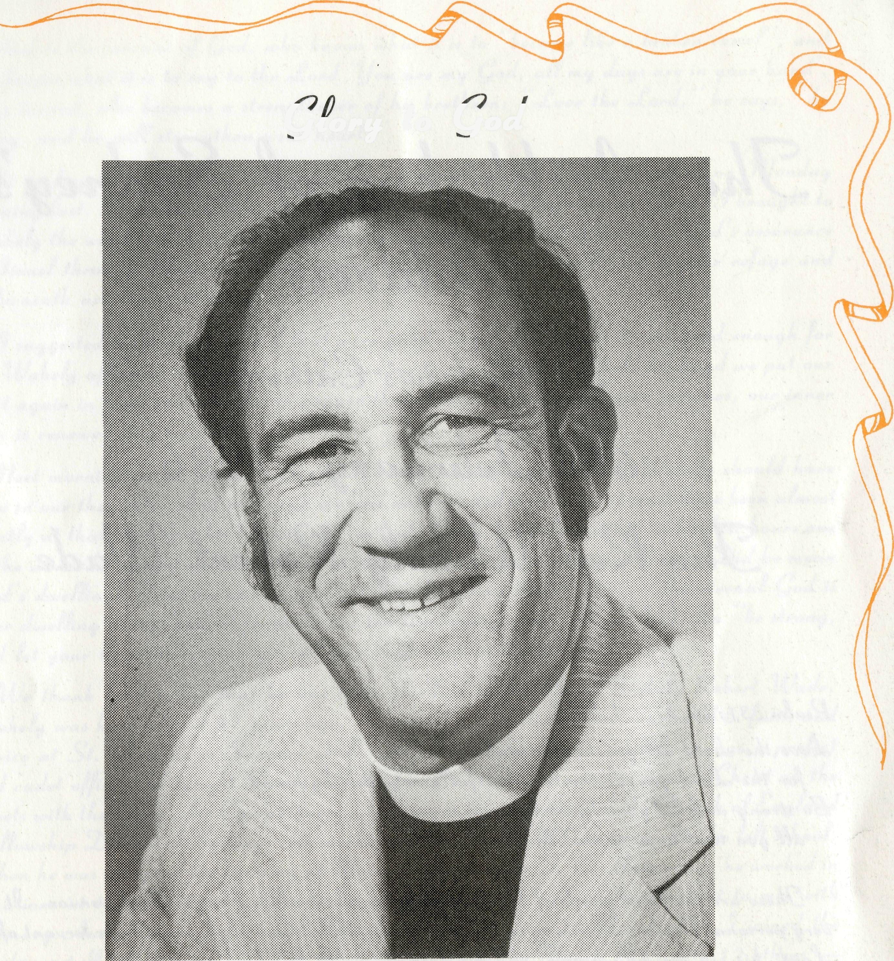
"A CLOUD AS SMALL AS A MAN'S HAND"
happen, then she said, as she played on in the set of tennis, she looked off into the West and there was one tiny cloud, and she said she watched it over the next half hour and it came closer and closer and then she said, as it started to move towards them, they were thinking that they were going to get some rain. It was a dark and black cloud but the whole of the rest of the sky was clear, just this one cloud mass. And then she remembered her prayer again and the cloud mass, as it were, changed direction and everyone watched it go towards this small hill. The small hill which was up at the back of the homestead of her neighbour who she had been praying for and they, the people in the tennis party watched as the cloud broke forth with lightning and they could see it was obviously raining on the side of this hill. Hills aren't top big out here but it was raining on the side of this hill and they heard later how that they had about 70 points of rain that had run down the side of the hill into the dam which supplied water to the house.
And as we yarned together, we remembered the story in the Old Testament of Elijah and the priests of Baal in 1 Kings. It reminded us of the small cloud, but more over, it reminded us that God answers prayer.
Michael Birch Winton
One of our parishioners here, who ^up until, probably, about ten years ago, lived the best part of her life (about fifty-five years I guess) out on a property, related how at one particular time, living on the property, she had a neighbour. A neighbour who she didn't really like, whose ways and manners caused her great concern and especially, I gather, the member of the congregation found difficulty coping with the ways this other woman lived her life, in terrps of cleanliness and looking after the children.
It was the middle of a drought and on that particular neighbour's property, the water had run out at the house. There was a great shortage and life was pretty difficult. The member of the congregation related how, in her prayers, God had convicted her of the resentment and rather uncharitable feelings that she was holding towards her neighbour. She repented of that and then she prayed and she prayed that God would bring some rain to give some water to this family so that their life would be that much more bearable in the heat. They had been carting water and it was scarce, so she prayed her prayer, and it was a Sunday morning and they were going off at lunch time to another neighbour's place for tennis. Midway through the afternoon, she remembered her prayer. The sky she noticed was clear and she wondered what would
Glory to God

We thank God for the great witness of our friend Wakely Wade who died rejoicing in the Lord on Monday, 3rd February, 1986. The funeral from St Andrews Cathedral Sydney attended by almost 400 people was widely representative of the church in Australia and a tribute to his fine contribution to the work of the Church in the outback.

Our loving prayers surround Gwen and members of the family, we are confident that the presents and power of the Risen Christ Will be their strength.

God bless you all,
Lance R. Shilton
Chairman, BCA Council
The Archbishop of Sydney’s
Address
St Andrew’s Cathedral
6th February, 1986
The Rev Wakley Robert Wade

Psalm 31:26,27. A.APB.

Love the Lord all you is faithful ones:
For the Lord guards the true but fully requites the proud.
Be strong and let your heart take courage:
Or you that hope in the Lord.

These are the final words of Psalm 31 in the Australian prayer book version. It is a very personal Psalm, describing in the first person the distress experienced by a Lord, his cry for deliverance, and his deep trust. It has been pointed out as an unusual feature of this Psalm that “it makes the journey twice over from anguish to assurance”. What ever was the nature of the “terror on every side” which the Psalm speaks of, it took its toll in physical suffering and was deep water for the sufferer. It has been suggested that echoes of this Psalm are to be found in both the prayer of Jonah and the prayers of Jeremiah. It is of special comfort to all who suffer that the last words of Jesus on the cross were taken from this Psalm: “into your hands I can meet my spirit”. The verse goes on: “you will redeem me, O Lord, God of truth”.
Almost the whole Psalm is addressed by the Psalmist immediately to God, whether words of complaint or trust or rejoicing and praise. And then at the end he turns, as it were, to those around him:
“Love the lord, all you his faithful ones:
For the Lord guards the true but fully requites the proud.
Be strong and let your heart takes courage:
All you that hope in the Lord.” I’m really into
And so the servants of God, who knows what it is to “become like a broken vessel”, and who knows what it is to say to the Lord “you are my God, all my days are in your hand’, being turned, also becomes a strengthener of his brethren: “Love the lord,” he says, “be strong. And he will strengthen your heart.”
It’s so happened that my wife and I were reading this Psalm together on Monday morning last. The evening before we had been briefly with Wakely and Gwen. I brought to Wakely the word that had been in my mind concerning him during the day, god’s assurance to Israel through Moses in Deuteronomy 33:27: “the eternal God is your refuge and underneath are the everlasting arms.”
I suggested to Wakely that if that were good enough for Moses it was good enough for us. Wakley affirmed that at once and asked me to pray, and as I held his hand we put our trust again in God and recall in prayer though our outward man perishes, out in no man is renewed day by day.
Next morning as we read Psalm 31 at home it was inevitable that Wakely should have been in our thoughts. And although we had not expected it so soon, It must have been almost exactly at the time that his life came to an end. Gwen Has told me that in his last hours one of the words he seemed deliberately to answer was “dwelling”, “the dwelling”. Did he mean gods dwelling? That seemed to satisfy. Was he going there? Yes. “The eternal God is your dwelling place, and underneath are the everlasting arms” (R.S.V.). So “be strong, and let your heart take courage, all knew that hope in the Lord”.
We thank God today that he has been glorified in the life of Wakely Robert Wade. Wakley was born almost 57 years ago, the son of a Christian home, nurtured in faith and service at St Andrews, Summer Hill. At Homebush high school, He was a prefect and Cadet officer, He taught Sunday school and was not ashamed to preach Christ on the streets with the Open Air Campaigners. He was on the committee of the Church of England Fellowship Diocese of Sydney. He worked for Shell Oil Company after you left school. When he was accepted for training and Moore College under J.C. Hammond, he worked in vacations at the Abattoirs. He was never afraid to work and never reluctant to mix with ordinary Australians. I first met Wakely in his last year at Moore when I joined the teaching staff. He was ordained by Archbishop Mowll in March 1953 with 12 others – a very faithful band, eight of her are still ministering in this diocese, to Interstate and one overseas.
Wakley had carried his open-air preaching into his ministry as a catechist in the parish of Redfern where he had special responsibility for Ultimo. After ordination he served curacies is at Miranda, Wollongong and Corramal. Wakley was greatly blessed in his marriage with Gwen Webster. Ever practical and economical, he took his bride on their honeymoon on a bicycle built for two, or at least on a motorcycle with similar accommodation, before making their home in the rectory at Mulgoa. Incumbencies followed Guildford, St. Philip’s Auburn and Brighton-le-Sands, all faithful and effective pastoral ministries.
Since 1977, Wakely’s work has been with the Bush Church Aid Society, first as State Secretary in N.S.W, and since 1980 as Federal Secretary. This work has been very highly valued, and Wakley commended himself and B.C.A. I’m surenot only to its regular constituency but also to the whole Australian church. He travelled widely, he and his

family accepting the separation this involved. B.C.A. Has grown under his leadership. He has easy rapport with the bishops of the dioceses in which B.C.A men and women are working. The Primate has asked me to convey to this congregation today his appreciation of Wakley leadership and his contribution to the life of the church across Australia. The presence of Bishop Muston who has come from North West Australia is a testimony to the feelings of many in the distant places. I understand that a service of prayer and Thanksgiving is being held about now in Geraldton at which B.C.A. people and others have gathered from many places.
Wakley had a deep concern for the welfare of B.C.A. workers. No one felt under pressure from him. In an easy-going manner he could negotiate a way through complicated problems. Although he had strong convictions, He was a good committee man and it could work with the decisions of a group. I learned to appreciate his discussions and consultations, and his management of B.C.A. Federal Council which engendered fellowship as well as business. Truly, Wakely belong to the company of “real Australians”. He was down to earth, But with no guile, and was always conscious of his calling as a minister of the Gospel.
Someone close to him for many years has called him a “born clergyman” and one who improved his talent with due care. His sense of humour and he’s ready laugh made his personal relationships easy and warm. As a result he lead others on the basis of the acceptance of them so that his opinions were always respected.
The last few months were clouded with illness. An operation was necessary in October and Wakely made a good recovery at first. He was planning a. reduced workload I’ve hoping to carry on. He was able to be present at the C.M.S. Summer School a month ago and attended most of the sessions. But a sudden deterioration of his condition occurred. Friends in the church at Longueville where he and his family enjoy warm fellowship prayed that he might be spared pain, and this was answered. He served the Lord gladly and well in his generation, and has fallen asleep. To Gwen we express our loving sympathy, As to their children Christine and David, Kathleen and Philip, and their grandsons Daniel and Joshua. Also to his brother Graham and his family.
Wakley shared his thoughts about his illness with many of his friends in a very warm and positive letter towards the end of last year. It was his gratitude and his confidence in God which came through most strongly. Let us share that gratitude and confidence. Let us take up the cause of Christ in ministry, in preaching, in encouraging, in meeting the needs of this vast continent of ours. Let us heed the charge of one who has known the deliverance of the Lord:

Love the Lord, all you his faithful ones:
For the Lord guards the true but fully requites the proud.
Be strong and let your heart take courage:
All you that hope in the Lord.

ANNUAL MEETINGS
WA ANNUAL RALLY featuring Field Reports from Greg Jones (Mt Magnet), Chris Clerke (Gnowangerup Aboriginal Training College) at St Barnabas Carlisle, 239 Orrong Rd, Friday 2nd May, 1986, 8 pm. Bring a Car Load. Supper Provided. (This meeting will be preceded by the AGM at 7.30 pm).
VIC/TAS The Annual Meeting of Victorian and Tasmanian Branches of the Society will be held at St John's, Footscray, Tuesday 29th April, 1986 at 8 pm.
The meeting preceded by a dinner at 6 pm at St John's Hall. If you would like to come to the dinner please contact the Victorian Office. Transport is available from and to the city if required. Special Guests will be The Reverend Errol and Mrs Anne Sorensen.
SA The annual meeting of the South Australian Committee will be held at 7.30 pm on Monday 7th April, 1986 at St George's Magill.
QLD The Annual Meeting of the Queensland Branch of the Society will be held at The Webber House, Friday 11th April, 1986 at 7.00 pm. Webber House is located in Ann St, Brisbane. There will be an Audio-Visual followed by supper.
THE ANNUAL GENERAL MEETING
will be held on Thursday, the 29th May, 1986 at St Andrew's House, Sydney Square at 9.30 am. THANKSGIVING SERVICE AND ANNUAL RALLY
Friday 30th May
Service: 6.30 pm St Andrew's Cathedral
Rally: 7.45 pm Chapter House
Special Guest: The Reverend Greg Jones from Mt Magnet

POST & ROUS
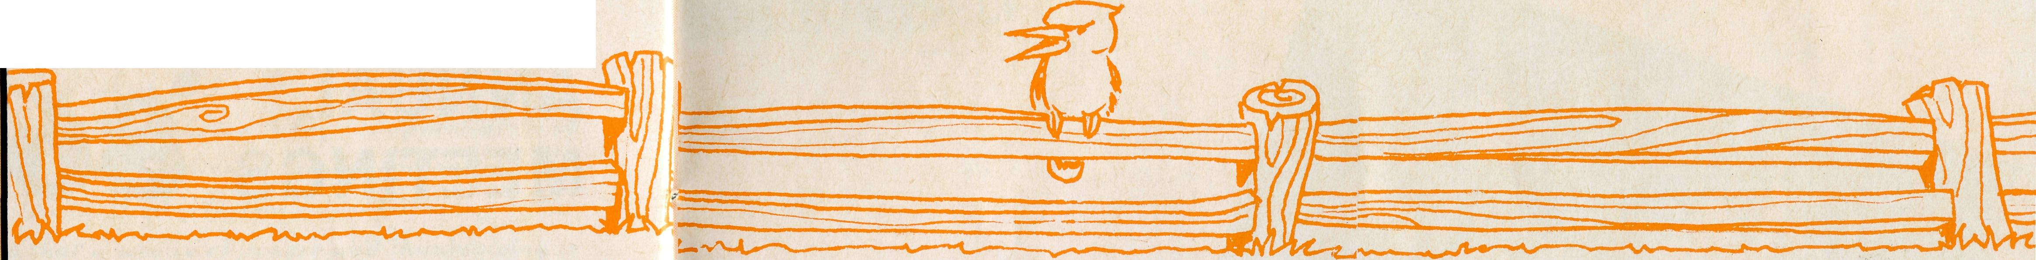
All enquiries to:
REAL AUSTRALIAN EDITOR
Brian Roberts
THE BUSH CHURCH AID SOCIETY
OF AUSTRALIA
135 BATHURST STREET,
SYDNEY, 2000
Phone (02)264 3164
Patron: The Primate, The Most Revd. John Grindrod.
President: The Most Revd. Donald Robinson, Archbishop of Sydney.
Vice-Presidents: Mr. Harold Bragg, O.A.M., Mr. Richard Stokes.
B.C.A.
STATE OFFICE
CONTACTS.. .
Federal Secretary:
General Secretary: The Revd. Brian
Roberts.
Communications Officer: Mr. Peter
Oram.
B.C.A. House, 135 Bathurst Street,
Sydney, N.S.W. 2000.
Phone: (02) 264-3164, 264-3780.
Victorian Secretary: The Revd. Alan Hoskin, 205 Flinders Lane, Melbourne, Vic. 3000. Phone: (03) 63-8962.
Sth. Australian Secretary: Rev. Bruce Cliff, 350 King William Street, Adelaide, S.A. 5000. Phone: (08)212-7804.
Queensland Hon. Secretary: Mr. Allan
Sauer, 28 Doughty Avenue, Holland Park
4121.
Phone: (07) 397 1501.
Western Australia Hon. Secretary: The Revd. Peter Brain, St. Luke's Rectory, 78 Pitchford Avenue, Maddington 6109. Phone: (09) 459-5169.
WELCOME:
Sister Helen Plumb as a Staff
Worker based in the Sydney Office.
Miss Megan Woodward as The
Reverend Brian Roberts' Personal
Secretary, she'll take over from Nina
Allan.
Sister June English in her new role
in coordinating the BCA Nursing
Services.
Sister Elizabeth Clegg as relief
sister to Cook and Tarcoola
Hospitals.
FAREWELL
Mrs Nina Allan after nine years' service in the Sydney Office. Nina has made a wonderful contribution to the Society as a whole not simply just the Sydney Office, her pleasant and efficient service on the switch for many years and her care of the Box Secretaries have been just two areas where Nina has excelled. Nina is an Aussie despite her accent (English/Scot). She was born in Tasmania and lived for many years in the UK and of course chose to marry Eric, a true Scot, which explains her brogue. We say a big thank you in the name of the Lord to Nina and wish her and Eric a long and happy retirement.
EXPRESSION OF THANKS The executive has decided that a presentation is to be made to Mrs Gwen Wade, wife of the late Federal Secretary, in recognition of her contribution to the work of the society. Subscriptions to this gift will be received at the Sydney office. The presentation is to be made at the A.G.M. in May.
DROP-IN ZEEHAN
The Drop-in Centre, the site at St Luke's Church at Zeehan has been finished. It was opened by two of the oldest locals on the 21st December. Miss Ruby Dimsey who cut the ribbon and Mr Len Brown who made an appropriate speech. Ruby has lived in Zeehan for eighty-two years, Len for seventy-six. Congratulations to the Zeehan congregation and especially to Walter and Eleanor Wheeldon in making this dream a reality, and above all let us praise God for this new tool of ministry to reach out to the people of Zeehan.
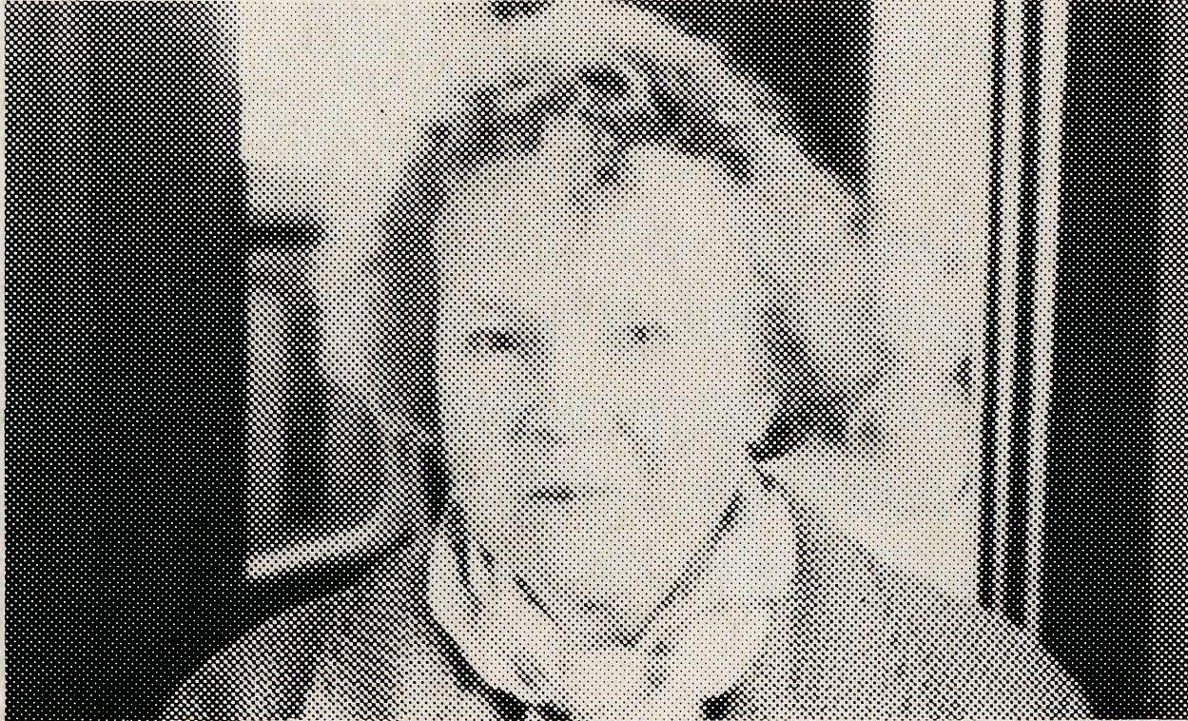
Miss Ruby Dimsey — Zeehan.
"THE SIN SHIFTER"
The existing vehicle in Winton Parish had to be replaced. The Uniting Church have been supplying the vehicles because our BCA Missioned care for the UCA people as well as the Anglicans. This time BCA had to assist a bit financially, so a suitable twin cab four-wheel-drive vehicle for the work could be bought. Mike Birch says, "It is a bright red model, creating quite a lot of local comment from, "The Rector's Sin Bin" to "The Sin Shifter". No doubt there will be fur-

ther confusion for the uninformed when they see a Uniting Church symbol on one side and a BCA Anglican Church logo on the other side.
PLEASE JOIN US

The Sydney Women's Auxiliary of the Society is an active group of ladies dedicated to the prayer and monetary support of those in the field.
Monthly meetings are held on the third Wednesday at BCA House Bathurst Street, Sydney and are pleasant gatherings of fellowship and sharing the news of recent BCA movements. Two special prayer meetings are held each year that have specific direction and are most uplifting. An annual Women's Rally and light luncheon with thank offerings and trading tables is held each Autumn with Regional Trading Tables operated by members throughout the year. These have proved to be a good source of income. One social function is also held each year and this year it will take the form of a luncheon at North Epping in May. Details are available from the office. Membership is open to all interested supporters of BCA and a warm and friendly welcome awaits you. Please join us.

10
THE REAL AUSTRALIAN
THE REAL AUSTRALIAN
11

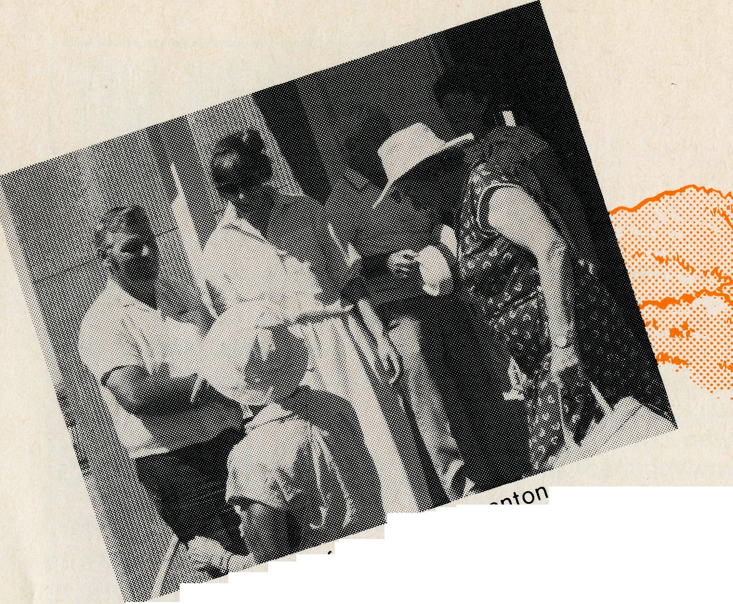
In what is believed to be a unique channel of Missionary Society support, BCA and Golden West Tours continue to offer a series of tours to Outback centres served by BCA Missioners. These tours are equal in standard to any tour offered in Australia, but have the added value of being planned to meet up with the extended family of BCA throughout Australia. In addition to the support offered to the Mis-sioner by the arrival of a group of supporters from back home, people who have travelled on the tours become more knowledgeable in their support of the families that they meet.
1985 Gulf and Reef Tour at Normanton. Spending some time chatting with John and Jennifer Summerell.
1985 Gulf and Reef Tour at the Bourke & Wills Camp (No it's not an Indian Chief on the right).
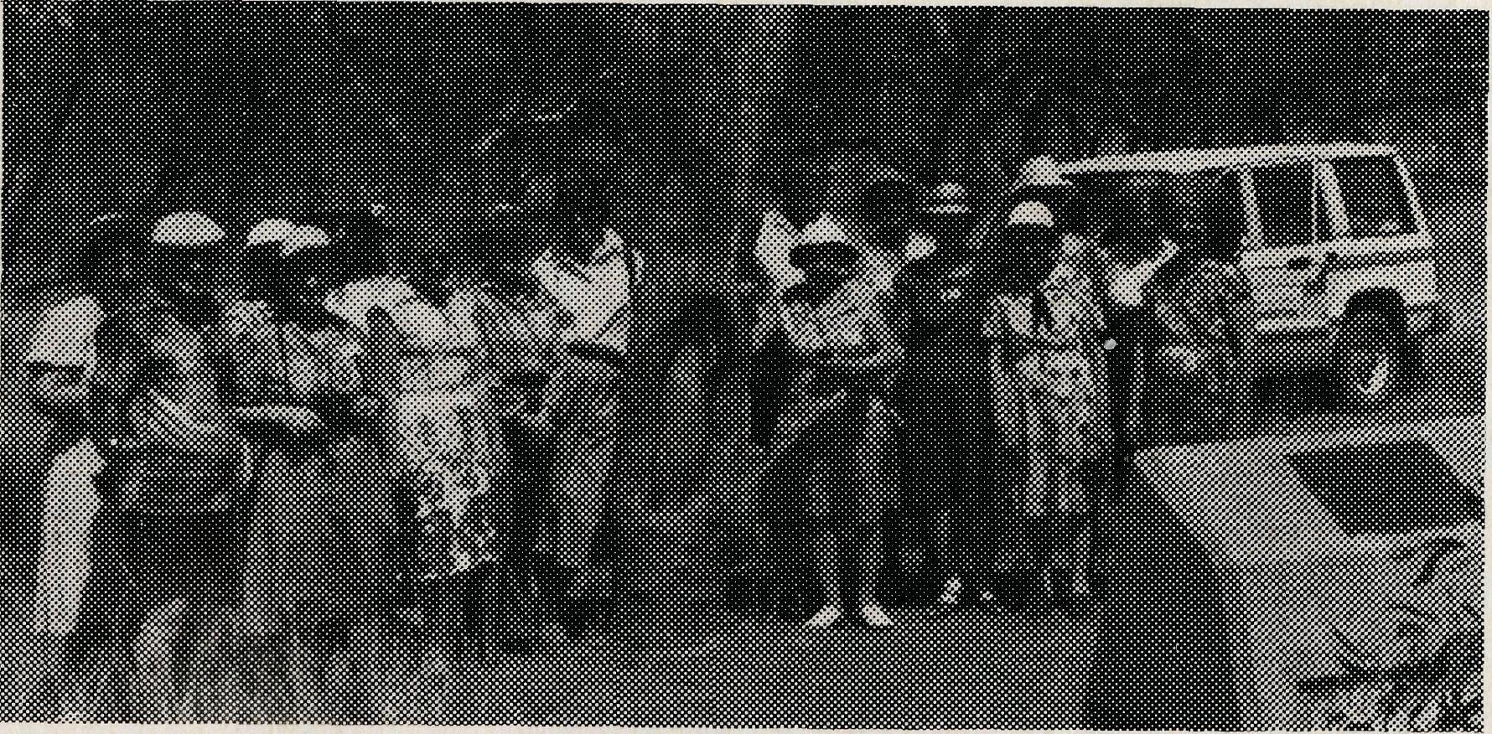
While travelling in the company of other Christians of like mind and interests, the tour can best be described as a travelling houseparty.
Tours for 1986 programme are:
GULF AND REEF TOUR: 23 days, departing from Sydney and Melbourne Monday 28th July, 1986. Includes Bourke, Charleville, Quilpie, Winton Mount Isa, Normanton, Georgetown, Atherton, Cairns and the Coastal return. $2285.00
1** ^{T}f5^^{,E} ^{IN} ™^{E} ^{SPRING:} Departures from Sydney and Melbourne, with the Abel Tasman crossing to Tasmania, and including Devonport Launceston, Hobart, Port Arthur, Zeehan (BCA) and the West Coast Departs Sydney Saturday 8th November, 1986, Melbourne Monday 10th, $1550 00 ex Sydney.
* * * LIGHTNING RIDGE AND THE GOLDEN WEST OF NSW: A short five day tour that covers the BCA centre of Lightning Ridge, as well as the Open Range Zoo at Dubbo and the Warrumbungle National Park. Departs from Sydney only 26th September, 1986. $475.00.
*** NORTH WESTERN AUTRALIA: Plans are progressing for the West Coast and the BCA centres for tours in 1986 and 1987. Details available as they come to hand.
Have your name added to a regular tours mailing list so that you can be kept up to date on the tour details as they come to hand.
CONTACT:
Miss Margaret Woolcott OR Mr John Cronshaw
BCA House Golden West Tours
135 Bathurst Street, ₂83 Main Street,
Sydney. 2000 Katoomba 2780
Phone (02) 264 3164 ₍₀47) 82 1866

THE REAL AUSTRALIAN
THE REAL AUSTRALIAN
13

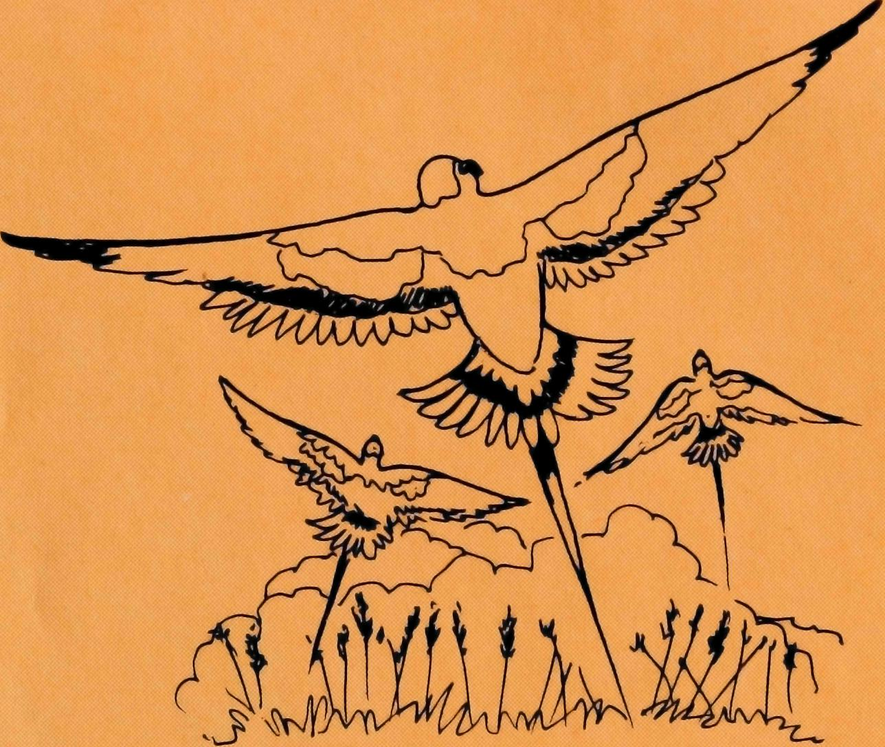
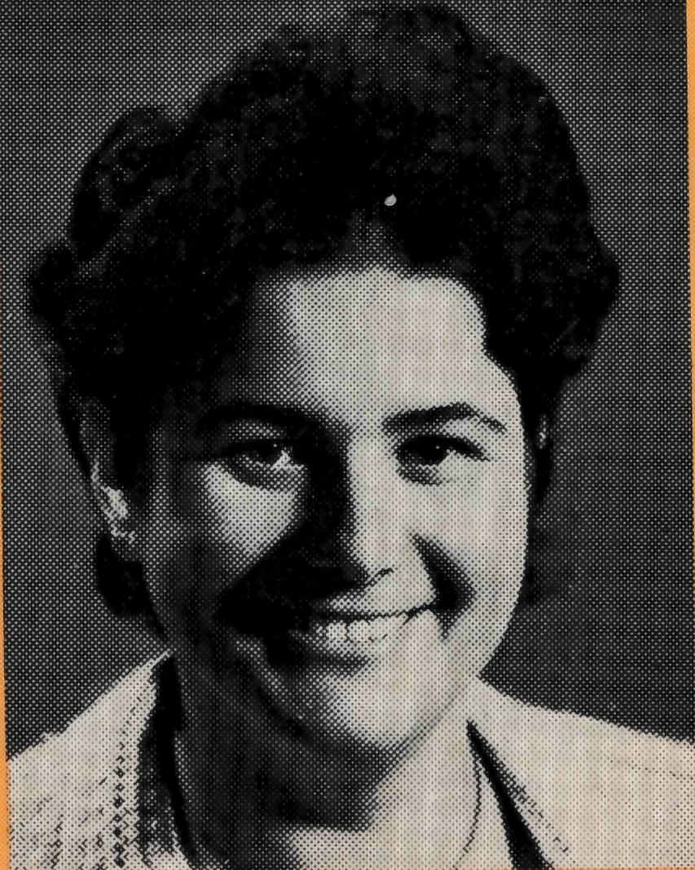
THE B.C.A. PRAYER
O Lord our God, help us to remember the people who live in the remote parts of our land. We ask You to bless those whom You have called into the fellowship of The Bush Church Aid Society, and call others to stand with them in the task. Grant that, through the ministry of the Word and Sacraments, through healing, and through caring for the young, the message of Your redeeming love may be proclaimed, through Jesus Christ our Lord. Amen.
HELEN'S NEW JOB: Sister Helen Plumb, who served at Tarcoola for some years has been appointed in a new capacity to the staff of BCA. After leaving Tarcoola Hospital Helen spent some time studying in Deaconess House and gaining pastoral experience. Her new role with BCA will have two facets. She will spend some time as a special deputationist in New South Wales and will also assist in BCA Field Situations helping to build up the local Church there. Helen was commissioned in Bega at the end of January by the rector, The Reverend Dalba Primmer who served with the Society in Newman in the late seventies.
THE REAL AUSTRALIAN
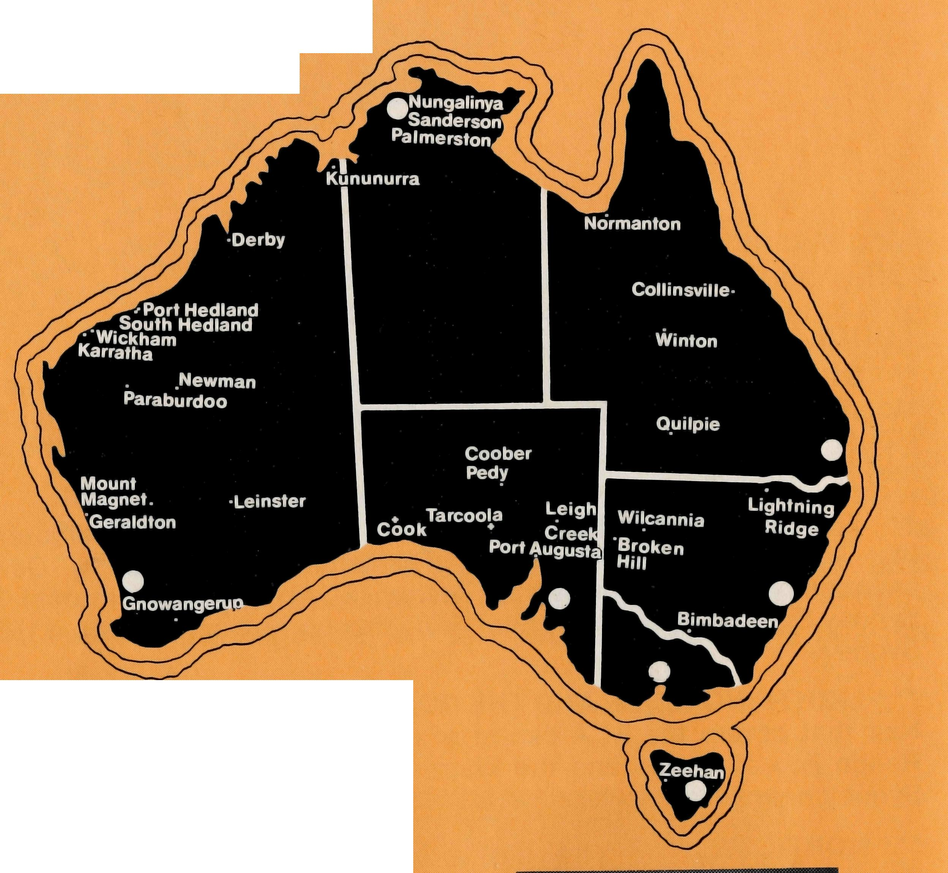
PRAYER CALENDAR
FIELD STAFF DIRECTORY
DIOCESE OF NORTHERN TERRITORY. The Rt. Revd. C. Wood.
- Darwin — Sanderson — Revd. Robert and Mrs. Rigmor George.
- Palmerston — The Revd. Ron and Mrs. Margaret Bundy. DIOCESE OF NORTH WEST AUSTRALIA. The Rt. Revd. G. B. Muston.
- Kununurra — The Revd. Peter Harradence.
- Derby — The Revd. Errol and Mrs. Anne Sorensen.
- Newman (East Pilbara) — The Revd. Arthur and Mrs. Pat Williams.
- South Hedland — The Revd. Peter and Mrs. Alison Moss.
- Port Hedland — The Revd. Adrian and Mrs. Willemien Moore.
- Karratha (West Pilbara) — The Revd. George and Mrs. Jacqueline Sansom.
- Wickham — The Revd. Angus and Mrs. Anne McDonald.

- Paraburdoo (South Pilbara) — The Revd. Gordon and Mrs. Ann Hargreaves.
- Geraldton — Mr. Martin and Mrs. Kim Weatherston.
- Mt. Magnet (Murchison) — The Revd. Greg and Mrs. Rhi Jones.
- Leinster — The Revd. Don and Mrs. Celia Miller. DIOCESE OF WILLOCHRA. The Rt. Revd. S. B. Rosier.

- Cook Hospital — Sister Margaret and Jack Barnes and Sister Ann Bolton; Sister June English (Nursing Co-ordinator); Sister Elizabeth Clegg (Relief Sister).
- Tarcoola Hospital — Nurses Mr. Keith and Mrs. Rhonda Anstee. Tentmaker . . . Sister Lynn Pickersgill.
- Coober Pedy — The Revd. Martin and Mrs. Vivien Bleby.
- Mid-West Mission — The Revd. David and Mrs. Margaret Griffin.

- Leigh Creek — The Revd. Des and Mrs. Judi Arthur. DIOCESE OF TASMANIA. The Rt. Revd. P. Newell.
- Zeehan — The Revd. Walter and Mrs. Eleanor Wheeldon. DIOCESE OF RIVERINA. The Rt. Revd. B. R. Hunter.
- Broken Hill Hostel — Mr. Tony and Mrs. Barbara Pickering, Mr. Bob Pearce.
- Wilcannia — Vacant.
DIOCESE OF ARMIDALE. The Rt. Revd. P. Chiswell.
- Lightning Ridge — The Revd. Cliff and Mrs. Megan Ainsworth. DIOCESE OF ROCKHAMPTON. The Rt. Revd. G. Hearn.
- Winton — The Revd. Michael and Mrs. Elizabeth Birch. DIOCESE OF NORTHERN QUEENSLAND. The Rt. Revd. J. Lewis.
- Collinsville — Vacant.
DIOCESE OF CARPENTARIA. The Rt. Revd. A. Hall-Matthews.
- Normanton (Southern Gulf) — The Revd. John and Mrs. Jennifer Summerell. DIOCESE OF BRISBANE. The Most Revd. J. Grindrod.
- Quilpie — Vacant. GENERAL

- VICTORIA. The Revd. Alan Hoskin, Mrs. Margo Bright. QUEENSLAND. Mr. Allan Sauer (Hon. Secretary).
- SOUTH AUSTRALIA — The Revd. Bruce Cliff, Mrs. Marilyn Brown. WESTERN AUSTRALIA. The Revd. Peter Brain (Hon. Secretary).
- FEDERAL & N.S.W. OFFICE, COUNCIL & SUPPORTERS
Federal Secretary. Vacant. N.S.W. The Revds. Brian Roberts, Eric Atkin, Mr. Peter Oram, Sister Helen Plumb, Miss Margaret Woolcott, Mesdames Jacqueline Griffiths, Dora Warwick, Vivien Bentley, Margaret Sadler, Miss Megan Woodward.
30 Nungalinya College — Mrs. Sandra Kinslow.
Gnowangerup — The Revd. Chris and Mrs. Marilyn Clerke.
Bimbadeen N.S.W. — Pastor Graham Paulson.
15
THE REAL AUSTRALIAN

