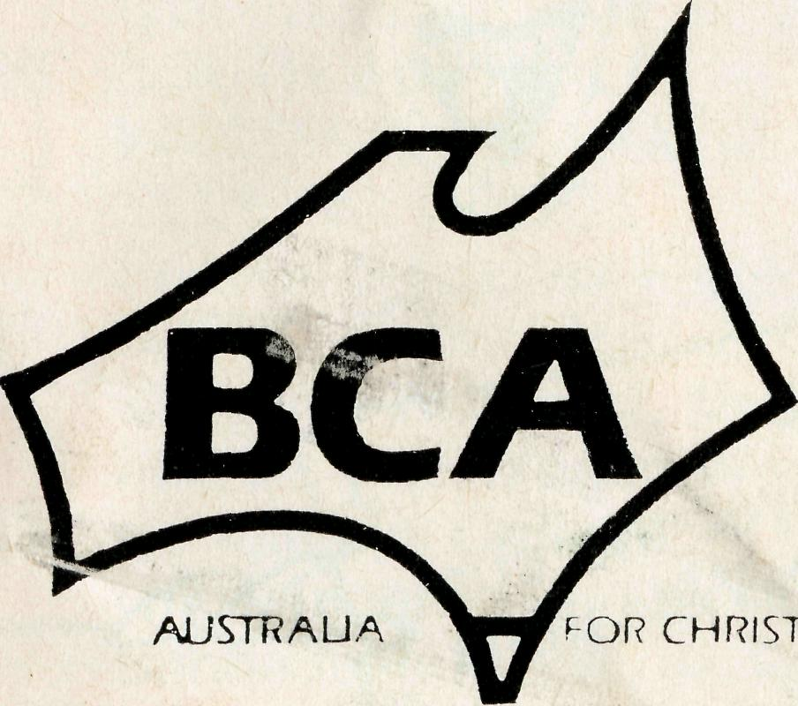
OPPORTUNITY FOR MISSIONARY SERVICE IN NORTH WEST AUSTRALIA
"CHRISTIAN BUILDER"
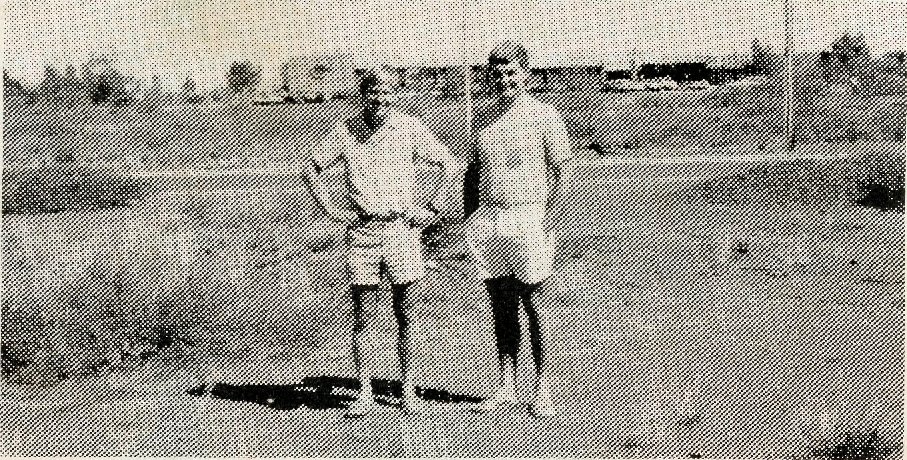
Revd. Peter Moss and David Stevens (a parishioner on the site of the St. Peter's South Hedland.
The Diocese of North West Australia has launched its "OUTBACK CHURCH FOUNDATION". Initially the Foundation will build seven churches and two rectories throughout the Diocese. The Bush Church Aid Society has undertaken to find and fund a builder to co-ordinate, supervise and erect the proposed buildings throughout 1987.
Further information about this unique opportunity from the Federal Secretary of B.C.A.
B.C.A. IN PARTNERSHIP UPFRONT OUTBACK
please cut off and return
Mr/Mrs Miss/Rev
I WISH TO:
- KNOW
- PRAY a GIVE
THE BUSH CHURCH AID SOCIETY
NSW 135 Bathurst Street, Sydney, 2000 Phone: (02) 264 3164
(Receive the Real Australian) (Join the Prayer Fellowship. Please send me the Prayer Notes) EL (I would like a B.C.A. money box.) D (Please inform me of needs regularly)
a go
(I am interested in serving God in Outback Australia)
Printed by Ambassador Press Pty. Ltd., Granville 2142.
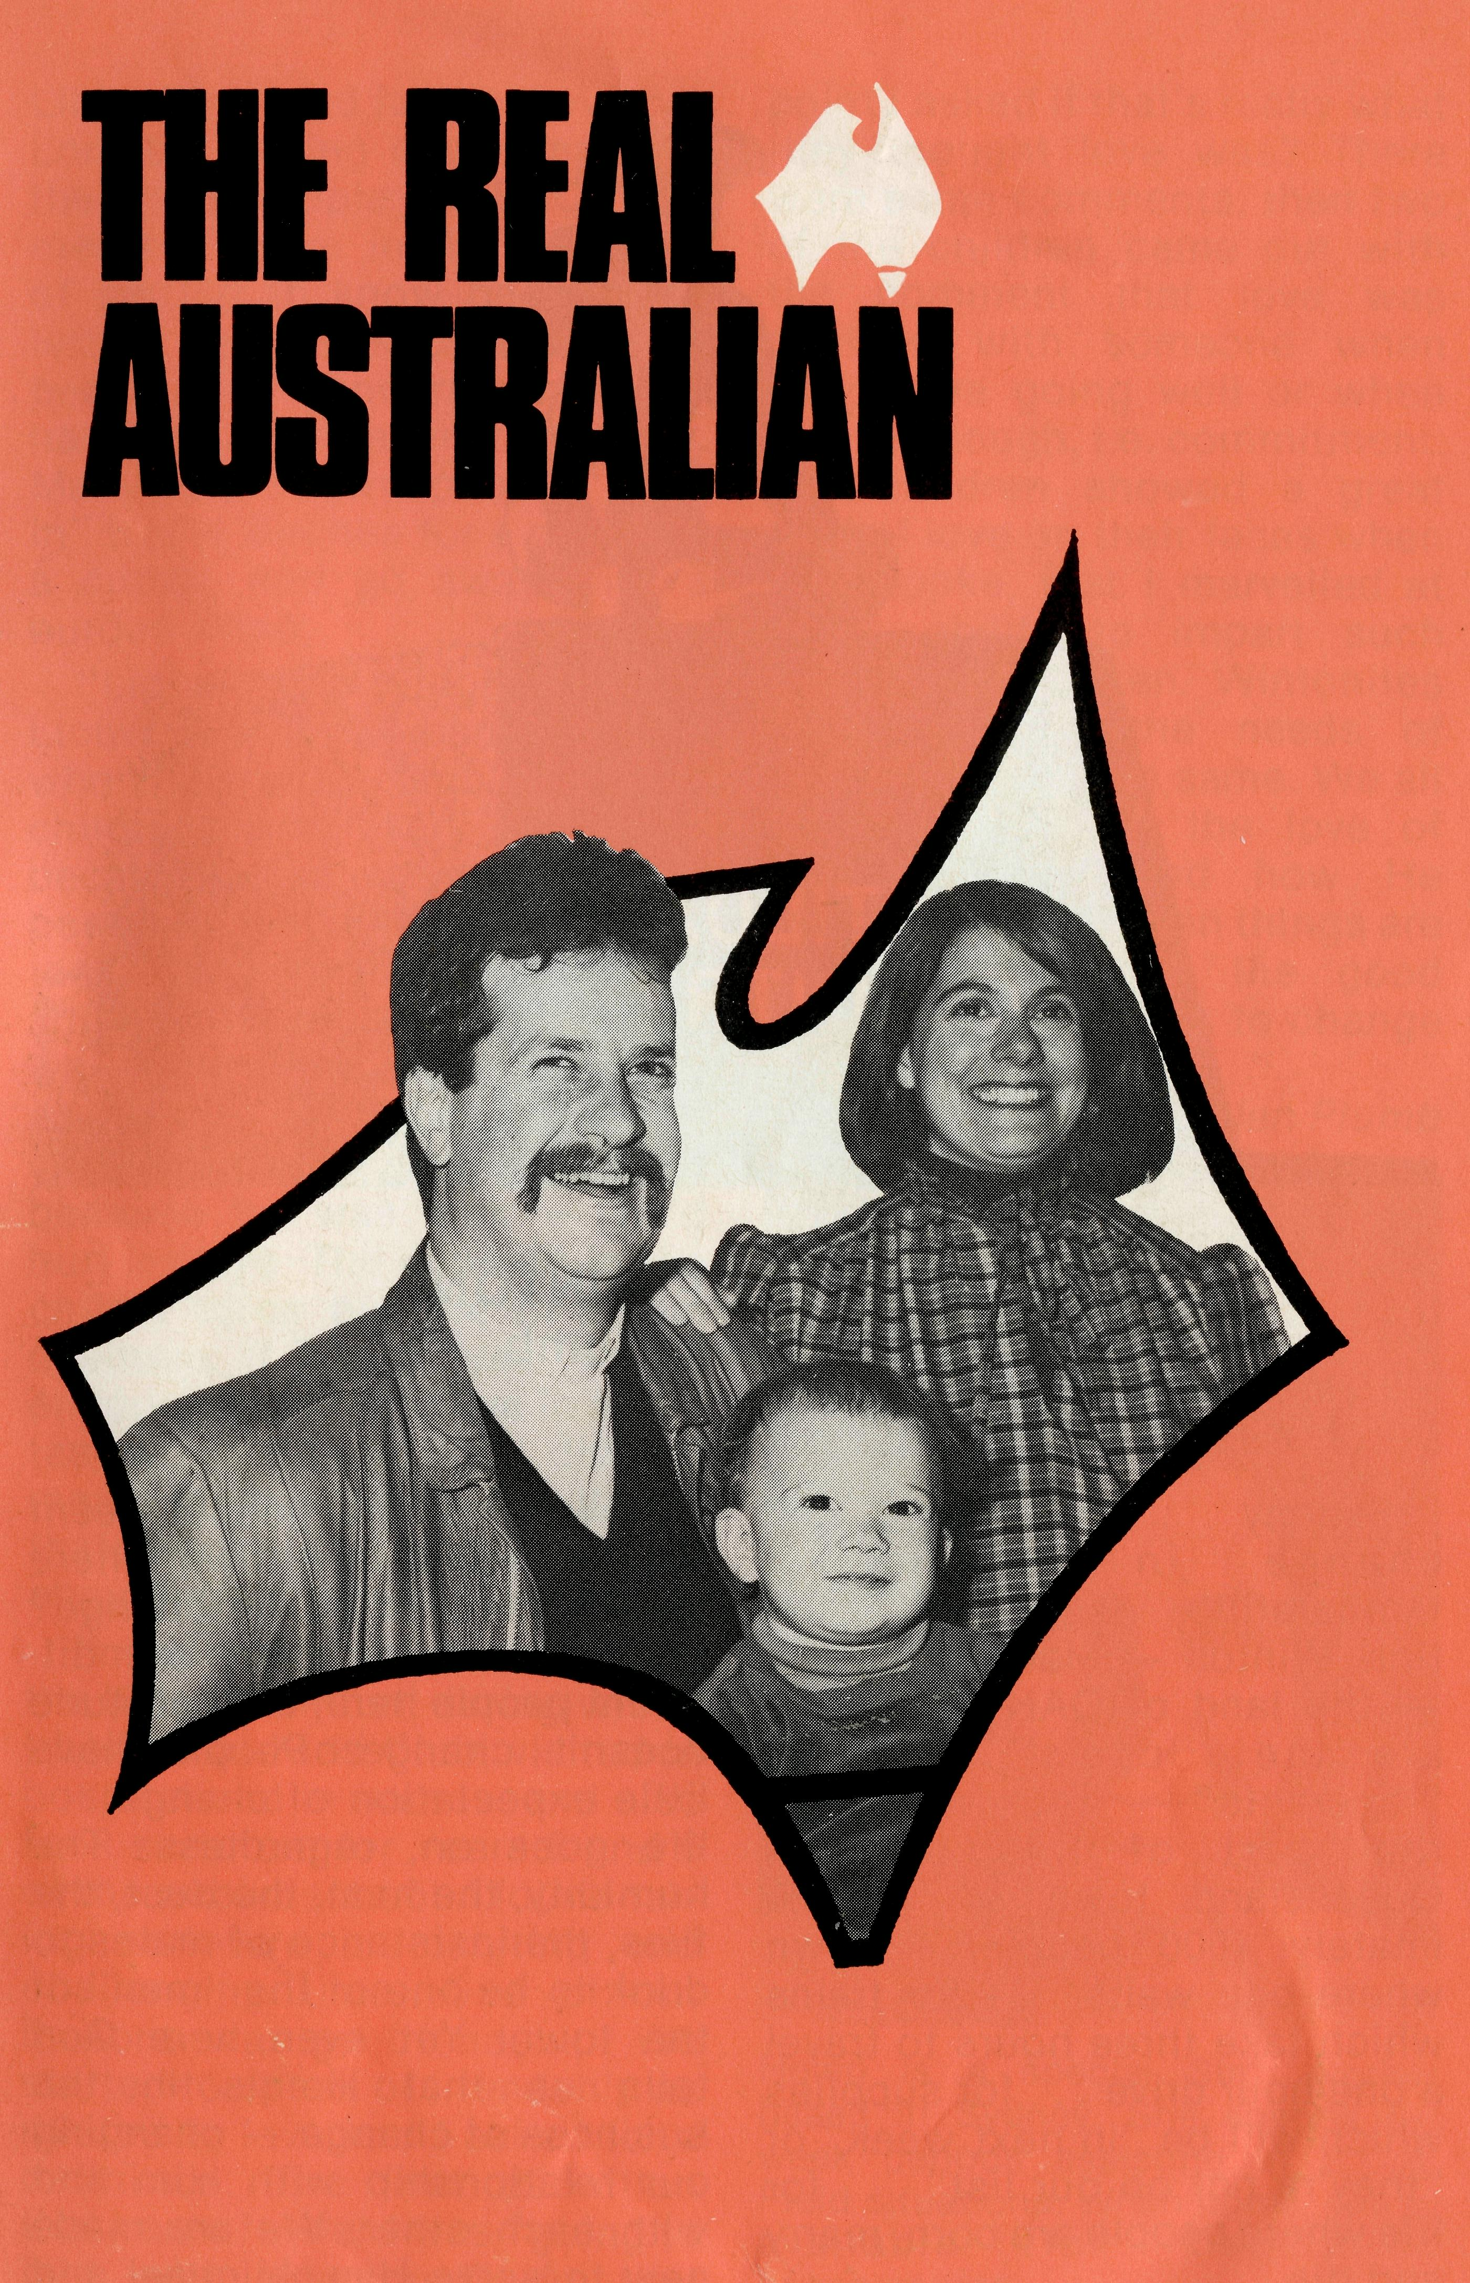
SEPTEMBER 1986. $3.00 subscription. Reg. by Australia Post. Publication No. NAR 0630

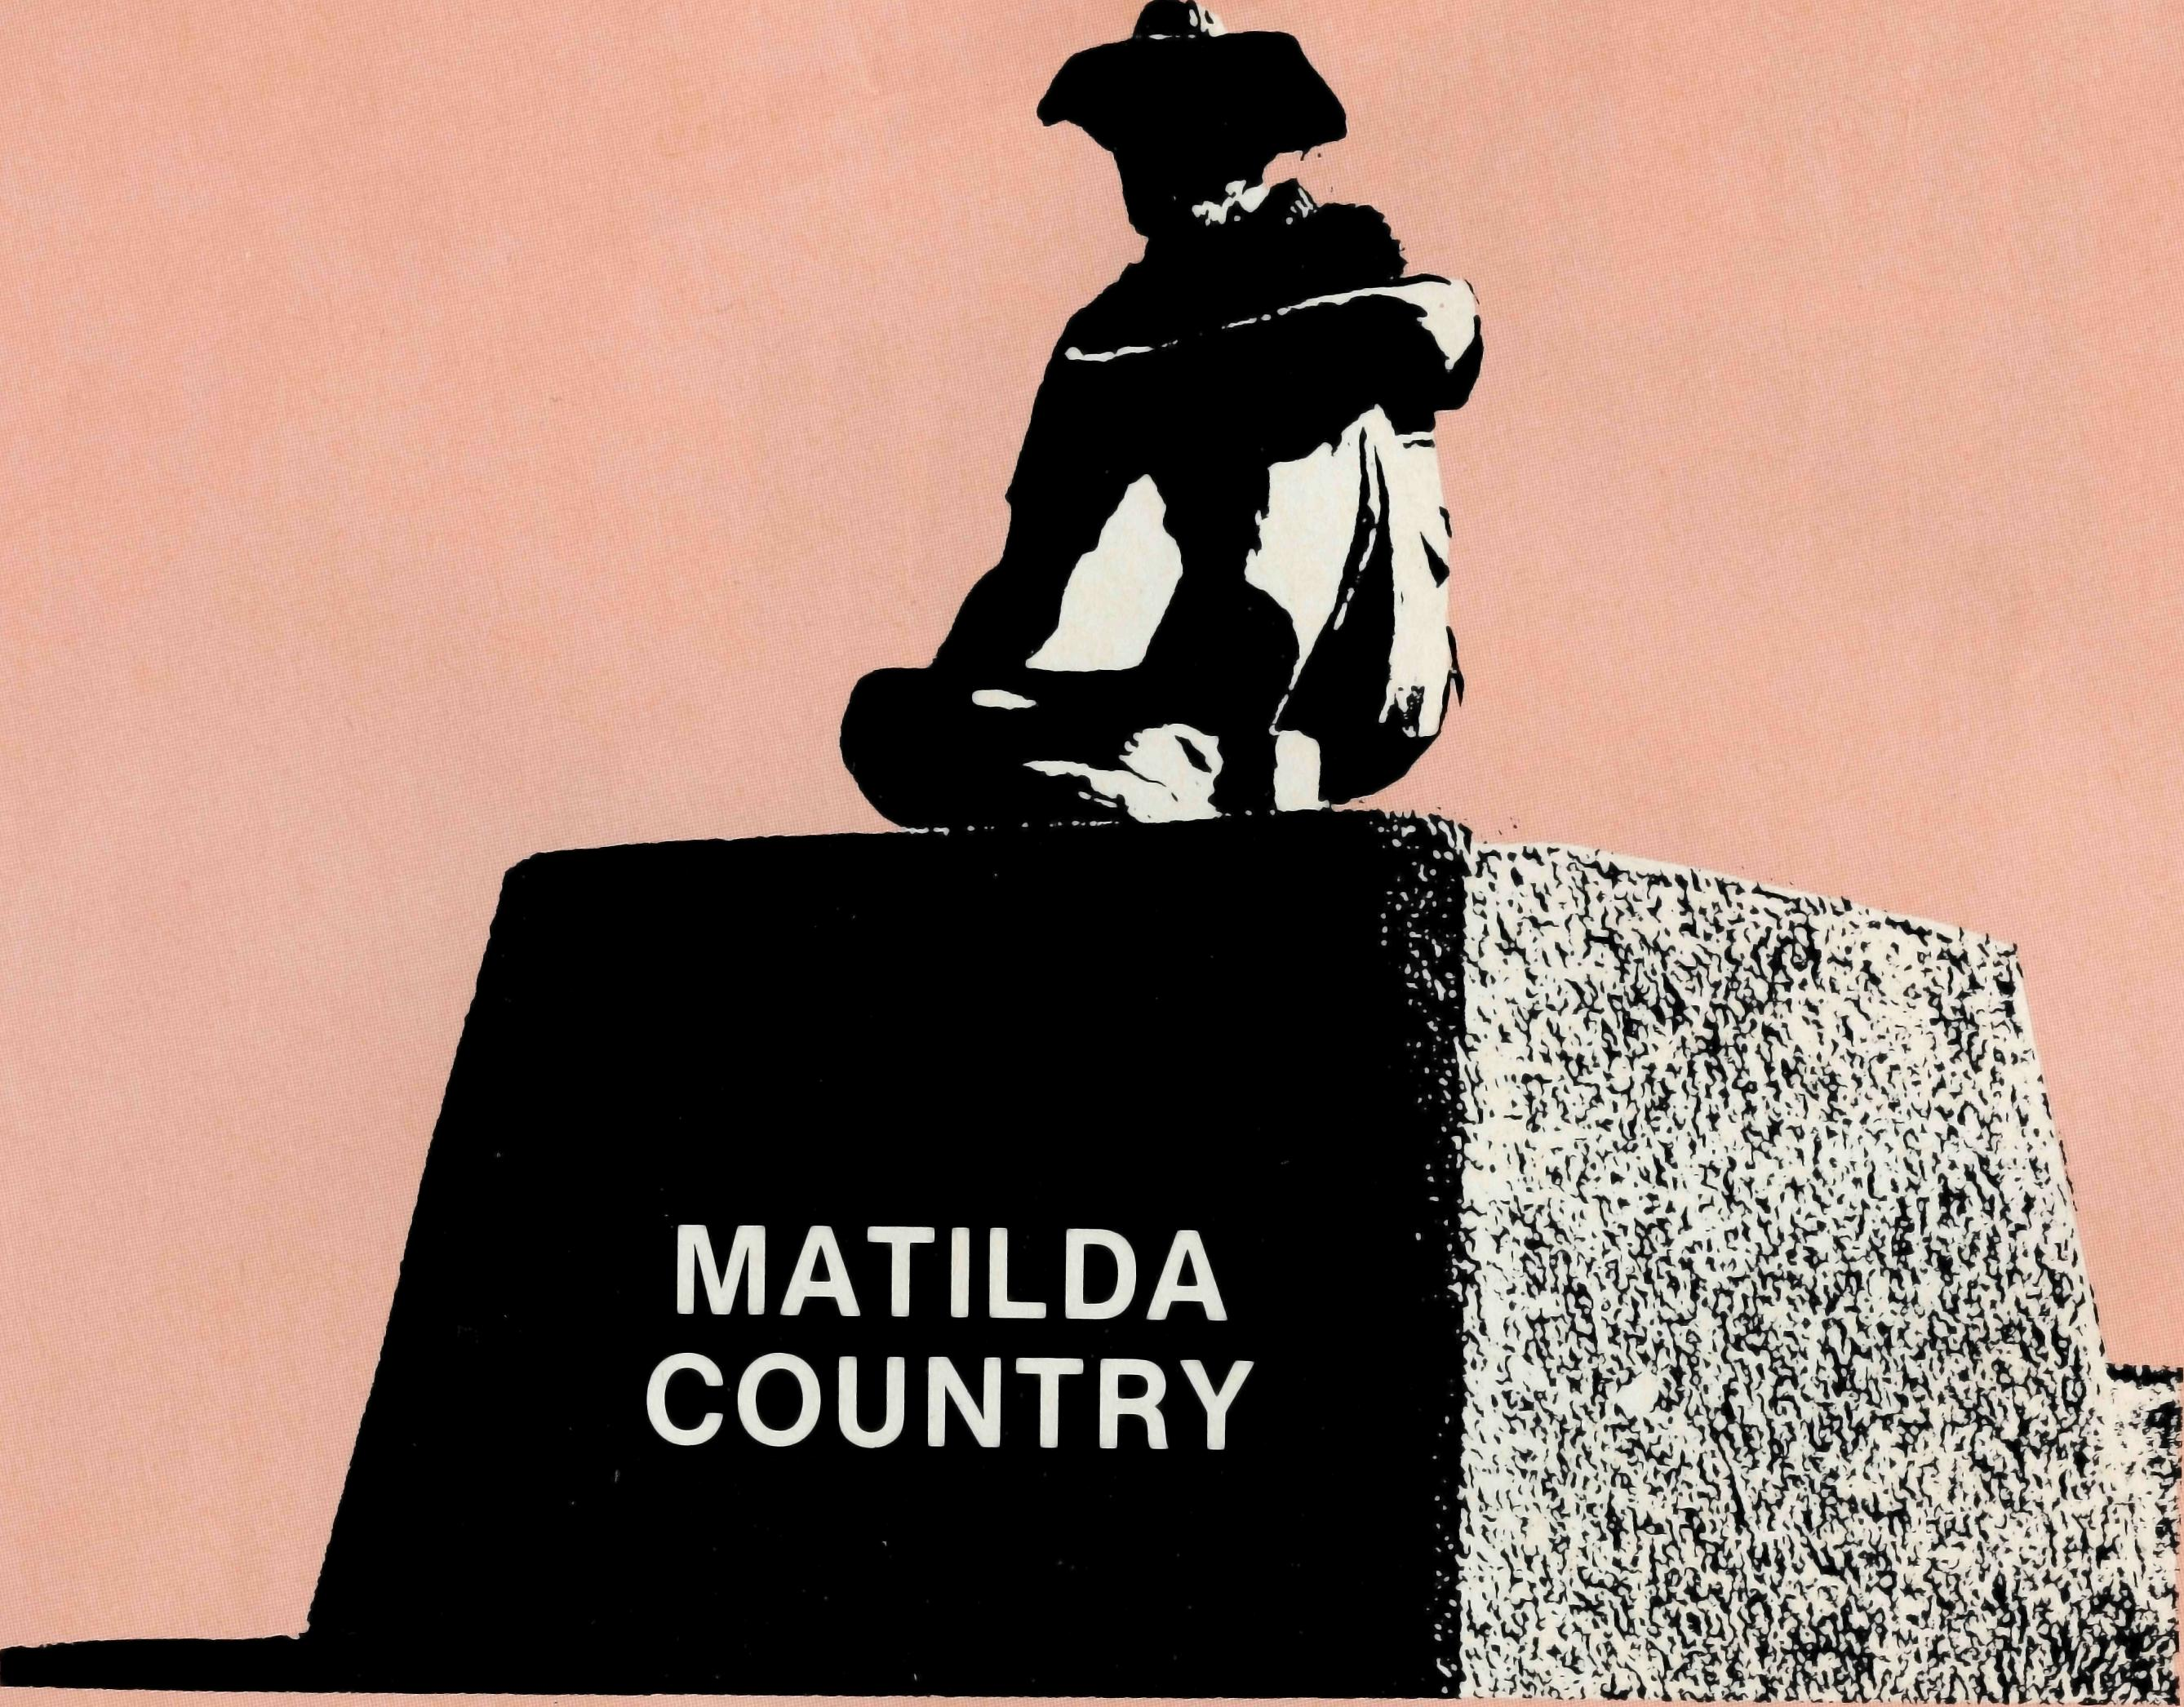
Sydney . . . Winton, a vast change In population, temperature, degree of isolation. Winton — Matilda Country — the land of QANTAS. There are the "locals" and the "itinerants" — both are a very real part of this outback Queensland town of approximately 1000 people. A town where one waits ... for trains which take three hours to travel a one-hour drive ... for supplies which will be "in next week" or "they're not on our list" ... for life where people are born, marry and die.
A REPORT OF WINTON
from Helen Plumb
How does the gospel seem real to people in a town where there seems to be no change? . . . even though there are different people here, their attitude doesn't change. People have little expectation of change . . . life goes on, regardless. The humidity, the heat, the dust, the flies, the insistence of mates to drink to be one of the "men" of the town. Yet even here God tells us that He is in the business of change — changing our relationship with Him and with each other. We are made new to serve Him. Michael and
THE REAL AUSTRALIAN

Libby Birch and family serve our Lord by inviting many, many of the townspeople for BBQs and meals. They're in the business of getting to know people and letting others know them as people. A wonderful ministry has been undertaken in this way. Many of the townspeople "drop in" to the Birches for a chat and a cuppa, and go away with a burden lifted.
"Lionel" came to Kids Club. Lionel is a small hand puppet, who visited Kids Club only if the children were very quiet — because he is very shy. Lionel got on so well with the children that two asked for Lionel's address before he left. There was a problem: Lionel had lost an eye. One of the children asked if we could pray for Lionel because he was sick — he'd hurt his eye. The concern in the child's voice put me in a real dilemma. If I said "yes" I'd be encouraging him to live in a fantasy world. If I said "no", did that mean there were some things that were too small to pray about? What would you say?
I'm very grateful to have had the time in Winton, during which I helped at Kids Club, visited in hospital and in homes, and also took scripture for Years 5 and 6 of the public school. I found taking scripture an exciting and challenging time. One of our lessons was on friendship. We started to speak of friendship as related to love and I asked for a definition. The first definition that came forward was "going to bed with someone". At that
THE REAL AUSTRALIAN
point I asked if that's really what they thought love was? There were some comments, then two of the children came out with the comment that love was sticking with someone when things are going well or when they are tough, i.e. commitment. The children showed a great deal of love on their faces when they spoke, that I marvelled at God's ability to impart such wisdom to chidren. Wintonites or Sydneyites, the needs of people are still the same. We all need to know of the love of Jesus for us, and how He "sticks with us" when things are tough, as well as the good times, and causes us to change into His likeness.
Helen Plumb
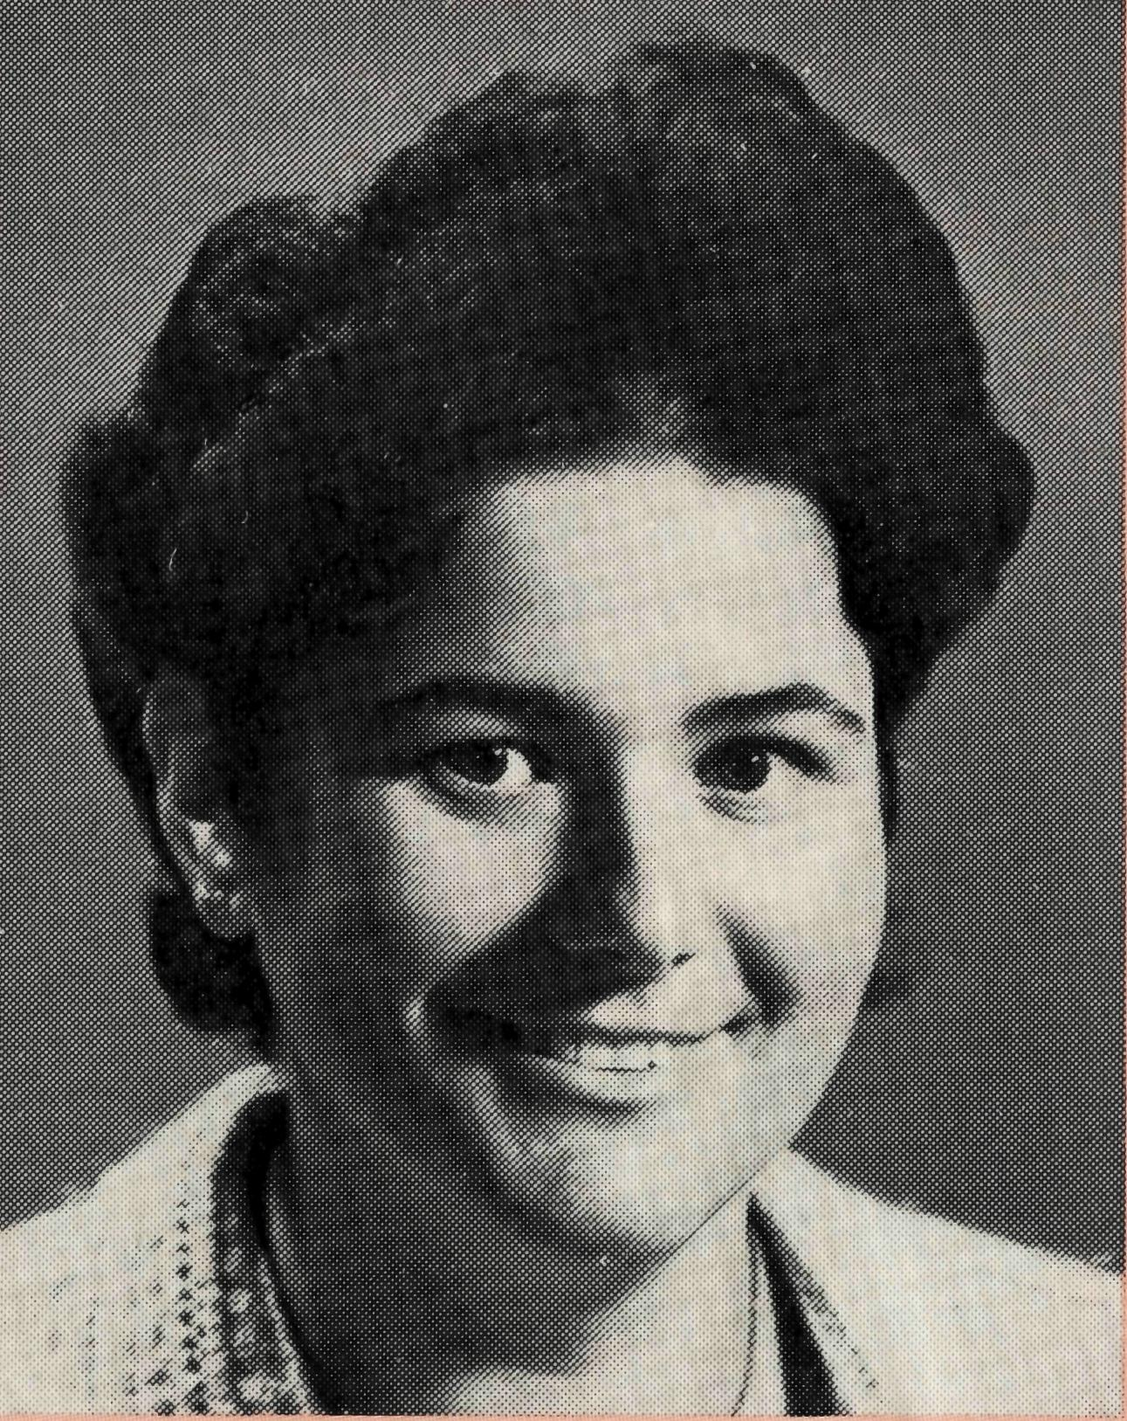
Helen is a special Staff worker based in Sydney. She spends 6-8 week periods assisting in B.C.A. Field situations. When home, she is available for Deputation engagements.

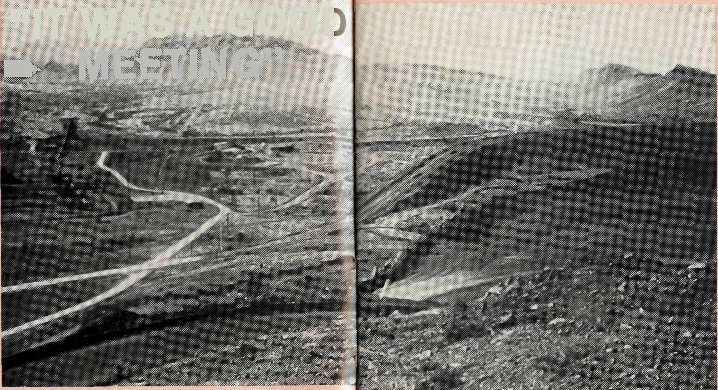
"IT WAS A GOOD MEETING"
All enquiries to:
THE REAL AUSTRALIAN EDITOR
Brian Roberts
THE BUSH CHURCH AID SOCIETY
OF AUSTRALIA
135 BATHURST STREET,
SYDNEY, 2000
Phone (02)264 3164
Patron: The Primate, The Most Revd. John Grindrod.
President: The Most Revd. Donald Robinson, Archbishop of Sydney. Vice-Presidents: Mr. Stan Hummerston, O.A.M.; Mr. Richard Stokes.
B.C.A.
STATE OFFICE
CONTACTS.. .
Federal Secretary: (Elect) Rev. Ernie
Carnaby.
General Secretary: The Revd. Brian
Roberts.
Communications Officer: Mr. Peter
Oram.
B.C.A. House, 135 Bathurst Street,
Sydney, N.S.W. 2000.
Phone: (02) 264-3164, 264-3780.
Victorian Secretary: The Revd. Alan
Hoskin, 205 Flinders Lane, Melbourne,
Vic. 3000.
Phone: (03) 654-8022.
Sth. Australian Secretary: Rev. Bruce
Cliff, 350 King William Street, Adelaide,
S.A. 5000.
Phone: (08) 212-7804.
Queensland Hon. Secretary: Mr. Allan
Sauer, 28 Doughty Avenue, Holland Park
4121.
Phone: (07) 397 1501.
Western Australia Hon. Secretary: The Revd. Peter Brain, St. Luke's Rectory, 78 Pitchford Avenue, Maddington 6109. Phone: (09)459-5169.
SOUTH PILBARA PARISH: PARABURDOO
The weekly notice sheet read "Monday 17th, 6.30 pm, Vestry Meeting at Richard and Jenny's, Tom Price".
Three of us travelled 80 km from Paraburdoo to the meeting which was preceded, as usual, by a lovely meal and lots of chat about work, holidays, four-wheel drives and the water level in the bores.
The meeting began with a devotion on worship and an opening prayer, followed by apologies, minutes of the last meeting, correspondence and then the treasurer's report.
Jim, our treasurer, informed us that we had $117 in the bank and all accounts were paid. Then he reported on the outcome of our building project over the past nine months. The cost was $4312.65 and through donations and a small amount of fund-raising we had received $4312.65
THE REAL AUSTRALIAN
— the exact same amount (although Jim did say that he put in 62 cents to make it balance).
We took this as a real sign of God's blessing and we are all very thankful to God for His faithfulness. Many B.C.A. supporters have prayed about the project — that the finance would be provided for building the carport into a study — and so we can rejoice together. (Thanks to our many friends who made donations.)
The Vestry went on to discuss and plan the strategy for outreach which it has developed.
We simply alternate social activities in the towns with more Christian activities. We invite a wide circle of people to the social activities, thus forming bridges of friendship — in the hope that, in time, they will accept an invitation to a service or an activity where some aspect of the gospel is presented in one way or another.
THE REAL AUSTRALIAN
Some of our social activities have been kite-flying and BBQs, pool nights where we hire the local swimming pool and also invite all the other churches, family fun nights, and a Christmas dinner in the back garden of one of our homes.
Some of our more Christian-oriented activities were a visit by John Chapman speaking on "Being Friends with God" — as well as teaching on "Sharing Your Faith"; also a "Walk Through the Bible" seminar; Josh McDowell's "Evidence of Faith" film series; and later in the year a visit by Graham Laycock — a Baptist layman and physiotherapist who is also blind.
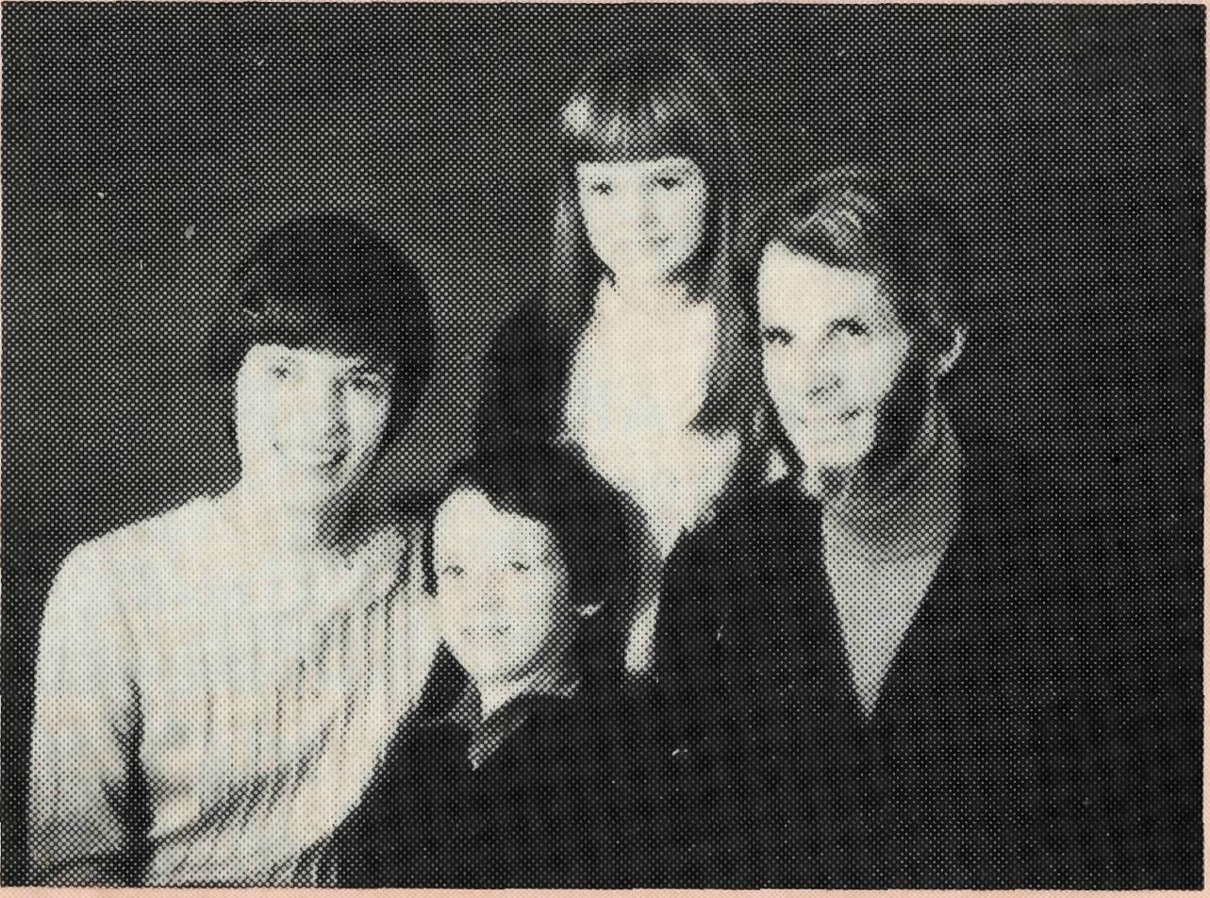
Revd. Gordon and Mrs. Ann Hargreaves.
Meanwhile it's on with the general business which concludes with prayer at 9.45 pm, and we set off again on the home trip with thankfulness to God for another good meeting — and keeping a close eye out for the 'roos and cattle on the road.

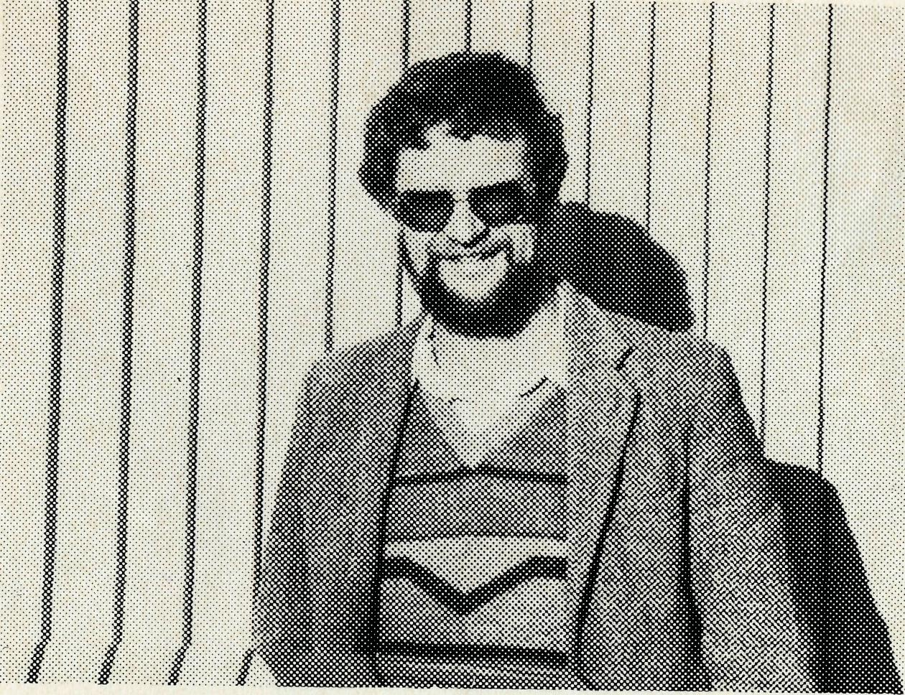
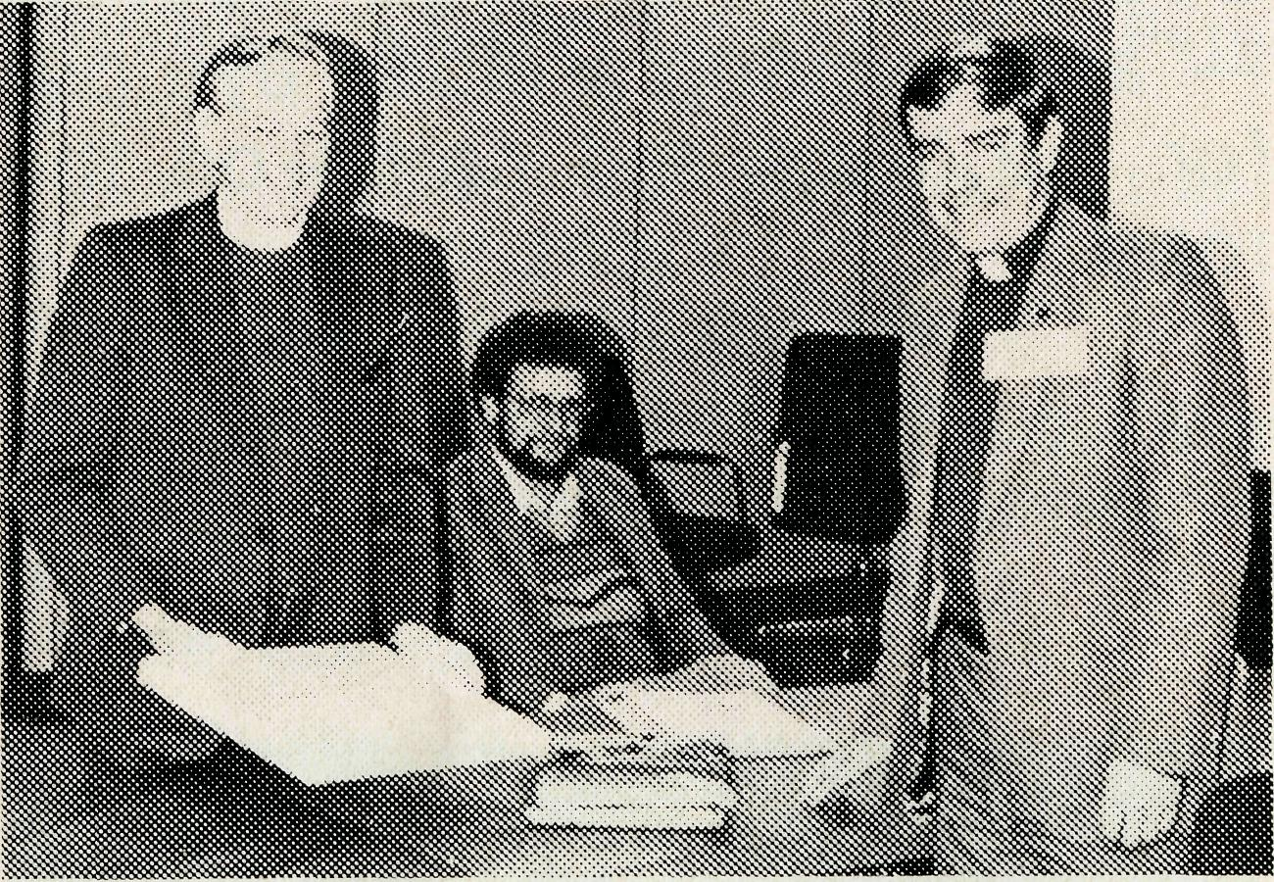
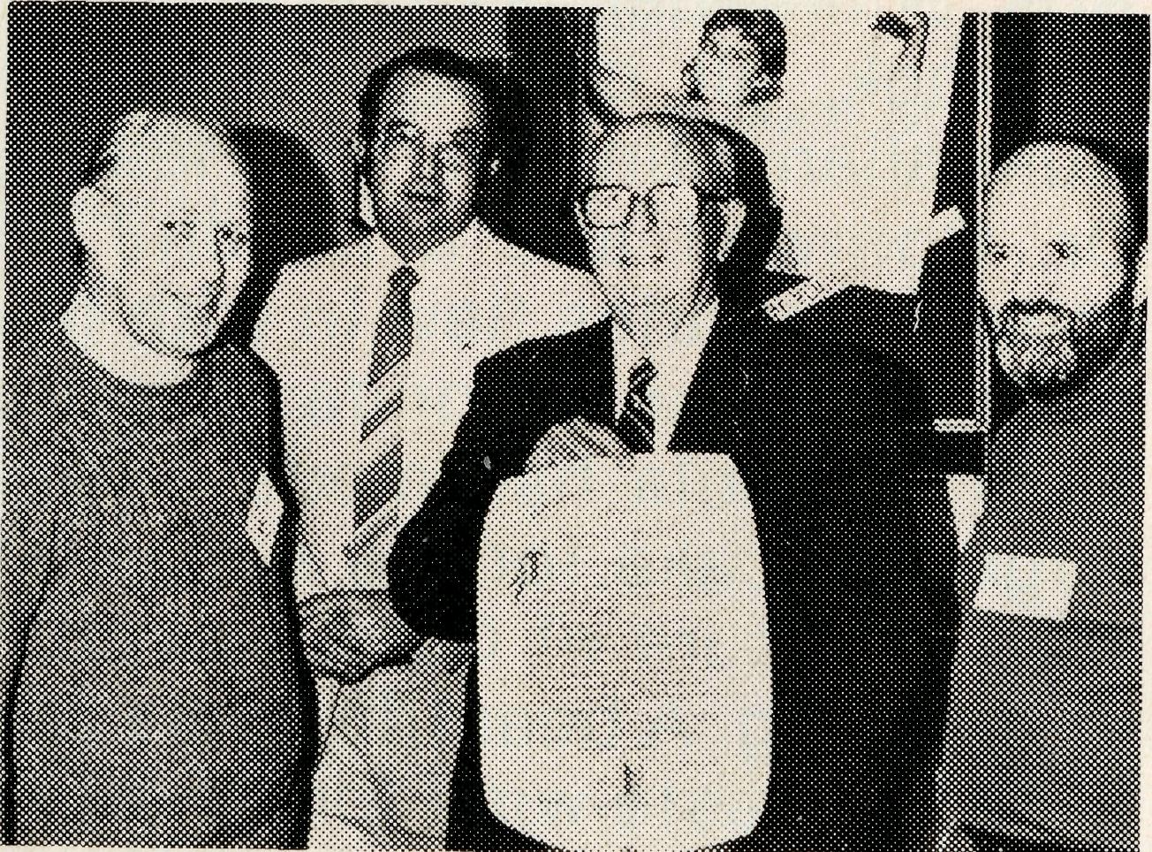
GUEST MISSIONER
CHAIRMAN RETIRES
The Dean of Sydney, the Very Reverend Lance Shilton, resigned as Chairman of the Executive of the B.C.A. Council. Under his Chairmanship over the past seven years the Society has forged forward in its ministry to Outback Australia. As a token of thankfulness for his service, the Reverend Ernie Carnaby (Federal Secretary Elect) made a presentation of an original painting of an outback scene to Dean Shilton on behalf of the council.
The Dean, with Ernie Carnaby (Greg Jones, B.C.A. Missionerat Mt. Magnet in background).
MISSIONERS AND THEIR FAMILIES
Tribute was paid to the self-giving nature of the Missioners and their families. Reports from each of the centres of Ministry were collated together and cir-
Left to right: The Reverend Brian Viney (Victoria), Mr. John Cronshaw (N.S.W.), Mr. Harold Bragg. The Reverend Alan Hoskin (Victorian State Secretary).
HIGHLIGHTS
of Annual General Meeting
and Meeting of the Council
of B.C.A. 1986
culated to each of the members of the Council prior to the meeting. These formed a basis for discussion about the ministry which is offered by the Society to remote Australia. The need to improve the support structure for missioners and special workers not only while on the field but before and after service was highlighted.
CHRISTIAN BUILDER
Discussion at the council meeting and later finalised at Executive level was the decision to support the "Outback Church Foundation" in the Diocese of Northwest Australia. The Foundation which was launched in July in the Northwest aims to build multi-purpose Church buildings in seven centres. They are urgently needed at Newman, Paraburdoo, South Hedland, Port Hedland, Wickham, Kununurra and Kalbarrie. The Bush Church Aid Society has decided to try and find and fund a Christian builder to supervise the direction of these buildings during 1987. The Society's currently advertising to fill this vacancy for a missionary builder.
THE REAL AUSTRALIAN
The Reverend Greg Jones, Missioner at Mt. Magnet, led a devotion on the gospel narrative of the Good Shepherd in the same way that he would have if he were addressing a fellowship of Aboriginal people in his parish. Greg showed by example the wide variety of gifts that were needed to have an effective ministry in the bush.
Mr. Harold Bragg, O.A.M., retires
After almost a lifetime of association with B.C.A., Mr. Harold Bragg, one of the Society's Vice-Presidents, retired. The Reverend Tom Morgan, in summing up the valuable contribution made by Mr. Bragg to the Society, drew attention to the fact that Mr. Bragg's mother was a foundation member of the Society and that Mr. Bragg had continued the family support. An illuminated address was presented to Mr. Bragg (pictured) which said,
TO Mr. HAROLD MARTIN
BRAGG, O.A.M. Esq.
On the occasion of your
retirement as Vice-President Members of the Bush
Church Aid Society of
THE REAL AUSTRALIAN
Australia wish you to have this memento, in recognition of your many important and valuable services, which through a long course of years, and with much sacrifice of time, you have rendered to the Society.
As a supporter, member of Council and its Executive, and since 1974 a Vice-President, you have ever displayed clear Christian thinking and your conduct has been characterised by devotedness, energy and faithfulness. While at the same time you have set an example of liberality in the support of the Society. Your ability in the printing craft has enhanced our publications and furthered our Lord's loving care for the people of the outback.
It is our earnest prayer, for
you and Mrs. Bragg, that the
blessings of our Heavenly
Father may follow you
everywhere and always.
President Chairman
May 29, 1986

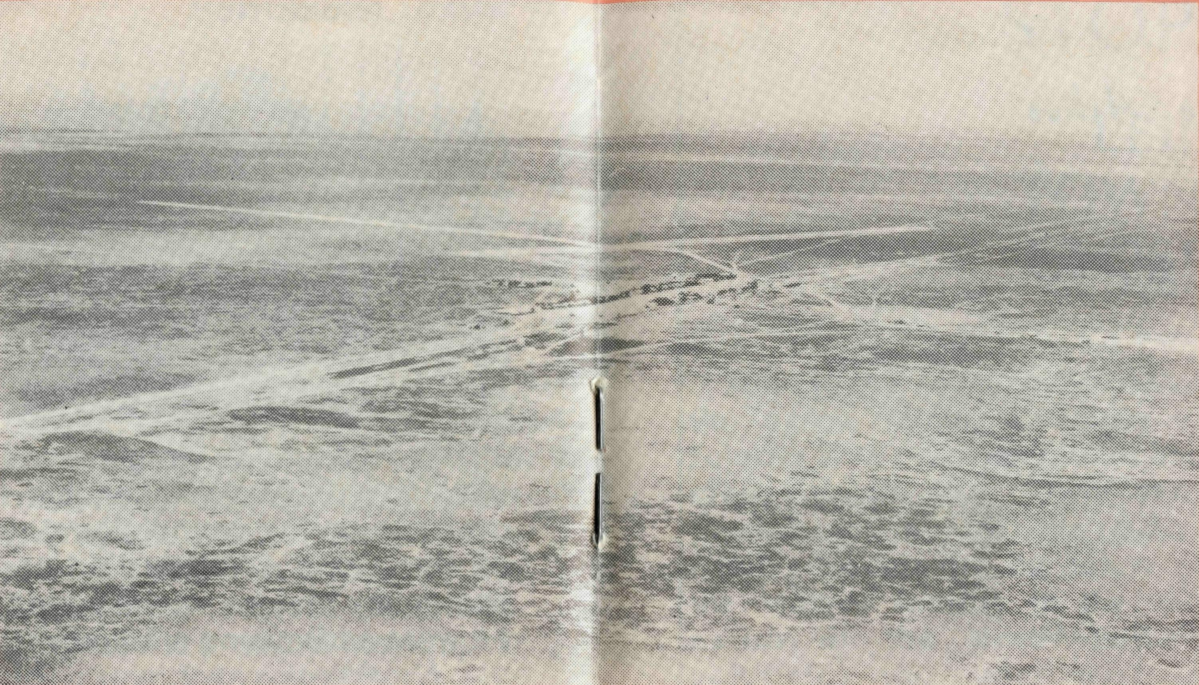
Cook from the air.
• Hospital staff at Cook
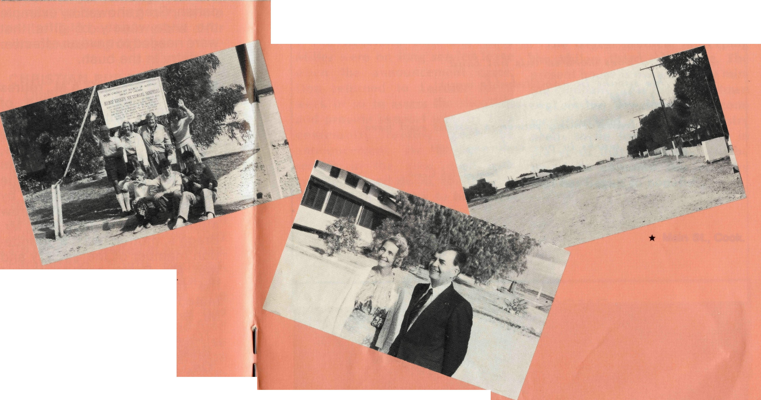
BISHOP KIRKBY
MEMORIAL HOSPITAL,
COOK
OPENING AND DEDICATION
David Griffin, Midwest Mission
"It's a long way to Tipperary, it's a long way to go", or so we are told in the old ballad. Well, believe me, it's a long way to Cook but that did not stop a large number of people from making the journey for the opening of the hospital extension. Those who attended came by road, rail and air. Bruce Cliff, the South Australian Secretary, arranged a large bus-load of people from Adelaide, bringing with them some people from as far afield as Gippsland and Sydney. The Bishop of Willochra came in by train and there were two aeroplanes. The little four seater which I flew in which the Reverend Brian Roberts, Acting Federal Secretary, Lyn Pickers-gil, ex-B.C.A. Cook and Royal Flying Doctor Service sister, and Ros Schraeder, ex-B.C.A. Staff at Cook, all came. The South Australian Minister for Health, Dr. Cornwall and a handful of other dignitaries flew in with the RFDS. Sister Rhonda Anstee from Tarcoola had made a very large fruitcake for the occasion with a picture of Cook Hospital in the icing. A beautiful cake art-wise and taste-wise too. It must have weighed a tonne, but Keith Anstee managed to bring it out by train.
• Dr. John Cornwall, Minister for Health with Sister Margaret Barnes.

Main St., Cook.
Prior to the Anzac weekend, Cook and out west was fine but the rain chose that weekend to come. We in the small plane had an interesting weekend watching the weather, the clouds and rain squalls but all the effort in trying to get there was worthwhile. The joy of being there to celebrate 50 years of medical and spiritual ministry was a highlight of the weekend. To look to the future was important also for the dedication of the new renovations and additions to the hospital for the future ministry to remote peope along the transline brought home the importance of the Bush Church Aid Society's endeavour of winning Australians for Christ.

THE REAL AUSTRALIAN
THE REAL AUSTRALIAN

STOP PRESS
LEINSTER TOWNSHIP TO CLOSE DOWN
Beauty for Ashes

Dull green rocky hills
Dust rising in willy willys
The hot sun beating down
The haunting beauty holds us
As if sought in a trap

Does God really care
The people in this land
Trapped in a lifestyle in isolation
What can we say?
How can we tell them of your love?

God does work in this hot land
He speaks in unmistakable ways
He will not be ignored
His transforming power is just as real here
As he works in our ordinary lives

From Leigh Creek
The sudden announcement that the Agnew Mining Company at Leinster is to cease operations and close down the town sent Shockwaves through the B.C.A. family. Concern for the future of the Miller's ministry in the vast parish of the North Eastern goldfields was uppermost in everyone's thinking when the news was announced.
The Reverend Don and Celia Miller were on long service leave when the announcement came. Don returned to Leinster for a week or so to assess the situation and provide support ministry to a community reeling from the announcement. He is keen to remain in the area, even with Leinster closed down, for there is still a lot of ministry to be under-
taken. Leonora is a growing and busy centre. Laverton remains in need of ministry. Wiluna has been a centre of ministry for many years and should remain so. Then added to that is the station country throughout the whole parish and the special work Don has been developing, in a low-key way, in supporting Aboriginal Christians and assisting work among them.
The largest problem in keeping the Millers there is housing. The present house is owned by the mining company (as is the whole town of Leinster) so alternate accommodation and a base of ministry needs to be found. Please be in prayer so that some way will be found to continue this ministry that has begun so hopefully.

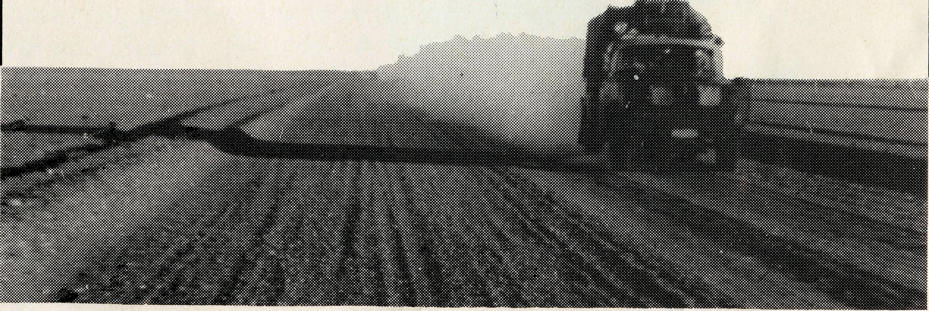
YOUR WELCOME
The Commissioning Service for the new Federal Secretary, Revd. Ernie Carnaby, will be held in St. Andrew's Cathedral on Tuesday, 16 December 1986 at 5.30 pm. All invited.

IO
THE REAL AUSTRALIAN
THE REAL AUSTRALIAN
II

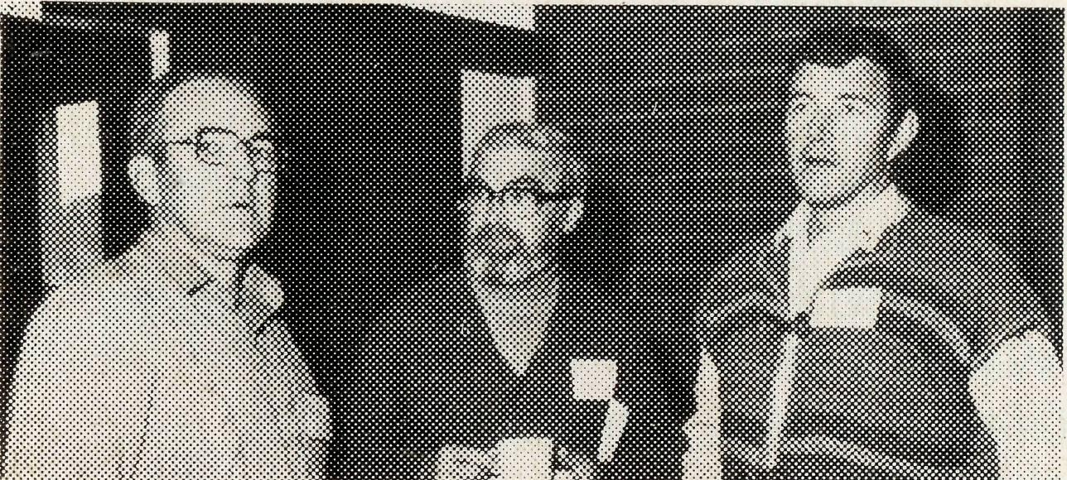
CONGRATULATIONS
FAREWELL
- Reverend Mapson and Ruth Williams from Wilcannia to retirement in the Southern Region of Sydney Diocese. Mapson and Ruth have both, individually, shown great zeal in announcing the gospel in Wilcannia and beyond.
- Sister Elizabeth Clegg as relief sister at Cook and Tarcoola Hospitals back to Melbourne. Libby's excellent nursing skills will be sorely missed.
- Reverend Peter Harradence from Kununurra to St. Thomas' Upper Beaconsfield, Victoria. See Update on Page 12.
- Reverend Eric Atkin from the Sydney Office to retirement and honorary ministry in his local church. Eric has faithfully served the Society as the Sydney Office Manager, Accountant, and Deputa-tionist for the past 10 years. He has been meticulous in his accounting and administrative duties and his straightforward counsel has been valued by the staff at home and on the field.
Peter Oram, our communications man, said of Eric's impending retirement, "We shall miss his terrific sense of humour, his definite stance on biblical issues, his care but firmness where Society procedures are concerned. Above all his thoughtful prayers and Bible study leadership."■
12
WELCOME
- To the Reverend Murray and Mrs. Jane Lamont from Werribee, to go to Kununurra in February 1987. Murray and Jane have a little boy, James, and he is to have a brother or sister soon. Remember them in prayer as they prepare for move to the Northwest.
- May Morrow from South Yarra, Melbourne, to go to Broken Hill Hostel as assistant to Tony and Barbara Pickering. May's appointment to the Hostel comes as an answer to many people's prayer to fill that vacancy.
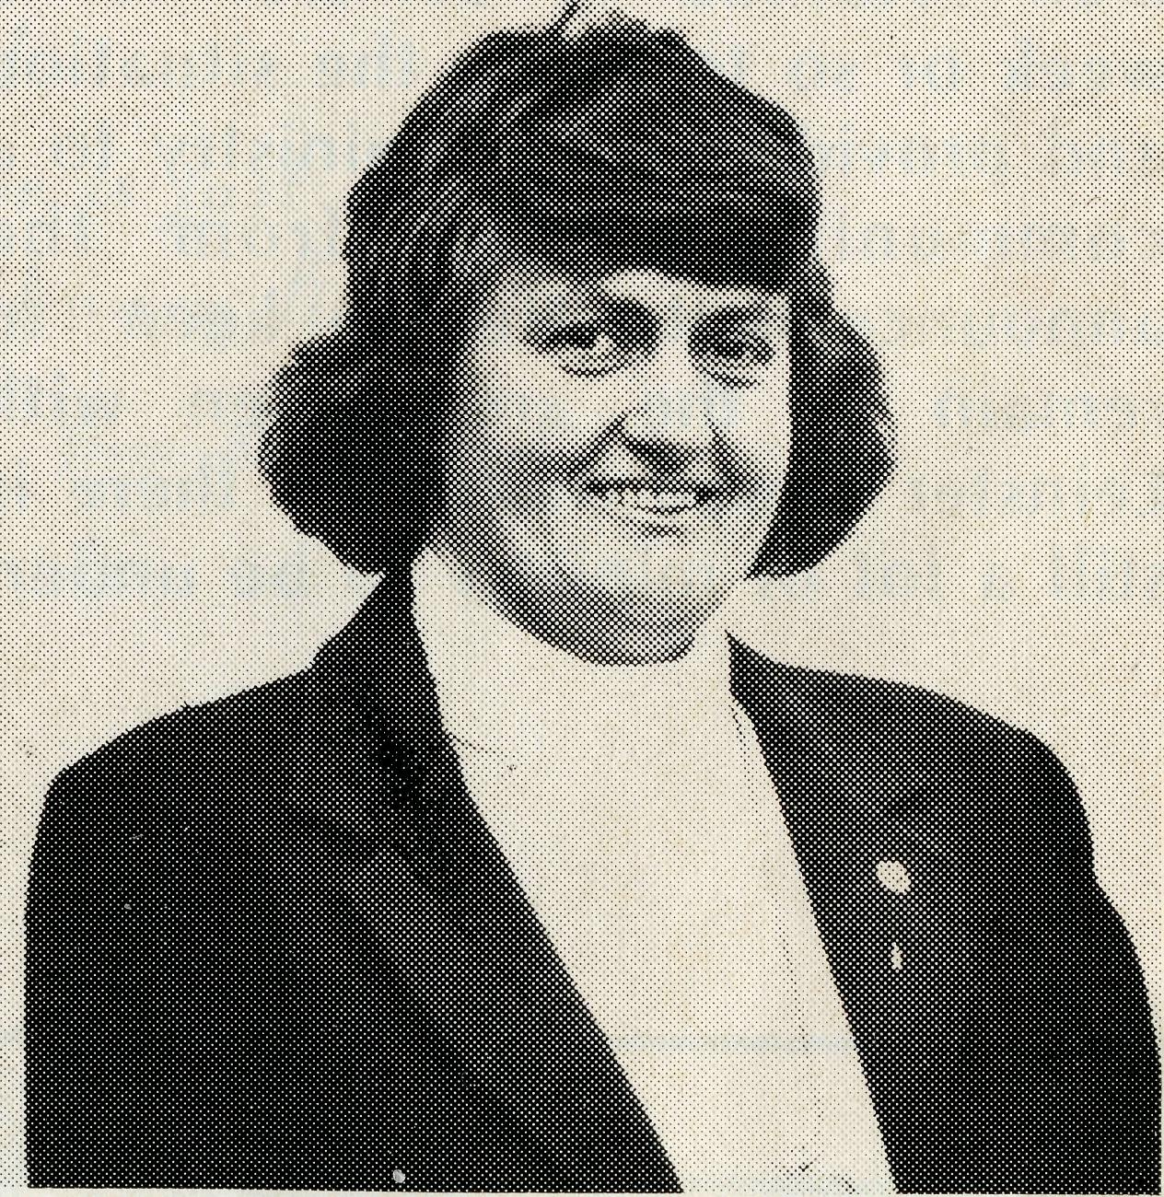
COLLINSVILLE
After a vacancy at Collinsville/ Glenden of nearly nine months, the Diocese of North Queensland has found a parish priest and has taken responsibility for the ministry since late July.
THE REAL AUSTRALIAN
Left to right: Revd. Arthur William, Ven. Bernie Buckland, Revd. Angus McDonald.
Bernard Buckland, Rector of Broome and ex-B.C.A. Missioner in South Australia and Western Australia, was recently collated as an Archdeacon for Kimberley area. The service and the handing over of the licence actually took place in the Newman Rectory loungeroom in the presence of Arthur and Pat Williams, B.C.A. Missioners at Newman.
SYDNEY WOMEN'S AUXILIARY
Proceeds from the midyear luncheon have been sent to Sister June English for the purchasing of sewing materials to assist her with activities among women who live in the isolated communities along the trans-Australian railway line. The Auxiliary over the coming months will be preparing and despatching Christmas parcels to all families and workers in the field.
LATE REVD. BILL AND MRS. MARGARET SMITH
We have just received the sad news that Bill and Margaret were both killed in a car accident in New Zealand recently. Bill and Margaret served as B.C.A. missioners in the Murchison from 1969-73.
THE REAL AUSTRALIAN
NEW VICE-PRESIDENT
Mr. Stan Hummerston, O.A.M., was elected to the position of the Vice-President to the Society at the recent Annual Meeting. Stan has been with the Bush Church Aid Society since 1958 serving at the Port Lincoln Hostel, as administrator of the Flying Medical Service at Ceduna, as administrator in the Society's Head Office and the Diocesan Administrator of the Diocese of North West Australia. Stan was awarded the Order of Australia Medal in January 1984 and retired later that year from full-time service with the Society.
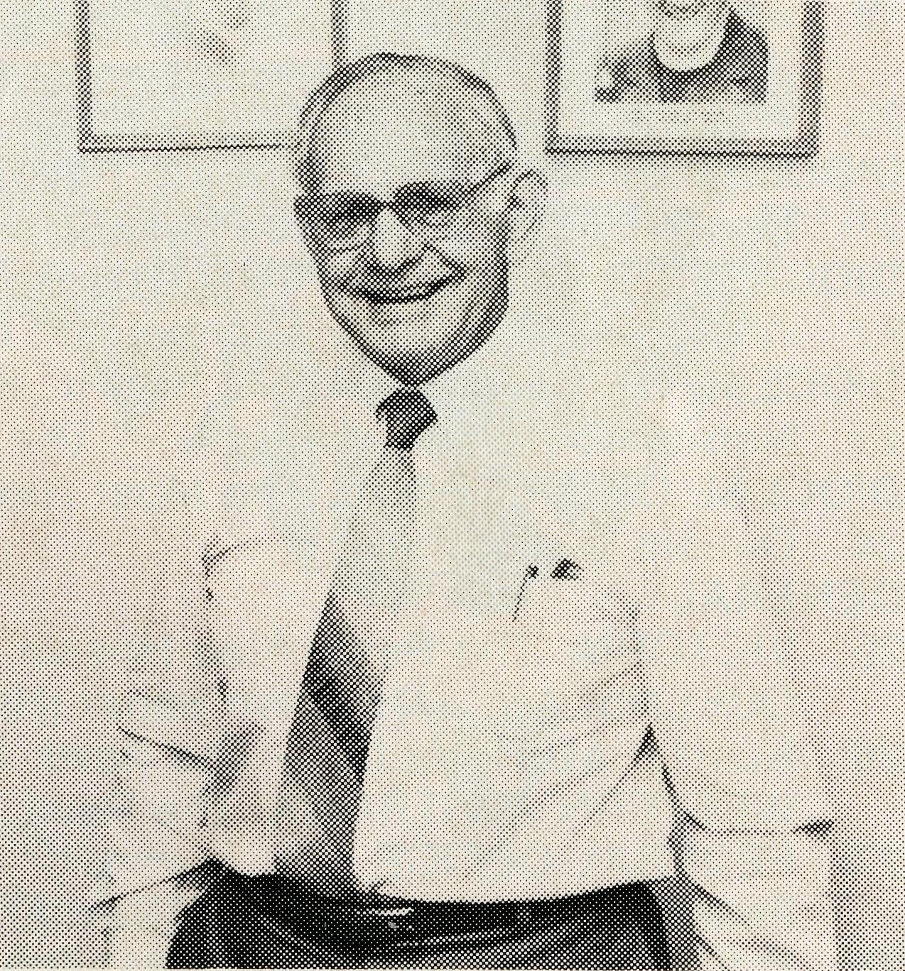
During this year, Stan has helped as assistant to the Acting Federal Secretary and his appointment as Vice-President ensures that his valuable expertise in remote ministry will certainly continue to enhance the Society's work.
13

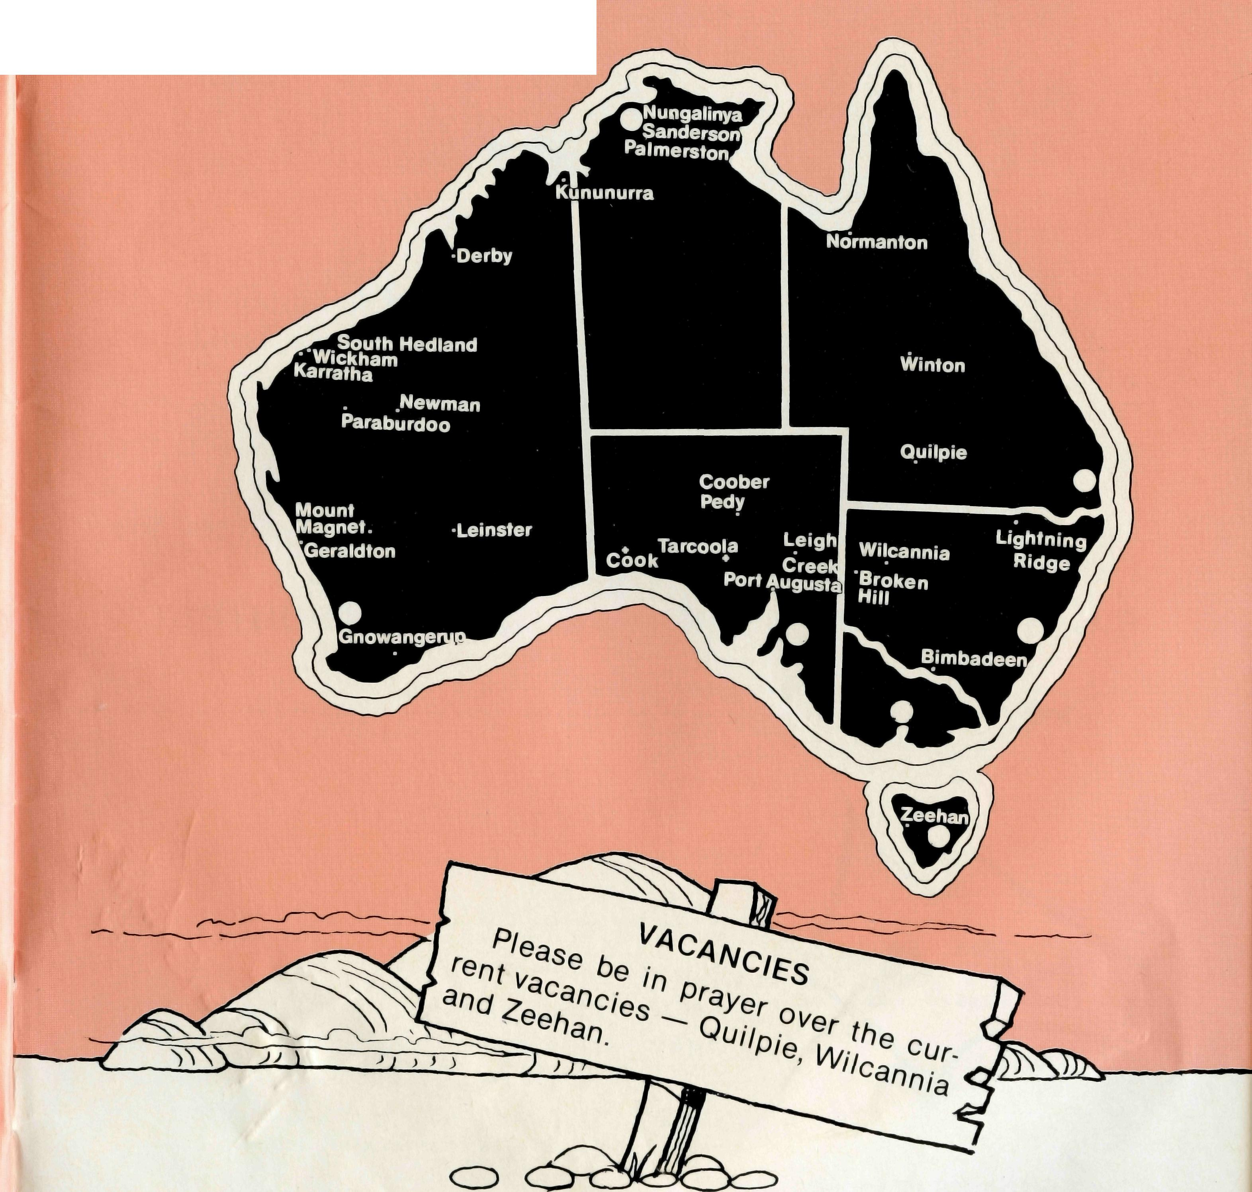
PRAYER CALENDAR
FIELD STAFF DIRECTORY
DIOCESE OF NORTHERN TERRITORY. The Rt. Revd. C. Wood.
- Darwin — Sanderson — Revd. Robert and Mrs. Rigmor George.
- Palmerston — The Revd. Ron and Mrs. Margaret Bundy. DIOCESE OF NORTH WEST AUSTRALIA. The Rt. Revd. G. B. Muston.
- Kununurra — The Revd. Murray and Mrs. Jane Lamont
- Derby — The Revd. Errol and Mrs. Anne Sorensen.
- Newman (East Pilbara) — The Revd. Arthur and Mrs. Pat Williams.
- South Hedland — The Revd. Peter and Mrs. Alison Moss.
- Karratha (West Pilbara) — The Revd. George and Mrs. Jacqueline Sansom.
- Wickham — The Revd. Angus and Mrs. Anne McDonald.
- Paraburdoo (South Pilbara) — The Revd. Gordon and Mrs. Ann Hargreaves.

- Geraldton — Mr. Martin and Mrs. Kim Weatherston.
- Mt. Magnet (Murchison) — The Revd. Greg and Mrs. Rhi Jones.
- Leinster — The Revd. Don and Mrs. Celia Miller. DIOCESE OF WILLOCHRA. The Rt. Revd. S. B. Rosier.

- Cook Hospital — Sister Margaret and Jack Barnes and Sister Ann and Jeff Bolton; Sister June English (Nursing Co-ordinator).
- Tarcoola Hospital — Nurses Mr. Keith and Mrs. Rhonda Anstee.
- Coober Pedy — The Revd. Martin and Mrs. Vivien Bleby.
- Mid-West Mission — The Revd. David and Mrs. Margaret Griffin.

- Leigh Creek — The Revd. Des and Mrs. Judi Arthur. DIOCESE OF TASMANIA. The Rt. Revd. P. Newell.
- Zeehan — Vacant.
DIOCESE OF RIVERINA. The Rt. Revd. B. R. Hunter.
- Broken Hill Hostel — Mr. Tony and Mrs. Barbara Pickering; Mrs. May Morrow (Assistant).
- Wilcannia — Vacant.
DIOCESE OF ARMIDALE. The Rt. Revd. P. Chiswell.
- Lightning Ridge — The Revd. Cliff and Mrs. Megan Ainsworth. DIOCESE OF ROCKHAMPTON. The Rt. Revd. G. Hearn.
- Winton — The Revd. Michael and Mrs. Elizabeth Birch. DIOCESE OF CARPENTARIA. The Rt. Revd. A. Hall-Matthews.
- Normanton (Southern Gulf) — The Revd. John and Mrs. Jennifer Summerell. DIOCESE OF BRISBANE. The Most Revd. J. Grindrod.
- Quilpie — Vacant. GENERAL

- VICTORIA. The Revd. Alan Hoskin, Mrs. Margo Bright. QUEENSLAND. Mr. Allan Sauer (Hon. Secretary).
- SOUTH AUSTRALIA — The Revd. Bruce Cliff, Mrs. Jocelyn Phillips. WESTERN AUSTRALIA. The Revd. Peter Brain (Hon. Secretary).
- FEDERAL OFFICE
Federal Secretary Elect. — Rev. Ernie Carnaby (commences Dec. '86).
- N.S.W. — The Revd. Brian Roberts, Mr. Peter Oram, Sister Helen Plumb, Miss Margaret Woolcott, Mesdames Jacqueline Griffiths, Vivien Bentley, Margaret Sadler, Miss Megan Woodward.
- Nungalinya College — Mrs. Sandra Kinslow. Gnowangerup — The Revd. Chris and Mrs. Marilyn Clerke. Bimbadeen N.S.W. — Pastor Graham Paulson.
- COUNCIL, EXECUTIVE, SUPPORTERS, BOX SECRETARIES.
THE B.C.A. PRAYER
O Lord our God, help us to remember the people who live in the remote parts of our land. We ask You to bless those whom You have called into the fellowship of The Bush Church Aid Society, and call others to stand with them in the task. Grant that, through the ministry of the Word and Sacraments, through healing, and through caring for the young, the message of Your redeeming love may be proclaimed, through Jesus Christ our Lord. Amen.

14
THE REAL AUSTRALIAN
THE REAL AUSTRALIAN
15

