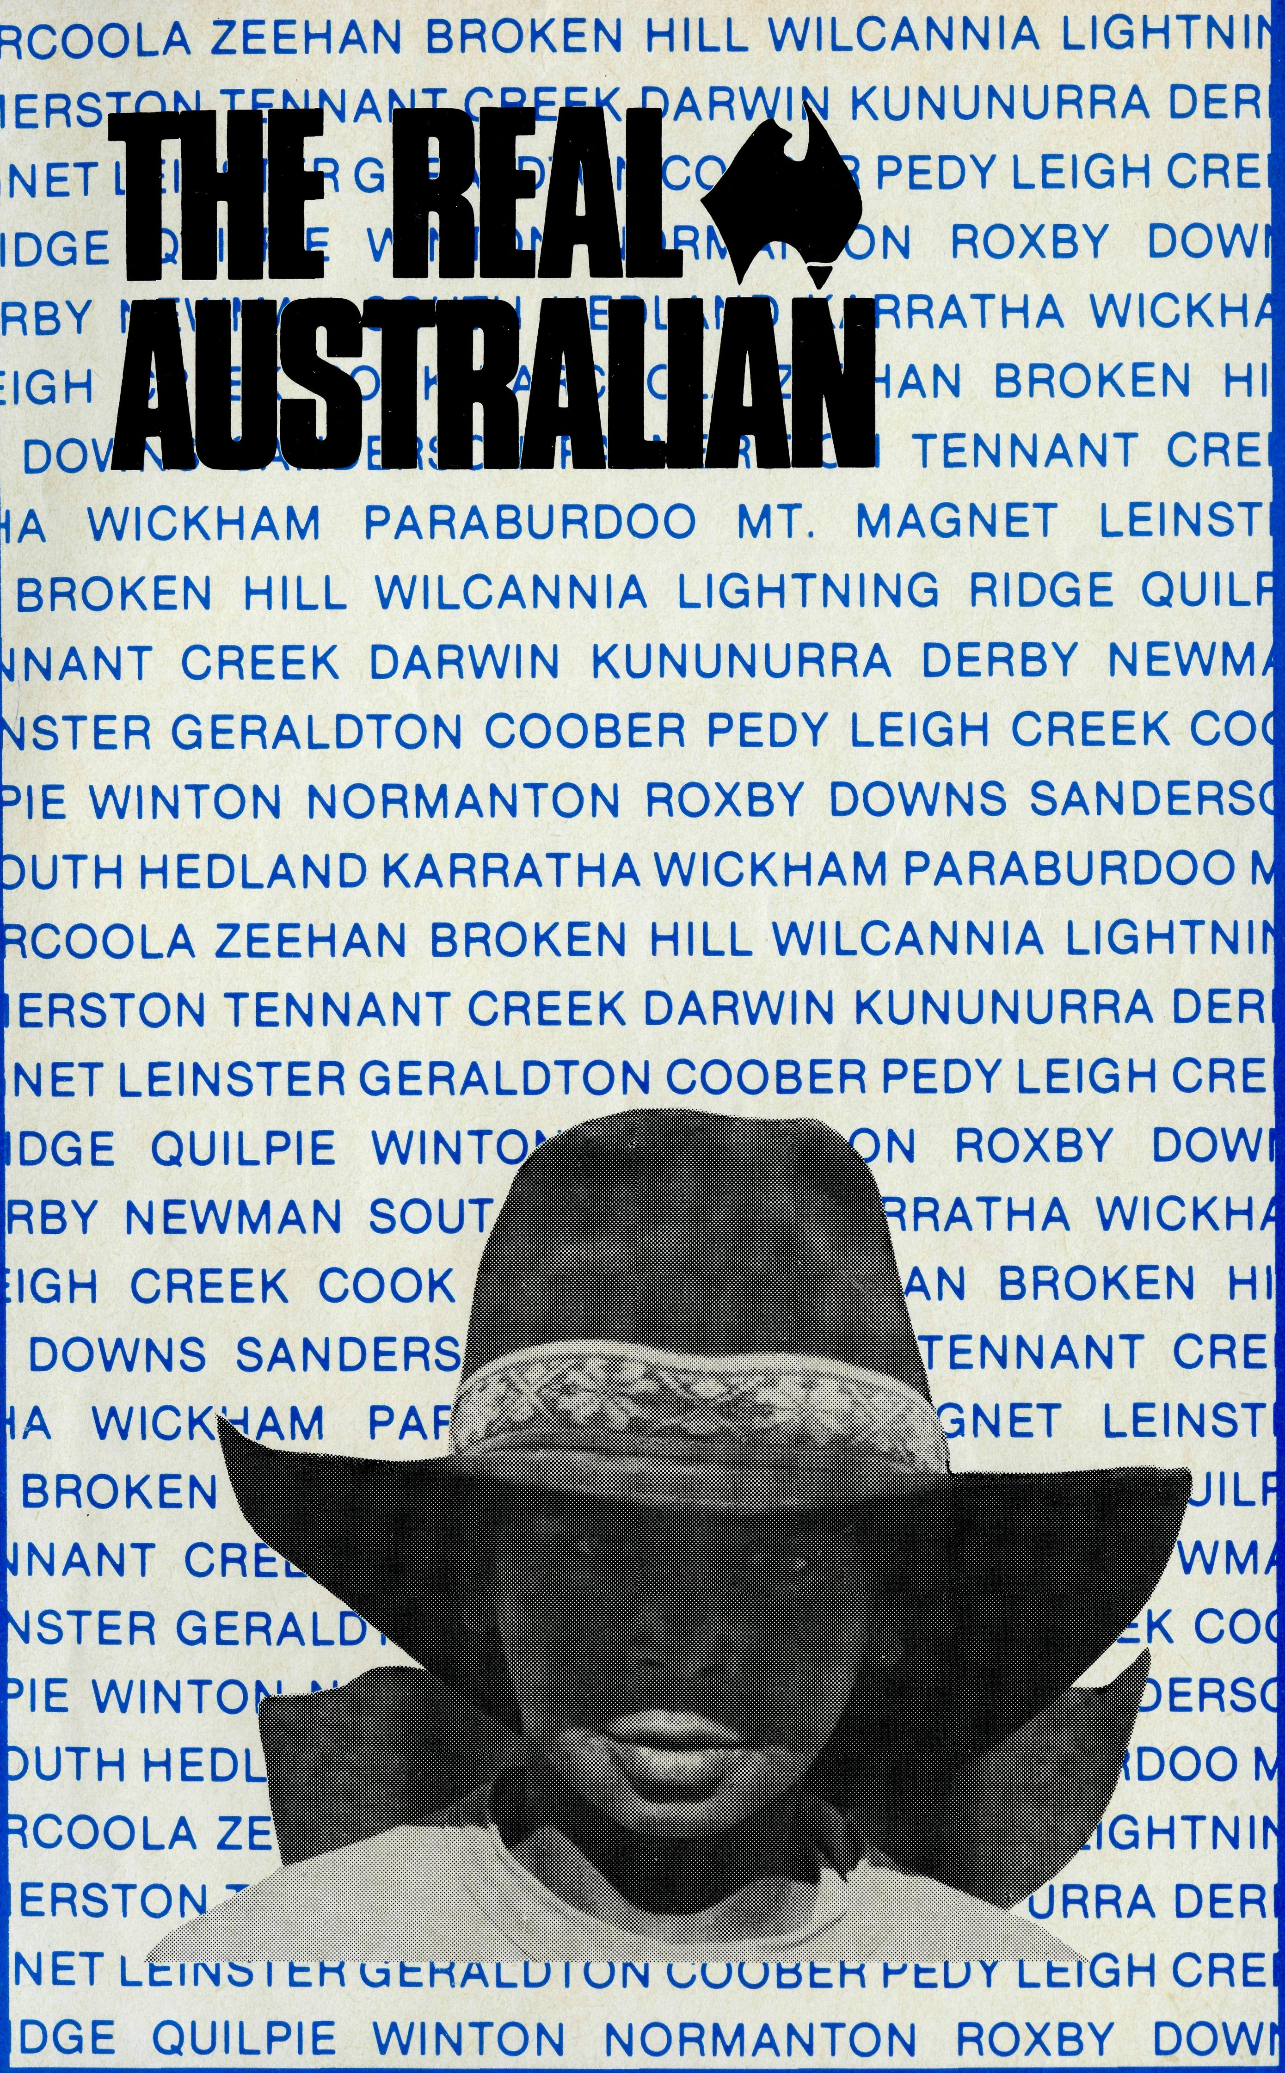
DOES IT MATTER HOW I GIVE TO B.C.A.?
Basically from B.C.A.'s point of view the answer is No!
But there are a variety of ways, one or more of which may be more convenient for you.
The Society has initiated over the years the use of B.C.A. Mission Boxes, Parish Duplex envelopes, Thanksgiving appeals complete with response envelopes, gift envelopes enclosed in each issue of the Real Australian magazine and just in recent times, the use of Bankcard and MasterCard.
The question is often asked "Must I use all the envelopes and appeals sent, together with my mission box." Again the answer is No! Just choose the way or ways that suit best.
Many people have found the envelopes enclosed in each quarterly issue of the Real Australian a convenient reminder of their decision to give to the Society's work. Using this method of giving means that the Society's cash flow is well regulated and now with the use of Bankcard and MasterCard facilities, cheques or money orders many not need to be written.
With such a variety of ways open for your gift to reach B.C.A. from time to time you may receive in the mail, envelopes, appeals or reminders of Box Openings following close to each other. Don't feel intimidated, just choose your way forward, remembering that others from among the 20,000 supporters will choose a different means to ensure that the work of B.C.A. goes forward.
You will note the response slip now carries our new facility for Bankcard or MasterCard donations.
If you would like to use this method of giving just carefully fill in your details and enclose the form in the addressed envelope provided. Of course if you don't want to damage the magazine you could copy down the relevant details on plain paper, sign it, and sent to us.
B.C.A. values the individual support of members of the B.C.A. family, for without that the ministry that the Society promotes would soon cease.
please cut off and return
Mr/Mrs/Miss/Rev
Address
. Postcode.
- I wish to receive further copies of this magazine, "The Real Australian" D I wish to receive quarterly copies (free) of The Prayer Fellowship Notes
- Enclosed is my gift of $
OR
Please debit $_
. from my Bankcard/MasterCard
No.
Card holder's signature-
. Expiry date_
THE BUSH CHURCH AID SOCIETY OF AUSTRALIA 135 Bathurst Street, Sydney. Phone: (02) 264 3164 or your B.C.A. State office

Printed by Ambassador Press Pty. Ltd., Granvill 2142.
DECEMBER 1987. $3.00 subscription. Reg. by Australia Post Publication No. NAR 0630

All enquiries to:
THE REAL AUSTRALIAN EDITOR
Brian Roberts
THE BUSH CHURCH AID SOCIETY
OF AUSTRALIA
135 BATHURST STREET,
SYDNEY 2000
Phone (02) 264 3164
Patron: The Primate, The Most Rev. John Grindrod.
President: The Most Rev. Donald Robinson, Archbishop of Sydney.
Vice-Presidents: Mr. Stan Hummerston, O.A.M.; Mr. Richard Stokes.
B.C.A. CONTACTS . . .
B.C.A. HOUSE, SYDNEY, 135 Bathurst Street,
Sydney, N.S.W. 2000.
Phone: (02) 264 3164, 264 3780.
Federal Secretary: Rev. Ernie Carnaby.
General and N.S.W. State Secretary: Rev. Brian Roberts.
Victorian Secretary: Rev. Alan Hoskin to
31.12.87;
Rev. Brian Viney from 1.2.88. 205 Flinders
Lane, Melbourne, Vic. 3000.
Phone: (03) 654 8022.
South Australian Secretary: Rev. Bruce Cliff,
Church Office, 44 Currie Street, Adelaide, S.A.
5000.
Phone: (08)212 7804.
Queensland Hon. Secretary: Mr. Allan Sauer, 28 Doughty Avenue, Holland Park 4121. Phone: (07) 397 1501.
Western Australia Hon. Secretary: Rev. Peter Brain, St. Luke's Rectory, 78 Pitchford Avenue, Maddington 6109. Phone: (09)459 5169.
The box was big enough to hold anything from a washing machine to a lawn-mower. It was brown, and tightly secured with masking tape and string. It sat on the lounge room floor and asked a thousand questions. What? How? Why? From where? From whom?
It was Dad's Christmas present to Mum.
Us kids had already received ours — we didn't have the patience that Mum did. While we were quite happy and contented with our new footie, or new Barbie Doll, or big block of chocolate, we couldn't sit still until the surprise and mystery of that big brown box had been explained.
So we badgered Mum until she began unwrapping.
Dad sat in a corner chair, pretending he wasn't at all interested. He had a smirk on his face, and weighed in regularly with the sort of wet joke fathers are famous for. He had us expecting either a baby elephant or a new fishpond.
Mum got the scissors and cut the string. Then she slowly peeled off the masking tape. She wasn't quick enough for us kids, so we all jumped up to help. The smirking father in the corner told us all to sit down. Mum continued her unwrapping, and pulled open the top of the box.
A three-metre barbed-wire fence
THE REAL AUSTRALIAN
The Surprise Christmas Present
would not have stopped the charge that followed. In the flurry of bodies that occurred, three of the four children in our family only just managed to escape serious injury from falling head first into the box.
After the excitement had quietened down a bit, Mum showed us the smaller box she had discovered inside. Our curiosity grew. A couple of us had to go to the toilet. Everything stopped until everyone was present and accounted for. Dad interrupted to take a photo. We've still got it, and it shows all our noses six inches longer than normal. Even Nana and Papa leaned forward excitedly.
Inside the smaller box was another, and inside that still another. There was a noisy chorus of groans as still more wrapping was revealed. The process seemed as if it would go on for ever.
Eventually, Mum got to a very small parcel. It was wrapped in pretty pink paper, with a matching ribbon.
Breath was bated. The munching of Christmas toffees stopped. The Christmas tree stood tall and elegant and silent. I even stopped punching my brother. All attention was focused on Mum, as she slowly unwrapped the pink parcel. Dad's smirk was changing to a smile.
Inside the parcel was a jewellery case. In it, a ring. A beautiful shiny ring. "An eternity ring!" Mum whispered.
I thought she said maternity, and said that was a real surprise Christmas present.
Mum gave Dad a kiss, and I accidently locked my brother in the big box and sat on it.
We took turns looking at the ring. It was a beautiful symbol of love, and a promise of future love.
There is a lot of wrapping around our surprise Christmas present.
THE REAL AUSTRALIAN
The advent of God's Son is wrapped up in masses of tinsel along our crowded Christmas streets. It is submerged behind the fat red bellies and the fake white beards of the million-and-one jolly, ho-ho-hoing Santas doing the rounds in department store sleighs. It is disguised in Christmas cakes and puddings and turkeys and jars of chocolate-coated nuts. It is covered by layer after layer of office parties, after-work drinks, late-night shopping, and the card from one person we left off our list.
Even our "Carols by Candlelight", our special Christmas Eve services, our warm feelings of special love and friendship and fellowship, are but more layers.
When all these layers are stripped away, then there is revealed the real gift, the real surprise Christmas present — the baby wrapped only in rags in a dirty stable in Bethlehem. This kicking, squirming baby is the Son of God born as man.
This gift is priceless. It is the measure of God's love for us. Its value far exceeds that of anything else we might ever receive, this Christmas or any other this side of eternity.
And as my Dad's gift of an eternity ring to my Mum was a symbol of love, and a promise, so is this child.
Yet this is more than just a symbol and an earthly promise. This is a real, unshakeable promise. This is love that can never be swayed by the vagaries of earthly life, a love that will not pass away in death. God's love, in this gift of his Son is eternal — a true eternity ring.
Take hold of it and wear it. Know the love with which it is given and with which it continues to be given.
From the highly-recommended book / Love a Sunburnt Stomach by Jonathan Krause (© 1985 Lutheran Publishing House) Used by permission.

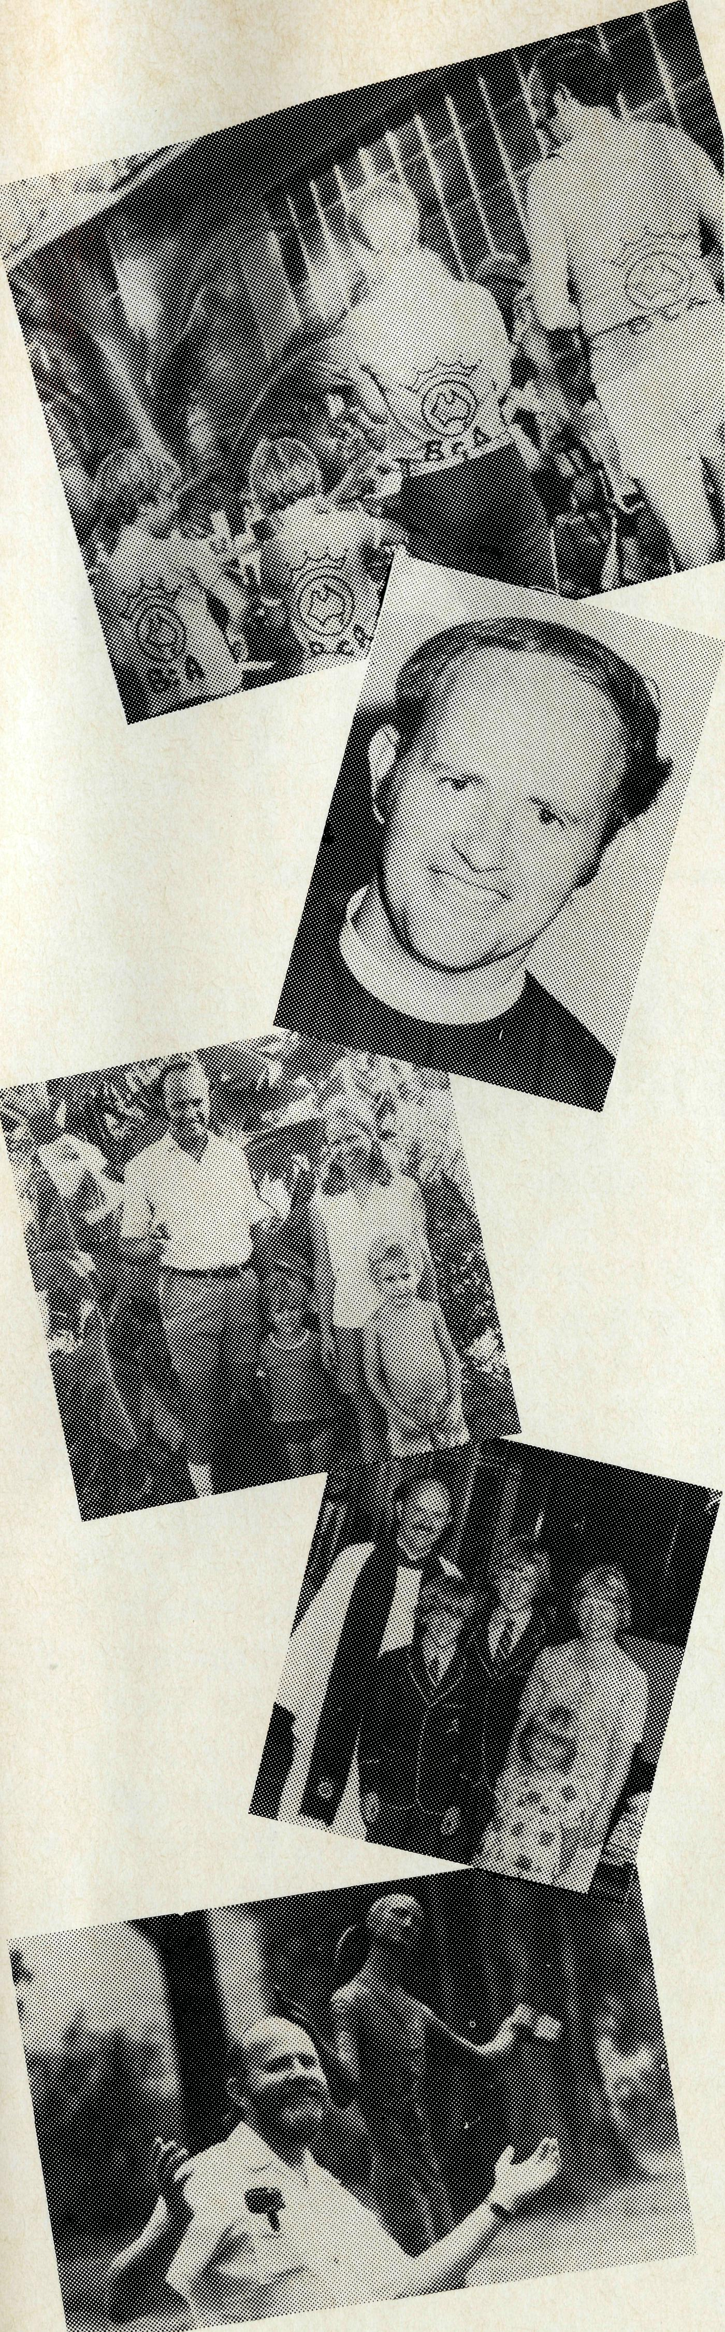
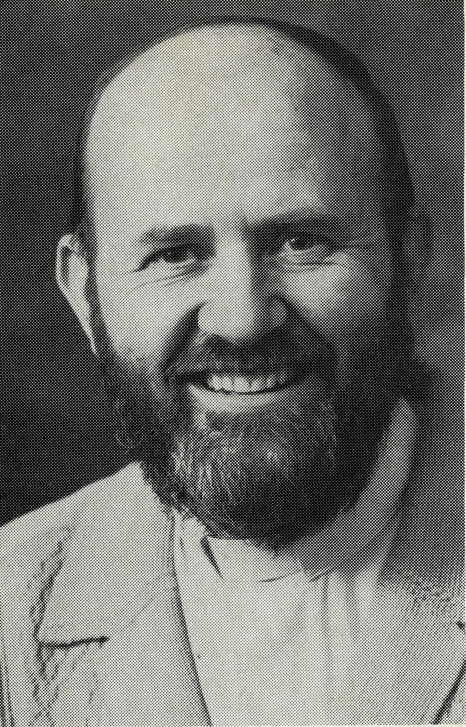
The Rev. Alan Hoskin our Victorian/ Tasmanian State Secretary finishes his work with the Society in January '88 and he was asked for his reflections on his work both as a Missioner and as State Secretary.
"Is it 10 years?" Bishop Ged Muston is partly to blame for our B.C.A. involvement. When he was Federal Secretary of the Society he spoke at St. John's Blackburn when I was a
Curate and told of the need for Clergy in the Outback. Philippa and I asked each other after the service "could we think of any reason why we couldn't go"? We couldn't, and a year and a half later we were in Darwin. Philippa had earlier felt a call to service with B.C.A. as a nurse — but she ended up serving as a Rector's wife.
We look back on our four year ministry in Darwin as an adventure. There was an initial bit of disappointment that Nightcliff Parish was a busy suburb rather than the "glamorous Outback". We quickly realised that in so many ways it was like any other B.C.A. centre. It was very isolated and sometimes the isolation gets to you. There were people — so many people — trying to run away from problems and discovering that most problems can't be run away from. In fact they often enlarge in isolated areas. So much of my Darwin ministry was directed towards helping people sort out problems. It was a great Church, St. Peter's, and we had many hands to help.
The extremes of weather is another area we had in common with other B.C.A. areas. Beautiful weather for part of the year but terrible weather for the majority. Philippa, particularly with her fair skin, had to dress carefully. She always wore a sun hat but still she came back from Darwin with skin problems. And then of course there was Cyclone Tracy. A terrifying time as part of our Rectory blew down around us — Philippa seven months pregnant at the time and feeling odd pains — Philippa and the children evacuated on one of those huge airlifts out of Darwin. On reflection Philippa and I saw how the Lord had prepared us for that time. For six months prior to the cyclone we had shared together a particularly close time of regular Bible readings and prayer together and so when the cyclone hit although we were very afraid we sensed the Lord's
THE REAL AUSTRALIAN
THE REAL AUSTRALIAN
power and can still testify boldly that we have a Lord who can take us through storms of life.
It's an intriguing mystery, the B.C.A. family. We were conscious through the cyclone and later, that there were so many people who prayed for us and cared for us. We estimate we were probably in a state of shock for the first year after the cyclone. We would also pay tribute to the people of St. Thomas' Langwarrin in Melbourne who were so caring and patient with us. We spent seven happy busy years in Langwarrin.
The B.C.A. beckoned again. Victorian Secretary? — they must be joking. When God gave out administrative gifts he left me out! But we've been here now six years and I have learned a number of administrative skills in the process. The job does put strains on family life and the family members needed to learn to "free me" for ministry but we felt again with deep gratitude the care and prayer support of the B.C.A. family.
Two major areas stand out in my time as Victorian/Tasmanian Secretary. The first is that I am encouraged by the number of individuals and Churches in Victoria and Tasmania who in their own ways take their responsibility very seriously to see the Good News spread to the ends of the earth (I can remember Tammie Frazer saying Meekatharra was the "end of the earth"!). Second, I have been privileged to get to know so many of our Missioners and their families. I continually marvel at their willingness to be obedient to their Lord and to work in remote parts of Australia and I praise God as I see and hear their faithful ministries.
Can you ever leave the B.C.A. family? I'm not sure you can. But I praise God for my time spend in serving my Lord in such a great Society as the "BUSH CHURCH AID SOCIETY".

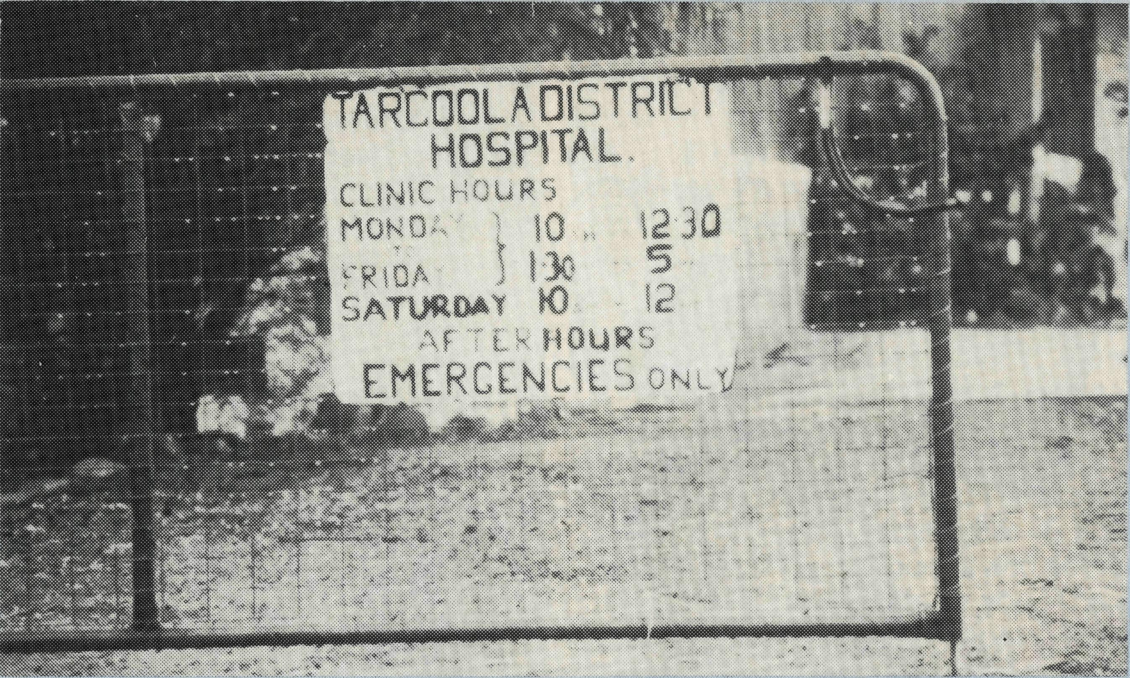
Jean Henderson, one of our two nurses based at Tarcoola, writes:
"We have had some interesting medical cases — and varied, too. The remote nursing experience gained in Papua New Guinea has been a tremendous help. Working under such conditions a nurse learns to assess, to evaluate her patients and also learns to ponder, to pray, and to use medical text books in the pondering and problem solving process, as well as the phone, to discuss the problem with the Royal Flying Doctor service.
There was a child with a fractured femur. The plane with a doctor was sent from Port Augusta
FEMURS, FINGERS AND SOME FIRST EXPERIENCES
to collect the lad, but we had instructions to give analgesia, then to straighten the leg and put it in traction. We didn't have a traction outfit (we do now) so the headmaster quickly made me a spreader S^xS" with a hole in the middle. A piece of rope from a B.C.A. carton the week before came in useful to put through the hole and fasten the straightened leg to the end of the bed. We had the necessary elastoplast and pressure bandages. I was interested to hear that the traction was left on for some weeks, and that the nursing staff at Port Augusta said to others — "Look at the traction that the Tarcoola nurses have applied!"
One morning at 7 a.m. we were called to a case of premature rupture of membranes in a lady who was 32 weeks pregnant. Fortu-
nately it was the day of the Flying Doctor's visit, and some 3¹/2 hours later we had a doctor. Cathy was able to have her baby two weeks later, Craig Bradley is home again and is thriving, a five pounder. Alas the mother was only back from hospital for a few weeks when we had another early morning call. This time she had severe back pain, and one look at her, and the pain that she was experiencing — it could only be one thing, a stone in the kidney. Again it was "doctor's day" so the plane took the patient to Port Augusta and then to Adelaide.
A 19-year-old youth went to a barbecue and tried to light the fire with petrol. He had nasty burns to the upper arm and across his back. He healed so quickly. There have been guards from the trains with steel specks in the eye, a hazard for the railwaymen; a driver with a leg injury from the air hose; a few days ago a child who had his fingers caught in the safe, and lost the top of his finger. The bone was exposed, but his nail was intact. However, the Flying Doctor felt that he should be taken to Port Augusta, so the plane came to collect him and his mother. The poor mum was very upset.
There was a call out one night to a man who had a gun and was threatening suicide. He was feeling dejected because his pension had been reduced, as a result of his wife's earnings. The station master was able to remove the gun and we were able to talk the man into coming to the hospital for the night. His wife was away for 24-hours and he was missing her.
After some sedation and a good night's sleep we were able to have a good talk with him, and point out that he had done a great job in providing for his family earlier, but now his wife was the healthier and stronger person and she was the provider. His turn would come again when she retired. He stayed two days with us and then returned happily home.
Jenny had her first experience of minor surgery when she had to incise and remove a broken-off piece of mulga from a station hand's hand. There have been a number of sutures for her to do, to get her hand in. In fact we have both been doing suturing."
Jenny Thompson will leave
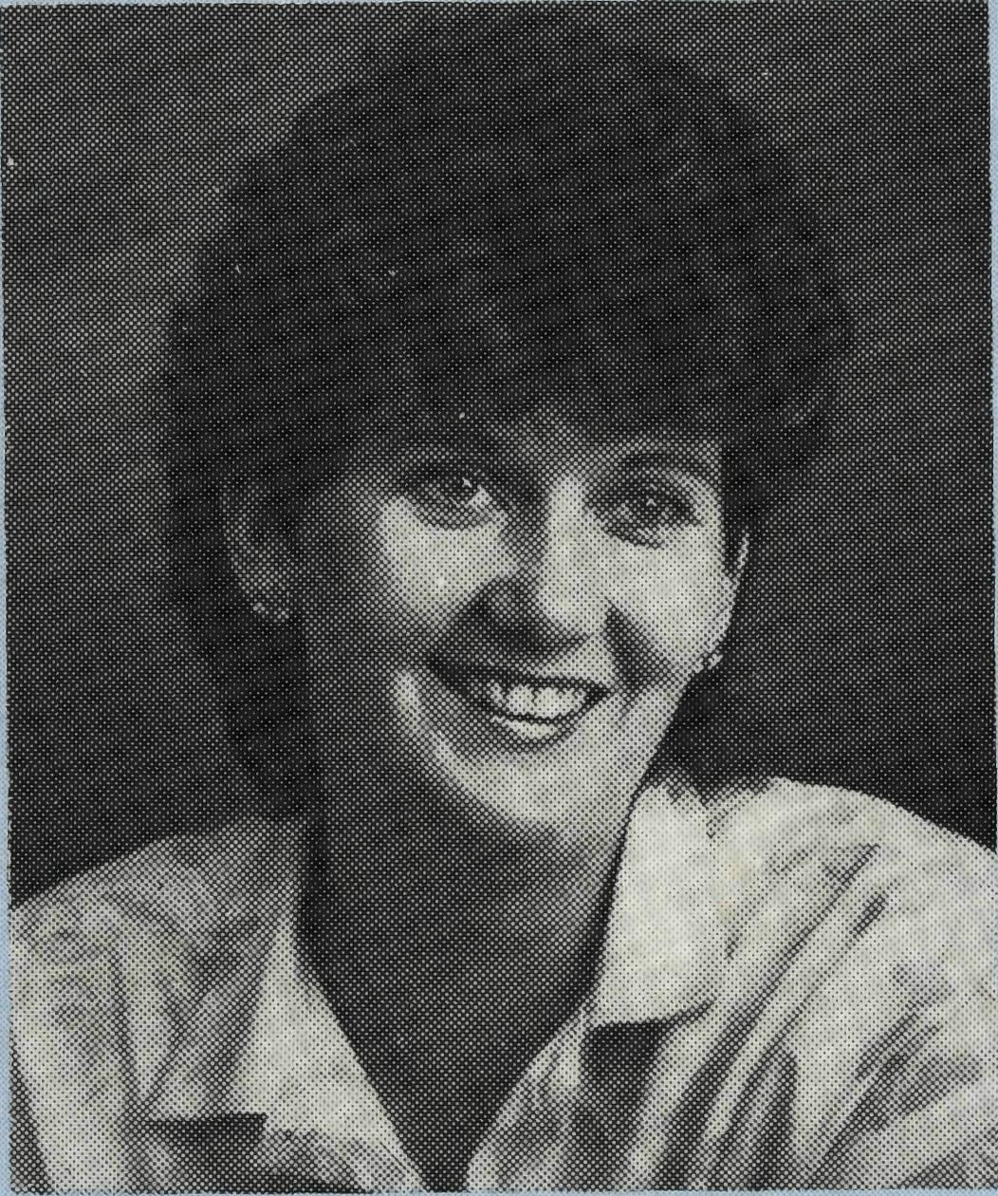
Tarcoola early January, 1988 to do midwifery in Scotland. Also Cathy Waters from Cook will leave this month to do further study.
We have appreciated greatly the ministry both medical and spiritual, our nurses offer to the folk along the Trans Line.
For 1988 we will need two D.C. Sisters to bring our nursing team up to its full complement.
Please Pray!

THE REAL AUSTRALIAN
THE REAL AUSTRALIAN

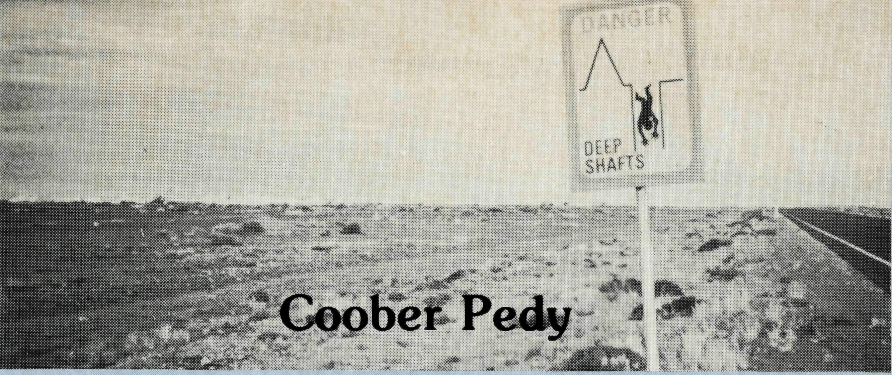
"This is God speaking — Repent!" These words startled the tourists (locally known as vegies) as they inspected the Catacomb Church in Coober Pedy. Actually it wasn't God — that time — but one of the Bleby children, speaking down an air vent! At a recent rally Martin Bleby told this story. But God is using him and Vivien as well as their children, to speak for Him in this area of South Australia, so apparently barren that is might well be thought God-forsaken, yet because of the opal-mining about 4000 people of over 40 nationalities now live there, and since Coober Pedy lies on the now bituminised road north to Alice Springs it is visited by thousands of tourists every year. Yes, He is using them, and sometimes the most unlikely people — like Albert, who complained about the distraction to the services caused by children, was himself given the first child to look after in an "adoption" scheme, and had led the way in the development of a very special relationship between the men and the children.
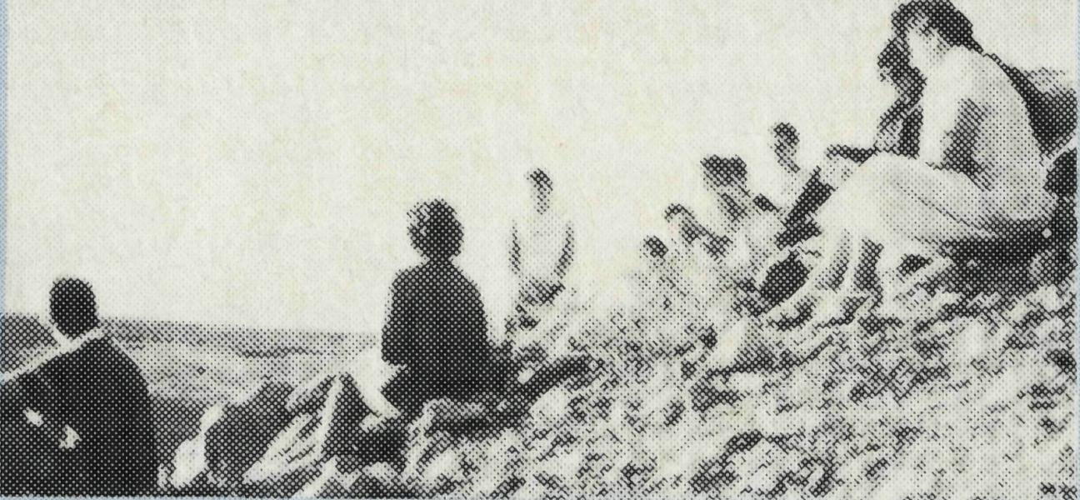
Then there's Brian. When he came 17 years ago he wasn't a Christian, but was persuaded by his wife Judy to come once, and then again, to a service, and by the third week Brian decided that he'd better give in — and now he is a churchwarden and "one of the most delightful Christians."
And then too there's Peter, who hung around after digging a 77 feet
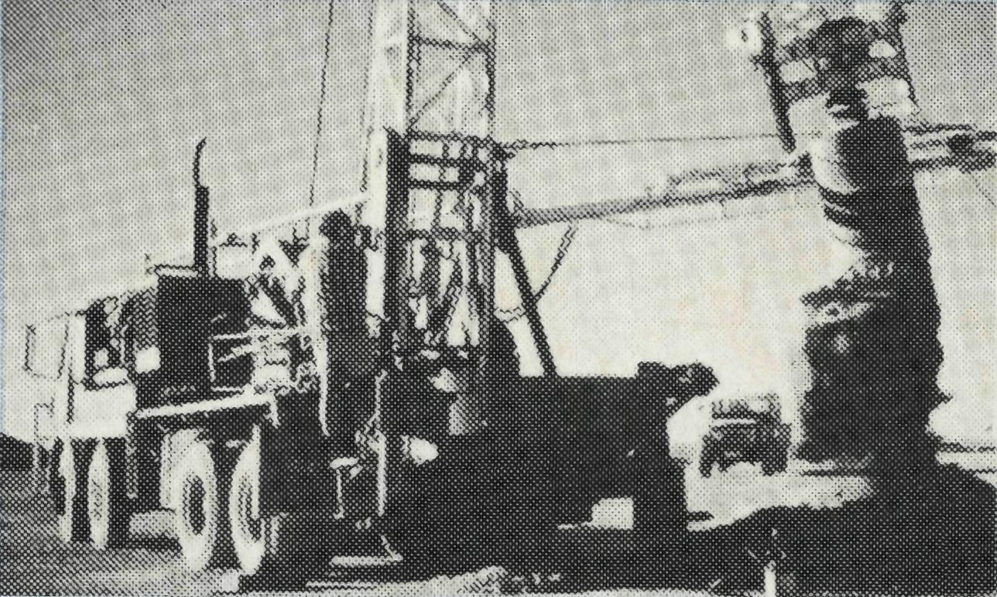
deep toilet shaft, mustering courage to say, "I want to give my life to the Lord, how do you do that?"
Everyone in town knows the underground church "building", even if they don't all worship there. Apart from ceiling and walls that need no paint but are of varied hues, distinguishing features are a windlass from the opal fields supported on legs made of mulga, and a cross and lectern also made of that local timber. Sunday morning services last about 2V2 hours, with a cup of tea break in the middle, and the opportunity to have very supportive fellowship.
The tourists are very welcome but sometimes hard to take. Just as Martin is going to prayer or sermon preparation, he hears the local tour leader just the other side of the door: "Now you'll notice . . ."
But what's it like living in Coober Pedy? Well, for one thing, the children are trained, when walking on the opalfields, never to look anywhere but on the ground at their feet, and never to step backwards; for there are abandoned shafts everywhere. This is the worst time of year, when the north duststorms blow. There is a wonderful new hospital where Vivien works two mornings a week. There is a school of around 400, about a quarter of them aborigines, and in every class there are very few with English as their first language. The dug-out rectory is actually superb and very comfortable.
But Coober Pedy is just the centre of a parish of 264,000 sq. km, stretching through Oodnadatta to the Simpson Desert to the N.T. border across to the W.A. border and about half-way down to the great Australian Bight. Some stations Martin is able to visit regularly.
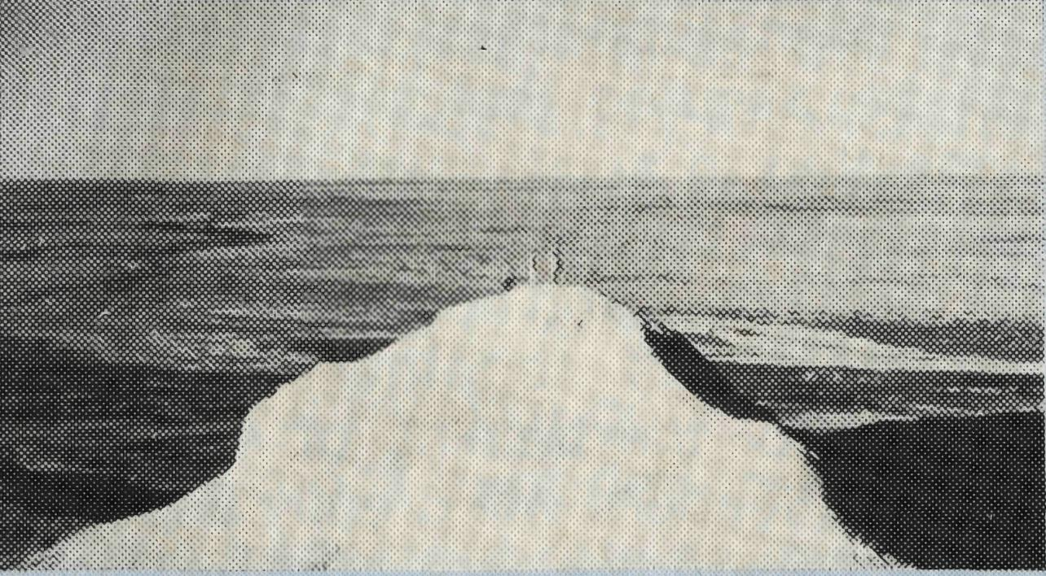
Oodnadatta used to be a railhead for the old Ghan. Now it has only about 120 Aborigines and very few whites. They are desperate for a more regular ministry than Martin can provide. Let us quote his words:
"Let me tell you about a funeral I went to of a little boy killed in an accident. Often I arrive in places just after these things happen. I am very con-
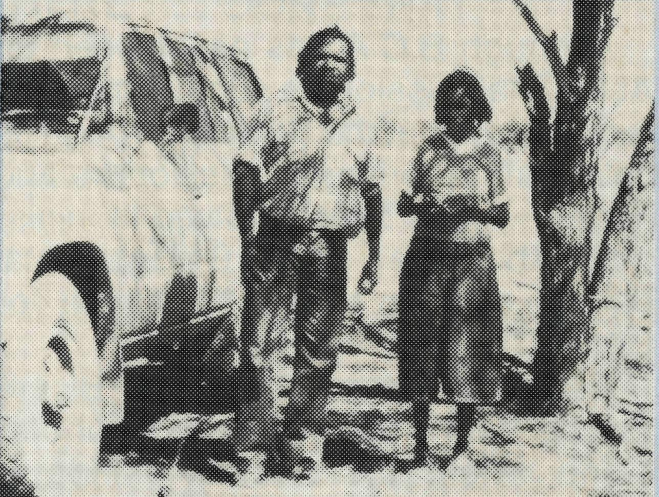
scious of God's guiding and sorting out my timetable, often differently from the way I planned it. We approached the edge of the camp and there was an increase of wailing. We just sat down alongside the parents who were surrounded by people with their arms around them. After a while the wailing died down and the aboriginal evangelist said "now you give the word of God." So I read a passage about Rachel weeping for her children and I prayed, and Peter read the 23rd Psalm in English and his own language, and prayed." He later participated in the funeral. As Martin says, "It is good to know you are a part of what God is doing, something that is much bigger than just me or B.C.A."
On returning to Coober Pedy, Mac Job, ex B.C.A. Pilot who had spent much time in Coober Pedy, had visited them, and said it was wonderful to see some life and a joyous community centred on the Catacomb Church — so different from the Coober Pedy he knew in the 1950s. He said it emphasised the value of the consistent, faithful, long-term ministry that B.C.A. provides.

THE REAL AUSTRALIAN
THE REAL AUSTRALIAN

The Federal Secretary Writes ...
B.C.A. and Aborigines
"BEEN THERE . . . DONE THAT . . ."
From the list of places on Brian Viney's service record card, he would certainly be entitled to say: "BEEN THERE . . . DONE THAT."

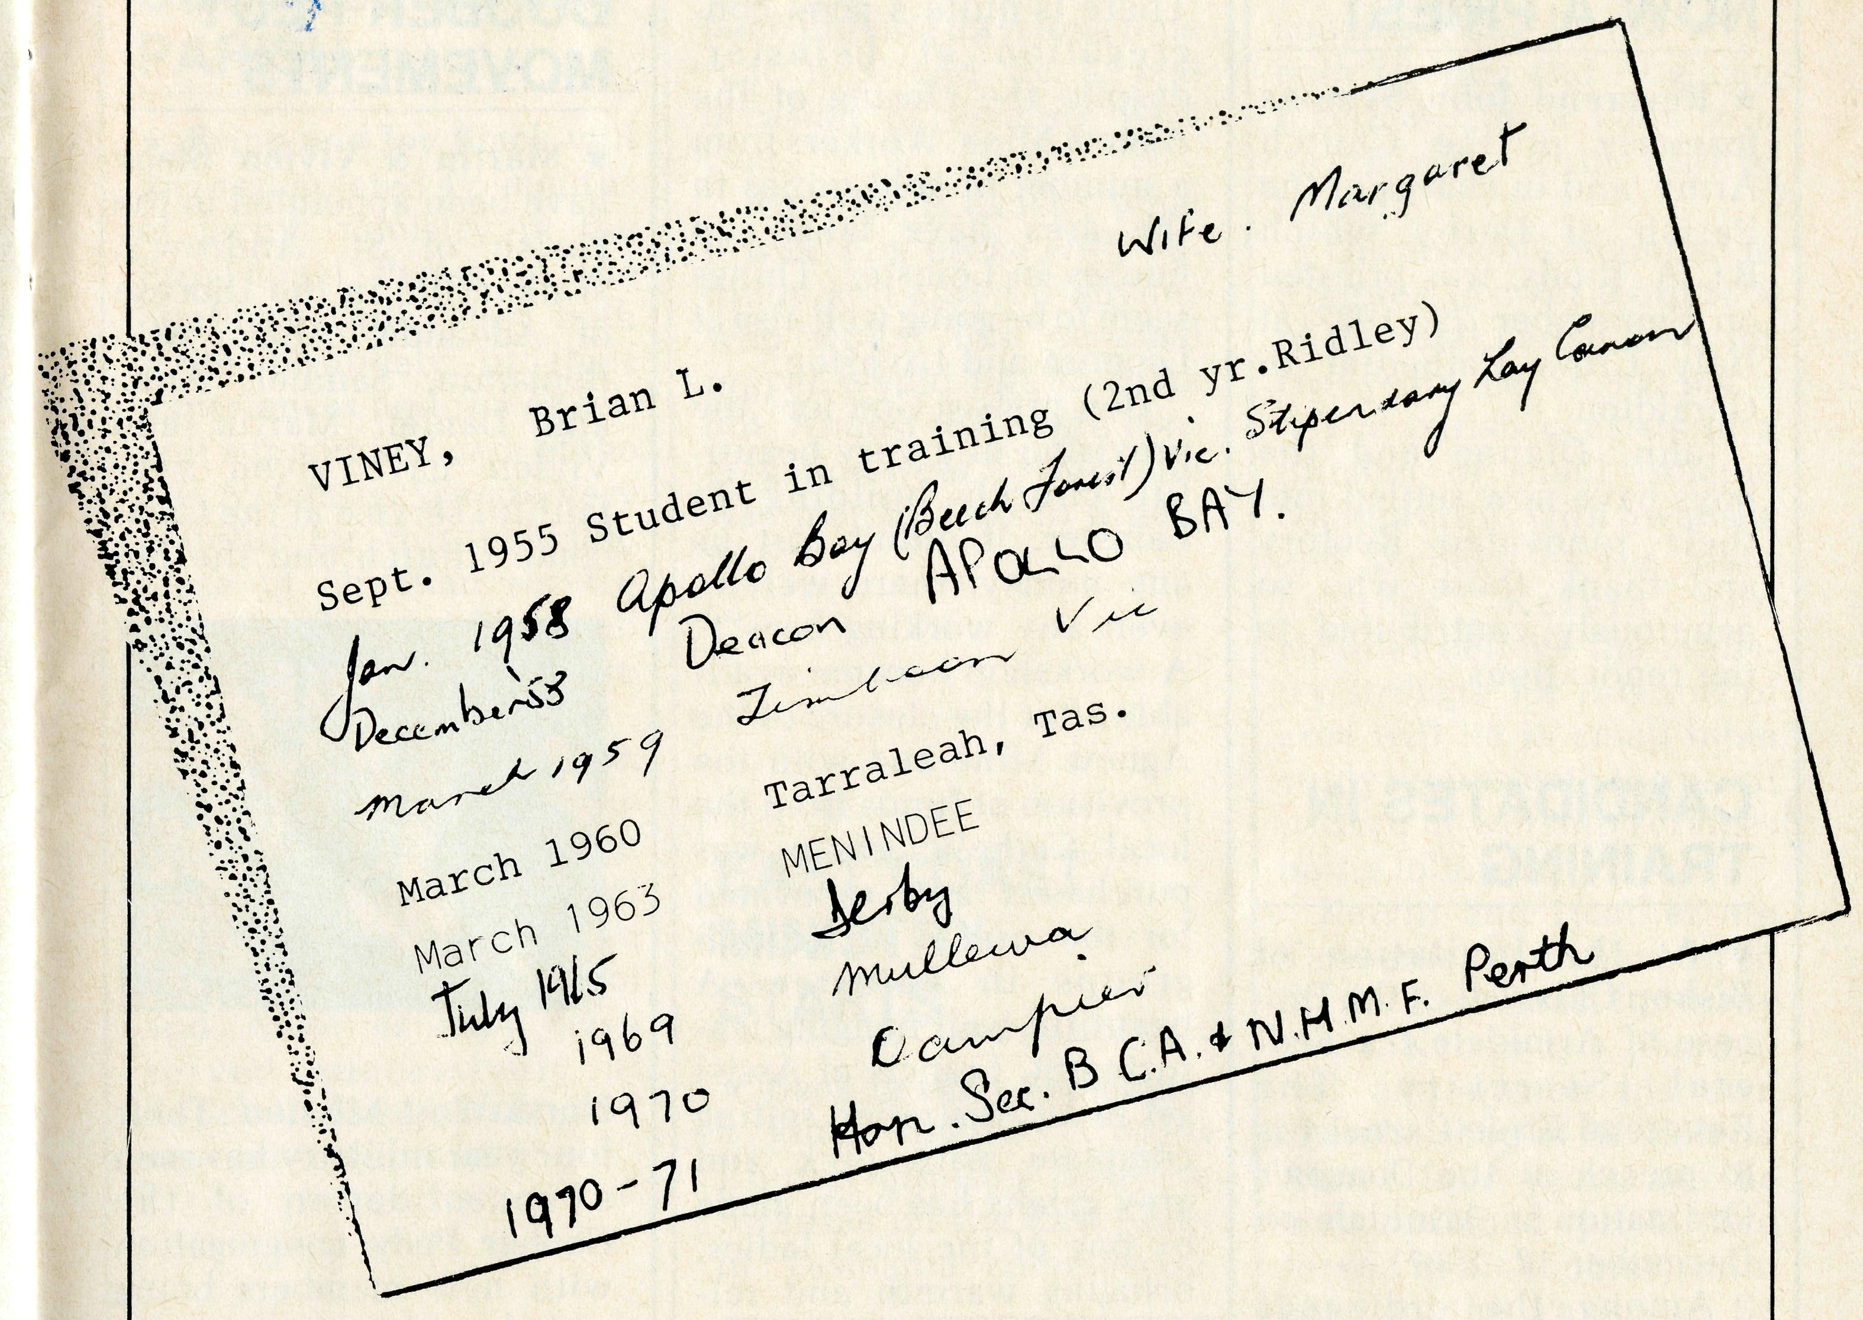
Although B.C.A has never been an Aboriginal mission as such, it must be recognised that the Society through its field staff — primarily missioners and nurses — has been involved in ministry to Aborigines since 1919, as a vital part of our aim to win "Australia for Christ".
As we move forward into our Bicentennial Year it is important to understand where the Society stands in relation to our Aboriginal people.
We believe that the gospel of Jesus Christ as declared in the New Testament is the only way of salvation for all people, Aborigine, Islander and white Australians alike. Consequently B.C.A. seeks to foster a spirit of oneness in Christ between Aborigine and non-Aborigine, but acknowledges that Christian Aborigines may want to distance themselves from the established churches to maintain their cultural identity and pride as they work out the relationship between the gospel and Aboriginal Spirituality. We must encourage our Aborigine friends to express their Christian faith within Aboriginal culture. This will not be an easy task!
What is needed today are Aborigine men and women who are culturally sensitive and biblically equipped to establish strong churches within Aboriginal communities wherever Aborigine people reside. Great spiritual blessing has come already in our own nation where Aborigines are sharing the gospel with other Aborigines.
In recent years God has allowed B.C.A. the privilege of being part of the support network for Aboriginal training colleges. Here students acquire skills in leadership and community development, biblical training and cultural
appreciation. This teaching enables our original Australians to take up leadership roles and to minister to their own people.
At present B.C.A. supports staff at Nungalinya College in Darwin. Mrs. Sandra Kinslow gently supervises two Aborigine assistants in the College office. A grant for computer equipment has helped in the financial operations of Nungalinya's Queensland branch, Wontulp-Bi-Buya, and freed two staff members in Townsville to concentrate on their extension ministry.
At Bimbadeen College in Coota-mundra the Society provides the stipend for the Principal, Pastor Graham Paulson. Financial support is also given to the Wiradjuri Christian Development Ministries based in Wagga Wagga.
Along with A.B.M. and the National Home Mission Fund, B.C.A. has pledged ongoing support for the Aboriginal Affairs Officer to General Synod. This appointment in 1988 is expected to go to an Aborigine. I am fully involved in these important discussions in a committee headed by the Primate.
As keen supporters of B.C.A. you can be assured that the Society is committed to active involvement with Aborigines, particularly in areas where our missioners and nurses are already working. This together with our support for the training of Aborigine christian leaders will greatly assist in strengthening the aboriginal church.
"All one in Christ Jesus",
Ernie.
In announcing the Rev. Brian Viney's appointment as the new B.C.A. State Secretary for Victoria, the Federal Secretary said: "Brian and Margaret are among the most experienced B.C.A. folk anywhere in the country. We could not have called a more experienced person for this important role covering the Province of Victoria and Diocese of Tasmania."
Brian is presently the vicar of St. John's Footscray and will take up his new task in February 1988.
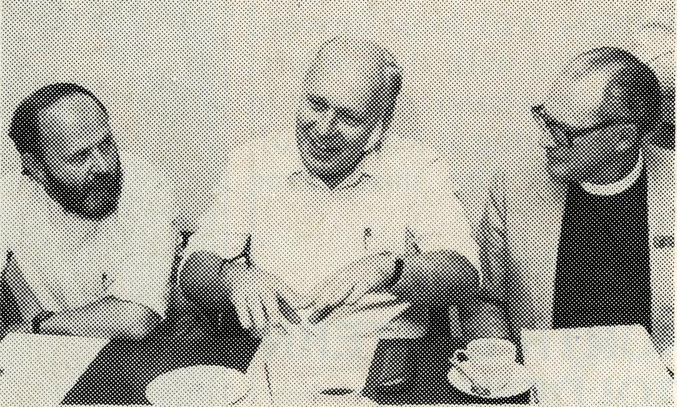
Rev. Brian Viney (centre), Revds. Alan Hoskin (left) and Tom Morgan (right) at a recent B.C.A. executive meeting.

io
THE REAL AUSTRALIAN
THE REAL AUSTRALIAN
II

POST & RAILS

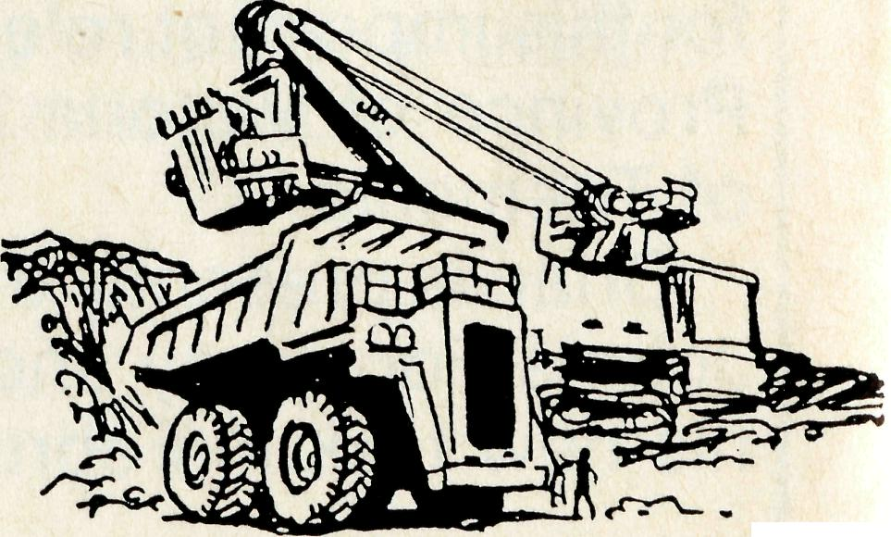
THE REAL AUSTRALIAN
NOW A PRIEST
* Reverend John Symons
formerly of the Church Army, and in charge of the Parish of Derby which B.C.A. funds, was priested on September 29, 1987 at Holy Cross Cathedral in Geraldton.
John, Dianne and the boys have now settled into their renovated Rectory and thank those who so generously contributed to the renovations.
CANDIDATES IN
TRAINING
* At the invitation of Bishop Chiswell of the Diocese of Armidale the Federal Secretary The Reverend Ernie Carnaby is to preach at the Deacon's Ordination in Armidale on December 12, 1987.
Among the ordinands will be Mr. Ray Arthur. Ray and Lyn have had a keen interest in B.C.A. work and after a period of curacy the Arthurs will look forward to service with the society. B.C.A. has been involved in their training at Moore College over the past three years.
NORTH EASTERN GOLDFIELDS
* Bishop Ged reports that Don and Celia Miller are really going well, considering the present difficulties.
There is quite a good congregation at Leinster, despite the closing of the Agnew Mine. Workers from a number of gold mines in the area have taken up houses in Leinster. Things seem to be going well also at Leonora and Laverton.
Don praises God for "the provision of a very beautiful church building in Leinster. It didn't cost us any money, there weren't even any working bees!!!" A workshop became available after the closure of the Agnew Mine and with the provision of funds from the local Catholic group was purchased and renovated for the use of all church groups in Leinster. A beautiful wall hanging featuring St. Francis of Assisi set in an Australian setting complete with pink and grey galahs has been made by one of the local ladies, bringing warmth and relevance to the new church.
PARABURDOCV TOM PRICE
* Gordon and Ann are
delighted that their new church in Paraburdoo is underway. Gordon has indicated that Hammersley Iron have laid off 200 staff members, including some members of the congregation. This just serves to underline the fluctuation in most congregations of the North-West, particularly in the mining towns of the Pilbara.
COOBER PEDY MOVEMENTS
* Martin & Vivien Bleby
have been appointed to the Parish of St. Andrew's, Walkerville in the Diocese of Adelaide. Along with Benjamin, Samuel, Anna and Daniel, Martin and Vivien have given very faithful service at the Catacomb Church and the Far
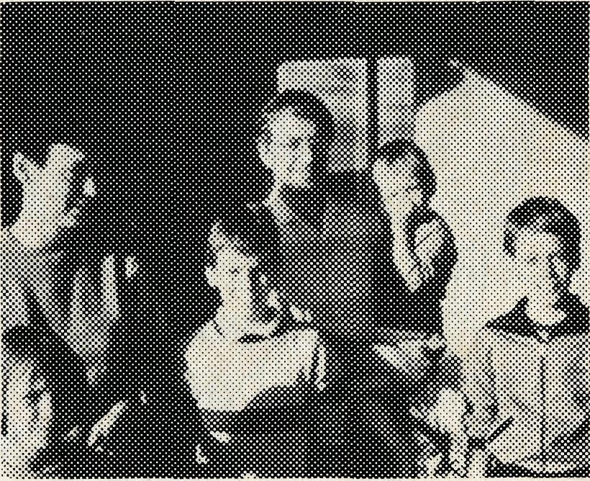
North-West Mission. Their
four year ministry has seen
a consolidation of the
Coober Pedy congregation
with new members being
added, and a very regular
ministry to Mintabie, Maria
Bore, Oodnadatta,
Indulkana, Ernabella and other parts of the North-West. They will be greatly missed from the B.C.A. ranks. Will you pray with us that the right couple will be raised up by God to replace the Bleby's?
SOUTHERN GULF
PARISH
* Brian and Joy Black will have completed 4V2 months of locum ministry in the Provisional Parish of the Southern Gulf. They both write positively of their experiences and the excellent support and care of the B.C.A. family. We are very grateful for this valuable piece of christian service and wish Brian and Joy well as they make their future home in Kurrajong.
Errol and Anne Sorensen will follow hard on the heels of Brian and Joy at Normanton, until the end of the year. It has been an incredible year for Errol and Anne as they have served successively at Bourke, Longreach and now on to Normanton.
BLESSINGS AT TENNANT CREEK
* There has been a steady growth in numbers in the congregation since the beginning of the year. A few have been to check out the new minister — but most have stayed on with us.
Our largest congregation was fifty people, though forty have been regular each week despite some families being away over the holiday period.
Pentecost Sunday was a very special day for the Anglican Church in
THE REAL AUSTRALIAN
Tennant Creek. We had been praying for a long time that it would be a real occasion of meeting with God.
And that is exactly what it was! Tim broke with tradition and asked if anyone who would like personal prayer would like to come out. Almost the entire congregation went forward and was met by God in a new way.
EAST COAST
MINISTRY
STARTS
* Back in early September
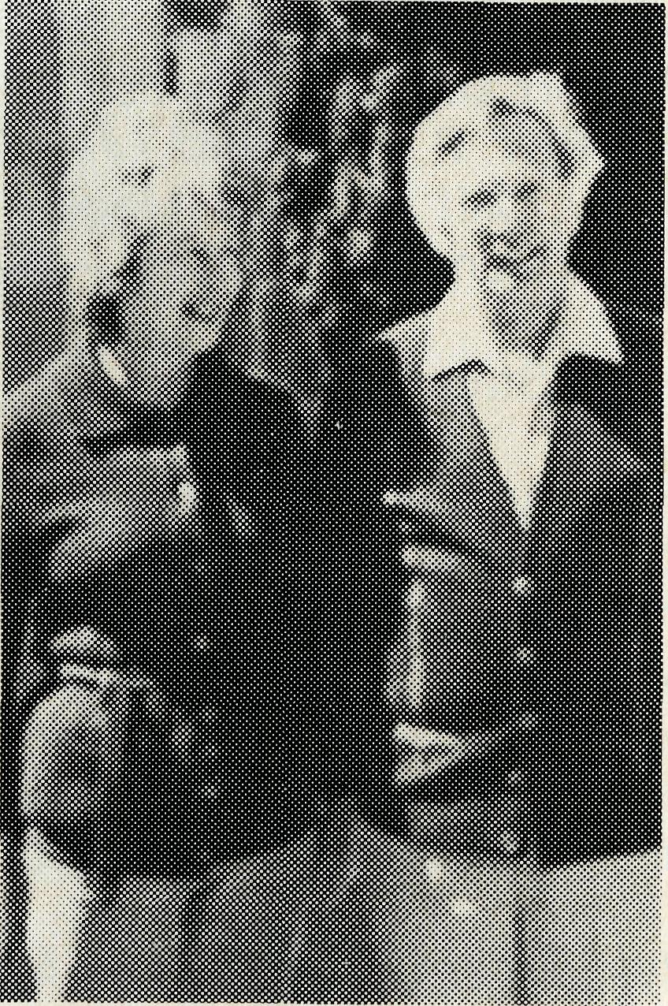
The Rev. Kelvin and Mrs Heather Viney took up the
a joint Anglican Uniting Church ministry based at Swansea on the East Coast of Tasmania commenced.
challenge to bring the small congregations in the area, both Uniting and Anglican together with a view to a combined and viable ministry.
The Society responded to a request to meet about 25% of the total parish costs for two years, i.e. $6,000 p.a.
The parish consists of a number of small isolated communities with Swansea and Bicheno as the main centres. Kelvin and Heather believe the ministry strength for this sort of area will lie in small bible study groups with the usual pattern of worship services being followed.
13
Kelvin and Heather are Tasmanians and have lived on the East Coast for many years. Kelvin is a pharmacist and owned his own chemist shop at St. Helens. About four years ago he was ordained priest and served as an honorary minister in the Parish of St. Helens. Their understanding of the locality gives the Vineys a good start for this ministry.
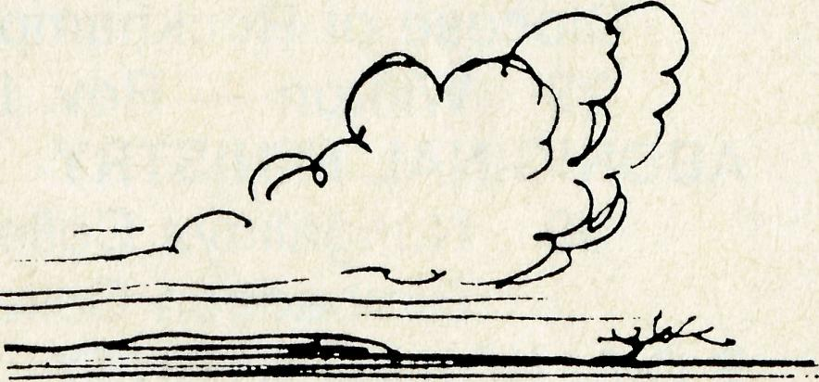

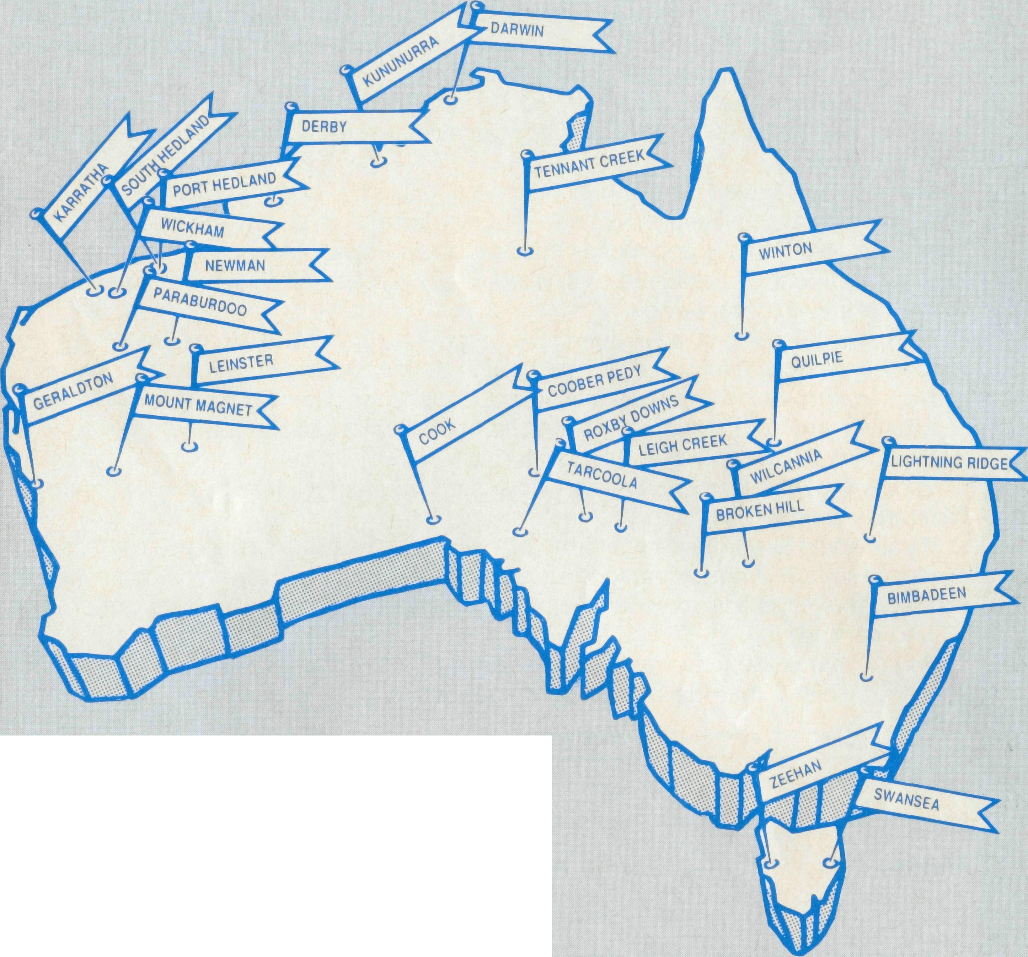
PRAYER CALENDAR
FIELD STAFF DIRECTORY
NORTHERN TERRITORY
Diocese of Northern Territory — Rt. Rev. C. Wood.
- Sanderson — Rev. Robert and Mrs. Rigmor George.
- Palmerston — Rev. Ron and Mrs. Margaret Bundy.
- Tennant Creek — Rev. Tim and Mrs. Kerrie Brownscombe.
- Diocesan Secretary/Treasurer — Mr. Ian Moore. WESTERN AUSTRALIA
Diocese of North West Australia — Rt. Rev. G. B. Muston.
- Kununurra — Rev. Murray and Mrs. Jane Lamont.
- Derby — Rev. John and Mrs. Dianne Symons.
- Newman — Rev. Arthur and Mrs. Pat Williams.
- Port Hedland — Rev. Adrian and Mrs. Willemein Moore.
- South Hedland — Rev. Peter and Mrs. Alison Moss.

- Karratha — Rev. George and Mrs. Jacqueline Sansom.
- Wickham — Rev. Angus and Mrs. Anne McDonald.
- Tom Price/Paraburdoo — Rev. Gordon and Mrs. Ann Hargreaves.
- Mt. Magnet (Murchison) — Rev. Greg and Mrs. Rhi Jones.
- Leinster (North-East Goldfields) — Rev. Don and Mrs. Celia Miller.
- Diocesan Registrar — Mr. Martin Weatherston in Geraldton. Hon. B.C.A. Secretary for W.A. — Rev. Peter Brain.
SOUTH AUSTRALIA
- State Secretary of S.A. — Rev. Bruce Cliff, Mrs. Jocelyn Phillips. Diocese of Willochra — Rt. Rev. D. McCall.
- Coober Pedy — Vacant.
- Roxby Downs and Mid-West Mission — Rev. Colin and Mrs. Ruth Nelson.
- Leigh Creek — Rev. Des and Mrs. Judi Arthur.
20 Hospitals: Cook Hospital — Sister June English, Sister Gai Mee.
Tarcoola Hospital — Sisters Jean Henderson and Jennifer Thompson.
VICTORIA AND TASMANIA
21 State Secretary for Vic. and Tas. — Rev. Brian Viney (from Feb. '88), Mrs. Margo
Bright.
Diocese of Tasmania — Rt. Rev. P. Newell.
22 Zeehan — Deaconess Daphne Robey.
23 Swansea — Rev. Kelvin and Mrs. Heather Viney.
NEW SOUTH WALES
Diocese of Riverina — Rt. Rev. B. R. Hunter.
24 Broken Hill Hostel — Mrs. May Morrow, Mrs. Lois Hustwaite.
- Wilcannia — Rev. Robert and Mrs. Phyllis Collie. Diocese of Armidale — Rt. Rev. P. Chiswell.
THE B.C.A. PRAYER

0 Lord our God, help us to remember the people who live in the remote parts of our land. We ask You to bless those whom You have called into the fellowship of the Bush Church Aid Society, and to call others to stand with them in the task of making Christ known. Grant that, through the ministry of the Word and Sacraments, through healing, and through caring for the young, the message of Your redeeming love may be proclaimed; through Jesus Christ our Lord. AMEN
- Lightning Ridge — Rev. Cliff and Mrs. Megan Ainsworth.
27 State Office, N.S.W. and General Secretary — Rev. Brian Roberts, Mrs. Michele
Peacock.
Hon. B.C.A. Queensland State Secretary — Mr. Allan and Mrs. Annette Sauer. QUEENSLAND
Diocese of Brisbane — The Most Rev. J. Grindrod.
28 Quilpie — Rev. Bob and Mrs. Sue Witten.
Diocese of Rockhampton — Rt. Rev. G. Hearn.
29 Winton — Rev. Lex and Mrs. Rhonda Carey.
ABORIGINAL MINISTRY
30 Nungalinya College — Mrs. Sandra Kinslow.
Bimbadeen College — Pastor Graham Paulson.
B.C.A. HOUSE, SYDNEY
31 Federal Office — Rev. Ernie Carnaby, Miss Margaret Woolcott.
Home Base Staff — Mr. Jim Gosbee, Sister Helen Plumb, Mr. Peter Oram, Mesdames Vivien Bentley, Jacqueline Griffiths, Margaret Sadler. COUNCIL, EXECUTIVE, SUPPORTERS, BOX SECRETARIES.
out where the action is...
.

14
THE REAL AUSTRALIAN
THE REAL AUSTRALIAN

