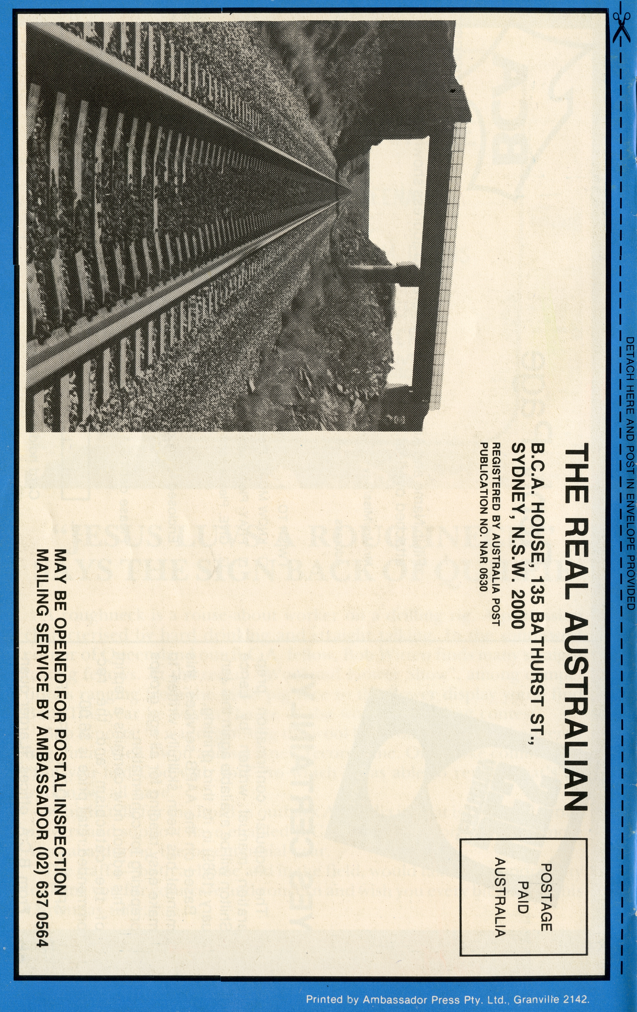
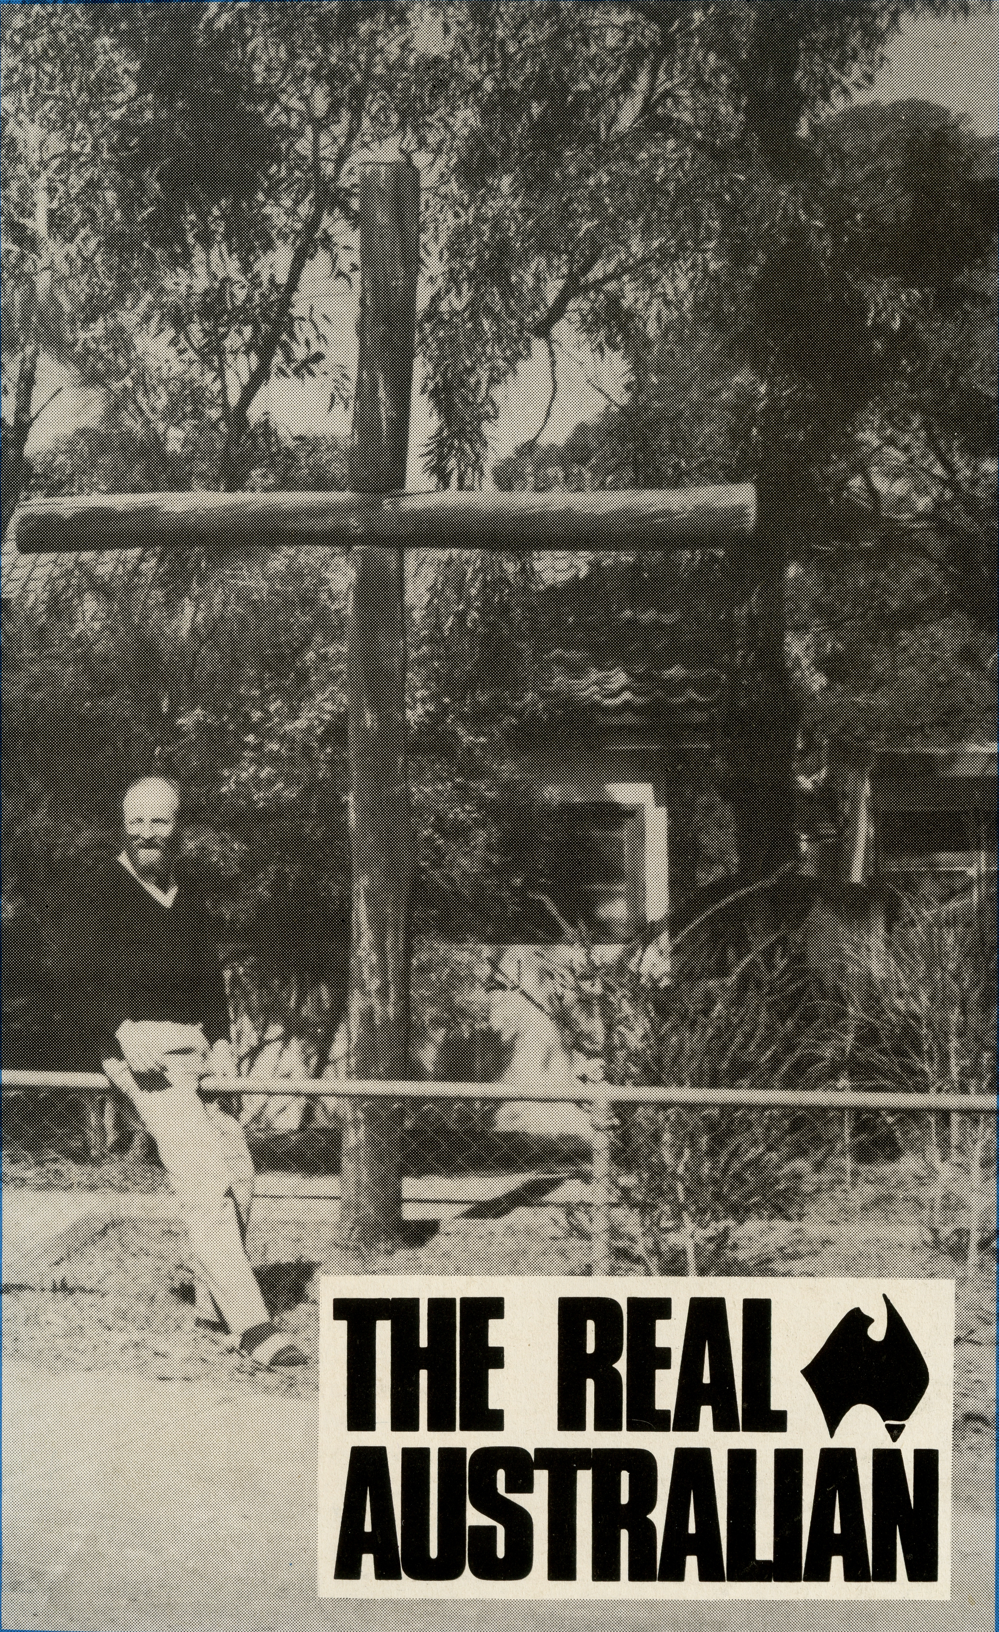
DECEMBER 1988. $3.00 subscription. Reg. by Australia Post Publication No. NAR 0630

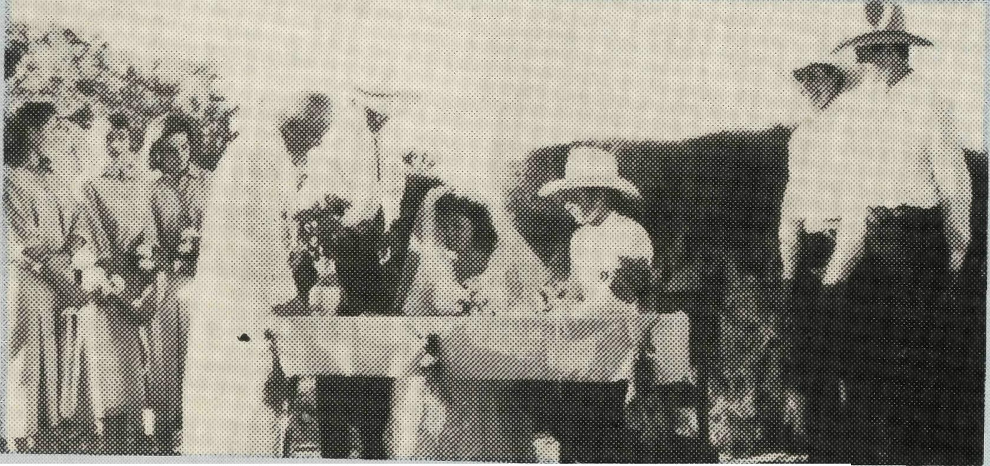
Signing the register at Christmas Creek.
All enquiries to:
THE REAL AUSTRALIAN EDITOR Brian Roberts
THE BUSH CHURCH AID SOCIETY
OF AUSTRALIA
135 BATHURST STREET,
SYDNEY 2000
Phone (02) 264 3164
Patron: The Primate, The Most Rev. John Grindrod.
President: The Most Rev. Donald Robinson, Archbishop of Sydney.
Vice-Presidents: Mr. Stan Hummerston, O.A.M.; Mr. Richard Stokes.
Hon. Treasurer: Mr. R. Ctercteko.
B.C.A. CONTACTS . . .
B.C.A. HOUSE, SYDNEY, 135 Bathurst Street,
Sydney, N.S.W. 2000.
Phone: (02) 264 3164, 264 3780.
Federal Secretary: Rev. Ernie Carnaby.
General and N.S.W. State Secretary: Rev. Brian Roberts.
Victorian Secretary: Rev. Brian Viney, 205 Flinders Lane, Melbourne, Vic. 3000. Phone: (03) 654 8022.
South Australian Secretary: Rev. Robert George, Church Office, 44 Currie Street, Adelaide, S.A. 5000. Phone: (08) 212 7804.
Queensland Hon. Secretary: Mr. Allan Sauer, 28 Doughty Avenue, Holland Park 4121. Phone: (07) 397 1501.
Western Australia Hon. Secretary: Rev. Peter
Brain, 27 Leach Street, Wanneroo, W.A.
6065.
Phone: (09) 405 1325.
FRONT COVER: Rev. Ron Ross outside the church at Kambalda.
CHRISTMAS
CREEK WEDDING
Report from John Symons Derby, North West Australia.
For most people of the south, winter could be a concern for a wedding, especially when you think of the weather. Not so in the North West when from April to November there is not a cloud in the sky making it almost impossible for a wedding to be spoilt by rain.
The Parish of Derby covers the Shire of the West Kimberley and a little bit more. Within this vast 102,700 sq km and in the south east is Christmas Creek Station, 1,000,000 acres of cattle country. It was from Christmas Creek that one morning I received a phone call, "my fiancee and I would like to get married" was what the female voice on the other end said. I asked her where she lived and vaguely knew when she said Christmas Creek. My family and I had lived in Derby for fourteen months and I remembered seeing the sign on the road between Fitzroy Crossing and Halls Creek. "Do you ever come to Derby?" I asked and was relieved when she said they would be in Derby in two weeks.
This was to be my first wedding and so we set a time for an interview. Kris and Christine were in their early 20s and both worked at Christmas Creek. Kris as overseer and Christine as Governess. They were reasonably shy people, however, we talked, I shared the Gospel and filled in the necessary paper work.
After I prayed, they left with a New Testament and a book on marriage to read before my next visit. I had said that I would be in Fitzroy Crossing and would come to see them. Time soon passed by and I was soon on my way to Fitzroy Crossing and Christmas Creek. After a few visits on the way I finally arrived at Christmas Creek about 3.00 pm I had been invited to spend the night, so this allowed plenty of time for my talk with them and to spend time with the manager and his family and some of the workers. The wedding date was set and I made another appointment to see them before the wedding. When this other appointment came I once again spent the night at the station, building relationships.
Tuesday, 28 June 1988 finally came. She looked beautiful in her bridal gown and the men looked quite handsome in their western outfits. The front garden had been
chosen for the event. Lawns had been mowed, hedges clipped, chairs set in place and bales of hay had been placed around.
The reception was to be in the same place so tables had been set, food prepared and in one corner of the garden was a large pig on a spit cooking slowly. People had travelled a long way for this memorable event.
Cars, light aircraft and helicopter, from Perth, Melbourne and the surrounding stations. The ceremony commenced at 3.30 pm, father giving away daughter, Kris and Christine exchanging marriage vows to become husband and wife. Please pray for them.
Some may think that what was missing was the Church. God had provided a beautiful day, scenes of His creation and the peace of Christmas Creek. To Him be the glory. As for me, well, I had to be in Koolan Island the very next day so could not spend the night at the Station. I stayed for the reception and after the cutting of the three tier cake headed off for home, 3V2 hours away and very conscious of how many stray cattle there may be on the road.
Ministering in a Parish as vast and remote as Derby, you become very aware of the prayer that is being offered by your supporters. Bush
Church Aid Society is a family spread throughout this wonderful land that God has provided. Thank you for your prayers and the support that you give that makes this ministry in Derby continue making it possible for people like Kris and Christine to call upon the Church for God's blessing upon their marriage.

From the Federal Secretary.
Celebrations
"Let's celebrate in '88!"
Urged on by the media we have willingly participated.
But the party is almost over!
- Who will ever forget the First Fleet re-enactment on Sydney Harbour? ... and the 10,000 proud aboriginal people who marched from Redfern to Hyde Park?
- The arrival of the Tall Ships.
- The opening of the new Parliament House in Canberra by Her Majesty ... and the national gathering on the eve of the opening when Christians of all denominations joined in intercession for the nation.
- The staging of World Expo in Brisbane from May to October.
- The Naval Salute and Review of 40 warships from many nations.
In this bicentennial year we are commemorating two hundred years of white settlement on our shores. The birth of a nation? What of the thousands of years of aboriginal occupancy prior to 1788 and subsequent injustices perpetuated against them?
One of the most significant events of 1988 was "Operation Good News" undertaken by the Christian Churches nationally,
wherby a Bicentennial New Testament was offered to every household and dwelling in Australia. Thrilling accounts have reached us of the success of this operation, whether in Wicannia, Lightning Ridge, Roxby Downs, North West Australia, or in our cities. Looking back over the B.C.A. Prayer Notes we see how many times Good News '88 comes up for prayer and praise. The right of every Australian to hear the gospel in a language they can understand. Pray that many in Oz will turn to Christ.
Other memorable events of deep interest to the B.C.A. family have been ...
* The opening of four new churches in the Pilbara regior of North West Australia at Port Hedland, South Hedland, Paraburdoo and Newman during the visit of the Archbishop of Canterbury last February. The prayer offered by Bill Warburton, Archdeacon of the Pilbara, is that these new churches will become "dynamic centres of prayer and outreach." It is encouraging to hear that the Outback Church Foundation has moved to complete the task of erecting three further church buildings in Wickham Kununurra and Kalbarri, makinc seven churches in all, at a cost Oj over one million dollars. Christian friends around Australia have given or promised more than $800,000 to the Foundation already.
* The opportunity to help two struggling parishes formerly staffed by the Society ... Ron and Colleen Ross from Perth have taken up their ministry at Kambalda/Norseman in the W.A. Goldfields. Kambalda just south of Kalgoorlie is a beautiful town of about 5000 residents, but the population turnover is high. The town was built in the late sixties during the nickel boom. Ron is also responsible for Norseman, 135 km south of Kambalda, where the Anglican Church has been a traditional part of that settled community for over 90 years. Then there are periodic visits to Salmon Gums and out along the Eyre Highway to the S.A. border.
Bishop Hearn of Rockhampton approached B.C.A. for help again with ministry at Blackwater. In its early days Blackwater was originally supported by the Society and reached financial viability in 1980. It continued as a viable parish for five years but then came the downturn in the mining industry. This reached a crisis early in 1988 when one of the four mines closed and many folk were made redundant.
Distances in this parish, the pastoral demands and evangelistic opportunities make it imperative that a resident minister be maintained. There are 7500 residents in Blackwater and four small rural communities spread over rugged country. The Society has agreed to provide financial help for three years and has endorsed Glen and Kay Zimmerle as B.C.A. missioners. This is real "church aid"!
* New work at Omeo in Gippsland Diocese . . . this alpine parish north of Bairnsdale had been without a resident minister for five years. Veteran B.C.A. workers Errol and Anne Sorenson accepted the challenge and began | ministry there in June. The parish has about 200 Anglican families in a population of 1600, and includes the Dinner Plains Ski Resort, a copper mine at Benambra, sheep, cattle and timber. Errol is concerned to reach the men for Christ as the Church has largely been maintained by a small group of faithful women.
From a Christian perspective there is far greater cause for rejoicing than the bicentennial extravaganza. Shortly we will celebrate the coming of Christ as Messiah and King in God's world. To all who receive him and believe in his name, he gives the right to become children of God. (John 1:12) Jesus came to share our human condition and die for us on the cross.
Christmas is a wonderful event to be celebrated. God has stepped on to the stage of human history in the Person of his Son. In celebrating His coming we are reminded of the need to proclaim the good news I of Christ throughout this nation in every city, town and outback community.
The party's over, but we continue to celebrate the acts of God.
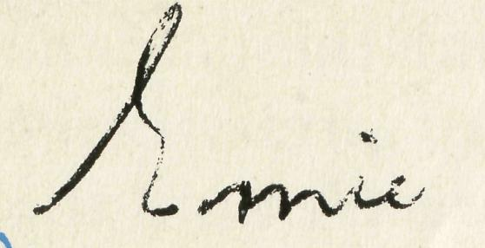

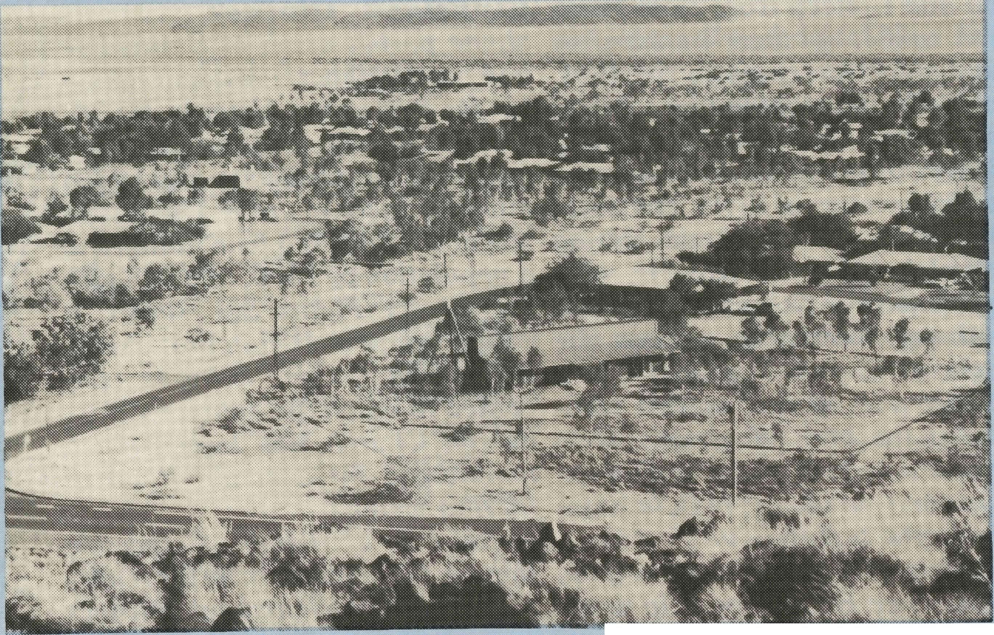
FIRST IMPRESSIONS OF BEING WITH B.C.A. AT KARRATHA, W.A.

Eight months ago we had never heard of Karratha, but this was to change when Bishop Muston, from the Diocese of North Western Australia, wrote to us about it. This was to result in our being accepted by B.C.A. and in our preparations to go west. Having lived in Victoria for 19 years we now were faced with continuously warm weather, so we stored much of our winter clothing, as well as much of our furniture before leaving. Our family did the journey in two parts our three boys and one ancient cat flew over 10 days after we started the long journey in our Hiace van, towing our fishing boat. The drive across the Nullabor and then up north took seven days of pretty constant driving, and it wasn't until the last day, when the Tropic of Capricorn was

passed, that we began to feel the North West warmth.
We actually arrived three days earlier than we were expected, and luckily just a couple of hours after the Rectory painting was finished. Our first meeting with some of the parishioners was then, and later that evening, at an informal healing service at our church. Over the next few day we were to meet more parishioners, open bank accounts, enrol the children at schools and see a little more of the town before the boys arrived.
Terry and Fiona Redmond.
The parishioners have been very welcoming and friendly, which has helped us all settle in, and very soon after our arrival we became immersed in two important fund raising activities, helping to sell about 3000 hamburgers and
frankfurts (otherwise known as Pluto Pups as they're covered with batter) over two successive weekends. Apart from the funds that were raised, these were good occasions for getting to know parishioners and the community better.
We enjoyed the north-western winter, which meant a succession of predictably sunny days which have all been between 27° and 31°. The average temperature is known to rise by a couple of degrees each month until the heat sets in by about December. We are awaiting this with a sense of anticipation and by the time you read this we trust we haven't melted
After the Victorian winter countryside, the stark dryness of the W.A. scenery seems somewhat harsh, but we have found that it grows on one and has a beauty all its own.
The cooler months are good for visitors, some touring around, others visiting and staying with family here, and for several weeks it seemed that there was always a visitor joining in the morning worship.
Karratha is a bit like an oasis in the desert. It has modern houses, an excellent shopping centre, and numerous facilities, it also has no traffic lights or parking meters. Once one gets away from the suburbs and town centre the red sand, scrubby bush and stony hills take over. The present population is about 15,000 with quite a large number of people living in caravan parks. There was an exodus of construction workers in early November, when the N.W. Shelf Gas Project reached completion. Numerous parishioners are now
starting to make preparations to leave as well.
Our main centre of worship, plus the Rectory, is at Karratha, and at Dampier we have a weekly service in the Uniting Church. Dampier is 20 km away, on the coast. It's older than Karratha, with about 1 500 residents, and it is rather a pretty place. There is a multitude of off shore islands which adds to this beauty. All the main industrial activity takes place at Dampier, iron-ore comes in by rail from Tom Price and Paraburdoo, salt is harvested and shipped off, and the Natural Gas pipeline comes on shore for processing.
We have enjoyed the friendship and fellowship of our people here, and are beginning to contemplate our mission to the vast majority of people outside the life of the church
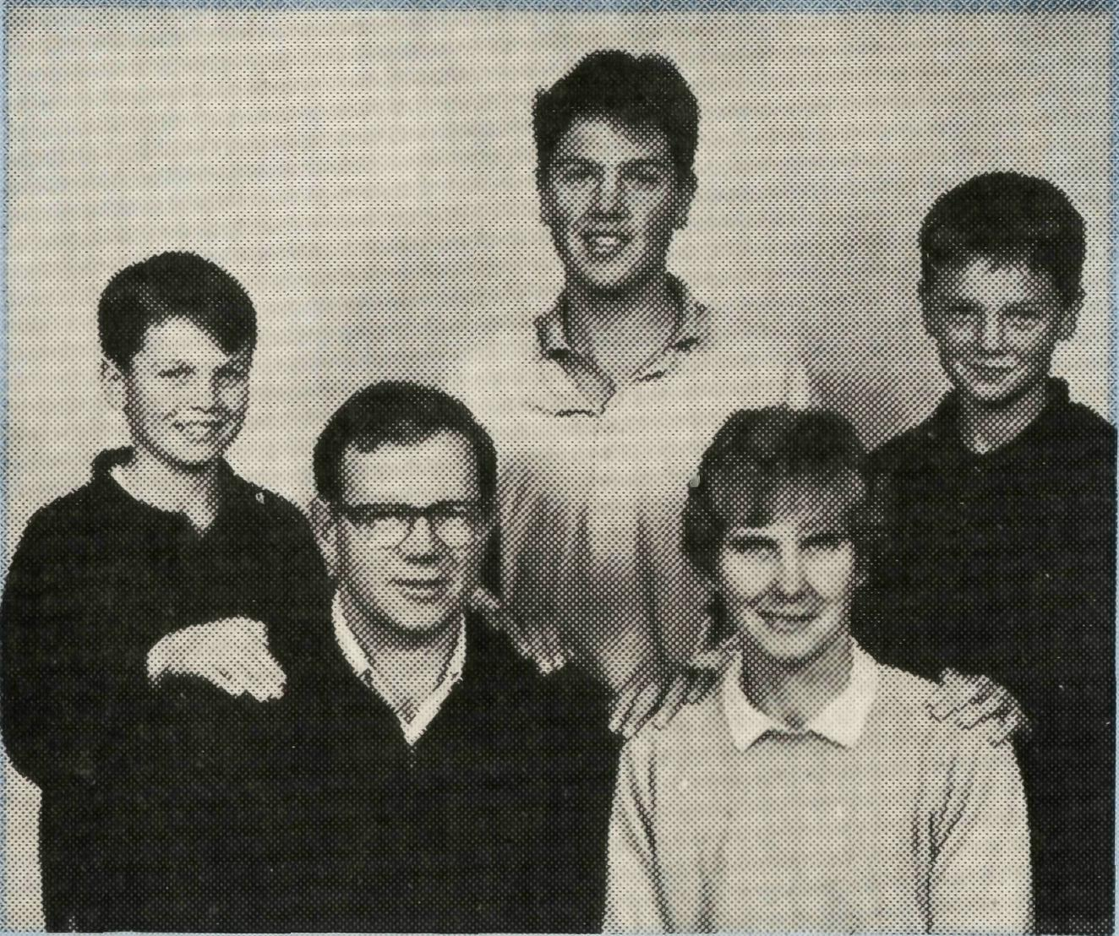
Rev. Terry and Mrs. Fiona Redmond, Jonathon (11), Mark (16), Bruce (13).
here. We look forward to working with the nucleus of committed and gifted parishioners, and we ask for your prayers and the blessing of the Holy Spirit as we work to further God's Kingdom here.

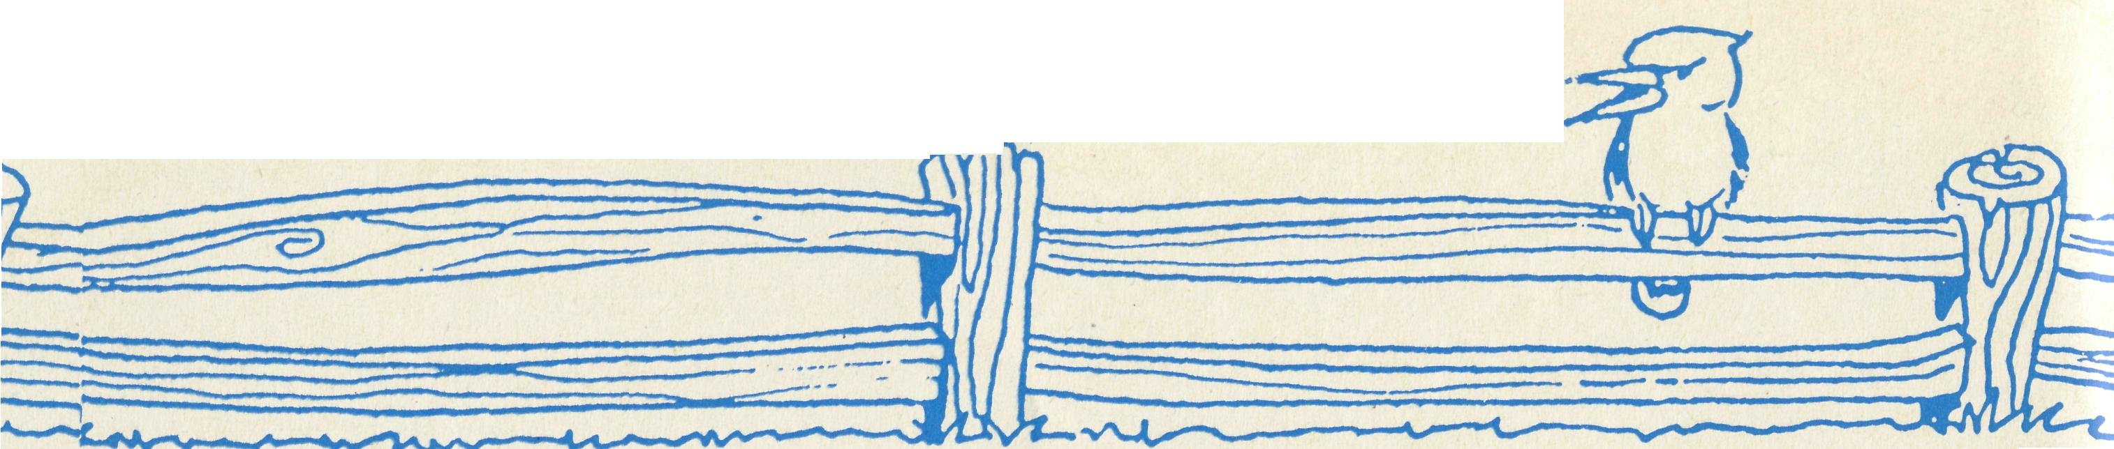
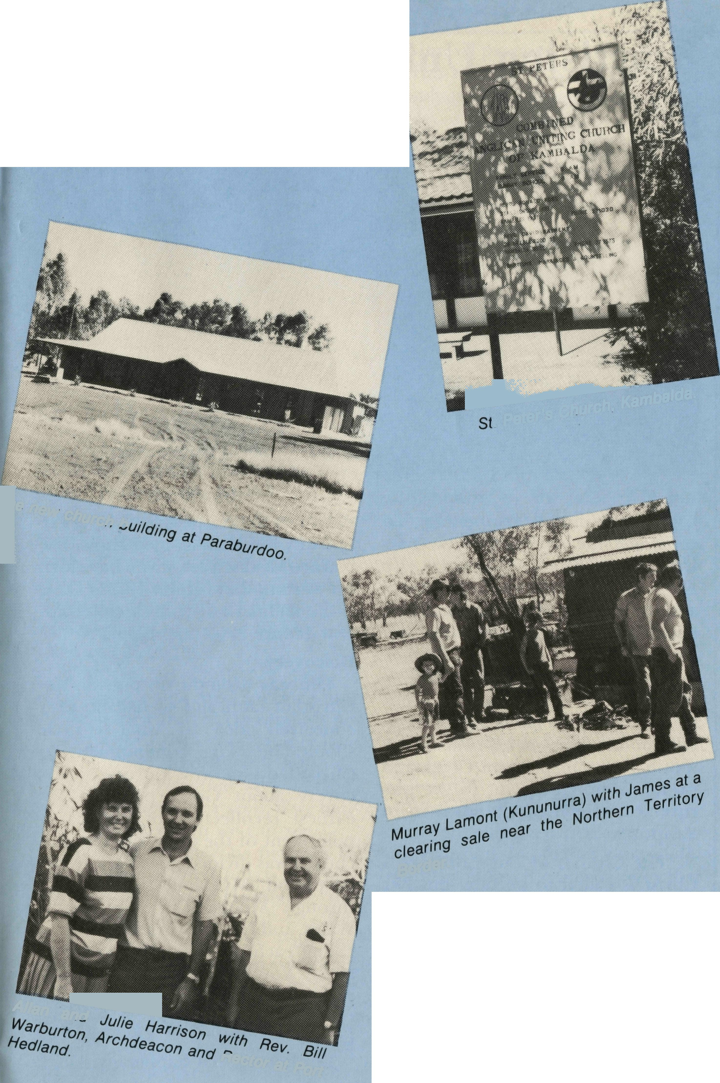
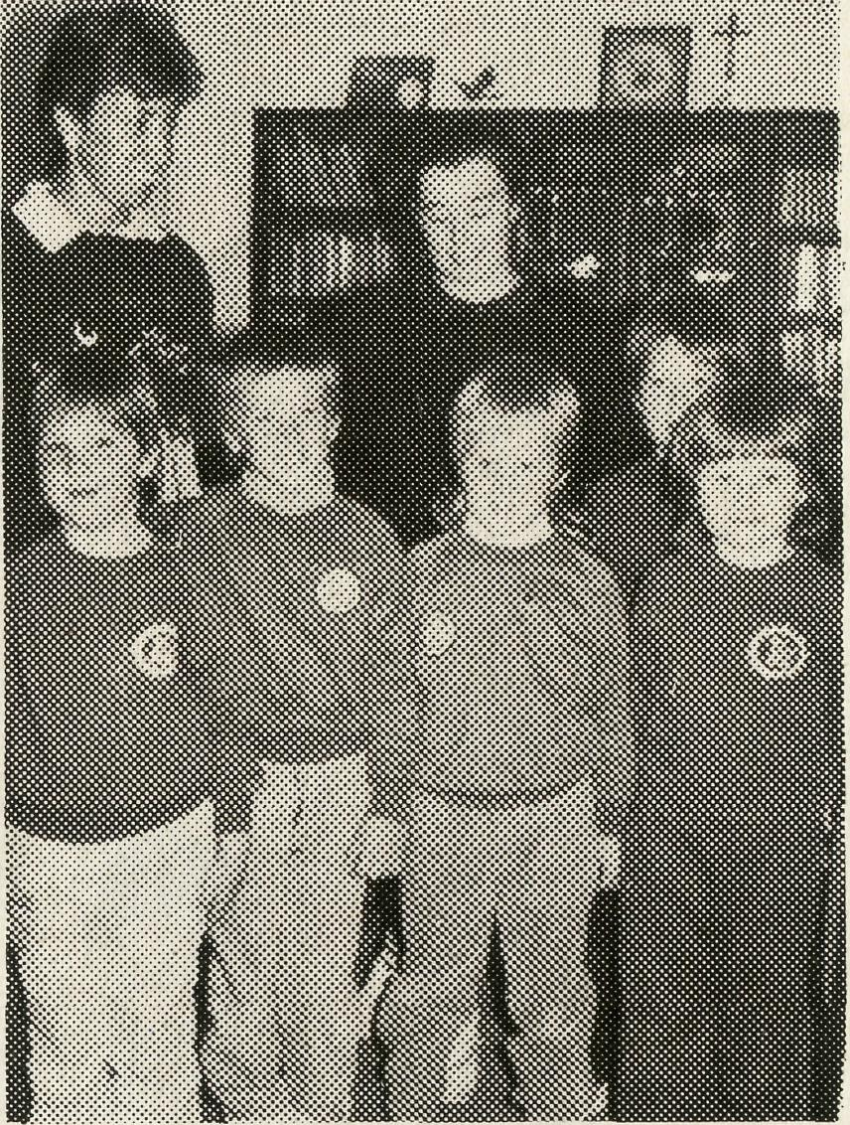
POST & RAILS
B.C.A.'s Australia
WEST AUSTRALIAN OFFICE MOVES
* The Rev. Peter Brain our
Honorary West Australian secretary has moved parishes and the new address is:
27 Leach Street, Wanneroo, 6065.
COOK HOSPITAL HOSTS SCHOOL VISIT
■fes>*^{M}*
I⁶'^{ne}* church h '
*Sr. Ruth Leske (right) and Sr. Narelle Webster with students from Penong at Cook Hospital.
SOUTH AUSTRALIAN RALLY REPORT
* This year's rally was held on an October Sunday afternoon, which was a departure from the usual evening meetings of past years. One hundred and fifteen people gathered at St. Martin's, Campbelltown, which is the home parish of the Georges.
Referring to Ezekiel,
Border-
Allan a!^!^^^
^{nect}or at _{Port}
BACK COVER PHOTO:
The Pannawonica to Roeburne and Paraburdoo to Dampier railway lines crossover.
WELCOME
* Rev. Bob and Mrs. Caro
line Booth have arrived in
Newman in the Diocese of
North West Australia. They
report that they received a
very warm welcome at
their induction to the par
ish and that the weather
during their first week or so
was moderate. Bob and
Caroline have five children
Simon 11, Philippa 9, Emily
7, Phoebe and Sarah 5.
* Sister Mary Grace
Bingham from Adelaide to
our hospitals on the
Transline to work as relief
sister.
* Rev. Glen and Mrs. Kaye
Zimmerle have now
become B.C.A. supported
staff — the Zimmerle's are
at Blackwater in the Dio
cese of Rockhamptom.
FAREWELLS
- Rev. Peter and Mrs. Alison Moss from South Hedland to Perth. After the 31st December, 1988 the Society, by agreement with the Diocese, will not continue with funding for the South Hedland Parish.
- Rev. Don Miller from Leinster to "Ullula" property Western Australia. Don will continue to have pastoral responsibility for Wiluna and some local work in the Diocese. Don hopes to use his "Ullula" property as a base for helping aboriginal people.
Chapter 37, the State Secretary spoke on the nature of B.C.A. ministry as raising "old bones to new life", through proclamation of Christ, and prayer for God's Spirit to quicken spiritual growth.
Sister Jean Henderson shared about life and ministry at Tarcoola Hospital. Ken Langshaw ably chaired the gathering, while flute and violin solos created an atmosphere of worship and quiet thankfulness. The occasion was a source of great encouragement to all who attended.
The new church building at Paraburdoo.
St Peter’s Church, Kambalda.
STAMPS STAMPS
* Thank you for the many contributions of used (and some mint) that we continually receive.
Please keep sending them.
If you have never thought of it before, why not save your stamps and send them to us here at B.C.A.
It is helpful if the stamps are already trimmed (not too close approximately 1.2 cm around the edge of the stamp). Or, just tear the stamps off your letters. If you are trimming the stamps, could we ask that you cut them so that they are on single paper only.
Murray Lamont (Kununurra) with James at a clearing sale near the Northern Territory Border
Big bundles, or little bundles, many or few, all are accepted with thanks.
Income 1986 $3,350 Income 1987 $5,650
Thank You.
Allan and Julie Harrison with Rev. Bill Warburton, Archdeacon and Rector at Port Hedland.

THE REAL AUSTRALIAN
THE REAL AUSTRALIAN

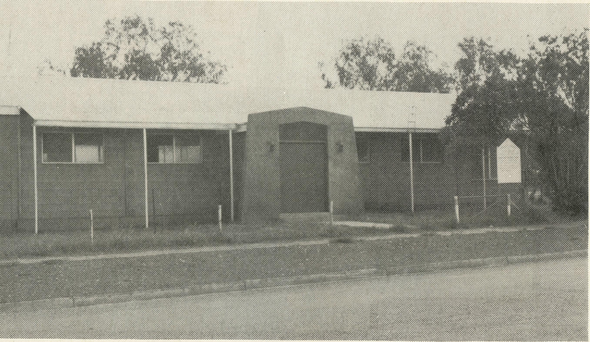
Practising Unity
Was it a unique happening? To celebrate the arrival of the new Uniting Church pastor, the Anglican church closed its doors and went down to welcome the new pastor and take part in the induction service.
Tim Brownscombe is the Priest-in-charge of the Tennant Creek Anglican Parish. He is reluctant to talk too much about his role in promoting unity in Tennant Creek and prefers simply to point to the picture of the Church drawn in Scripture.
"The Church of our Lord Jesus Christ is called to be one, but her track record is not at all good. The Church should be an example of love to a broken and divided world but, tragically, it too is beset by division."
How can the world believe in Christ while it sees his followers divided among themselves? Christ
10
Tennant Creek Anglican Church.
taught us to be a people of love, He said "By this shall all men know that you are My disciples, if you have love for one another" (John 13:35) Love is the hallmark of true discipleship. Our failure is to our shame!"
Discovery
Tim was brought up outside the Christian faith and so had no preconceived idea of what church should be. His commitment to Christ led him on a journey of discovery about God's people. "My earliest recollection of the disappointment of the discovery that the church was divided goes back to my childhood. My family was passing through Mudgee, in New South Wales, and I saw two grand churches facing each other on opposite corners!" You can imagine Tim's feelings when twenty years later he returned to Mudgee as an assistant priest!
But before that happened, Tim's
THE REAL AUSTRALIAN
search for truth took him through the doors of almost every Christian denomination. During one of his teenage years, he went to every church in the district, often attending four or five services every Sunday!
That experience has given Tim a deep longing for the Body of Christ to be seen to be together. In a talk he gave in Mudgee, he said "unity within the Church is of utmost importance. It is a major theme of the New Testament.
Jesus' own concern for unity is reflected in His great "High Priestly prayer. I do not pray for these only, but also for those who believe in Me through their word, that they may all be one, even as we are one (John 17). "Paul continually stresses the priority of unity. In Romans he teaches that we should live at peace with all men if it is at all possible. The Corinthian church is rebuked for its factions, and in Ephesians the believers are described as one new man in Christ."
John, in his Epistle of love, is supremely concerned for love and unity in the Church. He reminds his readers of Christ's command to love one another and then continues. "How can we say that we love God, whom we have never seen, if we hate our brother whom we can see?"
There are numerous pictures of the oneness of the Church in Scripture. Jesus speaks of Himself as "the Good Shepherd" and of His followers as "one flock". St. Paul says that in Holy Communion we are all "one loaf and that we are "one body with many parts". Again he describes the unity of the church by saying we are a holy temple built onto one foundation."
THE REAL AUSTRALIAN
Vision in practice
Tim believes it is not enough to simply nod assent to the concept of unity, or to just point to the fact that the true Church is united, though "invisible" we need to demonstrate that we believe in Unity.
For Tennant Creek that has meant a growing trust and sharing of ministry. Initially, any proposal for combined worship was met with suspicion and flatly vetoed. But gradually the barriers have come down.
When the Uniting Church was without a minister for nine months during 1987, Tim was able to take a leadership role in their mid-week Kids Club. He also conducted a wedding and a funeral there.
Scripture in the school is now taught on a combined basis instead of in denominational groups. When this article was Written the Christian Revival Crusade was without a pastor and they were joining with the Anglicans for services on Sunday nights!
Tim says, "Trust is beginning to develop between the clergy as they begin to grasp the vision. The future is in God's hands as we seek His will to reach out into our community together."
When God's people join together for evangelism, particularly if it is undergirded by prayer, the community will surely come to know that there is a God who is able to restore relationship, mend broken marriages and homes, and put back together again. "How good and pleasant it is when brothers live together in unity. There God commands a blessing (Psalm 133).
Reprinted from New Day International with permission.
11

PRAYER CALENDAR
FIELD STAFF DIRECTORY

NORTHERN TERRITORY
Diocese of Northern Territory — Rt. Rev. C. Wood.
- Sanderson — Rev. Greg and Mrs. Kerry Thompson (from October 9).
- Palmerston — Rev. Ron and Mrs. Margaret Bundy.
- Tennant Creek — Rev. Tim and Mrs. Kerrie Brownscombe.
- Diocesan Secretary/Treasurer — Mr. Ian Moore. WESTERN AUSTRALIA
Diocese of North West Australia — Rt. Rev. G. B. Muston.
- Kununurra — Rev. Murray and Mrs. Jane Lamont.
- Derby — Rev. John and Mrs. Dianne Symons.
- Newman — Rev. Bob and Mrs. Caroline Booth.
- Port Hedland — Ven. Bill and Mrs. Jennifer Warburton.
- Karratha — Rev. Terry and Mrs. Fiona Redmond.

- Wickham — Rev. Allan and Mrs. Julie Harrison.
- Tom Price/Paraburdoo — Rev. Gordon and Mrs. Ann Hargreaves.
- Mt. Magnet (Murchison) — Vacant.
- Leinster (North-East Goldfields) — Vacant.
- Diocesan Registrar — Mr. Martin Weatherston in Geraldton. Diocese of Perth — Most Rev. Peter Carnley
15 Kambalda/Norseman — Rev. Ron and Mrs. Colleen Ross
Hon. B.C.A. Secretary for W.A. — Rev. Peter Brain
SOUTH AUSTRALIA
Diocese of Willochra — Rt. Rev. D. McCall.
- Coober Pedy — Rev. Ian and Mrs. Robin Robertson.
- Roxby Downs and Mid-West Mission — Rev. Colin and Mrs. Ruth Nelson.
- Leigh Creek — Vacant.
State Secretary of S.A. — Rev. Robert George, Mrs. Jocelyn Phillips.
19 Cook: Bishop Kirkby Memorial Hospital — Sister June English, Gai Mee, Ruth
Leske. Relief Sister Mary Grace Bingham.
20 Tarcoola Hospital — Sisters Jean Henderson and Janette Harris (on leave).
VICTORIA AND TASMANIA
Diocese of Gippsland — Rt. Rev. C. Sheumack.
21 Omeo — Rev. Errol and Mrs. Anne Sorensen.
State Secretary for Vic. and Tas. — Rev. Brian Viney, Mrs. Margo Bright. Diocese of Tasmania — Rt. Rev. P. Newell.
- Zeehan — Vacant.
- Swansea — Rev. Kelvin and Mrs. Heather Viney. NEW SOUTH WALES
Diocese of Riverina — Rt. Rev. B. R. Hunter.
24 Broken Hill Hostel — Mrs. May Morrow, Mrs. Lois Hustwaite, Mr. Nick
Puttman.
- Wilcannia — Rev. Robert and Mrs. Phyllis Collie. Diocese of Armidale — Rt. Rev. P. Chiswell.
- Lightning Ridge — Rev. Cliff and Mrs. Megan Ainsworth.
State Office, N.S.W. and General Secretary — Rev. Brian Roberts, Mrs. Michele Peacock. QUEENSLAND
Diocese of Brisbane — The Most Rev. J. Grindrod.
27 Quilpie — Rev. Bob and Mrs. Sue Witten.
Hon. B.C.A. Queensland State Secretary — Mr. Allan and Mrs. Annette Sauer. Diocese of Rockhampton — Rt. Rev. G. Hearn.
28 Winton — Rev. Lex and Mrs. Rhonda Carey.
29 Blackwater — Rev. Glen and Mrs. Kaye Zimmerle.
ABORIGINAL MINISTRY
30 Nungalinya College — Miss Claire Laker.
Bimbadeen College — Maika and Ana Bovoro (Dean).
B.C.A. HOUSE, SYDNEY
31 Federal Office — Rev. Ernie Carnaby, Miss Margaret Woolcott.
Home Base Staff — Mr. Jim Gosbee, Sister Helen Plumb, Mesdames Vivien
Bentley, Jacqueline Griffiths, Margaret Sadler.
COUNCIL, EXECUTIVE, SUPPORTERS, BOX SECRETARIES.
THE REAL AUSTRALIAN
out where the action is...
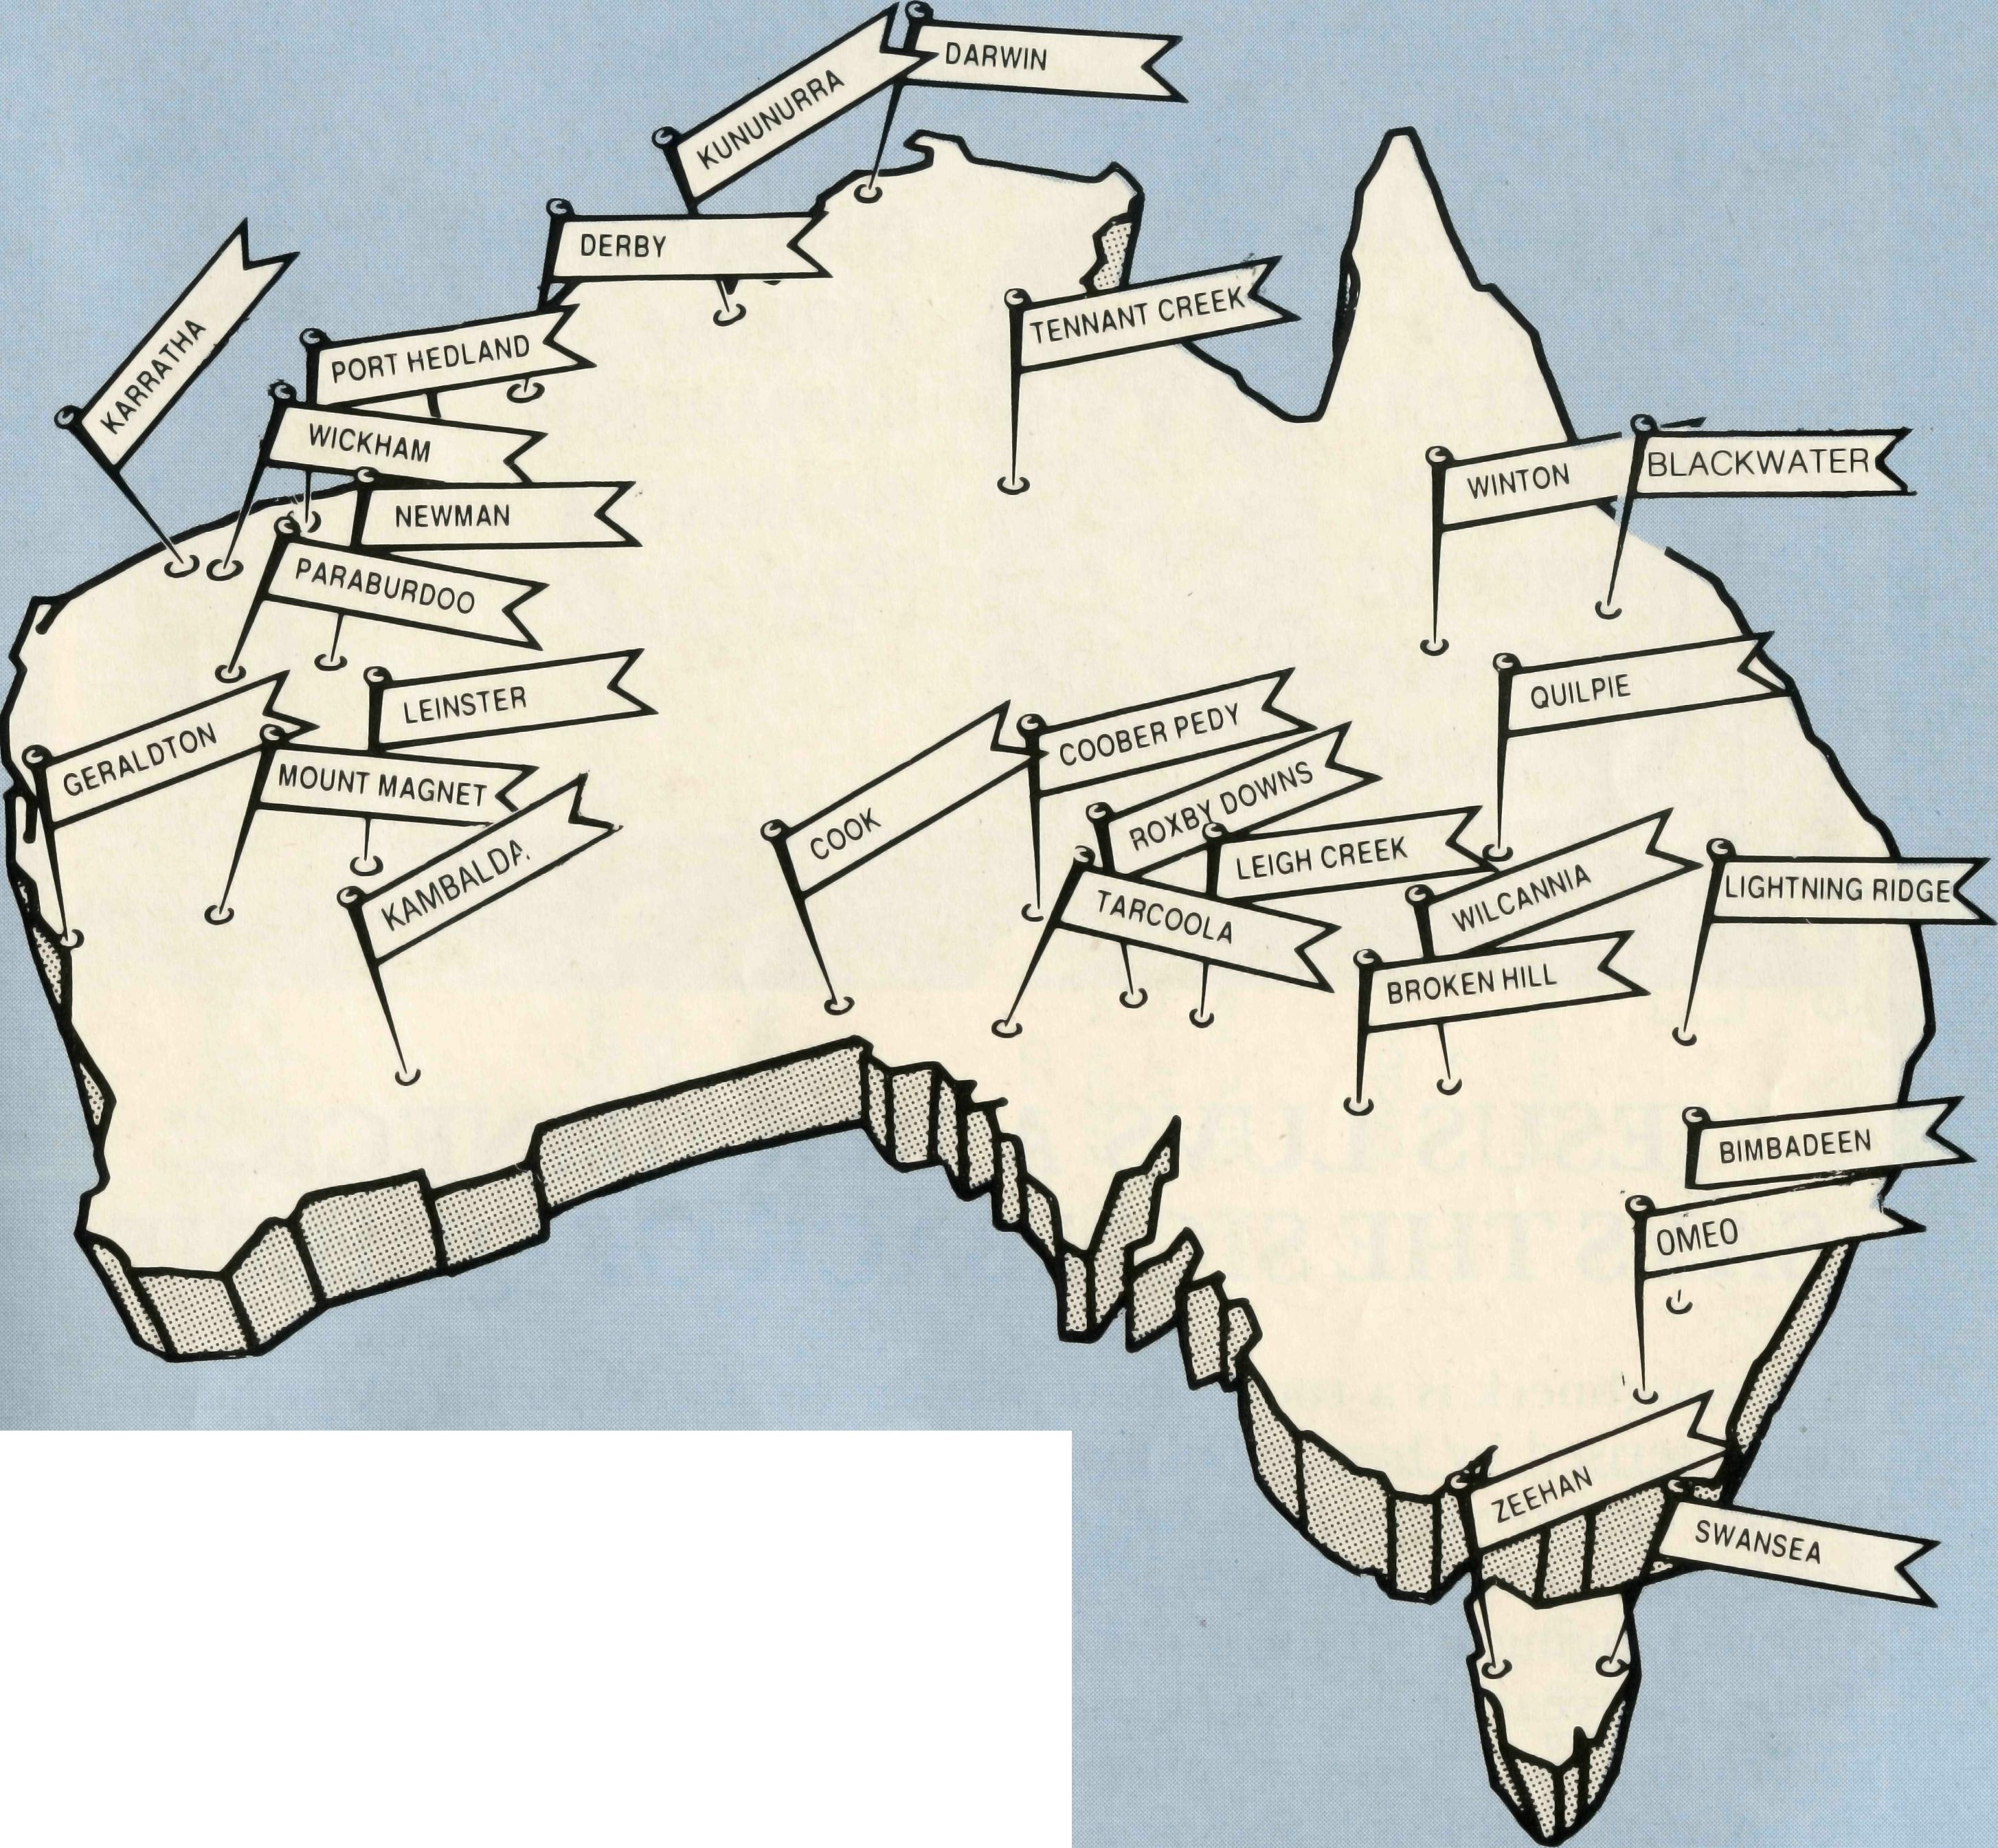
THE B.C.A. PRAYER

O Lord our God, help us to remember the people who live in the remote parts of our land. We ask You to bless those whom You have called into the fellowship of the Bush Church Aid Society, and to call others to stand with them in the task of making Christ known. Grant that, through the ministry of the Word and Sacraments, through healing, and through caring for the young, the message of Your redeeming love may be proclaimed; through Jesus Christ our Lord. AMEN.
THE REAL AUSTRALIAN

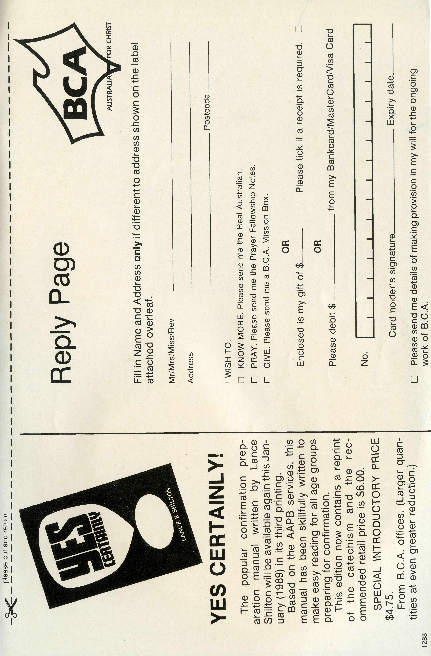
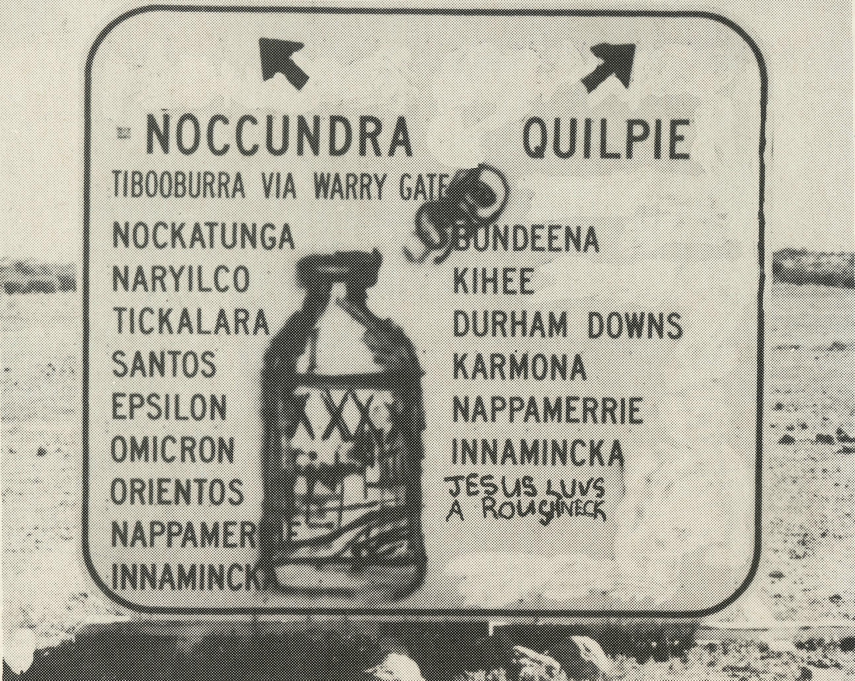
"JESUS LUVS A ROUGHNECK," SAYS THE SIGN BACK OF QUILPIE
A roughneck is a rouse-about worker on a drilling rig. A profession characterised by hard drinking and straight talking. In the south-west corner of Queensland our B.C. A. fellow, Bob Witten finds many straight talking fellows. At the recent "Wool and Flower Show", among competitions ranging from the 1988 pig race to the flower display you'll find Bob. This year he was in charge of the wool bale rolling contest.
Bob reports: "I was organising the wool bale rolling and was badgered to go in it. Well I won and set a new record time. One bloke commented "But you had God with you", to which I was able to reply "That's an option we all have."
Straight talk for the Lord in outback Australia is what is required. Your prayers and support have enabled B.C. A. to witness for Jesus in remote Australia during the bicentennial year.
The staff— both at home and in the field, would take this opportunity to thank you for your care and concern and wish you every blessing at this Christmas time.
14
THE REAL AUSTRALIAN

