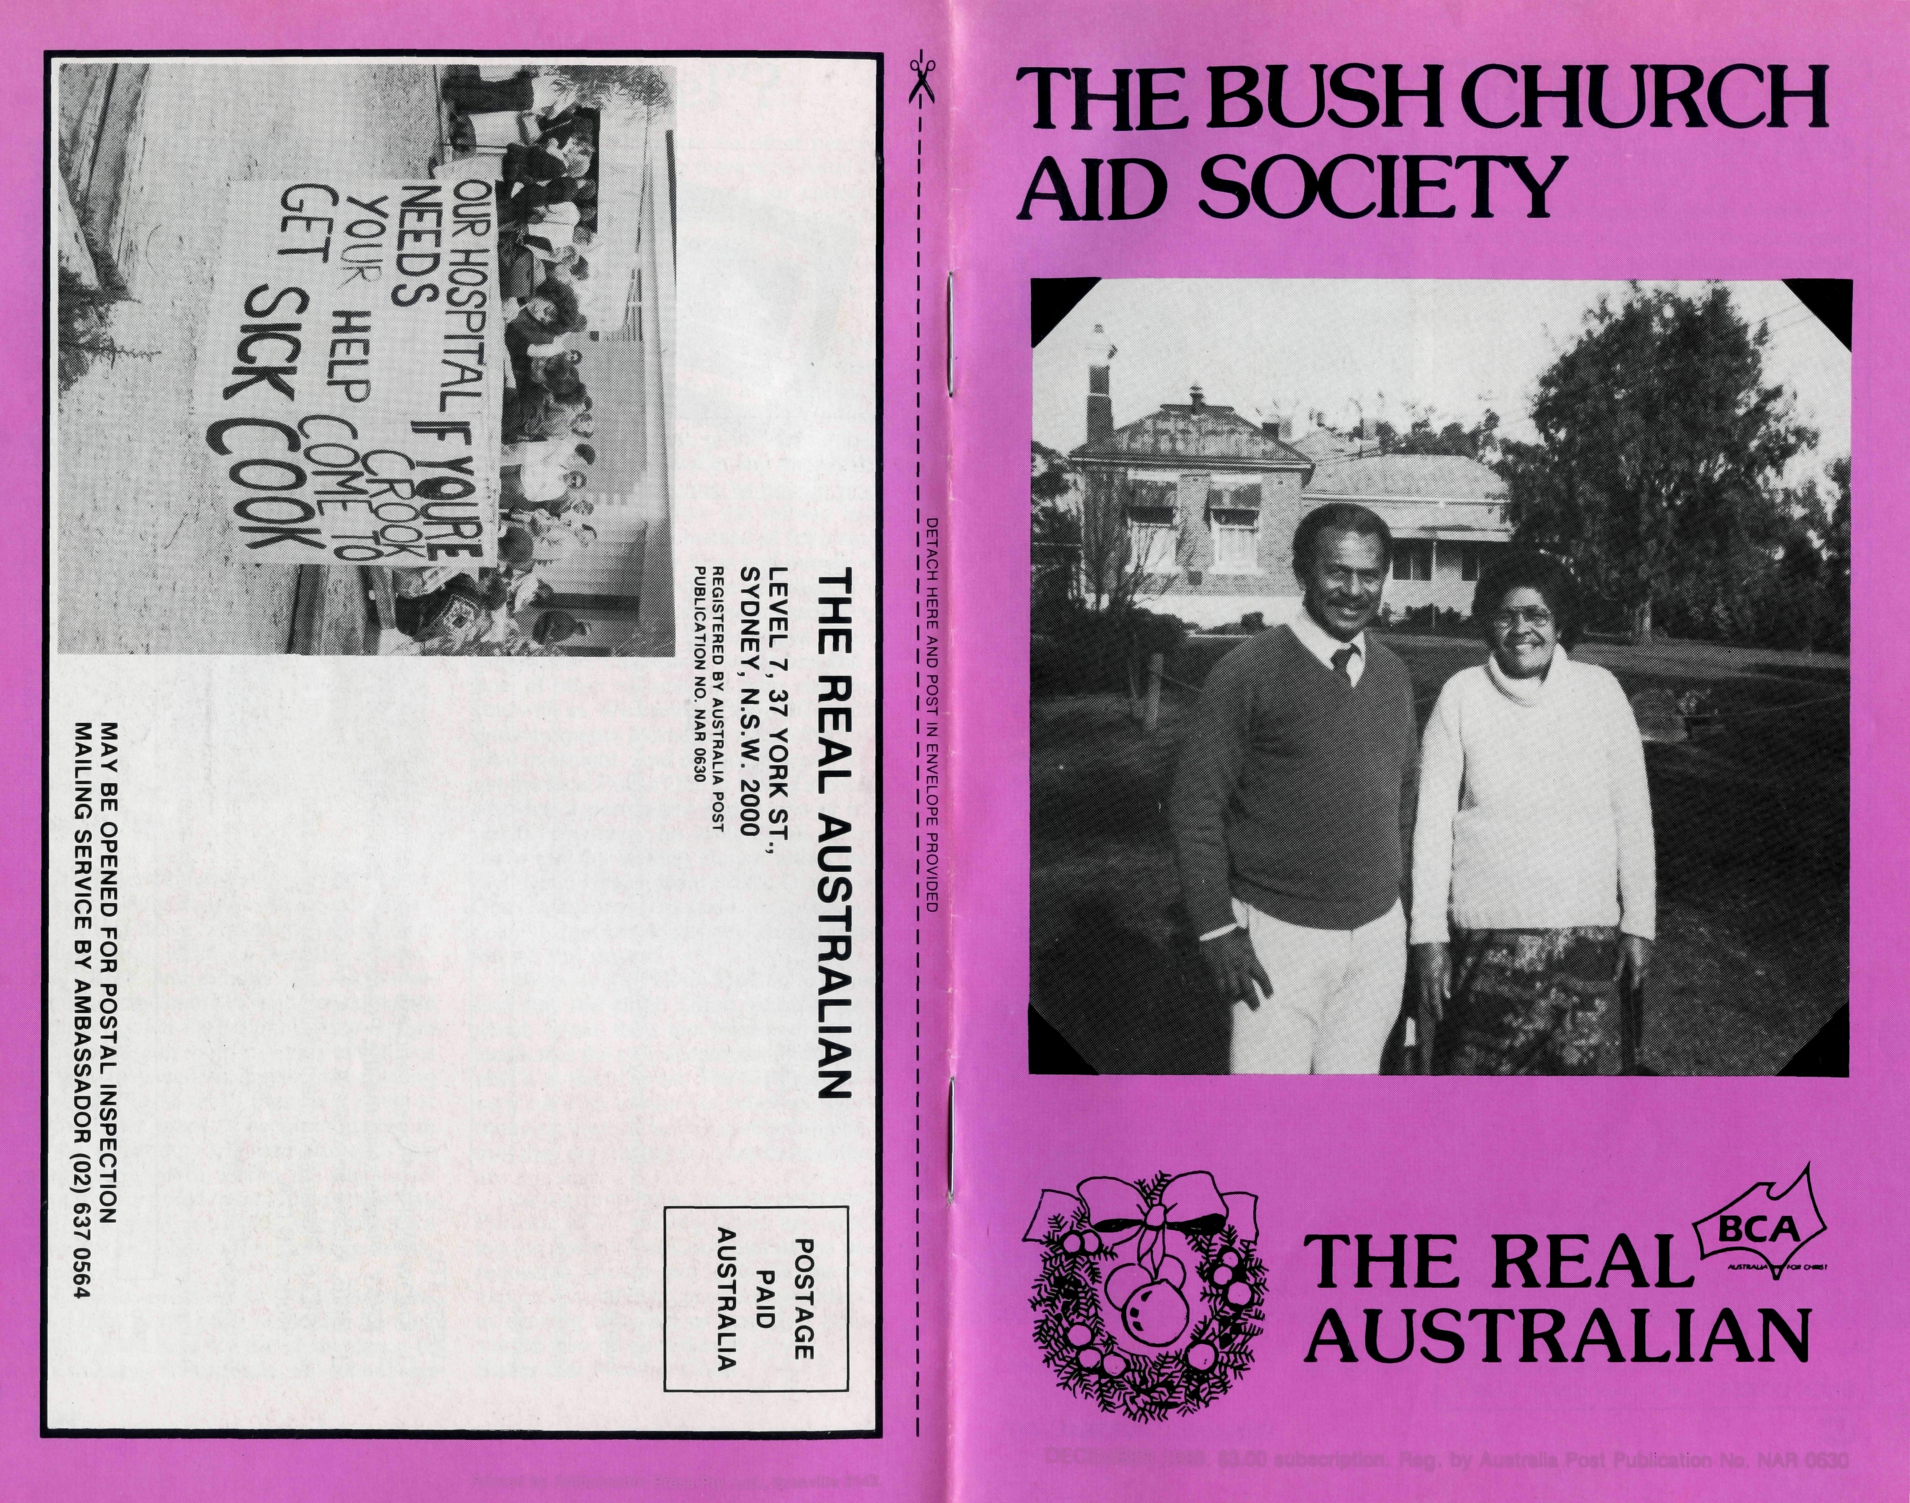
DECEMBER 1989. $3.00 subscription. Reg. by Australia Post Publ.cation No. NAR 0630
Printed by Ambassador Press Pty. Ltd., Granville 2142.

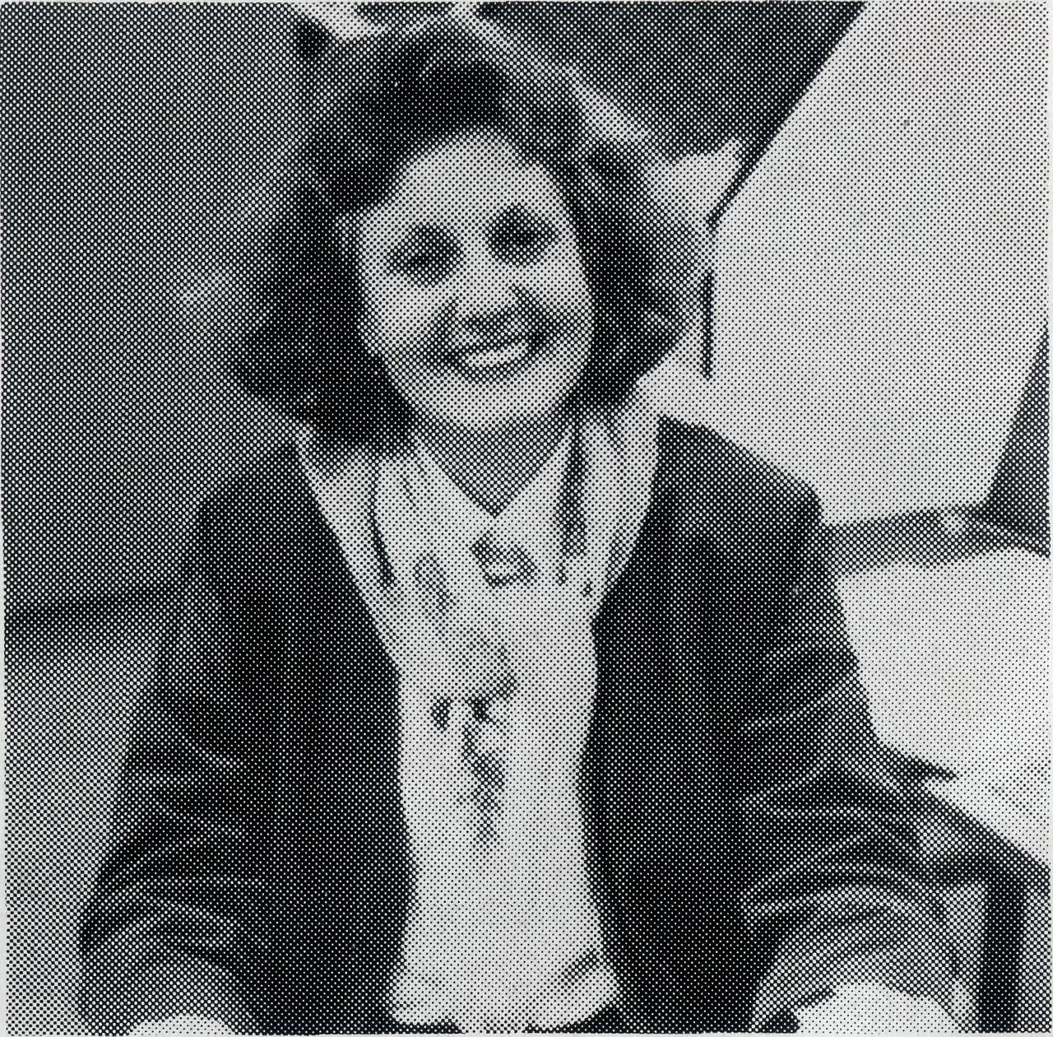
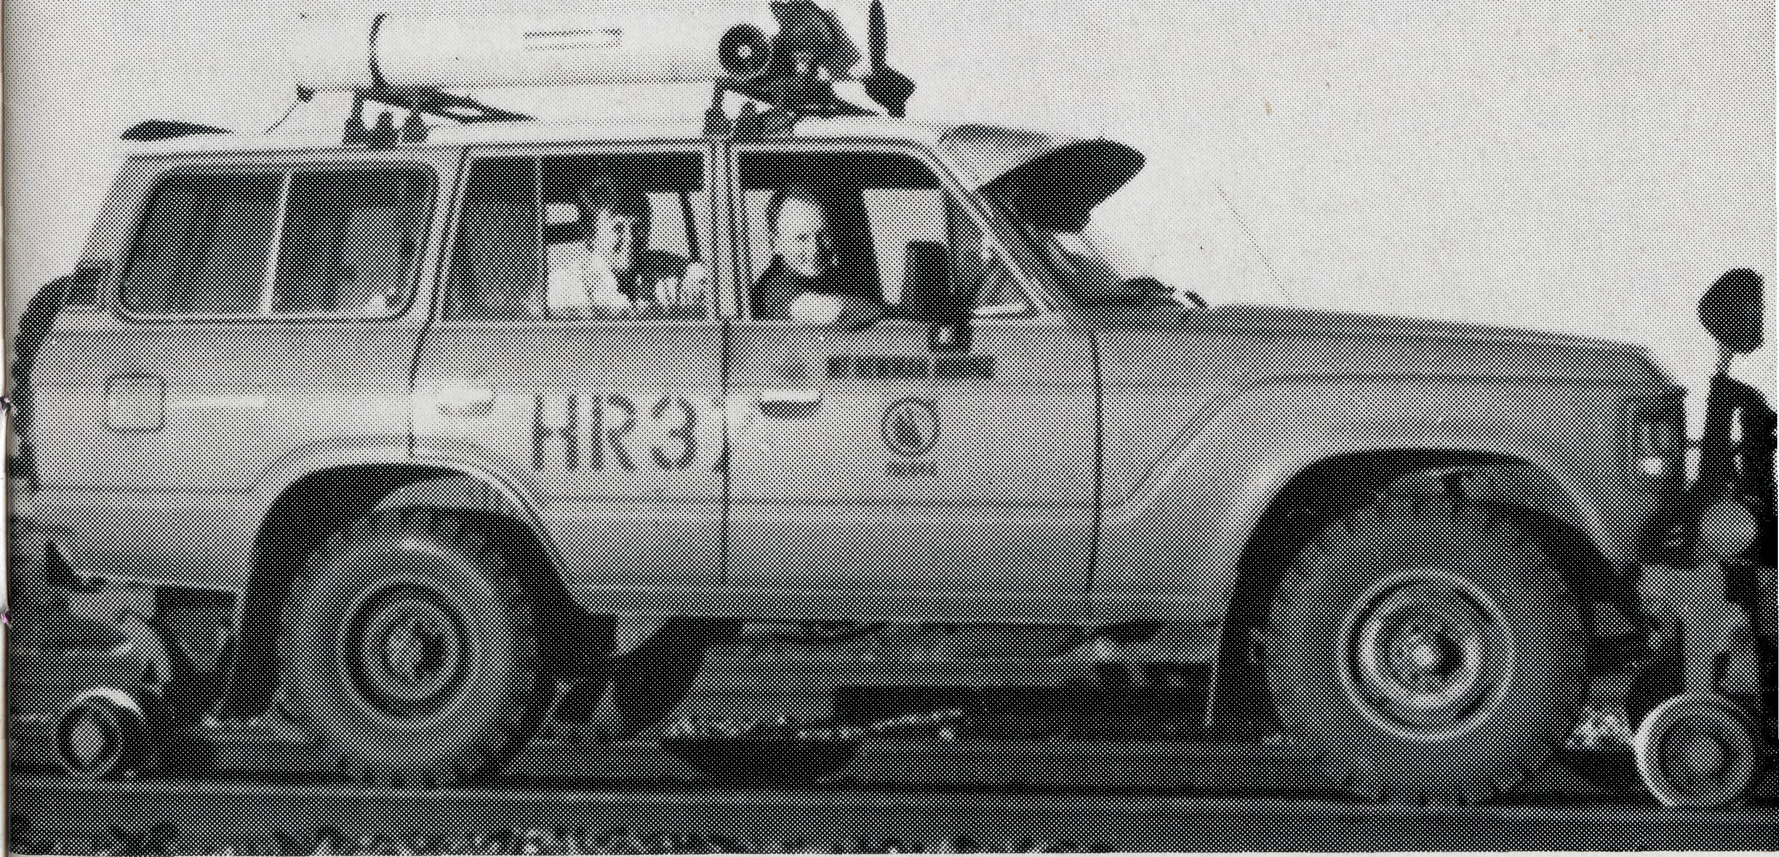
MEET JO PHILLIPS!
"The Goodhews travelled in a 'high rail' vehicle on Mt. Newman rail line near Port Hedland."
All enquiries to:
THE REAL AUSTRALIAN EDITOR David Mulready
THE BUSH CHURCH AID SOCIETY
OF AUSTRALIA
LEVEL 7, 37 YORK STREET,
SYDNEY 2000
Phone (02) 262 5017
Fax (02) 262 5020
Patron: The Primate, The Most Rev. John Grindrod.
President: The Most Rev. Donald Robinson, Archbishop of Sydney.
Vice-Presidents: Mr. Stan Hummerston, O.A.M.; Mr. Richard Stokes.
Hon. Treasurer: Mr. R. Ctercteko.
B.C.A. CONTACTS . . .
Federal Secretary: Rev. Ernie Carnaby.
N.S.W. Secretary: Rev. David Mulready. Level 7, 37 York Street, Sydney, N.S.W. 2000. (Next to Wynyard Station) Phone: (02)262 5017.
Victorian Secretary: Rev. Brian Viney, Shop 1, 205 Flinders Lane, Melbourne, Vic. 3000. Phone: (03)654 8022.
South Australian Secretary: Rev. Bob George,
Church Office, 44 Currie Street, Adelaide, S.A.
5000.
Phone: (08) 212 7804.
Queensland Secretary: Rev. Ernest Horth, P.O. Box 472, Upper Mt. Gravatt, Old. 4122. Phone: (07) 349 9081.
Western Australia Hon. Secretary: Rev. Peter
Brain, 27 Leach Street, Wanneroo, W.A.
6065.
Phone: (09)405 1325.
FRONT COVER: Pastor Maika and Mrs. Ana Bovoro of Bimbadeen Aboriginal Bible College.
BACK COVER: The famous sign at Cook.
For three and a half years now Jo Phillips' cheery voice has been heard answering the telephone in the B.C.A. office in Adelaide. She has worked for two South Australian Secretaries, as well as seeing the State Office move from the old site to its current locality among the other Diocesan Offices.
Jo is married to Lynton, who works during the day with the Electricity Trust of South Australia. At night he is hard at work on his theology studies, having begun a Diploma in Ministry Course this year. Shane (18) and Michael (17) make up the Phillips household.
Both Jo and Lynton are active members of the Parish of Tea Tree Gully in the north eastern suburbs of Adelaide. Jo is currently working hard at a Bethel Course, while Lynton serves as an Elder and Lay Reader, and occasionally preaches when the opportunity comes.
When asked what she liked most about working in the B.C.A. office she was quick to reply that the last Field Staff Conference was for her a highlight. Being able to meet personally some of the folk she often speaks to on the phone was a special treat.
What does she like doing least? Well, in a hesitant way she replied that changing Bob's drafts for the umpteenth time on the same day was not especially exciting.
Thank you Jo for your efforts in the office, and may you continue to develop your ministry to the field staff as they call into the office, as well as to the many B.C.A. supporters who constantly drop in.
Bob George
THE REAL AUSTRALIAN
IN THE WEST WITH B.C.A.
Bishop Harry Goodhew, Chairman of B.C.A., reports on his recent tour of duty .. .
various locations in Western Australia. It is a vast State. Many travel long distances. Isolation can be a challenge to families who have come from the more contained areas of suburban life. Yet dedication to Christ keeps B.C.A. personnel at the work, and makes them diligent and devoted in seeking to make Christ known, and to encourage His people.
The costs of conducting this type of ministry in these extensive areas is unavoidably great. Small communities need the constant financial support which Christians in the greater population centres can provide. This is where the Society fulfils such an important role in seeking dedicated people to work in the field, to support them in prayer and to offer sustained financial support, so that ministry in the more remote areas can be continued.
I encourage you to continue your loyal and valuable support for the Society so that these areas might be ministered to in a way that is adequate and effective.
It is nearly 25 years since my wife and I served with the B.C.A. in the old Ceduna Mission. In April this year we had the pleasure of observing a new generation of B.C.A. workers serving Christ in Western Australia. Having recently assumed the position of Chairman of B.C.A., the Society thought it would be valuable for me to see the work in that vast stretch of Australia.
We visited: Darwin, Kununurra, Derby, Port Hedland, Newman, Karratha, Mt. Magnet, Wiluna and Perth. It was a special privilege to have the opportunity to take a series of Bible studies at the Clergy School for the Diocese of the North West and to share with them in the other sessions that formed part of a first-rate Clergy School.
THE REAL AUSTRALIAN
Although lots of things have changed in 25 years in the work of the B.C.A., there are some things that have not changed. My wife and I were impressed with the commitment of those who represented Christ and the Society in the

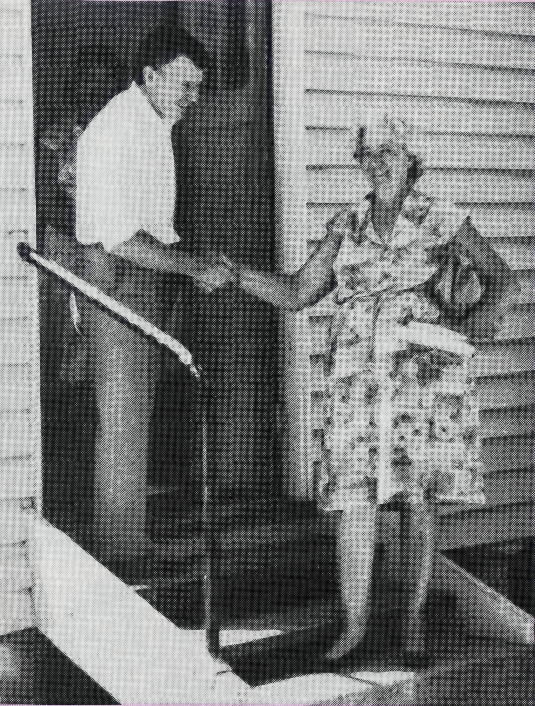
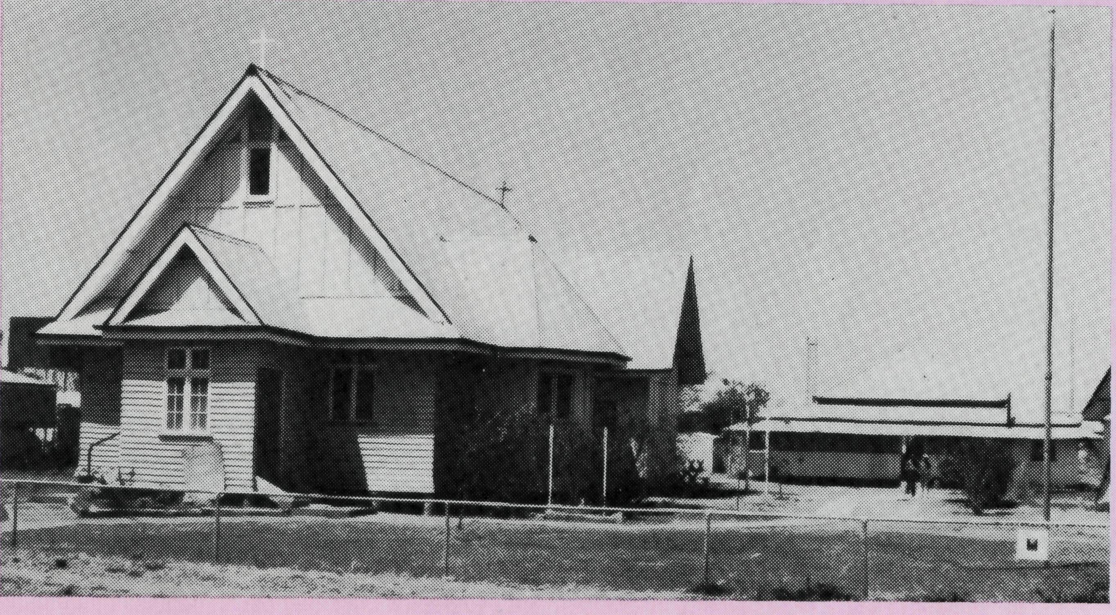
A BODY — FATHER'S DESIGN
This article is intended to allow part of the Winton Church body to speak for itself. But by way of introduction allow me to share some keys that we have discovered.
Where a church is to be an effective force in the transformation of a community it must break into the local scene through the witness of transformed renewed locals.
Should the transformation of locals not be a reality, the church may have some good things happening, but it will remain on the fringe of the community and never see the advance of the Kingdom of God within the community. When a local church begins to function according to God's design, i.e. a body with many parts all taking their rightful place, the community will see God breaking into lives in an ongoing and consistent way.
God is building His body in Winton. Local people are meeting Jesus and their lives are being transformed. The following words are brief statements from the Winton Church body . . .
- "As a local of Winton it is a tremendous encouragement to me to witness development of the body as the Spirit carries out His work. It is also a real release to have my own areas of ministry of encouragement and evangelism recognised and used by the body."
- "We came here not knowing what to expect regarding a Christan church. But God provided a beautiful Godly family, growing, developing and maturing in God."

- "After many years of virtually finding my own way in the faith, I arrived in Winton and became involved in this body and have been so excited to be in a growing body committed to both the Lord Jesus and to each other and to be released in the gifts that I have known for so long that the body needs. It has just proven to me the old saying, 'we all need to be needed'."
- "I always feel "lifted higher" when I go home from church. I know I can battle on through till Sunday without the presence of the body. Coming together as a body also reassures me of His grace and presence."
- "A visitor attended worship with the body here at St. Paul's while travelling through a couple of times, however, during his visit last month, his lack of relationship with the Lord was exposed. After worship, three of the men went back to the Church to pray with him. He walked out of the building with tears of joy and said, "I feel ten feet tall". How Jesus lifts us up and blesses us, and the body too, as He ministers through us.
- "I arrived in Winton on transfer in October '88. During that time the Lord has done great things. He is stretching me personally and teaching me how to use the gifts He has given me more effectively."
- "The Church is like a single body, which has many parts; it is still one body, even though it is made up of different parts." 1 Corinthians 12:12.
Contributed by the Rev. Lex Carey.
THE REAL AUSTRALIAN
THE REAL AUSTRALIAN
Sunday morning at Winton.

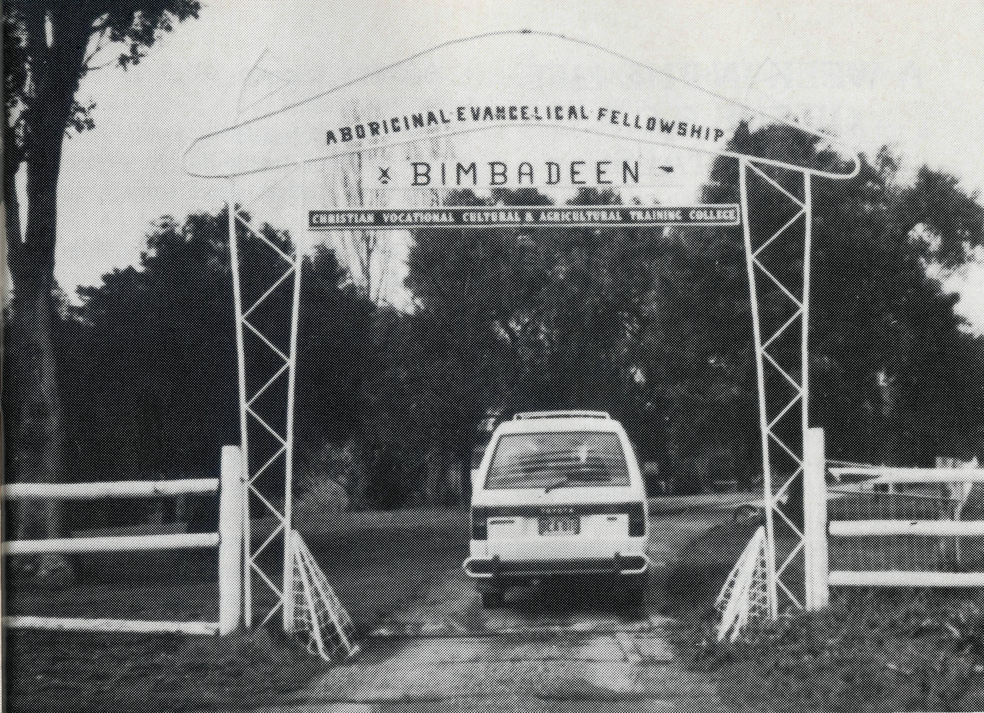
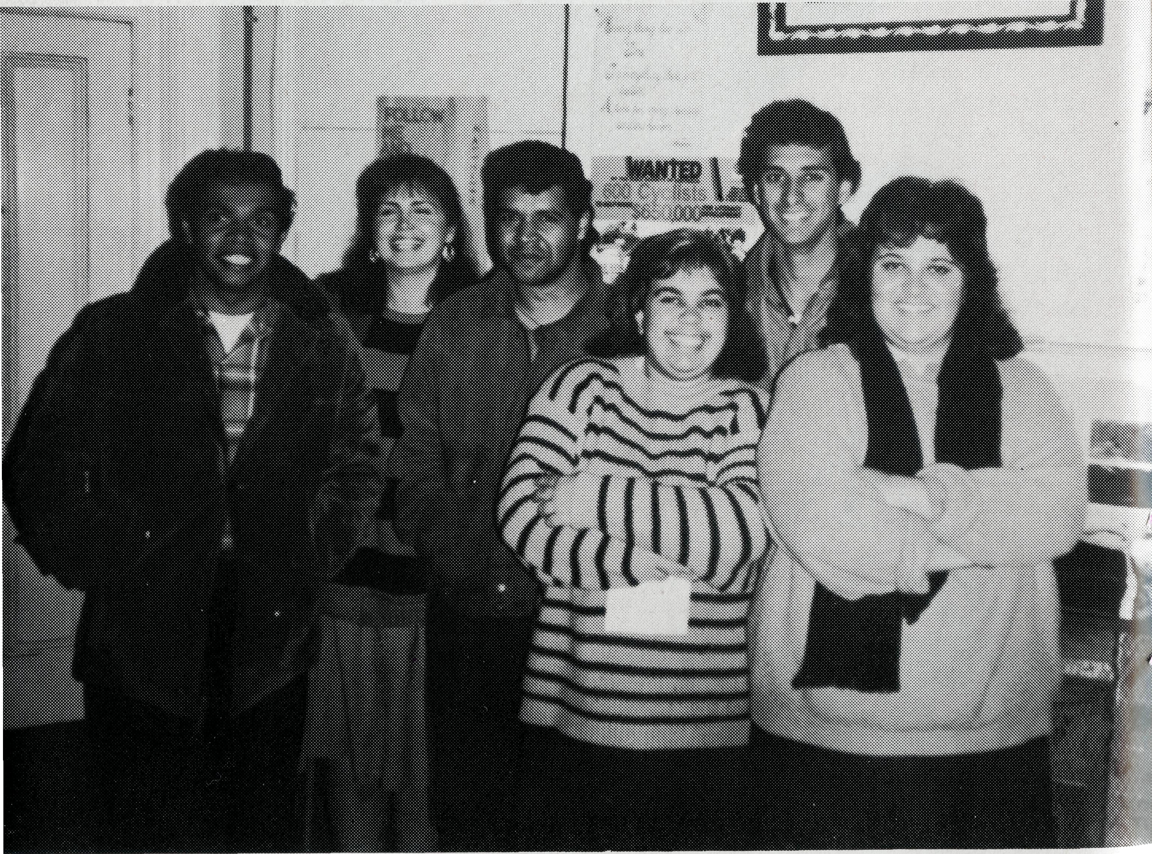
The property manager, Lindsay Jacques and mechanic Rod Brown, attend to the supervision of the farming side of the venture, which currently pays one salary.
Maika writes "Ana and I have been so grateful for the fellowship of the B.C.A. both in terms of the financial help as well as and even more so in terms of prayers. We simply thrive on prayers! We have weathered so many spiritual storms that defy explanation except the miracles of prayer! The Lord indeed is faithful and good!"
Continue to pray for this vital work at Bimbadeen.
The entrance to Bimbadeen.
VIDEO TAKES A PEW:
UPDATE ON BIMBADEEN
Bimbadeen Bible College at Cootamundra has just completed its 10th year of operation.
Set up in 1979 by the AEF (Aboriginal Evangelical Fellowship) Bimbadeen equips Aboriginals to minister to their own people.
Situated on an 800 acre property, the college has been home during 1989 for six students: John, Michael, Vernan, Michelle, Sophia and Sharon.
Pastor Maika Bovoro is the Dean of Students and has been Acting Principal for some time. He is ably assisted by voluntary staff: George Graetz, Peter Clements and Danny Hunt.
Need a good missionary segment at your meeting, parish weekend or evening service?
B.C.A. now has three audio visuals on video (VHS) lasting 10-13 minutes.
RENT FREE FOR THE ASKING!
Contact your State Office.

The Class of 1989.
THE REAL AUSTRALIAN

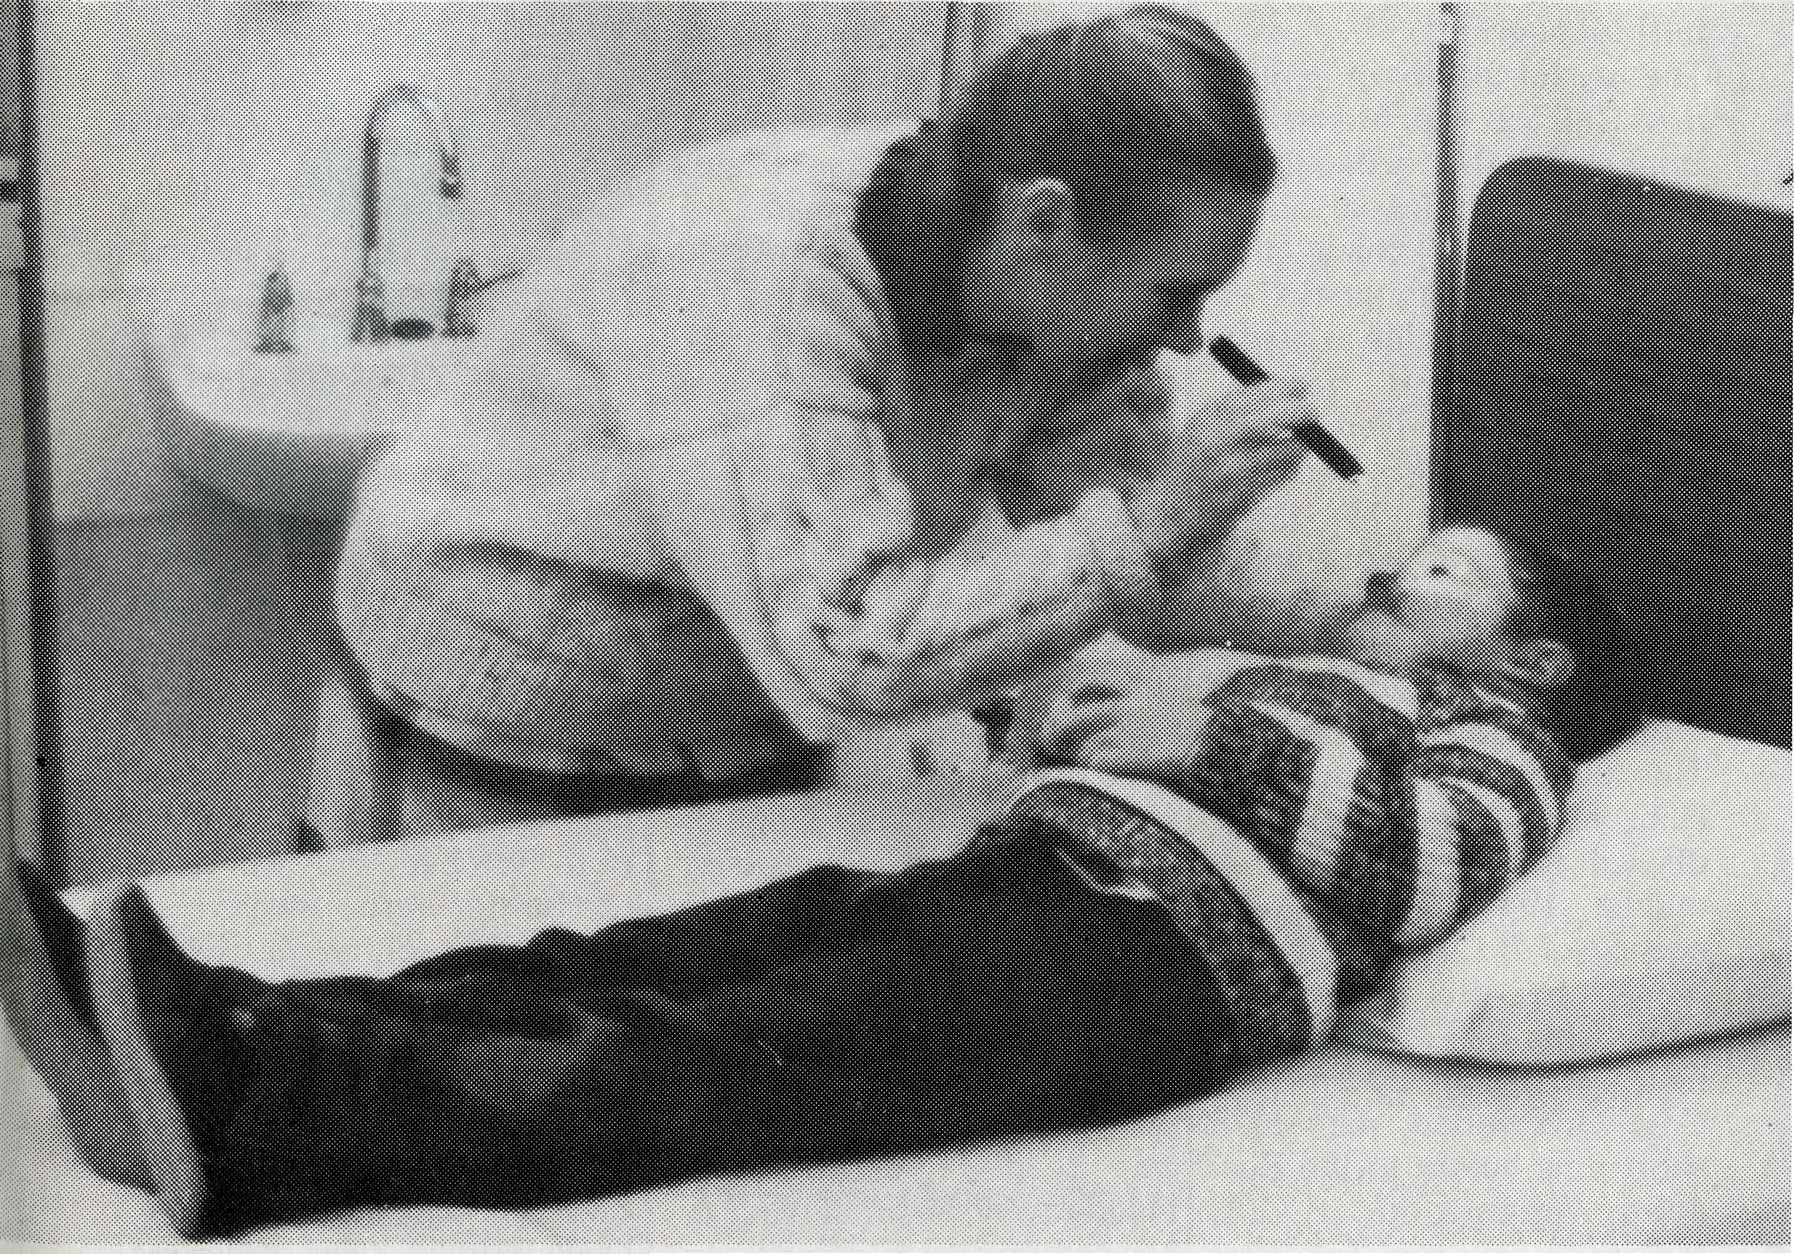
dispatched on a delayed passenger train * later treated in Pt. Augusta for a broken leg
While the week documented is a little unusual, the ministry of the B.C.A. nurses is ongoing. There is always hospital administration, routine domestic duties, the heavy call on hospitality, community participation and Christian Education programmes. The lot of a B.C.A. nurse, may at times be lonely, but never inactive.
Please continue to give thanks to God for those committed enough to serve on the Trans-line, and stand with them in your regular and informed prayer support.
Rev. Bob George
Sister Ros Jinks and patient.
A WEEK IN THE LIFE
OF THE B.C.A.
HOSPITALS
"What do you do all day?" is often asked of the B.C.A. nurses working on the Trans-line. In a small and isolated railway community there may not be a lot of continuous activity, but where the hospital is the hub of the community even in a small town, there is always something to consume the valuable time of the nurses.
During a week in May, there was more than the usual run of events. The following diary records the saga of events as they happened to the nurses on duty at the time.
Tuesday, May 9:
TARCOOLA HOSPITAL
- Colin Nelson arrived by train
- doctor's day with accompanying clinic
- in the evening, Ruth called out to Barton — mother and sick daughter evacuated and admitted to hospital at 1.00 am.
Wednesday, May 10:
- notified of a mentally disturbed patient who had jumped the westbound passenger train
- admitted to hospital — refused to go to Pt. Augusta hospital
- in the evening, media besiege the hospital with phone calls
- Colin able to hold small service with interruptions
Thursday, May 11:
- at 3.00 am mentally disturbed patient put on west-bound train
- 6.00 am phone runs hot with media again
- mid-morning, the train returns with same patient en route to
Adelaide because of derailment further west
- Ruth battles to convince train staff that patient needs to go to Pt. Augusta, rather than remain in Tarcoola
- at same time plane full of media lands at airstrip, chasing a story
- Ruth and Susan retreat to hospital and lock all doors to keep media out
COOK HOSPITAL
- early afternoon Gai is informed of three patients coming her way from the derailment at Forest, with suspected cyanide poisoning (potential for serious cardiac arrest, and Gai alone at Cook to deal with this crisis)
- patients arrive at Cook, and fortunately not as serious as first thought, but admitted for the night
TARCOOLA HOSPITAL
* in the evening an asthmatic from
outlying station admitted to
hospital
Friday, May 12:
* basically a quiet and unexciting
day
Saturday, May 13:
COOK HOSPITAL
- 3.00 am a section car hits train in the darkness of early morning
- later two patients admitted, one with head injury and one with back injury
Sunday, May 14:
- a second derailment on line causes further disruption of rail traffic
- Ruth arrives in Cook, so that Gai can drive out the next day for a special meeting in Adelaide
THE REAL AUSTRALIAN
TARCOOLA HOSPITAL
- another child at Barton requires a R.F.D.S. evacuation
- plane is initially thought to require fuel at Tarcoola before travelling on to Pt. Augusta
- Susan (alone at Tarcoola) sets in motion unfamiliar refueling procedure (but not required in the end)
Monday, May 15:
- public holiday, but many outpatient calls in late afternoon
- an alert from Commonwealth Hill that a person may require assistance as a result of motor bike accident
Tuesday, May 16:
- dentist and C.A.F.H.S. clinic
- patient also arrives from Commonwealth Hill and is treated and

POST & RAILS

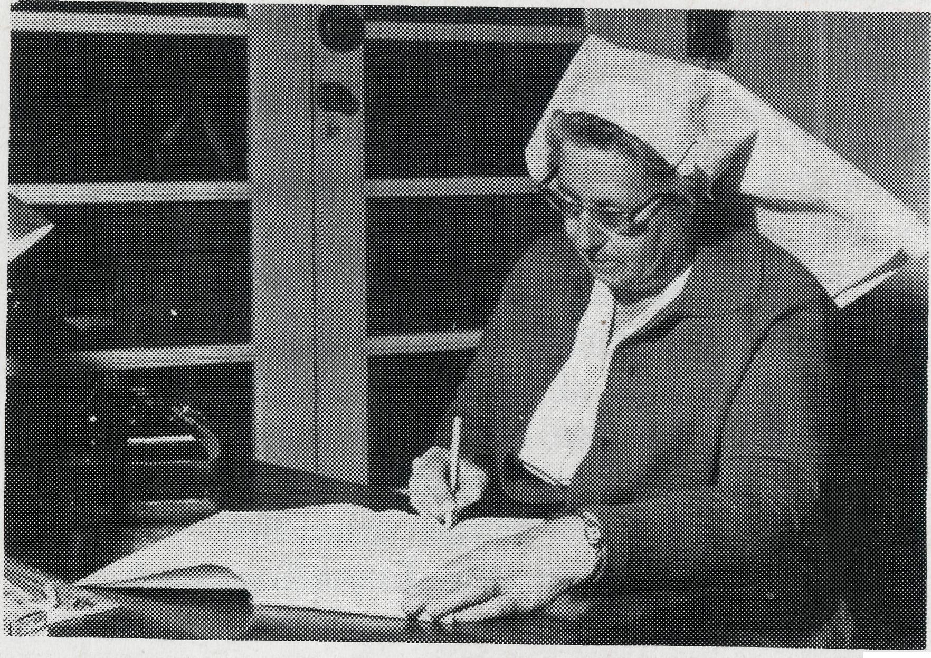
MAUDE ROSS M.B.E: 1912-1989

^k "Well done good and faithful servant"

The recent death of Maude Ross (20.9.89 at Mowll Village) closed the earthly life of a loyal and faithful servant of the Lord who spent a large part of her life with the B.C.A. family. Her early life as a parishioner of All Saints" Anglican Church, Nowra, saw her active in GFS and Girl Guide circles.

The desire for missionary service moved Maude to undertake the midwifery course at Crown Street Women"s Hospital, Sydney. This training plus her capability as a good cook was offered to the Lord in the middle 1940s through the agency of B.C.A. Maude felt moved to offer herself for work with B.C.A. when she heard that her friend Mrs. Cora Greenwood, married a short time before to the Rev. John Greenwood, B.C.A. Missioner in the Far-West Mission based at Ceduna,

South Australia, had volunteered to be the cook at the Ceduna Base Hospital. The vacancy had caused a problem for the hospital which seemingly had no solution. Maude was then anxious to enter missionary service as she felt a challenge had been made.

More than 20 years were to pass for Maude serving at the Bishop Kirkby Memorial Hospital, Cook. This helpful servant not only gave relief to the medical staff but proved a loving and concerned friend held in high regard by many people across the vast Nullarbor Plain. Whether assisting with the birth of babies, doing the domestic work and cooking, giving relief in time of emergencies, maintaining religious instruction in school classes, attending to Sunday School programmes and Church Services, Maude was a cheery, competent servant of her Lord. The presence and prompting of the Holy Spirit was readily perceived as Maude went about serving in her commendable manner. In 1970 the honour of M.B.E.
was conferred for her work in a part of Australia where conditions in summer with the temperature in the 40s, can prove most exacting and draining of energy.
Those who served with Maude Ross count it a privilege to have shared the B.C.A. family fellowship with one who appreciated the significance of Our Lord Jesus Christ's commendation. . . "I chose you and appointed you that you should go and bear fruit ..." (John 15:16)
John Greenwood
STAMPS FOR SALE
* A great selection of reasonably priced stamps awaits your perusal at the Sydney office.
TASSIE OFF THE B.C.A. MAP
B.C.A. supporters will be interested to learn that Zeehan has now been made part of the Parish of Queenstown and is no longer a B.C.A. parish.
Our links with Swansea have also come to an end. As from October, BCA will have no further responsibility for the parish, although Kelvin Viney will continue to be both Anglican and Uniting minister of the area. We shall continue to pray for Kelvin and Heather as they serve the Lord in Swansea. So, for the time being, B.C.A. has no supported work in Tasmania.
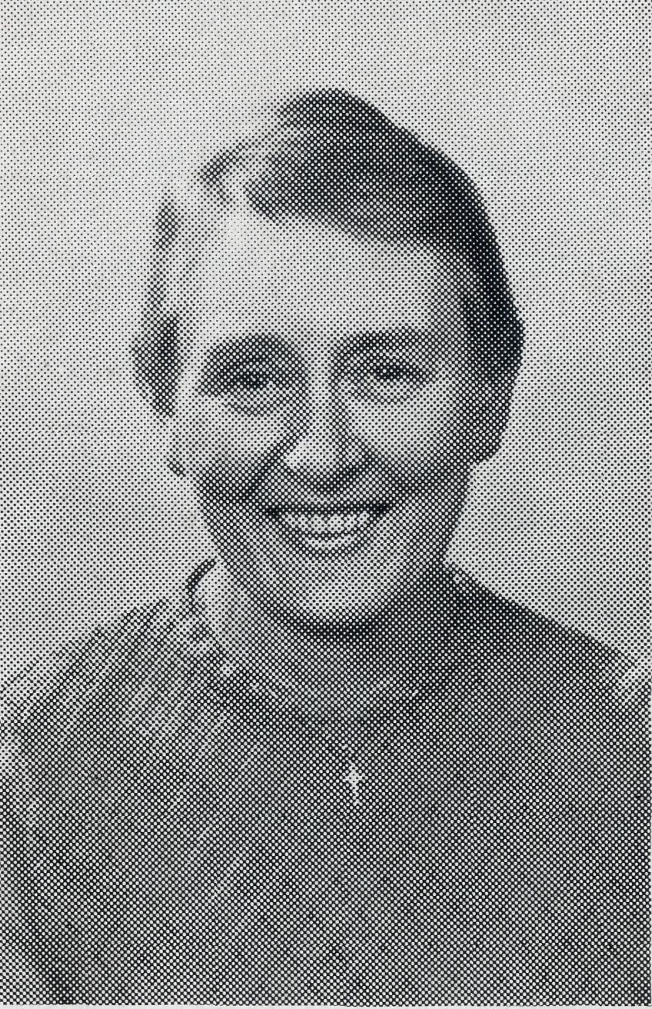
FAREWELL LOIS HUSTWAITE
On December 3, a farewell was planned at Broken Hill
for Lois, ending a 2V2 year ministry as Assistant Hostel Supervisor, (mum, granny, counsellor, cook, carer, Christian "model") at our Students' Hostel.
Lois has been a great member of a great team and we thank God for her loving service for the Lord.
A "FIVE STAR" BOX OPENING
What a joy to one of our Box
Secretaries in September, to find over $1,400 from a pensioner couple! In fact they needed two boxes to fit it all in!
Mr. S. collects aluminium cans, Mrs. S. takes in ironing.
Thank God for imaginative givers! Is there a story to beat this one for imagination and results?
"KING PARROT"
Have you heard that
screeching bird? King parrot, glorious
plumage! Creator's glory flashing by —
green, and brilliant red. "Tis good", our God has said. From tree to tree he flies in
haste, His appetite is mounting. He'll die without a meal! Sweet fruit the Lord provides. He"s heard his cries.
Sustain us, Lord, You said
You would. "Only trust Me and obey" Single minded, without guile, Make us trusting like the
bird Whose call we heard.
Margaret Lambeth
Bimbadeen Bible College
at Cootamundra needs books for its library — Bible commentaries, doctrine, church history etc. No ancient texts please.
Send to:
The Principal, Bimbadeen Bible College P.O. Box 313, Cootamundra 2590.
POSITIONS VACANT
* Hostel parent at Broken
Hill, to assist Nick Puttman from early 1990. The position requires a convinced Christian lady or "married couple to serve in this Christian "home away from home", for 17-20 young people.
* Parish Minister at
Paraburdoo, Diocese of N.W.
Australia. To commence as
soon as possible!
"UP MINTABIE WAY"
On the opal fields up Mintabie
way, Where the landscape holds
you in its sway, The bulldozers rip up the
promising earth, Opal buyers assess the
mineral"s worth, And Christians meet to pray. On the opal fields up Mintabie
way, A Sunday School starts — a
promising day! The children learn of Christ
the Lord — the Son of God,
to be adored; Lord, bless what teachers say!
Brian Black

10
THE REAL AUSTRALIAN
THE REAL AUSTRALIAN
11

PRAYER CALENDAR
NORTHERN TERRITORY
Diocese of Northern Territory — Rt. Rev. C. Wood.
- Sanderson — Rev. Greg and Mrs. Kerry Thompson.
- Palmerston — Rev. Ron and Mrs. Margaret Bundy.
- Tennant Creek — Rev. Tim and Mrs. Kerrie Brownscombe.
- Diocesan Secretary/Treasurer — Mr. David Martin.
WESTERN AUSTRALIA
Diocese of North West Australia — Rt. Rev. G. B. Muston.
- Kununurra — Rev. Murray and Mrs. Jane Lamont.
- Derby — Rev. John and Mrs. Dianne Symons.
- Newman — Rev. Bob Booth.
- Port Hedland — Ven. Bill and Mrs. Jennifer Warburton.
- South Hedland — (Locum).

- Karratha — Rev. Terry and Mrs. Fiona Redmond.
- Wickham — Rev. Allan and Mrs. Julie Harrison.
- Tom Price/Paraburdoo — Rev. Philip and Mrs. Lyn Kitchen (Locum).
- Mt. Magnet (Murchison) — Rev. Don Miller (Locum).
- Diocesan Registrar — Mr. Martin Weatherston in Geraldton.
Diocese of Perth — Most Rev. Peter Carnley.
15 Kambalda/Norseman — Rev. Ron
and Mrs. Colleen Ross.
Hon. B.C.A. Secretary for W.A. —
Rev. Peter Brain. SOUTH AUSTRALIA
Diocese of Willochra — Rt. Rev. D. McCall.
- Coober Pedy — Rev. Ian and Mrs. Robin Robertson.
- Roxby Downs and Mid-West Mission — Rev. Colin and Mrs. Ruth Nelson.
- Leigh Creek — Rev. Peter and Mrs. Margaret Achurch.
State Secretary of S.A. — Rev. Bob George, Mrs. Jocelyn Phillips.
19 Cook: Bishop Kirkby Memorial Hospi
tal — Sisters Ros Jinks, Gai Mee,
Ruth Leske.
FIELD STAFF DIRECTORY
20 Tarcoola Hospital — Sisters Mary-
Grace Bingham, Susan Green.
VICTORIA AND TASMANIA
Diocese of Gippsland — Rt. Rev. C. Sheumack.
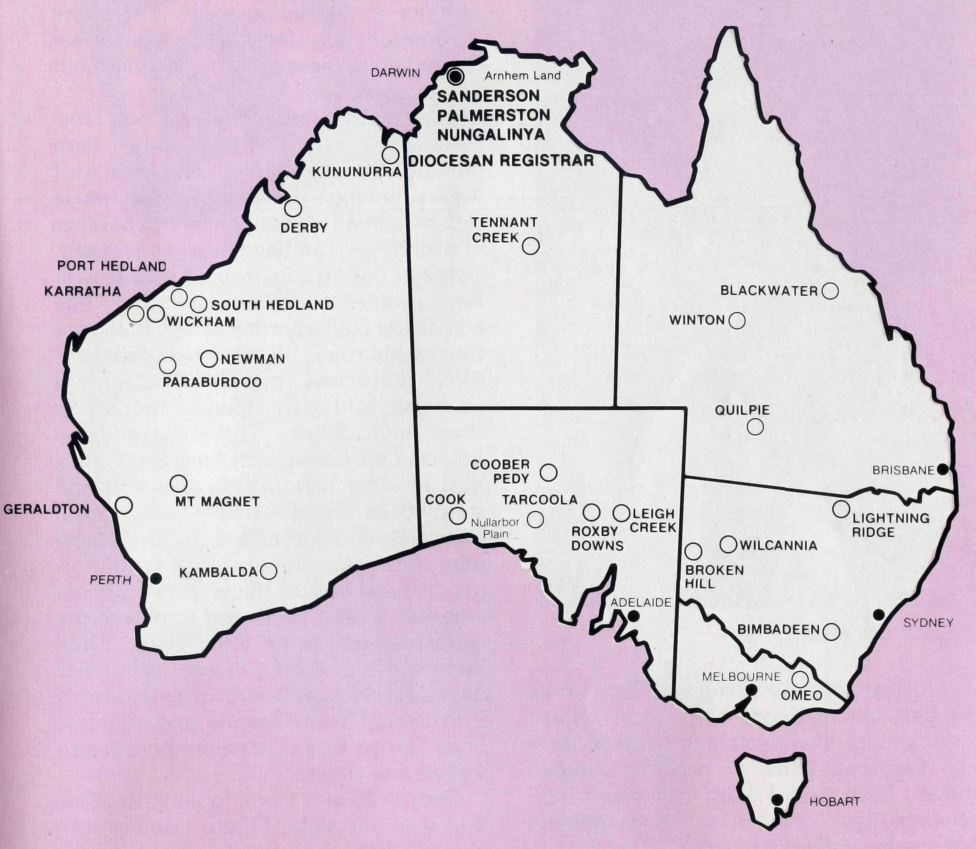
21 Omeo — Rev. Errol and Mrs. Anne
Sorensen.
State Secretary for Vic. and Tas. — Rev. Brian Viney, Mrs. Margo Bright. NEW SOUTH WALES
Diocese of Riverina — Rt. Rev. B. R.
Hunter.
- Broken Hill Hostel — Mr. Nick and Mrs. May Puttman.
- Wilcannia — Rev. Bob and Mrs. Phyllis Collie, Rev. Allen and Mrs. Mahalia Mathieson.
Diocese of Armidale — Rt. Rev. P. Chiswell.
- Lightning Ridge — Rev. Cliff and Mrs. Megan Ainsworth.
- State Office, N.S.W. Secretary — Rev. David Mulready, Mrs. Michele Peacock. Deputationist — Rev. Brian Black.
QUEENSLAND
Diocese of Brisbane — The Most Rev. J. Grindrod.
26 Quilpie — Rev. Bob and Mrs. Sue
Witten.
State Sec. For Old. and northern
N.S.W. Rev. Ernest Horth. Diocese of Rockhampton — Rt. Rev. G. Hearn.
- Winton — Rev. Lex and Mrs. Rhonda Carey.
- Blackwater — Rev. Glen and Mrs. Kaye Zimmerle.
ABORIGINAL MINISTRY
29 Nungalinya College — Mrs. Wendy
Gibson and Miss Helen Kassman.
Bimbadeen College — Pastor Maika
and Mrs. Ana Bovoro (Dean).
B.C.A. HEAD OFFICE
30 Federal Office — Rev. Ernie Carnaby,
Miss Margaret Woolcott.
Home Base Staff — Mr. Jim Gosbee, Mesdames Jacqueline Griffiths, Margaret Sadler.
*lf you'd like more details for prayer, send for our quarterly prayer notes. (See reply page).
out where the action is...
THE B.C.A. PRAYER
O Lord our God, help us to remember those who live in the remote parts of our land. We ask you to strengthen and encourage all whose ministries are supported by the Bush Church Aid Society. Refresh them in times of discouragement and loneliness and call others to stand with them in the task of making Christ known. Grant that, through the ministry of the Word and Sacraments, through healing, through service and by caring for the young, the message of your redeeming love may be proclaimed, and accepted by the people throughout our land. We ask these things through Jesus Christ our Lord, who lives and reigns with you and the Holy Spirit, one God, for ever and ever. AMEN.

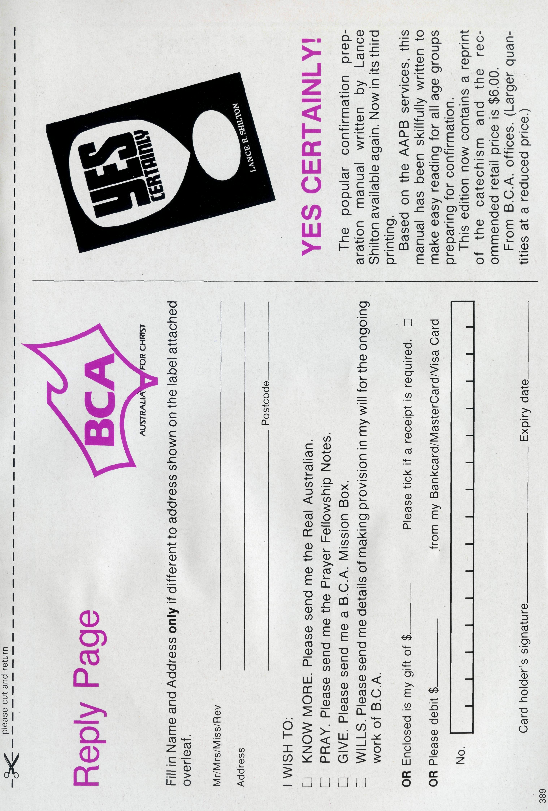
"Hospital" or "Hostel"?
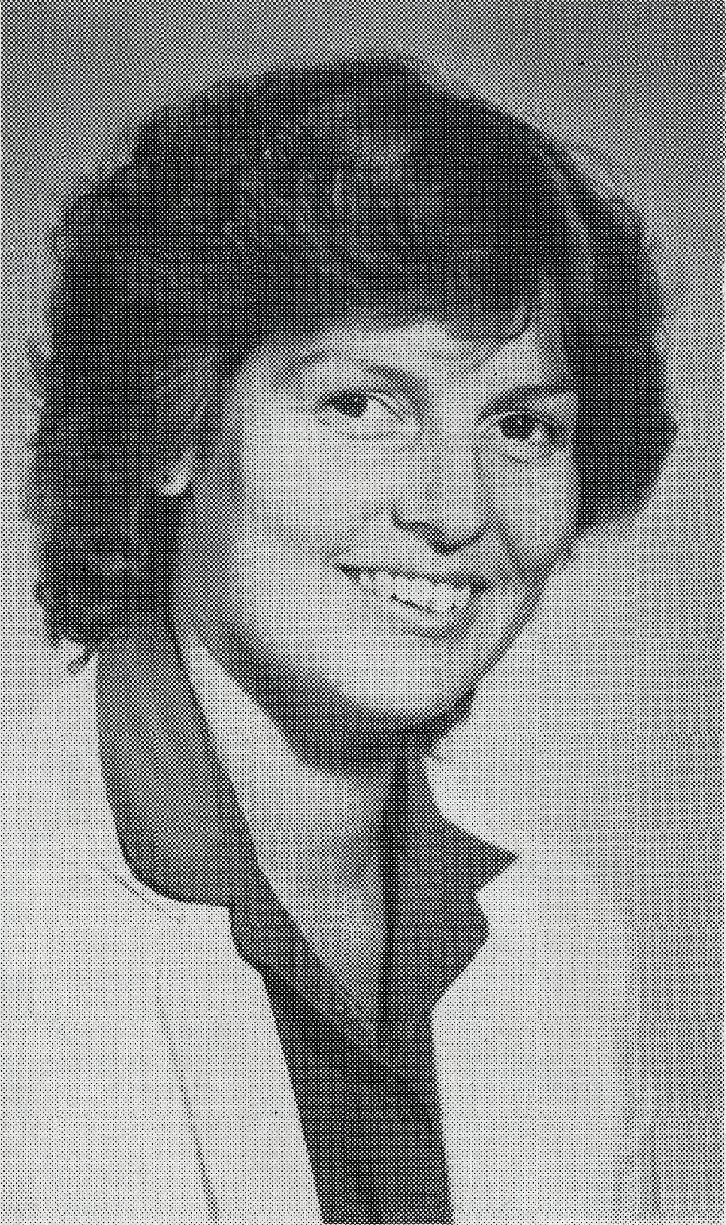
the hospital. There are no other people living here. Therefore there is no hotel or motel, no camping grounds or caravan parks, not even a milk bar where people can get a take-away meal. There are accommodation facilities available for railway employees and their families but for no one else.
Sister Gai Mee.
It is late in the evening and Ruth Leske is busy talking to one of the locals while I am sitting down watching the television and knitting, when we hear the doorbell ring. Ruth and I both call out simultaneously to "come in" and two complete strangers enter the hospital. They explain that because of the very windy conditions outside they were having trouble erecting their tents and ask if there is a hotel or some other place of accommodation in Cook where they and their husbands can stay for the night. I offer the suggestion that if they would like to, they could stay in the hospital overnight. After looking a bit surprised at our offer they very readily accept.
Cook is a railway town and everyone who lives in the town works for the railways or are here for the convenience of the railways, for example, the school and
It is not uncommon for the Cook Hospital to be full of visitors rather than patients. Sometimes Ruth and I feel as if we are running a motel or boarding house rather than a hospital, given the number of visitors we can have in any one week. Some of our visitors may be people who have decided to follow the railway line across the Nullarbor instead of following the coastal road. We have had people in 4WD vehicles, people cycling on pushbikes and even Japanese tourists on their motorbikes. There have been Englishmen, Canadians, Americans and a host of other nationalities who visit and stay with us. We have had the ABC media and newspaper journalists stay in the hospital overnight. And of course I can't forget the local Police Officer from Tarcoola who has a permanent bed in one of the wards, whenever he visits Cook. Then there are the visiting clergy, either our own Colin Nelson from Roxby Downs or Bob George from Adelaide, and of course I can't forget Ernie Carnaby who has also visited and stayed.
People fly into Cook looking to refuel and stay the night. Often it comes as a shock when they are informed by the locals that the only accommodation available is at the hospital. The person finds it very hard to explain to relatives, when they ring them to leave a contact number, that they are staying at a hospital and they are not sick.
Are we running a hospital or hostel? Perhaps when nursing sisters are applying for positions at Cook one of the prerequisites should not only be nursing experience, but also previous experience in running a hostel or boarding house should also be considered! Sister Gai Mee — Cook

