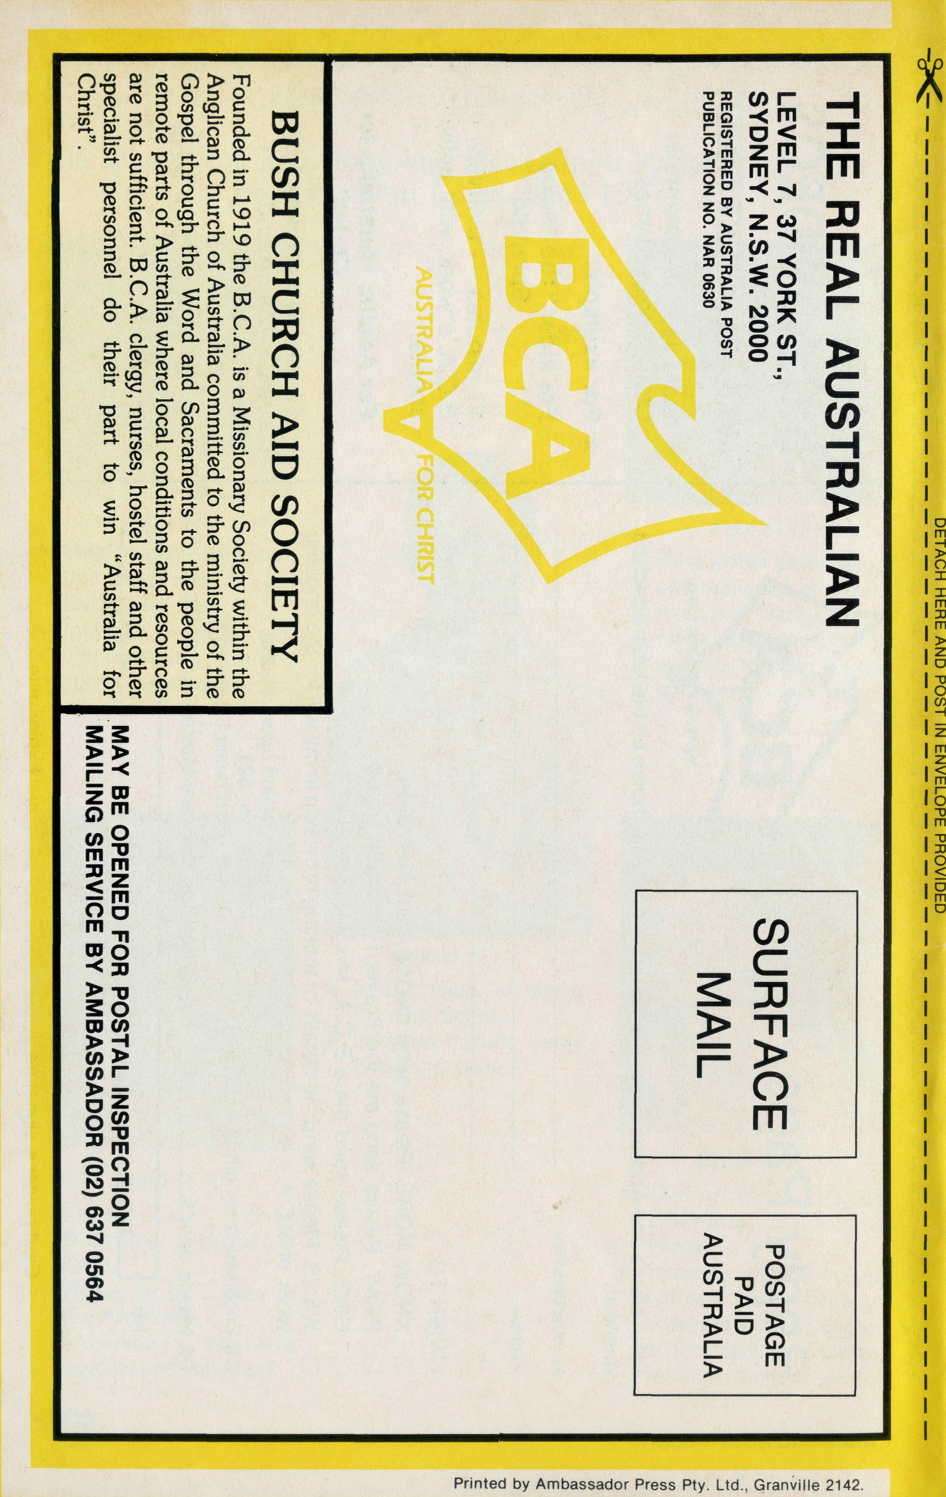
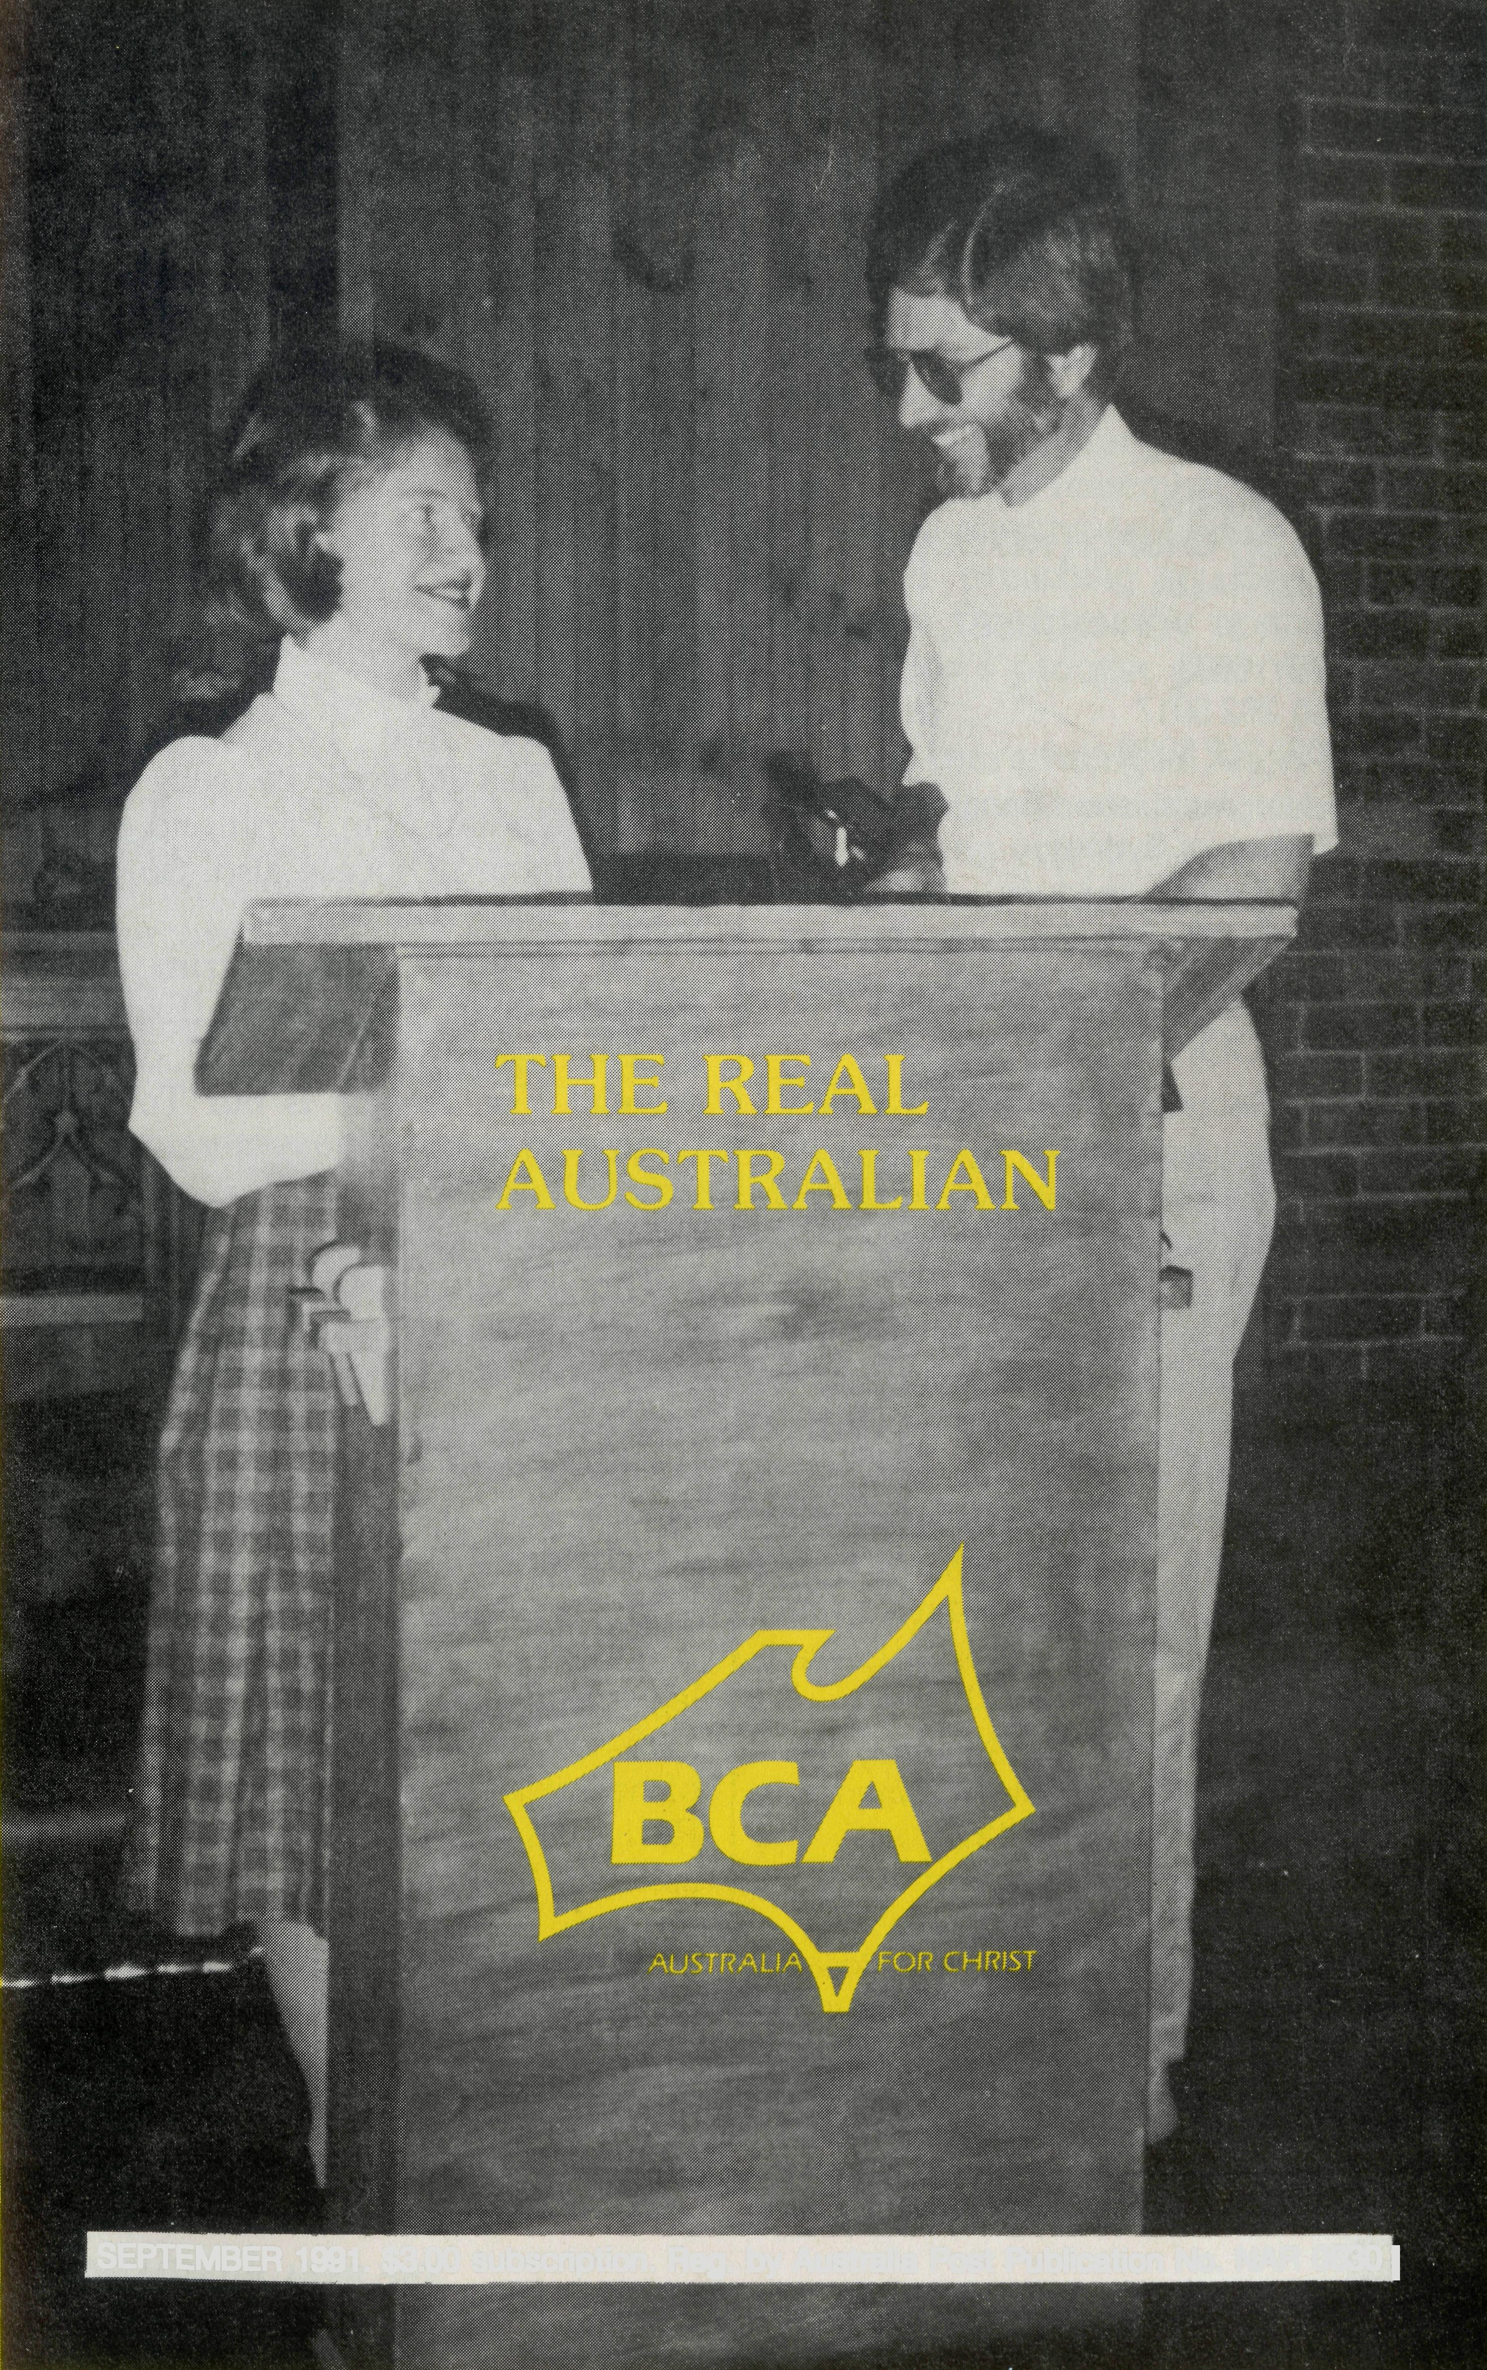
SEPTEMBER 1991. $3.00 subscription. Reg, by Australia Post Publication No. NAR 0630|

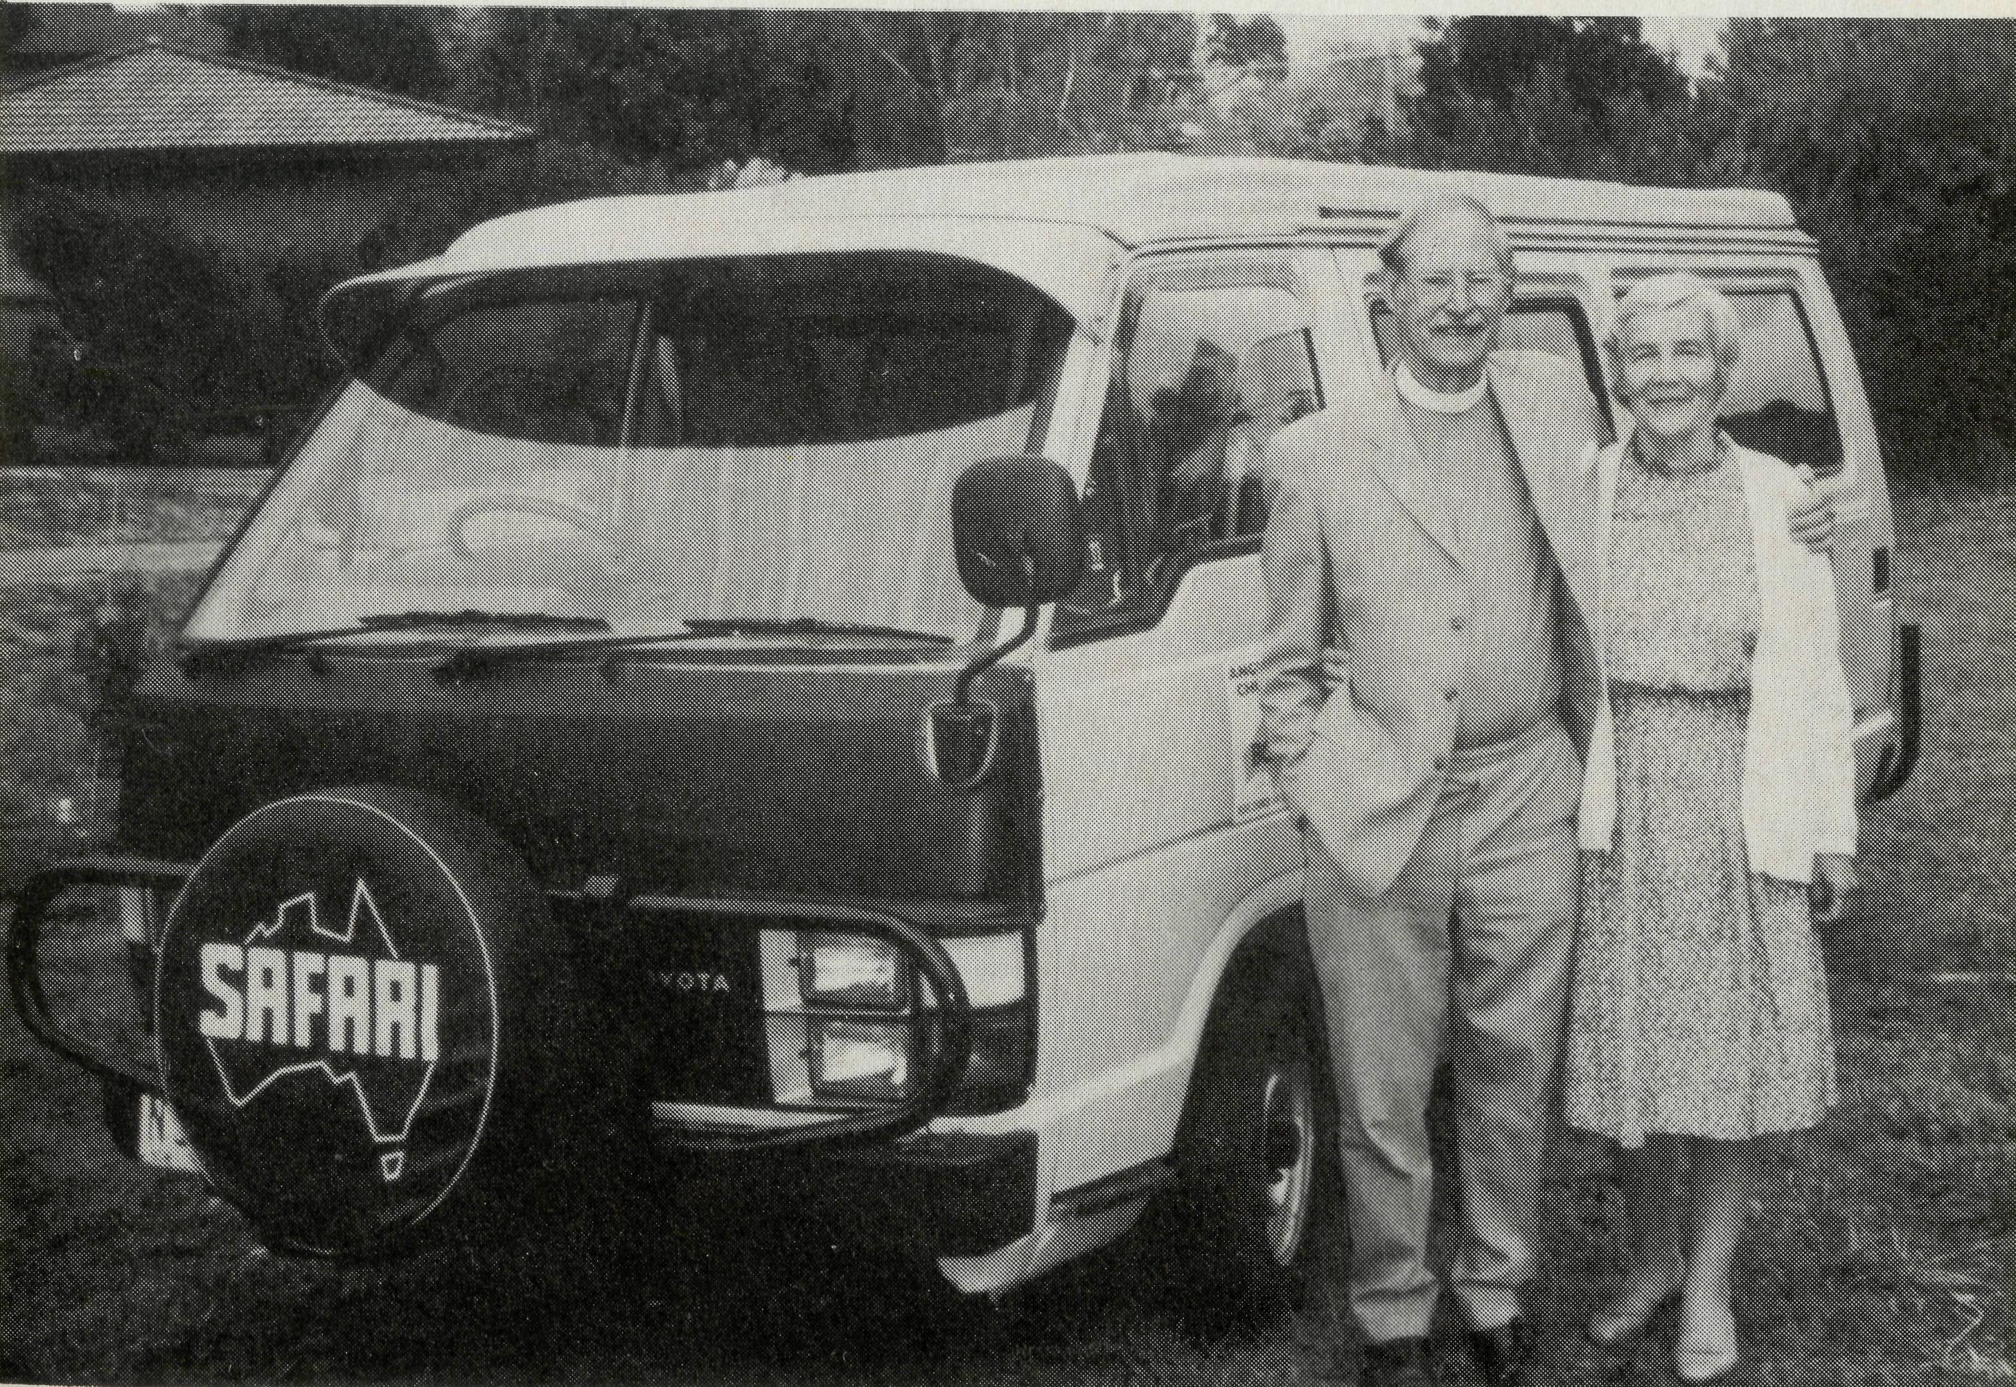
THE REAL AUSTRALIAN
First published 1920. Edition No. 273 Circulation: 26,000
All enquiries to:
THE EDITOR
David Mulready
THE BUSH CHURCH AID SOCIETY
OF AUSTRALIA
LEVEL 7, 37 YORK STREET,
SYDNEY 2000
Ph (02)262 5017
Fax (02) 262 5020
President: Archbishop Donald Robinson, Archbishop of Sydney.
Vice-Presidents: Mr. Richard Stokes O.A.M; Mr. Stan Hummerston, O.A.M.
Hon. Treasurer: Mr. R. Ctercteko.
B.C.A. CONTACTS . . .
Federal Secretary: Rev. Ernie Carnaby.
N.S.W. Secretary: Rev. David Mulready. Level 7, 37 York Street, Sydney, N.S.W. 2000. (Next to Wynyard Station) Ph (02)262 5017.
Victorian Secretary: Rev. Brian Viney, Shop 1, 205 Flinders Lane, Melbourne, Vic. 3000. Ph (03) 654 8022.
South Australian Secretary: Rev. Bob George, Church Office, 44 Currie Street, Adelaide, S.A. 5000. Ph (08) 212 7804.
Queensland Secretary: Rev. Ernest Horth, P.O. Box 6472, Upper Mt. Gravatt, Old. 4122. Ph (07)349 9081.
Western Australia Hon. Secretary: Rev. Peter Brain, 27 Leach Street, Wanneroo, W.A. 6065. Ph (09)405 1325.
FRONT COVER:
Sister Susan Green from Cook Hospital is interviewed by the Rev. Gary Nelson at Milperra (Sydney) during the morning service. Sue kindly attended several meetings during her holidays in May.
“Australia all over” in the company of an Angel!
It all started with a phone call from Ernie Carnaby when we doing a locum in Perth last year. "Would we consider doing a three-month deputation stint promoting B.C.A. in Perth churches in 1991?" The result was in the form of another question which came to our minds: "Why not spend say, 10 weeks visiting work supported by B.C.A. in N.S.W., Queensland, the Top End and W.A.?" Then we would be really fired up for deputation in Perth and perhaps Bunbury Diocese also. So our B.C.A. Safari was born.
Her golden colour, trim but matronly lines, and a verse (Exodus 23:20) determined she be called Angela! Yes, Angela is our Toyota Campervan, and after visiting work in four states, we are now involved in a deputation ministry in "the west".
Though Angela has run strongly and sweetly, another test has been for Edith and me. Living and travelling at very close quarters, day and night (all but three nights in the last 20 have been in Angie) has been a marriage enrichment experience!
We've visited 20 different parishes and work, including Nungalinya College, Darwin supported by B.C.A., and we've received many expressions of appreciation of the Society. One Parish now self-supported, was assisted by B.C.A. to get off the ground.
We've met some fine clergy families, but ministering over vast distances to graziers or cattlemen's famlies, in mining towns, multicultural communities, coping with
THE REAL AUSTRALIAN

hard luck stories in financial recession, puts a lot of pressure on clergy. Our admiration goes specially to the wives who have to cope with the front door, back door and telephone when the missioner is away.
Yes, these men and their wives need our prayers more and more. The enemy attacks through the world, the flesh and the Devil. Make no mistake about it. Do you get the B.C.A. Prayer Notes? On the long stretches of highway from Queensland to the Top End, we've prayed together in Angie as we've driven along, and listened to uplifting tapes.
We've had interesting opportunities for ministry and counselling in Churches and in Caravan Parks along the way. One lonely sad looking guy sat on the step of his van. In my best okker, I said to him, "Which
way are ya goin' mate?" Don replied disconsolately T don't know whether to go east or west". I shared a little of the Lord's leading of us and gave him a St. John's Gospel and a tract. "Read it", I said, "the Lord will show you the way."
We thank God for good health and safety. Please remember us during our three months deputation, speaking and preaching in Perth and Bunbury Dioceses. We continue to claim God's promise given to us in Canberra . . .
"See, I am sending an Angel ahead of you to guard you along the way, and to bring you to the place I have prepared" — which reminds me, we specially thank God for the loan of a house in Perth to use as our base.
Joe & Edith Mullins
Joe and Edith Mullins ... with their angel. THE REAL AUSTRALIAN

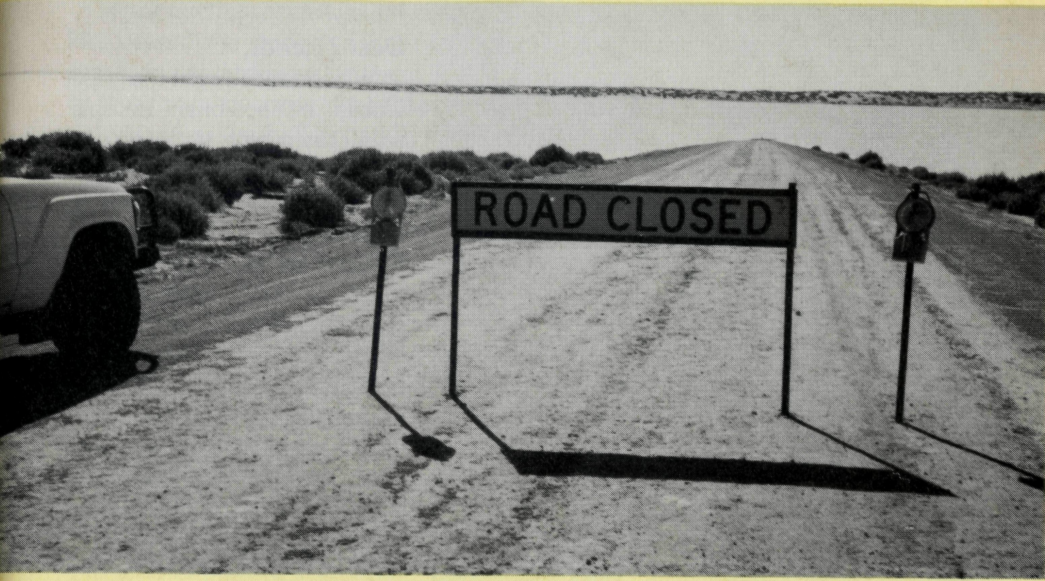
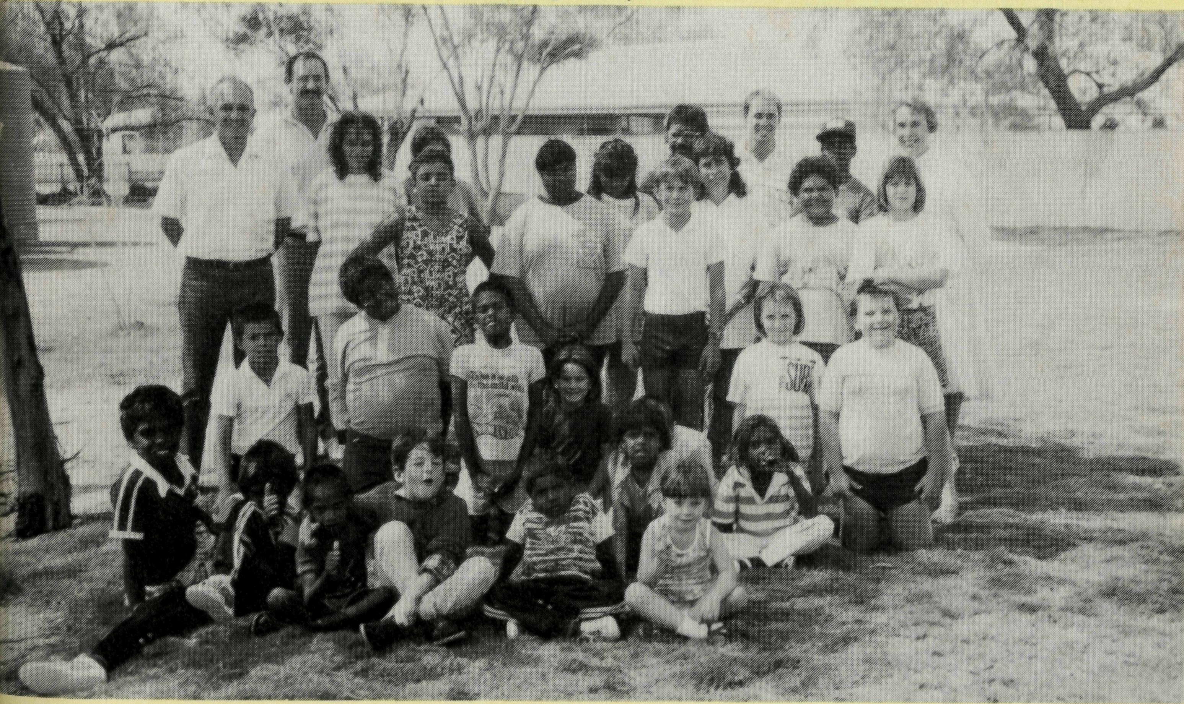
changes, we are thankful we serve the One who never changes. We simply seek the Father's Wisdom to make Jesus known in the midst of them all.
No, we do not have teams of people wanting to change trains (or buses) here — there are no passenger trains anyway — but we see change in many other ways. It is change which presents the most significant challenge to B.C.A.'s ministry here. The work involves both the main township and the patrol area on a 50/50 basis.
Leigh Creek itself is experiencing dramatic change following the Electricity Trust's decision to implement a plan to reduce significantly its coal production at the nearby coalfield. This programme will result in a fall in the town population over three years by about 40% to 1100 as the govern ment uses more natural gas for electricity generation. As a consequence there has been much need for ministry as folk face the decision of accepting severance packages or transfer or remaining to face an uncertain employment future.
In August 1990, the Joint Parish Council invited "Aussies Afire" to conduct a renewal weekend in May 1991 as a mission to the church to better equip us for mission both within the church and the community. At that time, we could not have been aware that our folk would be starting to head for pastures new some nine months later. The mission took palce only two weeks before a large contingent of our folk were to leave us. Those leaving received a very special blessing as they experienced the Lord's desire to equip them in various ways for their task in their new situations. How perfect is
^{“All change at Leigh Creek”}
the Lord's timing! One man finally surrendered his life to the Lord Jesus and was Born Again after being a very regular churchgoer for years.
As for us who remain, the Lord has given us a vision of consolidation as well as of a nursery for the nurturing of new Christians before they, too, leave for other places.
In the patrol area, change is again affecting population — the sheep population — as the drop in the market for wool combined with dry seasons has forced farmers to reduce stocks. The loss of income in the face of continuing costs and liabilities has caused family problems with wives having to seek other work — sometimes at a considerable distance.
As change takes place in the bush, new developments arise. The increasing trend to promote tourism in all areas of the country has shown itself in our neck of the woods, too. At least one sheep station is considering the idea of developing the property as a tourist venture. In the meantime, they are working with the Correctional Services Dept. and hosting low security offenders who are offered work on the property under supervision — an unusual but worthwhile diversification.
At the Southern end of the parish, there are prospects for a new tourist development to serve the Flinders Ranges near Hawker. The thought of a full-scale international airport in the middle of this beautiful and peaceful part of the world is a change many cannot envisage.
Whatever the outcome of all these
THE REAL AUSTRALIAN
Peter & Margaret Achurch
Ministry stopped by flooding Cooper Creek near Moomba.
Peter and Margaret have served in the Parish of Leigh Creek since March 1989.
Margaret and Peter with students and staff at Marree Area School. THE REAL AUSTRALIAN

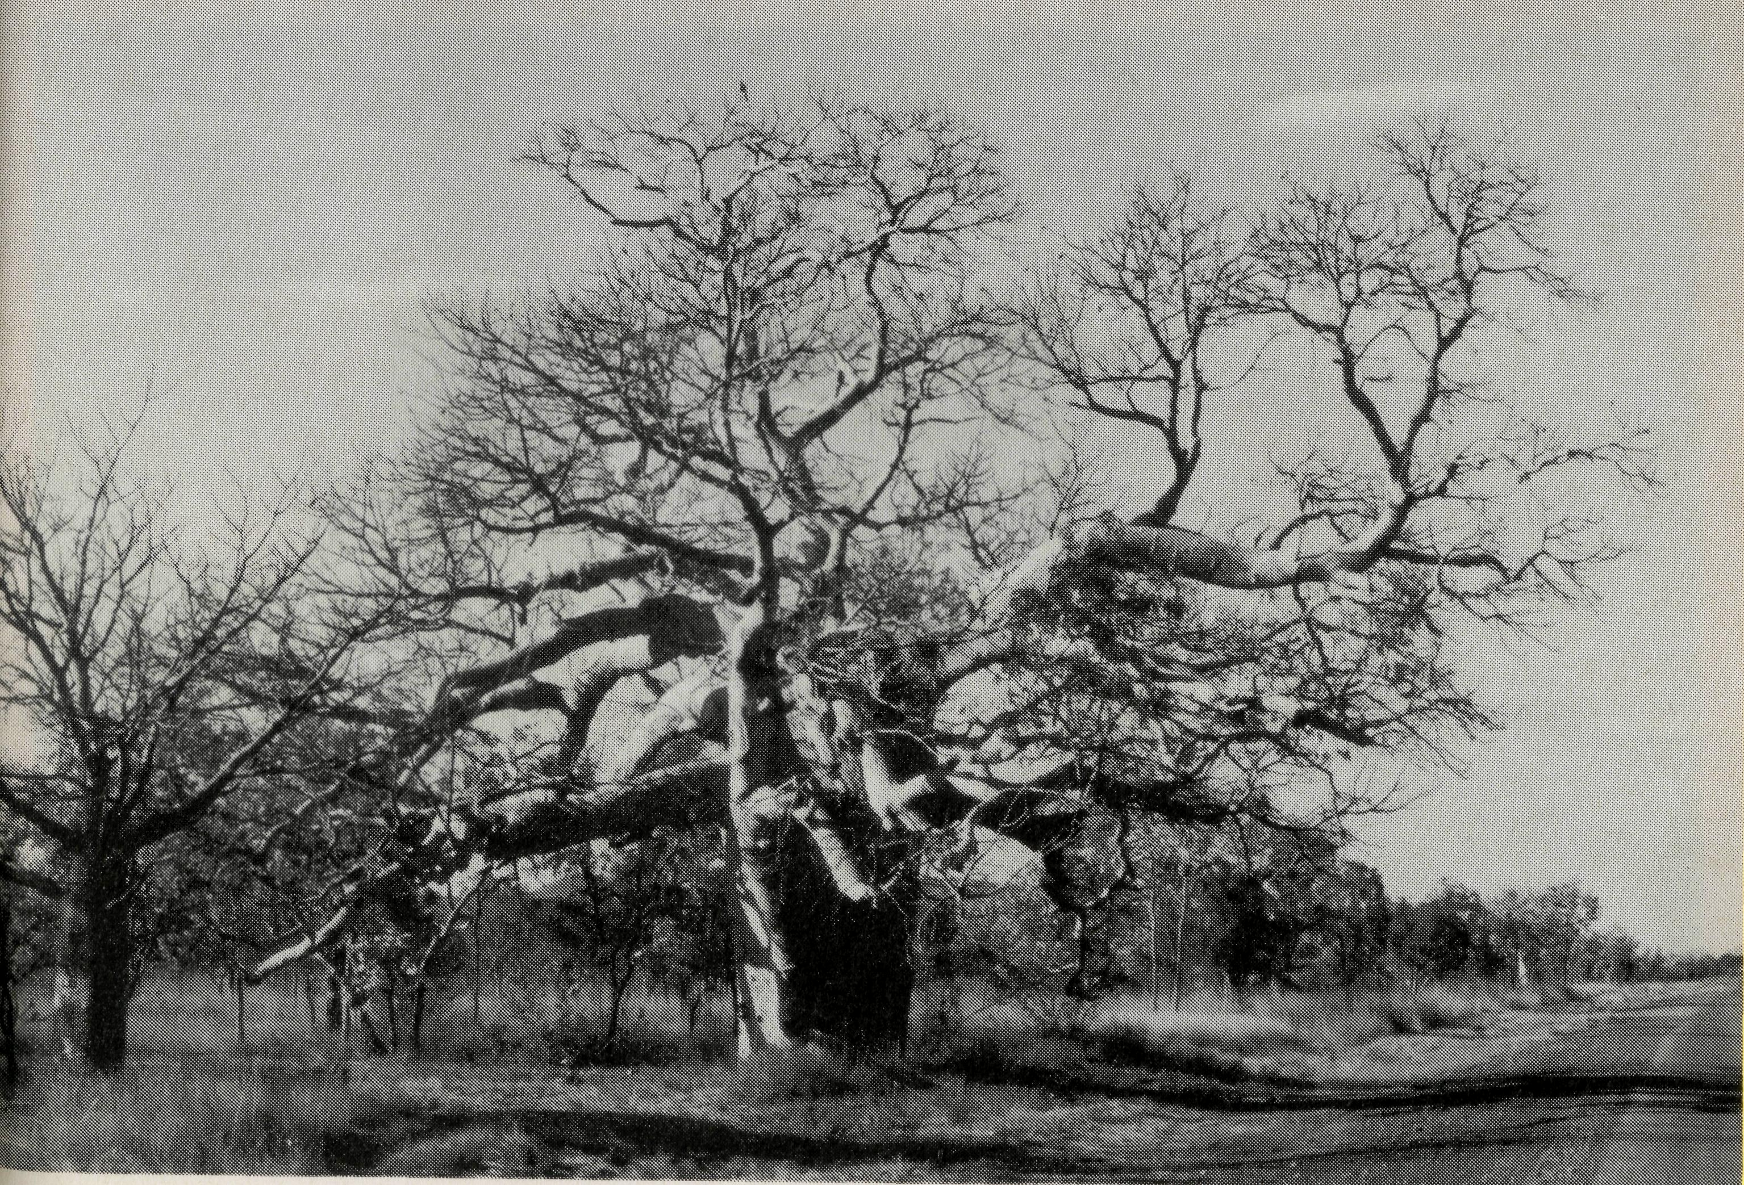

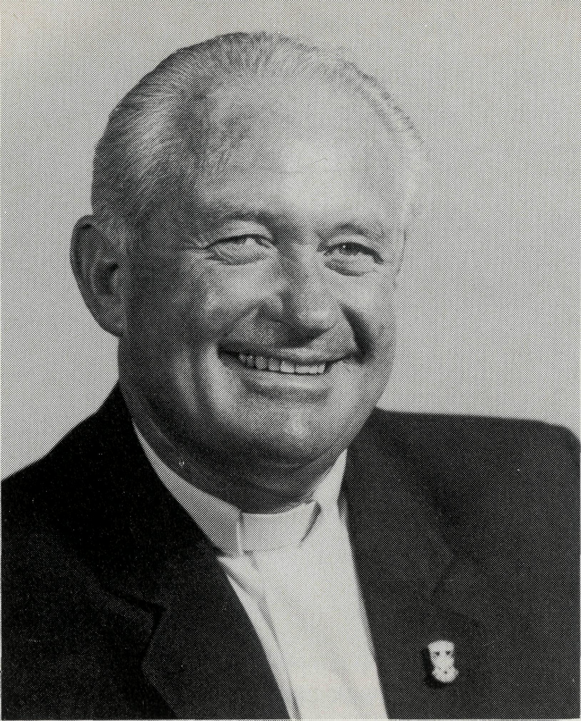
Dear Friends,
Whoever thought that one would be so busy in this small town high in the northwest of Western Australia.
Derby is a Co-operating Parish with the Uniting Church in Australia and it was on 14th December 1989 that the Reverend George Woodward (Uniting Minister), left Derby to minister in Queensland. From then until 1st June 1991 there has been no-one to take his place. This has meant a little extra work for me to do although Uniting Clergy did visit from Darwin, Kununurra and Broome. One is kept on the go in this vast expanse of the Kimberley. For two days on weeks one, three and five of the month I visit Koolan Island. Life here has been very difficult for some with people being made redundant, others transferring or still others seeking other employment. It is interesting to see God's people react to this knowing full well that there is not an indefinite amount of iron ore here on the Island.
It is God's people who rationally work things out with His help and in this time of hardship for our country, positions have been found and so transfer takes place hence we have lost people from our worship; but praise God we have gained others. As we study the scriptures at Bible Study we see Spiritual growth. We are studying "Spiritual Gifts", a Lifebuilder Bible Study looking at the "Gifts" of Ephesians, Romans, 1 Corinthians and 1 Peter. The people have also chosen "Fruit of the Spirit" to study next. It is wonderful to see the people become aware of what God wants them to do and the gifts they have to offer for the building up of His Church.
Derby is also studying the same book with similar results, Praise God. We have had new people enter our congregation this year while others have left. The people are becoming more involved in the practical side of workship. For example, in addition to our normal church cleaning/morning tea roster, we have rosters for Bible reading and the children's talk and Sunday School. This
6 THE REAL AUSTRALIAN
A letter from Derby.
may not be new to some of you, but in Derby it has been a real breakthrough.
St. Paul's was built in the early 50s and consequently requires quite a bit of doing up. The concrete floor needs raising by 100 mm and a path placed around the perimeter.
Work on the windows and vestry lining is also required. I don't think work has been done since the late 60s, apart from a coat of paint. With all this in mind we need to raise between $50,000 and $60,000. A lot of money, yes, but as the funds become available we will do the jobs in priority.
In August we had an adult baptism. Please pray with us and Mark as he grows in his walk with Christ. Pray with us also for the many opportunities of sharing the gospel with three couples who come for preparation in marriage. Pray also for Fred who upon attending a service recently was touched in such a way that he could not sing all the songs. His comment later was "I don't know if God's looking for me or I for Him". May God's Spirit so bring to him the reality of Christ's love.
We thank God for you all: the Family of "The Real Australian" and for the privilege of serving Him in the remote part of Australia.
God Bless you all.
Rev. John E. Symons
John and Dianne Symons have been at Derby since 1987.
Boab tree outside Fitzroy Crossing. THE REAL AUSTRALIAN

Changed Lives”
The Rev. Brian Harding and his wife Joy took up ministry in the huge isolated Parish ofParaburdoo in May 1990. They travel great distances and are thoroughly enjoying their time. Brian shares news of "changed lives" in his area . . .
NAME THESE B.C.A. LEADERS!
Last year a young timid New Zealand girl came to church at Tom Price. We have all come to know and love her. Since then she has given birth to a son. Doctors had once said that she and her husband could never have children. She was recently confirmed as an expression of her growth in Faith.
In our street we have an ex-Vietnam veteran who served for 20 years in the army. Two years ago he cried out for help and a young Christian man prayed with him and led him to Christ.
He has grown in the faith and is now studying theology. His wisdom and simple faith are being used by God as he ministers to the young key Christians of the community, as well as those outside the Church. He has now become a full member of our Church and is a Lay Reader.
I was in the home of a hard drinking man with his mates, and a young unmarried mother spoke about baptism for her child. These fellows said, "He can do it", and she said to me, "But are you a Christian?" What she meant was that her ances-
try was Roman Catholic, and a "Father" should baptise her child
The ignorance of God or the Church is incredible! The children at School have been told by the Deputy Principal that they must attend "school scripture", which is good, but I do not think we are going to get many who will pay $3.00 per year for the books. These people earn big money but see no reason to give any to the Church, yet those who have called on us at all times of day and night in crises, know where to turn!
Each of these towns is unique and refreshing to work in. People from many parts of the world live here. We have joined "Lions" and "Lionesses" and Joy belongs to the Community singing group. This enables us to meet people outside the Church. We have also met many people as we have attended seminars on Child Abuse, Domestic Violence and Youth Support Committee briefings.
We thank God for the past year spent in this area. We love the country, the life style, the climate and the people.

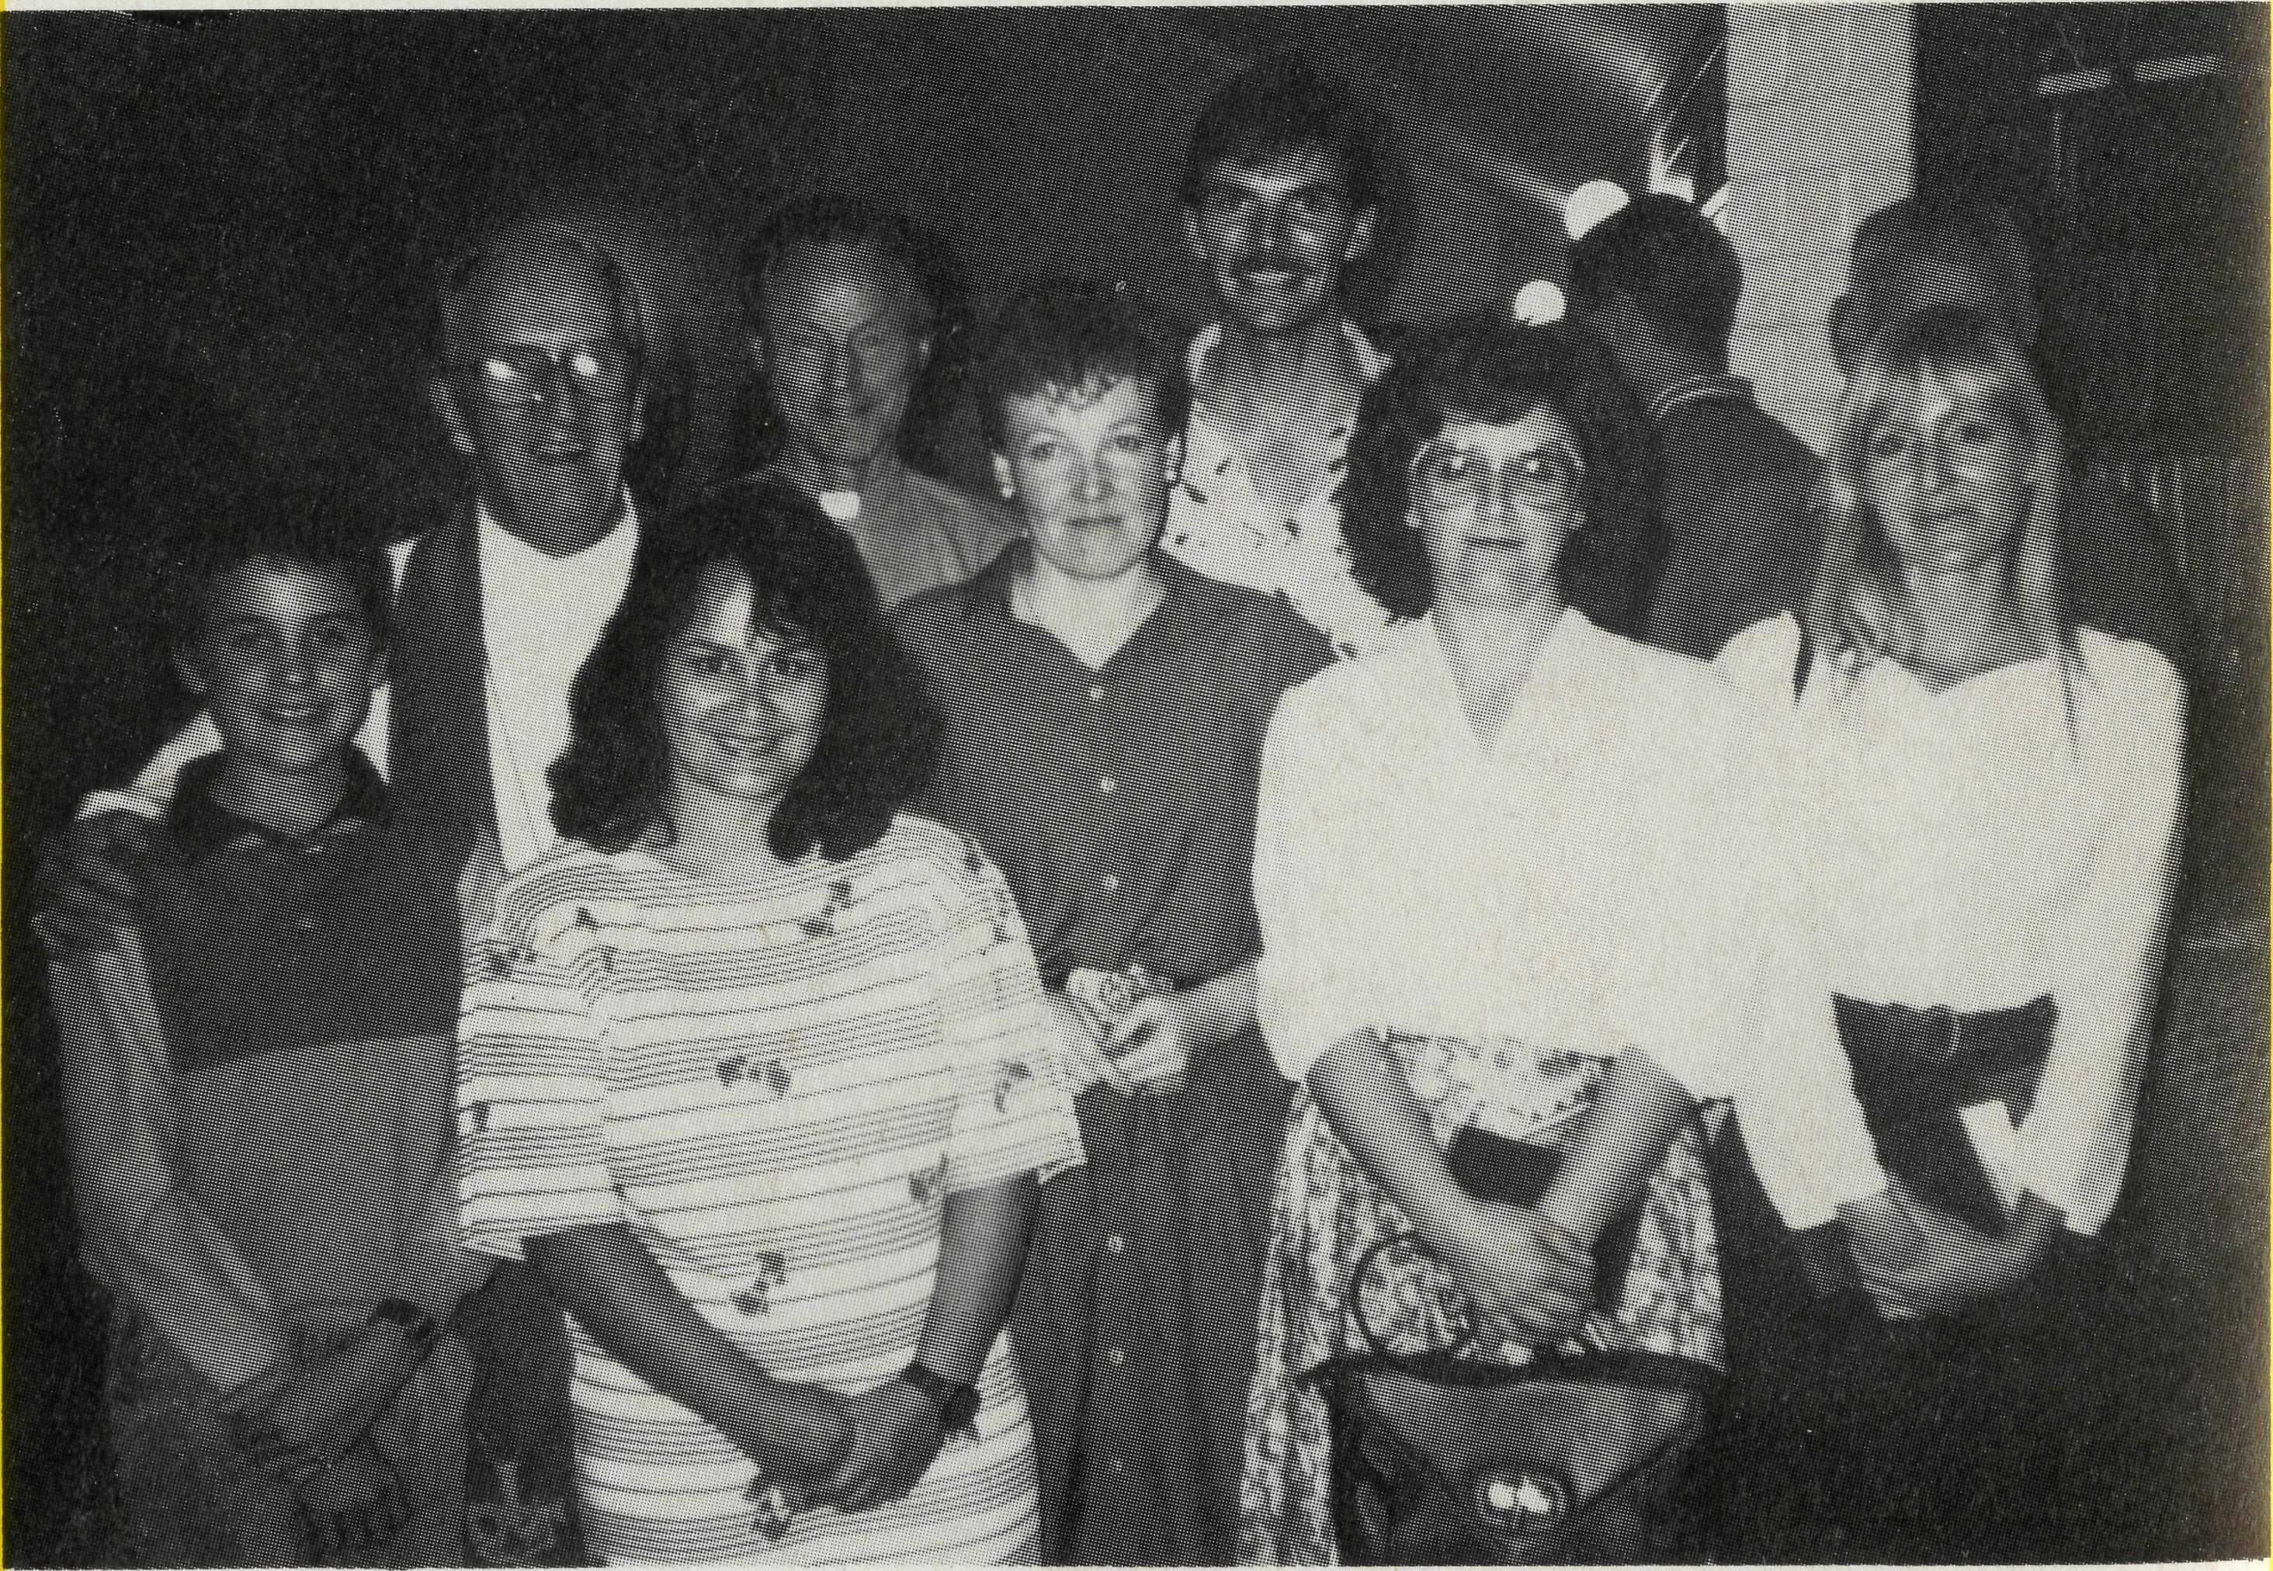
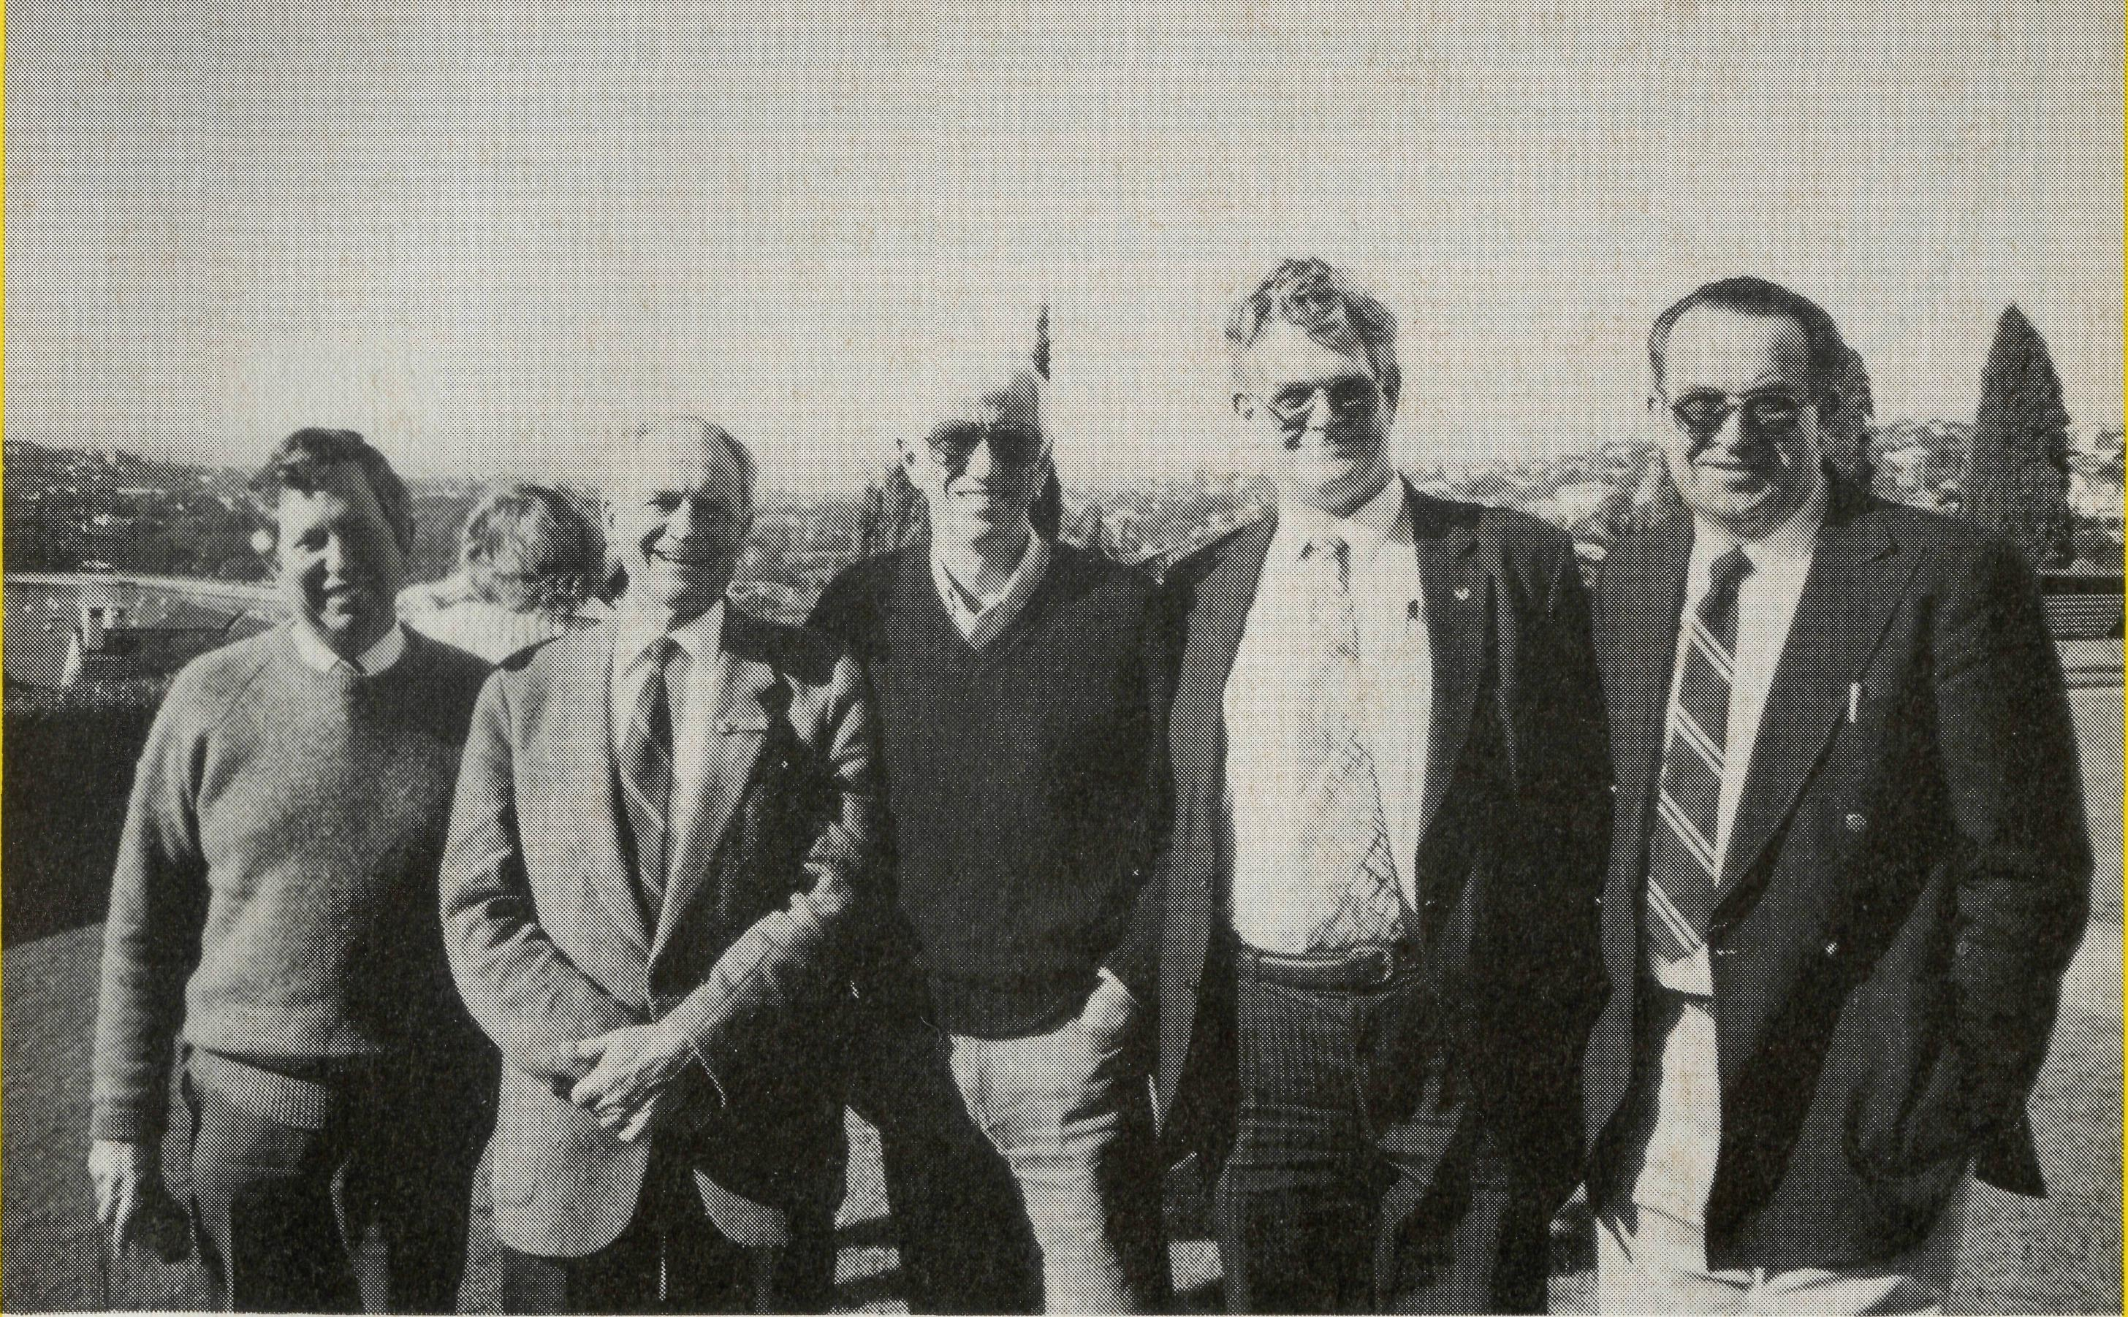
Confirmation at Paraburdoo 1991.
THE REAL AUSTRALIAN
B.C.A. Council members L. to R. Revs. John Butler, Tom Morgan, Barry Huggett, Messrs. Bill Milford and John Cronshaw, photographed at the Annual Conference Day in May.
THE REAL AUSTRALIAN 9

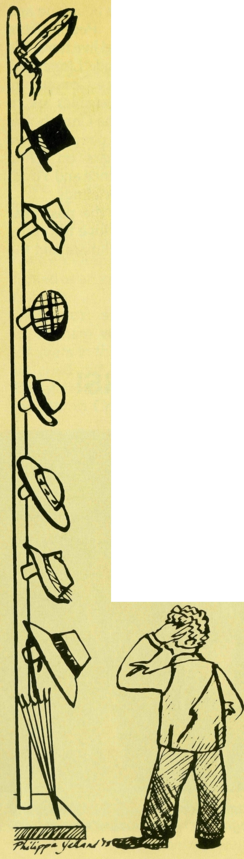
What am I?
Our town is used as an overnight stopover for people travelling in the Northern Territory. Last year, over a thousand people received refreshment, enjoyed a meal or slept at our establishment ... so I am a motel manager!
In the last six months alone, five churches and groups have come through town and requested a guided tour of the district ... so I am a tour operator!
Quite often I find myself in the role of song-leader, as I am considered to have a reasonable singing voice. This year, the R.S.L. asked me to record a number of hymns which were then distributed through the Northern Territory for use on Anzac Day ... so I am a recording artist!
I have found my way onto some eight committees in the town over the past few years. I am called upon to chair A.G.M.'s and public meetings. This year, I am the President of the Lions Club ... so I am a professional M.C. and committee person!
Since September 1990, Peko Mines have been winding down their operation in this district. At approximately three-monthly intervals, some 50 people or so have been retrenched. Many of these people have come to me to discuss their future ... so I am a retrenchment counsellor!
Two years ago I helped to build an extension onto the Preschool. Last year I built an extension onto the Rectory and early this year I completed building a verandah onto the Day-Care Centre ... so I am a builder!
I was teaching basic housepainting skills to Aboriginal trainees at the local T.A.F.E. in the second half of 1990 ... so I am a teacher!
Teachers having problems at school have sought me out as a sounding board. I am the coordinator for Religious Education for the four schools in the district. I teach four scripture classes each week ... so I am a school chaplain!
Since the beginning of this year I have been working on a Diploma of Education through the University of the Northern Territory, where I am enrolled as a 'full-time' student!
THE REAL AUSTRALIAN
On several occasions I have been asked to perform marriage ceremonies for couples who know me as an identity about the town, but who are not churchgoers ... so I am a marriage celebrant!
Within our Ministers' Fraternal are clergy of quite contrasting colours of Christianity. These people would have no natural inclination to relate to each other and very little even as fellow ministers! As the current president of the fraternal, much effort goes into smoothing troubled waters ... so I am a diplomat!
What am I? I am a B.C.A. Missioner! I am the Priest-in-Charge of the Parish of Tennant Creek. I am Tim Brownscombe.
Of all the roles played by a parish minister, the one I most enjoy is spiritual mentor. As a Christian priest, some people will look towards me as a spiritual father. One such person was David, who has spent a number of stints in Tennant Creek on secondment from Alice springs with a government department.
David first came to Tennant Creek for just six weeks as a relief. He would probably admit that he thought being a 'Christmas and Easter' Christian was enough. He came to the Easter Sunday Service.
Not long after that, David returned to Tennant Creek for another 18 months. During that time, we saw David's commitment grow from occasional to regular attender and his faith become more real to him.
I would like to tell the story of David's growing understanding of prayer:
It was the beginning of a new year. There was an influx of toddlers and preschoolers, who were a little distracting to their Mums and Dads who were trying to worship. After the servie, I stood and talked with David over a cup of tea. We looked out the side door of the church and David said "I can see a swing set, right there".
On Wednesday of that week, I was given some play equipment by a member of another church, who had found it at the dump. It was in very good condition and I installed it the following day.
When David came the next Sunday, he was beside himself with excitement exclaiming "That's what I saw! That's exactly what I saw last week!" This was David's first experience of God's provision and answer of prayer.
Shortly after this, David announced that he was going to pray that we would get proper accommodation, as it wasn't right for the family to put up with such cramped quarters. We tried to moderate him, but he insisted that God answers prayer.
About a year later, on yet another six week sojourn to Tennant Creek, David was one of the men who joined in the working bee to pour the cement for the slab for the extensions to the Rectory. He felt it was right that he had been present, as his prayers had made it happen.
in
Nine months later, about a week before the dedication of the completed extensions, David was leaving Tennant Creek for the last time: he was moving to South Australia. As we sat down to have coffee in the new loungeroom in the extension, tears came to his eyes as he saw the final fruit of his prayers. He said, "He just didn't know it could be this good." He is more than a pew-warmer in his new parish!
THE REAL AUSTRALIAN

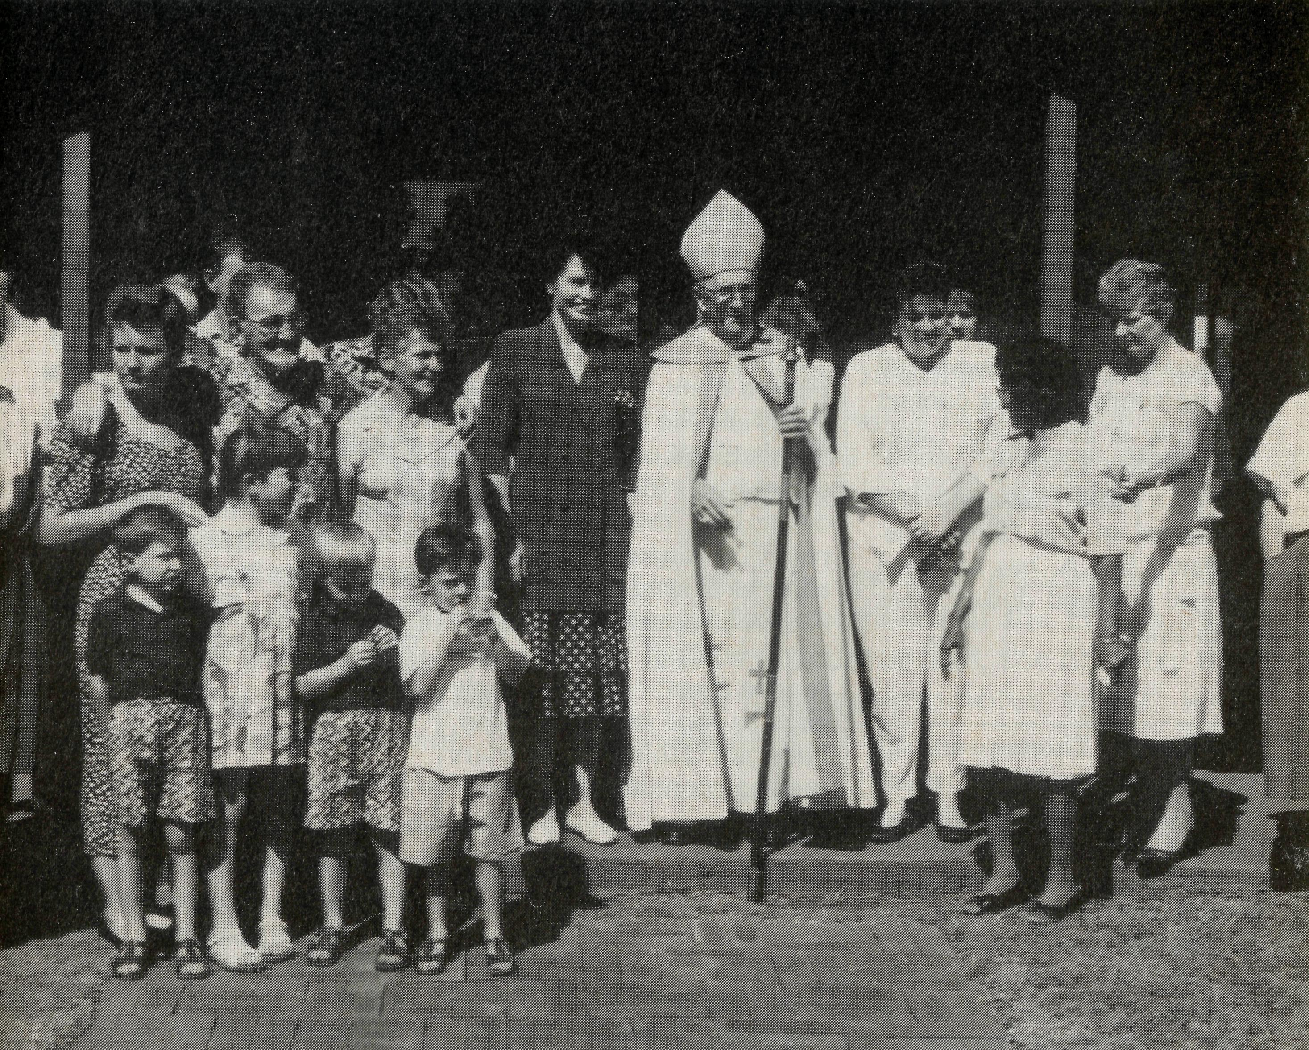
^{Newman:}
The house of Rhonda the hangel; Lenny the "no named" boy, the converted Ex-Soldier and the unusual Ashtray!
"Hullo Misses. Remember me? I was a hangel. My name is Rhonda." Rhonda greeted us as we arrived at the Nullagine school for Scripture classes. She was referring to our Christmas Carol Service and the Manger Scene the children did. All to the accompaniment of a raging thunderstorm!
At Marble Bar, 311 km north of Newman, we asked the children: "When you hear the word Easter, what do you think about?" Our question was met with silence. It seemed an explanation was necessary: "Most children think of holidays and Easter ^{e}S9^{s}"• They were amazed! "Easter is about Jesus!" they said.
In Marble Bar, Betty Lou and I stay in the "Oolanyah" Hostel for the Aborigine students. Among them we were introduced to "NYABARU" Stream. His name is Lenny, but because someone of the same name died, he is "NYABARU" or "No Name". There is so much to learn about Aboriginal culture and spirituality.
In Newman, the ministry is as varied as in any parish. A little harder perhaps to organise anything because of the shifts. Bible study has to be held twice on the same day so shift workers have an opportunity to attend.
We have our outreach into the community through C.W.A., Depart-
ment of Community Services, Lions Club, Newman Community Car Committee and the Fringe Dwellers Support Group.
Every Baptism and Marriage preparation, every First Communion and Confirmation class, home visit or counselling session is an opportunity taken to share the Good News. The "fruit" varies as Jesus said it would (Matthew 13:18-23).
Answering the phone the other evening, I was greeted with "You have a lot to answer for!" An unbelieving ex-soldier and his wife a committed Christian have become firm friends. Over the six years we've known them, I've been privileged to share with them through some of their difficult times, a few of their marital tensions and their happy times.
At their request, during a Sunday service, they renewed their marriage vows. This marked a turning point in their relationship. They've since moved to another town.
And now, "You have a lot to answer for!" was his way of introducing the fact that the Lord had touched him. He had accepted and committed his life to Jesus as his Saviour. Praise God. I thank the Lord for this opportunity to have ministered and witnessed to this young man.
"What about an offering" asked Gabrield, the Portuguese cook at the Bamboo Creek Mine camp. I'd forgotten and was packing up after the Holy Communion Service in the Wet Mess. He promptly picked up an ashtray and took a collection from those at the bar. Some fifty people live at the camp an 81 km journey East of Marble Bar. Ulf and Drago took me on a tour underground and after work, met me in the Mess. There too I met many of the men and women who work in the office, mill or underground. After dinner, the bar was closed for an hour so I could hold the service, then we continued our conversations into the night.
The Lord comes up with some wonderful blessings!
Raymond & Betty Lou Molyneux
Confirmation at Newman (confirmees Donna and Thea stand by the Bishop).
The Rev. Raymond and Mrs Betty Lou Molyneux have been in the Newman Parish since September 1990.

THE REAL AUSTRALIAN
THE REAL AUSTRALIAN

POST & RAILS

Does it matter how I give to B.C.A.?
BEREAVEMENT:
Miss Margaret Woolcott,
Secretary to the Federal Secretary from 1983 to 1990 died on 24th June. Margaret's trust in the Lord Jesus Christ remained firm to the end. We praise God for her valued ministry with B.C.A. and extend our love to Bruce and Helen, Stephen and David.
BROKEN ANTIQUES RESTORED TO B.C.A’S BENEFIT:
Mr Geoffrey Danger of Mereweather, N.S.W. is restoring small broken antiques and giving the proceeds of such sales to B.C.A. If readers have small tables, chairs, boxes, writing slopes, tea caddy's, etc., to give or sell for restoration, please contact Geoffrey at 25 Rowan Lane, Merewether 2291.
Since this request last appeared in the "Real Australian", B.C.A. has received several hundred dollars from such sales!
B.C.A. BUS TOUR:
The Rev Jim Thomson and 40 supporters from N.S.W. spent 10 days in June/July visiting the B.C.A. supported centres of Quilpie, Winton and Lightning Ridge. A great time was had by all!

CROYDON, N.Q.
B.C.A. supporters contributed towards the cost of a new Church building some years ago. The Parish Secretary has written to advise that the new building was opened in May.
14
BLACKWATER:
Glen & Kaye Zimmerle and
their children Andrea and Andrew, left Blackwater in June. They are now living in Toowoomba. They were supported by B.C.A. for 2Vz years and will be greatly missed both from Blackwater and the B.C.A. family. The parish will be ministered to by neighbouring clergy for the forseeable future.

MORE PRAY-ERS WANTED!
The last two years have seen a 100% increase in the B.C.A. supporters who receive our free quarterly Prayer Notes . . . that's around 7000 who receive them. The Rev. Brian Viney and Ms Margo Bright in the Victorian office have done a terrific job in further developing this most useful resource. Australia Post won't allow us to send them out with the Real Australian — thus the extra mailing! If you don't receive them — use the reply page to send for them today. Let's see 10,000 supporters praying more effectively!
NO MORE BOOKS THANKS!
The Broken Hill Hostel requested books in the last edition of "The Real Australian". Such has been the response, that they are starting a book shop! (ONLY JOKING.) Thank you for the books — they've got enough!
FEDERAL COUNCIL:
Have you ever wondered who contributes to the work of the Society by serving on the Federal Council?
Here is a list of the current Council:
President: Archbishop D. W. B. Robinson.
Vice-Presidents: Mr R. T. Stokes, Mr S. E. Hummerston.
Chairman of Council: Bishop R. H. Goodhew. Hon. Treasurer: Mr R. Ctercteko.
Federal Secretary: The Rev. E. W. Carnaby.
Members from N.S.W.: The Rev. J. A. Butler, The Rev. C. J. Clerke, The Rev. L. F. Monaghan, Mr. F. Chilton, Mr. J. Cronshaw, Mr. J. Wenden. Vic: The Rev. B. D. Huggett, The Rev. T. F. Morgan, Mr. J. Bleakley, Mr. W. Milford, Mrs A. Hargreaves, Miss L. Morgan. S.A.: Mr. K. Langshaw. Qld: Archdeacon N.J. Knott, Mr A. Sauer. W.A.: The Rev. P. R. Brain. Tas: Archdeacon I. E. A. Booth.
GERALDTON:
After 10 years in the position Mr Martin Weatherston has resigned as Diocesan Registrar in the Diocese of northwest Australia from 1st June. His place has been taken by the longtime Secretary in the same office, Mrs Kay Winfield. We thank God for Martin and Kim's ministry and welcome Kay to a B.C.A. supported ministry.
THE REAL AUSTRALIAN
Basically from B.C.A.'s point of view the answer is NO!
But there are a variety of ways, one or more of which may be more convenient for you.
The Society has initiated over the years the use of B.C.A. Mission Boxes, Parish Duplex envelopes, Thanksgiving appeals complete with response envelopes, gift envelopes enclosed in each issue of the Real Australian magazine and the use of Bankcard and MasterCard facilities.
The question is often asked "Must I use all the envelopes and appeals sent, together with my mission box?" Again the answer is NO! Just choose the way or ways that suit best.
Many people have found the envelopes enclosed in each quarterly issue of the Real Australian a convenient reminder of their decision to give to the Society's work. Using this method of giving means that the Society's cash flow is well regulated.
With such a variety of ways open for your gift to reach B.C.A. from time to time you may receive in the mail, envelopes, appeals or reminders of Box Openings following close to each other. Don't feel intimidated, just choose your way ahead, remembering that others from among the 20,000 supporters will choose a different means to ensure that the work of B.C.A. goes ahead.
THE REAL AUSTRALIAN
You will note the response slip carries our facility for Bankcard or MasterCard donations: If you would like to use this method of giving just carefully fill in your details and enclose the form in the addressed envelope provided and add a stamp. Of course, if you don't want to damage the magazine you could copy down the relevant details on plain paper, sign it, and send it to us.
Over the years, some supporters have remembered the work of B.C.A. in their wills. We have some B.C.A. committee members who are solicitors and they're available for consultation. We also have a specially prepared leaflet available upon request.
B.C.A. values the individual support of members of the B.C.A. family, for without that, the ministry that the Society promotes would soon cease.
TAX DEDUCTIBLE GIFTS TO B.C.A.
Gifts to B.C.A.'s General Funds are NOT tax deductible. However, gifts made to our Hostel and Medical work are! (It is preferable for our management purposes to direct such tax deductible gifts to the Hostel rather than hospitals as we do receive some government contributions towards our Medical work but NOT the Hostel Ministry.)

PRAY FOR OUR FIELD STAFF

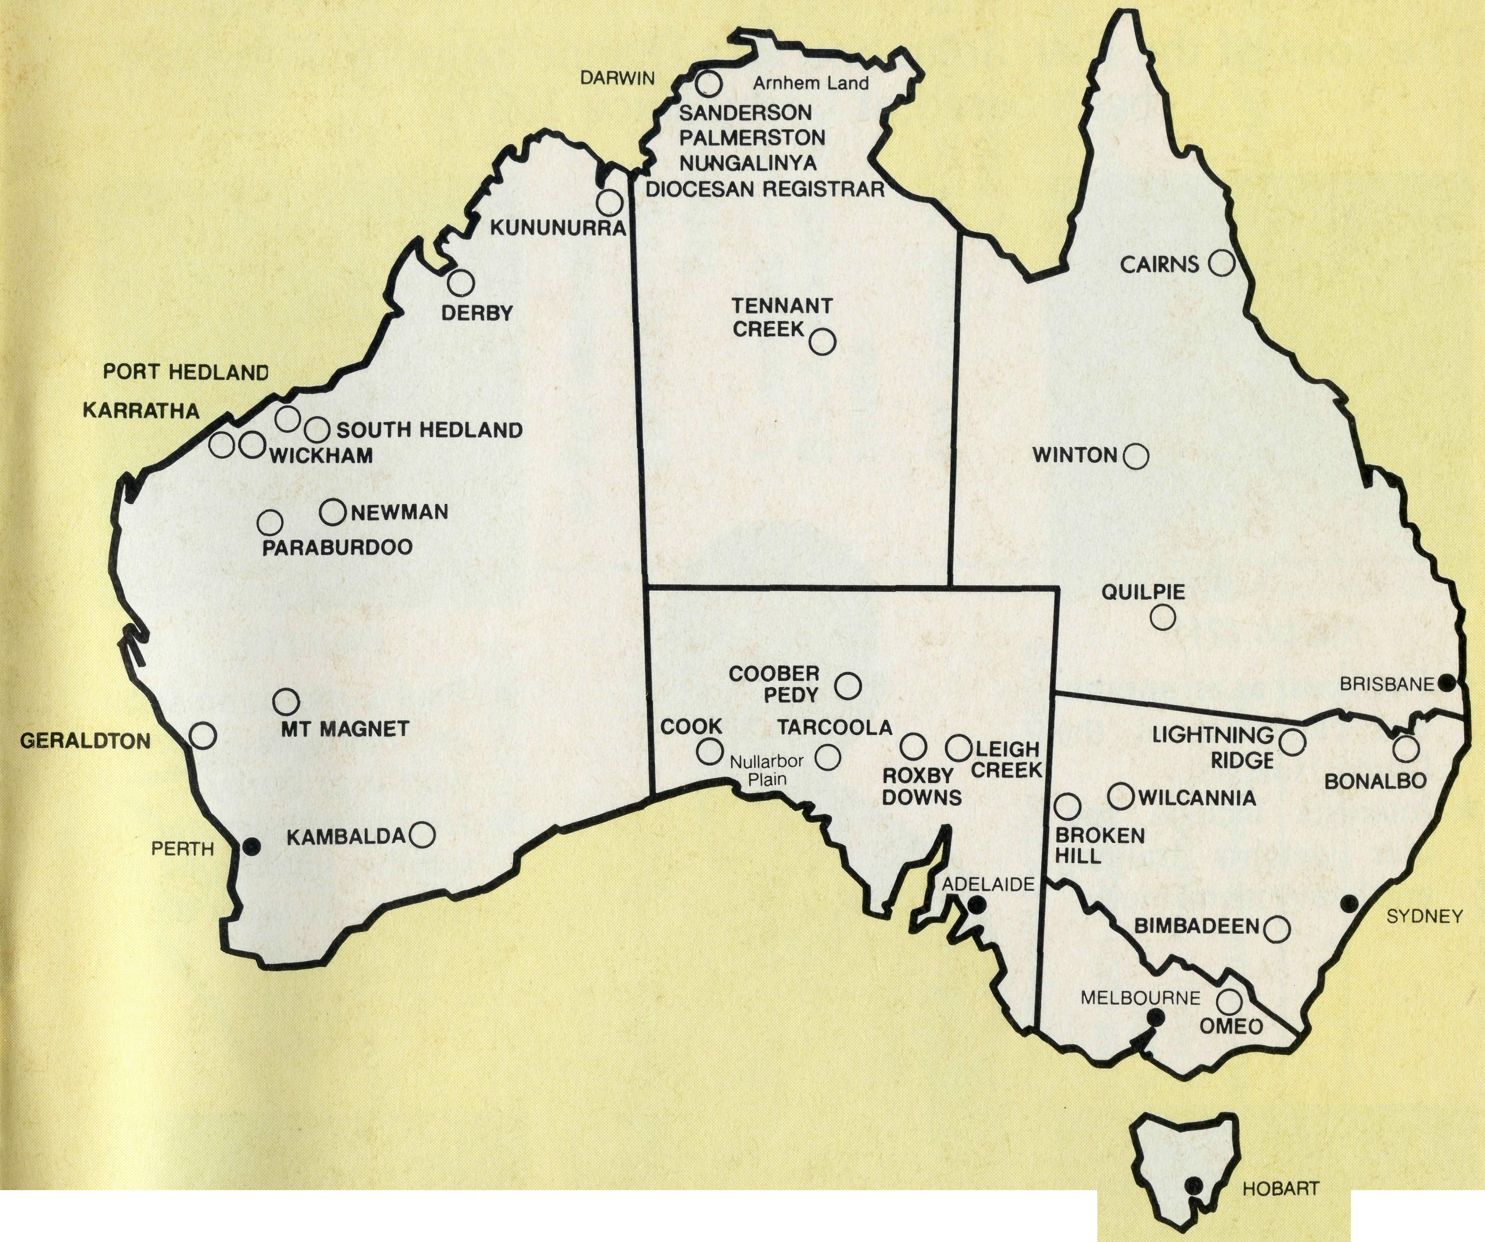
NORTHERN TERRITORY
Diocese of Northern Territory — Bishop Clyde Wood.
- Sanderson — Rev. Greg and Mrs. Kerry Thompson.
- Palmerston — Rev. Ron and Mrs. Margaret Bundy.
- Tennant Creek — Rev. Tim and Mrs. Kerrie Brownscombe.
- Diocesan Secretary/Treasurer — Mr. David Martin. WESTERN AUSTRALIA
Diocese of North West Australia — Bishop Ged Muston.
- Kununurra — Rev. Murray and Mrs. Jane Lamont.
- Derby — Rev. John and Mrs. Dianne Symons.
- Newman — Rev. Raymond and Mrs. Betty-Lou Molyneux.
- Port Hedland — Archdeacon Bill and Mrs. Jennifer Warburton.
- South Hedland — Rev. Ray and Mrs. Lyn Arthur.

- Karratha — Rev. Terry and Mrs. Fiona Redmond.
- Wickham — Rev. Allan and Mrs. Julie Harrison.
- Tom Price/Paraburdoo — Rev. Brian and Mrs. Joy Harding.
- N.W. Australia: Youth Ministry: Catherine Ross; Counselling Ministry.
- Mt. Magnet (Murchison) — Rev. Philip and Mrs Margaret Bassett.
- Diocesan Registrar — Mrs. Kaye Winfield in Geraldton. Bluff Point: Rev. Jon and Mrs. Rae Reinertsen (Curate).
Diocese of Perth — Archbishop Peter Carnley.
16 Kambalda/Norseman — Rev. Ron and Mrs. Colleen Ross.
Hon. B.C.A. Secretary for W.A. — Rev. Peter Brain.
SOUTH AUSTRALIA
Diocese of Willochra — Bishop David McCall.
- Coober Pedy — Rev. Ian and Mrs. Robin Robertson.
- Roxby Downs and Mid-West Mission — Rev. Colin and Mrs. Ruth Nelson.
- Leigh Creek — Rev. Peter and Mrs. Margaret Achurch. State Secretary for S.A. — Rev. Bob George, Mrs. Jo Phillips.
- Cook: Bishop Kirkby Memorial Hospital — Sisters Gai DiDonna, Susan Green. Tarcoola Hospital — Sisters Mary-Grace Bingham, Meryl Burden, Christina Ryman.
VICTORIA AND TASMANIA
Diocese of Gippsland — Bishop Colin Sheumack.
21 Omeo — Rev. Errol and Mrs. Anne Sorensen.
State Secretary for Vic. and Tas. — Rev. Brian Viney, Ms. Margo Bright. NEW SOUTH WALES Diocese of Riverina — Bishop Barry Hunter.
22 Broken Hill Hostel — David and Elisabeth Bull, Simon and Susan Heath.
Wilcannia — Rev. Bob and Mrs. Phyllis Collie.
Diocese of Armidale — Bishop Peter Chiswell.
- Lightning Ridge — Rev. Cliff and Mrs. Megan Ainsworth. Diocese of Grafton — Bishop Bruce Schultz.
- Bonalbo — Rev. Dick and Mrs. Pat Freeman.
- State Office — Revs. David Mulready and Jim Thomson. Mrs. Michele Peacock. QUEENSLAND
Diocese of Brisbane — Archbishop Peter Hollingworth.
- Quilpie — Rev. Bob and Mrs. Sue Witten.
- State Secretary for Old. and northern N.S.W. Rev. Ernest Horth. Diocese of Rockhampton — Bishop George Hearn.
- Winton — Rev. Lex and Mrs. Rhonda Carey. ABORIGINAL MINISTRY
29 Cairns, Townsville, Mackay: Bishop Arthur Malcolm.
Nungalinya College — Principal: Rev. Dr. Les Brockway.
Bimbadeen College — Mr. Dennis and Mrs. Maureen Atkinson.
B.C.A. HEAD OFFICE
16
30 Rev. Ernie Carnaby, Mr. Jim Gosbee, Mesdames Jacqueline Griffiths, Lay Lee
Boughton and Eileen Darbin.
THE REAL AUSTRALIAN
WINNING AUSTRALIA FOR CHRIST

O Lord our God, help us to remember those who live in the remote parts of our land. We ask you to strengthen and encourage all whose ministries are supported by The Bush Church Aid Society. Refresh them in times of discouragement and loneliness and call others to stand with them in the task of making Christ known. Grant that, through the ministry of the Word and Sacraments, through medical work, through service and by caring for the young, the message of your redeeming love may be proclaimed, and accepted by the people throughout our land. We ask these things through Jesus Christ our Lord, who lives and reigns with you and the Holy Spirit, one God, for ever and ever. AMEN.
17
*lf you'd like more details for prayer, send for our FREE quarterly prayer notes. (See reply page.)
THE REAL AUSTRALIAN

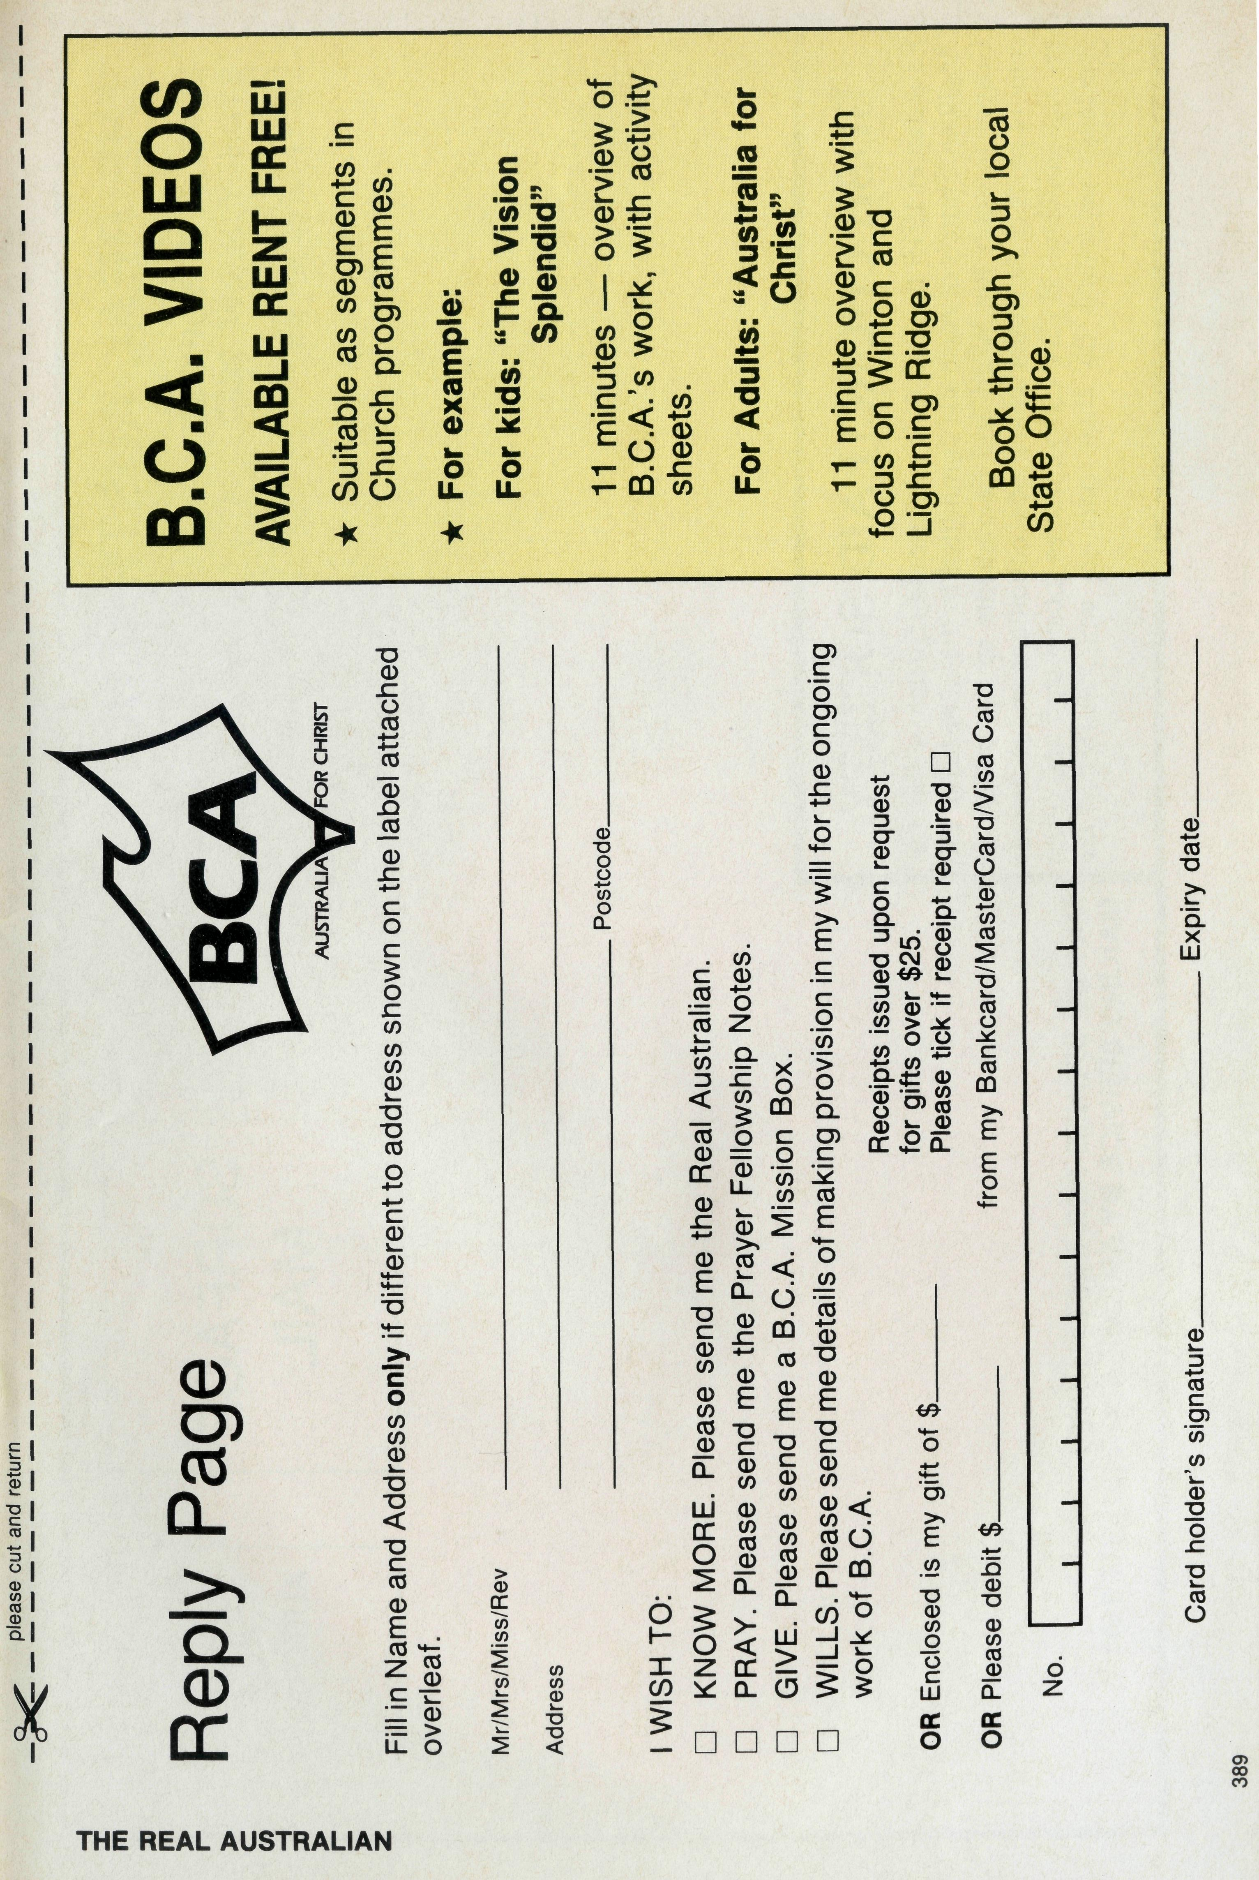
The Symons boys of Derby
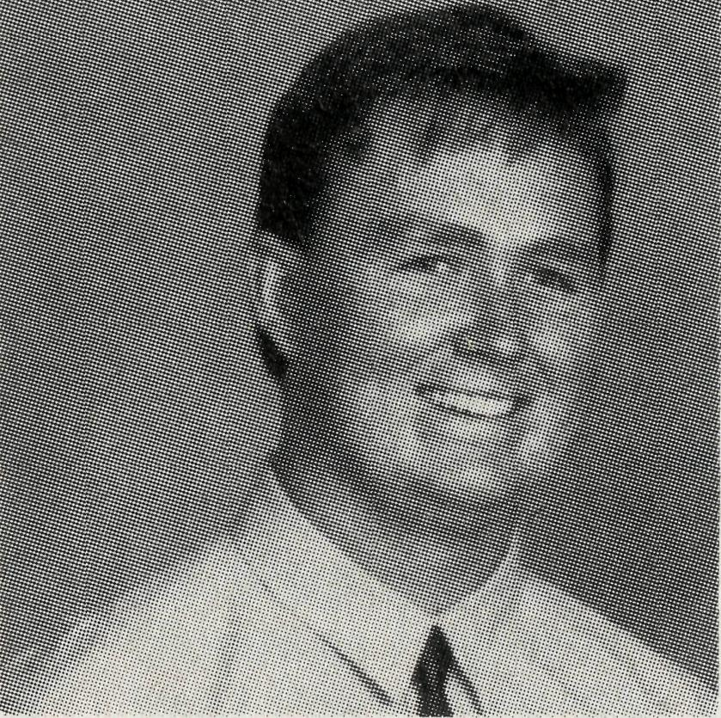
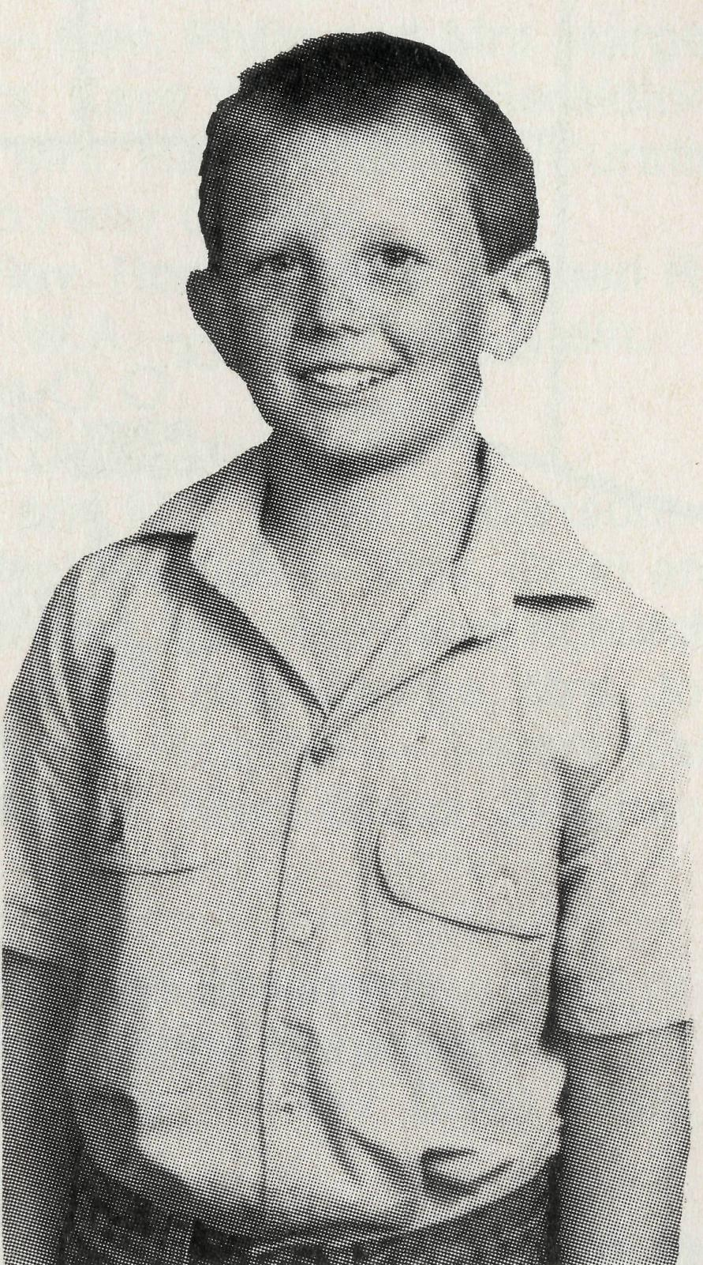
The sons of the Rev. John and Mrs Dianne Symons who have been based at Derby since 1987.
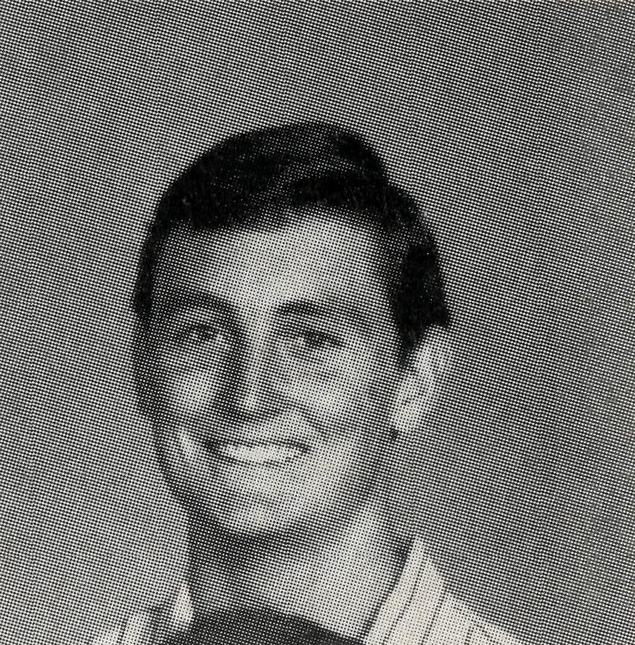
Martin (21)
- Final year as an apprentice carpenter at the Derby Hospital.
- Interests include regular weights training and heavy metal music.
Paul (19)
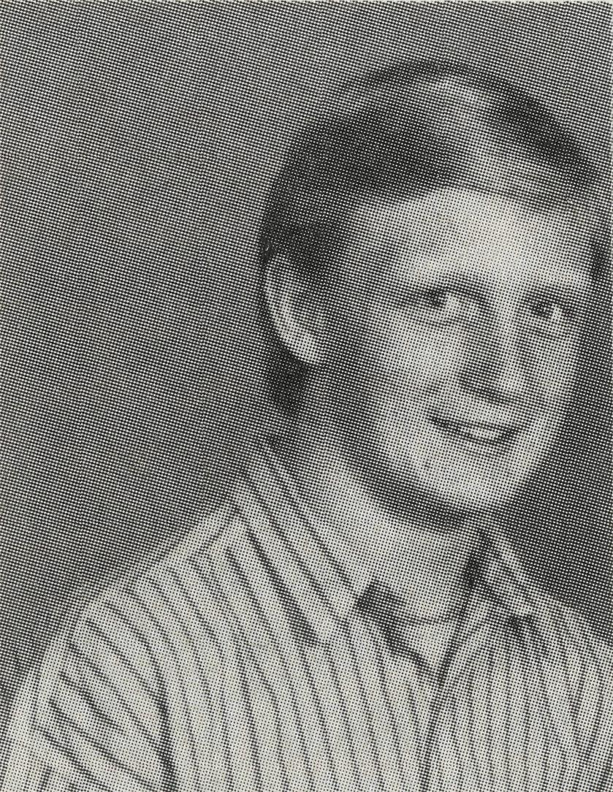
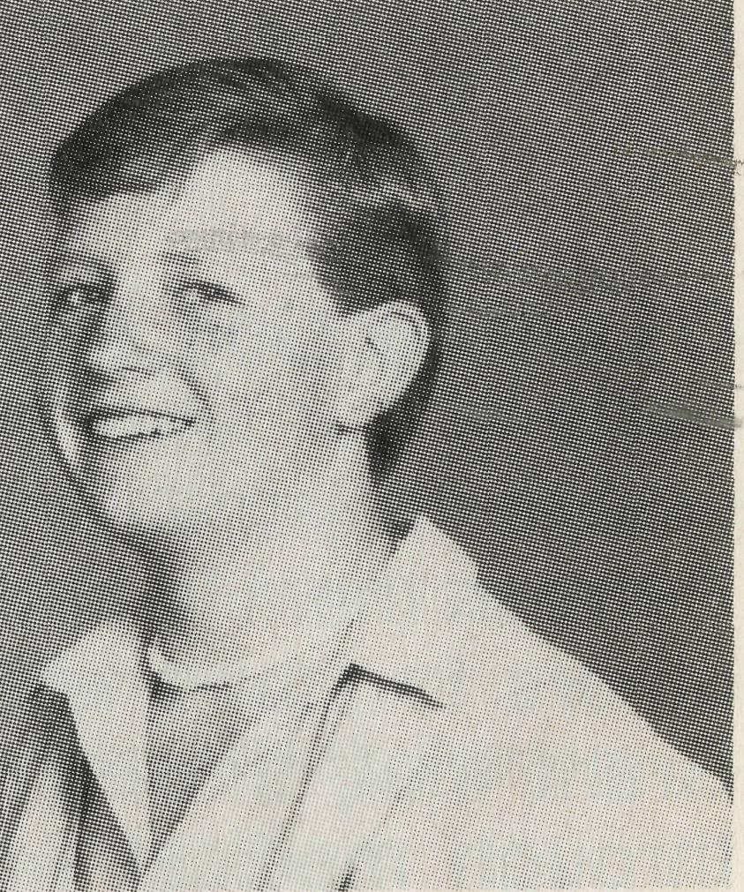
- PPaul works as an assistant manager at Wool-worths in Derby.
- HHe is very interested in weights training, at the gym every week day.

- .
CChris (15)
Aaron (11)

- In 6th Class at Derby Primary School
- Interests include swimming and piano.

- In 6th Class at Derby Primary School.
- Interests include swimming and piano.

Craig (17)
- Doing Year 12 at Boarding School in Perth.
- Hopes to be a pilot in the Air Force.
- Interests include weights and volley ball.

- DDoing Year 10 at Boarding School in Perth.
- IInterests include volley ball and music. Chris is a drummer: part of the school band and writes his own songs.

