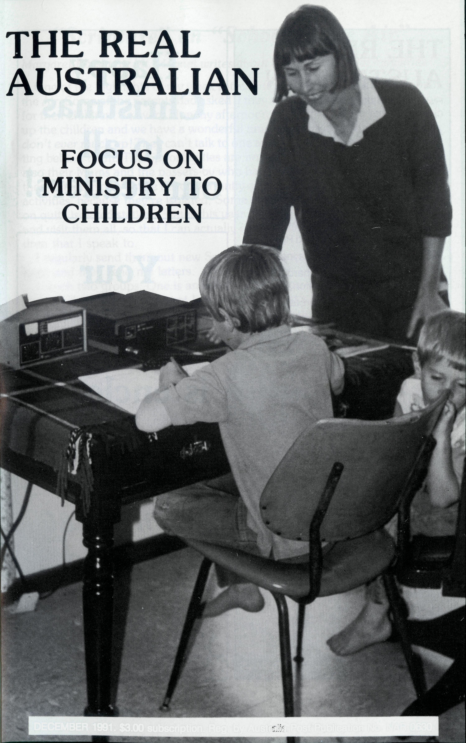
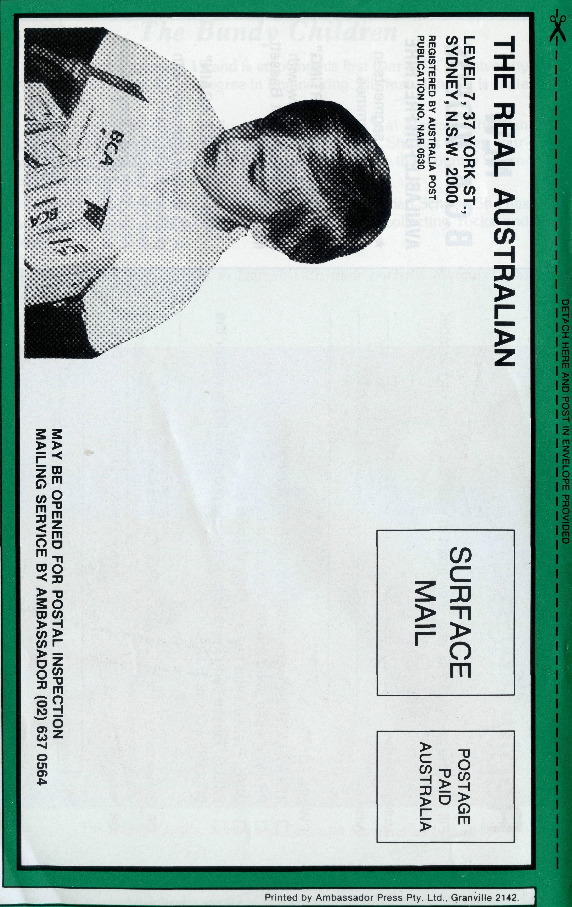
DECEMBER 1991. $3.00 subscription. Reg. by Australia Post Publication No. NAR 0630

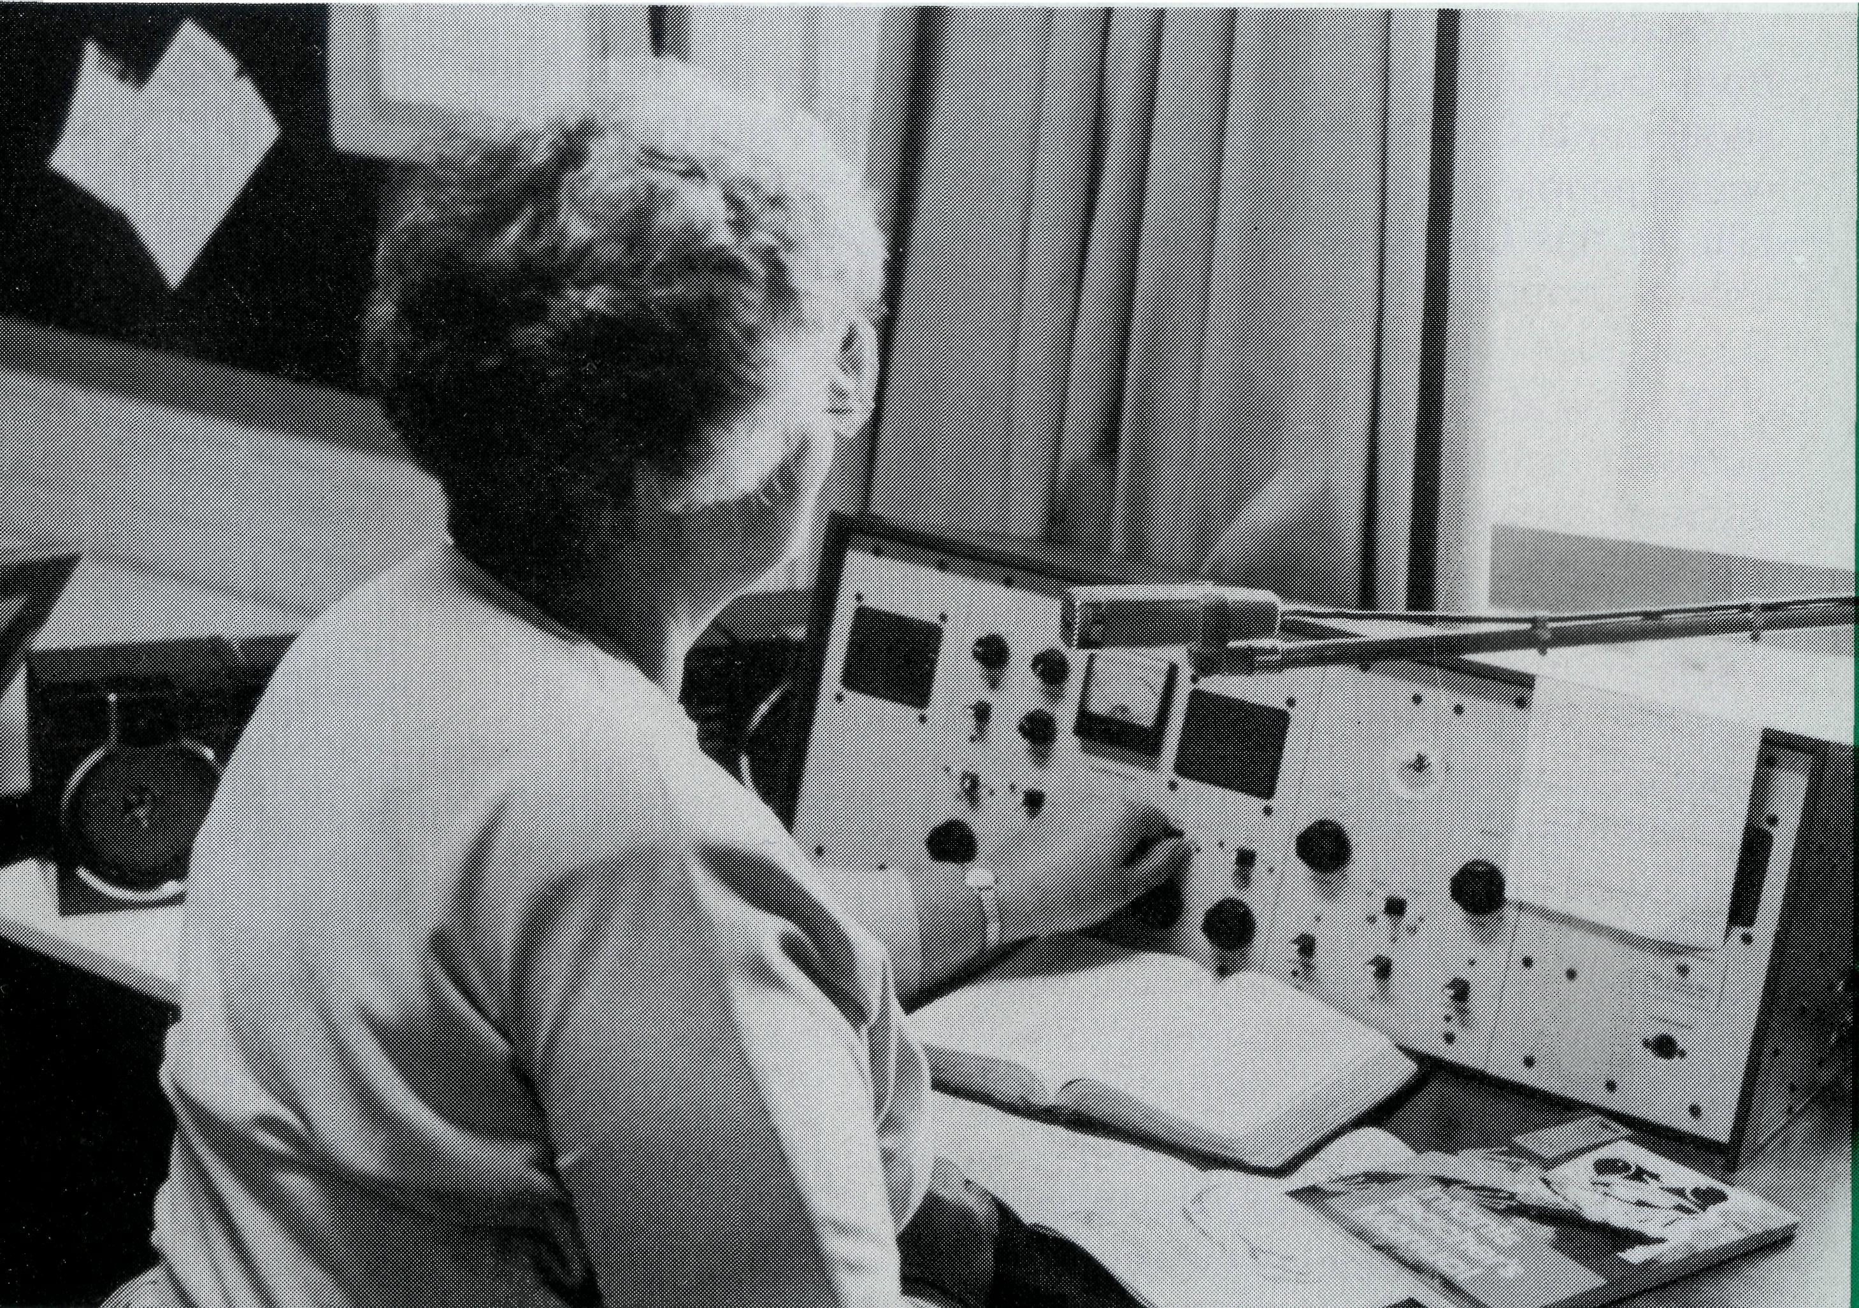
THE REAL AUSTRALIAN
First published 1920. Edition No. 274 Circulation: 26,000
All enquiries to:
THE EDITOR
David Mulready
THE BUSH CHURCH AID SOCIETY
OF AUSTRALIA
LEVEL 7, 37 YORK STREET,
SYDNEY 2000
Ph (02) 262 5017. Fax (02) 262 5020
President: Archbishop Donald Robinson.
Patron: Archbishop Keith Rayner
Vice-Presidents: Mr. Richard Stokes O.A.M; Mr. Stan Hummerston, O.A.M.
Hon. Treasurer: Mr. R. Ctercteko.
Federal Secretary: Rev. Ernie Carnaby.
N.S.W. Secretary: Rev. David Mulready. Level 7, 37 York Street, Sydney, N.S.W. 2000. (Next to Wynyard Station) Ph (02) 262 5017.
Victorian Secretary: Rev. Brian Viney, Shop 1, 205 Flinders Lane, Melbourne, Vic. 3000. Ph (03) 654 8022.
South Austraiian Secretary: Rev. Bob George, Church Office, 44 Currie Street, Adelaide, S.A. 5000. Ph (08) 212 7804.
Queensland Secretary: Rev. Ernest Horth, P.O. Box 6472, Upper Mt. Gravatt, Old. 4122. Ph (07) 349 9081.
Western Australia Hon. Secretary: Rev. Peter Brain, 27 Leach Street, Wanneroo, W.A. 6065. Ph (09) 405 1325.
FRONT COVER:
Receiving "Scripture" by School of the Air is Jeremy Thurkle with his Mum, Rebecca and Jeremy's little brother.
BACK COVER:
Children give towards our work too!
Happy Christmas
to all our readers!
Your
1992
Calendar
is enclosed
Use
a magnet
to hold
it on
your fridge!
"Scripture" on "School of the Air"
Margaret Bassett ofMt. Magnet writes about one of her special ministries . .
One of the highlights of my week is teaching "Scripture" on The School of the Air. Some of the parents had asked if they could have religious instruction for their children. So every Monday afternoon I sit in front of my radio and call up the children and we have a wonderful time. On School of the Air children don't ever muck up /They can't talk to one another and they all have Mum sitting behind them. The opportunities are not just to speak to the children but also their Mums and the passers-by who have radios in their cars. Of course, these children don't have the opportunity of joining in Sunday School or other activities, because they're isolated. Some of them are as far as 600 km away on quite isolated stations. Later this year Philip and I are going to go around and visit them all, so that I can actually get to meet the faces behind the children that I speak to.
I regularly send them out new Scripture Books with a letter. They're very keen and they send me letters.
I teach two groups: One is an infants school age, and the second group is 3rd to 6th class. We've learnt lots of songs and it's wonderful listening to a whole lot of children who can't hear one another singing the same song at the one time. It's quite a gabble. Their Mums often come on at the end of the lesson and tell me how much they and their children enjoy it.

THE REAL AUSTRALIAN

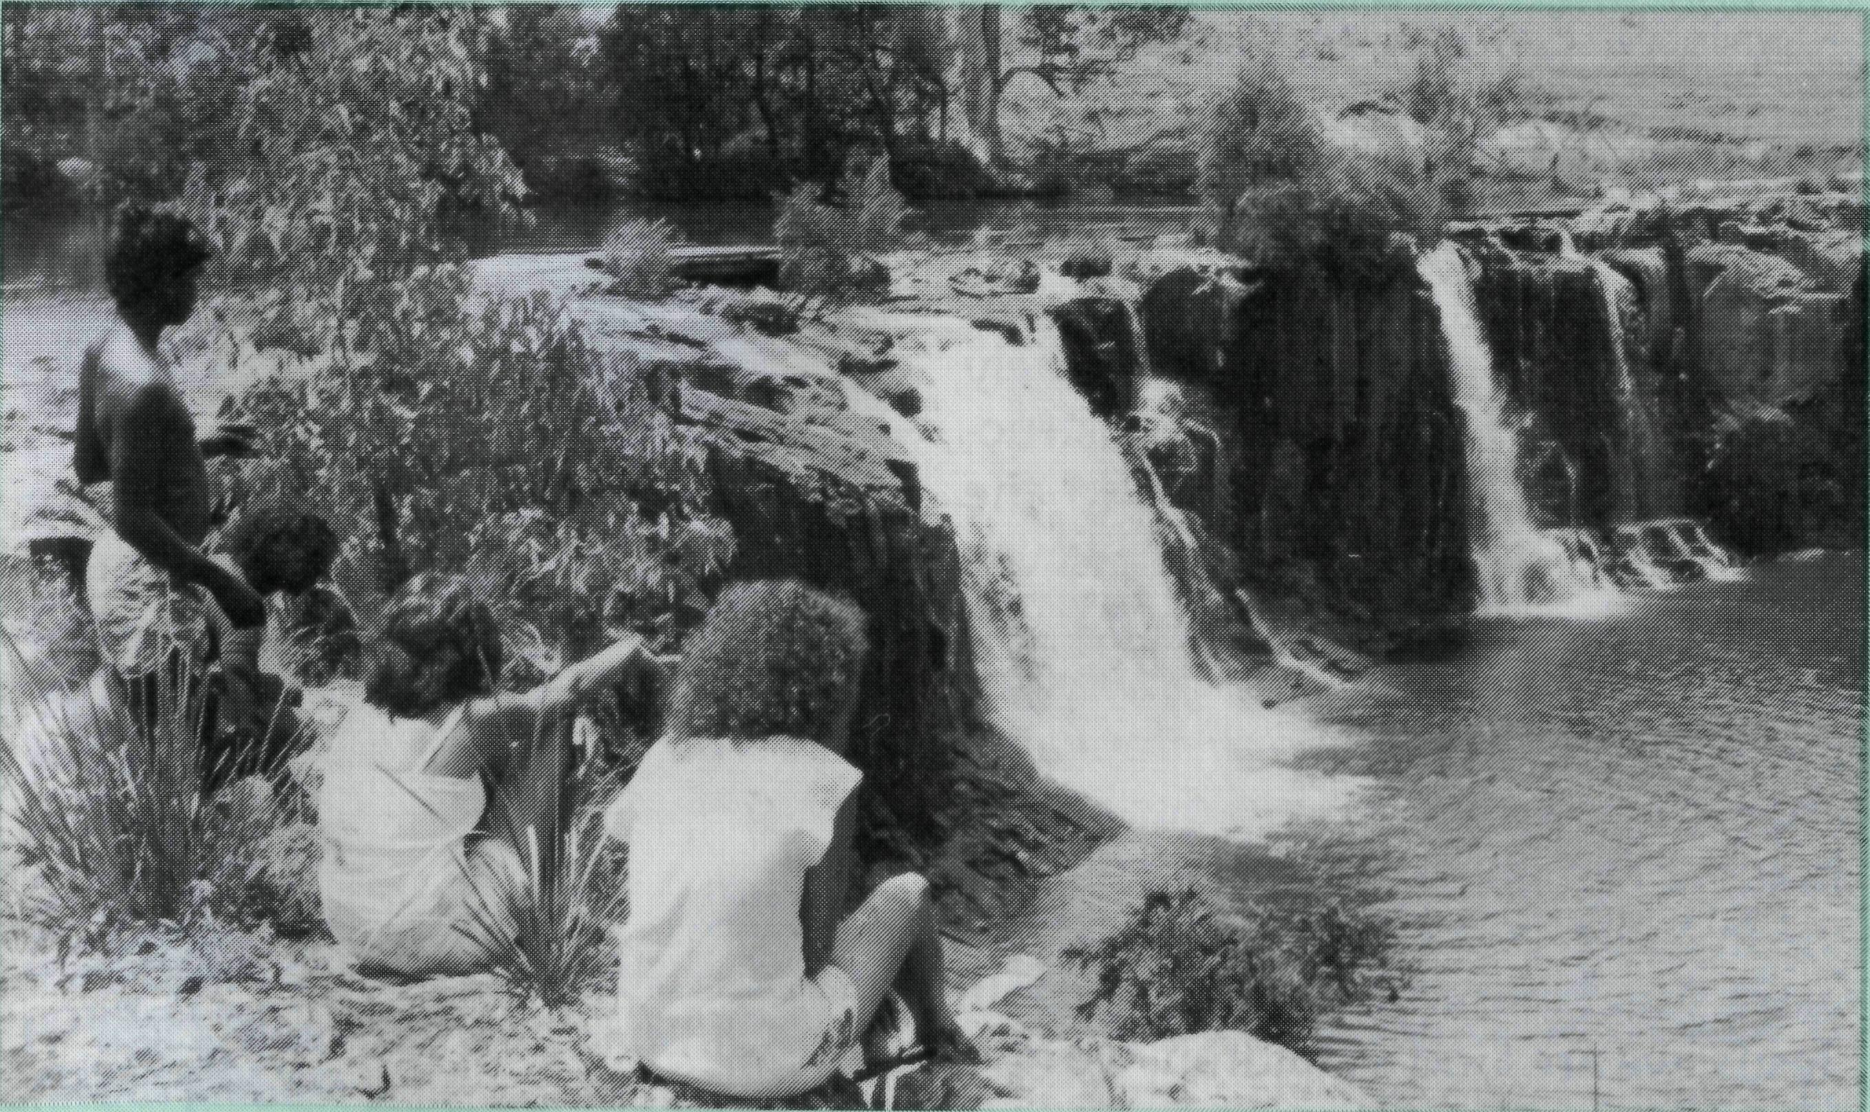
Reaching Children of the Upper Clarence
Picnic at Tooloom Falls near Urbenville.
"Who is not weak?"
Life is so fragile in the lucky country!
On the land drought and flood have deeply affected rural communities. None more so than Nyngan in central N.S.W. This combined with farm debts, high interest rates, depressed prices for wool and wheat, have caused much hardship for rural families. A potential new ministry is opening up for the Society as we offer spiritual and emotional support for those suffering from severe economic difficulties.
Across Australia, unemployment queues lengthen as nearly 10% are out of work. Those most affected are in the 15-19 age group. Thousands of public service jobs are disappearing. There are urgent calls for emergency accommodation, food and clothing. The Care Group at St. James' Sanderson is providing practical assistance for needy people in the Darwin area.
Because of the recession more families from outlying properties are enquiring about our B.C.A. Hostel which caters for young people attending school in Broken Hill. In this Christian home, fees cover only a proportion of total costs, while B.C.A. supporters meet the rest.
There is also a crisis in family life and personal relationships, particularly in outback areas and mining towns. Isolation from extended family support brings added stress in times of crisis. Finding a resolution for marital difficulties and relationship problems is hard when professional Christian help is often unavailable. To meet this critical need B.C.A. has funded a part-time Christian counsellor to work in the Pilbara towns of Karratha and Dampier, and next year a full-time counsellor for Darwin to work with "Anglicare": a ministry to hurting families and fractured relationships.
In many rural dioceses the Anglican Church lacks resources of manpower and finance to maintain adequate ministries.
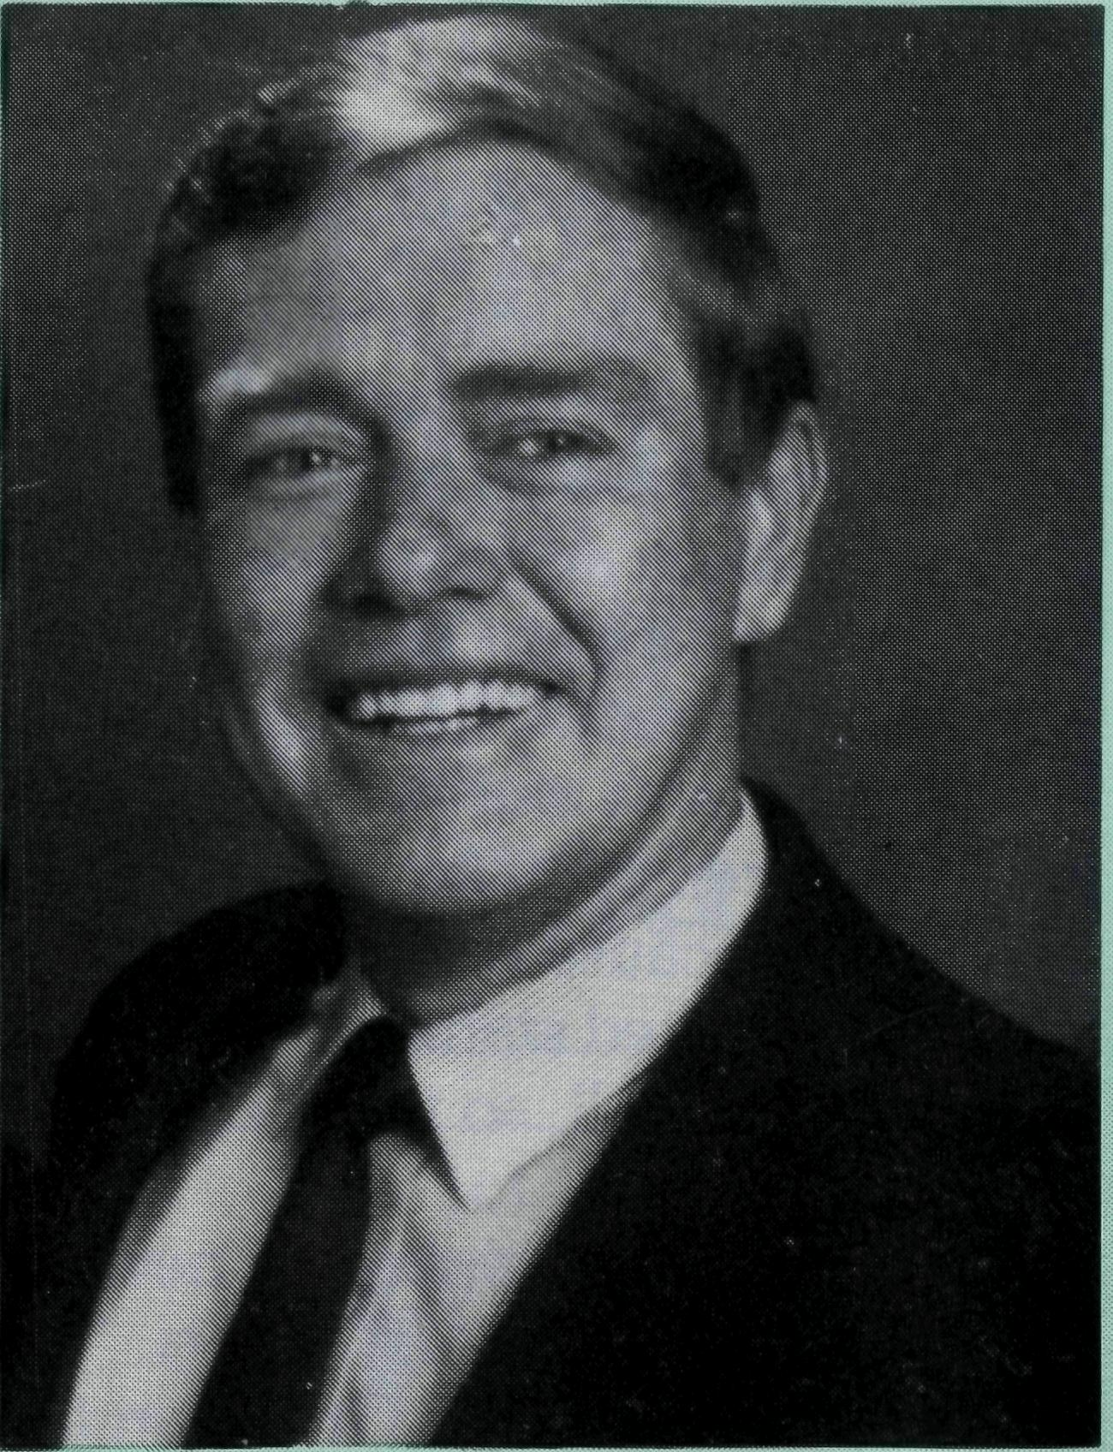
Bishop Ged Muston, recently retired, says "in the North West... the church is a fragile body. If six families left, a North West parish could look very frail.
In the parish of Wilcannia covering one-eighth of N.S.W., Bob Collie is the only resident clergyman of any demonination. Bob and Phyllis visited all 300 station properties of the region over the last five years.
B.C.A. staffs two isolated hospitals at Cook and Tarcoola. Our five dedicated nurses are the front line health professionals and carers for these railway communities.
Without B.C.A.'s assistance in the provision of bush clergy, registered nurses for remote areas, hostel parents, youth workers and trained counsellors, people living in remote Australia would be further disadvantaged.
St. Paul wrote this to the Corinthians: "To be sure we are weak and fragile but we live by God's power in serving you". [2 Cor. 12]
ERNIE CARNABY
At the time of writing, children from the Bonalbo Central School (Kinder to Year 12) are pouring out of the school next door to the Rectory, a good short-cut to the shop on our other side! There are some black faces among the white, but in the Central School at Woodenbong, 50 km away, and in the Primary School at Tabulam, 30 km distant, there are many more Aboriginal children.
Religious instruction is taken in all seven schools in our area by clergy and lay folk. Children are taught in their own classes — no dividing up into denominations — with an agreed syllabus using "Christian Education Publications". This excellent material, provided by our Guilds, the Uniting and R.C. Churches, challenges the children to apply the Scriptures to their own lives and experience.
The children are responding well. They love the bookmarks, stickers,
and certificates which give an added incentive, and also a verse of Scripture as a bonus. I help with classes in four of the schools. I especially enjoy Year 4 at Woodenbong which I share with the Uniting Church pastor (one-third of this class is Aboriginal). It is great to have contact with the children in this way.
I would like to start Kids Clubs in each of the centres of our Parish when leaders are found to help. It is not possible to have a Parish Youth Group as children are so scattered. Some of the children had the chance to go to the Diocesan Camps in October at Ballina.
Please pray that these young people will come to know Jesus as their Lord, and then be willing to share His love with others.
Dick and Pat Freeman have been serving in the Parish of the Upper Clarence since 1989.

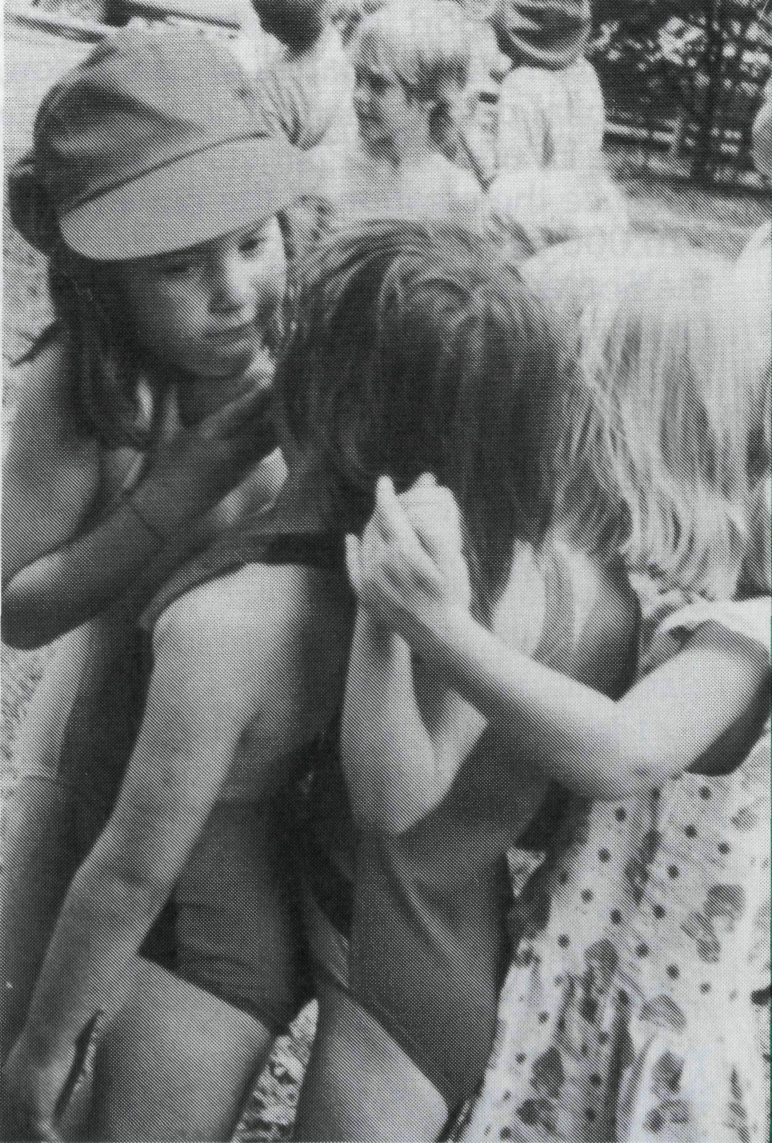
As I said . . . sacred and secular often touch here. We are always in contact with the fringe. Religious instruction has been a big factor in the outward direction of St. Luke's.
One incident stands out for me: while jogging during the school holidays a young boy asked me if R.I. was recommencing soon. It was the way he asked that got to me. With a gravelly voice, like the singer Joe Cocker, he said ... "Hey, Mr. Bundy, you still got religion?"
RON BUNDY
Ron and Margaret Bundy have served in the Palmerston Parish since December 1985.
Sr. Christina and Brenton Light (11 years) following a Bible reading together at Sunday School.
St. Luke's children on a Sunday School picnic.
Children of Tarcoola
Mark leapt off the pinball machine. Automatically I caught him. Black meets white, children do not discriminate. Love is freely given, no holds barred.
Two weeks later in R.I. class Mark and three others tried to disrupt the lesson. Mark would not be removed from the class, not even by the Headmaster! Threat and persuasion were of no use. I gently touched his knee and said "Mark, I love having you here with us, you can come back again next time, but today you need to accept the punishment." Eyes met eyes, understanding that I cared flashed out from within him. Slowly he left the room.
Two lovely sets of white teeth shone at me from the dark verandah, voices piped up, "Excuse me Sr. Christina, we've come to visit you." A delighted Shannan and Mark passed through the "Private Staff Only" door and into the lounge room. Besides fun chatter, they politely helped me eat half a bar of chocolate, then they spirited themselves off home to await their parents' return.
The junior primaries sat attentively listening to the Bible story. Instructions were given as regards to the work sheet. Tony piped up, "Excuse me Sr. Christina, can we pray?" A chastened Sister read the prayer for the lesson and the children repeated after me "Thank you God our Father that we can be your friends by trusting in Jesus." Children clutching their work sheet murmured, "we believe in Jesus, we are God's children, we love Him".
Lulu, Kylie, and Jacinda, sat together on the clinic bed and produced their bruises and scratches for a dab of Bettadine and a bandaid. They then proceeded to chatter about their day. Then as quick as a wink they leapt off the bed and asked to take Ben (Sr. Mary-Grace's dog) for a walk. One hour later three dust-covered girls clutching wild flowers and one still active Ben returned.
The strip of land between the hospital and the school is covered with wild flowers. The girls depositing some of these delightful sprays in my hands brought the analogy to my mind that they, the children of Tarcoola are so like these desert blooms. These sometimes tough and independent no-nonsense children, with the rain of love and care bring forth a lovely bloom.
Sr. Christina Ryman
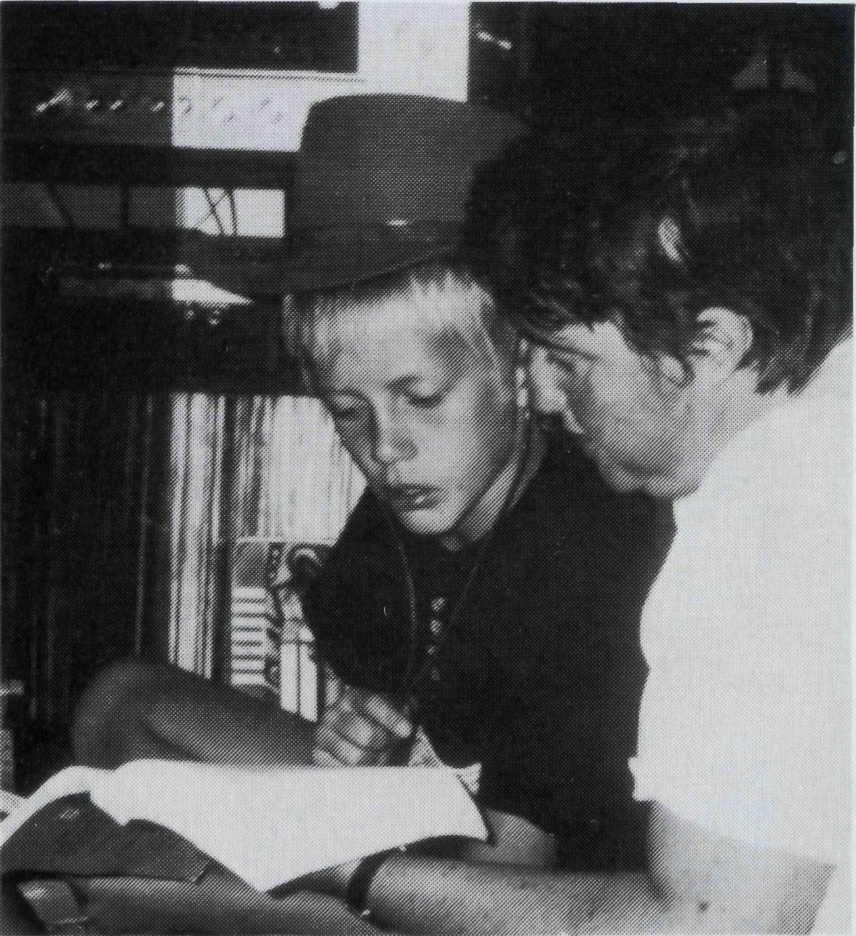
Sisters Christina and Mary-Grace serve the Lord together at Tarcoola Hospital. Pray for them in their contact with children.
"God and Gravel. . . or . . . Sacred and Secular
I was spreading gravel on the edge of our new car park. Six-year-old David approached and said "What are you doing? Why do you keep moving the truck? Can I help?" In the midst of the dust and the sweat he asked, "Mr. Bundy . . . where does God live?" I was tempted to answer "No. 9 Priest Circuit," but I restrained myself. What followed was a brief discussion about God, about how He knows and sees everything. We continued to shift gravel.
Here is an example of one of the things that I love about ministry to children (and adults) in Palmerston. It is "earthed" in daily life . . . the sacred and secular often touch.
The contact with young David, along with 800 other primary school children, comes from regular religious instruction in the three State schools. "R.I." was started in Palmerston back in 1983 by Lynne Bigg, who was one of the founding members of St. Luke's. I believe that "R.I." beats all other forms of children's ministry by miles.
No matter what kind of kid's programme a church runs (and we have one) — we won't reach the 80% that R.I. does. It means that every week a team, including ten people from St. Luke's, bring relevant Bible teaching to 10% of Palmerston's entire population. Different methods are used including: singing, reading, drama, story telling and videos.
There are many "spin offs" such as contact with teachers and parents ... especially when their kids yell out to you at the shops or at the local pool.

From Bishop Clyde Wood of the Northern Territory
From Bishop Ged Muston of North West Australia

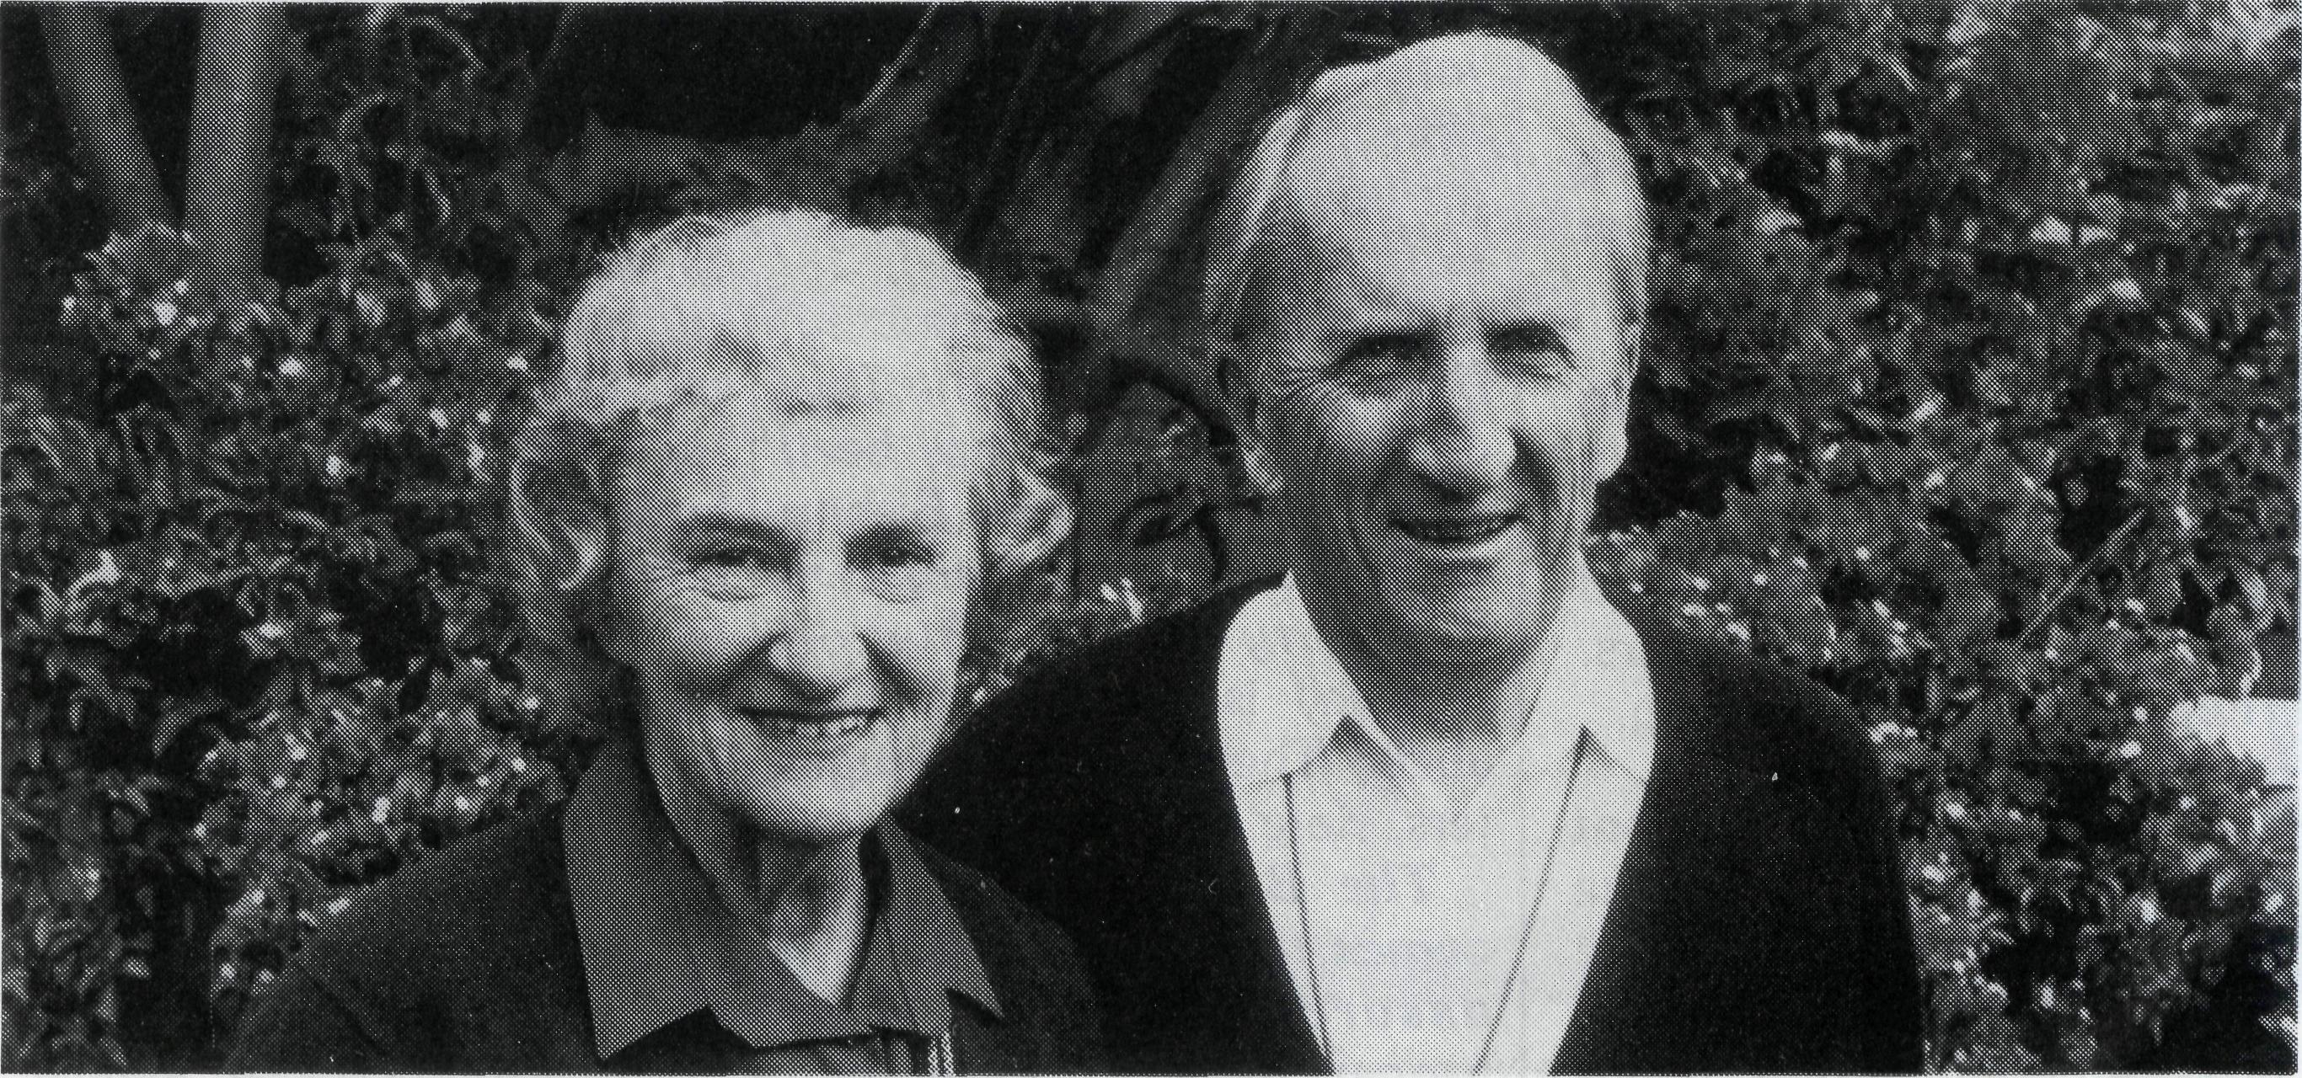
Dear Friends,
Luke 1:38 tells us that "Mary said, 'Behold I am the handmaid of the Lord; let it be to me according to your word.'" It may not often be the case that B.C.A. would see its reason for being to be bound up in those words of Mary to the Archangel Gabriel! However, the task of B.C.A. is to be an agent of enabling the word of God to be made known throughout Australia. It does this primarily as a "handmaid" of the Dioceses of the Australian Church.
The Diocese of the Northern Territory was created in 1968 as a "Missionary Diocese", "missionary" in this context in primarily financial terms, needing support from the church beyond its own boundaries.
The Diocese of the Northern Territory has an ongoing tension between its awareness of the form of the church that is suitable for its outback and rapidly growing areas and at the same time the need to be aware that a really healthy mission church is self supporting, self propagating and self managing.
In such a context there is always a need for what one might call "seed money", the opportunity to get things started so that a local response may be generated. B.C.A. has provided seed money for the Diocese and has continued to provide ongoing support for programmes in the process of consolidation. During the last decade B.C.A. has provided support for ministry in the parish of St. Peter's, Nightcliff. Full provision for the ministry for the parish of Sanderson, as well as in that case financial undergirding for capital development. The Society has provided ministry support at Alyangula on Groote Eylandt. For Palmerston it has provided the full costs of the provision of ministry since the creation of the parish in 1985. Since 1987 it has provided a subsidy of $16,000 per year to make ministry possible in the town of Tennant Creek. In Darwin the Society has provided most of the financial support needed for the Registrar of the Diocese, and has made substantial contribution to the administration of Nungalinya College.
The really important thing that comes from all this is the impact that the Society has therefore had on the lives of a very large number of people scattered over a vast area in the Northern Territory. Many people have heard of the good news of Jesus Christ probably for the first time, and many others have been nurtured in their faith in a way which would not have been possible without the support of the Society.
As I make preparation to leave the Diocese, it is good to have this opportunity to place before members of B.C.A., Australia wide, my deep appreciation for their support in prayer, in finance and fellowship in the body of Christ.
My thanks to members of staff of B.C.A., especially the Rev. Ernie Carnaby, but to all those who have worked with him to make my job just that much easier and yet at the same time more exciting.
Every blessing to all who may read this.
Yours in Christ,
BISHOP CLYDE WOOD
Bishop Wood is moving to the Diocese of Brisbane as the Regional Bishop responsible for the Western Area, including the B.C.A. supported Parish of Quilpie. The B.C.A. family thanks God for his ministry in theN.T. and looks forward to an ongoing link in his new ministry.
I first heard of B.C.A. as a youngster in my home parish. I can still remember the vivid word pictures conveyed by Tom Hughes, David Livingstone, Reg Langshaw and others. I am grateful to God that life has kept me in frequent touch with this great society.
So for me one of the highlights of this past ten years in the North West has been the partnership we have had with B.C.A. The Society's name tells the story of that partnership.
B.C.A. is a CHURCH society. It is committed to encouraging "those gifts which build up the church". The link with the North West has been a maturing partnership which recognised the dangers of paternalism and encouraged the growth of responsibility in the local church. And it is a committed Anglican society, believing God has a great work to do through the special gifts of our communion.
B.C.A. is committed to the BUSH. It has always known of the special opportunities there are in remote places to bring the Gospel to people and strengthen the church in its witness. And it has certainly brought AID to the church there, without reserve.
Above all it is a SOCIETY, a fellowship of real people who have loved us and prayed for us and cared for us consistently over those years. The Diocese of the North West thanks God for B.C.A., and so do I.
Bishop Ged and Mrs. Laurel Muston.
Bishop Muston has retired from the leadership of the Diocese of North West Australia after 10 years in that role. He and Mrs. Muston now live in Perth. The B.C.A. family thanks God for their Ministry and wishes them a long and happy retirement.

POST & RAILS

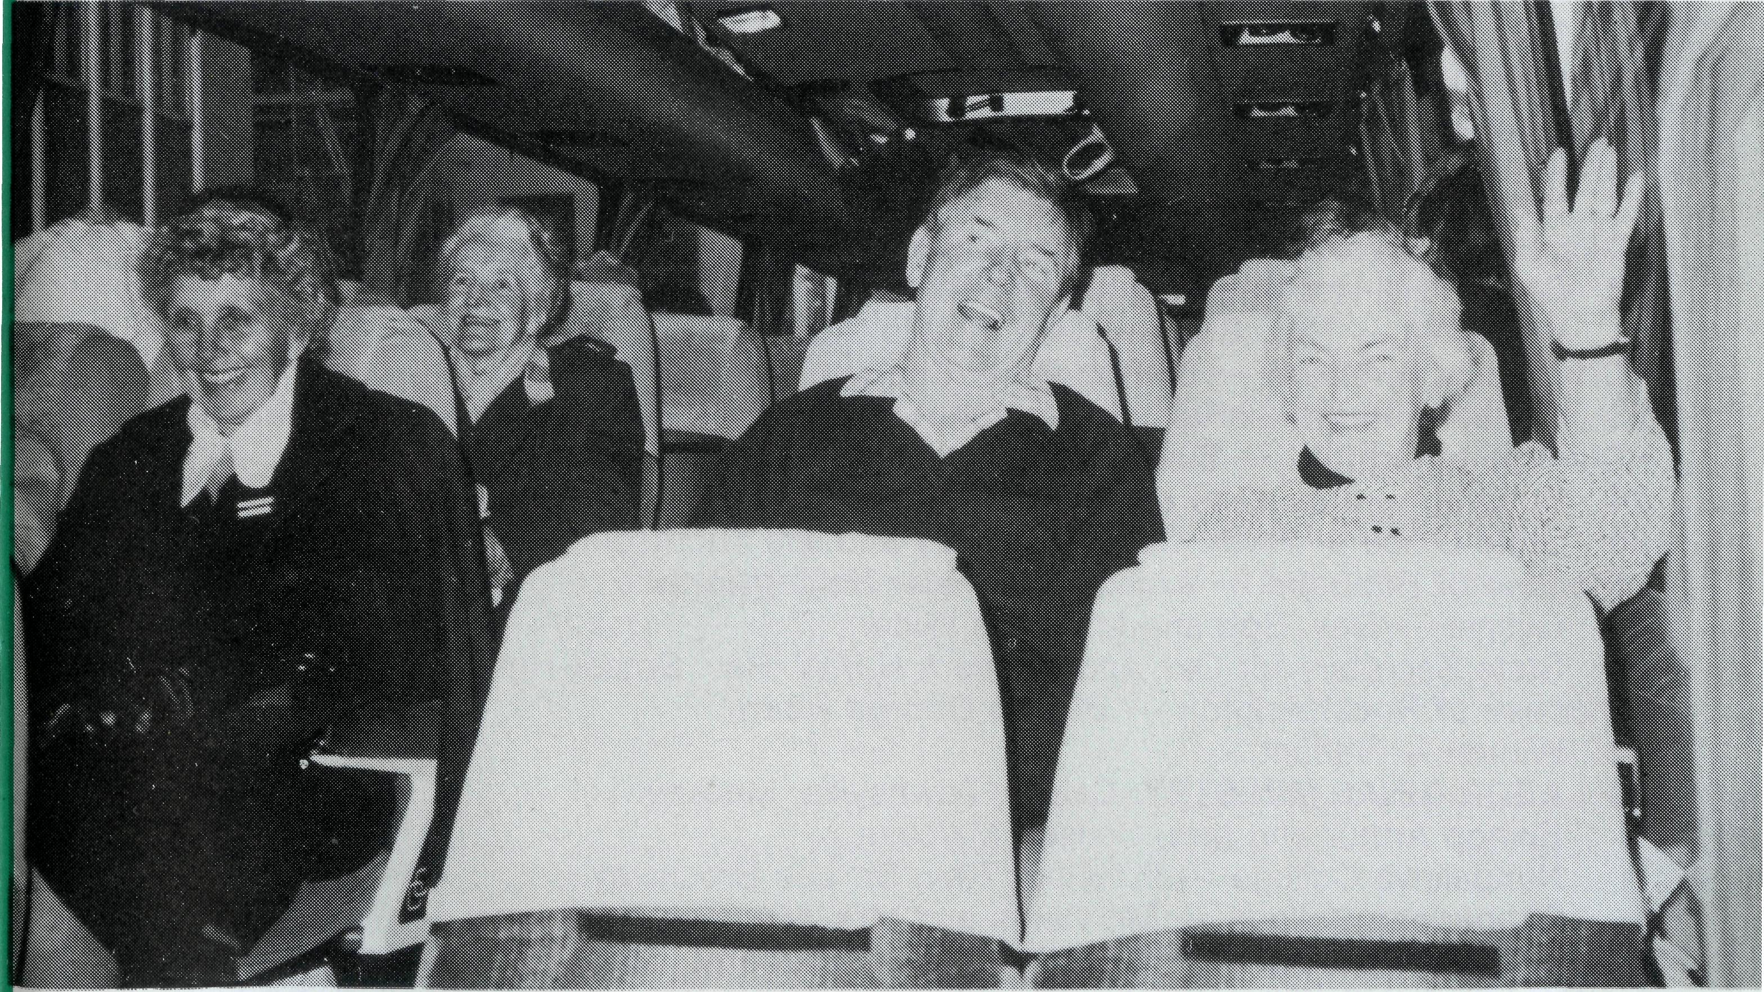
FAREWELL!
We seem to be saying goodbye to a number of Held Staff at the moment!
We praise God for their contribution over their years of service with B.C.A. and pray for God's blessing upon their future ministry.
Lex and Rhonda Carey
moved from Winton in November after nearly four years. Lex is now the Rector of Sarina in North Queensland.
Simon and Susan Heath
moved from the Hostel at Broken Hill early in October after 18 months. They've returned to Melbourne.
Susan Green will leave Cook Hospital in December after two and a half years nursing on the "transline". Susan is returning to Sydney for further study.
Colin and Ruth Nelson will leave Roxby Downs in December after nearly four and a half years. Colin has been appointed Rector of Lang Lang in the Diocese of Gippsland.
Enrol and Anne Sorenson
will retire from Omeo in December after three and a half years. In all they've served with B.C.A. for 10 years. They're retiring to Geelong.
Murray and Jane Lamont
will move back to Melbourne in December after nearly five years in Kununurra. Murray has been appointed as Rector of Langwarrin.
Cliff and Megan Ainsworth will leave Lightning Ridge in January after a seven-year ministry. Cliff has been appointed as a Part Time Assistant Minister in the Sydney parish of Eastwood. He will spend the other half of each week doing further study at Moore College.
WELCOME!
We are glad to welcome to our fellowship The Reverend Norm and Mrs. Leonie Fagg and their two children, Iain (7) and Catriona (5). Norman has been appointed to Omeo from February 1992. The Faggs have served in the Sydney parishes of Sans Souci, Lalor Park and Berkeley.
The Rev. Tony Nichols of Melbourne has been elected to be the new Bishop of the Diocese of North West Australia. He will take up his new ministry in February 1992. Mr. Nichols is married to Judith. They have four children: Naomi, Elizabeth, Daniel and John. Mr. Nichols is currently Principal of St. Andrew's Hall, the training college for C.M.S. Missionaries.
Bishop Richard Appleby, Assistant Bishop in the Diocese of Newcastle, has been elected to be the new Bishop of the Northern Territory from February 1992. Bishop Appleby is married to Elizabeth. They have two daughters, Kate and Sarah.
The B.C.A. Family welcomes the new leaders and assures them of their prayers as they take on their new roles.
MOVES!
After nearly five years in the Parish of Derby, The Rev. John and Mrs. Dianne Symons will move to Kununurra in late December. Christopher and Craig will continue in boarding school in Perth, Aaron and Martin will move to Kununurra and Paul will remain in Derby.
QUEENSLAND AND
NORTHERN
NEW SOUTH WALES
The Reverend Ernest Horth and his wife Ida had an enjoyable three weeks in the Diocese of North Queensland. The trip was a combination of work and pleasure (tough job this!!). Ernest has reported on the generosity and loving support received, plus the willingness of people to share openly with others their journey of faith with Jesus.
The Queensland Provincial Council of the Anglican Men's Society at its recent Annual Meeting decided to support ministry in the "outback" and other needy areas of this country through B.C.A. They set a target of $4000 for the period of May 1991 to October 1992. By the end of September $1300 had already been received. Great work men!
Many Box Secretaries have been very busy holding special functions to publicise B.C.A., and recruiting new "supporters" to the B.C.A. Family. Well done!
B.C.A. Coach Trip
A few lines from one of the passengers — Kath Marshall.
It was a great privilege to be a member of the coach trip which recently visited our missioners serving at Quilpie, Winton and Lightning Ridge.
We soon reached the Queensland border where we found the red earth, the semi arid conditions and the vast distances between towns. We would travel all day hardly passing a person or place. It made one realise how isolated many of our missioners are and what a sacrifice they make to take the gospel to those living way beyond the "black stump"!
The tour was a very happy one. The Rev. Jim Thomson took the daily devotions, and his wife Maisie led the singing. We were so well looked after, but we had our moments! The coach was stuck for an hour in a hole on a rough road, but no worries. Helping hands soon put things right. We had evenings of fun and games; the skies were cloudless and we had golden sunshine all the way. We saw so much of God's handiwork and our hearts were gladdened by the wonderful work B.C.A. is doing in bringing the love of the Lord Jesus to men and women who live in those outback places.
Be sure to join the next B.C.A. bus tour when you hear of one!
B.C.A. bus tour: Happy on the way. L. to R.: Dyllis Mason, Daphne McLaughlan, Terry and Shirley Thyer.

10
THE REAL AUSTRALIAN
THE REAL AUSTRALIAN
11

PRAY FOR OUR FIELD STAFF
WINNING AUSTRALIA FOR CHRIST

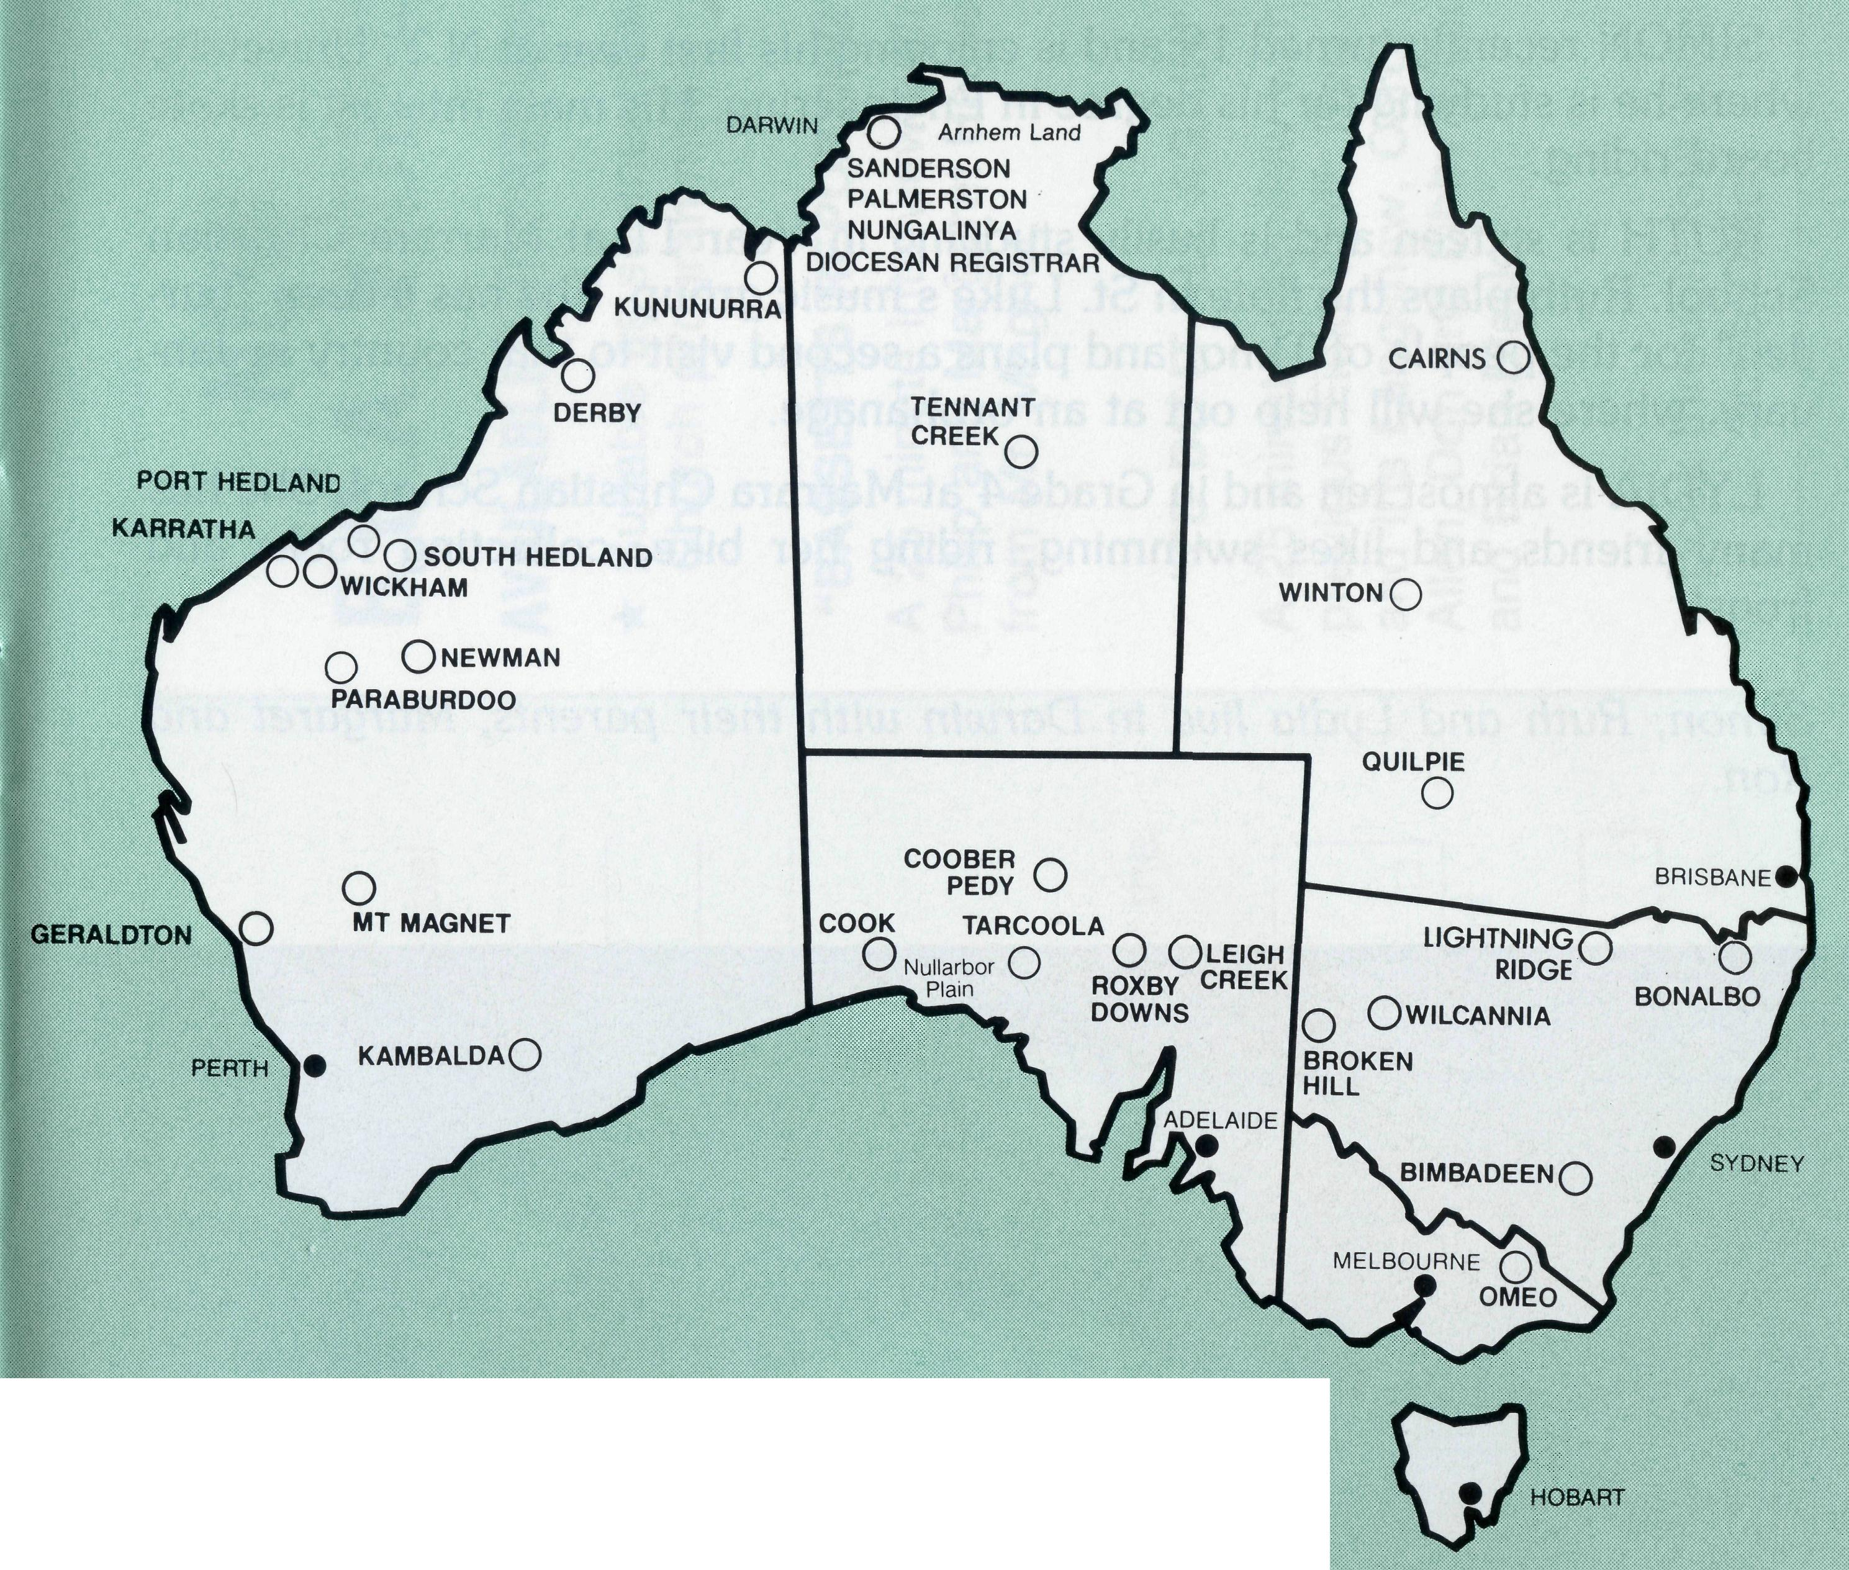
• Diocese of Northern Territory — Bishop Richard Appleby (from February)
- Sanderson — Rev. Greg and Mrs. Kerry Thompson.
- Palmerston — Rev. Ron and Mrs. Margaret Bundy.
- Tennant Creek — Rev. Tim and Mrs. Kerrie Brownscombe.
- Diocesan Secretary/Treasurer — Mr. David Martin.
• Diocese of North West Australia — Bishop Tony Nichols (from February).
- Kununurra — Rev. Murray and Mrs. Jane Lamont (from January: the Symons).
- Derby — Rev. John and Mrs. Dianne Symons (from January: vacant).
- Newman — Rev. Raymond and Mrs. Betty Lou Molyneux.
- Port Hedland — Archdeacon Bill and Mrs. Jennifer Warburton.
- South Hedland — Rev. Ray and Mrs. Lyn Arthur.

- Karratha — Rev. Terry and Mrs. Fiona Redmond.
- Wickham — Rev. Allan and Mrs. Julie Harrison.
- Tom Price/Paraburdoo — Rev. Brian and Mrs. Joy Harding.
- N.W. Australia: Youth Ministry: Catherine Ross; Counselling Ministry.
- Mt. Magnet (Murchison) — Rev. Philip and Mrs Margaret Bassett.
- Diocesan Registrar — Mrs. Kay Winfield in Geraldton. Bluff Point: Rev. Jon and Mrs. Rae Reinertsen (Curate).
• Diocese of Perth — Archbishop Peter Carnley.
16 Kambalda/Norseman — Rev. Ron and Mrs. Colleen Ross.
Hon. B.C.A. Secretary for W.A. — Rev. Peter Brain.
• Diocese of Willochra — Bishop David McCall.
- Coober Pedy — Rev. Ian and Mrs. Robin Robertson.
- Roxby Downs and Mid-West Mission — Rev. Colin and Mrs. Ruth Nelson (from January — vacant).
- Leigh Creek — Rev. Peter and Mrs. Margaret Achurch. State Secretary for S.A. — Rev. Bob George, Mrs. Jo Phillips.
- Cook: Bishop Kirkby Memorial Hospital — Sisters Gai DiDonna, Christina Ryman. Tarcoola Hospital — Sisters Mary-Grace Bingham, Meryl Burden.
• Diocese of Gippsland — Bishop Colin Sheumack.
21 Omeo — Rev. Errol and Mrs. Anne Sorensen (from January: Rev. Norman and Mrs.
Leonie Fagg).
THE B.C.A. PRAYER
State Secretary for Vic. and Tas. — Rev. Brian Viney, Ms. Margo Bright.
• Diocese of Riverina — Bishop Barry Hunter.
22 Broken Hill Hostel — David and Elisabeth Bull.
Wilcannia — Rev. Bob and Mrs. Phyllis Collie.
• Diocese of Armidale — Bishop Peter Chiswell.
23 Lightning Ridge — Rev. Cliff and Mrs. Megan Ainsworth (from January: Vacant).
• Diocese of Grafton — Bishop Bruce Schultz.
- Bonalbo — Rev. Dick and Mrs. Pat Freeman.
- State Office — Revs. David Mulready and Jim Thomson. Mrs. Michele Peacock.
• Diocese of Brisbane — Archbishop Peter Hollingworth.
- Quilpie — Rev. Bob and Mrs. Sue Witten.
- State Secretary for Qld. and northern N.S.W. Rev. Ernest Horth.,
• Diocese of Rockhampton — Bishop George Hearn.
- Winton — Vacant.
- ABORIGINAL MINISTRY: Cairns, Townsville, Mackay: Bishop Arthur and Mrs. Colleen Malcolm. Nungalinya College — Principal: Rev. Dr. Les Brockway. Bimbadeen College — Mr. Denis and Mrs. Maureen Atkinson.
- B.C.A. FEDERAL OFFICE: Rev. Ernie Carnaby, Mr. Jim Gosbee, Mesdames Jacqueline Griffiths, Lay Lee Boughton and Eileen Darbin.
O Lord our God, help us to remember those who live in the remote parts of our land. We ask you to strengthen and encourage all whose ministries are supported by The Bush Church Aid Society. Refresh them in times of discouragement and loneliness and call others to stand with them in the task of making Christ known. Grant that, through the ministry of the Word and Sacraments, through medical work, through service and by caring for the young, the message of your redeeming love may be proclaimed, and accepted by the people throughout our land. We ask these things through Jesus Christ our Lord, who lives and reigns with you and the Holy Spirit, one God, for ever and ever. AMEN.
*lf you'd like more details for prayer, send for our FREE quarterly prayer notes. (See reply page.)

THE REAL AUSTRALIAN
THE REAL AUSTRALIAN

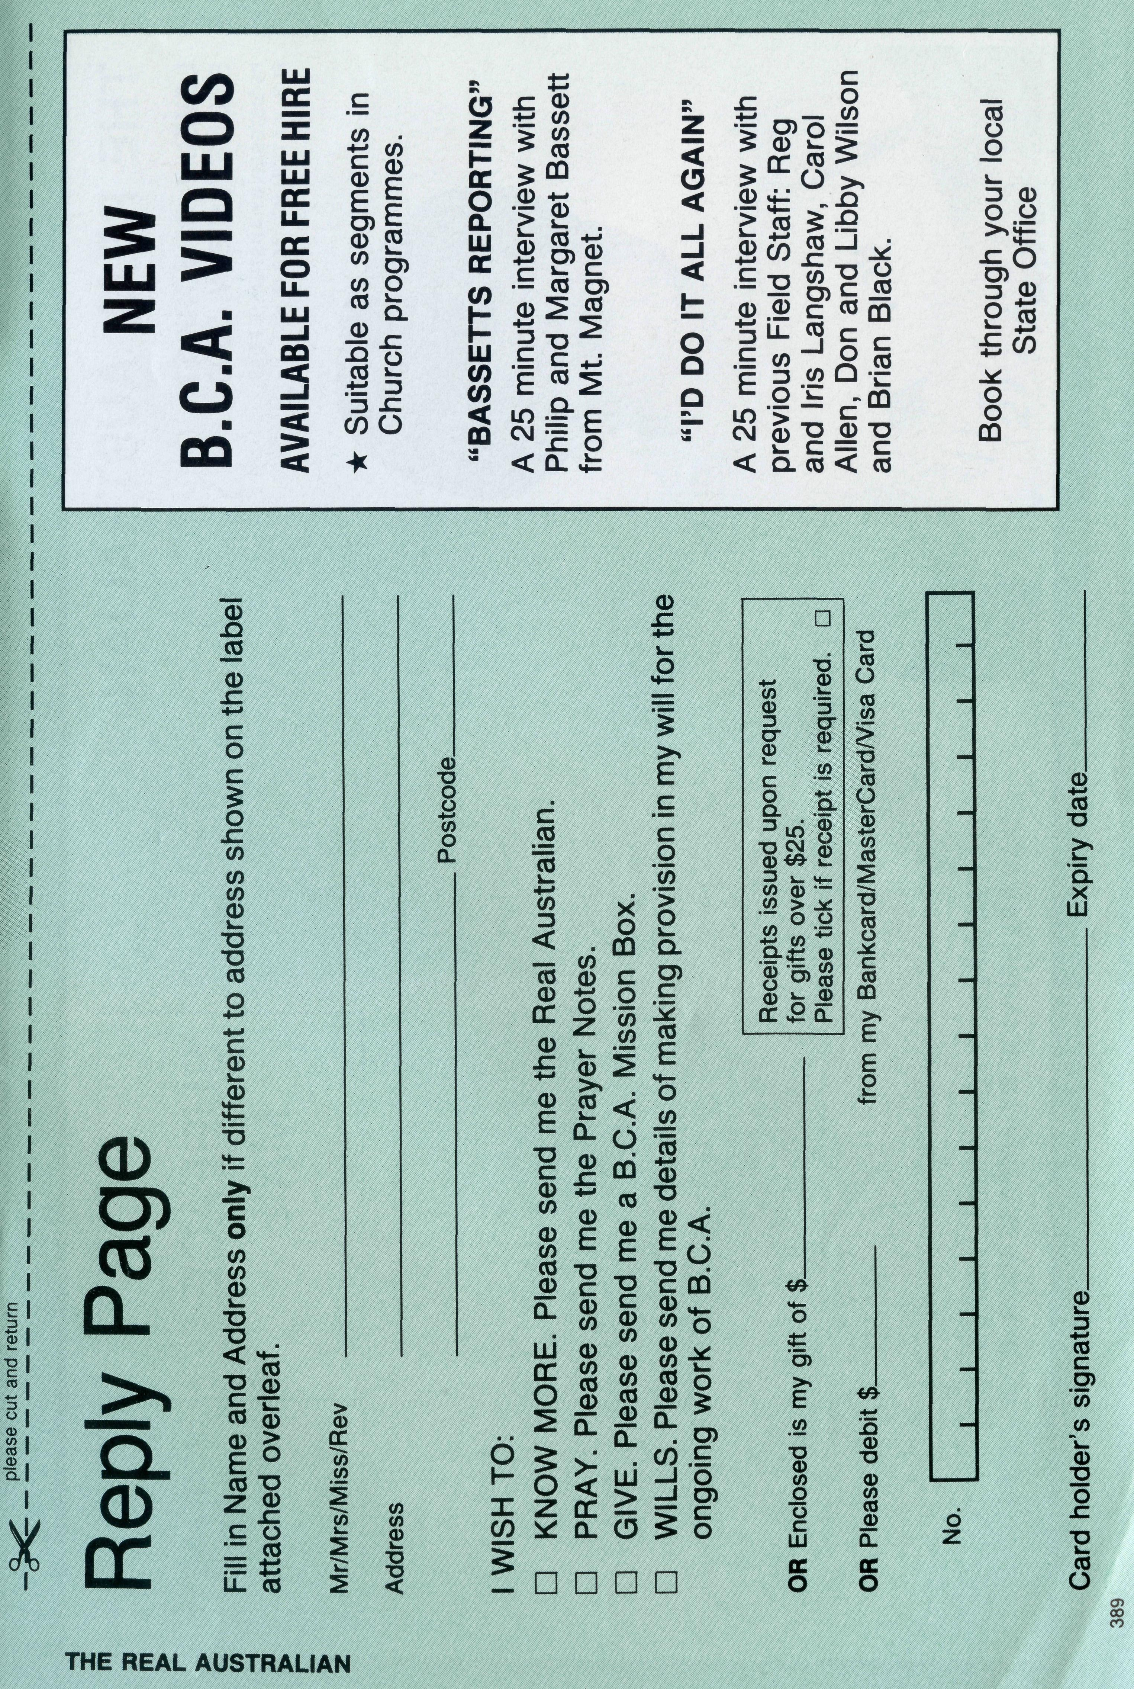
The Bundy Children
SIMON recently turned 19 and is enjoying his first year at NT. University where he is studying for his degree in Engineering. His main interest is skate board riding.
RUTH is sixteen and is busily studying in Year 11 at Marrara Christian School. Ruth plays the flute in St. Luke's music group. She has a deep "burden" for the people of Timor and plans a second visit to that country in January, where she will help out at an orphanage.
LYDIA is almost ten and in Grade 4 at Marrara Christian School. She has many friends and likes swimming, riding her bike, collecting rocks and frogs!
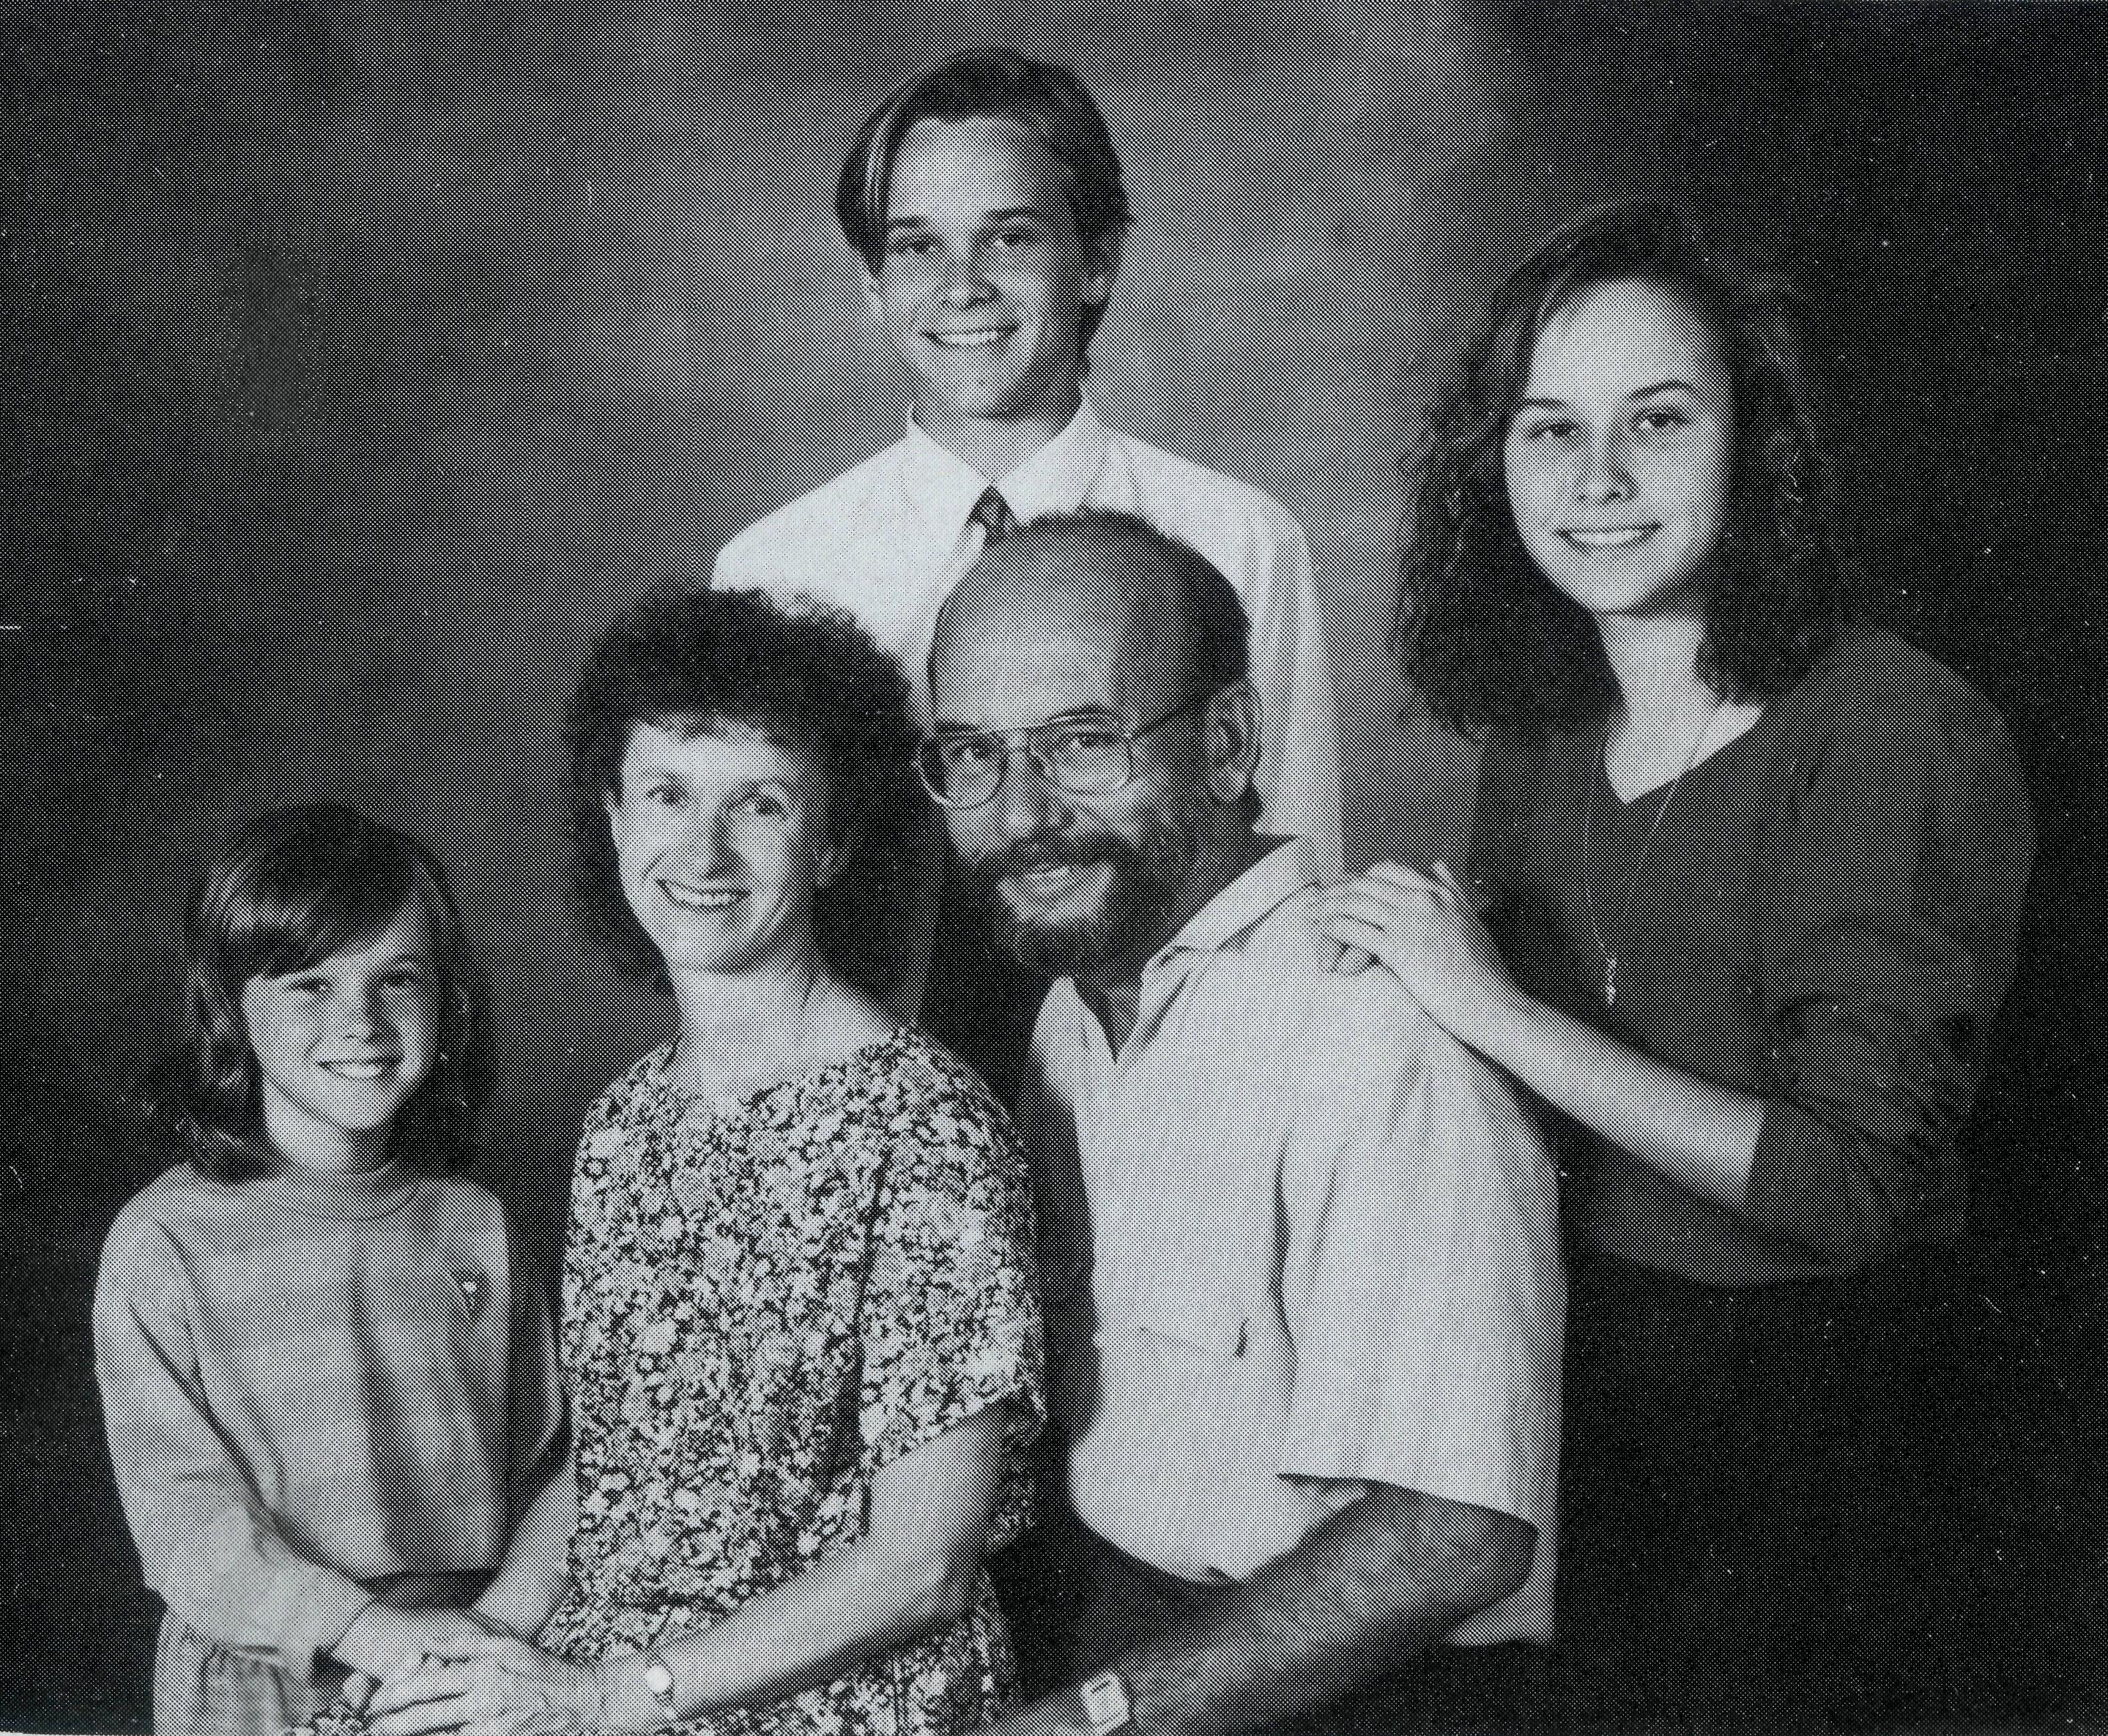
The Bundys: Lydia, Simon and Ruth with Margaret and Ron.
Simon, Ruth and Lydia live in Darwin with their parents, Margaret and Ron.

