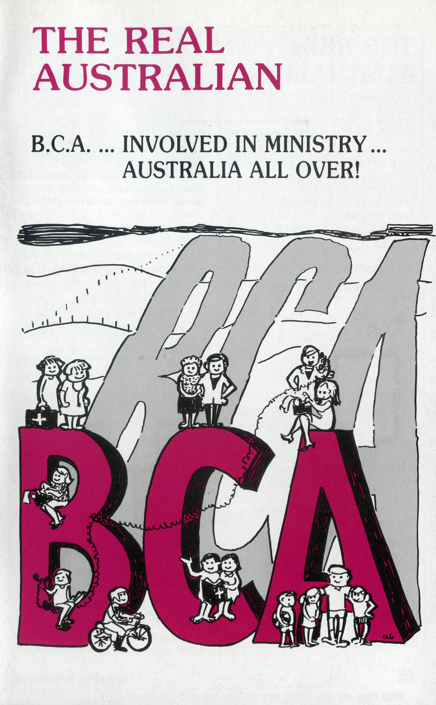
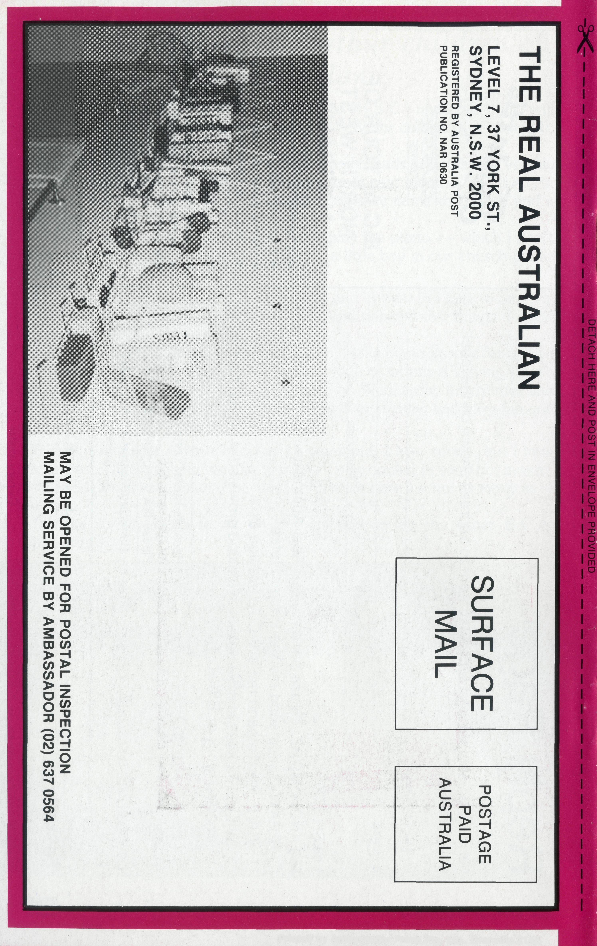
MARCH 1992. $3.00 subscription. Reg. by Australia Post Publication No. NAR 0630
Printed by Ambassador Press Pty. Ltd., Granville 2142.

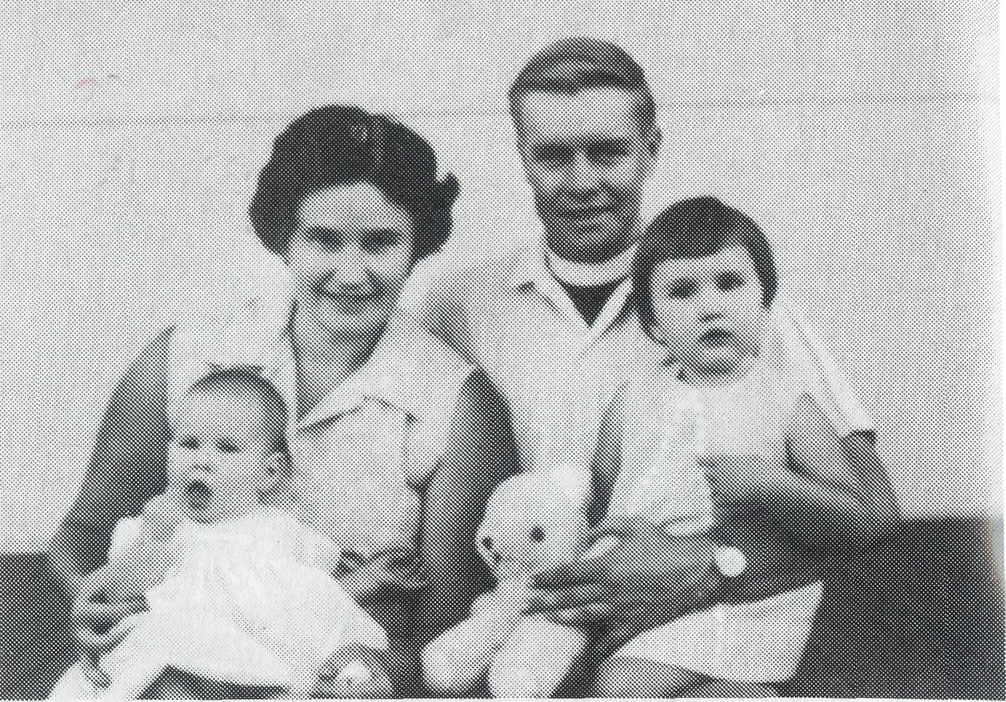
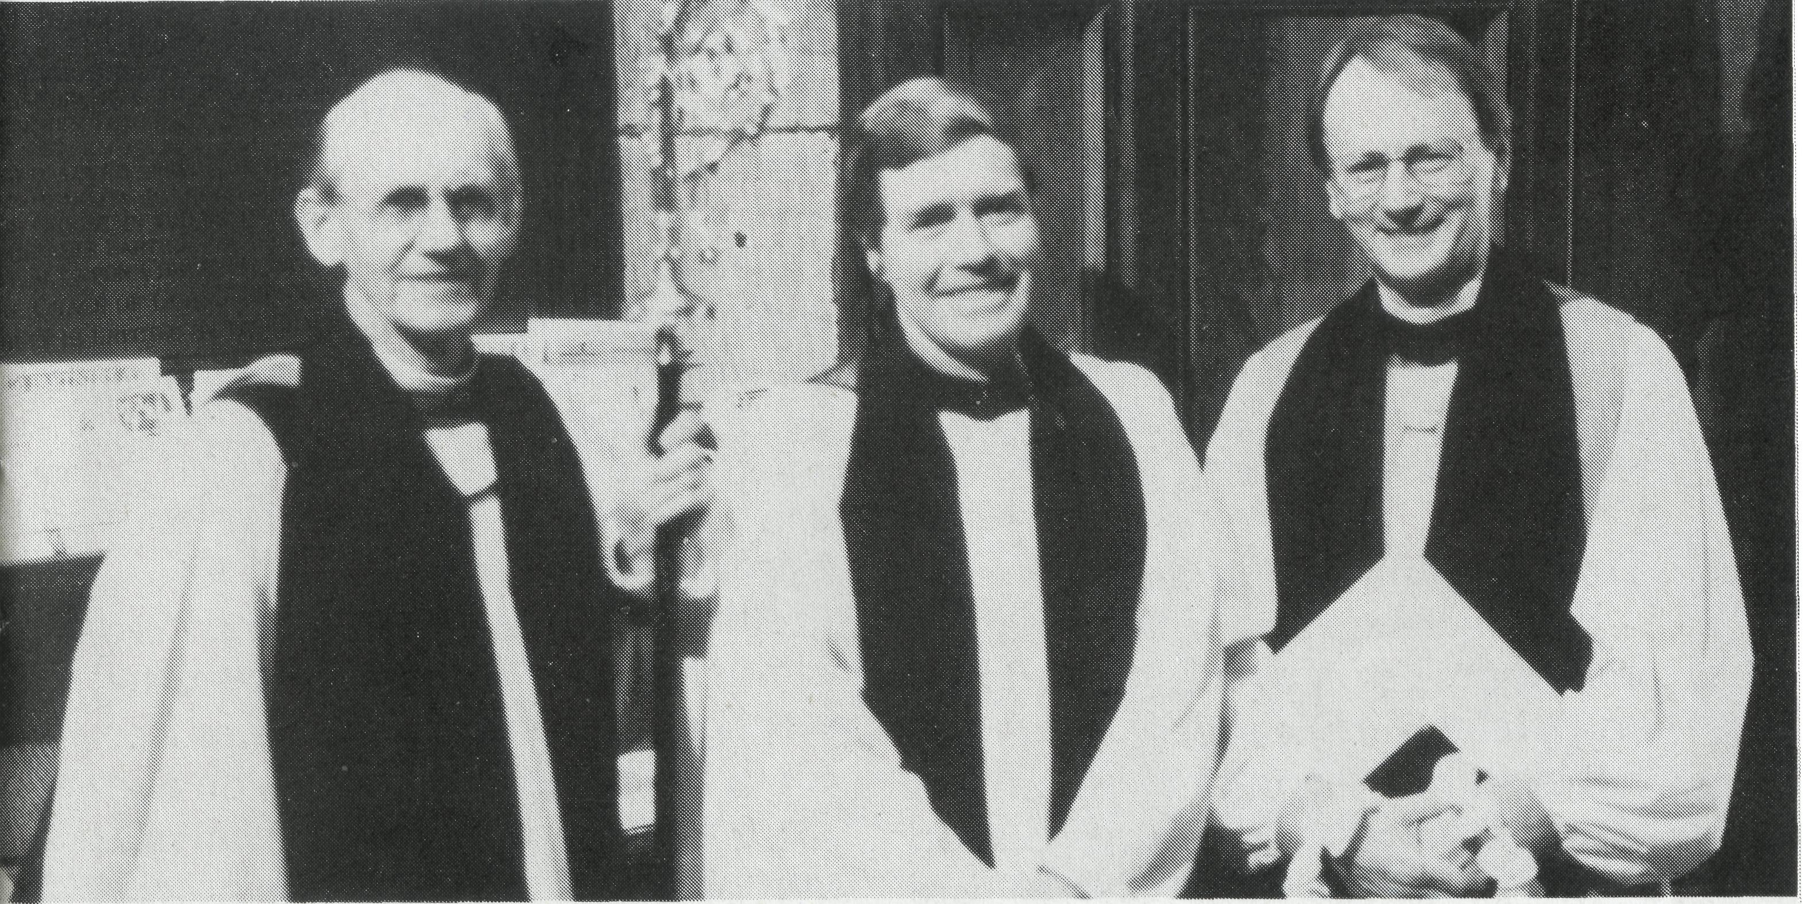
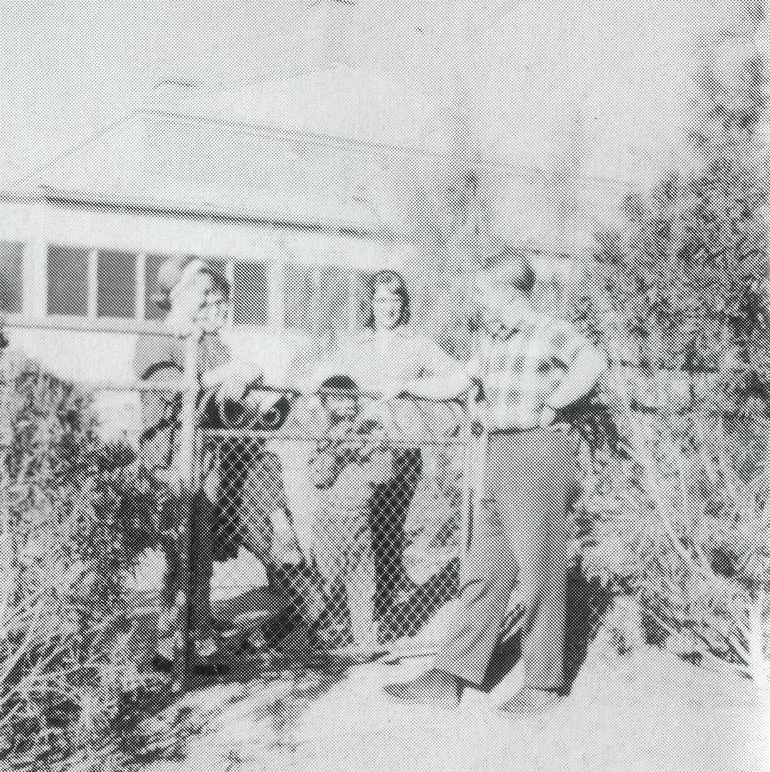
Ernie Carnaby resigns
Photo taken in 1986 at Ernie's commissioning: Archbishop Robinson (President B.C.A.), Ernie, Bishop Goodhew (Chairman B.C.A.).
THE REAL AUSTRALIAN 3
THE REAL AUSTRALIAN
First published 1920. Edition No. 275 Circulation: 27,000
All enquiries to:
THE EDITOR David Mulready
THE BUSH CHURCH AID SOCIETY
OF AUSTRALIA
LEVEL 7, 37 YORK STREET,
SYDNEY 2000
Ph (02) 262 5017. Fax (02) 262 5020
President: Archbishop Donald Robinson.
Patron: Archbishop Keith Rayner
Vice-Presidents: Mr. Richard Stokes O.A.M; Mr. Stan Hummerston, O.A.M.
Hon. Treasurer: Mr. R. Ctercteko.
Federal Secretary: Vacant.
N.S.W. Secretary: Rev. David Mulready. Level 7, 37 York Street, Sydney, N.S.W. 2000. (Next to Wynyard Station) Ph (02)262 5017.
Victorian Secretary: Rev. Brian Viney, Shop 1, 205 Flinders Lane, Melbourne, Vic. 3000. Ph (03)654 8022.
South Australian Secretary: Rev. Bob George, Church Office, 44 Currie Street, Adelaide, S.A. 5000. Ph (08) 212 7804.
Queensland Secretary: Rev. Ernest Horth, P.O. Box 6472, Upper Mt. Gravatt, Old. 4122. Ph (07)349 9081.
Western Australia Hon. Secretary: Rev. Peter Brain, 27 Leach Street, Wanneroo, W.A. 6065. Ph (09)4051325.
BACK COVER:
An unusual feature of the Broken Hill Hostel: The girl's bathroom!! Ever seen anything like it?
Ernie and Jan, Jane and Robyn at Leigh Creek (Jane was married in December 1991).
Prior to serving with B.C.A. as Federal Secretary, Ernie and Jan Carnahy had a jew years in the 60s in the Parish of Leigh Creek. These two photos date from that period!
A young Ernie parish visiting at Leigh Creek.
THE REAL AUSTRALIAN
It is with mixed feelings that we received the resignation of The Rev. Ernie Carnaby as our Federal Secretary. Mixed; sad because we have appreciated his leadership so greatly, but glad for the Parish of Turramurra in their acquisition of such a fine man for their new Rector.
Ernie has led the Bush Church Aid Society for the last five years with courage, application and good humour. We have all come to appreciate his cheerfulness, his dedication and his deep interest in the ministry of the gospel in the remote and isolated areas of this large continent of ours. Together with Jan, Ernie has worked hard to promote the cause that we serve together in this society. They have been a gracious and caring couple and have taken the members of the Society to their hearts as family. The care of missioners has been a high priority
with Ernie and Jan and their warmth and spiritual vigour have been a great encouragement to those in the field.
Ernie has given wise and patient leadership to the Federal Council and its Executive, and we thank him for his careful attention to the details of all that is involved in conducting the life of a society like ours.
We, with Ernie and Jan, stand committed to the task of bringing Christ to Australia and Australians. They have led us in this task in the last five years and we are grateful. As they move to Turramurra to continue that work from the basis of a local church, we wish them God's blessing; and I and members of the Council ask your prayers for both Ernie and Jan in their ministry, and for ourselves as a Society as we seek someone to replace Ernie as Federal Secretary. BISHOP R. H. GOODHEW Chairman B.C.A.

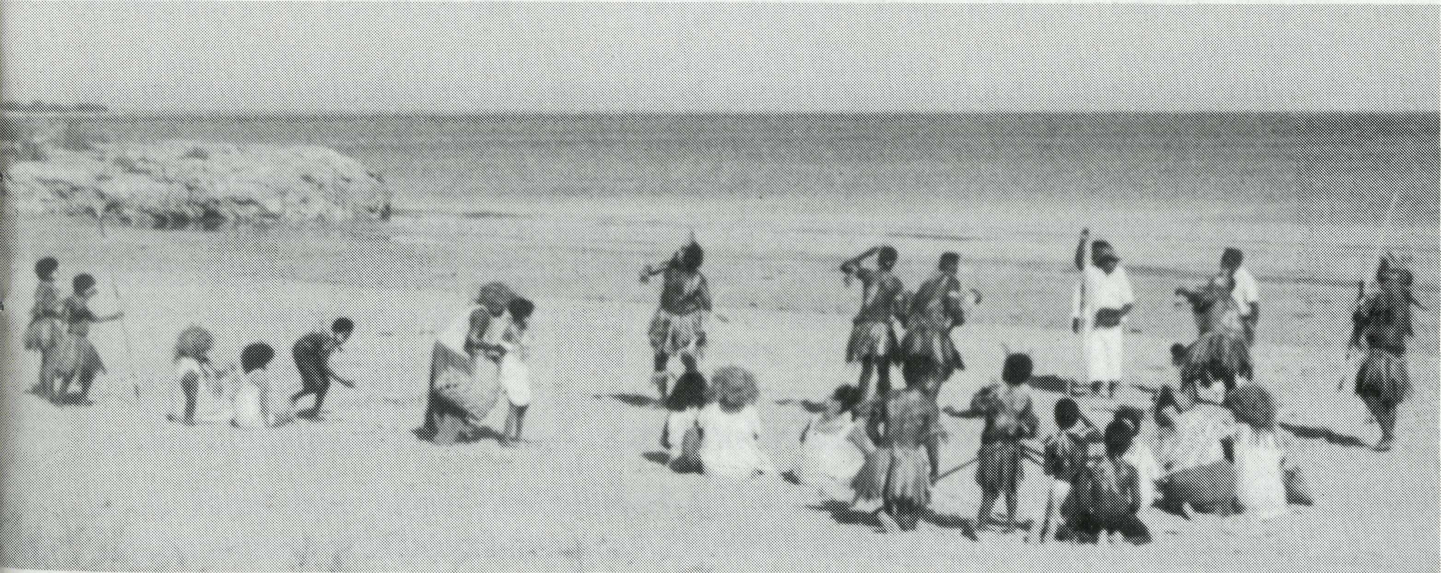
FROM THE FEDERAL SECRETARY .
Church Aid — a unique role!
There are numerous aid organisations working in Australia raising funds for projects around the world. B.C.A. is a "Church Aid" Society, unique among aid agencies, because we are geared to take the good news of Jesus Christ into the outback and to assist the church in remote areas. We do so in partnership with 11 dioceses of the Australian Church, from North Queensland to Willochra to North West Australia. B.C.A. has built up an impressive record of service to the outback church since 1919.
Co-operating parishes
The congregations are working together for the spread of the gospel and worshipping as a united "family" — at Winton, Roxby Downs, Leigh Creek, Kambalda and Derby. Our B.C.A. supported staff have so much to teach christians in the cities about co-operation with other denominations. Yes, there are problems, such as recognising each other's ministries, sharing in Holy Communion and adapting our church structures to local needs. But the blessings are great as Christians work side by side to further the kingdom of God.
The Aboriginal church
How encouraging it is to witness the emergence of so many Aboriginal and Islander leaders who are establishing Aboriginal churches across the nation. In Cairns Bishop Arthur Malcolm and Colleen are involved in mid-week services aimed at attracting Aboriginal and Islander
people. Bishop Arthur makes home calls and regular visits to nursing homes, rehabilitation centres and prisons, as he serves his people in the North.
Nungalinya College, established 18 years ago in Darwin, trains Aboriginal and Islander people for ministry through biblical and community studies. Students are now drawn from all over Australia. By 1994 the College hopes to appoint an Aboriginal person to be trained as the next Principal.
Bimbadeen Aboriginal Training College at Cootamundra —set up by A.E.F. — equips young men and women for ministry mainly in country towns around the Riverina.
B.C.A. gives substantial prayer and financial support for Aboriginal ministry.
There are many other aspects of "church aid" involving the Society — support for youth work in the north west, a youth hostel in Broken Hill, and Diocesan Registrars based in Geraldton and Darwin. As B.C.A. continues to serve bush parishes in the name of Christ, we depend on you for prayer and financial backing.
Farewell and appreciation
After b^{x}A years as Federal Secretary I leave B.C.A. with very mixed feelings to take up a new role as Rector of St. James' Turramurra on Sydney's north shore. Jan and I will miss you all in the "family". It is a great gospel enterprise in which we share.
ERNIE CARNABY
Nungalinya College news
Greetings from Nungalinya College!
1991 has been a year of many blessings. It is a joy to work among Aboriginal people and to see the Holy Spirit working among them. Many of them have testified to the changes in their lives through the saving power of Jesus Christ.
Some of the highlights of the year have been: The Coming of the Light
For the first time in Darwin the Torres Strait Islander community celebrated the "Coming of the Light" to re-enact the arrival of the first missionaries in Torres Strait. After the ceremony the large crowd came to Nungalinya for a day of dancing, feasting and rejoicing.
Further Aboriginal participation in college management
We now have the first Aboriginal Chairperson of the Council. He is Rev. Wali Fejo of the Uniting Aboriginal and Islander Christian Congress. All new appointments as Chairperson of college committees will be Aboriginals. Steps are being taken to identify and train an Aboriginal Principal by 1994. This person will then work beside the current Principal for a couple of years. New married students cottages
Two magnificent donations, $50,000 from the BHP Community Trust and $66,000 from a bequest to the N.S. W. Uniting Church Synod made it possible to erect two new married students' cottages. A volunteer Mobile Mission Maintenance work party erected the cottages for us.
Do you want to know more about Nungalinya College
Write to the college at P.O. Box 40371, Casuarina, N.T. 0811, or send a FAX to (089) 27 2332 and we will place you on the mailing list to receive Nungalinya News four times a year.
Re-enactment of the arrival of the first missionaries in Torres Strait
LES BROCKWAY Principal

THE REAL AUSTRALIAN

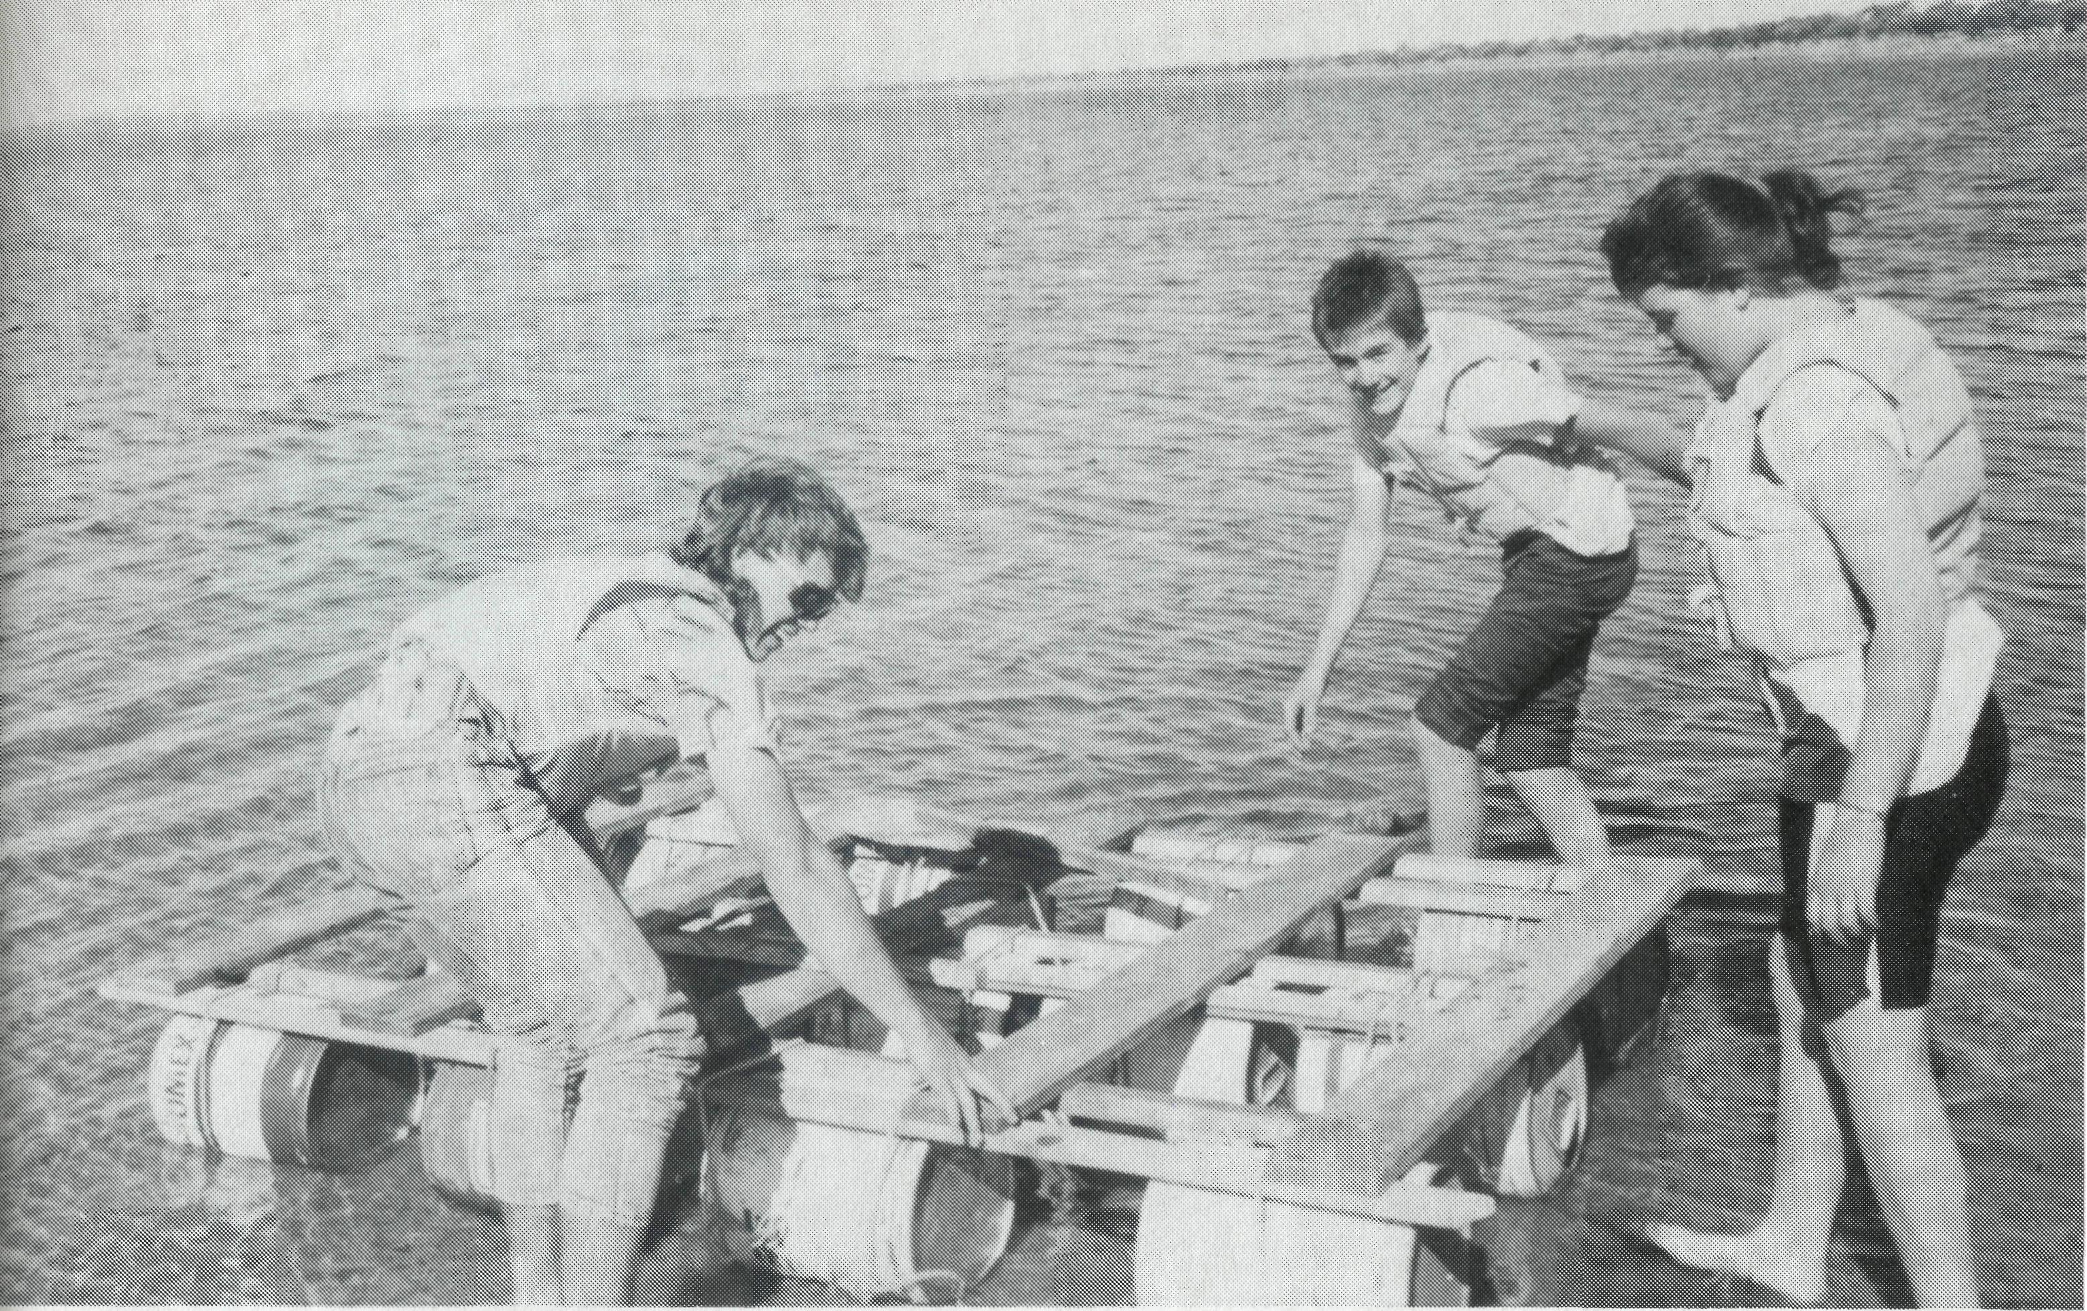
Daniel's Den re-visited!!
A very special letter came to Brian and Judy the other day. It was from Serena. (Brian and Judy are a Catacomb Church couple who work among our youth here in Coober Pedy.) What a wonderful letter! This young lady, Serena, had been a member of Daniel's Den (the youth group) a few years ago. She had just come to know Jesus as her Lord and she was writing to say how all she had heard about the Lord as a "Daniel's Denner" was not true in her life and she said that the things of God she had learnt were so precious and vital to her. How thankful she was now! What better news could Christian workers get!
You've got no idea of the praise and thanks which welled up in our hearts as that letter was read. And tears of joy! Serena had been one of those 'difficult to manage' members — and now she was a Christian! Serena? Praise be to God! What might have happened to Serena if the Word of Christ had not been shared with her some time before in her outback home town? Who knows?
Then there's Mark. Now Mark is still with us. He's a young chap with an open heart. Oh, he's got plenty of problems — like lots of others, but he committed himself to Jesus not so long ago and now his life is taking on a new shape. He has clear goals as to his career and the Lord is in all of that. In Mark's life there is much to overcome, but his Lord will see him through and keep him as a witness to the power of God. He is "on track". But what if Mark had not heart of the love of Christ?
News of Serena and Mark is great news. The 'seed' has sprouted and taken root. There are times when this happens on the spot, but at other times it may take place down the track a bit ... as with Serena.
Isn't it great? It's great because the gospel is powerful — to change young lives today; and it's great that this gospel is being shared by people in the bush who love Jesus — not just in urban areas, but in places like Coober Pedy in the hot far north of South Australia.
Pray for people — like Brian and Judy — who have the plight of our Australian youth on their hearts, and pray for all who hear.
IAN ROBERTSON
(The Rev. Ian and Mrs. Robin Robertson have served with B.C.A. at Coober Pedy for four years.)
Daniel's Den afloat on Lake Phi Upson.
OBITUARY
THE REV. TIMOTHY ROD BROWNSCOMBE [1956-1992]
It is with deep sadness that we record the death of Timothy Brownscombe in Adelaide on 21 January, from encephalitis.
Tim and Kerrie and their family arrived in Tennant Creek in February 1987, following curacies in Mugdee and Blayney. With the support of B.C.A. the Brownscombe's accepted the daunting challenge of Tennant Creek with over half the population being Aboriginal. Over the past five years they have left their mark on this highly mobile town, through community involvement, industrial chaplaincy at Warrego Mine, and training Aboriginal lads in painting (TAFE). Tim supervised the renovation and extensions to the Rectory, and saw much spiritual growth in people's lives. He was laid to rest in Tennant Creek on 28 January 1992. Our prayers and loving support go with Kerrie, Beth, Ann, Philip and Catherine in their resettlement.
A fund has been established to help Kerrie and the children. Donations can be sent to your State Office clearly marked for their
personal support.

THE REAL AUSTRALIAN
THE REAL AUSTRALIAN

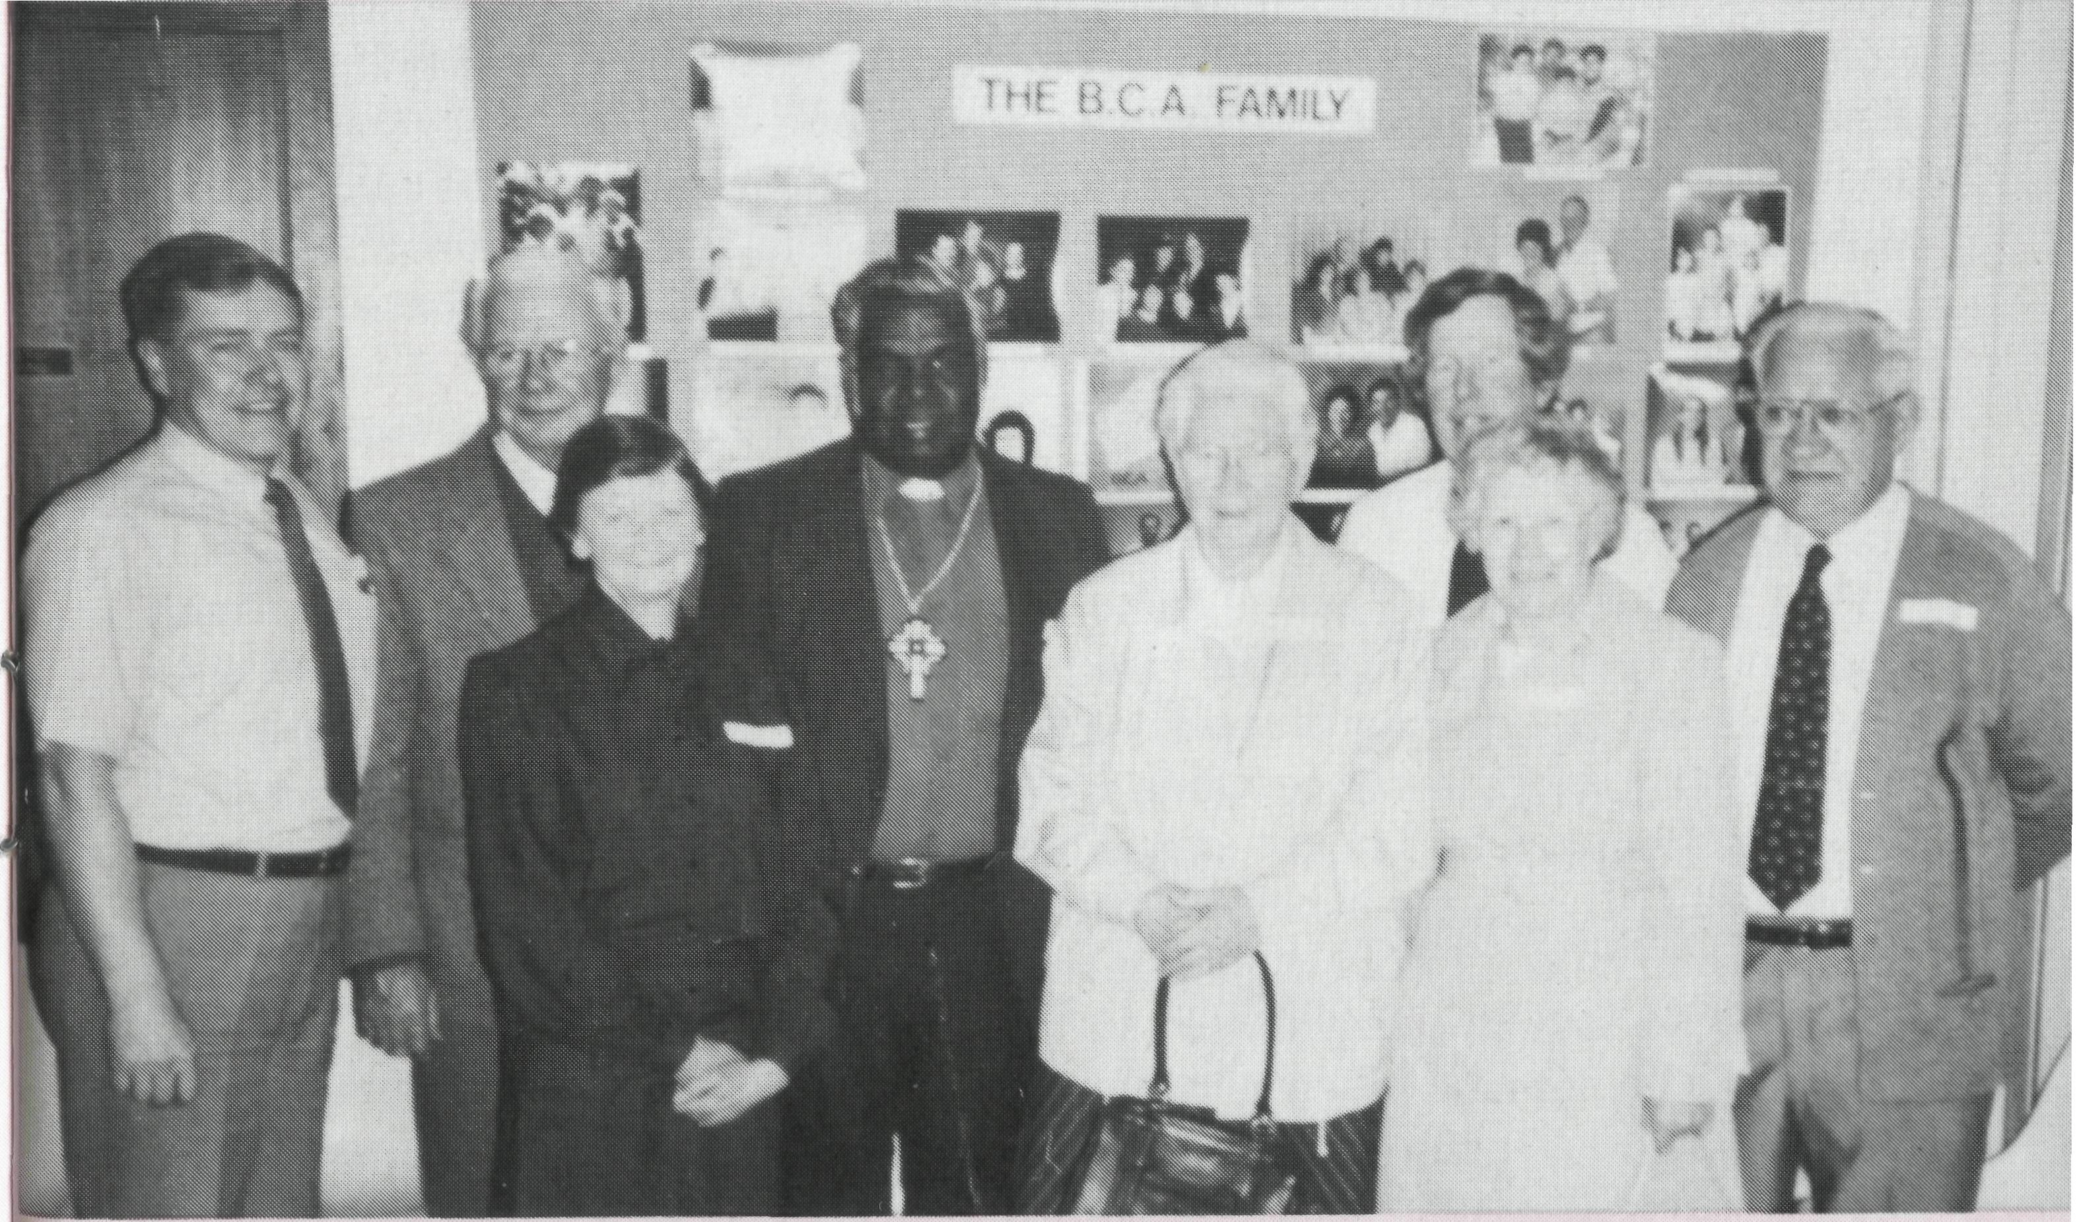
One true church in Wickham
For more than two years Wickham parish has taken part in monthly combined services together with other denominational groups. These services are a great time of joy and fellowship as Christians come together to celebrate their love of Jesus. As many as eight different church groups have been represented at times, and it is truly a wonderful time of unity and love.
These combined services first began in 1989, when Wickham members were invited to a gathering offered by a group of Assembly of God, Thursday Islander people from the nearby town of Karratha.
After a family fun time of cricket during the afternoon, and then a great feast, a wonderful time of celebration followed as the Lord was praised. Everyone sang and danced to the sound of guitars and drums playing joyous Christian music. No place existed for denominational differences, and indeed there were none! It was simply unity of love and praise for the living God.
It was at this time that everyone realised that one and the same God was being praised, why not do it together regularly. Since then many others have joined with us, and different groups lead the service each month on a rotational basis. At the most recent meeting seven Pastors prayed together for even stronger unity, fellowship and outreach. This was followed by all present joining together in small groups, to pray for the same.
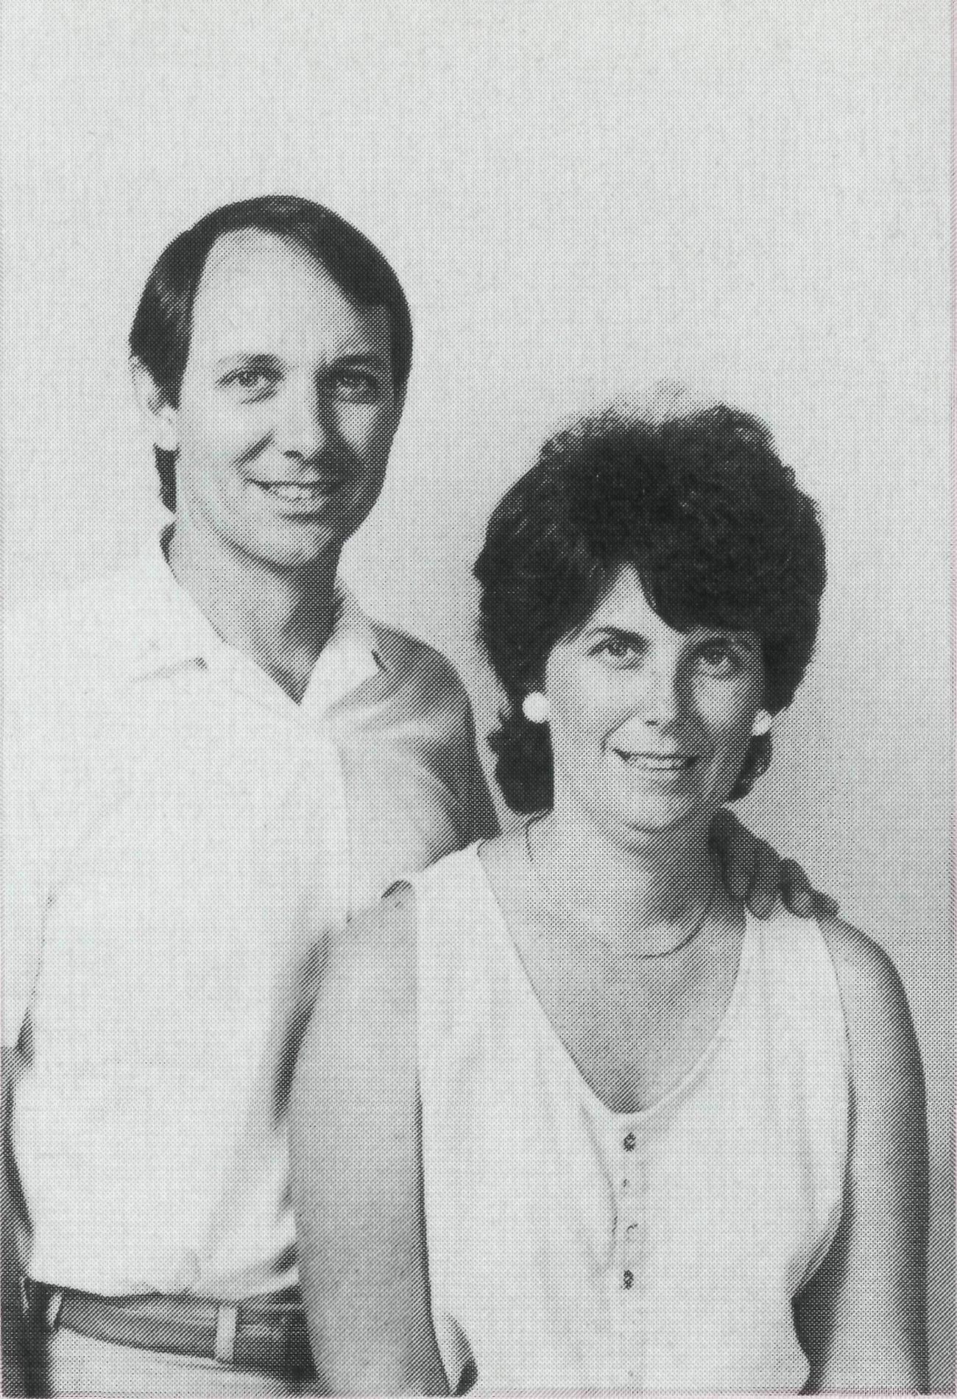
Our hope for the future is that greater co-operation between groups will bring about greater growth of God's church in the region. That the unity experienced and shown will bring about real awareness of Jesus to community members.
There is only ONE true church of Jesus Christ. It makes real sense to join together as one to show Him and others that we mean it!
There has also been a personal touch for us as a B.C.A. family. Because of the transient nature of people in mining towns, we are constantly losing friends! The broader scope for friendships through contact during these services has lessened this very much.
God is good.
ALLAN HARRISON
(Allan and Julie Harrison have ministered in Wickham since January 1988.)
I couldn't go on without you!!
Bishop Arthur Malcolm writes . . .
Dear friends,
Thank you for your constant support! We need you very much — you are part of this ministry in North Queensland: a ministry of one God for all people.
The work I am involved in is taking me to distant places. I am seeing that God is moving among his people and that there is a gradual awakening of people to the fact that God does love us and expects us to love one another.
Ministry works are being started. A small number of God's people have responded to God's call. The Rev. James Lefwhich, a very faithful servant with a burning soul for his Aboriginal and Islander people, is constant in his urge to get "the works" going!
We are thankful for your gift of a bus. It is being frequently used. A good number of people are carried to and from services.
Thank you again. I could not go on if it were not for you B.C.A. supporters and others who God calls together in the giving of their gifts for the overall good of His church.
May God bless and lead you.
Bishop Malcolm with B.C.A. supporters at a luncheon in the Sydney office.
ARTHUR and COLLEEN MALCOLM (B.C.A. has supported the Malcolms' ministry among Aboriginal people in North Queensland since January 1991.)

THE REAL AUSTRALIAN

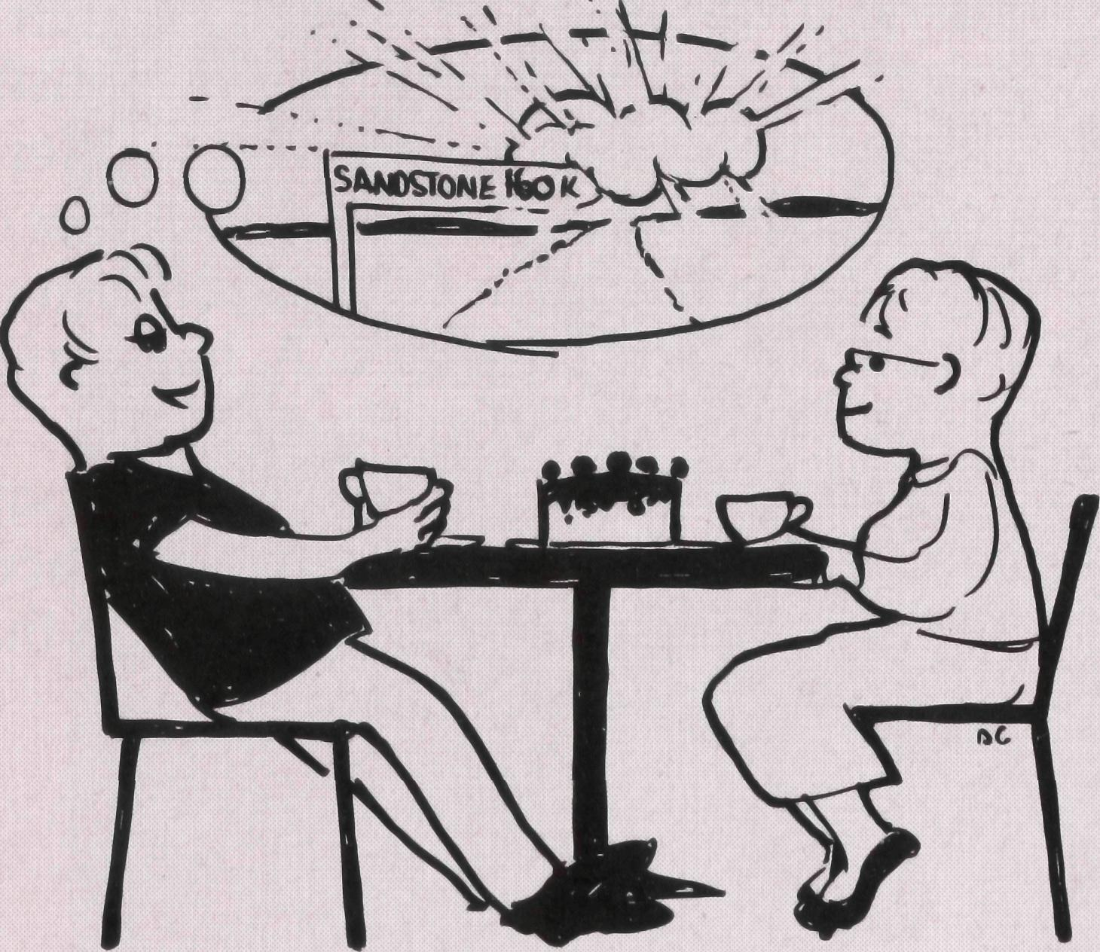
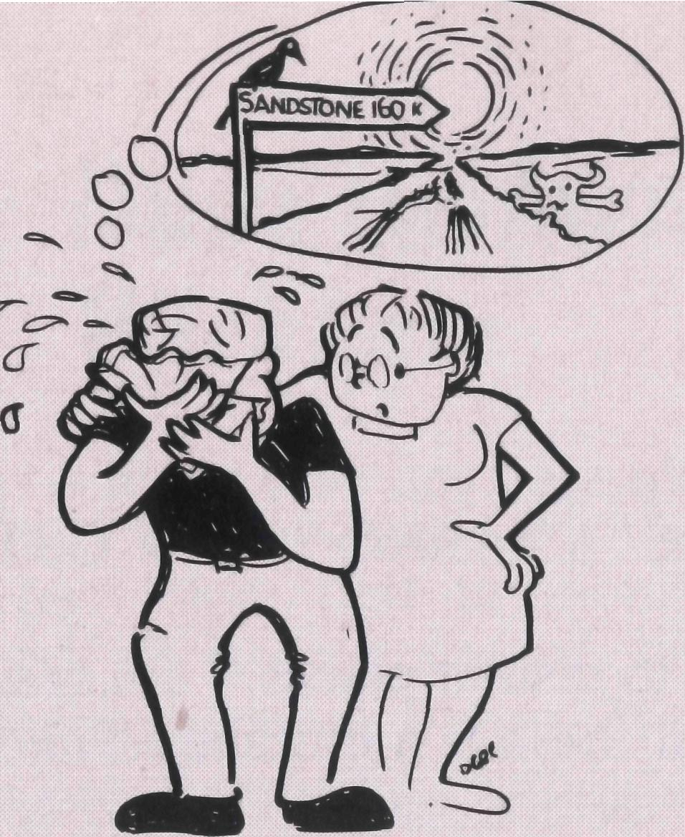
Along the Sandstone road
Phil and Margaret Bassett have served with B.CA. in the Parish of The Murchison for two years. Phil writes about life on the road to Sandstone . . .
Wake up about 6.30 a.m. Feel lousy. Stagger out to breakfast. In the bathroom shaving. Recognise the lousy feeling as fear. Fear of the dreaded Sandstone Road. Today I promised to go to Sandstone, a pretty little town of about 40 souls located 160 km of poor gravel road east of Mt. Magnet. Last time I drove the Sandstone Road I blew a tyre; time before that hit a kangaroo. My score so far: Sandstone Road 100; me nil. Every time I drive the Sandstone Road there is at least one incident. A tyre, a kangaroo, loose sand ($16,000 to fix the car that time). Margaret asks me what's wrong. "Nothing", I reply. "Don't tell me 'Nothing' . . . Come on. What's wrong?" Red-blooded, intrepid, B.CA. Missioner that I am, I burst into tears. "I'm afraid to face the Sandstone Road." "Ring them up and tell them you're not coming." Is her protective, wifely advice. "That would only make it worse next time," I reply, wiping my eyes. "I've got to go."
Half an hour later I stop at the end of the bitumen, 200 metres from the centre of town and squint into the morning sun at the dreaded Sandstone Road stretching ahead of me. The surface looks worse than the last time I drove it. I remember the verse from Isaiah Chapter 40, "A voice of one calling: 'In the desert prepare the way for the LORD; make straight in the wilderness a highway for our God'." I think, "How nice it would be to have a real four-lane bitumen highway stretching across this desert. Oh Well. Lord please keep me safe today. Here goes nothing."
The surface is badly rutted from the heavy road trains hauling supplies out to the gold mines near Sandstone. It is very dry and dusty and needs grading.
Past the turn-off to Yuanmi mine (Pronounced "You an' me"). It's much better now they've realigned it. Used to be the worst curve on the road with loose gravel, like driving on ball bearings. I had a blow out on the curve last year. Lost two tyres in two seconds. Past the Cue turn-off. Half-way mark. Past Windsor Station. Can't stop today. Must call next time I come along the Sandstone Road. The Cook kids liked the Bible Cartoon Videos. Must take them some more. Wonder how Wendy is handling her grief at her brother's death. Seemed OK last time I saw her.
Go slow on the next bit. Too many memories of my crash earlier in the year. The bull-dust is getting deep again. Be worse in the summer. Hard to pick exactly where the crash happened any more. That looks like Cath and Gary's car approaching. Stop in the middle of the road for a talk. "Gary's bringing a
load of goats in the truck. We'll clear $1 a head for them. See you about 3 pm at the Rectory." Pass Gary about 10 minutes later. Toot and wave but don't stop. Cath and Gary are badly hit by the wool crisis. Their 100,000 acre property only supports 2000 sheep. Barely enough to make a living. That's why it's so important to get rid of the goats which compete for feed. Gary is one of our Parish Wardens, while Cath and Gary are our Synod reps.
Arrive in Sandstone about 10 a.m. Into the School for Scripture. Walk into the schoolroom. All nine kids look up and smile. "Good morning Mr. Bassett," the kids chorus. "Can we sing the Na-na-na-na song?" Sing a few songs, tell them the story of "The Rich, Young Ruler". Do the activity sheets. Into the staff-room for morning tea. Colleen has bought cake and chocolate bikkies. Colleen is a Christian and a member of our church at Sandstone. Go round to the P.O. Store where Meg, another parishioner is snowed under with customers, so go a couple of doors down to visit Dawn, wife of the Shire Clerk and occasional church goer. Dawn very apologetic about not being at church last time we came to town. Spend a pleasant 45 minutes talking to her and her husband who comes home for lunch. Dawn says she's coming to the concert tonight with Colleen. The concert is part of the celebrations to mark 100 years since the discovery of gold at Mt. Magnet.
The University of W.A. Symphony Orchestra is coming and Margaret has been training a Junior and a Senior Choir at Mt. Magnet Primary School. Up to Meg's house, as she's gone home for lunch. Meg's husband died leaving her with an unsaleable business. She's a lovely soul. Have lunch with Meg and set off to face the dreaded Sandstone Road back to Mt. Magnet.
Arrive home about 3 p.m. totally without incident. Notice the grader out at the Magnet end at last. Cath and Gary arrive so Margaret puts the kettle on. Cath has a bad back and is receiving treatment from the physio in Magnet. About 6.00 we leave for the concert which is being held in a shearing shed on one of the stations 55 km south of Magnet. The shed is packed, the kids sing wonderfully, the orchestra plays beautifully, the shed smells like a shearing shed should. Over supper I talk to Dawn and she brings up the possibility of having her children baptised. Opens the way for talking about her own faith and possible baptism. Suggests I call and talk some more next time I come to Sandstone. On the way home think, "Maybe the dreaded Sandstone Road really is a 'highway for our God' in the wilderness of outback Western Australia."

no
THE REAL AUSTRALIAN
THE REAL AUSTRALIAN
in

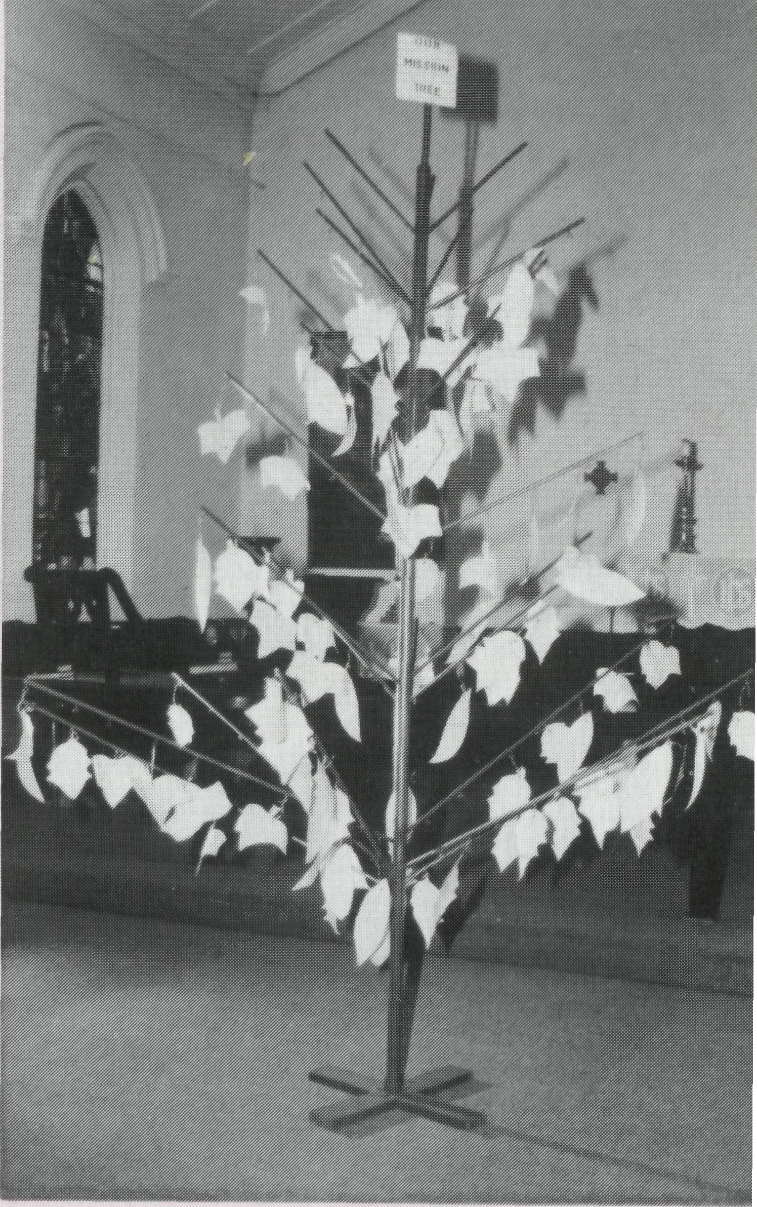
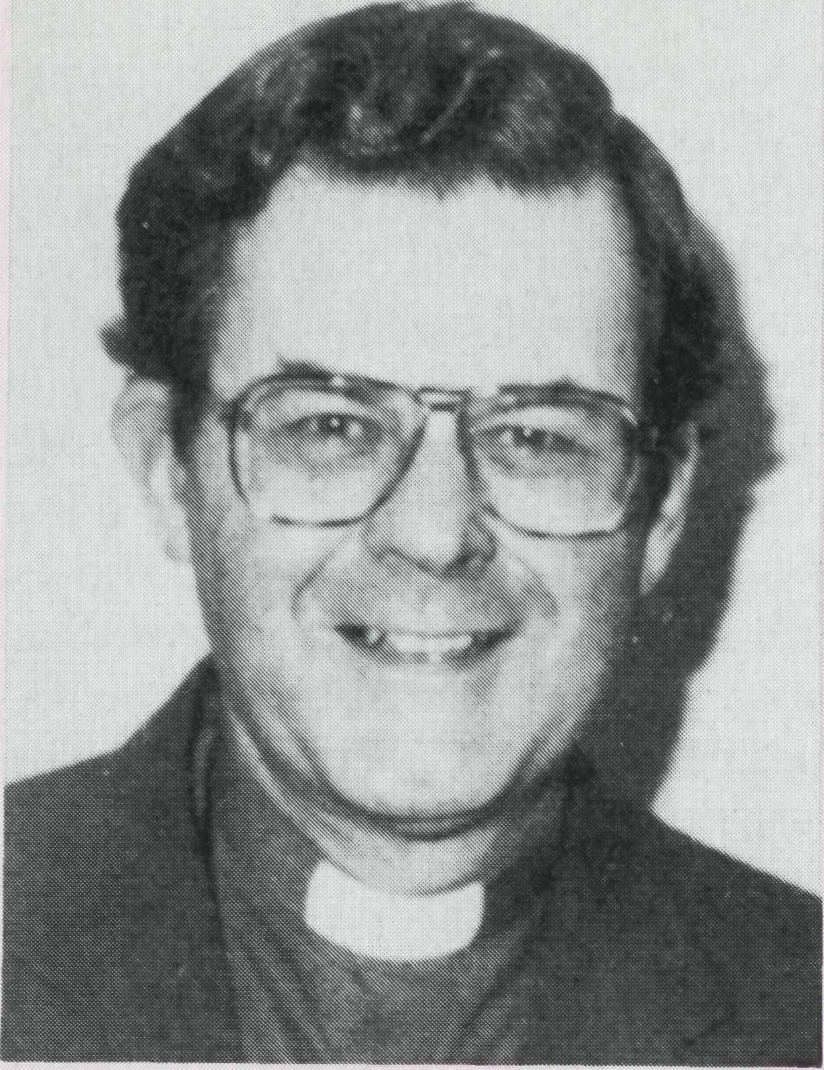
MESSAGE FROM THE PRIMATE
Archbishop Rayner has recently become patron of B.C.A. He writes concerning B.C.A.'s role in the Australian church.
The bush has always posed a major challenge to the Australian church — its distances are vast, its people scattered, its population transient and its resources limited. From the beginning of our history church leaders have puzzled as to how to minister to Australians living in remote areas.
The temptation has always been to ignore the problem and to concentrate our ministry in areas where tangible results come easily; but though relatively few compared with the populations of our great cities, each one of these people in the bush is a child of God, created by God to share his eternal life. We dare not let them lose that destiny for which they were created. Besides, though relatively few, they play a disproportionate role in the well-being of the whole Australian community. Australia owes it to them to see that spiritually they are not neglected.
In years past, the bishops of bush dioceses used to come to General Synod or the National Bishops' Conference complaining that the needs of their dioceses were neglected by the National Church. They had plenty of ground for complaint. The larger dioceses, which were comparatively rich in human and financial resource, were often so full of their own needs that they spared little thought for their Christian brothers and sisters in remote areas.
We cannot pretend that this situation has been entirely reversed today. But it is to the credit of The Bush Church Aid Society that Australian Anglicans have begun to recognize their responsibility to the people of the bush. In challenging clergy and lay workers to offer for service in bush postings, in calling upon Anglicans in the cities and towns to give generously to provide for ministry in the bush and in enlisting an army of praying people to bring before God the needs of the bush, B.C.A. has performed a notable service for the mission of the church in Australia.
Primate
In times of rural recession and depopulation the problems of providing an adequate ministry of Word and Sacrament are as great as ever. B.C.A. deserves our enthusiastic support so that we may fulfill St Paul's injunction to "Bear one another's burdens".
Ernest Horth suggests . . .
Grow a Mission Tree in ^{y}92!
The concept of a "Mission Tree" sparked off new enthusiasm in The Parish of St. John's, Dalby, Diocese of Brisbane. They made a tree out of wood and dowelling material. On the branches were little hooks. Women's groups in the Parish made the leaves out of various materials and these leaves would eventually attach to the hooks. The tree itself could not be missed because it was positioned near the front entrance to the Church.
Parishioners provided empty jars to the Parish Office where a sticker, including a spot for recording "Name" was placed on the jars. Wording on the sticker includes, "Mission and Service"; "Thank you for helping make Christ known", "Our Church in Mission".
Money collected in the jars was distributed to various "Mission projects" agreed on by the Parish. When a jar was handed in, the amount of money collected was entered on a leaf of the "Mission Tree" (name of person who collected money can be included if desired). The person who collected the money may hang the leaf on a branch of the "Mission Tree" during a service of worship or at some other time. As each leaf is added, there is a tangible witness to the whole congregation as to how well the project is going. As the volume of leaves increases at St. John's, so too did the enthusiasm and the amount of money given by thd^ parish to its mission projects.
THE REAL AUSTRALIAN
Maybe your Parish could try something similar. You may have an even better idea. At Dalby, not only did the "Mission Tree" help increase the amount of money given to mission projects; it involved more of the congregation; it created a focal point of interest for discussion about and prayer support for missionaries, in particular.
The tree can be a focus of the fact that the mission of the congregation is to reach out in the love of Christ to those in need, sharing with them the love of Christ.

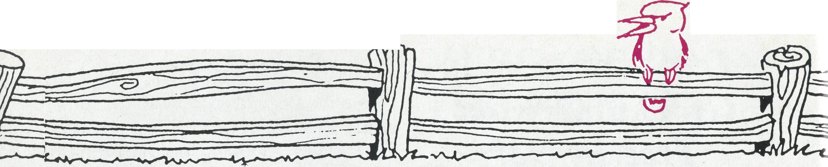
POST & RAILS.
B.C.A. annual meetings in 1992
B.CA. SUPPORTERS' WEEKEND
Following a successful weekend in November 1990, a follow-up weekend is being organised.
Date: 30th October to 1st November 1992.
Venue: "Gilbulla" Conference Centre, Menangle (near Camden), 50 km west of Sydney.
Programme includes:
- Stimulating Bible studies
- Informative reports from field staff
- Relaxing and enjoyable fellowship
- Great amenities and meals
Who can come? All welcome!
Organise a car load from Canberra, Newcastle, Bathurst, The Riverina, Sydney or wherever!!
Application and details from: Rev. David Mulready, Level 7, 37 York Street, Sydney 2000.
SOUTH AUSTRALIAN
B.C.A. WORKER'S REUNION
IN ADELAIDE
SUNDAY, 9th JUNE 1992 (Queen's Birthday Long Weekend)
The South Australian B.C.A. Committee is keen to contact any folk who have served with B.C.A. in South Australia over the years, to arrange a reunion.
For further details and expressions of interest, please contact John Argall, 3 Cedric Avenue, Redwood Park, or (08) 265 1825.
NOMINATION TO COMMITTEE:
Nominations for State or Federal Committees must be in the hands of the State Secretaries in writing at least two weeks prior to the meeting date, duly signed by the proposer and candidate. Anyone interested in being involved in a committee should liaise with their State Secretary.
WELCOME
The B.C.A. family warmly welcomes new field staff: Lightning Ridge: The Rev. Mark and Mrs. Lucy Taylor from Moree (N.S.W.) late February.
Roxby Downs: The Rev. John and Mrs. Leonie Rutherford from Streaky Bay (S.A.) in January. Their children are Kathryn (15), Nigel (13), Narelle (10), Emily (8).
Broken Hill Hostel: Mr.
Shane and Mrs. Suzanne Morrow from Springwood Parish (N.S.W.) commenced duties as assistant hostel parents in January.
Blackwater: Yes! Blackwater is back on the B.C.A. map. The Rev. Peter and Mrs. Jeanette Blundell from Bacchus Marsh (Vic.) commenced ministry in January. Their children are James (4) and Megan (2). N.B. Jeanette Blundell is the sister of Kerrie Brownscombe (Tennant Creek) — daughters of Rae and Bill King from Mt. Kuringai (Sydney).
UNUSUAL GIFTS
B.C.A. has recently received several unusual gifts to be sold to support B.C.A. ministry. OPALS — from a supporter in Lightning Ridge. GOLD AND SILVER pendants and a DIAMOND ring — from Sydney supporters. The diamond ring sold for $650.
Old jewellery can be turned into cash for the Lord's work through a trusted contact. Contact your State Secretary!
MOVING
The Reinertsens have moved to Derby to replace the Symons (who moved to Kunu-nurra in January). This is Jon's first appointment following his brief curacy in the Parish of Bluff Point (Geraldton).
BIOGRAPHICAL HELP NEEDED
Mrs. Val Hunt, niece of The Rev. R. R. Hawkins, Rector of Cobar in 1920, would like to hear from folk who could provide information which could be used in helping her to write his biography (c/- B.C.A. Sydney).
FEDERAL A.G.M.:
Date: Thursday, 28th May,
9.30 a.m.
Location: Ave Maria Retreat
House,
6 Wentworth Street, Point Piper.
N.S.W. BRANCH:
Date: Wednesday, 8th April,
8.00 p.m. Coffee and Dessert.
Location: St. Matthew's, West
Pymble.
Field Staff Present: Sister Susan
Green, Rev. Cliff Ainsworth.
QLD. & NTH. N.S.W. BRANCH:
Date: Friday, 3rd April, 6.30 for
7.00 p.m. start.
Location: Holland Park Parish
Hall — Catered Dinner.
Cost: Donation.
R.S.V.P.: (07) 349 9081.
ANNUAL THANKSGIVING SERVICE:
Date: Thursday, 28th May,
7.00 p.m.
Location: St. Philip's, York
Street, Sydney.
Field Staff: Rev. Cliff Ainsworth.
Preacher: The Rev. John Jones.
VIC. & TAS. BRANCH:
Date: Tuesday, 28th April.
Location: Holy Trinity,
Doncaster.
Speakers: Bishop Ged and Mrs
Laurel Muston.
Also: Sorensens, Hardings,
Nelsons, Heaths and Lamonts.
Dinner: 5.45 p.m.
Meeting: 7.45 p.m.
R.S.V.P.: Monday, 20th April.
S.A. & N.T. BRANCH: Date: Monday, 27th April, 6.30 p.m. Tea 7.45 p.m. A.G.M. Location: St. Swithun's Anglican Church, Cnr. Morphett Road and Nilpena Avenue, Morphettville.

PRAY FOR OUR FIELD STAFF
WINNING AUSTRALIA FOR CHRIST

• Diocese of Northern Territory — Bishop Richard Appleby
- Sanderson — Rev. Greg and Mrs. Kerry Thompson.
- Palmerston — Rev. Ron and Mrs. Margaret Bundy.
- Tennant Creek — Mrs. Kerrie Brownscombe and children (refer page 7).
- Diocesan Secretary/Treasurer — Mr. David Martin.
• Diocese of North West Australia — Bishop Tony Nichols.
- Kununurra — Rev. John and Mrs. Dianne Symons.
- Derby — Rev. Jon and Mrs. Rae Reinertsen.
- Newman — Rev. Raymond and Mrs. Betty Lou Molyneux.
- Port Hedland — Archdeacon Bill and Mrs. Jennifer Warburton.
- South Hedland — Rev. Ray and Mrs. Lyn Arthur.

- Karratha — Rev. Terry and Mrs. Fiona Redmond.
- Wickham — Rev. Allan and Mrs. Julie Harrison.
- Tom Price/Paraburdoo — Rev. Brian and Mrs. Joy Harding.
- N.W. Australia: Youth Ministry: Catherine Ross; Counselling Ministry.
- Mt. Magnet (Murchison) — Rev. Philip and Mrs Margaret Bassett.
- Diocesan Registrar — Mrs. Kay Winfield in Geraldton.
• Diocese of Perth — Archbishop Peter Carnley.
16 Kambalda/Norseman — Rev. Ron and Mrs. Colleen Ross.
Hon. B.C.A. Secretary for W.A. — Rev. Peter Brain.
• Diocese of Willochra — Bishop David McCall.
- Coober Pedy — Rev. Ian and Mrs. Robin Robertson.
- Roxby Downs and Mid-West Mission — Rev. John and Mrs. Leone Rutherford.
- Leigh Creek — Rev. Peter and Mrs. Margaret Achurch. State Secretary for S.A. — Rev. Bob George, Mrs. Jo Phillips.
- Cook: Bishop Kirkby Memorial Hospital — Sisters Gai DiDonna, Christina Ryman.
Tarcoola Hospital — Sisters Mary-Grace Bingham, Meryl Burden.
• Diocese of Gippsland — Bishop Colin Sheumack.
21 Omeo — Rev. Norman and Mrs. Leonie Fagg.
State Secretary for Vic. and Tas. — Rev. Brian Viney, Ms. Margo Bright.
• Diocese of Riverina — Bishop Barry Hunter.
22 Broken Hill Hostel — David and Elisabeth Bull and Shane and Suzanne
Morrow.
Wilcannia — Rev. Bob and Mrs. Phyllis Collie.
• Diocese of Armidale — Bishop Peter Chiswell.
23 Lightning Ridge — Rev. Mark and Mrs. Lucy Taylor.
• Diocese of Grafton — Bishop Bruce Schultz.
- Bonalbo — Rev. Dick and Mrs. Pat Freeman.
- State Office — Revs. David Mulready and Jim Thomson. Mrs. Michele Peacock.
• Diocese of Brisbane — Archbishop Peter Hollingworth.
- Quilpie — Rev. Bob and Mrs. Sue Witten.
- State Secretary for Old. and northern N.S.W. Rev. Ernest Horth, Mrs. Elaine Kuiri.
• Diocese of Rockhampton — Bishop George Hearn.
- Winton — Vacant.
- ABORIGINAL MINISTRY: Cairns, Townsville, Mackay: Bishop Arthur and Mrs. Colleen Malcolm. Nungalinya College — Principal: Rev. Dr. Les Brockway. Bimbadeen College — Mr. Denis and Mrs. Maureen Atkinson.
- B.C.A. FEDERAL OFFICE: Mr. Jim Gosbee, Mesdames Jacqueline Griffiths, Lay Lee Boughton and Eileen Darbin.
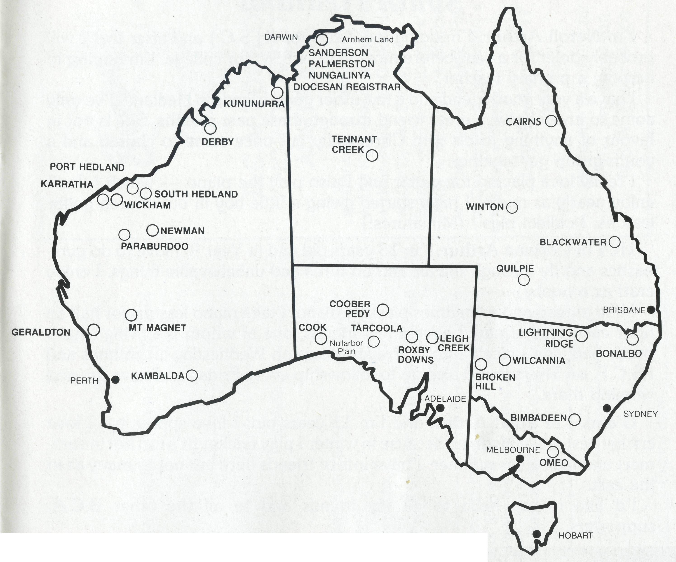
THE B.C.A. PRAYER
0 Lord our God, help us to remember those who live in the remote parts of our land. We ask you to strengthen and encourage all whose ministries are supported by The Bush Church Aid Society. Refresh them in times of discouragement and loneliness and call others to stand with them in the task of making Christ known. Grant that, through the ministry of the Word and Sacraments, through medical work, through service and by caring for the young, the message of your redeeming love may be proclaimed, and accepted by the people throughout our land. We ask these things through Jesus Christ our Lord, who lives and reigns with you and the Holy Spirit, one God, for ever and ever. AMEN.
*lf you'd like more details for prayer, send for our FREE quarterly prayer notes. (See reply page.)

17

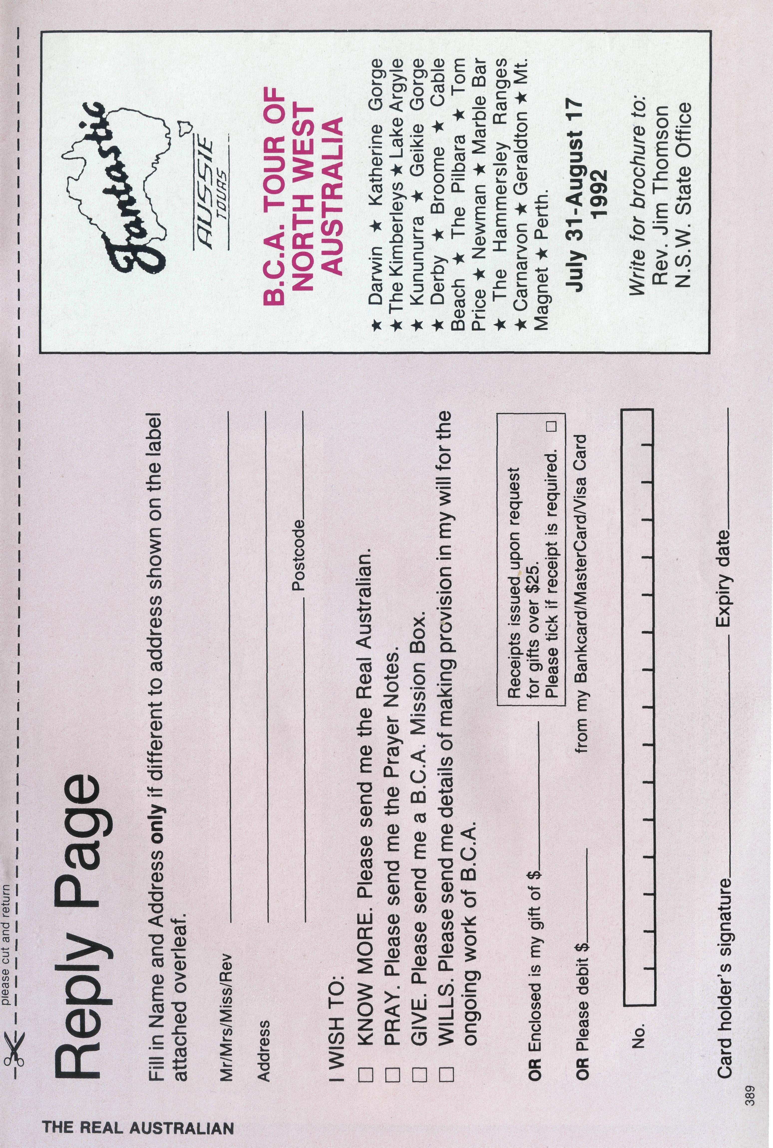
A few lines from the Arthur children of South Hedland
I'm Ncroli Arthur. I'm doing my T.E.E. or (H.S.C.) and after that I will probably defer for a year before moving to N.S.W. for college. I'm hoping to become a primary teacher.
I have a very good friend and a few other good friends in Hedland. I've only come to know Kylie, a great friend through these past months. She is not in favour of anything to do with Christianity but once came to church and a youth group get-together.
I really love playing the guitar and I also play the piano — which I don't enjoy nearly as much! I have started giving a little boy in our church guitar lessons. I collect pigs!! (Miniatures!)
Hi, I'm Corinne Arthur. I'm 13 years old and in Year 9. I love to do gymnastics and fly through the air and do turns and unbelievable things. I enjoy craft as a hobby.
I like to read and sometimes play the piano. I take piano lessons for half an hour each Wednesday. I have a few friends, one of whom is leaving (that's pretty bad, she's nice!) I go to Prayer group on Wednesday lunchtimes and I.S.C.F. on Thursdays. I also go to fellowship every Friday and have fun and worship there.
G'day. I'm Scott Arthur and I'm 11 years old. I love sports, but I love cricket best. I like Hedland because in winter I play cricket (it's too hot in summer) and tee-ball in summer. I have lots of friends here but not as many as in the east.
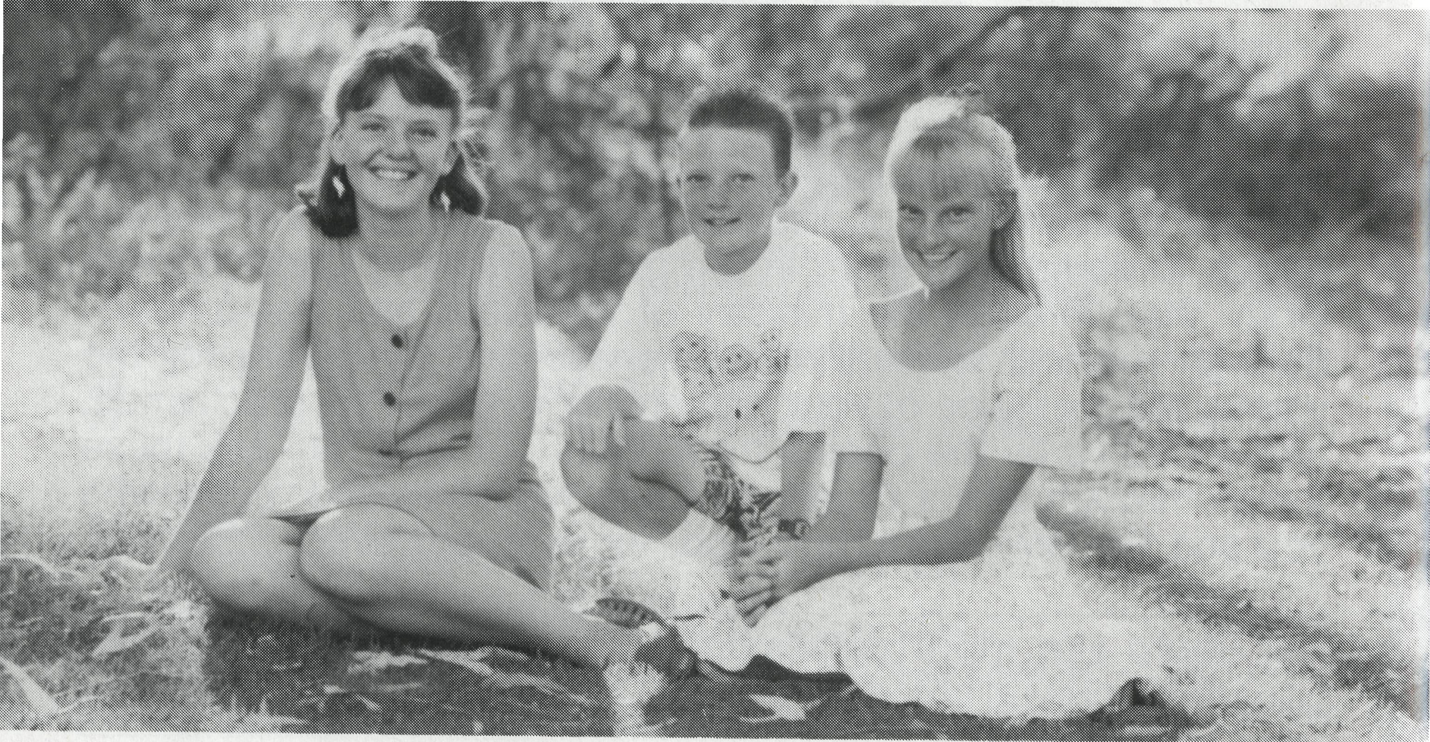
I'd like to say hello to all my friends and to all the other B.C.A. supporters.

