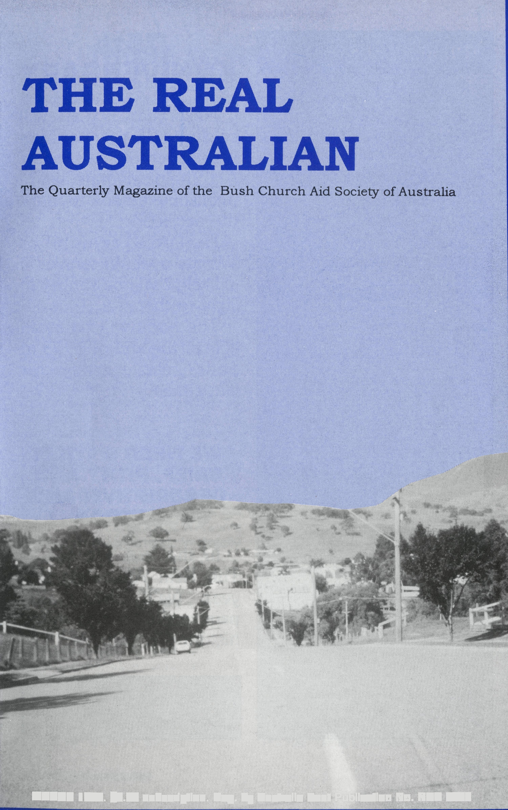
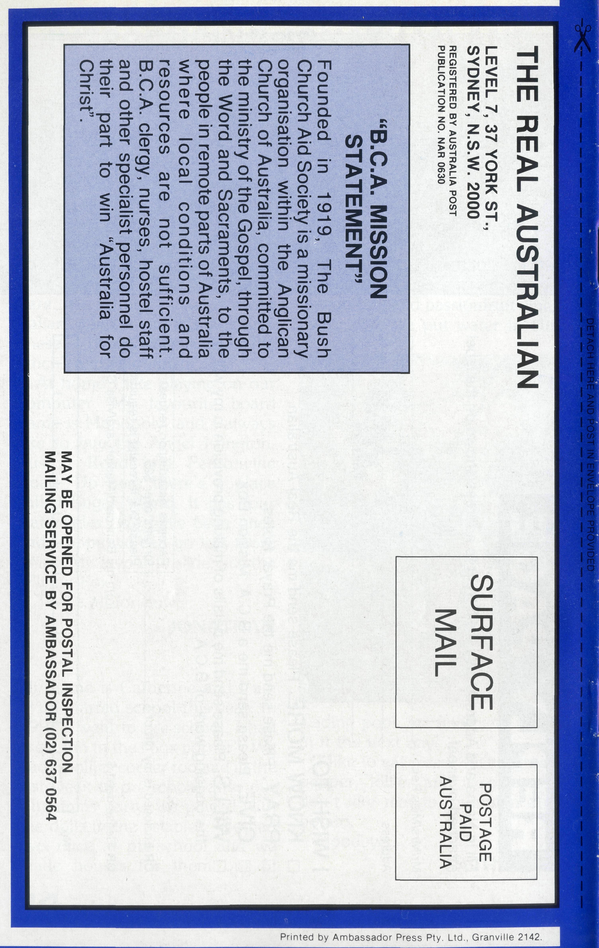
MARCH 1993. $3.00 subscription. Reg. by Australia Post Publication No. NAR 0630

THE REAL AUSTRALIAN
First published 1920. Edition No. 279 Circulation: 28,000
All enquiries to: THE EDITOR
David Mulready
THE BUSH CHURCH AID SOCIETY OF AUSTRALIA
LEVEL 7, 37 YORK STREET,
SYDNEY 2000
Ph (02) 262 5017. Pax (02) 262 5020
B.C.A. DIRECTORY
President: Archbishop Donald Robinson Chairman: Bishop Harry Goodhew Patron: Archbishop Keith Rayner
Vice-Presidents: Mr. Stan Hummerston, O.A.M.; Mr. Ray Otercteko.
Hon. Treasurer: Mr. R. Otercteko.
Federal Secretary: Rev. Brian Roberts.
Level 7, 37 York Street, Sydney, N.S.W.
Victorian Secretary: Rev. Brian Viney, Shop 1, 205 Flinders Lane, Melbourne,
South Australian Secretary: Rev Bob
George, Church Office, 44 Currie Street, Adelaide, S.A. 5000. Ph (08) 212 7804.
Queensland Secretary: Rev Ernest Horth, P.O. Box 6472, Upper Mt. Gravatt, Old. 4122. Ph (07)349 9081.
Western Australia Hon. Secretary: Rev
Peter Brain, 27 Leach Street, Wanneroo, W.A. 6065. Ph (09) 405 1325.
75th ANNIVERSARY
Next year B.C.A. will celebrate 75 years of Ministry in remote Australia.
To help celebrate, we're publishing a book to mark the occasion.
Do you remember "Wings over Wilcannia?"
Well it will be similar in style to that.
The book will be available at the end of 1993 at $5.00 each, ready for Christmas!!
WE NEED A TITLE!
BRIEF, PITHY AND
DESCRIPTIVE! ANY
SUGGESTIONS?
In the four editions of The Real Australian this year, we'll devote one page each time to some historical reflections.
FRONT COVER PHOTO:
The road into Omeo.
THE REAL AUSTRALIAN
THOSE WERE THE DAYS!
Dorothy Hyslop is the daughter of The Rev David and Mrs Lily Livingstone. She dropped us a line about ministry with B.C.A. in the early years . . .
In a way Dad never really left B.C.A. In his following parishes he always made sure it was represented several times a year and I am sure there were later missioners because of this. In going to St. Anne's Ryde he felt he was following a B.C.A. tradition as an earlier bishop had served in both. The property commissions he set up there were instituted with B.C.A. very much in mind.
As he lay dying in 1990, it was not to his childhood that Dad's thoughts returned, but to his time with B.C.A. All the old bush stories came back and the nursing staff were fascinated by his night time reminiscences.
My parents, David and Lily Livingstone, were with B.C.A. for 14 years, giving it a big slice of the best years of their lives. They were aged 26 and 23 when they went to Wilcannia in 1938. Fifty-five years later Wilcannia is still considered a difficult place to live. Imagine what it was like in the midst of the Great Depression! They took with them their first new-born baby, David, and my brother John was also born while they were there, not the ideal circumstances for a new mother.
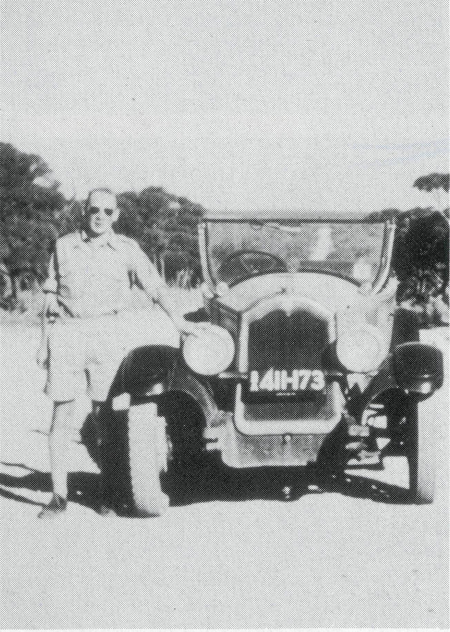
During that time my mother was asked to "mind" a property 10 miles out of White Cliffs with only her baby and a housemaid for company. The owner of the property was dying and everyone on the station except for one housemaid had gone to the hospital in Wilcannia to be with him. While doing the household chores the petrol iron blew up in my mother's face. I don't know how this terrible emergency was solved, but . my father was called to the Wilcannia hospital to visit a burns victim, totally unaware that it was his wife! As she was so bandaged he still didn't know even when he first saw her.
The Rev. David Livingstone in 1930.
Dad took as his life's motto Romans 12, verse 1: . . . that you present your bodies a living sacrifice, holy, acceptable to God, which is your reasonable service. The humility and sacrifice he practised are not fashionably exciting virtues that people want to publicise today. He was a minister greatly loved and valued by "the little people".
THE REAL AUSTRALIAN

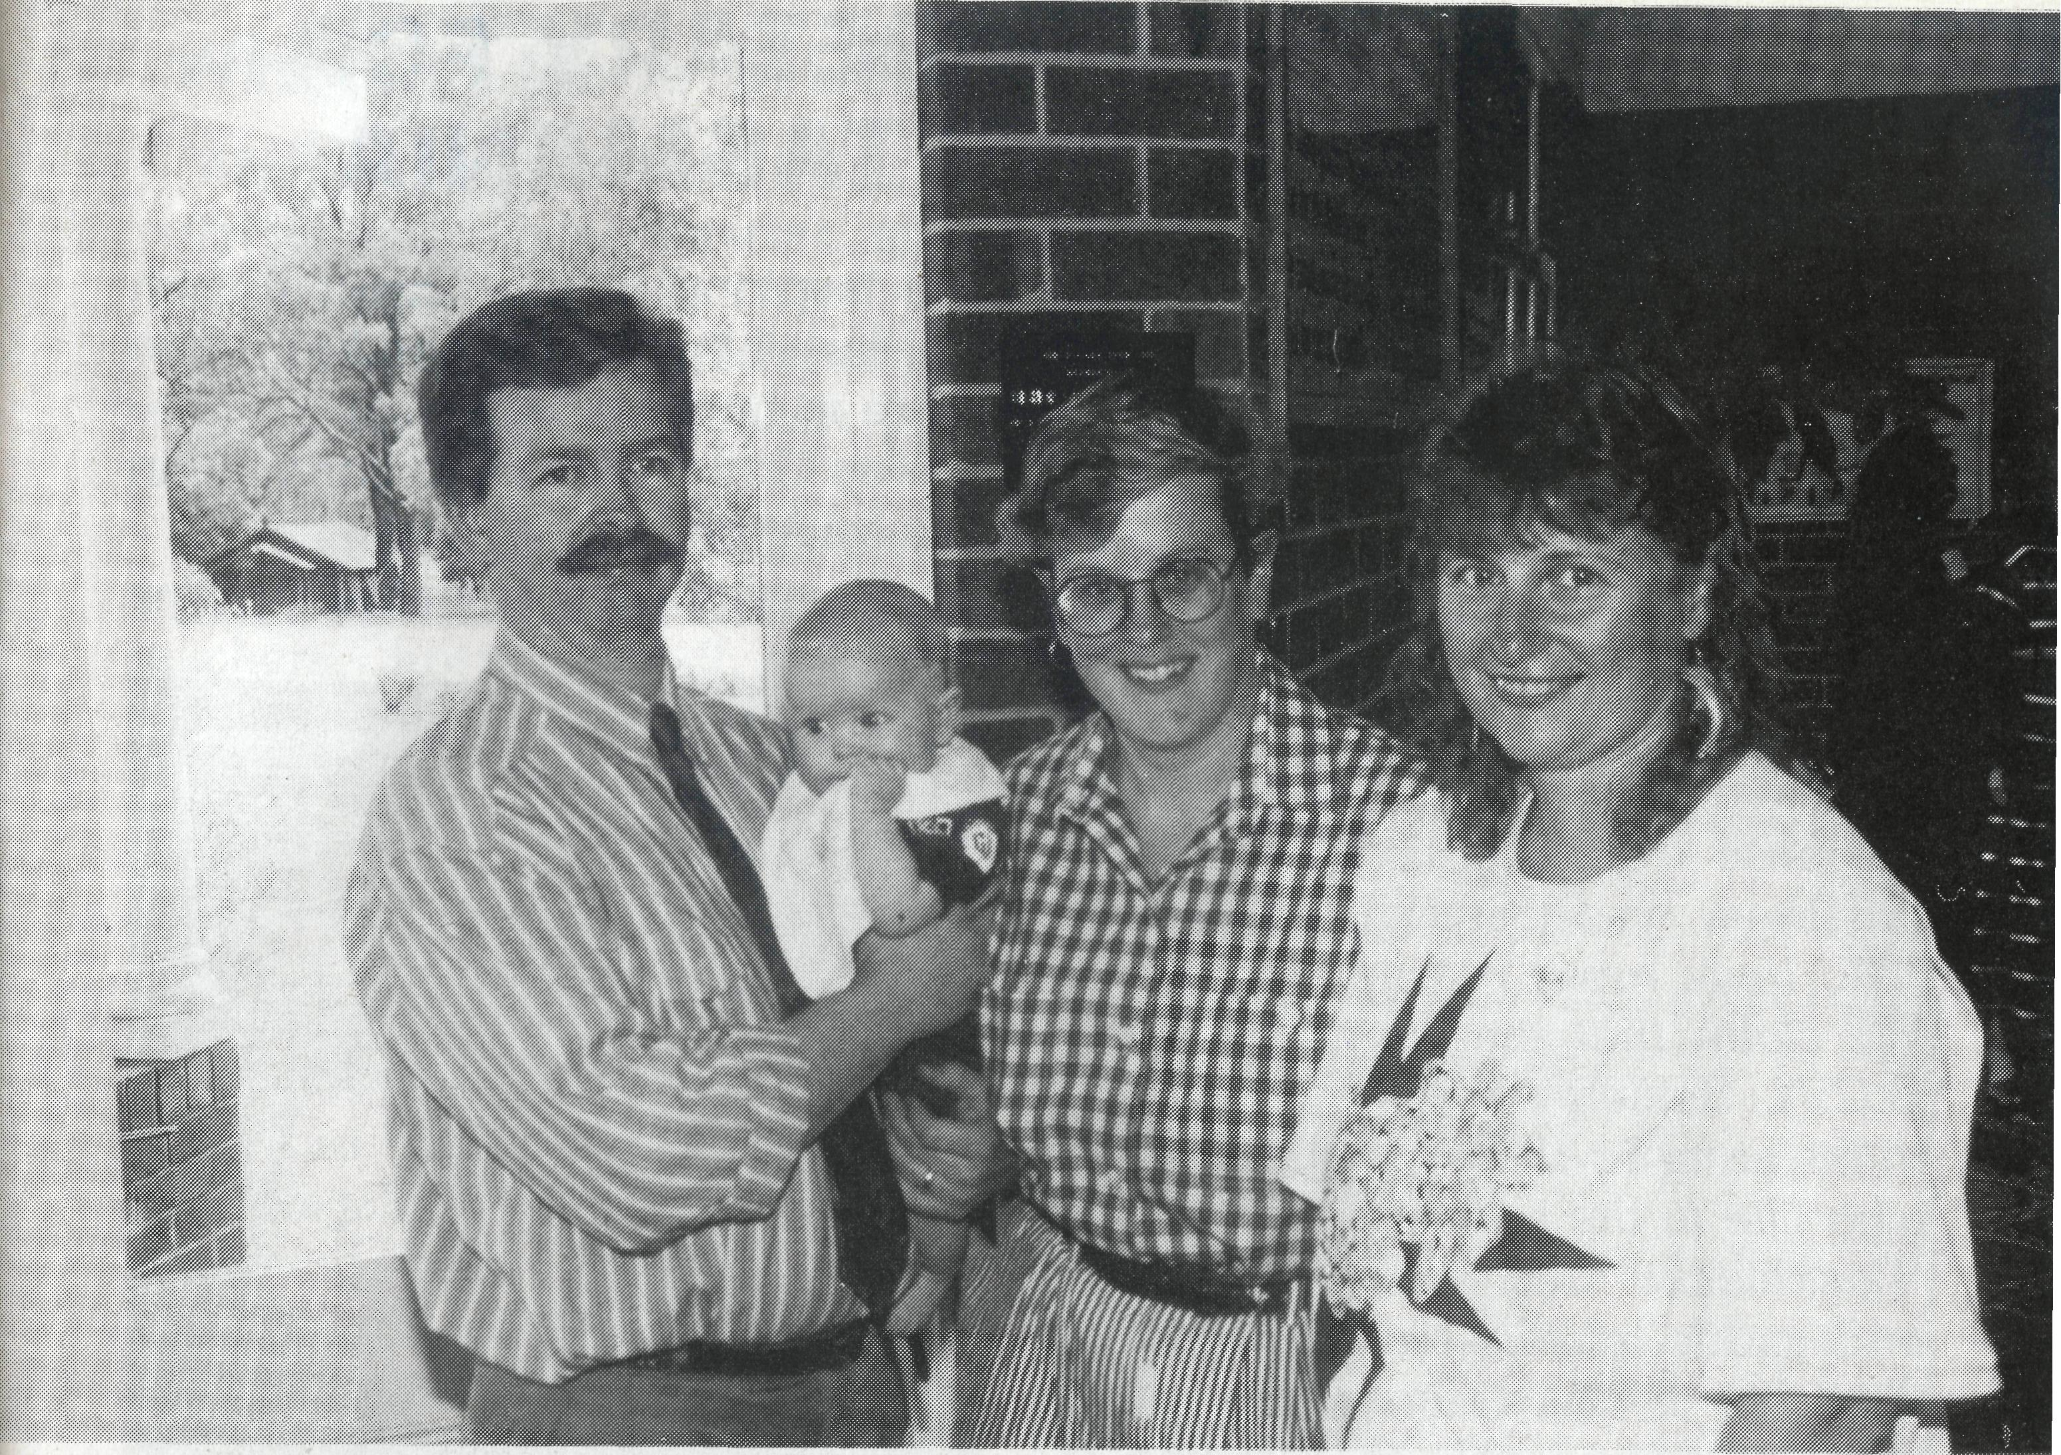
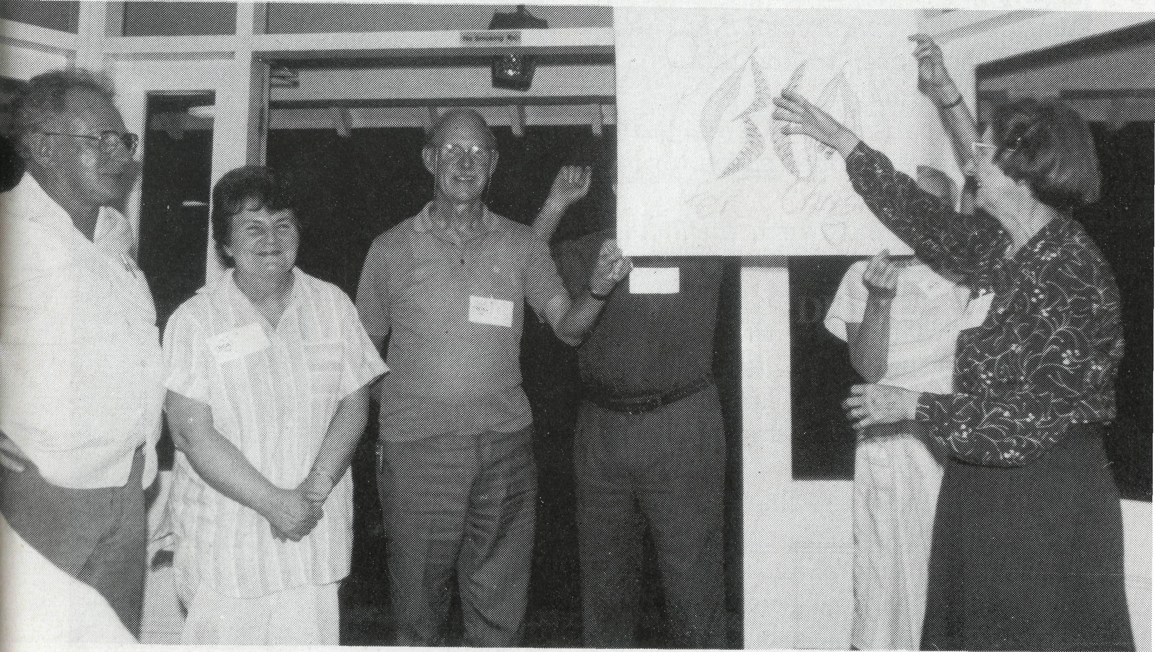
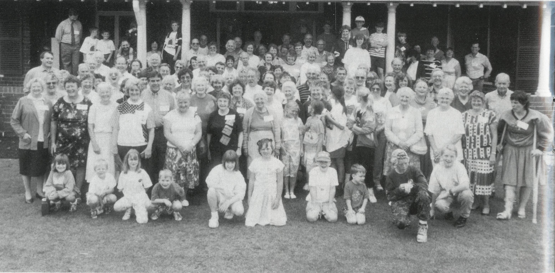
NSW SUPPORTERS¹ WEEKEND 1992
These photographs tell a story! In October last, 120 B.C.A. supporters gathered for a weekend at Gilbulla, west of Sydney.
Bible Studies were led by our Federal Secretary, Brian Roberts. Field Staff present included Dick and Pat Freeman (Bonalbo) and Mark and Lucy Taylor and baby Randall (Lightning Ridge) and Jenny Gaulton and children (Leinster). Brian Black led the singing. Lots of previous staff were there too! (Dalba Primmer, Bruce Woolcott, Beryl McLaughlin, Roy and May Buckingham, Ros Jinks, Kerrie Brownscombe and the children and Dora Warwick). It was great to have the Mullins along as well.
A great weekend of FUN, FELLOWSHIP, FOOD, INFORMATION AND FEEDING on God's Word!
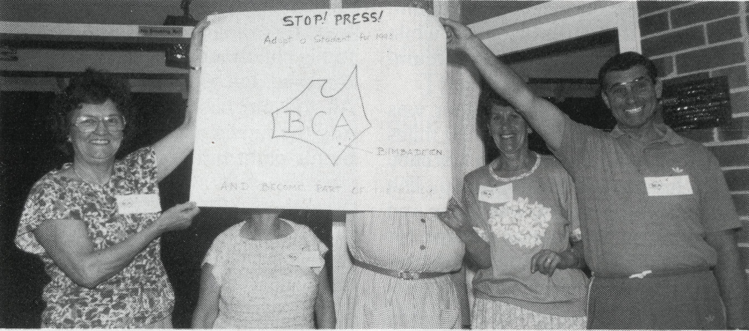
The next weekend is planned for 21st-23rd October, 1994. Mark it in your diary now!
Mark, Randall and Lucy Taylor with Jenny Gaulton.
Dick and Pat Freeman and Joe Mullins look on as artist Shirley Kilminster explains her group's artwork to everyone else.

THE REAL AUSTRALIAN
THE REAL AUSTRALIAN

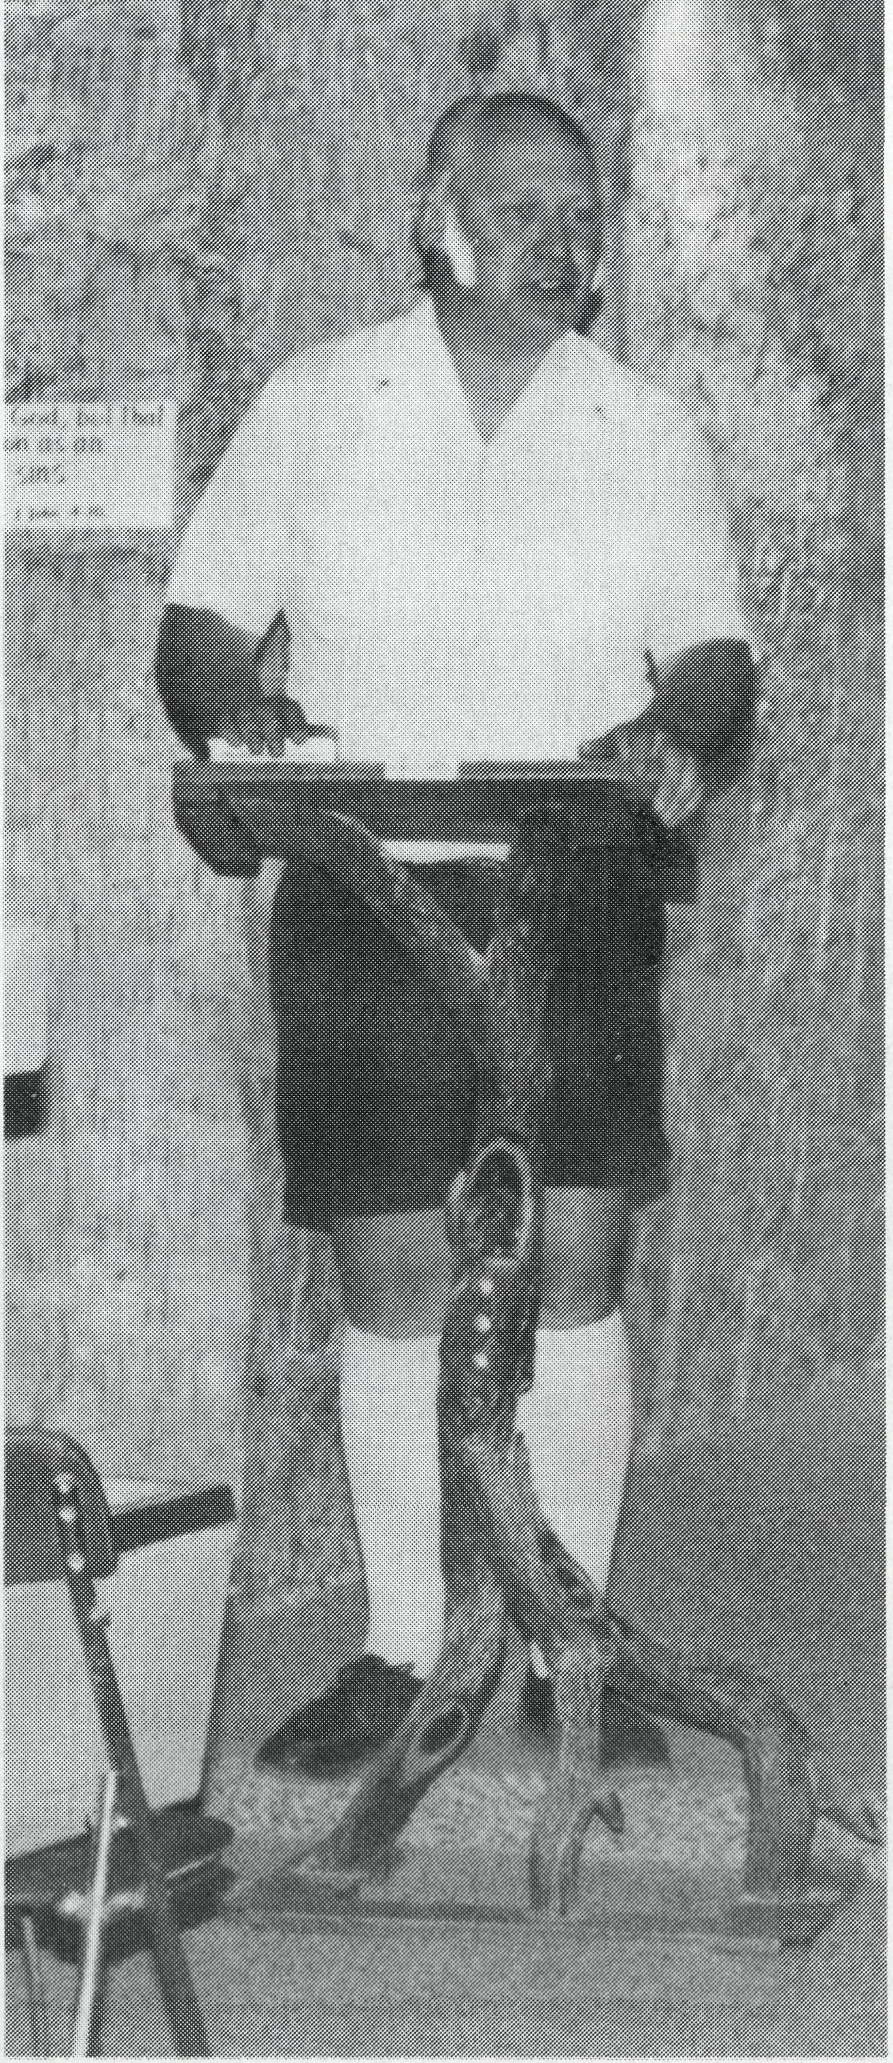
and inspiring in the Christian faith and for all that is sweet and sane and noble in human life.
May God enable us to continue in this tradition.
THE REV. BRIAN VINEY
The Rev. Brian Viney preaching in The Catacomb Church, Coober Pedy.
FROM THE SECRETARY FOR VICTORIA AND TASMANIA
What's in a name?
Occasionally people have queried the name of this publication and wondered whether we are suggesting that to be a 'real' Australian you have to live somewhere remote and isolated. Apparently after the first issue back in 1920 people commented on the name which brought the following response from our first Organising Missioner, S. J. Kirkby: "We have more reasons than one. We claim that the work which the B.C.A. Society is doing is that of ministering to the men and women who live in the real Australia of our 'Backblocks' and in the sheep-run and cattle-raising districts inland. City life in Australia is in many respects comparable to and similar to city life in England. We must go out into the country to the 'other side of the sunset' to find that which is truly Australian."
In the next issue of the magazine Kirkby gives a second reason for the name:
"Our paper stands for a distinctive work in the land. It also stands for a distinctive type of character. To us a Real Australian is one who puts the religion of the Lord Jesus Christ absolutely first in his life and who counts the service of the master as worthy of sacrifice."
Well Australia has changed a little since the 1920s but we can still claim to be a real Australian organisation calling on the "Real Australians" of the settled areas to enable our ministry to continue. Kirkby spoke of B.C.A. standing for all that is heroic
WHAT'S IN A SIGN?
What's in a sign? Ours at Cook is a point of amusement, interest, question and photography!
Tourists fleetingly pass through, make a few comments, then push on.
Who are the people living with the sign? Railway workers, school teachers, hospital staff, all with families.
The sign is painted on the Railway's steel water tank. Solid, welded and rivetted, rust is now showing, paint peeling. It is in need of renewing.
Our town, a little like the sign, at times can be depressed, lonely and sad. Negative attitudes and habits stemming from isolation, family backgrounds and the uncertain economic situation of our country.
Sunshine and light sometimes peek through when least expected. "Candy" an original Australian, with husband and sister-in-law Julie with seven children have come to town. Candy is a strong and gentle wife and mother. Sensitive to people and situations, imparting encouragement to me especially. May my response to Candy and family be a genuine outpouring of the Lord Jesus' love, care and concern.
Like the "sign" we as Christians find we too need the outside scraped off, repainting, in readiness for more effective service.
Pray along with us, as the very tiny Christian group in Cook, that we will be legible, clear, useable in our town.
SR. CHRISTINA RYMAN
Bishop Kirkby Memorial Hospital
Cook, S.A.
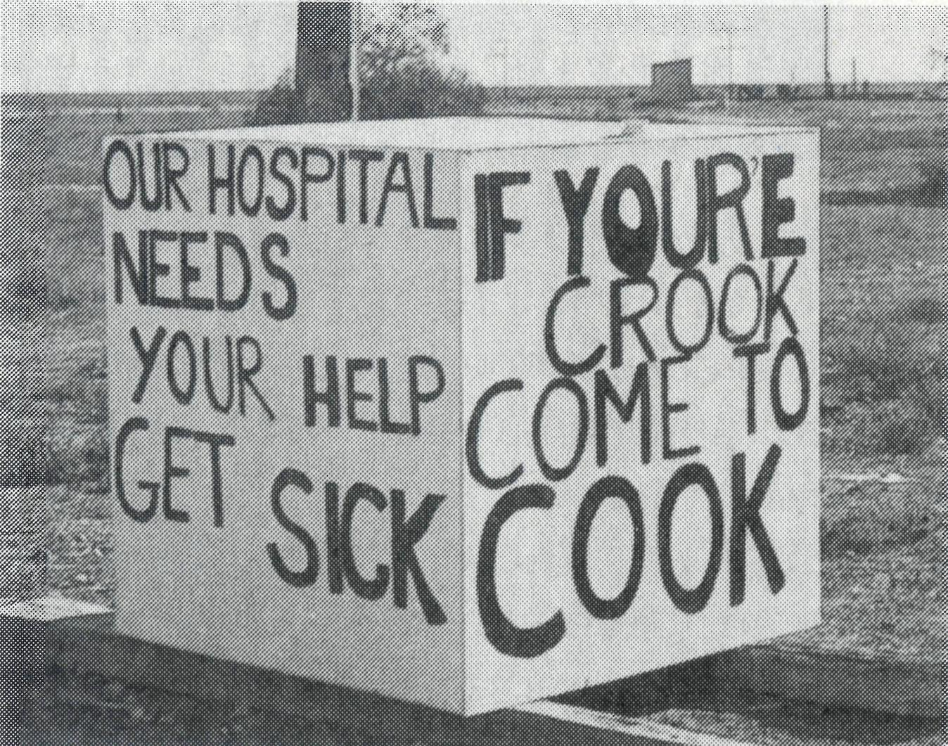
ANGELS ON THE TRACK

(A tribute to the nurses of the
Bush Church Aid Society)

Way out in remote Australia
In our country’s vast outback,
B.C.A. have nurses –
They have “angels on the track”.
They serve in lonely places there,
These girls are never slack;
The love of Christ is clearly seen
In “angels on the track”.
Of gifts of faith and hope and love,
In them there is no lack;
They bring sweet fragrance of the Christ –
These “angels on the track”.
They serve the wide community,
All persons white and black;
The railway fettlers, station hands
Bless “angels on the track”.
Besides attending patients needs –
(“Hi Betty!” “Morning Jack!”)
They teach and preach and lead the young –
These angels on the track”.
When day is done and “angels” rest,
They’re glad to “hit the sack”;
Our thanks go up to God who calls
For “angels on the track”.
Our thanks go up to God who calls
For "angels on the track".

Printed with permission.
© BRIAN BLACK

PRAYER AND PROVIDENCE
When we ask people to pray for our safety, there are a few things which are in the back of our minds, but nothing very concrete. That is, until we experience a few close calls, and consider the frailty of our human existence. Travelling on isolated mountain roads, using an axe for the first time after not needing to for 30 years, living in older buildings erected before present day stringent stipulations — these all have their unique hazards.
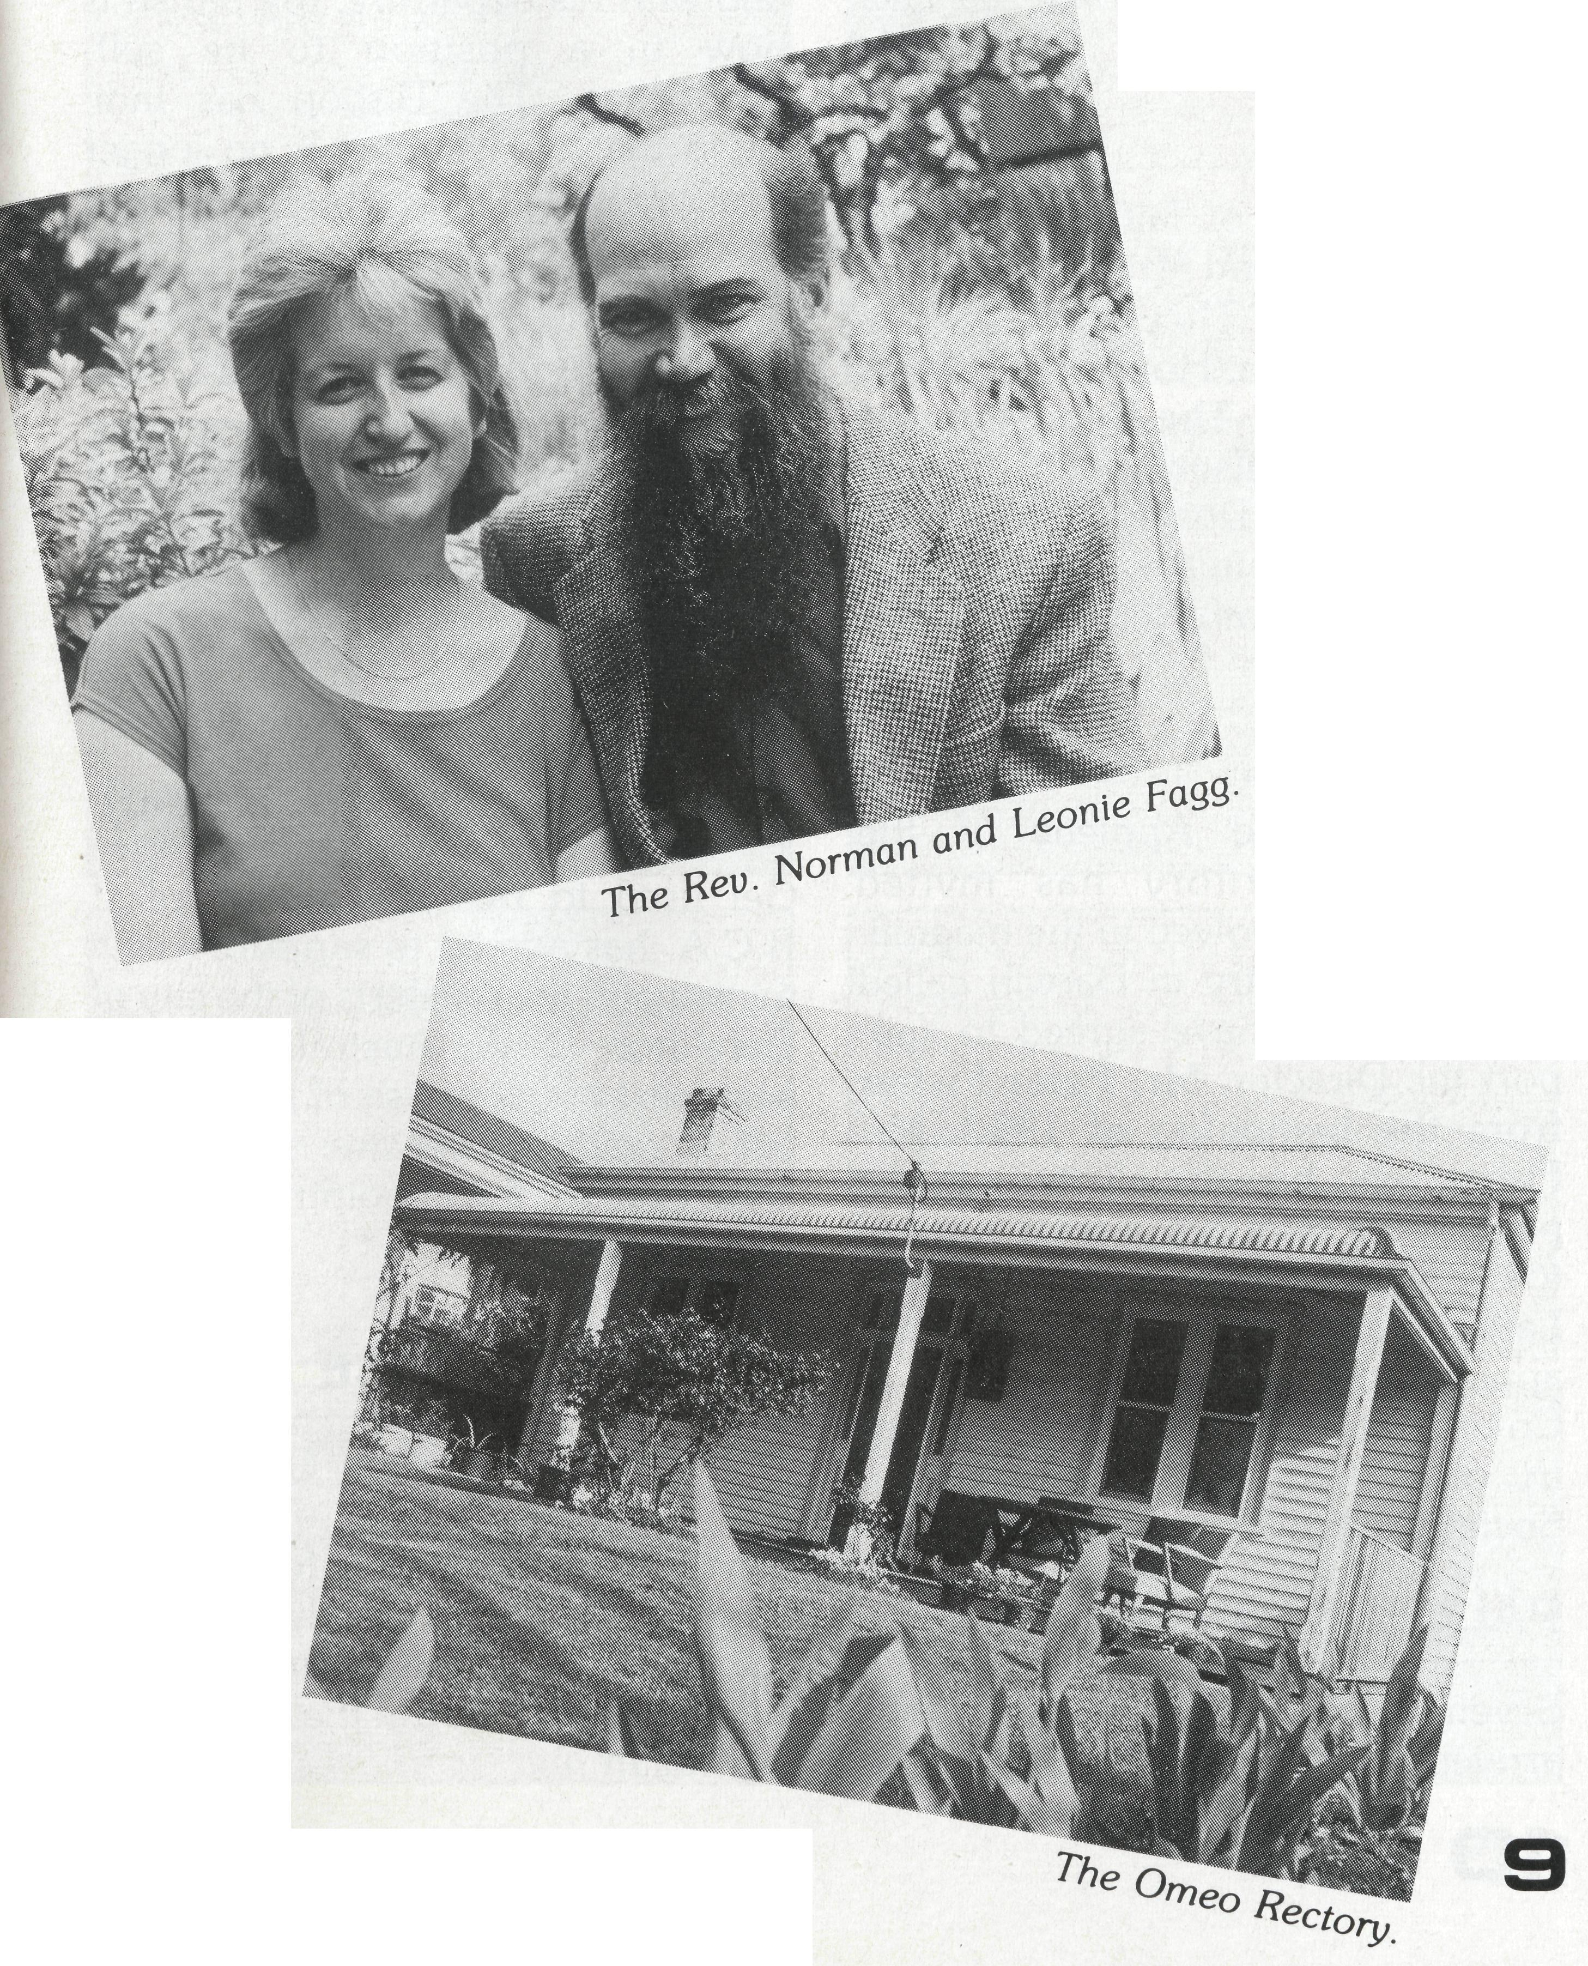
God has been very kind to us. We were returning from Wollongong via the Corryong-Benambra Road. We were about half way between Corryong and Omeo (151 km) when the car stopped. We had plenty of petrol. It just wouldn't start. Not many vehicles use that road, especially late in the day. Yet 10 minutes after we stopped another traveller stopped to see what was our problem. She was going on to the next town north and would contact the RACV for us. In the next two hours, four other vehicles passed us, three of which stopped. None of the drivers knew anything about our car's workings, but it was encouraging to know that we weren't just abandoned. After ZVi hours the RACV guys arrived. They couldn't find the source of the problem, although they had a few ideas, so we were put up onto their trailer and taken back to Omeo (that was an experience in itself). After unloading the luggage from the boot of the car, I then discovered some loose wires which when rejoined solved the problem. It was an interesting experience sitting out there waiting. The children became quite anxious at first, but we were able to pray with them, and their fears went. Leonie took them for a short walk, looking at the wild flowers along the side of the road while I waited with the car, then as darkness fell we played games and generally kept our minds off the waiting. We are in a most beautiful part of the world. We were grateful that, although we were stuck on an isolated mountain road, at the beginning of spring when the snow is thawing, and it's still quite cool, and we'd come through some bad weather earlier in the day, we were kept safe and dry.
This is the second time we have been conscious of the providence of God. Just after we moved in to the Rectory, I heard a crackling noise in the hallway. It turned out that the wiring behind the fuse board was very close to fusing, and/or catching fire. The electrician came and repaired it, but he said we were probably half an hour away from a major fire, if I hadn't heard it and turned off the power.
On all the roads around here wombats and kangaroos are an ever present reminder that we aren't the only species inhabiting this area. Wombats seem to have the idea that they have right of way — they just trundle out onto the road — and motorists beware! The highways are constantly littered with their dead bodies, and they can do some serious damage to cars and cause serious accidents. One night recently while travelling home along the Corryong-Benambra road we met three wombats. Swerving to miss them, or just slowing to let them cross has allowed us to avoid any serious encounters with them, so far. However, on the same journey we had a closer encounter of the kangaroo
8 THE REAL AUSTRALIAN
kind. By the grace of God I saw it coming, it was hopping along the side of the road beside us. But as they often do, it just hopped right out in front of us. Having already slowed down, I braked heavily, the nose of the car dipped, we caught the roo low down, and it just rolled over, lay on the bonnet of the car as we skidded to a stop, and just before it reached the windscreen, slid off onto the road in front of the car. Before anyone could move it was up and bounded off into the bush. No damage was done to the car. And once again we gave thanks that the Lord is ever present with us, and that His people are praying for
us.
Thank you Lord, and thank you B.C.A. prayer supporters.
NORMAN FAGG Omeo

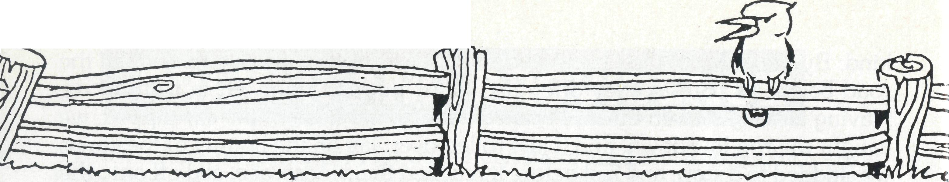
POST & RAILS
MRS. FREDA RAINSFORD 1901-1992
Mrs. Rainsford (Mother of The Rev. Barry) was buried at St. James' Turramurra on 26th August. A long-time supporter of B.C.A., Mrs. Rainsford was Box Secretary for many years and made hundreds of items of handiwork for sale with the proceeds going to B.C.A. Praise God for her lite and ministry.
THE REAL AUSTRALIAN
Time moves on and so do our B.C.A. Field Staff.
Fortunately, the Lord raises up others to replace them. We thank God for the ministry of those who leave and warmly welcome our new comers . . .
WILCANNIA
After six years of faithful ministry, The Rev. Bob and Mrs. Phyllis Collie are retiring. They return to Melbourne in March. Hot on their heels in March will be The Rev. Don and Mrs. Helen Wilson, from Penrith, west of Sydney. Don and Helen have served the Lord in Anglican parishes for 34 years in both New Zealand and Sydney.
DARWIN
Bishop Richard Appleby of the Northern Territory has invited B.C.A. to be involved in the magnificent care ministry in Darwin called Anglicare. We have agreed to support the Director, Mr. Peter Fisher from the beginning of 1993. Mr. Fisher, who has already been in the position for over two years is married to Lynne. They have three girls: Kate, Lauren and Alex. Prior to this appointment, Peter had served as Coordinator of Care Force, a ministry of the Anglican Home Mission Society in Wollongong, N.S.W.
PALMERSTON
Seven years to the day after they arrived in Darwin, The Rev. Ron

and Margaret Bundy with Simon, Ruth and Lydia moved prior to Christmas, to the parish of The Gap' in the Diocese of Brisbane. Ron was the founding Rector of Palmerston and with his departure, the parish is now in a position to be self-supporting. The Bishop has indicated that our support is no longer needed and Palmerston will now come off the B.C.A. map.
TARCOOLA
Sister Gill Wright of Melbourne commenced duties at Tarcoola hospital in January. Pray for Gill as she settles into this isolated community.
WAGGRAKINE (Pronounced Woggrackine)
Get used to this new name folks! B.C.A. has agreed to support a new ministry on the outskirts of the city of Geraldton (N.W. Australia). It has been part of the parish of Bluff Point but is ready to become a separate area. Pray for the appointment of the right Minister.
BRISBANE OFFICE
The State Secretary for Queensland and Northern N.S.W., The Rev. Ernest Horth and his wife Ida, have accepted the Parish of Balwyn in Melbourne. They'll take up the appointment in May. (More in the June 'Real Australian'.)
B.C.A. ANNUAL MEETINGS IN 1993

FEDERAL A.G.M.
Date: Thursday, 27th May,
9.30 a.m. Location: St. Stephen's, 6 Harry
Street, Eastlakes. Parking also in Westcott Street with entry through Church Hall.

N.S.W. BRANCH:
Date: Tuesday, 20th April,
8.00 p.m. Coffee & Dessert. Location: St. John's Parramatta. Speaker: Rev. Brian Roberts, Federal Secretary.

QLD. & NTH. N.S.W. BRANCH:
Date: Friday, 23rd April. Commence
6 p.m. with Dinner.
Location: Parish of The Gap,
Brisbane.
Chair: Bishop Clyde Wood.
Speakers: Rev. Ron & Margaret
Bundy.
R.S.V.P. (07) 349 9081 – 14.4.93

W.A. A.G.M.
Date: Sunday, 21st March. 7.00 p.m.
Location: Holy Cross Church,
Cnr. McLean Street & Coleman Crescent,
Speaker: Bishop Tony Nichols

ANNUAL THANKSGIVING
SERVICE
Date: Thursday. 27th May,
7.00 p.m.
Location: St. Philip's. York Street,
Sydney. Field staff: Sr. Christina Ryman.
Preacher: Bishop Harry Goodhew.

VIC. & TAS. BRANCH: Date: Monday, 3rd May. Location: St. Mark's. Forrest Hill Speakers: Fed. Sec. Rev. Brian
All state secretaries present
Dinner: 6 p.m. Meeting: 8 p.m.
R.S.V.P. 26th April. Ph. 654 8022

S.A. & N.T. BRANCH
Date: Tuesday, 4th May. Location: St. Aiden's, Payneham. Speaker: Federal Sec. BCA. Rev. B.
A.G.M.: 7.45 p.m.

Nominations for State or Federal Committees must be in the hands of
two weeks prior to the meeting date, duly signed by the proposer and candidate. Anyone interested in being
with their State Secretary.

PRAY FOR OUR STAFF
WINNING AUSTRALIA FOR CHRIST

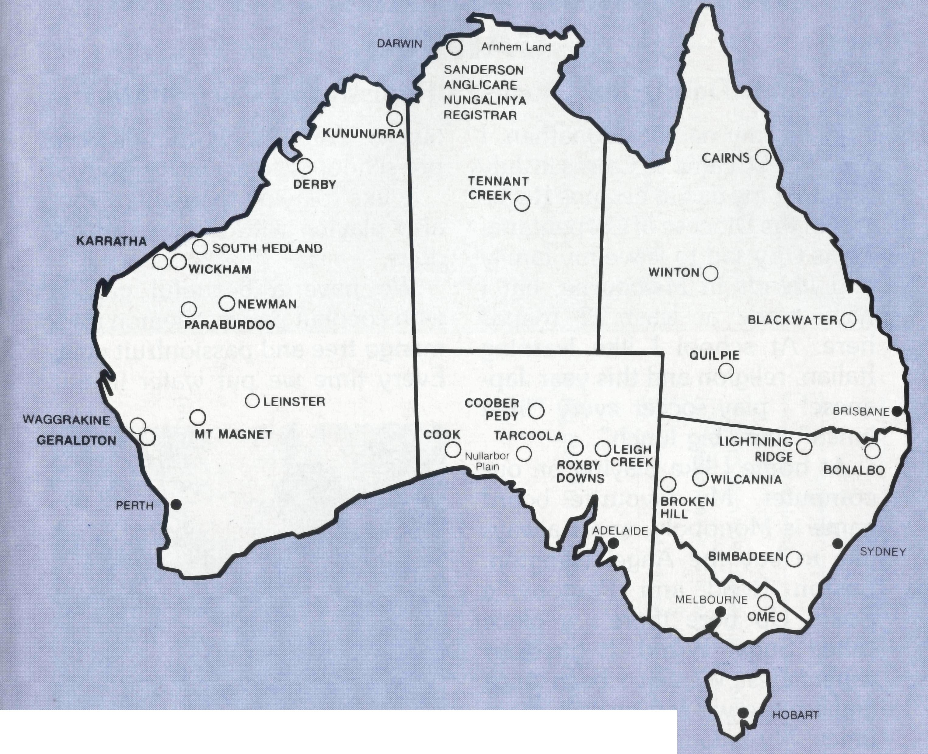
• Diocese of Northern Territory — Bishop Richard Appleby
- Sanderson — Rev. Greg and Mrs. Kerry Thompson and Mr. Keith Nolan.
- Anglicare Director — Mr. Peter Fisher.
- Tennant Creek — Vacant.
- Diocesan Secretary/Treasurer — Mr. David Martin.
• Diocese of North West Australia — Bishop Tony Nichols.
- Kununurra — Rev. John and Mrs. Dianne Symons.
- Derby — Rev. Jon and Mrs. Rae Reinertsen.
- Newman — Rev. Raymond and Mrs. Betty Lou Molyneux.
- South Hedland — Rev. Ray and Mrs. Lyn Arthur.
- Karratha — Rev. Terry and Mrs. Fiona Redmond.

- Wickham — Rev. Bill and Mrs. Jocelyn Ross.
- Tom Price/Paraburdoo — Rev. Brian and Mrs. Joy Harding. Waggrakine — Vacant.
- Counselling Ministry: Neil Hamilton.
- Mt. Magnet (Murchison) — Rev. Philip and Mrs Margaret Bassett.
- Leinster — Rev. Les and Mrs. Jenny Gaulton.
- Diocesan Registrar — Mrs. Kay Winfield in Geraldton.
• Diocese of Perth — Archbishop Peter Carnley.
16 Hon. B.C.A. Secretary for W.A. — Rev. Peter Brain.
• Diocese of Willochra — Bishop David McCall.
- Coober Pedy — Vacant.
- Roxby Downs & Mid-West Mission — Rev. John and Mrs. Leone Rutherford.
- Leigh Creek — Rev. Peter and Mrs. Margaret Achurch.
State Secretary for S.A. — Rev. Bob George, Mrs. Aila Alderson.
20 Cook: Bp Kirkby Mem. Hosp. — Gai DiDonna & Christina Ryman.
Tarcoola Hospital — Wendy (and Ford) McDonald, Gill Wright.
• Diocese of Gippsland — Bishop Colin Sheumack.
21 Omeo — Rev. Norman and Mrs. Leonie Fagg.
State Secretary for Vic. and Tas. — Rev. Brian Viney, Ms. Margo Bright.
• Diocese of Riverina. Vacant.
22 Broken Hill Hostel — David and Elisabeth Bull, Shane and Suzanne Morrow.
Wilcannia — Rev. Don and Mrs. Helen Wilson.
• Diocese of Armidale — Bishop Peter Chiswell.
23 Lightning Ridge — Rev. Mark and Mrs. Lucy Taylor.
• Diocese of Carpentaria — Bishop Tony Hall Matthews.
23 Diocesan Registrar — Mr. John Bleakley.
• Diocese of Grafton — Bishop Bruce Schultz.
- Bonalbo — Rev. Dick and Mrs. Pat Freeman.
- N.S.W. Office — Revs. David Mulready and Jim Thomson. Mrs. Michele Peacock.
• Diocese of Brisbane — Archbishop Peter Hollingworth.
- Quilpie — Vacant.
- State Sec. for Old. & north. N.S.W. Rev. Ernest Horth, Mrs. Elaine Kuiri.
• Diocese of Rockhampton — Bishop George Hearn.
28 Winton — Vacant.
Blackwater — Rev. Peter and Mrs. Jeannette Blundell.
29 ABORIGINAL MINISTRY:
Bishop Arthur and Mrs. Colleen Malcolm — Cairns, Townsville and Mackay. Nungalinya College — Principal: Rev. Dr. Les Brockway. Bimbadeen College — Mr. Denis and Mrs. Maureen Atkinson.
30 B.C.A. FEDERAL OFFICE: Rev. Brian Roberts, Mr. Jim Gosbee, Mesdames
Jacqueline Griffiths, Lay Lee Boughton and Eileen Darbin.
THE B.C.A. PRAYER
0 Lord our God, help us to remember those who live in the remote parts of our land. We ask you to strengthen and encourage all whose ministries are supported by The Bush Church Aid Society. Refresh them in times of discouragement and loneliness and call others to stand with them in the task of making Christ known. Grant that, through the ministry of the Word and Sacraments, through medical work, through service and by caring for the young, the message of your redeeming love may be proclaimed, and accepted by the people throughout our land. We ask these things through Jesus Christ our Lord, who lives and reigns with you and the Holy Spirit, one God, for ever and ever. AMEN.
If you'd like more details for prayer, send for our FREE quarterly prayer notes. (See reply page.)

THE REAL AUSTRALIAN
THE REAL AUSTRALIAN

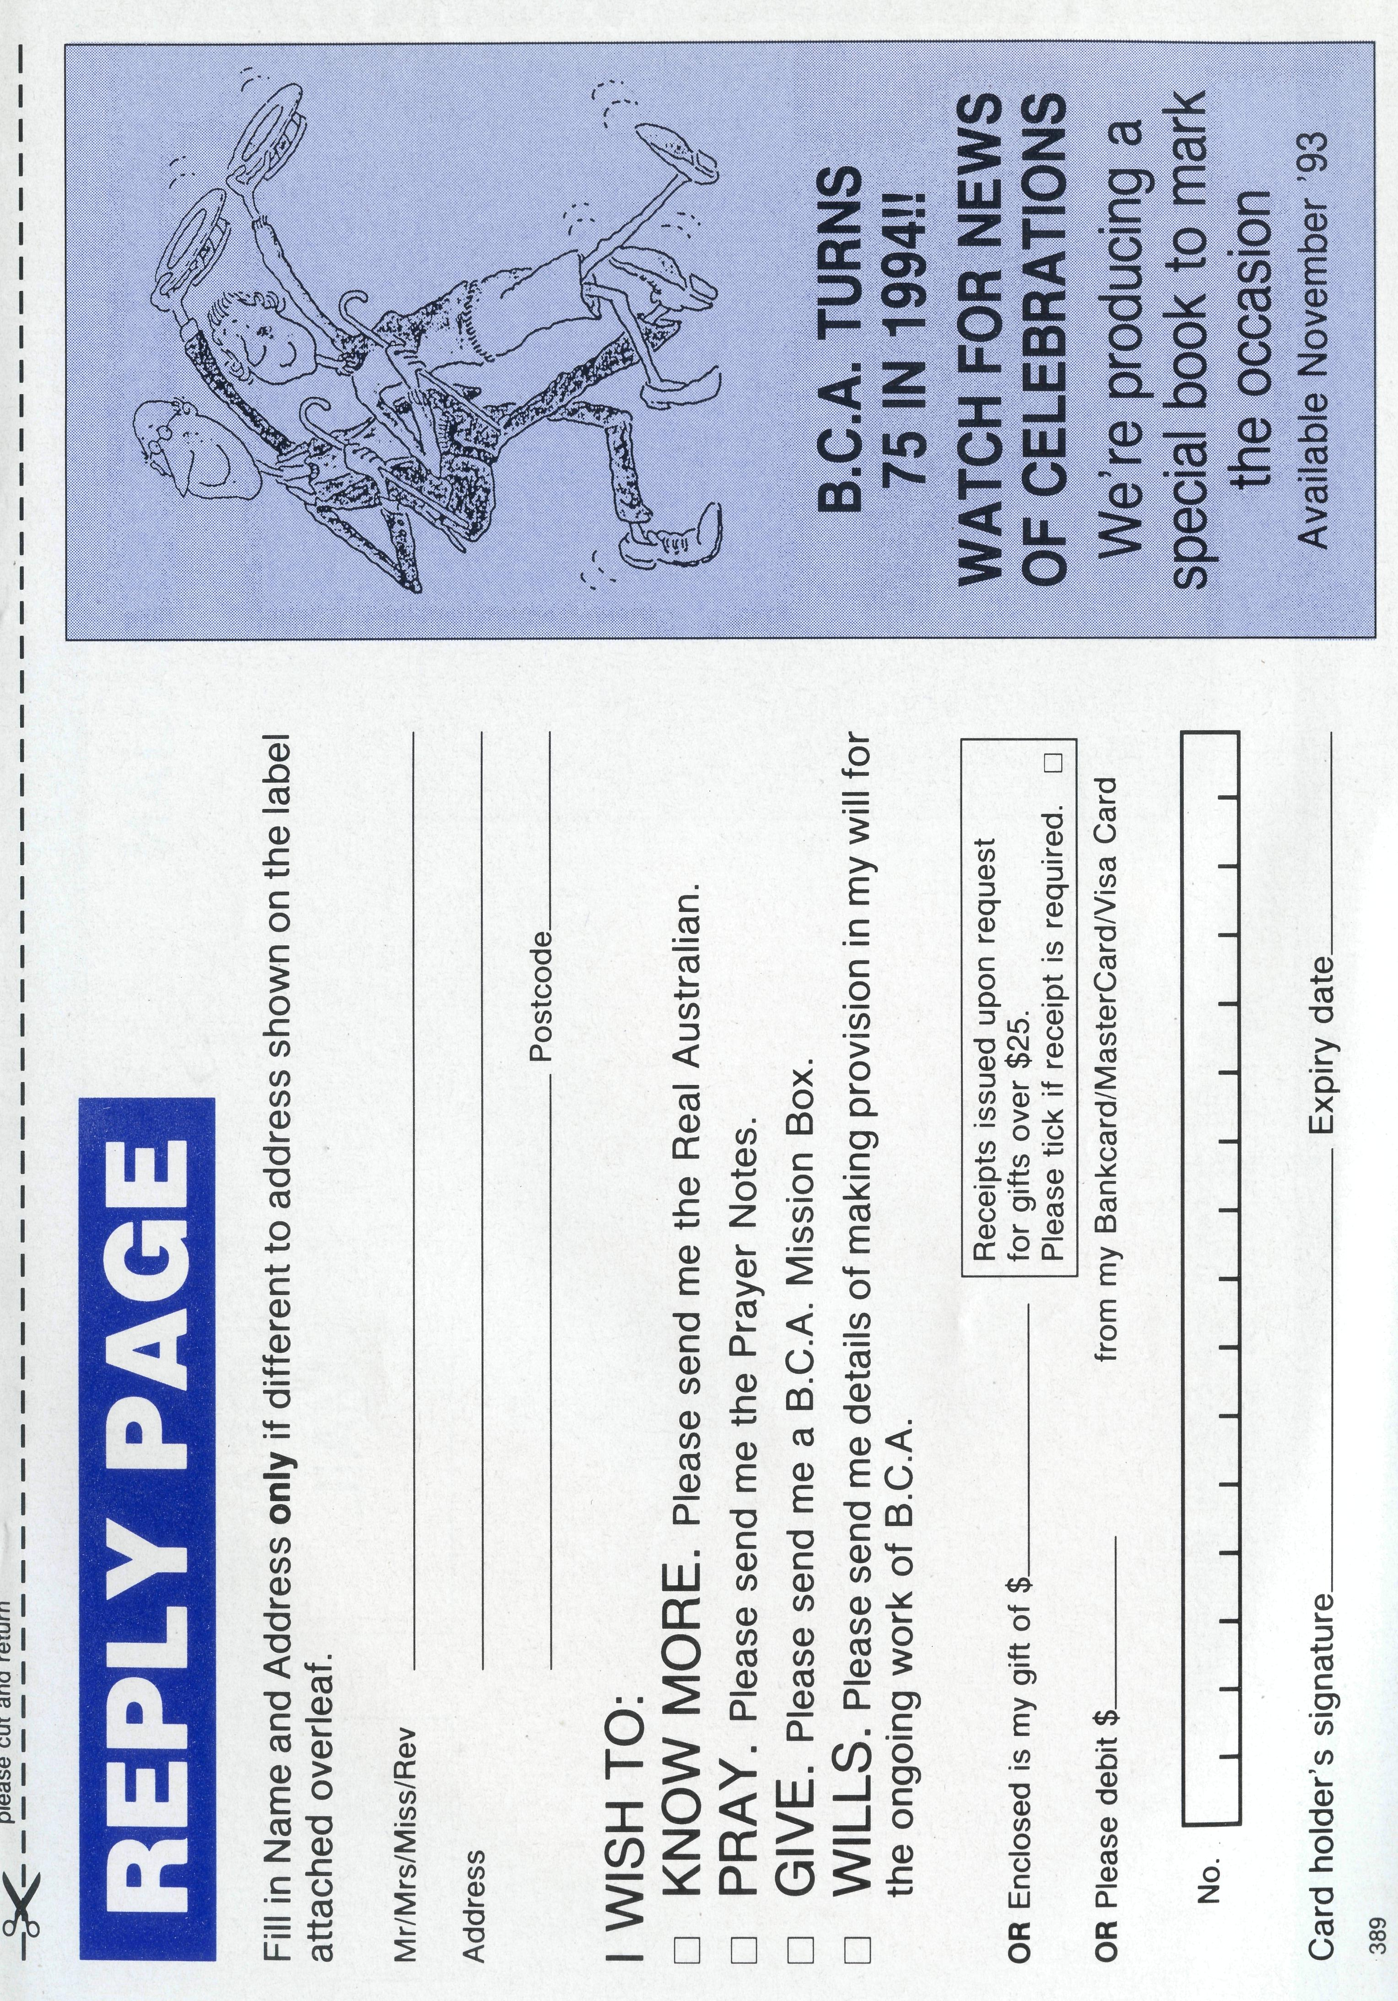
INTRODUCING JONATHAN AND
CATHERINE BLEAKLEY FROM
CAIRNS
(Their Dad is the Diocesan Registrar of Carpentaria)
blocks. Some of my friends from preschool go to my new school.
I like playing computer too, also playing with Duplo and my dolls.
We have a beautiful garden with coconut palms, a lemon tree, mango tree and passionfruit vine. Every time we put water in our
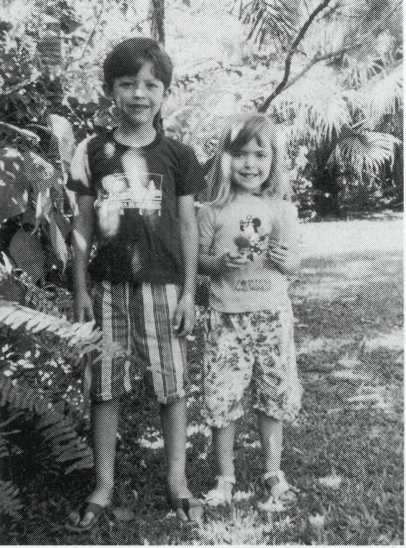
Hello, my name is Jonathan. I am l^{x}k. We came to Cairns in July 1992 for my dad to become Registrar of the Diocese of Carpentaria. I was very sad to leave my family and friends in Melbourne, but I have made at least 12 friends here. At school I like learning Italian, religion and this year Japanese! I play soccer every "little lunch" and "big lunch".
At home I like playing on our computer. My favourite board game is Monopoly, and I always like to buy the Angel Islington, Euston Road and Pentonville Road. Up here there's a place called Sugar World. It has four waterslides. We have been once and I hope we can go lots more times. My favourite slide was the "Flying Fox".
That's all for now,
JONATHAN
wading pool, we find cane toads in it the next day!
I like to eat pizza, olives, green pepper, lollies and ice-cream. I don't like mango, pumpkin and potato.
Goodbye.
CATHERINE
My name is Catherine and I am 4%. I started school this year. In 1992 I went to preschool. I had great fun in the "box corner". We had a dollies corner too and in the last week of preschool after our Christmas party, we played with the dolls in the "stable". We had two mice at pre-school and we made houses for them out of

