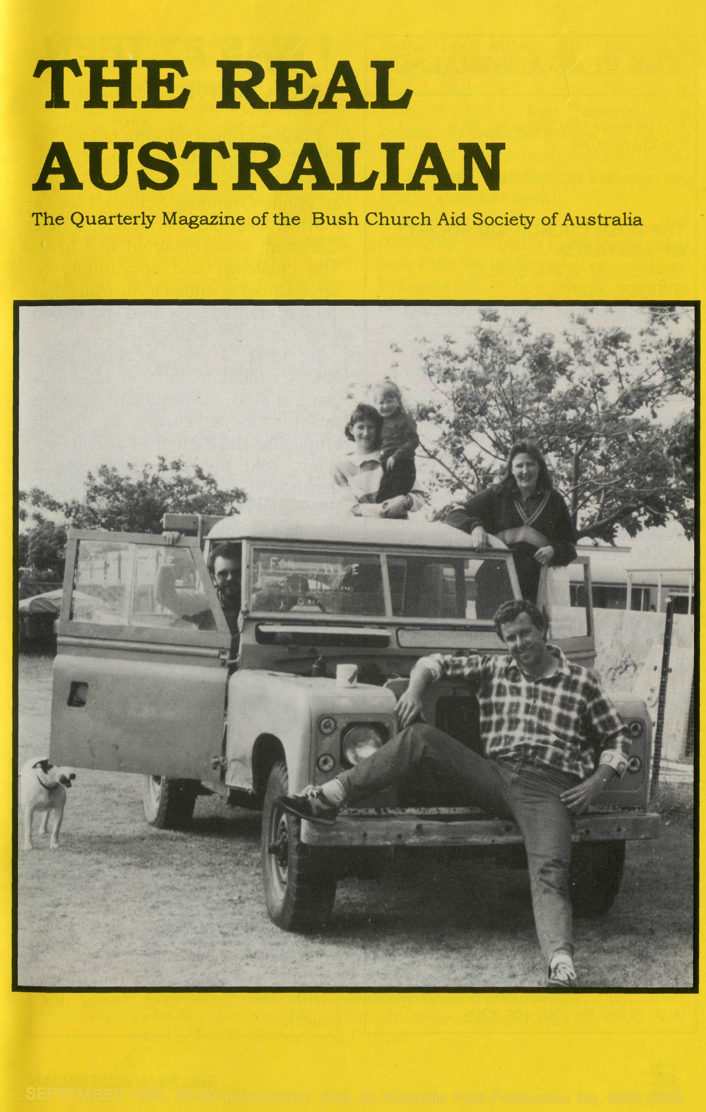
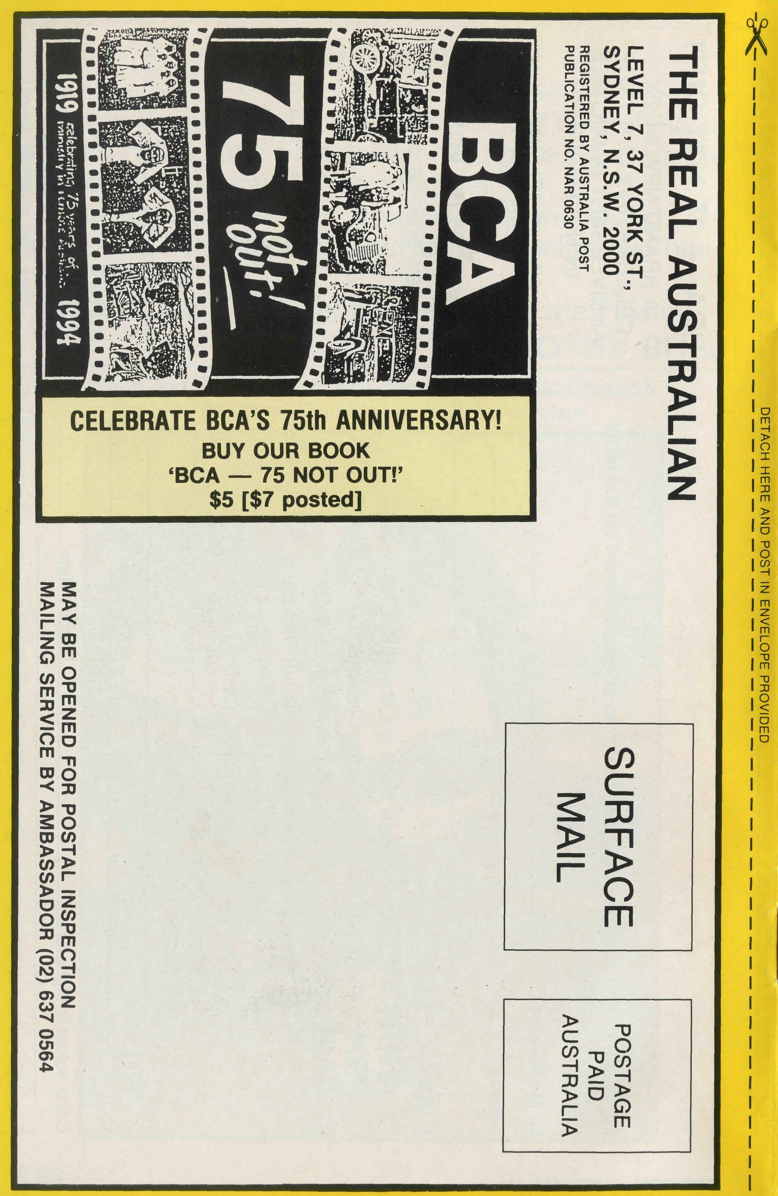
SEPTEMBER 1993. $3.00 subscription. Reg. by Australia Post Publication No. NAR 0630
Printed by Ambassador Press Pty. Ltd., Granville 2142.

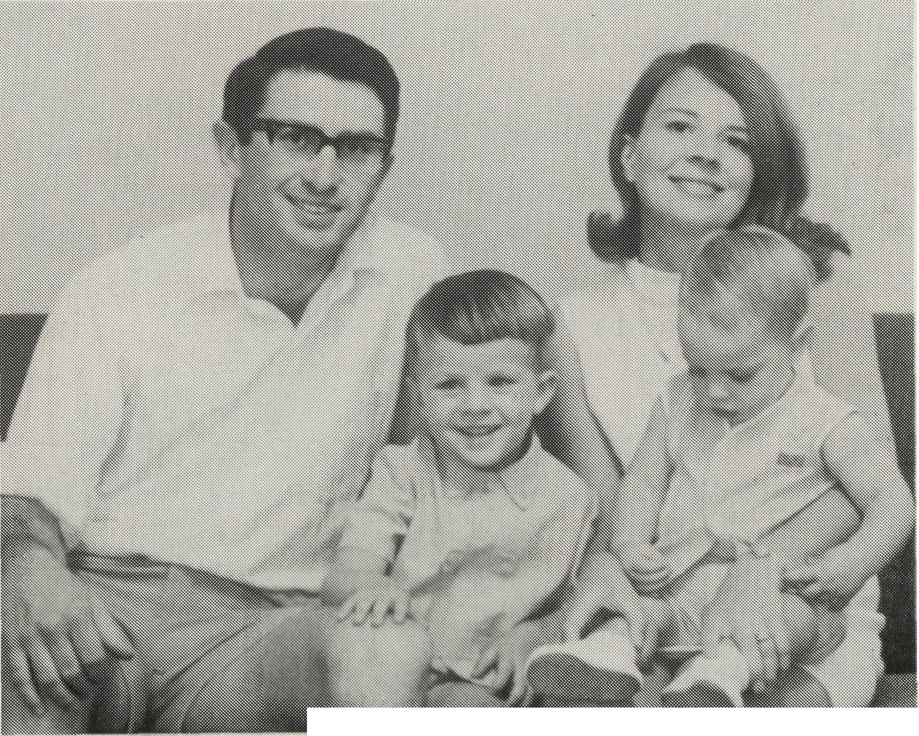
The Rev. Brian and Mrs. Carolyn Carter in Leigh Creek in 1971 with Michael and Phillip.
THE REAL AUSTRALIAN
First published 1920. Edition No. 281 Circulation: 28,000
All enquiries to: THE EDITOR
David Mulready
THE BUSH CHURCH AID SOCIETY OF AUSTRALIA
LEVEL 7, 37 YORK STREET,
SYDNEY 2000
Ph (02) 262 5017. Fax (02) 262 5020
B.C.A. DIRECTORY
President: Archbishop Harry Goodhew
Chairman: Archdeacon Vic Roberts
Patron: Archbishop Keith Rayner
Vice-Presidents: Mr. Stan Hummerston, O.A.M.; Mr. Ray Otercteko.
Hon. Treasurer: Mr. R. Otercteko.
Federal Secretary: Rev. Brian Roberts.
N.S.W. Secretary: Rev. David Mulready. Level 7, 37 York Street, Sydney, N.S.W. 2000. Ph (02)262 5017.
Victorian Secretary: Rev. Brian Viney, Shop 1, 205 Flinders Lane, Melbourne, Vic. 3000. Ph (03) 654 8022.
South Australian Secretary: Rev. Bob George, Church Office, 44 Currie Street, Adelaide, S.A. 5000. Ph (08) 212 7804.
Queensland Secretary: Rev. Les Monaghan, P.O. Box 6472, Upper Mt. Gravatt, Old. 4122. Ph (07) 349 9081.
Western Australia Hon. Secretary: Rev. Peter Brain, 27 Leach Street, Wanneroo, W.A. 6065. Ph (09)405 1325.
I WAS 27 THEN
B.C.A. SERVICE 1966-1973
I was recruited into the fellowship of B.C.A. supporters by John Greenwood, the N.S.W. Secretary, in 1953 at Trinity Grammar School. I was a fourteen-year-old school boy, a new Christian, just converted to Christ. The challenge and opportunity to serve Christ in outback Australia that John presented took hold and stayed with me in the years ahead.
In 1961, I was accepted as a B.C.A. candidate. In 1966, after four years at Moore College and eighteen months as a curate at South Hurstville, Bill Rich, the Federal Secretary told me that there was a vacancy at Tarcoola and the North West Line Mission, and I was to fill it. My wife Carolyn and I were handed plane tickets for Adelaide, told to buy a car, go to Tarcoola and start work. I was 27.
This was a mission district described as "A thousand miles long and four feet eight and a half inches wide". It was the Trans Australia Railway line between Port Augusta and Kalgoorlie, and a few sheep stations in the Tarcoola area. The job was to evangelise the itinerant fettlers and railway families along the line. I would set off with a pocket full of Scripture Gift Mission tracts in English and a range of European languages, for the fettlers were nearly
FRONT COVER PHOTO:
The Hostel staff from Broken Hill with the Landrover ready for work.
all new Australians, and had to travel the line on the weekly supply train — "The Tea and Sugar".
In 1967 the boundary of the Diocese of Willochra was changed to include Tarcoola, and this meant that Coober Pedy came within the area. Once a month I would drive the 150 rough miles north and visit the town for a week. As a result of this ministry a small, regular congregation came together, the foundation of the present Catacomb Church.
In 1969 Carolyn and I moved to Leigh Creek to take over the work of the Northern Mission from Ernie and Jan Carnaby. Space prevents an account of our many adventures in the work of the gospel — perhaps a highlight was to facilitate Pitjantjatjara Christian leaders from Indulkana coming to preach the gos-pel to other Aborigines in Oodnadatta.
Those years gave us the privilege of fellowship with some of B.C.A.'s heroes — Allan Chadwick, Stan Hummerston, John Lindridge, Maud
Ross, Lola Hicks, Ann Dau, Ron Keynes, Merna Mueller, Rosemary Bond, Barbara Fox, Barry Rainsford, Ged Muston, Theo Hayman and others. As well there were the people of Christ in the bush schools, cattle and sheep stations and along the track.
Looking back from the perspective of twenty-five years I am dismayed at how little we understood evangelism, but amazed at how much ambition and energy we had. The aim was to reach every person in South Australia north of Port Augusta, no matter how isolated and remote, with the gospel. For all our inexperience we gave that our best shot. The results — how the Lord may have used our efforts, for his purpose, we trust to Him.
BRIAN & CAROLYN CARTER June 1993
(The Rev Brian Carter is back with B.C.A. as a part-time Deputationist in the Dioceses of Canberra/Goulburn, The Riverina and Bathurst)

THE REAL AUSTRALIAN
THE REAL AUSTRALIAN

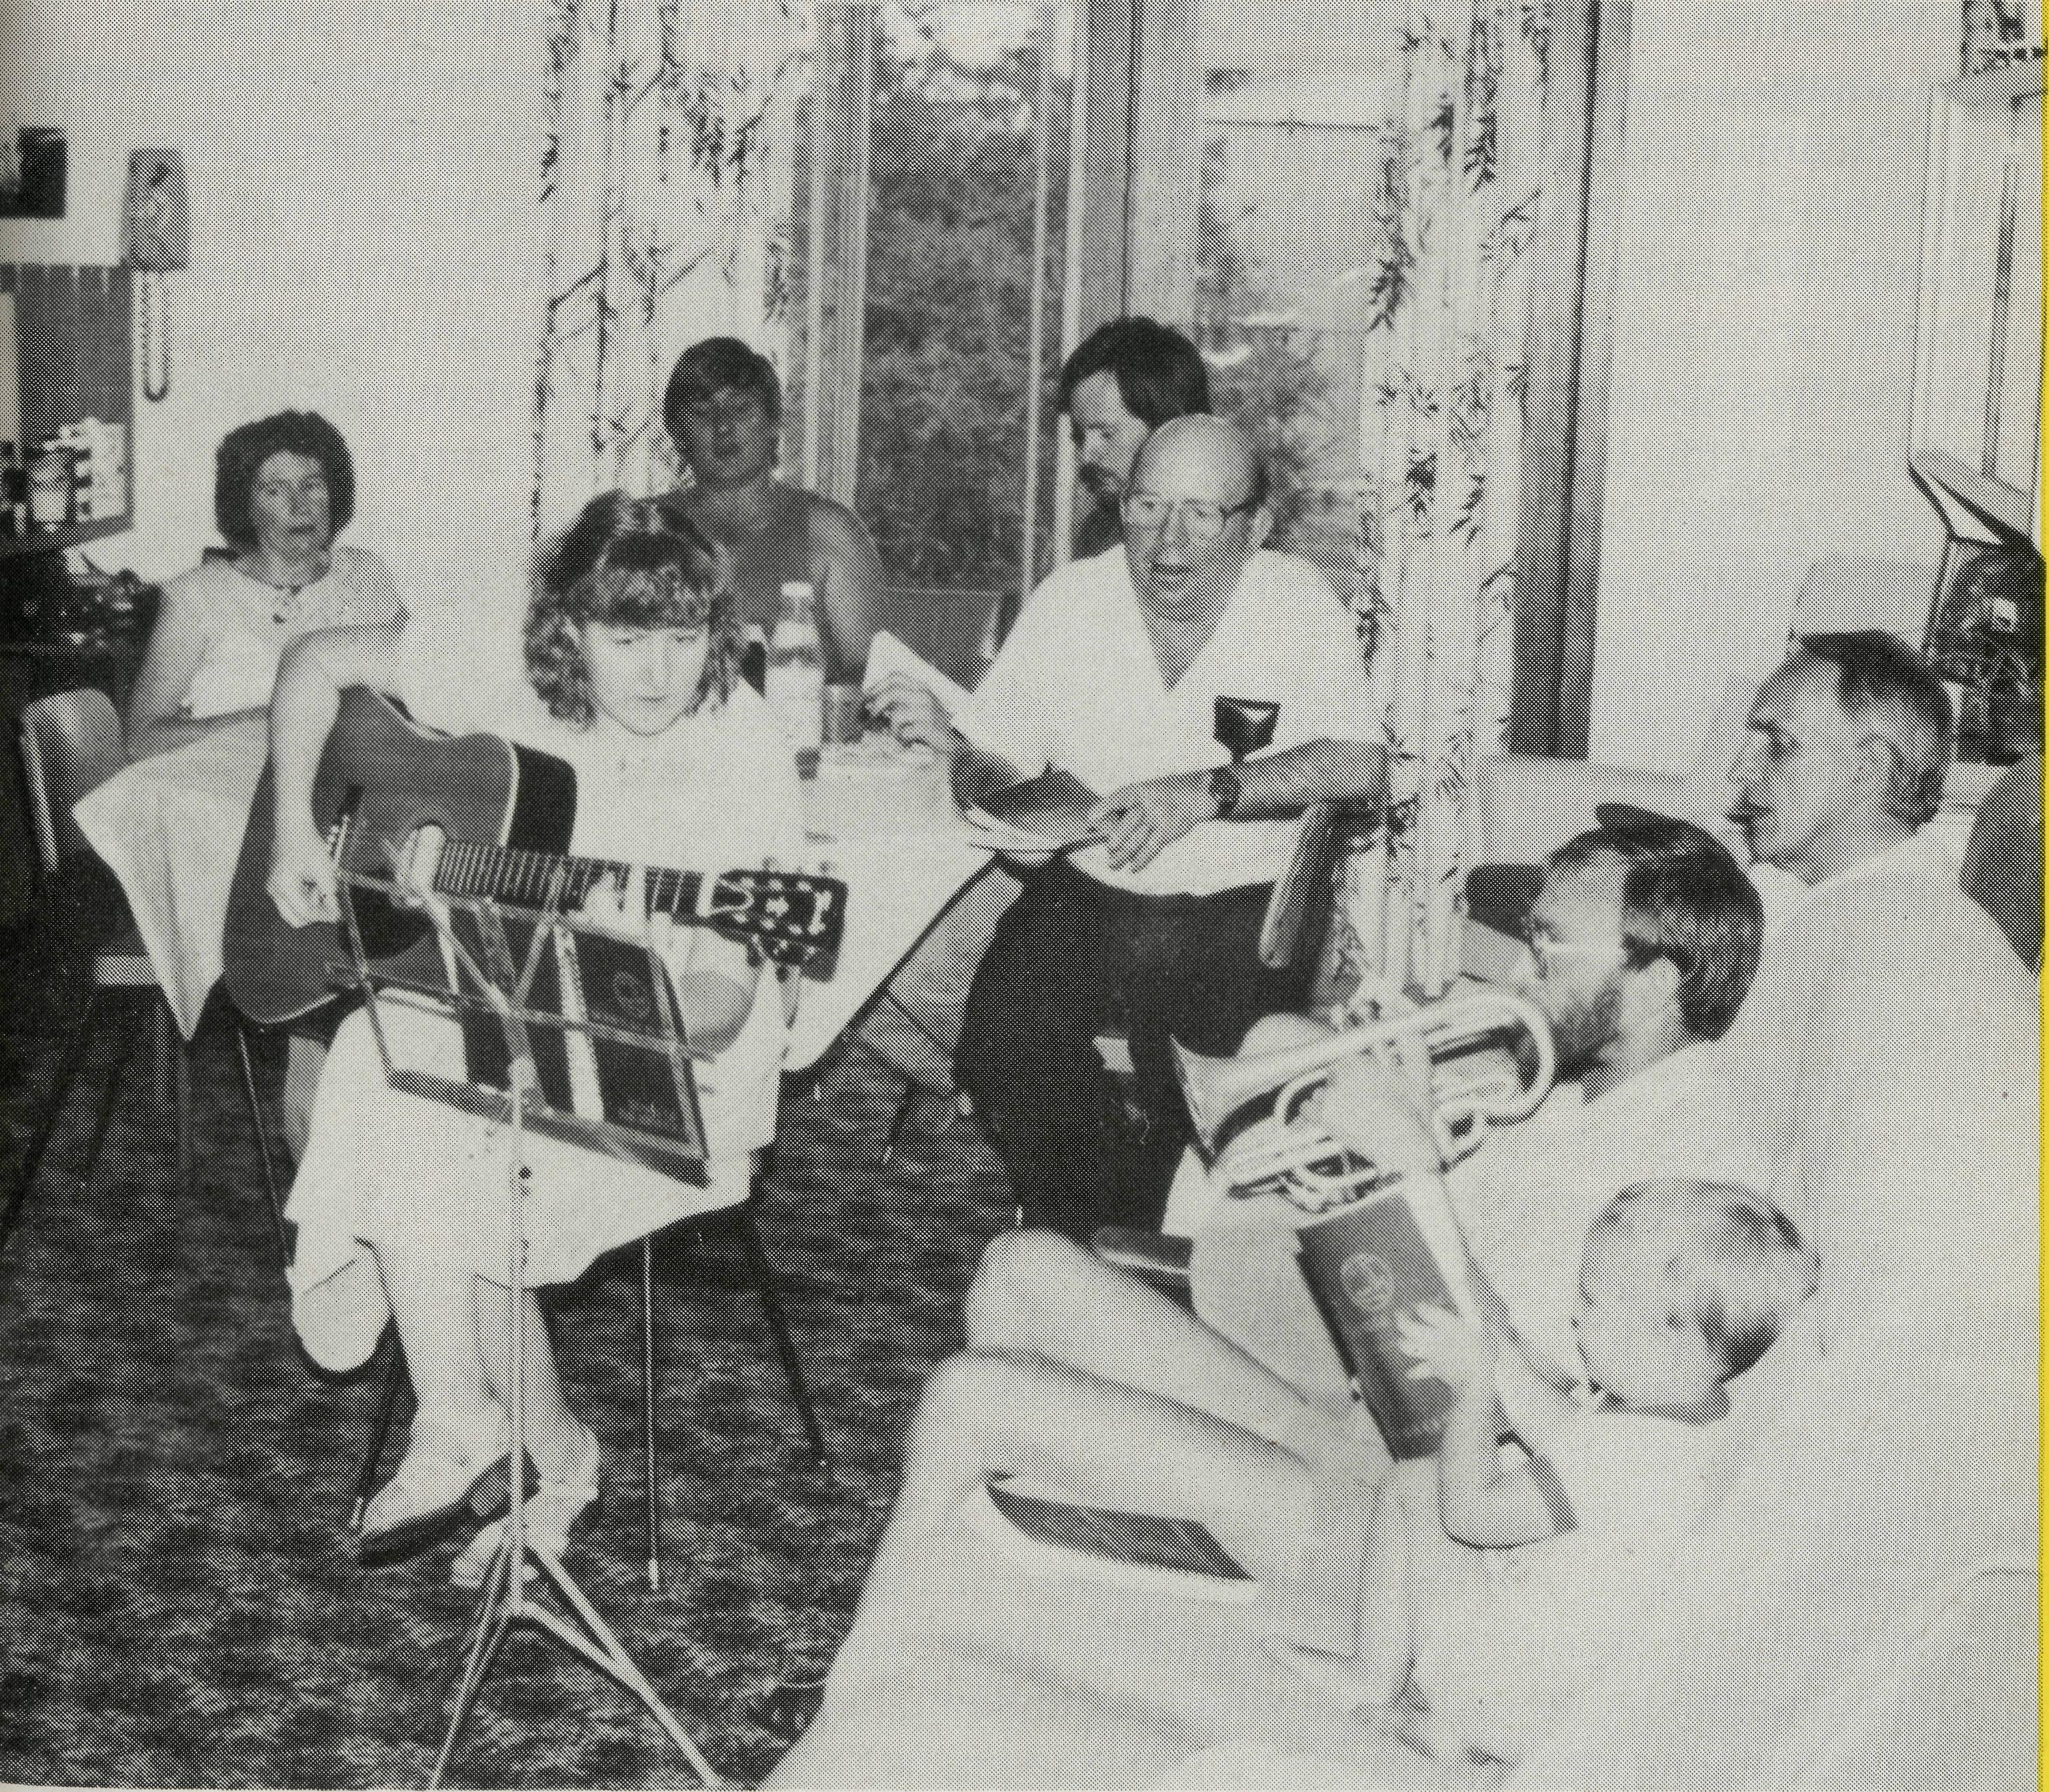
LEIGH CREEK — STILL CHANGING
It doesn't seem two years ago that we last contributed an article to The Real Australian which was entitled "All Change at Leigh Creek". When we were invited to do so again, the immediate thought was that nothing much had changed and that nothing of real note had taken place in the interim. However, when we committed the task to prayer, we realised that change had continued to take place in various ways.
Leigh Creek township continues to service the Electricity Trust coalmining operation where the workforce has now stabilised for the present at least. The social problems did not go away with the large reduction in the workforce two years ago. In some cases, uncertainty of the future has increased the problems. The Church family, on the other hand, has grown in its faith and service and has accepted more responsibility for the wellbeing of its own members and for others. The result is that more ministry is taking place in the community and this is a meaningful tool for evangelism.
The most rewarding change to be witnessed is surely that of a changed life. A few weeks ago, one of our regular church attenders gave her life to Jesus and asked Him into her heart by His Spirit. God's timing was absolutely perfect as this lovely person died a short time later and has since gone to be in the Presence of the Lord Jesus.
The Kids Club in Leigh Creek is small but several children have already given themselves to the Lord Jesus and opened their hearts to Him as Lord and Saviour. To see changed lives is a privilege beyond all others. All praise and thanks to our Almighty Heavenly Father.
In the outreach to children and young people there has been increased response in the schools with more questions being asked about our faith in Jesus Christ and the role of the Church in the community. In Leigh Creek there is now the prospect of the appointment of a school chaplain before the end of 1993 to meet the realised need by the school and the community for the sort of support and assurance that the Church alone can bring in times of uncertainty.
Meanwhile life for many on the station properties is becoming more difficult as it is for many folk all around outback Australia. Apart from widespread concern about low commodity prices, much concern has been aroused over the proposal to include the Lake Eyre basin (over 1,000,000 hectares) in the World Heritage list. Conversion of large areas of holdings to conservation zones would mean a ban on grazing on those areas and would have an adverse affect on economic viability. Land holders have banded together to resist the prospect of listing as they intend to maintain the properties which have been run by their families for several generations in many cases.
** THE REAL AUSTRALIAN
One of the more unusual tasks undertaken recently has been spreading a person's ashes in an area designated by the deceased. The area is that known as Cameron Corner at the meeting of three states (N.S.W., Qld., S.A.). The approach is from the Strezlecki Track involved negotiating 168 sandhills each way! Most were capped with a stable material but, on one occasion, where the approach looked harmless enough, the vehicle hit the obscured bottom ridge of the capping and took off until it landed on top of the hill with a crash.
As I descended the hill I looked in the mirror to see what had fallen off — only to see one of the spare wheels rolling into the bush! There was no real harm done to the vehicle or the driver but I drove a little more sedately after the experience and gave thanks to Almighty God for His protection and for the strength and reliability of the trusty Landcruiser.
PETER & MARGARET ACHURCH
Home Fellowship group in the Leigh Creek Rectory.
(Peter and Margaret have served in the Parish of Leigh Creek and the Northern Mission since March, 1989)

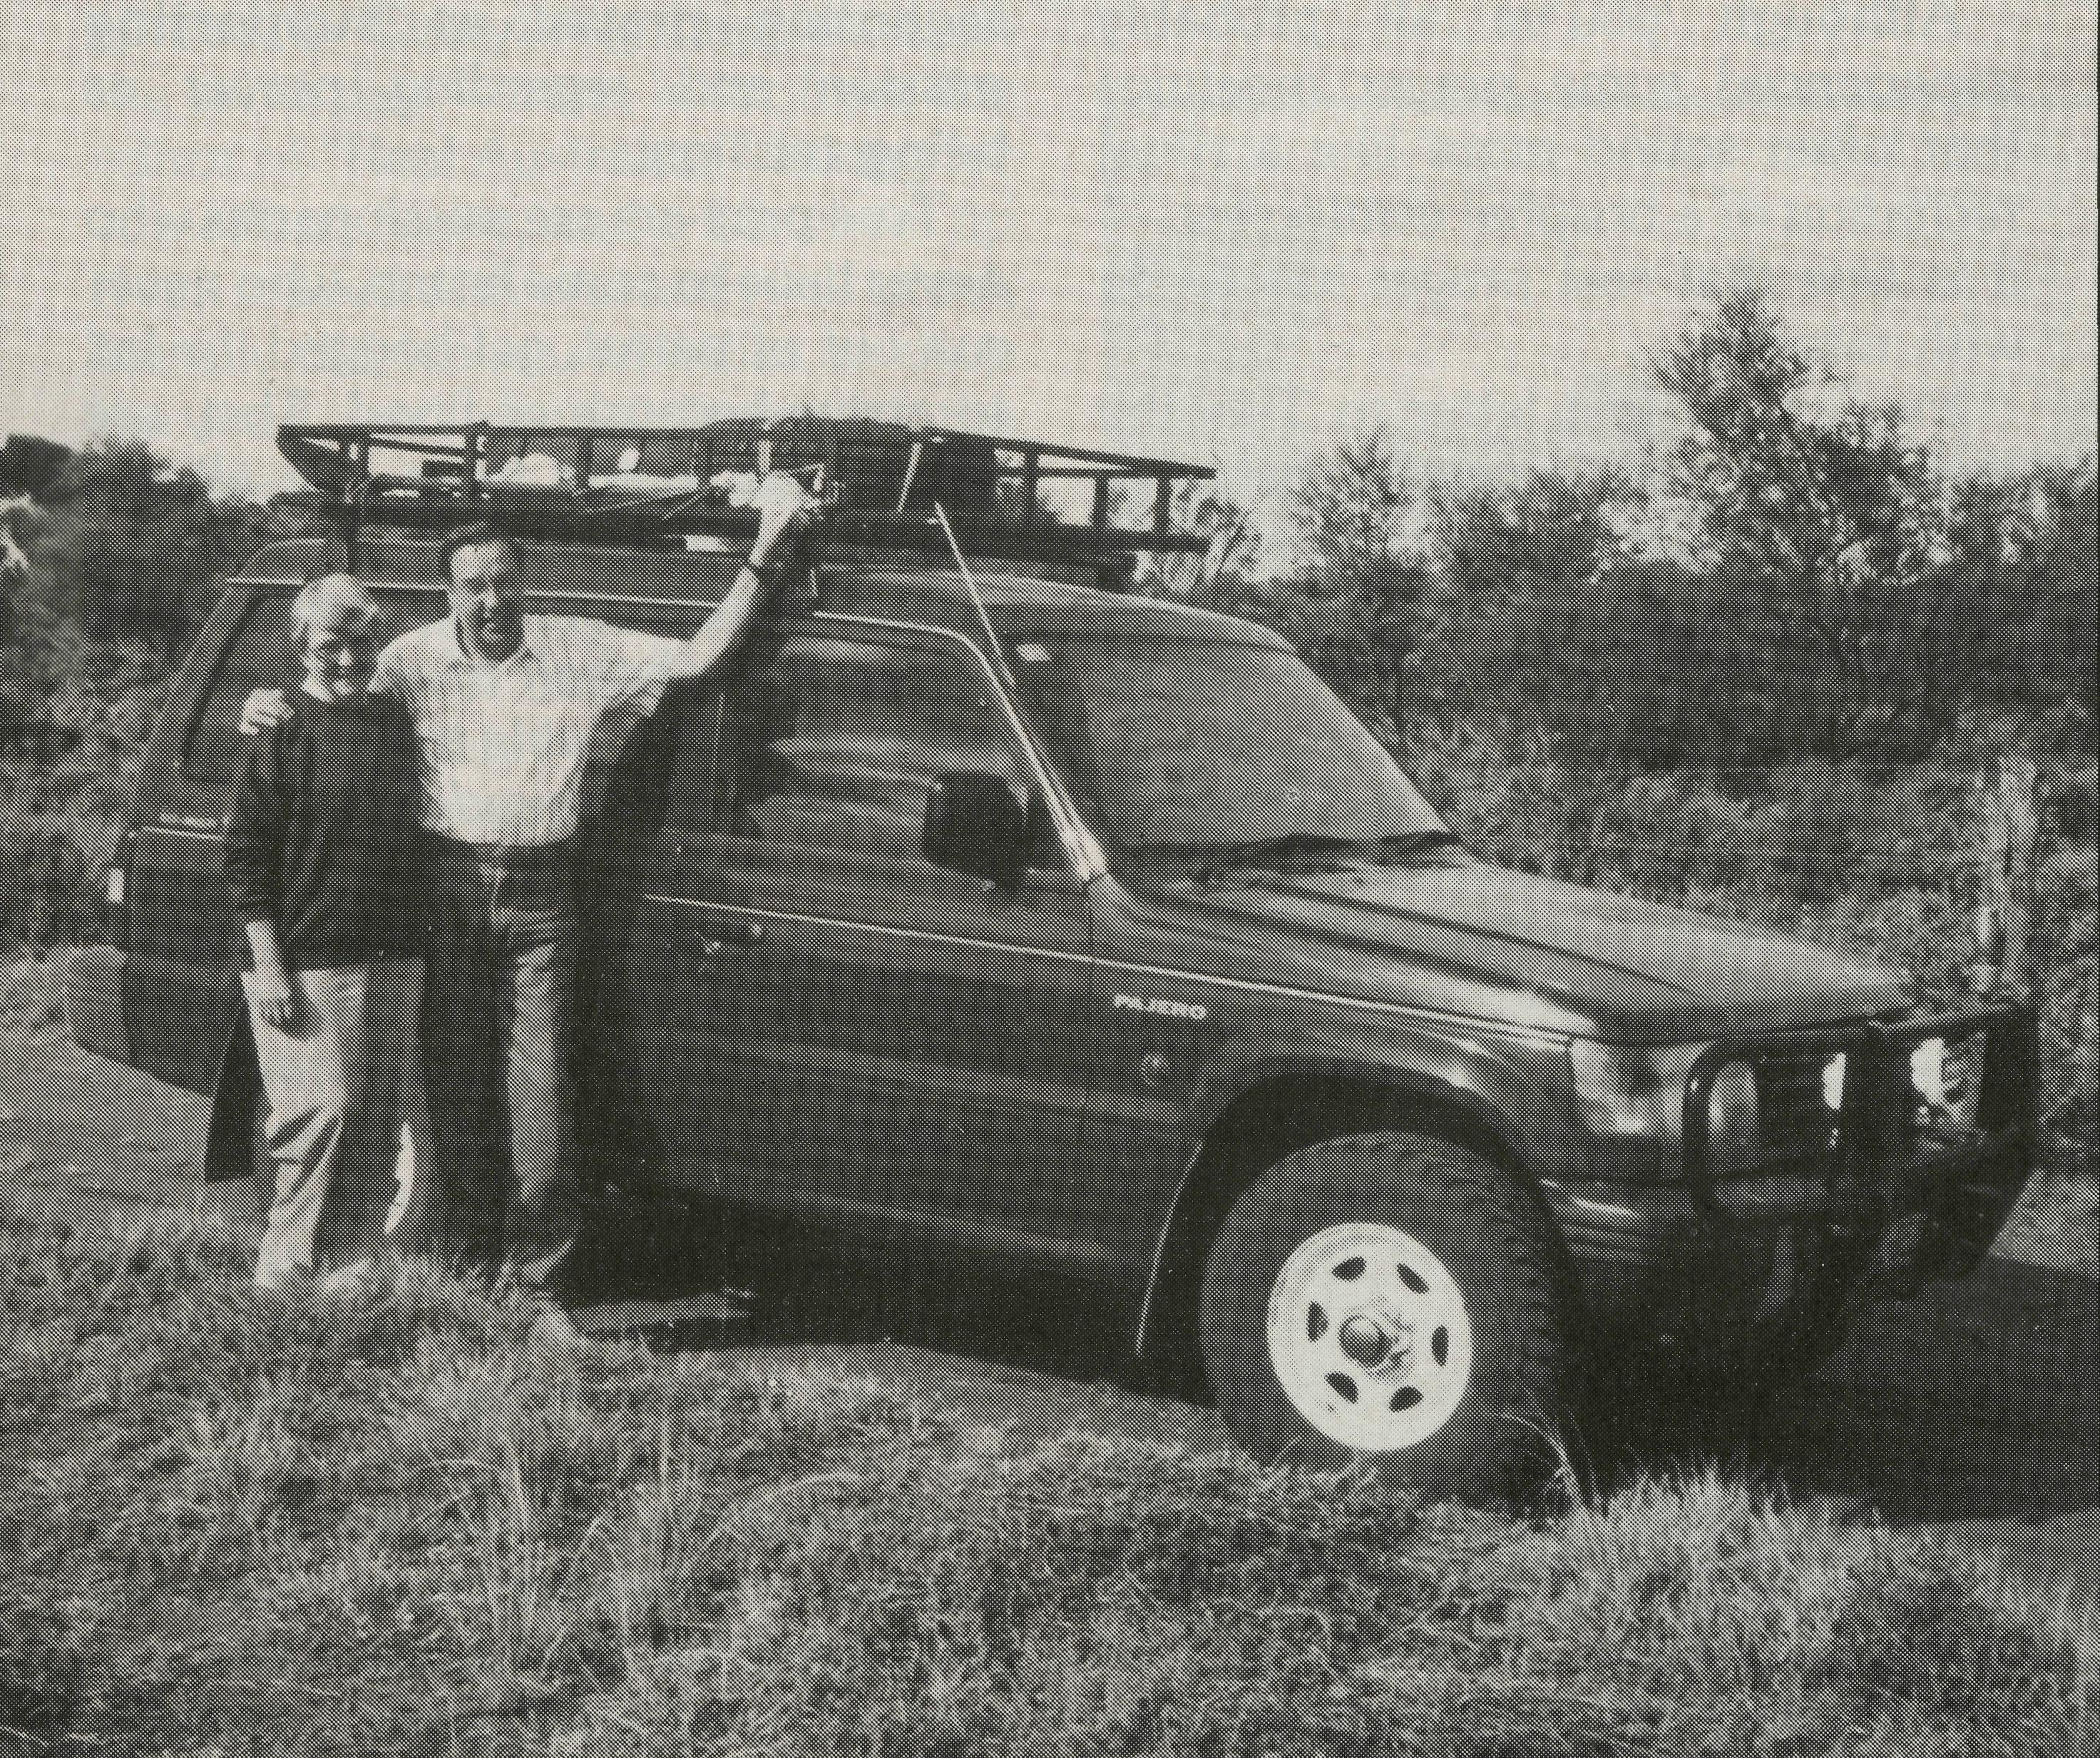
CITY PRIEST GOES WEST
"City Priest Goes West", that's how the Penrith Press labelled an article on us at the beginning of the year as news leaked out that we were soon off, with The Bush Church Aid Society, to Wilcannia (about 1000 km west of Sydney and 200 km this side of Broken Hill). My brother thought we were mad, needing a psychiatrist, but other Christians were very encouraging and supportive of us being called to the largest parish (in area) in the State.
We had visited Bob and Phyllis Collie, previous incumbents, in 1991, and at the end of last year and admired the tremendous work they had done. They were both gifted evangelicals from the Melbourne Diocese.
We knew the ministry would be different. We knew something of the remote outback, as we had spent many holidays "in the bush". But there is something romantic about a holiday — living "in the bush" is a different story. And living in Wilcannia, one time "Queen City of the West", late 19th century is a different story.
Wilcannia no longer has the paddle wheelers plying the Darling River laden with wool from prosperous stations of up to 1 million acres shearing 100,000 sheep. Wilcannia no longer has the rattle of Cobb and Co. coaches in the main street, or camel trains bringing wool bales to the wharf warehouses. No longer do the five banks compete for customers or the fourteen pubs dispense liquor or the church, built in 1883, ring with a hundred voices. No longer does the Anglican Minister ride around the parish on horseback, leaving Wilcannia on a 3000 mile trip into the outback, returning weary and red mud stained two or three months later.
We admire those faithful clergy, committed to Christ and the gospel, in the early days travelling by horse, push bike, motor bike and then motor car or in the case of Len Daniels by "old wire and paste plane".
Today the river traffic is gone, most of the shops have gone, boarded-up, broken, deserted. Westpac alone remains among the banks, two pubs still enjoy plenty of patronage, the beautiful sandstone church, restored for the bi-centenary still stands large in the main street, reminding residents and tourists of the faithful ministry of the people of God. Today the land is the same, except the properties are smaller, about 100,000 acres, the carrying capacity of sheep is smaller, about 5-10,000 sheep in good times. During the recent drought some properties of 10,000 sheep were reduced to 500, how do you cope with that trauma? Today the B.C.A. Missioners, Helen and myself get around the parish in a 4WD air-conditioned Pajero. Five hours to Tibooburra, four hours to Wanaaring, two hours to Tilpa and one hour to White Cliffs and if its been raining you may have to sleep out overnight as the roads turn to red bogs and the creeks rise quickly. (We had such an experience.)
Bush ministry is different, challenging and we've never prayed so much! Wilcannia now has a population of between 800-1000, two-thirds Aboriginal and the other one-third doubtful about the future. We are learning about the
6 THE REAL AUSTRALIAN
town by visiting door to door and its amazing what interesting people "live in the bush". We are learning of the joy outback Christians have in meeting and worshipping together. At Tilpa, one family travel for an hour and a half over very rough roads to get to a service, in a hall once a month, that's commitment! At Wilcannia two station families travel 60 and 35 km to fellowship around the Word of God. Coming from Penrith where there are 20 churches within 5 km and still people reckon it's too far to go to Church, I admire these beautiful outback Christians who meet in small numbers, five, ten, fifteen, "to spur one another on to love and good works . . . and to encourage one another".
And we thank God for our churches "back home" who pray and give to the Bush Church Aid Society to make it all possible.
Ministry in the outback! Yes, I recommend it, we are having the experience of a lifetime.
The Rev. Don and Mrs. Helen Wilson on the track.
THE REAL AUSTRALIAN
DON WILSON

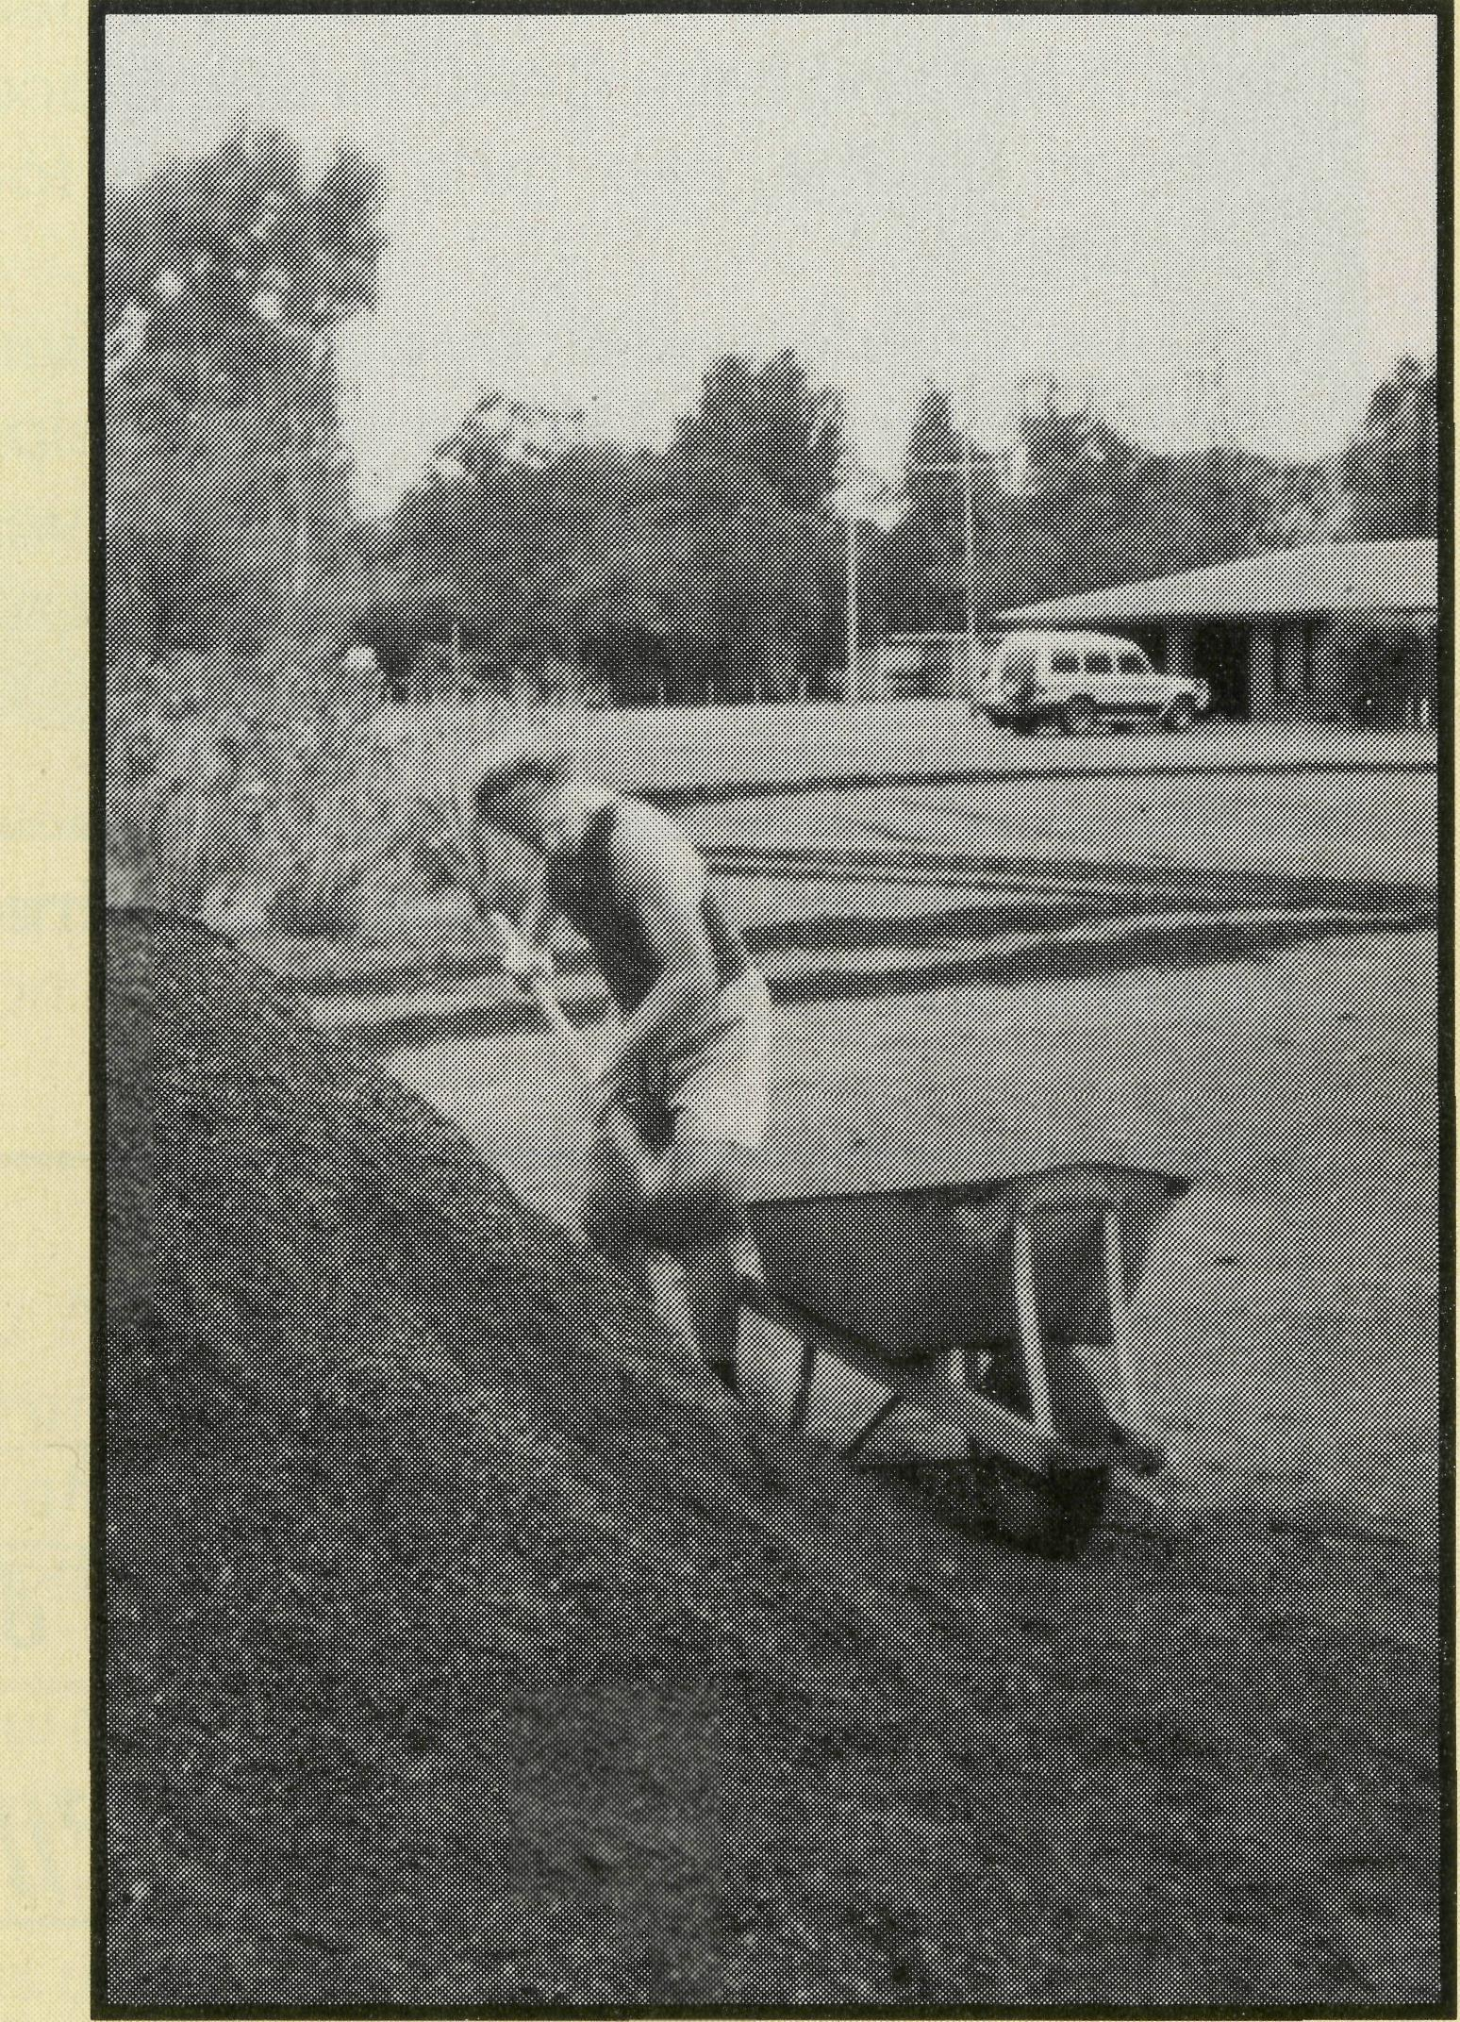
FEDERAL SECRETARY'S MESSAGE
AUSTRALIANS
E
prAying for australians
REAL PRAYER FOR REAL AUSTRALIANS
Prayer and Mission go hand in hand
Although you've all probably experienced some prayer meetings that often sound more like a ritual recitation of a hospital waiting list — it is true that real prayer has to do with mission.
Paul in his first letter to Timothy makes it plain that prayer on behalf of all people is an urgent business that has a priority. Not only is it a priority for us, but it is very important, pleasing and acceptable to God. God's word links the action of prayer to the action of mission when Paul, speaking to Timothy says that God "desires all to be saved and come to a knowledge of the truth". This is the action of mission and the purpose and goal for all the B.C.A.'s ministries.
Each one of us would agree that the agents appointed to spread the good news through the B.C.A. network of ministries need our prayer because prayer leads to action in mission, not complacency.
But sometimes, we may feel that because we can't go out there our-
selves and that we "just" pray, we are somehow escaping our responsibility. Perhaps — in fact — we are actually accepting the responsibility.
There is a vital difference between regarding prayer as supporting mission and regarding prayer as being mission.
True prayers are missionaries who never have to come home, who never run out of petrol, get bogged, or fail to arrive because of flood. They are able to be in the front line all the time.
So, "First of all I urge that prayers be made on behalf of all . . . this is good and acceptable to God... who desires all to be saved." (from 1 Tim 2:1-7).
So that we all can be in mission, B.C.A. publishes a free quarterly set of Prayer Notes complete with details and profiles of the people and places.
There's a response slip at the back of the magazine for you to send in, so that the Notes can be forwarded to you.
Remember, you can be active in mission and that Real Australians can be praying for Real Australians.
BRIAN
THE REAL AUSTRALIAN
LIFE'S NEVER
BORING IN PARABURDOO
It would be a lie to say it never rains in Paraburdoo, but yet it hardly ever rains. We have had 50 mm, best in a year, and never a day has gone by without watering. Oh the joy of reticulation at the Church, but it does turn the clay pan car park into red mud, which does not mix well with white church shoes or carpets.
Hence the need of crushed rocks, and this morning was the day to spread it. Everything happened on the same day — rain, letter from the editor of "Real Australian" asking for something funny, and a 10-wheel tip truck loaded with crushed rock which literally did wheely-wheelies to drop the load, and nearly destroyed the reticulation main water line. Praise God for His provision, but have you ever tried to put huge chunks of clay back into wheel tracks?
Ann and John decided that the church surrounds must be beautiful. John has a church boarding school background, Ann has a deep unshakeable faith. It was found Ann had a rare inoperable brain tumour. The shock for John was devastating but praise be to God, Ann's Perth-based mentor led him to a personal commitment to Christ.
On returning home John felt compelled to return gear that was not rightfully his to the mining company, and had great difficulty convincing his work mates that he would not again do any private work in company time.
THE REAL AUSTRALIAN
There has been a great chain of prayer for Ann covering the continent and in two years there has been no enlargement of the tumour. Two weeks ago she asked me to pray for her as she had been to the doctor, my heart sank, then she added, "I think I am pregnant". It took time to go from despair to exultation.
At Church John announced over a cuppa "Ann is pregnant and I do not know how it happened." We all do drop clangers at times!
BRIAN HARDING (Brian and Joy Harding have served in the Anglican Parish of Paraburdoo-Mt. Tom Price since May, 1990)
The Rev. Brian Harding moving the red gravel. Who says the Clergy never work!

FOCUS OIM NEWMAN

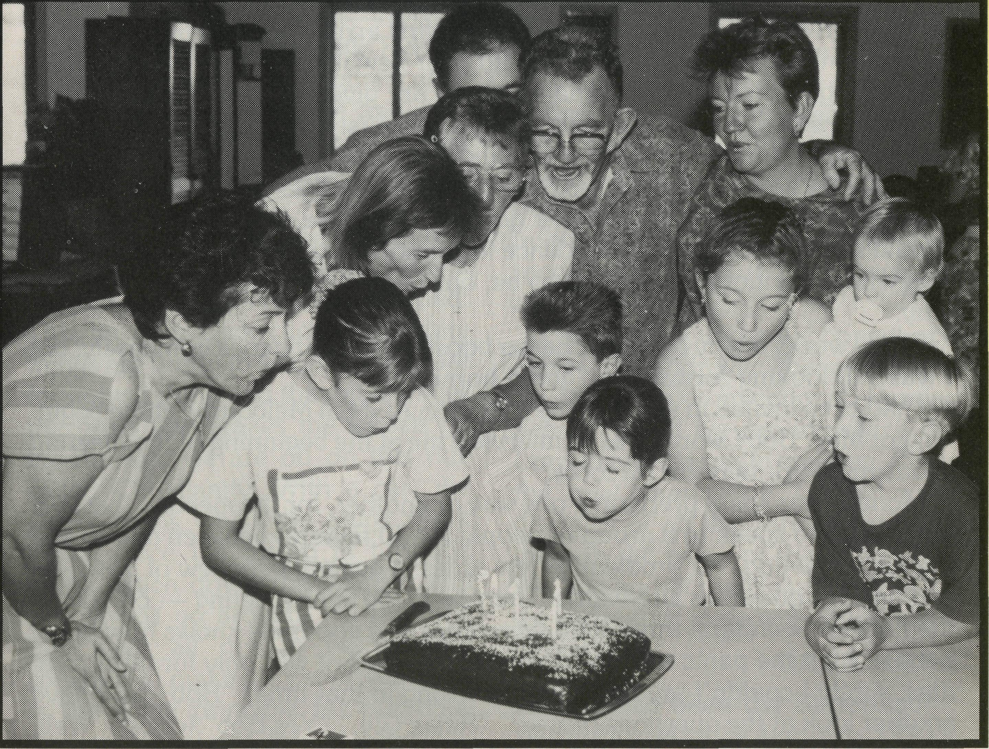
"I think I'll visit the stations and take up a collection," Bidge suggested. That's twice the Bishop has been due to conduct a Confirmation in Marble Bar and twice rain closed roads." In July, Marble Bar celebrated the town's centenary with a joyful service of praise and thanksgiving. We're still planning to obtain a building for use as a church.
Telfer, some 650 km by a challenging road from Newman, is now part of the parish ministry. "You'll see some changes when next you come," Felicity told me over the phone. "This family has moved south, that family has gone back east, a third ... But we've been blessed. Three men have started coming to our services." As at Nullagine and Marble Bar, teaching RE in the Telfer School is a joy. The best student in one class was their teacher.
In Newman, other churches were invited to share with us a Christian witness, manning a stall at the Multi-Cultural Festival. We prepared a display, handed out tracts, sold Bibles and spoke with people.
Mandy and her family left Marble Bar, taking the experience of God's healing for her and baby Brett. Kristy; Stacey and their parents left Newman with the joy of the two girls coming to Christ through the KANGA Club ministry.
"Don't be depressed by people leaving," I was told recently. "Think of the seeds you've sown." When you've helped someone along their spiritual journey, you don't lose touch. Even as I was writing, Barbara rang to share with me where she now is in her journey and to talk about the next step.
RAYMOND MOLYNEUX
(Raymond and Betty Lou have served in the parish of Newman since September, 1990)
Celebrating the 5th Anniversary of St. Stephen's Newman. All except the baby were present in 1988 for the Service of Dedication.

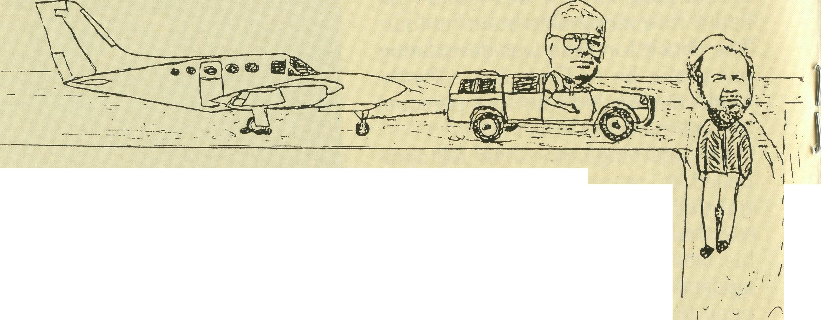
Fly ? I think I’ll walk, thanks.
Bishop Tony as “Skypilot”
Ray tows in the Bishop's plane.
The Rev. Raymond Molyneux writes . . .
This cartoon concerns Bishop Tony Nichols and the bad vibes he has about flying in small planes. We d been rained in again, preventing our trip to Marble Bar for a Confirmation Service, after which I was to drive him to Port Hedland. He was instead, to fly up on the company plane.
The plane arrived, landed... and blew a tyre on the runway! As the tractor was locked away, I offered to tow the plane in to the terminal apron. After numerous previous close escapes in various countries, Tony was not amused at this incident. He was disappointed, as was I, that for once I didn 't have my camera.
Hence my art work!

10
THE REAL AUSTRALIAN
THE REAL AUSTRALIAN
11

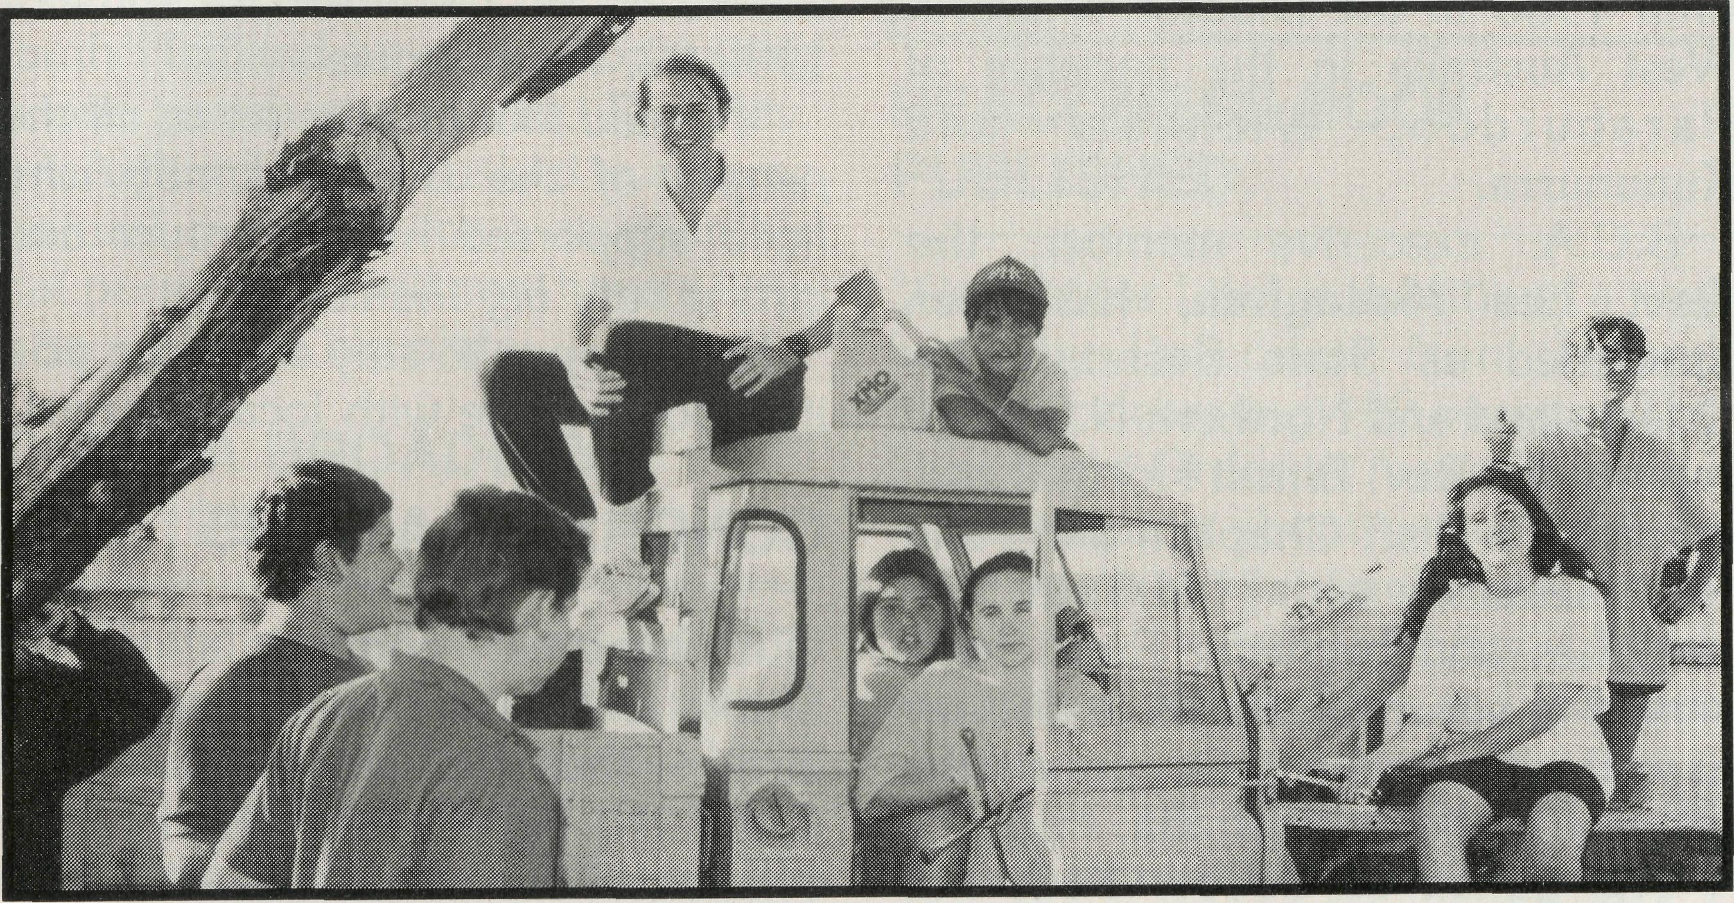
Some of the Hostel children eager to resurrect the Landrover.
I arrived in Tarcoola in January '93 . . . 48 degrees for three days following a week of 45 degrees was really a little hard to bear — particularly for a Pom! My minister back home in Melbourne had sard to me before I left, "Gill, you'll go through a period of euphoria when you first arrive followed by a period of depression before you finally settle into your new life." I didn't believe him. I was wrong. Nurses in Cook and Tarcoola are given 10 days off evey three months in lieu of overtime and days off. Those first three months couldn't go fast enough. Would I ever adjust to living in a "goldfish bowl"? We have to be available 24 hours a day, and so have to leave messages on the door and the answering machine whenever we go out telling the world where we are. Would I ever gain enough confidence for remote area nursing? I thought this was where the Lord wanted me to be, but I was blowed if I could work out why.
Three weeks on my own over Easter boosted my confidence immensely, but I was still looking forward to "going home".
I had been invited to speak at the Victorian AGM in Melbourne at the beginning of May. Bob George was to interview me at the beginning of the meeting about my work here in Tarcoola.
Monday was spent preparing, one way or another, for the meeting that evening. I was to speak to a group of people for 30 minutes between dinner and the main meeting. No problem! A few slides, a general overview of Tarcoola and time for questions afterwards. Then came the main meeting — oh boy — the Federal Secretary, three state secretaries and goodness knows how many people! I felt the panic start to rise inside me. Well, it was only for three minutes, surely I couldn't say anything too wrong in that time? "Bob, can I have another look at the questions please?" "Relax Gill." "Yes Bob" (oops!). Well, we did it. Bob asked the questions, and I answered them. I met a lot of people that night, caught up with old friends, answered lots of questions, had lots of fun, and even acquired a new pig to add to my collection. We had a great time.
To coin a phrase of a well-known Melbourne bishop, "Why am I telling you all this?" Well, that was two months ago now, and I'm back in Tarcoola, 1200 km from Melbourne — come to that 100's of km from anywhere! Quite simply, I love it. Since I've been back I have received a number of letters from people who I met at that meeting, all offering their support and prayers, and assuring me of the prayers of their various parishes. Maybe you have to be here, in a situation like Tarcoola, and like all the other B.C.A. centres to know just how much that means. It's good to know that there are people out there who, though they may not know you personally, still care enough about you to pray for you, and think of you, and even write to you occasionally. It's great being in Tarcoola (most of the time!). It's a great feeling being part of such a wonderful family. Thanks.
GILL WRIGHT
THE CHRISTIAN
LIFE IS LIKE A
LANDROVER!
Here at the Broken Hill Hostel, we're embarking on another wayward adventure to inspire and educate the children at the Hostel and introduce them to the Christian life.
Here we are under the bonnet of a car. Now! the round bit goes up and down. This bit goes round and round. This bit goes click click. The white things are pretty to see. The wires are for lights I think and that bit changes the gears and makes the wheels go around and we are off on this ride called Christianity. With a car, the petrol burns when the plugs spark which force the piston to turn the crank which drives the gearbox and the wheels go around. All the little bits have all got to be working together to make the car driveable. It is the same principle for our daily walk with the Lord. Prayer is the fuel.
Love is the spark which forces our hand to turn the pages of the Bible which drives our legs to go and spread the good news of the Lord.
The children of the Hostel eagerly await the commencement of this project as they have decided who is to do all the jobs. Several of the boys want to work on the engine, others the brakes. The girls want to paint the car but the choice of colour leaves much to be desired (pink and blue). I will be overseeing the whole venture, but hopefully as a team we will all work together to make the car driveable again.
I realise that under the bonnet of a
Series 2 Landrover there is not a
church or a conventional Sunday
School, but if we can introduce the
Lord to any person in any way, this is
the great commission "Go and make
disciples of all the nations baptising
them in the name of the Father and
the Son and of the Holy Spirit." This
we endeavour to do with the children
in our care. _{DAyiD} _{B(JLL}
(David has been the Supervisor of the Hostel since January, 1991)

THE REAL AUSTRALIAN

POST & RAILS

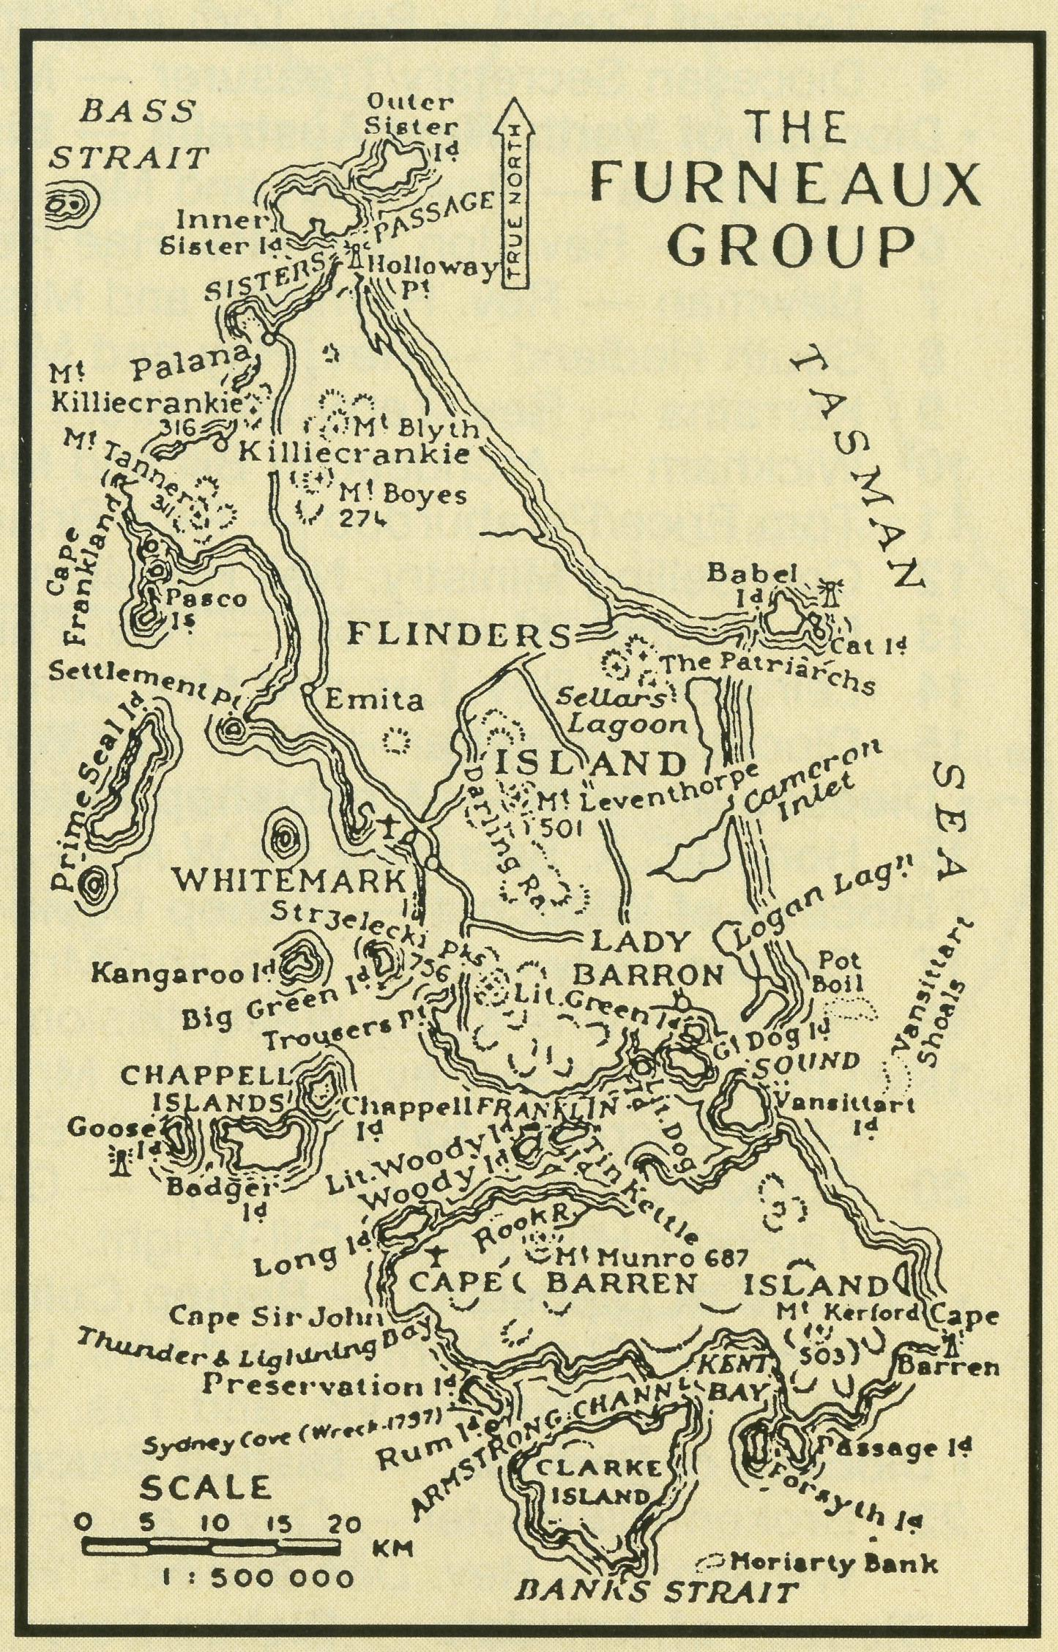
NEW B.C.A. PRESIDENT AND CHAIRMAN
Key positions in the fabric of the B.C.A. organisation changed hands at our A.G.M. on May 27.
Our new president is Archbishop Harry Goodhew who replaces Archbishop Donald Robinson.
Our new chairman is Archdeacon Victor Roberts, Archdeacon of Wollongong. Do pray for our leaders in these responsible positions.
WELCOME
The Rev. Tom and Mrs. Carol Williams have accepted the Parish of Tennant Creek. Tom and Carol served with the Society from 1979 until 1983 in the Diocese of North West Australia in the parishes of Paraburdoo, Wickham and Kununurra.
B.C.A. executive member, the Rev. Les Monaghan, has been appointed as State Secretary for Queensland and Northern N.S.W. to replace the Rev. Ernest Horth. Les is currently a Staff Chaplain and Field Representative with H.M.S. in Sydney. Les and his wife, Ruth, have served in several parishes in Sydney as well as the parish of Dongara in the Diocese of N.W. Australia.
The parish of Coober Pedy has been filled! The Rev. Bob and Mrs.
Denise Rothwell took up their appointment on 1st September. They come from the Parish of Canley Heights in Sydney's west, where they've served since 1984. The Rothwells replaced the Robertsons who moved last Christmas.
A RECORD
B.C.A. has recently received a legacy from a member who has been supporting B.C.A.'s work since 1927 ... that's 65 years! Praise God for such commitment.
KEITH NOLAN SAYS THANKS
Keith Nolan was supported by B.C.A. as Youth Minister in the Darwin Parish of Sanderson for some of 1992-93. Keith writes . . .
"I would like to pass on to all the people of the B.C.A. family who have supported me in prayer and gifts a very big thanks."
Keith hopes to stay on in the position for a while with local Support.
CONGRATULATIONS
Our heartiest congratulations to Shane and Suzanne Morrow on the birth of their first child: a daughter, CAITLIN SKYE, on 15th June. Shane and Suzanne are the Assistant Hostel Parents at Broken Hill.
FURNEAUX ISLANDS
B.C.A. has responded to the challenge to help the Diocese of Tasmania minister to the Aboriginal peoples living within the diocese. The focus of the work will be the Furneaux Group of Islands to the north east of Tasmania in Bass Strait.
The Rev. Donald Moffat based on Flinders Island has been involved in the special ministry as part of the normal parish activity and the B.C.A. grant will enable him to travel to and from the communities more frequently, giving greater opportunities for ministry.
HEDLAND
The parishes of Port Hedland and South Hedland have been operating as one parish since June. The Rev. Ray Arthur has been asked to assume pastoral oversight for a six-month's trial period. Ray will now have a little extra work on his plate.
THELMA BROADLEY 1908-1993
Mrs. Broadley died suddenly on 15th July. She and Bert Broadley served with B.C.A. at Ceduna between 1935 and 1946 with a break of two years while they served at St. Marys. We extend our love to their family.
DEACONESS BOOK PUBLISHED
"Caught for Life" is the title of a new book by Deaconess Nora Hyland (Tress) celebrating 100 years of The Deaconess Order in Australia.
Information about several B.C.A. deaconesses is included: Ada Howland, Dorothy Harris, Agnes McGregor, Peggy Spry and Beatrice Clarke.
Copies are available at $19.95 from Deaconess Hyland, "Condry", Araluen, N.S.W. 2622.

14
THE REAL AUSTRALIAN
THE REAL AUSTRALIAN

PRAY FOR OUR STAFF
WINNING AUSTRALIA FOR CHRIST

• Diocese of Northern Territory — Bishop Richard Appleby
- Sanderson — Rev. Greg and Mrs. Kerry Thompson.
- Anglicare Director — Mr. Peter Fisher.
- Tennant Creek — Rev. Tom and Mrs. Carol Williams.
- Diocesan Secretary/Treasurer — Mr. David Martin.
• Diocese of North West Australia — Bishop Tony Nichols.
- Kununurra — Rev. John and Mrs. Dianne Symons.
- Derby — Rev. Jon and Mrs. Rae Reinertsen.
- Newman — Rev. Raymond and Mrs. Betty Lou Molyneux.
- South Hedland — Rev. Ray and Mrs. Lyn Arthur.
- Karratha — Rev. Terry and Mrs. Fiona Redmond.

- Wickham — Archdeacon Bill and Mrs. Jocelyn Ross.
- Tom Price/Paraburdoo — Rev. Brian and Mrs. Joy Harding.
- Counselling Ministry: Neil Hamilton.
- Mt. Magnet (Murchison) — Rev. Philip and Mrs Margaret Bassett.
- Leinster — Rev. Les and Mrs. Jenny Gaulton.
- Diocesan Registrar — Mrs. Kay Winfield in Geraldton.
• Diocese of Perth — Archbishop Peter Carnley.
16 Hon. B.C.A. Secretary for W.A. — Rev. Peter Brain.
• Diocese of Willochra — Bishop David McCail.
- Coober Pedy — Rev. Bob and Mrs. Denise Rothwell.
- Roxby Downs & Mid-West Mission — Rev. John and Mrs. Leone Rutherford.
- Leigh Creek — Rev. Peter and Mrs. Margaret Achurch.
State Secretary for S.A. — Rev. Bob George, Mrs. Aila Alderson.
20 Cook: Bp Kirkby Mem. Hosp. — Gai DiDonna & Christina Ryman.
Tarcoola Hospital — Gill Wright.
• Diocese of Gippsland — Bishop Colin Sheumack.
21 Omeo — Rev. Norman and Mrs. Leonie Fagg.
State Secretary for Vic. and Tas. — Rev. Brian Viney, Ms. Margo Bright.
• Diocese of Riverina. — Bishop Bruce Clark.
22 Broken Hill Hostel — David and Elisabeth Bull, Shane and Suzanne Morrow.
Wilcannia — Rev. Don and Mrs. Helen Wilson.
• Diocese of Armidale — Bishop Peter Chiswell.
23 Lightning Ridge — Rev. Mark and Mrs. Lucy Taylor.
• Diocese of Grafton — Bishop Bruce Schultz.
- Bonalbo — Rev. Dick and Mrs. Pat Freeman.
- N.S.W. Office — Rev. David Mulready, Mrs. Michele Peacock.
• Diocese of Brisbane — Archbishop Peter Hollingworth.
- Quilpie — Vacant.
- State Sec. for Old. & north. N.S.W. Rev. Les Monaghan, Mrs. Elaine Kurri.
• Diocese of Rockhampton — Bishop George Hearn.
28 Winton — Vacant.
Blackwater — Rev. Peter and Mrs. Jeannette Blundell.
29 ABORIGINAL MINISTRY:
Bishop Arthur and Mrs. Colleen Malcolm — Cairns, Townsville and Mackay. Nungalinya College — Principal: Rev. Dr. Les Brockway. Bimbadeen College — Mr. Denis and Mrs. Maureen Atkinson. Furneaux Islands — Rev. Donald Moffat. Dio. of Tas.
30 B.C.A. FEDERAL OFFICE: Rev. Brian Roberts, Mr. Jim Gosbee, Mesdames
Jacqueline Griffiths, Lay Lee Boughton and Eileen Darbin.
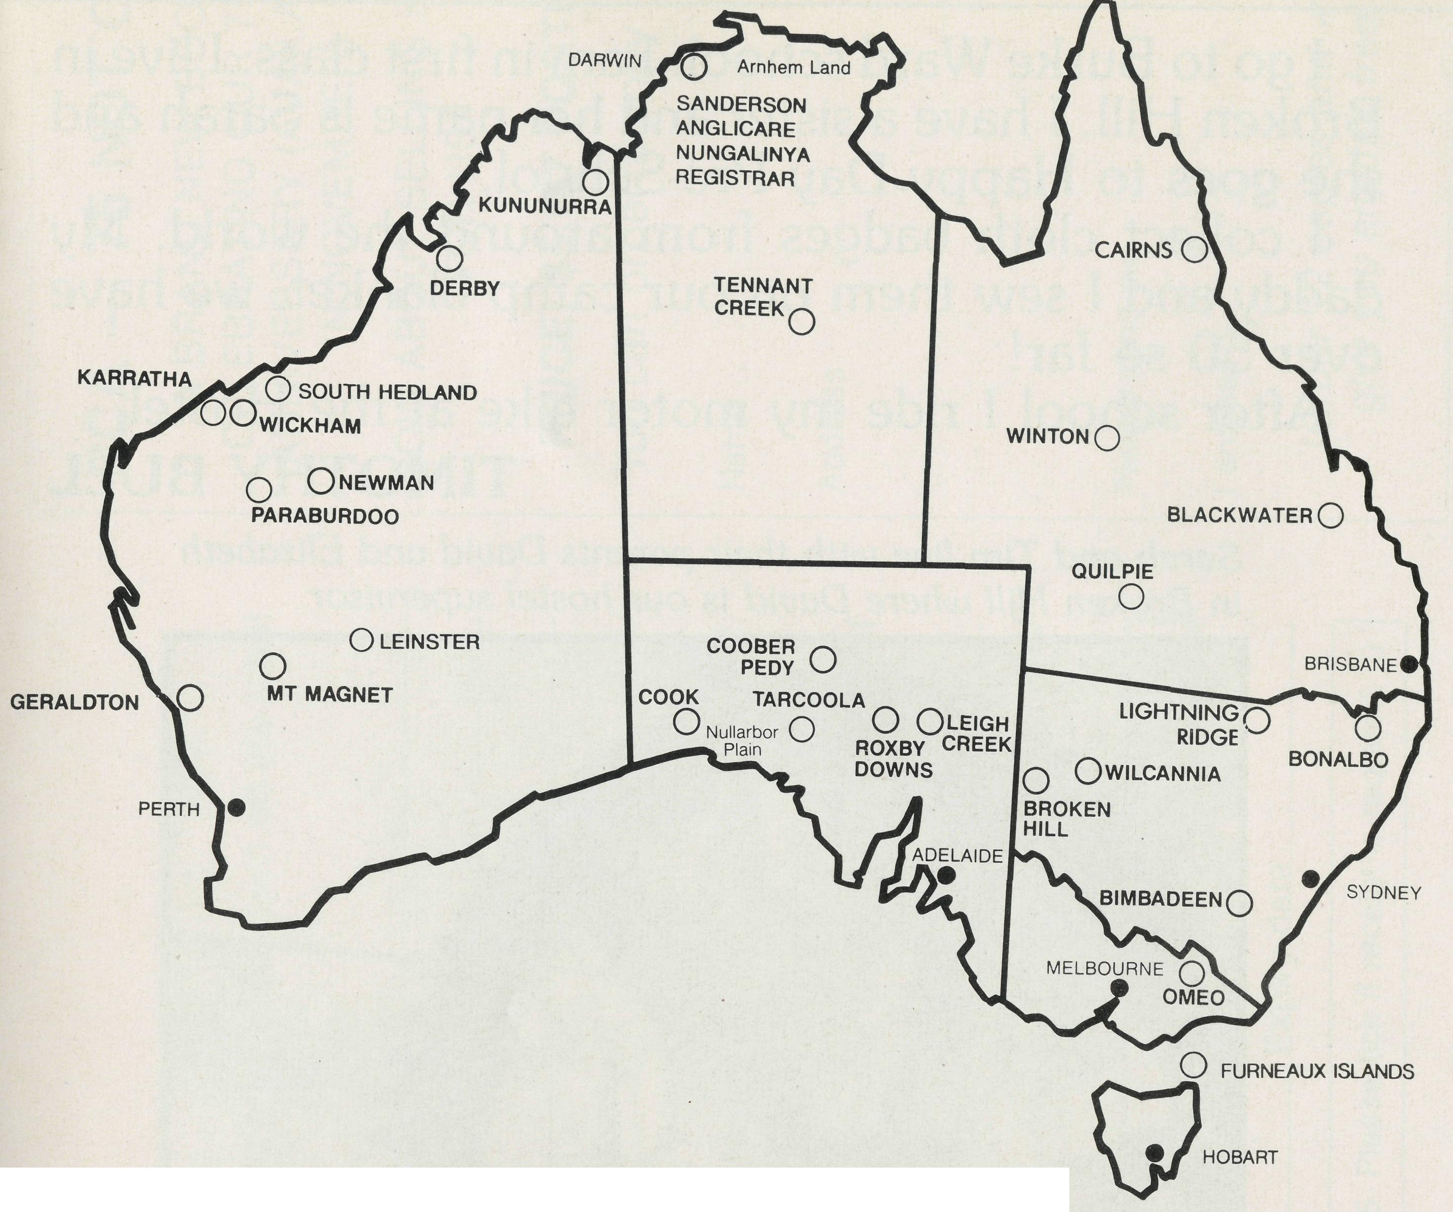
THE B.C.A. PRAYER
O Lord our God, help us to remember those who live in the remote parts of our land. We ask you to strengthen and encourage all whose ministries are supported by The Bush Church Aid Society. Refresh them in times of discouragement and loneliness and call others to stand with them in the task of making Christ known. Grant that, through the ministry of the Word and Sacraments, through medical work, through service and by caring for the young, the message of your redeeming love may be proclaimed, and accepted by the people throughout our land. We ask these things through Jesus Christ our Lord, who lives and reigns with you and the Holy Spirit, one God, for ever and ever. AMEN.
If you'd like more details for prayer, send for our FREE quarterly prayer notes. (See reply page.)

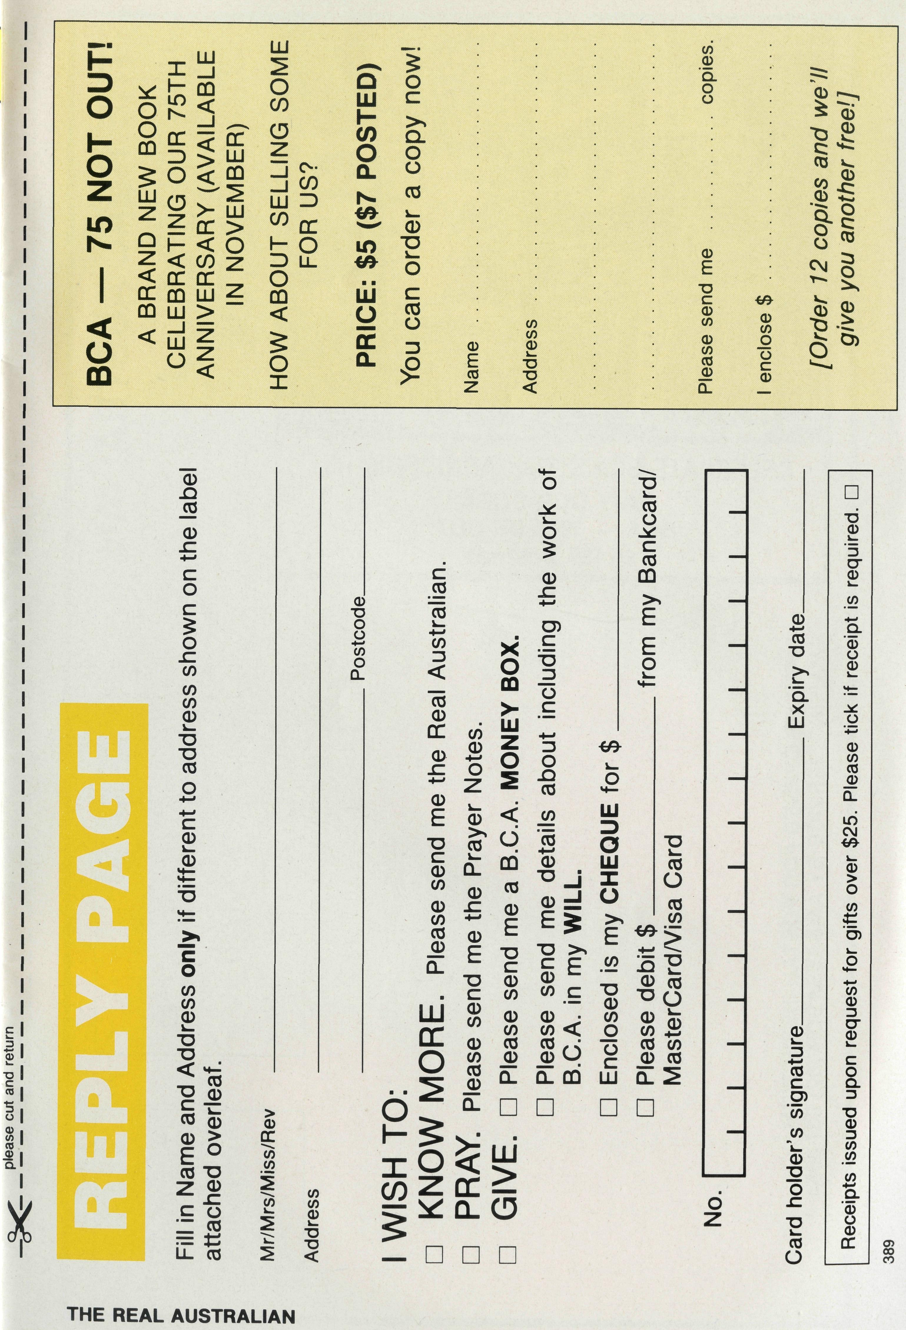
GOOD-DAY!
I go to Burke Ward school. I am in first class. I live in Broken Hill. I have a sister and her name is Sarah and she goes to Happy Day Pre-School.
I collect cloth badges from around the world. My daddy and I sew them on our camp blanket, we have over 50 so far!
After school I ride my motor bike at the Hostel.
TIMOTHY BULL
Sarah and Tim live with their parents David and Elizabeth in Broken Hill where David is our hostel supervisor.
