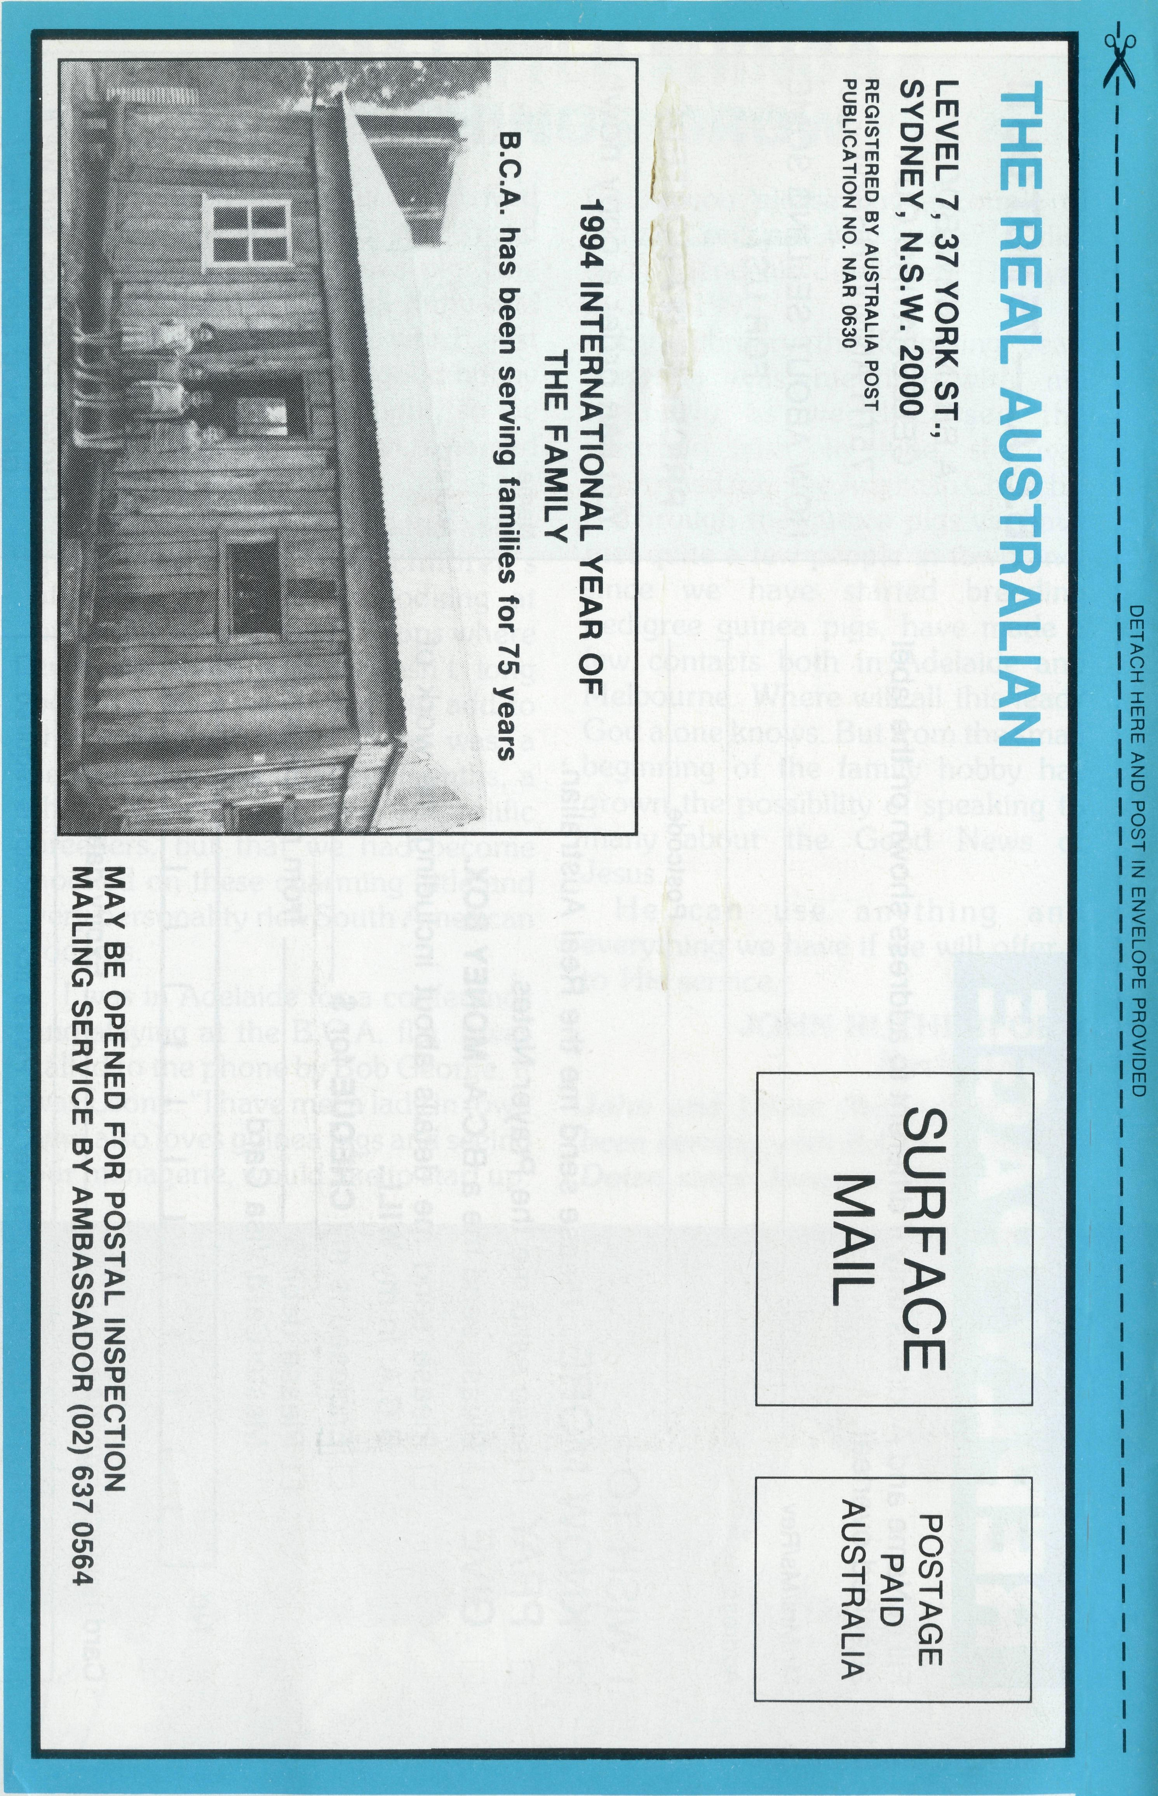
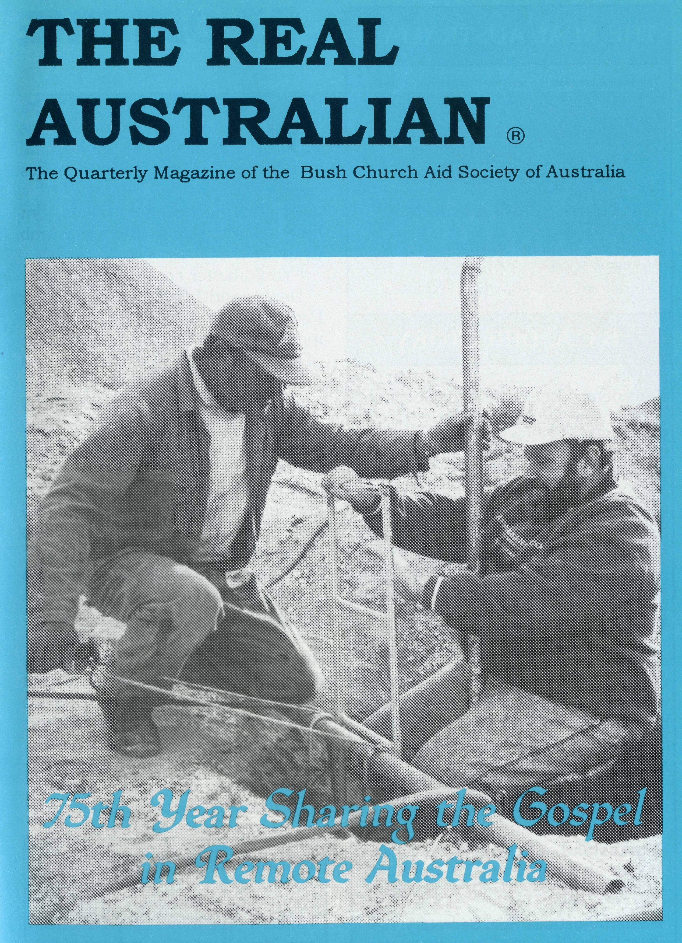
MARCH 1994. $3.00 subscription. Reg. by Australia Post Publication No. NAR 0630

Printed by Ambassador Press Pty. Ltd., Granville 2142.

THE REAL AUSTRALIAN

AT THE CARING EDGE

Meanwhile Denise found her way to an annexe set up by the Hospital Auxiliary. She worked with more than 30 volunteers who looked after those who were alright physically. At the same time many others with Mine Rescue, SES and Ambulance or Nursing training were recovering and helping those affected. We saw many of our own Church members among them.
The Real Australian is a registered trade mark of the Bush Church Aid Society.
First published 1920. Edition No. 283
Circulation: 28,000
All enquiries to: THE EDITOR
Greg Thompson
THE BUSH CHURCH AID SOCIETY OF AUSTRALIA
LEVEL 7, 37 YORK STREET,
SYDNEY 2000
Ph (02) 262 5017. Fax (02) 262 5020

President: Archbishop Harry Goodhew
Chairman: The Rev. Dr. Vic Roberts
Patron: Archbishop Keith Rayner
Vice-Presidents: Mr. Stan Hummerston, O.A.M.; Mr. Ray Otercteko.
Hon. Treasurer: Mr. R. Otercteko.
Federal Secretary: Rev. Brian Roberts.
N.S.W. Secretary: Rev. Greg Thompson, Level 7, 37 York Street, Sydney, N.S.W. 2000. Ph (02)262 5017.
Victorian Secretary: Rev. Brian Viney, Shop 1, 205 Flinders Lane, Melbourne, Vic. 3000. Ph (03) 654 8022.
South Australian Secretary: Rev. Bob George, Church Office, 44 Currie Street, Adelaide, S.A. 5000. Ph (08) 212 7804.
Queensland Secretary: Rev Les
Monaghan, P.O. Box 6472, Upper Mt. Gravatt, Old. 4122. Ph (07) 349 9081.
Western Australia Hon. Secretary: Rev. Peter Brain, 27 Leach Street, Wanneroo, W.A. 6065. Ph (09) 405 1325.
Saturday, shortly before 7.00 p.m. The phone rang. "Bob? This is Phyllis. I was just up at the hospital and heard that there's been a bus crash ..."
I called the hospital. "Hello, I'm the new Minister at the Catacomb Church."
"You'd better come ..."
Denise and I had been in Coober Pedy just two weeks. A visit to the modern hospital now shot to the top of the list of things to do. The injured driver had been picked up while walking to get help. They were still waiting for the passengers, forty students from a Catholic High School.
A report came in: there were several serious injuries and one girl had died. The Catholic Priest went out to the crash site and I had a long talk with Harry the driver. When others arrived for treatment I met Cassie. She had needed some stitches but was more concerned for her friends. After we talked I took her to see Harry. She set aside her own grief and helped to reassure him. Then we both went to talk to other teachers and students.
FRONT COVER PHOTO:
Rev. Bob Rothwell at Lloyd Hetzel's opal mine. Lloyd assisted as a Mine Rescue Squad volunteer at the bus crash site.
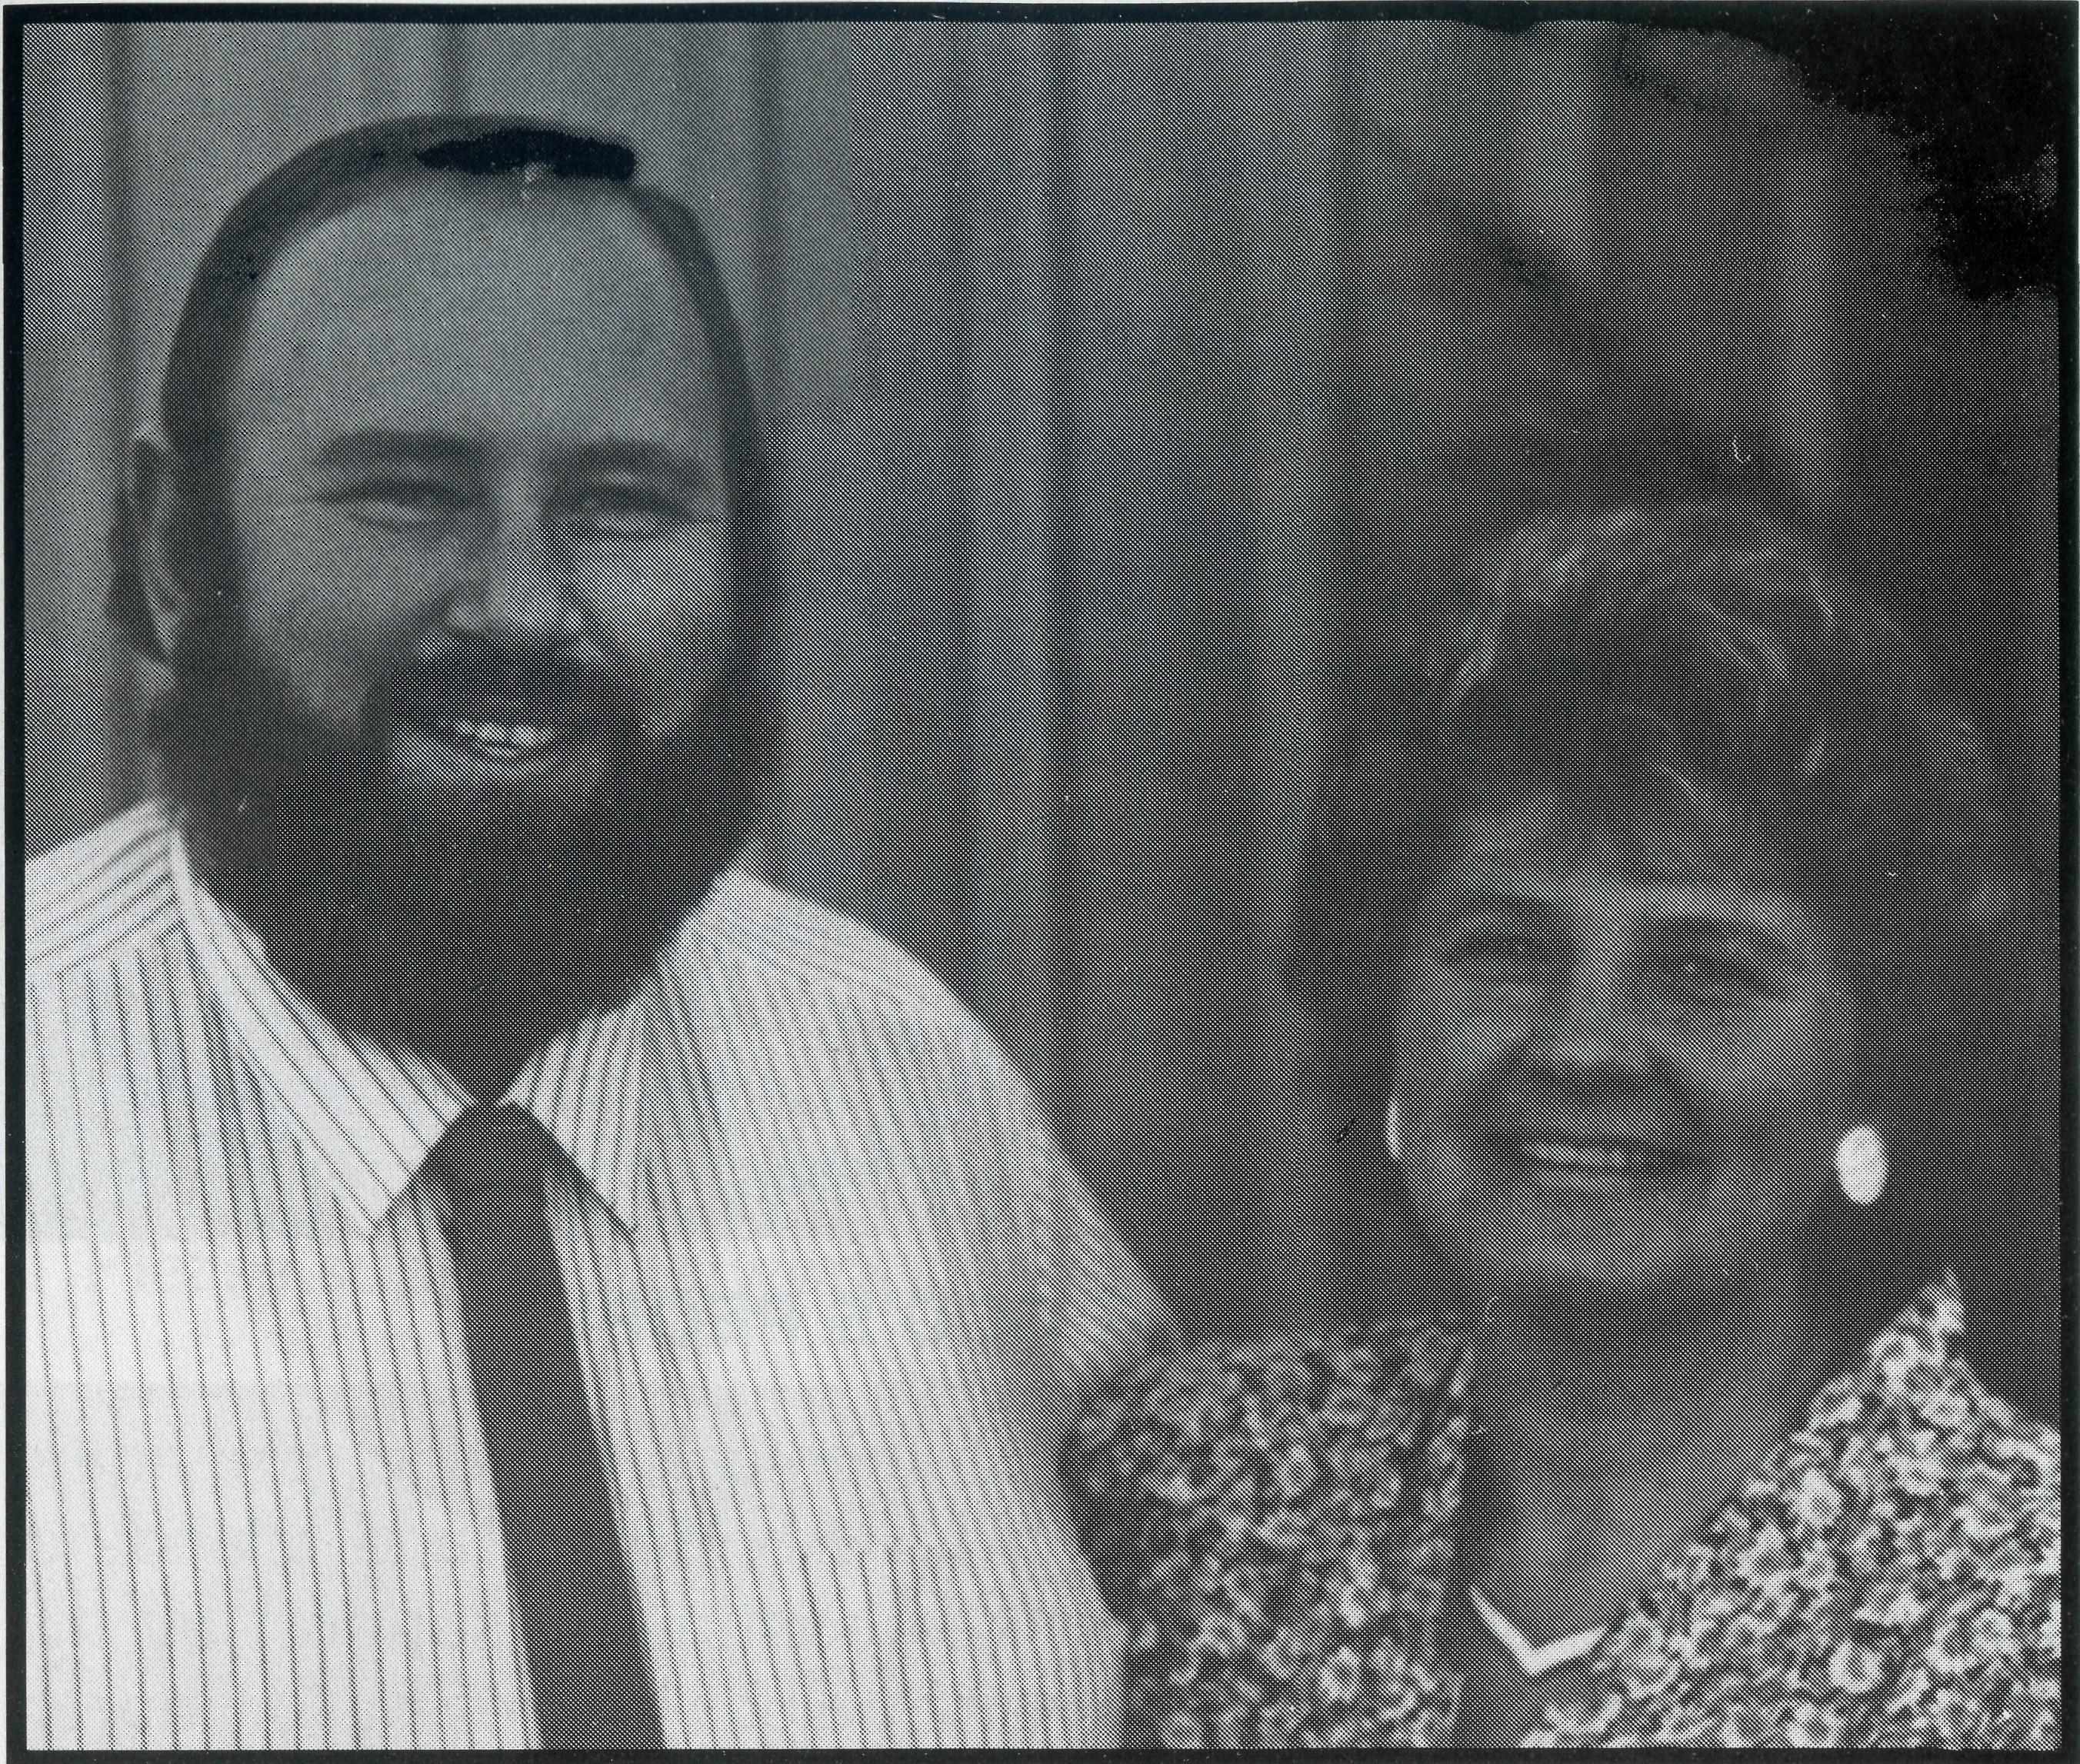
Sunday, after Church. I called on Harry again. The others had gone to larger hospitals or the motel but a few students came back for dressings and they joined me in Harry's room to help him face the cold reality of what had happened.
I went home with a great deal of respect for the compassion both of those young victims, and of the people of Coober Pedy.
BOB ROTHWELL
Bob and Denise Rothwell arrived at Coober Pedy from Sydney at the beginning of September 1993 after serving at Canley Heights.

THE REAL AUSTRALIAN
THE REAL AUSTRALIAN

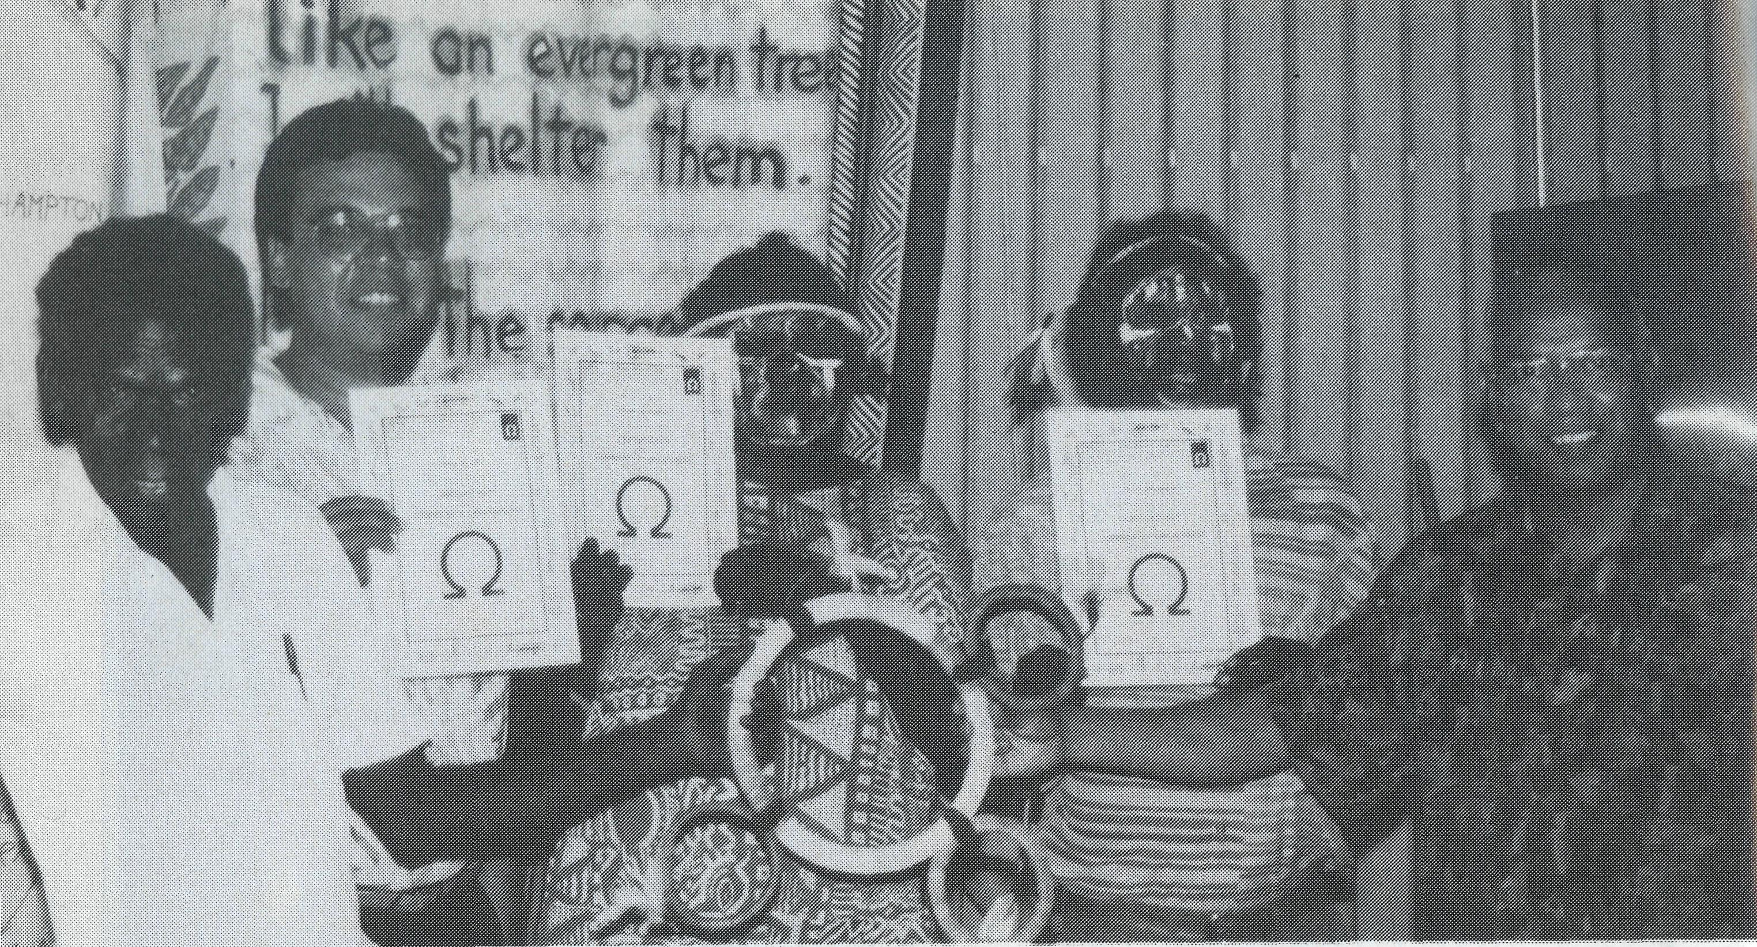
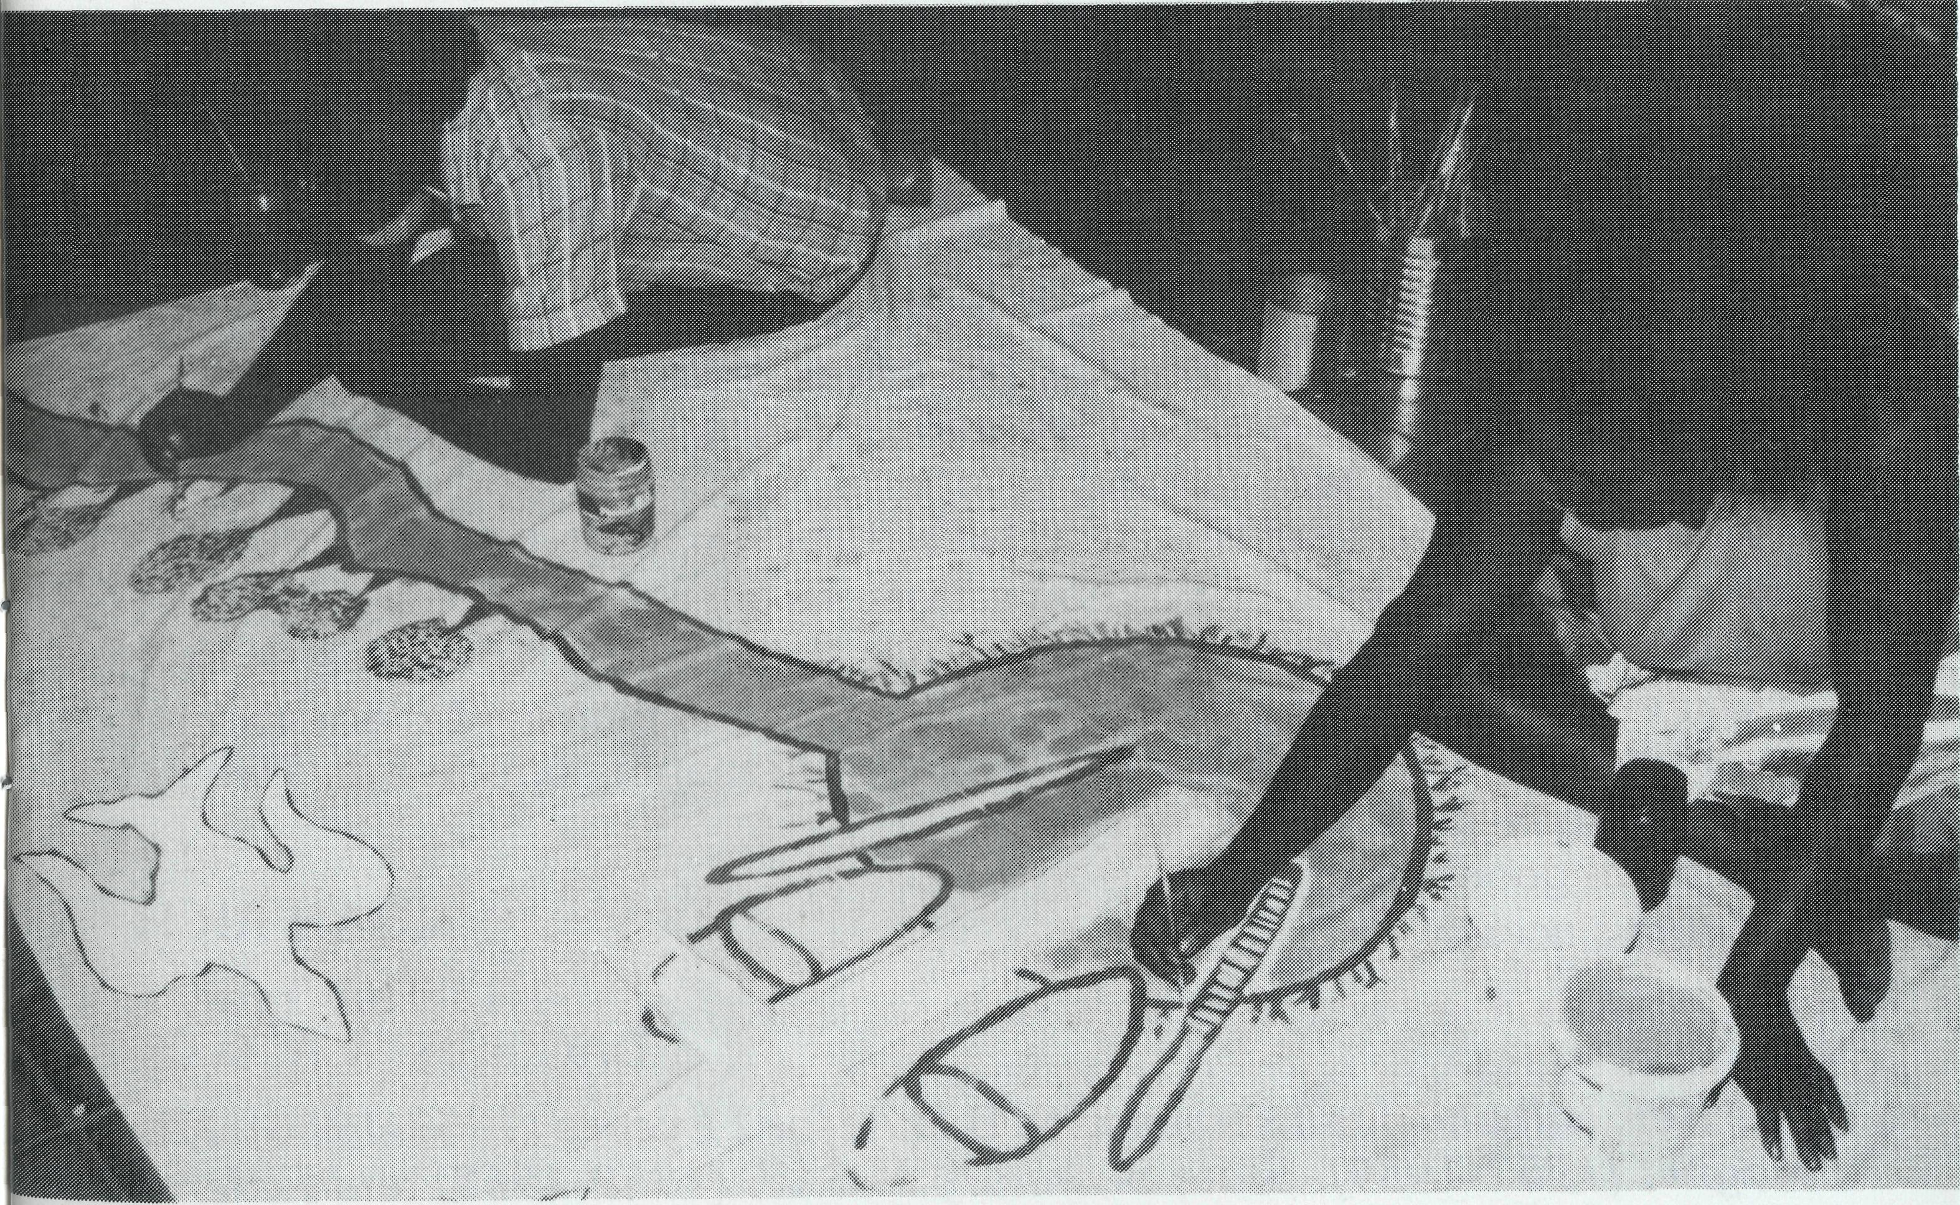
NUNGALINYA COLLEGE — DARWIN
TRAINING FOR GOD'S PEOPLE
Nungalinya College is an Ecumenical College providing Christian education and training for Aborigines and Islanders. The college deeply appreciates the continuing support by the Bush Church Aid Society. The visit by a bus load of Bush Church Aid tourists in July 1993 enabled us to show something of our work to supporters from the southern states. The programs taught at the college are: Theology and Church Leadership Community Organising Bi-Cultural Life Studies for Women Literacy and Numeracy Craft and Micro-Enterprise, and Cross Cultural Awareness for non-Aborigines. The college has had much to thank God for in 1993. A subsidy from the Northern Territory Government enabled a new Education Facilities Building to be built. This was dedicated by the Primate, Archbishop Dr. Keith Rayner at the annual Open Day in August 1993.
4 THE REAL AUSTRALIAN
A Certificate and an Associate Diploma in Theology have received national accreditation. A Diploma and a Bachelor's Degree will now be prepared for accreditation. Accreditation gives students nationally recognised qualifications and allows them to receive an Abstudy allowance.
The College Library is being substantially upgraded. The new accredited courses require better library facilities and the decision of the Taxation Commissioner to make donations to the library tax deductible is expected to encourage support for this important task.
The college has a promotional video telling of its work in detail. A copy can be sent to church organisations who would like to use it to support our programs.
B.C.A. continues to assist Nungalinya College with the support of Ms Elizabeth Caldwell, a literacy worker and a parishioner of St. James Sanderson. Elizabeth spends her time at College and in Aboriginal communities assisting students with their reading, writing and public speaking skills.
Sharing God's story through art.
THE REAL AUSTRALIAN
Please support the work of the college in your prayers.

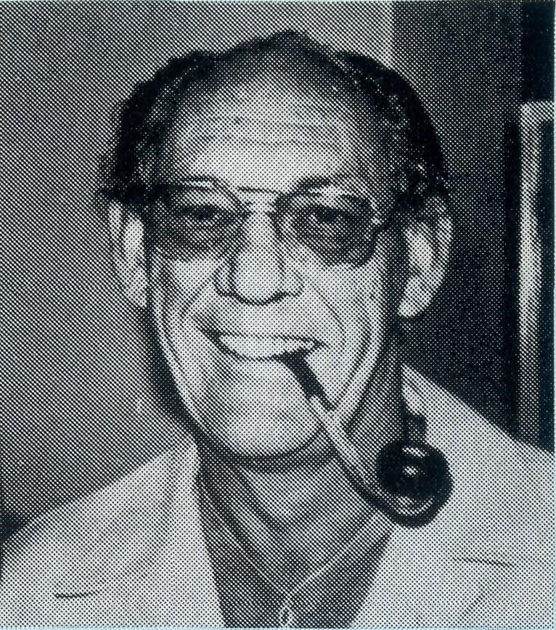
B.C.A. ANNUAL MEETINGS IN 1994
NOMINATION TO COMMITTEE:
Nominations for State and Federal Committees must be in the hands of the State Secretaries in writing at least two weeks prior to the meeting date, duly signed by the proposer and candidate. Anyone interested in being involved in a committee should liaise with their State Secretary.
LETTER TO THE EDITOR
The Editor
Dear Sir,
I wonder if Brian Carter's story in The Real Australian (September 1993) "I Was 27 Then" triggered memories for others — it certainly did for me and moved me to write to you.
Bill was 27 when he offered for service with B.C.A. and was sent to Western Australia with Don Douglas to pioneer a new frontier for the Society. The Sydney Morning Herald carried a report with the by-line "Pioneer Ministry for W.A." and we frequently had that pioneer feeling!
Bill's brief was to re-establish a resident ministry in the Murchison goldfields after a break of nearly 50 years and, although there were church buildings, there was no house, no car and consequently no family. With Mark about three years old and Peter six we waved him off not knowing what the future held.
The vestry of the sadly dilapidated corrugated iron church at Mt. Magnet gave Bill a place to sleep and work (taking meals and showers at the local hotel) until the ceiling collapsed. With the possibility of a house being many months away Bill negotiated use of the CWA Rooms and we joined him there — the lack of a bathroom providing many hilarious moments and taxing our initiative as we watched the construction of a Rectory with some impatience over six months.
The B.C.A. staff network of close friendship in South Australia was gratfully experienced later in Bill's ministry, but one of my most enduring memories was the reality of being supported and upheld by B.C.A. supporters and friends both within Australia and beyond.
Another memory I cherish is of a visit by the Primate of the day Archbishop Mowll and his wife, to our CWA home, bringing gifts of unavailable food items and charming everyone at an official Civic Welcome.
Our energy and enthusiasm were no doubt greater than our experience and knowledge on occasions but was a faith and life-shaping opportunity I would not have missed for worlds.
With all good wishes,
Yours sincerely, ^{JOAN} ^{K1CH}
4/13 Troy Terrace DAGLISH, W.A. 6008
The Rev. Bill and Joan served with B.C.A. for 11 years (1957-1968). Mt. Magnet (1957-1959), State Secretary N.S.W. (1959-1962) and Federal Secretary (1963-1968). Bill died in 198?.
6 THE REAL AUSTRALIAN

FEDERAL A.G.M.
Date: Thursday, 26th May, 9.00 a.m.
Location: 37 York St. Level 15, Room 2 | Sydney.

QLD. & NTH. N.S.W. BRANCH
Date: Friday, 20th May,
6.00 p.m. Tea followed by
A.G.M. at 7.30 p.m.
Location: St. John's Wishart on
Mt. Gravatt &
Capalaba Rds.
VIC. & TAS. BRANCH
Date:
THE REAL AUSTRALIAN
Location: To be advised.
N.S.W. BRANCH
Date: Tuesday, 19th April,
7.30 p.m. Coffee & Dessert. Location: Holy Trinity, Lambeth
Street, Panania. Rev. Greg Thompson, the new N.S.W. State Secretary, will be commissioned.
S.A. & NT. BRANCH
Date: Monday, 2nd May. Location: St. Leonards Church,
David Ave., Glenelg
North. Tea: 6.30 p.m. A.G.M.: 7.45 p.m.
W.A. BRANCH
Date: Wednesday, 13th April, 3.30 p.m.
Location: Boardroom, Geoffrey Sambell Centre, 42 Colin Street, West Perth.

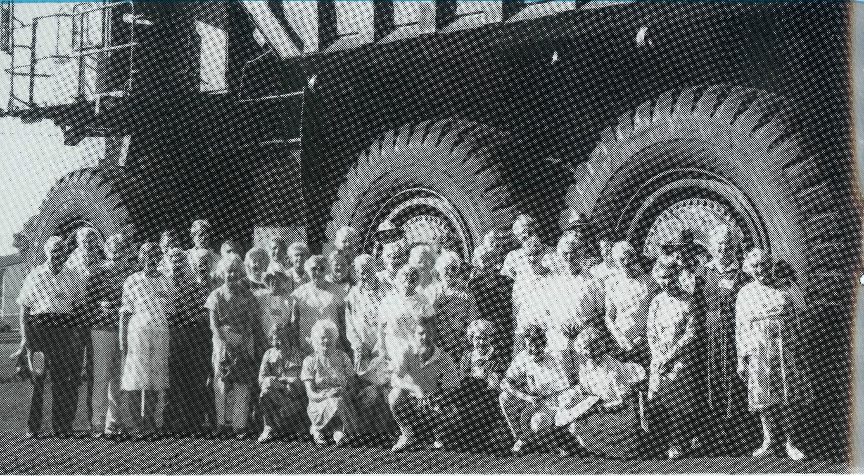
COACHING IMPROVES YOUR GAME!
Why did 40 odd people choose B.C.A. coaching! After all, it was a considerable amount of money to pay to sit on a coach all day, motoring around the bush visiting a few people living in obscure places. Now was it "40 odd" people, or 40 "odd people"?
Well, let me assure you it was more than the charm of the three good looking hosts that provided the incentive.
Last August a contingent of South Australians and some other co-opted 'crow-eaters' flew to Darwin to begin a tour of the great North West.
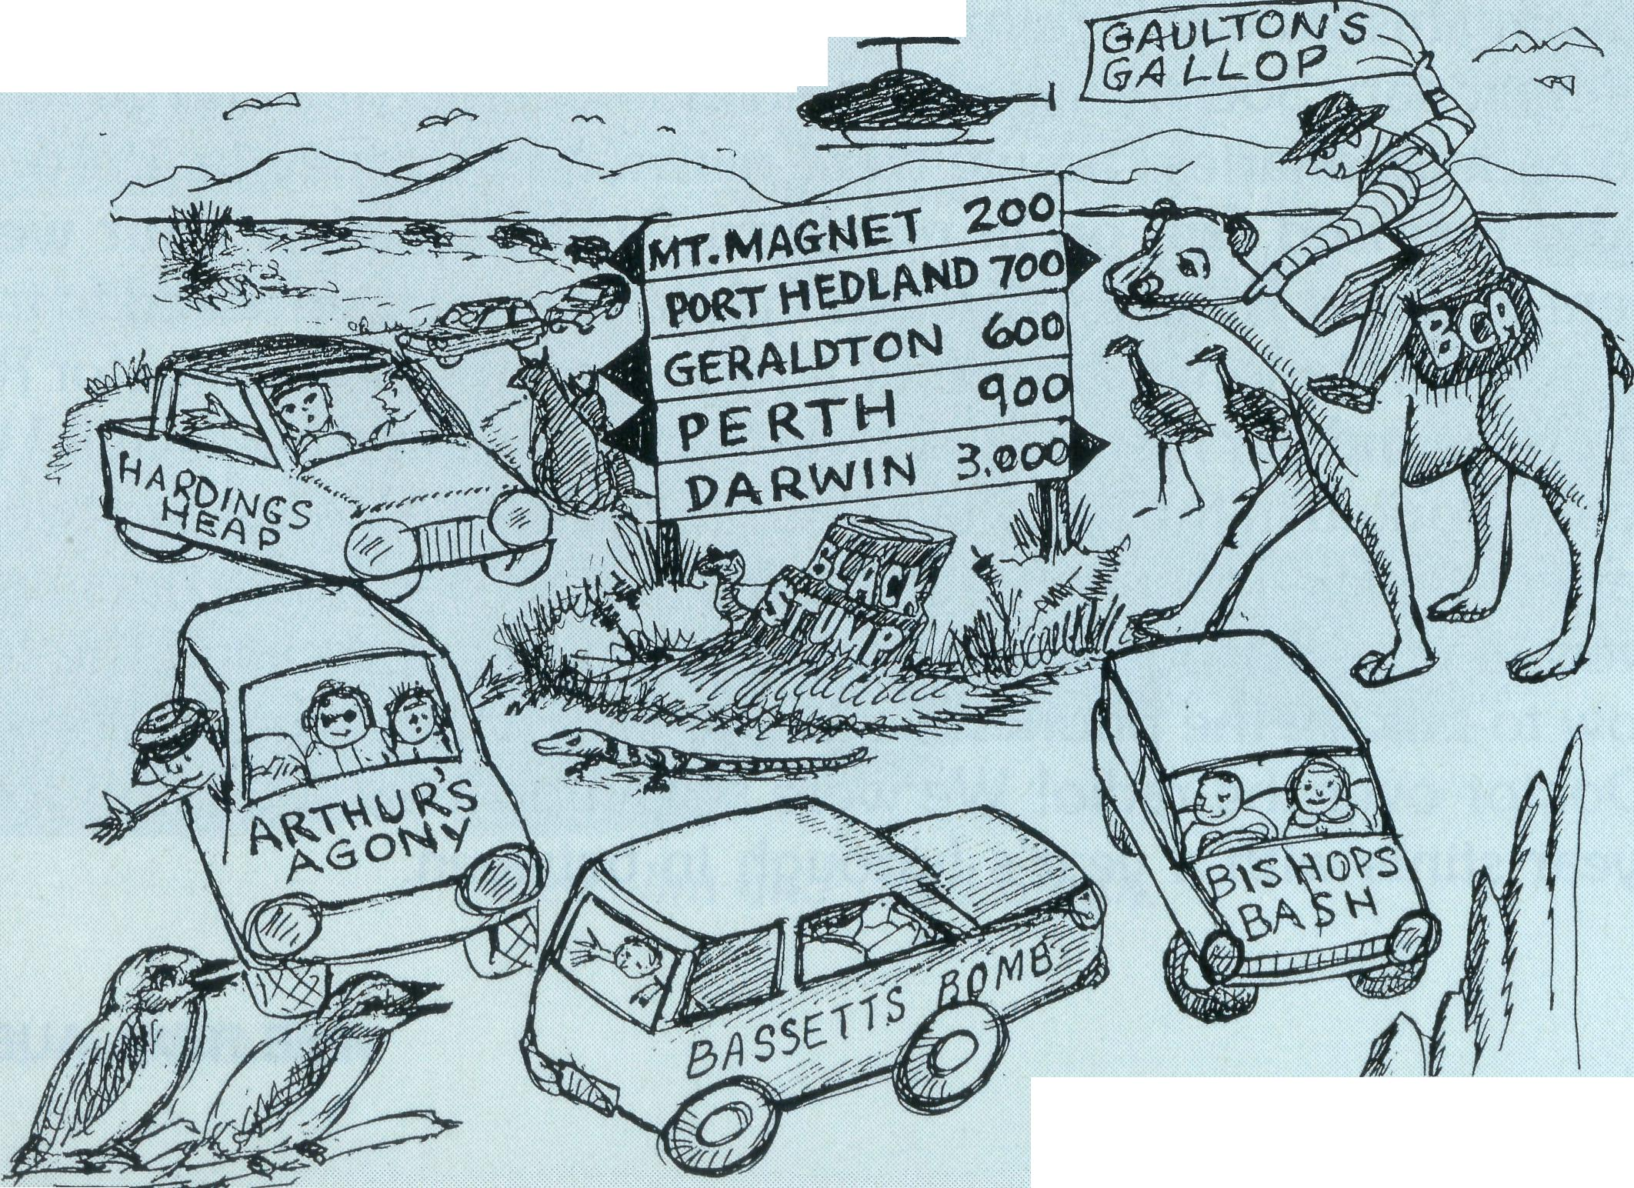
The tour was magnificent in every sense — good fun, good fellowship, incredible sights and sounds, and committed B.C.A. missioners. Even the morning devotions were uplifting, in spite of the captive audience. It was a kind of Biblical meals on wheels.
Twelve B.C.A. areas of ministry were visited from Darwin to Perth. In a graphic way, each tourer experienced something of the living and ministering conditions of B.C.A. field staff and their families.
So what seemed to be a strange way of passing the time, ended up being a never to be forgotten holiday with like-minded people.
B.C.A. tours are great opportunities to experience first hand what God is doing through dedicated Christians serving in remote areas. Let B.C.A. know if you are interested in joining a tour.
REV. BOB GEORGE
8 THE REAL AUSTRALIAN

KEEPING THE WHEELS TURNING KAY WINFIELD — NWA REGISTRAR
When I began working in the Diocesan Office (is it really 25 years ago?), the Diocese of The North West had only been running its own affairs for six years. The mining boom was just starting. Although stipends were paid from a central office, our few parishes were almost autonomous centres, linked by visits from the Bishop. In those days the Diocese had a Bishop with private means who kept accounts on the back of an envelope. Now still with limited resources we provide for a Bishop and support network for the Diocesan family.
In 1970, when B.C.A. funded the appointment of our first Administrator/ Registrar (Mr. Stan Hummerston, O.A.M.) administration became more centralised and efficient. The number of parishes grew dramatically.
As with the Diocese, my ministry has changed over the years. I have run the gamut from Office Manager to Secretary, to Part-time Bookkeeper and now Registrar. We are still a very small concern with one office lady and me. I still plug gaps!
The greater proportion of my time is taken up with financial matters: every facet of bookkeeping (from posting, to preparing financial statements); investment of parish trust funds and our See Endowment (such as it is); preparation of budgets to accompany our requests for outside aid, and generally shuffling moneys around to keep the cash flowing in the right accounts. Finance is my biggest headache and we are certainly grateful to B.C.A. and other mission bodies for their tremendous generosity.
Because I have been here so long, I find I am an historical consultant and resource person; Bishop's minder and memory; sounding board for Rectors and chief worrier.
Sometimes the job is exciting, sometimes frustrating, but always worthwhile because I know that I am supporting the extension of God's Kingdom.
KAY WINFIELD
CLERGY GET-TOGETHER KAY WINFIELD
Illustration: Shirley Kilminster.
NORTH WEST STYLE

BUFFALO TONGUE AND GOATS MILK
This month we talk to well-known Streaky Bay identity Glad Smith. Many people would know of Glad's close association with the Bush Church Aid Society (B.C.A.) but, as I found out, that's just the tip of the iceberg! Glad allowed Hannah and myself to come into her home to talk to her. Tell us about your early life as a Christian
I was born at Dungog N.S.W. into a Christian family. At the age of four I invited the Lord into my heart. This was a very real experience for me but my parents couldn't believe that it was. Therefore they couldn't accept me as a genuine Christian. Because I was such a shy, timid child I was convinced that I wasn't a Christian. So there was a large gap in my life as a Christian until I was 20 years old. What changed then?
I left home then to work for the doctor and his wife at Tuncurry on the N.S.W. coast. I was very happy there and formed a very close friendship with friends of my parents — Fred and Beth Elliot. They were former missionaries and were heavily involved in the work of the church. Fred, who was the baker at nearby Forster, asked me if I would take on teaching Sunday School at Tuncurry. I told him that I couldn't. I believed that I wasn't a Christian. Fred told me that I was. I just didn't have assurance. At a prayer meeting Fred asked the people there to pray for someone who lacked assurance. It did come and I wrote in my bible at that time "Blessed assurance, Jesus is mine!" I believe that assurance is critical for Christian growth. It sounds like Fred and Beth were pretty important to you
They were. They gave me lots of encouragement. I lived with them for some time — to help look after their five children when Beth became very ill. They gave me wonderful hospitality; they shared with the Lord what they had. How did you meet your husband?
I met Jim while I was staying at Fred and Beth's. At that stage Jim was a missionary just out of Bible college and used to stay at Fred and Beth's. He used to travel out from the aboriginal mission at Purfleet, 21 miles into Forster by bicycle, to take services. We became engaged and I entered the Sydney Bible Training Institute at Strathfield. I didn't complete my course though; the Church Missionary Society asked Jim and I to get married and go to northern Australia as missionaries. So we were married in Sydney in 1946. Where did you and Jim go in northern Australia after your wedding?
We went to Roper River for three months and were then asked to transfer to Oenpelli mission station in Amhem Land, just off the East Alligator River. We went in by boat and our first meal was buffalo tongue and goats milk! While we were there I worked in the hospital. Prior to our arrival there had been no-one to look after the sick. I thanked God for the first aid and home nursing skills I'd learnt working for the doctor at Tuncurry. I also appreciated the fact that I knew how to talk on the phone. It came in very handy when talking with the Flying Doctor over the radio! We were at Oenpelli for a total of four years. Two 2-year stints with a year's furlough in between.
GLAD SMITH REMEMBERS
Where did your time with B.C.A. take you?
After Jim was ordained we shifted to Ceduna and were there for over a year. Part of Jim's area of service was the railway communities along the Trans Australian line; they used to use Cook as a base and be shunted along the line from siding to siding in a railway car! After Ceduna we were at Cowell for a short period and came to Streaky Bay in 1957 to take on this parish. Jim died in 1972 while still minister of the parish. Despite my earlier misgivings, I actually ended up being very happy to be a minister's wife. How close are people who have served with B.C.A.?
They are a very closely knit group. Once you join up with B.C.A. you never sever your links with it — even after your days of formal service are over. It is like a close family where people can and do rely on each other. I love attending their supportive group meetings every two years and I have B.C.A. visitors stay with me from time to time.
How did you see the role of two groups you're involved in, the fellowship group and the Bay Bazaar?
The fellowship group has been going for 12 years now and it is really encouraging to see women talking and praying out loud. The Bay Bazaar is a service to God and the community and is a great way of making contact with people.
What have been your joys in the life of the church at Streaky Bay in recent years?
Personally I have been very happy. I have a wonderful church family and that "family" includes all denominations. I've seen a great change in people over these years. They are more involved in the church and its activities.
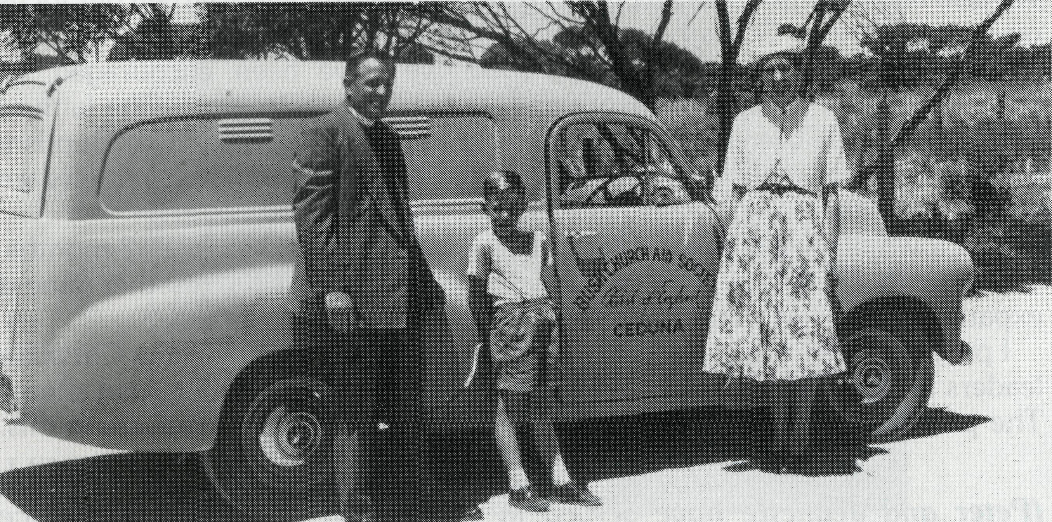
Rev. Jim and Glad Smith.
BOB GEORGE State Secretary S.A.

10
THE REAL AUSTRALIAN
THE REAL AUSTRALIAN
11

A NEW FOUNDATION FOR MINISTRY
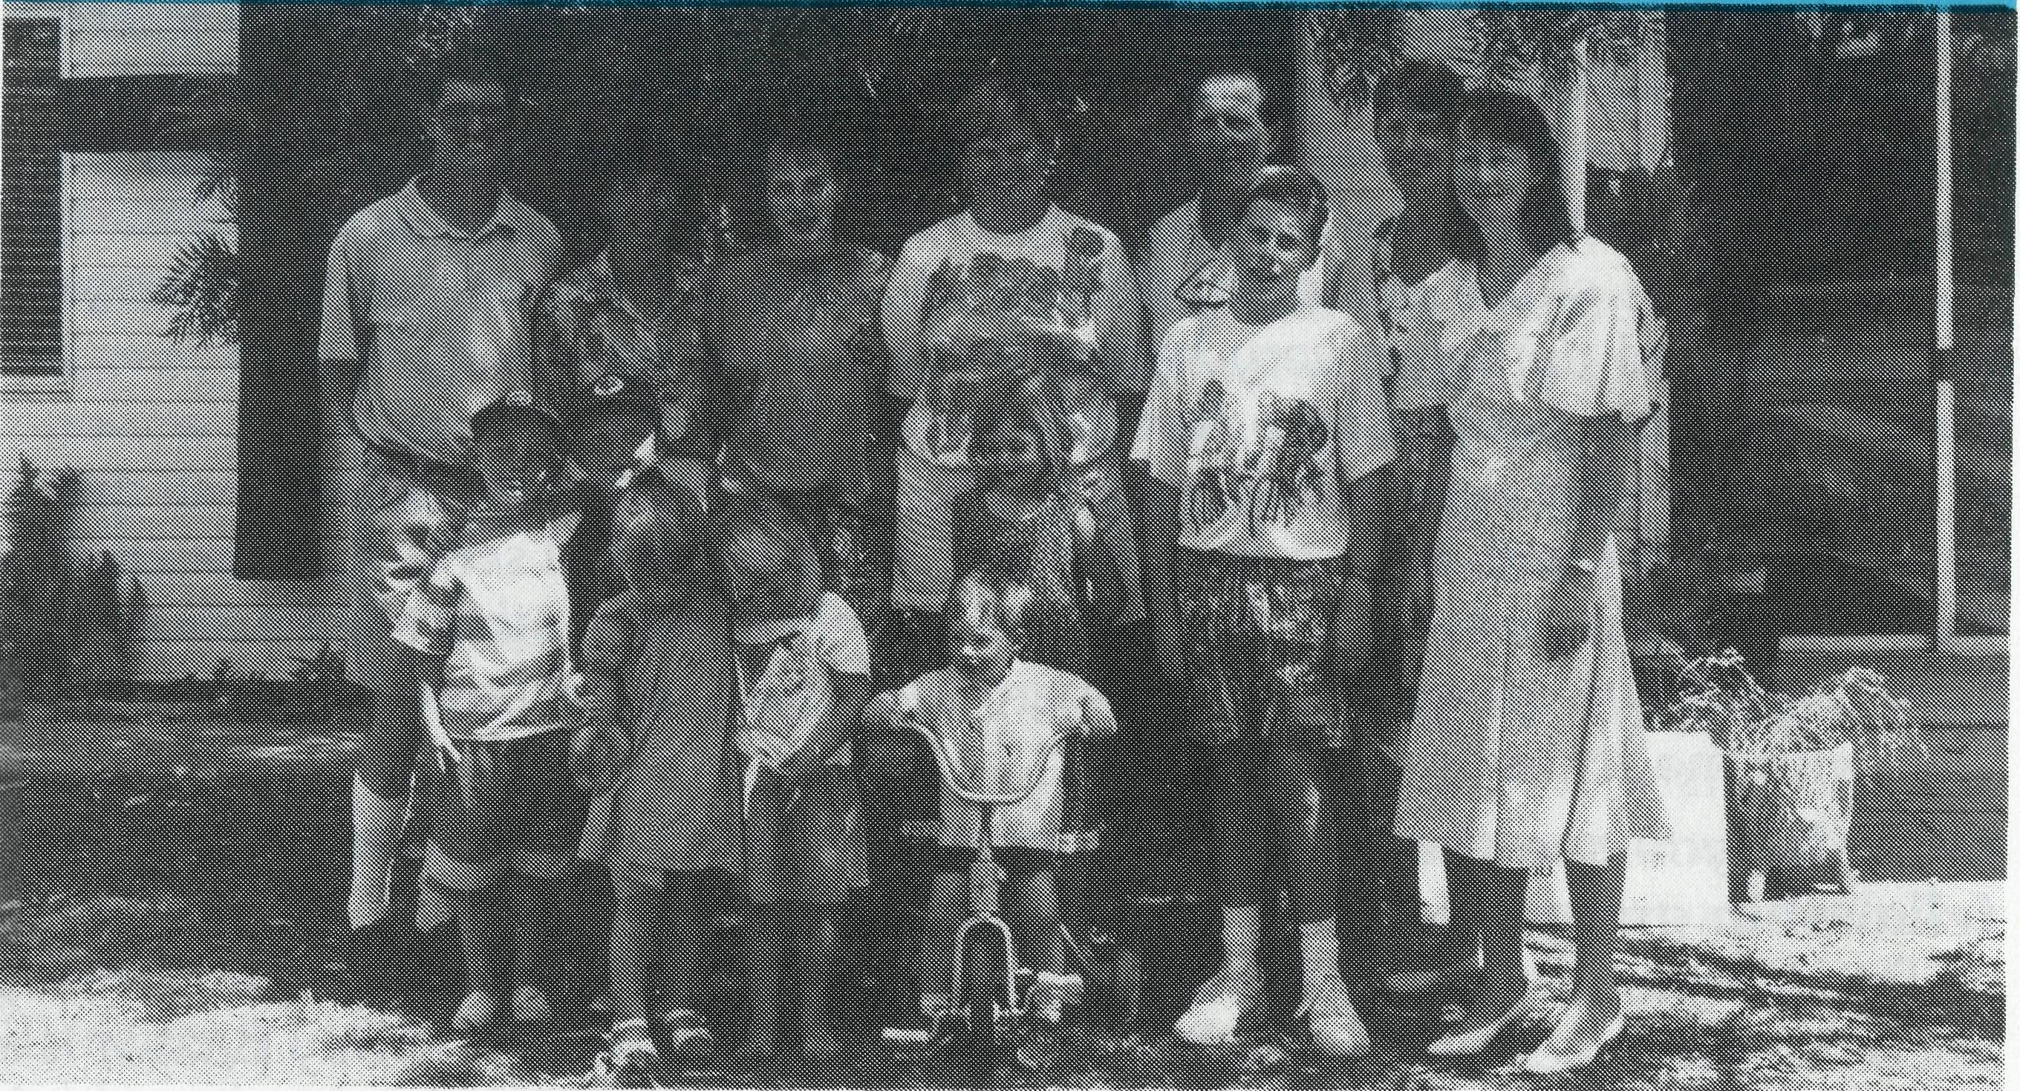
In July 1992 I described the Parish of Blackwater as a "Renovator's Delight". I emphasised the need to build a new foundation.
We have built a new foundation. In this slow process we have strengthened parish structures such as Parish Council membership, rosters and regular worship in the smaller centres. There is certainly a more positive feel about the place.
Financially we have not improved. Key givers have left, but we are paying our bills and we give thanks to God for His provision.
Last October we celebrated the 20th Anniversary of St. Stephen's Centre. We also had a Parish Council planning day. It was a time to sharpen our focus on who we are as God's people and to clarify our direction.
Despite slow progress through 1993 we have been encouraged. In particular in the re-establishment of a Sunday School Program. The faith of three or four children in particular has been growing steadily. Our Baptism preparation has resulted in a few people worshipping again. Many others are slowly developing in faith.
The town of Blackwater has also had good news over the last 12 months. The mine that closed in 1992 has re-opened on a small scale. Another mine is expanding with the potential of about 150 permanent jobs.
I pray that God will use this expansion (or other means) to bring Christian leaders to town. This is still our greatest area of need. It is a long road ahead. The parish is in a critical stage of its life and we value your prayers in this.
PETER BLUNDELL (Peter and Jeanette have served in the Parish of Blackwater since
January 1992)

WHAT IS A CATTLE SCHEME?
Several B.C.A. supporters have asked me this. It is a way of raising regular funds for the life of the parish. Some places use the same principles with wool or grain. The Parish buys cattle and places them on properties around the Parish. After an appropriate time they are sold and some of the money taken out of the scheme to contribute to Church funds.
In our case it is used to replace the car every few years. Our cattle are identified by our brand 2QE.
Currently the scheme is suffering from the worst drought on record in the Central Highlands. It will take some time to build it up again.
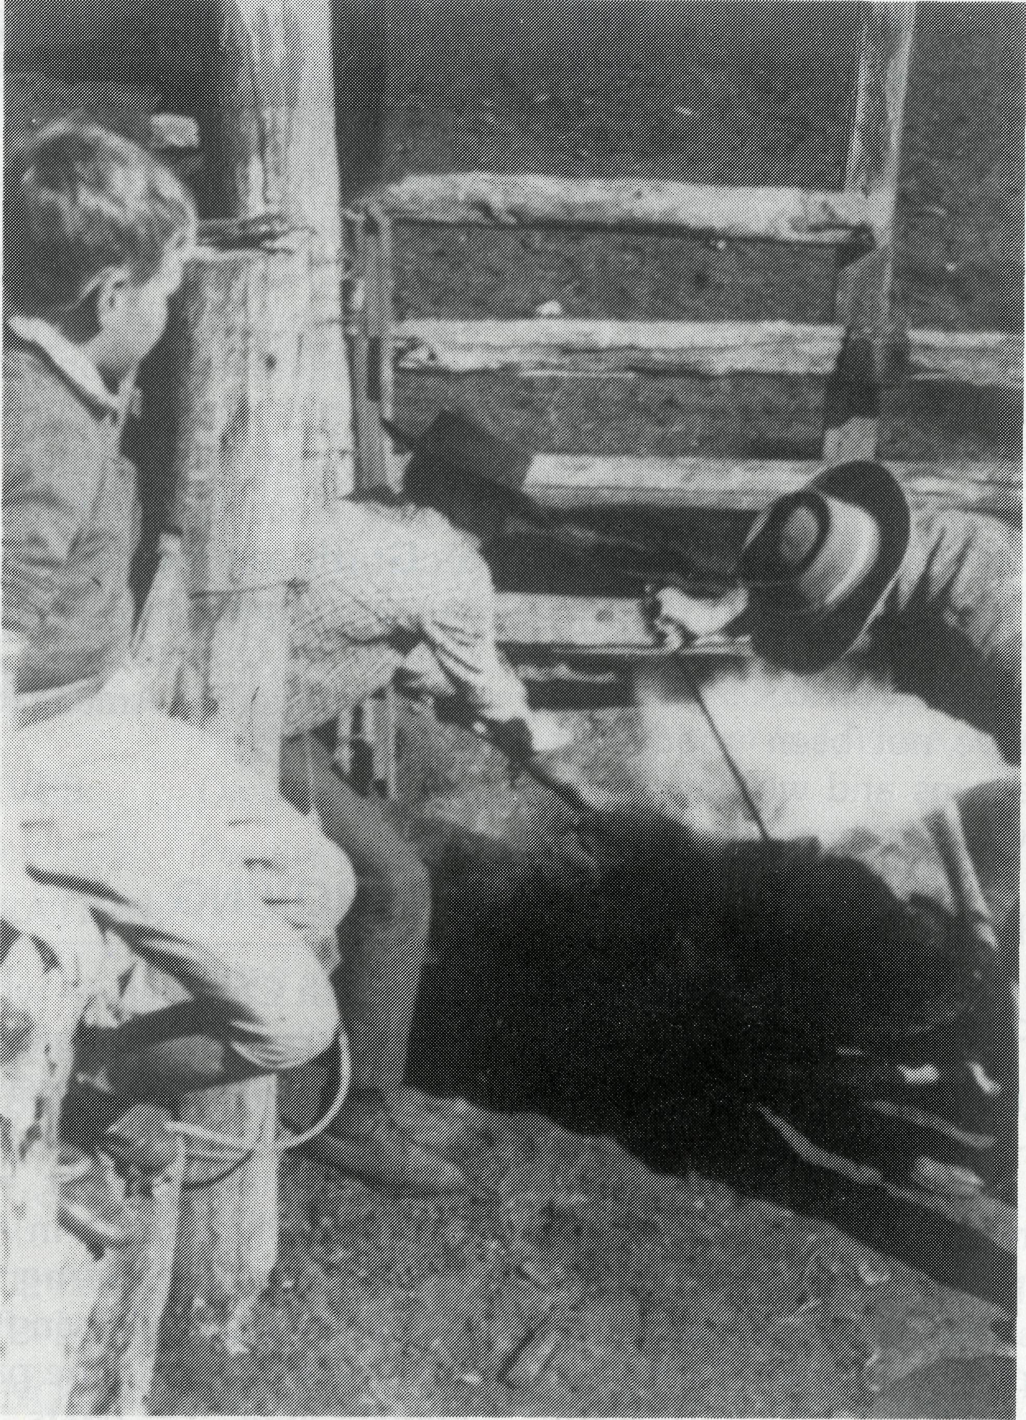
Branding church cattle at Blackwater.
PETER BLUNDELL

THE REAL AUSTRALIAN
THE REAL AUSTRALIAN
13

POST & RAILS

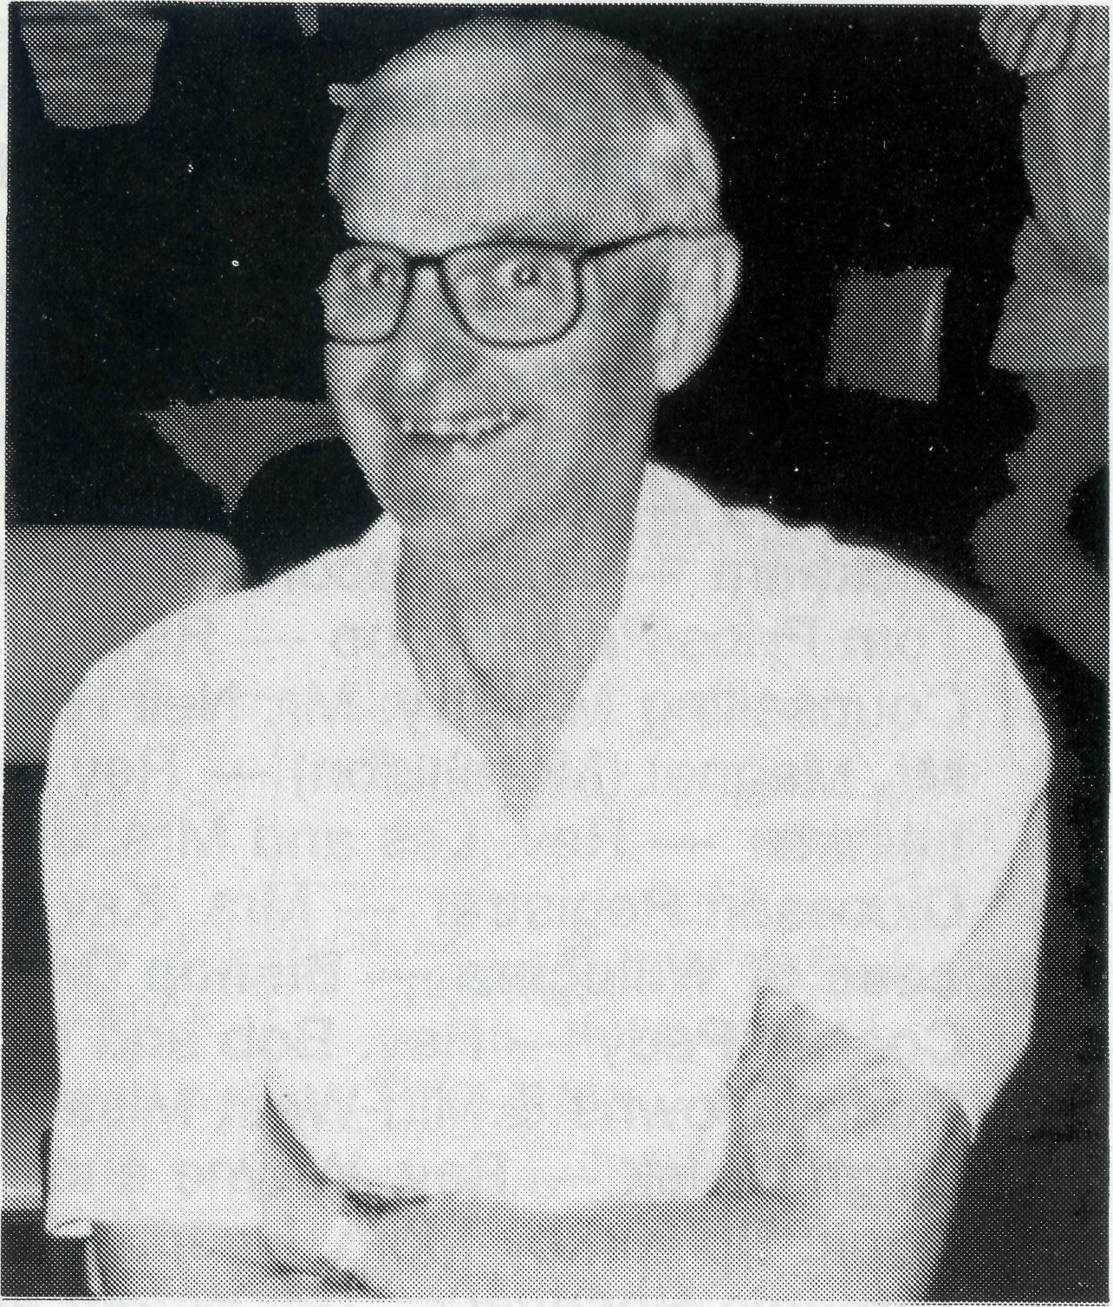
S.A. SOJOURNS
The Rev. Wayne and Mrs. Cherylene Ireland are our new
missioners at Leigh Creek. They commenced in mid January, and have three children — Cameron (24), Natasha (22) and Matthew (12). They come from Euroa in Victoria.
The Rev. Peter and Mrs. Margaret Achurch left Leigh Creek in January. After five years in the parish they have purchased a home in Adelaide where Peter will pursue a full time course of study. We wish them well in this new venture.
Sister Chris Woon from Kingston in South Australia has joined the hospital staff at Cook. Sister Christina Ryman left Cook in December after three years with the Society. We wish her well in the future. Her plans are uncertain at this time.
Ceduna is back on B.C.A.'s map. Harvests have not been good over the past seasons and we have been asked to give short-term assistance to the parish to enable the ministry to continue there. The Rev. George and Mrs. Judy Thomas will continue to minister there.
VIC. PILGRIMS
The Rev. Norm and Mrs. Leonie Fagg, Iain and Catriona after two years at Omeo are presently living at Robertson. Omeo has ceased to be a B.C.A. supported parish. Norm and Leonie are seeking God's purposes at this time concerning future ministry.
QLD. MUSTERING
Mrs. Dianne Harris is now settling into the Queensland and Northern N.S.W. Office. We welcome Dianne and hope that she will enjoy being part of our family.
The Rev. Jim Leftwich will be supported as Priest in Charge of the Aboriginal and Torres Strait Island Congregation in Cairns, which means a full-time ministry can now be conducted at St. Luke's. Jim's wife Lala and two children, Loryanna (18) and Damon (15), are also welcomed into the B.C.A. family. As Bp. Arthur Malcolm has handed over this ministry to Jim he will no longer be B.C.A. supported but continue in our prayers and good wishes.
The Rev. Ian and Mrs. Glenda McGrath commenced in Bonalbo in January 1994. They have come from Bowen in Queensland. They have three children — Amelia (6), Joel (5) and Isaac (2).
NT. ROVING
Elizabeth Caldwell — who is a liter acy worker at Nungalinya — is engaged in one to one assistance with the theological students. We are supporting a staff member, rather than as previously a Grant in Aid.
With the Rev. Greg and Mrs. Kerry Thompson leaving Sanderson to come to Sydney, the parish of St. James, after 12 years of B.C.A. support, has become self-supporting.
N.S.W. TREKKING
Broken Hill BCA House — We welcome Mr. Neville and Mrs. Margaret Coombs as our new hostel parents. They commenced at the beginning of the school term. They are from Bald Hills in Queensland.
Walgett — The Society is assisting the Bishop of Armidale to provide a priest for this parish for the next three years to re-establish a strong ministry there. The Rev. Clive and Mrs. Vivienne Robinson have begun ministry at Walgett after ministering in Quirindi.
W.A. WALK WITH MORRIS
Dr. Leon Morris
SATURDAY, 30th APRIL, 1994
A MISSIONS DAY SPONSORED BY BUSH CHURCH AID SOCIETY AT KESWICK CONVENTION CENTRE (Kelvin Road, Orange Grove)
ELECTIVES:
GAMES:
CELEBRATION
LUNCH:
TIME:
FEATURING: Dr. Leon Morris — former Principal of Ridley College, Melbourne, and B.C.A. missioner in Ceduna, S.A.
On practical aspects of mission.
For the young at heart.
Of singing.
Bring your own or provided ($5.00).
9.45 a.m. to 3.00 p.m.
BRING A CAR LOAD
MAKE IT A PARISH DAY
Dr Morris will speak on: "Motives for Mission in the 20th Century"
ELECTIVES WILL INCLUDE: Encouraging missionary support in the parish. Responding to prayer letters. How can parishes offer practical help.
ENQUIRIES or LUNCH ORDERS (Peter Brain, 405 1325).

14
THE REAL AUSTRALIAN
THE REAL AUSTRALIAN

PRAY FOR OUR STAFF
WINNING AUSTRALIA FOR CHRIST

• Diocese of Northern Territory — Bishop Richard Appleby
- Anglicare Director — Mr. Peter Fisher.
- Tennant Creek — Rev. Tom and Mrs. Carol Williams.
• Diocese of North West Australia — Bishop Tony Nichols.
- Kununurra — Rev. John and Mrs. Dianne Symons.
- Derby — Rev. Jon and Mrs. Rae Reinertsen.
- Newman — Rev. Raymond and Mrs. Betty Lou Molyneux.
- Hedland — Rev. Ray and Mrs. Lyn Arthur.
- Karratha — Rev. Terry and Mrs. Fiona Redmond.
- Wickham — Archdeacon Bill and Mrs. Jocelyn Ross.
- Tom Price/Paraburdoo — Rev. Brian and Mrs. Joy Harding.

- Counselling Ministry: Mr. Neil Hamilton.
- Mt. Magnet (Murchison) — Rev. Philip and Mrs Margaret Bassett.
- Leinster — Rev. Les and Mrs. Jenny Gaulton.
- Diocesan Registrar — Mrs. Kay Winfield in Geraldton.
• Diocese of Willochra — Bishop David McCall.
- Coober Pedy — Rev. Bob and Mrs. Denise Rothwell.
- Roxby Downs & Mid-West Mission — Rev. John and Mrs. Leone Rutherford.
- Leigh Creek — Rev. Wayne and Cherylene Ireland.
- Cook: Bp Kirkby Mem. Hosp. — Gai DiDonna & Chris Woon.
- Tarcoola Hospital — Gill Wright and Denise Broadwood.
- Ceduna — Archdeacon George and Judy Thomas.
• Diocese of Riverina. — Bishop Bruce Clark.
- Broken Hill B.C.A. House — Neville and Margaret Coombs.
- Wilcannia — Rev. Don and Mrs. Helen Wilson.
• Diocese of Armidale — Bishop Peter Chiswell.
- Lightning Ridge — Rev. Mark and Mrs. Lucy Taylor.
- Walgett — Rev. Clive and Vivienne Robinson.
• Diocese of Grafton — Bishop Bruce Schultz.
24 Bonalbo — Rev. Ian and Glenda McGrath.
• Diocese of Brisbane — Archbishop Peter Hollingworth.
25 Quilpie — Vacant.
• Diocese of Rockhampton — Bishop George Hearn.
- Winton — Rev. Geoff and Gill Bransgrove.
- Blackwater — frev. Peter and Mrs. Jeannette Blundell.
- ABORIGINAL AND TORRES STRAIT ISLANDER MINISTRY: Cairns: St. Luke's — Rev. Jim and Lala Leftwich. Nungalinya College — Ms. Elizabeth Caldwell. Bimbadeen College — Mr. Denis and Mrs. Maureen Atkinson. Furneaux Islands — Rev. Donald Moffat. Dio. of Tas.
- STATE OFFICES:
Hon. Secretary for W.A. — Rev. Peter Brain.
State Secretary for S.A. — Rev. Bob George, Mrs. Aila Alderson.
State Secretary for Vic. and Tas. — Rev. Brian Viney, Ms. Margo Bright.
State Secretary for N.S.W. — Rev. Greg Thompson, Mrs. Michele Peacock.
State Secretary for Qld. & Northern N.S.W. — Rev. Les Monaghan and Dianne
Harris.
30 B.C.A. FEDERAL OFFICE: Rev. Brian Roberts, Mr. Jim Gosbee, Mesdames
Jacqueline Griffiths, Lay Lee Boughton and Eileen Darbin.
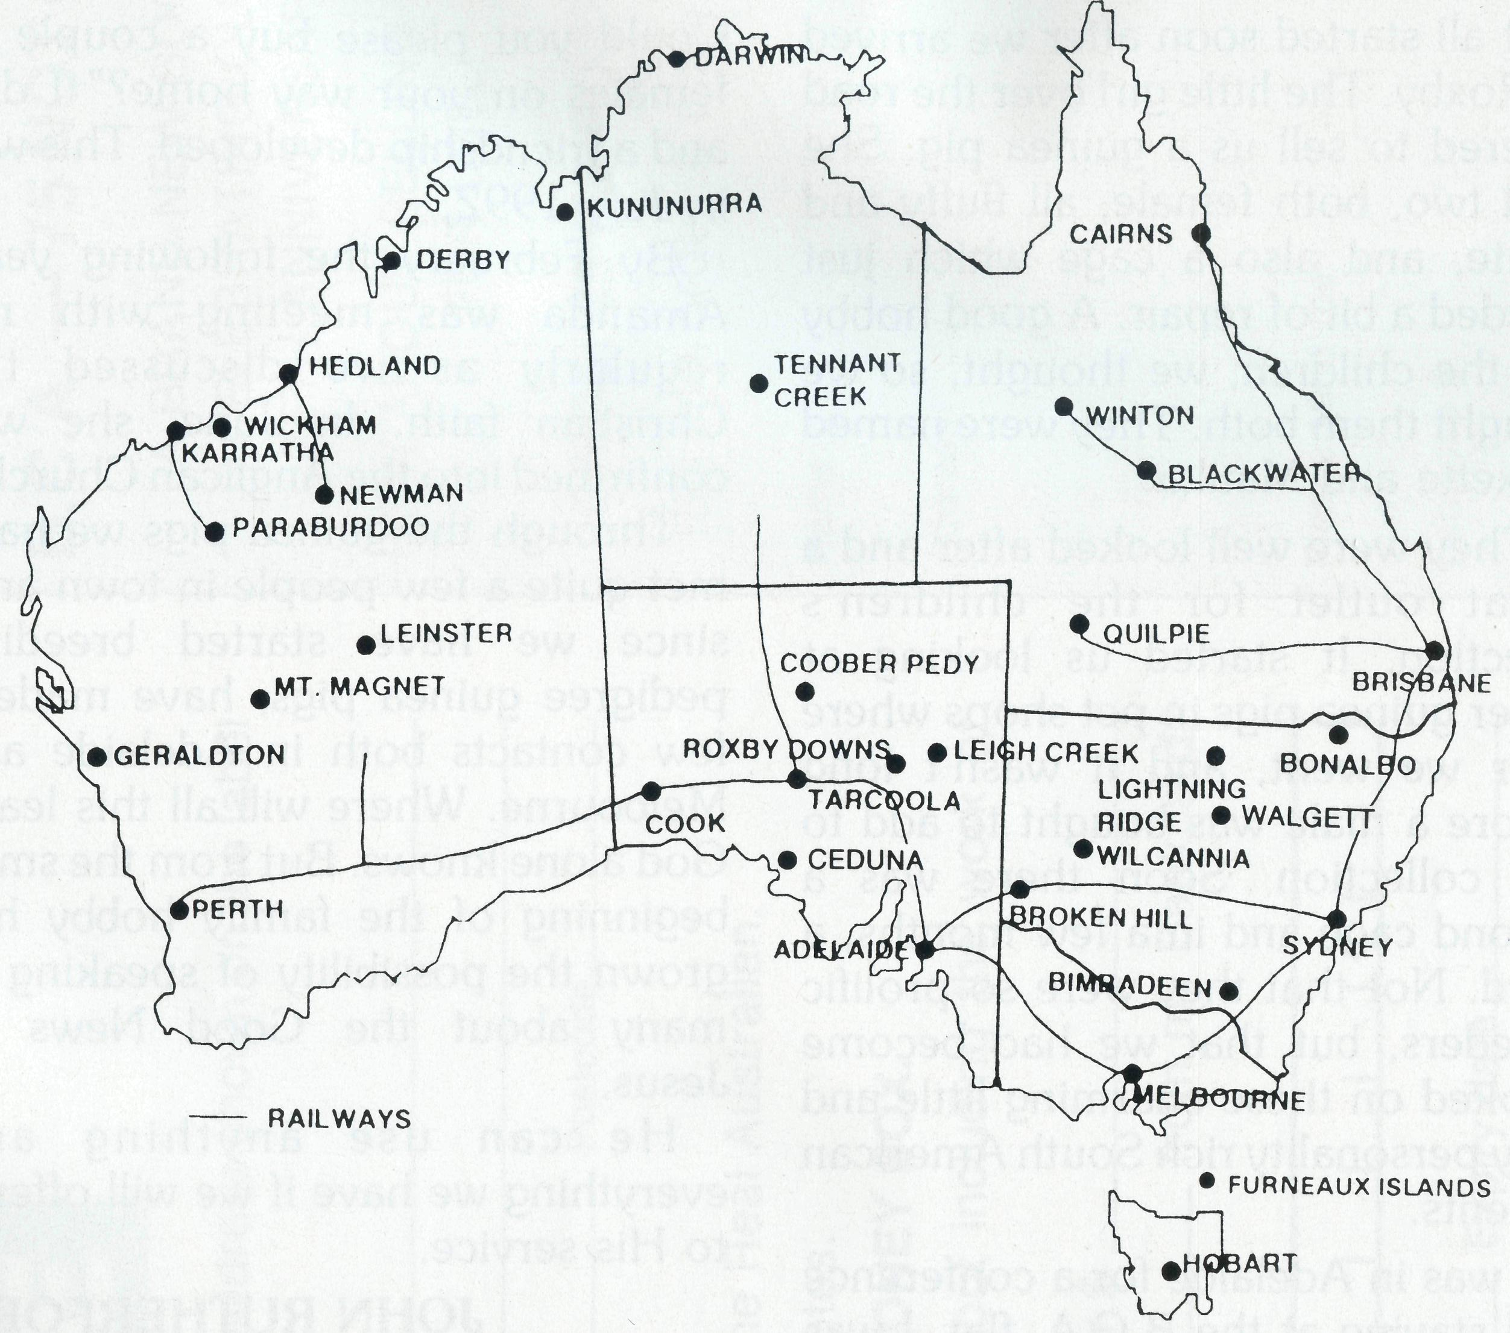
THE B.C.A. PRAYER
O Lord our God, help us to remember those who live in the remote parts of our land. We ask you to strengthen and encourage all whose ministries are supported by The Bush Church Aid Society. Refresh them in times of discouragement and loneliness and call others to stand with them in the task of making Christ known. Grant that, through the ministry of the Word and Sacraments, through medical work, through service and by caring for the young, the message of your redeeming love may be proclaimed, and accepted by the people throughout our land. We ask these things through Jesus Christ our Lord, who lives and reigns with you and the Holy Spirit, one God, for ever and ever. AMEN.
*lf you'd like more details for prayer, send for our FREE quarterly prayer notes. (See reply page.)

THE REAL AUSTRALIAN
THE REAL AUSTRALIAN
17

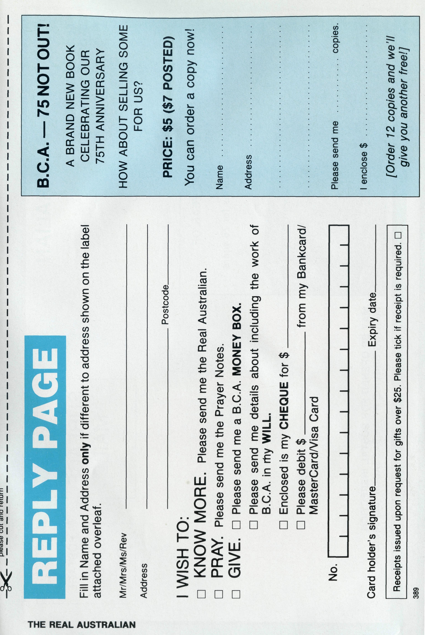
FROM LITTLE THINGS, BIG THINGS GROW
It all started soon after we arrived at Roxby. The little girl over the road offered to sell us a guinea pig. She had two, both female, all fluffy and white, and also a cage which just needed a bit of repair. A good hobby for the children, we thought, so we bought them both. They were named Roxette and Matika.
They were well looked after and a great outlet for the children's affection. It started us looking at other guinea pigs in pet shops where ever we went, and it wasn't long before a male was bought to add to the collection. Soon there was a second cage and in a few months, a third. Not that they were so prolific breeders, but that we had become hooked on these charming little and very personality rich South American rodents.
I was in Adelaide for a conference and staying at the B.C.A. flat. I was called to the phone by Bob George. It was Leone. "I have met a lady in town who also loves guinea pigs and seeing our menagerie, would like to start up.
Could you please buy a couple of females on your way home?" I did, and a friendship developed. This was in July 1992.
By February the following year, Amanda was meeting with me regularly as we discussed the Christian faith. In June, she was confirmed into the Anglican Church.
Through the guinea pigs we have met quite a few people in town and, since we have started breeding pedigree guinea pigs, have made a few contacts both in Adelaide and Melbourne. Where will all this lead? God alone knows. But from the small beginning of the family hobby has grown the possibility of speaking to many about the Good News of Jesus.
He can use anything and everything we have if we will offer it to His service.
JOHN RUTHERFORD Roxby Downs
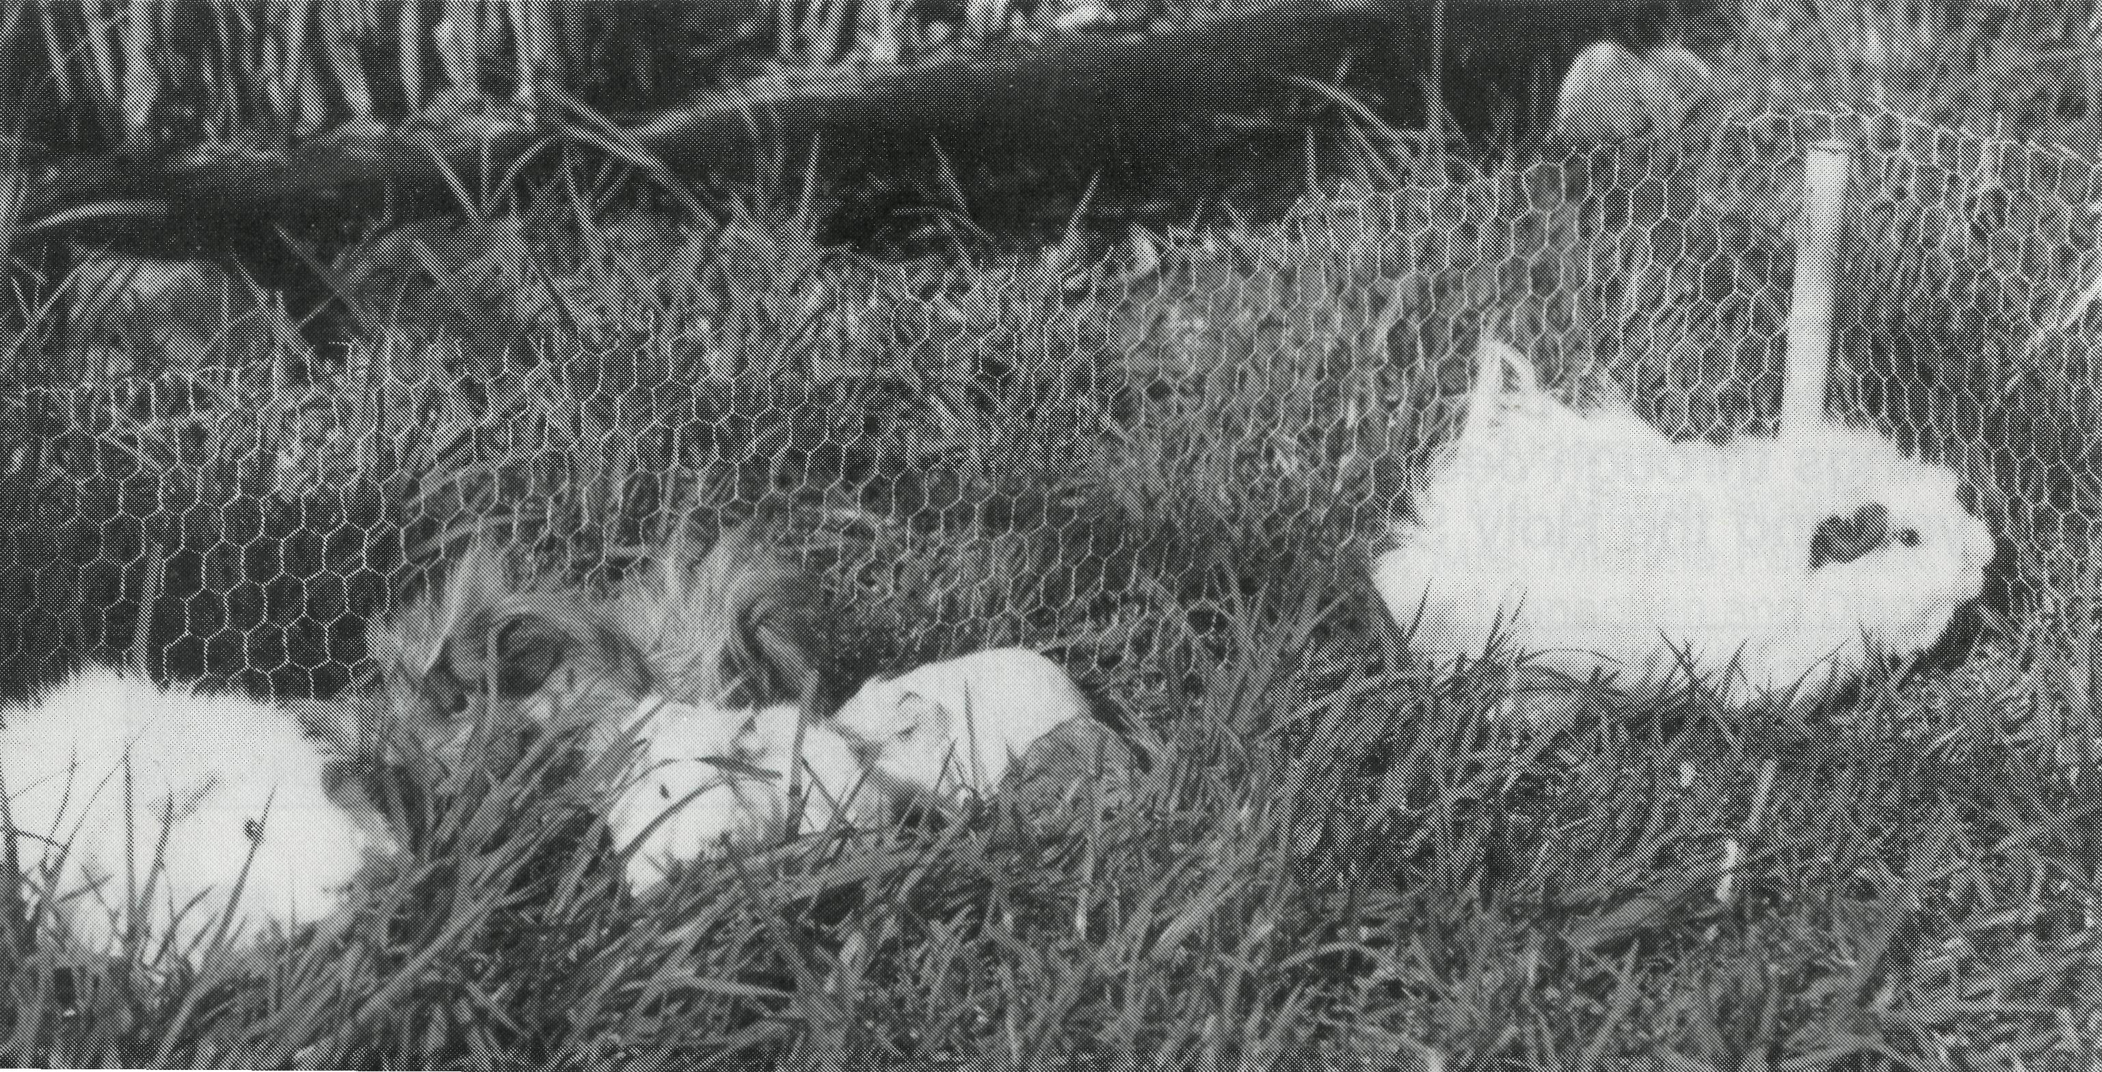
John and Leone Rutherford have been serving with B.C.A. at Roxby Down since January 1992.

