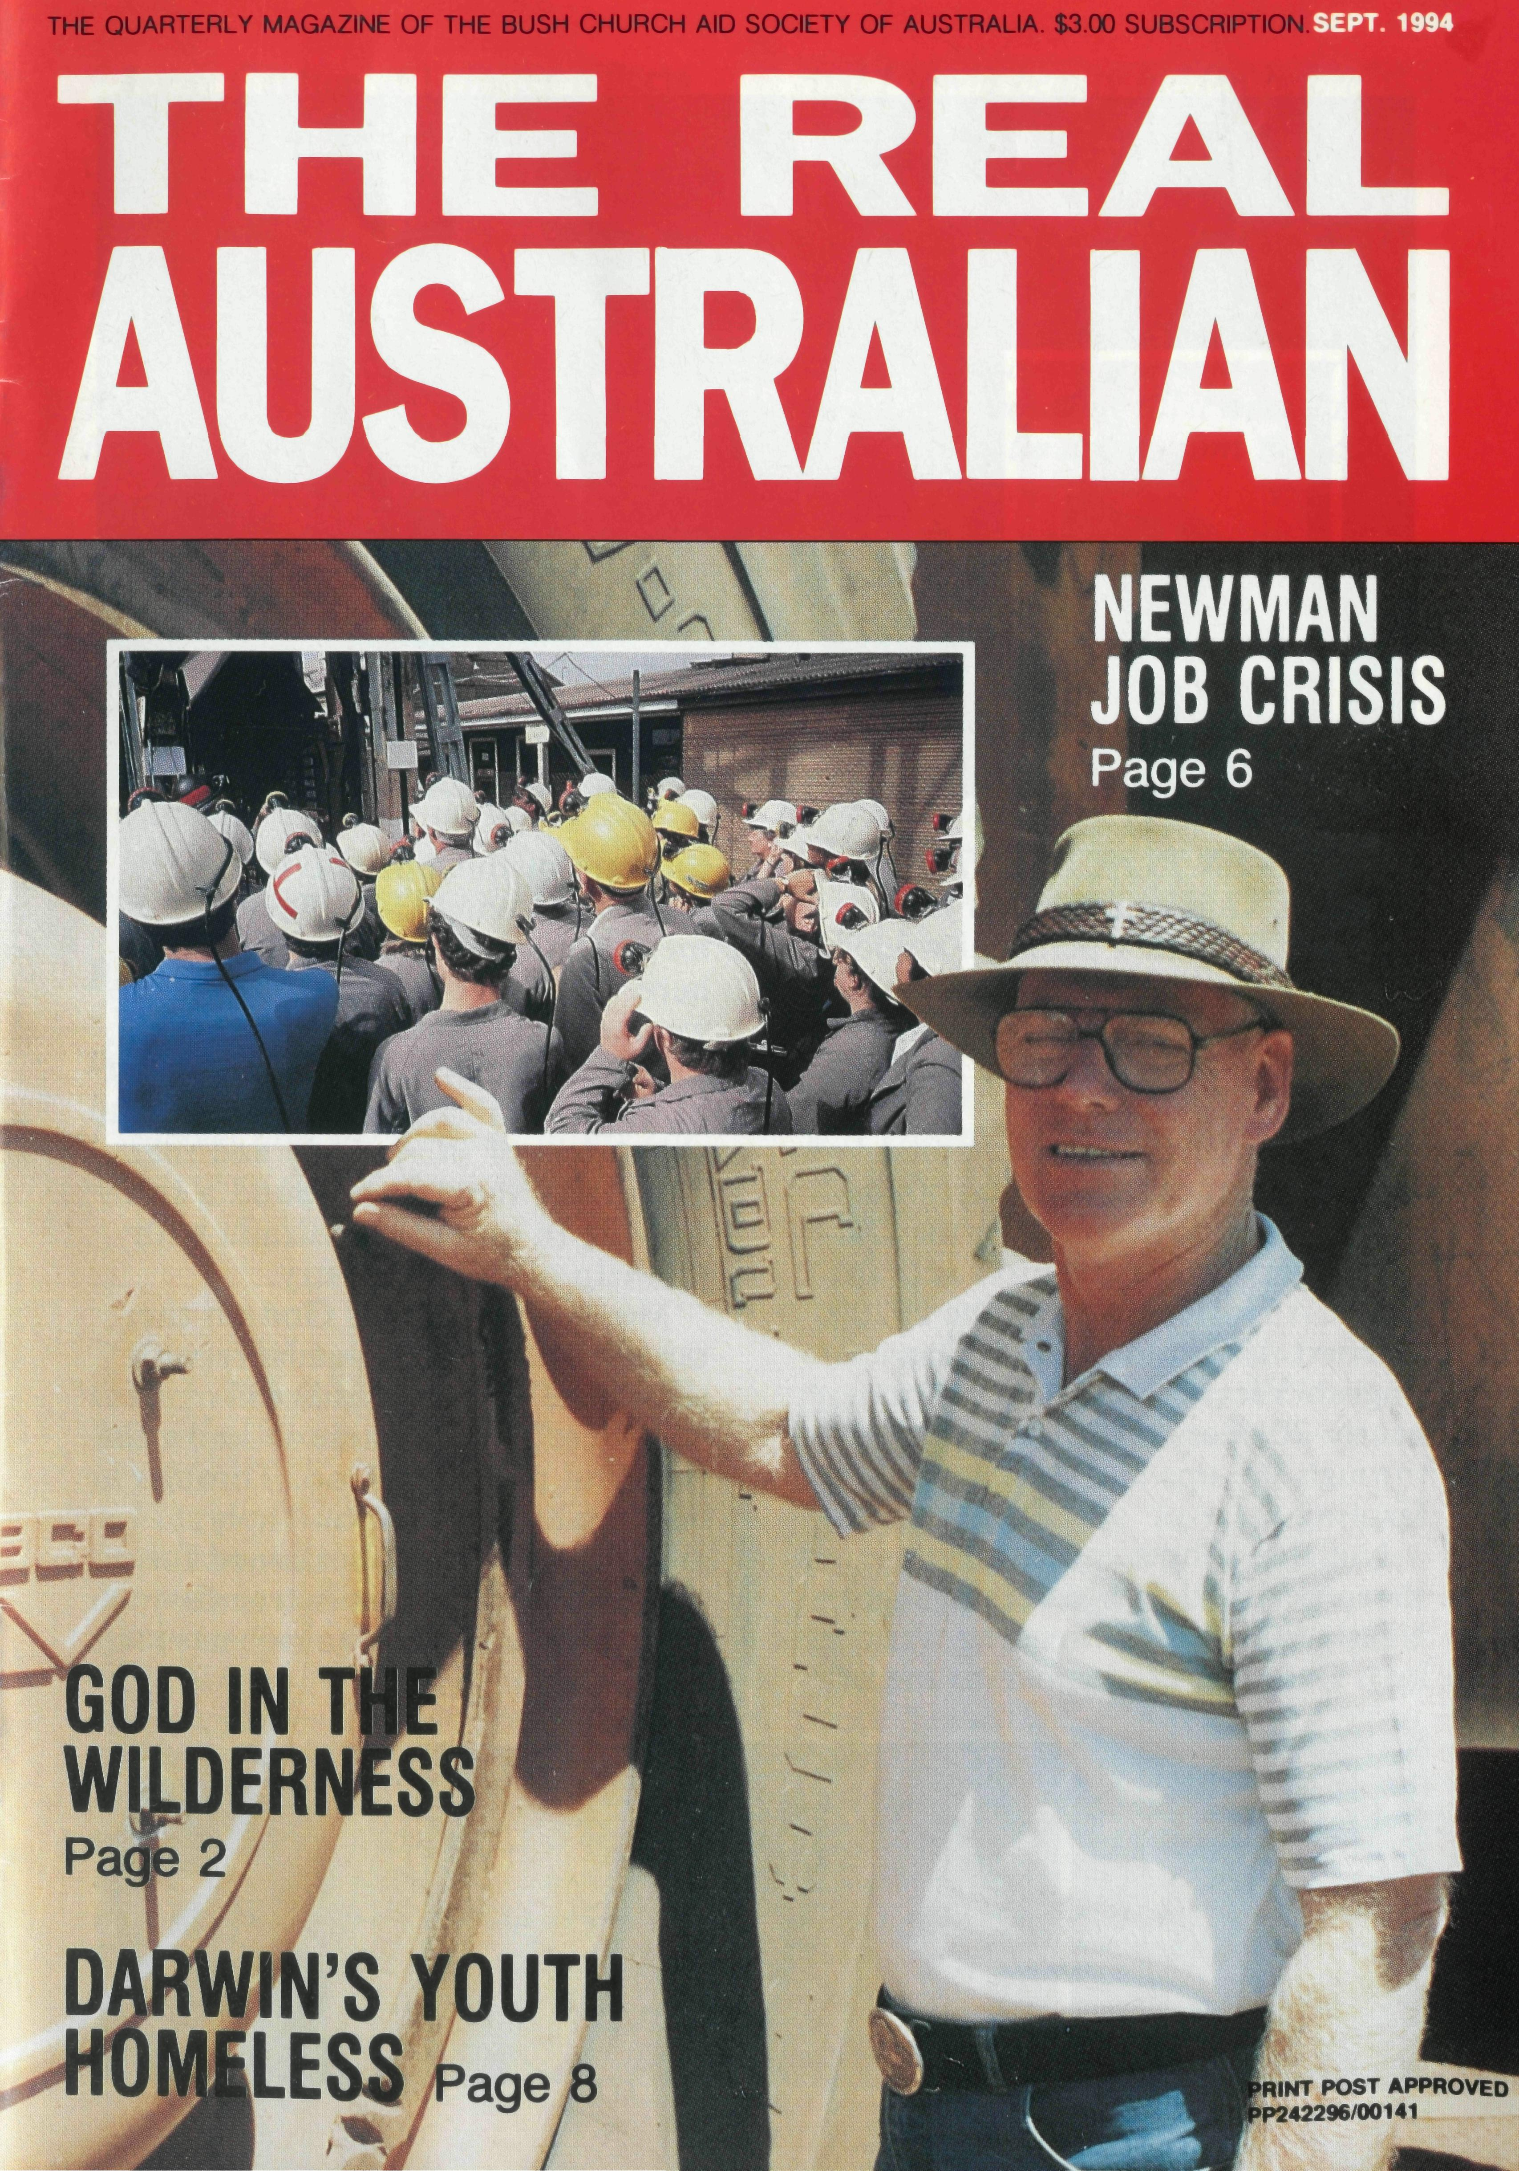
Printed by Ambassador Press Pty. Ltd., Granville 2142

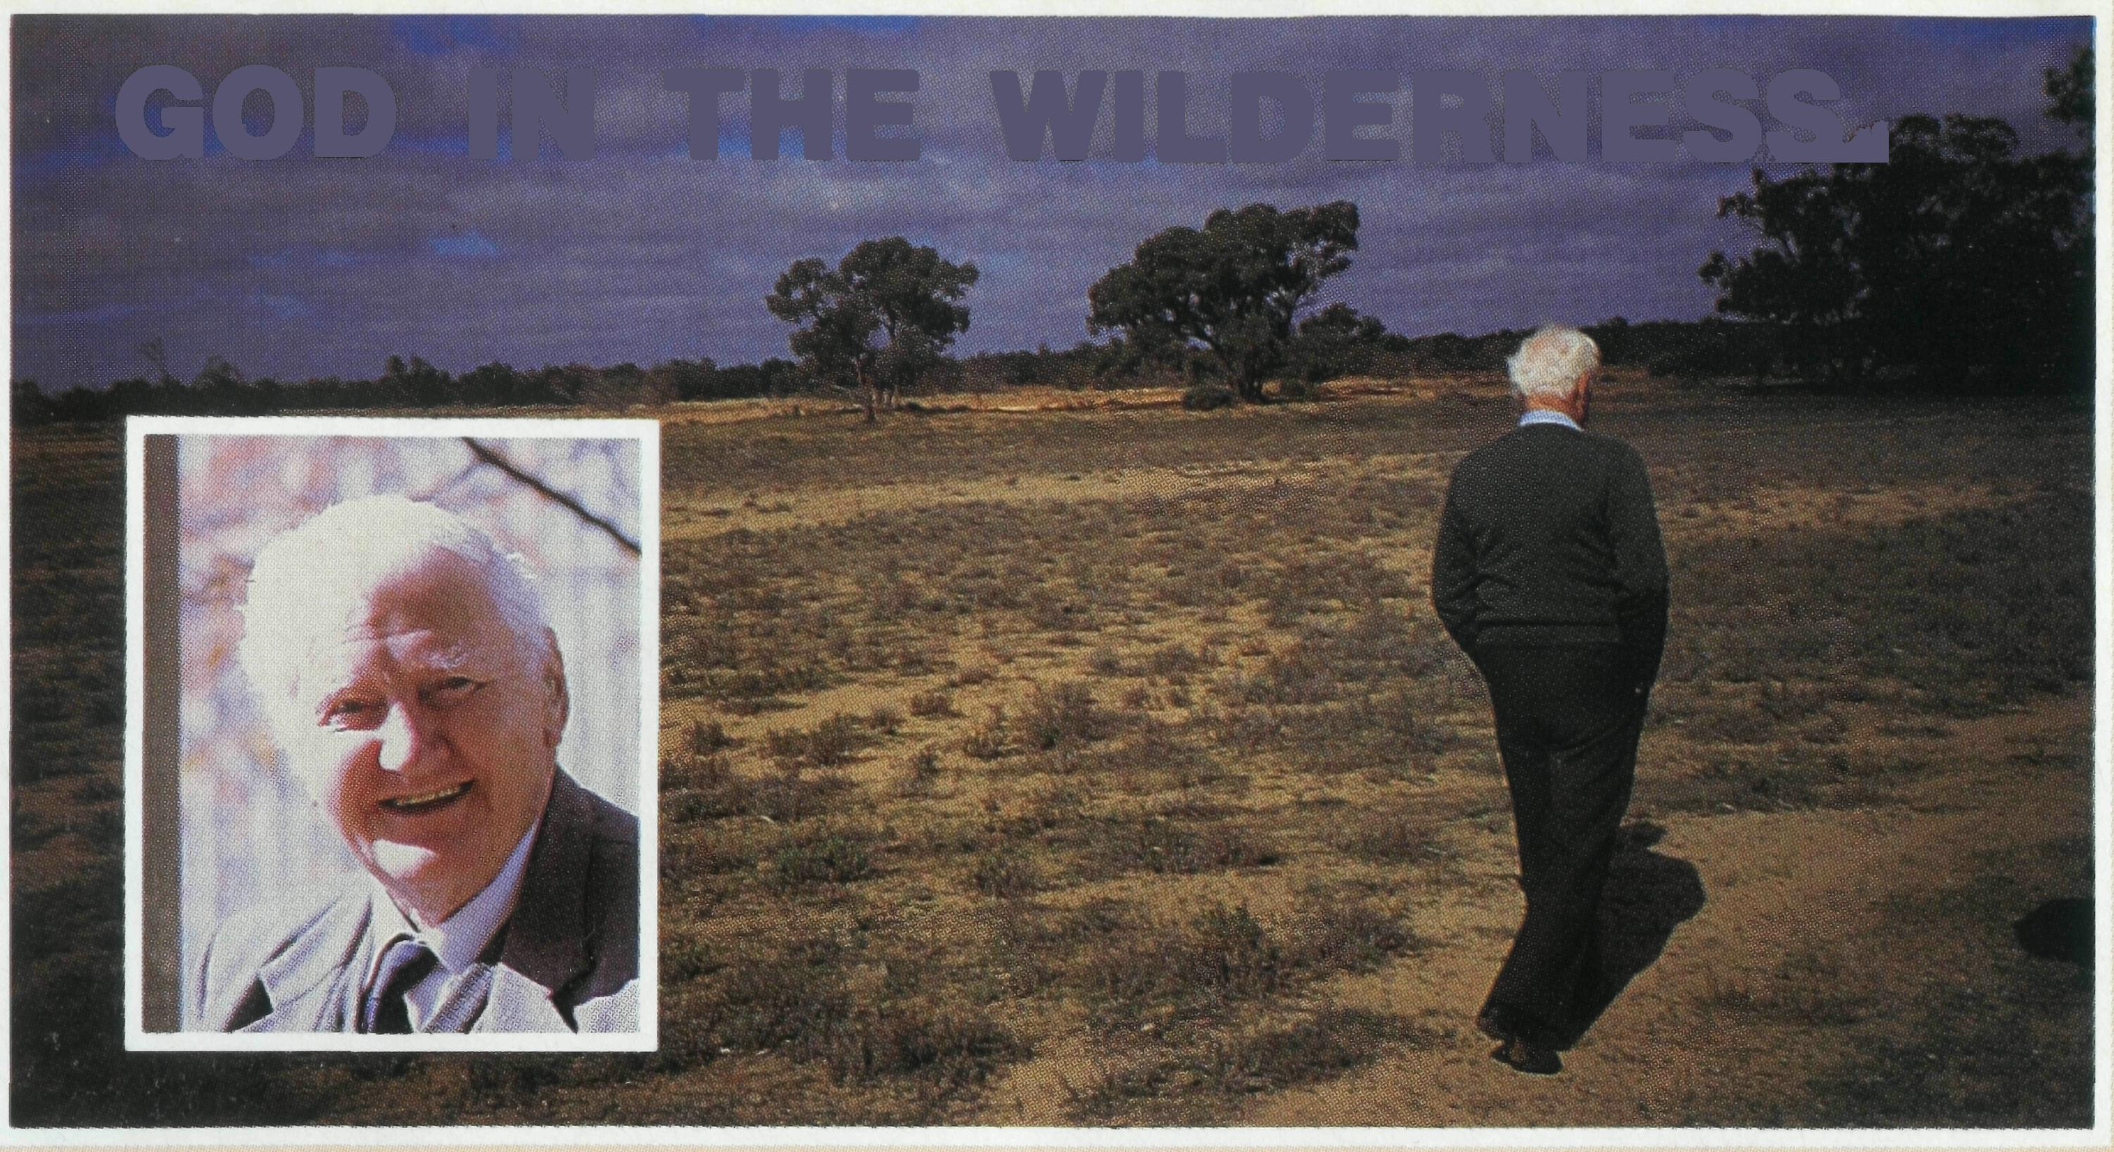
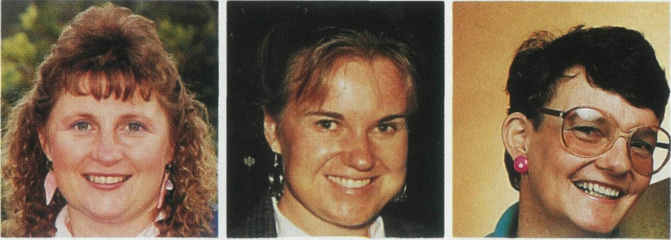
GOD IN THE WILDERNESS,
the pain of this but also of their faith in a loving God. They said to me: "You are so close to God out here. You have no control over the weather, you must depend on Him."
Dal and Allyn are parishioners at St. James Wilcannia and are faithful supporters of BCA. They and many others like them have found a spiritual life in outback Australia with the help of BCA ministry.
Moses encountered God on the far side of the desert at Horeb (Exodus 3) In the middle of "nowhere" Moses came to know the powerful person of God. Through a burning bush and upon "holy ground" Moses was sustained for the tasks ahead. This is true for BCA people in their gospel service.
WHATEVER PLACE we find ourselves in, God can meet us there. Whether it be in a personal wilderness or a place in outback Australia, nowhere is too remote for God to meet and sustain us in the spiritual life.
Dal and Allyn Mann live on a sheep station called Billilla, 50km southwest of Wilcannia on the Darling River. Dal, a jackaroo and an old BCA Hostel boy from the 1920's, married Allyn a daughter of an English Vicar from Sydney. For nearly 70 years they have gone through the ups and downs of sheep farming.
Not that long ago most of their sheep perished in a severe drought. Nearly 70 years of breeding was lost. Dal and Allyn spoke to me of
Above: Dal Mann Left: Jenny Gaul ton Centre: Kerry Thompson Right: Lyn Arthur

Jenny Gaulton at Leinster reflects upon the character of God who sustains her spiritual life in the poem The Desert.
THE DESERT
I was driving along one day in my car in a barren landscape near and far Inside my car it was nice and cool to go out in the heat I'd be a fool. There was nothing out there for me
to see, I just kept on driving as fast as could
be. I only wanted to get to the beach and put the desert out of my reach. How could anything live out here, where the sun can only scorch and sear. I wanted the beauty that God had
made and I hoped the memory of this land
would fade. But I thought, God also made this
land, the rocks, the dunes of the red, red
sand. I stopped and climbed out of my car and looked at the landscape near
and far.
Kerry Thompson writes of the spiritual challenge in making a transition from the Northern Territory to Sydney life:
Finding God wherever we are is often not easy. Some places and circumstances seem naturally to open our spirits to God, some to close us down in fear. Somehow for me, whatever the circumstances, Darwin seemed a place of the former. It always seemed possible to find a quiet space — a tree to sit under, a long empty beach to walk along, a friend to share with — whatever was needed to restore equilibrium. As with David the very beauty of the world around "spoke" God to you (Ps.19).
And I saw a beauty hidden before, so I went further to look for more. I found a flower so tiny, so small, that made the trees look sturdy and
tall. That animals lived here was plain to
see and was that a sculpture out of a tree? I kept on discovering till it went dark and reluctantly drove from this desert park.
Sometimes it seems that God has
gone far, that of me He doesn't want a bar. But when I stop and take a look and reach out my hand for His book, I realise that I'm the one to blame and hang my head in total shame. I know that God has never left me only kept Himself hidden so I would
see that He is one to rule my life and by letting Him I'll stay out of
strife. I know I need God to help me each day. May I always rely on you God I pray.
Jenny Gaulton Prayer Notes Day 11
Uprooted from that loved space though and thrust into the shock waves of Sydney, those safety valves were no longer available.
Coping with the loss, the many changes has of course not been easy yet percolating through it all is the one lesson I can never seem to learn often enough — that in the end the only true peace lies within. It is a state of mind and heart not altered by external circumstances for it is fixed on God's love and faithfulness which are unchanging In the words of Paul "fix our eyes... on what is unseen, For what is seen is temporary, but what is unseen is eternal" 2 Cor 4:18.
Cont. page 13

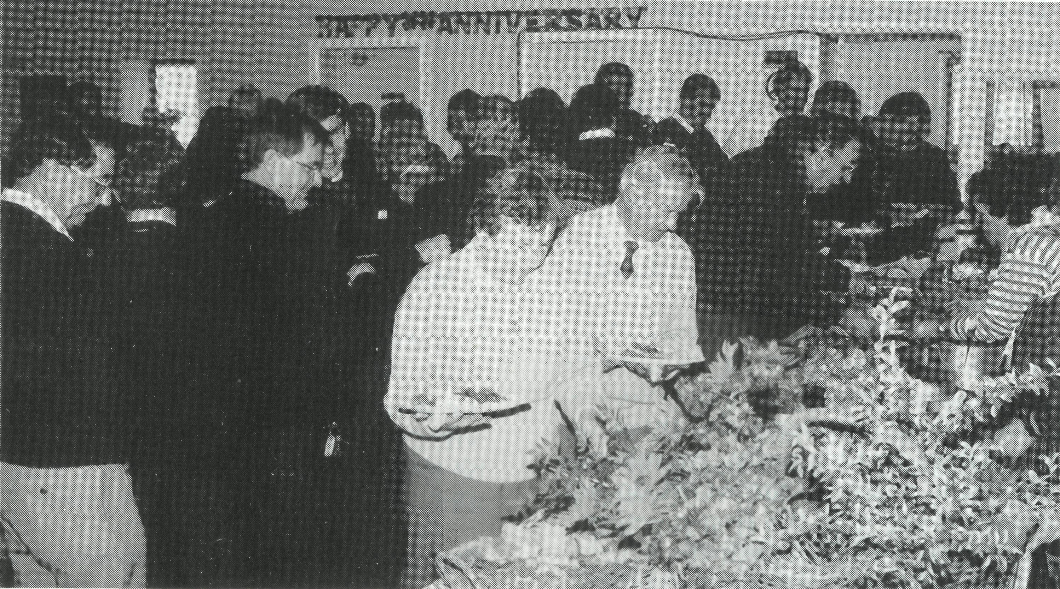
75 years of ministry in the bush...
THE REAL AUSTRALIAN
The Real Australian is a registered trade mark of the Bush Church Aid Society. First published 1920. Edition No. 285 Circulation: 28,000
All enquiries to:
Greg Thompson
The Editor
The Bush Church Aid
Society of Australia
Level 7, 37 York Street,
Sydney 2000
Ph (02) 262 5017. Fax (02) 262 5020
B.C.A. DIRECTORY
President: Archbishop Harry Goodhew
Chairman: The Rev. Dr. Vic Roberts
Patron: Archbishop Keith Rayner
Vice-Presidents: Mr. Stan Hummerston, O.A.M.; Mr. Ray Ctercteko.
Hon. Treasurer: Mr. R. Ctercteko. Federal Secretary: Rev. Brian Roberts. N.S.W. Secretary: Rev. Greg Thompson, Level 7, 37 York Street, Sydney, N.S.W. 2000. Ph (02) 262 5017.
Victorian Secretary: Rev. Brian Viney, PO Box 343 East Melbourne 3002. Ph (03) 654 8022.
South Australian Secretary: Rev. Bob George, Church Office, 44 Currie Street, Adelaide, S.A. 5000. Ph (08) 212 7804. Queensland Secretary: Rev. Les Monaghan, P.O. Box 6472, Upper Mt. Gravatt, Qld. 4122. Ph (07) 349 9081. Western Australia Contact: Rev. Fred Buchanan (Acting Secretary), GPO Box N1024, Perth 6001.
FRONT COVER PHOTO: Rev. Raymond Molyneux at a mine site.
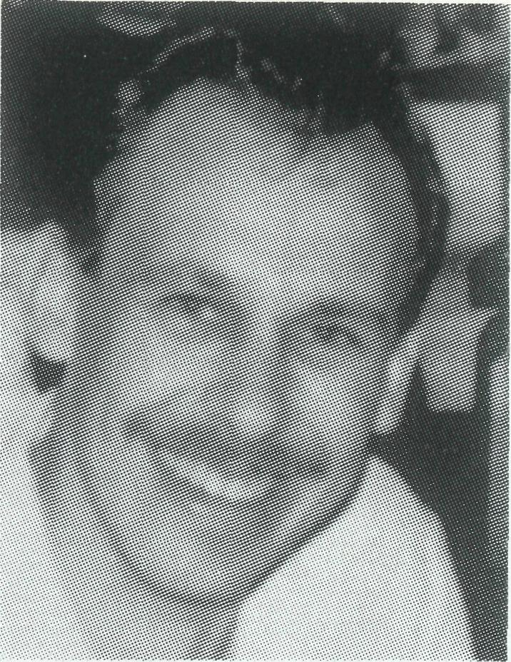
EDITORIAL
"YOU MUST have a positive attitude to live out here", said Dal Mann on my recent visit to his sheep property, south west of Wilcannia on the Darling River. As I write this, the Darling River has stopped flowing and much of rural Australia is in the grip of drought.
Being positive in the face of trials is not easy. We may try to run from them, or perhaps unhelpfully unload our stress on the people close to us or seek to walk through the crisis with the courage of God and the help of His Spirit.
This issue's articles provide windows for us, into BCA supported ministry situations, where people are finding the presence and help of God to sustain them in trying circumstances.
May they be an encouragement to your spiritual life and your prayers for the people of remote and rural Australia.
GREG THOMPSON
P.S. Thank you to the many who sent letters of encouragement regarding the new format.
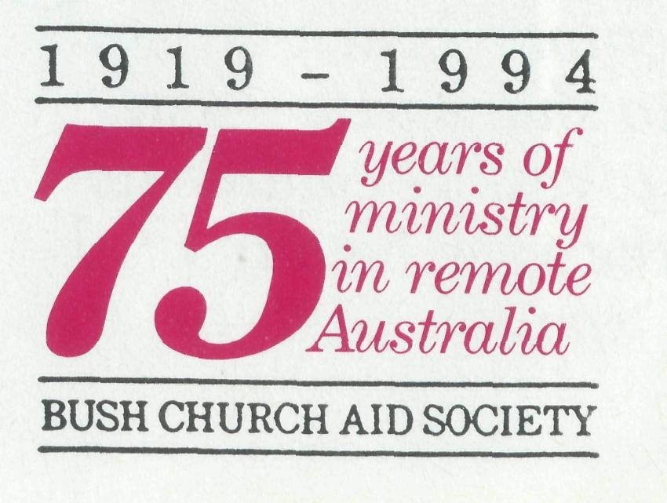
ON THE 28th June 1994, a unique and special gathering of the Riverina Synod, former BCA staff, the people of Wilcannia, and Mends and staff of BCA gathered at St James' Wilcannia on the Darting River.
It was a typical bush affair — people started heading for the celebration days ahead of time, those who arrived early camping in the local accommodation.
Those running late sent word on ahead that there was difficulty with the transport The bus from Broken Hill had blown a radiator hose.
Scheduled for an 11 am start, we started "on time" at 12 noon — no-one was hassled, the spare time spent meeting old Mends, catching up on what had happened in the intervening years and recounting the stories of the 75 years BCA had ministered in Wilcannia, the parish in the far west of the State and in the northern part of the Diocese of the Riverina
Wilcannia service and luncheon.
BCA made its first appointment in Wilcannia in 1920 and opened a
children's hostel and centred its van ministry there for many years.
The Diocese was well represented at the celebration service and luncheon. At least one delegate from each parish was present plus a host of BCA supporters, locals and former staff.
It was a great coming together. The Rev Reg Langshaw and his wife, Iris, were special guests. Reg, in addressing the congregation of up to 200 people, said "It has been 56 years since I last stood in this pulpit". A number of the younger cleigy nudged each other in amazement that one person's ministry could go on so long Reg's sermon showed all the hallmarks of an experienced clergyman — a skilful weaving together of the old ways and stories of ministry at Wilcannia in the 30s with a careful exposition of scripture. The Bishop, Bruce Clark celebrated the Eucharist and the congregation moved over to the parish hall for lunch.
BCA Federal Secretary Rev Brian Roberts See Day 30 Prayer Notes

Raymond and Betty Lou Molyneux minister in the parish of Newman. The area sometimes said to be where "they ship off our
mountains to Japan and they come back as Toyotas." With
changing international markets, the towns in this area have been
hit hard by Company retrenchments. The Rev Raymond Molyneux
of Newman writes of the effect this is having on church life:
NORTH WEST TOWNS
FACE UNCERTAINTIES
OF REDUNDANCY
NEWMAN IS down about 2500 people over the past three years. Last year in Marble Bar, five families left out of a population of 300. Each time we go to Bamboo Creek and Telfer, people we've known have gone. Normay has closed down. To the north, the towns of Goldsworthy and Shay Gap no longer exist.
Morale is poor because of the uncertainty, and stories abound of people's experiences. Employees are protected to some extent because of the Union/Company agreements, but staff seem to have little protection.
The uncertainty is reflected in incidents of domestic violence, child abuse and drinking. Schools are affected by the lower number of pupils. Small businesses face increasing rents and costs with less income.
For us in the Church family, it means lower numbers in the congregations, less income to meet our budget, four treasurers and three secretaries in 18 months. Members elected to vestry at the AGM do not always make it to the first meeting and others leave through the year.
In our children's ministry we are told, " I don't think I'll be able to
come next year. I don't know if we will be here". So, at the beginning of each term we have a "Hello Party" and at the end, a "Goodbye Party" — just in case.
But it's not all one way. We have been blessed with some new families joining our congregation and a positive response to baptism preparation. We are encouraged, too, by news of ex Newman parishioners continuing their Christian journey in other parishes.
Another benefit of all this is that wherever we go, we meet old Newman friends.
Ministry in all this uncertainty has to do with keeping up morale, the congregation's and our own. Although it's hard seeing people so shaken by the situation, God's strength enables us.
My ministry is to help the congregation by encouraging them with "victory" preaching rather than "defeatist" preaching. To focus on the good things and achievable goals within our congregation and not to be overly concerned about the long term plan. This is in God's hands.
Raymond & Betty Lou Molyneux See Prayer Notes Day 6
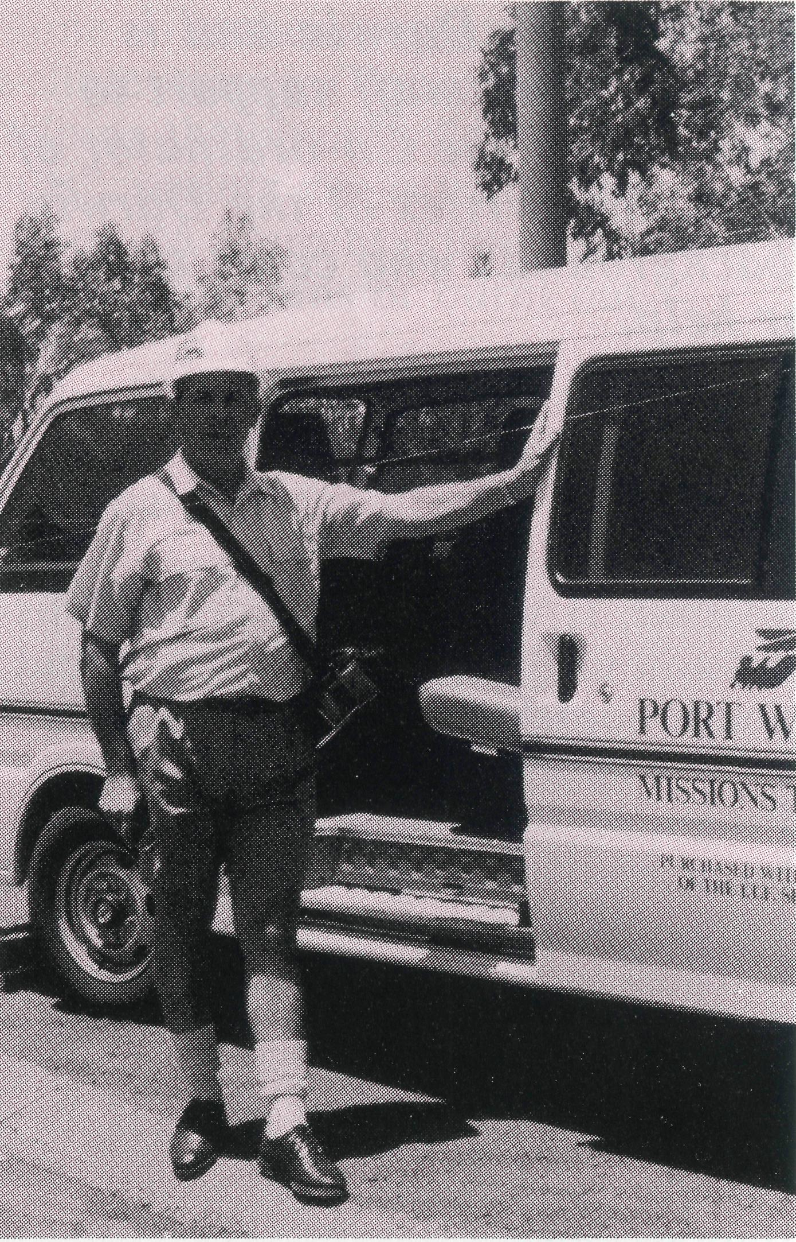
Bill Ross ready to visit seamen.
THE NORTH West Diocese has a history of contact with seafarers, supporting Mission to Seamen centres in Dampier, Port Hedland and Geraldton.
Archdeacon Bill Ross has now taken up this ministry at Port Walcott near Wickham, with the provision of a small bus and a mobile phone. The bus was purchased from an International Transport Workers grant and is used to transport the seamen to and from on shore visits. The phone was supplied by the Seafarers fund.
Bill visits as many ships as possible during the week. The provision of a mobile phone is a valuable service to these seamen, who often have little time to go ashore due to such fast loading times. The phone is in use for up to three hours when
Seafarers appreciate mobile telephone
Bill goes aboard, giving ample opportunity for seafarers to ring back home. It is particularly appreciated by the many crews, who may have been away from home for nine months or more.
While calls are being connected and completed, Bill has the opportunity to talk or minister to any who are lonely or may have had troubling news from home.
Bill aims to build up a supply of Bible literature in a variety of languages to offer to seafarers. He is also in the process of setting up a roster system so that members of the Wickham congregation can become involved in this worthwhile ministry.
Bill writes: "Although there is frequently language difficulties and many of the seaman are from countries not Christian, there are opportunities to show God's love and now and then to speak of it. In twelve months I have visited 90 ships. I enjoy meeting the crews and seeing their beaming faces when they've talked to wife or sweetheart at home."
Bill & Jocelyn Ross have been at Wickham since February 1993.
See Day 8 Prayer Notes

Peter Fisher is the Director ofAnglicare in Darwin and is
supported by BCA. He provides direction and staff support to
Anglicare personnel like Gill Chisholm who is the Co-ordinator of
Anglicare⁹s Youth Housing Programme. She writes of the Darwin
young people and their family backgrounds who come to
Anglicare for help.
EXPLODING THE MYTHS
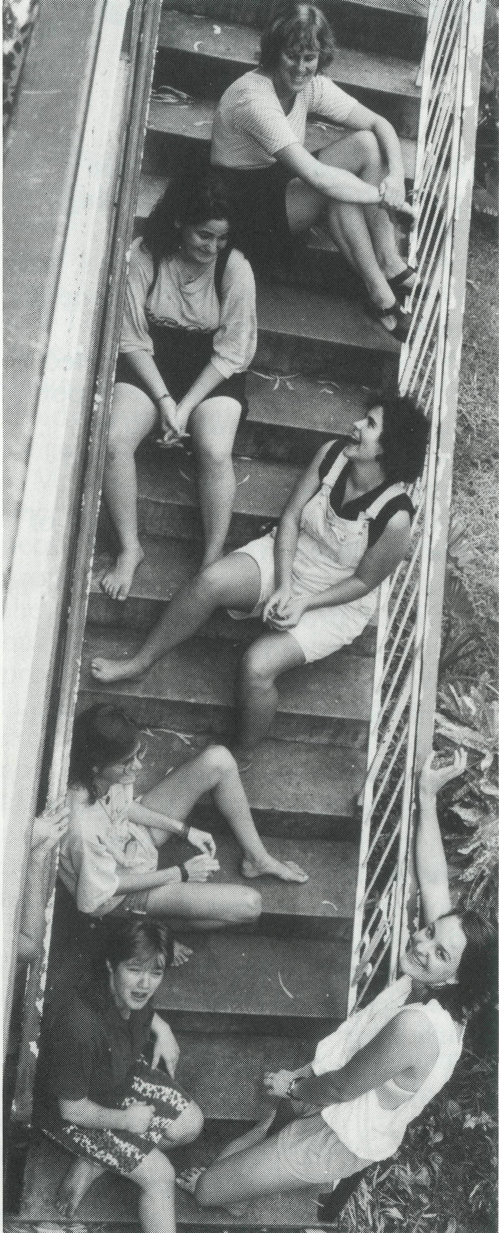
THERE HAS been considerable discussion in the media recently about youth homelessness and responses to it. Anglicare's Youth Housing Programme has been assisting homeless young people since August 1992. The picture of homelessness in Darwin would appear to be quite different from the "popular" image emanating from Sydney and Melbourne. But it's not always accurate to judge a situation from first impressions.
If you were to meet our kids, I think that initially you'd be surprised. They look just like any 15-19 year old that you'd be proud to call your own. Most have completed or are in the process of completing high school. For the most part, they dress pretty normally, speak in well constructed sentences, chew with their mouth closed and wash on a regular basis. Sometimes their hair colour or style is a bit weird; sometimes they have lots of ear-rings; less often they'll have a tattoo or two. For fun they go to the movies on Tuesdays or fishing off the Nightcliff rocks, or they muck around at the Eatery at Casuarina. Some have a criminal record; most don't.
Shouldn't they be at home?
So you might be thinking, what's going on? What's Anglicare doing housing a bunch of kids who look pretty normal? Shouldn't they be at

home with their parents? Shouldn't welfare agencies concentrate on helping the obvious "down and outs", society's rejects, the kids we see on "A Current Affair" sleeping in Life Line bins or burnt out squats?
But if you were able to talk with some of them your impression may well change.
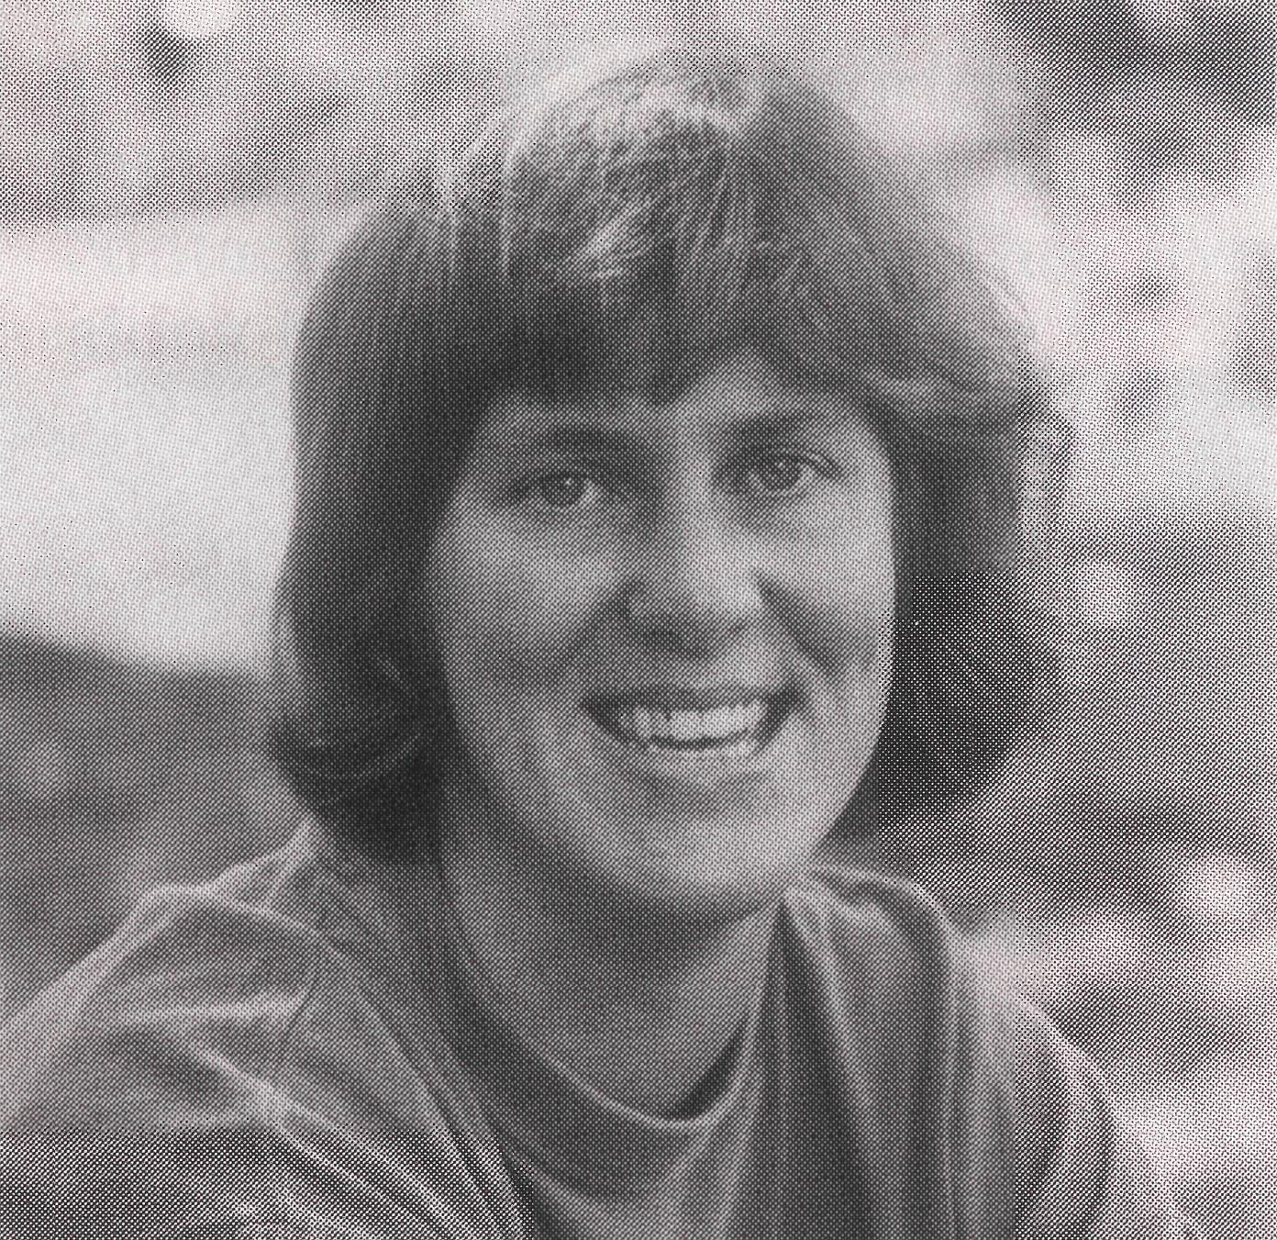
Gill Chisholm
If you had been us during the past year or so, you'd have met two young women with symptoms of serious eating disorders. Young women having real difficulties facing adulthood as a reaction to childhood sexual abuse.
Others have had little choice but to face adulthood somewhat earlier than their peers. So far we've housed three couples expecting babies and two single mothers.
Some kids have had to leave home because of violent clashes with the new partners of their parents, a couple have been made state wards because of botched overseas adoption arrangements, some live with us after a sentence at the juvenile detention centre. One 16 year old who left her alcoholic mother, now gives "outreach" support to her one year old brother and
14 year old sister who had to stay at home. The sister's boyfriend, also aged 14, lives there too, on the mother's condition that they share a room. All these kids look O.K.
It's hard to measure or identify external symptoms with loss of innocence. It might be years before the kids themselves have a chance to recognise this and grieve. Our job now is to support and cushion their progress.
Economic poverty is matched with a poverty of relationships
All of our kids survive on incomes well below the poverty line (and please don't fall for the myth of the single mum out for the cushy life provided by the supporting parent's benefit.) This in itself makes them remarkable people. Their economic poverty is matched with a poverty of relationships. When we understand that this can permeate all backgrounds, we can see how homelessness can result.
Our task is to acknowledge the existence of the issues at a stage when they can be addressed by intervention and support. We are in the enviable position, if you like, of being able to assist our homeless young people before they get to the stage of having to spend extended periods " on the streets" or resorting to prostitution or crime to support their lifestyle or drug habit. My point is that we can be seduced by myths and stereotypes and respond either by denying the existence of problems because they don't fit the "Willesee" picture, or by desperately looking for "suitably " disadvantaged (ie overtly down and out) young people for our programmes when all the time they're staring us in the face. And they look like us.
See Day 1 Prayer Notes

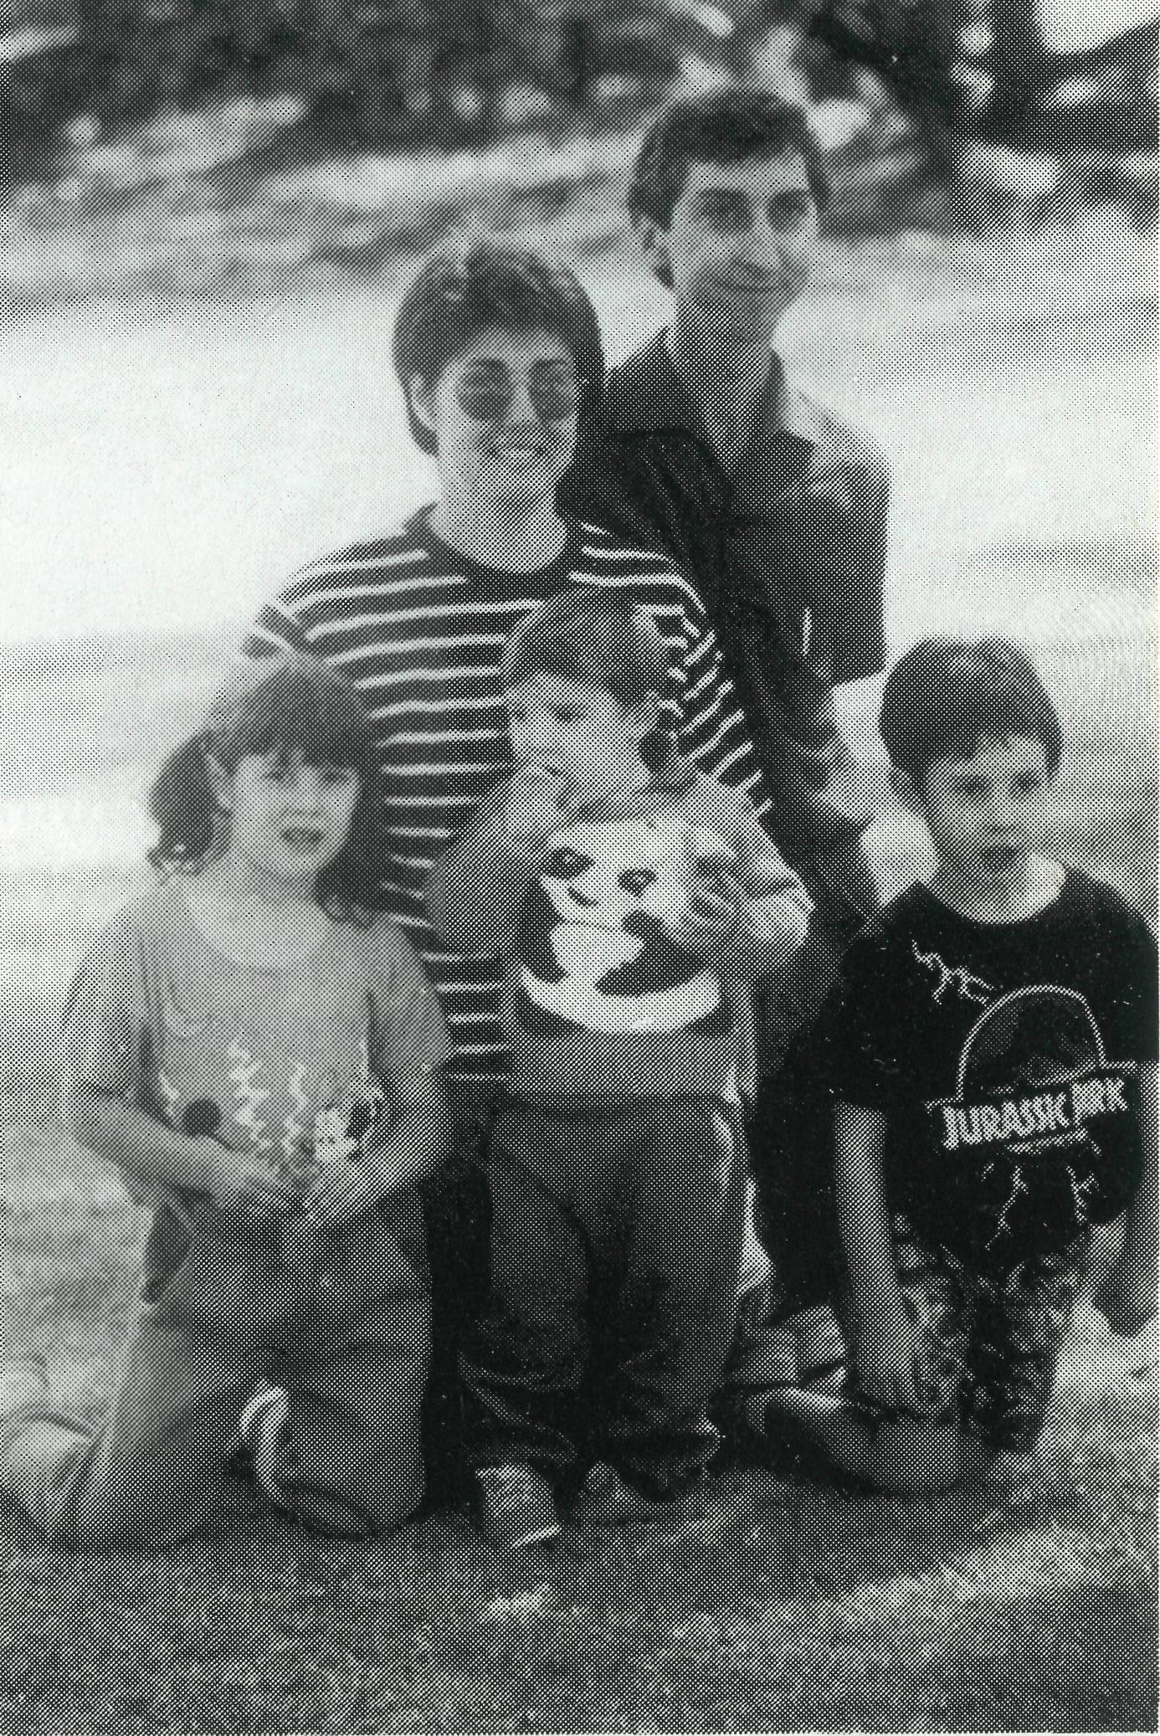
Blackdog whom Glenda met in the Post Office one day. Dressed in black from top to toe with long beard and hair. Blackdog is an occasional visitor to the town for mail. Glenda enquired about his real name from the Postmaster. "It's Blackdog" he said. "His mail is addressed to Blackdog, Bonalbo". Like Blackdog, many of the
Ian and Glenda McGrath with their 3 children moved to Bonalbo from Bowen, Qld in January, 1994. The children love life at Bonalbo, with Joel especially excited that Daddy comes to his
school for Scripture.
A family moves to the Upper Clarence
FROM LIFE in Bowen Qld to life in Bonalbo Northern NSW, the McGraths have not only moved hundreds of kilometres but to another world.
The Parish of the Upper Clarence has 7 centres with the average attendance on a good Sunday being half a dozen at each of the Church Services. The rising age profile and the small numbers has much to do with the recent history of the region with all the mines closing down along with the butter factory, timber mill and all the support services that accompany these industries. Many Upper Clarence families have moved to find work at Casino or Lismore.
Escape
In their place folk from the cities have discovered that real estate prices are much lower in the Upper Clarence and that there are no Social Security and Commonwealth Employment Offices in any of the seven towns. For those who wish to escape the demands of work and accountability, family life in the Upper Clarence is an alternative lifestyle.
The locals name these folk the "ferals", the wild ones. Like
10
"alternative" people seek refuge in the hills and have no recognisable home address. They have come to abandon all ties with authority and choose not to join community groups or the church. However they are interested in spiritual things, accepting many wayout ideas.
There are many families living in isolated situations
I'd value BCA Supporters praying that we'd be able to make helpful contacts with these folk. They live along bush tracks which are atrocious to travel on, sometimes taking me 45 minutes to travel 5 km. As you travel these tracks there are many families living in isolated situations with tin shacks for homes.
A divine appointment
Prayers have been answered in my visits to Upper Clarence folk. For even in the town centres finding streets and locations of parishioners is very difficult. Town maps are inaccurate and where there are street signs on occasions they are switched by the local hooligans for their amusement. Recently, thinking I had found the right home of a parishioner, I knocked and was welcomed by Arch. He said this was the first time in 30 years that somebody had visited from the church.
I thought this didn't seem quite right, so I checked with him regarding Parish roll details. Well it turned out that I had the wrong person and wrong address but the right appointment. God had directed me to Arch who had recently moved to the area and now he comes to church regularly. This was a divine appointment and I believe , a consequence of people praying for BCA staff for opportunities to share the gospel.
Prayer brings people together in the Upper Clarence. This was certainly true of the "Australians for Reconciliation", a service held in Woodenbong in June. Prayer gathered together Aboriginal and non-Aboriginal Christians from the Anglican, Uniting, Roman Catholic, Pentecostal Presbyterian and the Mulli Mulli Full Gospel churches. The focus of the evening was reconciliation. We heard that personal reconciliation with God leads to reconciliation between Aboriginal and non-Aboriginal Australians. The government can legislate for change, but the government cannot change peoples' hearts.
However, the hearts of people do change through a relationship with God. Only then can we have true national reconciliation between the dagays (Europeans) and the bagals (Aboriginals).
God has helped us so much in the transition to Bonalbo life and the ministry opportunities that have arisen. Glenda and I can affirm to you the reality of prayer support. Family life here can be difficult but with God and your prayers it is an adventure with many blessings on the way.
Ian McGrath
See Prayer Notes Day 20
W.A. RESIGNATION:
The Rev Peter Brain has been the Hon.Secretary of BCA in Western Australia since 1983. In that time he has greatly assisted with deputations and supporter encouragement. Peter is stepping down from this role though he still will be a part of the W.A. Committee. BCA thanks Peter for his skills and time that he has given to BCA's ministry in W.A. as Hon Secretary.

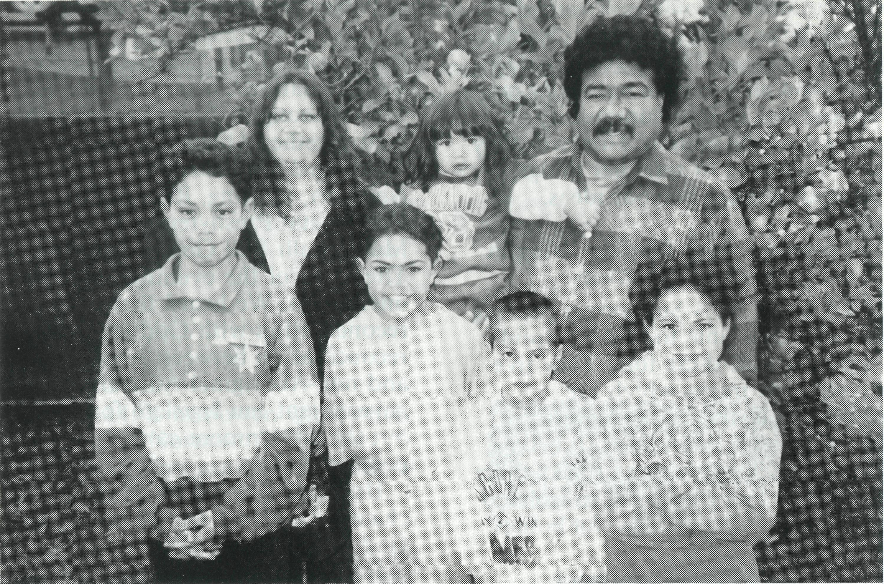
was responsible for family life. In modern society there are too few support systems in place. It is little wonder then that modern family life is dysfunctional.
At Bimbadeen College we adhere to an important principle. Every person is responsible for the college's well being. In traditional Aboriginal life, individuals and groups were assigned areas of responsibility for the good of the community. In College, every person is given responsibility whether in gardening, farming, cooking or chopping wood for fires.
This community life provides an environment for families to grow spiritually and educationally. Christian discipleship here is both studying God's Word and learning
to live alongside one another. It is through this experience of shared responsibility and acceptance of one another that our family life is enriched. Students who leave our college to minister in rural and urban communities will be aware of cultural differences, learn to be adaptable to situations they face and will then be able to minister in different settings.
When we understand God's lessons in the scriptures we will find life to be purpose filled and a blessing to families.
BCA supports Denis and Maureen Atkinson and staff who work at the College.
See Prayer Notes Day 25

One of Bimbadeen s families.
COMMUNITY LIFE
Len McNally is the Principal of Bimbadeen College at
Cootamundra, NSW. He writes of the College's community life in
helping Aboriginal families prepare for ministry throughout Australia.
RECENTLY I attended a seminar on "Suicide Awareness". The speaker pointed out that the rate of completions in rural NSW was five or six times that of the national average for males aged 15-25 years. Further, that there are more deaths by suicide than by car accident. This is disturbing. People from the very young to the very old are killing themselves and in between we have dysfunctional lives in marriage breakdown.
The Biblical model of life is one of community. We are not designed
to live in isolation. It is little wonder that Christians are called children of God. This surely means that we are related to one another. I would be as bold to suggest that the traditional Aboriginal culture can help in tackling and understanding the problem. Traditionally the Aboriginal family was not limited to what is called nuclear. It included the whole of the community. The mother and father were the ones who gave love and the aunts and uncles brought discipline. This meant that the whole community
GOD IN THE WILDERNESS conW.
Lyn Arthur in the Hedland Parish considers the women's group she meets with each week as a source of encouragement to her faith. She writes:
"Cockroaches, spiders and cobwebs, red dust, hot days . . . These things seem to be an integral part of life in the north west of Australia; it's hard to remember (but not imagine) life without them. And yet in His goodness God has obviously prepared me for the things He had ahead for me. Cockroaches and spiders don't bring out the hysterical in me and it's much easier getting out of bed on a warm morning. I also love the wide open spaces and strong colours of our countryside. Most of all I thank God for the small group of women I meet with each week who are hungry to learn and grow as His children. Each lady can recount a past sorrow and heavy burdens from time to time yet all now feel a freedom and joy in Christ
that is very obvious as we study God's word together. I'm glad God has given me the chance to share with these ladies and to grow with them." Prayer Notes Day 5
For BCA field staff and their families it is the ongoing encounter with God in Christ through prayer, the scriptures, the people and places of remote Australia, that sustains their spiritual life and enables them to face the challenges of ministry.
"For the garden is the only place there is, but you will not find it until you have looked for it everywhere and found nowhere that is not a desert." W.H. Auden.
Greg Thompson.
Greg & Kerry Thompson moved from St James Sanderson (Darwin) to Sydney in January, 1994.

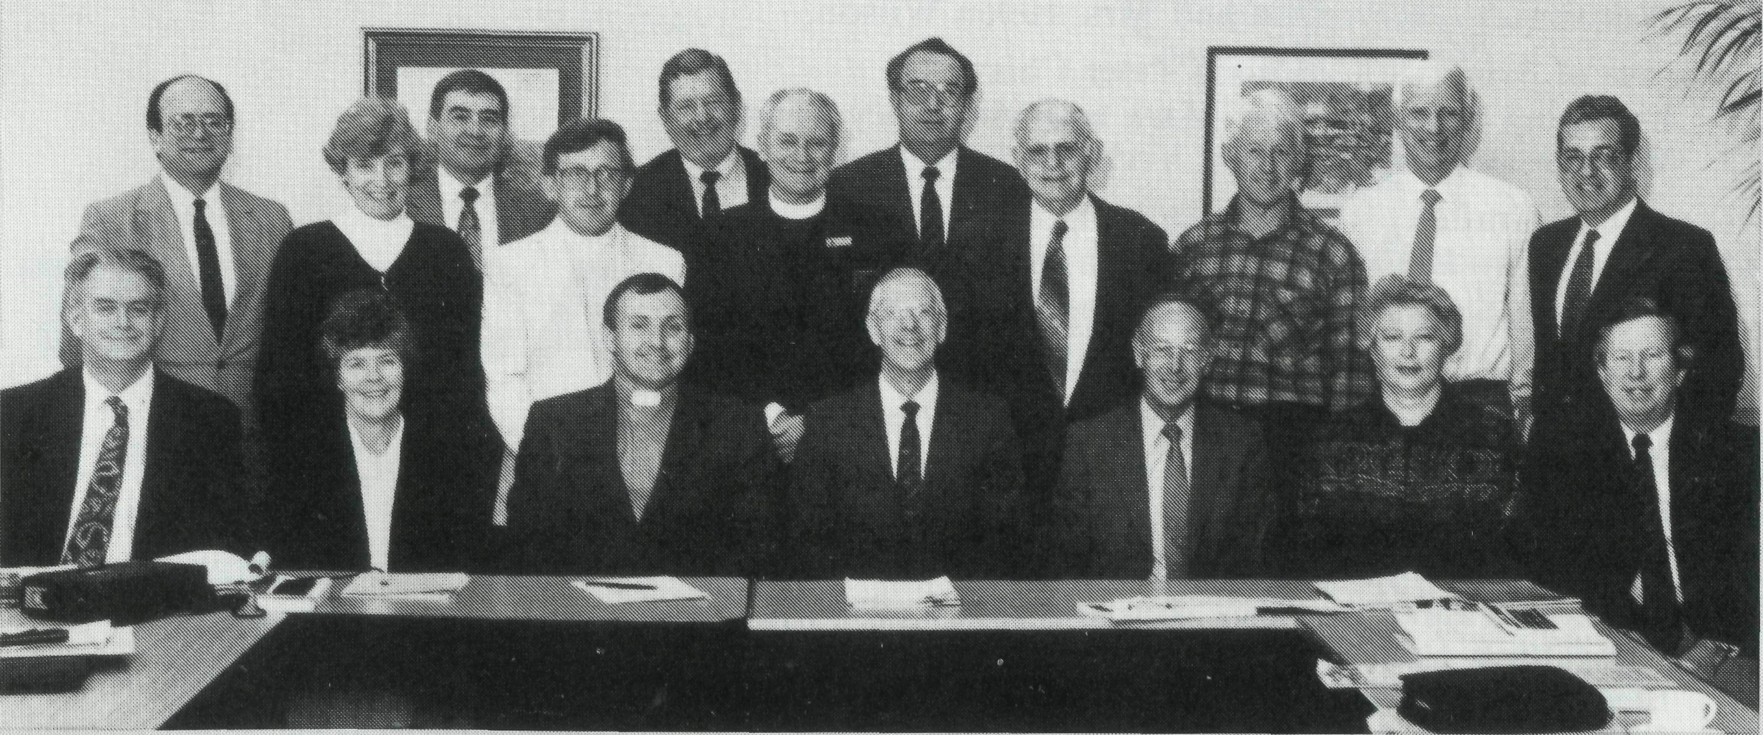
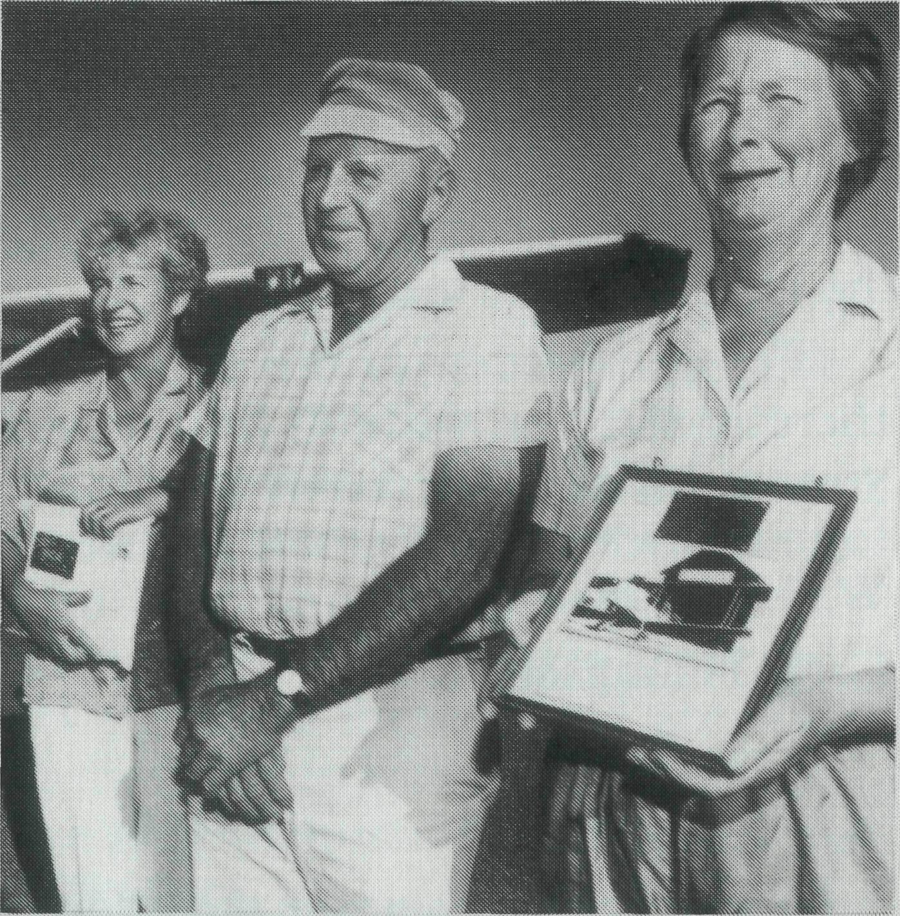
Post & Rails
1994 Annual Federal Council Meeting of The BCA Society;
Back row I to r — Mr Fred Chilton (NSW) Mrs. Ann Hargreaves (Vic) Mr. Allan Sauer (Qld) Mr. Ken Langshaw (SA) Rev Tom Morgan (Vic) Mr. John Cronshaw (NSW) Mr Stan Hummerston (SA), Rev Chris Clerke (NSW) Rev Barry Huggett (Vic) Mr. John Wenden (NSW).
Front row — I to r — Mr. Bill Milford (VIC) Miss Lilian Morgan (Vic) Rev Brian Roberts (Federal Secretary), Rev Dr Vic Roberts (Chairman) Mr. Kevin Alexander (Hon Treasurer) Miss Carol Allen (NSW) Rev John Butler (NSW)
15
BCA Flight commemorates 75 years of care:
Two special passengers were on board a commemorative flight in Ceduna on Sunday, 29th May to mark the 75th Anniversary of the Bush Church Aid Society. Former BCA Nurse Val Puckridge ( pictured left) and the daughter of the former Ceduna based BCA pilot Allan Chadwick, and Glenys Kau (pictured right) took to South Australian skies with local pilot Doug Marchant to commemorate the contribution of the BCA flying medical services.
The trio did a circuit of Ceduna carrying a bundle of special commemorative envelopes, which will be sold to support the BCA's continuing medical work in the outback. The registration plate held
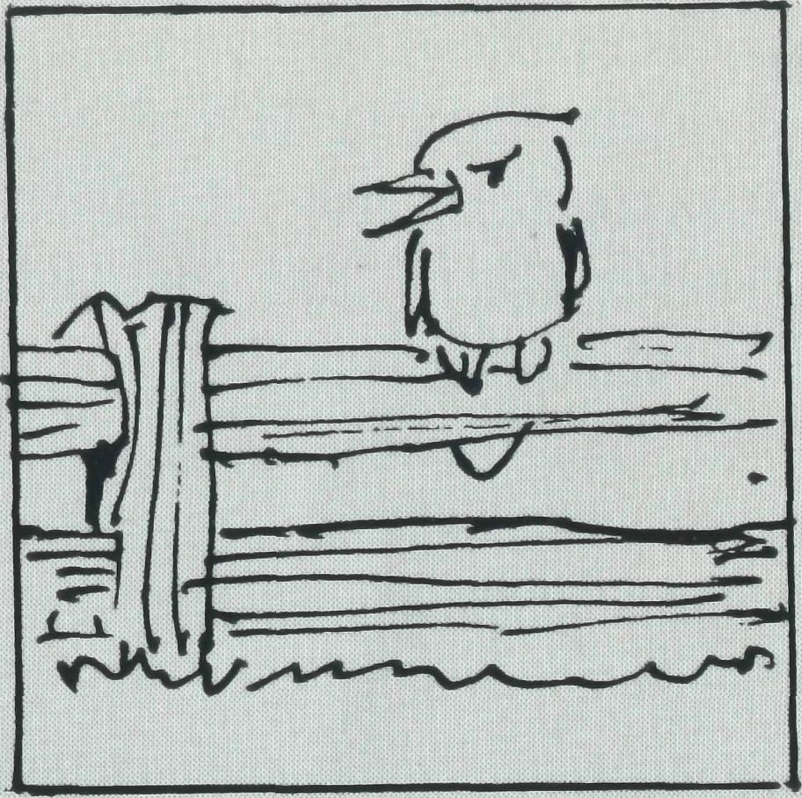
by Glenys, comes from the first aircraft used by the medical service at Ceduna. It was then a new Fox Moth and carried BCA medical personnel to outback areas in S.A.
BCA opened its first Ceduna hospital in an old stone farmhouse on the outskirts of the town in 1925. It began the Flying Medical Service in Ceduna in 1938 continuing until 1967 when the Royal Flying Doctor Service took responsibility for the area formerly served by BCA.
The BCA Tree:
Some trees kill all surrounding vegetation, but others feed more deeply and are an aid to all other growth, said Bishop John Noble at the recent Queensland BCA AGM in St. John's Wishart.
BCA nourished the church in remote areas in providing clergy and other specialist workers without which churches and their community contribution would be diminished.
State Secretary, Les Monaghan, outlined the work of the society and a band from St. Barts, Mt. Gravatt led spirited and inspiring singing.
TRAINS TO PLANES:
A Flying Service Remembered. Photo by Mike Burton
Sr Chris Woon from Cook is engaged to a Royal Flying Doctor pilot, Ray Mundy. The wedding day will be 29 October 1994. Chris will continue at Cook till the end of this year. BCA congratulates Chris and Ray on their new life together.
BACK TO PARISH MINISTRY:
The Rev Bob George has been invited to become Rector of St Bartholomews Norwood, Adelaide. He officially finishes as BCA State Secretary on the 20th September ending more than 16 years of BCA supported ministry. Bob and Rigmor George began their time with BCA in 1978 at Winton, then to Sanderson, NT in 1982 and lastly to Adelaide in 1988 as State Secretary. BCA wishes Bob, Rigmor, Todd and Robyn God's richest blessings in their next move and extends its appreciation for their sacrificial and faithful service. His commissioning service is on Wednesday, 21 st September at 8.00.pm. at St.Bartholomews Norwood.
DERBY ENCOURAGEMENT:
Jon Reinertsen sometimes gets discouraged when its time for some families to leave Derby and the small congregation. He says; "We
don't have the population to readily absorb those kinds of shocks. The Lord takes care of our morale. You just have to leave it to Him and accept the reality of the situation. Say, you hear a church warden is moving, you walk across the street to the post office, get your mail, and amongst it all, you find a postcard from a BCA Supporter to let you know they're praying for you. It's a wonderful support."
75TH ANNIVERSARY DINNER — 15TH SEPTEMBER:
6.30.pm. St. Alban's Lindfield — $ 15 each. Bookings Essential. Ring Michele Peacock on 262 5017.
1995 BCA BUS TOURS:
■ 7 day tour Northern NSW
24 Mar-30 Mar.
■ 27 day tour of Outback Australia
25 April-22 May
Details ring BCA (02) 262 5017

PRAY FOR OUR STAFF

OUR MISSION FIELD

• Diocese of Northern Territory — Bishop Richard Appleby
- Anglicare Director — Mr. Peter Fisher.
- Tennant Creek — Rev. Tom and Mrs. Carol Williams.
• Diocese of North West Australia — Bishop Tony Nichols.
- Kununurra — Rev. John and Mrs. Dianne Symons.
- Derby — Rev. Jon and Mrs. Rae Reinertsen.
- Newman — Rev. Raymond and Mrs. Betty Lou Molyneux.
- Hedland — Rev. Ray and Mrs. Lyn Arthur.
- Karratha — Rev. Terry and Mrs. Fiona Redmond.
- Wickham — Archdeacon Bill and Mrs. Jocelyn Ross.
- Tom Price/Paraburdoo — Rev. Brian and Mrs. Joy Harding.

- Counselling Ministry:
- Mt. Magnet (Murchison) — Rev. Philip and Mrs Margaret Bassett.
- Leinster — Rev. Les and Mrs. Jenny Gaulton.
- Diocesan Registrar — Mrs. Kay Winfield in Geraldton.
• Diocese of Willochra — Bishop David McCall.
- Coober Pedy — Rev. Bob and Mrs. Denise Rothwell.
- Roxby Downs & Mid-West Mission — Rev. John and Mrs. Leone Rutherford.
- Leigh Creek — Rev. Wayne and Cherylene Ireland.
- Cook: Bp Kirkby Mem. Hosp. — Gai DiDonna & Chris Woon.
- Tarcoola Hospital — Gill Wright.
- Ceduna — Archdeacon George and Judy Thomas.
• Diocese of Riverina. — Bishop Bruce Clark.
- Broken Hill BCA House — Neville and Margaret Coombs.
- Wilcannia — Rev. Don and Mrs. Helen Wilson.
• Diocese of Armidale — Bishop Peter Chiswell.
- Lightning Ridge — Rev. Mark and Mrs. Lucy Taylor.
- Walgett — Rev. Clive and Vivienne Robinson.
• Diocese of Grafton — Bishop Bruce Schultz.
24 Bonalbo — Rev. Ian and Glenda McGrath.
• Diocese of Brisbane — Archbishop Peter Hollingworth.
25 Quilpie — Terry and Sherry Leonard.
• Diocese of Rockhampton — Bishop George Hearn.
- Winton — Rev. Geoff and Gill Bransgrove.
- Blackwater — Rev. Peter and Mrs. Jeannette Blundell.
- ABORIGINAL AND TORRES STRAIT ISLANDER MINISTRY:
Cairns: St. Luke's — Rev. Jim and Lala Leftwich. Nungalinya College — Ms. Elizabeth Caldwell. Bimbadeen College — Mr. Denis and Mrs. Maureen Atkinson. Furneaux Islands — Rev. Donald Moffat. Dio. of Tas.
29 STATE OFFICES:
Acting Hon. Secretary for W.A. — Rev. Fred Buchanan.
State Secretary for S.A. — Rev. Bob George, Mrs. Aila Alderson.
State Secretary for Vic. and Tas. — Rev. Brian Viney, Ms. Margo Bright.
State Secretary for N.S.W. — Rev. Greg Thompson, Mrs. Michele Peacock.
State Secretary for Qld. & Northern N.S.W. — Rev. Les Monaghan and Dianne Harris.
30 BCA FEDERAL OFFICE: Rev. Brian Roberts, Mr. Jim Gosbee, Mesdames Jacqueline Griffiths,
Lay Lee Boughton and Eileen Darbin.
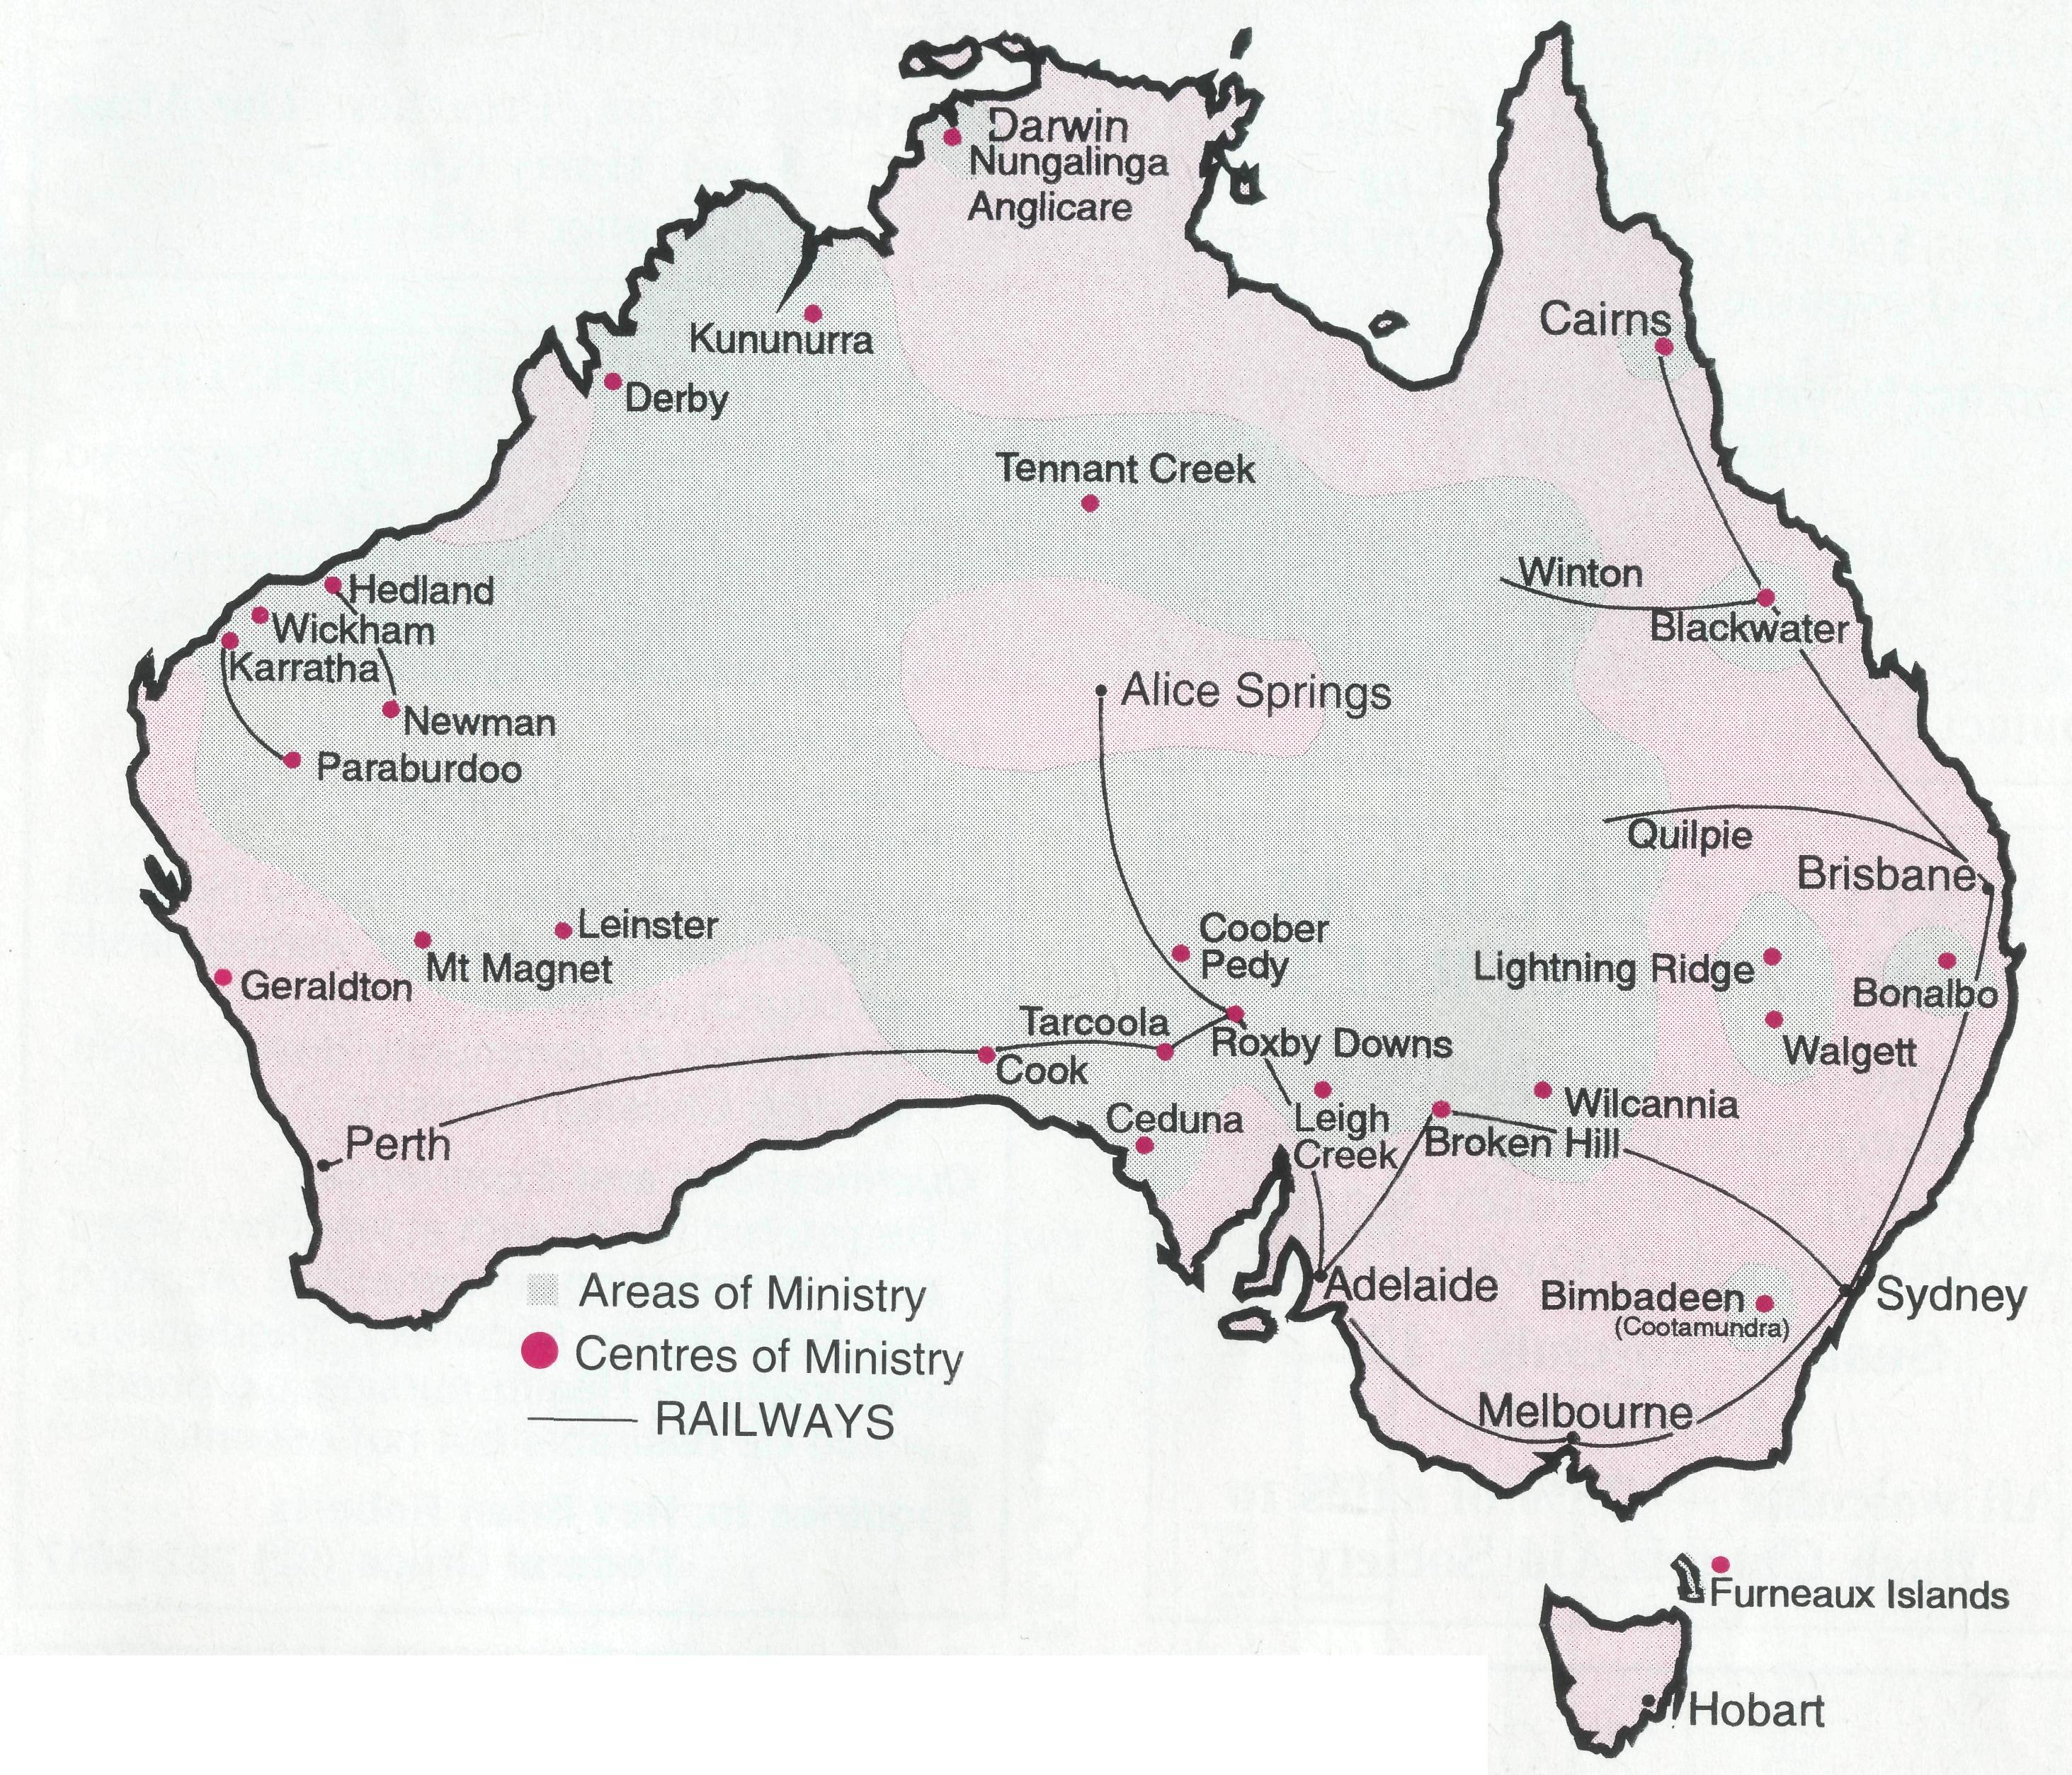
The BCA prayer
O Lord our God, help us to remember those who live in the remote parts of our land. We ask you to strengthen and encourage all whose ministries are supported by The Bush Church Aid Society. Refresh them in times of discouragement and loneliness and call others to stand with them in the task of making Christ known. Grant that, through the ministry of the Word and Sacraments, through medical work, through service and
by caring for the young, the message
of your redeeming love may be pro
claimed, and accepted by the people
throughout our land. We ask these
things through Jesus Christ our
Lord, who lives and reigns with you
and the Holy Spirit, one God, for
ever and ever. AMEN.
*If you'd like more details for prayer, send for our FREE quarterly prayer notes. (See reply page.)
17

BROKEN HILL — BCA HOUSE
Broken Hill has a lot to offer the tourist — art, national parks, mine tours and BCA supporters can now enjoy this and experience life at BCA House with the children first hand.
Our visitors' room, twin beds and own bathroom is available during term times at $50 per night including breakfast and evening meal.
Contact Neville or Margaret Coombs (080) 87 4231
Larger parties (including school or university groups) can be catered for during holiday periods — for details contact Federal Office.

ADELAIDE REUNION
Sunday, 30 October 1994
Following an Anniversary Service in St Peter's Cathedral, Adelaide, to mark 75 years of BCA Ministry, a reunion dinner is planned for former BCA workers. Further details from John Argall. Phone (08) 265 1825.
Service 3.30 pm. Preacher: The Most
Revd. Harry Goodhew.
Dinner 6.30 pm
NURSING ON THE TRANSLINE
Applications are invited from registered nurses to join our team of nurses working between the two remote area hospitals of Cook and Tarcoola on the East-West Transline Railway of South Australia. Duties include:
WATERCOLOURS AT WOLLSTONECRAFT
Sale of Brian Eggleton's
watercolours will be from his
home at 12/57 Shirley Road,
Wollstonecraft, (02) 436 1093.
Sunday, November 13, 11 am-5 pm
All welcome — 25% of sales to Bush Church Aid Society
- Assessment and Diagnostic Skills
- Primary Health Care
- Administrative duties within the Hospital
- Provision of hospitality for visiting health and church personnel
- Involvement in community development, including Christian ministry
Qualifications and Experience:
• Registered Nurse with at least two years'
post registration experience. Accident
and Emergency, Midwifery, Paediatric or
Occupational Health nursing experience
would be desirable but not essential.
B.C.A. SUPPORTERS’ WEEKEND "HOME AND AWAY”
AT: Gilbulla Conference Centre, Menangle
WHEN: Friday evening, 21 October to Sunday afternoon, 23 October
SPEAKER: Mrs Judith Nichols, from the Diocese of North West Australia, wife of Bishop Tony Nichols
Field Staff sharing in the weekend will be Tom and Carol Williams from Tennant Creek and Don and Helen Wilson from Wilcannia.
Weekend includes sessions on the family from an outback perspective, as well as a jazz concert, opportunity to swim, play sports and enjoy good company. A children's program is also being provided. Applications close 30 September and final payment by 7 October.
Bookings essential 120 places only. Phone Michele Peacock (02) 262 5017. COST: Singles $90 approx. Families $275 maximum.

Enquiries to: Rev Brian Roberts
Federal Office (02) 262 5017

