THE QUARTERLY MAGAZINE OF THE BUSH CHURCH AID SOCIETY OF AUSIHAUA $3.00 SUBSCRIPTION

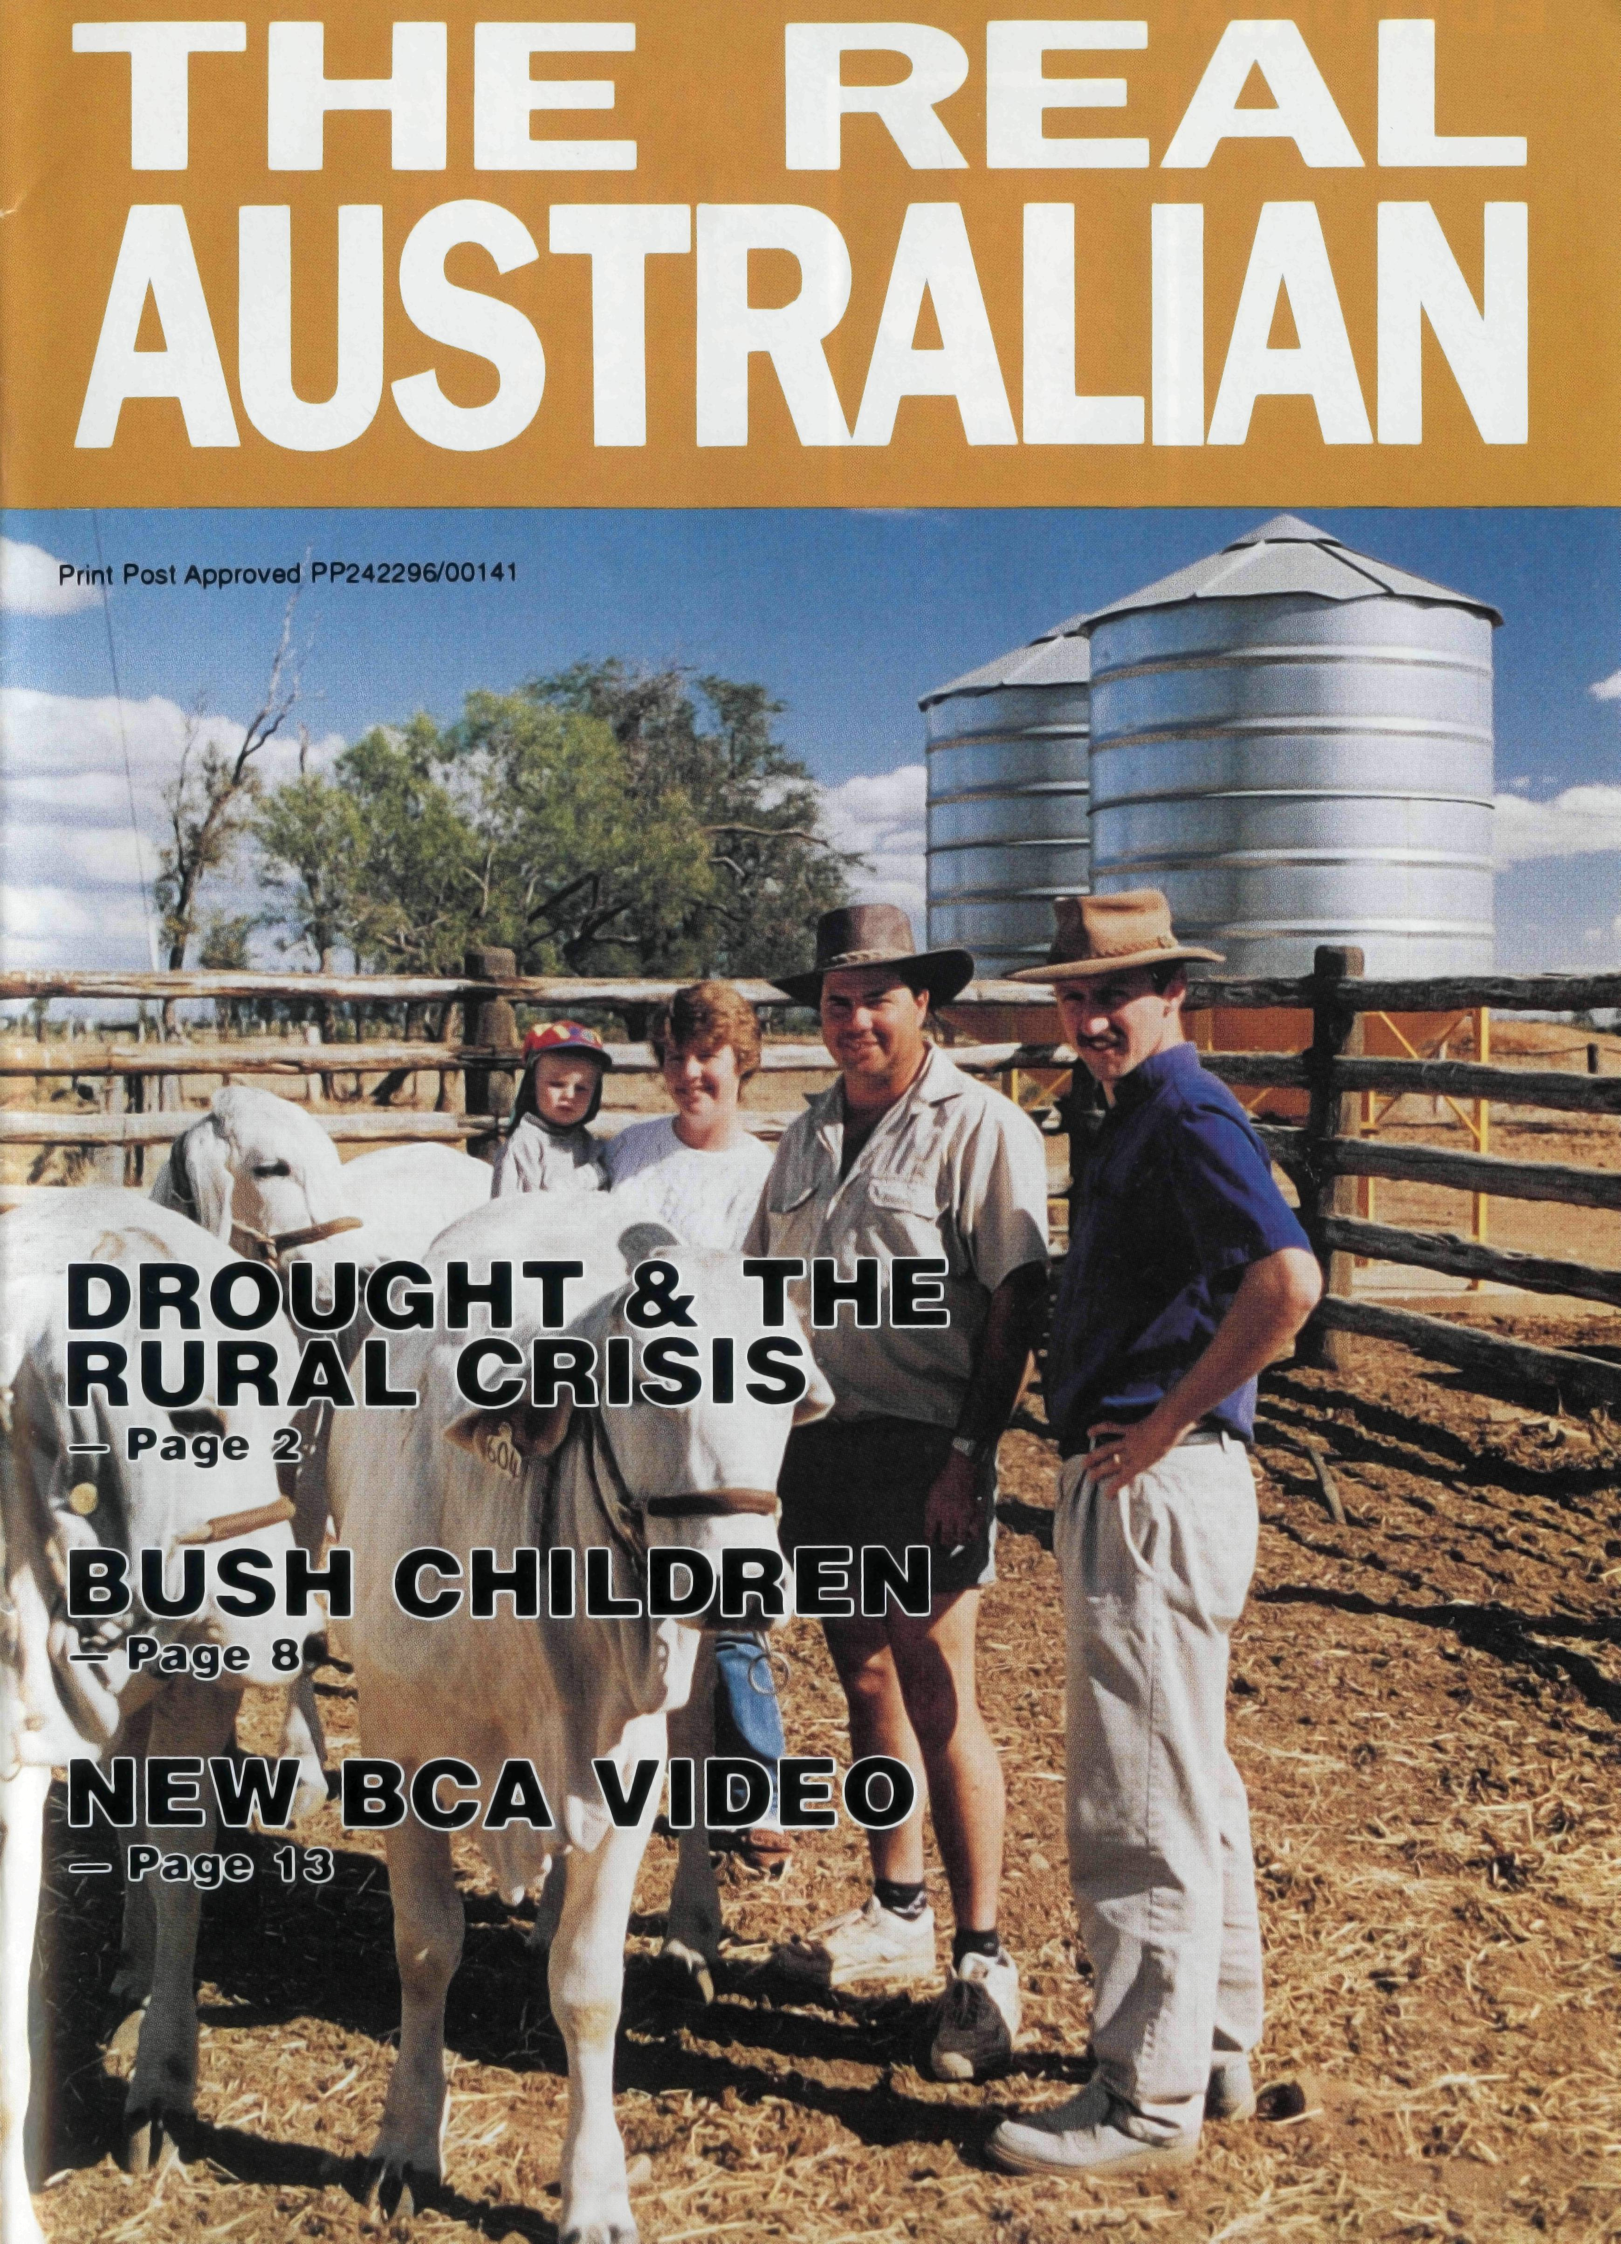
I will say of the Lord
'He is my refuge and
my fortress, my God
in whom I trus’
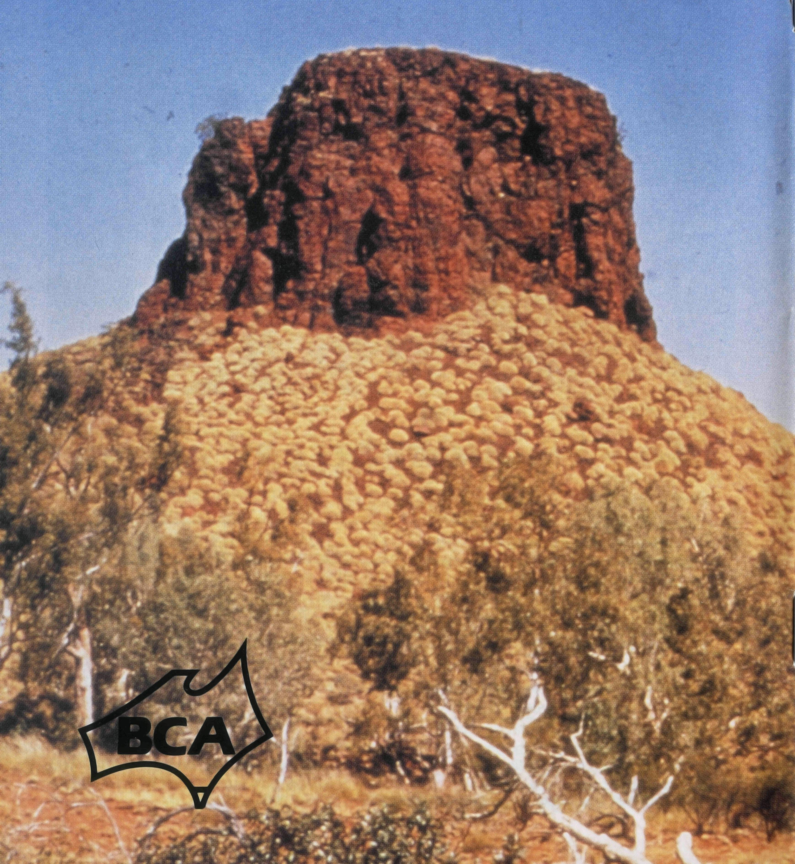
— Psalm 91:2

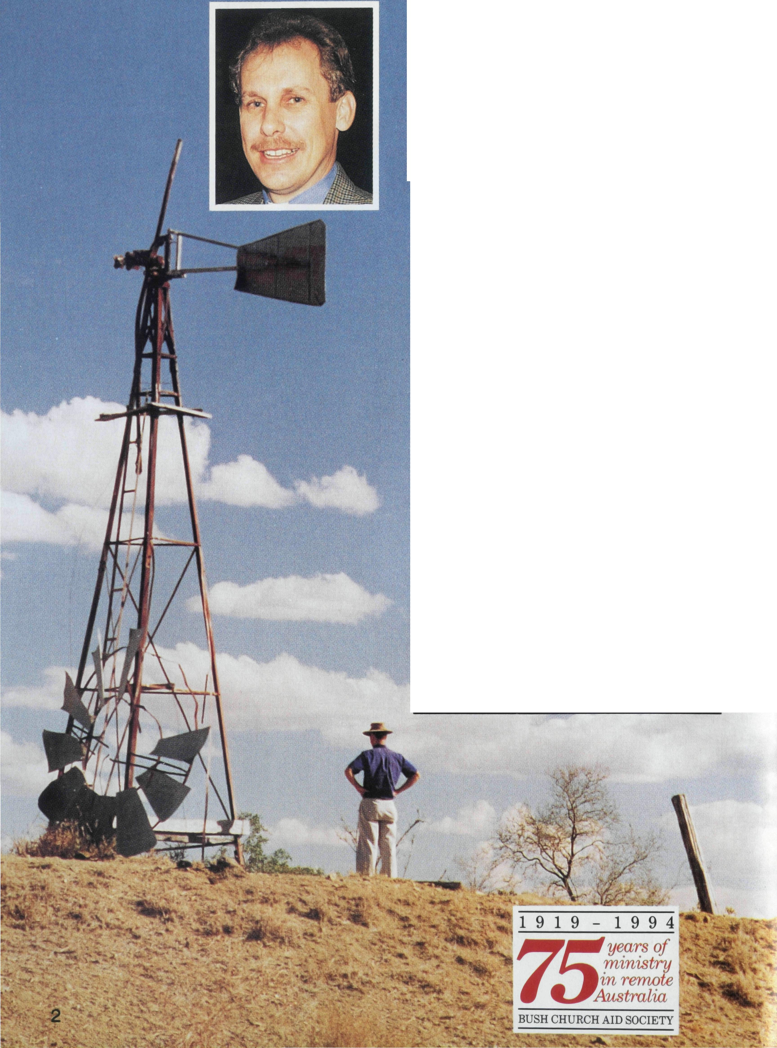
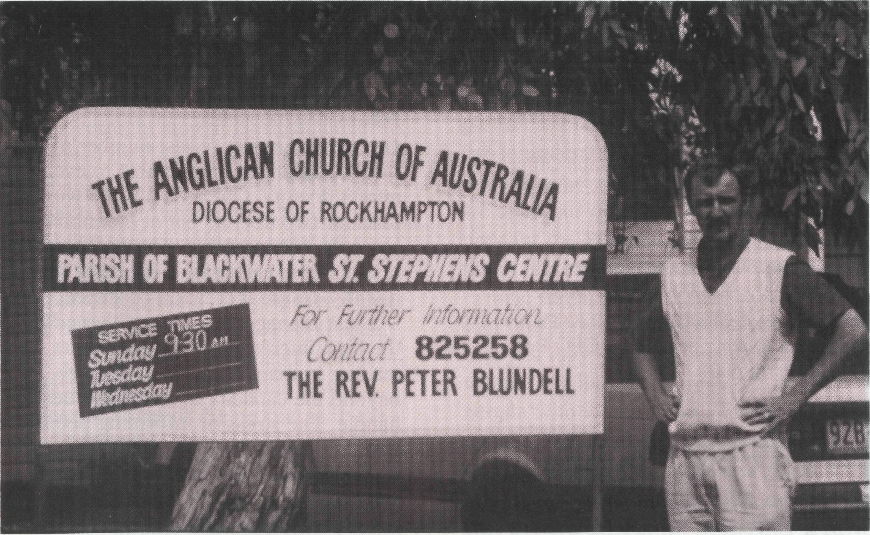
DROUGHT AND THE RURAL CRISIS
By Greg Thompson
THE COMING of rain will not resolve the long term crisis in rural areas. Over the last decade or more with the declining economic protection, the loss of taxation benefits in property improvements and the increasing production costs with little rise in commodity prices has meant a decreasing return for farmers and graziers.
During the early 80's many primary producers recognised the need to move to a larger scale of operations, borrowing heavily. This coincided with rising interest rates and the productivity of their properties not coping with interest payments. So debt was further increased.
This drought has been the last straw for not only farming families (95% of farms are family businesses) but also the communities of small businesses which service rural areas.
Contd. next page
EDITORIAL

Merv Wearne is a rural counsellor in Walgett shire. He said their region is in the fourth year of drought. Farmers have had no cash flow income for nearly four years. They struggle to service debts to their commercial lenders like wool firms, the Commonwealth Bank and the Primary Industry Bank. Farmers can apply for government assistance for up to 50% of their interest bill. However, as the cheque goes to a bank, that money can not be used for day to day expenses.
Local doctors report high distress levels in the community. Graziers are stressed at seeing the cattle they've nurtured fade away and then having to shoot them. Currently, Merv is seeing 112 clients for counselling in his work.
Rev. Peter Blundell serving rural families.
He writes in his report: "There is a cloud of sadness and disappointment hanging over the rural industry at present, with even the older long-term families indicating a preference to "sell up and go". Couple this to the Federal Government's policy of "produce more, or go" and the greenies "give nature a
go", by turning huge parcels of land into nature reserves, and the outlook is not good. It has been said that one of the worst forms of child-abuse is that of leaving the farm to your children! Present indications are that the next generation are too wise in the head to take on the land gamble. With modern industry conditions, shorter hours, flexi-days-regular pay packets etc. the life style of the land will have to offer more than bank bills and ulcers to attract the youth of today. If the industry is to survive, a much more attractive proposal than that which is currently offered, will need to be implemented. The days of the aristocratic, rich grazing families of the past are indeed passed. The whole scene has changed to a business operation, where cash flows and budgets are the order of the day. Entrepreneurs will buy the holdings as a tax-benefit and small country towns will gradually die. Rural export dollars will diminish, exacerbating the country's overseas debt."
Contd. page 4

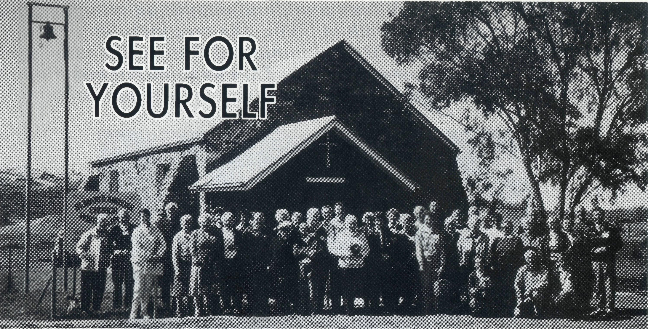
THE REAL AUSTRALIAN,
The Real Australian is a registered trade mark of the Bush Church Aid Society. First published 1920. Edition No. 286 Circulation: 28,000
All enquiries to.
Greg Thompson
The Editor
The Bush Church Aid
Society of Australia
Level 7, 37 York Street.
Sydney 2000
Ph (02) 262 5017. Fax (02) 262 5020

Patron: Archbishop Keith Rayner
President: Archbishop Harry Goodhew
Chairman: The Rev. Dr. Vic Roberts
Vice-Presidents: Mr. Stan Hummerston, O.A.M.; Mr. Ray Ctercteko.
Hon. Treasurer: Mr. R Ctercteko.
Federal Secretary: Rev. Brian Roberts.
N.S.W. Secretary: Rev. Greg Thompson, Level 7, 37 York Street, Sydney, N.S.W. 2000. Ph (02) 262 5017.
Victorian Secretary: Rev. Brian Viney, PO Box 343 East Melbourne 3002. Ph (03) 654 8022.
South Australian Office: Church Office, 44 Currie Street, Adelaide, S.A. 5000. Ph (08) 212 7804.
Queensland Secretary: Rev. Les Monaghan, P.O. Box 6472, Upper Mt. Gravatt, Qld. 4122 Ph (07) 349 9081.
Western Australia Contact: Rev. Fred Buchanan (Acting Secretary), GPO Box N1024, Perth 6001.
FRONT COVER PHOTO:
Rev. Peter Blundell meeting with a Christian family on the land.
4
The Country Women's Association
of NSW have released findings from a recent survey on the rural crisis: On Adults: Where once casual workers were employed to cover the more hectic periods of property management, wives are more than likely to be found assisting their husbands. Either that or one of the spouses has obtained employment in the nearest centre whilst the remaining partner runs the farm. On Families: The effect on families is quite devastating with many families being divided over large distances. Long working days are required due to the distances to be travelled for work commitments. The community support networks are breaking down because of the fact that fewer people have the time to undertake the numerous duties that once were performed by volunteers. This is placing more pressure back on organisations like Home Care which are ill equipped or financed to take up the slack. On Marriages: The divorce and separation rates on rural properties is on the increase due to the pressure of trying to make ends meet and the sense of failure and hopelessness that many people experience. This leads to a breakdown in the communication between couples as people try to cope in their own way with stress and the hopelessness of perceived failure.
On Stress Levels: A vast number of rural communities are unable to even attract doctors. One area has the workload for two doctors but at the moment has only one available. The one doctor remaining is taking time off more frequently, a sure indication of stress.
Bank managers are being blamed for the high interest rates of latter years leading in many cases to debt levels beyond the capacity of the properties to handle. The stress of informing people that they have run out of options is extremely high for bank managers and staff.
Contd. page 18
WHEN Don and Helen Wilson left the parish of Penrith on the western outskirts of Sydney to become the BCA field staff at Wilcannia in far western NSW they not only left behind their grown up family, but also many friends they had made during their ministry.
So when the opportunity came to visit them on a BCA Coach tour , and to see their outback parish, 11 friends from Penrith joined 29 other BCA supporters on a five day trip they will long remember.
An overnight stop at Nyngan, once devastated by floods, and now in the grip of drought, was followed by a five hour trip next day to Wilcannia where Don and Helen were waiting to greet us. After a picnic lunch in the shady grounds of St James', they spoke of their work in this vast parish of 43,000 square miles (1/8 of NSW) populated by just 2,000 people. A walking tour gave a glimpse of some of the problems in the town.
Don and Helen then joined us on the coach as we travelled the dusty 100 km to the opal mining town of White Cliffs where we stayed for two nights under-
ground in the"Dug Out Motel". Of course we saw the sights, the vast number of mullock heaps evidencing the work of hundreds of miners searching for the elusive opal, the underground showrooms, the now disused solar power station, the golf-course with dirt fairways and sandy "greens". But the most memorable experience was to share in worship at St Marys on Sunday morning with several of the local Christians.
As we shared in friendship over meals with Don and Helen, as we met the people in their pastoral care, we were learning to understand more the significance and importance of their ministry. Now as we open our prayer notes on Day 23 and pray for the Wilsons, it will be with much more meaning and understanding.
Take the opportunity to take a BCA tour and visit some of our missioners, so that you may see for yourself the places where they live and minister. The forty people who went on the Wilcannia tour are certainly glad they did. (See details on page 15.)
Rev John Butler
Chairman of NSW Committee

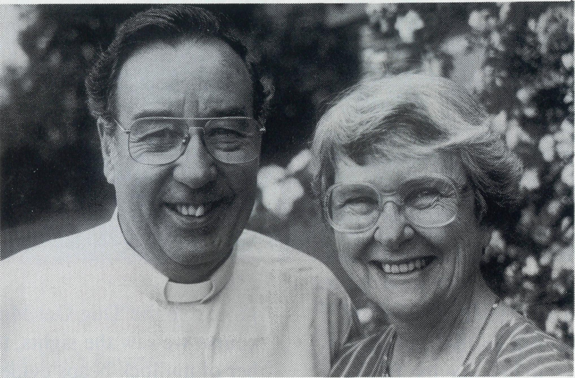
Don and Helen Wilson provide ministry to an area
covering almost 118th of NSW. The area includes
small communities like Wilcannia and White Cliffs as
well as 250 or more properties. They were interviewed
by Greg Thompson on his recent visit to their parish.
"WE ARE SEEING A MINISTRY OF JESUS"
WHAT ARE PEOPLE LIKE OUT HERE IN WESTERN NSW ? Don: People fall into two categories, town people and station people. In Wilcannia there are about 750 Aboriginal and 150 non-Aboriginal people. It is a town with a young population, so the majority of people fall between the age group of 12 and 35. There are about 90% unemployed and that's a very sad situation. Families are stressed in the community.
IN WHAT WAYS CAN YOU HELP FAMILIES IN THE TOWN?
Don:Where it is possible and applicable, we provide counselling. Not so long ago we supported a previous police patrol commander and his wife through a difficult situation in the town. This is one of the real roles of BCA in the bush. It's a personal ministry.We may not be seeing
6
lots of people being converted but we are seeing a ministry of Jesus in going about sowing the seeds of righteousness and helping where we can. It's showing compassion and that's a healing ministry that goes on in the lives of people here.
HOW DO YOU MINISTER TO FAMILIES ON PROPERTIES? Don: We drive to see them and that can take us away for three days. It's a very costly thing for BCA, but it is very worthwhile for people in the bush, particularly people who have a Christian faith. They look forward to seeing you and they are very much encouraged. Our role is to share the Word of God, giving gospel portions. Just on our last visit out to Tibooburra, one of the women asked "Tell me, what is so different about John's gospel from the other gospels?" I explained to her that John's gospel was
around the seven signs of Jesus and to point her to John 20:31. On returning home I sent her a Bible Study on John's Gospel hoping that she might follow it up herself.
ARE THERE MANY OPPORTUNITIES FOR MINISTRY?
Don: Well there are not very many opportunities. Life in the bush is very busy contrary to popular opinion. If they are running a property on their own (as most of them do nowadays) they are very busy people. If there are children in the house and they have a mother who is supervising the children with their school of the air lessons, then she is expected to do the domestic chores and also help out in the paddock with her husband. They are really very hard working people.
WHAT ARE SOME OF THE CRISES HAPPENING AMONG FAMILIES IN THE BUSH? Don: From an economic point of view the crisis of the drought which this area had for three years up until 1992 meant that most of the sheep farmers out here were shooting their sheep. On one property a farmer shot 7,000 sheep and just bulldozed them into a pit. Another one of our families who come to church were down to 500 sheep and eventually lost their property because they just couldn't recover from that. Recently a farmer paid $4 per head of sheep to transport them to the saleyards. He was then paid $1 per head for the sale of them. But I really think one of the great crisis is the drought of hearing the Word of God. The opportunities are still there by tape or radio ministry but they don't have the opportunity as we do in the city where the church is just around the corner. The contact that the property people have with the gospel is that occasional visit from BCA supported ministry.
WHAT WOULD YOU SAY TO PEOPLE ABOUT YOUR WORK? Don: We desperately need Christians to come and live in country towns whether it be Wilcannia or anywhere else. We are praying that God will call Christian teachers,doctors, nurses, policemen, carpenters, plumbers, electricians,semi-retired or retired people who will come and live for a year or two and just be in the town in a supportive role. There is a turnover in this town of 25% every year. It doesn't take long for you to lose a whole congregation. In one year you might have a dozen coming to church and the next year you might have 3 or 4. BCA centres all over Australia are like that, because they depend on a very itinerant sort of congregation. This can be a real pressure and really drive you to your knees praying that God will do something in this place.
IS WHAT YOU'RE DOING WORTH ALL THE RESOURCES THAT KEEP YOU HERE? Don: The question is often asked, "Is it really worth it?" Is it worth people in the city supporting BCA? Here I think that no ministry is only ever gauged by cost effectiveness. I suppose you have to come back to say, "Was it cost effective for God to give his only Son to love the world to save a few? " Is it worth us going to talk to somebody 350 kms away to encourage a mother who wants her daughter to follow the Lord? Is it worth going to a school where we are teaching children who come from godless homes and a little girl gives her life to the Lord?
Then she goes home and wants to be baptised and that whole family comes to church to hear the gospel and say, "Yes, they want to follow Christ" Yes that is worth it!
Contd. page 11

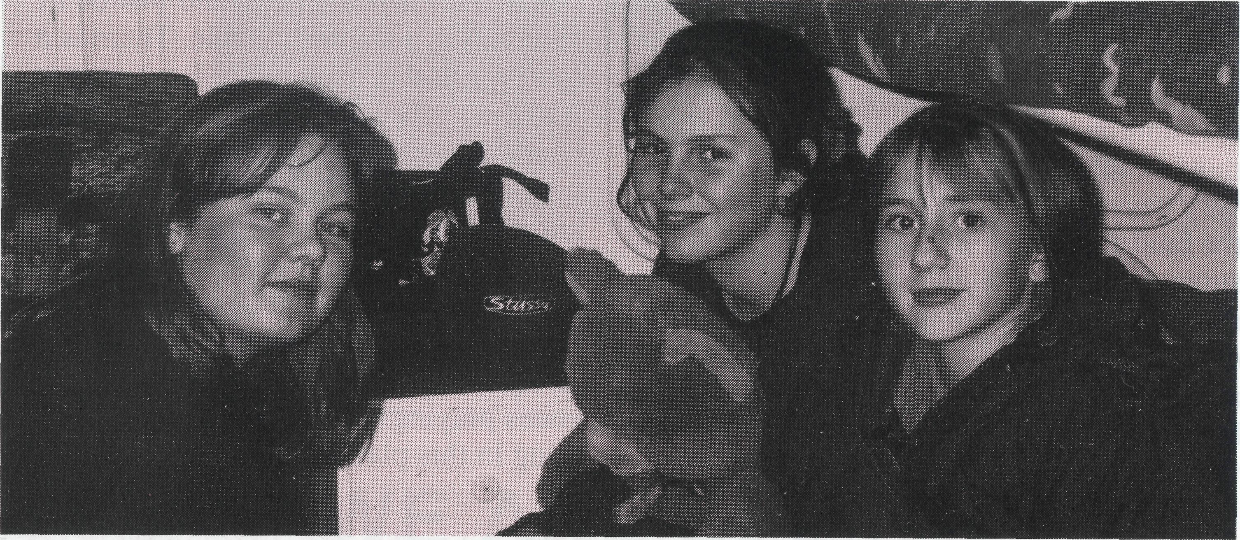
It is a huge contrast from Bald Hills in Brisbane whet* Neville and Margaret Coombs have lived in the Parish
of Northpoint to ministry in Broken Hill and BCA House. BCA House was opened in 1950 and continues
to serve the people of Western NSW by providing
accommodation and care for children from properties
and small communities. Greg Thompson interviewed
Margaret and Neville recently.
Bush Children
HOW WOULD YOU DESCRIBE THE PEOPLE FROM PROPERTIES AND THEIR CHILDREN?
Margaret: Their relationship to the land is really important to them. They are very much at the mercy of the elements and are always waiting for the rain. There's a sense of somehow conquering the land, of somehow taming it. For the children coming to BCA house they face a lot of real life situations at a very young age. They have been able to be free and enjoy the space of country living. They like to be called "bush children." The children from the earliest of ages are driving four wheel drives and bikes and mustering cattle. While they might be missing socialising with other children by living on properties, they are able to really talk about subjects confidently because they have had to do this on School of the Air.
8
WHAT ARE SOME OF THE STRESSES FOR THESE FAMILIES? Margaret: Recently, the major ones have been that of drought and rural finances. Some of the children at BCA House have had to really pull their weight in the work load on the property. There isn't much time for relaxation or leisure. There is work to be done and the children need to participate in it.
HOW DO BUSH CHILDREN COPE WITH MOVING?
Margaret: It is really quite difficult for them. We need to remember they have had the freedom of all the open spaces. Now they are in BCA House with 20 other young people which is rather daunting for them. They have to learn to relate to different authority figures with us as house parents. Then there is the great change in going to a school room
situation, when all of their early education has been through School of the Air with just Mum and maybe sister or brother.
HOW DOES BCA HOUSE HELP THESE CHILDREN? Margaret: We are giving them a Christian home-away-from-home environment . This is a stable basis for them in which to launch into their new experiences in education. We provide for the parents the assurance their children are going to be cared for while they are going through this great change in their lives. It is a family ministry.
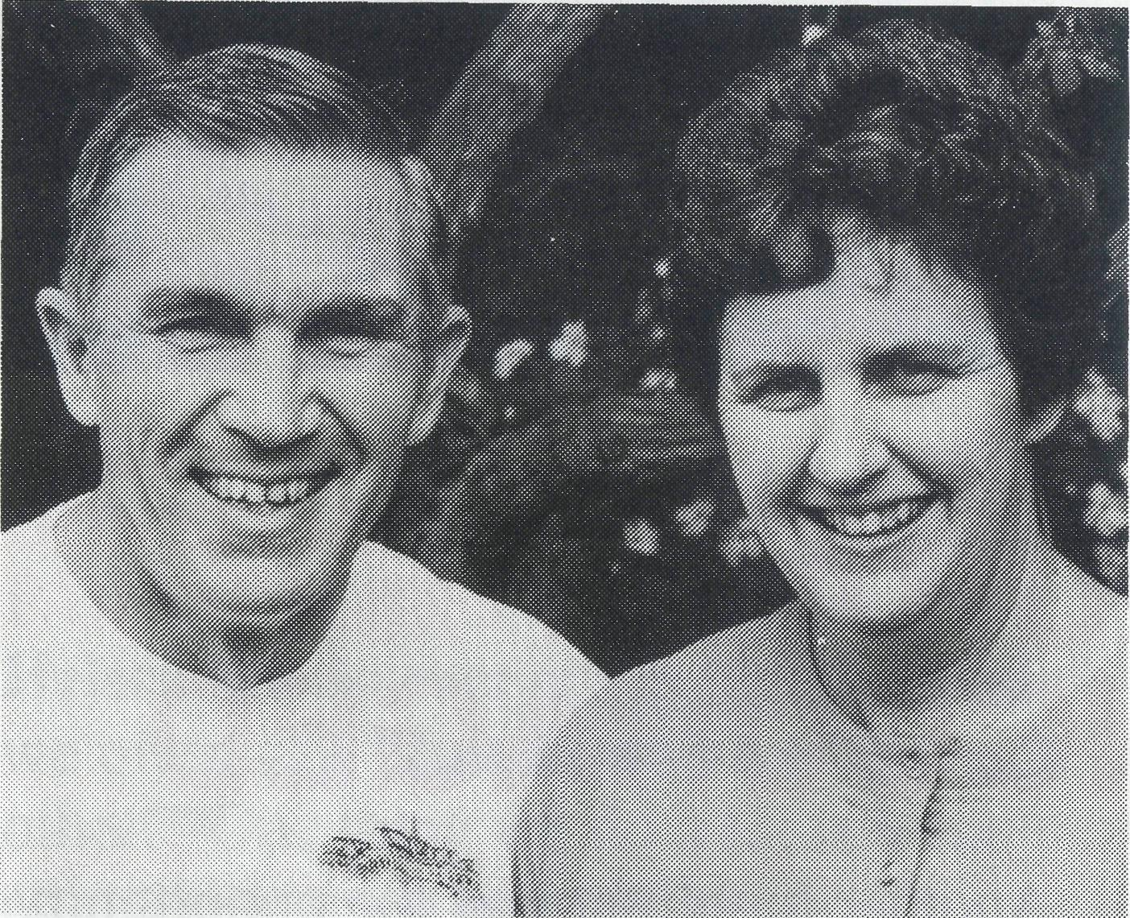
WHAT ARE SOME OF THE ISSUES YOU FACE IN THIS MINISTRY? Margaret: The day to day issues of being there for the children for all the beginning of school jitters and knowing we are here for when the children come home. There are bigger crises we must respond to. We had one family lose their home, which is very traumatic. We were called upon to share the news with them which wasn't easy, but in a way it has helped strengthen relationships with the children. We are also facing peer group pressure on the children. Then there are issues of illness. We have had accidents, broken wrists, chipped ankles and these are all crises. They need responding to on the run. Sometimes, you don't have time to reflect on how it is going but you
are really responding as if this was your own child. It is very demanding and it's very worthwhile.
HOW IS YOUR MINISTRY SUSTAINED THROUGH ALL THESE ISSUES? Margaret: I guess in one word. "Emmanuel...God with us!" Without the knowledge of God's presence and without the knowledge of all the BCA supporters praying for us, the task would be too difficult. We came knowing that God was here before us and that sustains us.
WHAT IS YOUR VISION FOR THIS MINISTRY?
Margaret: A particular dream is the children might be able to reflect back on the time they shared at BCA House. Hopefully they will remember this an an experience in their life where they saw Christ alive.
HOW DO YOU SET BOUNDARIES AT BCA HOUSE?
Neville: With great difficulty. We try to make rules that are in their best interests. We have to be flexible as well as implementing rules in a loving and caring manner. We show our parental care by being consistent, being honest with them and by example.
HOW DOES BCA HOUSE RELATE TO THE LOCAL PARISH? Neville: One of the house rules is that, seeing BCA is a Christian ministry, the children do actually go to church each Sunday. We attend three Sundays at the local parish and on the fourth Sunday we attend the South Parish where there is a family service. The children seem to accept it and we are encouraged by that. We get a lot of support here from the local parishes. We know that not only in their prayer life but in practical terms they are with us.
Contd. page 15

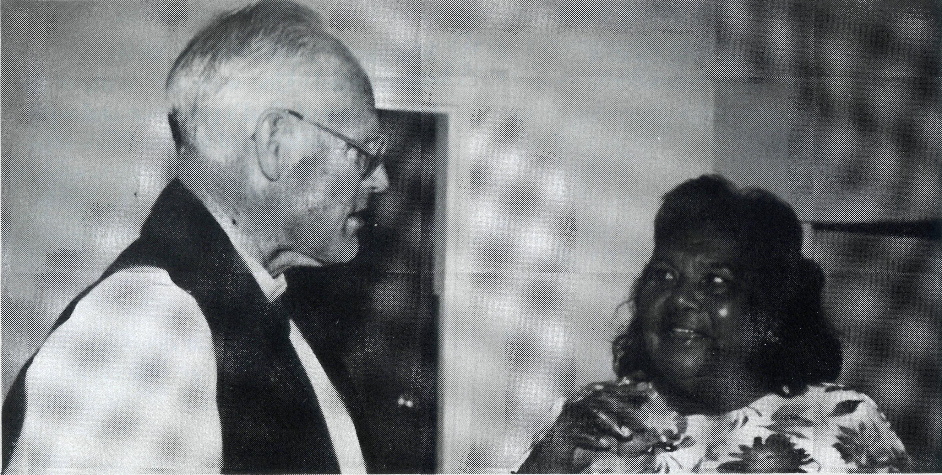
The Rev Brian Viney, Vic/Tas State Secretary of BCA
and Christian friend, Mr Ted Gray travelled over
10,000 km in Mr Gray's Cessna 172 visiting 18 BCA
field staff in June of this year.
remember when their last church had blown down into a place where at least a few saw the value of a worship centre.
Could it be that the ministry of Raymond Molyneux and others has brought new life to this small community?
Ted and I flew into Laverton WA late one Sunday afternoon. Les Gaulton had driven across as part of one of his regular visits through his parish. He met us at the airstrip and took us to the mine manager's house for a meal. There we met Annie who explained that her husband had been called away. She coped with getting herself and two small children ready for church as well as providing a sumptuous feast for three hungry men. As we talked I had the feeling that we had met somewhere before.
Ministry of Jesus (contd.)
Then the penny dropped. Over 6 years ago when I visited John Symons at Derby he took me to Koolan Island, where we shared a meal in the home of the Assistant Mine Manager. It was Annie and her husband Brian and their new baby that I met then. What a joy it was to find her still doing her part for the kingdom of God.
It had been an inspiring three weeks . We had covered more than half of Australia without visiting a single city. We had found people serving God faithfully and expressing the joy of knowing that faithful Christians all over Australia are praying for them. Thanks be to God.
See Prayer Notes Day 19

Rev Raymond Molyneux with a parishioner.
TO ENCOURAGE AND TO BE ENCOURAGED
THIS TRIP was a time to be encouraged and to encourage the dedicated field staff and their families in North West Australia, Northern Territory and South Australia. Ted, the pilot remarked once "It's amazing ! Each one of these guys seem to be just right for the job and they all seem to have just the right partner with them !"
There were some places where we felt particularly welcome. At Mt Magnet, Philip and Margaret Bassett carry on faithfully with precious little to encourage them. However one lady in Cue showed just how much they and other field workers were appreciated when she commented. "What other organizations apart from BCA would send people to a place like this just to encourage a few people like us and bring us into the Kingdom?". 10
Another highlight was the opportunity to be in Marble Bar with all the clergy of the Pilbara, together with Bishop Tony Nichols, for the dedication of the new St Hugh's church. The day of fellowship was capped off by an inspiring service with a good representation of locals along with visitors.
Raymond Molyneux , the local BCA supported Anglican minister told me that the original St Hugh's was blown down by a cyclone sometime during the seventies. However no one in Marble Bar can remember when or any detail of its demise. Recently members of the local community had been keen to have a worship centre again and with the help of BHP Iron Ore obtained a suitable building.
The next morning, I wondered what had changed a community that couldn't
HELEN, YOUR MINISTRY WITH DON SEEMS LIKE A PARTNERSHIP?
Helen: We do everything together and we often say, "Just as well we like each other!" One thing we do a lot is walk around the town and talk to people. That's a difference in the ministry here. We chat to people in the back yard or when they call on us here or when we go walking down the town. When travelling, we do it together. The roads can be pretty treacherous out here. Recently we rolled the car. We had been through 80 kms of muddy road. We slipped and slid and before we knew it we turned around and the car went over on its side.
WHAT'S YOUR VISION FOR THIS AREA?
Helen: Wilcannia is a wonderful place. I think there is tremendous potential in the town and in the people but they need to be freed. Only God can do that. There seems to be little change and sometimes you pray and you really wonder why God is not doing anything. On occasions
some of the nurses come in and in sheer frustration they will cry and say, "God, why don't you do something?" Because they see people coming up to the hospital time and time again and there seems to be no solution. So they cry, we cry and then we pray and we just go back and face it all again.
HOW DO YOU COPE WITH THE PRESSURES OF MINISTRY? Don: The pressures have driven us to a greater prayer life. We've never prayed more than we have here in Wilcannia. We are closer to the pressure of the town, closer to the police and to the aboriginal issues. Our first introduction to the problems of Wilcannia was in our first week. The house was broken into and during church! So we became very concerned about the town and we have taken a great interest in town affairs, by going along to all the public meetings. I became the secretary of the Community Consultative Committee. This was a new style of ministry.
See Prayer Notes Day 23
11

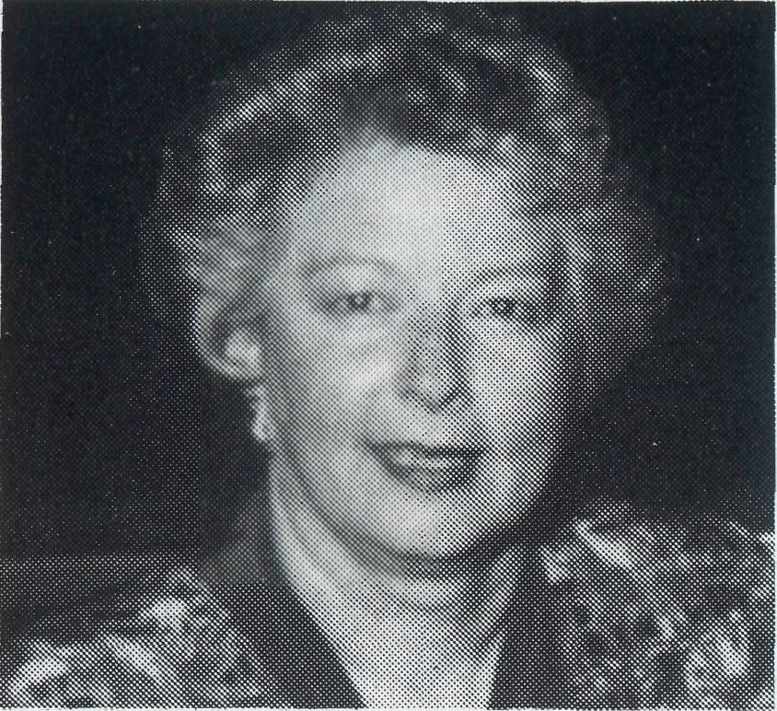

The 75th Anniversary Dinner ofBCA was held at
St Alban's Lindfield on 15 September. Nearly 90
participants celebrated and remembered the pioneering
work of Anglicans prepared to bring gospel ministry
to outback Australia.
Post & Rails
Women Pioneers in the Outback
THE FEDERAL Chairman of BCA, the Rev Dr Vic Roberts spoke of the crucial and numerically prominent role of women in pioneering ministry in Australia who served with BCA. This was in spite of the ecclesiastical climate of the day that limited their leadership and ministry roles. Yet from the early 1920's BCA saw the potential of deaconesses, nurses, hostel sisters and teachers as frontline workers for Christ in many remote areas. These women, alongside ordained men, quickly demonstrated the value of BCA in rural and remote communities.
By the mid 1970's there had been BCA deaconesses in the Dioceses of Gippsland, Bendigo, Willochra, Riverina, Newcastle and Armidale.
Guest speaker Miss Carol Allen, Director of Nursing Chesalon Homes, reflected on the humanity, humour and
Miss
Carol
Allen
the help of God she encountered while serving as a BCA nurse in Cook 1970-72 and Coober Pedy 1973-77. She said "My first view of the Nullarbor Plain came through the window of the train at about 6am, as I hurtled towards Cook Hospital and the unknown. I looked out at the barrenness and desolation and wondered (not for the last time) what I was doing there. Yet through that emptiness and barrenness the Lord was there, with me all the way. The vision and the assurance given are as vivid to me today as they were then." "I will never leave you or forsake you" and the Lord hasn't."
BCA continues to provide medical work on the Transline today. Without women prepared to serve in the outback many families would not receive support and care they so desperately need.
See Prayer Notes Day 16
BCA VIDEO RELEASE
AVAILABLE NOW from your local BCA State Secretary is the video "Nowhere is too remote for God."
The introduction and conclusion of the video captures the beauty of Australia and the challenge of ministry in rural and remote communities with "The Great Southland". A kaleidoscope of Australian scenes enhanced by a moving song sung by Steve Grace.
The second segment of the video is entitled "Crisis in the Bush" which explores the life of people on the land in Western NSW. It focuses on the need for Christian ministry to families on properties and in small communities who often experience drought, economic downturn, relationship stress and spiritual challenges. Rev Don and Helen Wilson, who are supported by BCA, share their thoughts and prayers on these crises in the bush.
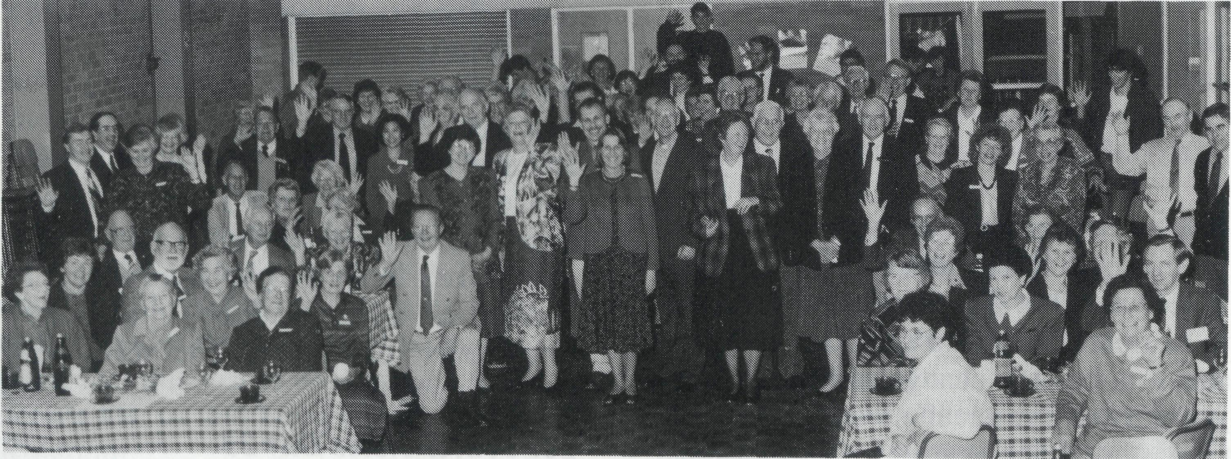
The final segment is called "Bush Children" focusing on BCA House in Broken Hill which provides a ministry to outback families. Children from isolated areas are able to experience " a home away from home" environment so that they may complete their education.
The video could be used in small groups, among friends for prayer, a box holder gathering, passed on to your parish council or mission committee, used during a prayer breakfast, even for school scripture classes or Sunday school events.
Contact your local BCA Office today !
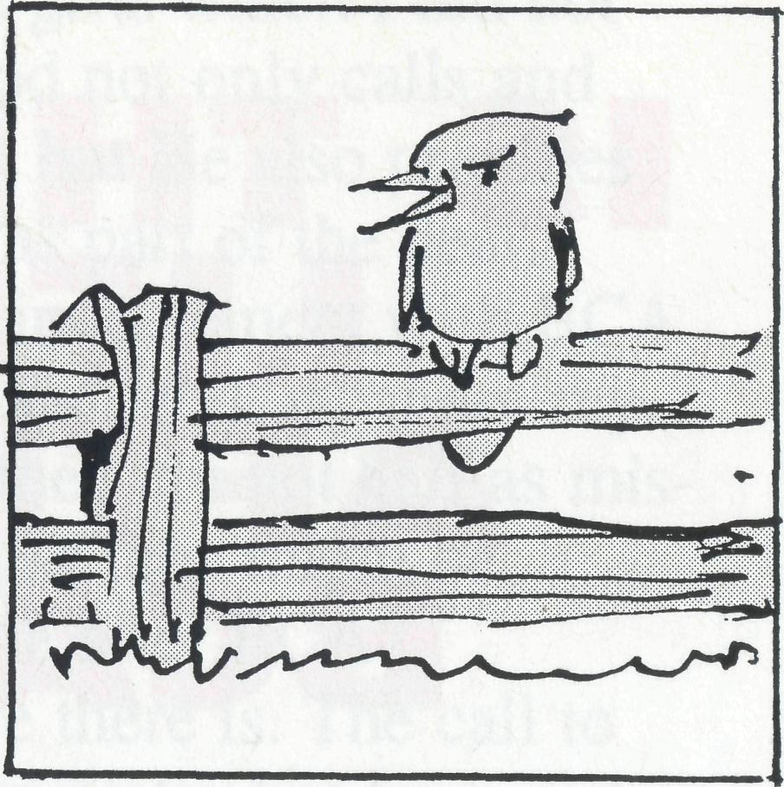
TARCOOLA HOSPITAL
Finding nurses willing to work in remote Australia has been very difficult of late. The Executive have had to give notice that BCA will not be able to continue to supply nurses to the Tarcoola Hospital Board beyond the end of this year. Sr Gill Wright will complete her term at Tarcoola in early January.
The Society will continue to minister at Cook through our hospital. Long and short term nursing opportunities exist with BCA working along with Gai DiDonna. For more details contact your local State Secretary.
The pastoral care of the people along the line continues to be under the Rev John Rutherford's ministry based at Roxby Downs.
SOUTH AUSTRALIAN SECRETARYSHIP
The Society continues to seek to assess the task of the secretary in South Australia,with a report to BCA Council due in May 1995.
We are all aware that it will be important to keep the BCA effort alive till then, so a series of Contract Deputationists — Former Field Staff are lining up to help. Mrs Aila Anderson, our SA Office Secretary, will now bear a large part of the day to day organisation.
REMEMBER THE SITUATION IN PRAYER.
13

The Rev Bob George, former BCA State Secretary for
SA and recently, the new Rector of St Bartholomew's
Norwood, reflects on his time with BCA.
IS THERE
LIFE
AFTER
BCA?
HAVING SUBMITTED my last lot of praise and prayer points for the BCA Prayer Notes, I pondered the profound complexities of life after BCA. What would it be like to no longer be part of the BCA family, which has been such an integral part of my life for the last 16 years or so?
I recall the visit to the curate's house at Wollongong of the then Federal Secretary, the Rev Theo Hayman. He seemed so disappointed, when after a truly stirring pitch about the call to serve God in the bush, I did not sign on the dotted line there and then.
He was a lot happier later, however, when Rigmor and I fronted for another interview. BCA service had always been my objective since Bible College days in Adelaide. I had to be sure the timing was right, and that Winton was the place to begin.
As a family of three we arrived at Winton in 1978. We were soon very sure we had made the right decision, and that God had not only called, but empowered us to serve Him in a remote area.
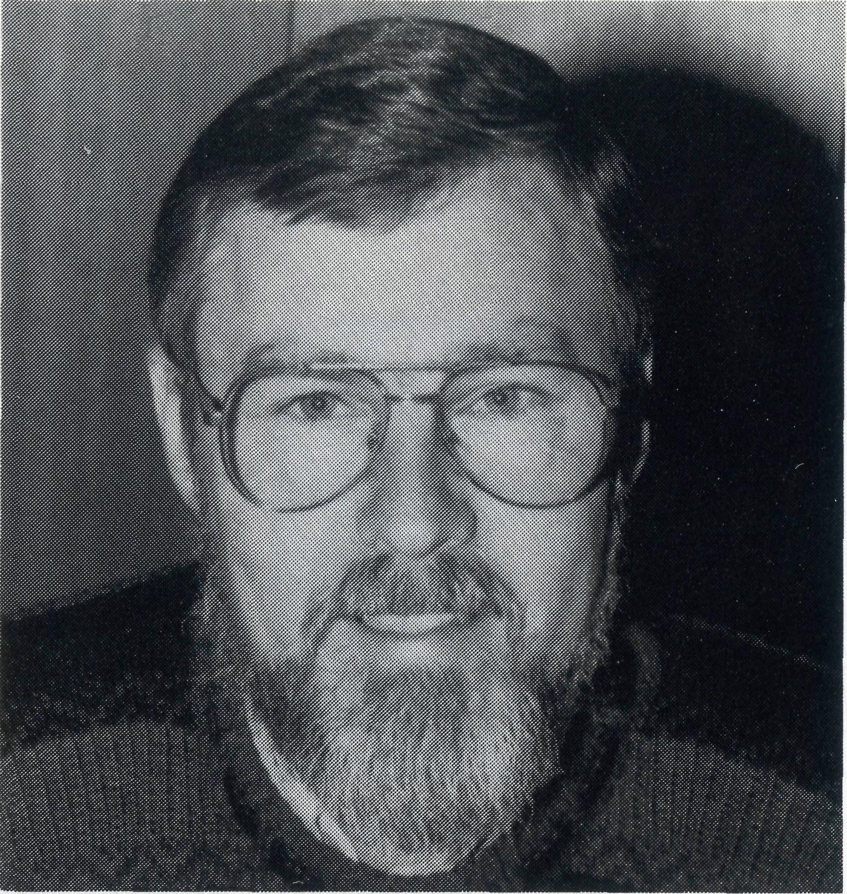
There were numerous mistakes and poor decisions in early days at Winton, but it seemed that God minimised any disastrous effects. God has always been so gracious, and long suffering with me.
Four years were spent in Western Queensland, and we were very conscious of being buoyed along by the prayers of faithful BCA supporters.
We moved to Sanderson in Darwin from Winton in 1982.1 can remember the bishop of the NT the Right Rev Ken Mason, wisely and caringly advising me not to move to Darwin before Christmas. That time of year is particularly difficult on account of the weather and the separation from immediate family support structures.
Those who know me well, realise that I always instinctly do what I am told!?! As a family we moved to Darwin on December 23. After attending a service, I vividly remember the four of us having Christmas dinner alone in the new rectory, knee-deep in boxes and with most of our furniture still where the removalists had dumped it.
For some strange reason that turned out to be one of the best Christmases we ever had. Again, we were sure that God had led us to our new home, and the humidity and the isolation did not worry us at all. In fact, it never did. Home for us has always been where you are, and not where you have come from. Darwin was a great place to be, in spite of the so-called tiresome weather and sense of isolation.
Even now, in a mad moment, I still pine for Darwin. The privilege of being part of that church planting ministry at Sanderson, supported by BCA and in partnership with the Diocese of the Northern Territory, will always be for me a very special BCA memory.
In the last year or so at Sanderson, I remember agonising over a sermon, and reflecting on how the work of a BCA State Secretary must be the pits. Who would ever want a job like that?
God has a remarkable sense of humour, and after 6 years in Adelaide, I have come to realise that one can actually enjoy serving as a State Secretary. I
Bush Children (contd.)
HOW DO THE FAMILIES REGARD BCA HOUSE?
Margaret: From feedback we have received, they are happy to know their children have a home to come home to and they have people here who really have their best interests at heart. They assure us by supporting us in all we are trying to do with their children.
WHAT WOULD YOU SAY TO PEOPLE WHO SUPPORT YOU AT BCA HOUSE?
Margaret: The knowledge people do pray for us is very supportive. If we could invite people to join that wonderful BCA prayer support this would be really great.
See Prayer Notes Day 24
have discovered gifts which I did not realise I had. God not only calls and gives the ability, but He also provides job satisfaction as part of the deal.
As my direct involvement with BCA has now come to an end, what are my feelings? Well, they are not half as miserable as I thought they might be. Is there really life after BCA?
Well, I believe there is. The call to return to urban ministry has been just as clear and strong as any to serve with BCA. I look forward to becoming deeply involved in the lives of a smaller local group of people, rather than the many people extended over a vast area.
As I adjust to a different style of ministry, I have come to the conclusion, that while it is possible to take a person out of BCA, it does not mean that you have to take BCA out of the person.
I look forward to the years ahead, associated in a different way with the Society, but in another sense still actively involved, praying earnestly for all that BCA is involved with throughout Australia.
COACH TOURS FOR 1995
NSW 75TH ANNIVERSARY TOUR
A seven-day tour departing Sydney 24 March for Port Macquarie, Casino, Bonalbo, Glen Innes, Lightning Ridge, Walgett, Dubbo and returning to Sydney 30 March.
THE REAL AUSTRALIAN TOUR
A twenty-seven day tour which takes in I northern NSW, western Queensland, the Northern Territory, the Kimberleys, Tanami desert, Alice Springs and Uluru, Coober Pedy, Tarcoola and Roxby Downs, Broken Hill and Wilcannia. The tour leaves Sydney 25 April and I returns 21 May.
QLD/NORTHERN NSW TOUR
A sixteen-day tour departs Tamworth 7 August and returns 22 August. (07) 349 9081.
Ring (02). 2625017 or send for further details to BCA, Level 7, 37 York Street, Sydney 2000

15

by caring for the young, the message
of your redeeming love may be pro
claimed, and accepted by the people
throughout our land. We ask these
things through Jesus Christ our
Lord, who lives and reigns with you
and the Holy Spirit, one God, for
ever and ever. AMEN.
*If you'd like more details for prayer, send for our FREE quarterly prayer notes. (See reply page.)
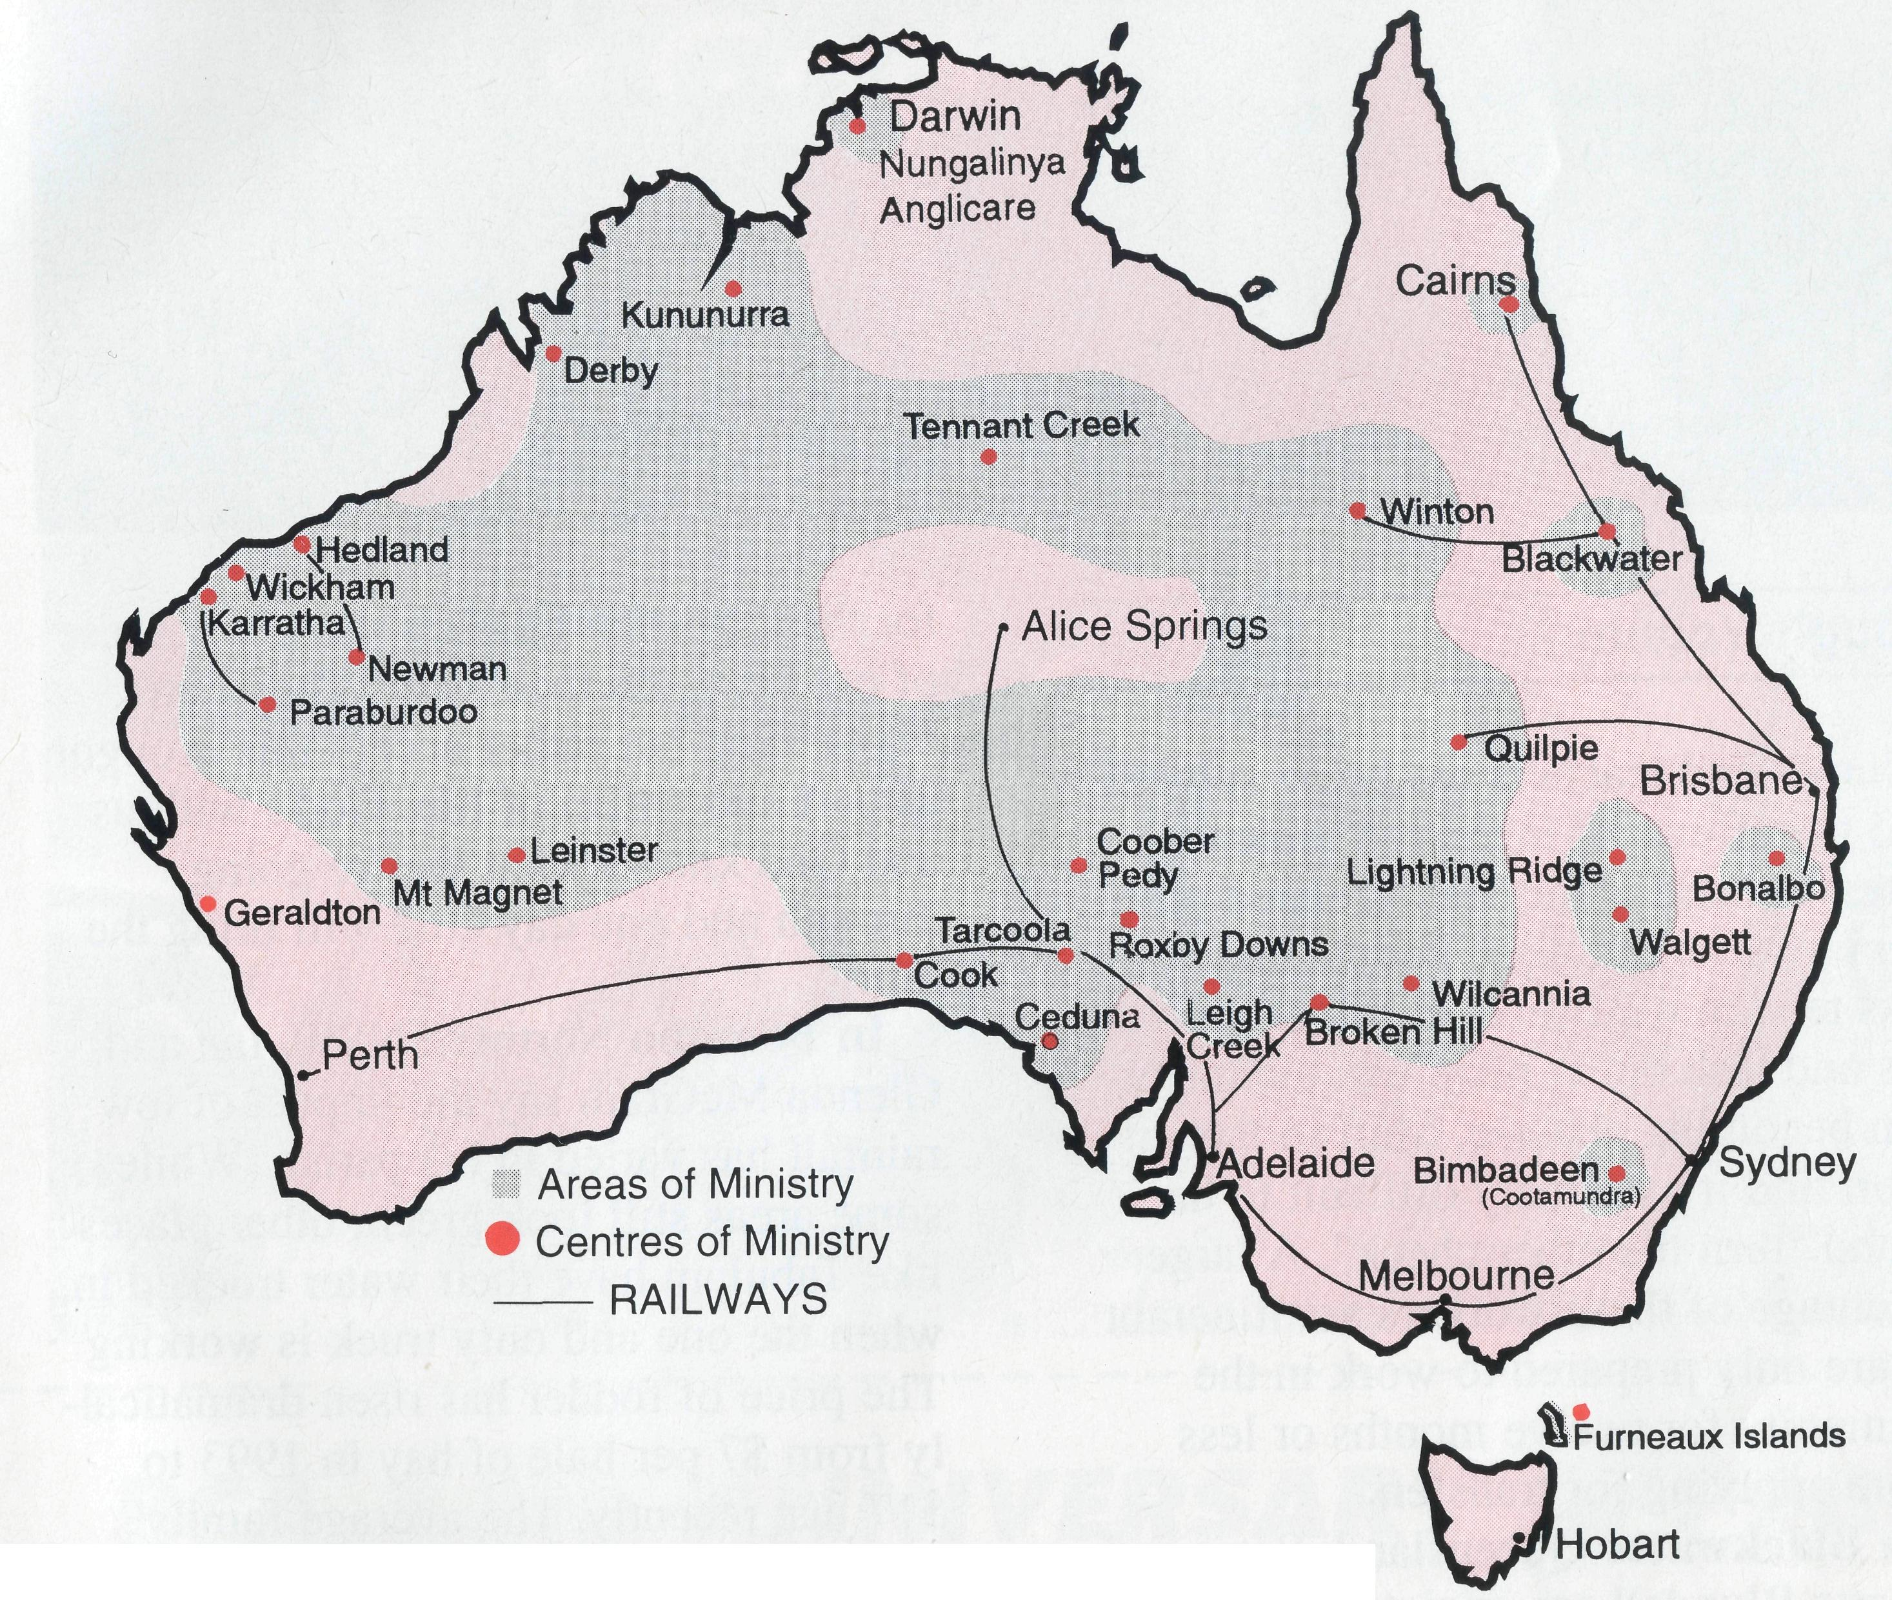
PRAY FOR OUR STAFF
• Diocese of Northern Territory — Bisbop Richard Appleby.
- Anglicare Director — Mr. Peter Fisher and Mrs. Lynne Fisher.
- Tennant Creek — Rev. Tom and Mrs. Carol Williams.
• Diocese of North West Australia — Bishop Tony Nichols.
- Kununurra — Rev. John and Mrs. Dianne Symons.
- Derby — Rev. Jon and Mrs. Rae Reinertsen.
- Newman — Rev. Raymond and Mrs. Betty Lou Molyneux.
- Hedland — Rev. Ray and Mrs. Lyn Arthur.
- Karratha — Rev. Terry and Mrs. Fiona Redmond.
- Wickham — Archdeacon Bill and Mrs. Jocelyn Ross.
- Tom Price/Paraburdoo — Rev. Brian and Mrs. Joy Harding.

- Counselling Ministry:
- Mt. Magnet (Murchison) — Rev. Philip and Mrs Margaret Bassett.
- Leinster — Rev. Les and Mrs. Jenny Gaulton.
- Diocesan Registrar — Mrs. Kay Winfield in Geraldton.
• Diocese of Willochra — Bishop David McCall.
- Coober Pedy — Rev. Bob and Mrs. Denise Rothwell.
- Roxby Downs & Mid-West Mission — Rev. John and Mrs. Leone Rutherford.
- Leigh Creek — Rev. Wayne and Mrs. Cherylene Ireland.
- Cook: Bp Kirkby Mem. Hosp. — Sr. Gai DiDonna & Sr. Chris Woon.
- Tarcoola Hospital — Sr. Gill Wright.
- Ceduna — Archdeacon George and Mrs. Judy Thomas.
• Diocese of Riverina — Bishop Bruce Clark.
- Broken Hill BCA House — Mr. Neville and Mrs. Margaret Coombs.
- Wilcannia — Rev. Don and Mrs. Helen Wilson.
• Diocese of Armidale — Bishop Peter Chiswell.
- Lightning Ridge — Rev. Mark and Mrs. Lucy Taylor.
- Walgett — Rev. Clive and Mrs. Vivienne Robinson.
• Diocese of Grafton — Bishop Bruce Schultz.
24 Bonalbo — Rev. Ian and Mrs. Glenda McGrath.
• Diocese of Brisbane — Archbishop Peter Hollingworth.
25 Quilpie — Rev. Terry and Mrs. Sherry Leonard.
• Diocese of Rockhampton — Bishop George Hearn.
- Winton — Rev. Geoff and Mrs. Gill Bransgrove.
- Blackwater — Rev. Peter and Mrs. Jeannette Blundell.
- ABORIGINAL AND TORRES STRAIT ISLANDER MINISTRY: Cairns: St. Luke's — Rev. Jim and Mrs. Lala Leftwich. Nungalinya College — Ms. Elizabeth Caldwell.
Bimbadeen College — Mr. Denis and Mrs. Maureen Atkinson. Furneaux Islands — Rev. Donald Moffat. Dio. of Tas.
29 STATE OFFICES:
Acting Hon. Secretary for W.A. — Rev. Fred Buchanan.
State Secretary for S.A. — Vacant, Mrs. Aila Alderson.
State Secretary for Vic. and Tas. — Rev. Brian Viney, Ms. Margo Bright.
State Secretary for N.S.W. — Rev. Greg Thompson, Mrs. Michele Peacock.
State Secretary for Qld. & Northern N.S.W. — Rev. Les Monaghan and Mrs. Dianne Harris.
30 BCA FEDERAL OFFICE: Rev. Brian Roberts, Mr. Jim Gosbee, Mesdames Jacqueline Griffiths,
Lay Lee Boughton and Eileen Darbin.

OUR MISSION FIELD
The BCA prayer
O Lord our God, help us to remember those who live in the remote parts of our land. We ask you to strengthen and encourage all whose ministries are supported by The Bush Church Aid Society. Refresh them in times of discouragement and loneliness and call others to stand with them in the task of making Christ known. Grant that, through the ministry of the Word and Sacraments, through medical work, through service and

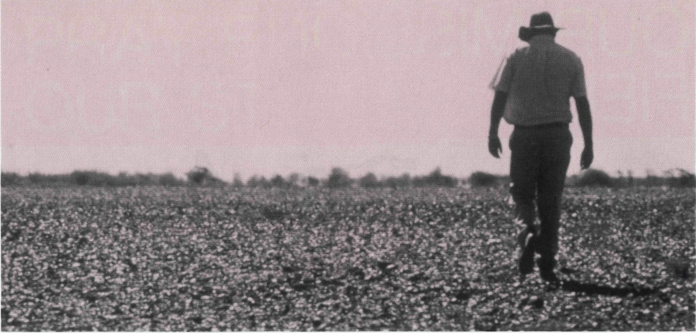
Drought (contd.)
Nurses and teachers are being subjected to the effects of increased violence, depression and other health related problems in the community. People under stress tend to over-react to minor problems and lash out at people in authority, often becoming abusive. Staff in this situation find it extremely difficult to handle and "turn the other cheek". A large percentage of these workers are itinerant and are only prepared to work in the community for twelve months or less before applying for transfers.
In Blackwater Queensland, Peter and Jeanette Blundell are ministering to grain growers and graziers in their parish. There is an atmosphere of depression coupled with a resistance by some families to ask for or receive help. Peter works closely with the drought support worker and other local churches in the distribution of food assistance. Blackwater churches will be sending Christmas gifts to farming families as the end of the year approaches.
The drought has brought the parish together in a common purpose of prayer and mutual support between the mining community in Blackwater and the rural families in the district. Peter says that
for the Christian families there is a sense of not being on their own."They don't blame God but rather accept this drought as part and parcel of life. God's with us and God knows what they're going through and one day God will bring the rain."
In Bonalbo Northern NSW, Ian and Glenda McGrath say the impact of low rainfall has varied in his parish. While some areas still look green, other places like Tabulam have their water trucked in, when the one and only truck is working. The price of fodder has risen dramatically from $7 per bale of hay in 1993 to $17 just recently. The average family income in the Upper Clarence region in 1993 was $13,500. The seasonal work provided by the rural economy is virtually gone and so there are many folk leaving on account of unemployment.
However, God is breaking through the low morale of people with his love. After doing Christianity Explained recently with Ian, a herbalist at Woodenbong gave her life to Christ and is sharing her faith with friends.
BCA continues to support Christ-centred ministry to drought areas. Your prayers and support for BCA staff are valued by the Society.
GREG THOMPSON
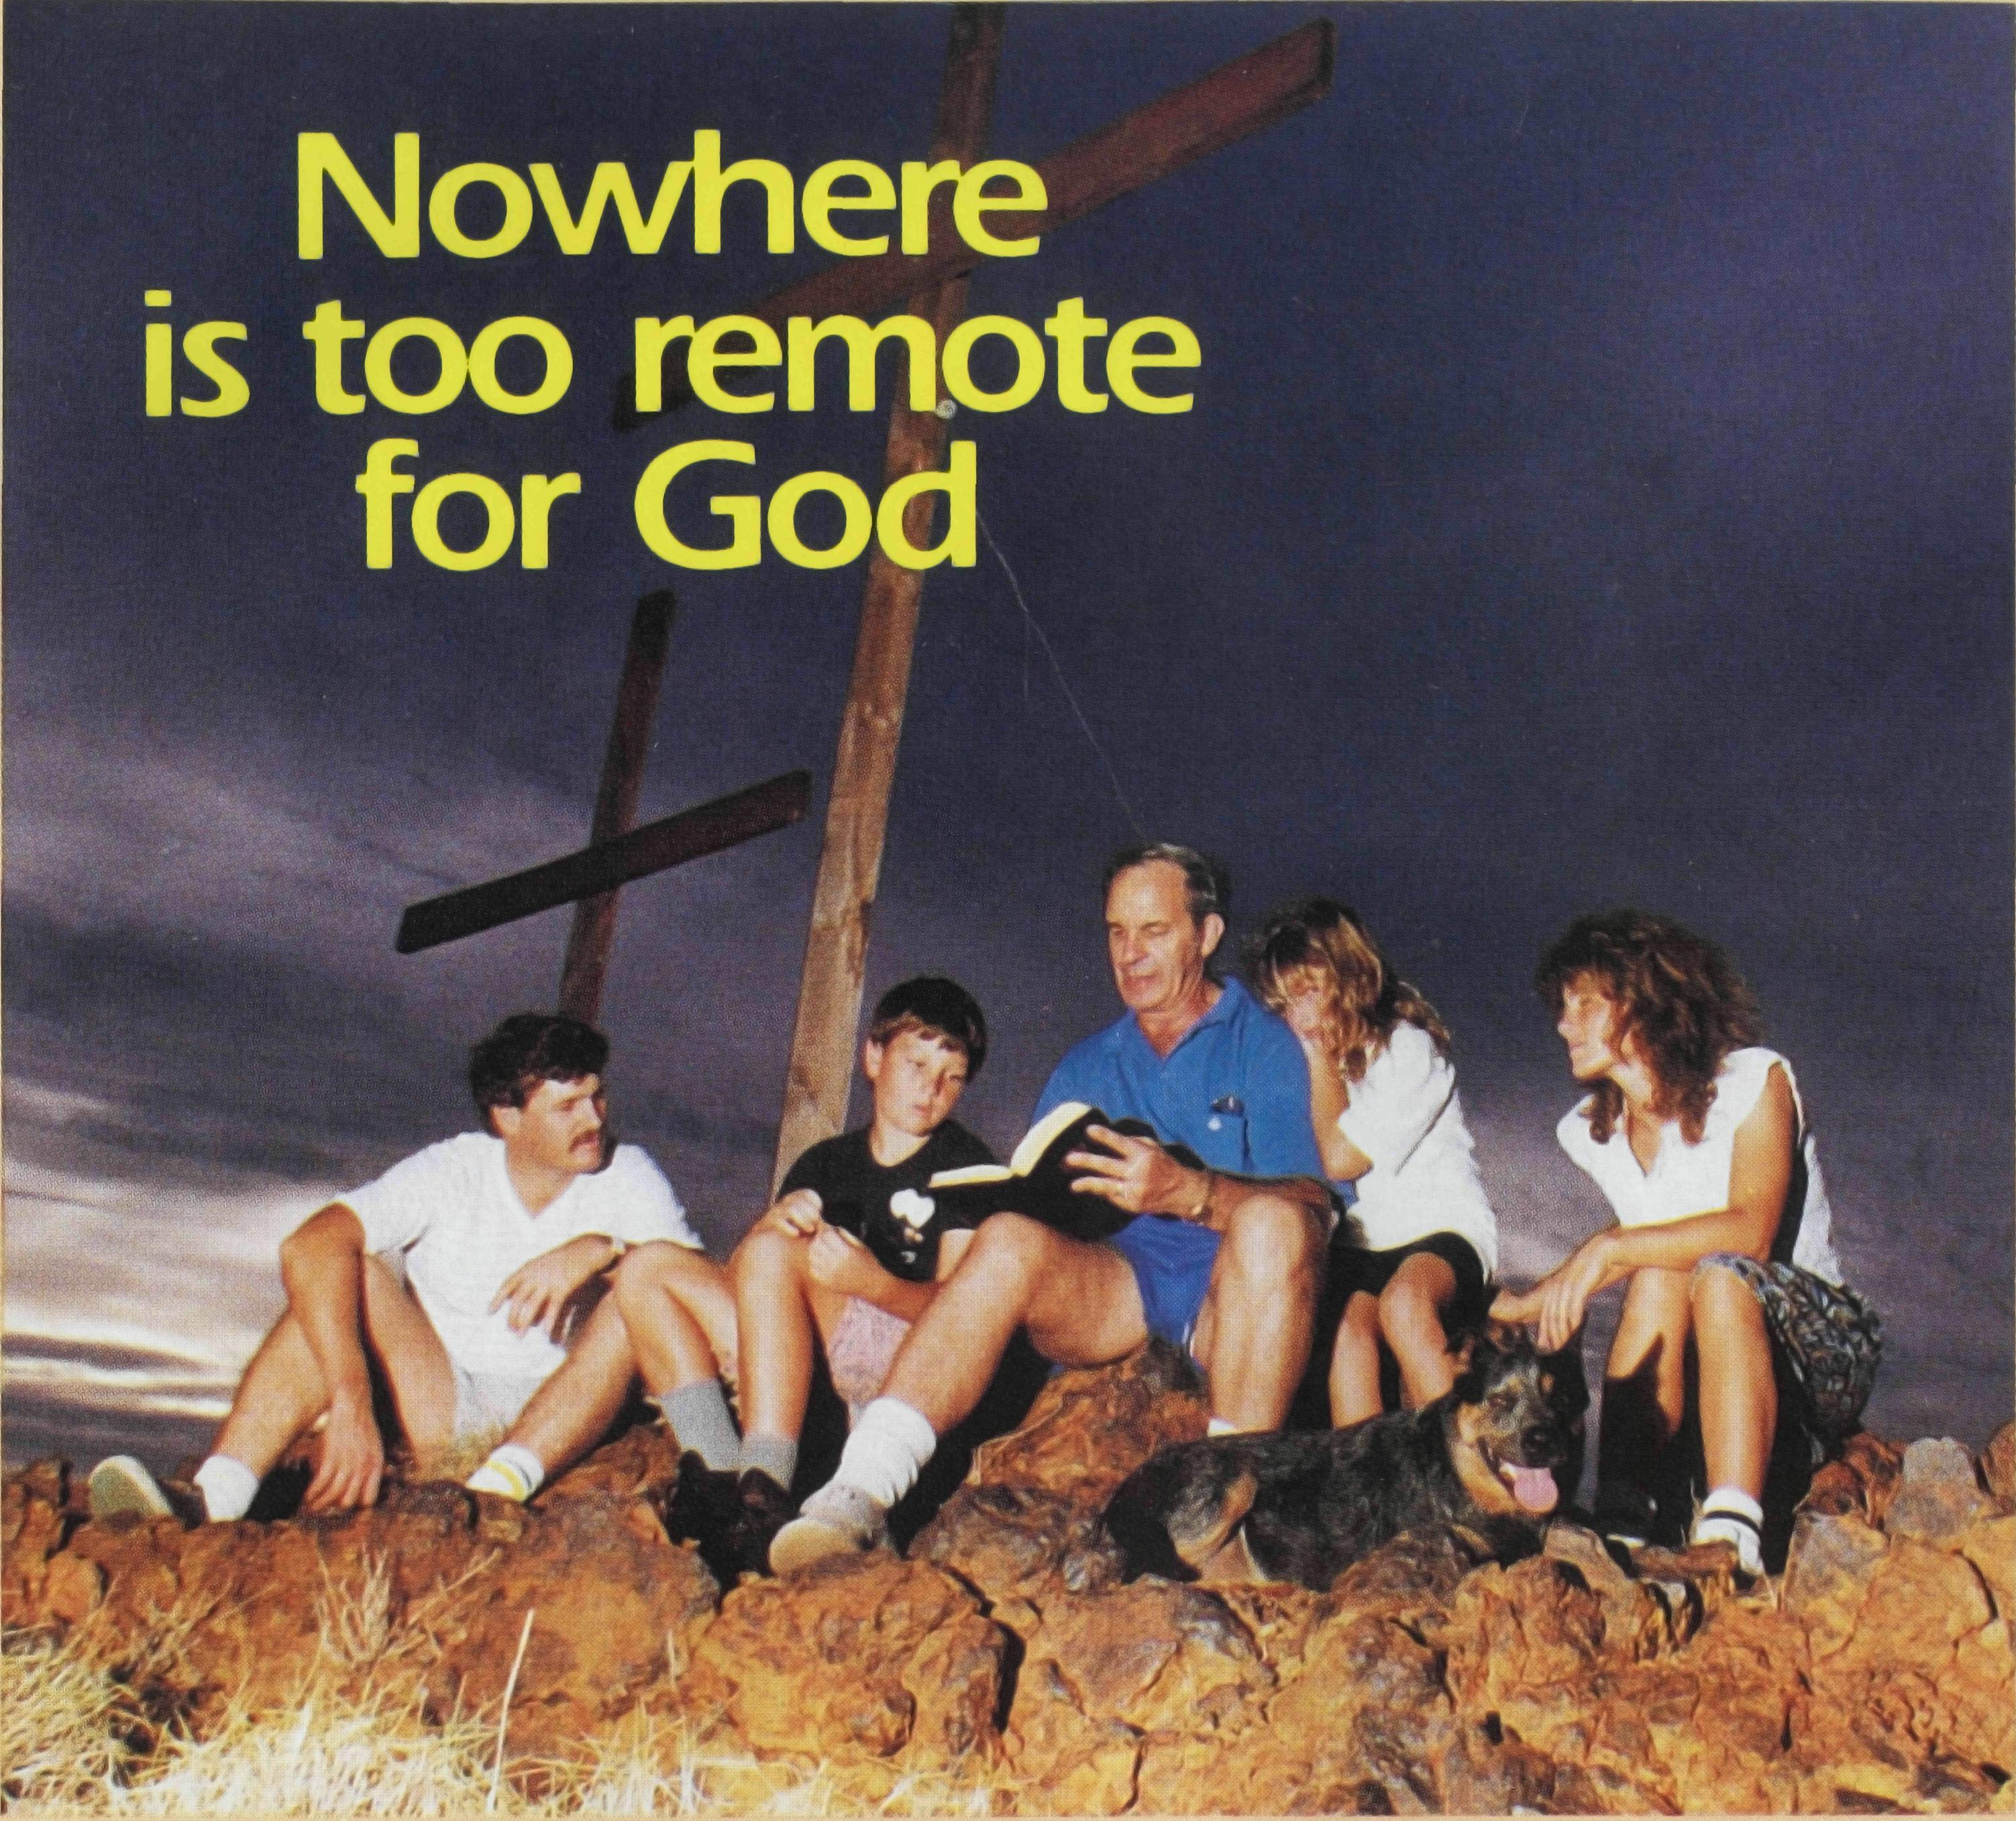
I'll celebrate BCA's 75th Anniversary by helping to continue this vital ministry to Australia's remotest families. I'll pray for the work, and enclose my gift of the amount indicated OR please charge that amount to my D Bankcard □ MasterCard □ Visa Card:
I I I I I I I I I I 1 I I I I 1 I
BCA 75th ANNIVERSARY APPEAL

1 | $25 | $50 | $75 | $100 | $250 | $500 | $
Signature Expiry d | °
 | ate
Name:_
Address^
-Postcode -
Please allocate my gift to: □ Medical & Hostel (tax deductible) □ Outback Ministry
Please complete and return with your gift to
Bush Church Aid, local office or 7th Level, 37 York Street, Sydney 2000.

