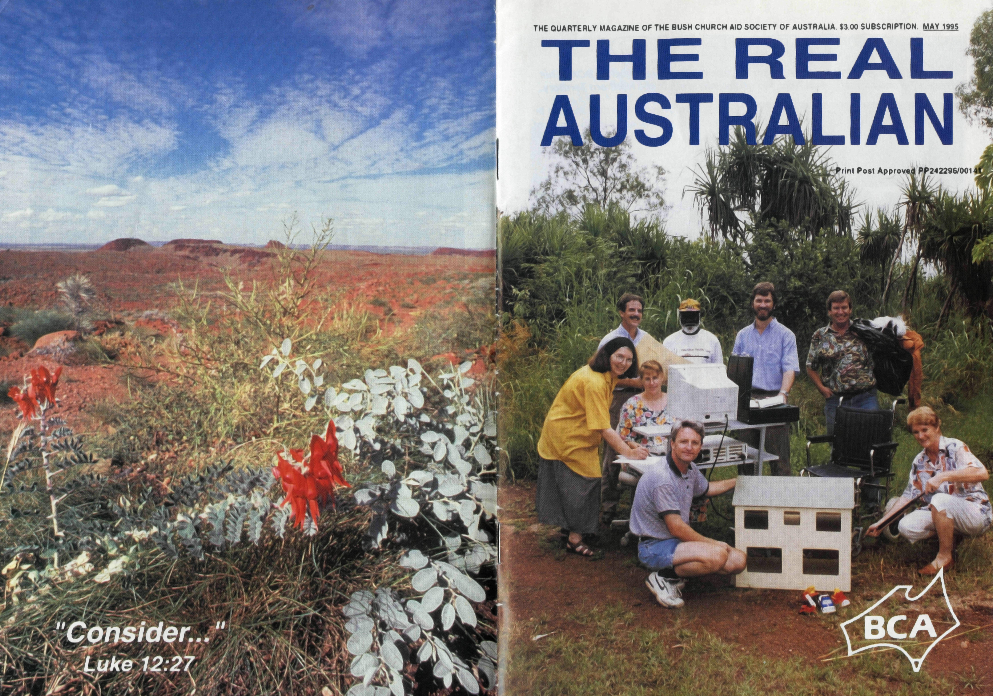

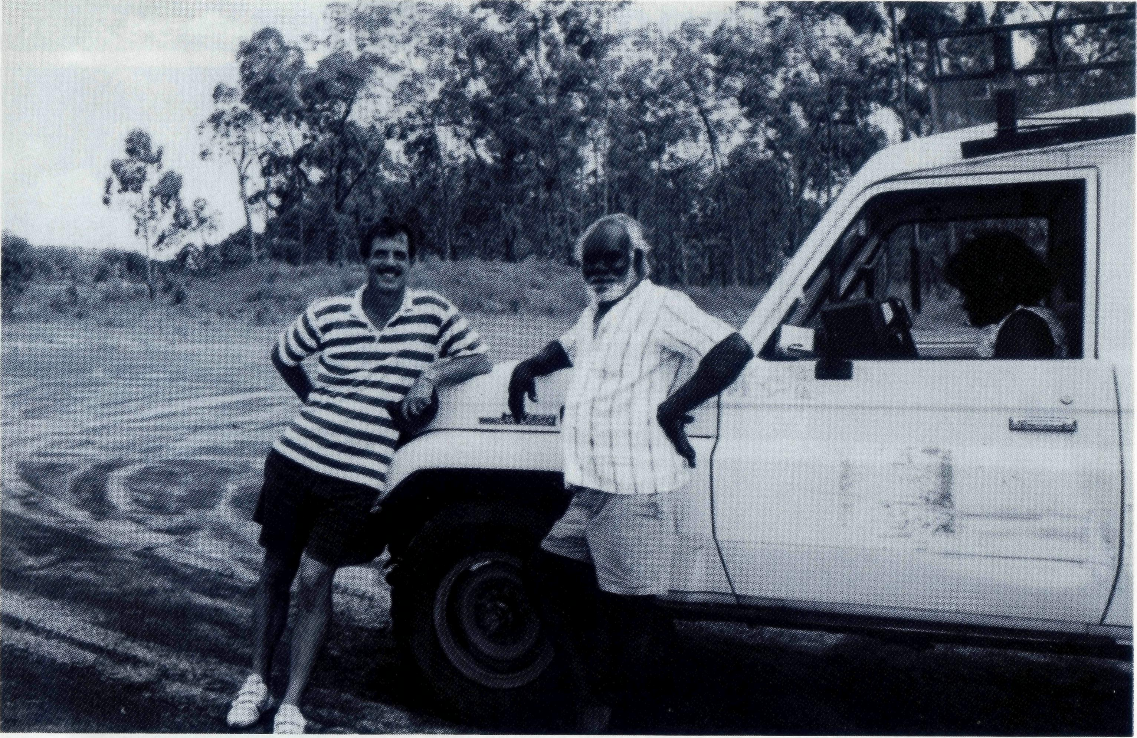
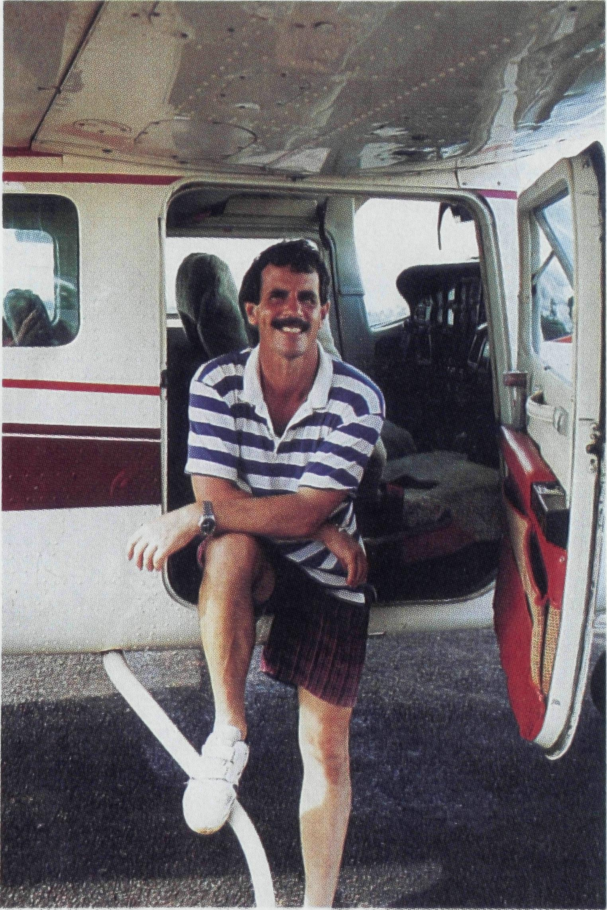
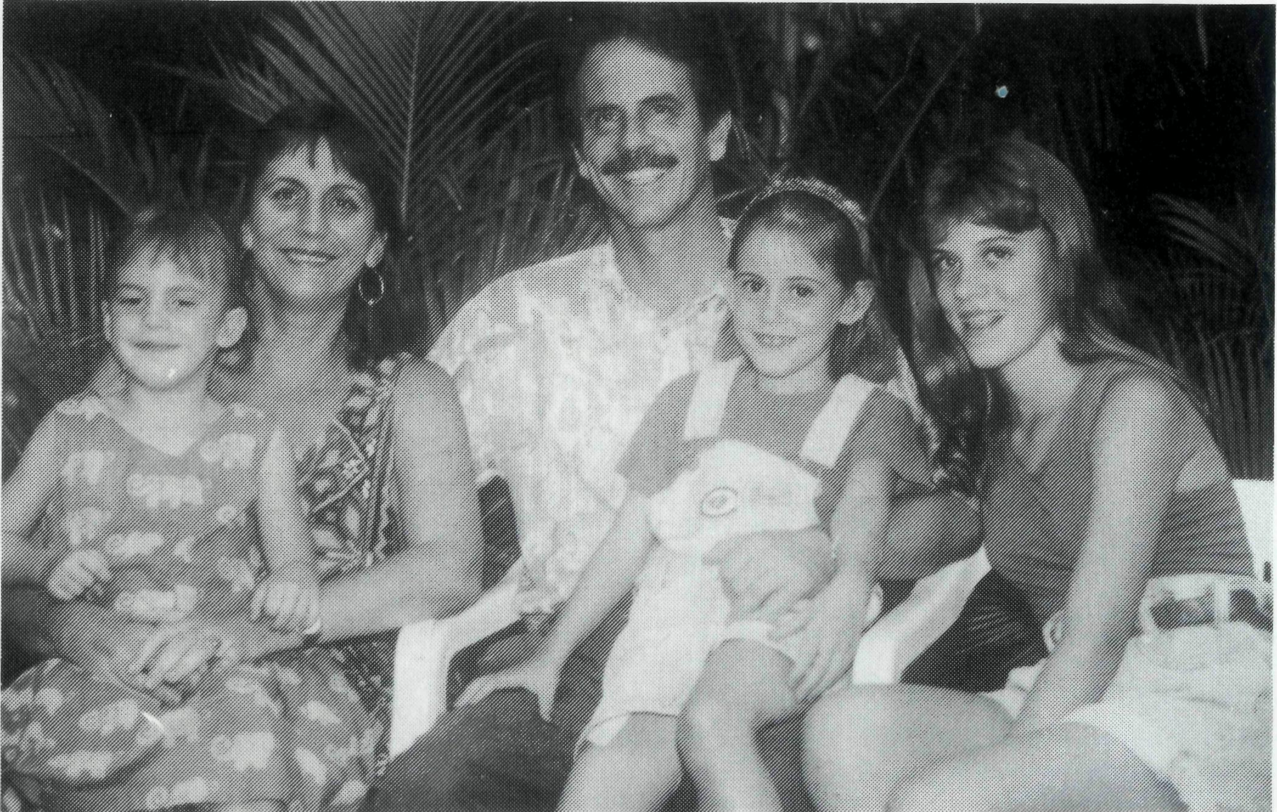
TOP END
cost clothing for disadvantaged people and to generate income for its services. Another opportunity will be the study on aboriginal aged care at Groote Eylandt which will continue the pioneering work Anglicare has been doing in remote communities.
See Day 2 Prayer Notes
THE MORNING that Peter arrived in Canberra to attend his first meeting of the National Family Services Council he felt shaken and worse for wear. He had been invited by the Hon Peter Duncan to attend as a representative for community services in remote communities. In Darwin, on the previous night, he had urgently been called by the Anglicare staff to assist in containing a violent person at Ebirra accommodation units. However Peter was himself turned upon by a man and was hit in the face. Peter said that while he was being struck, he choose not to retaliate. On reflection he believed that
Peter Fisher is the Director ofAnglicare in Darwin and is supported by BCA in his leadership and ministry of an Anglican community work in the Northern Territory.
God was with him in the crisis and that he was enabled to show an alternative way of responding to violence in front of the aboriginal women and children who were staying at Ebirra. With the arrival of a car at the scene, the violent man panicked and ran off.
MINISTRY
Those at the Family Services Council in Canberra the following morning were introduced in an unexpected way to the challenges of providing care to remote communities and the people who come to stay at Ebirra while in Darwin. Their questions of Peter about the attack enabled him to share the growing and important work of Anglicare. He informed them of Anglicare's important role in helping aboriginal and non-aboriginal people through counselling, disability services, youth housing, substance abuse programs and the Ebirra accommodation program which assists families from aboriginal communities to be accommodated in Darwin while they receive medical treatment. As the Anglicare Director, Peter has a strategic role at a national level in advising the Federal Attorney General on policy and services in remote communities and at a local level in supporting staff and applying Christian wisdom, leadership and prayer to complex and difficult social problems. Peter has the responsibility of appointing staff who provide specialist care and Christian concern through the many programs. At the weekly staff prayer meeting the concerns of the staff, the ministry demands of the week and the needs for new workers are brought before God. The power of prayer is essential to
Mr Peter Fisher and Murabuda Warramarrba who works with Anglicare on Groote Eylandt (see next page)
staff as they are often faced with threats to their own safety as well as carrying significant work loads in caring for people. The pastoral care of staff by Peter is an important ministry to staff at the front line of care.
For Peter, Anglicare is a channel for the gospel to reach people at their point of need. BCA has provided not only the financial resources for Peter's ministry but the prayer support to enable this gospel ministry to continue. His vision for Anglicare is that of a partnership in Christ between the dedicated staff and the Anglican parishes in the Top End.
New challenges this year for Anglicare will be the development of an opportunity shop to provide low

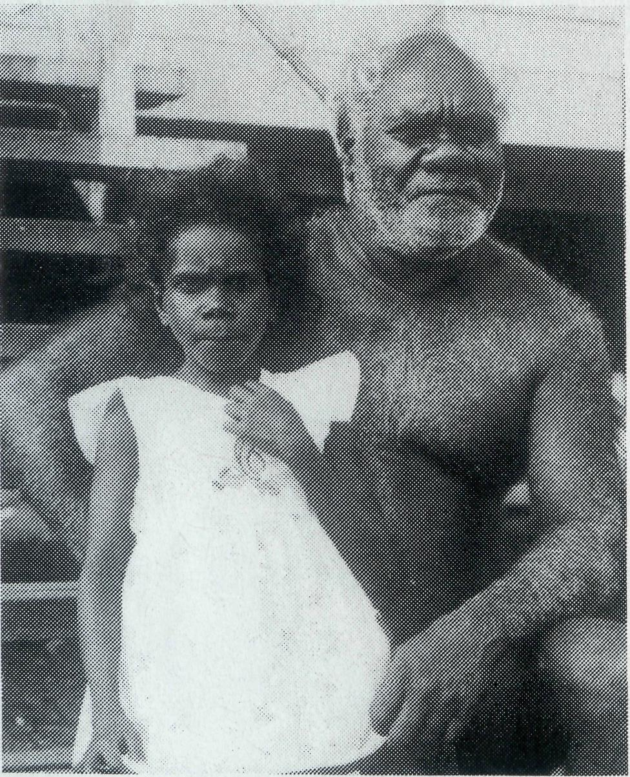
Bryan and Cathy Massey,
former CMS workers,
have been working with
Anglicare for 5 years
at Angurugu on
Groote Eylandt
(Gulf of Carpentaria).
They help the aboriginal
community address the
growing problems of
alcoholism, petrol sniffing
and crime on the island.
Brian writes of his work
and the opportunity to
minister God's love
through Anglicare.
identified. We expect this program will start in a small way and expand.
These programs undertaken by the Aboriginal people who live and work here at Angurugu help to foster self esteem and generate a feeling of hope in our community where we have experienced, in the not so distant past, a real feeling of hopelessness.
We thank our Heavenly Father for His enabling in these tasks He has given us and look expectantly forward to what He has ahead for us.
Marabuda and girl
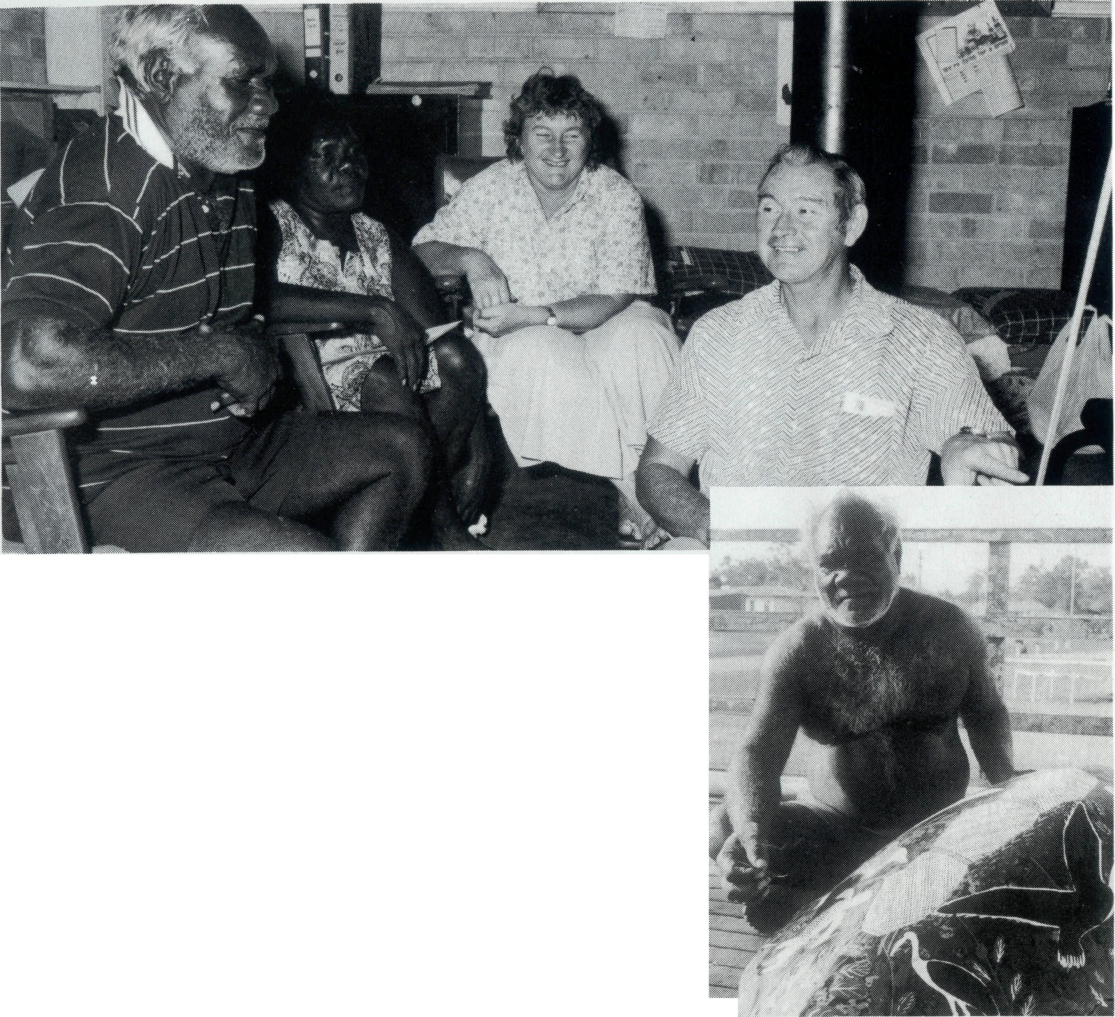
Sick and Tired Ones
We have been living on Groote Eylandt for almost 25 years since coming here with CMS. Our work with Anglicare started when we were asked to join a team headed by Murabuda Warramarrba. This team was subsequently named Anglicare CAAPS Team. We learned about alcohol and its effects on people and families and some ways we could combat the problems associated with this. Through this training over the past 8 years we have identified other areas where help is urgently needed and Anglicare is able to offer help and support. We have an Aboriginal operated Respite Care Program where the 'sick and tired ones', as Murabuda calls them, can be helped by offering respite, as well as training, to the carers and cared for alike. A feeding program for the needy will start soon in association with Anglicare here on Groote. A number of needy people have already been

The R.eai Australian
The Real Australian is a registered trade mark of the Bush Church Aid Society. First published 1920. Edition No. 288. Circulation: 28,000
All enquiries to:
Greg Thompson
The Editor
The Bush Church Aid
Society of Australia
Level 7, 37 York Street
Sydney 2000
Ph (02) 262 5017 Fax (02) 262 5020
/3.C.A. uirectory
Patron: Archbishop Keith Rayner President: Archbishop Harry Goodhew Chairman: The Rev. Dr. Vic Roberts
Vice-Presidents: Mr. Ray Ctercteko, Mr. Stan Hummerston, O.A.M.
Hon. Treasurer: Mr. Kevin Alexander
Federal Secretary: Rev. Brian Roberts
N.S.W. Secretary: Rev. Greg Thompson, Level 7, 37 York Street, Sydney, N.S.W. 2000. Ph (02) 262 5017.
Victorian Secretary: Rev. Brian Viney, PO Box 343, East Melbourne 3002. Ph (03) 654 8022.
South Australian Office: Church Office, 44 Currie Street, Adelaide, S.A. 5000. Ph (08) 212 7804.
Queensland Secretary:
Rev Les Monaghan, PO Box 6565,
Upper Mt. Gravatt, Qld. 4122.
Ph (07) 349 9081. Fax (07) 849 7927
Western Australia Contact:
Rev. Fred Buchanan (Acting Secretary), GPO Box N1024, Perth 6001.
FRONT COVER PHOTO:
Mr Peter Fisher and some of the
Anglicare staff.
Thanks for your Help
Dear Friends,
Just a quick note to let you know just how much your kind gifts at Christmas were fully appreciated by the property folk in our shire. The monies received were put together by a core group in the shire of which our parish was a part, and gifts were sent to every property child (over 420) and all the families received a voucher to use at the local stores. The property folk were overwhelmed by the generosity of their southern friends and so on behalf of all of them I would like to say a very sincere thank you. So many children had a truly wonderful Christmas which would have otherwise been a very lean one. Once again thanks, you have instilled in the hearts of these people the meaning of true Christian giving.
You may like to know that we have had about 6 inches of rain since January (that varies greatly from area to area and in our shire we remain drought declared) and that we appreciate your continuing prayer for rain.
Yours in His Service,
Jeannette Blundell
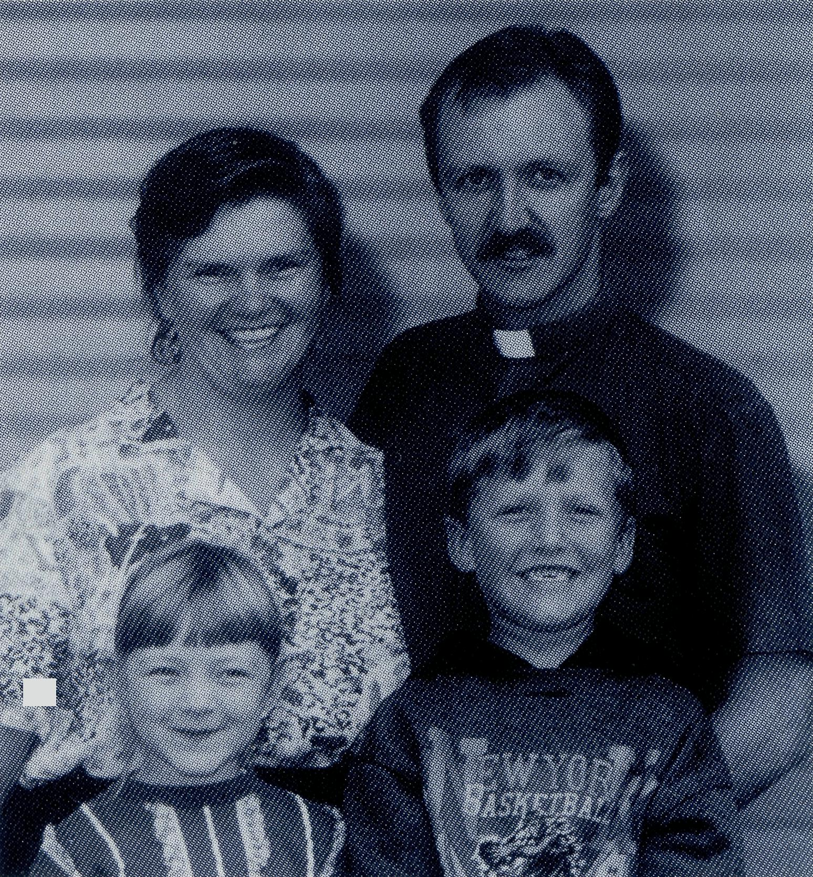
m
Parish of Blackwater

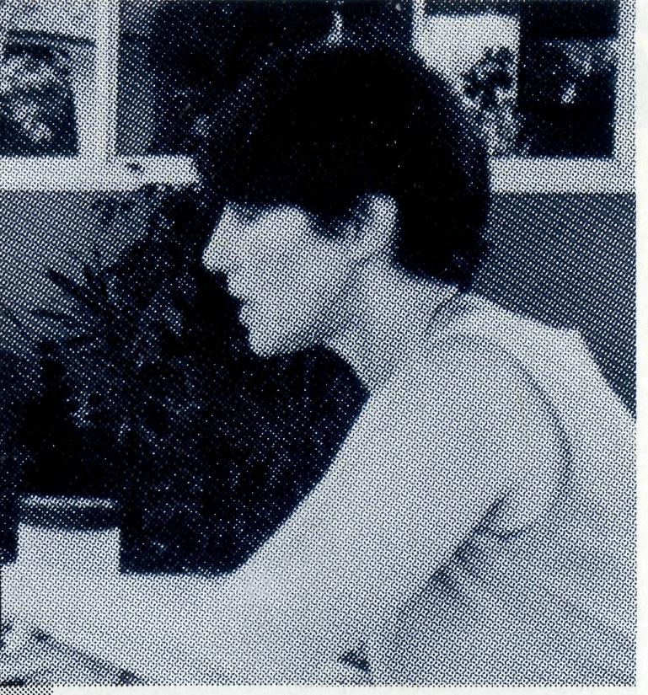
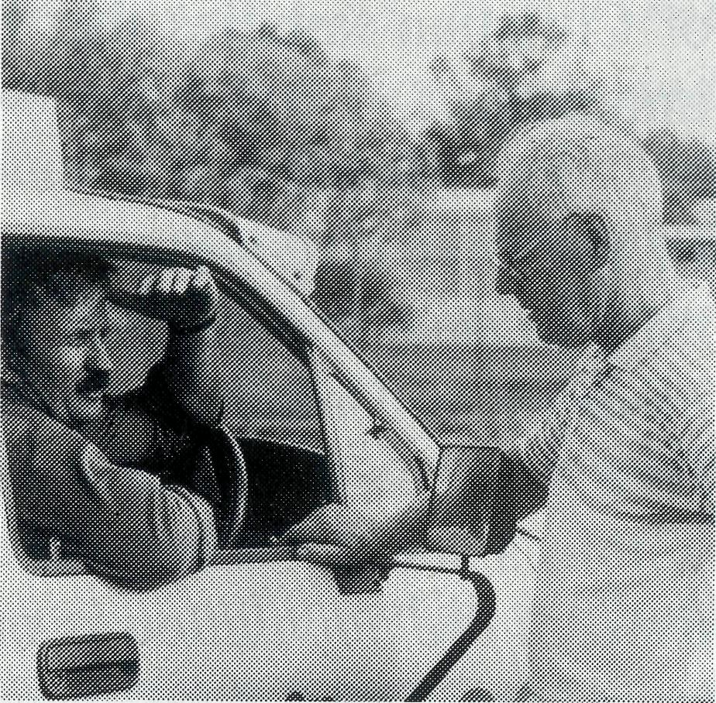
From Fear to Confidence
Elizabeth Caldwell from Darwin shared recently of her work at Nungalinya College
bit of probing I discovered that he was a musician, poet, lyri-
set up mining town has commented that the parents set the tone of complaint and very soon the children take it up so that, despite good amenities, nothing is ever right
about the town. Ray Molyneux
However there is evidence that this mentality is changing in places like Karratha-Dampier where people are taking a longer term view and even talking of settling there.
Despite the high wages families also live under the constant threat of retrenchment. Ray Molyneux at Newman has become used to the idea of losing a substantial proportion of his parishioners each year. Throughout the North West we have become used to a steady loss of population. People are being converted. Indeed we want the Gospel to come by grace but Christians are often not around long enough for their pockets to be converted too so that the church can become financially independent.
Even when earning a high wage people find that they are not free from problems. Boredom, isolation and lack of meaning to life or absence of family support often mean money will be blown in drinking, gambling, child support payments and extravagant life-style.
The cost of living is high. A grant of $60,000 from Sydney is sufficient only to place and support a clergy family in
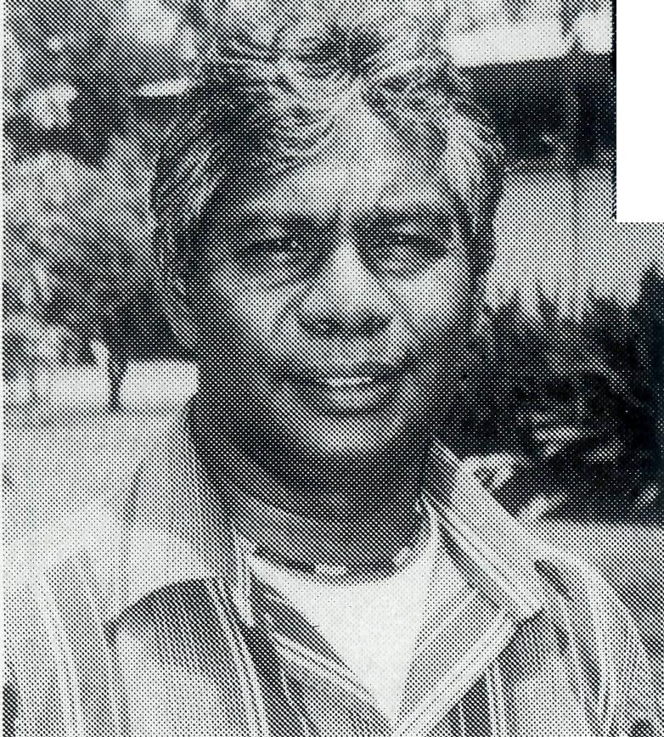
I teach basic literacy to adult learners who are indigenous Australians from anywhere in Australia and who come with many different backgrounds and wide range of life experiences. One of my assignments early in the year is to run a week-long module for students who are undertaking Nungalinya courses in Textile Arts on how to construct a resume that they could send to future employers. Each member of the class works on a computer disk, and each one learns enough about Macintosh computers to complete their own resume and print a copy and to keep their resume up to date.
The age range of the participants is usually from early 20's to late 50's. Most of the students are Aboriginal people with urban life experience, some are traditional, or tribal people. Some of them have done other courses, and some have work experience. Very few have paper qualifications. Looking back over the years of formal education can be depressing for some - and it can bring back some awful memories.
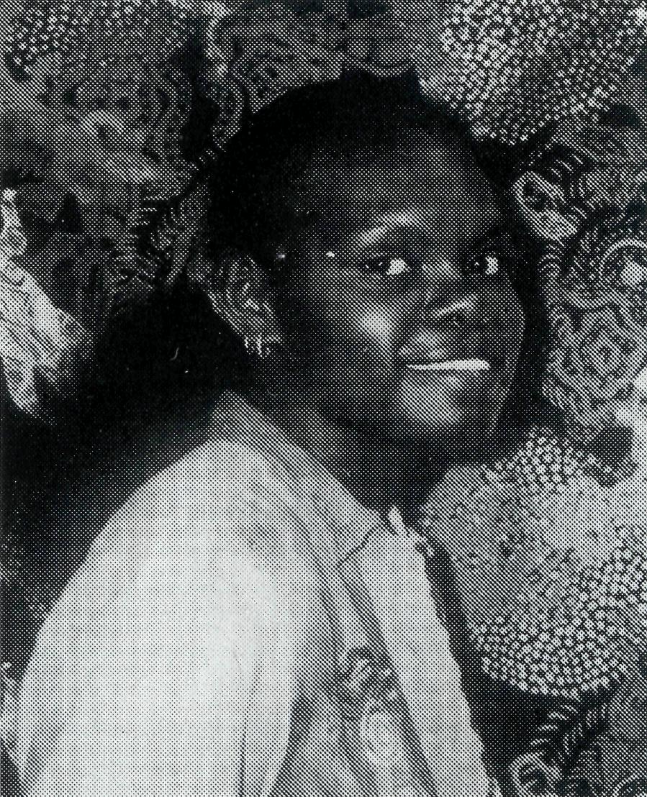
I decided that by producing their own resumes, students would have a learning experience that
affirmed them and revealed the richness of knowledge, skills and attitudes they had gained through their own experience of life. I discovered that most of the tribal people can have knowledge of up to 5 or 6 languages, and perhaps speak two or three languages well. Many are surprised and delighted to discover that they can add to their resume the things about themselves that they like most, or pastimes that they enjoy. One young man who had not even completed primary school, could not think of anything good about his school experience and had never had a job, was not convinced that writing a resume would be of any benefit to him. After a
cist, had done a lot of sketches and had a deep appreciation of nature. When he finally completed the first draft of his resume he recog-New Nungalinya nised it as a tool Principal: Rev Waily Fejo _{w}hich he was totally in charge of, for showing a potential employer what kind of person he is. After completing the module on writing resumes some members of the group apply themselves to the rest of their course in textile arts with greater focus and enthusiasm. I get to know some very interesting people during this module and I am pleased to help them explore themselves and their own lives in a new way. I look forward to seeing them at the end of their course, when they come with their disks to update their resumes.
Many of our students come with the impression that any return to formal education would mean taking up where they left off as children. They remember the failures and their sense of power-lessness. Contemplating a return to literacy and numeracy classes particularly can drain away self esteem. That's why these people were not doing a literacy course, they were doing a course in Textile Arts.
Those who make the effort to return to education need to be recognised as mature adults, with a wealth of experience, who have successfully negotiated the path to adulthood, now in the process of meeting new challenges that circumstances denied them earlier in life. I don't see these people very often, but whenever I do, they all greet me very, very warmly. I am grateful to know that I did something for them on the path to greater self esteem.
See Prayer Notes Day 1
Home and Away Part II
At the Gilbulla Conference last year Mrs Judith Nichols, wife of Bishop Tony
in the North West Diocese, shared on the nature and challenge of ministering
to families. Below is the second part of her talk reflecting on the pressures
on families to change.
I
N 1969 during the telecast of the landing of the first man on the Moon one of our elderly parishioners in the church where my husband was serving at that time burst into uncontrollable weeping. Her daughter reported to us that her mother had grown up with the horse and buggy, seen the advent of the motor-car, electricity and the telephone, but this venture into space had finally been too much for her. Change is always present in the seasons, in birth and growth. But it confuses and unsettles us when we are being subjected to it in so many areas. How then is the family being put under pressure to change?
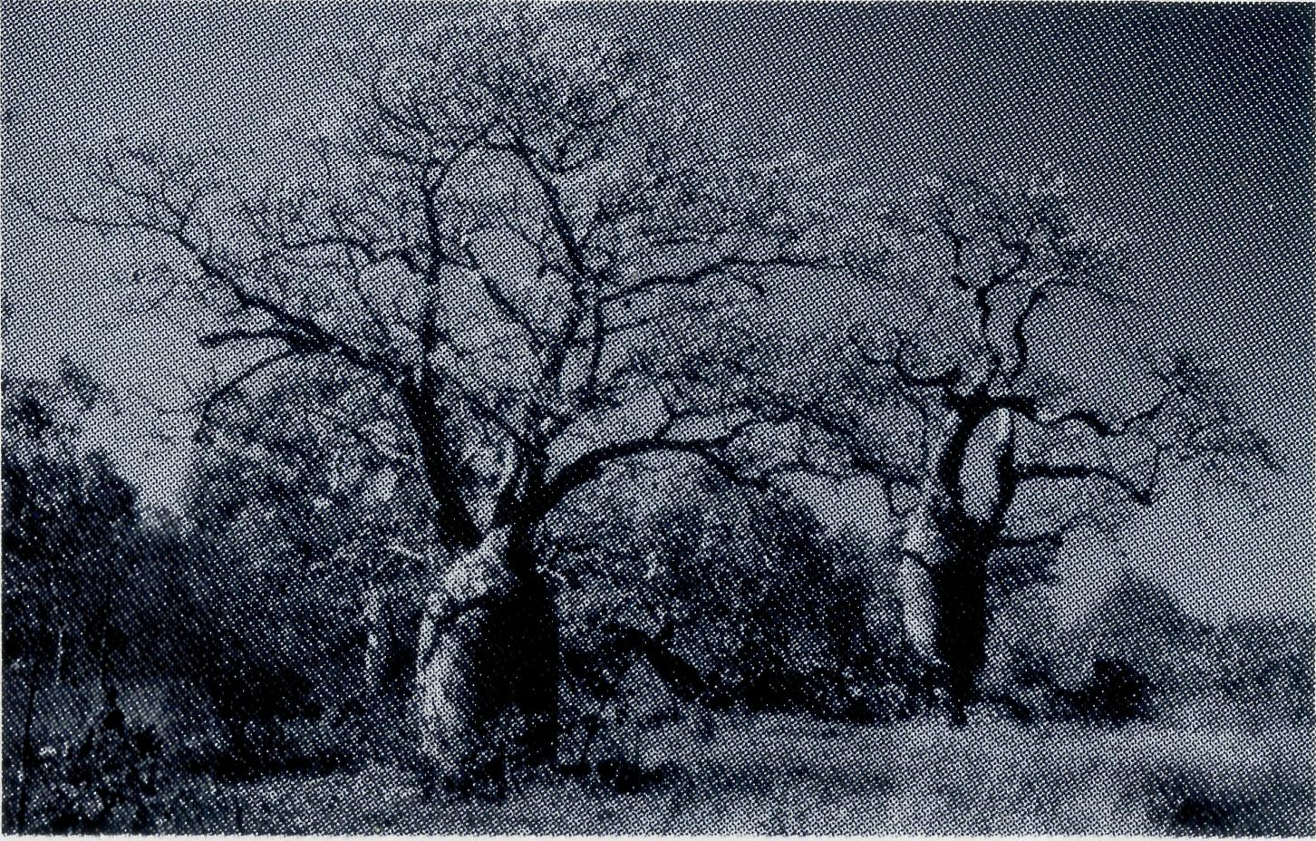
Baobab Trees
Materialism In the North West, economics have a profound effect on communities. Perhaps the majority of people come to make money, either to pay off a mortgage or for a world trip. After they have made their pile the intention is always to head back for the comfort zones in the south. This militates against any sense of community because it fosters a plunder mentality - "we'll make what we can in this godforsaken place and clear out". It can also lead to a culture of complaint. One clergy wife in a very well

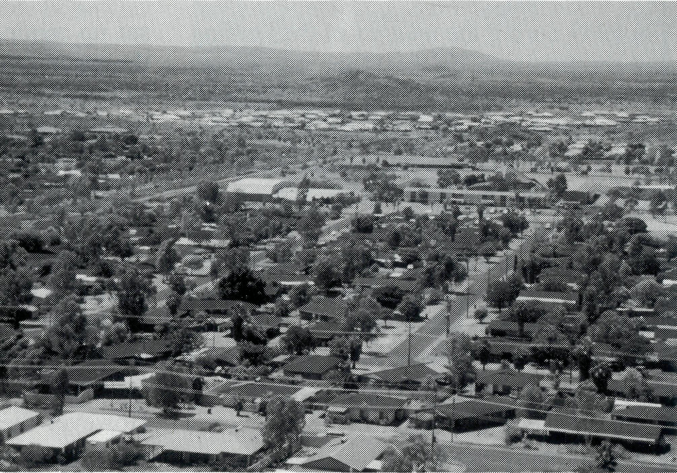
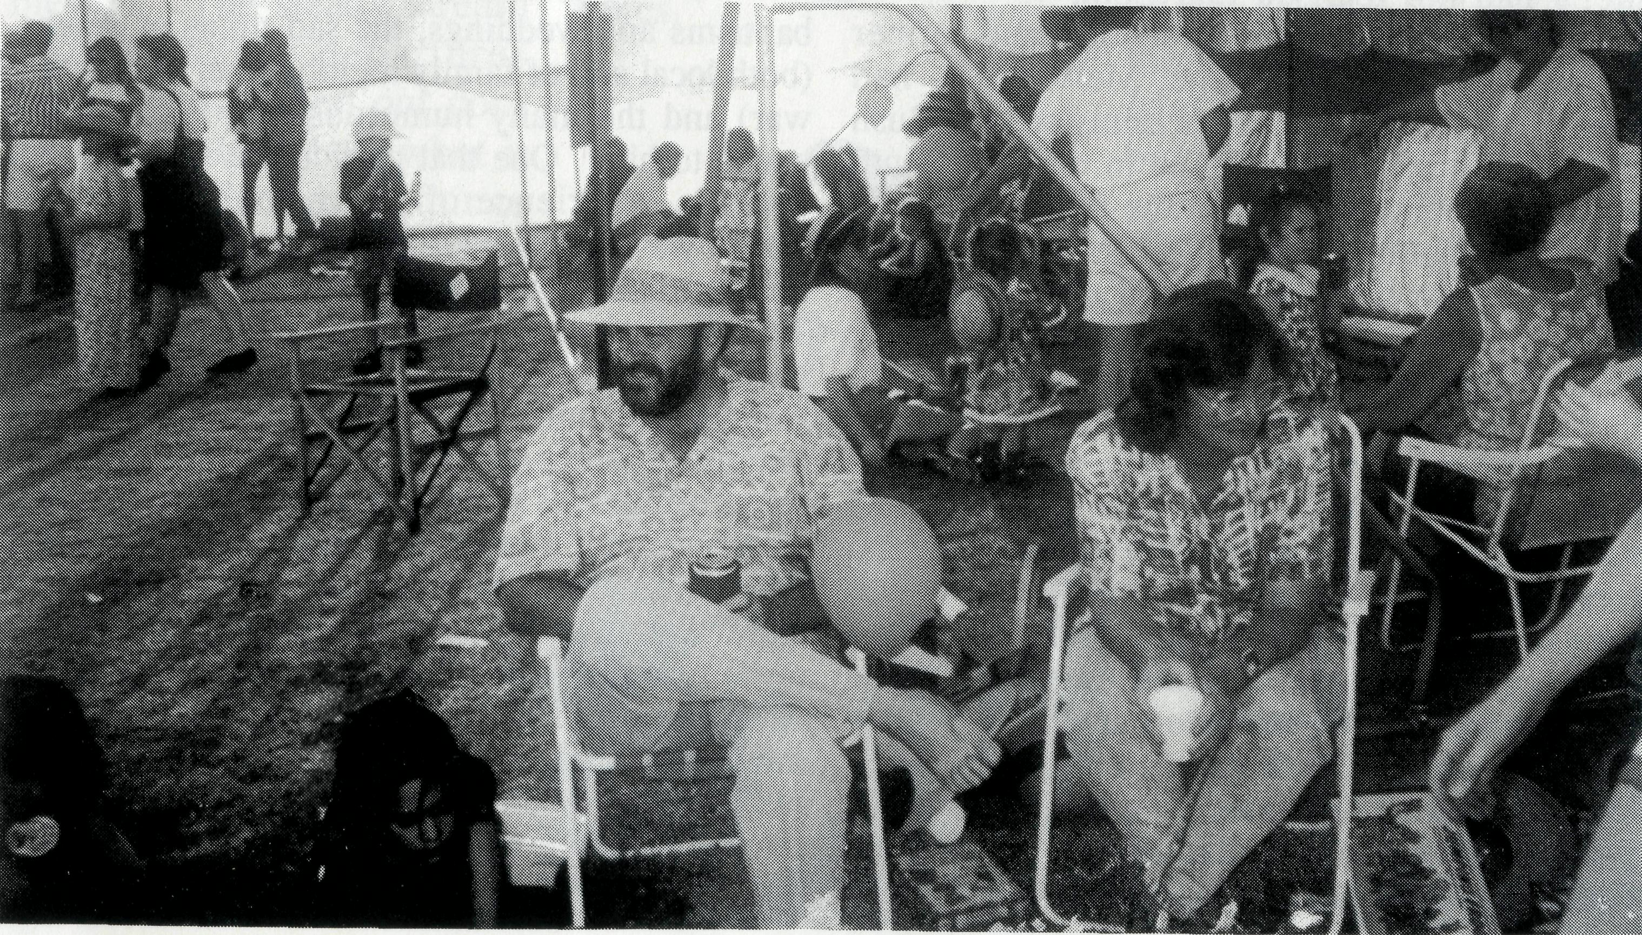
Exmouth for one year. Money is seen as the solution to the problems of the human heart and it is very difficult for the church to shake free from this mentality. Money is needed to put people in place for ministry but it is what follows in the teaching of God's word and the establishment of Christian families that is important.
Mobility In the last five years one million people in Australia have moved interstate and five million have moved within a state. More than a third of the population is on the move. We are all aware of the flight from the rural communities because of the drought and the fluctuation I in commodity prices. Every farm job lost results in 2-3 jobs lost in the wider community.
Life on farms and stations is becoming hard. Whereas large properties once supported whole communities of cooks, mechanics and stockmen, they have been reduced to highly mechanised operations maintained by one family. Thus the wife can be book-keeper, teacher and part-time stockman. Some families cannot afford to come to town. This is where the support of clergy with fuel allowances for travel is so important.
In Sandstone, in the Murchison, some families who would like to leave are trapped. They can't sell businesses or assets. Most clergy in the North West spend a large amount of time travelling to reach places of ministry.
Thus we have a picture of people moving who would like to stay and people stuck who would like to move. Tourism represents a special kind of mobility. The population of the delightful
scenic fishing village of Kalbarri escalates from 1500 to 15,000 in the tourist season. Tiny Shark Bay sees a quarter of a million tourists a year coming to see the dolphins. Broome with its ambience of unrestrained hedonism has a steady influx of young
Wickham, WA people looking for work and a good time. People bent on having a good time are in need of the Gospel. Who is going to minister to the steady stream of caravans going up the coast in May and down again in October? Even grandparents do their own thing nowadays and are not always around to be called upon. Innovative ministries are clearly called for, such as Christian retirees who are prepared to travel up and down the highways ministering to people in the caravan parks.
Mobility of person also leads to mobility in relationships. When things get hard in a relationship it is so easy to move on and there are no community structures because there is no sense of community. But mobility also means that families can lack once assumed support structures in grandparents, friends, uncles and aunts. One of our clergy wives welcomed a friend visiting by saying, "It's wonderful to see someone who has known me for more than a year."
The Culture of Change
There is nothing new about coping with change. Down through the ages people have experienced traumatic dislocation and the destruction of their certainties. Who can forget the faces of the displaced persons of the 40's and 50's with haunted expressions and fear-ridden pasts. Doctors, musicians, teachers and intellectuals working on road gangs or making up the great labour force of the Snowy Mountains scheme.
Jeremiah speaks of the anguish of God's people taken into exile. For them it was part of a purifying process. In our modern society, however, we see change for change's sake. No longer a culture changing but the development of a culture of change which promotes the idea of change as being intrinsically good. We must confront the culture of change with the things of eternity.
What is our response?
Change can be very difficult to accept
What, as Christians ought we to do?
Accept? Adapt? Opt out?
Change like everything else must be subjected to the scrutiny of God's Word. Hang on to these words of Paul when the world is seeking to shape your family and when society is bombarding you with its message of change for change's sake:
"I appeal to you therefore, brothers and sisters by the mercies of God, to present your bodies as a living sacrifice, holy and acceptable to God, which is your spiritual worship. Do not be conformed to the world but be transformed by the renewing of your minds, so that you may discern what is the will of God - what is good and acceptable and perfect." (Romans 12:1-2)
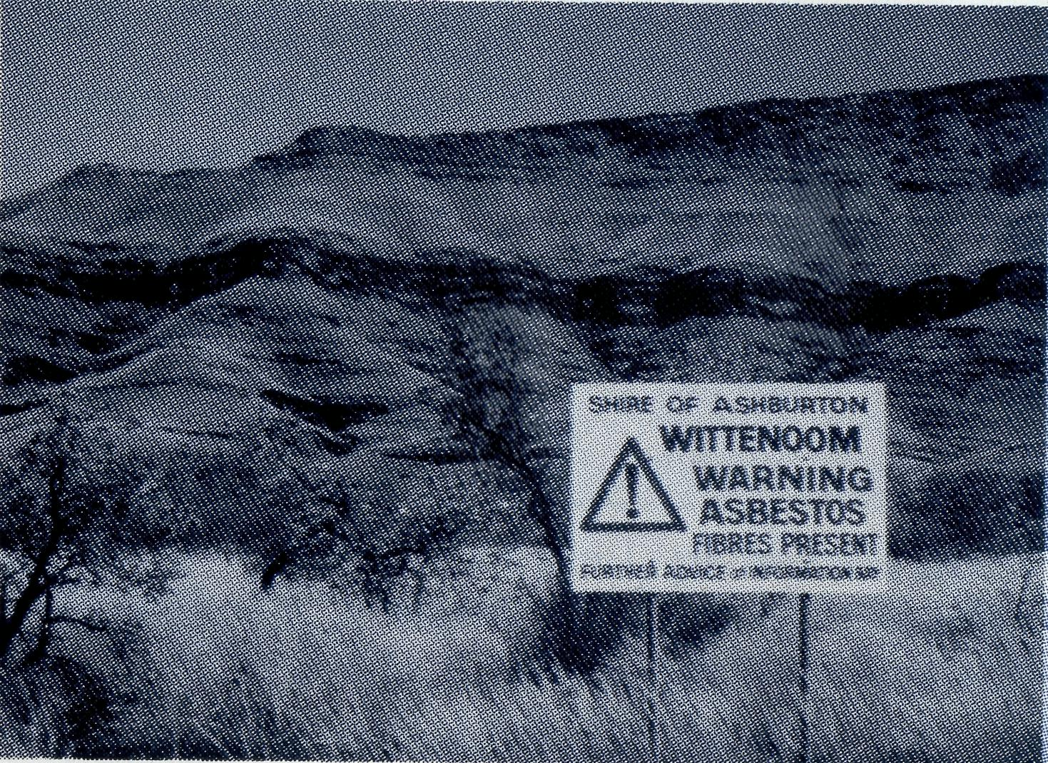
Judith Nichols

Post & Rails
Book Launch
Dr Leon Morris' autobiography "Bush Parson" was launched in Sydney, Melbourne and Adelaide in February with many BCA supporters and friends attending. At the Sydney launch Bishop Donald Robinson said, "The book provides an important reminder of the early days of the Society's work and pays tribute to the people of South Australia where Leon ministered". Life as a 'Bush Parson* in the Minnipa Mission of South Australia had it humorous moments.
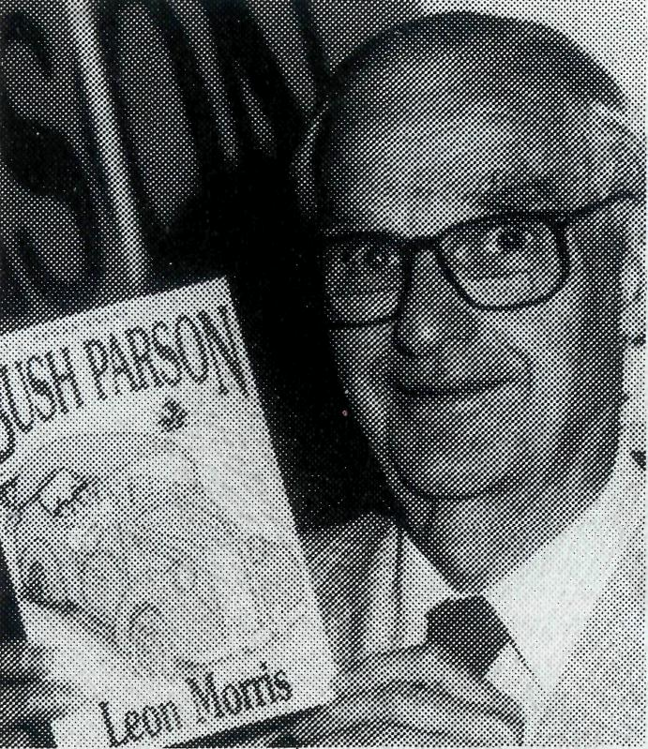
The book records the troubles experienced with his old De Soto car and how that a group of Irish supporters agreed to replace the vehicle on two conditions. The new van was to be painted green and it was to be called "St Patrick's Van". As there were no reservations about either

Bush Parson by Leon Morris is available through your local BCA office.
What a surprise this book was to me! I had not realised that Leon Morris - academic biblical scholar and former Principal of Ridley College, Melbourne - had spent five years early fh his ministry as a Bush Church Aid priest at Minnipa in outback South Australia in the war years of the 1940's. This slim volume originated from Dr Morris going through his accumulation of material and coming across several copies of circular letters he sent during this time. He writes that even though the vast majority of his almost 60 years as a clergyman has been spent in tertiary educational circles "always at the back of my mind I have treasured up the memory of my one pastoral charge, that of being the minister to a congregation scattered over thousands of square miles in a remote part of South Australia". Now in his retirement he has given us a little gem of his experiences. Bush Parson reveals the hardships of both priest and people during those years of privations - isolation, rationing (especially of petrol), heat, drought, long distances to

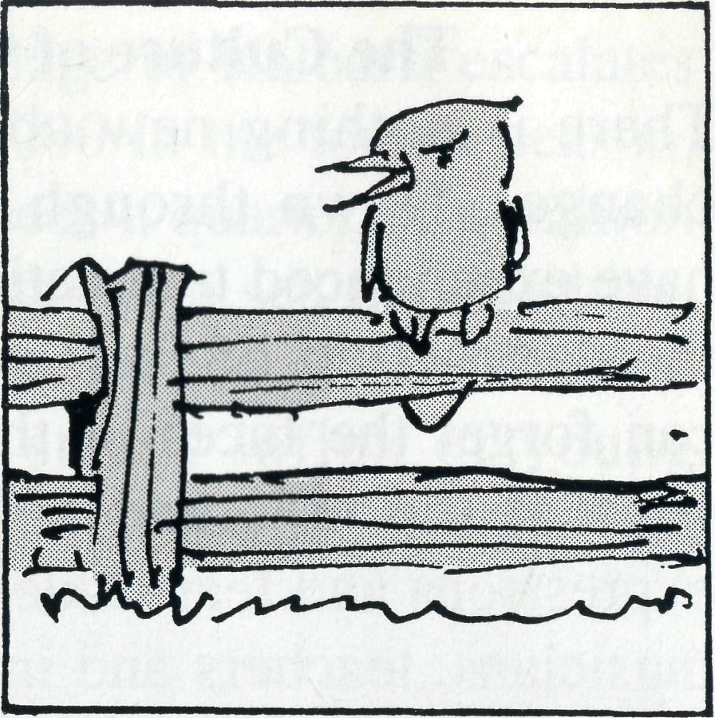
condition, the parson soon had a more serviceable vehicle, even if it did have an Irish saint's name!
Dr Morris said "My challenge to mission came during a missionary address at the Katoomba Christian Convention. Years later I found a copy of that sermon - it was a shocker; but God used the speaker and his message. This book is my tribute to the big-hearted people I met in the outback. I want to acknowledge my debt to so many battlers in their very difficult situations. With them I want to link those in our cities who are interested enough to support with their prayers and their gifts those who go out to minister to their outback cousins. I am indebted to them both".
In launching the 'Bush Parson' Bishop Robinson described it as a "Wonderful book about a wonderful work and a wonderful life".

travel, breakdowns etc, etc. Yet those were good years for Leon Morris as he shares with his readers the small community camaraderie, the happy events such as baptisms and weddings, the sad times of deaths (both local and of family members serving in the war) and the many humorous events that happened to him. One that particularly amused me was his experience of being anchored to the floor by a toddler who sat on his legs while he was in a kneeling position during a service. This book gives and excellent picture for the privations faced by BCA missionaries in these frontier situations of our country. Even today it requires courage, perseverance and especially a sense of humour to be involved in what I regard as an essential part of our church's ministry. Dr Morris is to be commended for not letting these experiences to him and his wife Mildred - a triple certificate nursing sister who was a wonderful support to him and a tremendous asset in those communities - remain unrecorded. I read his memoirs within a couple of hours as I just could not put the book down. Rev Owen Thomas ofCoromandel Valley, Sth Australia
From Raymond and Betty-Lou at Newman:
"My run of good times came to an abrupt end with my glasses breaking and a wisdom tooth gone bad. My glasses are held together with an elastic band. I tried the string tied to the door trick with my tooth - and pulled the door off its hinges. The dentist couldn't move it either. Told you I have a solid head. Anyway, the surgeon is going to try.
The Parish has been truly blessed. The steady stream of redundancy departures has slowed but left our congregation about half what it was. Even so, great things have been achieved by very hard work and God's blessing. The Craft group especially, has done so much for the Craft Market Day at the Gallery-Museum, a stall at the shopping centre, and the Trash and Treasure day. Visits to Bamboo Creek and Telfer have been a great joy, though the Telfer road is about as bad as it could be. The children seem to enjoy our coming and line up for
their hugs. We meet so many fascinating and lovely people.
All through the year we have been greatly encouraged by your prayers and support. Thank you. I don't know if you realise just what blessing it is for the people in the field."
DERBY MOVE
The Rev Jon and Mrs Rae Reinertsen and their children, Hannah and Nath -anael, will be leaving Derby Parish at the end of June to take up the position of Rector in the Parish of East Avon, Perth Diocese. Jon writes; "We have enjoyed our time with BCA and will greatly miss the faithful prayer support of the readers of the 'Real Australian' and the Prayer Notes."
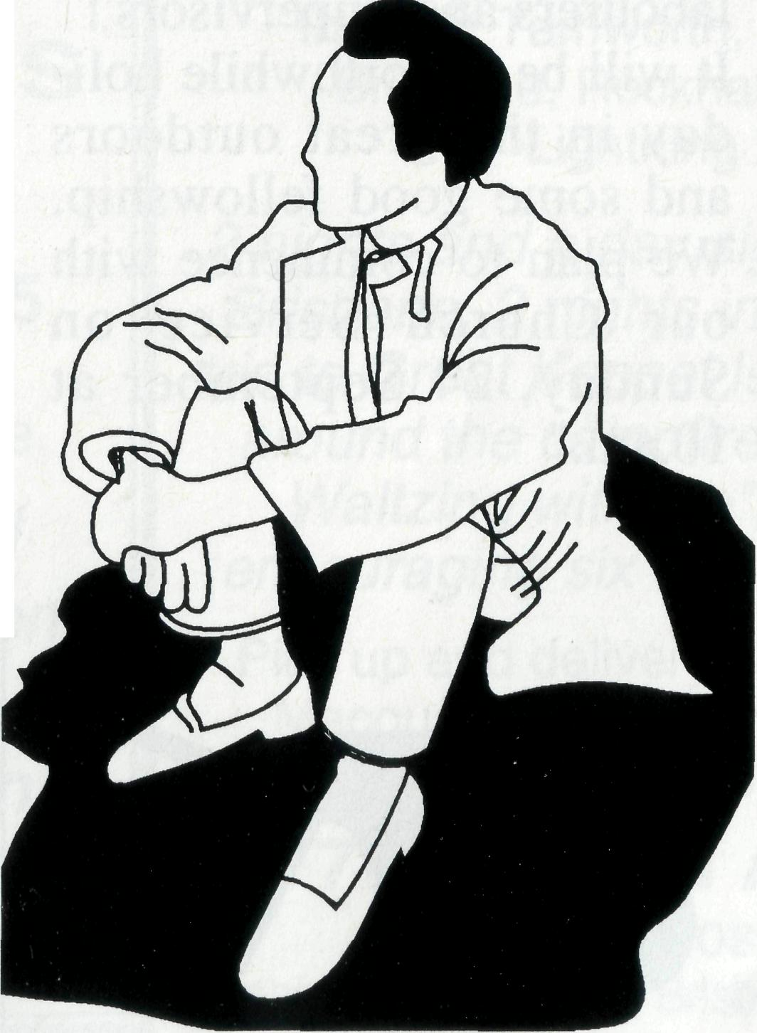
Furneaux Islands
Donald Moffat wrote recently: "On 2nd and 3rd of January the Aboriginal community celebrated their Wybalenna Festival and this year they asked me to conduct a special service on Tuesday 3rd in the Wybalenna Chapel. This was prompted by an elder, Auntie Ida West. We had a congregation of about 20 of all ages. What to me was most significant was the time a small group, including Auntie Ida, shared with me over a 'cuppa' in the house that the Aborigines have 'occupied'. As we sat around they started telling stories and 'letting me in' on some of their spiritual experiences as Aborigines.
I was greatly encouraged by this experience. Some people could have trouble with some of the things I heard, not that they would hear them, but people like Auntie Ida West see no conflict between their Aboriginal spiritual experiences and Christianity. Perhaps it is that Christians seal Christianity into an air tight, easily defined, culturally restricted box. There is no room for that box when Aborigines start speaking about their own spiritual experiences."
11

Post & Rails con't
Your Pravers
have been Answered:
Donald and Helen Wilson reported recently from Wilcannia on answered prayers:
"At Tibooburra the School Principal has agreed to the school receiving 'Outback Patrol's Air lessons every week. We will fit in with these when we are there. This is a great breakthrough as previously only two girls had these lessons. Sometimes at Wilcannia 50% of the congregation are men. Mind you that may only be five but five men at Church even if it is only now and then is quite an achievement here. God has answered the prayer about 'Family Time', but not the way we hoped. In June an Assemblies of God (AOG) Pastor came to town with his Aboriginal wife and three school children. The Aboriginal children, up to 20, who were coming to us now go to the AOG. Pray now that he may be able to break through to them with the truth of the gospel and that he may not become discouraged and leave. Despite that we have a couple of white families now coming regularly.
12
Holidays with a Difference
Don & Helen Wilson of Wilcannia have written "In September school holidays this year we are planning to do some repairs to the roof of the stone Church at White Cliffs.
We are looking for a team of Christians who would like to make this happen in the remote opal town. With the right people we should be able to do the work in three days and then people may like to go on to see the sights of White Cliffs or Broken Hill, or camp out in Mootwingee National Park (with Aboriginal carvings) before returning home. We hope to be able to supply the materials (or get them donated) but tradesmen will need to bring then-own tools.
If you know of anyone who would like to be part of this outback adventure, please let us know before 1 June. We need tradesmen and labourers and 'supervisors'! It will be a worthwhile holiday in the great outdoors and some good fellowship. We plan to commence with our Church Service on Sunday, 24 September at lO.am."
Mrs Bertha King Geq
Mrs King Gee was an enthusiastic prayer and financial supporter of BCA for many years. She was a valued member of Holy Trinity Anglican Church, Peakhurst, and her death on 28 January, aged 92, brought great sadness to us all mingled with praise and thanks to God for her life of
service to Him and others. Mrs King Gee was a great woman of prayer and many individuals can testify of her concern for a prayer need they had and of her consistency and genuine interest as she prayed for them. As a BCA boxholder, she was most generous and eager to hand in her box each time.
Although frail and in pain Mrs King Gee was an inspiration to all and a wonderful example of the love of Christ who she served so faithfully.
HAVE YOU a use for 15
volumes of an American
Encyclopedia (1964 edition).
they are currently stored in
Sydney. If you are interested,
telephone the owner, Liz Maher, direct on 02 350 6180..
Heading West
The Rev Bob McKay, Rector of the Anglican parish of Trevallyn /Riverside, Tasmania, will return to familiar territory after Easter as he and his wife Jan move to Paraburdoo in a six-month secondment to the Anglican Diocese of North West Australia and the Bush Church Aid Society.
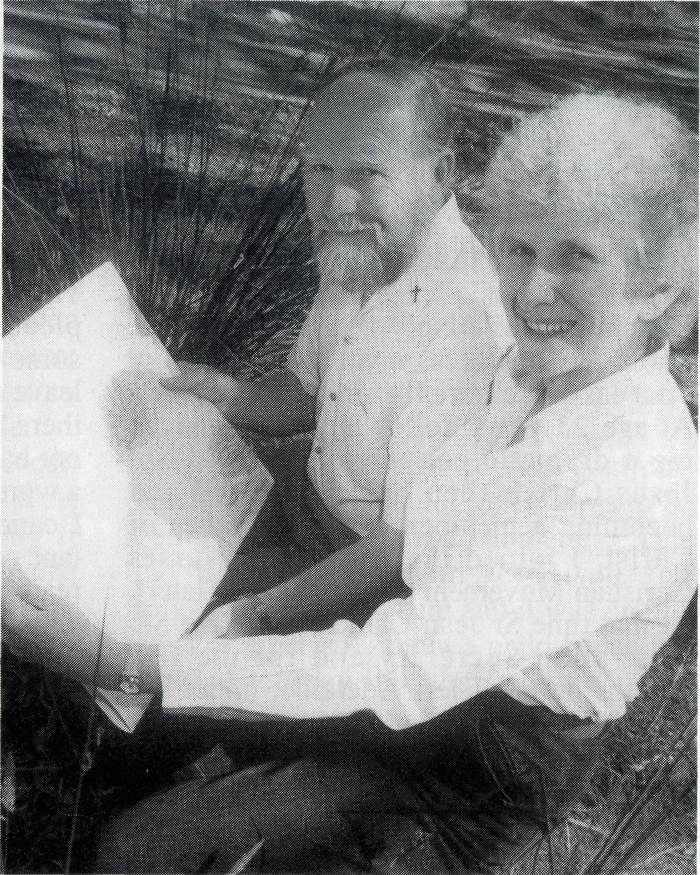
Mr McKay has long been associated with rural life. He grew up in Western Australia and started his practice as a veterinarian in that State before moving to Tasmania 20 years ago. He was district veterinarian for Devonport and Kentish with the Department of Agriculture for six years until his preparation for ordination in 1981.
His previous appointment was at Huonville, south of Hobart. Bob McKay said this week that he had been supportive of BCA for many years and was interested in experiencing how the Church functions in more remote areas. He also hopes to forge links between Tasmania and the Church in North West Australia.
Mrs McKay, well known as an announcer with Launceston radio WAY-FM, will take six months leave from that position and hopes to share in music ministry in schools in the wide-spread parish.
BCA
SUPPORTERS
WEEKEND
7th-9th July, 1995 at Albion,
in the heart of Brisbane
with Geoff and Gill Bransgrove fresh from Winton with studies on
"The Compassion
of Christ"
(full catered cost $70.00).
CCome visit the BCA Fields in motels on THE 16 DAY BUS TOUR
through Tamworth, Port Macquarie, Grafton,
Brisbane, Rockhampton, Winton, Quilpie,
Lightning Ridge, Walgett.
2 nights and a day sightseeing and shopping in Brisbane, 2 nights in Rockhampton and a day
trip to Great Keppel Island, 2 nights on a station around the campfire at Winton. Do "Come a
Waltzing with Me", as well as visiting and encouraging six of our missioners on the field.
Pick up and delivery home all towns en route Port Macquarie to Brisbane. Transport arranged for passengers South of Tamworth or Port Macq.
7th - 22nd AUGUST, 1995
Cost: $1,500
Further Details contact Brisbane office or phone (07) 349 9081.

A RING IN!
Mrs Jane Manning (nee Branford)
wrote recently to BCA about how she
came to serve as a nurse with BCA
at Ceduna in the early 1940's.
Her connection with BCA continues
today through her grandchildren at
Mutooroo Station, who attend BCA
House in Broken Hill.
Dear Rev Brian Roberts, Tom Jones Snr, who was Organising Missioner at that time, would have described me as a "ring in" because of the circumstances of my being at Ceduna. Those circumstances involve quite a story - not easy to tell briefly but I'll try. At age 23 years, following what was for me a dramatic conversion to the Lord Jesus Christ, then being baptised and becoming a member of the Churches of Christ, I joined the Australian Nurses Christian Movement (name changed later). At that time Sr Jean Clarkson was the Sth Australian Secretary and for the few months before I left Adelaide, under her leadership, I gained a whole new experience of Christian fellowship. She was to me a true friend.
My first appointment after training at the Royal Adelaide Hospital was as Charge Sister at the then new Tumby Bay Hospital. However, I could never please the ageing, sick matron. Eventually I found myself praying earnestly for God to show me what to do. I wanted to leave what seemed to be a hopeless situation for me. My mother, the only person with whom I shared my deepest self, said that "perhaps it was God's will for me to stay and be His witness in that hard place". I had prayed much and was now getting impatient. Rightly or wrongly, Mum and I decided to set a date. If no positive guidance came from the Lord by that date, I would believe that mother was right and that it must be God's will for me to stay and depend on His love and strength. The set date came and seemed nothing different from any other day. As I cycled to my mother's home I felt at peace that this
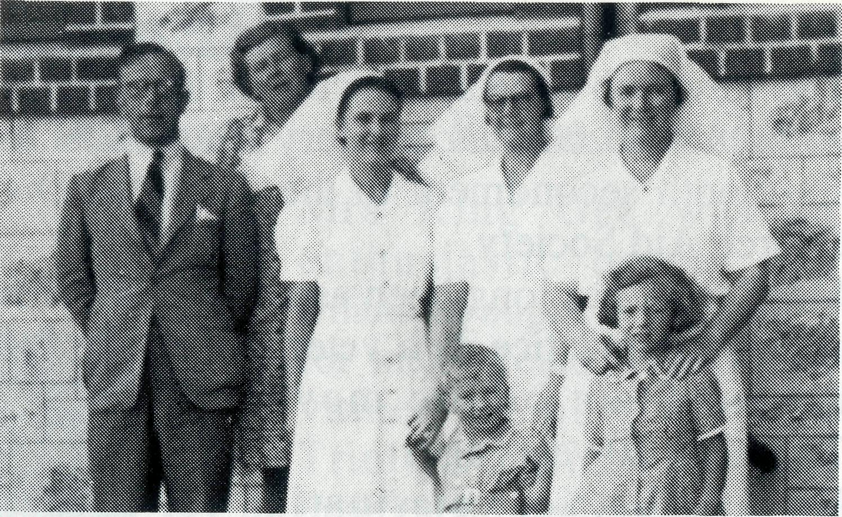
Sr Jane Branford (first from right)
was the answer to my much praying. On my way back to duty I had to collect the Hospital mail from the post office. There was a letter for me from Sr Clarkson pleading "Dear Jane, could you please some how, some way, take six months" leave and go to Ceduna. The BCA sisters there are not only short-staffed, but have not had holidays for three years. Oh, what a word from God at the eleventh hour!! I cannot find words to describe the exultant consciousness of God's Presence as I read the letter. I think the old bike took wings as I flew back to work. That was the beginning of the most wonderful five years of my life. Early in 1946 my husband and I and our one year old daughter left Ceduna and began farming at Bordertown in a very small and humble way. Although very poor financially, God's blessings were many. I was able to go back to Ceduna many times for visits. In that way I met many more younger BCA workers. During those years our humble abode became 'Halfway House' for some of the staff and missioners as they travelled from West to East on leave. When Florence Dowling retired she lived with us on the farm for six months.
I clearly remember so much about the people, places and exciting events of those epoch years. I wish I had kept a written record of so much that happened.
Yours sincerely in Christian Love, Jane Manning (nee Branford)
P.S. I will be 'eighty not out' this year and must cope with an eye condition called glaucoma, which doesn't seem to be responding to treatment. But the Lord is teaching me how to "make the best of each day" and life is sweet, because of the life He gives.
A Patch of Green Grass
Terry and Sherry Leonard started their ministry in Quilpie in 1994. The Anglican Parish of Quilpie covers approximately one third of the Brisbane Diocese (1,000km x 800km)
The November issue of the Real Australian had an insert which said that no part of Australia is too remote for God. For both Sherry and I this is true as we have seen God working in some of the most remote areas of Australia. Let me tell you a story from our first pastoral trip to Birdsville. Prior to the trip we had a telephone call from a lady living in the top North-West corner of South Australia, enquiring if their daughter could be baptised at some time in the immediate future. Having ascertained that they lived about four hours
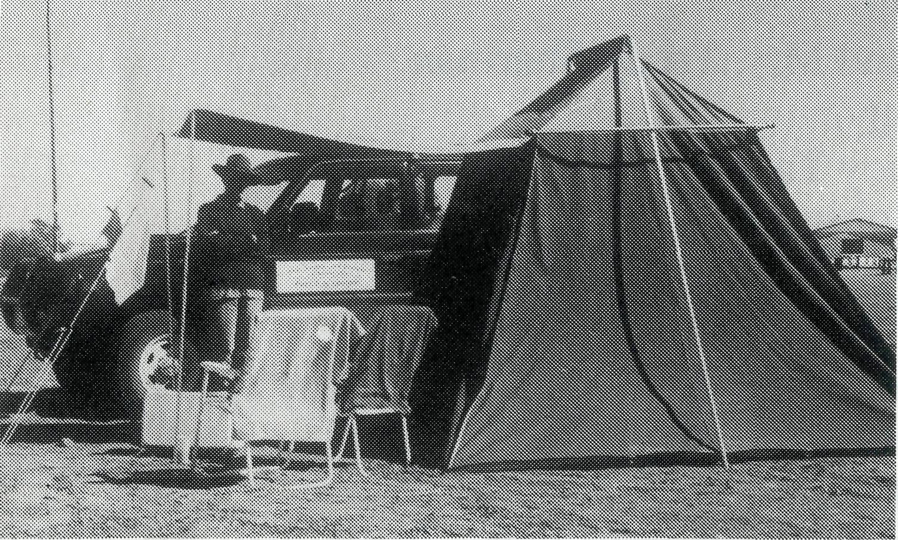
south-east of Birdsville, we made arrangements to do the baptism on our return journey from Birdsville.
After having a fruitful visit to the properties and several of the townsfolk of Birdsville, we re-packed our tent and gear and set out for the top end of South Australia. We thought that the road after leaving the bitumen on the Diamantina Development Road was the worst that we had travelled on. Little did we know what was in store. Travelling around the edge of the Sturt Stoney Desert proved to be an
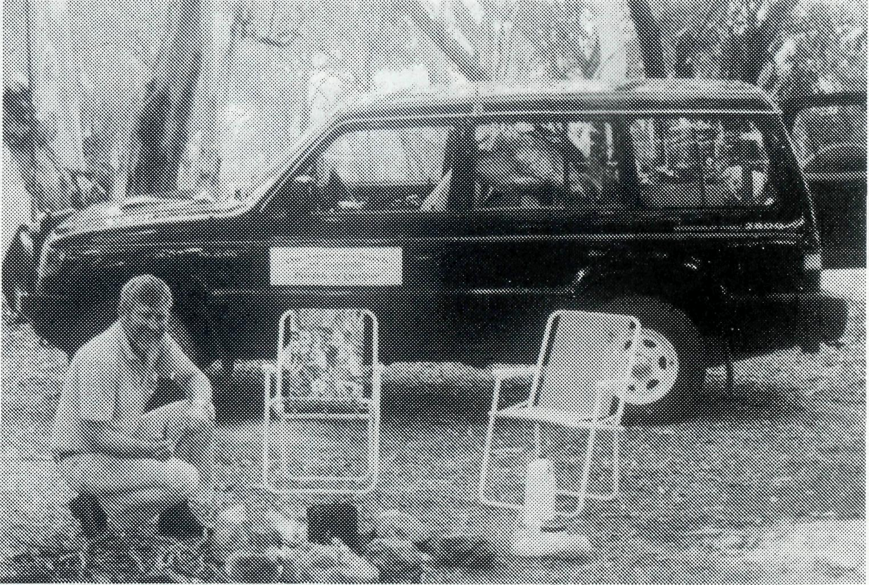
endurance test of both vehicle and driver. I've never seen so many stones in one area before. The road had been graded (I think about a hundred years ago, and never been touched since) straight through with the larger rocks pushed to one side. Praise God for 4WD's.
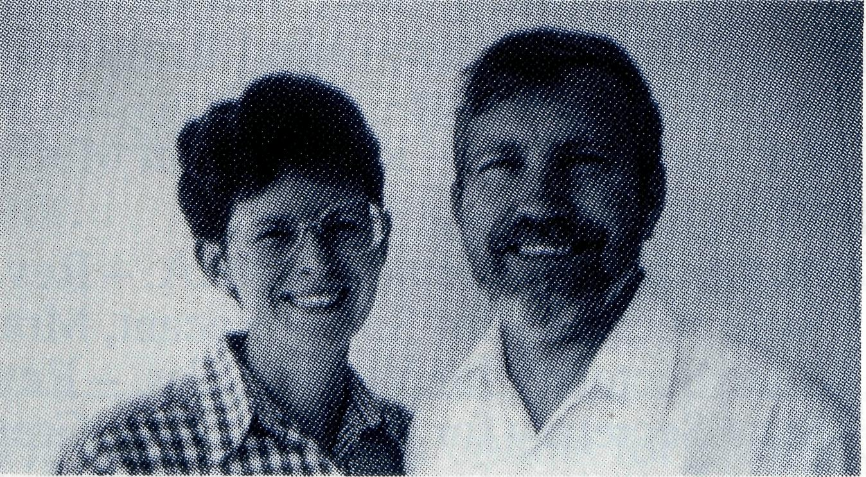
Terry Leonard
See Day 28 Prayer Notes
Arriving at the property we were confronted with the only patch of green grass to be seen for several hundred kilometres. This had been planted and fertilised and watered with loving care and it was on this patch of green grass that a child began her spiritual journey into the family of God. The only witnesses to this great event were the parents of the child, several ringers, Sherry and myself, multitudes of angels and our loving Heavenly Father. The nearest neighbours were about an hours drive east and then no-one else for 200 odd kilometres in any direction. Truly there is no place in Australia that is too remote for God, or too remote for the Church to reach because of the support of BCA and many thousands of Christians who give generously to this work of God.

14
15

PRAY FOR OUR STAFF
OUR MISSION FIELD

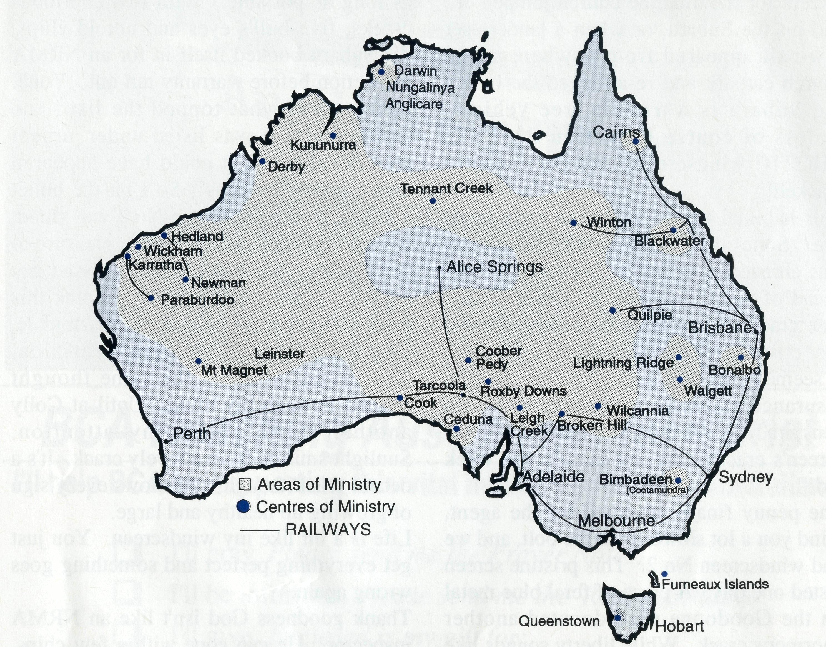
for the young, the message of your redeeming love may be proclaimed, and accepted by the people throughout our land. We ask these things through Jesus Christ our Lord, who lives and reigns with you and the Holy Spirit, one God, for ever and ever.
AMEN.
* If you'd like more details for prayer,
send for our FREE quarterly prayer
notes. (See reply page).
• Diocese of Northern Territory - Bishop Richard Appleby.
- Anglicare Director - Mr. Peter and Mrs. Lynne Fisher.
- Tennant Creek - Rev. Tom and Mrs. Carol Williams.
• Diocese of North West Australia - Bishop Tony Nichols.
3 Kununurra - Rev. John and Mrs. Dianne Symons.
4 Derby - Rev. Jon and Mrs. Rae Reinertsen.
- Newman - Rev. Raymond and Mrs. Betty Lou Molyneux.
- Hedland - Rev. Ray and Mrs. Lyn Arthur.
- Karratha - Rev. Terry and Mrs. Fiona Redmond.
- Wickham - Archdeacon Bill and Mrs. Jocelyn Ross.
- Tom Price/Paraburdoo - Vacant

- Dampier - Counselling Ministry (Kinway)
- Mt. Magnet (Murchison) - Rev. Philip and Mrs. Margaret Bassett.
- Leinster - Rev. Les and Mrs. Jenny Gaulton.
• Diocese of Willochra - Bishop David McCall.
- Coober Pedy - Rev. Bob and Mrs. Denise Rothwell.
- Roxby Downs and Mid-West Mission - Rev. John and Mrs. Leone Rutherford.
- Leigh Creek - Rev. Wayne and Mrs. Cherylene Ireland.
- Cook: Bp Kirkby Mem. Hosp. - Sr. Gai DiDonna.
- Ceduna - Archdeacon George and Mrs. Judy Thomas.
• Diocese of Riverina - Bishop Bruce Clark.
- Broken Hill BCA House - Mr. Neville and Mrs. Margaret Coombs.
- Wilcannia - Rev. Don and Mrs. Helen Wilson.
• Diocese of Tasmania - Bishop Phillip Newell.
20 Queenstown (West Coast) - Rev. David and Mrs. Trudy Sharman.
• Diocese of Armidale - Bishop Peter Chiswell.
- Lightning Ridge - Rev. Mark and Mrs. Lucy Taylor.
- Walgett - Rev. Clive and Mrs. Vivienne Robinson.
• Diocese of Grafton - Bishop Bruce Schultz.
23 Bonalbo - Rev. Ian and Mrs. Glenda McGrath.
• Diocese of Brisbane - Archbishop Peter Hollingworth.
24 Quilpie - Rev. Terry and Mrs. Sherry Leonard.
• Diocese of Rockhampton - Bishop George Hearn.
- Winton - Rev. Geoff and Mrs. Gill Bransgrove.
- Blackwater - Rev. Peter and Mrs. Jeannette Blundell.
- ABORIGINAL AND TORRES STRAIT ISLANDER MINISTRY: Cairns: St. Luke's - Rev. Jim and Mrs. Lala Leftwich. Nungalinya College - Ms. Elizabeth Caldwell.
Bimbadeen College - Mr. Denis and Mrs. Maureen Atkinson. Furneaux Islands - Rev. Donald Moffat, Diocese of Tasmaina.
28 STATE OFFICES:
Acting Hon. Secretary for W.A. - Rev. Fred Buchanan.
State Secretary for S.A. - Vacant, Mrs. Aila Alderson.
State Secretary for Vic. and Tas. - Rev. Brian Viney, Ms. Margo Bright.
State Secretary for N.S.W. - Rev. Greg Thompson, Mrs. Michele Peacock.
State Secretary for Qld & Northern N.S.W. - Rev. Les Monaghan, Mrs. Dianne Harris.
29 BCA FEDERAL OFFICE: Rev. Brian Roberts, Mr. Jim Gosbee, Mesdames
Jacqueline Griffiths and Eileen Darbin.
The BCA prayer
O Lord our God, help us to remember those who live in the remote parts of our land. We ask you to strengthen and encourage all whose ministries are supported by The Bush Church Aid Society. Refresh them in times of discouragement and loneliness and call others to stand with them in all task of making Christ known. Grant that, through the ministry of the Word and Sacraments, through medical work, through service and by caring

Rev’s Rave Page
Except for the time the church jumped out and hit the Subaru, or when a landcruiser tow-ball appeared from nowhere in the church carpark and re-arranged the boot -the Subaru is a trouble free vehicle. Unless of course I mention the PSYCHOTIC windscreen. It's permanently cracked!
This habitual behaviour began early in its life. Soon after delivery the windscreen was christened by a bolt from a cultivator ahead of us on the back road from Colly. One graceful bounce of the bolt and a two foot crack in the windscreen. It seemed innocent enough to me, but the insurance company in Sydney sniffed a conspiracy - "What do you mean the windscreen's cracked, the car is only one week old!"
The penny finally dropped for the agent, mind you a lot slower than the bolt, and we had windscreen No 2. This pristine screen lasted one day. A piece of feral blue metal on the Goodooga road donated another enormous crack. While liberty sounds like Liberal, the windscreen is definitely a Labor voter, because it's recalcitrant. The Subaru is solely responsible for a jump in ACI shares and a re-employment programme for windscreen repairers. I couldn't face calling the insurance company again only two days after a new fitting. I put it off

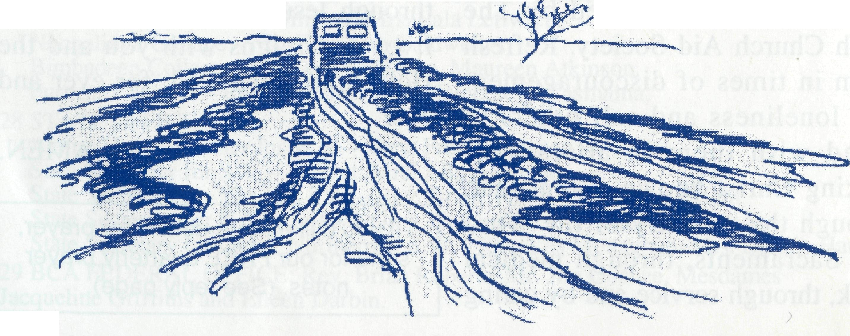
as long as possible. With two enormous cracks, five bull's eyes and untold chips, the Subaru booked itself in for an NRMA inspection before warranty ran out. You'll never guess what topped the list - the windscreen. It was listed under 'urgent repairs', although it could have appeared under 'totally obvious'. So I bit the bullet and last week windscreen No 3 was fitted. A beautiful clear windscreen, a pleasure to drive with. An evil thought crossed my mind - "Whoever gets the first crack this time will get severely stirred". Armidale, Guyra, Inverell, Delungra, Warialda, Gravesend, Moree - the same thought flashed through my mind. Until at Colly another flash caught my attention. Sunlight smiling from a lovely crack. It's a decent crack though, and shows every sign of growing up healthy and large. Life is a bit like my windscreen. You just get everything perfect and something goes wrong again.
Thank goodness God isn't like an NRMA inspector. He can cope with a few chips, cracks and other faults. We don't have to be perfect before he loves us. It's beaut too that God isn't like my insurance agent. He believes us when we talk to him and answers our prayers in the way that is best for us.
Mark Taylor 1994 See Prayer Notes Day 21
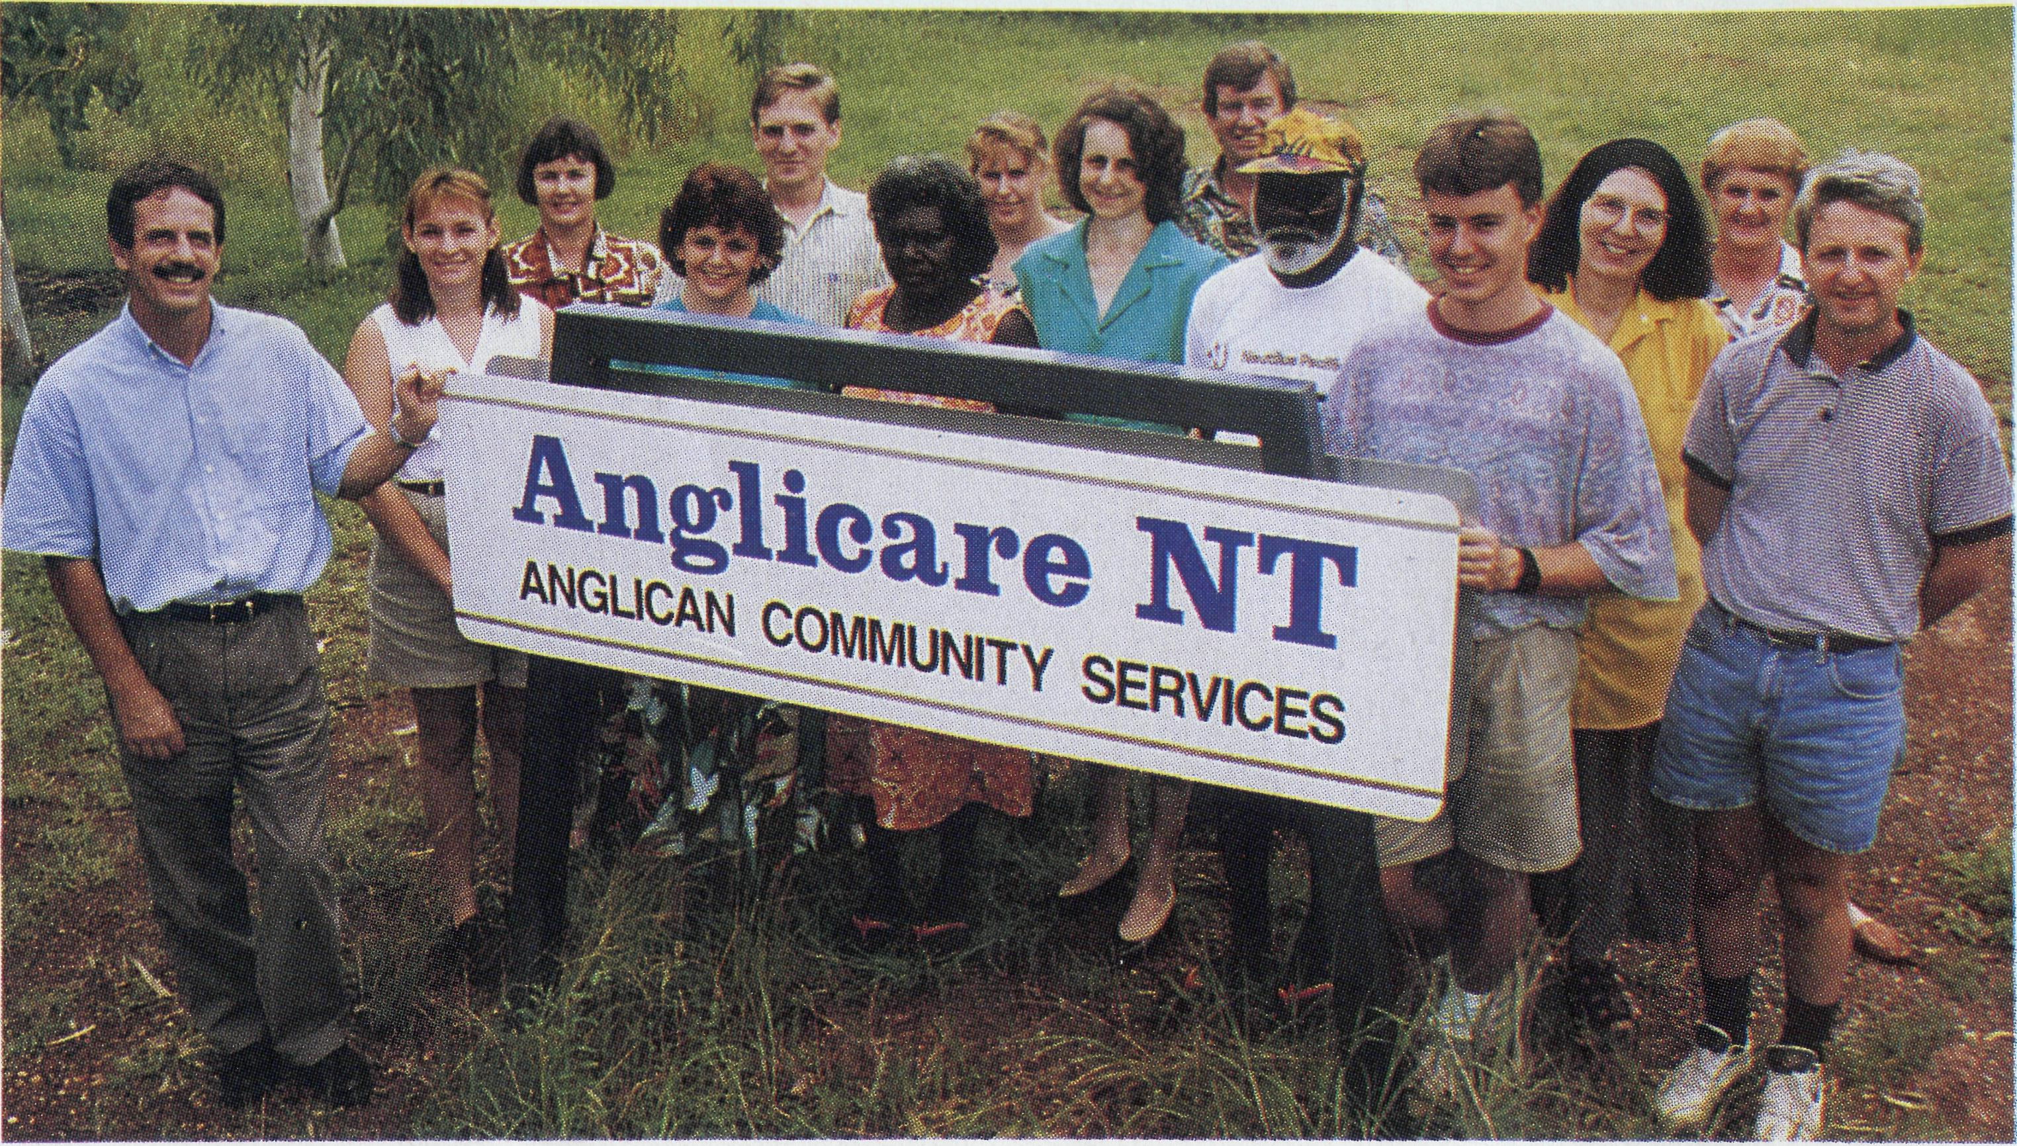
BCA Reaching Australians for Christ
I'll help BCA by supporting this vital ministry to remote Australians
- I'll pray. Please send me the Prayer Notes.
- I'll be informed. Please send me the 'Real Australian'. O I'll give. Enclosed is my gift for:

$ | $25 | $50 | $75 | $100 | $250 | $500 | $
or pleas | e charge this amount to my -□ Bankcard □ Mastercard □ Visacard
.Expiry Date:
Signature:.
Name:
Address:—
Receipts issued upon request for gifts over $30.00. Please tick box if receipt is required. □
Please complete and return with your gift to:
The Bush Church Aid Society (local State Office) or Level 7,37 York Street, Sydney 2000

