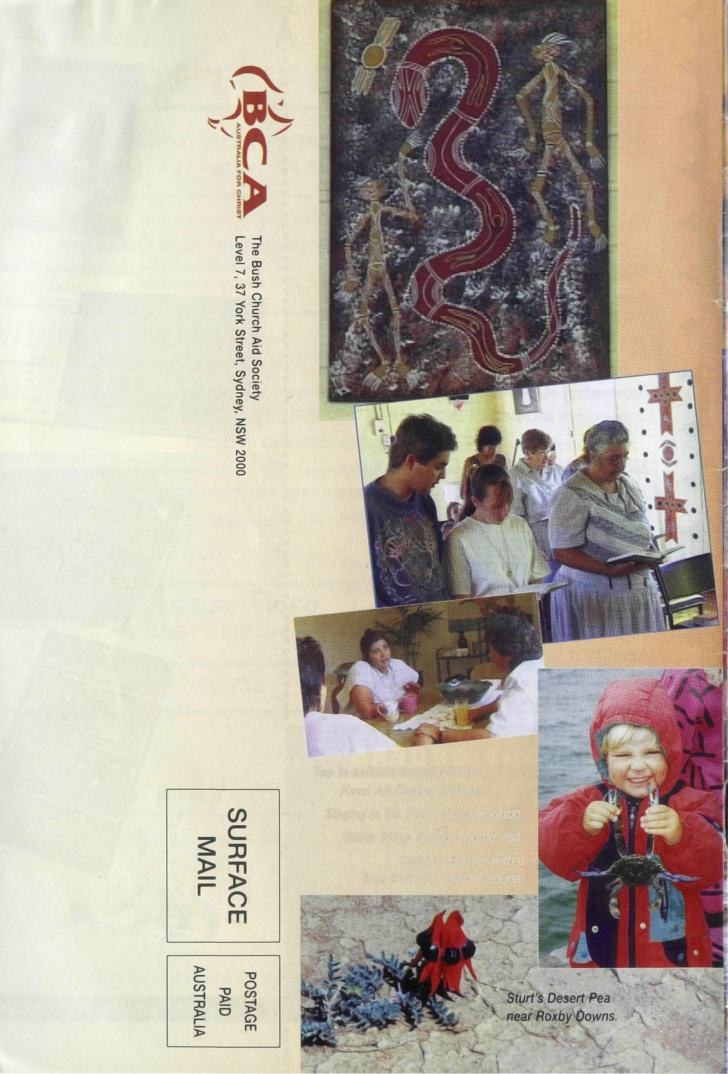
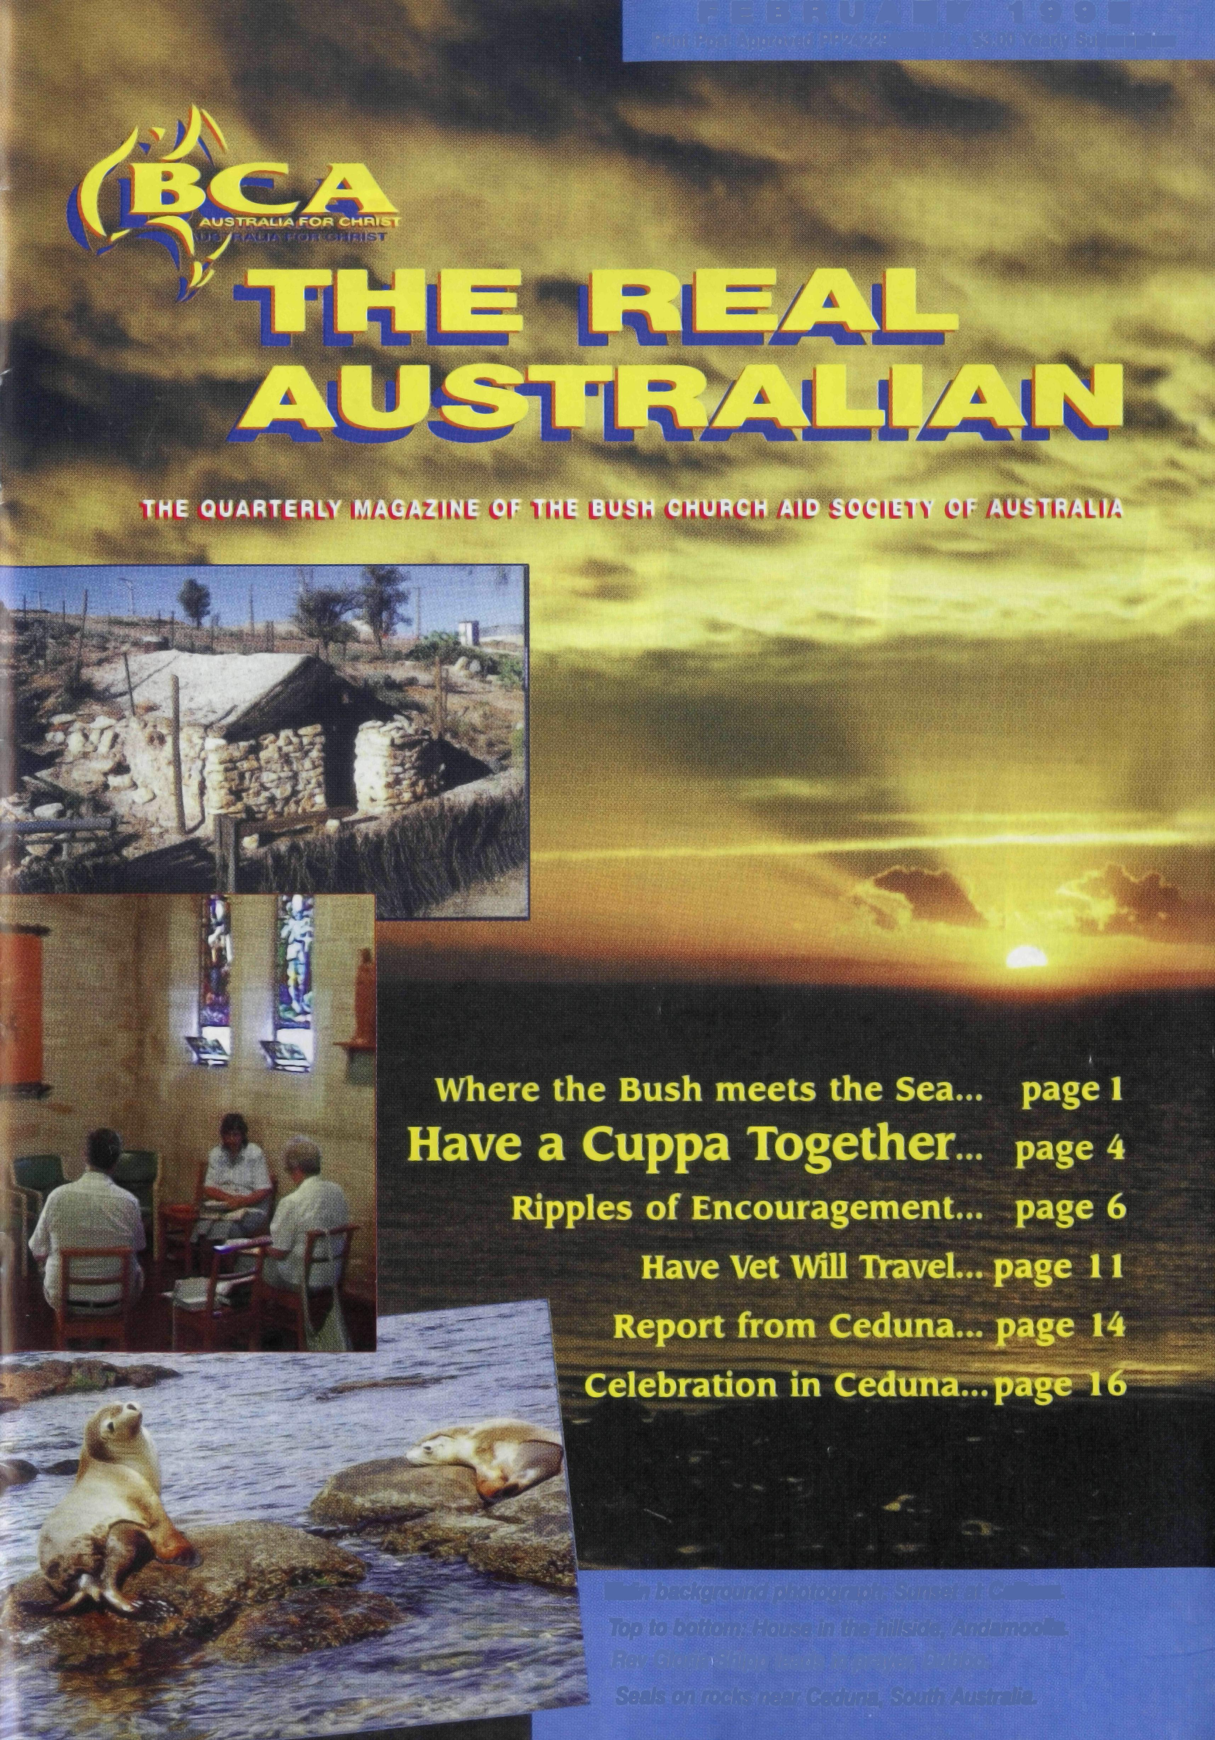
F E B R UA RY 19 9 8
Print Post Approved PP242296/00141 • S3.00 Yearly Subscription
Top to bottom: Painting in the Koori Art Centre, Dubbo.
Singing in the Koori church, Dubbo.
Gloria Shipp during a home visit.
Stephen Beever with a Blue Swimmer crab, Ceduna.
Main background photograph: Sunset at Ceduna. Top to bottom: House in the hillside, Andamooka. Rev Gloria Shipp leads in prayer, Dubbo. Seals on rocks near Ceduna, South Australia.

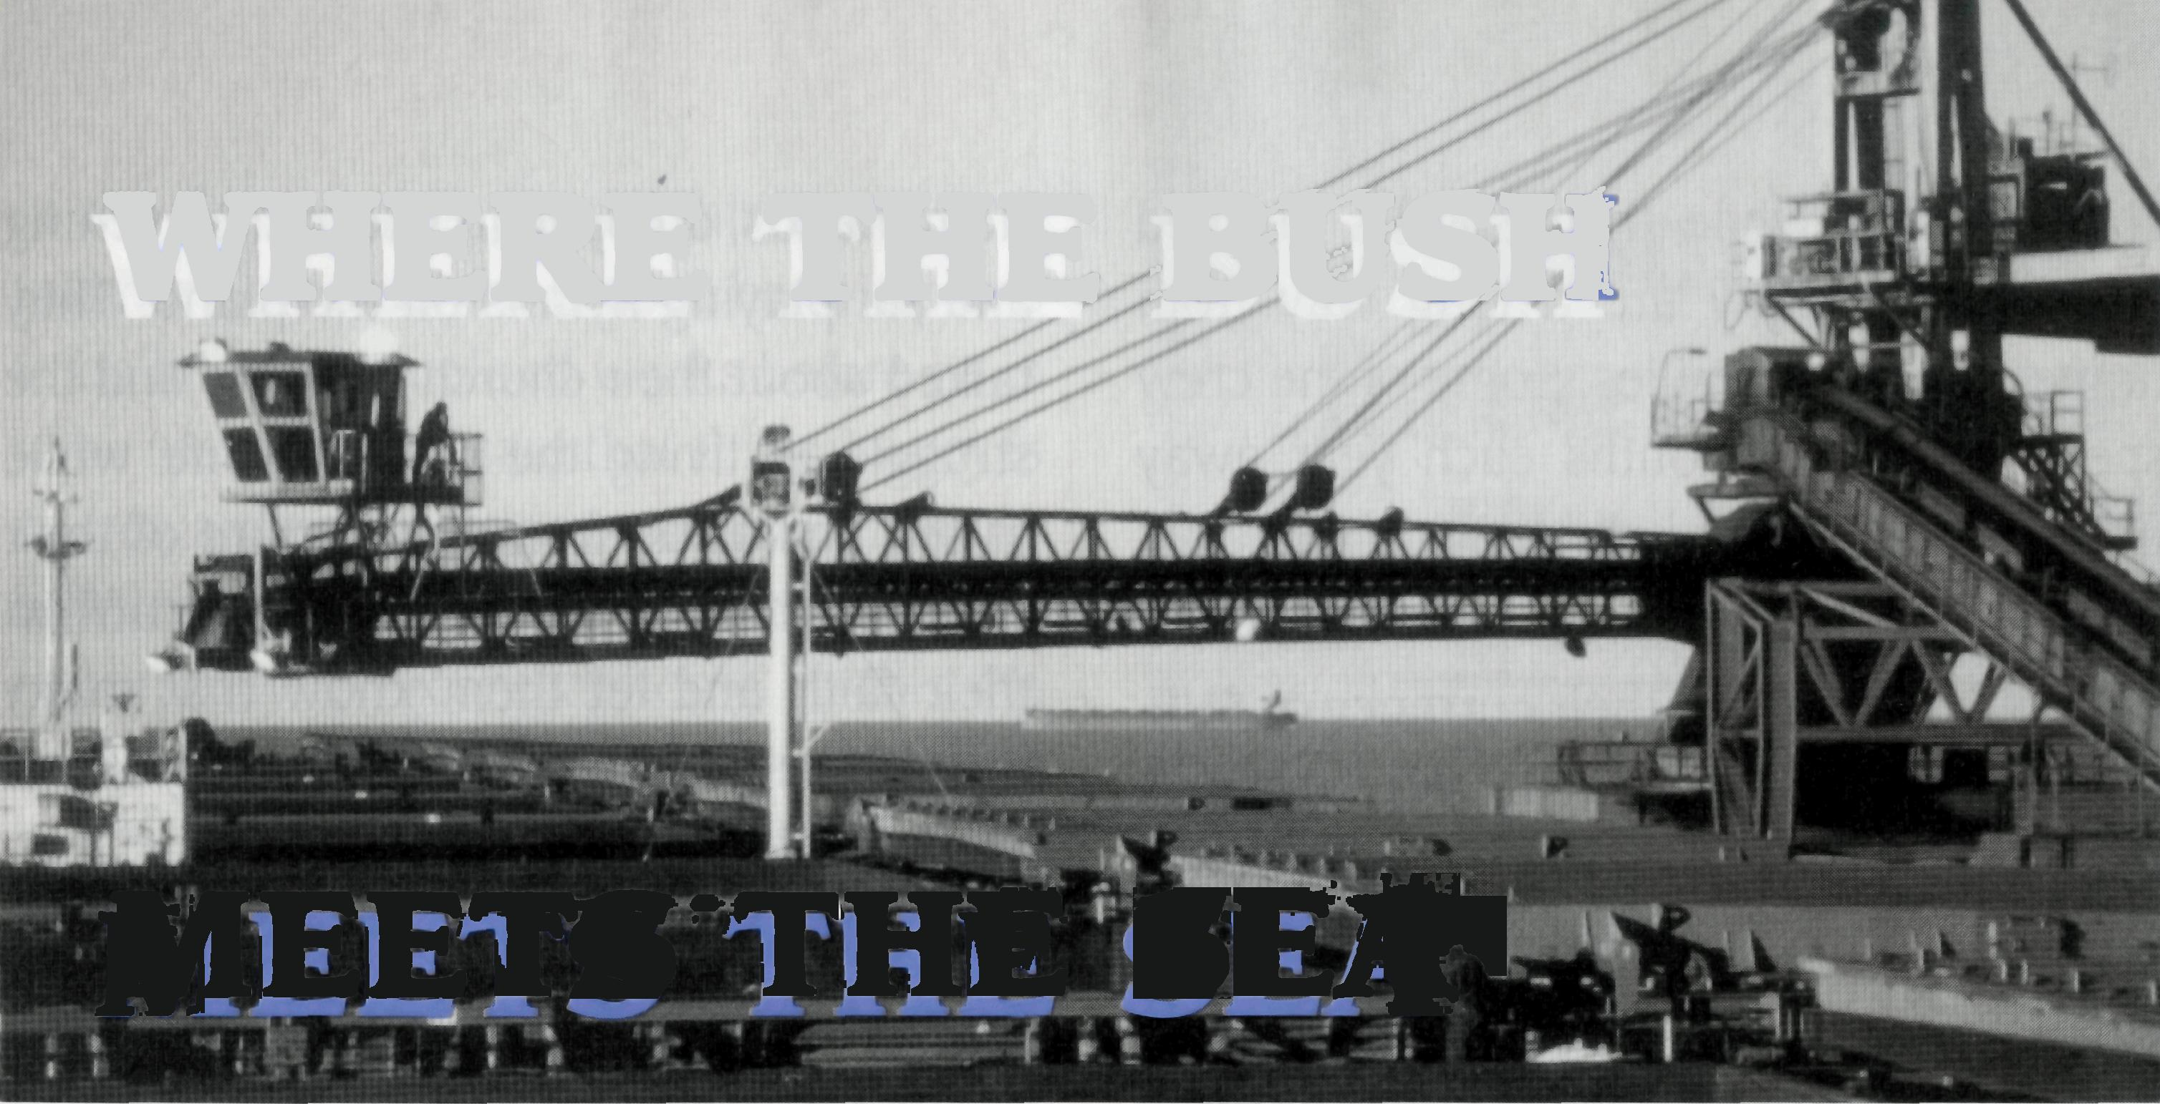
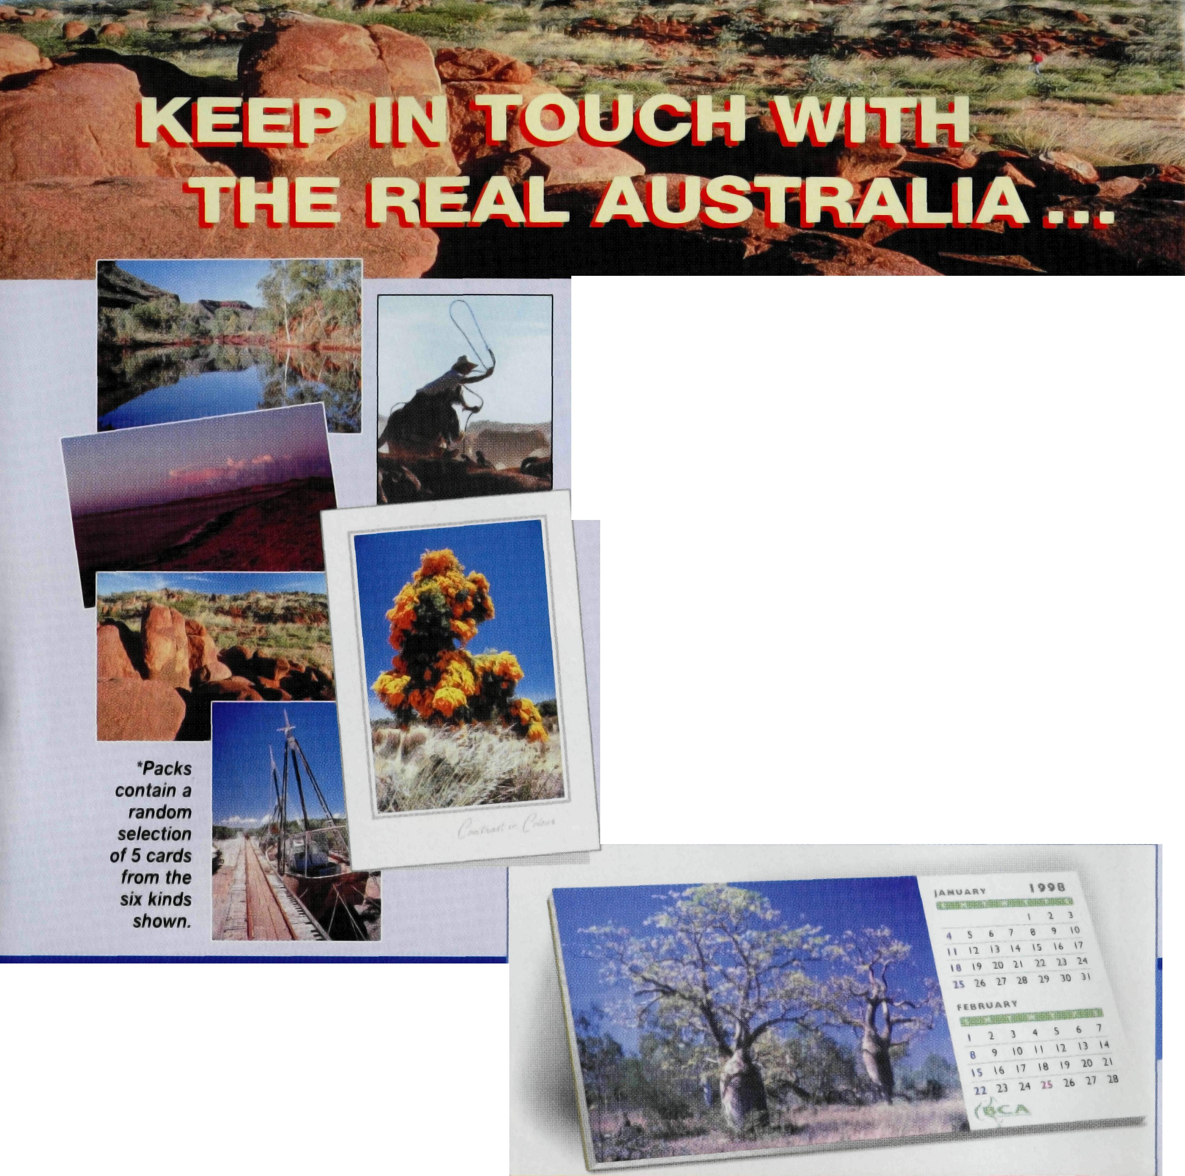
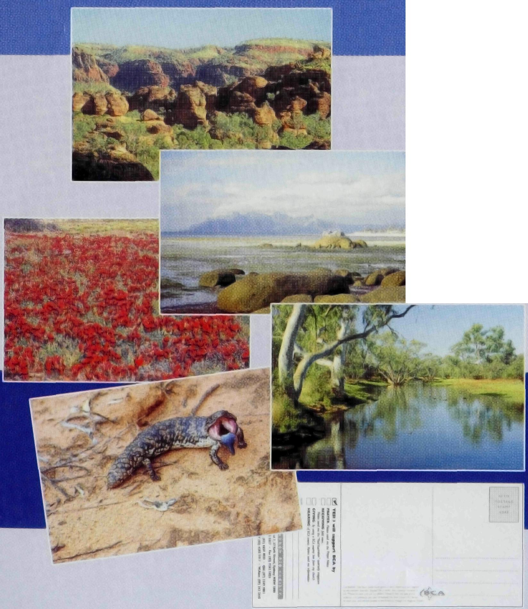
Your keeping in touch helps BCA keep in touch
with remote families and friends right across Australia.
REAL AUSTRALIA" GREETING CARDS
Each pack contains 5 cards* showing typical Australian outback life and scenes. Each card is 175mm x 115mm folded with no message inside. Envelopes are included. Single pack orders: $7.50 pack of 5 cards.
SAVE with multiple pack orders:
$7.50 for the first pack and only $6.50 for each
additional pack (postage included).
A Two-in-One gift or use it yourself!
Pop-out self strutted desk calendars with 2 months per page. When
the two months have passed, peel off the page and you have
a postcard to send! Size 99mm deep x 210mm wide.
$7.50 each (postage included)
DESK CALENDARS
GET IN TOUCH TODAY
Use the form on the back flap of this magazine to ORDER from your BCA Regional Office.
WHERE THE BUSH
MEETS THE SEA

Patron: The Most Rev Keith Rayner
President: The Most Rev Harry Goodhew Chairman: The Rev Dr Vic Roberts Vice-Presidents: Mr Ray Ctercteko • Rev Tom Morgan Hon. Treasurer: Mr Kevin Alexander
National Secretary: Rev Brian Roberts

NSW Secretary: Rev Greg Thompson Level 7, 37 York Street, Sydney, NSW 2000 Phone: (02) 9262 5017 • Fax: (02) 9262 5020 email: bca.nswoffice@accnet.net.au

In the North West of Australia, people from all over the world come to Australian shores. Men (and some women) who sail the world as officers and crew on some of the largest tankers, call in at places like Port Hedland, Wickham and Karratha/Dampier. They come to load iron ore, natural gas and salt.
They come from all nations and stop for a short while on their journey. BCA has a powerful, ongoing ministry to many of these sailors. It is a unique and special ministry.
At Port Hedland, every Tuesday night Ian Forsyth goes down to the Seafarers Centre and spends time with crew members who
The Real Australian is a registered trade mark of the Bush Church Aid Society. First published 1920 • Edition No. 299 • Circulation 30,000
All enquiries to: The Editor, Greg Thompson,
The Bush Church Aid Society of Australia, Level 7, 37 York Street, Sydney, NSW 2000. email address:
BCA DIRECTORY
bcafed@ozemail.com.au Website: www.bushchurchaid.com.au

Victorian Secretary: Rev Murray Lamont PO Box 343, East Melbourne, Vic. 3002 Phone: (03) 9654 8022 • Fax: (03) 9654 8962
SA Secretary: Rev Owen Thomas PO Box 1224, Blackwood, SA 5051 Phone & Fax: (08) 8388 2346 email: owen.thomas@accnet.net.au
Qld Secretary: Rev Les Monaghan PO Box 6565, Upper Mt Gravatt, Qld. 4122 Phone: (07) 3349 9081 • Fax: (07) 3849 7927 email: les.monaghan@accnet.net.au
WA Secretary: Rt Rev Bernard Buckland GPO Box N1024, Perth, WA 6001 Phone: (08) 9527 6090
DESIGN & ARTWORK BY BOKKAROO GRAPHICS (02) 9281 1410

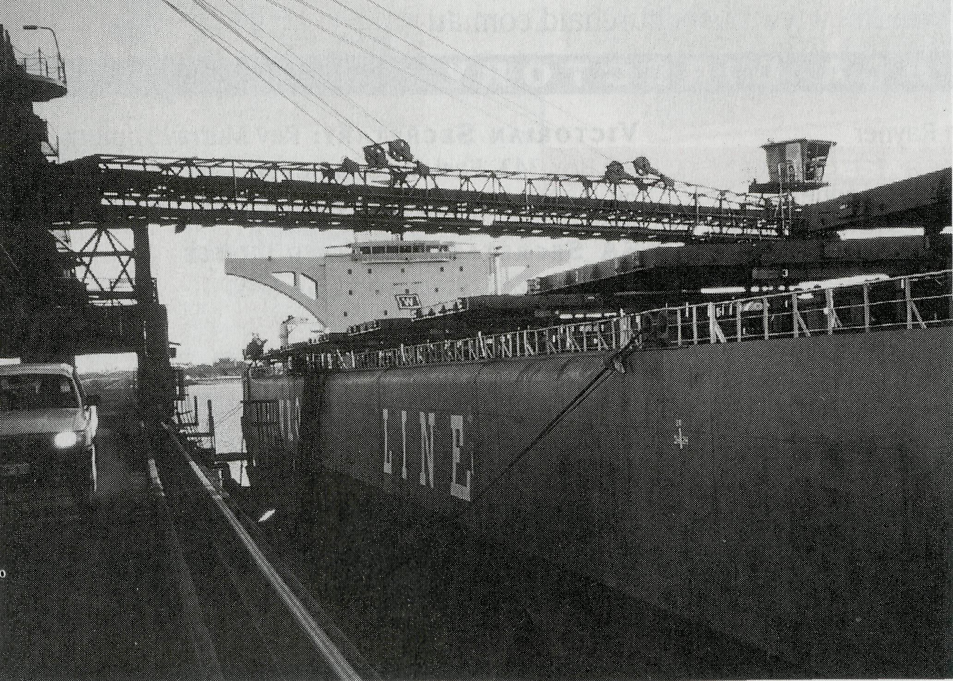
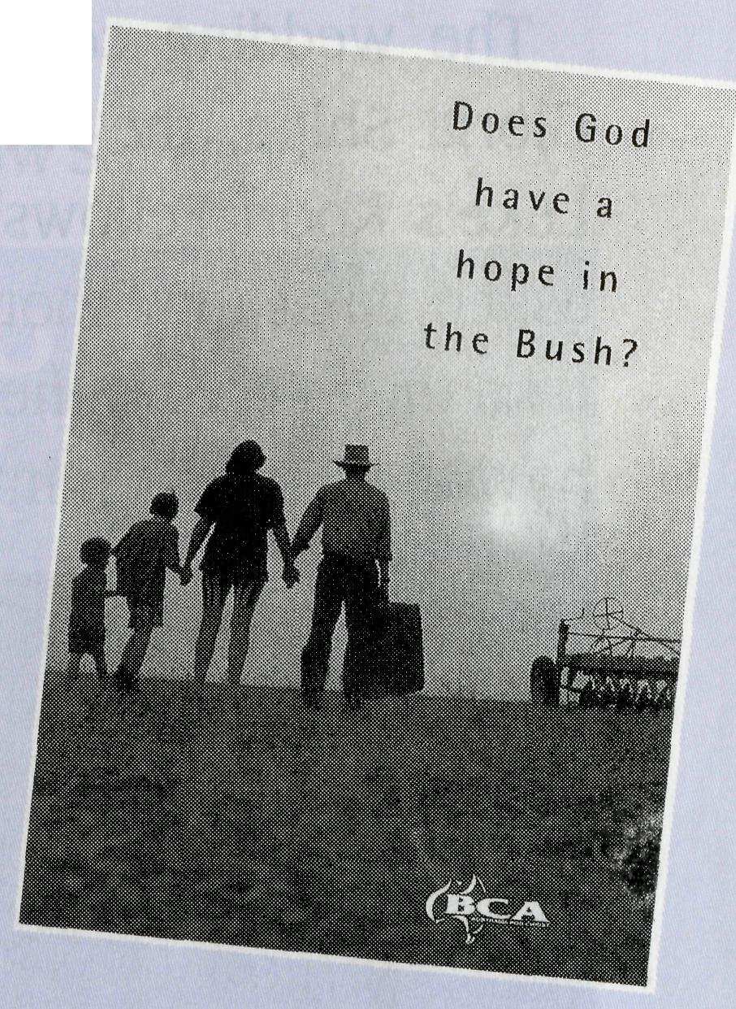
come ashore while their ship is berthed and loaded. Many are a long way from home and their families. Some of the crew spend up to 10 months each year away from their wives and children.
Ian helps them to phone home and work out the cost in either their currency or $US. He helps them in the shop to find the things they need for themselves, or as gifts to take or send home. While English is the language of the sea, many really struggle to communicate. However their smile says it all!
Many pause for a drink, a game of pool, table tennis or darts and talk about family and needs. Recently I was able to spend a night with Ian at the Centre and the members of a Norwegian ship that had a Filipino crew. Many of the crew had a Catholic background and wanted to talk about life on the sea and family in the Philippines. They were so grateful for being ashore in that Christian environment.
The First Mate and his wife, from the
Netherlands, dropped in late in the evening and sat playing hymns on the piano. They talked about their church at home and the struggle in living the Christian life while at sea and away from the nurture of their church friends. We were able to affirm their faith and let them know that many people are praying for them as they travel God's world.
At Wickham, further down the coast, Bill Ross often spends the late afternoon on board a ship tied up at the wharf. A wharf that extends some 3.7 kilometres out into the ocean. Wickham is too small to have a Seafarers Centre so Bill takes his mobile phone out onto the ships. I was with Bill when we went aboard an Indian tanker loading iron ore. We spent some 2 or 3 hours talking with the officers and crew and seeing the joy and thankfulness as they were able to speak with their wives and children on Bill's mobile phone. They were well aware that we were Christians, with BCA, there to tell and show the love and concern of the Lord for them and those they loved at home. Bill often drives them into town in the Seafarers bus and then takes them back later in the evening. Practical Christianity, showing Jesus' love for the world that comes to us.
One of the officers talked with his wife. She is pregnant and he hopes to be home in time to see his next child born. One
of the deck hands phoned his fiance and told her how much he missed her. He plans to be home a couple of weeks before he is to be married. Bill said that this ministry is so rewarding because you see instantly how much each person appreciates the opportunity to recontact home. In this the Lord is wanting to make or remake that special contact with people. We pray for real openings.
Karratha/Dampier is the busiest port in Australia, in terms of tonnage moved. Iron ore arrives from Paraburdoo and Tom Price. Natural gas is piped in from the North West Shelf and salt is "farmed" from the area around Dampier. Each of these industries has its own port facility, and ships to take the products overseas. Here Philip Knife ministers each Thursday night to many sailors from many nations. Philip drives the bus that picks up the crews and takes them to the centre where they are cared for. In this very busy centre, God's world comes to Australia. So many Bibles go out into this world from the centre as men recognise His word in their language. Philip writes their name in the front of the Bible and prays that they may come to a personal relationship with the author.
This is a little known ministry of BCA, but it is powerful and effective. Pray for Ian, Bill and Philip and their wives, as they spend vital time with these men who are so open to friendship and love. Pray that the conversation will focus on Jesus and His love for them. Through this ministry BCA, with your support, is able to "go and make disciples of all nations." RIC BOLLEN—Assistant Secretary-NSW/ACT.
“Does God have a hope in the bush?”
- a BCA Youth Project

A provocative question for our Youth Project this year. The hope that God has for people to respond to Him or perhaps the hope that country people have for God in tough times. It is a question for young people in schools or church groups to explore.
The project is a CONTEST* to introduce Year 10 to 25 year olds to bush life and the way in which God, through BCA and country Christians, is touching rural and remote communities. In no more than 500 words young people are asked to research, reflect upon and respond to the project's question.
*For New South Wales, Queensland and ACT only.
Share in the project by sponsoring a young person in your church.
Up to seven winners will be given the opportunity to go on an outback trip in July 1998. An entry fee of $25 per person will help cover the trip's costs. Application forms are available from Sydney and Brisbane offices.

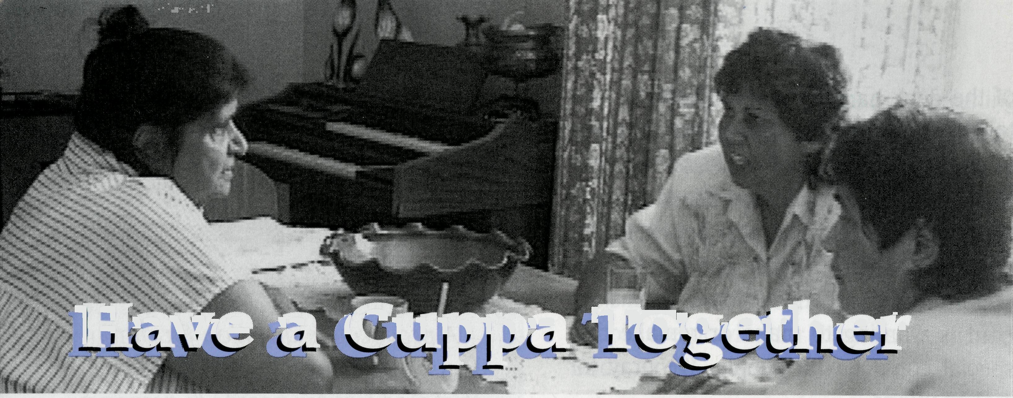
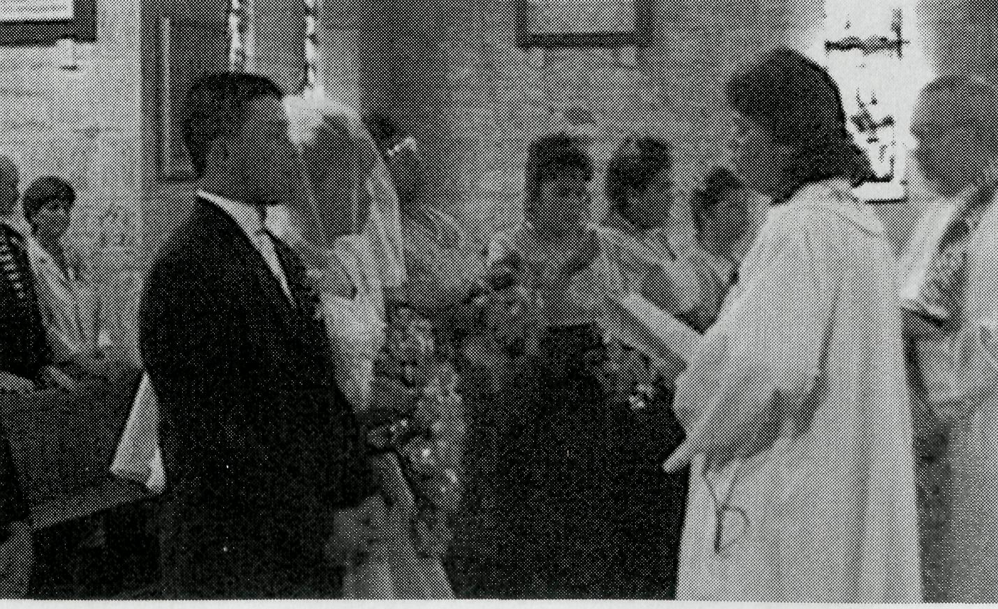
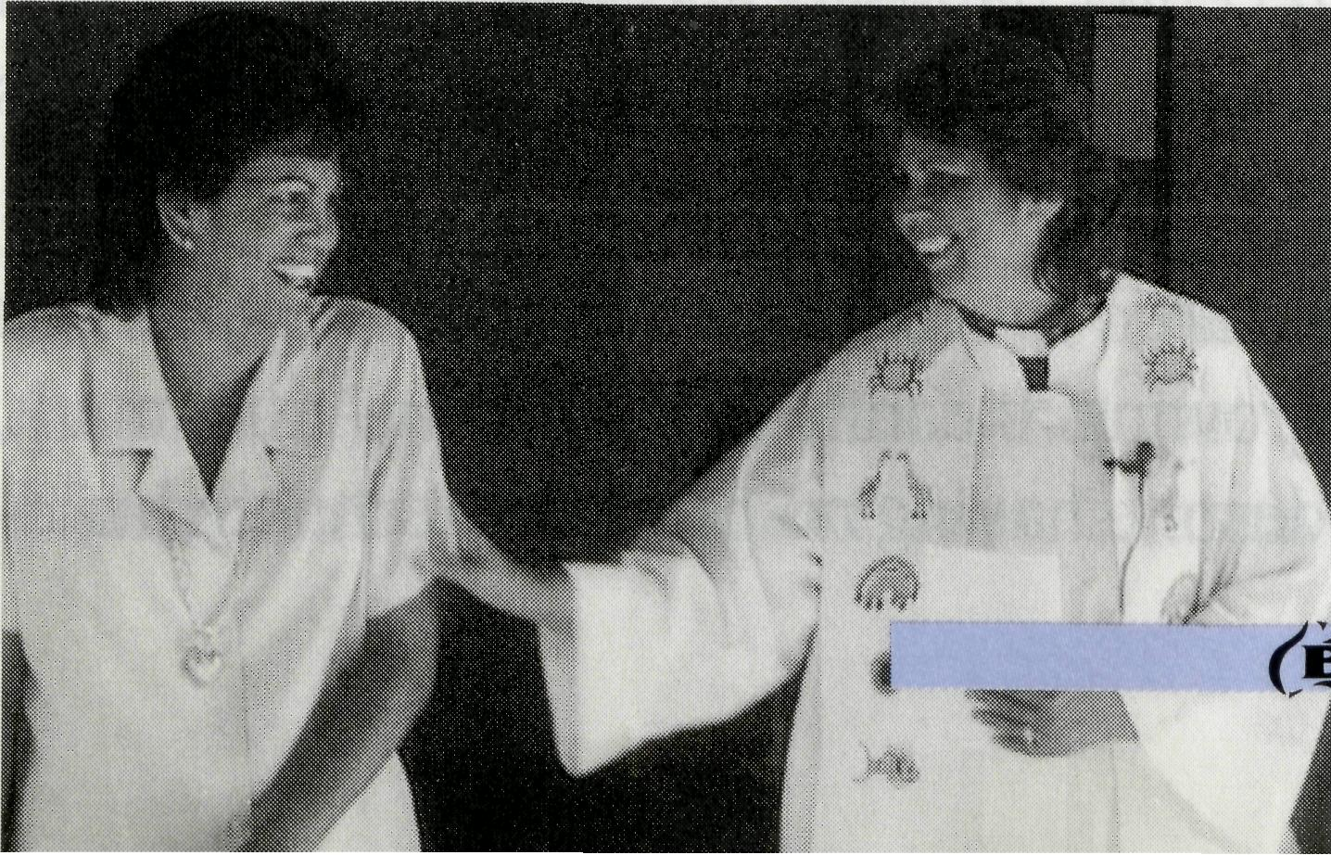
BCA recently announced support of Rev Gloria and Mr Eddie Shipp in Dubbo for four years in order to help the Koori ministry in Western NSW. In a city of 40,000 people, there are over 7,000 Koori people.
Matthew and Leanne, a Non aboriginal and Aboriginal stood side by side in Western NSW declaring their love and commitment to each other. In a week of emotive debate over the Federal Government's Wik plan, there was a sign in a country community that reconciliation and hope were alive.
The wedding couple stood before Rev Gloria Shipp, the Anglican minister of St Luke's Koori Fellowship in Dubbo. When asked what they thought of having Gloria take their service, they replied it was great having a woman minister.
Above: Gloria on a home visit. Top right: Lewis plays the didgeridoo in the art centre, watched by Eddie and Gloria Shipp.
Gloria originally comes from Nyngan and has worked among Aboriginal people in community services for a number of years in country areas. She is married to Eddie and they have 3 children and 5 grandchildren.
In 1984 Gloria committed her life to Christ. However it wasn't until she travelled to Nungalinya College in Darwin for bible and community training that she reconciled her Koori identity with Christianity. She discovered there that Christ accepted her Koori identity. This has been a catalyst for her calling to minister to the Koori people. Gloria says "My calling is to work for God. The vision I have is for Aborigines to be self-sufficient and to have leaders in the church and community. This can be done by discovering and using their gifts, to know their own identity, and most of all to know Christ as their Lord and Saviour."
Mary is a member of the Koori Fellowship. Married to a shearer and having lived many years in country areas she had never found an inner acceptance. Under Gloria's care and leadership, Mary
Have a Cuppa Together
found a spiritual home and received a life changing encounter with Christ. She said that after her baptism she went home and slept for many hours. On waking she felt incredibly light hearted and said "I am okay". She met the Christ who loved her and has given her a new life and church family.
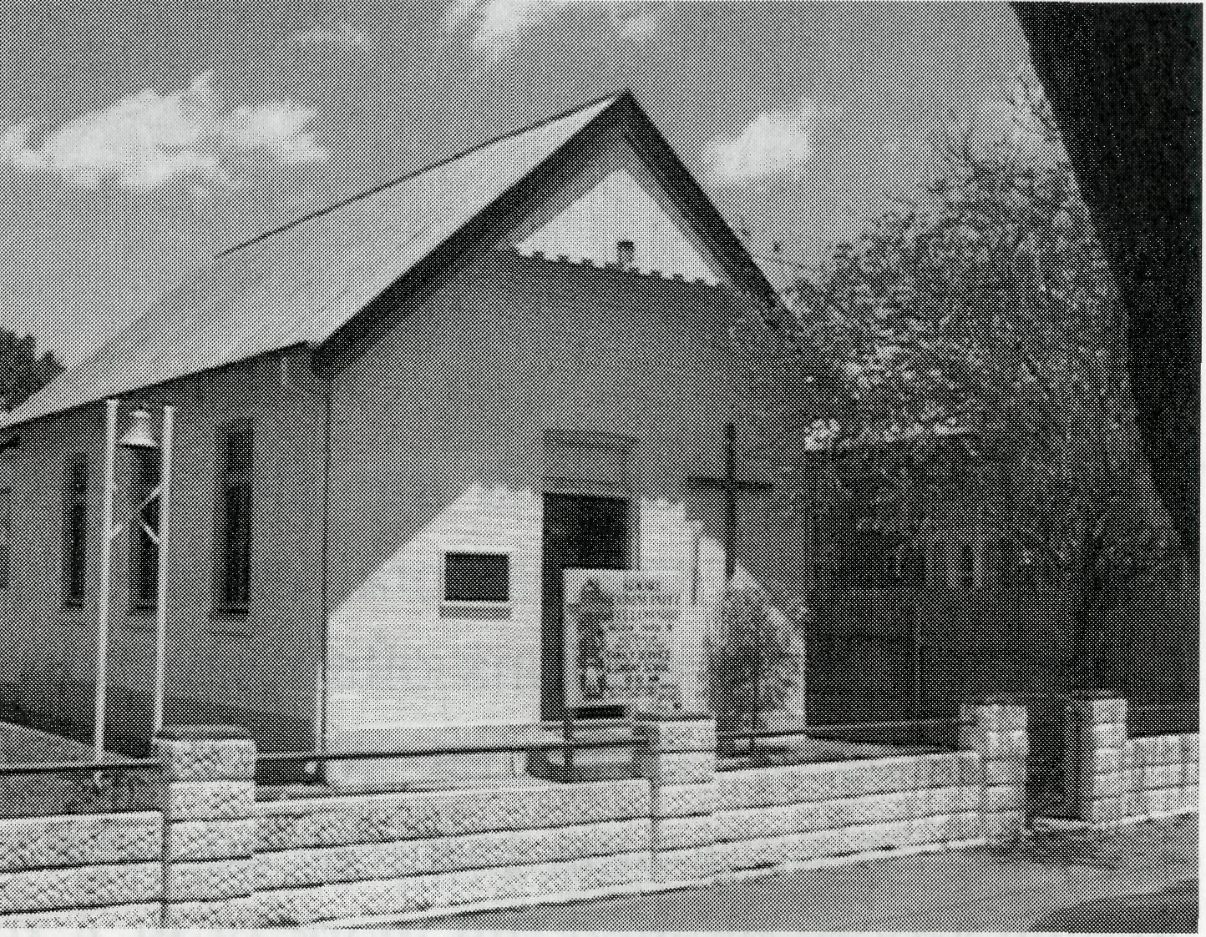
The Koori Fellowship meets in a small brick building each Sunday. Inside there is the creative use of Aboriginal art in decoration. Eddie, Gloria's husband, has helped in producing the art that speaks of Christ among Koori people. Koori people have a profound gift in expressing their faith stories through creative means.
Children and families mix well in the service. Use of clapstick and didgeridoo alongside use of the Anglican Prayer Book provide a meeting of European and Aboriginal spirituality. There is a reverential listening to the scriptures and the
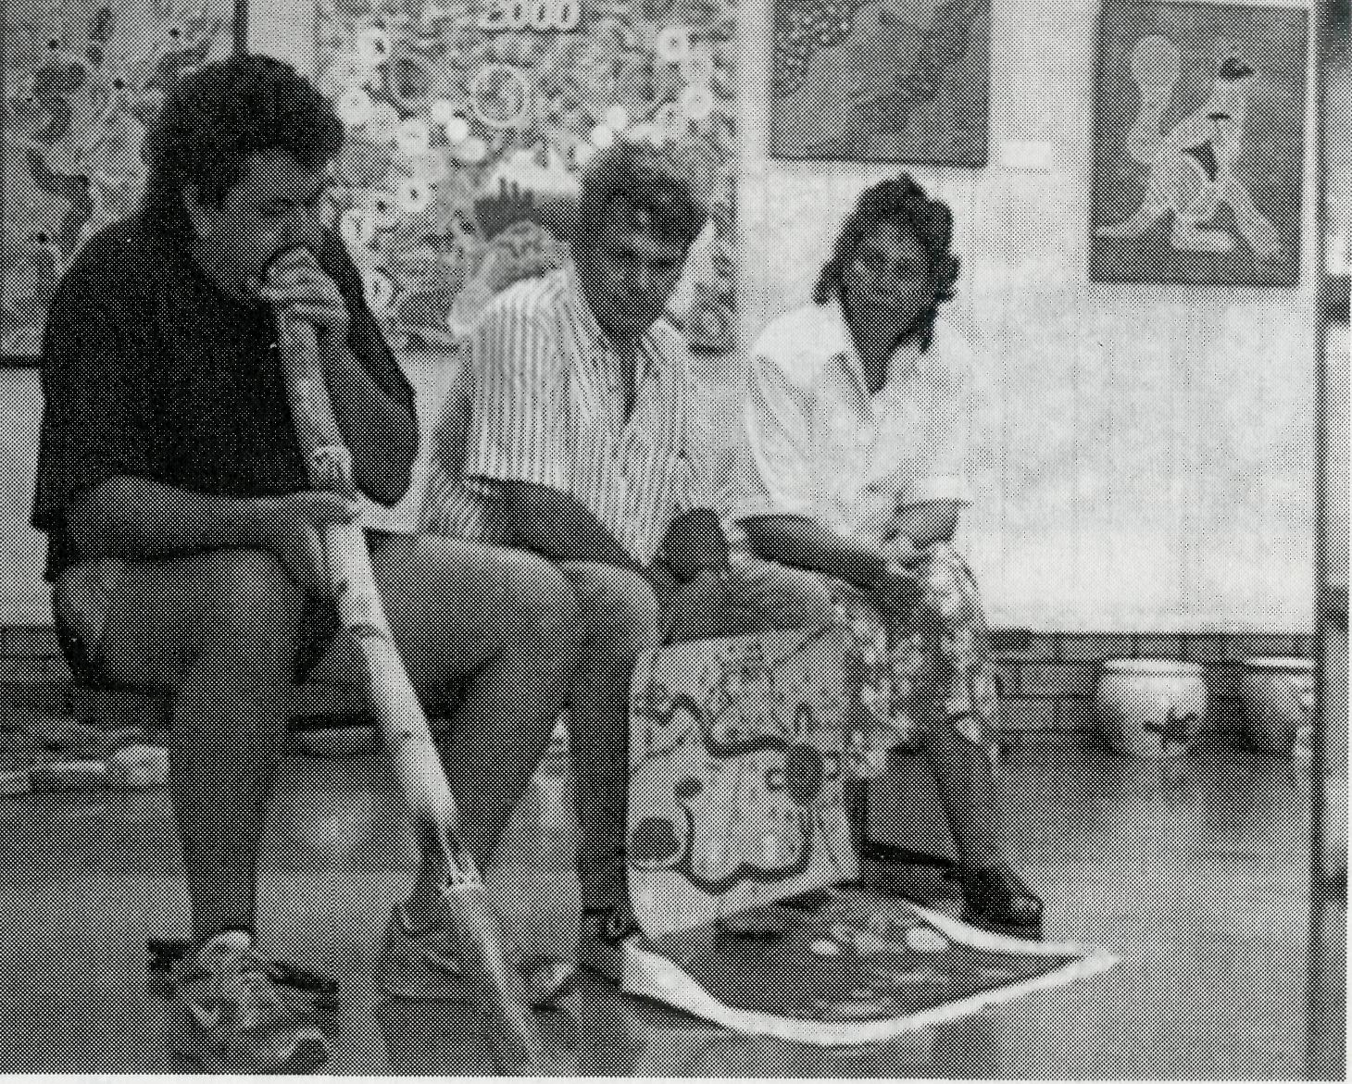
sermon, heartfelt prayers for those in need, a warm embrace and handshake with the Peace, a thankful sharing in Holy Communion and a great cuppa afterwards. Gloria said that sometimes they start with a cuppa in order to welcome and help people share their concerns which are later taken up in the prayers. As a member reflected; "It's just like a kitchen"—children and adults sharing, laughing, praying in a warm place of community.
"Reconciliation," says Gloria, "begins with Christ and leads us to sit down and listen to one another with respect. If people could make time to have a cuppa maybe they could overcome barriers and work together."
GREG THOMPSON—NSW Secretary
EXMOUTH
Once supported by BCA, the Anglican Church of Exmouth in the Diocese of North West now helps support BCA! Exmouth has similar ministerial requirements to most of the other norwest BCA supported parishes, and should anyone be travelling through the area, you would be welcome at the Exmouth Naval Chapel for the service at 9.00am every Sunday.
REV ROD WILLIAMS
Phone (08) 9949 1694. Fax (08) 9949 2463

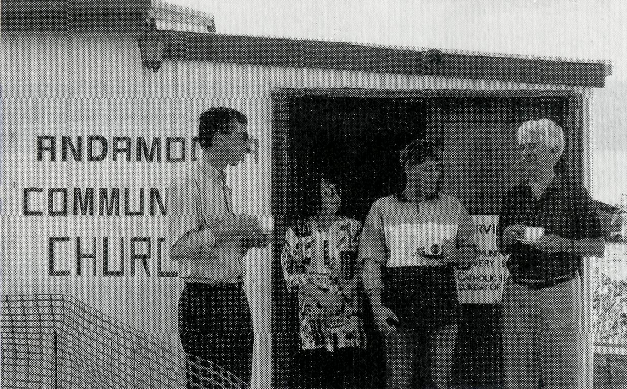
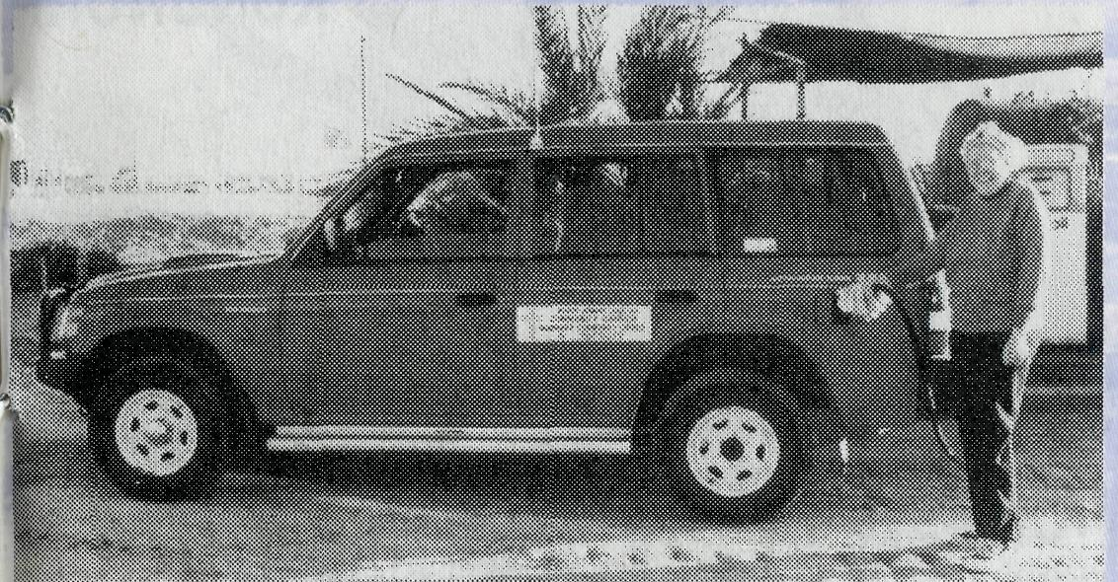
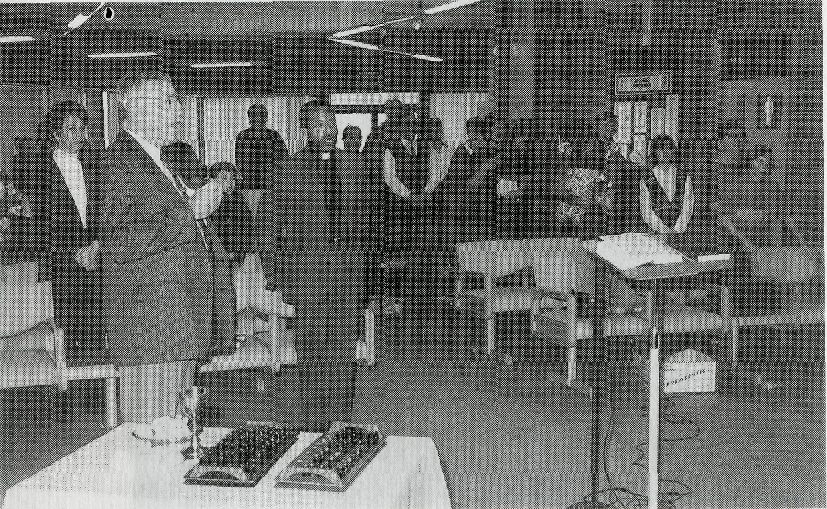
Ripples of Encouragement
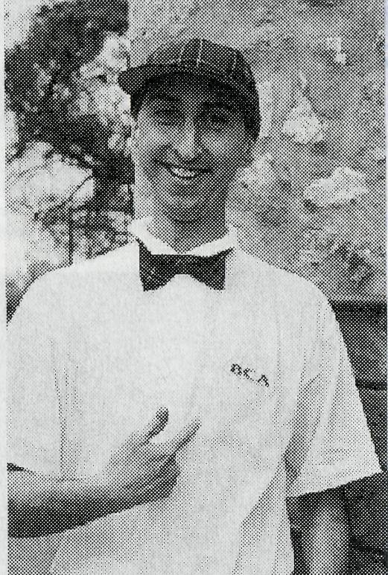
My wife and I were sitting in a small outback store with a couple of petrol pumps out the front, listening to Marie Powell—a Christian lady of great faith. Born in Zambia, she had come with her family to Australia 28 years ago and the lure of opals had drawn them to Andamooka.
"We used to see a minister only every 3 or 4 months when the Lutheran Pastor came by. Now, thanks to BCA, we have a service every Sunday and someone to look after our needs. He's young, he's a very good teacher, his sermons are terrific, he's God's man for this town," said Marie with conviction.
We had come from Sydney to see at first hand how BCA is helping the 'Battlers of the Bush' and this was surely a heartwarming and encouraging start. However, we were soon to learn that ministering to the opal community at Andamooka was only one of many aspects of the work of Ian and Glenda McGrath, the BCA team based at Roxby Downs.
Church in the foyer of the Roxby Downs Community Centre

Left: Ian models woollen product at Bulgunnia Station.
Top right: Ian enjoys a cuppa after a service at Andamooka.
Right: Marie fills the BCA vehicle at Andamooka.
Another major task is the planning of regular visits to the pastoral community living on remote stations often separated by hundreds of kilometres. We made one such trip to Bulgunnia Homestead, where Ashley Moore likened the work of BCA to dropping a stone in the water in the city and the ripples reach out to all the remote areas of Australia. "Ian's work touches us very deeply," she said, "from the joy of having him baptise our grand-daughter to having someone share a problem or a bible reading."
At present it would seem that there is a great opportunity for ministry in Roxby Downs itself with its transitory community of miners and their families. Ian tells of examples of great encouragement such as the couple now attending his 'Christianity Explained' course after the wife was recently baptised and where the husband claims that "with Jesus, his life now has real hope and meaning".
Ian reports that his congregation is growing steadily towards the 100 mark, despite having no permanent church build-
ing. At present, they meet in the foyer of the Roxby Downs Community Centre. However, exciting new plans are in progress.
Thanks to Ian's passion and planning and with the help of a small group of supporters, a suitable block of land in town has been secured and cleared for a new Anglican church. OEP (Olympic Dam Expansion Project) have offered to lay the concrete slab and other local companies have agreed to provide other services and supplies, such as plumbing, construction and paint, either free of charge or at hugely discounted prices. Praise the Lord that this vision is coming to fruition and pray for stamina and faithfulness to see its completion. What a blessing it will be for the furthering of God's work in Roxby.
As we boarded the 19 seater Kendall Airlines Metro back to Adelaide after our short visit, it was very pleasing to reflect on having seen how BCA's ministry was touching the lives of real people in outback Australia. And there is so much that can be done with the prayerful and financial assis-
BCA Archives
Can anyone identify this BCA Sister please? This photograph was taken at Cook Hospital at the end of October 1937. The Sister is holding Sydney James Cook born 30/10/37.
CLEM KIRKBY
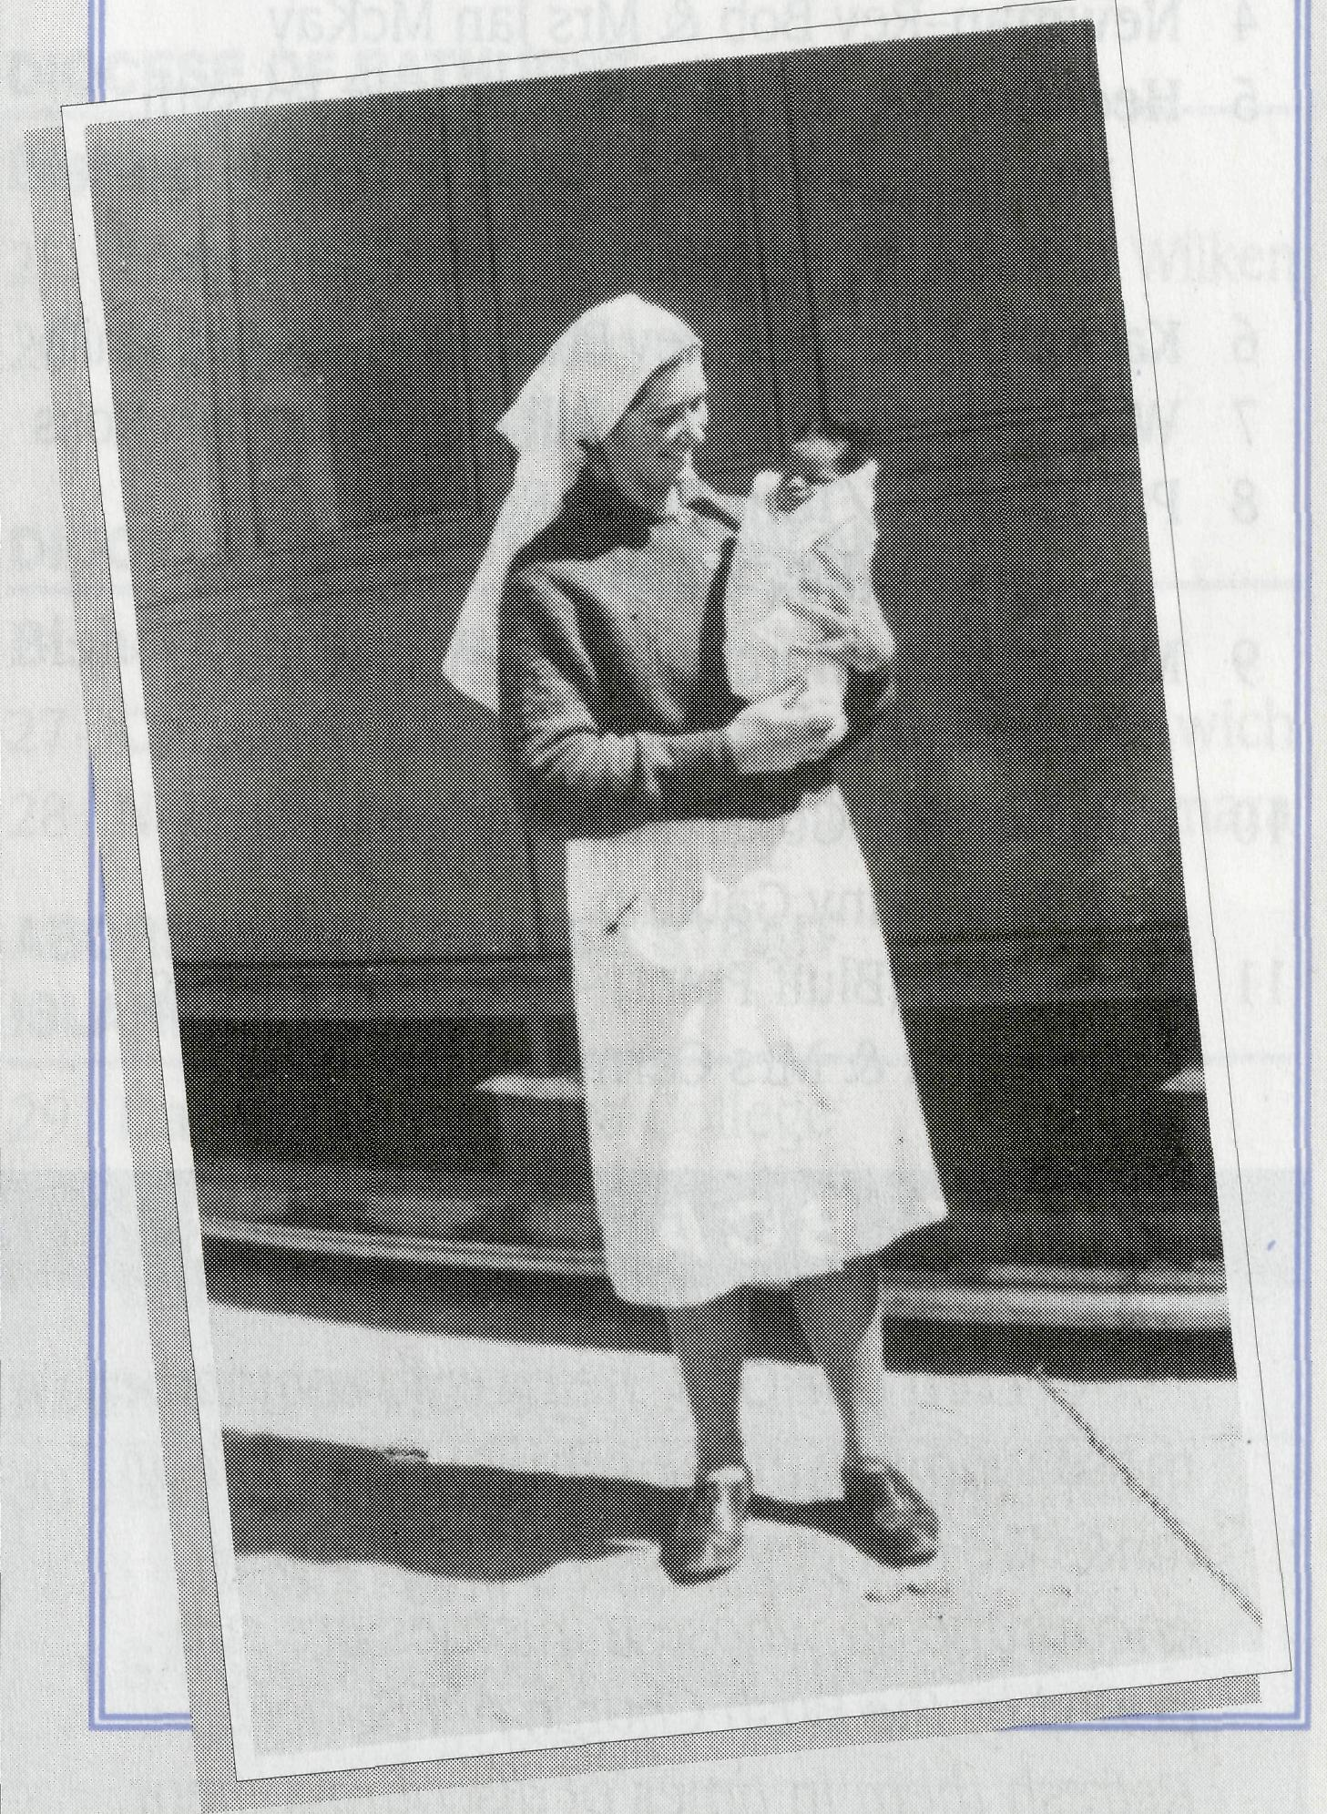
tance of BCA supporters in our larger towns and cities—sending out the ripples of encouragement.
A final thought—if there are individuals or parish groups with building and decorating skills looking for an exciting and worthwhile holiday project for 1998, then Ian McGrath (08) 8671 0270 would be just thrilled to hear from you.
ALAN ROGERS—Parishioner, St Stephen's, Normanhurst

PRAY FOR OUR STAFF
OUR MISSION FIELD
PRAY FOR OUR STAFF

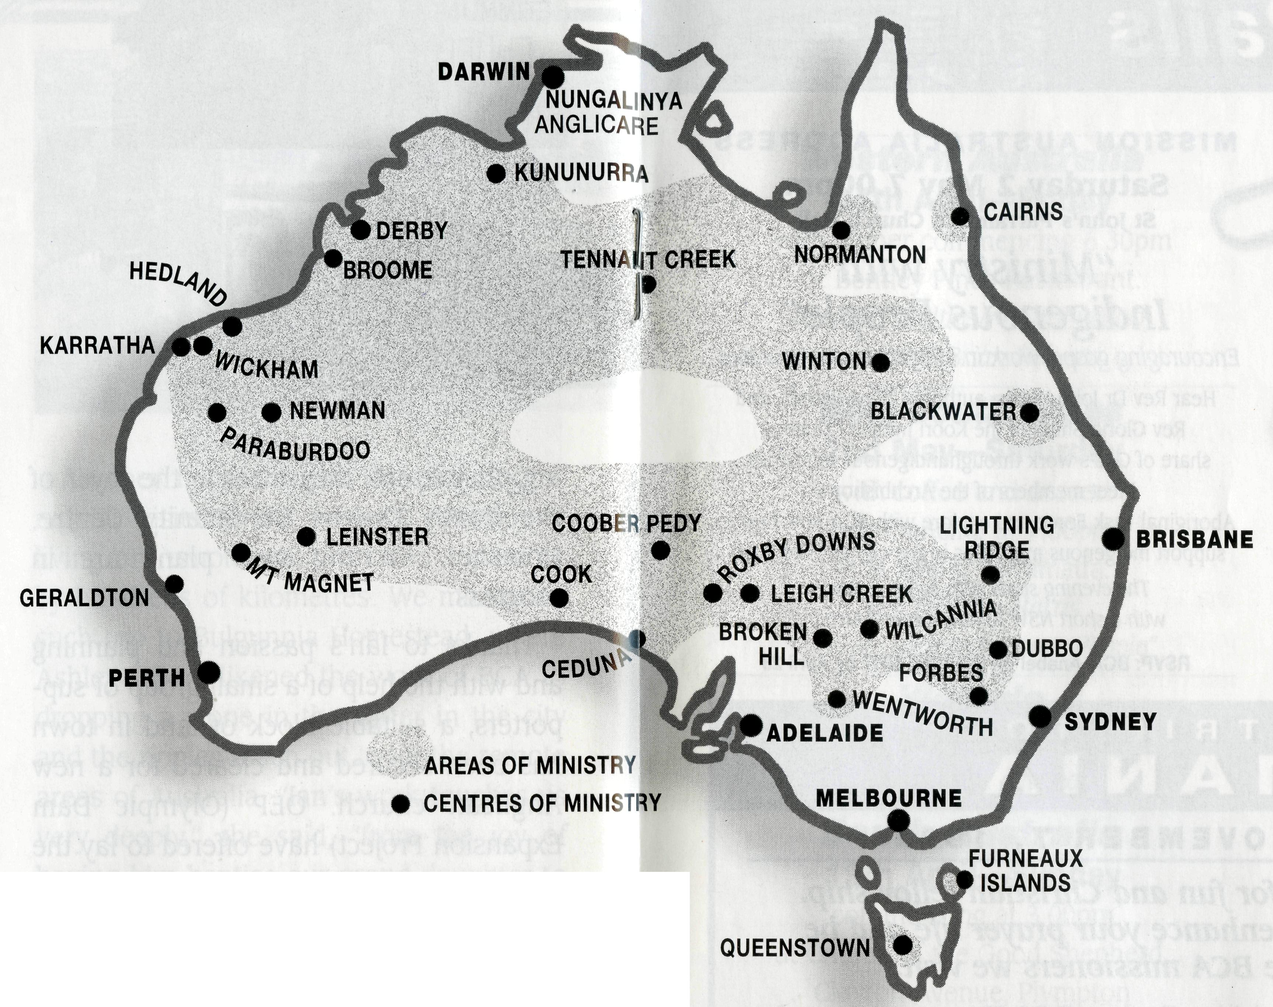
DIOCESE OF NORTHERN TERRITORY Bishop Richard Appleby
1 Tennant Creek-Rev Tom & Mrs Carol Williams
DIOCESE OF NORTH WEST AUSTRALIA Bishop Tony Nichols
2 Kununurra-Rev Bob
& Mrs Denise Rothwell (locum)
3 Broome-Rev David
& Mrs Cheryl O'Mara (Ministry Training)
- Newman-Rev Bob & Mrs Jan McKay
- Hedland-Rev Ian & Mrs Margaret Forsyth
Rev Malcolm
& Mrs Leanne Reid (Ministry Training)
- Karratha/Dampier-Rev Philip & Mrs Kathy Knife
- Wickham-Archdeacon Bill & Mrs Jocelyn Ross
- Paraburdoo/Tom Price-Rev Neil
& Mrs Anthea Walthew
9 Mt Magnet (Murchison) -ministered to
by Geraldton clergy
10 Leinster (NE Goldfields)-Rev Les
& Mrs Jenny Gaulton
11 Geraldton (Bluff Point)-(Ministry Training)
Rev Neil & Mrs Carmen Ellis
THE BCA PRAYER
O Lord our God, help us to remember those who live in the remote parts of our land. We ask you to strengthen and encourage all whose ministries are supported by the Bush Church Aid Society. Refresh them in times of discouragement and loneliness and call others to stand with them in the task of making Christ known. Grant that, through the ministry of the Word and Sacraments, through medical work, through service and by caring for the young, the message of your redeeming love may be proclaimed and accepted by the people throughout our land. We ask these things through Jesus Christ our Lord, who lives and reigns with you and the Holy Spirit, one God, for ever
and ever .
Amen.
DIOCESE OF WILLOCHRA Bishop David McCall
- Coober Pedy-vacant
- Roxby Downs and Mid-West Mission-
Rev Ian & Mrs Glenda McGrath
- Leigh Creek-Rev Ted & Mrs Morwen Watkins
- Cook-Bishop Kirkby Memorial Hospital-
Sr Anneliese Cusack
16 Ceduna-Rev Tom & Mrs Michelle Beever

If you'd like more details for prayer, send for our free quarterly prayer notes.
DIOCESE OF RIVERINA
Bishop Bruce Clark
17 Broken Hill BCA House-Mr Ian
& Mrs Carol Blow
18 Wilcannia-Mr Brian
& Mrs Beverley Bell (lay catechist)
19 Wentworth-Rev Don and Mrs Helen Wilson
DIOCESE OF TASMANIA Bishop Phillip Newell
20 Queenstown (West Coast)-
Rev David & Mrs Trudy Sharman
21 Furneaux Islands-Rev Geoff
& Mrs Gill Bransgrove
DIOCESE OF ARMIDALE
Bishop Peter Chiswell
22 Lightning Ridge-Rev Geoff
& Mrs Catherine Hearne
DIOCESE OF ROCKHAMPTON Bishop Ron Stone
- Winton-Rev Peter & Mrs Jeanette Blundell
- Blackwater-Rev Clive
& Mrs Vivienne Robinson
DIOCESE OF BATHURST
Bishop Bruce Wilson
- Forbes BCA House-Mr Peter & Mrs Jenny Wilken
- Dubbo-Koori ministry-Rev Gloria
& Mr Eddie Shipp
DIOCESE OF NORTH QUEENSLAND
Bishop Clyde Wood
- Cairns-St Luke's-Rev Jim & Mrs Lala Leftwich
- Normanton-Rev Vic & Mrs Doreen McNamara
ABORIGINAL & TORRES STRAIT
ISLANDER MINISTRY
29 Darwin-Nungalinya College
-Ms Elizabeth Caldwell Darwin-Anglicare-Mr Peter & Mrs Lynne Fisher
REGIONAL OFFICES
30 WA Part-time Secretary-Bishop Bernard
& Mrs Coralie Buckland
SA Secretary-Rev Owen Thomas, Mrs Aila Alderson
Vic. & Tas. Secretary-Rev Murray Lamont, Ms Margo Bright
NSW Secretary-Rev Greg Thompson, Mr Ric Bollen, Ms Anabel Walters
Qld. & Northern NSW Secretary-Rev Les Monaghan, Mrs Dianne Harris, Mrs Ruth Blackburn
BCA NATIONAL OFFICE
31 Rev Brian Roberts, Mr Jim Gosbee,
Mr Dennis Outred, Mrs Amutha Gibson, Mrs Michele Peacock, Mrs Thelma Doyle

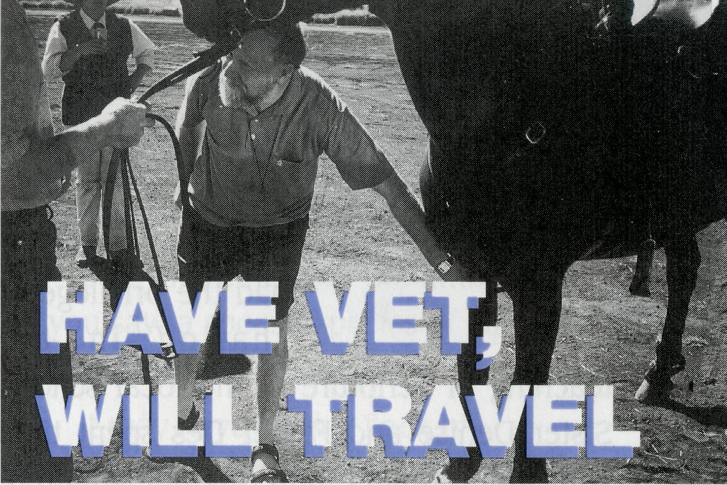
POST & Rails
Join a BCA 'Bush 'n City' tour for fun and Christian fellowship.
The first-hand knowledge will enhance your prayer life and be
an encouragement to the BCA missioners we visit.
Seventeen Days from Tamworth, visiting Forbes BCA House,
the Victorian countryside, Devonport in Tasmania, Cradle Mountain, Queenstown, Gordon River Cruise, Mt Field National Park, Hobart, Port Arthur, Cadbury's factory, Salamanca, Richmond, St Helen's, Launceston and the Furneaux Islands.
For travel advice and assistance in getting to Tamworth—talk to us.
Price of $2045 (Pensioners $1995) includes twin share motel accommodation and most meals (optional additional $220 to take the air flight over and ground tour with the Bransgroves on the Furneaux Islands).
Phone: (07) 3349 9081 for brochure and to book
or write to BCA, PO Box 6565, Upper Mt Gravatt, Qld. 4122.
BCA supports missioners in areas shown in bold.
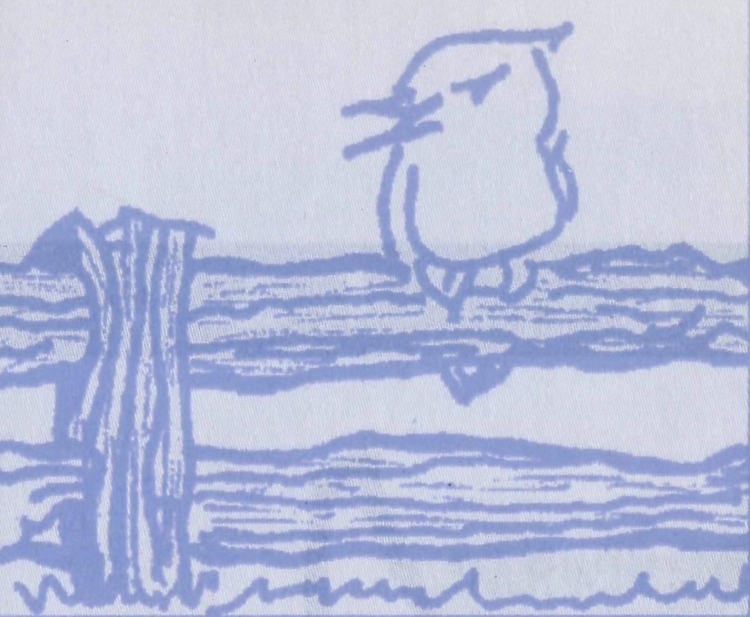
MISSION AUSTRALIA ADDRESS
Saturday 2 May 7.00pm
St John's Parramatta Church Hall
"Ministry with Indigenous People"
Encouraging gospel work in indigenous communities.
Hear Rev Dr John Harris, author of "One Blood", and
Rev Gloria Shipp of the Koori ministry Dubbo,
share of God's work through indigenous ministries.
Meet members of the Archbishop's
Aboriginal Task Force and explore with BCA how best to
support indigenous ministries in the city and the bush.
COACH TRIP to Western NSW and South Australia
15-29 August, 1998
Phone Owen Thomas (08) 8388 2346 for details

The evening starts with coffee & dessert
with a short NSW Annual General Meeting.
RSVP: BCA-Anabel on (02) 9262 5017 by April 28

*
ANNUAL
GENERAL
MEETINGS
DATES
Western Australia
24th April—Friday
with dinner commencing 6.30pm
at Bentley Pines Restaurant.
Rev Neil Walthew (Paraburdoo)
and Rev Brian Roberts
New South Wales
2nd May—Saturday
with coffee and dessert
commencing at 7.00pm
at St John's, Parramatta.
Rev Dr John Harris
'Ministry with Indigenous People"
COACH TRIP TO
TASMANIA
OCTOBER 22 to NOVEMBER 7, 1998
16th May—Saturday
Venue to be advised
South Australia
19th April—Sunday
commencing at 3.00pm
at Church of the Good Shepherd,
Clayton Avenue, Plympton
with Rev Ted & Mrs Morwen Watkins (Leigh Creek)
Queensland/Northern NSW
17th May—Sunday
1 .OOprn BYO basket lunch
followed by AGM at 2.00pm
at St Francis College, 23 Milton Road, Milton.
2.30pm MISSION AUSTRALIA Address
Rev Drjohn Harris
"Ministry with Indigenous People"
National Office
21st May—Thursday
9.30am at Level 15, 37 York Street, Sydney.
Where on earth is Nullagine? What is there? Why is it important?
Mid way between Newman and Marble Bar in the Pilbara of Western Australia, is this small town of some 160 people. A gentle, peaceful mixture of 120 aborigines and 40 non-indigenous Australians. A town with a Roadhouse, a School and the Conglomerate Pub.
Recently I travelled with Bob McKay for a Sunday night service in the town "hall". With us were Sister Denise and Father Des, of the Catholic Church at Newman. We often stopped along the 200km dirt road to appreciate the beauty of the Pilbara in both its unique landscape and its wild flowers.
At 5.30pm, the four of us gathered for "church", along with one lady from town. As Father Des led us in song and Bob opened up God's word, our one local lady began to share with us both her struggles, and those of her two daughters. One daughter lived in Newman, while the other was on the other side of this vast country.
We had a very special time praying for her and asking that the Lord would not only meet her needs, but also those of her daughters. There was a real sense of His presence as together, in unity, the church meeting that night in Nullagine, poured

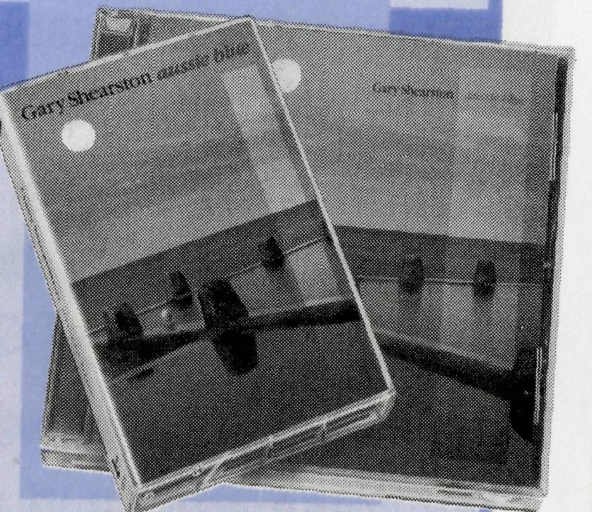
out its needs before God.
The next day we had the privilege of sharing in the teaching of Scripture at the local school. Sister Denise and Father Des spent time with the primary and infants children, while Bob and I interacted with the secondary students. Bob showed a section of the movie "Jesus" and talked about God coming in His Son to bring new life. Bob asked me to explain why Jesus came. I was able to tell the story of the rescue of Tony Bullimore—an event that took place last January some 2600kms south of Perth. A rescue that, together with that of two others, cost over $10 million. We looked at the cost of the rescue and the distance travelled to bring Tony Bullimore home. We talked about the rescue mission that God launched some 2000 years ago, at great cost to Himself, to bring lost humanity back to Himself. We realised that nowhere was too far from rescue.
The ten aboriginal secondary students listened carefully. But so did their two teachers. One, a first year out teacher, shared later that he was a Christian who had got away a little from the Lord, but had
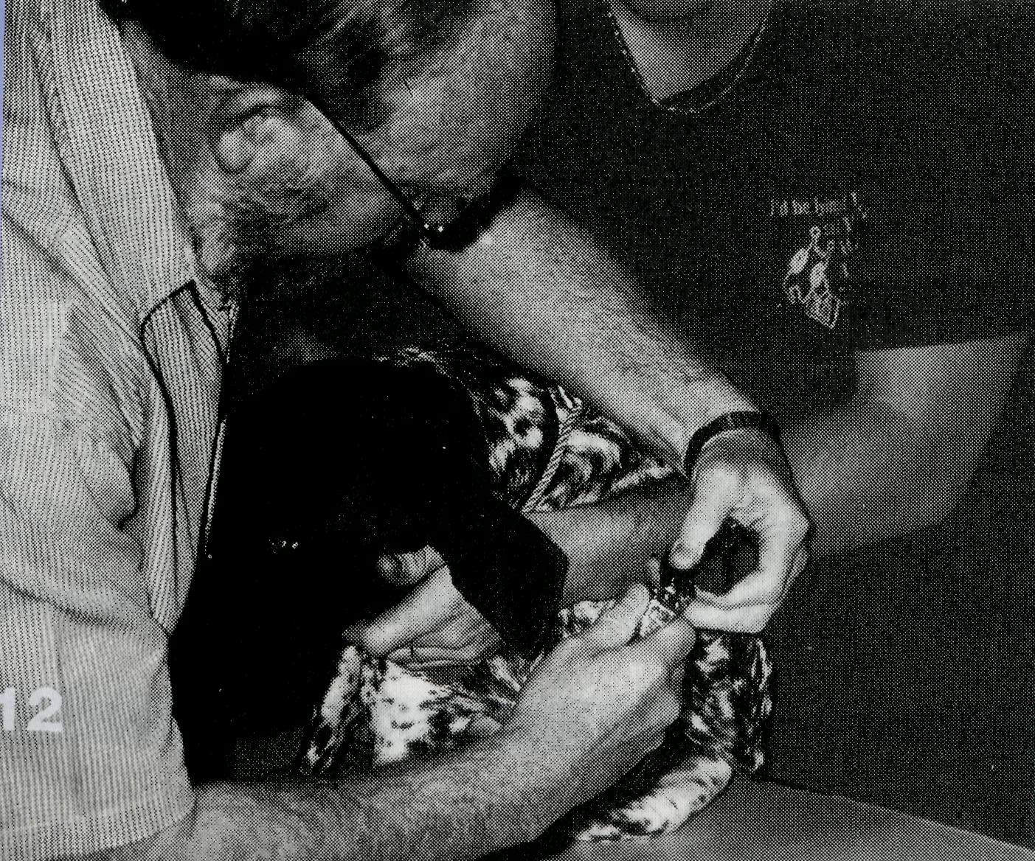
been challenged to come back. As we talked later, he asked when the next service would be. We said next month. He said he would be there. Praise the Lord!!! While Bob helped some of the locals with veterinary needs, I was able to sit with three older aboriginal men on the grass opposite the hotel. They told me of their nomadic background and their deep desire to see their grandchildren grow up to both read and write, something they could not do. They described the town, which now was their home. One introduced me to his son.
On the way back to Newman, we called in to a station for Bob to check a mare in foal. This property covered over 1.2 million acres. What a great opportunity to talk with and share practically with the people on the station. Bob was welcomed both as a vet and as a minister of the gospel.
Later on the side of the road we refuelled the car from cans of petrol carried. Here in the middle of the Pilbara we realised the great privilege of travelling as brothers and sisters in Christ, to take his love to the small town of Nullagine. So much of its future depends on the ongoing support of the ministry of people like Bob, Sister Denise and Father Des, and all those who so effectively give and pray that the love of the Lord would impact and rescue all those who have become lost.
The story of BCA has been and always will be that of rescue. Using all the gifts and talents that the Lord gives to us, to go
(Page 11) Bob checks a mare in foal and Left, attends to a dog on his rounds.
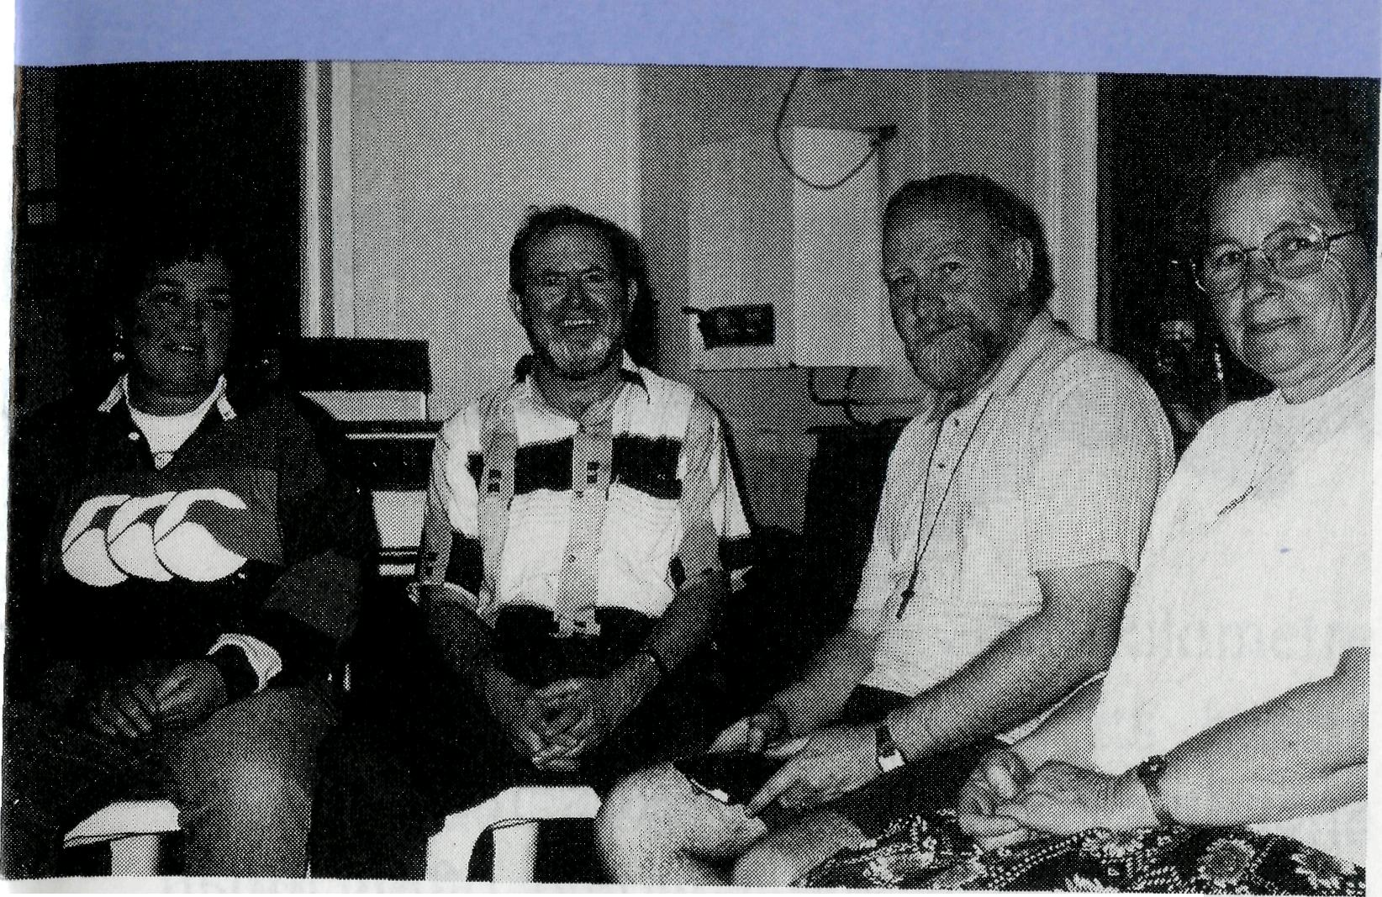
"Church" gathering at Nullagine. Sister Denise, Father Des, Bob and a local Christian.
to where people are, to get alongside of them in their physical and spiritual need and let them know that God cares. Jesus continually went out of His way to meet with individuals, often in outback environments, to let them know that He was the God who rescues. We are called to continue that rescue mission to the people of the rural and remote urban areas of this country. What an amazing privilege. There is "Hope on the Horizon" for all those who seem so far away. "The Son of man came to seek out and to save the lost". (Luke 19:10 NRSV)
RIC BOLLEN—Assistant Secretary-NSW/ACT
EVOCATIVE CD OR CASSETTE
“aussie blue”
Rev Gary Shearston (Rector
Hay, NSW) former international
folk singer, evokes images of
Australia ranging from convict
Tasmania, east-coast summer
beach culture to gold and opal
prospecting. Songs that speak of our Aussie
character and cause you to stop, reflect and meditate.
To ORDER use the form on the back flap
of this magazine (from BCA NSW office only).
Bird Watching
Can you remember the time that you saw a special species of bird for the first time?
It may have been a flock of Budgerigars in the wild instead of in cages, or that beautiful Australian finch, the Gouldian Finch. On one of our early tours, I can remember the thrill of all the coach group when we saw a pair of Brolgas dancing in the late afternoon just by the roadside, and all our childhood memories of the poetry about the Brolga, the dancing bird of the plains, were relived.
You don't have to be an avid birdwatcher to enjoy the sights and sounds of birds.
There are two birds in the Bible that are mentioned regularly. The first one that probably comes to your mind is the eagle. A bird with which we associate strength and freedom, found in the outback of Australia and is mentioned in the Bible as an image of soaring above those things that surround us.
"...but they who wait for the Lord shall renew their strength. They shall mount up with wings like eagles" Isaiah 40:31. In many churches, the Bible is read from a lectern where the book rests on eagles wings.
But my vote for the most thought provoking bird mentioned in the Bible is the sparrow.

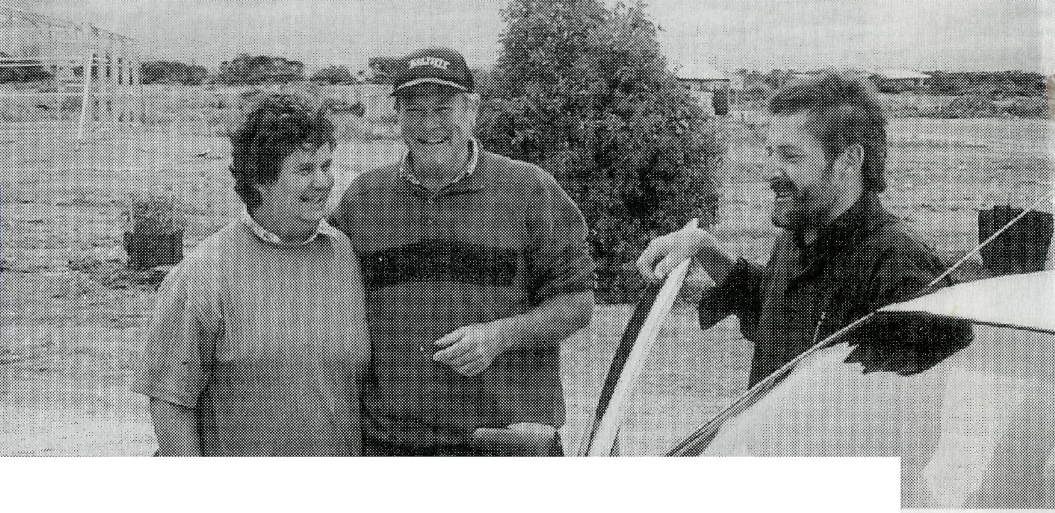
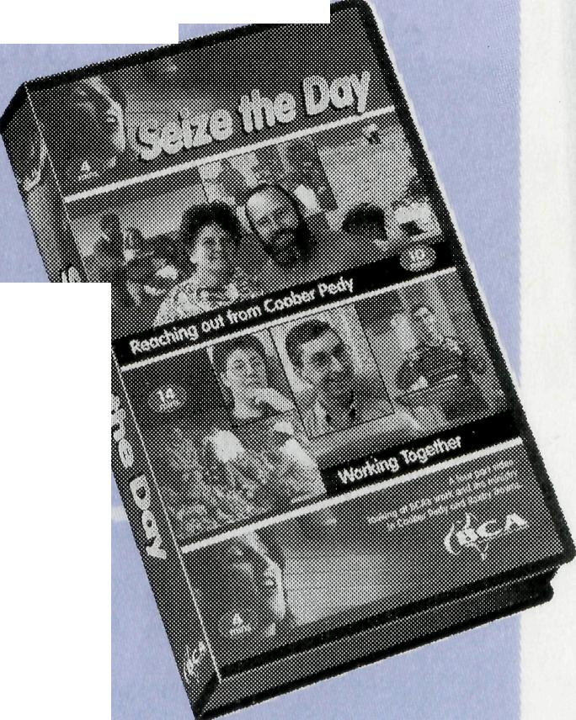
Report from Ceduna

It's no accident that this little scavenging urban bird is mentioned. It appears in every city of the world and so we will always see the sparrow, and in seeing it, be reminded of God's promises to us all.
"Are not two sparrows sold for a penny? And not one of them will fall to the ground without your Father's will." Matt 10:29.
This verse continues with a reminder that God's knowledge of us is so intimate that even the number of hairs on our head are known-something we don't even know about ourselves. "Fear not therefore, you are of more value than many sparrows."
Each time you see the humble sparrow, spare a thought, and offer a prayer of thankfulness to God that you are of more value than many sparrows, because God's protection of them, and knowledge of our circumstances are in His hands.
A four part video looking at BCA's work and the ministry in Coober Pedy \ and Roxby Downs.
Available from your Regional BCA office.
JOHN CRONSHAW-Member BCA Executive. (John has led several BCA coach tours.)
Seize the Day
/t seems rather ironic that after spending the last nine years in Melbourne where Michelle and I would often moan "Please Lord, don't let it rain today", now here we are ministering in a place where we often pray, "Please Lord, let it rain today!". Quite a contrast! We, along with many others, pray that prayer because, although Ceduna is blessed with a wonderful climate, everything depends upon the right amount of rainfall at the right time in this large wheat-growing community.
Ceduna is beautifully situated on the shores of Mural Bay and is the last major town before an east-west crossing of the Nullarbor. Appropriately, the name Ceduna is derived from the Aboriginal word "Chedoona" which means "a resting place".
Ceduna is the focal point and business centre of the far west coast of South Australia. The major areas of industry are wheat farming, oyster farming, fishing and gypsum and salt mining. However, because of the location of the town on the coast and on the edge of the Nullarbor combined with its wonderful climate, tourism has also become an important aspect of the life of Ceduna.
We have been warmly welcomed into the community and made to feel at home in this friendly town. I was rather concerned we might not be welcome when straight after arrival our daughter Elizabeth's pet black rabbit (which had
somehow survived a hot 2000 kilometre car trip) dug its way out of its hutch. Blackie had been vaccinated against the calici virus and during the day it took to recapture her, I had visions of little black rabbits popping up all around the countryside where the virus was meant to be eliminating the rabbit population. Fortunately we were able to catch Blackie and prevent any embarrassing moments discussing a rising population of black rabbits around town!
Since our arrival in the parish (Feb 97) we've been privileged to see the divine work of our Lord in so many areas. There's been a considerable growth in church attendance, particularly of young families and this has resulted in a growing Sunday School. The young ones are involved in our monthly family services and they, along with the development of our music group, are providing blessings in our worship. We have seen God at work within the parish as we have extended an already established prayer program that has everyone in the parish praying for each other. We've seen His work also in the establishment of the Christian Radio Network which will enable us to take the Gospel message into the homes of our community. And we've seen His work in so many pastoral settings such as following the tragic death of a young lad in a motor accident which has deeply affected many people.
The parish of Ceduna holds a long and
historic association with BCA and although the parish is now only partly funded by BCA, the two hold a very special link that binds us together. Michelle and I rejoice in that link and in the way BCA supporters make regular contact through letters, telephone calls, visiting for worship on Sunday or popping into the rectory. Most of all we value the wonderful prayer support that we receive.
I knew from the very first time I stood on the tarmac of the Ceduna airport, when Michelle and I were flown here for our interview in November '96, that Ceduna was the place to which God was calling us. After our months here, we have no doubt in our hearts, nor is there any doubt in the hearts of the people here, that God has called us to the parish of Ceduna. We value your continued prayer as we minister here.
TOM BEEVER-Ceduna
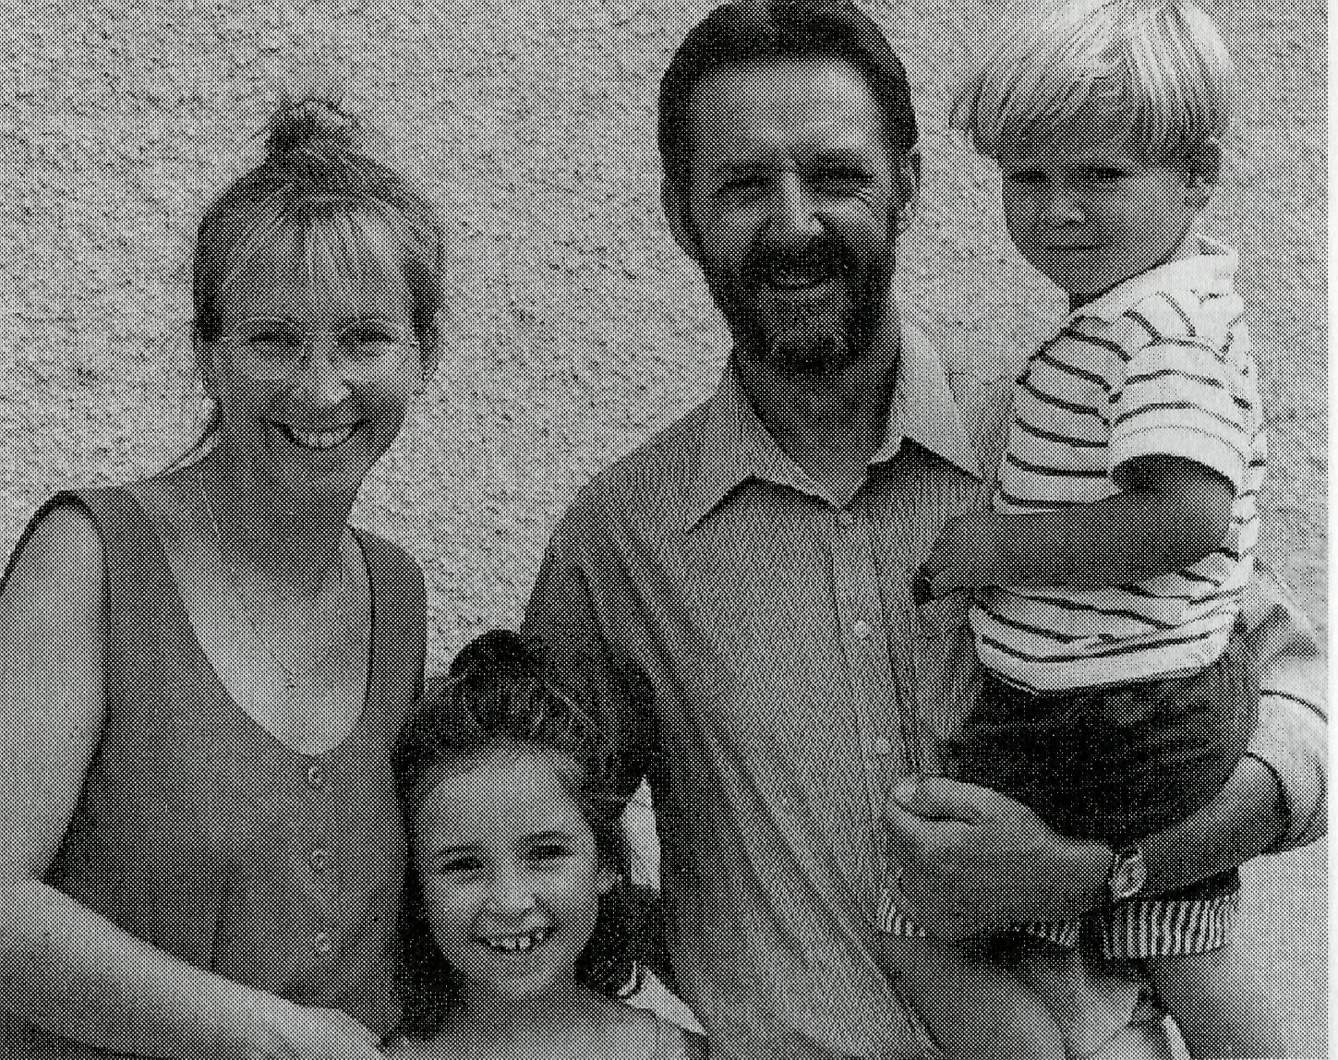

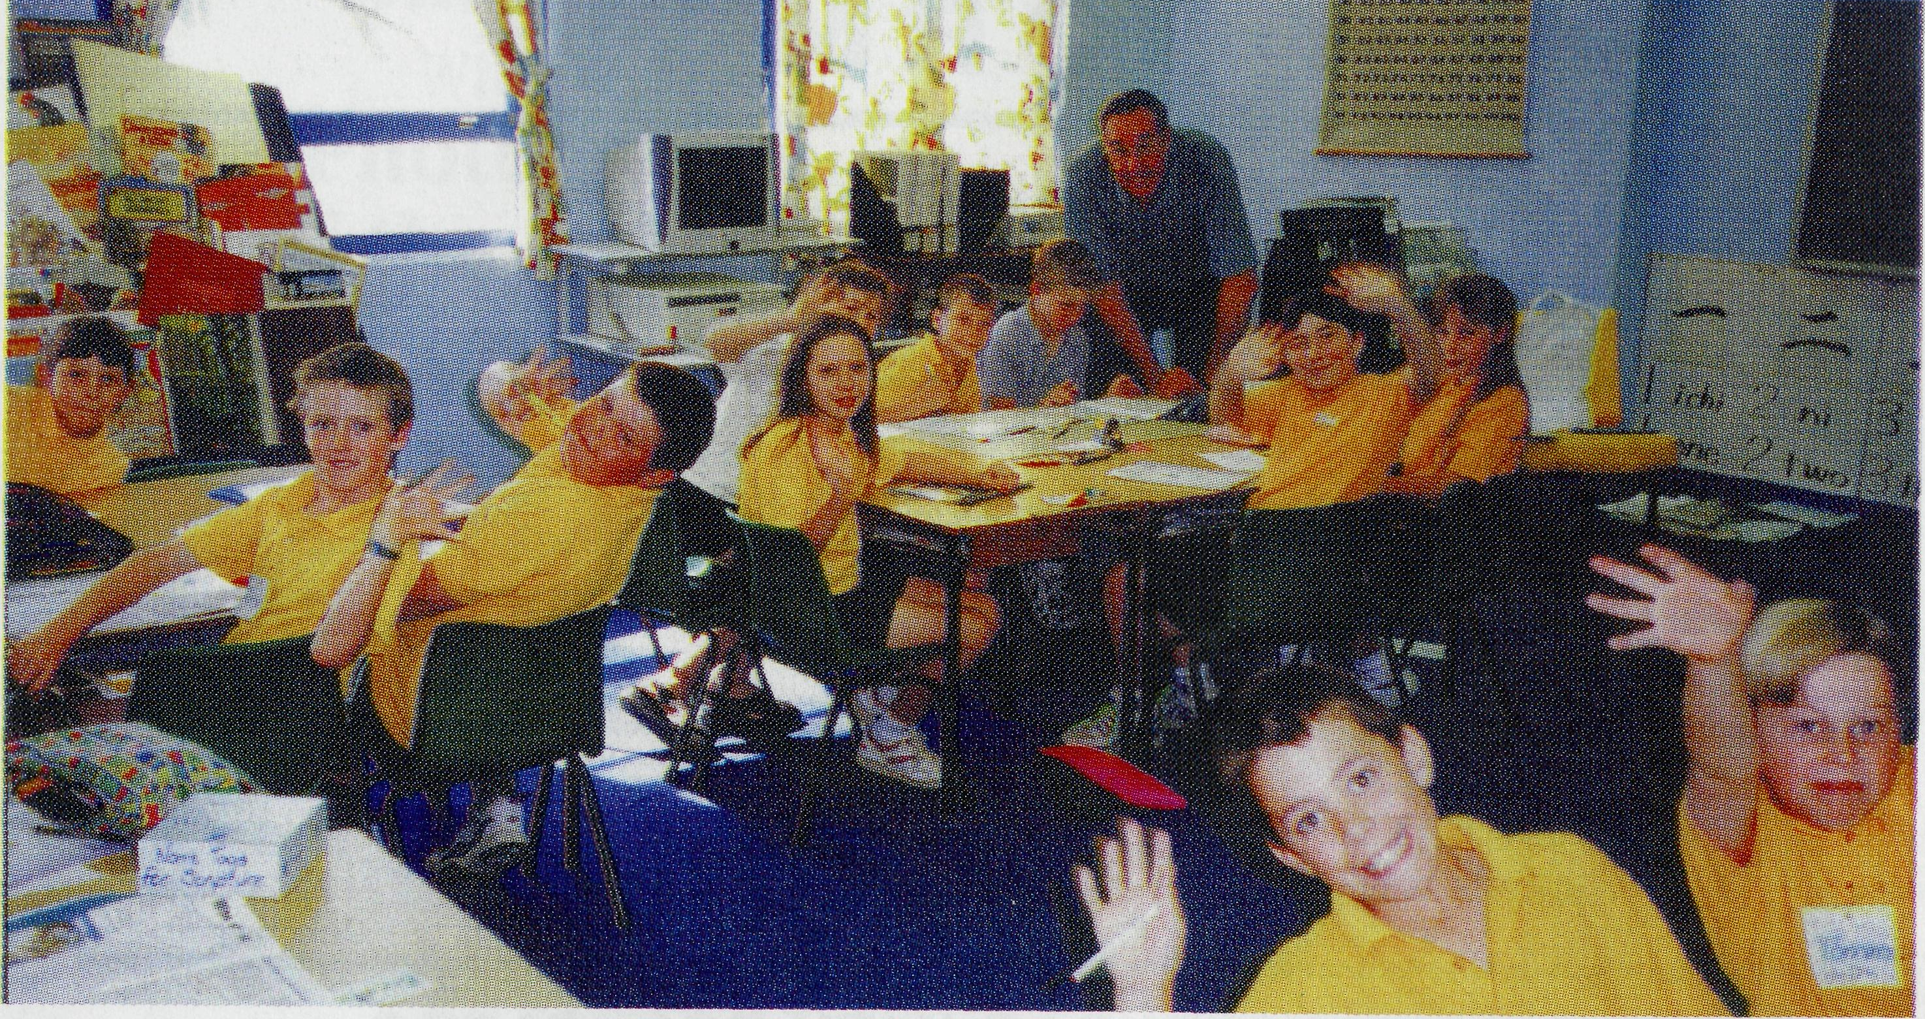
Kids in Don Wilson's Scripture class at Wentworth Primary School enjoying learning about Jesus.
Above: At the Celebration in Ceduna (from left) Gai Di Donna, SrAnneliese Cusack, (Cook), Hilary Thomas and Gloria Cox.
Below: Picture donated to BCA and painted by local Ceduna artist, Norma Pearsons.
Bottom: The congregation at Ceduna at the 60th Anniversary of the Bishop Kirkby Memorial Hospital in Cook, praising the Lord for his goodness and opportunities over the years.
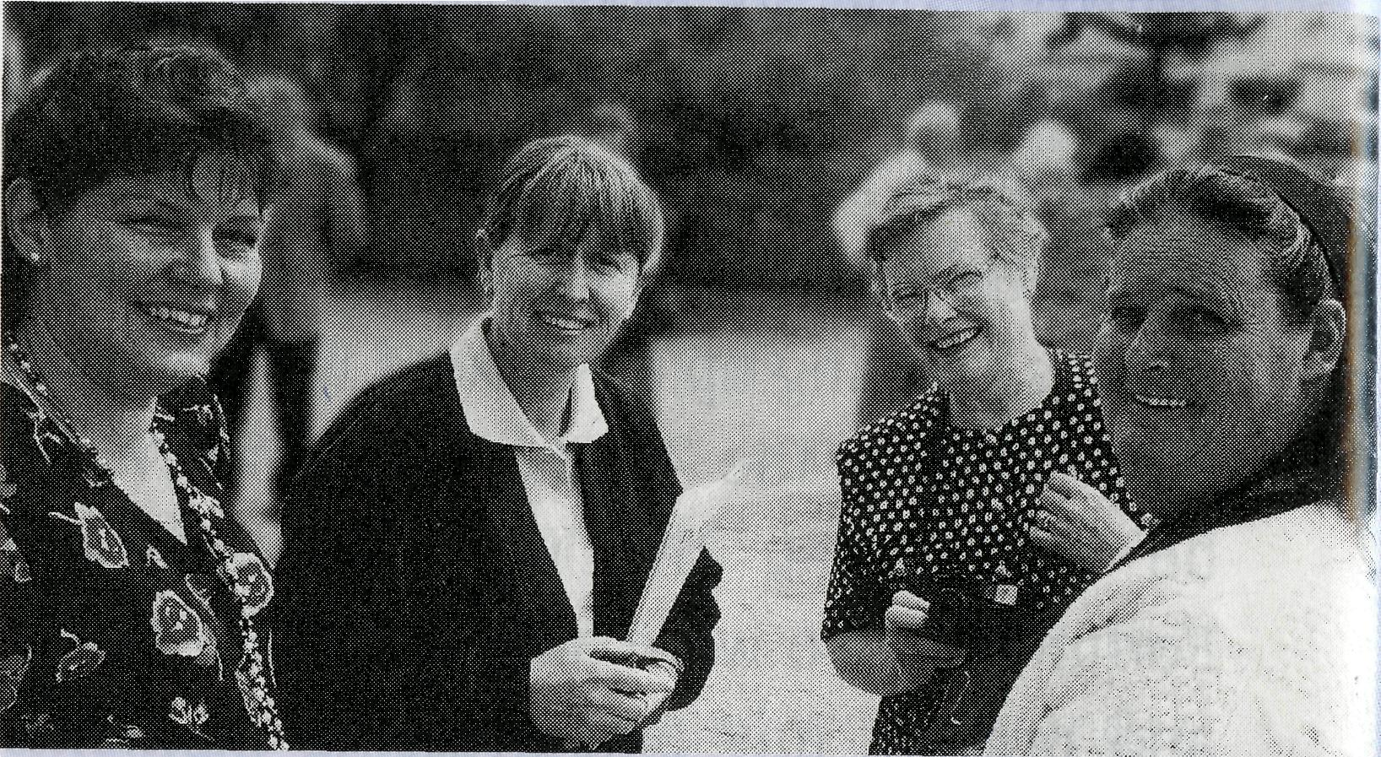
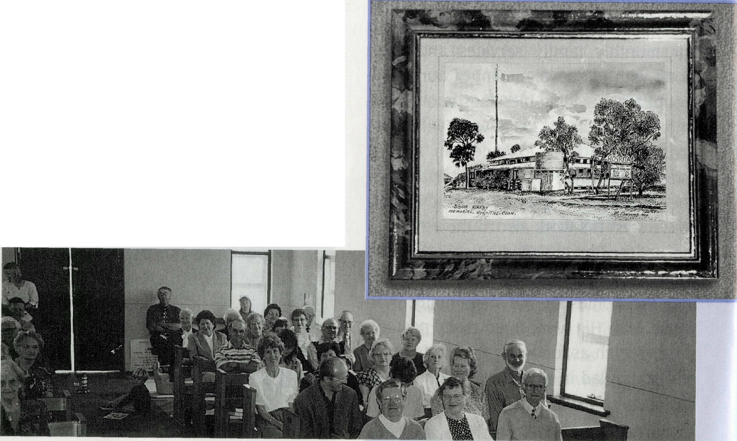
Celebration in Ceduna
60th Anniversary of the Bishop Kirkby Memorial Hospital, Cook, S.A.
In November last year, many of those who lived and worked in Cook or were part of BCA's Flying Medical Service, gathered in Ceduna and Adelaide to commemorate the 60 years of the nursing service at the Bishop Kirkby Memorial Hospital at Cook.
Over 50 people attended a celebration dinner, in Ceduna, where BCA's medical ministry started in 1925. Stories were shared and old photos rekindled memories of the early days giving latecomers to Cook a taste of what it was like .
At.a Service in St Michael and All Angel's Church, the National Secretary, Rev Brian Roberts, recalled the visions of the second Organising Missioner Tom Jones who called for people to "attempt Great Things for God" and God, true to his promises and answering prayer, supplied what was needed to build and run the Hospital since 1937.

While people were meeting in Ceduna, Rev Bob George, former BCA Regional Secretary and closely involved with the hospital a decade ago, led a celebratory service in St Bartholomew's, Norwood. 20 former associates of the hospital not able to travel to Ceduna, attended.

YES! ■ ■•) support n nil the city
REV/MR/MRS/MISS/MS (Initials) (Surname)
TELEPHONE PARISH (if applicable)
♦♦♦ My Gift is enclosed for $
Please debit my J bankcard j mastercard ] visacard
NAME OF CARDHOLDER .
EXPIRY DATE ( | § j j SIGNATURE
♦ I would like to donate regularly using my credit card.
Please debit my card Q monthly ! J quarterly □ half yearly for $
*> Tick Box if receipt is required j Outback ministry
LJ Hostel (Tax Deductible)
- Please send me the prayer notes Q
- Please send me information of BCA events |
- Please send me a money box for my donations [
- Please send me information on how I can continue supporting BCA after I am gone.]
REAL AUSTRALIAN • FEBRUARY 1998

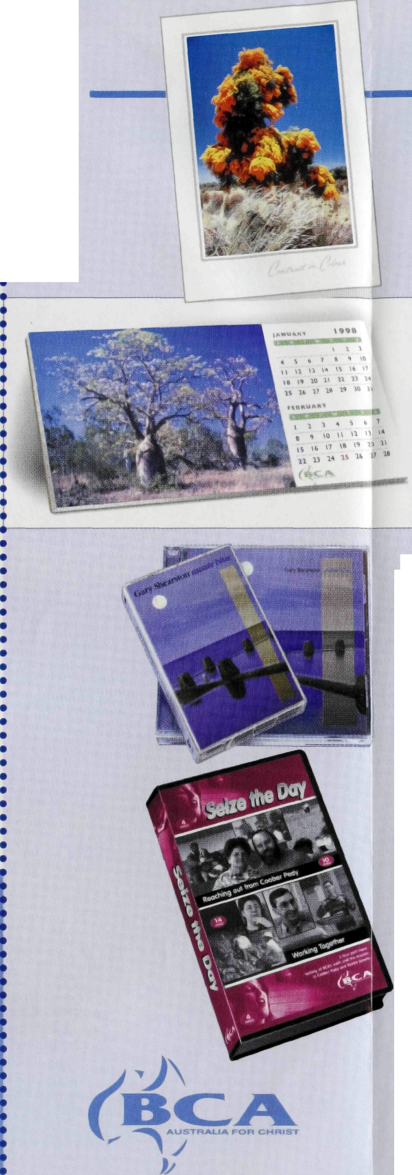
You could win a prize
with your
Photographs
of the Outback
Have you any photographs or slides which could be used on our next card series or calendar?
Any subject—scenes, birds, animals, insects, flowers, people or children engaged in rural activities—whatever you would like to see on a BCA card or calendar.
The photographs should only be of a locality or activity taking place in an area supported by BCA, so they can be linked to BCA and BCA's work.
Photographs must be in focus, can be colour or black & white and either slides or prints. If your photograph is selected, you will receive a prize from products listed in BCA's "Real Australian Gifts" Catalogue.
Send photographs wrapped sufficiently with stiff board to prevent creasing or damage with a self addressed and stamped envelope for their return
to: BCA Call for Outback Photographs, Level 7, 37 York Street, Sydney, NSW 2000
Please make sure we can read your name and be able to contact you by phone or mail if we have any questions about your photograph.
PHONE ORDERS
Please have your credit card details hand
NSW: Ph (02) 9262 5017 * Fax (02) 9262 502(T VIC: Ph (03) 9654 8022 » Fax (03) 9654 8962 SA: Ph (08) 8388 2346 * Fax (08) 8388 2346 QIP: Ph (07) 3349 9081 * Fax (07) 3849 7927 WA: Ph (09) 343 2445
Please make sure you include your name
postal address and phone number
if ordering by fax or e-mail*.
Seepage I (Directory)for e-mail addresses.

ORDER FORM

"REAL AUSTRALIA" GREETING CARDS
Please send me a single pack of 5 cards with envelopes for $7.50 =$
I will SAVE with a multiple pack order.
First pack of 5 cards with envelopes @ $7.50 =$
additional packs @ $6.50 each =$
BUSH PENCILS
pencils @ $2.00 each =$
1998 DESKTOP CALENDAR WITH POSTCARDS
desktop calendars with postcards @ $7.50 each=$
EVOCATIVE SOUNDS OF "AUSSIE BLUE"
cassettes @ $18.50 each =$
CDs @ $23.50 each =$
"SEIZE THE DAY" VIDEO
=$
videos @ $20.00 donation each
=$!
TOTAL

My cheque/money order is attached for | $
Please debit my Bankcard Mastercard | Visacard for $ | !
11 Mil | Expires on | ODD
Name on credit card signature
Please allow 2-3 weeks for delivery. All prices include postage and packing.
PLEASE FILL IN THE ORDER FORM, CUT OFF AT DOTTED LINE AND MAIL IN THE REPLY ENVELOPE PROVIDED

